CHANGE REQUEST
Meeting ID:* | SDS#39
Source:* | Kenichi Yamamoto, KDDI, kc-yamamoto@kddi.com  Catalina Mladin, Convida, mladin.catalina@convidawireless.com
Date:* | 2019-02-12
Reason for Change/s:* | The CR is to add new Monitoring Event Type (Number of UEs in an Area)
CR against: Release* | Release 4
CR against: WI* | Active WI-0058  MNT maintenance / < Work Item number(optional)>  Is this a mirror CR? Yes No  mirror CR number: (Note to Rapporteur - use latest agreed revision)  STE Small Technical Enhancements / < Work Item number (optional)>  Only ONE of the above shall be ticked
CR against: TS/TR* | TR-0024 3GPP Interworking v2.3.0
Clauses * | 8.x
Type of change: * | Editorial change  Bug Fix or Correction  Change to existing feature or functionality  New feature or functionality  Only ONE of the above shall be ticked
Impacted other TS/TR(s) | TS-0026
Post Freeze checking:* | This CR contains only essential changes and corrections? YES NO  This CR may break backwards compatibility with the last approved version of the TS? YES NO
Template Version: January 2017 (Do not modify)

oneM2M Notice
The document to which this cover statement is attached is submitted to oneM2M. Participation in, or attendance at, any activity of oneM2M, constitutes acceptance of and agreement to be bound by terms of the Working Procedures and the Partnership Agreement, including the Intellectual Property Rights (IPR) Principles Governing oneM2M Work found in Annex 1 of the Partnership Agreement.
GUIDELINES for Change Requests:
Provide an informative introduction containing the problem(s) being solved, and a summary list of proposals.
Each CR should contain changes related to only one particular issue/problem.
In case of a correction, and the change apply to previous releases, a separate “mirror CR” should be posted at the same time of this CR
Mirror CR: applies only when the text, including clause numbering are exactly the same.
Companion CR: applies when the change means the same but the baselines differ in some way (e.g. clause number).
Follow the principle of completeness, where all changes related to the issue or problem within a deliverable are simultaneously proposed to be made E.g. A change impacting 5 tables should not only include a proposal to change only 3 tables. Includes any changes to references, definitions, and acronyms in the same deliverable.
Follow the drafting rules.
All pictures must be editable.
Check spelling and grammar to the extent practicable.
Use Change bars for modifications.
The change should include the current and surrounding clauses to clearly show where a change is located and to provide technical context of the proposed change. Additions of complete clauses need not show surrounding clauses as long as the proposed clause number clearly shows where the new clause is proposed to be located.
Multiple changes in a single CR shall be clearly separated by horizontal lines with embedded text such as, start of change 1, end of change 1, start of new clause, end of new clause.
When subsequent changes are made to content of a CR, then the accepted version should not show changes over changes. The accepted version of the CR should only show changes relative to the baseline approved text.

Introduction
This contribution proposes functionality to enable an IN-CSE to request that a SCEF sends Monitoring Event reports for the number of UEs present in a geographical area. Based on these reports, the IN-CSE can analyze the congestion levels in each area and start/stop throttling of requests initiated by or targeted towards ADN-AEs and ASN/MN-CSEs hosted on UEs in the area to help manage the congestion levels in an underlying 3GPP network.
TS-0026 supports the ReportingNetworkStatus API to allow an IN-CSE to be notified of the network congestion status in a geographical area in the underlying 3GPP network. The API is available if an MNO supports RAN Congestion Awareness Function (RCAF) in the 3GPP network, which reports the network congestion status in a geographical area to the SCEF. ETSI ISG MEC supports the number of E-RAB active defined in RNIS API, and a list of UEs in a particular location defined in Location service API.
The SCEF supports the Monitoring Event API (Monitoring Type: Number of UEs in an Area) over T8 to allow an SCS/AS to ask for the number of UEs in a particular geographic area in an underlying 3GPP network. MNOs may be able to predict the general congestion status of each area based on the number of UEs without the RCAF implementation. The API may also be available for congestion analysis with the number/External Identifiers of ADN-AEs and ASN/MN-CSEs hosted on UEs in an area.
The Monitoring Event API (Number of UEs in an Area) and the ReportingNetworkStatus API can be used for the network congestion status in a geographical area. So some of the proposed procedures refer to clause 7.8 Informing about Potential Network Issues of TS-0026.

R03 contains following changes based on offline comments and discussion:
- Adding some use cases and APIs comparison to clause 8.x.1 description.
- Adding the parameter of locationArea5G and the supportedfeatures “Number_of_UEs_in_an_area_notification_5G” as new features for 5G NEF described in 3GPP TS 29.122-f20 published at December 2018.
- Renaming externalGroupID to M2M-Ext-Group-ID and updating the description of the M2M-Ext-Group-ID in the <remoteCSE> resource for consistent with M2M-Ext-ID attribute.
- Adding M2M-Ext-Group-ID attribute to the <AE> resource in order to support External Group Identifier of an Underlying Network in oneM2M System.
- Removing requirements of 8.x.3.1 Key SCEF NorthBound API because there are currently no requirements for 3GPP.
- Some editorial corrections (e.g. removal of maximumNumberOfReports in Step 2, change the response code in Step 4).

-----------------------Start of change 1-------------------------------------------

8.x Monitoring event (Monitoring Type: Number of UEs in an Area)

8.x.1 Description
The 3GPP SCEF functionality described in 3GPP TS 29.122 [i.x] supports APIs for monitoring specific events such as Number of UEs in an AreaE. Based on the reports, the IN-CSE can start/stop throttling of requests initiated by or targeted towards its registree AEs and CSEs that are hosted on UEs residing in this geographical area to help manage the congestion levels in the underlying 3GPP network.
TS-0026 [i.x] supports the ReportingNetworkStatus API to allow an IN-CSE to be notified of the network congestion status in a geographical area in the Underlying 3GPP network. The API is available if an MNO supports RAN Congestion Awareness Function (RCAF) in the 3GPP network, which reports the network congestion status in a geographical area to the SCEF. ETSI ISG MEC supports the number of E-RAB active defined in RNIS API, and a list of UEs in a particular location defined in Location service API. Table 8.x.1-1 shows the APIs comparison between MonitoringEvent API (Number of UEs in an Area) and ReportingNetworkStatus API.
Feature | MonitoringEvent API  (Number of UEs in an Area) | ReportingNetworkStatus API
Number of UEs | ✓ | N/A
External Identifier of UE | ✓ | N/A
Congestion Level | N/A | ✓  Indicate abstracted value (High, Medium, Low) or exact value (between 0 and 31)
Continuous reporting | N/A | ✓
Support of 5G NEF | ✓ | T.B.D
Table 8.x.1-1: APIs comparison between MonitoringEvent API (Number of UEs in an Area) and ReportingNetworkStatus API

Below are some possible use cases for use of the monitoring event for the number of UEs in an area. It is assumed that the IN-CSE is triggered to perform the procedure by its local policy and uses the location information deployed by an MNO (e.g. eNBs, CGIs).
- Use case 1: Congestion analysis with the External Identifiers of ADN-AEs and ASN/MN-CSEs hosted on UEs in an area.
In this use case it may be assumed that Area A is identified as a congested area by using ReportingNetworkStatus API. An M2M Service Provider wants to ensure that a particular group of ASN/MN-CSEs and/or ADN-AEs hosted on UEs in Area A maintains a high quality of service by performing additional monitoring procedures. The group may be identified in the Underlying Network by an External Group Identifier available at the IN-CSE. The IN-CSE sends a Monitoring Event Request with the External Group Identifier and the location information of Area A to the corresponding SCEF. When the IN-CSE receives a Monitoring Event Response from the SCEF, the IN-CSE receives the number of group member UEs found at the Area A.
Note that and the External Identifier(s) of the registree ASN/MN-CSEs/ADN-AEs may or may not be provided in the response, depending on MNO configuration of MME/SGSN.
Based on this information, the IN-CSE can take necessary measures such as adjusting other monitoring procedures for the group.

Based on this information the IN-CSE may take other actions, such as modifying the <schedule> resource of the group members.. Upon detecting an updated scheduleElement, the group members will modify when they send requests and make themselves available to receive requests.

- Use case 2: Congestion analysis for Edge/Fog Computing (Fog Node communicates with a SCEF via IN-CSE)
The use case is described in clause 6.20 High-precision Road Map using Edge/Fog Computing of TR-0026 [i.y]. In order to minimize the amount of data that needs to be sent from or toward devices and to minimize the amount of processing required by an IN-CSE, a Fog Node sends a request of the congestion status of Area A to the IN-CSE. The IN-CSE retrieves a Monitoring Event for the number of UEs in Area A to SCEF via T8 API. After receiving a Monitoring Event Notification, the IN-CSE sends a response of the congestion status of Area A to the Fog Node. Then the Fog Node analyzes the congestion level in Area A. Based on the congestion level analysis, the Fog Node starts throttling of requests initiated by or targeted towards ADN-AEs and ASN/MN-CSEs hosted on UEs in the Area A.
It is assumed that the Fog Node communicates with a SCEF via the IN-CSE.
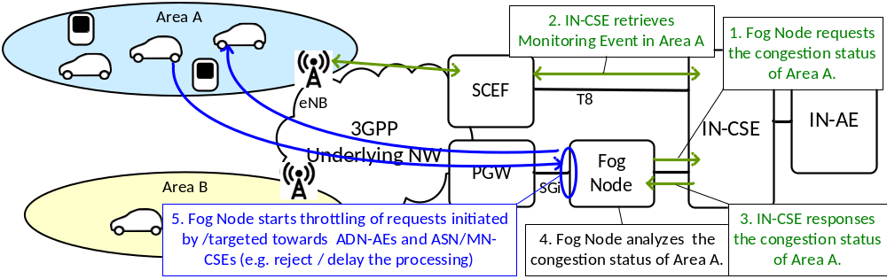
Figure 8.x.1-1: Use case 2: Congestion analysis with Edge/Fog Computing (Fog Node communicates with a SCEF via IN-CSE)

- Use case 3: Congestion analysis for Edge/Fog Computing (Fog Node communicates with a SCEF directly via T8 IF)
The use case is described in clause 7.3.1 and 7.3.2 of TR-0052, which provide oneM2M Platform Optimization Scenarios by using Monitoring Event API for the number of UEs in an area.
In this case, the Fog Node hosts a MN-CSE and retrieves congestion information from 3GPP Underlying Network by communicating with a SCEF directly via T8 interface. The communication procedure with the Fog Node is currently FFS by WI-0080 Edge and Fog Computing.

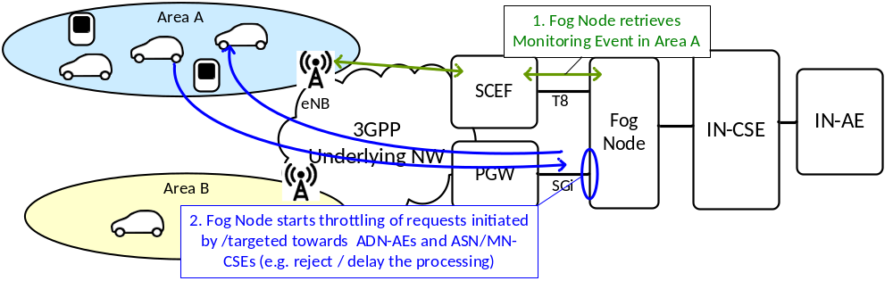
Figure 8.x.1-2: Use case 3: Congestion analysis with Edge/Fog Computing (Fog Node communicates with a SCEF directly via T8 IF)

- Use case 4: Congestion analysis of 4G UEs and 5G UEs
If a 3GPP Underlying Network supports both SCEF and NEF, the IN-CSE can retrieve the number of 4G UEs and 5G UEs in each area and analyze the congestion level at the areas.
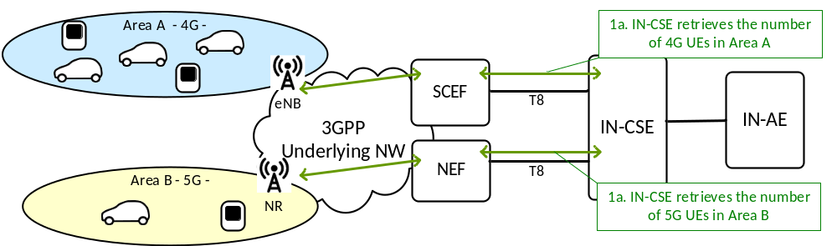
Figure 8.x.1-3: Use case 4: Congestion analysis of 4G UEs and 5G UEs

8.x.2 Feature Gap Analysis
The 3GPP defined term ‘SCS’ in the flows corresponds to oneM2M IN-CSE. The service flows defined in 3GPP TS23.682 [i.5] are used in the following section as informative information only. The oneM2M focus is on the T8 API of SCEF.

8.x.2.1 Monitoring event configuration via MME/SGSN.
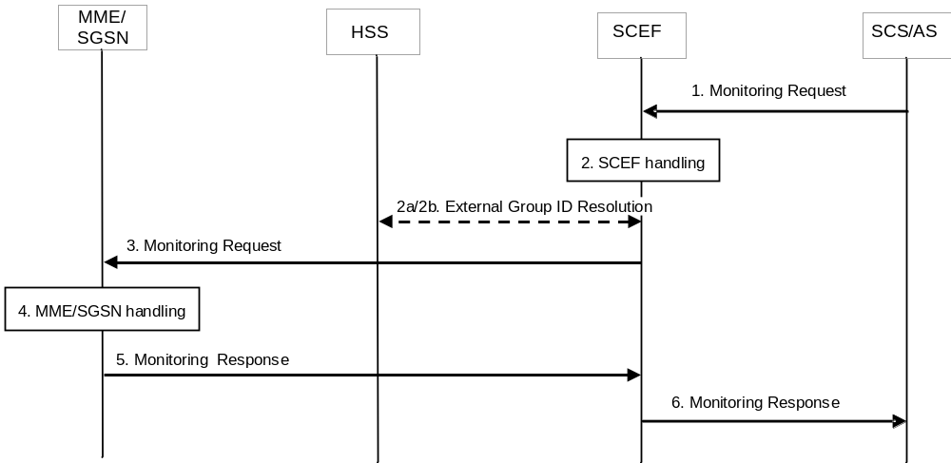
Figure 8.x.2.1-1: Monitoring event configuration via MME/SGSN [i.5]
Figure 8.x.2.1-1 illustrates the procedure of Monitoring event configuration via MME/SGSN, described in 3GPP TS23.682 [i.5]. The monitoring event Number of UEs in an area is applicable for the monitoring event configuration via MME/SGSN, and allows the SCS/AS to ask for the number of UEs that are in the geographic area described by the SCS/AS. The SCS/AS may request information about the UEs that the 3GPP network knows, by its normal operation, to be within the area (Last Known Location). For this monitoring event, only one-time reporting is supported. When the SCS/AS includes External Group Identifier(s) in the monitoring request, the MME/SGSN counts the number of UEs in the geographic area per External Group Identifier.
The involved steps are described below:
Step 1: SCS (IN-CSE) sends a Monitoring Request to the SCEF. The SCS sets Monitoring Type to "Number of UEs present in a geographic area (NUMBER_OF_UES_IN_AN_AREA)" and adds Location Type and Location Area before sending Monitoring Request to the SCEF. The request may optionally include External Group Identifier(s).

Step 6: The SCEF sends a Monitoring Response (Monitoring Event Report, Cause) message to the SCS (IN-CSE) to acknowledge acceptance of the Monitoring Request and to provide the requested monitoring information in Monitoring Event Report parameter. When External Identifiers are included in the results that are received from the MME(s)/SGSN(s) in step 5, they are included by SCEF in the response to the SCS/AS.
Table 8.x.2.1-1 shows the parameters for the Monitoring event API for the number of UEs in a geographic area, as described in 3GPP TS 29.122 [i.x]. , Table 8.x.2.1-2 and Table 8.x.2.1-3 show the parameters to be provided to indicate the location via locationArea and locationArea5G, respectively.

Table 8.x.2.1-1: Parameters for Number of UEs in a geographic area
Parameter | Cardinality | Description
supportedFeatures | 0..1 | supportedFeatures is used to negotiate the supported optional features of the API. This attribute shall be provided in the POST request and in the response of successful resource creation.  If it is set to the value of “8” (Number_of_UEs_in_an_area_notification), it indicates support for the number of UEs present in a given geographic area notifications and the feature supports the pre-5G (e.g. 4G) requirement.  If it is set to the value of “12” (Number_of_UEs_in_an_area_notification_5G), it indicates support for the number of UEs present in a given geographic area notifications and the feature supports the 5G requirement (only be supported in 5G).
notificationDestination | 1 | A URI of a notification destination that T8 message shall be delivered to.
monitoringType | 1 | Enumeration of monitoring type. It indicates "NUMBER_OF_UES_IN_AN_AREA".
maximumNumberOfReports | 0..1 | Identifies the maximum number of event reports to be generated by the HSS, MME/SGSN. For this monitoring event only One-time reporting is supported and the parameters shall be ignored by the SCEF if present in the request.
monitorExpireTime | 0..1 | Identifies the absolute time at which the related monitoring event request is considered to expire.
locationType | 0..1 | If "monitoringType" is "NUMBER_OF_UES_IN_AN_AREA", this parameter shall be included to identify whether the request is for Current Location or Last known Location. In this 3GPP release, locationType shall be set to "LAST_KNOWN_LOCATION".
locationArea | 0..1 | If "monitoring-Type" is "NUMBER_OF_UES_IN_AN_AREA", this parameter may be included to indicate the area within which the SCS/AS requests the number of UEs, described in Table 8.x.2.1-2. The supportedFeatures “Number_of_UEs_in_an_area_notification” is applicable for this parameter.
locationArea5G | 0..1 | If "monitoring-Type" is "NUMBER_OF_UES_IN_AN_AREA", this parameter may be included to indicate the area within which the SCS/AS requests the number of UEs, described in Table 8.x.2.1-3. The supportedFeature “Number_of_UEs_in_an_area_notification_5G” is applicable for this parameter.
externalGroupId | 0..1 | Identifies a user group as defined in 3GPP TS 23.682 [i.5]. It is used on the interface between the SCS/AS and the SCEF and on the interface between the SCEF and the HSS.
addExtGroupIds | 0..N | Identifies a user group as defined in 3GPP TS 23.682 [i.5]. For the feature "Number_of_UEs_in_an_area notification", "externalGroupId" may be included for single group and "addExtGroupIds" may be included for multiple groups but not both.
self | 0..1 | Link to this resource. This parameter shall be supplied by the SCEF in responses.
uePerLocationReport | 0..1 | If "monitoringType" is "NUMBER_OF_UES_IN_AN_AREA", this parameter shall be included to indicate the number of UEs found at the location.
externalIds | 0..N | Each element indicates an External Identifier of the UE.

Table 8.x.2.1-2: Parameters of locationArea
Parameter | Cardinality | Description
cellId | 0..N | Indicates a Cell Global Identification of the user which identifies the cell the UE is registered.
enodeBId | 0..N | Indicates an eNodeB in which the UE is currently located.
routingAreaId | 0..N | Identifies a Routing Area Identity of the user where the UE is located.
trackingAreaId | 0..N | Identifies a Tracking Area Identity of the user where the UE is located.
geographicArea | 0..N | Identifies a geographic area of the user where the UE is located.
civicAddress | 0..N | Identifies a civic address of the user where the UE is located.

Table 8.x.2.1-3: Parameters of locationArea5G
Parameter | Cardinality | Description
geographicAreas | 0..N | Identifies a list of geographic area of the user where the UE is located.
civicAddresses | 0..N | Identifies a list of civic addresses of the user where the UE is located.
nwAreaInfo | 0..1 | This IE represents the network area information of the user where the UE is located.

8.x.3 Key Issues and Requirements

8.x.3.1 Key SCEF NorthBound API Requirements
SCEF NorthBound interface

N/A

8.x.3.2 Potential impact on SCEF SouthBound Interface
N/A

8.x.3.3 Further 3GPP requirements and clarifications
N/A

8.x.3.4. oneM2M Key Issues
- Provide support for number of UEs in an area in Monitoring event.
- Provide support for configuration of 3GPP External Group Identifier for
- ASN-CSE/MN-CSE hosted on a UE .

8.x.4 oneM2M Solutions

8.x.4.1 Solution 1

8.x.4.1.1 Impacted Resources and Attributes
To implement this solution, the following attributes are proposed:
- The new attribute M2M-Ext-Group-ID corresponding to the externalGroupId as specified in 3GPP TS29.122 [i.Error: Reference source not found] is addednto the <AE> resource.
- The externalGroupID attribute for the <remoteCSE> resource is renamed as M2M-Ext-Group-ID and the description of the M2M-Ext-Group-ID is updated to be more generic and consistent with M2M-Ext-ID attribute.

8.x.4.1.1.1 Modified <remoteCSE > resource
The externalGroupID attribute for the <remoteCSE> resource is renamed as M2M-Ext-Group-ID and the description of the M2M-Ext-Group-ID is updated as shown in the table below.
Table 8.x.4.1.1.1-1: Modified attribute of <remoteCSE> resource
Attributes of <remoteCSE> | Multiplicity | RW/  RO/  WO | Description | <remoteCSEAnnc> Attributes
M2M-Ext-Group-ID  externalGroupID | 0..1 | RW | Supported when Registrar CSE is an IN-CSE. It is used by an M2M Service Provider (M2M SP) when services targeted to a group of M2M Devices are requested from the Underlying Network. It allows the Underlying Network to identify the group of M2M Devices (e.g. ADN, ASN, MN). To that effect, the Underlying Network maps the M2M-Ext-Group-ID to the Underlying Network specific Identifier it allocated to the target group of M2M Devices. It is the External-Group-ID as specified in 3GPP TS23.682 [i.14] clause 4.6.3. It is the globally unique ID exposed by the underlying network that is mapped to an internally used identifier for a specific group related services. | OA

8.x.4.1.1.2 Modified <AE> resource
New attribute for the <AE> resource is proposed as shown in the table below.
Table 8.x.4.1.1.2-1: New Attributes of <AE> resource
Attributes of <remoteCSE> | Multiplicity | RW/  RO/  WO | Description | <remoteCSEAnnc> Attributes
M2M-Ext-Group-ID | 0..1 | RW | Supported when Registrar CSE is an IN-CSE. It is used by an M2M Service Provider (M2M SP) when services targeted to a group of M2M Devices are requested from the Underlying Network. It allows the Underlying Network to identify the group of M2M Devices (e.g. ADN, ASN, MN). To that effect, the Underlying Network maps the M2M-Ext-Group-ID to the Underlying Network specific Identifier it allocated to the target group of M2M Devices. | OA

8.x.4.1.2 Proposed Flow

8.x.4.1.2.1 Monitoring event for Number of UEs in an Area
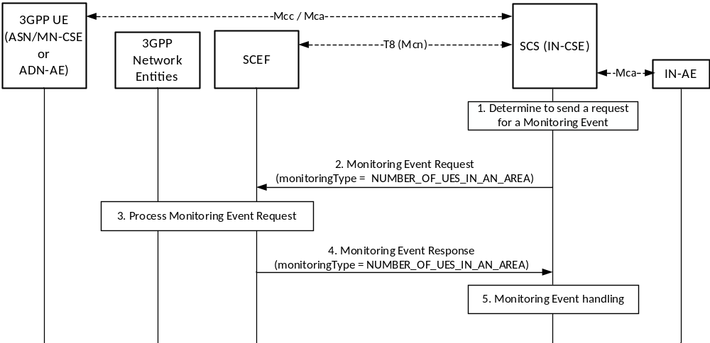
Figure 8.x.4.1.2.1-1: Monitoring event for Number of UEs in an Area

Pre-conditions:
There is a relationship in place between the Service Provider and MNO allowing the IN-CSE to request Monitoring events for number of UEs present in an area. The method for establishing this relationship is outside the scope of the present document.
An ASN/MN-CSE or ADN-AE registers with the IN-CSE and configures the M2M-Ext-ID attribute of its <remoteCSE> or <AE> resource. The IN-CSE examines the M2M-Ext-ID and recognizes that it is associated with an MNO that it has a relationship with.

If the deployment uses External Group Identifier as described in 3GPP TS29.122 [i.Error: Reference source not found], when ASN/MN-CSEs or ADN-AEs registes with the IN-CSE they uses externalGroupId information to configurs the M2M-Ext-Group-ID of the correspondins <remoteCSE> or <AE> resource. see clause 8.x.4.1.2.2 for changes UE Attach with oneM2M Registration Procedure when M2M-Ext-Group-ID is configured).
The IN-CSE is configured to be able to determine a location area ( i.e. locationArea and/or locationArea5G) of interest in the Underlying Network. The IN-CSE may use its location services or other location information. How the location area of interest is determined is outside the scope of the present document.
The IN-CSE is configured with system defaults for:
• The specified actions to generate the network congestion levels based on the number of UEs in an area.
• The specified actions to take based on the severity of each congestion level.
The configuration methods for these system defaults are outside the scope of the present document.

The ADN-AE’s or the ASN/MN-CSE’s <node> resource hosted on the IN-CSE has a child <schedule> resource and the IN-CSE has permissions to update it. The ADN-AE or the ASN/MN-CSE has a <subscription> for its <schedule> resource and when it receives a notification from the IN-CSE, it updates its communication schedule accordingly.
Step 1: IN-CSE determines to send a Monitoring Event Request for number of UEs in a geographic area.
The IN-CSE determines to send to a SCEF a Monitoring Event Request for number of UEs present in an area of interest. If applicable, the IN-CSE may
determine only the number of UEs within the group identified by the M2M-Ext-Group-ID. If M2M-Ext-Group-ID information is not applicable, all the UEs present in the area will be identified.

- Step 2: IN-CSE sends a Monitoring Event Request for the number of UEs in the area.
The IN-CSE sends a Monitoring Event Request for the geographical area of interest to the SCEF. The Monitoring Event Subscription request from the IN-CSE to the SCEF will comply with 3GPP TS 29.122 [i.x] as follows:
- An HTTP POST method will be used
- URI will be set to {apiRoot}/3gpp-monitoring-event/v1/{scsAsId}/subscriptions/. The {apiRoot} and {scsAsId} segments are configured based on Service Provider and MNO policies.
- The request payload will include a MonitoringEventSubscription data structure as specified in 3GPP TS 29.122 [i.x] with the following attributes:
  - notificationDestination will be set to a URI that the SCEF can target Location Reporting notifications towards. The value of this URI will be based on internal IN-CSE policies.
  - monitoringType will be set to NUMBER_OF_UES_IN_AN_AREA indicating the number of UEs in a given geographic area

  - monitorExpireTime is optional and may be set to an absolute time at which the monitoring event request is considered to expire. If used, the IN-CSE will configure this time based on Service Provider and MNO policies.
  - locationType will be set to LAST_KNOWN_LOCATION.

  - supportedFeatures will be set to a string value of “8” and/or “12” indicating support for Location Reporting notifications. If it is set to the value of “8” (Number_of_UEs_in_an_area_notification), the feature supports the pre-5G (e.g. 4G) requirement. If it is set to the value of “12” (Number_of_UEs_in_an_area_notification_5G), the feature supports the 5G requirement (only be supported in 5G).

  - locationArea and/or locationArea5G will be included to indicate the area of interest within which the IN-CSE requests the number of UEs. If supportedFeatures is set to the value of “8”, the locationArea attribute is applicable. If supportedFeatures is set to the value of “12”, the locationArea5G attribute is applicable.
  - externalGroupId will be set to the M2M-Ext-Group-ID if the deployment uses the External Group Identifier in step 0 and if the IN-CSE monitoring request targets identifying the number of UEs from a specific group in the area.
  - requestTestNotification, websockNotifConfig, addExtGroupIds, maximumNumberOfReports and groupReportGuardTime are not supported by the present document and will not be included.

Step 3: SCEF processes the Monitoring Event Request.
The SCEF processes the Monitoring Request together with the 3GPP network entities as described in 3GPP TS 29.122 [i.x].
Step 4: SCEF sends a Monitoring Event Response.
The SCEF sends a Monitoring Event Response to the IN-CSE to acknowledge the request has been accepted. This response is described in 3GPP TS 29.122 [i.x] and includes the following information.
- A response code of 201 CREATED.
- The URI of the Monitoring Event Subscription resource created by the SCEF. The URI is returned in the HTTP Location header with a format of {apiRoot}/3gpp-monitoring-event/v1/{scsAsId}/subscriptions/{subscriptionId}. The {apiRoot} and {scsAsId} segments are configured based on Service Provider and MNO policies. The {subscriptionId} segment is configured by the SCEF.
- The response payload will include a MonitoringEventReport data structure as specified in 3GPP TS 29.122 [i.x] that includes the attributes present in the request along with the following additional attributes:
  - ueCount is configured to indicate the number of UEs found at the location. If an externalGroupId has been provided in the request, the count indicates the number of UEs from the given group which are found at the location.
  - externalIds is configured to indicate External Identifier(s) of the UEs included in the number of UEs found denoted by ueCount.
Note that and the External Identifier(s) information may or may not be provided in the response, depending on MNO configuration of MME/SGSN.
  - self is configured with a URI to the resource created by the SCEF for the request.
Step 5: Monitoring Event handling at the IN-CSE.
The IN-CSE may use the information provided in the Monitoring Event Report

to modify the <schedule> resource of the group members such that they modify the times they send or receive requests.

  - How the IN-CSE determines the use of the information received from the monitoring event is outside the scope of the current document and may be based on agreements with the MNO.

8.x.4.1.2.2 Enhancements to support configuration of 3GPP External Group Identifier
The UE Attach with oneM2M Registration Procedure is depicted in clause 6.3 of TS-0026 [i.x]. The following modifications are introduced in the procedure in Step 2a and 2b in order to support the new attribute for the 3GPP External Group Identifier as described in clause 8.x.4.1.1.
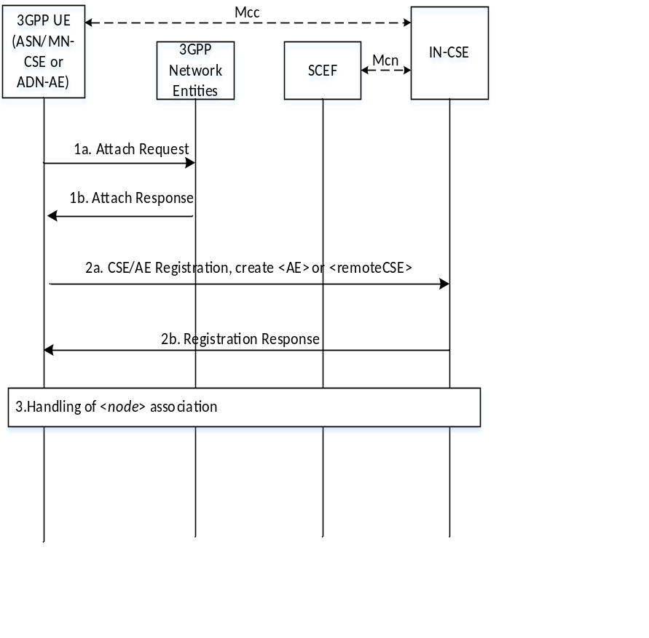
Figure 8.1.4.2.2-1 UE Attach Procedure with oneM2M Registration

All the steps not detailed below are executed as specified in clause 6.3 of TS-0026 [i.x].

Steps 2a and 2b: oneM2M Registration Request and Response

Information provided by the ASN/MN-CSE or ADN-AE(s) to the IN-CSE at this time will include, in addition to the other parameters specified (e.g.
M2M-Ext-ID, Trigger-Recipient-ID, etc.) the externalGroupIds used in the deployment. Note that not all the deployment UEs need to be provisioned with the same externalGroupIds.
In addition to the processing specified in clause 6.3 of TS-0026 [i.x] for this step: If configured, the externalGroupIds for each ASN/MN-CSE or ADN-AE(s) are stored as M2M-Ext-Group-ID attributes of the corresponding <AE> or <remoteCSE> resources created at this time.

-----------------------End of Change 1 ---------------------------------------------

-----------------------Start of change 2-------------------------------------------

2.2 Informative references
References are either specific (identified by date of publication and/or edition number or version number) or non-specific. For specific references, only the cited version applies. For non-specific references, the latest version of the referenced document (including any amendments) applies.
The following referenced documents are not necessary for the application of the present document but they assist the user with regard to a particular subject area.
[i.x] oneM2M TS-0026: 3GPP Interworking.
[i.x] oneM2M TR-0026: Vehicular Domain Enablement.

-----------------------End of Change 2 ---------------------------------------------

