CHANGE REQUEST
Meeting:* | SDS 39
Source:* | BeiXu, Huawei, Echo.xubei@huawei.com  Can Zhao, Huawei, zhaocan20@huawei.com
Date:* | 2019-02-11
Contact:* | BeiXu，Huawei，Echo.xubei@huawei.com
Reason for Change/s:* | Add a solution for the KI V2V network interface switching management for TR-0026
CR against: Release* | <Release> Release 4
CR against: WI* | Active < WI-0046: Vehicular Domain Enablement >  MNT Maintenace / < Work Item number(optional)>  STE Small Technical Enhancements / < Work Item number (optional)>  Only ONE of the above shall be ticked
CR against: TS/TR* | TR-0026-Vehicular_Domain_Enablement-V4_0_0
Clauses/Sub Clauses*
Type of change: * | Editorial change  Bug Fix or Correction  Change to existing feature or functionality  New feature or functionality  Only ONE of the above shall be ticked
Post Freeze checking:* | This CR contains only essential changes and corrections? YES NO  This CR may break backwards compatibility with the last approved version of the TS? YES NO  This CR is a mirror CR? YES if YES, please indicate the document number of the original CR: <Document Number) : NO
Template Version:27 May 2015 (Dot not modify)

oneM2M Notice
The document to which this cover statement is attached is submitted to oneM2M. Participation in, or attendance at, any activity of oneM2M, constitutes acceptance of and agreement to be bound by terms of the Working Procedures and the Partnership Agreement, including the Intellectual Property Rights (IPR) Principles Governing oneM2M Work found in Annex 1 of the Partnership Agreement.
GUIDELINES for Change Requests:
Provide an informative introduction containing the problem(s) being solved, and a summary list of proposals.
Each CR should contain changes related to only one particular issue/problem.
In case of a correction, and the change apply to previous releases, a separated “mirror CR” should be posted at the same time of this CR
Follow the principle of completeness, where all changes related to the issue or problem within a deliverable are simultaneously proposed to be made E.g. A change impacting 5 tables should not only include a proposal to change only 3 tables. Includes any changes to references, definitions, and acronyms in the same deliverable.
Follow the drafting rules.
All pictures must be editable.
Check spelling and grammar to the extent practicable.
Use Change bars for modifications.
The change should include the current and surrounding clauses to clearly show where a change is located and to provide technical context of the proposed change. Additions of complete sections need not show surrounding clauses as long as the proposed section number clearly shows where the new section is proposed to be located.
Multiple changes in a single CR shall be clearly separated by horizontal lines with embedded text such as, start of change 1, end of change 1, start of new clause, end of new clause.
When subsequent changes are made to content of a CR, then the accepted version should not show changes over changes. The accepted version of the CR should only show changes relative to the baseline approved text.

Introduction

Key Issue 8: V2V network interface switching management.
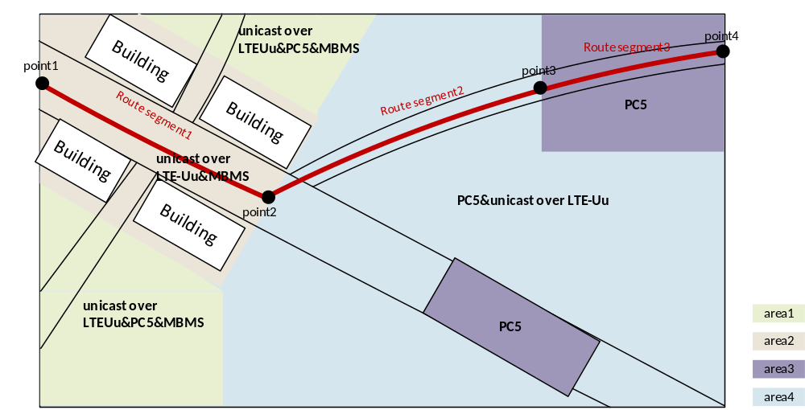
This results in the following issues:
- The IN-CSE does not have the supported communication mode of each vehicle and routing path of the platoon to plan the communication mode of the routing path.
- The IN-CSE lacks resources to store the relationship between planned communication mode and route segments.
- The IN-CSE cannot distinguish the leader vehicle role in a platooning group.
Potential Requirements：
- The oneM2M system shall support handover (e.g. east-west communication) over platoon relevant data from one Platooning Manager (running on edge node) to next Platooning Manager (running on neighbouring edge node).
- The oneM2M system shall support the Platooning data exchange between the vehicles, Platooning Service provider, Platooning Manager and oneM2M platform.
- The oneM2M system shall support a common information model for Platooning including vehicle state and platooning state.
- The oneM2M system should support a profile for Platooning with a consistent information model based on existing information models (e.g. ETSI ITS, DATEX and Sensoris).
- The oneM2M system shall support group management (e.g. .joining, leaving and changing vehicle’s role within the platoon) and group message communication for platooning service.
- The oneM2M system shall support Vehicle-to-Vehicle (V2V) communication via different network interfaces.
- The oneM2M system shall support management of Vehicle-to-Vehicle (V2V) network interface switching.

In the platoon, when one vehicle sends the request to the platoon, the request shall be sent to the IN-CSE/Group Hosting CSE firstly except the PC5.This contribution provides the solution about the IN-CSE/Group Hosting CSE plans the best group communication mode between them in advance according to the route and member supported communication modes.
- if the vehicle to vehicle communication mode is LTE-Uu unicast, the call flow is below:
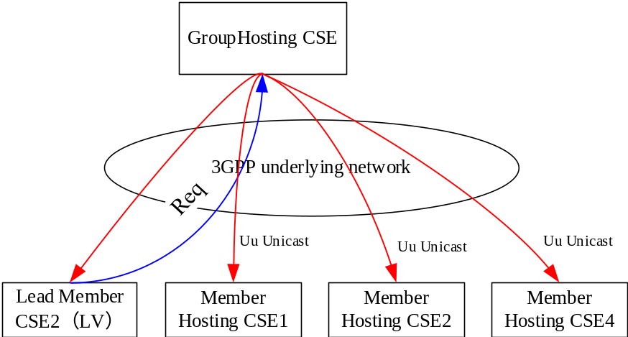
- if the vehicle to vehicle communication mode is MBMS, the call follow is below:
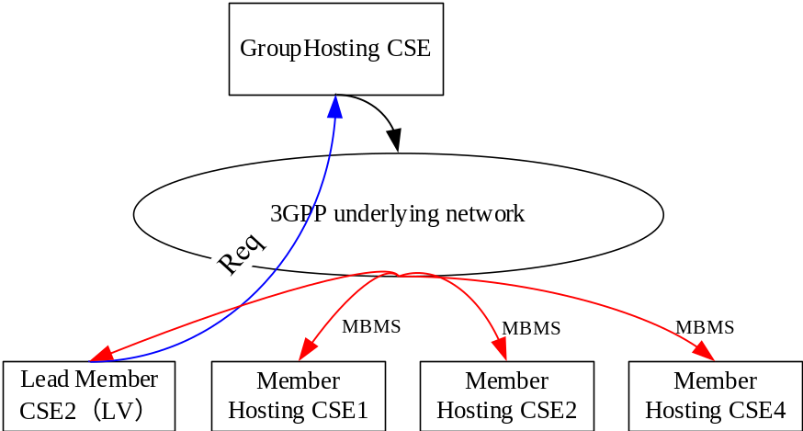
- if the vehicle to vehicle communication mode is IP multicast, the call flow is below:
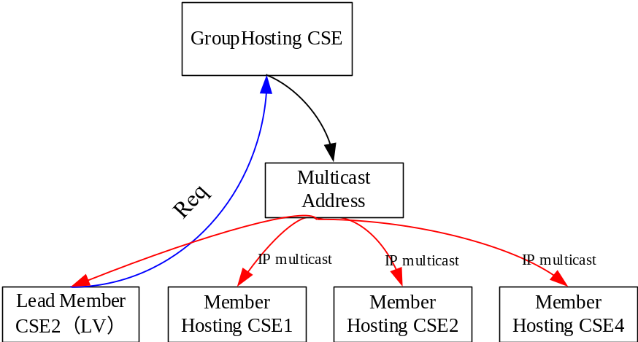
- if the vehicle to vehicle communication mode is PC5, the call flow is below:
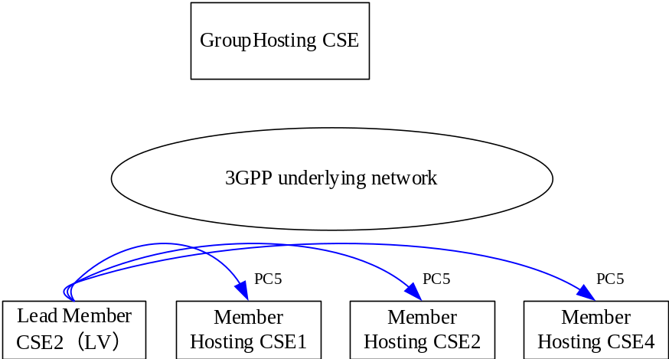

-----------------------Start of change 1-------------------------------------------

10.x Solution H: Network Communication Management

10.x.2 Detailed Procedure

10.x.2.2 Network communication management procedure for a Group

10.x.2.2.1 Network communication planning procedure

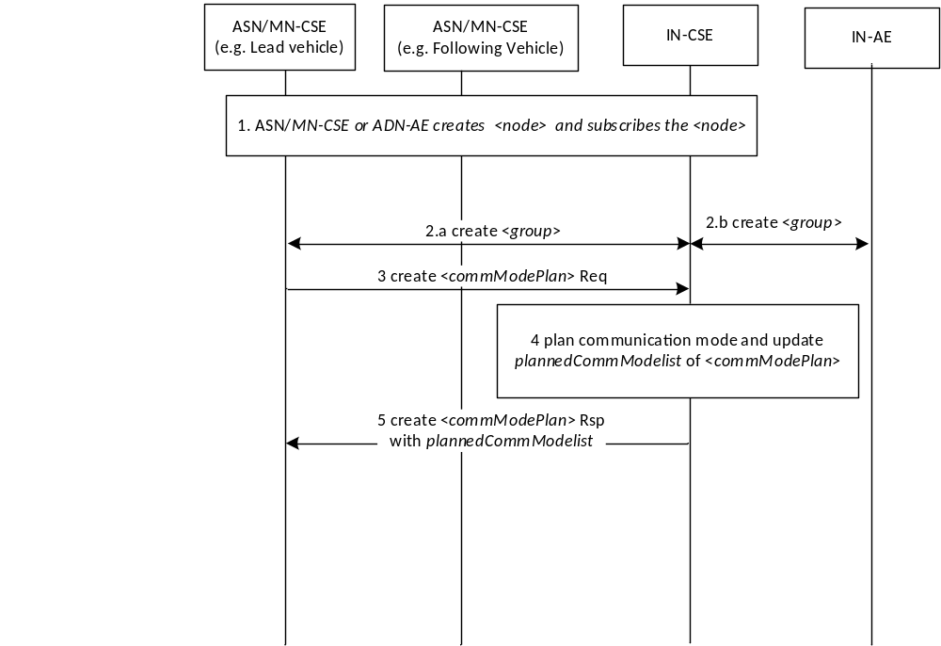
Figure 10.x.2.2.1-1. Solution Procedures for Network communication mode planning
The basic procedure is described as below:
Step 1: An MN/ASN-CSE creates the <node> resource hosted on the IN-CSE with a supportedCommModes attribute. The MN/ASN-CSE creates <subscription> resource of the <node> resource which is optional.
Step 2a and 2b: An ASN/MN-AE, or an IN-AE sends a <group> resource CREATE request to IN-CSE, including memberID, memberRoles (to indicate the lead vehicle of the platoon). IN-CSE creates the <group> resource.
Step 3: The lead member sends <commModePlan> CREATE request to IN-CSE, in which the value of Result Content is modified-attributes.
Step 4: The IN-CSE creates the <commModePlan> resource and checks targetedID. If the targetedID is the <group> resource ID, the IN-CSE checks the memberIDs of the <group> resource hosting on different member hosting CSEs and then gets the supportedCommModes attribute of the <node> resource associated with each member resource. The IN-CSE plans the group communication modes according to the routeInformation, groupID and the network information including MBMS SAI list, PC5/ LTE-Uu geographical area configuration, and supplementary information, e.g. map information. IN-CSE configures the plannedCommModeList which are the planned group communication modes.
Step 5: The IN-CSE sends the response including the updated plannedCommModeList.

Note1: It’s FFS to support the ADN-AE is the node which the group member resource hosts.
Note2: The current group network communication management can only be used when member hosting CSE and Group Hosting CSE have direct registration relationship.

10.x.2.2.2 V2X network communication switching procedure

10.x.2.2.2.1 Option 1: The lead vehicle sends switching message to each member to update the current communication mode

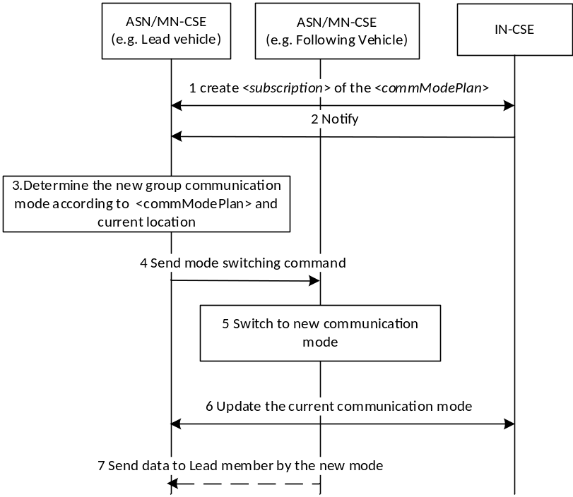
Figure 10.x.2.2.2.1-2. Solution Procedures for communication mode switching of Option 1
Step 1: The lead member creates <subscription> for the <commModePlan> resource.
Step 2: The IN-CSE sends a notification that includes updated plannedCommModeList to the MN/ASN-CSE hosted on the lead vehicle of the platoon when the resource is updated.
Step 3: The lead member determines the new communication mode between members according to the plannedCommModeList and current location.
Step 4: The lead member sends communication mode switching command to other members by current communication mode, e.g. PC5.
Step 5: The other members receive the command and switch to the new communication mode.
Step 6: The lead member sends the UPDATE operation of the currentCommMode of the <node>.
Step 7 (optional): The other member sends data to the lead member by the new communication mode according to the request from the lead member, e.g. Unicast over LTE-Uu.
Note: The solution of the communication procedure between vehicle and vehicle by PC5 is FFS.

10.x.2.2.2.2 Option 2: IN-CSE updates the current communication mode for each member
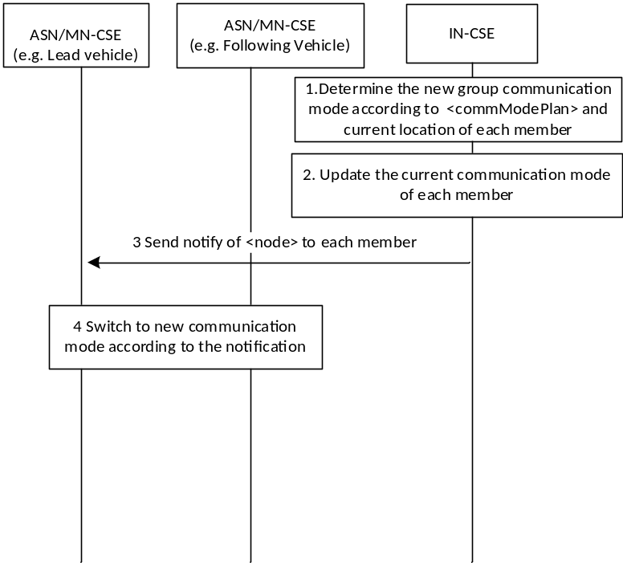
Figure 10.x.2.2.2.2-3. Solution Procedures for communication mode switching of Option 2
Step 1: The IN-CSE determines the new communication mode between members according to the plannedCommModeList and current location of each member.
Step 2: The IN-CSE updates the attribute currentCommMode of <node> resource of each member hosting of the group.
Step 3: The IN-CSE sends the notification to the each member of the group about the update of the <node> resource according to the communication mode before updating.
Step 4: The each member of the group switches to the new communication mode according to the notification.

10.x.2.2.2.3 Option 3: Each member updates the current communication mode
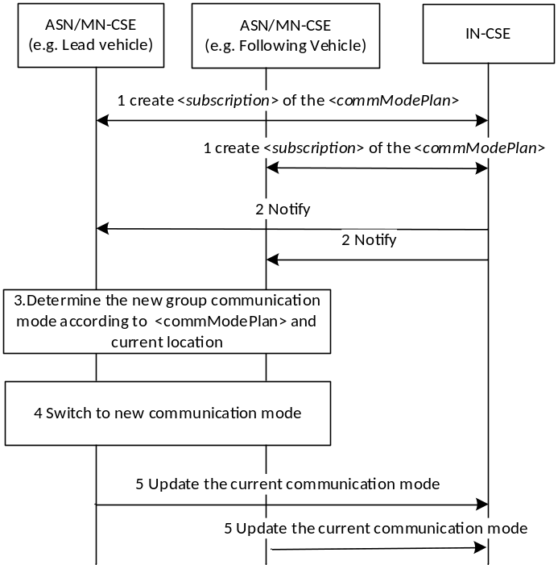
Figure 10.x.2.2.2.3-4. Solution Procedures for communication mode switching of Option 3
Step 1: The each member of the group creates <subscription> for the <commModePlan> resource.
Step 2: The IN-CSE sends a notification that includes updated plannedCommModeList to the each member of the group when the resource is updated.
Step 3: The each member determines the new communication mode between members according to the plannedCommModeList and current location.
Step 4: The each member switches to the new communication mode.
Step 5: The each member sends the UPDATE operation of the currentCommMode of the <node>.

10.x.2.2.3 Group Fanout procedure
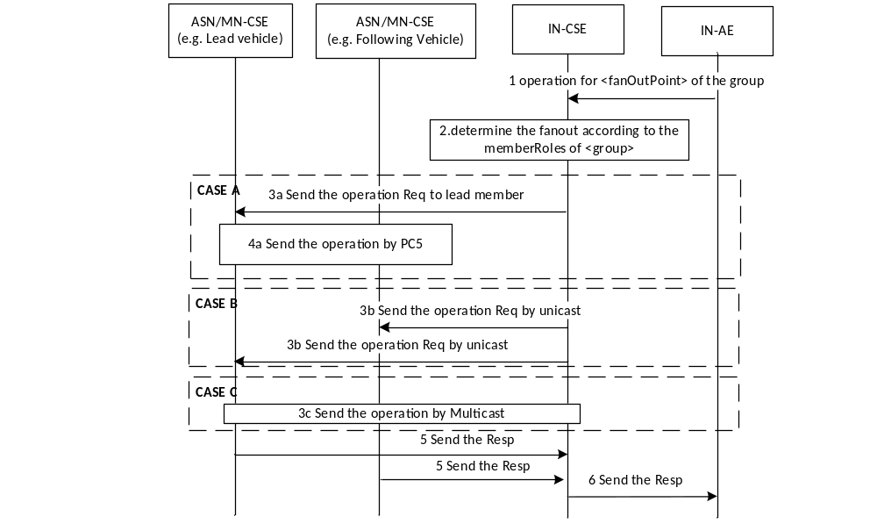
Figure 10.x.1.3-5. Solution Procedures for Group fanout by the memberRoles
Step1: The IN-AE sends operation for <fanOutPoint> of the group with the <group> resource ID.
Step2: The IN-CSE checks the <group> resource ID whether is the same with the targetedID of the <commModePlan>. If the same, then IN-CSE checks the attribute memeberRoles of the <group> which is the parent resource of <fanOutPoint>. If the memeberRoles attribute is configured and there is a lead member defined in the list, the IN-CSE determines the fanout mode according to the currentCommMode attribute of the <node> resource of the lead member:
Case A: If the currentCommMode is PC5, which means the group members communicate to each other by broadcast, go to Step 3a:
Step 3a: The IN-CSE sends the operation to the lead member by unicast.
Step 4a: The lead member sends the operation to the other members by PC5 or multicast broadcast. Go to Step 5.
Note: The procedure of communication between field nodes is FFS.
Case B: If the currentCommMode is Unicast over LTE-Uu, which means the group members communicate to each other by unicast over LTE-Uu, go to Step 3b:
Step 3b: the IN-CSE sends the operation to each group member by unicast. Go to Step 5.
Case C: If the currentCommMode is IP multicast or MBMS, which means the group members communicate to each other by multicast, go to Step 3c:
Step 3c: The IN-CSE sends the operation to the lead member by IP multicast or MBMS.
Step 5: Each member sends the response to the IN-CSE.
Step 6: The IN-CSE sends the response to the IN-AE.

10.x.2 Solution Applicability
This solution applies to Key Issue 8.

10.x.3 New Resources and Procedures

10.x.3.5 Modified <group> resource
New attribute as shown in Error: Reference source not found. The memberRoles attribute is used to indicate the leader of a group, and the leader should be one of members of the group.
Table 10.x.3.5-1: New attributes of <group> resource
Attributes of  <group> | Multiplicity | RW/  RO/  WO | Description | <groupAnnc>  Attributes
memberRoles | 0..1 | RW | List of arrays which consist of two elements: role and memberID. The role is the role of the member in a group:  - 0：Lead  The memberID should be one of the memberIDs. This attribute is used when the member roles of a group need to be specified, e.g. the lead vehicle of a platoon. | OA

-----------------------End of change 1---------------------------------------------

CHECK LIST
- Does this change request include an informative introduction containing the problem(s) being solved, and a summary list of proposals.?
- Does this CR contain changes related to only one particular issue/problem?
- Have any mirror crs been posted?
- Does this change request make all the changes necessary to address the issue or problem? E.g. A change impacting 5 tables should not only include a proposal to change only 3 tables. Includes any changes to references, definitions, and acronyms in the same deliverable?
- Does this change request follow the drafting rules?
- Are all pictures editable?
- Have you checked the spelling and grammar?
- Have you used change bars for all modifications?
- Does the change include the current and surrounding clauses to clearly show where a change is located and to provide technical context of the proposed change? (Additions of complete sections need not show surrounding clauses as long as the proposed section number clearly shows where the new section is proposed to be located.)
- Are multiple changes in this CR clearly separated by horizontal lines with embedded text such as, start of change 1, end of change 1, start of new clause, end of new clause.?

