Input Contribution
Meeting ID* | SDS#39
Title:* | TR-0057 – oneM2M overview
Source:* | Laurent Velez, ETSI, laurent.velez@etsi.org  Josef Blanz, Qualcomm, jblanz@qti.qualcomm.com
Date:* | 2019-02-13
Input related to* | TR-0057 V0.1.0
Intended purpose of  document:* | Decision  Discussion  Information  Other <specify>
Impacted other TS/TR(s)
Decision requested or recommendation:* | To incorporate into baseline the new proposed text if agreed.
Template Version: January 2017 (Do not modify)

oneM2M Notice
The document to which this cover statement is attached is submitted to oneM2M. Participation in, or attendance at, any activity of oneM2M, constitutes acceptance of and agreement to be bound by terms of the Working Procedures and the Partnership Agreement, including the Intellectual Property Rights (IPR) Principles Governing oneM2M Work found in Annex 1 of the Partnership Agreement.

Introduction
This contribution proposes an overview of the oneM2M architecture.

-----------------------Start of new text 1-------------------------------------------

5 oneM2M Overview

5.1 Introduction

5.1.1 oneM2M Service Layer
The architecture standardized by oneM2M defines an IoT Service Layer, i.e. a software Middleware sitting between processing / communication hardware / OS and IoT applications providing a rich set of functions needed by many IoT applications. It supports secure end-to-end data/control exchange between IoT devices and custom applications by providing functions for proper identification, authentication, authorization, encryption, remote provisioning & activation, connectivity setup, buffering, scheduling, synchronization, aggregation, group communication and device management, etc.
oneM2M’s Service Layer is typically implemented as a software layer and sits between IoT applications and processing or communication hardware and operating system elements that provide data storage, processing and transport, normally riding on top of IP. However, also non-IP transports are supported via interworking proxies. The oneM2M Service Layer provides commonly needed functions for IoT applications across different industry segments.

- oneM2M defines an horizontal architecture providing common services functions that enable applications in multiple domains, using a common framework and uniform APIs.
Using those standardized APIs make it much simpler for M2M/IoT solution providers to cope with complex and heterogeneous connectivity choices by abstracting out the details of using underlying network technologies, underlying transport protocols and data serialization. This is all handled by the oneM2M Service Layer without a need for the programmer to become an expert in each of these layers. Therefore, the application developer can focus on the process / business logic of the use case to be implemented and does not need to worry about how the underlying layers exactly work. This is very much like writing a file to a file system without worring how hard disks and their interfaces actually work.
Therefore, the IoT Service Layer specified in oneM2M can be understood as a distributed operating system for IoT providing uniform APIs to IoT applications in a similar way as a mobile OS does for the smart phone eco system.

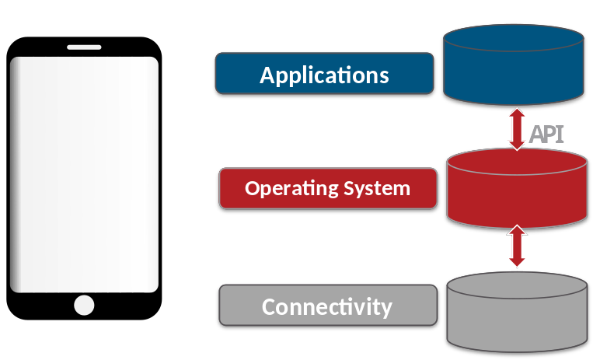
- Applications control connectivity Layer and built-in sensors via API’s provided by the Operating System
=> Applications are becoming portable

- Operating System collects data transfer requests from applications. The OS optimizes & controls use the of the network by the device and provides security

- Connectivity Layer provides access to the Internet via the wired and wireless networks

For example, the following “vertical” domains are isolated silos which makes it difficult to exchange data between each other. Using an “horizontal” architecture allows to provide a seamless interaction between applications and devices. In the below used case, a security application detects that when noboby is in the building , it triggers to switch off light and stop the air conditioned.
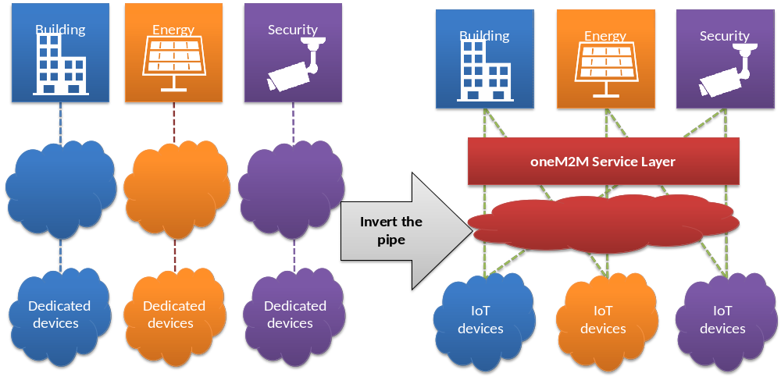

Without oneM2M
- Highly fragmented market with limited vendor-specific applications
- Reinventing the wheel: Same services developed again and again
- Each silo contains its own technologies without interoperability

With oneM2M
- End-to-end platform: common service capabilities layer
- Interoperability at the level of data and control exchanges via uniform APIs
- Seamless interaction between heterogeneous applications and devices

- Cloud provider independent : From Fragmentation to Standards ➔ decoupling Device, Cloud, and application by open interfaces
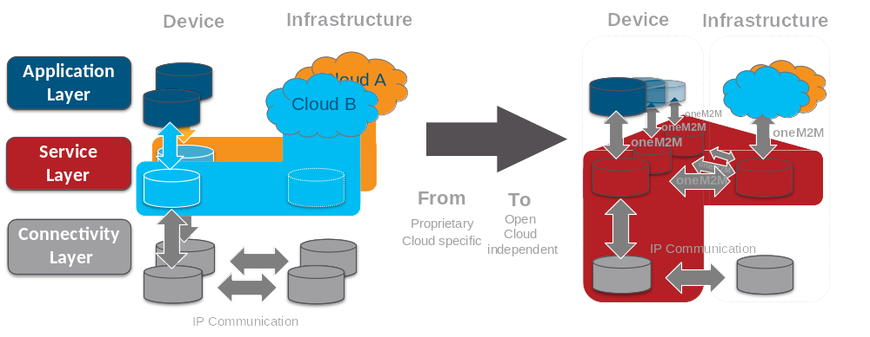
- Common IoT Key problems solved by oneM2M
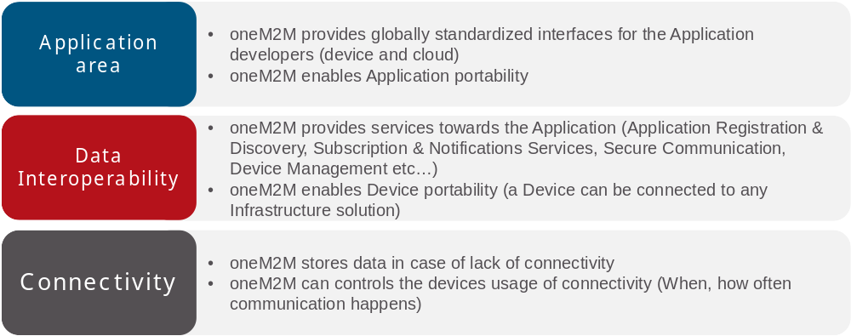

- oneM2M in a nutshell:
oneM2M’s Service Layer corresponds to a software “framework”, located between the IoT applications and communication HW/SW that provide storage/connectivity/data transport.
It provides functions that IoT applications across different industry segments commonly need (eg. data transport, security/encryption, scheduling, event notifications, remote software update...)
It supports cooperative intelligence in distributed applications i.e. in devices, gateways and back-end/cloud applications
It supports a selection of underlying transport protocols and serialization formats
It is like an Operating System for the Internet of Things, sitting on field devices/sensors, gateways and in servers.
And it is a standard – not controlled by a single private company.

5.1.2 Functional Architecture description
oneM2M Layered Model comprises three layers:
- the Application Layer,
- the Common Services Layer
- the underlying Network Services Layer.

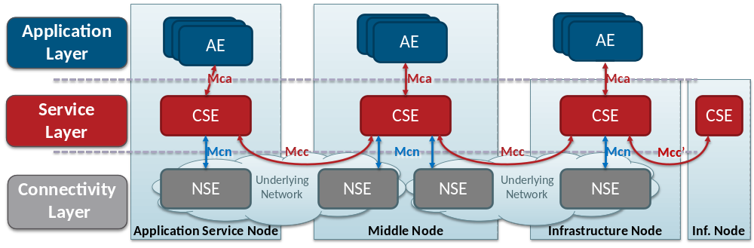
Figure 5.1.2-1: oneM2M Layered Model
oneM2M entities:
The oneM2M functional architecture comprises the following functions:
- Application Entity (AE): Application Entity is an entity in the application layer that implements an M2M application service logic. Each application service logic can be resident in a number of M2M nodes and/or more than once on a single M2M node. Each execution instance of an application service logic is termed an "Application Entity" (AE) and is identified with a unique AE-ID.
Examples of the AEs include an instance of a fleet tracking application, a remote blood sugar measuring application, a power metering application, or a pump controlling application.
- Common Services Entity (CSE): A Common Services Entity represents an instantiation of a set of "common service functions" of the oneM2M Service Layer. A CSE is actually the entiy that contains the collection of oneM2M-specified common service functions that AEs are able to use. Such service functions are exposed to other entities through the Mca (exposure to AEs) and Mcc (exposure to other CSEs) reference points. Reference point Mcn is used for accessing services provided by the underlying Network Service Entities such as waking up a sleeping device. Each Common Service Entity is identified with a unique CSE-ID.
Examples of service functions offered by CSE include: Data storage & sharing with access control and authorization, event detection and notification, group communication, scheduling of data exchanges, device management, and location services.
- Underlying Network Services Entity (NSE): A Network Services Entity provides services from the underlying network to the CSEs.
Examples of such services include location services, device triggering, certain sleep modes like PSM in 3GPP based networks or long sleep cycles.

oneM2M Reference Points:

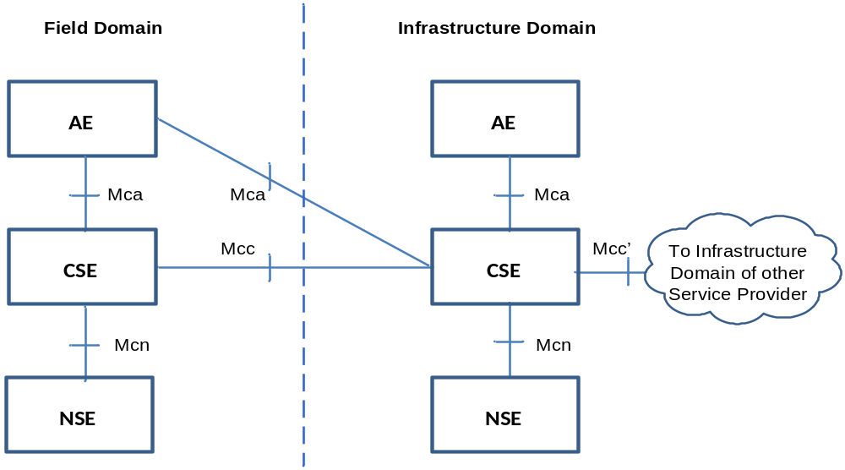
Figure 5.1.2-2: oneM2M Functional Architecture
The oneM2M functional architecture defines the following reference points:
- Mca reference point : Communication flows between an Application Entity (AE) and a Common Services Entity (CSE) cross the Mca reference point. These flows enable the AE to use the services supported by the CSE, and for the CSE to communicate with the AE. The AE and the CSE may or may not be co-located within the same physical entity.
- Mcc Reference point : Communication flows between two Common Services Entities (CSEs) cross the Mcc reference point. These flows enable a CSE to use the services supported by another CSE.
- Mcn Reference point : Communication flows between a Common Services Entity (CSE) and the Network Services Entity (NSE) cross the Mcn reference point. These flows enable a CSE to use the supported services provided by the NSE. While the oneM2M Service Layer is in general independent of the underlying network – as long as it supports IP transport – it leverages specific M2M/IoT optimization such as 3GPP’s eMTC features (e.g. device triggering, power saving mode, long sleep cycles, etc).
- Mcc’ Reference point : Communication flows between two Common Services Entities (CSEs) in Infrastructure Nodes (IN) that are oneM2M compliant and that resides in different M2M Service Provider domains cross the Mcc' reference point.
- Additional reference points are defined in oneM2M for specific purposes like enrolment functions etc. and are not detailed in this overview

oneM2M Nodes:
oneM2M has defined a set of Nodes that are logical entities identifiable in the oneM2M System. oneM2M Nodes typically contain CSEs and/or AEs. For the definition of Node types, oneM2M distinguishes between Nodes in the “Field Domain” – i.e. the domain in which sensors / actors / aggregators / gateways are deployed – and the “Infrastructure Domain” – i.e. the domain in which servers and applications on larger computers reside.

Application
Service
Node
Application
Dedicated
Node
Application
Dedicated
Node
Application
Dedicated
Node
Middle Node
Middle Node
Middle Node
Infrastructure Node
AE
AE
AE
AE
AE
CSE
CSE
CSE
AE
CSE
AE
AE
CSE
CSE
Figure 5.1.2-3: oneM2M node topology

Nodes could be of the following types:
- Application Dedicated Node (ADN): a Node that contains at least one AE and does not contain a CSE. It is located in the Field Domain. An ADN would typically be implemented on a rather resource constraint device that may not have access to rich storage or processing resources and – therefore – may be limited to only host a oneM2M AE and not a CSE. Examples for devices that would be represented by ADNs: Simple sensor or actor devices.
- Application Service Node (ASN): a Node that contains one CSE and contains at least one Application Entity (AE), located in the Field Domain. An ASN could be implemented on a range of different devices ranging from rather resource constraint devices up to much richer HW. Examples for devices that would be represented by ASNs: Data collection devices, more capable sensors and actors including simple server functions.

- Middle Node (MN): a Node that contains one CSE and could contain AEs. MNs are located in the Field Domain. There could be several MNs in the Field Domain of the oneM2M System. Typically a MN would reside in an M2M Gateway. MNs would be used to establish a logical tree structure of oneM2M nodes, e.g. for hierarchically aggregate data of buildings / neighborhoods / cities / counties / states etc.
- Infrastructure Node (IN): a Node that contains one CSE and could contain AEs. There is exactly one IN in the Infrastructure Domain per oneM2M Service Provider. As example of physical mapping, an IN could reside in an M2M Service Enablement Infrastructure.
- Non-oneM2M Node (NoDN): This Node type is not shown in the figure above. oneM2M specifications also define a Node Type for non-oneM2M Nodes which are Nodes that does not contain oneM2M Entities (neither AEs nor CSEs). Typically such Nodes would host some non-oneM2M IoT implementations or legacy technology which can be connected to the oneM2M system via interworking proxies.

5.1.3 Common Service functions
As a horizontal architecture providing a common framework for IoT, oneM2M has identified a set of common functionnalities, that are applicable to all the IoT domains. Think of these functions as a large toolbox with special tools to solve a number of IoT problems across many different domains. Very much like a screw driver can be used to fasten screws in a car as well as in a plane, the oneM2M CSFs are applicable to different IoT use cases in different industry domains. In its first phase, oneM2M went through a large number of IoT use cases and identified a set of common requirements which resulted in the design of this set of tools termed Common Service Functions. Furthermore, oneM2M has standardized how these functions are being executed, i.e. is has defined uniform APIs to access these functions. Figure 5.3.1-1 is showing a grouping of these functions into a few different scopes.

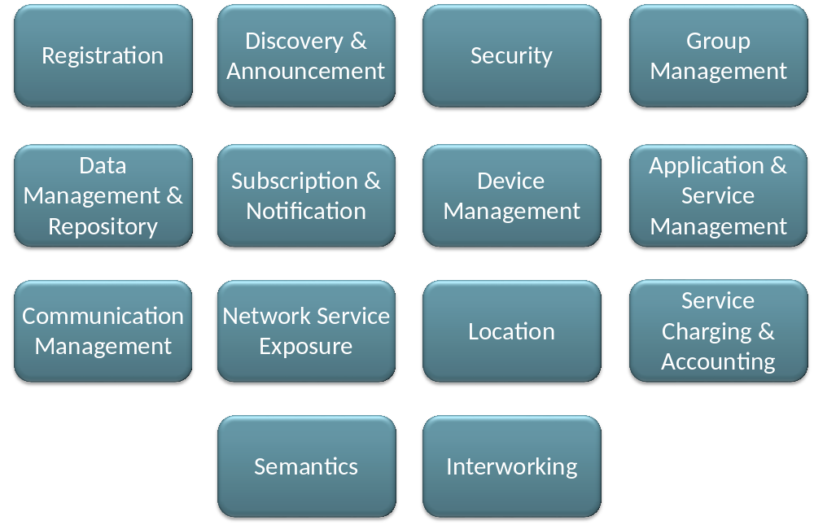
Figure 5.1.3-1: Common Service Functions
Such services reside within a CSE and are referred to as Common Services Functions (CSFs). The CSFs provide services to the AEs via the Mca reference point and to other CSEs via the Mcc reference point.
All these services are not specific to any IoT domain in particular. It enables each domain to build on the top of this service layer and really focus on its specific industrial needs. This is similar to functions of a generic operating system (OS) exposed to applications running on that OS. For instance many applications read and write to files. File I/O is typically provided by the OS. oneM2M’s Service Layer provides similar functions in a generic way to many different IoT Applications.

5.1.4 Benefits of using oneM2M
- Service Layer on top of transport network supporting a choice of transport protocols and serializations of data/messages
- Flexibility: It can be deployed on all domains, not tied to a particular protocol technology
- IP based: Relies on known existing APIs to handle IP communications
- Aware of optimizations if underlying network is 3GPP-based: Can make use of policy-based scheduling, power saving mode, triggering /wakeup of devices, non-IP data transport, etc without need for the developer to be aware of these terms.
- Enhances data sharing efficiency: Communications over an underlying network are policed by provisioned policies that govern the use of network resources based on configurable categories of events/messages. Avoids storm of low-value messages in netoworks with costly resources. Lowers Opex.
- For example in use cases with need for fast & compact message exchanges one may want to rely on TCP sockets (opened via web sockets) and use binary serialization (e.g. CBOR) where in other cases a combination of HTTPS/JSON may be preferable for simpler debugging.

- Evolution: Supported transport protocols and/or message serialization can evolve while the oneM2M code will not change. This allows for easy adaptation to future transport technologies.

- Horizontal platform provides common service functions that enable multiple IoT domains
- One investment/deployment serves multiple domains, do not re-invent the wheel. Lowers Capex.
- No need to maintain domain-specific platforms, reduction in Capex
- Cross-domain service/application innovation with a common framework and uniform APIs, allows for sharing of information and processes across domains that were isolated so far (e.g. home security system versus heating system), Supports new business opportunities.
- Re-use of the code whatever the domain was. Increases reusability / lowers Capex.

- Easy interworking/integration with existing & evolving deployments paves the way to long term evolution and sustainable economy
- Do not disrupt existing “vertical deployment”, but evolve. Supports interworking with legacy technology.
- Interworking with a rich set of proximal IoT technologies, embracing different ecosystems
- Take advantage of the operators’ network capabilities and existing management technologies

- Data sharing and semantic interoperability brings the real value
- data oriented RESTful API design
- semantic data annotation, discover and reasoning facilitates intelligent analytics and service mashups
- security protection at both channel and object level, with static and dynamic access control

- Open standards to avoid lock-in to a platform or a cloud provider
- No single party or company controls the technology / features

- Several open source implementations available ( CSE or AE)

- oneM2M is an international standard
- Developed using standardization methodology that has insured successful interoperability in many technical domains, same process as in 3GPP
- Developed by many companies based on consensus: It does not depend on a single or a small number of companies; not using a closed proprietary technology.
- It is an open standard: Transparent development process & open access to all deliverables; all the specifications, even the drafts are available at http://www.onem2m.org/technical/latest-drafts

In summary, the oneM2M initiative has the vision to remove fragmentation of the IoT world . Because it is independent of the access or protocol technology that is used for transport, it is designed to be a long term solution for IoT deployment.

-----------------------End of new text 1-------------------------------------------

