CHANGE REQUEST
Meeting:* | SDS 39
Source:* | BeiXu, Huawei, Echo.xubei@huawei.com  Can Zhao, Huawei, zhaocan20@huawei.com
Date:* | 2019-02-11
Contact:* | BeiXu，Huawei，Echo.xubei@huawei.com
Reason for Change/s:* | Add a solution for the KI V2V network interface switching management for TR-0026
CR against: Release* | <Release> Release 4
CR against: WI* | Active < WI-0046: Vehicular Domain Enablement >  MNT Maintenace / < Work Item number(optional)>  STE Small Technical Enhancements / < Work Item number (optional)>  Only ONE of the above shall be ticked
CR against: TS/TR* | TR-0026-Vehicular_Domain_Enablement-V4_0_0
Clauses/Sub Clauses*
Type of change: * | Editorial change  Bug Fix or Correction  Change to existing feature or functionality  New feature or functionality  Only ONE of the above shall be ticked
Post Freeze checking:* | This CR contains only essential changes and corrections? YES NO  This CR may break backwards compatibility with the last approved version of the TS? YES NO  This CR is a mirror CR? YES if YES, please indicate the document number of the original CR: <Document Number) : NO
Template Version:27 May 2015 (Dot not modify)

oneM2M Notice
The document to which this cover statement is attached is submitted to oneM2M. Participation in, or attendance at, any activity of oneM2M, constitutes acceptance of and agreement to be bound by terms of the Working Procedures and the Partnership Agreement, including the Intellectual Property Rights (IPR) Principles Governing oneM2M Work found in Annex 1 of the Partnership Agreement.
GUIDELINES for Change Requests:
Provide an informative introduction containing the problem(s) being solved, and a summary list of proposals.
Each CR should contain changes related to only one particular issue/problem.
In case of a correction, and the change apply to previous releases, a separated “mirror CR” should be posted at the same time of this CR
Follow the principle of completeness, where all changes related to the issue or problem within a deliverable are simultaneously proposed to be made E.g. A change impacting 5 tables should not only include a proposal to change only 3 tables. Includes any changes to references, definitions, and acronyms in the same deliverable.
Follow the drafting rules.
All pictures must be editable.
Check spelling and grammar to the extent practicable.
Use Change bars for modifications.
The change should include the current and surrounding clauses to clearly show where a change is located and to provide technical context of the proposed change. Additions of complete sections need not show surrounding clauses as long as the proposed section number clearly shows where the new section is proposed to be located.
Multiple changes in a single CR shall be clearly separated by horizontal lines with embedded text such as, start of change 1, end of change 1, start of new clause, end of new clause.
When subsequent changes are made to content of a CR, then the accepted version should not show changes over changes. The accepted version of the CR should only show changes relative to the baseline approved text.

Introduction

Key Issue 8: V2V network interface switching management.

This results in the following issues:
- The IN-CSE does not have the supported communication mode of each vehicle and routing path of the platoon to plan the communication mode of the routing path.
- The IN-CSE lacks resources to store the relationship between planned communication mode and route segments.
- The IN-CSE cannot distinguish the leader vehicle role in a platooning group.
Potential Requirements：
- The oneM2M system shall support handover (e.g. east-west communication) over platoon relevant data from one Platooning Manager (running on edge node) to next Platooning Manager (running on neighbouring edge node).
- The oneM2M system shall support the Platooning data exchange between the vehicles, Platooning Service provider, Platooning Manager and oneM2M platform.
- The oneM2M system shall support a common information model for Platooning including vehicle state and platooning state.
- The oneM2M system should support a profile for Platooning with a consistent information model based on existing information models (e.g. ETSI ITS, DATEX and Sensoris).
- The oneM2M system shall support group management (e.g. .joining, leaving and changing vehicle’s role within the platoon) and group message communication for platooning service.
- The oneM2M system shall support Vehicle-to-Vehicle (V2V) communication via different network interfaces.
- The oneM2M system shall support management of Vehicle-to-Vehicle (V2V) network interface switching.

In the platoon, when one vehicle sends the request to the platoon, the request shall be sent to the IN-CSE/Group Hosting CSE firstly except the PC5.This contribution provides the solution about the IN-CSE/Group Hosting CSE plans the best group communication mode between them in advance according to the route and member supported communication modes.
- if the vehicle to vehicle communication mode is LTE-Uu unicast, the call flow is below:
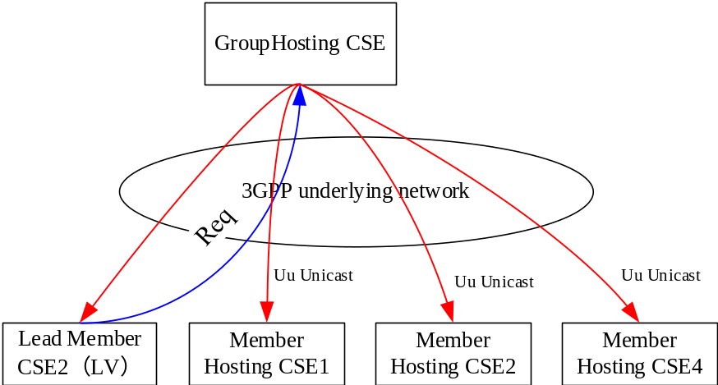
- if the vehicle to vehicle communication mode is MBMS, the call follow is below:
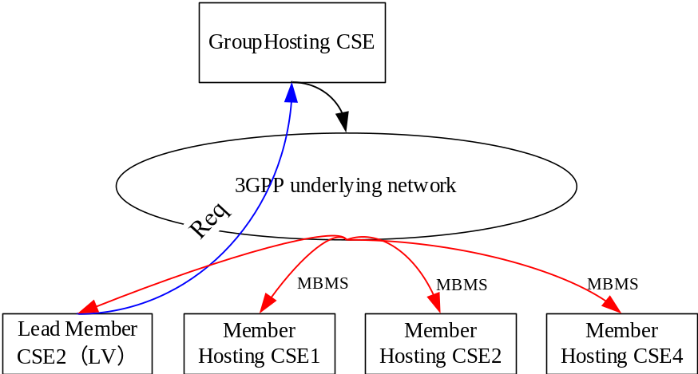
- if the vehicle to vehicle communication mode is IP multicast, the call flow is below:
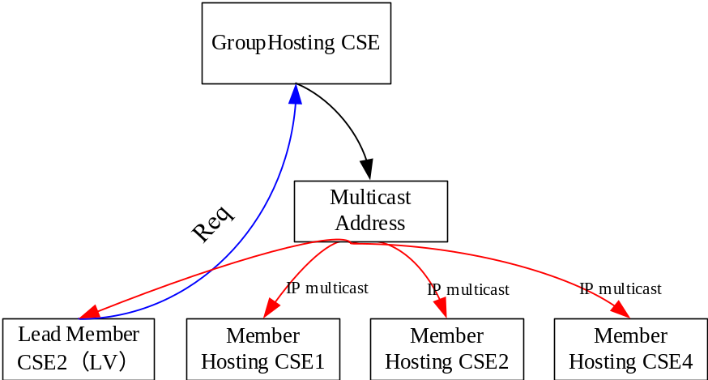
- if the vehicle to vehicle communication mode is PC5, the call flow is below:
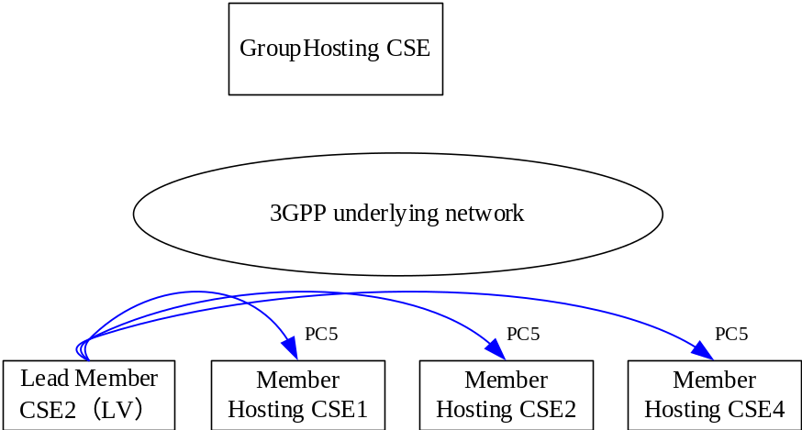

-----------------------Start of change 1-------------------------------------------

10.x Solution H: Network Communication Management

10.x.2 Detailed Procedure

10.x.2.2 Network communication management procedure for a Group

10.x.2.2.1 Network communication planning procedure

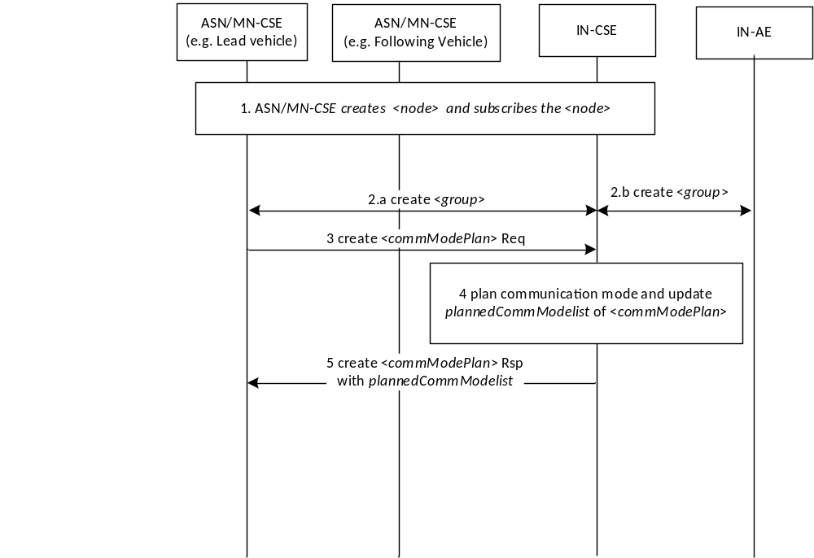
Figure 10.x.2.2.1-1. Solution Procedures for Network communication mode planning
The basic procedure is described as below:
Pre-conditions:
The MBMS service area information and PC5/LTE-Uu geographical area information provided by the operator is configured in the oneM2M System;
Step 1: An MN/ASN-CSE creates the <node> resource on the IN-CSE with the supportedCommModes attribute. The MN/ASN-CSE creates a <subscription> resource as a child of the <node> resource.
Note: The MN/ASN-CSE must be the Registree of the IN-CSE to support this procedure.
Step 2a and 2b: An ASN/MN-AE, or an IN-AE sends a <group> resource CREATE request to the IN-CSE, including memberIDs, memberRoles (e.g. lead vehicle of the platoon). For the platooning use case, the memberIDs attribute represents the <node> resource IDs that each ASN/MN-CSE resides. The IN-CSE creates the <group> resource.
Step 3: The lead member sends <commModePlan> resource CREATE request to the IN-CSE, in which the value of Result Content is “modified-attributes”.
Step 4: The IN-CSE creates the <commModePlan> resource including targetedID attribute check. After fetching the attribute, if the targetedID attribute represents the <group> resource ID, the IN-CSE retrieves the <node> resources of each member Hosting CSE. Then the IN-CSE gets the supportedCommModes attribute of the <node> resource associated with each member resource. The IN-CSE plans the group communication modes according to the routeInformation attribute, the <group> resource ID, and the network deployment information, and supplementary information, e.g. the map information of road topology. The IN-CSE obtains the network deployment information according to the MBMS SAI list, PC5/ LTE-Uu coverage geographical area configuration. The IN-CSE configures the plannedCommModeList attribute which are the planned group communication modes.

Note: Criteria and policies for IN-CSE’s planning is FFS.
Step 5: The IN-CSE sends the response to the leader member Hosting CSE including the plannedCommModeList attribute.

10.x.2.2.2 V2X network communication switching procedure

10.x.2.2.2.1 Option 1: The lead vehicle sends switching message to each member to update the current communication mode

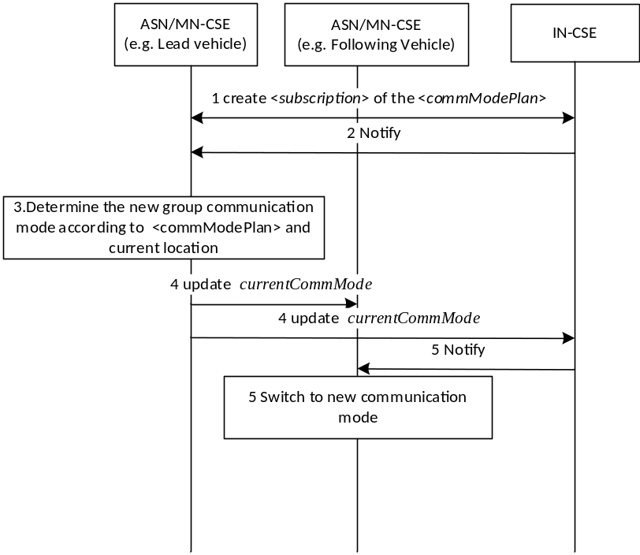
Figure 10.x.2.2.2.1-2. Solution Procedures for communication mode switching of Option 1
Step 1: The lead member Hosting CSE creates <subscription> resource for the <commModePlan> resource.
Step 2: The IN-CSE sends a notification that includes updated plannedCommModeList attribute to the MN/ASN-CSE hosted on the lead vehicle of the platoon when the IN-CSE receives the UPDATE request from the IN-AE to update the routeInformation attribute of the <commModePlan> resource and then updates the plannedCommModeList attribute.
Step 3: The lead member Hosting CSE determines the new communication mode for all members according to the plannedCommModeList and current location assuming all the member Hosting CSEs follow the lead member Hosting CSE.
Step 4: The lead member Hosting CSE sends UPDATE request for the currentCommMode of the <node> resource to other members to switch communication mode by current communication mode (e.g. PC5) if the member Hosting CSEs host the <node> locally. Or the lead member Hosting CSE sends UPDATE operation for the currentCommMode of the <node> resource to the <fanoutPoint> attribute of the <group> resource created in the step 2 of 10.x.2.2.1 if the member Hosting CSEs host the <node> on the IN-CSE.
Note: In this use case, it is assumed the lead member Hosting CSE has UPDATE privileged to the other members’ <node> resources
Step 5: The other member Hosting CSEs receive the UPDATE or NOTIFY and switch to the new communication mode (e.g. LTE-Uu) according to the received request.

Note: The solution of the communication procedure between vehicle and vehicle by interworking between oneM2M and 3GPP for PC5 is not currently supported so is FFS.

10.x.2.2.2.2 Option 2: IN-CSE updates the current communication mode for each member

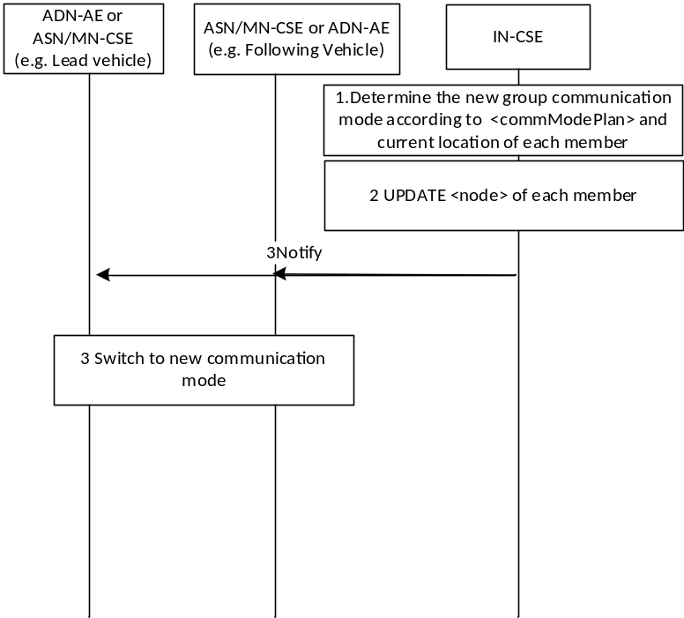
Figure 10.x.2.2.2.2-3. Solution Procedures for communication mode switching of Option 2
Pre-condition:
The IN-CSE is able to detect the location of its Registree ASN/MN-CSEs. For example, <locationPolicy> resources with Network Based mode may be used by the IN-CSE to get the location of each ASN/MN-CSE.
Step 1: The IN-CSE determines the new communication mode for all members according to the plannedCommModeList and current location of each member.
Step 2: The IN-CSE updates the currentCommMode attribute of <node> resource for each member Hosting CSE.
Note: In this use case, it is assumed the IN-CSE has UPDATE privileged to the members’ <node> resources.
Note: Decision criteria about the IN-CSE how to determine the current communication mode is FFS.

Step 3: Each Member Hosting CSE of the group switches to the new communication mode according to the notification.

10.x.2.2.2.3 Option 3: Each member updates the current communication mode
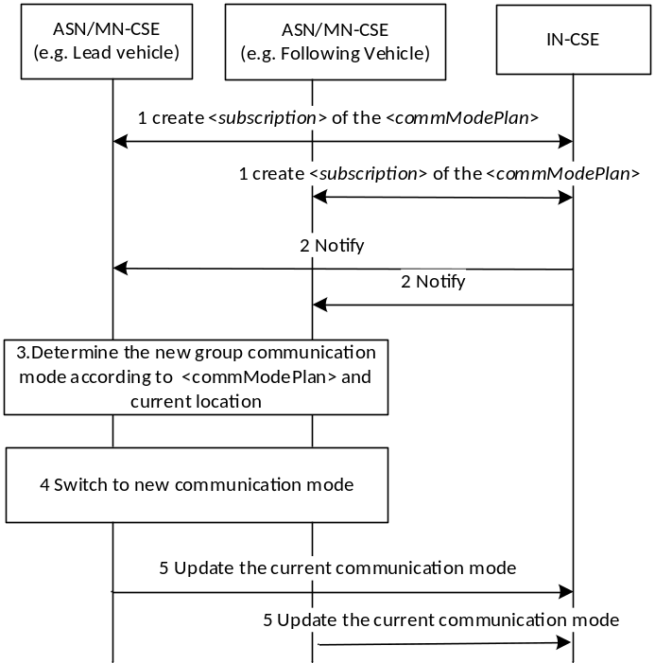
Figure 10.x.2.2.2.3-4. Solution Procedures for communication mode switching of Option 3
Step 1: Each Member Hosting CSE of the group creates a <subscription> resource for the <commModePlan> resource.
Note: Provision the <commModePlan> resource identifier to each member is out-of-scope.
Step 2: The IN-CSE sends a notification that includes updated plannedCommModeList to the each member Hosting CSE of the group when the IN-CSE receives the UPDATE request from the IN-AE to update the routeInformation attribute of the <commModePlan> resource and then updates the plannedCommModeList attribute.
Step 3: Each member Hosting CSE determines the new communication mode for itself according to the plannedCommModeList and current location.
Step 4: Each member Hosting CSE updates the currentCommMode attribute of <node> and switches to the new communication mode.

10.x.2.2.3 Group Fanout procedure
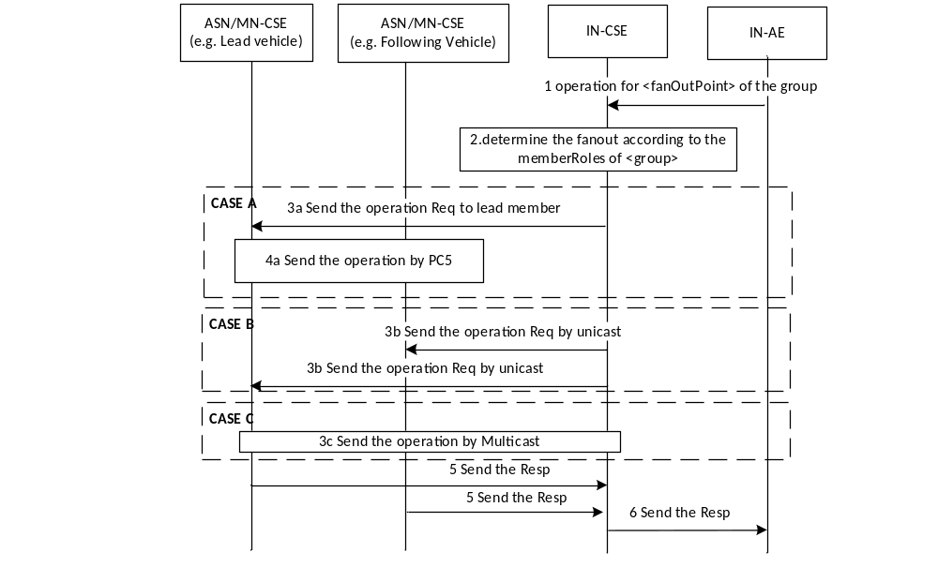
Figure 10.x.1.3-5. Solution Procedures for Group fanout by the memberRoles
Step1: The IN-AE sends operation for the <fanOutPoint> resource of the group with the <group> resource ID.
Step2: The IN-CSE checks the <group> resource ID whether is the same with the targetedID of the <commModePlan> resource. If the same, then IN-CSE checks the memeberRoles attribute of the <group>. The IN-CSE determines the fanout mode according to the currentCommMode attributes of the <node> resource of all member Hosting CSEs:
Case A: If the memeberRoles attribute is configured and there is a lead member defined in the list, and if the currentCommMode attribute of the lead member Hosting CSE and other member Hosting CSEs are PC5, go to Step 3a:
Step 3a: The IN-CSE sends the operation to the lead member Hosting CSE by unicast.
Step 4a: The lead member forwards the operation to the other Member Hosting CSEs by PC5 or multicast broadcast forcing the From in the request to be the IN-CSE ID. Go to Step 5.
Note: The procedure of communication between field nodes is FFS.
Case B: If the currentCommMode attribute is Unicast over LTE-Uu, go to Step 3b:
Step 3b: the IN-CSE sends the operation to each group Member Hosting CSE by unicast. Go to Step 5.
Case C: If the currentCommMode attributes are IP multicast or MBMS, go to Step 3c:
Step 3c: The IN-CSE sends the operation to the lead Member Hosting CSE by IP multicast or MBMS.
Step 5: Each Member Hosting CSE sends the response to the IN-CSE.
Step 6: The IN-CSE sends the aggregated response to the IN-AE.

10.x.2 Solution Applicability
This solution applies to Key Issue 8.

10.x.3 New Resources and Procedures

10.x.3.5 Modified <group> resource
New attribute as shown in Error: Reference source not found. The memberRoles attribute is used to indicate the leader of a group, and the leader should be one of members of the group.
Table 10.x.3.5-1: New attributes of <group> resource
Attributes of  <group> | Multiplicity | RW/  RO/  WO | Description | <groupAnnc>  Attributes
memberRoles | 0..1 | RW | List of arrays which consist of two elements: role and memberID. The role is the role of the member in a group:  - 0: Lead  - 1: reserved for the future use.  The memberID should be one of the memberIDs. This attribute is used when the member roles of a group need to be specified, e.g. the lead vehicle of a platoon. | OA

-----------------------End of change 1---------------------------------------------

CHECK LIST
- Does this change request include an informative introduction containing the problem(s) being solved, and a summary list of proposals.?
- Does this CR contain changes related to only one particular issue/problem?
- Have any mirror crs been posted?
- Does this change request make all the changes necessary to address the issue or problem? E.g. A change impacting 5 tables should not only include a proposal to change only 3 tables. Includes any changes to references, definitions, and acronyms in the same deliverable?
- Does this change request follow the drafting rules?
- Are all pictures editable?
- Have you checked the spelling and grammar?
- Have you used change bars for all modifications?
- Does the change include the current and surrounding clauses to clearly show where a change is located and to provide technical context of the proposed change? (Additions of complete sections need not show surrounding clauses as long as the proposed section number clearly shows where the new section is proposed to be located.)
- Are multiple changes in this CR clearly separated by horizontal lines with embedded text such as, start of change 1, end of change 1, start of new clause, end of new clause.?

