|  |  |
| --- | --- |
| Input Contribution | |
| Meeting ID* | SDS#40 |
| Title:* | TR-0043-Modbus-interworking-scenario |
| Source:* | JaeSeung Song, KETI, [jssong@sejong.ac.kr](mailto:jssong@sejong.ac.kr)  Sherzod Elamanov, KETI, [selamanov@gmail.com](mailto:selamanov@gmail.com) |
| Date:* | 2019-05-13 |
| Input related to* | TR-0043 Modbus Interworking |
| Intended purpose of  document:* | Decision  Discussion  Information  Other <specify> |
| Impacted other TS/TR(s) | N/A |
| Decision requested or recommendation:* | Add Section 6.1 Use Case |
| Template Version: January 2017 (Do not modify) | |

**oneM2M Notice**

The document to which this cover statement is attached is submitted to oneM2M. Participation in, or attendance at, any activity of oneM2M, constitutes acceptance of and agreement to be bound by terms of the Working Procedures and the Partnership Agreement, including the Intellectual Property Rights (IPR) Principles Governing oneM2M Work found in Annex 1 of the Partnership Agreement.

# Introduction

This contribution proposes to add a new section for Modbus Interworking Use Case.

### -----------------------Start of change 1-------------------------------------------

# 6 Scenarios for oneM2M and Modbus Interworking

*This clause studies the* *scenarios for oneM2M and Modbus Interworking, such as Modbus-based device can connect to IN directly or via MN/ASN, and Modbus-based devices can connect to each other via IN/MN/ASN.*

## 6.1 Use case

As the Modbus protocol is mainly used for industial purposes, a use case where a group of sensors working over Modbus are remotely monitored by client application will be described. The figure 6.1-1 below shows a possible use case of interworking between Modbus devices and oneM2M services. A factory has 3 sensors working on Modbus protocol which are connected to a local Modbus gateway (IPE) with an embedded application to send sensors data to oneM2M cloud server. The client can monitor sensors readings by accessing oneM2M cloud server.

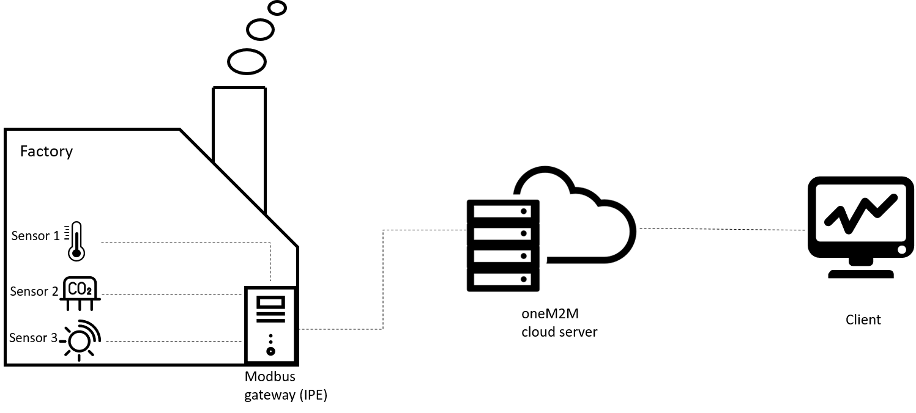

**Figure 6.1-1 Use case architecture overview.**

Figure 6.1-2 shows how the architecture presented in previous section can be presented in the form of Modbus and oneM2M entites. Sensors 1, 2, 3 from Figure 6.1-1 are represented as Modbus Slaves and are connected to Modbus Master. Modbus Master is integrated with oneM2M AE entity to use services provided by IN-CSE. Modbus Master coupled with oneM2M AE entity make up IPE. It is a key unit to provide interworking between Modbus devices and oneM2M based platform. Client application is represented as an AE.

AE

Modbus

Master

IPE

IN-CSE

Mca

Slave 1

Slave 2

Slave 3

Mca

AE

**Figure 6.1-2 Use case entity representation**

### -----------------------End of change 1 -------------------------------------------