|  |
| --- |
|  |

|  |  |
| --- | --- |
| CHANGE REQUEST | |
| Meeting ID:* | SDS 41 |
| Source:* | Bob Flynn, Convida Wireless , Bob.Flynn@convidawireless.com |
| Date:* | 2019-06-26 |
| Reason for Change/s:* | <exact change/s to be provided below> |
| CR against: Release* | Rel-4 |
| CR against: WI* | Active <Work Item number>  MNT maintenance / < Work Item number(optional)>  Is this a mirror CR? Yes  No  mirror CR number: (Note to Rapporteur - use latest agreed revision)  STE Small Technical Enhancements / < Work Item number (optional)>  Only ONE of the above shall be ticked |
| CR against: TS/TR* | TR-0024v4_1_0 |
| Clauses * | New Clause |
| Type of change: * | Editorial change  Bug Fix or Correction  Change to existing feature or functionality  New feature or functionality  Only ONE of the above shall be ticked |
| Other TS/TR(s) impacted | <TS/TR number>, <Version Number>, and <Description on which aspect should be reflected in this TS/TR> |
| Post Freeze checking:* | This CR contains only essential changes and corrections? YES  NO  This CR may break backwards compatibility with the last approved version of the TS? YES  NO |
| Template Version: January 2019 (do not modify) | |

**oneM2M Notice**

The document to which this cover statement is attached is submitted to oneM2M. Participation in, or attendance at, any activity of oneM2M, constitutes acceptance of and agreement to be bound by terms of the Working Procedures and the Partnership Agreement, including the Intellectual Property Rights (IPR) Principles Governing oneM2M Work found in Annex 1 of the Partnership Agreement.

GUIDELINES for Change Requests:

Provide an informative introduction containing the problem(s) being solved, and a summary list of proposals.

Each CR should contain changes related to only one particular issue/problem.

If this is a correction, and the change applies to previous releases, a separate “mirror CR” should be posted at the same time as this CR

Mirror CR: applies only when the text, including clause numbering are exactly the same.

Companion CR: applies when the change means the same but the baselines differ in some way (e.g. clause number).

Follow the principle of completeness, where all changes related to the issue or problem within a deliverable are simultaneously proposed to be made e.g. a change impacting 5 tables should not only include a proposal to change only 3 tables. Include any changes to references, definitions, and abbreviations in the same deliverable.

Follow the drafting rules.

All pictures must be editable.

Check spelling and grammar.

Use change bars for modifications.

The change should include the current and surrounding clauses to clearly show where a change is located and to provide technical context of the proposed change. Additions of complete clauses need not show surrounding clauses as long as the proposed clause number clearly shows where the proposed new clause is located.

Multiple changes in a single CR shall be clearly separated by horizontal lines with embedded text such as, start of change 1, end of change 1, start of new clause, end of new clause.

When subsequent changes are made to the content of a CR, then the accepted version should not show changes over changes. The accepted version of the CR should only show changes relative to the baseline approved text.

## Introduction

<Provide an introduction containing the problem(s) being solved, and a summary list of proposals. Discuss any risk of breaking backwards compatibility with the last published version of the impacted TS.>

### -----------------------Start of change 1-------------------------------------------

# x UE Device Connection Efficiency

## x.1 Introduction

In TS-0026 3GPP Interworking, clause 5 describes how oneM2M entities may be deployed in a 3GPP Network.



**Figure x.1-1: oneM2M Interfaces to the 3GPP Network**

TS-0026 discusses how an IN-CSE can offer value-added features to a 3GPP deployment based on the SCEF features added in 3GPP Rel 10-15.

In this deployment the UE can optionally host a oneM2M AE and/or CSE. Specifically, The “MTC Applications” hosted on the UE may be deployed as follows:

- Application only: UE may be an ADN oneM2M entity

- Application and CSE: UE may be an ASN or MN oneM2M entity

- CSE only: UE may be a MN oneM2M entity

- Neither application nor CSE: UE may be a NoDN.

While TS-0026 discusses the possibility of a CSE being present on the UE, the specification does not describe what features or value-added services may be offered by the CSE hosted on the UE.

GSMA has published TS.34 IoT device Connection Efficiency Guidelines V 5.0, 08 January 2018, that defines requirements for an IoT Service architecture that includes an IoT Service and an IoT Device hosted on a UE to operate in a manner that is consistent with the design and deployment of the mobile network.

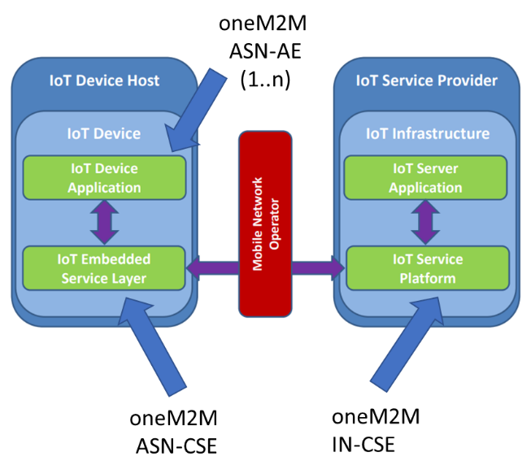

An initial analysis of TS.34 indicates that oneM2M has the basic framework in place to support these requirements.  The gaps that need to be addressed in oneM2M are the capabilities that are specific to GSMA TS.34 device functionality.  There are three main categories of functionality that IoT Devices hosted on a cellular device need to implement.

1. Communication management, where the device ensures that it operates according to communication policies, that may be dynamic based on mobile network condition.
2. Fault handling procedures, where the device handles unexpected events in a manner that does not impact the operation of the mobile network.
3. Management of the device components and policies that control the device behavior.

oneM2M has CMDH and Device Management services that are intended for these precise uses. The following sections will define the features and capabilities that a CSE hosted on a UE should implement to ensure safe operation on mobile networks.

By including these features in TS-0026, we can enhance the value-added services that oneM2M offers to address operational concern of MNOs.

## x.2 Key Issues

### x.2.1 Key Issue #y.1: <Device Management>

From GSMA TS.34 the following device Architecture is shown.



#### x.2.1.1 Key issue details

There are multiple firmware and chipset parameters that SHALL be manageable from the Service Provider, or MNO. This issue leads to the need for additional customizations of <managementObject> resources, specific to mobile devices.

#### x.2.1.2 Potential requirements

*Editor's Note: This clause will describe the potential requirements arising from the key issue.*

EDITORS NOTE: New <managementObject> specializations and defined call flows when an oneM2M entities uses these resources.

### x.2.2 Key Issue #y.2: <Communication Management>

Several requirements in GSMA TS.34 discuss the need to monitor the amount of communication, aggregate small communications into fewer large communications, etc. These requirements are aligned with the CMDH functionality described in TS-0001.

#### x.2.2.1 Key issue details

#### x.2.2.2 Potential requirements

*Editor's Note: This clause will describe the potential requirements arising from the key issue.*

EDITORS NOTE: examine existing policies for desired behaviors and possibly enhance the existing cmdh policies.

### x.2.3 Key Issue #y.3: <Fault handling behaviors>

#### x.2.3.1 Key issue details

#### Several requirements in GSMA TS.34 discuss how to handle communication failures. For example:

|  |  |
| --- | --- |
| TS.34_4.2_REQ_011 | The IoT Embedded Service Layer should always be prepared to handle situations when communication requests fail.  Communication retry mechanisms implemented within an IoT Device can vary and will depend on the importance and volume of downloaded data. Possible solutions can be:   * Simple counting of failed attempts since the data connection was first established (often the easiest solution). * Monitoring the number of failed attempts within a certain period of time. For example, if the data connection is lost more than five times within an hour, then the request can be suspended. This can be a more reliable technique to avoid short but regular connection problems, such as when a device is moving away from one network cell to another. The data connection can be lost when the device switches between cells, but when the cell is providing good coverage; the request can be processed successfully.   Depending upon the IoT Service, no communication request by the IoT Embedded Service Layer should ever be retried indefinitely – the request should eventually timeout and be abandoned.  Note: The requirements contained within section 5.2 of this document describe the functionality that, when implemented within the Communications Module to monitor IoT Embedded Service Layer behaviour, ensures the retry mechanisms implemented within the IoT Embedded Service Layer do not prevent the normal operation of the mobile network. |

#### x.2.3.2 Potential requirements

*Editor's Note: This clause will describe the potential requirements arising from the key issue.*

EDITORS NOTE These issues may require a combination of <managementObjects> and <cmdhPolicies>

## x.3 Solutions

*Editor's Note: This clause will contain the solutions that address the key issues in this area.*

### x.3.n Solution #y.n: <solution name>

*Editor's Note: Solutions within the area are not in any particular order but they are added incrementally (n = 1, 2, 3…) when new solution is identified. 'y' refers to the area.*

#### x.3.n.1 Introduction

*Editor's Note: Each solution should list the key issues that it addresses. There may be references to the key issues outside the area.*

<Text>

#### x.3.n.2 Solution details

*Editor's Note: This clause will describe the solution.*

<Text>

#### x.3.n.3 Evaluation

*Editor's Note: This clause will contain a variety of evaluations of this solution.*

EDITORS NOTE: Each evaluation will include the requirement ID(s) from GSMA TS.34 that is solved with the proposed solution

## x.4 Conclusions

*Editor's Note: This clause will contain the evaluation between the solutions, and the conclusions.*

EDITORS NOTE: This will be a consolidated list of the requirements that are met by the solutions proposed.

### -----------------------End of change 1---------------------------------------------

### -----------------------Start of change 2-------------------------------------------

### -----------------------End of change 2---------------------------------------------

CHECK LIST

* Does this Change Request include an informative introduction containing the problem(s) being solved, and a summary list of proposals.?
* Does this CR contain changes related to only one particular issue/problem?
* Have any mirror CRs been posted?
* Does this Change Request make **all** the changes necessary to address the issue or problem? E.g. A change impacting 5 tables should not include a proposal to change only 3 tables?Does this Change Request follow the drafting rules?
* Are all pictures editable?
* Have you checked the spelling and grammar?
* Have you used change bars for all modifications?
* Does the change include the current and surrounding clauses to clearly show where a change is located and to provide technical context of the proposed change? (Additions of complete clauses need not show surrounding clauses as long as the proposed clause number clearly shows where the new clause is proposed to be located.)
* Are multiple changes in this CR clearly separated by horizontal lines with embedded text such as, start of change 1, end of change 1, start of new clause, end of new clause.?