CHANGE REQUEST
Meeting ID:* | SDS#42
Source:* | Xiaotao Li, CMCC, lixiaotao@chinamobile.com  Yawen Niu, CMCC, niuyawen@chinamobile.com  Yongjing Zhang(zhangyongjing@huawei.com)
Date:* | 2019-09-08
Reason for Change/s:* | To introduce a solutions of automatic ontology mapping conflict detection and repair to meet the requirements ONT-020.
CR against: Release* | Release 4
CR against: WI* | Active <WI-0053>  MNT maintenance / < Work Item number(optional)>  Is this a mirror CR? Yes No  mirror CR number: (Note to Rapporteur - use latest agreed revision)  STE Small Technical Enhancements / < Work Item number (optional)>  Only ONE of the above shall be ticked
CR against: TS/TR* | TR-0033 V4.5.0
Clauses * | 8.12.6
Type of change: * | Editorial change  Bug Fix or Correction  Change to existing feature or functionality  New feature or functionality  Only ONE of the above shall be ticked
Impacted other TS/TR(s) | N/A
Post Freeze checking:* | This CR contains only essential changes and corrections? YES NO  This CR may break backwards compatibility with the last approved version of the TS? YES NO
Template Version: January 2017 (Do not modify)

oneM2M Notice
The document to which this cover statement is attached is submitted to oneM2M. Participation in, or attendance at, any activity of oneM2M, constitutes acceptance of and agreement to be bound by terms of the Working Procedures and the Partnership Agreement, including the Intellectual Property Rights (IPR) Principles Governing oneM2M Work found in Annex 1 of the Partnership Agreement.
GUIDELINES for Change Requests:
Provide an informative introduction containing the problem(s) being solved, and a summary list of proposals.
Each CR should contain changes related to only one particular issue/problem.
In case of a correction, and the change apply to previous releases, a separate “mirror CR” should be posted at the same time of this CR
Mirror CR: applies only when the text, including clause numbering are exactly the same.
Companion CR: applies when the change means the same but the baselines differ in some way (e.g. clause number).
Follow the principle of completeness, where all changes related to the issue or problem within a deliverable are simultaneously proposed to be made E.g. A change impacting 5 tables should not only include a proposal to change only 3 tables. Includes any changes to references, definitions, and acronyms in the same deliverable.
Follow the drafting rules.
All pictures must be editable.
Check spelling and grammar to the extent practicable.
Use Change bars for modifications.
The change should include the current and surrounding clauses to clearly show where a change is located and to provide technical context of the proposed change. Additions of complete clauses need not show surrounding clauses as long as the proposed clause number clearly shows where the new clause is proposed to be located.
Multiple changes in a single CR shall be clearly separated by horizontal lines with embedded text such as, start of change 1, end of change 1, start of new clause, end of new clause.
When subsequent changes are made to content of a CR, then the accepted version should not show changes over changes. The accepted version of the CR should only show changes relative to the baseline approved text.

Introduction
This CR provides a few solutions of automatic ontology mapping according to requirement ONT-020 in TS-0002. The supporting use cases can be found in TR-0001 clause 12.24.
Requirement ID | Description | Release
ONT-020  See REQ-2018-0049R03 | The oneM2M system shall be able to detect ontology’s mapping conflicts and repair them. | 4

-----------------------Start of change 1-------------------------------------------

2.2 Informative references
References are either specific (identified by date of publication and/or edition number or version number) or non-specific. For specific references, only the cited version applies. For non-specific references, the latest version of the referenced document (including any amendments) applies.
The following referenced documents are not necessary for the application of the present document but they assist the user with regard to a particular subject area.
[i.1] oneM2M Drafting Rules.
NOTE: Available at http://www.onem2m.org/images/files/oneM2M-Drafting-Rules.pdf.
[i.2] oneM2M TS-0002: "onM2M Requirements".
[i.3] oneM2M TS-0001: "Functional Architecture".
[i.4] oneM2M TS-0004: "Service Layer Core Protocol Specification".
[i.5] W3C Recommendation: "OWL 2 Web Ontology Language Structural Specification and Functional-Style Syntax".
NOTE: Available at http://www.w3.org/TR/owl2-syntax/#IRIs.
[i.6] oneM2M TS-0012: "Base Ontology".
[i.7] oneM2M TS-0030: "Generic Interworking".
[i.8] W3C Recommendation: "RDF 1.1 Concepts and Abstract Syntax".
NOTE: Available at http://www.w3.org/TR/rdf11-concepts/.
[i.9] W3C Recommendation: "RDF 1.1 XML Syntax".
NOTE: Available at https://www.w3.org/TR/rdf-syntax-grammar/.
[i.10] W3C Recommendation: "OWL Web Ontology Language Semantics and Abstract Syntax".
NOTE: Available at http://www.w3.org/TR/owl-semantics/.
[i.11] ETSI TS 103 264: "SmartM2M; Smart Appliances; Reference Ontology and oneM2M Mapping".
[i.12] oneM2M TS-0034: "Semantics Support".
[i.13] oneM2M TR-0007: "Study on Abstraction and Semantics Enablement".
[i.14] W3C Recommendation: "SPARQL Query Language for RDF".
NOTE: Available at http://www.w3.org/TR/rdf-sparql-query/.
[i.15] IETF RFC 3987: "Internationalized Resource Identifiers (IRIs)".
NOTE: Available at https://www.ietf.org/rfc/rfc3987.txt.
[i.16] oneM2M TR-0001: "Use Cases Collection".
NOTE: Available at https://www.ietf.org/rfc/rfc3987.txt.
[i.17] GeeksforGeeks: "Maximum Bipartite Matching".i.17
NOTE: Available at https://www.geeksforgeeks.org/maximum-bipartite-matching/.
[i.18] Princeton: "WordNet: A Lexical Database for English ".
NOTE: Available at https://wordnet.princeton.edu/.
[i.19] T. Mikolov, K. Chen, G. Corrado, and J. Dean: "Efficient estimation of word representations in vector space ".
NOTE: Published in International Conference on Learning Representations.
[i.20] J. Pennington, R. Socher, and C. D. Manning: "Glove: Global vectors for word representation ".
NOTE: Published in International Conference on Empirical Methods in Natural Language Processing.
[i.21] Reasoners and rule engines: "Jena inference support"
NOTE: Available at http://jena.apache.org/documentation/inference/index.html
[i.22] Univerity of Maryland College Park: "pellet "
NOTE: Available at http://pellet.owldl.com/

-----------------------End of change 1-------------------------------------------

-----------------------Start of change 2-------------------------------------------

8.12.4 Example implementation of ontology mapping algorithms

8.12.4.1 Introduction
In this clause, several potential solutions are specified for the automatic ontology mapping process, and each of them has their own methodology, which are discussed in details. Each ontology mapping algorithm is indicated as an <ontologyMappingAlgorithm> resource. A collection of ontology mapping algorithms is contained in an <ontologyMappingAlgorithmRepository> resource for individual ontology mapping tasks to select. The hosting CSE can retrieve the used <mappingAlgorithm> resources locally or from a remote <ontologyMappingAlgorithm> hosting CSE by the mappingAlgorithmLinks attribute. Accordingly, the resulted mapping relationships between the source and target ontologies are stored in the hosting CSE as an <ontologyMapping> resource.

8.12.4.2 Procedure for initiating an linguistic-feature extraction algorithm
Solution-1: In this alternative solution, the mapping relationships between the source ontology (Ontology-A) and the target ontology (Ontology-B) are discovered by measuring the edit distance between names of two entities belonging to two ontologies. Informally, the Levenshtein distance between two words is the minimum number of single-character edits (insertions, deletions or substitutions) required to change one word into the other. For example, the Levenshtein distance between “kitten” and “sitting” is 3. The similarity between two concepts (a and b) can be represented by the edit distance, i.e. sim(a,b) = 1- LD(a,b)/max(|a|,|b|), where LD is the Levenshtein distance function, |a| is the string length function. The following steps are performed for discovering mapping relationships between two ontologies by edit distance:
Step 1: The hosting CSE gets all entities (classes and object | data properties) of the source <ontology> resource (Ontology-A).
Step 2: The hosting CSE gets all entities (classes and object | data properties) of the target <ontology> resource (Ontology-B).
Step 3: The hosting CSE calculates the Levenshtein distances (LD) between names of two entities with same types (class to class, object property to object property, data property to data property) of Ontology-A and Ontology-B, and values from 0 to 1 are assigned for each pair of entities. For example:
- There is no edit operation from “Thing” to “Thing”, and LD(“Thing”, “Thing”) = 0, sim(“Thing”, “Thing”) =1 ;
- There is one deletion of "s" from “Devices” to “Device”, and LD(“Devices”, “Device”) = 1, sim(“Devices”, “Device”) =0.83 ;
- There is one insertion of "_" from “LightSensor” to “Light_Sensor”, LD(“LightSensor”, “Light_Sensor”) =1, sim(“LightSensor”, “Light_Sensor”) = 0.91.
Step 4: The hosting CSE filter entity mappings with a similarity exceeding the mappingThreshold attribute of the <ontologyMappingAlgorithm> resource.
Step 5: The hosting CSE extracts an optimal subset from the set of mappings in Step 4 by using Maximum Bipartite Matching (MBP) (See [i.17]) algorithms (e.g. Hungarian algorithm).
Step 6: The hosting CSE sorts the mappings according to the value of similarity from high to low, and stores the resulted mapping relationships in the <ontologyMapping> resource.

NOTE 1: In the mappings of Step4, an entity in the source ontology can be mapped to multiple entities in the target ontology. In the extracted mapping relationships of Step5, each entity in Ontology-A is only mapped to an entity in Ontology-B, and vice versa. Figure 8.12.4.2-1 shows an example for extracting an optimal subset from the filtered mappings of Step4 using MBP algorithm.

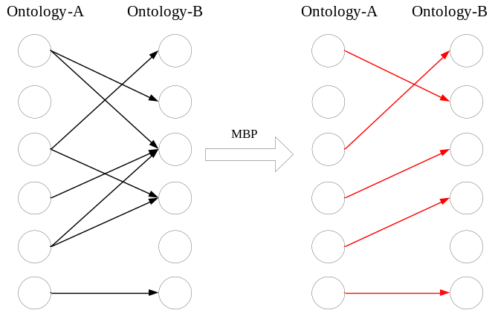
Figure 8.12.4.2-1: Extract an optimal subset between ontology A and ontology B using MBP algorithm

-----------------------End of change 2-------------------------------------------

-----------------------Start of change 3-------------------------------------------

8.12.6 Example implementation of ontology mapping conflict detection and repair

8.12.6.1 Introduction
In this clause, a potential solution is specified for the automatic ontology mapping conflict detection and repair process. The mapping relationships between the source ontology and target ontology are stored as the content of the mappingResult attribute in an <ontologyMapping> resource . The hosting CSE can extract the mapping relationships from the <ontologyMapping> resource and merge the source ontology into the target ontology with the mapping relationships. The inference engine (e.g. Jena (See [i.21]), Pellet (See [i.22], etc.) is deployed in the hosting CSE to perform reasoning for the merged ontology to detect the conflictions in it. If there is a conflict caused by a mapping, then the relationship is removed from the original mapping results; and if not, the mapping relationship is retained. Accordingly, the repaired mapping relationships after reasoning are used to replace the original results in the <ontologyMapping> resource by the Update operation on the Hosting CSE.

8.12.6.2 Procedure for initiating an ontology mapping conflict detection and repair algorithm
Solution-1: In this alternative solution, the conflicting mapping relationships between the source ontology (Ontology-A) and the target ontology (Ontology-B) are detected and repaired by inference based on an inference engine (e.g. Jena (See [i.21]), Pellet (See [i.22], etc.). The following steps are performed for detecting and repairing the conflicting mapping relationships between two ontologies.
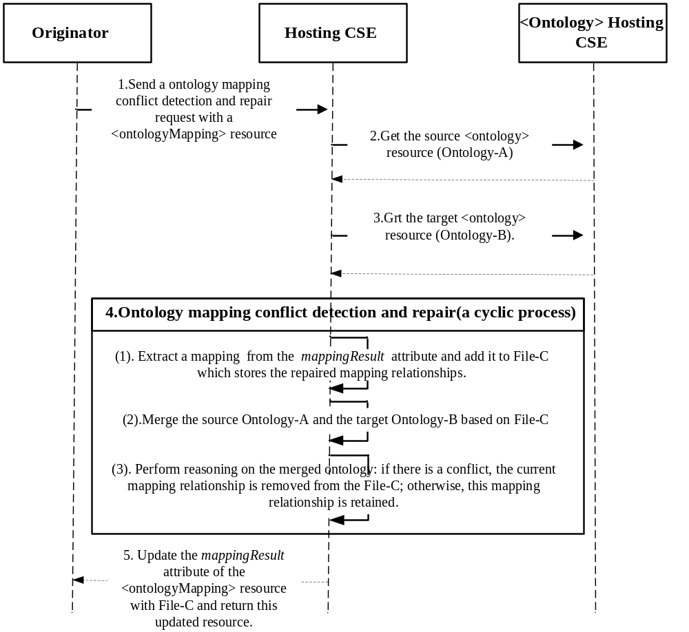
Figure 8.12.6.2-1: The ontology mapping conflict detection and repair procedure
Step 1: The hosting CSE receives a ontology mapping conflict detection and repair request from an Originator with a <ontologyMapping> resource.
Step 2: The hosting CSE gets the source <ontology> resource (Ontology-A).
Step 3: The hosting CSE gets the target <ontology> resource (Ontology-B).
Step 4: The hosting CSE traverses all the mapping relationships of the mappingResult attribute and merges the source Ontology-A and the target Ontology-B. Then, the hosting CSE performs the reasoning on the merged Ontology. If there is a conflict, the mapping relationship is removed; otherwise, the mapping relationship is retained. The specific steps are as follows:
- The hosting CSE extracts a new mapping relationship and add it to File-C which stores the repaired mapping relationships.
- The hosting CSE merges the source Ontology-A and the target Ontology-B based on File-C.
- The hosting CSE performs ontology reasoning on the merged ontology to detect the conflictions. If there is a conflict, the current mapping relationship is removed from the File-C, otherwise, the current mapping relationship is retained.
Step 5: The hosting CSE updates the mappingResult of the <ontologyMapping> resource with File-C.
An ontology mapping conflict detection and repair example as follows:
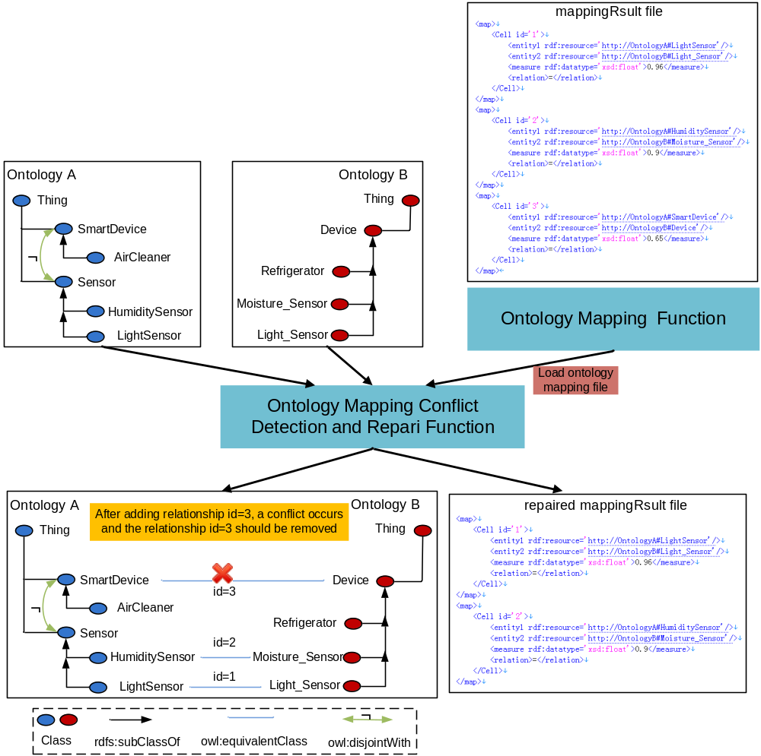

-----------------------End of change3-------------------------------------------

CHECK LIST
- Does this Change Request include an informative introduction containing the problem(s) being solved, and a summary list of proposals.?
- Does this CR contain changes related to only one particular issue/problem?
- Have any mirror CRs been posted?
- Does this Change Request make all the changes necessary to address the issue or problem? E.g. A change impacting 5 tables should not include a proposal to change only 3 tables?Does this Change Request follow the drafting rules?
- Are all pictures editable?
- Have you checked the spelling and grammar?
- Have you used change bars for all modifications?
- Does the change include the current and surrounding clauses to clearly show where a change is located and to provide technical context of the proposed change? (Additions of complete clauses need not show surrounding clauses as long as the proposed clause number clearly shows where the new clause is proposed to be located.)
- Are multiple changes in this CR clearly separated by horizontal lines with embedded text such as, start of change 1, end of change 1, start of new clause, end of new clause.?

