CHANGE REQUEST
Meeting ID:* | TDE#63
Source:* | Andreas Kraft
Date:* | 2024-02-27
Reason for Change/s:*
CR against: Release* | R2
CR against: WI* | Active <WI42>  MNT maintenance / < Work Item number(optional)>  Is this a mirror CR? Yes No  mirror CR number:  STE Small Technical Enhancements / < Work Item number (optional)>  Only ONE of the above shall be ticked
CR against: TS/TR* | tr-0025
Clauses * | 0, Contents, 2.1, 2.2, 3.1, 3.2, 5, 6, 7.1, 7.2.1, 7.2.2, 7.2.3, 7.2.4, 7.3.2, 7.3.3, 8.1, 8.2, 8.3, 8.4, 8.5.0, 8.5.1, 8.5.2, 8.6.1, 8.6.2, 8.6.3, 8.6.4, 8.7.1, 8.7.2, 8.7.3, 8.7.4.1, 8.7.4.2, 8.7.4.3, 8.7.4.4, 8.7.5.1, 8.7.5.2, 8.7.6.1, 8.7.6.2, 8.7.7, 8.7.8.1, 8.7.8.2, 8.7.9.1, 8.7.9.2, 8.7.9.3, 8.7.10.1, 8.7.10.2, 8.7.10.3, 8.7.10.4, 8.7.11.1, 8.7.11.2, 8.7.11.3, 8.7.11.4, 8.7.12.1, 8.7.12.2, 8.7.12.3, Annex A.1, Annex A.2.1, Annex A.2.2, Annex A.3, Annex A.4.1, Annex A.4.2, Annex A.5, Annex A.6, Annex A.7.1, Annex A.7.2, Annex A.8.1, Annex A.8.2, Annex A.9.1, Annex A.9.2, Annex A.10.1, History
Type of change: * | Editorial change  Bug Fix or Correction  Change to existing feature or functionality  New feature or functionality  Only ONE of the above shall be ticked
Other TS/TR(s) impacted | None
Post Freeze checking:* | This CR contains only essential changes and corrections? YES NO  This CR may break backwards compatibility with the last approved version of the TS? YES NO
Template Version: January 2019 (do not modify)
oneM2M Notice
The document to which this cover statement is attached is submitted to oneM2M. Participation in, or attendance at, any activity of oneM2M, constitutes acceptance of and agreement to be bound by terms of the Working Procedures and the Partnership Agreement, including the Intellectual Property Rights (IPR) Principles Governing oneM2M Work found in Annex 1 of the Partnership Agreement.
GUIDELINES for Change Requests:
Provide an informative introduction containing the problem(s) being solved, and a summary list of proposals.
Each CR should contain changes related to only one particular issue/problem.
In case of a correction, and the change apply to previous releases, a separate “mirror CR” should be posted at the same time of this CR
Mirror CR: applies only when the text, including clause numbering are exactly the same.
Companion CR: applies when the change means the same but the baselines differ in some way (e.g. clause number).
Follow the principle of completeness, where all changes related to the issue or problem within a deliverable are simultaneously proposed to be made E.g. A change impacting 5 tables should not only include a proposal to change only 3 tables. Includes any changes to references, definitions, and acronyms in the same deliverable.
Follow the drafting rules.
All pictures must be editable.
Check spelling and grammar to the extent practicable.
Use Change bars for modifications.
The change should include the current and surrounding clauses to clearly show where a change is located and to provide technical context of the proposed change. Additions of complete clauses need not show surrounding clauses as long as the proposed clause number clearly shows where the new clause is proposed to be located.
Multiple changes in a single CR shall be clearly separated by horizontal lines with embedded text such as, start of change 1, end of change 1, start of new clause, end of new clause.
When subsequent changes are made to content of a CR, then the accepted version should not show changes over changes. The accepted version of the CR should only show changes relative to the baseline approved text.

Introduction
Conversion to Markdown
https://git.onem2m.org/specifications/tr-0025/-/merge_requests/2
----------------------- Start of change 1 -----------------------

History
| | | | |Publication history|Publication** history|Publication history| |-|-|-| | | | | | | | | | | | |
| | | | |Draft history
(to be removed on publication)|Draft history
(to be removed on publication)|Draft history
(to be removed on publication)| |-|-|-| | | |
| | | |
| | | |
| | | |
| |V2.0.0|Fev 2017|Initial release 2 version based on TR-0025 V1.2.0
Implemented the agreed contribution from TST#27
- TST-2017-0052-TR-0025_update| |V2.0.1|24 June 2017|Implemented the agreed contributions from TST#29
- TST-2017-0117R01-CR-TR-0025_HTTP_Host_Header_correction_Rel_2
- TST-2017-0128-CR-TR-0025_Notification_correction_Rel_2| |V2.0.2|23 March 2018|Implemented the agreed contributions from TST#34
- TST-2018-0043R01-TR-0025_subscription_error_correction| |V2.0.3|06 June 2019|Implemented the agreed contributions from TDE#40
- TDE-2019-0076-Missing_resource_types_in_Content-Type_header_fields|
----------------------- End of change 1 -----------------------

----------------------- Start of change 2 -----------------------

Annex A.2.2 MN-CSE
HTTP Request:
GET /~/in-cse/server/home_gateway HTTP/1.1
Host: mn.provider.com:8080
X-M2M-Origin: /in-cse/Csmartphone_ae
X-M2M-RI: incse-12346
<span class="underline">X-M2M-RVI: 4</span>
Accept: application/xml
HTTP Response:
200 OK
X-M2M-RSC: 2000
X-M2M-RI: incse-12346
<span class="underline">X-M2M-RVI: 4</span>
Content-Type: application/xml
<?xml version="1.0" encoding="UTF-8"?>
<m2m:csr xmlns:m2m="http://www.onem2m.org/xml/protocols" rn="home_gateway">
<ty>16</ty>
<ri>csr-299409504</ri>
<pi>/in-cse</pi>
<ct>20150925T045938</ct>
<lt>20150925T045938</lt>
<et>20171005T105550</et>
<acpi>/in-cse/acp-666957710</acpi>
<poa>http://mn.provider.com:8080/</poa>
<cb>mn.provider.com/mn-cse</cb>
<csi>/mn-cse</csi>
<rr>true</rr>
</m2m:csr>
----------------------- End of change 2 -----------------------

----------------------- Start of change 3 -----------------------

8.7.9.1 Introduction

The discovery functionality in oneM2M is implemented using a RETRIEVE operation along with one or multiple filter criteria parameters.

In order to enable the retrieve operation for resource discovery, parameter filterUsage (shortname: fu) is included in the RETRIEVE request as a query string.
In addition, parameter resource type (shortname: rty) is used as a filterCriteria condition for the discovery of single light and group light members. The parameter discovery result type (shortname: drt) is set to 2 to indicate that the format of elements of URIList is unstructured. The detailed discovery procedures are presented in clauses 8.7.9.2 and 8.7.9.3.
----------------------- End of change 3 -----------------------

----------------------- Start of change 4 -----------------------

8.7.12.1 Introduction
Each time a content instance is created under a container of an ADN-AE, then a notification containing the whole created content instance is posted to the targeted subscriber i.e. ADN-AE1 or ADN-AE2, that can actuate the light with the new state received in the notification.
----------------------- End of change 4 -----------------------

----------------------- Start of change 5 -----------------------

8.7.10.4 Retrieve a group of latest content instances for all light states

A group of latest content instances can be retrieved via sending a RETRIEVE request targeting the group fanOutPoint (shortname: fopt) virtual resource and appending latest as shown in the following procedures.
If the response is preferred to be returned with a XML representation, the following is a HTTP request message example.
HTTP Request:
GET /~/mn-cse/home_gateway/containers_grp/fopt/la HTTP/1.1
Host: in.provider.com:8080
X-M2M-Origin: /in-cse/Csmartphone_ae
X-M2M-RI: mncse-55667
<span class="underline">X-M2M-RVI: 4</span>
Accept: application/xml
HTTP Response:
200 OK
X-M2M-RSC: 2000
X-M2M-RI: mncse-55667
<span class="underline">X-M2M-RVI: 4</span>
Content-Type: application/xml
<?xml version="1.0" encoding="UTF-8"?>
<m2m:agr xmlns:m2m="http://www.onem2m.org/xml/protocols">
<m2m:rsp>
<rsc>2000</rsc>
<rqi>mncse-55667</rqi>
<pc>
<m2m:cin rn="cin-394798749">
<ty>4</ty>
<ri>cin-394798749</ri>
<pi>cnt-181049109</pi>
<ct>20150925T045938</ct>
<lt>20150925T045938</lt>
<et>20151107T154802</et>
<st>0</st>
<cnf>text/plain:0</cnf>
<cs>3</cs>
<con>OFF</con>
</m2m:cin>
</pc>
<to>/in-cse/Csmartphone_ae</to>
<fr>/mn-cse/cnt-582759912/la</fr>
</m2m:rsp>
<m2m:rsp>
<rsc>2000</rsc>
<rqi>mncse-55667</rqi>
<pc>
<m2m:cin rn="cin-256599578">
<ty>4</ty>
<ri>cin-256599578</ri>
<pi>cnt-790965889</pi>
<ct>20150925T050515</ct>
<lt>20150925T050515</lt>
<et>20151107T154802</et>
<st>0</st>
<cnf>text/plain:0</cnf>
<cs>3</cs>
<con>OFF</con>
</m2m:cin>
</pc>
<to>/in-cse/Csmartphone_ae</to>
<fr>/mn-cse/cnt-582769893/la</fr>
</m2m:rsp>
</m2m:agr>
If the response is preferred to be returned with a JSON representation, the following is a HTTP request message example.
HTTP Request:
GET /~/mn-cse/home_gateway/containers_grp/fopt/la HTTP/1.1
Host: in.provider.com:8080
X-M2M-Origin: /in-cse/Csmartphone_ae
X-M2M-RI: mncse-55667
<span class="underline">X-M2M-RVI: 4</span>
Accept: application/json
HTTP Response:
200 OK
X-M2M-RSC: 2000
X-M2M-RI: mncse-55667
<span class="underline">X-M2M-RVI: 4</span>
Content-Type: application/json
{
"m2m:agr": {
"m2m:rsp": [
{
"rsc": 2000,
"rqi": "mncse-55667",
"pc": {
"m2m:cin": {
"ty": 4,
"ri": "cin-394798749",
"pi": "cnt-181049109",
"ct": "20150925T045938",
"lt": "20150925T045938",
"et": "20151107T154802",
"st": 0,
"cnf": "text/plain:0",
"cs": 3,
"con": "OFF"
}
},
"to": "/in-cse/Csmartphone_ae",
"fr": "/mn-cse/cnt-582759912/la"
},
{
"rsc": 2000,
"rqi": "mncse-55667",
"pc": {
"m2m:cin": {
"ty": 4,
"ri": "cin-256599578",
"pi": "cnt-790965889",
"ct": "20150925T050515",
"lt": "20150925T050515",
"et": "20151107T154802",
"st": 0,
"cnf": "text/plain:0",
"cs": 3,
"con": "OFF"
}
},
"to": "/in-cse/Csmartphone_ae",
"fr": "/mn-cse/cnt-582769893/la"
}
]
}
}
----------------------- End of change 5 -----------------------

----------------------- Start of change 6 -----------------------

8.7.10.3 Retrieve the latest content instance of ADN-AE2
The latest content instance of the light container resource for ADN-AE2 can be retrieved by the following procedures.
If the response is preferred to be represented in XML, the following is a HTTP request message example.
HTTP Request:
GET /~/mn-cse/home_gateway/light_ae2/light/la HTTP/1.1
Host: mn.provider.com:8080
X-M2M-Origin: /in-cse/Csmartphone_ae
X-M2M-RI: mncse-22336
<span class="underline">X-M2M-RVI: 4</span>
Accept: application/xml
HTTP Response:
200 OK
X-M2M-RSC: 2000
X-M2M-RI: mncse-22336
<span class="underline">X-M2M-RVI: 4</span>
Content-Type: application/xml
<?xml version="1.0" encoding="UTF-8"?>
<m2m:cin xmlns:m2m="http://www.onem2m.org/xml/protocols" rn="cin-256599578">
<ty>4</ty>
<ri>cin-256599578</ri>
<pi>cnt-790965889</pi>
<ct>20150925T050515</ct>
<lt>20150925T050515</lt>
<et>20151107T154802</et>
<st>0</st>
<cnf>text/plain:0</cnf>
<cs>3</cs>
<con>OFF</con>
</m2m:cin>
If the response is preferred be returned in representation of JSON, the following is a HTTP request message example.
HTTP Request:
~~GET /~/mn-HTTP/1.1~~
<span class="underline">GET /~/mn-cse/home_gateway/light_ae2/light/la HTTP/1.1</span>
Host: mn.provider.com:8080
X-M2M-Origin: /in-cse/Csmartphone_ae
X-M2M-RI: mncse-22336
<span class="underline">X-M2M-RVI: 4</span>
Accept: application/json
HTTP Response:
200 OK
X-M2M-RSC: 2000
X-M2M-RI: mncse-22336
<span class="underline">X-M2M-RVI: 4</span>
Content-Type: application/json
{
"m2m:cin": {
"ty": 4,
"ri": "cin-256599578",
"pi": "cnt-790965889",
"ct": "20150925T050515",
"lt": "20150925T050515",
"et": "20151107T154802",
"st": 0,
"cnf": "text/plain:0",
"cs": 3,
"con": "OFF"
}
}
----------------------- End of change 6 -----------------------

----------------------- Start of change 7 -----------------------

8.7.10.1 Introduction

The smartphone application can retrieve the latest light states via sending a RETRIEVE request targeting a container’s latest (shortname: la) virtual resource.
The smartphone application can also retrieve a group of latest light states via sending a RETRIEVE request targeting the group fanOutPoint virtual resource.
----------------------- End of change 7 -----------------------

----------------------- Start of change 8 -----------------------

8.6.1 oneM2M service platform (IN-CSE)
The oneM2M service platform is modelled as an IN-CSE and is responsible for

- handling the registration requests from the smartphone AE and home gateway MN-CSE
----------------------- End of change 8 -----------------------

----------------------- Start of change 9 -----------------------

8.7.4.2 Light application ADN-AE2
The registration of ADN-AE2 with MN-CSE is shown in the following procedure. Note that the access control policy identifier (unstructured SP-relative resourceID) which is assigned to ADN-AE2 is /mn-cse/acp-805496226.
The following example shows an ADN-AE registration request and response using HTTP with XML serialization.
HTTP Request:
~~POST /home_gateway?rcn=0 HTTP/1.1~~
<span class="underline">POST /~/mn-cse/home_gateway?rcn=0 HTTP/1.1</span>
Host: mn.provider.com:8080
X-M2M-Origin: C
Content-Type: application/xml;ty=2
X-M2M-RI: mncse-18346
<span class="underline">X-M2M-RVI: 4</span>
<?xml version="1.0" encoding="UTF-8"?>
~~<m2m:ae xmlns:m2m="http://www.onem2m.org/xml/protocols" rn="light_ae2">~~
<span class="underline"><m2m:ae xmlns:m2m="http://www.onem2m.org/xml/protocols" rn="light_ae2"></span>
<api>A01.com.company.lightApp2</api>
<rr>true</rr>
<poa>http://192.168.0.20:9090</poa>
<span class="underline"><srv>4<srv></span>
<acpi>/mn-cse/acp-805496226</acpi>
</m2m:ae>
HTTP Response:
201 Created
X-M2M-RSC: 2001
X-M2M-RI: mncse-18346
~~Content-Location: /mn-cse/ae-CAE340304042~~
<span class="underline">X-M2M-RVI: 4</span>
The following example shows an ADN-AE registration request and response using HTTP with JSON serialization.
HTTP Request:
~~POST /home_gateway?rcn=0 HTTP/1.1~~
<span class="underline">POST /~/mn-cse/home_gateway?rcn=0 HTTP/1.1</span>
Host: mn.provider.com:8080
X-M2M-Origin: C
Content-Type: application/json;ty=2
X-M2M-RI: mncse-18346
<span class="underline">X-M2M-RVI: 4</span>
{
"m2m:ae": {
"rn": "light_ae2",
~~"api": "A01.com.company.lightApp2",~~
<span class="underline">"api": "NA01.com.company.lightApp2",</span>
"rr": true,
"poa": [
"http://192.168.0.20:9090"
],
<span class="underline">"srv": [ "4"],</span>
"acpi": [
"/mn-cse/acp-805496226"
]
}
}
HTTP Response:
201 Created
X-M2M-RSC: 2001
X-M2M-RI: mncse-18346
~~Content-Location: /mn-cse/ae-CAE340304042~~
<span class="underline">X-M2M-RVI: 4</span>
----------------------- End of change 9 -----------------------

----------------------- Start of change 10 -----------------------

8.1 Introduction
Clause 8 presents necessary procedures required for the implementation of the remote lights control use case, including conditions that are met for the correct implementation of the current use case, and resource tree etc.
----------------------- End of change 10 -----------------------

----------------------- Start of change 11 -----------------------

Annex A.8.1 Latest contentInstance in ADN-AE1
HTTP Request:
GET /~/mn-cse/home_gateway/light_ae1/light/la HTTP/1.1
Host: mn.provider.com:8080
X-M2M-Origin: /mn-cse/Cgateway_ae
X-M2M-RI: mncse-12353
<span class="underline">X-M2M-RVI: 4</span>
Accept: application/xml
HTTP Response:
200 OK
X-M2M-RSC: 2000
X-M2M-RI: mncse-12353
<span class="underline">X-M2M-RVI: 4</span>
Content-Type: application/xml
<?xml version="1.0" encoding="UTF-8"?>
<m2m:cin xmlns:m2m="http://www.onem2m.org/xml/protocols" rn="cin-394798749">
<ty>4</ty>
<ri>cin-394798749</ri>
<pi>/mn-cse/cnt-582759912</pi>
<ct>20150925T053225</ct>
<lt>20150925T053225</lt>
<et>20171005T105550</et>
<st>0</st>
<cnf>text/plain:0</cnf>
<cs>2</cs>
<con>ON</con>
</m2m:cin>
----------------------- End of change 11 -----------------------

----------------------- Start of change 12 -----------------------

5 Use case
This guide is based on a home lighting use case involving lights in a home that can be remotely controlled by a user’s smartphone leveraging the capabilities of oneM2M. An overview of the use case is shown in figure 5-1. The main components are introduced as follows:
- The lights are deployed in a home and are attached to a home gateway.
- The home gateway communicates with a cloud service platform allowing the lights to be controlled remotely by the smartphone.
- The cloud service platform supports a set of services to enable the smartphone to more easily control the lights in the home. Some examples of services include registration, discovery, data management, group management, subscription/notification etc
- The smartphone hosts an application used to remotely control the lights in the home and supports the following capabilities:
  - Discovery of lights deployed in the home.
  - Sending commands to change light states i.e. ON and OFF.
  - Retrieval of light states.
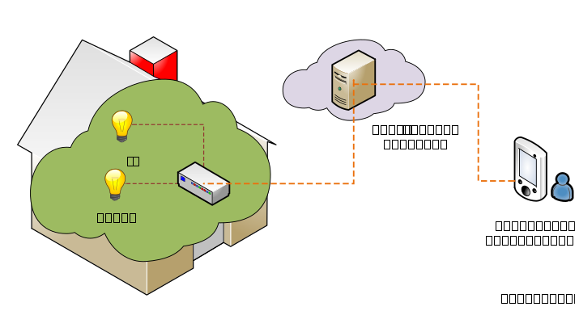
Figure 5-1: Overview of remote lights control use case
----------------------- End of change 12 -----------------------

----------------------- Start of change 13 -----------------------

8.7.1 Introduction
The implementation procedures in the current use case are mapped into HTTP bindings with both XML and JSON serializations of oneM2M primitives according to the standard APIs describing the reference points Mca and Mcc, as defined in oneM2M TS-0001 [i.2], oneM2M TS-0004 [i.3], the HTTP binding TS-0009 [i.4].
In addition, short names for the representation of the resources and attributes are used in the implementation procedures.
----------------------- End of change 13 -----------------------

----------------------- Start of change 14 -----------------------

Annex A.4.1 ADN-AE1
HTTP Request:
GET /~/mn-cse/home_gateway/light_ae1 HTTP/1.1
Host: mn.provider.com:8080
X-M2M-Origin: /in-cse/Csmartphone_ae
X-M2M-RI: mncse-12348
<span class="underline">X-M2M-RVI: 4</span>
Accept: application/xml
HTTP Response:
200 OK
X-M2M-RSC: 2000
X-M2M-RI: mncse-12348
<span class="underline">X-M2M-RVI: 4</span>
Content-Type: application/xml
<?xml version="1.0" encoding="UTF-8"?>
<m2m:ae xmlns:m2m="http://www.onem2m.org/xml/protocols" rn="light_ae1">
<ty>2</ty>
<ri>ae-CAE340304071</ri>
<pi>/mn-cse</pi>
<ct>20150925T052455</ct>
<lt>20150925T052455</lt>
<et>20171005T105550</et>
<acpi>/mn-cse/acp-805496226</acpi>
<api>A01.com.company.lightApp1</api>
<aei>CAE340304071</aei>
<rr>true</rr>
</m2m:ae>
----------------------- End of change 14 -----------------------

----------------------- Start of change 15 -----------------------

7.2.4 Discovery and retrieval of contentInstance resources
Call flows regarding the discovery and retrieval of contentInstance resources depicted in figure 7.2.4-1 and 7.2.4-2 are ordered as follows:
- The smartphone application (IN-AE) periodically sends a RETRIEVE request including the parameter filterUsage and specific filter criteria condition(s) as a query string for discovery of container resources stored in the MN-CSE of gateway.
2. The IN-AE also sends a Discovery request to the MN-CSE for the discovery of the group resources located in the MN-CSE.
- The gateway (MN-CSE) responds to the IN-AE with URIs of the discovered container resources under ADN-AE1 and ADN-AE2, if any.
For the case where the IN-AE sends a Discovery request for the discovery of group resources, the MN-CSE responds to the IN-AE with the URIs of the discovered group resources located in the MN-CSE, if any.
- The IN-AE sends GET requests for retrieval of the latest contentInstance resources from each discovered light container resource.
In the case of retrieval of the latest contentInstance resources of the group of containers, the IN-AE sends a retrieve request to the fanOutPoint of the discovered group resource.
- The MN-CSE responds to the IN-AE with the latest light state(s).
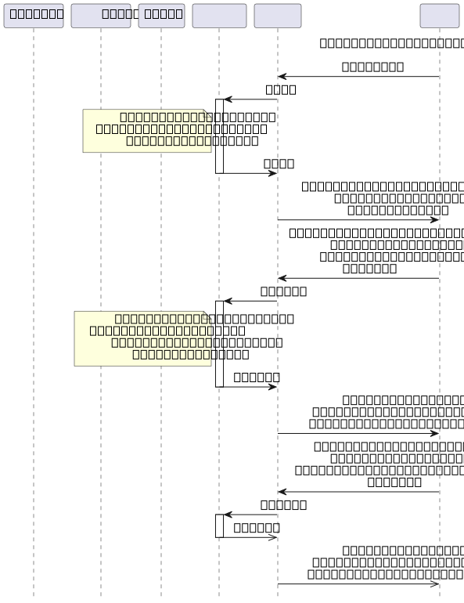
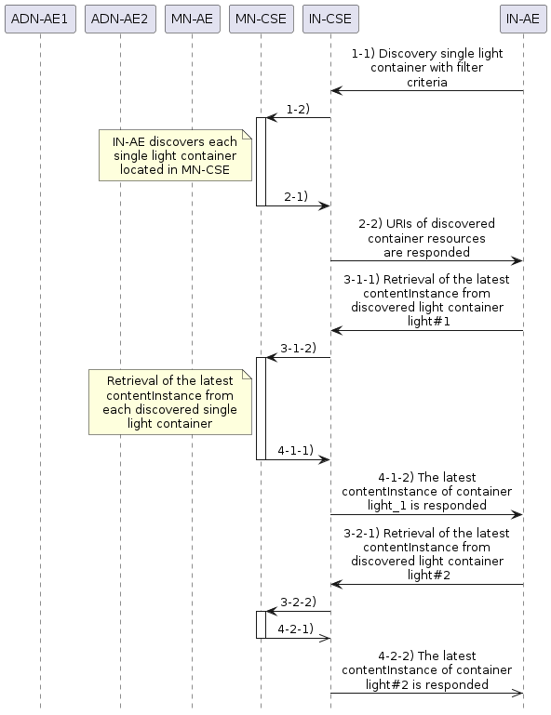
Figure 7.2.4-1: Discovery and single light retrieval phase call flows
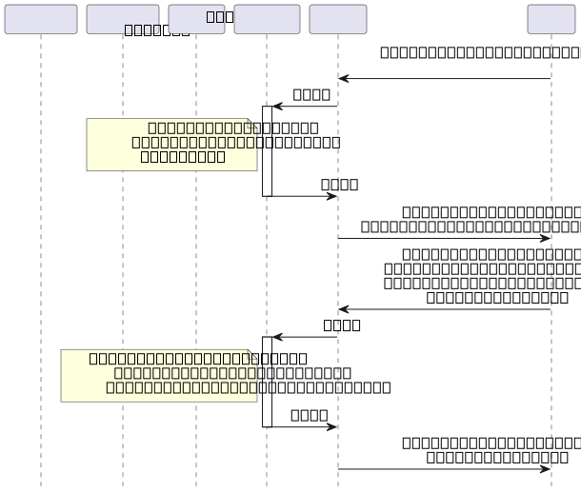
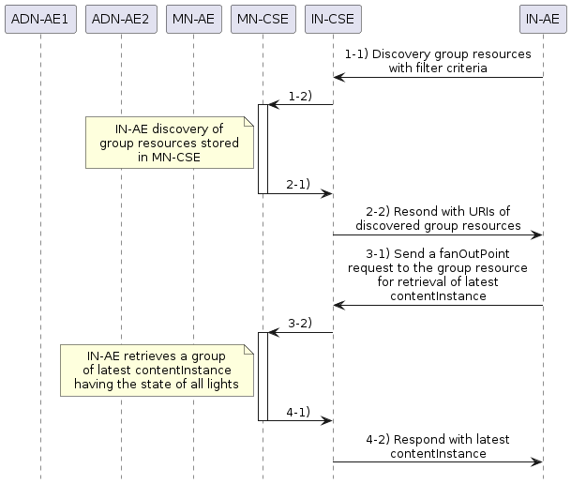
Figure 7.2.4-2 Discovery and a group of lights retrieval phase call flows
----------------------- End of change 15 -----------------------

----------------------- Start of change 16 -----------------------

7.3.3 Multiple light control
Users can also remotely control multiple lights through the smartphone application (IN-AE) by sending a single light control command to the group resource. A call flow for multiple lights control is depicted in figure 7.3.3-1 and the steps are ordered as follows:
- When the user updates the state of a group of lights on her/his smartphone, the IN-AE sends a contentInstance create request targeting the group resource on the MN-CSE. The MN-CSE then fans out the request to the individual Light container member resources on the MN-CSE..
2. For each contentInstances created sucessfully, the MN-CSE sends a notification to the corresponsding Light ADN-AE.

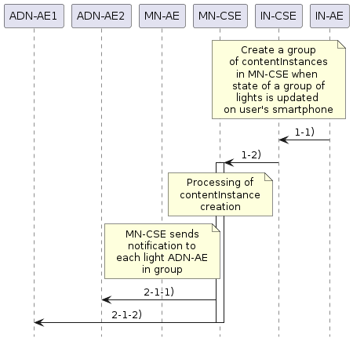
Figure 7.3.3-1: Multiple lights remote control phase call flows
----------------------- End of change 16 -----------------------

----------------------- Start of change 17 -----------------------

oneM2M Technical Report
Document Number | TR-0025 V2.0.3
Document Name: | Application Developer Guide
Date: | 2019-June-06
Abstract: | Provides a use case for guiding application developers to develop applications using functionalities provided by a oneM2M service platform.
Template Version:23 February 2015 (Dot not modify) | Template Version:23 February 2015 (Dot not modify)
This Specification is provided for future development work within oneM2M only. The Partners accept no liability for any use of this Specification.
The present document has not been subject to any approval process by the oneM2M Partners Type 1. Published oneM2M specifications and reports for implementation should be obtained via the oneM2M Partners’ Publications Offices.
About oneM2M
The purpose and goal of oneM2M is to develop technical specifications which address the need for a common M2M Service Layer that can be readily embedded within various hardware and software, and relied upon to connect the myriad of devices in the field with M2M application servers worldwide.
More information about oneM2M may be found at: http//www.oneM2M.org
Copyright Notification
- 2018, oneM2M Partners Type 1 (ARIB, ATIS, CCSA, ETSI, TIA, TSDSI, TTA, TTC).
All rights reserved.
The copyright and the foregoing restriction extend to reproduction in all media.
Notice of Disclaimer & Limitation of Liability
The information provided in this document is directed solely to professionals who have the appropriate degree of experience to understand and interpret its contents in accordance with generally accepted engineering or other professional standards and applicable regulations. No recommendation as to products or vendors is made or should be implied.
NO REPRESENTATION OR WARRANTY IS MADE THAT THE INFORMATION IS TECHNICALLY ACCURATE OR SUFFICIENT OR CONFORMS TO ANY STATUTE, GOVERNMENTAL RULE OR REGULATION, AND FURTHER, NO REPRESENTATION OR WARRANTY IS MADE OF MERCHANTABILITY OR FITNESS FOR ANY PARTICULAR PURPOSE OR AGAINST INFRINGEMENT OF INTELLECTUAL PROPERTY RIGHTS. NO oneM2M PARTNER TYPE 1 SHALL BE LIABLE, BEYOND THE AMOUNT OF ANY SUM RECEIVED IN PAYMENT BY THAT PARTNER FOR THIS DOCUMENT, WITH RESPECT TO ANY CLAIM, AND IN NO EVENT SHALL oneM2M BE LIABLE FOR LOST PROFITS OR OTHER INCIDENTAL OR CONSEQUENTIAL DAMAGES. oneM2M EXPRESSLY ADVISES ANY AND ALL USE OF OR RELIANCE UPON THIS INFORMATION PROVIDED IN THIS DOCUMENT IS AT THE RISK OF THE USER.
----------------------- End of change 17 -----------------------

----------------------- Start of change 18 -----------------------

8.7.8.2 Subscription to the content instance of ADN-AE2

When a subscription resource is created, the notification content type (shortname: nct) parameter is set to a value 1 to indicate that all attributes of the subscribed resource will be notified to the subscriber.
ADN-AE1 creates a subscription resource including the notification URI set to the resource identifier of ADN-AE1 so that the ADN-AE1 will get notified whenever a content instance child resource is created in the container. The corresponding subscription create request is shown in the following procedure.

When a subscription resource is created, the notification content type (shortname: nct) parameter is set to value 1 to indicate that all attributes of the subscribed resource will be notified to the subscriber.

ADN-AE2 creates a subscription resource including the notification URI set to the resource identifier of ADN-AE2 so that the ADN-AE2 will get notified whenever a content instance child resource is created in the container. The corresponding subscription create request is shown in the following procedures.
The following example shows a subscription create request and response using HTTP with XML serialization.
HTTP Request:
~~POST /home_gateway/light_ae2/light?rcn=0 HTTP/1.1~~
<span class="underline">POST /~/mn-cse/home_gateway/light_ae2/light?rcn=0 HTTP/1.1</span>
Host: mn.provider.com:8080
X-M2M-Origin: Clight_ae2
Content-Type: application/xml;ty=23
X-M2M-RI: mncse-29387
<span class="underline">X-M2M-RVI: 4</span>
<?xml version="1.0" encoding="UTF-8"?>
<m2m:sub xmlns:m2m="http://www.onem2m.org/xml/protocols" rn="lightstate_sub2">
<enc>
<net>3</net>
</enc>
<nu>Clight_ae2</nu>
<nct>1</nct>
</m2m:sub>
HTTP Response:
201 Created
X-M2M-RSC: 2001
X-M2M-RI: mncse-29387
~~Content-Location: /mn-cse/sub-856463728~~
<span class="underline">X-M2M-RVI: 4</span>
The following example shows a subscription create request and response using HTTP with JSON serialization.
HTTP Request:
~~POST /home_gateway/light_ae2/light?rcn=0 HTTP/1.1~~
<span class="underline">POST /~/mn-cse/home_gateway/light_ae2/light?rcn=0 HTTP/1.1</span>
Host: mn.provider.com:8080
X-M2M-Origin: Clight_ae2
Content-Type: application/json;ty=23
X-M2M-RI: mncse-29387
<span class="underline">X-M2M-RVI: 4</span>
{
"m2m:sub": {
"rn": "lightstate_sub2",
"enc": {
~~"net":<a href="#_ref_3">[~~
<span class="underline">"net": [</span>
3
~~]</a>~~
<span class="underline">]</span>
},
"nu": ["Clight_ae2"
],
"nct": 1
}
}
HTTP Response:
201 Created
X-M2M-RSC: 2001
X-M2M-RI: mncse-29387
~~Content-Location: /mn-cse/sub-856463728~~
<span class="underline">X-M2M-RVI: 4</span>
----------------------- End of change 18 -----------------------

----------------------- Start of change 19 -----------------------

8.7.6.1 Create a content instance of ADN-AE1
The creation of a content instance resource under the light container of ADN-AE1 with initial content OFF is shown in the following procedure.
The following example shows a contentInstance create request and response using HTTP with XML serialization.

HTTP Request:
~~POST /home_gateway/light_ae1/light?rcn=0 HTTP/1.1~~
<span class="underline">POST /~/mn-cse/home_gateway/light_ae1/light?rcn=0 HTTP/1.1</span>
Host: mn.provider.com:8080
X-M2M-Origin: Clight_ae1
Content-Type: application/xml;ty=4
X-M2M-RI: mncse-24345
<span class="underline">X-M2M-RVI: 4</span>
<span class="underline"><?xml version="1.0" encoding="UTF-8"?></span>
<m2m:cin xmlns:m2m="http://www.onem2m.org/xml/protocols">
~~<cnf>text/plain:0&lt;/cnf>~~
<span class="underline"><cnf>text/plain:0</cnf></span>
<con>OFF</con>
</m2m:cin>
HTTP Response:
201 Created
X-M2M-RSC: 2001
X-M2M-RI: mncse-24345
~~Content-Location: /mn-cse/cin-394798749~~
~~Content-Type: application/xml~~
<span class="underline">X-M2M-RVI: 4</span>
The following example shows a contentInstance create request and response using HTTP with JSON serialization.
HTTP Request:
~~POST /home_gateway/light_ae1/light?rcn=0 HTTP/1.1~~
<span class="underline">POST /~/mn-cse/home_gateway/light_ae1/light?rcn=0 HTTP/1.1</span>
Host: mn.provider.com:8080
X-M2M-Origin: Clight_ae1
Content-Type: application/json;ty=4
X-M2M-RI: mncse-24345
<span class="underline">X-M2M-RVI: 4</span>
{
"m2m:cin": {
"cnf": "text/plains:0",
"con": "OFF"
}
}
HTTP Response:
201 Created
X-M2M-RSC: 2001
X-M2M-RI: mncse-24345
~~Content-Location: /mn-cse/cin-394798749~~
~~Content-Type: application/json~~
<span class="underline">X-M2M-RVI: 4</span>
----------------------- End of change 19 -----------------------

----------------------- Start of change 20 -----------------------

8.7.4.3 Home gateway application MN-AE
The registration of MN-AE with MN-CSE is shown in the following procedure. Note that the access control policy identifier (unstructured SP-relative resourceID) which is assigned to MN-AE is /mn-cse/acp-805496226.
The following example shows an MN-AE registration request and response using HTTP with XML serialization.
HTTP Request:
~~POST /home_gateway?rcn=0 HTTP/1.1~~
<span class="underline">POST /~/mn-cse/home_gateway?rcn=0 HTTP/1.1</span>
Host: mn.provider.com:8080
X-M2M-Origin: C
Content-Type: application/xml;ty=2
X-M2M-RI: mncse-19347
<span class="underline">X-M2M-RVI: 4</span>
<?xml version="1.0" encoding="UTF-8"?>
~~<m2m:ae xmlns:m2m="http://www.onem2m.org/xml/protocols" rn="gateway_ae">~~
~~<api>A01.com.company.gatewayApp</api>~~
<span class="underline"><m2m:ae xmlns:m2m="http://www.onem2m.org/xml/protocols" rn="gateway_ae"></span>
<span class="underline"><api>NA01.com.company.gatewayApp</api></span>
<rr>false</rr>
<span class="underline"><srv>4</srv></span>
<acpi>/mn-cse/acp-805496226</acpi>
</m2m:ae>
HTTP Response:
201 Created
X-M2M-RSC: 2001
X-M2M-RI: mncse-19347
~~Content-Location: /mn-cse/ae-CAE340303271~~
<span class="underline">X-M2M-RVI: 4</span>
The following example shows an MN-AE registration request and response using HTTP with JSON serialization.
HTTP Request:
~~POST /home_gateway?rcn=0 HTTP/1.1~~
<span class="underline">POST /~/mn-cse/home_gateway?rcn=0 HTTP/1.1</span>
Host: mn.provider.com:8080
X-M2M-Origin: C
Content-Type: application/json;ty=2
X-M2M-RI: mncse-19347
<span class="underline">X-M2M-RVI: 4</span>
{
"m2m:ae": {
"rn": "gateway_ae",
~~"api": "A01.com.company.gatewayApp",~~
<span class="underline">"api": "NA01.com.company.gatewayApp",</span>
"rr": false,
<span class="underline">"srv": [ "4"],</span>
"acpi": [
"/mn-cse/acp-805496226"
]
}
}
HTTP Response:
201 Created
X-M2M-RSC: 2001
X-M2M-RI: mncse-19347
~~Content-Location: /mn-cse/ae-CAE340303271~~
<span class="underline">X-M2M-RVI: 4</span>
----------------------- End of change 20 -----------------------

----------------------- Start of change 21 -----------------------

8.7.6.2 Create a content instance of ADN-AE2
The creation of a content instance resource under the light container of ADN-AE2 with initial content OFF is shown in the following procedure.
The following example shows a contentInstance create request and response using HTTP with XML serialization.

HTTP Request:
~~POST /home_gateway/light_ae2/light?rcn=0 HTTP/1.1~~
<span class="underline">POST /~/mn-cse/home_gateway/light_ae2/light?rcn=0 HTTP/1.1</span>
Host: mn.provider.com:8080
X-M2M-Origin: Clight_ae1
Content-Type: application/xml;ty=4
X-M2M-RI: mncse-22345
<span class="underline">X-M2M-RVI: 4</span>
<span class="underline"><?xml version="1.0" encoding="UTF-8"?></span>
<m2m:cin xmlns:m2m="http://www.onem2m.org/xml/protocols">
~~<cnf>text/plain:0/cnf>~~
<span class="underline"><cnf>text/plain:0/cnf></span>
<con>OFF</con>
</m2m:cin>
HTTP Response:
201 Created
X-M2M-RSC: 2001
X-M2M-RI: mncse-22345
~~Content-Location: /mn-cse/cin-256599578~~
<span class="underline">X-M2M-RVI: 4</span>

The following example shows a contentInstance create request and response using HTTP with JSON serialization.
HTTP Request:
~~POST /home_gateway/light_ae2/light?rcn=0 HTTP/1.1~~
<span class="underline">POST /~/mn-cse/home_gateway/light_ae2/light?rcn=0 HTTP/1.1</span>
Host: mn.provider.com:8080
X-M2M-Origin: Clight_ae1
Content-Type: application/json;ty=4
X-M2M-RI: mncse-22345
<span class="underline">X-M2M-RVI: 4</span>
{
"m2m:cin": {
"cnf": "text/plains:0",
"con": "OFF"
}
}
HTTP Response:
201 Created
X-M2M-RSC: 2001
X-M2M-RI: mncse-22345
~~Content-Location: /mn-cse/cin-256599578~~
<span class="underline">X-M2M-RVI: 4</span>
----------------------- End of change 21 -----------------------

----------------------- Start of change 22 -----------------------

8.7.9.2 Discovery of single light registered with MN-CSE
The discovery of containers for each light registered with the MN-CSE by the smartphone AE is shown in the following procedure.
If the discovery response is preferred to be returned with a XML representation, the HTTP request message is sent as following example.
HTTP Request:
GET /~/mn-cse/home_gateway?fu=1&rty=3&drt=2 HTTP/1.1
Host: in.provider.com:8080
X-M2M-Origin: /in-cse/Csmartphone_ae
X-M2M-RI: mncse-99882
<span class="underline">X-M2M-RVI: 4</span>
Accept: application/xml
HTTP Response:
200 OK
X-M2M-RSC: 2000
X-M2M-RI: mncse-99882
X-M2M-CNST: 2
Content-Type: application/xml
<span class="underline">X-M2M-RVI: 4</span>
<?xml version="1.0" encoding="UTF-8"?>
<m2m:uril xmlns:m2m="http://www.onem2m.org/xml/protocols">
/mn-cse/cnt-582759912
/mn-cse/cnt-582769893
</m2m:uril>
If the discovery response is preferred to be returned with a JSON representation, the HTTP request message is sent as following example.
HTTP Request:
GET /~/mn-cse/home_gateway?fu=1&rty=3&drt=2 HTTP/1.1
Host: in.provider.com:8080
X-M2M-Origin: /in-cse/Csmartphone_ae
X-M2M-RI: mncse-99882
Accept: application/json
<span class="underline">X-M2M-RVI: 4</span>
HTTP Response:
200 OK
X-M2M-RSC: 2000
X-M2M-RI: mncse-99882
~~X-M2M-CNST: 2~~
<span class="underline">X-M2M-RVI: 4</span>
Content-Type: application/json
{
"m2m:uril": [
"/mn-cse/cnt-582759912",
"/mn-cse/cnt-582769893"
]
}
The smartphone application retrieves a list of URIs representing containers registered with MN-CSE from the response message, e.g. /mn-cse/cnt-582759912 which is the URI of container created in ADN-AE1. The retrieved URIs of the discovered containers are then used for the group member update operation.
----------------------- End of change 22 -----------------------

----------------------- Start of change 23 -----------------------

Annex A.2.1 IN-CSE
HTTP Request:
GET /~/in-cse/server HTTP/1.1
Host: in.provider.com:8080
X-M2M-Origin: /mn-cse/Cgateway_ae
X-M2M-RI: incse-12345
<span class="underline">X-M2M-RVI: 4</span>
Accept: application/xml
HTTP Response:
200 OK
X-M2M-RSC: 2000
X-M2M-RI: incse-12345
<span class="underline">X-M2M-RVI: 4</span>
Content-Type: application/xml
<?xml version="1.0" encoding="UTF-8"?>
<m2m:cb xmlns:m2m="http://www.onem2m.org/xml/protocols" rn="server">
<ty>5</ty>
<ri>/in-cse</ri>
<ct>20150925T045938</ct>
<lt>20150925T045938</lt>
<acpi>/in-cse/acp-666957710</acpi>
<cst>1</cst>
<lt;csi>in-cse</csi>
<srt>1 2 3 4 5 9 14 15 16 17 23</srt>
<poa>http://in.provider.com:8080/</poa>
</m2m:cb>
----------------------- End of change 23 -----------------------

----------------------- Start of change 24 -----------------------

8.6.3 Light applications (ADN-AE1 and ADN-AE2)
Each of the light applications are modelled as an ADN-AE and are responsible for
- initializing the light control device,
- registering the light devices with the MN-CSE,

- creating container resources light with access control policy gateway_acp in the MN-CSE, respectively,
- creating subscription resources lightstate_sub1 and lightstate_sub2 under the two light containers, and
- creating content instance resources under each light container with initial light states, respectively.
----------------------- End of change 24 -----------------------

----------------------- Start of change 25 -----------------------

8.7.9.3 Discovery of groups located in MN-CSE
The discovery of groups located in MN-CSE by the smartphone AE is shown in the following procedures.
If the discovery response is preferred to be returned with a XML representation, the HTTP request message is sent as following example:
HTTP Request:
GET /~/mn-cse/home_gateway?fu=1&rty=9&drt=2 HTTP/1.1
Host: in.provider.com:8080
X-M2M-Origin: /in-cse/Csmartphone_ae
X-M2M-RI: mncse-15001
<span class="underline">X-M2M-RVI: 4</span>
Accept: application/xml
HTTP Response:
200 OK
X-M2M-RSC: 2000
X-M2M-RI: mncse-15001
~~X-M2M-CNST: 2~~
<span class="underline">X-M2M-RVI: 4</span>
Content-Type: application/xml
<?xml version="1.0" encoding="UTF-8"?>
<m2m:uril xmlns:m2m="http://www.onem2m.org/xml/protocols">
/mn-cse/grp-977978327
</m2m:uril>
~~``````~~
<span class="underline">```</span>
If the discovery response is preferred to be returned with a JSON representation, the HTTP request message is sent as following example.
**HTTP Request**:
```http
GET /~/mn-cse/home_gateway?fu=1&rty=9&drt=2 HTTP/1.1
Host: in.provider.com:8080
X-M2M-Origin: /in-cse/Csmartphone_ae
X-M2M-RI: mncse-15001
<span class="underline">X-M2M-RVI: 4</span>
Accept: application/json
HTTP Response:
200 OK
X-M2M-RSC: 2000
X-M2M-RI: mncse-15001
~~X-M2M-CNST: 2Content-Type: application/json~~
<span class="underline">X-M2M-RVI: 4</span>
<span class="underline">Content-Type: application/json</span>
{
"m2m:uril": [
"/mn-cse/grp-977978327"
]
}
The smartphone application retrieves a list of URIs representing group resources located in MN-CSE from the response message, e.g. /mn-cse/grp-977978327 which is the URI of the group resource. The retrieved URIs of the discovered group resource are then used for the group member update operation.
----------------------- End of change 25 -----------------------

----------------------- Start of change 26 -----------------------

Annex A.5 Smartphone application IN-AE
HTTP Request:
GET /~/in-cse/server/smartphone_ae HTTP/1.1
Host: in.provider.com:8080
X-M2M-Origin: /mn-cse/Cgateway_ae
X-M2M-RI: incse-12349
<span class="underline">X-M2M-RVI: 4</span>
Accept: application/xml

HTTP Response:

```http
200 OK X-M2M-RSC: 2000 X-M2M-RI: incse-12349 X-M2M-RVI: 4
Content-Type: application/xml
~~**Resonse message*:~~

2 ae-CAE340304178 /in-cse 20150925T052622 20150925T052622 20171005T105550 /in-cse/acp-666957710 A01.com.company.lightControlApp CAE340304178 false ```
----------------------- End of change 26 -----------------------

----------------------- Start of change 27 -----------------------

8.7.11.3 Create a content instance under container of ADN-AE2

If the contentInstance create request body is represented in XML, the following is an HTTP request message the example.
HTTP Request:
POST /~/mn-cse/home_gateway/light_ae2/light?rcn=0 HTTP/1.1
Host: mn.provider.com:8080
X-M2M-Origin: /in-cse/Csmartphone_ae
Content-Type: application/xml;ty=4
X-M2M-RI: mncse-12222
<span class="underline">X-M2M-RVI: 4</span>
<span class="underline"><?xml version="1.0" encoding="UTF-8"?></span>
<m2m:cin xmlns:m2m="http://www.onem2m.org/xml/protocols">
<cnf>text/plain:0</cnf>
<con>ON</con>
</m2m:cin>
HTTP Response:
201 Created
X-M2M-RSC: 2001
X-M2M-RI: mncse-12222
~~Content-Location: /mn-cse/cin-237896783~~
<span class="underline">X-M2M-RVI: 4</span>
If the contentInstance create request body is represented in JSON, the following is a HTTP request message example.
HTTP Request:
POST /~/mn-cse/home_HTTP/1.1
Host: mn.provider.com:8080
X-M2M-Origin: /in-cse/Csmartphone_ae
Content-Type: application/json;ty=4
X-M2M-RI: mncse-12222
<span class="underline">X-M2M-RVI: 4</span>
{
"m2m:cin": {
"cnf": "text/plains:0",
"con": "ON"
}
}
HTTP Response:
201 Created
X-M2M-RSC: 2001
X-M2M-RI: mncse-12222
~~Content-Location: /mn-cse/cin-237896783~~
<span class="underline">X-M2M-RVI: 4</span>
----------------------- End of change 27 -----------------------

----------------------- Start of change 28 -----------------------

8.4 Modelling for Light State Data

The light state ON or OFF stored as the content of content instance resource is modelled as string as XML representation and can be represented as <con>ON</con> or <con>OFF</ con>, or as { ... "con" : "ON" ...} or {..."con" : "OFF" ...} as JSON , respectively.
----------------------- End of change 28 -----------------------

----------------------- Start of change 29 -----------------------

8.7.7 Group creation
The creation of a group resource by the MN-AE is shown in the following procedure. The group resource is created with two initial member ids of the light container resources..
The following example shows a group create request and response using HTTP with XML serialization.
HTTP Request:
~~POST /home_gateway/gateway_ae?rcn=0 HTTP/1.1~~
<span class="underline">POST /~/mn-cse/home_gateway/gateway_ae?rcn=0 HTTP/1.1</span>
Host: mn.provider.com:8080
X-M2M-Origin: Cgateway_ae
Content-Type: application/xml;ty=9
X-M2M-RI: mncse-76905
<span class="underline">X-M2M-RVI: 4</span>
<?xml version="1.0" encoding="UTF-8"?>
<m2m:grp xmlns:m2m="http://www.onem2m.org/xml/protocols" rn="containers_grp">
<mt>3</mt>
<mid>/mn-cse/cnt-582759912 /mn-cse/cnt-582769893</mid>
<mnm>10&lt;/mnm>
</m2m:grp>
HTTP Response:
201 Created
X-M2M-RSC: 2001
X-M2M-RI: mncse-76905
~~Content-Location: /mn-cse/grp-977978327~~
<span class="underline">X-M2M-RVI: 4</span>
The following example shows a group create request and response using HTTP with JSON serialization.
HTTP Request:
~~POST /home_gateway/gateway_ae?rcn=0 HTTP/1.1~~
<span class="underline">POST /~/mn-cse/home_gateway/gateway_ae?rcn=0 HTTP/1.1</span>
Host: mn.provider.com:8080
X-M2M-Origin: Cgateway_ae
Content-Type: application/json;ty=9
X-M2M-RI: mncse-76905
<span class="underline">X-M2M-RVI: 4</span>
{
"m2m:grp": {
"rn":"containers_grp",
"mt": 3,
"mid": [
"/mn-cse/cnt-582759912",
"/mn-cse/cnt-582769893"
],
"mnm": 10
}
}
HTTP Response:
201 Created
X-M2M-RSC: 2001
X-M2M-RI: mncse-76905
~~Content-Location: /mn-cse/grp-977978327~~
<span class="underline">X-M2M-RVI: 4</span>
----------------------- End of change 29 -----------------------

----------------------- Start of change 30 -----------------------

8.7.11.2 Create a content instance under container of ADN-AE1
If the contentInstance create request body is represented in XML, the following is a HTTP request message example.
HTTP Request:

POST /~/mn-cse/home_gateway/light_ae1/light?rcn=0 HTTP/1.1
Host: mn.provider.com:8080
~~X-M2M-Origin: /in-cse/Csmartphone_ae~~
Content-Type: application/xml;ty=4
<span class="underline">X-M2M-Origin: /in-cse/Csmartphone_ae</span>
X-M2M-RI: mncse-11123
<span class="underline">X-M2M-RVI: 4</span>
<span class="underline"><?xml version="1.0" encoding="UTF-8"?></span>
<m2m:cin xmlns:m2m="http://www.onem2m.org/xml/protocols">
<cnf>text/plain:0</cnf>
<con>ON</con>
</m2m:cin>
HTTP Response:
201 Created
X-M2M-RSC: 2001
X-M2M-RI: mncse-11123
~~Content-Location: /mn-cse/cin-789356234~~
<span class="underline">X-M2M-RVI: 4</span>
If the contentInstance create request body is represented in JSON, the following is a HTTP request message example.
HTTP Request:
POST /~/mn-cse/home_gateway/light_ae1/light?rcn=0 HTTP/1.1
Host: mn.provider.com:8080
X-M2M-Origin: /in-cse/Csmartphone_ae
Content-Type: application/json;ty=4
X-M2M-RI: mncse-11123
<span class="underline">X-M2M-RVI: 4</span>
{
"m2m:cin": {
"cnf": "text/plains:0",
"con": "ON"
}
}
HTTP Response:
201 Created
X-M2M-RSC: 2001
X-M2M-RI: mncse-11123
~~Content-Location: /mn-cse/cin-789356234~~
<span class="underline">X-M2M-RVI: 4</span>
----------------------- End of change 30 -----------------------

----------------------- Start of change 31 -----------------------

Annex A.4.2 ADN-AE2
HTTP Request:
GET /~/mn-cse/home_gateway/light_ae2 HTTP/1.1
Host: mn.provider.com:8080
X-M2M-Origin: /mn-cse/Cgateway_ae
X-M2M-RI: mncse-12348
<span class="underline">X-M2M-RVI: 4</span>
Accept: application/xml
~~````~~
<span class="underline">```</span>
**HTTP Response**:
``` http
200 OK
X-M2M-RSC: 2000
X-M2M-RI: mncse-12348
<span class="underline">X-M2M-RVI: 4</span>
Content-Type: application/xml
<?xml version="1.0" encoding="UTF-8"?>
<m2m:ae xmlns:m2m="http://www.onem2m.org/xml/protocols" rn="light_ae2">
<ty>2</ty>
<ri>ae-CAE340304042</ri>
<pi>/mn-cse</pi>
<ct>20150925T052542</ct>
<lt>20150925T052542</lt>
<et>20171005T105550</et>
<acpi>/mn-cse/acp-805496226</acpi>
<api>A01.com.company.lightApp2</api>
<aei>CAE340304042</aei>
<rr>true</rr>
</m2m:ae>
----------------------- End of change 31 -----------------------

----------------------- Start of change 32 -----------------------

8.7.4.4 Smartphone application IN-AE
The registration of IN-AE with IN-CSE is shown in the following procedure. Note that the access control policy identifier (unstructured SP-relative resourceID) which is assigned to IN-AE is /in-cse/acp-666957710.
The following example shows an IN-AE registration request and response using HTTP with XML serialization.
HTTP Request:
~~POST /server?rcn=0 HTTP/1.1~~
<span class="underline">POST /~/in-cse/server?rcn=0 HTTP/1.1</span>
Host: mn.provider.com:8080
X-M2M-Origin: C
Content-Type: application/xml;ty=2
X-M2M-RI: incse-16346
<span class="underline">X-M2M-RVI: 4</span>
<?xml version="1.0" encoding="UTF-8"?>
<m2m:ae xmlns:m2m="http://www.onem2m.org/xml/protocols" rn="smartphone_ae">
~~<api>A01.com.company.lightControlApp</api>~~
<span class="underline"><api>NA01.com.company.lightControlApp</api></span>
<rr>false</rr>
<span class="underline"><srv>4</srv></span>
<acpi>/in-cse/acp-666957710</acpi>
</m2m:ae>
HTTP Response:
201 Created
X-M2M-RSC: 2001
X-M2M-RI: incse-16346
~~Content-Location: /in-cse/ae-CAE340304178~~
<span class="underline">X-M2M-RVI: 4</span>
The following example shows an IN-AE registration request and response using HTTP with JSON serialization.
HTTP Request:
~~POST /server?rcn=0 HTTP/1.1~~
<span class="underline">POST /~/server?rcn=0 HTTP/1.1</span>
Host: mn.provider.com:8080
X-M2M-Origin: C
Content-Type: application/json;ty=2
X-M2M-RI: incse-16346
<span class="underline">X-M2M-RVI: 4</span>
{
"m2m:ae": {
"rn": "smartphone_ae",
~~"api": "A01.com.company.lightControlApp",~~
<span class="underline">"api": "NA01.com.company.lightControlApp",</span>
"rr": false,
<span class="underline">"srv": [ "4"],</span>
"acpi": [
"/in-cse/acp-666957710"
]
}
}
HTTP Response:
201 Created
X-M2M-RSC: 2001
X-M2M-RI: incse-16346
~~Content-Location: /in-cse/ae-CAE340304178~~
<span class="underline">X-M2M-RVI: 4</span>
----------------------- End of change 32 -----------------------

----------------------- Start of change 33 -----------------------

Annex A.10.1 Group1
HTTP Request:
GET /~/mn-cse/home_gateway/gateway_ae/containers_grp HTTP/1.1
Host: mn.provider.com:8080
X-M2M-Origin: /in-cse/Csmartphone_ae
X-M2M-RI: mncse-12357
<span class="underline">X-M2M-RVI: 4</span>
Accept: application/xml
HTTP Response:
200 OK
X-M2M-RSC: 2000
X-M2M-RI: mncse-12357
<span class="underline">X-M2M-RVI: 4</span>
Content-Type: application/xml
<?xml version="1.0" encoding="UTF-8"?>
<m2m:grp xmlns:m2m="http://www.onem2m.org/xml/protocols" rn="containers_grp">
<ty>9</ty>
<ri>grp-977978327</ri>
<pi>/mn-cse/ae-CAE340303271</pi>
<ct>20151004T045954</ct>
<lt>20151004T045954</lt>
<et>20171005T105550</et>
<acpi>/mn-cse/acp-805496226 /mn-cse/acp-805496226</acpi>
<mt>3</mt>
<cnm>2</cnm>
<mnm>10</mnm>
<mid>/mn-cse/cnt-582759912 /mn-cse/cnt-582769893</mid>
<mtv>true</mtv>
<csy>1</csy>
<fopt>/mn-cse/grp-977978327/fopt</fopt>
</m2m:grp>
----------------------- End of change 33 -----------------------

----------------------- Start of change 34 -----------------------

6 Architecture
This clause describes how the different components of this use case can be represented by corresponding oneM2M architectural entities as shown in figure 6-1.
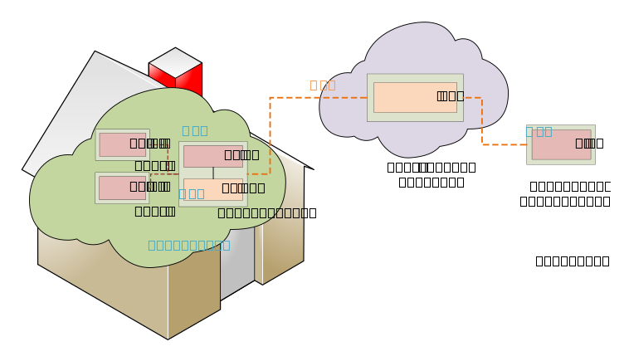
Figure 6-1: oneM2M functional architecture of remote lights control use case
In the oneM2M functional architecture two basic types of entities are defined. One is an AE (short for Application Entity) and the other is a CSE (short for Common Services Entity). In this use case, the lights and smartphone each host an AE. Also an IN-CSE (short for Infrastructure Node CSE) is hosted in the cloud by the oneM2M Service Provider and a MN-CSE (short for Middle Node CSE) is hosted on the Home Gateway.
The oneM2M defined Mca reference point is used to interface an AE and CSE. The oneM2M defined Mcc reference point is used to interface CSEs. In this use case, the reference point used between a Light AE and home gateway MN-CSE or Smartphone AE and IN-CSE is Mca while reference point used between the home gateway MN-CSE and oneM2M service platform IN-CSE is Mcc
In summary, applications used in the current use case are classified as follows:

- ADN-AE1 : an application embedded in Light#1 with capabilities to control Light#1 and interact with the home gateway MN-CSE through Mca reference point.
- ADN-AE2 : an application embedded in Light#2 with capabilities to control Light#2 and interact with the home gateway MN-CSE through Mca reference point.
- IN-AE : a smartphone application embedded in the smartphone device with capabilities to interact directly with the oneM2M service platform IN-CSE through Mcc reference point and thereby remotely control Light#1 and Light#2.
- MN-AE : a gateway application embedded into the home gateway that interacts with the MN-CSE through Mca reference point.
----------------------- End of change 34 -----------------------

----------------------- Start of change 35 -----------------------

8.7.5.2 Create a container of ADN-AE2
The creation of a container resource for ADN-AE2 is shown in the following procedure.
The following example shows a container create request and response using HTTP with XML serialization.

HTTP Request:
~~POST /home_gateway/light_ae2?rcn=0 HTTP/1.1~~
<span class="underline">POST /~/mn-cse/home_gateway/light_ae2?rcn=0 HTTP/1.1</span>
Host: mn.provider.com:8080
X-M2M-Origin: Clight_ae2
Content-Type: application/xml;ty=3
X-M2M-RI: mncse-62345
<span class="underline">X-M2M-RVI: 4</span>
<span class="underline"><?xml version="1.0" encoding="UTF-8"?></span>
<m2m:cnt xmlns:m2m="http://www.onem2m.org/xml/protocols" rn="light">
</m2m:cnt>
HTTP Response:
201 Created
X-M2M-RSC: 2001
X-M2M-RI: mncse-62345
~~Content-Location: /mn-cse/cnt-582769893~~
<span class="underline">X-M2M-RVI: 4</span>
The following example shows a container create request and response using HTTP with JSON serialization.
HTTP Request:
~~POST /home_gateway/light_ae2?rcn=0 HTTP/1.1~~
<span class="underline">POST /~/mn-cse/home_gateway/light_ae2?rcn=0 HTTP/1.1</span>
Host: mn.provider.com:8080
X-M2M-Origin: Clight_ae2
Content-Type: application/json;ty=3
X-M2M-RI: mncse-62345
<span class="underline">X-M2M-RVI: 4</span>
{
"m2m:cnt": {
"rn": "light"
}
}
HTTP Response:
201 Created
X-M2M-RSC: 2001
X-M2M-RI: mncse-62345
~~Content-Location: /mn-cse/cnt-582769893~~
<span class="underline">X-M2M-RVI: 4</span>
----------------------- End of change 35 -----------------------

----------------------- Start of change 36 -----------------------

8.5.2 Resource Structure of MN-CSE

The resource tree of the MN-CSE starts with a CSEBase named home_gateway depicted in figure 8.5.2-1.
The resource tree is constructed with child resources as follows:

- an accessControlPolicy named gateway_acp,
- an ADN-AE named light_ae1 which contains sub-resources of a container named light and multiple contentInstances,
- an ADN-AE named light_ae2 which contains sub-resources of a container named light and multiple contentInstances,
- lightstate_sub1 and lightstate_sub2 subscription resources that are child resources of the two light containers, and
- an MN-AE named gateway_ae which contains a group child resource,
- a group resource named containers_group whose members are the light containers of each AND-AEs. Smartphone application users with propper access control privileges can send a request to the fanOutPoint virtual resource of this group to create and retrieve content instances in the two light containers.
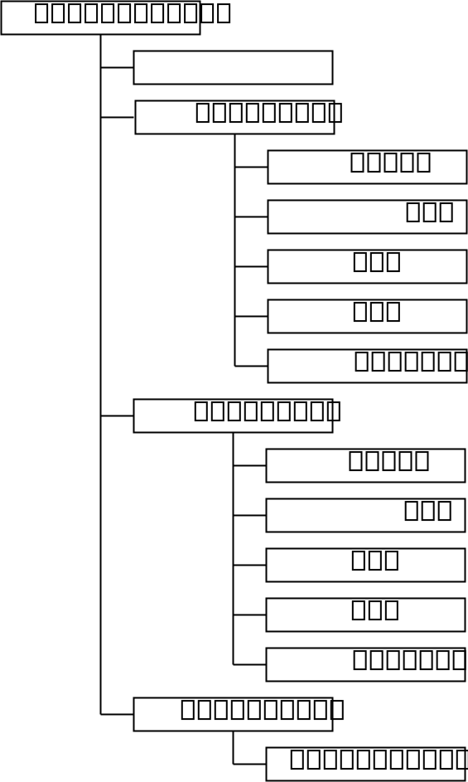
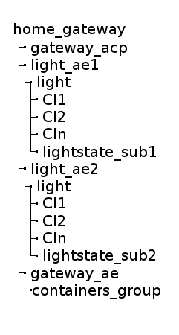
Figure 8.5.2-1: MN-CSE resource tree
----------------------- End of change 36 -----------------------

----------------------- Start of change 37 -----------------------

3.1 Definitions

For the purposes of the present document, the terms and definitions given in oneM2M TS-0011 [i.5] and the following apply.

>NOTE: A term defined in the present document takes precedence over the definition of the same term, if any, in oneM2M TS-0011 [i.5].
M2M service provider domain: part of the M2M System that is associated with a specific M2M Service Provider
registrar CSE: CSE where an Application or another CSE has registered
resource: uniquely addressable entity in oneM2M architecture
----------------------- End of change 37 -----------------------

----------------------- Start of change 38 -----------------------

8.5.1 Resource Structure of IN-CSE
The resource tree of IN-CSE starts with a CSEBase named server depicted in figure 8.5.1-1.

The root CSEBase has two direct child resources, a remoteCSE named home_gateway and an AE named smartphone_ae .
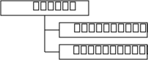
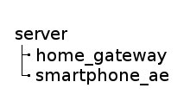
Figure 8.5.1-1: IN-CSE resource structure
----------------------- End of change 38 -----------------------

----------------------- Start of change 39 -----------------------

8.6.4 Smartphone application (IN-AE)
The smartphone application is modelled as a IN-AE, which directly communicates with the oneM2M service platform IN-CSE and is responsible for
- initializing the smartphone light control application,
- registering the smartphone application with the IN-CSE,
- discovering the two light containers,
- displaying the discovered light states,
- accepting the light state modification commands from the smartphone application user,
- executing the light state modification commands for single and multiple lights.
----------------------- End of change 39 -----------------------

----------------------- Start of change 40 -----------------------

8.7.12.2 Post a notification to ADN-AE1
If the notification request body is represented in XML, the following is a HTTP request message example.
HTTP Request:
POST / HTTP/1.1
Host: 192.168.0.10:9090
X-M2M-Origin: /mn-cse
X-M2M-RI: notif-12345
<span class="underline">X-M2M-RVI: 4</span>
Content-Type: application/xml
<?xml version="1.0" encoding="UTF-8"?>
<m2m:sgn xmlns:m2m="http://www.onem2m.org/xml/protocols" rn="cin-394798749">
<nev>
<rep>
<m2m:cin>
<ty>4</ty>
<ri>cin-394798749</ri>
<pi>cnt-790965889</pi>
<ct>20150925T050534</ct>
<lt>20150925T050534</lt>
<et>20151107T154802</et>
<st>0</st>
<cnf>text/plain:0</cnf>
<cs>3</cs>
<con>ON</con>
</m2m:cin>
</rep>
<net>3</net>
</nev>
<sur>/mn-cse/sub-856593979</sur>
</m2m:sgn>
HTTP Response:
200 OK
X-M2M-RSC: 2000
X-M2M-RI: notif-12345
<span class="underline">X-M2M-RVI: 4</span>
If the notification request body is represented in JSON, the following is a HTTP request message example.
HTTP Request:
POST / HTTP/1.1
Host: 192.168.0.10:9090
X-M2M-Origin: /mn-cse
X-M2M-RI: notif-12345
<span class="underline">X-M2M-RVI: 4</span>
Content-Type: application/json
{
"m2m:sgn": {
"nev": {
"rep": {
"m2m:cin": {
"ty": 4,
"ri": "cin-394798749",
"pi": "cnt-790965889",
"ct": "20150925T050534",
"lt": "20150925T050534",
"et": "20151107T154802",
"st": 0,
"cnf": "text/plain:0",
"cs": 3,
"con": "ON"
}
},
"net": 3
},
"sur": "/mn-cse/sub-856593979"
}
}
HTTP Response:
200 OK
X-M2M-RSC: 2000
X-M2M-RI: notif-12345
<span class="underline">X-M2M-RVI: 4</span>
----------------------- End of change 40 -----------------------

----------------------- Start of change 41 -----------------------

Annex A.3 Gateway device application MN-AE
HTTP Request:
GET /~/mn-cse/home_gateway/gateway_ae HTTP/1.1
Host: mn.provider.com:8080
X-M2M-Origin: /in-cse/Csmartphone_ae
X-M2M-RI: mncse-12347
<span class="underline">X-M2M-RVI: 4</span>
Accept: application/xml
HTTP Response:
200 OK
X-M2M-RSC: 2000
X-M2M-RI: mncse-12347
<span class="underline">X-M2M-RVI: 4</span>
Content-Type: application/xml
<?xml version="1.0" encoding="UTF-8"?>
<m2m:ae xmlns:m2m="http://www.onem2m.org/xml/protocols" rn="gateway_ae">
<ty>2</ty>
<ri>ae-CAE340303271</ri>
<pi>/mn-cse</pi>
<ct>20150925T052438</ct>
<lt>20150925T052438</lt>
<et>20171005T105550</et>
<acpi>/mn-cse/acp-805496226</acpi>
<api>A01.com.company.gatewayApp</api>
<aei>CAE340303271</aei>
<rr>false</rr>
</m2m:ae>
----------------------- End of change 41 -----------------------

----------------------- Start of change 42 -----------------------

Annex A.9.1 Subscription to container in ADN-AE1
HTTP Request:
GET /~/mn-cse/home_gateway/light_ae1/light/lightstate_sub1 HTTP/1.1
Host: mn.provider.com:8080
X-M2M-Origin: /mn-cse/Cgateway_ae
X-M2M-RI: mncse-12355
<span class="underline">X-M2M-RVI: 4</span>
Accept: application/xml
HTTP Response:
200 OK
X-M2M-RSC: 2000
X-M2M-RI: mncse-12355
<span class="underline">X-M2M-RVI: 4</span>
Content-Type: application/xml
<?xml version="1.0" encoding="UTF-8" standalone="yes"?>
<m2m:sub xmlns:m2m="http://www.onem2m.org/xml/protocols" rn="lightstate_sub1">
<ty>23</ty>
<ri>sub-856593979</ri>
<pi>/mn-cse/cnt-582759912</pi>
<ct>20150926T052955</ct>
<lt>20150926T052955</lt>
<et>20171005T105550</et>
<acpi>/mn-cse/acp-805496226</acpi>
<enc>
<net>3</net>
</enc>
<nu>/mn-cse/ae-CAE340304071</nu>
<nct>1</nct>
</m2m:sub>
----------------------- End of change 42 -----------------------

----------------------- Start of change 43 -----------------------

7.3.2 Single light control
Light#1 and Light#2 are controlled remotely by a human user through a smartphone application (IN-AE). A call flow for single light control is depicted in figure 7.3.2-1 and the steps are ordered as follows:
- When the user updates the light state on her/his smartphone, the IN-AE creates a new contentInstance representing a new light state under the targeted container of a Light ADN-AE stored in the MN-CSE.
- If the contentInstance is created sucessfully_,_ the MN-CSE sends a notification to the corresponsding Light ADN-AE to notify it that a new contentInstance resource was created.
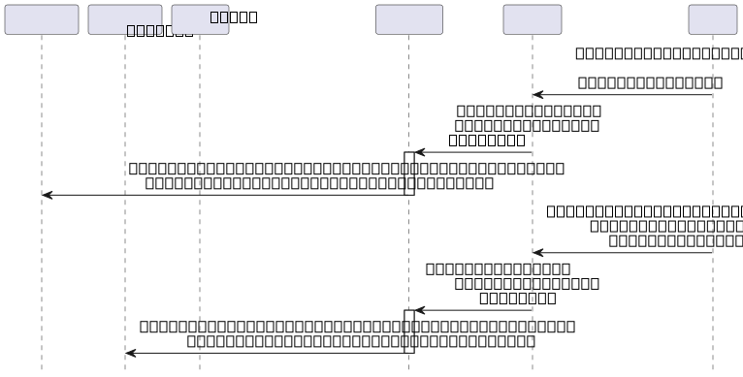
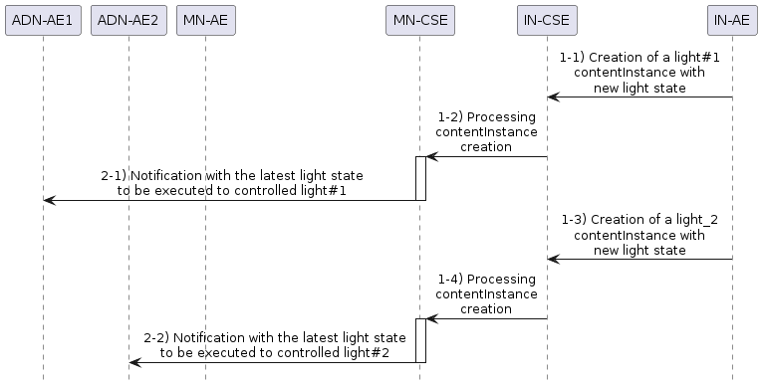
Figure 7.3.2-1: Single light remote control phase call flows
----------------------- End of change 43 -----------------------

----------------------- Start of change 44 -----------------------

8.3 Addressing for Entities
Each oneM2M entity including AE and CSE are addressable with correct host address that can be IP addresses or FQDN addresses resolved to IP addresses by DNS network services according to addressing rules specified in oneM2M standards.
The IN-CSE and MN-CSE entities presented in this use case are addressable with the following identifiers.
- IN-CSE:
  - CSE-ID: in-cse
  - resourceName of IN-CSE’s CSEBase resource: server
- MN-CSE:
  - CSE-ID: mn-cse
  - resourceName of MN-CSE’s CSEBase resource: home_gateway
----------------------- End of change 44 -----------------------

----------------------- Start of change 45 -----------------------

7.2.3 Discovery of group resources
Call flows regarding the discovery and update of group resources are depicted in figure 7.2.3-1 and ordered as follows:

1. Gateway application (MN-AE) periodically sends a RETRIEVE request including the parameter filterUsage and specific filter criteria condition(s) as a query string for discovery of container resources stored in the MN-CSE of gateway. The filter criteria conditions for the discovery operation include createdBefore, createdAfter, modifiedSince, unmodifiedSince, label, creator, expireAfter, resourceType etc.
- Gateway (MN-CSE) responds with URIs of the discovered container resources, if any, to the gateway application (MN-AE) according to the filter criteria(s).
- Gateway application (MN-AE) sends a update request to update the list of group members within the previously created group resource with identifiers of the discovered containers.
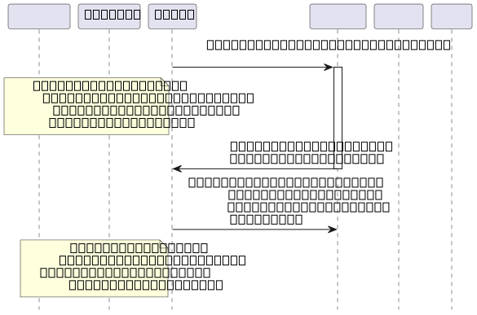
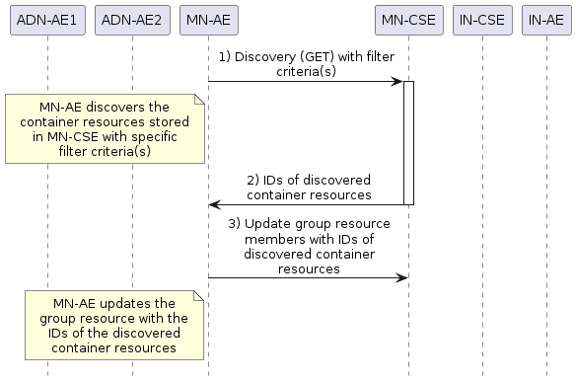
Figure 7.2.3-1: Discovery and group light state update phase call flows
----------------------- End of change 45 -----------------------

----------------------- Start of change 46 -----------------------

Annex A.1 Introduction
The information of resources created during each call flow of current use case can be retrieved via smartphone application IN-AE initiates a RETRIEVE request to the target resources as following.
----------------------- End of change 46 -----------------------

----------------------- Start of change 47 -----------------------

8.7.3 Access control policy creation
When an access control policy resource is created, a list of one or more allowed request originators is specified in the acor field and the allowed operations in the acop field.
The value of acop is set to 63 which indicates that the specified originator is granted privileges to conduct CREATE, RETRIEVE, UPDATE, DELETE, DISCOVERY, and NOTIFY operations.

The creation of access control policy resource gateway_acp in MN-CSE is implemented in the following procedure.

The following example shows an access control policy create request and response using HTTP with XML serialization.
HTTP Request:
POST /~/mn-cse/home_gateway?rcn=0 HTTP/1.1
Host: mn.provider.com:8080
X-M2M-Origin: Cgateway_ae
Content-Type: application/xml;ty=1
X-M2M-RI: mncse-62948
<span class="underline">X-M2M-RVI: 4</span>
<span class="underline"><?xml version="1.0" encoding="UTF-8"?></span>
<m2m:acp xmlns:m2m="http://www.onem2m.org/xml/protocols" rn="gateway_acp">
<pv>
<acr>
<acor>Cgateway_ae Clight_ae1 Clight_ae2 /in-cse/Csmartphone_ae</acor>
<acop>63</acop>
</acr>
</pv>
<pvs>
<acr>
<acor>Cgateway_ae</acor>
<acop>51</acop>
</acr>
</pvs>
</m2m:acp>
HTTP Response:
201 Created
X-M2M-RSC: 2001
X-M2M-RI: mncse-62948
~~Content-Location: /mn-cse/acp-805496226~~
<span class="underline">X-M2M-RVI: 4</span>

The following example shows an access control policy create request and response using HTTP with JSON serialization.
HTTP Request:
POST /~/mn-cse/home_gateway?rcn=0 HTTP/1.1
Host: mn.provider.com:8080
X-M2M-Origin: Cgateway_ae
Content-Type: application/json;ty=1
X-M2M-RI: mncse-62948
<span class="underline">X-M2M-RVI: 4</span>
{
"m2m:acp": {
~~"rn": "gateway\_acp",~~
<span class="underline">"rn": "gateway_acp",</span>
"pv": {
"acr": [
{
"acor": [
"Cgateway_ae",
"Clight_ae1",
"Clight_ae2",
"/in-cse/Csmartphone_ae"
],
"acop": 63
}
]
},
"pvs": {
"acr": [
{
"acor": [
"Cgateway_ae"
],
"acop": 51
}
]
}
}
}
HTTP Response:
201 Created
X-M2M-RSC: 2001
X-M2M-RI: mncse-62948
~~Content-Location: /mn-cse/acp-805496226~~
<span class="underline">X-M2M-RVI: 4</span>
The access control policy resource is used to grant applications the access rights to conduct specific operations and access to specific resources. The list of applications could be obtained with a discovery procedure using filter criteria conditions. For more details about the discovery procedure, please go to clause 8.7.9. Here it is required that the list of applications has been discovered before creating the access control policy resource.
----------------------- End of change 47 -----------------------

----------------------- Start of change 48 -----------------------

Contents
----------------------- End of change 48 -----------------------

----------------------- Start of change 49 -----------------------

8.5.0 Introduction
The development of an oneM2M application includes the design of the resource trees of service capability layers i.e. IN-CSE and MN-CSE in the current use case. The resource tree is constructed with child resources created according to the high level procedures presented in oneM2M application developer guide clause 7. All the child resources shown in the resource trees are mandatorily required in order to correctly implement the remote lights control use case.
----------------------- End of change 49 -----------------------

----------------------- Start of change 50 -----------------------

7.1 Introduction

The deployment of the oneM2M standard in the present use case requires procedures that are classified as follows:
- Registration : The current procedure contains light application registration, gateway application registration, and accessControlPolicy resource creation for selective access to data storage resources.
- Initial resource creation : The current procedure contains group resource creation, container resources creation with specific access control policies, content instance resources creation with initial light states, subscription resources creation for notifications.
- Discovery f container resource : all containers with a specific filter criteria are discovered by the gateway application and then configured as members of a group resource.
- Discovery and retrieval lights states : all containers with a specific filter criteria are discovered and retrieved using resource identities through a smartphone application which gains access to oneM2M service platform so content information can be retrieved.
- Single light switch on/off: Any light that is discovered by and connected to the smartphone application is able to be switched on and off via a smartphone application.
- Multiple lights switch on/off: Multiple lights that are discovered are able to be switched on and off together via a smartphone application.
----------------------- End of change 50 -----------------------

----------------------- Start of change 51 -----------------------

8.7.11.4 Update the state of all lights using group fanout
If the fanOutPoint request body is represented in XML, the following is a HTTP request message example:.
HTTP Request:
POST /~/mn-cse/home_gateway/gateway_ae/containers_grp/fopt HTTP/1.1
Host: mn.provider.com:8080
X-M2M-Origin: /in-cse/Csmartphone_ae
Content-Type: application/xml;ty=4
X-M2M-RI: mncse-33344
<span class="underline">X-M2M-RVI: 4</span>
<xml version="1.0" encoding="UTF-8"?>
<m2m:cin xmlns:m2m="http://www.onem2m.org/xml/protocols">
<cnf>text/plain:0</cnf>
<con>ON</con>
</m2m:cin>
HTTP Response:
200 OK
X-M2M-RSC: 2000
X-M2M-RI: mncse-33344
<span class="underline">X-M2M-RVI: 4</span>
Content-Type: application/xml
<?xml version="1.0" encoding="UTF-8"?>
<m2m:agr xmlns:m2m="http://www.onem2m.org/xml/protocols">
<m2m:rsp>
<rsc>2001</rsc>
<rqi>mncse-33344</rqi>
<pc>
<m2m:cin rn="cin-479874939">
<ty>4</ty>
<ri>cin-479874939</ri>
<pi>cnt-181049109</pi>
<ct>20151025T045938</ct>
<lt>20151025T045938</lt>
<et>20151207T154802</et>
<st>0</st>
<cs>2</cs>
</m2m:cin>
</pc>
<to>/in-cse/Csmartphone_ae</to>
<fr>/mn-cse/cnt-582759912</fr>
</m2m:rsp>
<m2m:rsp>
<rsc>2001</rsc>
<rqi>mncse-33344</rqi>
<pc>
<m2m:cin rn="cin-659957825">
<ty>4</ty>
<ri>cin-659957825</ri>
<pi>cnt-790965889</pi>
<ct>20151025T045938</ct>
<lt>20151025T045938</lt>
<et>20151207T154802</et>
<st>0</st>
<cs>2</cs>
</m2m:cin>
</pc>
<to>/in-cse/Csmartphone_ae</to>
<fr>/mn-cse/cnt-582769893</fr>
</m2m:rsp>
</m2m:agr>
If the fanOutPoint request body is represented in JSON, the following is a HTTP request message example.
HTTP Request:
POST /~/mn-cse/home_gateway/gateway_ae/containers_grp/fopt HTTP/1.1
Host: mn.provider.com:8080
X-M2M-Origin: /in-cse/Csmartphone_ae
Content-Type: application/json;ty=4
X-M2M-RI: mncse-33344
<span class="underline">X-M2M-RVI: 4</span>
{
"m2m:cin": {
"cnf": "text/plains:0",
"con": "ON"
}
}
HTTP Response:
200 OK
X-M2M-RSC: 2000
X-M2M-RI: mncse-33344
<span class="underline">X-M2M-RVI: 4</span>
Content-Type: application/json
{
"m2m:agr": {
"m2m:rsp": [
{
"rsc": 2001,
"rqi": "mncse-33344",
"pc": {
"m2m:cin": {
"ty": 4,
"ri": "cin-479874939",
"pi": "cnt-181049109",
"ct": "20151025T045938",
"lt": "20151025T045938",
"et": "20151207T154802",
"st": 0,
"cs": 2
}
},
"to": "/in-cse/Csmartphone_ae",
"fr": "/mn-cse/cnt-582759912"
},
{
"rsc": 2001,
"rqi": "mncse-33344",
"pc": {
"m2m:cin": {
"ty": 4,
"ri": "cin-659957825",
"pi": "cnt-790965889",
"ct": "20151025T045938",
"lt": "20151025T045938",
"et": "20151207T154802",
"st": 0,
"cs": 2
}
},
"to": "/in-cse/Csmartphone_ae",
"fr": "/mn-cse/cnt-582769893"
}
]
}
}
----------------------- End of change 51 -----------------------

----------------------- Start of change 52 -----------------------

3.2 Abbreviations
For the purposes of the present document, the following abbreviations apply:
ACP Access Control Policy
ADN Application Dedicated Node
ADN-AE AE which resides in the Application Dedicated Node
AE Application Entity
CoAP Constrained Application Protocol
CSE Common Services Entity
CSE-ID Common Service Entity Identifier
DNS Domain Name System
FQDN Fully Qualified Domain Name
HTTP HyperText Transfer Protocol
IN Infrastructure Node
IN-AE Application Entity that is registered with the CSE in the Infrastructure Node
IN-CSE CSE which resides in the Infrastructure Node
IP Internet Protocol
JSON JavaScript Object Notation
M2M Machine to Machine
Mca Reference Point for M2M Communication with AE
Mcc Reference Point for M2M Communication with CSE
MN Middle Node
MN-AE Application Entity that is registered with the CSE in Middle Node
MN-CSE CSE which resides in the Middle Node
PoA Point of Access
SP Service Provider
URI Uniform Resource Identifier
XML eXtensible Markup Language
----------------------- End of change 52 -----------------------

----------------------- Start of change 53 -----------------------

Annex A.7.2 Container under ADN-AE2
HTTP Request:
GET /~/mn-cse/home_gateway/light_ae2/light HTTP/1.1
Host: mn.provider.com:8080
X-M2M-Origin: /mn-cse/Cgateway_ae
X-M2M-RI: mncse-12352
<span class="underline">X-M2M-RVI: 4</span>
Accept: application/xml
HTTP Response:
200 OK
X-M2M-RSC: 2000
X-M2M-RI: mncse-12352
<span class="underline">X-M2M-RVI: 4</span>
Content-Type: application/xml
<?xml version="1.0" encoding="UTF-8" standalone="yes"?>
<m2m:cnt xmlns:m2m="http://www.onem2m.org/xml/protocols" rn="light">
<ty>3</ty>
<ri>cnt-582769893</ri>
<pi>/mn-cse/ae-CAE340304042</pi>
<ct>20150925T053135</ct>
<lt>20150925T053135</lt>
<et>20171005T105550</et>
<acpi>/mn-cse/acp-805496226</acpi>
<st>0</st>
<cni>1</cni>
<cbs>3</cbs>
</m2m:cnt>
----------------------- End of change 53 -----------------------

----------------------- Start of change 54 -----------------------

8.7.10.2 Retrieve the latest content instance of ADN-AE1
The latest content instance of the light container resource for ADN-AE1 can be retrieved by the following procedure.
If the response is preferred to be returned with a XML representation, the following is a HTTP request message example.
HTTP Request:
GET /~/mn-cse/home_gateway/light_ae1/light/la HTTP/1.1
Host: in.provider.com:8080
X-M2M-Origin: /in-cse/Csmartphone_ae
X-M2M-RI: mncse-11223
<span class="underline">X-M2M-RVI: 4</span>
Accept: application/xml
HTTP Response:
200 OK
X-M2M-RSC: 2000
X-M2M-RI: mncse-11223
<span class="underline">X-M2M-RVI: 4</span>
Content-Type: application/xml
<?xml version="1.0" encoding="UTF-8"?>
<m2m:cin xmlns:m2m="http://www.onem2m.org/xml/protocols" rn="cin-394798749">
<ty>4</ty>
<ri>cin-394798749</ri>
<pi>cnt-181049109</pi>
<ct>20150925T045938</ct>
<lt>20150925T045938</lt>
<et>20151107T154802</et>
<st>0</st>
<cnf>text/plain:0</cnf>
<cs>3</cs>
<con>OFF</con>
</m2m:cin>
If the response is preferred to be returned with a JSON representation, the following is a HTTP request message example.

~~GET /~/mn-cse/home_gateway/light_ae1/light/lat HTTP/1.1~~
<span class="underline">GET /~/mn-cse/home_gateway/light_ae1/light/la HTTP/1.1</span>
Host: in.provider.com:8080
X-M2M-Origin: /in-cse/Csmartphone_ae
X-M2M-RI: mncse-11223
<span class="underline">X-M2M-RVI: 4</span>
Accept: application/json
HTTP Response:
200 OK
X-M2M-RSC: 2000
X-M2M-RI: mncse-11223
<span class="underline">X-M2M-RVI: 4</span>
Content-Type: application/json
{
"m2m:cin": {
"ty": 4,
"ri": "cin-394798749",
"pi": "cnt-181049109",
"ct": "20150925T045938",
"lt": "20150925T045938",
"et": "20151107T154802",
"st": 0,
"cnf": "text/plain:0",
"cs": 3,
"con": "OFF"
}
}
----------------------- End of change 54 -----------------------

----------------------- Start of change 55 -----------------------

7.2.2 Initial resource creation
Call flows regarding the initial resource creation phase depicted in figure 7.2.2-1 are ordered as follows:

1. Gateway application (MN-AE) creates a group resource on gateway (MN-CSE), for updating and retrieving group light state named as containers_group . The group members are added from the list of discovered container resources that the MN-AE discovers. The group resource is created with a link to the same access control policy.
- Two container resources are created in the gateway (MN-CSE) to store the light states under the registered light application ADN-AE1 and ADN-AE2, respectively. The containers are created with a link to the same access control policy.
- Content Instance resources are created by light applications (ADN-AE1 and ADN-AE2) under each created container and represent the controlled light states.
- Subscription resources are created under the containers in the gateway (MN-CSE) so that subscribers, i.e. light applications, can be notified whenever there is a new contentInstance resource created by the IN-AE.
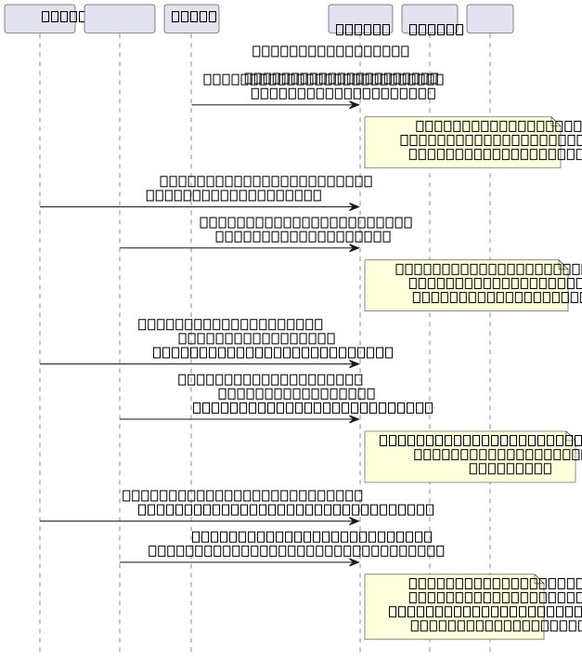
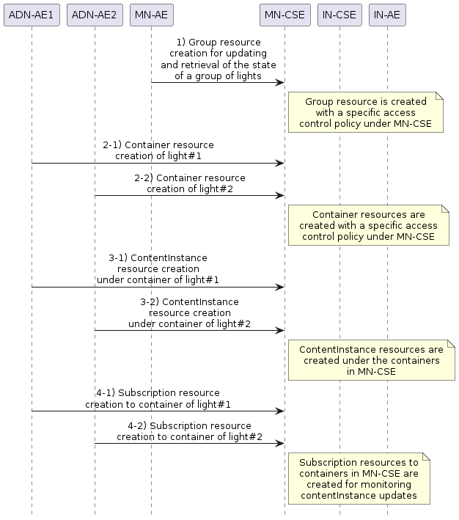
Figure 7.2.2-1: Initial resource creation phase call flows
----------------------- End of change 55 -----------------------

----------------------- Start of change 56 -----------------------

8.7.4.1 Light application ADN-AE1
The registration of ADN-AE1 with MN-CSE is shown in the following procedure. Note that the access control policy identifier (unstructured SP-relative resourceID) which is assigned to ADN-AE1 is /mn-cse/acp-805496226.
The following example shows an ADN-AE registration request and response using HTTP with XML serialization.
HTTP Request:
~~POST /home_gateway?rcn=0 HTTP/1.1~~
<span class="underline">POST /~/mn-cse/home_gateway?rcn=0 HTTP/1.1</span>
Host: mn.provider.com:8080
X-M2M-Origin: C
Content-Type: application/xml;ty=2
X-M2M-RI: mncse-92345
<span class="underline">X-M2M-RVI: 4</span>
<xml version="1.0" encoding="UTF-8"?>
<m2m:ae xmlns:m2m="http://www.onem2m.org/xml/protocols" rn="light_ae1">
~~<api>A01.com.company.lightApp1</api>~~
<span class="underline"><api>NA01.com.company.lightApp1</api></span>
<rr>true</rr>
<poa>http://192.168.0.10:9090</poa>
<span class="underline"><srv>4</srv></span>
<acpi>/mn-cse/acp-805496226</acpi>
</m2m:ae>
HTTP Response:
201 Created
X-M2M-RSC: 2001
X-M2M-RI: mncse-92345
~~Content-Location: /mn-cse/ae-CAE340304071~~
<span class="underline">X-M2M-RVI: 4</span>
The following example shows an ADN-AE registration request and response using HTTP with JSON serialization.
HTTP Request:
~~POST /home_gateway?rcn=0 HTTP/1.1~~
<span class="underline">POST /~/mn-cse/home_gateway?rcn=0 HTTP/1.1</span>
Host: mn.provider.com:8080#
X-M2M-Origin: C
Content-Type: application/json;ty=2
X-M2M-RI: mncse-92345
<span class="underline">X-M2M-RVI: 4</span>
{
"m2m:ae": {
"rn": "light_ae1",
~~"api": "A01.com.company.lightApp1",~~
<span class="underline">"api": "NA01.com.company.lightApp1",</span>
"rr": true,
"poa": [
"http://192.168.0.10:9090"
],
<span class="underline">"srv": [ "4"],</span>
"acpi": [
"/mn-cse/acp-805496226"
]
}
}
HTTP Response:
201 Created
X-M2M-RSC: 2001
X-M2M-RI: mncse-92345
~~Content-Location: /mn-cse/ae-CAE340304071~~
<span class="underline">X-M2M-RVI: 4</span>
----------------------- End of change 56 -----------------------

----------------------- Start of change 57 -----------------------

Annex A.7.1 Container under ADN-AE1
HTTP Request:
GET /~/mn-cse/home_gateway/light_ae1/light HTTP/1.1
Host: mn.provider.com:8080
X-M2M-Origin: /mn-cse/Cgateway_ae
X-M2M-RI: mncse-12351
<span class="underline">X-M2M-RVI: 4</span>
Accept: application/xml
HTTP Response:
200 OK
X-M2M-RSC: 2000
X-M2M-RI: mncse-12351
<span class="underline">X-M2M-RVI: 4</span>
Content-Type: application/xml
<?xml version="1.0" encoding="UTF-8" standalone="yes"?>
<m2m:cnt xmlns:m2m="http://www.onem2m.org/xml/protocols" rn="light">
<ty>3</ty>
<ri>cnt-582759912</ri>
<pi>/mn-cse/ae-CAE340304071</pi>
<ct>20150925T052955</ct>
<lt>20150925T052955</lt>
<et>20171005T105550</et>
<acpi>/mn-cse/acp-805496226</acpi>
<st>0</st>
<cni>1</cni>
<cbs>3</cbs>
</m2m:cnt>
----------------------- End of change 57 -----------------------

----------------------- Start of change 58 -----------------------

2.1 Normative references

Normative references are not applicable in the present document.
----------------------- End of change 58 -----------------------

----------------------- Start of change 59 -----------------------

2.2 Informative references

The following referenced documents are not necessary for the application of the present document but they assist the user with regard to a particular subject area.
- [i.1] oneM2M Drafting Rules
> NOTE: Available at http://www.onem2m.org/images/files/oneM2M-Drafting-Rules.pdf
- [i.2] oneM2M TS-0001 (V12.12.1): “Functional Architecture”.
- [i.3] oneM2M TS-0004 (V2.9.0): “Service Layer Core protocol Specification”.
- [i.4] oneM2M TS-0009 (V2.8.0): “HTTP Protocol Binding”.
- [i.5] oneM2M TS-0011: “Common Terminology”.
----------------------- End of change 59 -----------------------

----------------------- Start of change 60 -----------------------

8.7.11.1 Introduction
Once the smartphone application is registered with the IN-CSE, it can be granted access to resources including containers located in the MN-CSE so that smartphone application users can send light control commands for modifying the light states.
When the user makes a change to the light state via the smartphone user interface, the smartphone application performs a new content instance creation procedure carrying the new state.

The modification of a single light state is implemented by creating a new content instance resource for the specific container with access control policy acp1 (gateway_acp) while the modification of all light states is implemented by creating a new content instance resource for each member of group (containers_grp) with access control policy acp1 (gateway_acp). The implementation of the latter case is to target the fopt virtual resource of containers_grp resource with a content instance create request so that the content of all members of the group is updated together.
----------------------- End of change 60 -----------------------

----------------------- Start of change 61 -----------------------

Annex A.9.2 Subscription to container in ADN-AE2
HTTP Request:
GET /~/mn-cse/home_gateway/light_ae2/light/lightstate_sub2 HTTP/1.1
Host: mn.provider.com:8080
X-M2M-Origin: /mn-cse/Cgateway_ae
X-M2M-RI: mncse-12356
<span class="underline">X-M2M-RVI: 4</span>
Accept: application/xml
HTTP Response:
200 OK
X-M2M-RSC: 2000
X-M2M-RI: mncse-12356
<span class="underline">X-M2M-RVI: 4</span>
Content-Type: application/xml
<?xml version="1.0" encoding="UTF-8" standalone="yes"?>
<m2m:sub xmlns:m2m="http://www.onem2m.org/xml/protocols" rn="lightstate_sub2">
<ty>23</ty>
<ri>sub-856463728</ri>
<pi>/mn-cse/cnt-582759912</pi>
<ct>20150926T053055</ct>
<lt>20150926T053055</lt>
<et>20171005T105550</et>
<acpi>/mn-cse/acp-805496226</acpi>
<enc>
<net>3</net>
</enc>
<nu>/mn-cse/ae-CAE340304042</nu>
<nct>1</nct>
</m2m:sub>
----------------------- End of change 61 -----------------------

----------------------- Start of change 62 -----------------------

8.7.2 MN-CSE registration
The implementation starts with the registration of MN-CSE with IN-CSE as shown in the following procedure.
It is assumed that the an ACP resource acp-666957710 exists on the IN-CSE.
The following example shows the MN-CSE registration request and response using XML serialization.
HTTP Request:
POST /~/in-cse/server?rcn=0 HTTP/1.1
Host: in.provider.com:8080
X-M2M-Origin: /mn-cse
Content-Type: application/xml;ty=16
X-M2M-RI: incse-88643
<span class="underline">X-M2M-RVI: 4</span>
<?xml version="1.0" encoding="UTF-8"?>
<m2m:csr xmlns:m2m="http://www.onem2m.org/xml/protocols" rn="home_gateway">
~~<csi>mn-cse&lt;/csi>~~
~~<cb>mn.provider.com/mn-cse</cb>~~
<span class="underline"><csi>mn-cse</csi></span>
<span class="underline"><cb>//mn.provider.com/mn-cse</cb></span>
<rr>true</rr>
<poa>http://mn.provider.com:8080</poa>
<cst>2</cst>
<span class="underline"><srv>4</srv></span>
<acpi>/in-cse/acp-666957710</acpi>
</m2m:csr>
HTTP Response:
201 Created
X-M2M-RSC: 2001
X-M2M-RI: incse-88643
~~Content-Location: /in-cse/csr-299409504~~
<span class="underline">X-M2M-RVI: 4</span>

The following example shows the MN-CSE registration request and response using HTTP with JSON serialization.
HTTP Request:
POST /~/in-cse/server?rcn=0 HTTP/1.1
Host: in.provider.com:8080
X-M2M-Origin: /mn-cse
Content-Type: application/json;ty=16
X-M2M-RI: incse-88643
<span class="underline">X-M2M-RVI: 4</span>
{
"m2m:csr": {
"rn": "home_gateway",
"csi": "mn-cse",
~~"cb": "mn.provider.com/mn-cse",~~
<span class="underline">"cb": "//mn.provider.com/mn-cse",</span>
"rr": true,
"poa": [
"http://mn.provider.com:8080"
],
"cst": 2,
<span class="underline">"srv": [ "4" ],</span>
"acpi": [
"/in-cse/acp-666957710"
]
}
}
HTTP Response:
201 Created
X-M2M-RSC: 2001
X-M2M-RI: incse-88643
~~Content-Location: /in-cse/csr-299409504~~
<span class="underline">X-M2M-RVI: 4</span>
----------------------- End of change 62 -----------------------

----------------------- Start of change 63 -----------------------

Annex A.6 Access control policy
HTTP Request:
GET /~/mn-cse/home_gateway/gateway_acp HTTP/1.1
Host: mn.provider.com:8080
X-M2M-Origin: /mn-cse/Cgateway_ae
X-M2M-RI: mncse-12350
<span class="underline">X-M2M-RVI: 4</span>
Accept: application/xml
HTTP Response:
200 OK
X-M2M-RSC: 2000
X-M2M-RI: mncse-12350
<span class="underline">X-M2M-RVI: 4</span>
Content-Type: application/xml
<?xml version="1.0" encoding="UTF-8" standalone="yes"?>
<m2m:acp xmlns:m2m="http://www.onem2m.org/xml/protocols" rn="gateway_acp">
<ty>1</ty>
<ri>acp-805496226</ri>
<pi>/mn-cse</pi>
<ct>20150925T050238</ct>
<lt>20150925T050238</lt>
<et>20171005T105550</et>
<pv>
<acr>
<acor>/in-cse/home_gateway /mn-cse/Cgateway_ae /mn-cse/Clight_ae1 /mn-cse/Clight_ae2 /in-cse/Csmartphone_ae</acor>
<acop>63</acop>
</acr>
</pv>
<pvs>
<acr>
<acor>/in-cse/home_gateway /mn-cse/Cgateway_ae /mn-cse/Clight_ae1 /mn-cse/Clight_ae2 /in-cse/Csmartphone_ae</acor>
<acop>51</acop>
</acr>
</pvs>
</m2m:acp>
----------------------- End of change 63 -----------------------

----------------------- Start of change 64 -----------------------

8.7.5.1 Create a container of ADN-AE1
The creation of a container resource for ADN-AE1 is shown in the following procedure.
The following example shows a container create request and response using HTTP with XML serialization.

HTTP Request:
~~POST /home_gateway/light\_ae1?rcn=0 HTTP/1.1~~
<span class="underline">POST /~/mn-cse/home_gateway/light_ae1?rcn=0 HTTP/1.1</span>
Host: mn.provider.com:8080
X-M2M-Origin: Clight_ae1
Content-Type: application/xml;ty=3
X-M2M-RI: mncse/13345
<span class="underline">X-M2M-RVI: 4</span>
<span class="underline"><?xml version="1.0" encoding="UTF-8"?></span>
<m2m:cnt xmlns:m2m="http://www.onem2m.org/xml/protocols" rn="light">
</m2m:cnt>
HTTP Response:
201 Created
X-M2M-RSC: 2001
X-M2M-RI: mncse-13345
~~Content-Location: /mn-cse/cnt-582759912~~
<span class="underline">X-M2M-RVI: 4</span>
The following example shows a container create request and response using HTTP with JSON serialization.
HTTP Request:
~~POST /home\_gateway/light_ae1?rcn=0 HTTP/1.1~~
<span class="underline">POST /~/mn-cse/home_gateway/light_ae1?rcn=0 HTTP/1.1</span>
Host: mn.provider.com:8080
X-M2M-Origin: Clight_ae1
Content-Type: application/json;ty=3
X-M2M-RI: mncse-13345
<span class="underline">X-M2M-RVI: 4</span>
{
"m2m:cnt": {
"rn": "light"
}
}
HTTP Response:
201 Created
X-M2M-RSC: 2001
X-M2M-RI: mncse-13345
~~Content-Location: /mn-cse/cnt-582759912~~
<span class="underline">X-M2M-RVI: 4</span>
----------------------- End of change 64 -----------------------

----------------------- Start of change 65 -----------------------

8.2 Assumptions
Assumptions are presented as below in order to ensure the remote lights control use case can be correctly implemented.
- All the applications are server capable;
- Devices and application entites are independently addressable with host names resolved by DNS network services;
- Host port number 8080 is reserved for oneM2M services;
- Security is not considered in the current use case;
- HTTP binding of oneM2M primitives is used in the current use case;
- Both XML and JSON serializations of oneM2M primitives are used in the current use case;
- All mandatory HTTP headers are presented in the HTTP requests while optional headers are selectively used in the current use case;
- All mandatory resource attributes for resources presented in the current use case are presented in the HTTP requests while optional resource attributes are selectively used in the current use case;
- The IN-CSE and MN-CSE in the current use case are deployed within the same oneM2M Service Provider domain;
- All AEs in the current use case are initially registered with CSEs and the identifier of the AEs are assigned by the Registrar CSE of the AE accordinlgy, starting with a character of ‘C’;
- All resources created in the current use case are addressable with the oneM2M Resource Identifier form of Hierarchical address ;
- Short names for the representation of the resources and attributes are used in the current use case;
- Default access control policy has already been created under IN-CSE and it is used for MN-CSE registration with IN-CSE;
- All request originators send Blocking Requests for accessing resources located in CSEs.
----------------------- End of change 65 -----------------------

----------------------- Start of change 66 -----------------------

8.6.2 Home gateway application (MN-AE)

The home gateway application is modelled as an MN-AE and is responsible for
- initializing the home gateway device,
- creating an access control policy resource gateway_acp in the MN-CSE,
- registering the home gateway application with the MN-CSE,

- creating the group resource with access control policy gateway_acp in the MN-CSE, and
- discovering device applications registered with the MN-CSE.
----------------------- End of change 66 -----------------------

----------------------- Start of change 67 -----------------------

7.2.1 Application registration and Access control policy creation
Call flows regarding the registration phase depicted in figure 7.2.1-1 are ordered as follows:
- Gateway (MN-CSE) registers with the oneM2M service platform (IN-CSE).
- Gateway application (MN-AE) registers with the gateway (MN-CSE).
- Light applications (ADN-AE1 and ADN-AE2) register with the gateway (MN-CSE).
- Smartphone application (IN-AE) registers with the oneM2M service platform (IN-CSE).
- Gateway application (MN-AE) discovers the smartphone application (IN-AE) from gateway (MN-CSE) with specific filter criteria. The discovered IN-AE is granted access to the remote light control service containers.
- Gateway application (MN-AE) creates an accessControlPolicy resource granting all the entities playing roles in the current use case including ADN-AE1, ADN-AE2, MN-AE and IN-AE access to the created container and content instance resources.
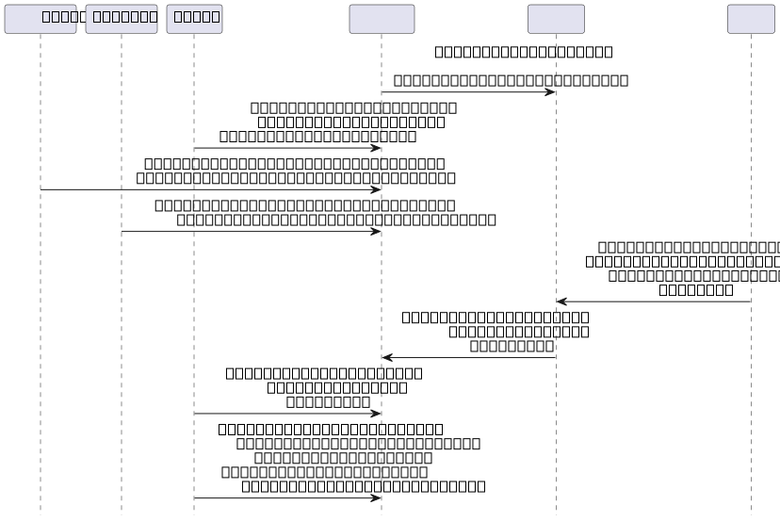
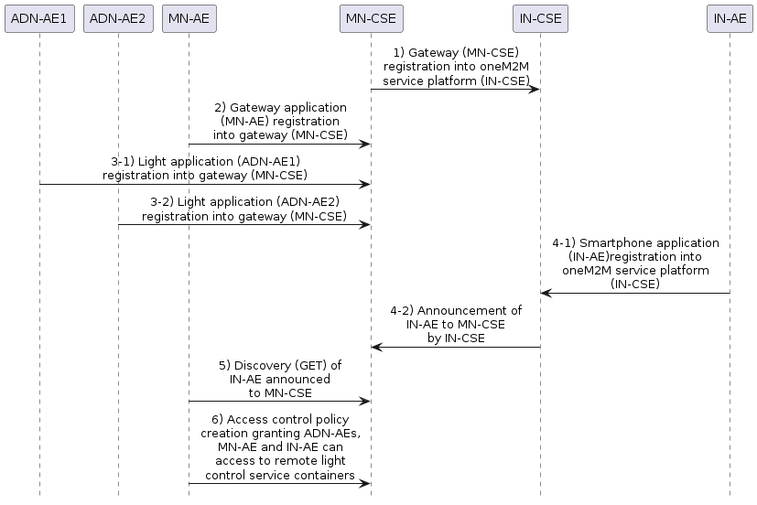
Figure 7.2.1-1: Registration phase call flows
----------------------- End of change 67 -----------------------

----------------------- Start of change 68 -----------------------

8.7.12.3 Post a notification to ADN-AE2
If the notification request body is represented in XML, the following is a HTTP request message example.
HTTP Request:
POST / HTTP/1.1
Host: 192.168.0.20:9090
X-M2M-Origin: /mn-cse
X-M2M-RI: notif-12346
<span class="underline">X-M2M-RVI: 4</span>
Content-Type: application/xml
<?xml version="1.0" encoding="UTF-8"?>
<m2m:sgn xmlns:m2m="http://www.onem2m.org/xml/protocols" rn="cin-256599578">
<nev>
<rep>
<m2m:cin>
<ty>4</ty>
<ri>cin-256599578</ri>
<pi>cnt-790965889</pi>
<ct>20150925T050623</ct>
<lt>20150925T050623</lt>
<et>20151107T154802</et>
<st>0</st>
<cnf>text/plain:0</cnf>
<cs>3</cs>
<con>ON</con>
</m2m:cin>
</rep>
<net>3</net>
</nev>
<sur>/mn-cse/sub-856463728</sur>
</m2m:sgn>
HTTP Response:
200 OK
X-M2M-RSC: 2000
X-M2M-RI: notif-12346
<span class="underline">X-M2M-RVI: 4</span>
If the notification request body is represented in JSON, the following is a HTTP request message example.
HTTP Request:
POST / HTTP/1.1
Host: 192.168.0.20:9090
X-M2M-Origin: /mn-cse
X-M2M-RI: notif-12346
<span class="underline">X-M2M-RVI: 4</span>
Content-Type: application/json
{
"m2m:sgn": {
"nev": {
"rep": {
"m2m:cin": {
"ty": 4,
"ri": "cin-256599578",
"pi": "cnt-790965889",
"ct": "20150925T050623",
"lt": "20150925T050623",
"et": "20151107T154802",
"st": 0,
"cnf": "text/plain:0",
"cs": 3,
"con": "ON"
}
},
"net": 3
},
"sur": "/mn-cse/sub-856463728"
}
}
HTTP Response:
200 OK
X-M2M-RSC: 2000
X-M2M-RI: notif-12346
<span class="underline">X-M2M-RVI: 4</span>
----------------------- End of change 68 -----------------------

----------------------- Start of change 69 -----------------------

8.7.8.1 Subscription to the content instance of ADN-AE1

When a subscription resource is created, the notification content type (shortname: nct ) parameter is set to a value 1 to indicate that all attributes of the subscribed resource will be notified to the subscriber.
ADN-AE1 creates a subscription resource including the notification URI set to the resource identifier of ADN-AE1 so that the ADN-AE1 will get notified whenever a content instance child resource is created in the container. The corresponding subscription create request is shown in the following procedure.
The following example shows a subscription create request and response using HTTP with XML serialization.
HTTP Request:
~~POST /home_gateway/light_ae1/light?rcn=0 HTTP/1.1~~
<span class="underline">POST /~/mn-cse/home_gateway/light_ae1/light?rcn=0 HTTP/1.1</span>
Host: mn.provider.com:8080
X-M2M-Origin: Clight_ae1
Content-Type: application/xml;ty=23
X-M2M-RI: mncse-67891
<span class="underline">X-M2M-RVI: 4</span>
<?xml version="1.0" encoding="UTF-8"?>
<m2m:sub xmlns:m2m="http://www.onem2m.org/xml/protocols" rn="lightstate_sub1">
<enc>
<net>3</net>
</enc>
<nu>Clight_ae1</nu>
<nct>1</nct>
</m2m:sub>
HTTP Response:
201 Created
X-M2M-RSC: 2001
X-M2M-RI: mncse-67891
~~Content-Location: /mn-cse/sub-856593979~~
<span class="underline">X-M2M-RVI: 4</span>
The following example shows a subscription create request and response using HTTP with JSON serialization.
HTTP Request:
~~POST /home_gateway/light_ae1/light?rcn=0 HTTP/1.1~~
<span class="underline">POST /~/mn-cse/home_gateway/light_ae1/light?rcn=0 HTTP/1.1</span>
Host: mn.provider.com:8080
X-M2M-Origin: Clight_ae1
Content-Type: application/json;ty=23
X-M2M-RI: mncse-67891
<span class="underline">X-M2M-RVI: 4</span>
{
"m2m:sub": {
"rn": "lightstate_sub1",
"enc": {
~~"net":<a href="#_ref_3">[~~
<span class="underline">"net":[</span>
3
~~]</a>~~
<span class="underline">]</span>
},
"nu": ["Clight_ae1"
],
"nct": 1
}
}
HTTP Response:
201 Created
X-M2M-RSC: 2001
X-M2M-RI: mncse-67891
~~Content-Location: /mn-cse/sub-856593979~~
<span class="underline">X-M2M-RVI: 4</span>
----------------------- End of change 69 -----------------------

----------------------- Start of change 70 -----------------------

Annex A.8.2 Latest contentInstance in ADN-AE2
HTTP Request:
GET /~/mn-cse/home_gateway/light_ae2/light/la HTTP/1.1
Host: mn.provider.com:8080
X-M2M-Origin: /mn-cse/Cgateway_ae
X-M2M-RI: mncse-12354
<span class="underline">X-M2M-RVI: 4</span>
Accept: application/xml
HTTP Response:
200 OK
X-M2M-RSC: 2000
X-M2M-RI: mncse-12354
<span class="underline">X-M2M-RVI: 4</span>
Content-Type: application/xml
<?xml version="1.0" encoding="UTF-8"?>
<m2m:cin xmlns:m2m="http://www.onem2m.org/xml/protocols" rn="cin-256599578">
<ty>4</ty>
<ri>cin-256599578</ri>
<pi>/mn-cse/cnt-582769893</pi>
<ct>20150925T053425</ct>
<lt>20150925T053425</lt>
<et>20171005T105550</et>
<st>0</st>
<cnf>text/plain:0</cnf>
<cs>2</cs>
<con>ON</con>
</m2m:cin>
----------------------- End of change 70 -----------------------

