ETSI TR 102 857 V0.3.2 (2013-06)
Technical Report
Machine to Machine Communications (M2M);
Use cases of M2M applications for Connected Consumer

Reference
DTR/M2M-00006
Keywords
Connected Consumer, Consumer Electronics, Embedded CE
ETSI
650 Route des Lucioles
F-06921 Sophia Antipolis Cedex - FRANCE

Tel.: +33 4 92 94 42 00 Fax: +33 4 93 65 47 16

Siret N° 348 623 562 00017 - NAF 742 C
Association à but non lucratif enregistrée à la
Sous-Préfecture de Grasse (06) N° 7803/88

Important notice
Individual copies of the present document can be downloaded from:
http://www.etsi.org
The present document may be made available in more than one electronic version or in print. In any case of existing or perceived difference in contents between such versions, the reference version is the Portable Document Format (PDF). In case of dispute, the reference shall be the printing on ETSI printers of the PDF version kept on a specific network drive within ETSI Secretariat.
Users of the present document should be aware that the document may be subject to revision or change of status. Information on the current status of this and other ETSI documents is available at http://portal.etsi.org/tb/status/status.asp
If you find errors in the present document, please send your comment to one of the following services:
http://portal.etsi.org/chaircor/ETSI_support.asp
Copyright Notification
No part may be reproduced except as authorized by written permission.
The copyright and the foregoing restriction extend to reproduction in all media.

© European Telecommunications Standards Institute yyyy.
All rights reserved.
DECTTM, PLUGTESTSTM, UMTSTM, TIPHONTM, the TIPHON logo and the ETSI logo are Trade Marks of ETSI registered for the benefit of its Members.
3GPPTM is a Trade Mark of ETSI registered for the benefit of its Members and of the 3GPP Organizational Partners.
LTE™ is a Trade Mark of ETSI currently being registered
for the benefit of its Members and of the 3GPP Organizational Partners.
GSM® and the GSM logo are Trade Marks registered and owned by the GSM Association.

Contents
Contents 3
Intellectual Property Rights 5
Foreword 5
1 Scope 6
2 References 6
2.1 Normative references 6
2.2 Informative references 6
3 Definitions, symbols and abbreviations 6
3.1 Definitions 6
3.2 Symbols 7
3.3 Abbreviations 7
4 M2M applications for Connected Consumer 7
4.1 General description of M2M applications for Connected Consumer 7
4.2 Specific examples for M2M applications for Connected Consumer 7
5 Use cases for connected consumer 7
5.1 Overview 7
5.1.1 Structure of the description for each Use Case 7
5.1.1.1 General Use Case Description 8
5.1.1.2 Stakeholders 8
5.1.1.3 Scenario 8
5.1.1.4 Information Exchanges 8
5.1.1.5 Potential new requirements 8
5.1.1.6 Use case source 8
5.2 Detailed use cases 8
5.2.1 Use Case 1 : Photo uploading from still camera 8
5.2.1.1 General Use Case Description 8
5.2.1.2 Stakeholders 9
5.2.1.3 Scenario 9
5.2.1.4 Information Exchanges 10
5.2.1.5 Potential new requirements 10
5.2.1.6 Use case source 10
5.2.2 Use Case 2 : Contents download to eBook reader device 11
5.2.2.1 General Use Case Description 11
5.2.2.2 Stakeholders 11
5.2.2.3 Scenario 12
5.2.2.4 Information Exchanges 12
5.2.2.5 Potential new requirements 12
5.2.2.6 Use case source 12
5.2.3 Use Case 3: Remote Control of Home Appliance 13
5.2.3.1 Stakeholders 13
5.2.3.2 Scenario 14
5.2.3.3 Information Exchanges 14
5.2.3.4 Potential new requirements 14
5.2.3.5 Use case source 15
5.2.4 Use Case 4: Surveillance Data Uploading 15
5.2.4.1 Stakeholders 16
5.2.4.2 Scenario 16
5.2.4.3 Information Exchanges 17
5.2.4.4 Potential new requirements 17
5.2.4.5 Use case source 17
5.2.5 Use Case 5: Inventory Management 18
5.2.5.1 Stakeholders 18
5.2.5.2 Scenario 19
5.2.4.3 Information Exchanges 19
5.2.5.4 Potential new requirements 19
5.2.5.5 Use case source 20
5.3 Potential requirements resulting from use cases 20
Annex <A>: Title of annex 20
A.1 First clause of the annex 20
A.1.1 First subdivided clause of the annex 20
Annex <y>: Bibliography 21
History 22

Intellectual Property Rights
IPRs essential or potentially essential to the present document may have been declared to ETSI. The information pertaining to these essential IPRs, if any, is publicly available for ETSI members and non-members, and can be found in ETSI SR 000 314: "Intellectual Property Rights (IPRs); Essential, or potentially Essential, IPRs notified to ETSI in respect of ETSI standards", which is available from the ETSI Secretariat. Latest updates are available on the ETSI Web server (http://webapp.etsi.org/IPR/home.asp).
Pursuant to the ETSI IPR Policy, no investigation, including IPR searches, has been carried out by ETSI. No guarantee can be given as to the existence of other IPRs not referenced in ETSI SR 000 314 (or the updates on the ETSI Web server) which are, or may be, or may become, essential to the present document.

Foreword
This Technical Report (TR) has been produced by ETSI Technical Committee Machine to Machine Communications (M2M).
The present document may be referenced by other TRs and Technical Standards (TS) developed by ETSI TC M2M. The present document is a TR and therefore, the content is informative, but when this TR is referenced by a TS, the referenced clauses may become normative with respect to the content of the referencing TS.

1 Scope
The present document includes Use Case descriptions for Connected Consumer applications in context of Machine-to-Machine (M2M) communications. The described Use Cases will be used to derive service requirements and capabilities of the functional architecture specified in ETSI TC M2M.

2 References
References are either specific (identified by date of publication and/or edition number or version number) or non-specific.
- For a specific reference, subsequent revisions do not apply.
- Non-specific reference may be made only to a complete document or a part thereof and only in the following cases:
- if it is accepted that it will be possible to use all future changes of the referenced document for the purposes of the referring document;
- for informative references.
Referenced documents which are not found to be publicly available in the expected location might be found at http://docbox.etsi.org/Reference.
NOTE: While any hyperlinks included in this clause were valid at the time of publication ETSI cannot guarantee their long term validity.

2.1 Normative references
The following referenced documents are indispensable for the application of the present document. For dated references, only the edition cited applies. For non-specific references, the latest edition of the referenced document (including any amendments) applies.
[1] ETSI TS 102 689: " Machine to Machine Communications (M2M); M2M Service Requirements".
[2] ETSI EN zzz zzz: "title".

2.2 Informative references
The following referenced documents are not essential to the use of the present document but they assist the user with regard to a particular subject area. For non-specific references, the latest version of the referenced document (including any amendments) applies.
[i.1] ETSI TR 102 725: " Machine to Machine Communications (M2M); Definitions".
[i.2] ….

3 Definitions, symbols and abbreviations

3.1 Definitions
Connected Consumer: Generic terminology describing a class of applications that serve the purpose of improving life style of human in the aspects of conveniences and entertainments by means of the communication capability embedded consumer electronics and consumer devices in the terms of machine-to-machine technology.

3.2 Symbols
For the purposes of the present document, the following symbols apply:
<symbol> <Explanation>
<2nd symbol> <2nd Explanation>
<3rd symbol> <3rd Explanation>

3.3 Abbreviations
For the purposes of the present document, the following abbreviations apply:
M2M Machine-to-Machine (Communications)
CE Consumer Electronics
<ACRONYM2> <Explanation>
<ACRONYM3> <Explanation>

5 M2M Use cases for connected consumer

‘Connected Consumer’ referred to in this Report is a human equipped with communication means that allow monitoring and controlling of devices, and possibly sharing contents with other humans, via M2M applications.
Use cases described below extend from leisure use cases to security use cases, and also include home automation use cases.

5.1 Use Case 1 : Photo uploading from still camera

5.1.1 General Use Case Description
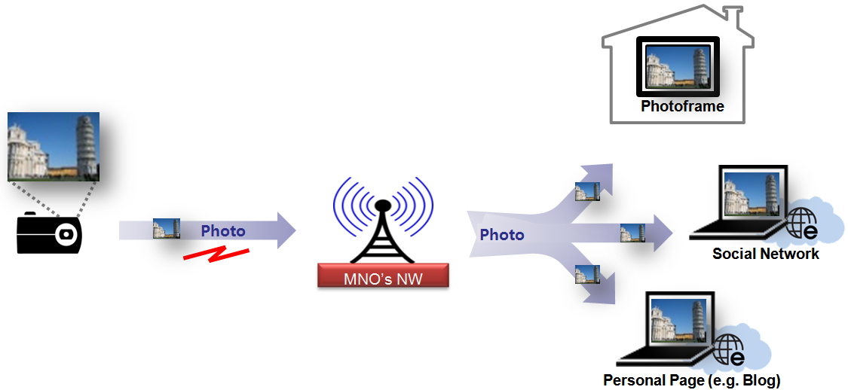
Figure 1: Photo uploading from still camera use case
This section describes the use case where a user is uploading a photo he/she has taken during her holidays to different social networks and also to her family photoframe at his/her house.

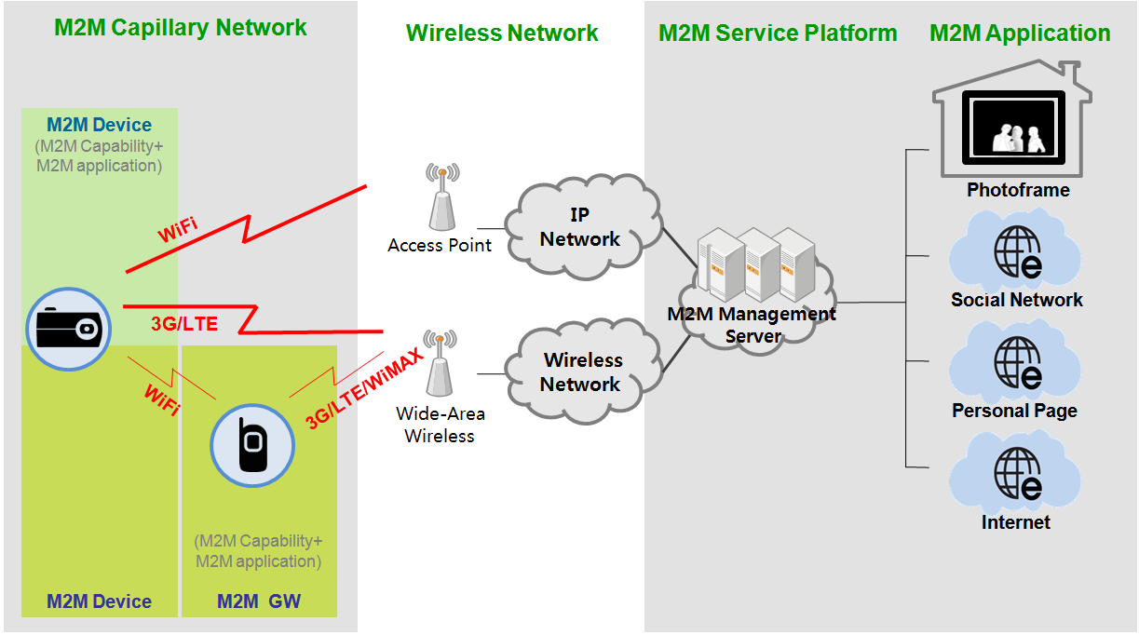
Figure 2: Generic framework for data uploading

5.1.2 Stakeholders
Holiday maker: The “holiday maker” is an individual, who could use the still camera with uploading capabilities to upload photos from his/her holidays to different social networking websites he/she is subscriber and also at a photoframe device that is residing at his/her house. This way other friends and family members will be able to see the photo instantaneously as it appears.

Still camera with uploading capabilities: Digital camera with uploading capabilities which acts like an M2M device with wireless network capabilities, user interface and interface into the M2M network. The device takes photos and uploads them to the different social networks the user is subscribed to or to photoframe where the user wants to send the pictures. Low power, low complexity protocols are likely required for these devices.

M2M service capability provider: Network entity that provides M2M communication services to the M2M application entities. These applications may support specific functional capabilities which assist in facilitating uploading of pictures from the still camera M2M device to the network. Additionally, the M2M service capability provider communicates with the social networking websites and the photoframe in order to adapt the photo to the requirements that are needed to be displayed at each one of them.
M2M application entity: Term created to bundle together, and treat as a single system element, stakeholders above the M2M scope. High-level application such as social networking websites, photoframe devices etc that receive the photos from the M2M service capability provider and display them for consumption by third party users (e.g. friends of the holiday maker).
Friends of the holiday maker: These are individuals, who are able to access the application entity either virtually e.g. through a website or physically if they are in the close proximity of the photoframe and they are able to see the photos that have been uploaded from the holiday maker.

5.1.3 Scenario
Initialization
The still camera with M2M device capabilities is attaching to the wireless network and performs registration in the M2M system. Registration includes the capability to maintain information describing the still camera device capabilities (e.g. model type, resolution etc), the user of the device, and the M2M application that will be used in order to display the data (e.g. social networking website-1, social networking website-2). For example, this may include registering the device with the manufacturer or data intermediary and performing other functions to uniquely identify the device. Registration may also include registering data that can be used to verify the state of the still camera by the M2M service capability provider.
Photo uploading
The photo uploading includes the tasks that the holiday maker takes a photo or even selects a photo from its already stored album photos and selects to upload it to a number of social networking websites that is subscribed to and also the photoframe that is at his/her home. The holiday maker after it selects the photo he/she wants to upload then chooses the appropriate destinations (e.g. social networking website-1, social networking website-2, my photoframe). Then he/she starts the uploading of the photo procedure.
Photo Display
The M2M service capability entity after it receives the photo from the still camera with M2M device capabilities and the destinations it is required to upload the photo, it adapts the photo to appropriate specifications for it to be displayed in the right format e.g. file type , resolution etc. Then it sends the photo to the appropriate M2M application entities that have been indicated in the destination list. The M2M application entities that are indicated display the photo in the right format and the friends of the holiday maker are able to access it and see it.

5.1.4 Information Exchanges
Registration
The still camera with M2M device capabilities is attaching to the wireless network and performs registration in the M2M system. Registration includes the capability to maintain information describing the still camera device capabilities (e.g. model type, resolution etc), the user of the device, and the M2M application that will be used in order to display the data (e.g. social networking website-1, social networking website-2). For example, this may include registering the device with the manufacturer or data intermediary and performing other functions to uniquely identify the device. Registration may also include registering data that can be used to verify the state of the still camera by the M2M service capability provider.
Photo Uploading
Capability to upload the photo to the M2M system from the still camera device with M2M capabilities.
Data Delivery
Capability to securely deliver data to the intended device (e.g. photoframe) or M2M application entity (e.g. social networking website) in the appropriate format and confirm delivery. .

5. 1.5 Potential new requirements
No potential new requirements identified.

5.2 Use Case 2 : Contents download to eBook reader device

5.2.1 General Use Case Description
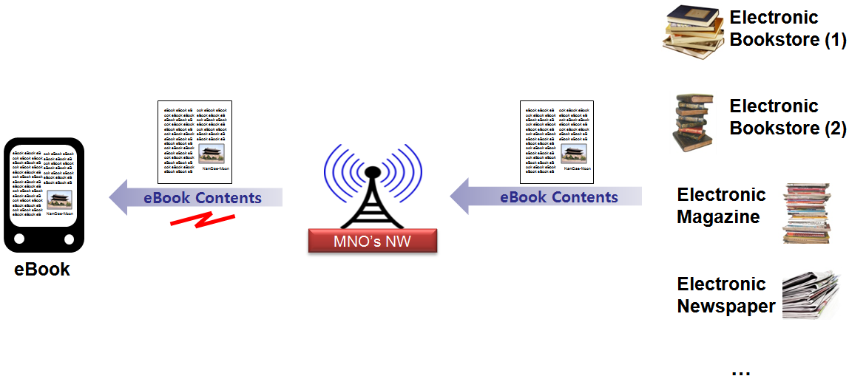
Figure 3: Electronic book download to eBook reader device
This section describes the use case where a user is downloading book or magazine or newspaper content in his/her eBook reader device in electronic format from several different suppliers e.g. electronic bookstores or content providers.

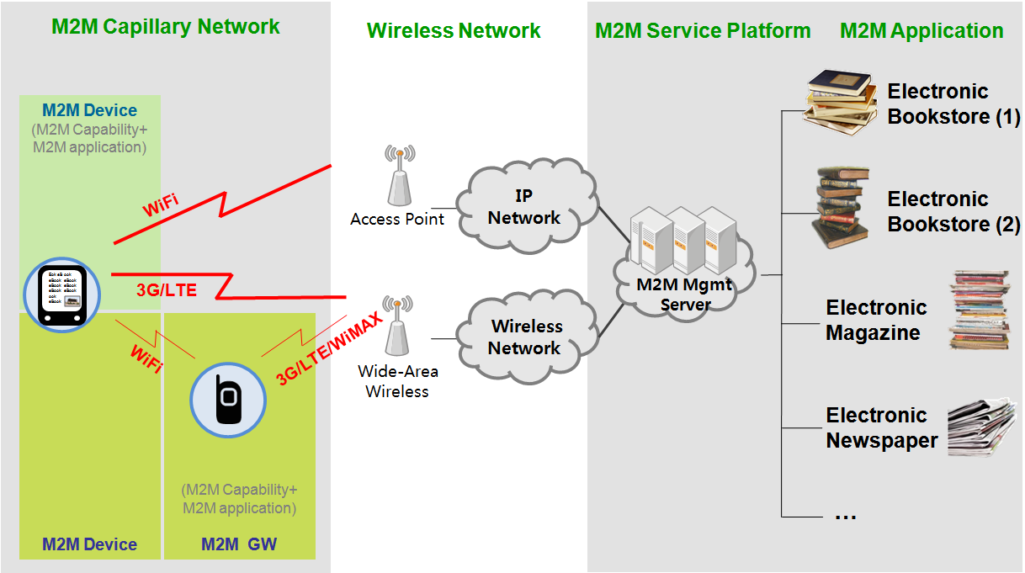
Figure 4: Generic framework for data downloading

5.2.2 Stakeholders
Book reader: The “book reader” is an individual, who could use the eBook reader device with downloading capabilities to content e.g. book or magazine material from different electronic bookstores or newspapers/magazines he/she is subscriber.

eBook reader device with downloading capabilities: eBook reader device with downloading capabilities which acts like an M2M device with wireless network capabilities, user interface and interface into the M2M network. The device downloads content from different content supplier websites, stores it and displays it to the book reader. Low power, low complexity protocols are likely required for these devices.

M2M service capability provider: Network entity that provides M2M communication services to the M2M application entities. These applications may support specific functional capabilities which assist in facilitating downloading content e.g. book material, news content, magazine articles. Additionally, the M2M service capability provider communicates with the third parties that supply the content in order to adapt the content to the requirements that are needed to be displayed to the type of eBook reader device that is downloading the content.
M2M application entity: Term created to bundle together, and treat as a single system element, stakeholders above the M2M scope. High-level application such as electronic bookstore websites, electronic news content suppliers etc that supply the content to the eBook reader device with M2M device capabilities.

5.2.3 Scenario
Initialization
The eBook reader device with M2M device capabilities is attaching to the wireless network and performs registration in the M2M system. Registration includes the capability to maintain information describing the eBook reader device capabilities (e.g. model type, resolution, file format, screen type etc), the user of the device, and the M2M application that will be used in order to display the data (e.g. bookstore-1 or newspaper-2). For example, this may include registering the device with the manufacturer or data intermediary and performing other functions to uniquely identify the device. Registration may also include registering data that can be used to verify the state of the eBook reader device by the M2M service capability provider.
Electronic book content downloading
The electronic book content downloading includes the tasks that the book reader selects the book from the list of supplied books from the electronic bookstore provider and selects the book to download. The book reader after he/she selects the electronic book he/she wants to download then chooses the appropriate format e.g. rich content with photos and embedded videos. Then he/she starts the downloading of the electronic book procedure.
Electronic book display and storage
The M2M service capability entity after it receives the request from the eBook reader device with M2M device capabilities, the book that is required to be downloaded and the destinations it is required to download from,. Sends the request to the appropriate M2M application entities that have been indicated in the destination list. The M2M application entities that are indicated provide the electronic book format and then the M2M service capability entity adapts the book content to appropriate specifications for it to be displayed in the right format e.g. file type, dimensions etc..

5.2.4 Information Exchanges
Registration
The eBook reader device with M2M device capabilities is attaching to the wireless network and performs registration in the M2M system. Registration includes the capability to maintain information describing the eBook reader device capabilities (e.g. model type, resolution etc), the user of the device, and the M2M application that will be used in order to display the data (e.g. electronic bookstore-1, electronic bookstore-2). For example, this may include registering the device with the manufacturer or data intermediary and performing other functions to uniquely identify the device. Registration may also include registering data that can be used to verify the state of the eBook reader device by the M2M service capability provider.
Book downloading
Capability to download the electronic book from the M2M system to the eBook reader device with M2M capabilities.

5.2.5 Potential new requirements
No potential new requirements identified.

5.3 Use Case 3: Remote Control of Home Appliance
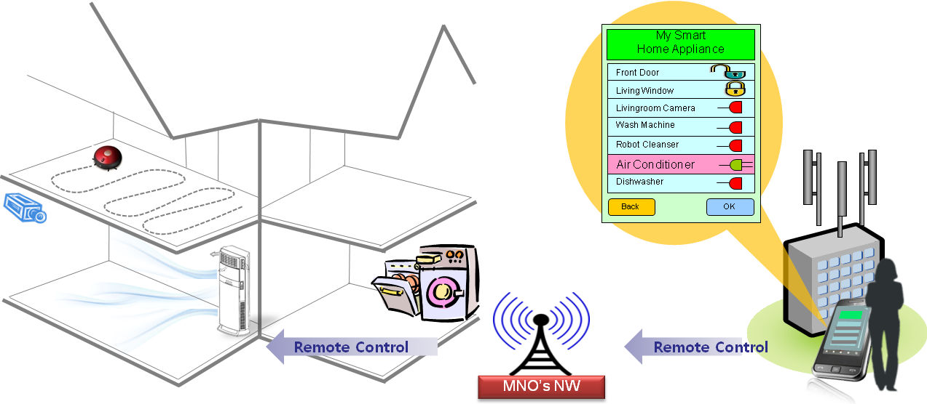
Figure 5: Remote Control of Home Appliances
This section describes the use case where a user is requesting a remote controlling of home appliances when he/she is outside house. For example, when it is too cold outside and the user wants to make his/her house warm before he/she returns home, he/she can turn on the air-conditioner by remote control device.

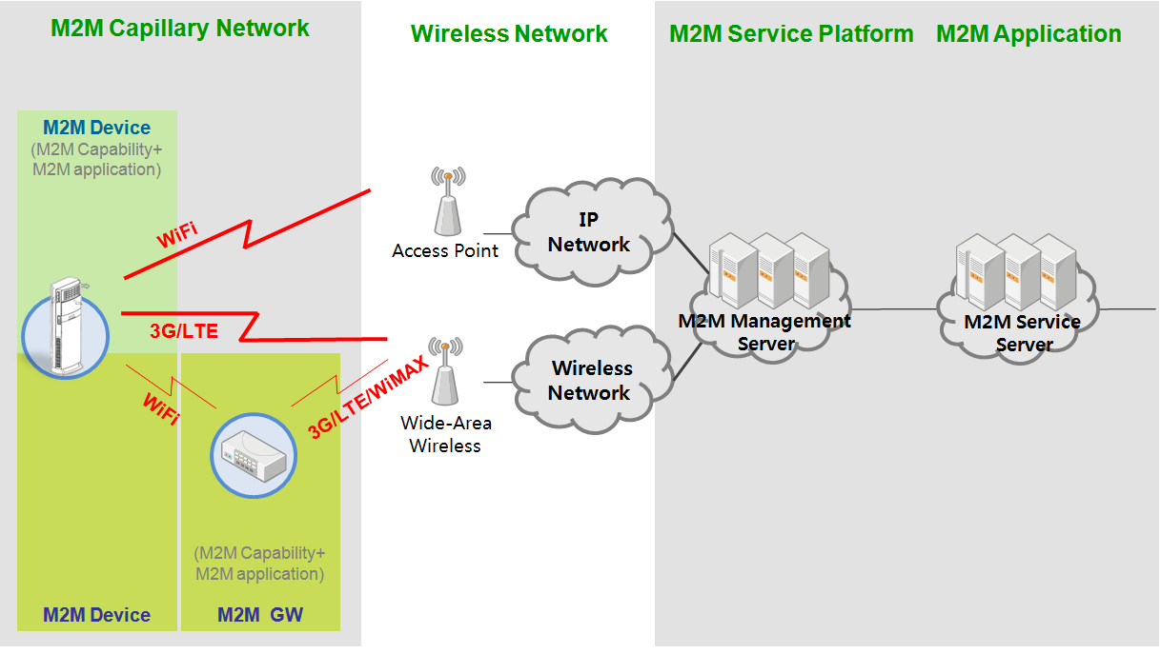
Figure 6: Example of High-level Architecture for Remote Control of Home Appliances

5.3.1 Stakeholders
Home appliance with communication capabilities: Home appliance with the communication capabilities which acts like an M2M devices with wireless network capabilities, interface and user interface into the M2M network. This M2M device can be operated by the remote control user via wireless network and it can be directly connected to the wireless network or can be connected via the M2M gateway to the wireless network.

Remote control user: The remote controlling user is an individual, who have authorization to remotely control his/her home appliances with his/her devices (e.g. handheld devices, note-pc, etc.).

M2M service capability provider: Network entity that provides M2M communication services to the M2M application entities. These applications may support specific functional capabilities which assist in communicating for remote control of home appliances with communication capabilities by remote controlling user.

M2M application entity: Term created to bundle together, and treat as a single system element, stakeholders above the M2M scope. High-level application such as remote service web-site, home appliances and personal devices with the remote control capabilities that sends and receives a command of remote control, that sends and receives the result of remote control and that displays the result of remote control.

5.3.2 Scenario
Initialization
The home appliances with the M2M device capabilities are directly attaching to the wireless network and perform registration in the M2M system. Or they setup the connection with the M2M gateway.
Registration includes the capability to maintain information describing the home appliances with the M2M device capabilities (e.g. the type of home appliances, etc.).

Request a Remote Operation
The remote control user using the handset or the PC sends a request to turn on or turn off the home appliance remotely. The result of the requested operation is returned to the remote control user from the home appliance with M2M capabilities via wireless network.

5.3.3 Information Exchanges
Registration
The home appliances with the M2M device capabilities are directly attaching to the wireless network and perform registration in the M2M system. Registration includes the capability to maintain information describing the home appliances with the M2M device capabilities (e.g. the type of home appliances, etc.).

Remote control Request
Remote control user sends a control message to the home appliance with M2M capabilities via the wireless network.

Remote control Response
Remote control user receives a result of the requested remote control from the home appliances with M2M capabilities.

5. 3.4 Potential new requirements
For the remote control of Home Appliance use cases, it shall support the below requirements:
- A M2M device should be able to register it’s capability information (e.g. access technology, its serial number, its accessible address, allowed user list, etc.) to the M2M System.
- M2M devices and M2M gateways should be able to perform access control that checks the access right of end-user, M2M device, M2M gateway who try to access the M2M device directly or via the M2M gateway or M2M System should be alternatively able to perform the access control of M2M devices.
- M2M devices and M2M gateways should be able to manage the scheduling of multiple accesses that multiple remote parties (i.e. end-users, M2M devices or M2M applications in M2M network, etc.) try to access one M2M device or one M2M gateway simultaneously.

5.4 Use Case 4: Surveillance Data Uploading
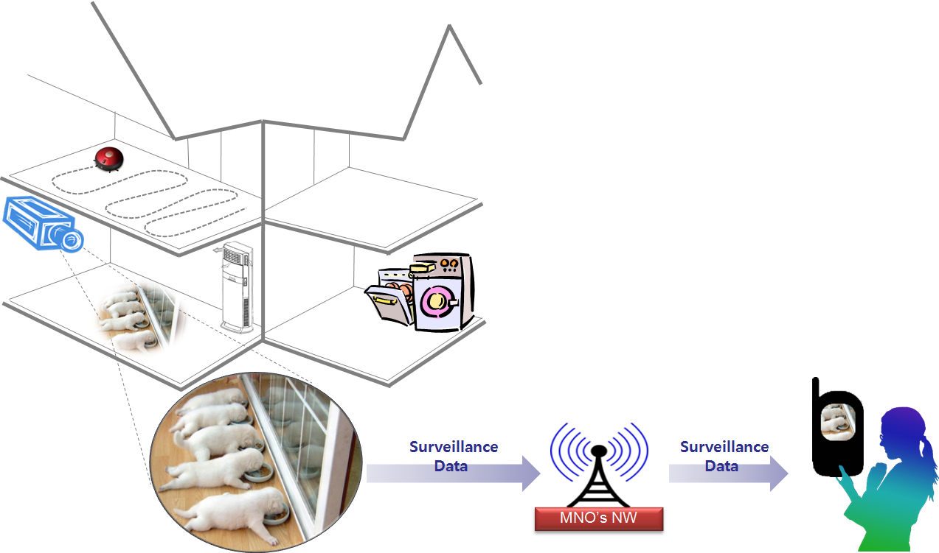
Figure 7: Surveillance Data Uploading Use Case

This section describes the use case where a user is requesting a video streaming data from the surveillance camera has taken his/her puppies during he/she is not at home.

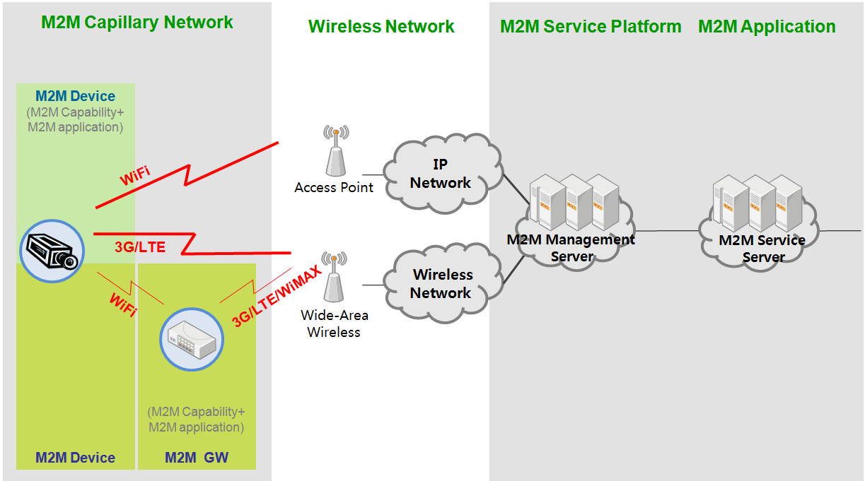
Figure 8: Example of High-level Architecture for Surveillance Data Uploading

5.4.1 Stakeholders
Surveillance camera with uploading capabilities: Surveillance camera with uploading capabilities which acts like an M2M device with wireless network capabilities, interface and user interface into the M2M network. The device records a real-time event, periodic events or scheduled events and uploads them to the Surveillance Data Requestor via wireless network. The surveillance camera with uploading capabilities may connect to M2M gateway for communication with the surveillance video requester.

Surveillance video requester: The “Surveillance video requestor” is an individual, who could trigger the surveillance video streaming data’s downloading to his/her personal devices, e.g. handset or smart-phone at outside, note-pc or lab-top at his work place and so on. This way will make them to see whether their puppies or children are safe when he/she is not at home.

M2M service capability provider: Network entity that provides M2M communication services to the M2M application entities. These applications may support specific functional capabilities which assist in facilitating uploading of video streaming data from the surveillance camera (i.e. M2M device) to the network. Additionally, the M2M service capability provider communicates with the personal handheld devices or with the personal computing devices in order to adapt the video streaming to the requirements that are needed to be displayed at the each device of them and to forward the video streaming to the surveillance video requestor.

M2M application entity: Term created to bundle together, and treat as a single system element, stakeholders above the M2M scope. High-level application such as surveillance video-sharing website, personal devices etc that receive and display the surveillance video streaming from the M2M service capability provider.

5.4.2 Scenario
Initialization
The surveillance camera with M2M device capabilities is attaching to the wireless network and performs registration in the M2M system when it turns on or it receives a request of surveillance video streaming. Registration includes the capability to maintain information describing the surveillance camera device’s capabilities (e.g. model type, resolution, codec, etc.), the registered user of device, the M2M application that will be used in order to record, store, forward the video streaming data.

Surveillance data recording and uploading
The video data recording and uploading includes the task that the surveillance camera with uploading capabilities receives a request to send the recorded-and-stored video streaming data or the real-time video streaming data which contains the activities of the surveillance video requester’s puppies or children at his/her house to his/her personal devices (e.g. handheld phone/smart-phone, note-pc, lab-top, etc.). After selecting the video or taking a real-time video streaming, the surveillance camera returns the video streaming data to the surveillance video requester. Then it starts the uploading of the surveillance video data.

Surveillance data display
The M2M service capability entity after it receives the video streaming data from the surveillance camera with M2M device capabilities and the destinations it is required to forward a video, it adapts the video to appropriate specifications for it to be displayed in the right format e.g. codec, file type , resolution etc. Then it sends the video streaming data to the appropriate M2M application entities that have been indicated in the destination list. The M2M application entities that are indicated display the photo in the right format.

5.4.3 Information Exchanges
Registration
The surveillance camera with M2M device capabilities is attaching to the wireless network and performs registration in the M2M system. Registration includes the capability to maintain information describing the surveillance camera device capabilities (e.g. codec, model type, resolution etc), the registered user of device, and the M2M application that will be used in order to display the surveillance video (e.g. the surveillance video website, handheld devices).

Surveillance Data Request
The surveillance video requester send a request surveillance video data and this request is forwarded to the surveillance camera via the wireless network. Surveillance data request includes his/her device capability (e.g. codec, resolution, etc.) and the requester’s information which will be used to check the authorized requester or not.

Surveillance Data Uploading
Capability to upload the surveillance video data to the M2M system from the surveillance camera with M2M capabilities.

Data Delivery
Capability to securely deliver the surveillance video data to the intended device (e.g. handheld phone, website, etc.) in the appropriate format and confirm delivery.

5.4.4 Potential new requirements

For the surveillance data uploading use cases, it should support the below requirements:
M2M capabilities in M2M Device and M2M Service Platform are able to support the following functionalities:
- capability management of M2M Device and of M2M Application in Network and Application Domain.
- An M2M device is able to register its device specific capabilities (e.g. resolution, screen size, memory size, supported codec, etc.)
- An M2M service platform is able to manage the M2M device specific capabilities
- This capability information of M2M Device can be queried by the M2M Applications in Network and Application Domain.
- Supporting of delivery mechanism such as :
- Periodical delivery
- Scheduled delivery at pre-defined time
- On-demand delivery
- Etc.

5.5 Use Case 5: Inventory Management

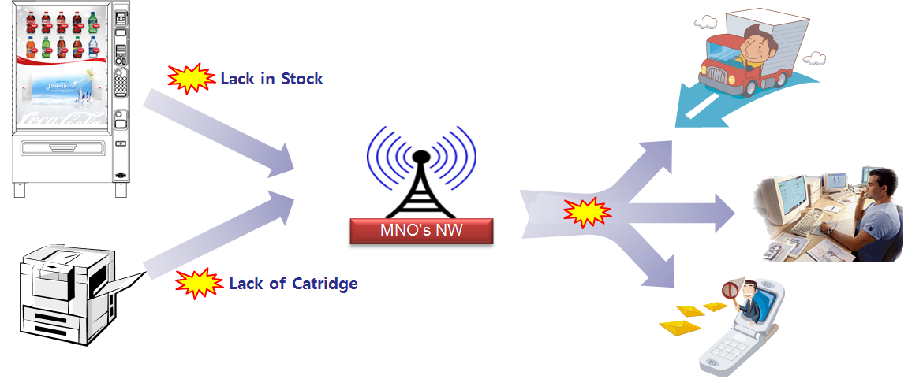
Figure 9: Stock management of interactive Vending Machine and networked printer
This section describes the use case which communication module embedded vending machine or printer reports its status to the manager and/or the service center. For example, if the stock of vending machine goes down to the any pre-defined level, the vending machine generates an alert message including the current status of stock and send the alert message to the vending machine owner and/or the service center which takes a responsibility on the stock management of vending machine. In this use case, the vending machine has a capability of self-checking of the stock and a communication capability to send an alert message to the relative parties.

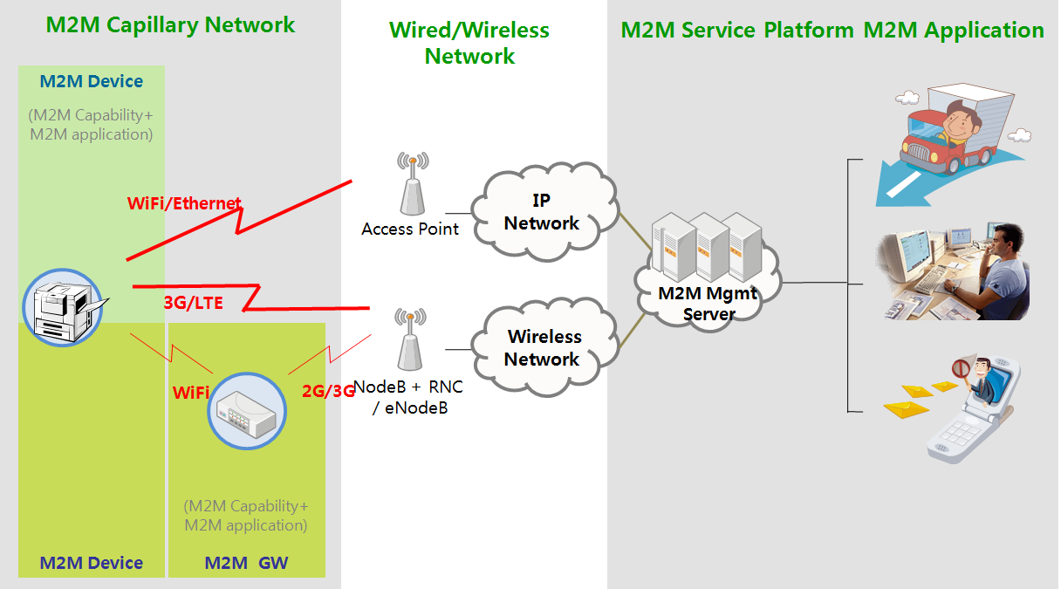
Figure 10: Example of High-level Architecture for Inventory Management

5.5.1 Stakeholders
Connected vending machine with communication capabilities: Vending machine with the communication capabilities as an M2M device has a connection to the network via unlicensed/licensed wireless connection or wired connection. This M2M device can monitor its status of inventory, configure an alert message (e.g. SMS, MMS) which indicate its lack of inventory and then send an alert message to an owner of vending machine and/or inventory management center.

Connected printer with communication capabilities: Connected printer with the communication capabilities as an M2M device also has a connection to the network via unlicensed/licensed wireless connection or wired connection. This M2M device can monitor its status of inventory (e.g. toner, paper), configure an alert message (e.g. SMS, MMS) which indicate its lack of inventory and then send an alert message to an owner of connected printer and/or inventory management center.

Owner of vending machine/connected printer: When it is not enough in stock of connected vending machine or connected printer, these M2M devices send alert messages to the owner.

Remote inventory management centre: When it is not enough in stock of vending machine or connected printer, these M2M devices send alert messages to the remote inventory management centre (i.e. After-sales service centre).

M2M application entity: M2M applications for remote inventory management and sending alert messages to remote inventory management centre and/or owner of vending machine/connected printer.

5.5.2 Scenario
Initialization
The vending machine or connected printer with the M2M device capabilities are directly attaching to the network and perform registration in the M2M system.

Detection of shortage in stock or operational error
Connected vending machine or connected printer can detect its status in stock and in operation.

Notification of status information to owner of connected vending machine/printer or to inventory management service centre
The status information such as lack of inventory or external shock or internal operational error can be alerted to owner of machines or after-sales service centre.

5.5.3 Information Exchanges
Registration
The vending machine or connected printer with the M2M device capabilities sends a registration request including its hardware, software, firmware information. After registration, the vending machine and connected printer are communication-ready state with the M2M network via access/core network.

Sending Inventory Status Information
When the vending machine or connected printer detects a shortage in stock, they send a notification to M2M application.

Sending Alert
When the M2M application receives the inventory status information, the M2M application sends a alert message to the owner of M2M devices.

5.5.4 Potential new requirements
For the inventory management use cases, it should support the below requirements

M2M capabilities in M2M Device and M2M Service Platform are able to support the following functionalities:
- Multiple M2M Network Application management
- M2M service platform is able to manage the registration information of the M2M Network Application.
- M2M service platform is able to send/forwards the message (or notification) to the multiple M2M Network Applications when it receives a message (or notification) from the M2M Device or M2M Gateway.
- M2M service platform is able to support sending of a notification towards the M2M Device or M2M Gateway. The format of notification can be a SMS, MMS and so on.

5.2 Potential new requirements resulting from Connected Consumer use cases
The list of requirements needed to support all the use cases in the previous clause is provided below. Each of these requirements could be used to derive corresponding M2M service requirements and/or capabilities in the M2M functional architecture.
M2M capabilities layer in M2M Device and M2M Service Platform should be able to support the following functionalities:
1. capability management of M2M Device and of M2M Application in Network and Application Domain.
* An M2M device is able to register its device specific capabilities (e.g. resolution, screen size, memory size, supported codec, etc.)
* An M2M service platform is able to manage the M2M device specific capabilities
* This capability information of M2M Device can be queried by the M2M Applications in Network and Application Domain.
2. Supporting of delivery mechanism such as :
* Periodical delivery
* Scheduled delivery at pre-defined time
* On-demand delivery
3. Multiple M2M Network Application management
- M2M service platform is able to manage the registration information of the M2M Network Application.
- M2M service platform is able to send/forwards the message (or notification) to the multiple M2M Network Applications when it receives a message (or notification) from the M2M Device or M2M Gateway.
- M2M service platform is able to support sending of a notification towards the M2M Device or M2M Gateway. The format of notification can be a SMS, MMS and so on.

History
Document history
<Version> | <Date> | <Milestone>
0.0.1 | 12-2009 | Skeleton of this TR approved at TC M2M #07 meeting
0.1.0 | 01-2010 | Use case 1 : Photo uploading from still camera is added  Use Case 2: Contents download to eBook reader device is added
0.2.0 | 03-2010 | Use Case 3: Remote Control of Home Appliance is added.
0.3.0 | 04-2010 | Use Case 4: Surveillance data uploading is added.  Use Case 5: Inventory Management is added.
0.3.1 | 04-2013 | Editorial update of the TR from the new rapporteur nominated at M2M#25.

