

OneM2M
Technical Specification
Document Number | oneM2M-TS-0003-Security_Solutions-V-0.5.0
Document Name: | oneM2M Security Solutions
Date: | 2014-06-02
Abstract: | Specification of oneM2M security solutions.

oneM2M IPR and copyright statements
“Participation in, or attendance at, any activity of oneM2M, constitutes acceptance of an agreement to be bound by all provisions of IPR policy of the admitting Partner Type 1 and permission that all communications and statements, oral or written, or other information disclosed or presented, and any translation or derivative thereof, may without compensation, and to the extent such participant or attendee may legally and freely grant such copyright rights, be distributed, published, and posted on oneM2M’s web site, in whole or in part, on a non-exclusive basis by oneM2M or oneM2M Partners Type 1 or their licensees or assignees, or as oneM2M SC directs.

Contents
Contents 2
1 Scope 4
2 References 4
2.1 Normative references 4
2.2 Informative references 5
3 Definitions, symbols, abbreviations and acronyms 5
3.1 Definitions 5
3.2 Symbols 8
3.3 Abbreviations 8
3.4 Acronyms 9
4 Conventions 9
5 Security Architecture 10
5.1 Overview 10
5.2 Resource Structure 12
5.3 Security Layers 13
5.3.1 Security Service Layer 13
5.3.2 Secure Environment Abstraction Layer 14
5.4 Integration within overall oneM2M architecture 14
5.5 Configuration 14
6 Security Services and Interactions 15
6.1 Interaction on Reference Points 15
6.1.1 Mca-Reference Point 15
6.1.2 Mcc-Reference Point 15
6.1.3 Mcc’-Reference Point 15
6.1.4 Mcn-Reference Point 16
6.1.4.1 Interworking with 3GPP networks 16
6.2 Internal Components 16
6.2.1 Registry 16
6.3 Security Service Layer 16
6.3.1 Access Management 16
6.3.1.1 Access Control 16
6.3.1.2 Authorization 18
6.3.1.3 Authentication 19
6.3.2 Authorization Architecture 19
6.3.3 Security Association Establishment 21
6.3.3.1 Network-based security association 21
6.3.3.1.1 GBA-based security association 21
6.3.4 Security Administration 22
6.3.4.1 Remote administration 22
6.3.4.1.1 Interworking with 3GPP and 3GPP2 22
6.3.4.1.2 tbd 22
6.3.4.2 Bootstrapping 22
6.3.4.2.1 Network-based Bootstrapping 22
6.3.4.2.1.1 GBA-based Bootstrapping 22
6.3.4.2.2 PKI-Based Bootstrapping 23
6.3.5 Identity Protection 23
6.3.6 Sensitive Data Handling 23
6.3.6.1 Sensitive Functions 24
6.3.6.2 Secure Storage 25
6.3.7 Trust Enabler security functions 26
6.4 Secure Environment AbstractionLayer Components 27
6.4.1 Secure Environment 27
6.4.2 SE Plug-in 27
6.4.3 Secure Environment Abstraction 27
7 Security API 27
7.1 API description 27
7.2 Security Transport 27
7.3 Authorization 27
7.3.1 Applying Access Control Policies: High Level Description 28
7.4 Sensitive Data Handling 31
7.5 Security Association 31
7.6 Security Administration 31
7.7 Identity Protection 31
7.8 Authentication 32
8 Security Frameworks 32
8.1 General Introductions to the Security Frameworks 32
8.1.1 General Introduction to the Direct Security Frameworks 32
8.1.1.1 General Introduction to the Pre-Provisioned Symmetric Key Framework 32
8.1.1.2 General Introduction to the Certificate-Based Security Frameworks 32
8.1.1.2.1 Credential Configuration for Certificate-Based Security Frameworks 32
8.1.1.2.2 Certificate Verification 33
8.1.2 General Introduction to the Centralized Security Frameworks 33
8.1.2.1 General Introduction to the M2M Authentication Function Framework 33
8.1.2.2 General Introduction to the GBA (Generic Bootstrapping Architecture) Framework 33
8.2 Security Association Establishment Frameworks 34
8.2.1 Overview on Security Association Establishment Frameworks 34
8.2.2 Direct Security Association Establishment Frameworks 36
8.2.2.1 Pre-Provisioned Symmetric Key Security Association Establishment Frameworks 36
8.2.2.2 Certificate-Based Security Association Establishment Frameworks 38
8.2.3 Centralized Security Association Establishment Frameworks 40
8.2.3.1 MAF-Based Symmetric Key Security Association Establishment Frameworks 40
8.2.3.2 GBA-Based Security Association Establishment Frameworks 41
8.3.1 Overview on Security Bootstrap Frameworks 41
8.3.1.1 Purpose of Security Bootstrap Frameworks 41
8.3.1.2 Overview on Security Bootstrap Frameworks 41
8.3.2 Direct Security Bootstrap Framework 44
8.3.2.1 Pre-Provisioned Symmetric Key Security Bootstrap Framework 44
8.3.2.2 Certificate-Based Security Bootstrap Framework 46
8.3.3 Centralized Security Bootstrap Framework 49
8.3.3.1 GBA-Based Security Bootstrap Framework 49
Proforma copyright release text block 49
Annexes 49
Annex <y>: Bibliography 51
History 51

1 Scope
The present document defines security solutions applicable within the M2M system.

2 References
References are either specific (identified by date of publication and/or edition number or version number) or non-specific. For specific references, only the cited version applies. For non-specific references, the latest version of the referenced document (including any amendments) applies.

2.1 Normative references
The following referenced documents are necessary for the application of the present document.
[1] void
[2] Open Mobile API specification V2.0.2
[3] GP TEE Client API….
[4] ETSI TS 133 220 "Digital cellular telecommunications system (Phase 2+); Universal Mobile Telecommunications System (UMTS); LTE; Generic Authentication Architecture (GAA); Generic Bootstrapping Architecture (GBA) (3GPP TS 33.220)"
[5] IETF RFC 5246 "The Transport Layer Security (TLS) Protocol Version 1.2".
[6] IETF RFC 6347 “Datagram Transport Layer Security Version 1.2”
[7] ETSI TS 102 225 (V11.0.0) "Smart Cards; Secured packet structure for UICC based applications (Release 11)" URL:http://www.etsi.org/
[8] ETSI TS 102 226 (V11.0.0) “Smart Cards; Remote APDU structure for UICC based applications (Release 11)” URL:http://www.etsi.org/
[9] 3GPP TS 31.115 (V10.1.0) "Remote APDU Structure for (U)SIM Toolkit applications (Release 10)"
[10] 3GPP TS 31.116 (V10.2.0) "Remote APDU Structure for (Universal) Subscriber Identity Module (U)SIM Toolkit applications (Release 10)"
[11] 3GPP2 C.S0078-0 (V1.0) "Secured packet structure for CDMA Card Application Toolkit (CCAT) applications"
[12] 3GPP2 C.S0079-0 (V1.0) "Remote APDU Structure for CDMA Card Application Toolkit (CCAT) applications"
[13] void
[14] 3GPP2 S.S0109-A "Generic Bootstrapping Architecture (GBA) Framework"
[15] RFC 4279 "Pre-Shared Key Ciphersuites for Transport Layer Security (TLS) "
[16] RFC 5246 "The Transport Layer Security (TLS) Protocol, Version 1.2"
[17] RFC 6347 "Datagram Transport Layer Security Version 1.2"
[18] RFC 5705 "Keying Material Exporters for Transport Layer Security (TLS)"
[19] RFC 3629 "UTF-8, a transformation format of ISO 10646".
[20] "Unicode Standard Annex #15; Unicode Normalization Forms", Unicode 5.1.0, March 2008. http://www.unicode.org

Editor’s note: add version numbers to references where missing.

2.2 Informative references
Clause 2.2 shall only contain informative references which are cited in the document itself.
The following referenced documents are not necessary for the application of the present document but they assist the user with regard to a particular subject area.
- Use the EX style, add the letter "i" (for informative) before the number (which shall be in square brackets) and separate this from the title with a tab (you may use sequence fields for automatically numbering references).
[i.1] oneM2M Drafting Rules (http://member.onem2m.org/Static_pages/Others/Rules_Pages/oneM2M-Drafting-Rules-V1_0.doc)
[i.2] oneM2M-TR-0004 Definitions and abbreviations
[i.3] 3GPP TR 33.868 V0.13.0; Security aspects of Machine-Type and other Mobile Data Applications Communications Enhancements; (Release 12)
[i.4] http://en.wikipedia.org/wiki/Public_key_certificate retrieved 2013-10-16.
Editor’s note: a more suitable reference is required for defining a Public Key Certificate
[i.5] http://en.wikipedia.org/wiki/Public_key_infrastructure retrieved 2013-10-16, This definition in term references an academic paper: "LPKI - A Lightweight Public Key Infrastructure for the Mobile Environments", Proceedings of the 11th IEEE International Conference on Communication Systems (IEEE ICCS'08), pp.162-166, Guangzhou, China, Nov. 2008.
Editor’s note: a more suitable reference is required for defining a Public Key Infrastructure
[i.6] oneM2M TR-0008, Security Analysis Technical Report
[i.7] eXtensible Access Control Markup Language (XACML) Version 3.0. 22 January 2013. OASIS Standard.
[i.8] Handbook of Applied Cryptography, A. J. Menezes, P. C. van Oorschot, S. A. Vanstone, CRC Press, 1996
[i.9] Recommendation ITU T X.509, Information technology – Open Systems Interconnection – The Directory: Public-key and attribute certificate frameworks, 10/2012.

3 Definitions, symbols, abbreviations and acronyms

3.1 Definitions
For the purposes of the present document, the terms and definitions given in [i.2] and the following apply:
Association Configuration: The phase of a Security Association Establishment Framework in which the entity establishing the Security Association (and the Central Key Distribution Server, in the case of Centralized Security Frameworks), are provided with identities (and any other relevant credentials) to ensure that the security association is established between the intended entities.
Association Security Handshake: The phase of a Security Association Framework in which the security association endpoints perform mutual authentication.
Bootstrap Credential: A pre-provisioned credential enabling mutual authentication of the Enrolee and the M2M Enrolment function
Bootstrap Credential Configuration: The phase of a Security Bootstrap Framework in which the Bootstrap Credentials are pre-provisioned to the Enrolee and the M2M Enrolment function.
Bootstrap Enrolment Handshake: The phase of a Security Bootstrap Framework in which the Enrolee and M2M Enrolment Function perform mutual authentication.
Bootstrap Instruction Configuration: The phase of a Security Bootstrap Framework in which the Enrolee and M2M Enrolment Function are provided with identities (and any other relevant credentials) to enable the M2M Enrolment function to establish a Master Credential between the intended Enrolee and M2M Authentication Function.
Bootstrap Server Function [13]: BSF is hosted in a network element under the control of an Mobile Network Operator. BSF, HSS, and UEs participate in GBA in which a shared secret is established between the network and a UE by running the bootstrapping procedure. The shared secret can be used between NAFs and UEs, for example, for authentication purposes.
Bootstrapping Transaction Identifier [13]: the bootstrapping transaction identifier (B-TID) is used to bind the subscriber identity to the keying material in GBA reference points Ua, Ub and Zn.
CA-Certificate [ i.8]: a certificate create by one certification authority (CA) certifying the public key of another CA.
Central Key Distribution Server: A server which can perform mutually authentication with a set of entities, and which can use this ability to securely distribute keys to sets of two or more of these entities.
Central Key Distribution Server Handshake: The Phase of a Centralized Security Association Establishment Framework in which an entity and the Centralized Key Distribution Server perform mutual authentication and generate a Symmetric Key which is can then be used in the Association Security Handshake for mutual authentication between that entity and other entities.
Centralized Security Framework: A Security Framework in which the entities authenticate each other with the assistance of a Central Key Distribution Server.
Certificate: See Public Key Certificate
Certificate Chain: A sequence of one or more CA-certificates, where: the Public Verification Key in each CA-certificate is certified in the previous CA-certificate; and the public key of the first CA-Certificate is trusted a priori. Trust in the public key in each CA-certificate can be based on trust in the previous CA-Certificate.
Certificate Name: A unique identifier in a name field of a Certificate (e.g. in the X.509 “Subject” or “Subject Alternative Name” attribute).
Certificate Verification: The process necessary to trust that an entity’s Certificate
Certification Authority [i.8]: Responsible for establishing and vouching for the authenticity of public keys. [This] includes binding public keys to distinguished names through signed certificates, managing certificate serial numbers, and certificate revocation.
Credential Configuration: The phase of a Security Association Establishment Framework in which the Credentials necessary for the Security Association Establishment Framework are configured to the relevant entities and functions.
Digital Signature [i.9]: Information is signed by appending to it an enciphered summary of the information. The summary is produced by means of a one-way hash function, while the enciphering is carried out using the private key of the signer.
Direct Security Framework: A Security Framework in which the entities authenticate each other directly, without assistance from a Central Key Distribution Server
Enrolee: An AE or CSE that requires remote provisioning of an Master Credential and Master Credential Identifier for an M2M Authentication Function.
Enrolment Key: A Symmetric Key established between an Enrolee and M2M Enrolment Function following successful mutual authentication. A Master Credential to be shared by the Enrolee and an M2M Authentication Function may be derived (at the Enrolee and M2M Enrolment Function) from the currently valid Enrolment Key, and the M2M Enrolment Function subsequently securely delivers the Master Credential to the M2M Authentication Function,
Enrolment Key Establishment: The phase of a Security Bootstrap Framework in which the Enrolee and M2M Enrolment function establish an Enrolment Key.
Entity Identifier: The CSE-ID (or AE-ID respectively) of a CSE (or AE respectively).
Generic Bootstrap Architecture: A set of 3GPP and 3GPP2 specifications providing security features and a mechanism to bootstrap authentication and key agreement for application security from the 3GPP and 3GPP2 underlying network authentication mechanisms
MAF Transaction Identifier: the MAF transaction identifier (M-TID) is used to bind the entity identifier to the keying material when using the MAF-Based Security Association Establishment Framework.
Message Integrity Code: A tag computed from a messages and a symmetric key, and attached to a message. The purpose of a messages integrity code is to facilitate, without the use of any additional mechanisms, assurances regarding both the source of a message and its integrity.
Note: A Message Integrity Code is sometimes called a “Message Authentication Code” – we have used “Message Integrity Code” since the abbreviation of “Message Authentication Code” (MAC) might be misunderstood to refer to “Media Access Control”. The definition is based on text from [i.8, p323].
M2M Secure Connection Key: Key shared between two CSEs of M2M Nodes (e.g. ASN/MN-CSE and IN-CSE) in order to secure the communication between those two entities. This M2M Secure Connection Key results from a successful M2M Security Association Establishment procedure.
Master Credentials: Credentials used to mutually authenticate between an ASN/MN-CSE and the MAF. This is done to secure access to the infrastructure of an M2M Service Provider. The Master Credentials are either pre-provisioned or remotely provisioned (without relying on those credentials).
Policy Access Point: The system entity that finds applicable policy or policy set.
Policy Decision Point [i.7]: The system entity that evaluates applicable policy and renders an authorization decision.
Policy Enforcement Point [i.7]: The system entity that performs access control, by making decision requests and enforcing authorization decisions.
Policy Information Point [i.7]: The system entity that acts as a source of attribute values.
Pre-Provisioned Secure Connection Key: A Symmetric Key that is pre-provisioned to two entities (which may be AEs or CSEs) to be used for mutual authentication of those entities in Security Association Establishment.
Pre-Provisioned Secure Connection Key Identifier: Identifier for a Pre-Provisioned Secure Connection Key.
Pre-Provisioned Symmetric Enrolee Key: A Symmetric Key that is pre-provisioned to the Enrolee and M2M Enrolment Function.
Pre-Provisioned Symmetric Enrolee Key Identifier: Identifier for a Pre-Provisioned Symmetric Enrolee Key
Private Signing Key: A secret key that can generate signatures that can be verified using a corresponding Public Verification Key.
Public Key Certificate [i.4]: An electronic document that uses a digital signature to bind a public key with an identity.
[i.8] A public-key certificate is a data structure consisting of a data part and a signature part. The data part contains cleartext data include, as a minimum, a public [verification] key and a string identifying the part (subject entity) to be associated therewith. The signature part consists of the digital signature of a certification authority over the data part, thereby binding the subject entity’s identity to the specified public key.
Public Key Infrastructure [i.5]: a set of hardware, software, people, policies, and procedures needed to create, manage, distribute, use, store, and revoke Public Key Certificates
Public Verification Key: A Credential that can verify digital signatures generated by a corresponding Private Signing Key, but which cannot be used to generate digital signatures.
Root Certificate: A Certificate signed by a public key that hashes to a Root of Trust.
Root of Trust: The hash of a public key that is trusted a priori.
Security Association Establishment Framework: A Security Framework for Security Association Establishment.
Security Bootstrap Framework: A Security Framework for Security Bootstrapping: a mechanism for remotely provisioning a Master Credential and Master Credential Identifier to a Enrolee and an M2M Authentication Function.
Security Framework: A set of procedures providing Security Association Establishment or Security Bootstrapping.
Self-Signed Certificate: A Public Key Certificate that is signed by the same entity whose identity it certifies.
Symmetric Key: A secret key that is shared between two entities.
X.509: An ITU-T recommendation for a Public Key Infrastructure.

3.2 Symbols
For the purposes of the present document, the [following] symbols [given in ... and the following] apply:
<symbol> <Explanation>
<2nd symbol> <2nd Explanation>
<3rd symbol> <3rd Explanation>

3.3 Abbreviations
For the purposes of the present document, the abbreviations given in [x] and the following abbreviations apply:
ACL Access Control List
API Application Programming Interface
ASN Application Service Node
Authn Authentication
BSF Bootstrapping Server Function
B-TID Bootstrapping Transaction Identifier
CA Certification Authority
Cert[Entity] A Certificate containing a Public Verification Key for which [Entity] knows the corresponding Private Signing Key,
CertName[Entity] An identifier that matches a unique value in a name field of Cert[Entity].
Chain[Entity] Certificate Chain from Cert[Entity] to a Root Certificate signed by RootOfTrust[Entity]
DTLS Datagram Transport Layer Security (Protocol)
Enrolee-ID Enrollee Identity
FQDN Fully Qualified Domain Name
GBA Generic Bootstrapping Architecture
GBA_ME ME-based GBA
GBA_U GBA with UICC-based enhancements
GUSS GBA User Security Settings
HLR Home Location Register
HSS Home Subscriber System
HW Hardware
IdA Identifier for entity A
IdB Identifier for entity B
Kc M2M Secure Connection Key
Ke Enrolment Key
KeId Enrolment Key Identifier
Km Master Credential
KmId Master Credential Identifier
Kpm pre-provisioned credential for Master Credential provisioning
KpmId pre-provisioned credential for Master Credential provisioning Identifier
Kpsa pre-provisioned credential for M2M Security Association Establishment
KpsaId pre-provisioned credential for M2M Security Association Establishment Identifier
Ks temporary Key material referred to in GBA
Ks_(ext/int)_NAF Derived key in GBA_ME / Derived key in GBA_U which remains on UICC
Ks..NAF Abbreviation of Ks_(int/ext)_NAF
M-TID MAF Transaction Identifier
MAF M2M Authentication Function
MAF-ID M2M Authentication Function Identifier
MEF M2M Enrolment Function
MIC Message Integrity Code
MN Middle Node
MZF M2M Authorization Function
NAF Network Application Function
PAP Policy Access Point
PDP Policy Decision Point
PEP Policy Enforcement Point
PIP Policy Information Point
PKI Public Key Infrastructure
PrivateKey[Entity] Private Signing Key of [Entity]
RBAC Role Based Access Control
RootOfTrust[Entity] A Root of Trust for Cert[Entity]
SE Secure Environment
SW Software
TLS Transport Layer Security (Protocol)
(D)TLS-PSK (D)TLS Pre-Shared Key (ciphersuites)
UE (3GPP) User Equipment
USS User Security Settings
URI Uniform Resource Identifier

3.4 Acronyms
None.

4 Conventions
The key words “Shall”, ”Shall not”, “May”, ”Need not”, “Should”, ”Should not” in this document are to be interpreted as described in the oneM2M Drafting Rules [i.1]

5 Security Architecture

5.1 Overview
The following figure 5-1 provides a high level overview of the Security architecture.
The architecture consists of following layers:
- Security Functions layer
This layer contains a set of security functions that are exposed at reference point Mca and Mcc. These security functions can be classified into six categories; they are Identification, Authentication, Authorization, Security Association, Sensitive Data Handling and Security Administration.
- Security Environment Abstraction Layer
This layer implements various security capabilities such as key derivation, data encryption/decryption, signature generation/verification, security credential read/write from/to the Secure Environments, and so on. The security functions in the Security Functions Layer invoke these functions in order to do the operations related to the Secure Environments. In addition this layer also provides physical access to the Secure Environments. Implementation of this is out of scope of the present document.
- Secure Environment layer
This layer contains one or multiple secure environments that provide various security services related to sensitive data storage and sensitive function execution. The sensitive data includes SE capability, security keys, local credentials, security policies, identity information, subscription information, and so on. The sensitive functions include data encryption, data decryption, and so on. Implementation of secure environments is out of scope of the present document.

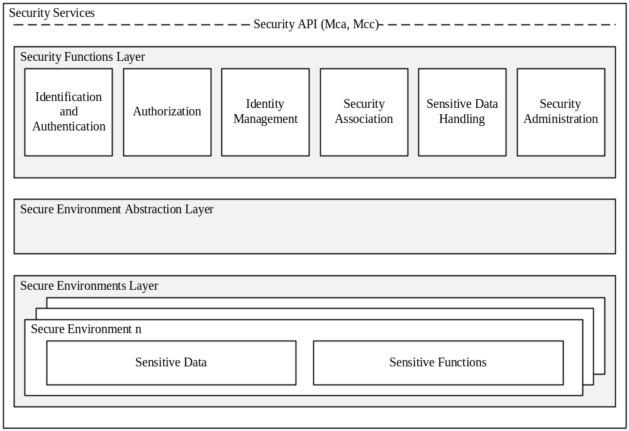
Figure 5-1: High level overview of the Security architecture

Editor’s note: Selection of the Secure environment is FFS.

Design principles:
- The architecture is split into several components and sub-components providing a modular design. With this design, mapping of the architecture to different nodes and entities is enabled.
- Depending on the requirements of each entity, Security should consist of components relevant to fulfil the requirements of the respective node or entity and the intended use case.
- The architecture may need to be adapted to be suitable for implementation in different entities. For example, the architecture can be mapped to different device classes.
- The security administration component shall enable administration of all sensitive resources (data and functions) and shall also allow configuration and extension of Security services itself.
- The Secure Environment within the CSE is accessed via the Secure Environment Abstraction layer and shall hold all sensitive resources.

5.1.1 Identification and Authentication
The Identification and Authentication function is in charge of identification and mutual authentication of CSEs and AEs.
Identification is the process of checking if the identity provided for authentication is valid. How to perform an identification process will depend on the purpose of authentication. For example, in the case of resource access, the authentication function may require the identification to check if the AE or CSE has registered with the local CSE; in the case of AE or CSE registration, the authentication function may require the identification to check if the identity provided by an AE or CSE fits a certificate. Once passing this checking process, the AE or CSE is identified, and the identified identity will be supplied to authentication process.
Authentication is the process of validating if the identity supplied in the identification step is associated with a trustworthy credential. How to perform an authentication process will depend on using which mutual authentication mechanism. For example, in the case of using certificate based authentication mechanism, the authentication function may require the authentication to verify a digital signature; in the case of using symmetric key based authentication mechanism, the authentication function may require the authentication to verify a Message Authentication Code (MAC). When this validating process has been completed, the AE or CSE is authenticated.

5.1.2 Authorization
The Authorization function is responsible for authorizing services and data access to authenticated entities according to provisioned access control policies and assigned roles.
Access control policy is defined as sets of conditions that define whether entities should be permitted access to a protected resource. The authorization function may support different authorization mechanisms, such as Access Control List (ACL), Role Based Access Control (RBAC), etc. The Authorization function may need to evaluate multiple access control policies in an authorization process in order to get a finial access control decision.
Authorization evaluation process is based on the Service Subscription resource which specifies what M2M Services and M2M Service roles the authenticated entity has subscribed to and the access control policies associated with the protected resource. The authorization evaluation process may also need to consider contextual attributes such as time or geographic location.
Prior to authorization mutual authentication between the originator CSE or AE and hosting CSE shall be performed.

5.1.2 Identity Management
The Identity Management function provides oneM2M identities / identifiers to the requesting entity in case those identities are stored within the secure environment. oneM2M identifiers as defined in [x] may also be treated as sensitive data that are accessible to AEs or CSEs and used independently of Authentication or Authorization functions.

5.2 Resource Structure
The following figure 5-2 shows the structure of Security resources. Further elements may be added as needed. Those elements are described further in clauses below.
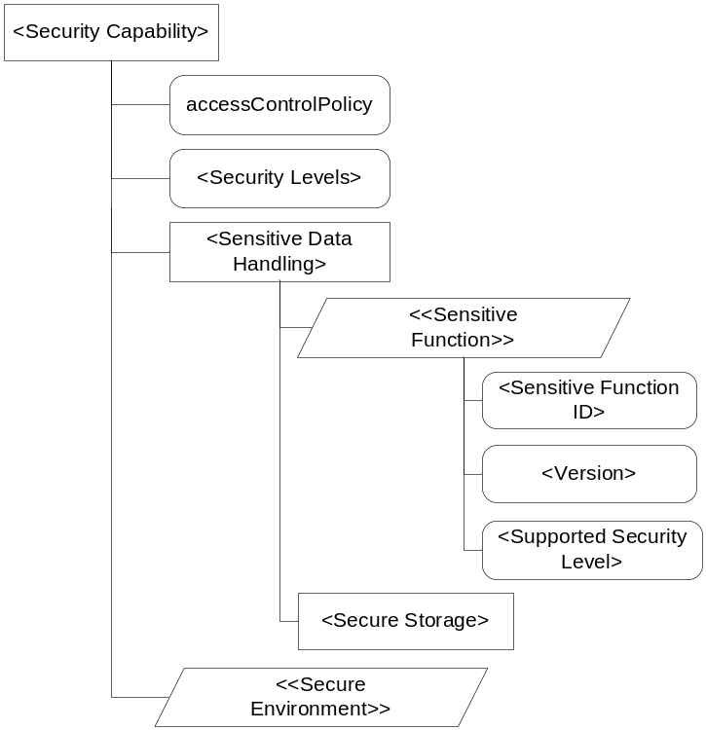
Figure 5-2: Security resource structure

Editor’s note: RESTful approach may only be suitable for a subset of the Security functionality. Functions that are put into an enabler function (highlighted in blue in above figure) need to be considered. Alternatively, a new resource type <Function> may be needed. Secure Environment Abstraction not classified as resource and therefore not included in the tree.
Editor’s note: Clarification on that structure required. E.g. Sensitive Data Handing and Secure Environment to be restructured? How to expose secure storage to DMR (e.g. for ownership / user name)

Child Resource Name | Child Resource Type | Multiplicity | Description
Sensitive Data Handling |  | 1 | Indicates which Sensitive Functions and Secure Storage capabilities are available
Secure Environment |  | 1..n | Describes the number and types of Secure Environment available within the CSE
Tbd…

AttributeName | Multiplicity | RW/  RO/  WO | Description
Access ControlPolicy | 1 | RO | Describes the access control policies
Security Level | 1 | RO | Indicates the supported security levels
Attributes tbd

5.3 Security Layers

5.3.1 Security Service Layer
The security service layer provides the following services:
- Access Management
  - Authorization
  - Authentication
  - Access Control
- Sensitive Data Handling
  - Sensitive Functions protection
  - Secure Storage
- Security Association Establishment
  - Secure Connection via secure session establishment
  - Secure Connection via object security
- Security Administration (including security bootstrapping)
- Identity Protection

Each of these services provides functions and resources on the Security Service and Administration API.

5.3.2 Secure Environment Abstraction Layer
The Secure Environment Abstraction Layer provides access to the Secure Environment via a general Security Transport API. A Plug-in associated to the type of Secure Environment shall provide physical / logical connectivity to the secure environment. The Secure Environment Abstraction Layer shall also be accessible on the Service Layer.

5.4 Integration within overall oneM2M architecture
Security services may be provided within the following architectural components and interacts on the different reference points as described below:
- CSE within an Application Service Node
  - Connected via the Mca-Reference Point to an Application Dedicated Node
  - Connected via the Mcc-Reference Point to a Middle Node
  - Connected via the Mcc-Reference Point to an Infrastructure Node
  - Connected via the Mcn-Reference Point to an Underlying Network Service Entity
- CSE within a Middle Node
  - Connected via the Mca-Reference Point to an Application Dedicated Node
  - Connected via the Mcc-Reference Point to an Application Service Node
  - Connected via the Mcc-Reference Point to a Middle Node
  - Connected via the Mcc-Reference Point to an Infrastructure Node
  - Connected via the Mcn-Reference Point to an Underlying Network Service Entity
- CSE within an Infrastructure Node
  - Connected via the Mca-Reference Point to an Application Dedicated Node
  - Connected via the Mcc-Reference Point to an Application Service Node
  - Connected via the Mcc-Reference Point to a Middle Node
  - Connected via the Mcc-Reference Point to an Infrastructure Node
  - Connected via the Mcc’-Reference Point to an Infrastructure Node
  - Connected via the Mcn-Reference Point to an Underlying Network Service Entity

5.5 Configuration
Security Services are modular and configurable according to the needs of the hosting CSE, its supported reference points and its purpose. The following table indicates which security components are mandatory or optional. Each sub-function may have different capabilities and technical implementation depending on the purpose and the node it resides in. Implementation of services may rely on functions provided by the underlying network over the Mcn reference point.
NOTE: Security capabilities residing within the Application Entity are out of scope, however their implementation can rely on functions and resources exposed through the Security API.

Resource / Component | Child resource | M/O
Access Management | tbd | O  Note: depending on use case
Secure Environment Abstraction | n/a | M
Sensitive Data Handling | Sensitive Function | O  Note: depending on use case
 | Secure Storage | M
Security Administration | Tbd | M
Security Association Establishment | Tbd | O  Note: depending on use case
Identity Protection | Tbd | O  Note: depending on use case

Configuration of Security Services is either done via Security Administration or by pre-provisioning of the respective entity.
The architecture shall support a plug-in concept that allows adding further security functions and secure environments.

6 Security Services and Interactions

6.1 Interaction on Reference Points

6.1.1 Mca-Reference Point
The Security API offers its functions to Application Entities / Application Dedicated Nodes through the Mca-Reference point. Implementation of the Security API is dependent on the operating system of the physical device it resides in.
Editor’s note: Categories of physical devices are currently discussed in WI-0006. Depending on the outcome of this WID, definitions may have to be adapted.

6.1.2 Mcc-Reference Point
Editor’s note: This section covers topics related end-to-end secure channel establishment between CSEs
Over this interface Security functions are exposed to other CSEs.

6.1.3 Mcc’-Reference Point
Editor’s note: This section covers topics end-to-end secure channel establishment in case they are different to Mcc-reference point. In addition there may be relation to topics such as M2M Subscription Management / Identifier handling.
Editor’s note: To check how this specific case of Mcc is named in the Architecture group.

6.1.4 Mcn-Reference Point
Editor’s note: This section covers topics such as GBA and Remote Subscription Management.

6.1.4.1 Interworking with 3GPP networks
Editor’s note: Add reference to [i.3].

6.2 Internal Components

6.2.1 Registry
Editor’s note: Further internal components such as a registry are FFS. This internal component may be needed to store management related information.

6.3 Security Service Layer

6.3.1 Access Management

6.3.1.1 Access Control
The access control service controls access of Application Entities and CSEs to security resources. Access Control is used by the service and Secure Environment Abstraction layer. Requesting entities access the security functions via the Mca, Mcc or Mcc’ reference point. Based on the access policies stored within the secure environment, the access control function grants or rejects access of the requesting entity to the called Security function, depending on the requested action and affected resources.

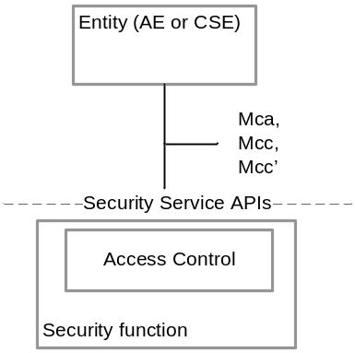
Figure 6-3-1-1: Access Control

Access Control Flow:
Editor’s note: Current Figure is not in line with decision not to specify communication within CSE: Needs to be aligned.

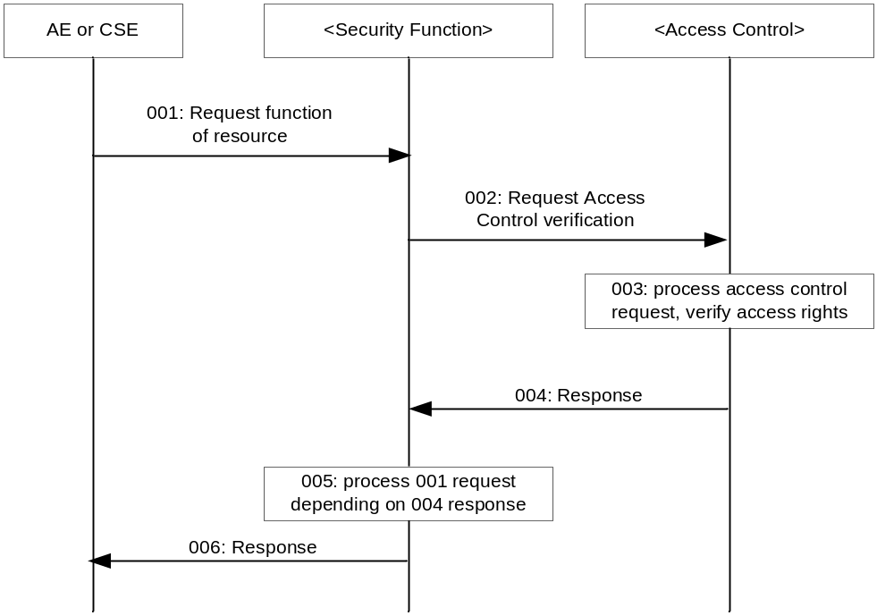

Step 001: The Originator AE or CSE calls a Security Function
Step 002: The Security Function shall forward the request to the Access Control resource together with the respective identifiers of the calling entity and related authentication material
Step 003: The access control component shall verify the access rights and grant access to the function requested by the Originator AE/CSE.
Step 004: Access control provides a response on the access control verification to the Security Function
Step 005: Depending on the response of the access control component, the called function shall be processed or rejected.
Step 006 Security function provides result / response to the originating AE/CSE

6.3.1.2 Authorization
The Authorization service provides functions to authorize access of AEs or CSEs to that particular function calling the Authorization service. As indicated in the figure 6-3-1-2 below, the requesting entity shall call functions over the Mca, Mcc or Mcc’ reference point. The called function may want to verify the authorization status of the requesting entity and initiates an authorization request.
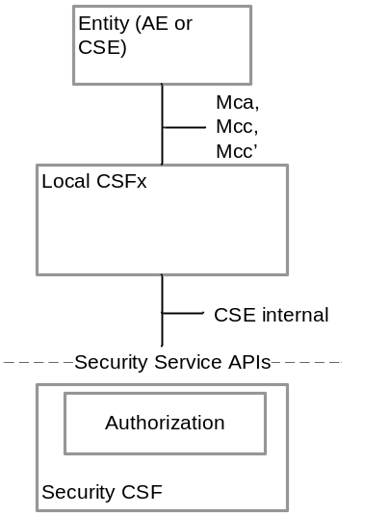
Figure: 6-3-1-2: Authorizsation

Authorization Flow:

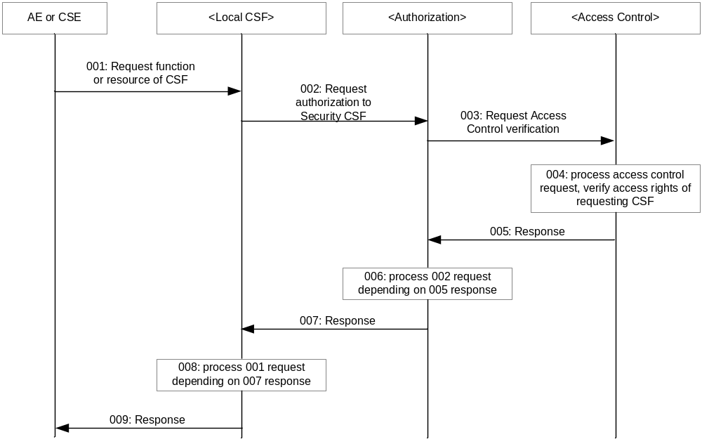

Step 001: The originating AE or CSE requests certain functions. If a Security function is requested the access control flow as described above shall apply.
Step 002: The called entity shall request to check authorization of the AE/CSE and verify if access to the called function is allowed. Therefore, the called entity shall send an authorization request to the authorization function.
Step 003: The Authorization function shall verify that the calling entity is allowed to access the authorization function and therefore shall request an access control verification.
Step 004: Access control shall process the verification request.
Step 005: Depending on access control rights, the Access Control function shall send a response to the Authorization function..
Step 006 The authorization function shall process the request initiated by the originator based on the result retrieved by the access control function.
Step 007: A response to the entity shall be sent.
Step 008: Based on the response, the entity shall process the request of the initiating AE or CSE.
Step 009: The result of the entity processing of the request shall be sent back to the originator.

6.3.1.3 Authentication
This component provides authentication services to the Application Layer.

6.3.2 Authorization Architecture
The following figure 6-3-2 provides a high level overview of the authorization architecture. This architecture comprises four subcomponents that are described as follows:
- Policy Enforcement Point (PEP)
PEP intercepts resource access requests, makes access control decision requests, and enforces access control decisions. The PEP coexists with the entity that need authorization services.
- Policy Decision Point (PDP)
PDP interacts with the PAP and PIP to get applicable authorization polices and attributes needed for evaluating authorization policies respectively, and then evaluates access request using authorization policies for rendering an access control decision. The PDP is located in the Authorization service.
- Policy Access Point (PAP)
PAP obtains applicable authorization policies according to an access control decision request. These applicable policies should be combined in order to get a finial access control decision. The PAP is located in the Authorization service.
- Policy Information Point (PIP)
PIP provides attributes that are needed for evaluating authorization policies, for example the IP address of the requester, creation time of the resource, current time or location information of the requester. The PIP is located in the Authorization service.
The Authorization service may comprise any of the subcomponents: PDP, PAP and/or PIP. This means that the subcomponents PEP, PAP, PDP and PIP could be distributed across different nodes. For example the PEP is located in an ASN/MN and the PDP is located in the IN.

NOTE: Release 1 does not support separation of PAP and PIP on different CSE from PDP.
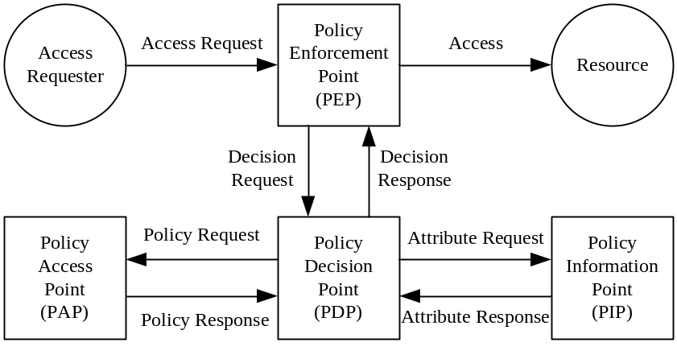
Figure 6-3-2a: Overview of the authorization architecture

The authorization procedure is shown in the figure 6-3-2b below:
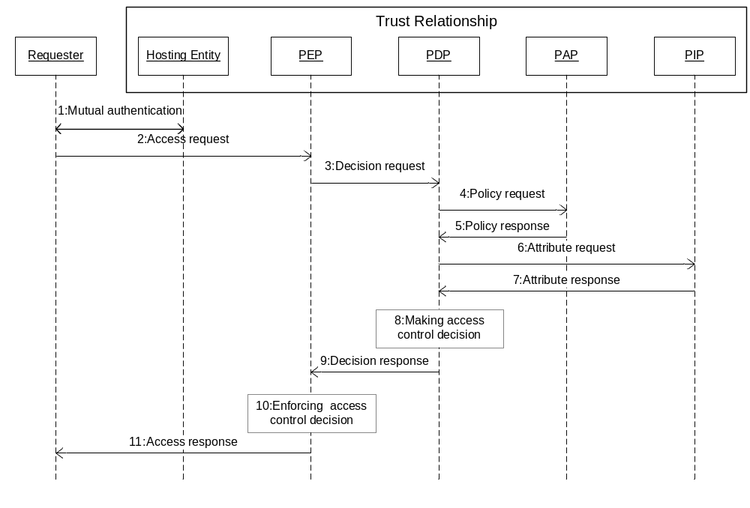
Figure 6-3-3b: Authorization Procedure

Step 001: Mutual authentication (Pre-requisite).
Step 002: Access Requester sends an Access Request to the PEP.
Step 003: PEP makes an Access Control Decision Request according to the requester’s Access Request, and sends the Access Control Decision Request to the PDP.
Step 004: PDP sends an Access Control Policy Request that is generated based on the Access Control Decision Request to the PAP.
Step 005: PAP finds all applicable access control policies to the access request and sends them back to the PDP. When multiple access control polices are involved, the PAP also provides a policy combination algorithm for combining multiple evaluation results into one finial result.
Step 006 PDP sends Attribute Request to the PIP if any attributes are required for evaluating these access control policies.
Step 007: PIP gets required attributes and sends them back to the PDP.
Step 008: PDP evaluates Access Request using access control policies. When there are multiple applicable access control policies, the PEP needs to calculate a final Access Control Decision using the policy combination algorithm.
Step 009: PDP returns the Access Control Decision back to the PEP.
Step 010: PEP enforces the access control decision, i.e. either forwards the Access Request to the resource or denies this access.
Step 011: PEP returns access result back to the Access Requester.

6.3.3 Security Association Establishment
This service shall provide functions to establish a security association between different entities.
In addition, this service shall be able to use an existing security association to perform the following functions:
- Secure Connection via secure session establishment.
- Secure Connection via object security.
The Security Association Establishment component may rely on an external M2M Authentication Function to establish security associations.
Editor’s note: to be completed.
For a secure connection on 3GPP networks [i.3] applies.

6.3.3.1 Network-based security association
In case of scenario where the M2M Service Provider and the operator of the underlying network have an agreement to use the underlying network credentials as the basis for establishing a secure connection between a M2M Application Service/Middle Node and Infrastructure Node (including the case that the M2M Service Provider and the operator of an underlying network are actually the same entity), GBA procedure could be used to perform the security association establishment procedure, as specified in [4].
It is important that this feature is used only within the scope of an appropriate agreement between the M2M Service Provider and the operator of the underlying network. The normative text in clause y.1 implicitly assumes that such an agreement is already in place. Since the present document is a technical specification, it does not address the details of such an agreement.

6.3.3.1.1 GBA-based security association
The GBA procedure shall be applied as specified in [4] for scenarios where the operator of an underlying network supports GBA, e.g. 3GPP or 3GPP2, and the underlying network credentials are to be used as the basis for establishing a secure connection between a M2M Application Service/Middle Node and Infrastructure Node
The Secure Connection relies on a symmetric shared short term key used for M2M Service Connection to establish a secure session between a M2M Application Service/Middle Node and Infrastructure Node.
Editor’s note: This paragraph is not GBA specific and should be moved to a more generic section when available.
Clause 8.1.3 specifies how the short term key used for M2M Service Connection is obtained using the GBA framework.

6.3.4 Security Administration
The Security Administration service shall provide functions to manage the Security functions, resources and attributes. This shall include management of resources provided via the secure environment. In addition it should provide functions to manage sensitive data such as identifiers and subscriptions on behalf of other entities.
Editor’s note: to be completed. Bootstrapping to be mentioned. Align with ARC related to provided functions. Align with MAS about responsibility.

6.3.4.1 Remote administration
The Security Administration service shall provide mechanisms for secure remote administration of sensitive data and functions stored in secure environment of M2M Nodes, reusing mechanisms provided by existing standards where appropriate.

6.3.4.1.1 Interworking with 3GPP and 3GPP2
In case the secure environment of the underlying network is used to store the sensitive data of the M2M Service Layer and in case the underlying network is a 3GPP or 3GPP2 network, OTA mechanisms as specified in [7] and [8], and its extensions [9], [10] for 3GPP underlying networks or [11] and [12] for 3GPP2 underlying networks shall be used to securely administrate the sensitive data of the M2M Service Layer.

6.3.4.1.2 tbd
<Text>
Editor’s note: appropriate additional specifications and interworking mechanisms for other transport networks are FFS.

6.3.4.2 Bootstrapping
Bootstrapping is the post-provisioning of the essential information for the service layer security between an Application Service/Middle Node and the Infrastructure Node of a chosen M2M Service Provider. The essential security information includes the security credentials, the identifiers and access control information. The bootstrapping component may rely on an external M2M Enrolment Function to establish appropriate credentials.
Editor’s note: Need to precise in the TS the exact content of the bootstrapped information
Editor’s note: Should Bootstrapping to Application Dedicated Node (without CSE) be addressed?

6.3.4.2.1 Network-based Bootstrapping
For scenarios where the M2M Service Provider and the operator of an underlying network have an agreement to use the underlying network credentials as the basis for the bootstrapping of a root credential shared between an Application Service/Middle Node and an Infrastructure Node (including the case that the M2M Service Provider and the operator of an underlying network are actually the same entity), GBA procedure specified in [4] may be used to perform bootstrapping with that M2M Service Provider.
It is important that this feature is used only within the scope of an appropriate agreement between the M2M Service Provider and the operator of the underlying network. The normative text in clause &.3.3.2.1.1 implicitly assumes that such an agreement is already in place. Since the present document is a technical specification, it does not address the details of such an agreement.

6.3.4.2.1.1 GBA-based Bootstrapping
The GBA procedure as specified in [4] shall be used for scenarios where the operator of an underlying network supports GBA infrastructure, e.g. 3GPP or 3GPP2, and the underlying network credentials are to be used as the basis for the post-provisioning of root credential shared between an Application Service/Middle Node and an Infrastructure Node.
The root credential shared between an M2M Application Service/Middle Node and an Infrastructure Node is a symmetric shared long term M2M Root Key.
Editor’s note: This paragraph is not GBA specific and should be moved to a more generic section when available.
Clause 8.1.2 specifies how the long term M2M Root Key is obtained using the GBA framework.

6.3.4.2.2 PKI-Based Bootstrapping
For scenarios where post- provisioning of a root credential should be independent of underlying network credentials, a Public Key Infrastructure (PKI)-based Bootstrap may be used for the post- provisioning of a root credential shared between an Application Service/Middle Node and an Infrastructure Node.
PKI-Based bootstrap applies TLS (RFC 5246 [5]) or DTLS (RFC 6347 [6]) using both server Certificates and client Certificates to perform mutual authentication and derivation of the resulting root credential.

6.3.5 Identity Protection
Identity Protection provides services to the Application Layer such as pseudonyms and protecting the anonymity of transactions.

6.3.6 Sensitive Data Handling
The Sensitive Data Handling service provides certain Sensitive Functions to the Application Layer.
Sensitive Functions shall include following functions:
- Secure Storage.

In addition the service should support the following sensitive functions
- Cryptographic operations.
- Methods for bootstrapping initial secrets (e.g. GBA).

Editor’s note: to be completed.

Resource Structure
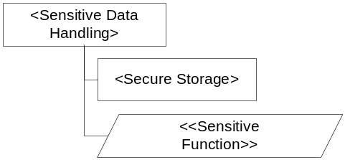
Editor’s note: to be completed.
Child Resource Name | Child Resource Type | Multiplicity | Description
Sensitive Functions |  | N
Secure Storage |  | 1..N

AttributeName | Multiplicity | RW/  RO/  WO | Description
Attributes tbd

6.3.6.1 Sensitive Functions
This service shall provide AEs and CSEs with access to Sensitive Functions of the SE.
Resource Structure
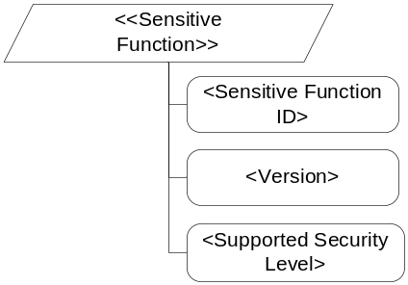
Editor’s note: to be completed. Sensitive Functions may include cryptographic algorithms, …
AttributeName | Multiplicity | RW/  RO/  WO | Description
Sensitive Function ID | 1 | RO | Unique Identifier of the sensitive function
Version | 1 | RO | Version number of the sensitive function
Supported Security Level | 1 | RO | Indicates the Security Level provided by the sensitive function

6.3.6.2 Secure Storage
This service shall provide AEs and CSEs with access to the secure storage capability of the SE. Data securely stored by the AE or CSE shall only be accessible through the Security API and by authorized entities. Secure Storage should be managed by the Secure Environment. Stored data shall be associated with the entity owning the data, i.e. the entity that requested the data to be stored within the secure storage.
Resource Structure
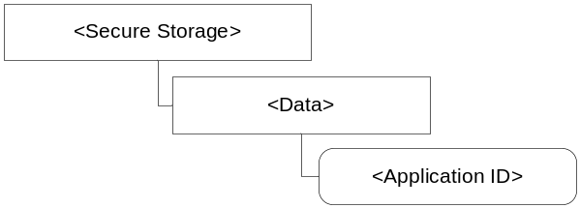
Editor’s note: to be completed.

6.3.7 Trust Enabler security functions
OneM2M Trust Enabling Architecture requires the presence of three security functionalities within the Infrastructure Domain: the M2M Authentication Function (MAF), the M2M Enrolment Function (MEF) and the M2M Authorization Function (MZF). They can be either under M2M Service Provider control or delegated to a M2M Trust Enabler.
- M2M Enrolment Function (MEF)
The MEF supports the security bootstrap procedure enabling the provisioning of the Master Credentials to be used to mutually authenticate entities accessing the infrastructure of an M2M Service Provider. The MEF relies on an initial credential pre-provisioned in the M2M node (e.g. during manufacturing). In case of M2M Security Remote Provisioning procedure, the MEF provides the M2M Master Credential both to the MAF and the ASN/MN-CSE.
- M2M Authentication Function (MAF)
M2M Master Credentials, used to mutually authenticate CSEs/AEs before granting them access to M2M services, shall be securely stored. M2M Master Credentials shall be securely stored in a specific infrastructure functionality named M2M Authentication Function (MAF).
The MAF securely contains the set of M2M Master Credentials that are used for authenticating CSEs/AEs that have been enrolled for M2M services. The MAF stores the M2M Master Credentials and possibly the identifiers of the associated CSE/AE. The MAF is identified by its MAF-ID.
When M2M Security Remote Provisioning procedure takes place to share a M2M Master Credential between an ASN/MN CSE and the M2M Authentication Function, the M2M Enrolment Function (MEF) communicates with the MAF through an appropriate secure interface, if not co-located.
The MAF is also in charge of all security operations involving the usage of the M2M Master Credentials.
- M2M Authorization Function (MZF)
The MZF is in charge of authorization aspects. . It provides an M2M entity (AE or CSE) with proof that it may use specific M2M services, application, or privilege (i.e. apply an existing role to perform specific operations on an M2M resource).
Editor’s note: Description and usage of MZF need further details.

6.4 Secure Environment AbstractionLayer Components

6.4.1 Secure Environment
The Secure Environment component is a logical entity that provides Sensitive Functions operating on Sensitive Data, Secure Storage and other resources / functions.
There is no assumption made on the particular implementation of the Secure Environment. A SE may be implemented as an independent HW Security Element or as an integrated SW function. Each Secure Environment shall be associated with one certain Security Level depending on the particular implementation of the SE. Different Secure Environments may provide different Security Levels.
There shall be at least one Secure Environment within or accessible via the Security API, however there may be multiple.

6.4.2 SE Plug-in
The SE Plug-in enables physical access to the respective Secure Environment. Depending on the type of Secure Environment, the SE Plug-in may be implemented differently for each Secure Environment.
NOTE: Specification of the SE Plug-in is out of scope of the present document.

6.4.3 Secure Environment Abstraction
This component shall enable entities accessing the Security Service API direct access to the Secure Environment Abstractionlayer. For this purpose the generic Secure Environment Abstractioncomponent shall expose functions provided by the Secure Environment Abstractionlayer functions to the Application layer. The Secure Environment Abstractionlayer is specific to the underlying secure environment. The Secure Environment Abstractioncomponent provides an abstraction layer exposing a Secure Environment agnostic interface to the Application layer. The Secure Environment Abstractioncomponent provides the capability to extend the SEC API depending on the use case with proprietary functions.
The generic Secure Environment Abstractioncomponent provides access to resources residing within the secure environment. Access to those functions shall be restricted to functions that are not addressable by the standardised SEC API.

7 Security API

7.1 API description
General description of the API…

7.2 Security Transport
The Security Transport API provides a communication framework to the secure environment.
The Security Transport API shall be implemented according to the Security Transport API as defined in [2].
Editor’s note: a more detailed description of the mapping of the architecture to the architectures defined in [2] and [3] may be added.

7.3 Authorization
Editor’s note: add API functions required to provide Authorization Service here.

7.3.1 Applying Access Control Policies: High Level Description
The present clause describes the process for authorization of (resource access) requests using <accessControlPolicy> resources (described in clause 9.6.2 “Resource Type accessControlPolicy” of TS-0001 [TS0001]). For requests to an <accessControlPolicy> resource, the request is evaluated against the selfPrivileges attribute in that <accessControlPolicy> resource. For other resource types, the resource access request is evaluated against the privileges attributes of the <accessControlPolicy> resources associated with the targeted resource (clause 9.6.2 “Resource Type accessControlPolicy”of TS-0001 [TS0001] describes how to determine the <accessControlPolicy> resources associated with the targeted resource). For other resource types, authorization is granted if the request is evaluated to “Granted” for at least one such privileges attribute.
There is no difference between the procedure for evaluating a request against a privileges attribute and the procedure for evaluating a request against a selfPrivileges attribute, so this high level description describes only the evaluation against a privileges attribute.
A privileges attribute is a set of access-control-rule-tuples. If a request evaluates to “Granted” against at least one access-control-rule-tuple, then the request evaluates to “Granted” against the privileges. In other words, each access-control-rule-tuple provides one acceptable combination of constraints in order for the request to be allowed. Alternatively, a privileges attribute represents the logical OR of the constraints in its access-control-rule-tuples.
An access-control-rule-tuple is comprised of three component parameters. A request evaluates to “Granted” against an access-control-rule-tuple only if the request evaluates to “Granted” for all of the component parameters. In other words, an access-control-rule-tuple represents the logical AND of constraints in its components. The three component parameters of an access-control-rule-tuple supported in this specification are:
- accessContolOriginators: which represents the set of Originators that can be authorized using this access-control-rule-tuple;
- accessControlOperations: which represents the set of operations that can be authorized using this access-control-rule-tuple;
- accessControlContexts: which represents a set of request contexts that are allowed using this access-control-rule-tuple.
The accessControlOriginators component parameter contains a set of parameters of varying type: each type is a different way of describing one or more Originators (see clause 9.6.2.1 of TS-0001 [TS0001] for details). The request evaluates to “Granted” against the accessControlOriginators parameter if the Originator matches any of those descriptions. In other words, accessControlOriginators represents the logical OR of the constraints in its set of parameters.
The accessControlOperations component parameter contains the set of operations (e.g. Create, Retrieve, Delete etc.) which are allowed to be applied on the requested resource (the types of operations are defined in clause 9.6.2.3 of TS-0001 [TS0001]). The request evaluates to “Granted” against the accessControlOperations component parameter if the requested operation is indicated in accessControlOperations. In other words, accessControlOriginators represents the logical OR of the constraints in its set of parameters.
The accessControlContexts contains a set, where each element of the set represents a set of constraints on the request context. A request evaluates to “Granted” against the accessControlContexts parameter if the request context is allowed according to the constraints of at least one resource context constraint. In other words, accessControlContexts represents the logical OR of the request context constraints.
Each element representing a request context constraint contains three parameters (see clause 9.6.2.2 “accessControlContexts” of TS-0001 [TS0001] for details):
- accessControlTimeWindows: Represents a set of time windows which are compared against the time that Authorization Decision is made;
- accessControlLocationRegions: Represents a set of location regions which are compared against the location of the Originator of the request;
- accessControlIpAddresses: Represents a set of IP addresses and/or IP address blocks which are compared against the IP address of the Originator of the request.
A request evaluates to “Granted” against a request context constraint if each of the following conditions are met.
- The time of the Authorization Decision is within one of the time windows described by the accessControlTimeWindows parameter;
- The location of the Originator is within at least one of the location regions described by the accessControlLocationRegions parameter;
- The IP address of the Originator matches at least one of the IP addresses or IP address blocks represented by the accessControlIpAddresses parameter.
In other words, for each parameter (accessControlTimeWindows, accessControlLocationRegions, accessControlIpAddresses) the request has to match at least one of the constraints. Alternatively, for each parameter (accessControlTimeWindows, accessControlLocationRegions, accessControlIpAddresses), take the logical OR of the constraints within that parameter; and then take the logical AND of the result for the three parameters.
The logic for evaluating a request against a privilege can be described mathematically as follows. A privileges or selfPrivileges attribute included in an <accessControlPolicy> resource represents a set of access control rules, acrs, which is built as in the graph below:
acrs = { acr(1), acr(2), ..., acr(k), ..., acr(K) }
acr(k) = {acr(k)_accessControlOriginators, acr(k)_accessControlOperations, acr(k)_accessControlContexts} }
Set of originator parameters of any type defined in
TS-0001 Table 9.6.2.1-1. Examples:
{CSE-ID1, AE-ID1, AE-ID2, entityGroup1, entityGroup2}
{all}
Set of allowed operations of any type defined in TS-0001 Table 9.6.2.3-1. Examples:
{Create, Retrieve, Update, Delete, Discover, Notify}
{Retrieve, Discover, Notify}

Set of context constraints consisting of the 3 elements defined in TS-0001 Table 9.6.2.2-1:
{accessControlTimeWindows(k, m), accessControlLocationRegions(k,m), accessControlIpAddresses(k, m)}

Set of time windows defined by start and end time
Example:
{04:30 – 06:00, 11:30 – 12:30, 22:15 – 00:30}
Set of location regions defined by list of objects representing geographical regions
Example:
{geoRegion1, geoRegion2, geoRegion3}
Set of IP addresses or address blocks
Example (IPv4):
{212.75.201.105, 88.77.0.0/16, 116.27.123.0/24}
Set (list) of M_k context constraints (number of elements M_k can be different for each acr(k)):
{acr(k)_accessControlContext(k, 1), …
…, acr(k)_accessControlContext(k, m), …
…, acr(k)_accessControlContext(k, M_k)}

The parameters associated with a request, which are evaluated against the parameters contained in the access control rules, are denoted as follows:
rq_orig: originator of the request (i.e. URI of the originating entity)
Editor’s Note: It needs to be reviewed how to represent accessContolOriginators in the access control rules and the rq_orig parameter in requests. The used parameters require adequately long life time.
rq_op: operation requested (i.e. Create, Retrieve, Update, etc.)
rq_time: time when the request was received (e.g. time in hh:mm:ss UTC, exact format TBD)
rq_ip: IP address of the originator (i.e. set of IPv4/IPv6 addresses, address blocks or address prefixes)
Editor’s Note: It needs to be reviewed whether use of IP addresses or use of FQDN representations is more appropriate for such constraint..
rq_loc: location information about the originating entity (format TBD)
The access decision is the result of evaluating a given set of access control rules, acrs. It is denoted
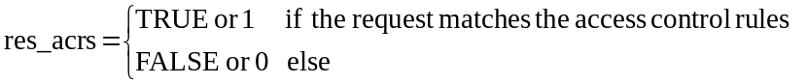
The access decision res_acrs is derived by evaluating each access control rule as follows:
res_acrs = res_acr(1) OR res_acr(2) ... OR res_acr(k) … OR res_acr(K),
where res_acr(k) represents the logical evaluation result (i.e. TRUE/FALSE or 1/0) of the request parameters against the k^{th} access control rule in the set acrs, which can be expressed as follows:
res_acr(k) = res_origs(k) AND res_ops(k) AND res_ctxts(k), k = 1…K.
The 3 partial logical result variables on the right side of above equation can be defined by using the following set function:
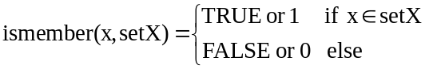
With this definition:
res_origs(k) = ismember(rq_orig, acr(k)_accessControlOriginators)
res_ops(k) = ismember(rq_op, acr(k)_ accessControlOperations)
The third partial logical result res_ctxts(k) is derived as follows
res_ctxts(k) = res_context(k, 1) ... OR res_context(k, m) ... OR res_context (k, M_k),
where,
res_context(k, m) = res_time(k, m) AND res_ip(k, m) AND res_loc (k, m), k = 1…K, m = 1…M_k
and
res_time(k, m) = ismember(rq_time, acr(k)_accessControlTimeWindows(m))
res_ip(k, m) = ismember(rq_ip, acr(k)_accessControlIpAddresses(m))
res_loc (k, m) = ismember(rq_loc, acr(k)_accessControlLocationRegions(m))

7.4 Sensitive Data Handling
Editor’s note: add API functions required to provide Sensitive Data Handling here.

7.5 Security Association
Editor’s note: add API functions required to provide Security Association here.

7.6 Security Administration
Editor’s note: add API functions required to provide Security Administration here.

7.7 Identity Protection
Editor’s note: add API functions required to provide Identity Protection here.

7.8 Authentication
Editor’s note: add API functions required to provide Authentication Service here.

8 Security Frameworks

8.1 General Introductions to the Security Frameworks

The security frameworks can be categorized into two main types
- Direct Security Frameworks: where the entities authenticate each other directly, without assistance from a Central Key Distribution Server
- Centralized Security Frameworks: where the entities authenticate each other with the assistance of a Central Key Distribution Server.

8.1.1 General Introduction to the Direct Security Frameworks

8.1.1.1 General Introduction to the Pre-Provisioned Symmetric Key Framework
Editor’s Note: Text is needed here.

8.1.1.2 General Introduction to the Certificate-Based Security Frameworks
Editor’s Note: Further Introductory material could be appropriate here.
This clause describes the Credential Configuration and Certificate Verification used in the Certificate-Based Security Association Establishment Framework and Certificate-Based Security Bootstrap Framework.

8.1.1.2.1 Credential Configuration for Certificate-Based Security Frameworks
If an entity is to authenticate itself using a Certificate-Based Security Framework, then the entity shall be pre-provisioned with the following information
  - The entity’s Private Signing Key and the corresponding Public Verification Key.
NOTE: an entity authenticates itself to other entities by proving that it knows the Private Signing Key corresponding to a particular Public Verification Key.
Editor’s Note: In some cases the Private Signing Key is unique to a single entity. In other cases, the Private Signing Key might be used to authenticate all entity's executing on a particular piece of hardware or used to authenticate all AEs executing a particular piece of software. This needs clarification text.
  - The entity’s Certificate containing the entity Public Verification Key and the entity’s Certificate Name (a unique identity) provided in a name field of the Certificate (e.g. in the X.509 “Subject” or “Subject Alternative Name” attribute). Two options are available:
    - The entity is configured with a valid Certificate Chain from the entity’s Certificate to a Root Certificate. The entity’s Root of Trust is the cryptographic hash of the Public Verification Key in this Root Certificate.
    - Alternatively, the entity’s Certificate is a self-signed certificate, for which the entity’s Private Signing Key is used to generate the Certificate signature (the certificate is verified using the entity’s Public Verification Key). In this case the cryptographic hash of entity’s Public Verification Key is both the entity’s Root of Trust and the entity’s Certificate Name. This implies that the cryptographic hash of the entity’s Public Verification Key must be present in a name field of the entity’s Certificate.
Editor’s Note: Conditions under which a self-signed certificate can be trusted or possible means to verify it (e.g. OCSP) are FFS.
NOTE: This pre-provisioning (by definition) uses mechanisms not specified by oneM2M.
Editor’s Note: Details for OCSP [RFC2560] and Certificate Revocation Lists (CRLs) are FFS.
Editor’s Note: Usage of certificates other than X.509 is FFS.

8.1.1.2.2 Certificate Verification
This clause describes how an entity authenticates the other entity in the Security Handshake of a Certificate-Based Security Framework.
The other entity’s Certificate is received during the Security Handshake.
The other entity’s Certificate is verified as follows:
- If the other entity’s Certificate is a self-signed certificate, then verify each of the following:
  - The other entity’s Certificate Name and other entity’s Root of Trust (received during Association Configuration or Bootstrap Instruction Configuration) are identical.
  - The other entity’s Certificate Name (received during Association Configuration or Bootstrap Instruction Configuration) is identical to a value in a name field (e.g. in the X.509 “Subject” or “Subject Alternative Name” attribute) of other entity’s Certificate (received during the Security Handshake).
  - The other entity’s Root of Trust (received during Association Configuration or Bootstrap Instruction Configuration) is identical to the Public Verification Key (or hash thereof) in the other entity’s Certificate (received during the Security Handshake).
- If the other entity’s Certificate is not a self-signed certificate, then verify each of the following:
  - The other entity’s Certificate Name (received during Association Configuration or Bootstrap Instruction Configuration) is identical to a value in a name field (e.g. in the X.509 “Subject” or “Subject Alternative Name” attribute) of the other entity’s Certificate (received during the Security Handshake)..
  - The other entity Certificate has a valid Certificate Chain (received during the Security Handshake) to a Certificate whose Public Verification Key (or hash thereof) is identical to the other entity' Root of Trust (received during Association Configuration or Bootstrap Instruction Configuration).

NOTE: After a successful Security Handshake in which the other entity provides a Certificate Chain, the other entity’s identity (received during Association Configuration or Bootstrap Instruction Configuration) can be associated with additional information extracted from the other entity’s Certificate Chain (e.g. the other entity Manufacturer, other entity owner, or conformance criteria). These details are not described in the present document.
Editor’s Note: Details of credentials for OCSP [RFC2560] may be required here.

8.1.2 General Introduction to the Centralized Security Frameworks

8.1.2.1 General Introduction to the M2M Authentication Function Framework
Editor’s Note: Text is needed here.

8.1.2.2 General Introduction to the GBA (Generic Bootstrapping Architecture) Framework
A general introduction to GBA is included in TR-0008 [i.6].
After a successful GBA bootstrapping, the M2M Application Service/Middle Node and the BSF share a security association which consists of a bootstrapping transaction identifier (B-TID) and key material (GBA bootstrap Ks).
This security association may be used by the M2M Application Service/Middle Node to derive NAF keys (Ks_(ext/int)_NAF) shared between a M2M Application Service/Middle Node and a M2M Infrastructure Node or an M2M Authentication Framework.

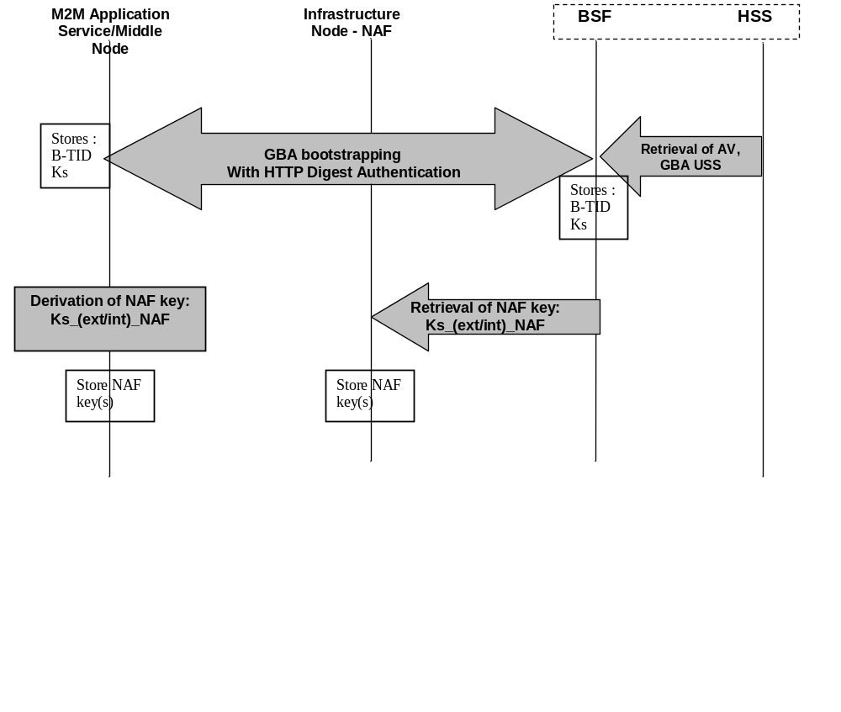 Figure 8.1.2.2-1 GBA framework. Note that the Network application Function (NAF) may be an Infrastructure Node or an M2M Authentication Function.

8.2 Security Association Establishment Frameworks

8.2.1 Overview on Security Association Establishment Frameworks
The oneM2M system supports the following Security Association Establishment Frameworks:
- Direct Security Association Establishment Frameworks
  - Pre-Provisioned M2M Secure Connection Key Security Association Establishment. A symmetric key is pre-provisioned to the entities: this is called the Pre-Provisioned M2M Secure Connection Key, and denoted Kpsa. The entities authenticate each other by verifying Message Integrity Codes (MIC) in the Security Handshake which were generated using the symmetric key. For more details see clause 8.2.2.1.
  - Certificate-Based Security Association Establishment: The entities are each issued with
    - a Private Signing Key that is known only to that entity,
    - a Certificate containing the corresponding Public Verification Key, and
    - (Optionally) a Certificate Chain from the entity’s Certificate to a Root Certificate.
The entities must validate each other’s Certificate before trusting the Public Verification Keys in the Certificate. Within the Security Handshake, entity A creates a digital signature of the session parameters using its private signing key and entity B verifies the digital signature using entity A’s public verification key. Then the roles are reversed: entity B creates a digital signature and entity A verifies it. For more details see clause 8.2.2.2.
- Centralized Security Association Establishment Frameworks: In such schemes, entity A and a Central Key Distribution Server authenticate each other and derive a M2M Secure Connection key (Kc) that the Central Key Distribution Server delivers to entity B. The entities then authenticate each other using the M2M Secure Connection key (Kc). The oneM2M authentication Frameworks using centralized key distribution are:
  - GBA based Security Association Establishment. This Security Association Establishment Framework uses 3GPP or 3GPP2 symmetric keys to authenticate entity A and the Central Key Distribution Server. The details are specified by 3GPP [4] and 3GPP2 [14]. For more details see clause 8.2.2.
  - M2M Authentication Function (MAF)-based Security Association Establishment. This Security Association Establishment Framework uses symmetric keys to authenticate the entity A and the Central Key Distribution Server. For more details see clause 8.2.3.1.
For a more detailed description of the above Security Association Establishment Frameworks, it is useful to compare the following aspects of the Security Association Establishment Frameworks:
- Credential Configuration:
  - For Central Key Distribution Security Association Establishment Frameworks:
    - Entity A is configured with (or otherwise establishes) the Master Credential (Km) that the entity A will use to authenticate the entity A to the Central Key Distribution Server.
    - The Central Key Distribution Server is configured with the Master Credential (Km) that will be used to authenticate the Central Key Distribution Server to entity A.
The details for the GBA-Based Security Association Establishment Framework are out of scope.
  - For other Security Association Establishment Frameworks, each entity is pre-provisioned with the Credential that the entity will use to authenticate itself to the other entity.
- Association Configuration: Configuration of entity identifiers (that is, CSE-ID or AE-ID) for the entities to be authenticated.
Additionally, in the case of Certificate-Based Authentication Framework: each entity is configured with the Certificate Name and Root of Trust that the entity will use to verify the other entity.
- Central Key Distribution Server Handshake: When a Centralized Security Association Establishment Framework is used, entity A and the Central Key Distribution Server (MAF or GBA-BSF) perform mutual authentication and generate a key, Km or Ks respectively, which is then used to derive a M2M Secure Connection Key (Kc) used in the Security Handshake for mutual authentication between entity A and entity B. This is not applicable to Direct Security Association Establishment Frameworks.
- Association Security Handshake: Identification, authentication and security context establishment between the entities.
Figure 8.2.1-1 provides a summary of the above defined four Security Association Establishment Frameworks.
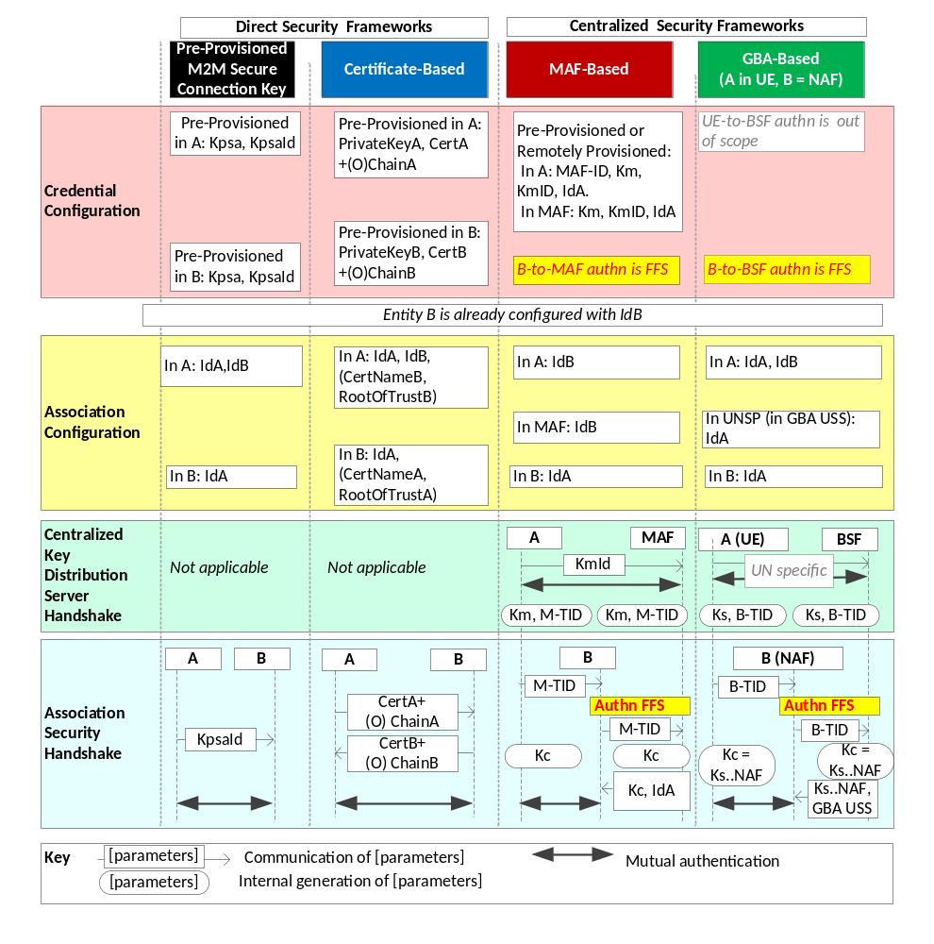
Figure 8.2.1-1 : Overview of the Security Association Establishment Frameworks supported by oneM2M.
Editor’s note: In the above figure, the illustrations of the MAF-based and GBA-based centralized security frameworks may need to be updated when the detailed flows have been agreed.

8.2.2 Direct Security Association Establishment Frameworks

8.2.2.1 Pre-Provisioned Symmetric Key Security Association Establishment Frameworks
This clause describes the Pre-Provisioned Secure Connection Key Security Association Establishment Framework. This framework enables mutual authentication of two entities corresponding to either two CSEs or a CSE and an AE. The Credential for this framework is a long-term symmetric key that has been pre-provisioned into the entities to be authenticated. This key is called a Pre-Provisioned Secure Connection Key and is denoted Kpsa. The entities authenticate each other by verifying message authentication codes in the Security Handshake which were generated using the Pre-Provisioned Secure Connection Key.
NOTE: Long term Pre-Provisioned Secure Connection Keys can pose a security risk if not adequately secured, and for this reason long term Pre-Provisioned Secure Connection Keys are recommended to be stored in Secure Environments.
Figure 8.2.2.1-1 illustrates the sequence of events when using the Pre-Provisioned Secure Connection Key Security Association Establishment Framework. In this description, “Entity A” and “Entity B” correspond to either two CSEs or a CSE and an AE or an AE and a CSE (respectively).
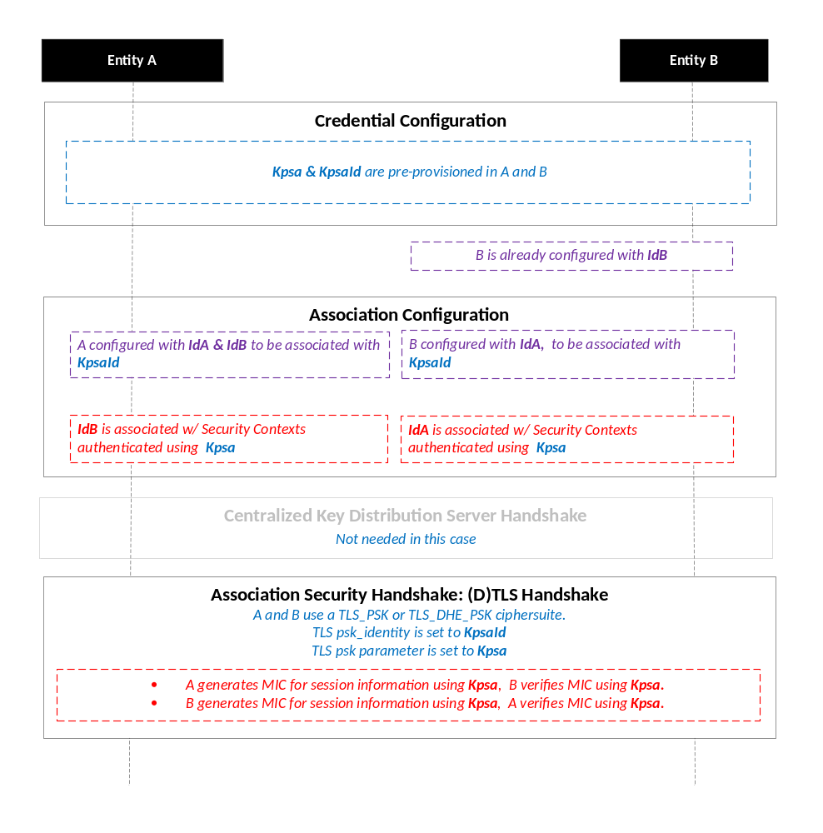
Figure 8.2.2.1-1: The sequence of events when using the Pre-Provisioned Secure Connection Key Security Association Establishment Framework. The following font colours differentiate the general topic that the text relates to:
- Blue italic text highlights details specific to this particular Security Association Establishment Framework.
- Purple italic text highlights technical actions that may include steps not specified by oneM2M.
- Red italic text highlights security-related properties.

Credential Configuration: The Pre-Provisioned Secure Connection Key (Kpsa) and the corresponding Pre-Provisioned Secure Connection Key Identifier, denoted KpsaId, are pre-provisioned to both entities.
NOTE: This pre-provisioning (by definition) uses mechanisms not specified by oneM2M.
Association Configuration: Each entity is configured with the information needed for mutual authentication and identification:
  - Entity A is commanded to initiate Security Context Establishment, and includes the following arguments:
    - The Pre-Provisioned Secure Connection Key Identifier KpsaId.
    - Entity A identity (IdA). Entity A is to assume this identity when interacting with Entity B.
    - Entity B identity (IdB). Entity A is to use this identity for Entity B authenticating using the above arguments. This identity is also used to route the (D)TLS exchange.
The mechanisms for achieving this are discussed in clause 8.4.1.2 (for the cases where Entity A is in the Field Domain) and Clause 8.4.2 (for the cases where Entity A is in the Infrastructure Domain).
NOTE: Entity A will associate Entity B’s identity with messages secured within Security Contexts established using the Pre-Provisioned Secure Connection Key Kpsa associated with the Pre-Provisioned Secure Connection Key Identifier KpsaId
  - Entity B is configured with the following arguments describing Entity A authorized to perform Security Context Establishment with the Registrar:
    - The Pre-Provisioned Secure Connection Key Identifier KpsaId.
    - Entity A identity (IdA). Entity B is to use this identity for Entity A authenticating using the above arguments..
    - Entity B Identity (IdB), if not already configured to Entity B. Entity B is to assume this identity when interacting with Entity A.
The mechanisms for achieving this are discussed in clause 8.4.1.2 (for the cases where Entity B is in the Field Domain) and Clause 8.4.2 (for the cases where Entity B is in the Infrastructure Domain).
NOTE: Entity B will associate the configured Entity A identity with messages secured within Security Contexts established using the Pre-Provisioned Secure Connection Key Kpsa associated with the Pre-Provisioned Secure Connection Key Identifier KpsaId.
NOTE: in many scenarios, the entity identities will be configured when the Pre-Provisioned Secure Connection Key Kpsa is established, so a separate configuration is not required in those scenarios.

Centralized Key Distribution Server Handshake: There is no Centralized Key Distribution Server Handshake applied in the Pre-Provisioned Secure Connection Key Security Association Establishment Framework.
Association Security Handshake: The entities perform a (D)TLS-PSK handshake [15] to establish a secure session.
- The “psk_identity” parameter [15] is set to the value of the Pre-Provisioned Secure Connection Key Identifier KpsaId.
- The “psk” parameter [15] is set to the value of the Pre-Provisioned Secure Connection Key Kpsa.
- Mandatory and optional (D)TLS cipher suites for this phase are specified in clause 9.2.

8.2.2.2 Certificate-Based Security Association Establishment Frameworks
This clause describes the Certificate-Based Security Association Establishment Framework.
Figure 8.2.2.2-1 illustrates the sequence of events when using the Certificate-Based Security Association Establishment Framework. In this description, “Entity A” and “Entity B” correspond to either two CSEs or a CSE and an AE.
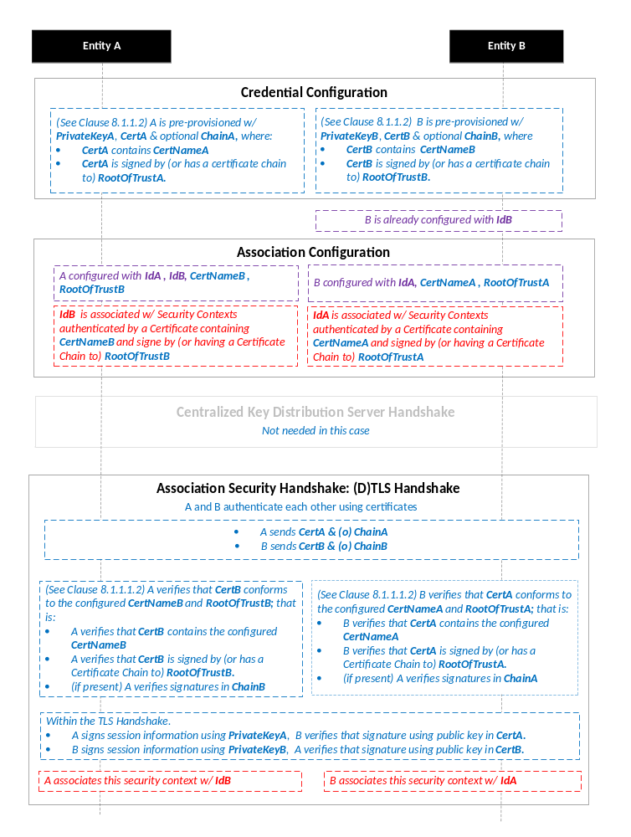
Figure 8.2.2.2-1: The sequence of events when using the Certificate-Based Security Association Establishment Framework. The following font colours differentiate the general topic that the text relates to:
- Blue italic text highlights details specific to this particular Security Association Establishment Framework.
- Purple italic text highlights technical actions that may include steps not specified by oneM2M.
- Red italic text highlights security-related properties.

Credential Configuration: The master credentials for each entity are pre-provisioned as described in Clause 8.1.1.2.1 “Credential Configuration for Certificate-Based Security Frameworks”
Association Configuration: Entity A and Entity B are configured with the information needed for the authentication and identification (during Security Handshake) of Entity B and Entity A respectively:
  - Entity A is commanded to initiate a Security Handshake, and the command includes the following arguments:
    - The Entity B Certificate Name (Entity B Certificate must include this value in a name field).
    - The Entity B Root of Trust (Entity B Certificate must be self-signed using this root of trust, or have a Certificate Chain to this root of trust).
    - The Entity A identity (IdA) Entity A is to use this entity identity with Entity B.
    - The Entity B identity (IdB). Entity A is to use this identity for Entity B authenticating using the above arguments. This is used to route the (D)TLS exchange).
The mechanisms for achieving this are discussed in clause 8.4.1.2 (for the cases where Entity A is in the Field Domain) and Clause 8.4.2 (for the cases where Entity A is in the Infrastructure Domain).
NOTE: The Entity A will associate Entity B’s identity with messages secured within Security Contexts established in accordance with the configured Entity B Certificate Name and Entity B Root of Trust.
  - The Entity B is configured with the following arguments describing Entity A authorized to perform Security Handshake with Entity B:
    - The Entity A Certificate Name. The Entity A Certificate must include this value in a name field.
    - The Entity A Root of Trust. The Entity A Certificate must be self-signed using this root of trust, or have a Certificate Chain to this root of trust.
    - The Entity A identity (IdA). Entity B is to use this entity identity for Entity A authenticating using the above arguments.
    - The Entity B Identity (IdB), if not already configured to Entity B. Entity B is to assume this identity when interacting with Entity A.
The mechanisms for achieving this are discussed in clause 8.4.1.2 (for the cases where Entity A is in the Field Domain) and Clause 8.4.2 (for the cases where Entity A is in the Infrastructure Domain).
NOTE: Entity B will associate Entity A’s identity with messages secured within Security Contexts established in accordance with the configured Entity A Certificate Name and Entity A Root of Trust.

Centralized Key Distribution Server Handshake: There is no Centralized Key Distribution Server Handshake applied in the Certificate-Based Security Association Establishment Framework.
Association Security Handshake:
- Each entity verifies the other entity’s certificate as described in clause 8.1.1.2.2 “Certificate Verification”.
- The entities authenticate each other using the validated certificates as specified in TLS 1.2 RFC 5246 [16] and DTLS 1.2 RFC 6347 [17] specifications.
- Mandatory and optional (D)TLS cipher suites for this phase are specified in clause 9.2.

8.2.3 Centralized Security Association Establishment Frameworks

8.2.3.1 MAF-Based Symmetric Key Security Association Establishment Frameworks
Editor’s Note: Text is required here.
Editor’s Note: This will include reference to the communication (protocol?) between the entity B and the MAF in clause 8.5.

8.2.3.2 GBA-Based Security Association Establishment Frameworks
To obtain a short term key used for M2M Service Connection between a M2M Application Service/Middle Node and a M2M Infrastructure Node, the M2M Application Service/Middle Node shall perform a successful GBA bootstrapping and derive a NAF key (Ks_(ext/int)_NAF). This NAF key is the M2M Secure Connection Key used for M2M Service Connection.
Editor’s Note: Further text is required here.

8.3 Security Bootstrap Frameworks

8.3.1 Overview on Security Bootstrap Frameworks

8.3.1.1 Purpose of Security Bootstrap Frameworks
The MAF-based Security Association Establishment Framework uses a Master Credential (Km) and corresponding Master Credential Identifier (KmId), shared by a CSE/AE and an M2M Authentication Function, to establish security associations between the CSE/AE and other CSEs and/or AEs as described in clause 8.2.3.
The Master Credential (Km) and corresponding Master Credential Identifier (KmId) shall either be pre-provisioned or remotely provisioned to the CSE/AE and M2M Authentication Function.
The details for pre-provisioning are not described in this specification.
Clause 8.3 describes the set of remotely provisioning mechanisms; called Security Bootstrap Frameworks. An M2M Enrolment Function facilitates the remote provisioning.

8.3.1.2 Overview on Security Bootstrap Frameworks
An AE or CSE that requires remote provisioning of a Master Credential and Master Credential Identifier is called an Enrolee.
The oneM2M system supports the following Security Bootstrap Frameworks:
- Direct Security Bootstrap Frameworks
  - Pre-Provisioned Symmetric Enrolee Key Security Bootstrap Framework. A symmetric key is pre-provisioned to the Enrolee and M2M Enrolment Function for the mutually authentication of those entities. For more details, see clause 8.3.2.1.
  - Certificate-Based Security Bootstrap Framework: The Enrolee and M2M Enrolment Function are each issued with
    - a Private Signing Key that is known only to that entity,
    - a Certificate containing the corresponding Public Verification Key, and
    - (Optionally) a Certificate Chain from the entity’s Certificate to a Root Certificate.
The Enrolee and M2M Enrolment Function shall validate each other’s Certificate before trusting the Public Verification Keys in the Certificate. Within the Security Handshake, the M2M Enrolment Function creates a digital signature of the session parameters using its private signing key and the Enrolee verifies the digital signature using the M2M Enrolment Function’s public verification key. Then the roles are reversed: the Enrolee creates a digital signature and the M2M Enrolment Function verifies it. For more details see clause 8.3.2.2.
- Centralized Security Bootstrap Frameworks
  - GBA-based Security Bootstrap Framework. In this case, the M2M Enrolment Function includes the functionality of a GBA Bootstrap Server Function. This framework uses 3GPP or 3GPP2 symmetric keys to authenticate the Enrolee and the M2M Enrolment Function (which is also a GBA BSF). The details are specified by 3GPP [4] and 3GPP2 [14]. For more details see clause 8.3.3.1.
For a more detailed description of the above Security Bootstrap Frameworks, it is useful to compare the following aspects of the Security Bootstrap Frameworks.
- Bootstrap Credential Configuration: The Enrolee and M2M Enrolment Function are pre-provisioned with the Bootstrap Credential that the entity will use to authenticate itself to the other entity. The mechanisms for this pre-provisioning are not described in this specification.
- Bootstrap Instruction Configuration: The Enrolee and M2M Enrolment Function are provided with
  - The M2M Authentication Function Identifier (MAF-ID) identifying the M2M Authentication Function for which the Enrolee is to be remotely provisioned.
Note: The identity of the M2M Authentication Function is assumed to have been configured prior to the Bootstrap Instruction Configuration phase.
  - The CSE-ID or AE-ID that the M2M Authentication Function is to associate with the Enrolee.
Additionally, in the case of Certificate-Based Security Bootstrap Framework:
  - The Enrolee is configured with the M2M Enrolment Function URI (for the purpose of routing the (D)TLS messages to the M2M Enrolment Function), M2M Enrolment Function Certificate Name and M2M Enrolment Function Root of Trust that the Enrolee will use to verify the M2M Enrolment Function.
  - The M2M Enrolment Function is configured with the Enrolee Certificate Name and Enrolee Root of Trust that the M2M Enrolment Function will use to verify the Enrolee.
Editor’s Note: The specification may need more details regarding configuring the identities of the M2M Enrolment Function and M2M Authentication Function.

- Bootstrap Enrolment Handshake: Identification, authentication and security context establishment between the Enrolee and M2M Enrolment Function.
- Enrolment Key Generation: generating a symmetric Enrolment Key,(Ke) and corresponding Enrolment Key Identifier (KeId) shared by the Enrolee and M2M Enrolment Function, which is used for subsequent generation of the Master Credential (Km).
- Usage in Centralized Key Distribution Server Handshake: During the Centralized Key Distribution Server Handshake of the MAF-Based Security Association Establishment, the following steps occurs
  - The Enrolee derives the Master Credential (Km) from the Enrolment Key (Ke) and M2M Authentication Function Identifier (MAF-ID). Details of the derivation are provided in clause 9.4.
  - The Enrolee generates the Master Credential Identifier (KmId) from Master Credential (Km) as described in clause 9.1, and stores Km and KmId.
  - The Enrolee passes the Enrolment Key Identifier (KeId) to the M2M Authentication Function (see “Centralized Key Distribution Server Handshake” in clause 8.2.3.1)
NOTE: When the Enrolee first communicates with the M2M Authentication Function, then the M2M Authentication Function has not yet retrieved the Km from the M2M Enrolment Function. Consequently, the Enrolee provides the KeId to the M2M Authentication function, which is then passed to the M2M Enrolment Function to identify the Enrolment Key. The M2M Enrolment Function then returns the Km from which the M2M Authentication Function can derive the KmId. In subsequent Security Establishments, the Enrolee may provide the KmId or the KeId, and the M2M Authentication Function will know that both identifiers indicate the retrieved Km. For more details, see “Centralized Key Distribution Server Handshake” in clause 8.2.3.1.
  - Upon receipt of the KeId, the M2M Authentication Function determines if it already has the corresponding Km and CSE-ID or AE-ID of the Enrolee
    - If the M2M Authentication Function already has the corresponding Km and CSE-ID or AE-ID of the Enrolee, then the Km is used for mutual authentication (see “Centralized Key Distribution Server Handshake” in clause 8.2.3.1)
    - If the M2M Authentication Function does not have the corresponding Master Credential (Km) and CSE-ID or AE-ID of the Enrolee, then the following steps are followed.
      - The M2M Authentication Function (securely) passes the KeId to the M2M Enrolment Function, along with the M2M Authentication Function’s URI.
      - The M2M Enrolment Function derives the Km from the Ke and MAF-ID. Details of the derivation are provided in clause 9.4.
      - The M2M Enrolment Function returns the Km to the M2M Authentication Function. The M2M Enrolment Function also passes the USS, including the CSE-ID or AE-ID of the Enrolee. More details are provided in clause 8.6.
      - The M2M Authentication Function generates the Master Credential Identifier (KmId) from Master Credential (Km) as described in clause 9.1, and stores Km and KmId
      - The Master Credential (Km) is used for mutual authentication (see “Centralized Key Distribution Server Handshake” in clause 8.2.3.1)
Figure 8.3.1-1 provides a summary of the above defined Security Bootstrap Frameworks
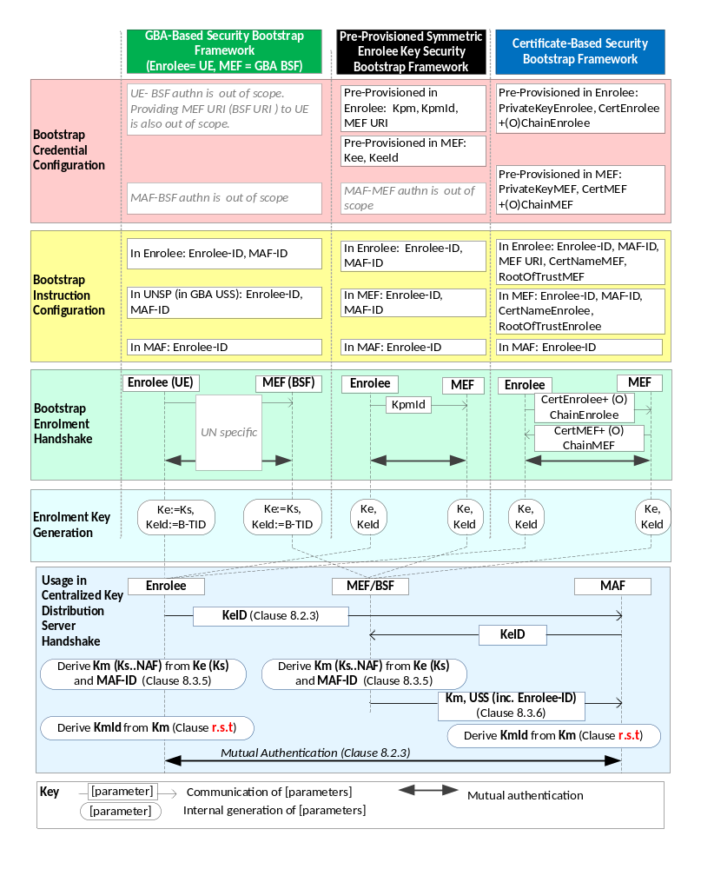Figure 8.3.1.2-1: Overview of the Security Bootstrap Frameworks supported by oneM2M.
Editor’s note: In the above figure, the illustrations of the GBA-based centralized security frameworks may need to be updated when the detailed flows have been agreed. Additionally, more parameters may need to be transferred from MAF to MEF in the “Usage in Centralized Key Distribution Server Handshake”. This is FFS.

8.3.2 Direct Security Bootstrap Framework

8.3.2.1 Pre-Provisioned Symmetric Key Security Bootstrap Framework
This clause describes the Pre-Provisioned Symmetric Key Security Bootstrap Framework. The Bootstrap Credential for this framework is a long-term symmetric key that has been pre-provisioned into the Enrolee and M2M Enrolment Function; this key is called a Pre-Provisioned Symmetric Enrolee Key and is denoted Kpm.
NOTE: Long term Pre-Provisioned Symmetric Enrolee Keys can pose a security risk if not adequately secured, and for this reason it is recommended that Long term Pre-Provisioned Symmetric Enrolee Keys are stored in Secure Environments.
Figure 8.3.2.1-1 illustrates the sequence of events when using the Pre-Provisioned Symmetric Enrolee Key Security Bootstrap Framework.
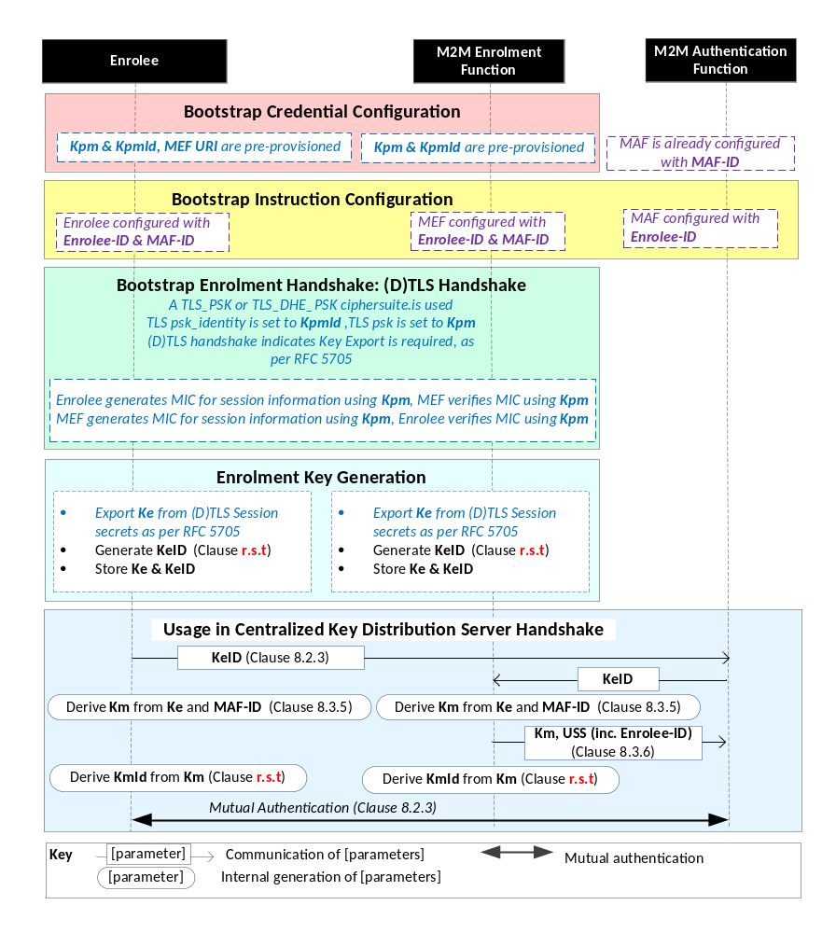
Figure 8.3.2.1-1 : The sequence of events when using the Pre-Provisioned Symmetric Key Security Bootstrap Framework.The following font colours differentiate the general topic that the text relates to:
- Black text contains Security-Bootstrap-Framework-independent details
- Blue italic text highlights details specific to this particular Security Bootstrap Framework.
- Purple italic text highlights technical actions that may include steps not specified by oneM2M.
Editor’s Note: More parameters may need to be transferred from MAF to MEF in the “Usage in Centralized Key Distribution Server Handshake”. This is FFS.
Bootstrap Credential Configuration: The Pre-Provisioned Symmetric Enrolee Key (Kpm) and the corresponding Pre-Provisioned Symmetric Enrolee Key Identifier, denoted KpmId, are pre-provisioned to both entities. The Enrolee is also provisioned with the M2M Enrolment Function’s URI (MEF URI), for the purpose of routing the (D)TLS exchange.
NOTE: This pre-provisioning (by definition) uses mechanisms not specified by oneM2M.
Bootstrap Instruction Configuration: The Enrolee and M2M Enrolment Function are configured with the information needed for authorizing the remote provisioning:
  - The Enrolee is configured with (or otherwise obtains) the following arguments to initiate remote provisioning :
    - M2M Authentication Function identity (MAF-ID): Identifying the M2M Authentication Function for which the Enrolee is to be provisioned.
    - Enrolee identity (Enrolee-ID): the Enrolee is to use this identity with the identified M2M Authentication Function.
    - The Enrolee associates these arguments with the M2M Enrolment Function. The M2M Enrolment Function can be identified to the Enrolee using the Pre-Provisioned Symmetric Enrolee Key Identifier (KpmId) or the M2M Enrolment Function URI.
The mechanisms for achieving this are discussed in clause 8.4.1.3.
  - M2M Enrolment Function is configured with the following arguments to authorize the M2M Enrolment Function to remotely provision the Enrolee for a M2M Authentication Function:
    - M2M Authentication Function Identity (MAF-ID) of the M2M Authentication Function for which the Enrolee is to be provisioned.
    - Enrolee identity (Enrolee-ID). The M2M Enrolment Function is to provide this entity identity for the Enrolee with the Master Credential (Km) to the target M2M Authentication Function, when requested by the M2M Authentication Function.
    - The M2M Enrolment Function associates these arguments with an Enrolee. The Enrolee can be identified to the M2M Enrolment Function using the Pre-Provisioned Symmetric Enrolee Key Identifier (KpmId).
The mechanisms for achieving this are discussed in clause 8.4.2.
Bootstrap Security Handshake: The Enrolee and M2M Enrolment Function perform a (D)TLS-PSK handshake [15] to establish a secure session.
- The “psk_identity” parameter [15] is set to the value of the Pre-Provisioned Symmetric Enrolee Key Identifier (KpmId).
- The “psk” parameter [15] is set to the value of the Pre-Provisioned Symmetric Enrolee Key (Kpm).
- Mandatory and optional (D)TLS cipher suites for this phase are specified in clause 9.2.

Enrolment Key Generation:
- The Enrolment Key (Ke) is generated from the (D)TLS session secrets by the Enrolee and M2M Enrolment Function using TLS Key Export (RFC 5705) [18], as described in clause 9.3.
- The Enrolment Key Identifier (KeId) is generated by the Enrolee and M2M Enrolment Function, as described in clause 9.1.
- The Enrolee and M2M Enrolment store the Enrolment Key (Ke) and Enrolment Key Identifier (KeId).

NOTE: The Enrolment Key Generation for the Pre-Provisioned Symmetric Enrolee Key Security Bootstrap Framework is identical to the Enrolment Key Generation for the Certificate-Based Security Bootstrap Framework.
Usage in Centralized Key Distribution Server Handshake: See “Overview of Security Frameworks” in Clause 8.3.1.

8.3.2.2 Certificate-Based Security Bootstrap Framework
This clause describes the Certificate-Based Security Bootstrap Framework. The Bootstrap Credentials for this framework are Certificates.
Figure 8.3.2.2-1 illustrates the sequence of events when using the Certificate-Based Security Bootstrap Framework.
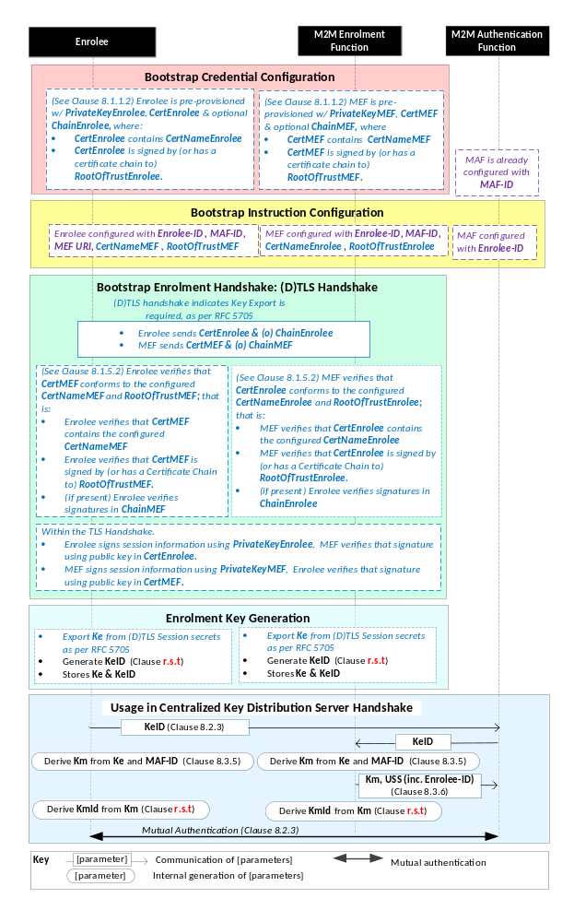
Figure 8.3.2.2-1: The sequence of events when using the Certificate-Based Security Bootstrap Framework.The following font colours differentiate the general topic that the text relates to:
- Black text contains Security Bootstrap-Framework-independent details
- Blue italic text highlights details specific to this particular Security Bootstrap Framework.
- Purple italic text highlights technical actions that may include steps not specified by oneM2M.
- Red italic text highlights security-related properties.
Editor’s Note: More parameters may need to be transferred from MAF to MEF in the “Usage in Centralized Key Distribution Server Handshake”. This is FFS.
Bootstrap Credential Configuration: For this Security Bootstrap Framework, Enrolee and M2M Enrolment Function authenticate each other using a Public Key Certificate. The Bootstrap Credentials for the Enrolee and M2M Enrolment Function are pre-provisioned as described in clause 8.1.1.2.1 “Credential Configuration for Certificate-Based Security Frameworks”.
NOTE: The identities of the M2M Enrolment Function and M2M Authentication Function are assumed to have been configured prior to this phase.
Editor’s Note: The specification may need more details regarding configuring the identities of the M2M Enrolment Function and M2M Authentication Function.
Bootstrap Instruction Configuration: The Enrolee and M2M Enrolment Function are configured with the information needed for authorizing the remote provisioning:
  - The Enrolee is configured with (or otherwise obtains) the following arguments to initiate remote provisioning:
    - The URI of the M2M Enrolment Function which will facilitate the remote provisioning, for the purpose of routing the (D)TLS exchange.
    - The M2M Enrolment Function Certificate Name (M2M Enrolment Function Certificate must include this value in a name field);
    - The M2M Enrolment Function Root of Trust (M2M Enrolment Function Certificate must be self-signed using this root of trust, or have a Certificate Chain to this root of trust);
    - The target M2M Authentication Function Identity (MAF-ID), with whom the Enrolee is to be provisioned using Security Bootstrap.
    - The Enrolee identity (Enrolee-ID): The Enrolee is to use this entity identity with the identified M2M Authentication Function.
The mechanisms for achieving this are discussed in clause 8.4.1.2.
  - The M2M Enrolment Function is configured with the following arguments describing Enrolee authorized to perform Security Handshake with M2M Enrolment Function:
    - The Enrolee Certificate Name. The Enrolee Certificate must include this value in a name field.
    - The Enrolee Root of Trust. The Enrolee Certificate must be self-signed using this root of trust, or have a Certificate Chain to this root of trust.
    - The target M2M Authentication Function Identity (MAF-ID), with whom the Enrolee (authenticated using the above Enrolee Certificate Name and Enrolee Root of Trust) is to be provisioned using Security Bootstrap.
    - The Enrolee identity (Enrolee-ID). The M2M Enrolment Function is to provide this entity identity for the Enrolee with the Master Credential (Km) to the target M2M Authentication Function, when requested by the M2M Authentication Function..
The mechanisms for achieving this are discussed in clause 8.4.2.
Bootstrap Security Handshake: The Enrolee and M2M Enrolment Function perform a (D)TLS handshake as specified in TLS 1,2 RFC 5246 [16] and DTLS 1.2 RFC 6347 [17] specifications.to establish a secure session.
- Each entity (Enrolee and M2M Enrolment Function) verifies the other entity’s certificate as described in clause 8.1.1.2.2 “Certificate Verification”.
- The Enrolee and M2M Enrolment Function authenticate each other using the validated certificates as specified in TLS 1.2 RFC 5246 [16] and DTLS 1.2 RFC 6347 [17] specifications.
- Mandatory and optional TLS cipher suites for this phase are specified in clause 9.2.
Enrolment Key Generation:
- The Enrolment Key (Ke) is generated from the (D)TLS session secrets by the Enrolee and M2M Enrolment Function using TLS Key Export (RFC 5705) [18], as described in clause 9.3.
- The Enrolment Key Identifier (KeId) is generated by the Enrolee and M2M Enrolment Function, as described in clause 9.1.

- The Enrolee and M2M Enrolment store the Enrolment Key (Ke) and Enrolment Key Identifier (KeId).

NOTE: The Enrolment Key Generation for the Pre-Provisioned Symmetric Enrolee Key Security Bootstrap Framework is identical to the Enrolment Key Generation for the Certificate-Based Security Bootstrap Framework.
Usage in Centralized Key Distribution Server Handshake: See “Overview of Security Frameworks” in Clause 8.3.1.

8.3.3 Centralized Security Bootstrap Framework

8.3.3.1 GBA-Based Security Bootstrap Framework
To share a long term Master Credential between an Application Service/Middle Node and an M2M Authentication Function, the M2M Application Service/Middle Node shall perform a successful GBA bootstrapping and derive a NAF key (Ks_(ext/int)_NAF). This NAF key is the Master Credential.
Editor’s Note: Further text is required here.

The following text is to be used when appropriate:

Proforma copyright release text block
This text box shall immediately follow after the heading of an element (i.e. clause or annex) containing a proforma or template which is intended to be copied by the user. Such an element shall always start on a new page.
Notwithstanding the provisions of the copyright clause related to the text of the present document, OneM2M grants that users of the present document may freely reproduce the <proformatype> proforma in this {clause|annex} so that it can be used for its intended purposes and may further publish the completed <proformatype>.
<PAGE BREAK>

Annexes
Each annex shall start on a new page (insert a page break between annexes A and B, annexes B and C, etc.).
Use the Heading 9 style for the title and the Normal style for the text.
Annex <A> (Informative): Mapping of 3GPP GBA terminology
Following table provides a mapping of terminology and abbreviations used in GBA according to 3GPP specification [4] to corresponding oneM2M terminology and abbreviations as used within the present document.

GBA entities, keys and processes | oneM2M Security Bootstrap entities, keys & processes
UE | Enrolee
BSF | MEF
NAF | MAF
Bootstrapping Procedure | Bootstrap Security Handshake + Temporary Enrolment Key Generation
Ks | Ke
B-TID | KeId
Bootstrapping Usage Procedure | Usage in Centralized Key Distribution Server Handshake
NAF FQDN | IdMAF
Ks_(ext/int)_NAF | Km (Master Credential)

Annex <B>(Informative): General Mutual Authentication Mechanism
oneM2M mutual authentication schemes allow oneM2M entities to prove that they know related credentials such as Master Credentials, without having to exchange value of those credentials, and sensitive data such as identities and identifiers. To prevent reading and copying of credentials, a secure environment within the Security CSF provides protection against tampering of those credentials and related processed information.
Editor’s Note: It needs to be defined which oneM2M identities represent sensitive data that should not be exchanged over the communication link between entities A and B.
A general mutual authentication protocol is applied to both symmetric and asymmetric key based schemes. Precise protocol messages and parameters depend on the chosen scheme and the security parameters selected. Typically it consists of following steps as shown in Figure B-1:

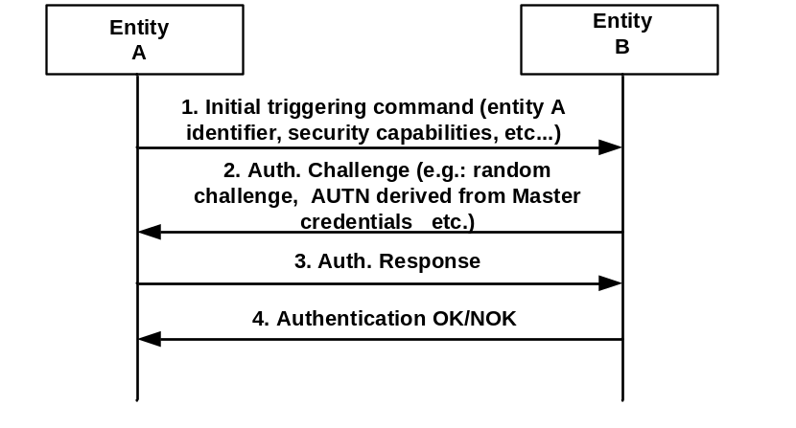
Figure B-1: Mutual Authentication

Editor’s Note: Adding a reference to an existing and suitable Challenge Response scheme/specification/standard is FFS.

1. An initial step where an entity A is securely identified to an entity B with whom previous or no previous contact has been made. In this step entity A identifies itself to an entity B protected against eavesdropping, i.e. no exchange of key material (Master Credential).
2. In the second step entity B sends a challenge to entity A. The Authentication challenge consists of random challenge, authentication token of entity B derived from Master credentials, etc. The authentication challenge depends on the chosen scheme and the security parameters selected for symmetric and asymmetric key based schemes.
3. The entity A replies with an authentication response derived from its known Master Credentials and the received Athentication challenge. This response is sent if entity B has been successfully authenticated by entity A.
4. Entity B then verifies the relation between entity A’s identity and the response received in step 3, which gives a high probability that the entity B knows a secret value associated with the entity A’s identity provided in step 1.

Annex <y>:
Bibliography
The annex entitled "Bibliography" is optional.
It shall contain a list of standards, books, articles, or other sources on a particular subject which are not mentioned in the document itself
It shall not include references mentioned in the document.
Use the Heading 9 style for the title and B1+ or Normal for the text.
- <Publication>: "<Title>".
OR
<Publication>: "<Title>".
<PAGE BREAK>

History
This clause shall be the last one in the document and list the main phases (all additional information will be removed at the publication stage).
Publication history
V1.1.1 | <dd-Mmm-yyyy> | <Milestone>

Draft history (to be removed on publication)
V.0.0.0 | 07 Aug 2013 | Initial version agreed at SEC#4 in oneM2M-SEC-2013-0026R01-Skeleton_TS_Security_Solutions
V0.1.0 | 18 Oct 2013 | Incorporates following contributions agreed at SEC 7.0:  oneM2M-SEC-2013-0041R01-SecurityCSF_Architecture  oneM2M-SEC-2013-0044R04-Network-based_bootstrap  oneM2M-SEC-2013-0050R03-PKI-Based_Post_Provisioning  oneM2M-SEC-2013-0051R01-secure_remote_administration
V0.2.0 | 21 Jan 2014 | Incorporates following contributions agreed at SEC 8.0:  oneM2M-SEC-2013-0066R01-Bootstrapping_Definition  oneM2M-SEC-2013-0070R03-GBA_framework  oneM2M-SEC-2013-0073R04-Security_CSF_Architecture_Figure  oneM2M-SEC-2013-0075R01-Clean_up_Security_TS
V0.3.0 | 25 Mar 2014 | Incorporates following contributions agreed at SEC 9.0:  SEC-2014-0044R03-SEC_CSF_Architecture_Figure_Update_for_Security_TS  SEC-2014-0045R02-SEC_CSF_Authorization_Description_Update_for_Security_TS  SEC-2014-0055R04-MAS_and_MTF_description
V0.4.0 | 15 Apr 2014 | Incorporates following contributions agreed at SEC 10.0:  SEC-2014-0240R02-SEC_CSF_Authorization_Procedure_for_Security_TS  SEC-2014-0241R03-SEC_CSF_Architecture_General_Description_for_Security_TS  SEC-2014-0259R01-Credentials_definitions  SEC-2014-0260R01-Credentials_abbreviations  SEC-2014-0243R03-Overview_of_Security_Frameworks  SEC-2014-0242R03-Certificate-Based_Security_Framework_Common_Details
SEC-2014-0247R03-Overview_of_Security_Bootstrap_Frameworks
SEC-2014-0244R04-Certificate-Based_Security_Bootstrap_Framework
SEC-2014-0252R03-Pre-Provisioned_Symmetric_Enrolee_Key_Security_Bootstrap_Framework
SEC-2014-0224R07-Overview_of_Security_Association_Establishment_Frameworks
SEC-2014-0227R05-Certificate-Based_Security_Association_Establishment_Framework
SEC-2014-0226R05-Pre-Provisioned_Symmetric_Association_Key_Framework
SEC-2014-0254R02-Precisions_on_M2M_Trust_Functions
SEC-2014-0239R01-Clarifications_to_TS-0003
Following actions have been resolved and changes incorporated into this version of the document:
A-WG4-TP10_006: extract table from document SEC-2014-0263-Temporary_Enrolment_Key_Terminology and add to TS 0003 as an informative Annex
A-WG4-TP10_A02: make the necessary alignments regarding “Master Credential” when integrating the agreed contributions into the TS
Several editorial corrections incorporated.
V0.5.0 | 02 June 2014 | Incorporates following documents agreed during conference calls  SEC-2014-0288R01-TS0003_V0_4_0_CSFcleanup  SEC-2014-0277R03-cleanup_TS0003_clause8  SEC-2014-0249R05-General_Mutual_Authentication_Mechanism  SEC-2014-0285R05-AccessControlPolicy_Processing_Summary

