

OneM2M
Technical Specification
Document Number | oneM2M-TS-0003-Security_Solutions-V-0.6.0
Document Name: | oneM2M Security Solutions
Date: | 2014-06-23
Abstract: | Specification of oneM2M security solutions.

oneM2M IPR and copyright statements
"Participation in, or attendance at, any activity of oneM2M, constitutes acceptance of an agreement to be bound by all provisions of IPR policy of the admitting Partner Type 1 and permission that all communications and statements, oral or written, or other information disclosed or presented, and any translation or derivative thereof, may without compensation, and to the extent such participant or attendee may legally and freely grant such copyright rights, be distributed, published, and posted on oneM2M's web site, in whole or in part, on a non-exclusive basis by oneM2M or oneM2M Partners Type 1 or their licensees or assignees, or as oneM2M SC directs.

Contents
1 Scope 5
2 References 5
2.1 Normative references 5
2.2 Informative references 6
3 Definitions and abbreviations 7
3.1 Definitions 7
3.2 Abbreviations 9
4 Conventions 10
5 Security Architecture 11
5.1 Overview 11
5.1.1 Identification and Authentication 12
5.1.2 Authorization 12
5.1.3 Identity Management 12
5.3 Security Layers 13
5.3.1 Security Service Layer 13
5.3.2 Secure Environment Abstraction Layer 13
5.4 Integration within overall oneM2M architecture 14
6 Security Services and Interactions 14
6.1 Security Service Layer 14
6.1.1 Access Management 14
6.1.1.1 Authentication 14
6.1.2 Authorization Architecture 14
6.1.3 Security Association Establishment 17
6.1.3.1 Security association based on pre-existing (network layers) credentials 17
6.1.3.1.1 GBA-based security association 17
6.1.4 Security Administration 17
6.1.4.1 Security Pre-Provisioning 17
6.1.4.2 Remote security administration of SE 18
6.1.4.3 Bootstrapping 18
6.1.4.3.1 Network-based Bootstrapping 18
6.1.4.3.2 PKI-Based Bootstrapping 18
6.1.5 Identity Protection 19
6.1.6 Sensitive Data Handling 19
6.1.6.1 Sensitive Functions 19
6.1.6.2 Secure Storage 19
6.1.7 Trust Enabler security functions 19
6.2 Secure Environment AbstractionLayer Components 20
6.2.1 Secure Environment 20
6.2.2 SE Plug-in 20
6.2.3 Secure Environment Abstraction 20
7 Authorization and Access Control 20
7.1 Applying Access Control Policies: High Level Description 20
8 Security Frameworks 23
8.1 General Introductions to the Security Frameworks 23
8.1.1 General Introduction to the Direct Security Frameworks 24
8.1.1.1 General Introduction to the Pre-Provisioned Symmetric Key Framework 24
8.1.1.2 General Introduction to the Certificate-Based Security Frameworks 24
8.1.1.2.1 Credential Configuration for Certificate-Based Security Frameworks 24
8.1.1.2.2 Certificate Verification 24
8.1.2 General Introduction to the Centralized Security Frameworks 25
8.1.2.1 General Introduction to the M2M Authentication Function Framework 25
8.1.2.2 General Introduction to the GBA (Generic Bootstrapping Architecture) Framework 25
8.2 Security Association Establishment Frameworks 26
8.2.1 Overview on Security Association Establishment Frameworks 26
8.2.2 Direct Security Association Establishment Frameworks 28
8.2.2.1 Pre-Provisioned Symmetric Key Security Association Establishment Frameworks 28
8.2.2.2 Certificate-Based Security Association Establishment Frameworks 30
8.2.3 Centralized Security Association Establishment Frameworks 32
8.2.3.1 MAF-Based Symmetric Key Security Association Establishment Frameworks 32
8.2.3.2 GBA-Based Security Association Establishment Frameworks 34
8.3 Security Bootstrap Frameworks 37
8.3.1 Overview on Security Bootstrap Frameworks 37
8.3.1.1 Purpose of Security Bootstrap Frameworks 37
8.3.1.2 Overview on Security Bootstrap Frameworks 37
8.3.2 Direct Security Bootstrap Framework 40
8.3.2.1 Pre-Provisioned Symmetric Key Security Bootstrap Framework 40
8.3.2.2 Certificate-Based Security Bootstrap Framework 42
8.3.3 Centralized Security Bootstrap Framework 45
8.3.3.1 GBA-Based Security Bootstrap Framework 45
9 Security Framework Procedures and Parameters 47
9.1 Security Association Establishment Framework Procedures and Parameters 47
9.1.1 Credential Configuration Procedures and Parameters 47
9.1.1.1 Credential Configuration of Field-Domain Security Association End-Points 47
9.1.1.2 Credential Configuration of Infrastructure-Domain Security Association End-Points 48
9.1.1.3 Credential Configuration of M2M Authentication Functions 48
9.1.2 Association Configuration Procedures and Parameters 49
9.1.2.1 Association Configuration of Field-Domain Security Association End-Points 49
9.1.2.2 Association Configuration of Infrastructure-Domain Security Association End-Points 50
9.1.2.3 Association Configuration of M2M Authentication Functions 50
9.1.2.4 Association Configuration of UNSP Authentication Servers 50
9. 2 Security Bootstrap Framework Procedures and Parameters 51
9.2.1 Bootstrap Credential Configuration Procedures and Parameters 51
9.2.1.1 Bootstrap Credential Configuration of Enrolees 51
9.2.1.2 Bootstrap Credential Configuration of M2M Enrolment Functions 52
9.2.1.3 Bootstrap Credential Configuration of M2M Authentication Functions 52
9.2.2 Bootstrap Instruction Configuration Procedures and Parameters 52
9.2.2.1 Bootstrap Instruction Configuration of Enrolees 53
9.2.2.2 Bootstrap Instruction Configuration of M2M Authentication Functions 53
9.2.2.3 Bootstrap Instruction Configuration of M2M Enrolment Functions 54
9.2.2.4 Bootstrap Instruction Configuration of UNSP Authentication Server 54
Annex A (informative): Mapping of 3GPP GBA terminology 56
Annex B (informative): General Mutual Authentication Mechanism 57
Annex C (informative): Security protocols associated to specific SE technologies 58
C.1 UICC 58
C.2 Other secure element and embedded secure element with ISO 7816 interface 58
C.3 Trusted Execution Environment 58
C.4 SE to CSE binding 58
Annex D (normative): UICC security framework to support oneM2M Services 58
D.1 Access Network UICC-based oneM2M Service Framework 59
D.1.1 Access Network UICC-based oneM2M Service Framework characteristics 59
D.1.2 M2M Service Framework discovery for Access Network UICC 60
D.1.3 Content of files at the DF_{1M2M} level 61
D.1.3.1 EF_{1M2MST} (oneM2M Service Table) 61
D.1.3.2 EF_{1M2MSID} (oneM2M Subscription Identifier) 63
D.1.3.3 EF_{1M2MSPID} (oneM2M Service Provider Identifier) 63
D.1.3.5 EF_{M2MCSEID} (M2M local CSE Identifier) 64
D.1.3.6 EF_{M2MAE-ID} (M2M Application Identifiers list) 64
D.1.3.7 EF_{M2MNSCLIDS} (M2M IN-CSE IDs list) 65
D.1.3.8 EF_{MAFFQDN} (MAF-FQDN) 65
D.1.3.9 EF_{1M2MMEFID} (M2M Enrolment Function Identifier) 66
D.2 oneM2M Service Module application for symmetric credential on UICC (1M2MSM) 67
D.2.1 oneM2M Service Module application file structure 67
D.2.1.1 Content of UICC files at the Master File (MF) level 67
D.2.1.2 Content of files at the 1M2MSM ADF (Application DF) level 67
D.2.2 oneM2M Subscription related procedures for M2M Service 67
D.2.2.1 Initialization – 1M2MSM Application selection 68
D.2.2.2 1M2MSM session termination 68
D.2.2.3 oneM2M Service discovery procedure 68
D.2.2.4 oneM2M Service provisioning procedures 68
D.2.2.5 oneM2M Application Identifiers provisioning procedure 68
D.2.2.6 oneM2M Service bootstrapping related procedures 68
D.2.2.7 oneM2M Security Association related procedures 69
History 70

1 Scope
The present document defines security solutions applicable within the M2M system.

2 References
References are either specific (identified by date of publication and/or edition number or version number) or non-specific. For specific references, only the cited version applies. For non-specific references, the latest version of the referenced document (including any amendments) applies.

2.1 Normative references
The following referenced documents are necessary for the application of the present document.
[1] oneM2M TS-0001 "oneM2M Architecture"
[2] Open Mobile API specification V2.0.2
[3] GP TEE Client API….
[4] void
[5] IETF RFC 5246 "The Transport Layer Security (TLS) Protocol Version 1.2".
[6] IETF RFC 6347 "Datagram Transport Layer Security Version 1.2"
[7] ETSI TS 102 225 (V11.0.0) "Smart Cards; Secured packet structure for UICC based applications (Release 11)" URL:http://www.etsi.org/
[8] ETSI TS 102 226 (V11.0.0) "Smart Cards; Remote APDU structure for UICC based applications (Release 11)" URL:http://www.etsi.org/
[9] 3GPP TS 31.115 (V10.1.0) "Remote APDU Structure for (U)SIM Toolkit applications (Release 10)"
[10] 3GPP TS 31.116 (V10.2.0) "Remote APDU Structure for (Universal) Subscriber Identity Module (U)SIM Toolkit applications (Release 10)"
[11] 3GPP2 C.S0078-0 (V1.0) "Secured packet structure for CDMA Card Application Toolkit (CCAT) applications"
[12] 3GPP2 C.S0079-0 (V1.0) "Remote APDU Structure for CDMA Card Application Toolkit (CCAT) applications"
[13] 3GPP TS 33.220 "Digital cellular telecommunications system (Phase 2+); Universal Mobile Telecommunications System (UMTS); LTE; Generic Authentication Architecture (GAA); Generic Bootstrapping Architecture (GBA) (3GPP TS 33.220)"
[14] 3GPP2 S.S0109-A "Generic Bootstrapping Architecture (GBA) Framework"
[15] IETF RFC 4279 "Pre-Shared Key Ciphersuites for Transport Layer Security (TLS) "
[16] IETF RFC 5246 "The Transport Layer Security (TLS) Protocol, Version 1.2"
[17] IETF RFC 6347 "Datagram Transport Layer Security Version 1.2"
[18] IETF RFC 5705 "Keying Material Exporters for Transport Layer Security (TLS)"
[19] IETF RFC 3629 "UTF-8, a transformation format of ISO 10646".
[20] "Unicode Standard Annex #15; Unicode Normalization Forms", Unicode 5.1.0, March 2008. http://www.unicode.org
[21] GlobalPlatform Device Technology TEE Administration framework, DRAFT
[22] GlobalPlatform Device Technology TEE System Architecture, Version 1.0
[23] ETSI TS 102 671 "Smart Cards; Machine-to-Machine UICC; Physical and logical characteristics" URL:http://www.etsi.org/
[24] ETSI TS 102 221 "Smart Cards; UICC-Terminal Interface; Physical and logical characteristics" URL:http://www.etsi.org/
[25] ETSI TS 102 484 "Smart Cards; Secure channel between a UICC and an end-point terminal" URL:http://www.etsi.org/
[26] ISO/IEC 7816-4: "Identification cards - Integrated circuit cards - Part 4: Organization, security and commands for interchange".
[27] ETSI TS 101 220 "Smart Cards; ETSI numbering system for telecommunication application providers" URL:http://www.etsi.org/
[28] 3GPP TS 33.222, " Generic Authentication Architecture (GAA), Access to network application functions using Hypertext Transfer Protocol over Transport Layer Security (HTTPS)", Rel-12
[29] 3GPP TS 24.109, "Bootstrapping interface (Ub) and network application function interface (Ua)", Rel-12
[30] 3GPP TS 29.109, "Protocols details Generic Authentication Architecture (GAA); Zh and Zn Interfaces based on Diameter protocol; Stage 3", Rel-12

Editor's note: add version numbers to references where missing.

2.2 Informative references

The following referenced documents are not necessary for the application of the present document but they assist the user with regard to a particular subject area.

- [i.1] oneM2M Drafting Rules
NOTE: Available at http://member.onem2m.org/Static_pages/Others/Rules_Pages/oneM2M-Drafting-Rules-V1_0.doc.
[i.2] oneM2M-TR-0004 Definitions and abbreviations
[i.3] 3GPP TR 33.868 V0.13.0; Security aspects of Machine-Type and other Mobile Data Applications Communications Enhancements; (Release 12)

[i.6] oneM2M TR-0008, Security Analysis Technical Report
[i.7] eXtensible Access Control Markup Language (XACML) Version 3.0. 22 January 2013. OASIS Standard.
[i.8] Handbook of Applied Cryptography, A. J. Menezes, P. C. van Oorschot, S. A. Vanstone, CRC Press, 1996
[i.9] Recommendation ITU T X.509, Information technology - Open Systems Interconnection - The Directory: Public-key and attribute certificate frameworks, 10/2012.
[i.10] 3GPP TR 33.868 “3rd Generation Partnership Project; Technical Specification Group Services and System Aspects; Study on security aspects of Machine-Type Communications (MTC) and other mobile data applications communications enhancements”.

3 Definitions and abbreviations

3.1 Definitions
For the purposes of the present document, the terms and definitions given in [i.2] and the following apply:
association configuration: phase of a Security Association Establishment Framework in which the entity establishing the Security Association (and the Central Key Distribution Server, in the case of Centralized Security Frameworks), are provided with identities (and any other relevant credentials) to ensure that the security association is established between the intended entities
association security handshake: phase of a Security Association Framework in which the security association endpoints perform mutual authentication
bootstrap credential: pre-provisioned credential enabling mutual authentication of the Enrolee and the M2M Enrolment function
bootstrap credential configuration: phase of a Security Bootstrap Framework in which the Bootstrap Credentials are pre-provisioned to the Enrolee and the M2M Enrolment function
bootstrap enrolment handshake: phase of a Security Bootstrap Framework in which the Enrolee and M2M Enrolment Function perform mutual authentication
bootstrap instruction configuration: phase of a Security Bootstrap Framework in which the Enrolee and M2M Enrolment Function are provided with identities (and any other relevant credentials) to enable the M2M Enrolment function to establish a Master Credential between the intended Enrolee and M2M Authentication Function
bootstrap server function [13]: BSF is hosted in a network element under the control of an Mobile Network Operator. BSF, HSS, and UEs participate in GBA in which a shared secret is established between the network and a UE by running the bootstrapping procedure
NOTE: The shared secret can be used between NAFs and UEs, for example, for authentication purposes.
bootstrapping transaction identifier [13]: bootstrapping transaction identifier (B-TID) is used to bind the subscriber identity to the keying material in GBA reference points Ua, Ub and Zn
CA-Certificate [ i.8]: certificate created by one certification authority (CA) certifying the public key of another CA
central key distribution server: server which can perform mutually authentication with a set of entities, and which can use this ability to securely distribute keys to sets of two or more of these entities
central key distribution server handshake: Phase of a Centralized Security Association Establishment Framework in which an entity and the Centralized Key Distribution Server perform mutual authentication and generate a Symmetric Key which is can then be used in the Association Security Handshake for mutual authentication between that entity and other entities
centralized security framework: Security Framework in which the entities authenticate each other with the assistance of a Central Key Distribution Server
certificate: See Public Key Certificate.
certificate chain: sequence of one or more CA-certificates, where: the Public Verification Key in each CA-certificate is certified in the previous CA-certificate; and the public key of the first CA-Certificate is trusted a priori
NOTE: Trust in the public key in each CA-certificate can be based on trust in the previous CA-Certificate.
certificate name: unique identifier in a name field of a Certificate (e.g. in the X.509 "Subject" or "Subject Alternative Name" attribute)
certificate verification: process necessary to trust that an entity's Certificate
certification authority [i.8]: responsible for establishing and vouching for the authenticity of public keys
NOTE: [This] includes binding public keys to distinguished names through signed certificates, managing certificate serial numbers, and certificate revocation.
credential configuration: phase of a Security Association Establishment Framework in which the Credentials necessary for the Security Association Establishment Framework are configured to the relevant entities and functions
digital signature [i.9]: information is signed by appending to it an enciphered summary of the information
NOTE: The summary is produced by means of a one-way hash function, while the enciphering is carried out using the private key of the signer.
direct security framework: Security Framework in which the entities authenticate each other directly, without assistance from a Central Key Distribution Server
enrolee: AE or CSE that requires remote provisioning of an Master Credential and Master Credential Identifier for an M2M Authentication Function
enrolment key: symmetric key established between an Enrolee and M2M Enrolment Function following successful mutual authentication
NOTE: A Master Credential to be shared by the Enrolee and an M2M Authentication Function may be derived (at the Enrolee and M2M Enrolment Function) from the currently valid Enrolment Key, and the M2M Enrolment Function subsequently securely delivers the Master Credential to the M2M Authentication Function,
enrolment key establishment: phase of a Security Bootstrap Framework in which the Enrolee and M2M Enrolment function establish an Enrolment Key
entity identifier: CSE-ID (or AE-ID respectively) of a CSE (or AE respectively)
generic bootstrap architecture: set of 3GPP and 3GPP2 specifications providing security features and a mechanism to bootstrap authentication and key agreement for application security from the 3GPP and 3GPP2 underlying network authentication mechanisms
MAF Transaction Identifier (M-TID): used to bind the entity identifier to the keying material when using the MAF-Based Security Association Establishment Framework
message integrity code: tag computed from a messages and a symmetric key, and attached to a message
NOTE 1: The purpose of a messages integrity code is to facilitate, without the use of any additional mechanisms, assurances regarding both the source of a message and its integrity.
NOTE 2: A Message Integrity Code is sometimes called a "Message Authentication Code" - we have used "Message Integrity Code" since the abbreviation of "Message Authentication Code" (MAC) might be misunderstood to refer to "Media Access Control". The definition is based on text from [i.8] (p323).
M2M secure connection key: key shared between two CSEs of M2M Nodes (e.g. ASN/MN-CSE and IN-CSE) in order to secure the communication between those two entities
NOTE: This M2M Secure Connection Key results from a successful M2M Security Association Establishment procedure.
master credentials: Credentials used to mutually authenticate between an ASN/MN-CSE and the MAF. This is done to secure access to the infrastructure of an M2M Service Provider
NOTE: The Master Credentials are either pre-provisioned or remotely provisioned (without relying on those credentials).
policy access point: system entity that finds applicable policy or policy set
policy decision point [i.7]: system entity that evaluates applicable policy and renders an authorization decision
policy enforcement point [i.7]: system entity that performs access control, by making decision requests and enforcing authorization decisions
policy information point [i.7]: system entity that acts as a source of attribute values
pre-provisioned secure connection key: Symmetric Key that is pre-provisioned to two entities (which may be AEs or CSEs) to be used for mutual authentication of those entities in Security Association Establishment
pre-provisioned secure connection key identifier: Identifier for a Pre-Provisioned Secure Connection Key
pre-provisioned symmetric enrolee key: Symmetric Key that is pre-provisioned to the Enrolee and M2M Enrolment Function
pre-provisioned symmetric enrolee key identifier: Identifier for a Pre-Provisioned Symmetric Enrolee Key
private signing key: secret key that can generate signatures that can be verified using a corresponding Public Verification Key
public key certificate: electronic document that uses a digital signature to bind a public key with an identity
NOTE: [i.8] A public-key certificate is a data structure consisting of a data part and a signature part. The data part contains cleartext data include, as a minimum, a public [verification] key and a string identifying the part (subject entity) to be associated therewith. The signature part consists of the digital signature of a certification authority over the data part, thereby binding the subject entity's identity to the specified public key.
public key infrastructure: set of hardware, software, people, policies, and procedures needed to create, manage, distribute, use, store, and revoke Public Key Certificates. For more details, see [i.8].
public verification key: Credential that can verify digital signatures generated by a corresponding Private Signing Key, but which cannot be used to generate digital signatures
root certificate: Certificate signed by a public key that hashes to a Root of Trust
root of trust: hash of a public key that is trusted a priori
security association establishment framework: Security Framework for Security Association Establishment
security bootstrap framework: Security Framework for Security Bootstrapping: a mechanism for remotely provisioning a Master Credential and Master Credential Identifier to a Enrolee and an M2M Authentication Function
security framework: set of procedures providing Security Association Establishment or Security Bootstrapping
self-signed certificate: Public Key Certificate that is signed by the same entity whose identity it certifies
symmetric key: secret key that is shared between two entities
X.509: ITU-T recommendation for a Public Key Infrastructure

3.2 Abbreviations
For the purposes of the present document, the abbreviations given in [i.2] and the following abbreviations apply:
ACL Access Control List
API Application Programming Interface
ASN Application Service Node
Authn Authentication
BSF Bootstrapping Server Function
B-TID Bootstrapping Transaction Identifier
CA Certification Authority
Cert[Entity] A Certificate containing a Public Verification Key for which [Entity] knows the corresponding Private Signing Key,
CertName[Entity] An identifier that matches a unique value in a name field of Cert[Entity].
Chain[Entity] Certificate Chain from Cert[Entity] to a Root Certificate signed by RootOfTrust[Entity]
DTLS Datagram Transport Layer Security (Protocol)
Enrolee-ID Enrollee Identity
FQDN Fully Qualified Domain Name
GBA Generic Bootstrapping Architecture
GBA_ME ME-based GBA
GBA_U GBA with UICC-based enhancements
GUSS GBA User Security Settings
HLR Home Location Register
HSS Home Subscriber System
HW Hardware
IdA Identifier for entity A
IdB Identifier for entity B
Kc M2M Secure Connection Key
Ke Enrolment Key
KeId Enrolment Key Identifier
Km Master Credential
KmId Master Credential Identifier
Kpm pre-provisioned credential for Master Credential provisioning
KpmId pre-provisioned credential for Master Credential provisioning Identifier
Kpsa pre-provisioned credential for M2M Security Association Establishment
KpsaId pre-provisioned credential for M2M Security Association Establishment Identifier
Ks temporary Key material referred to in GBA
Ks_(ext/int)_NAF Derived key in GBA_ME or Derived key in GBA_U which remains on UICC
Ks..NAF Abbreviation of Ks_(int/ext)_NAF
Ks_NAF Derived key in the ME
Ks_ext_NAF Derived key in GBA_U sent to the ME
Ks_int_NAF Derived key in GBA_U which remains on UICC
M-TID MAF Transaction Identifier
MAF M2M Authentication Function
MAF-ID M2M Authentication Function Identifier
MEF M2M Enrolment Function
MIC Message Integrity Code
MN Middle Node

NAF Network Application Function
PAP Policy Access Point
PDP Policy Decision Point
PEP Policy Enforcement Point
PIP Policy Information Point
PKI Public Key Infrastructure
PrivateKey[Entity] Private Signing Key of [Entity]
RBAC Role Based Access Control
RootOfTrust[Entity] A Root of Trust for Cert[Entity]
SE Secure Environment
SW Software
TEE Trusted Execution Environment
TLS Transport Layer Security (Protocol)
(D)TLS-PSK (D)TLS Pre-Shared Key (ciphersuites)
UE (3GPP) User Equipment
USS User Security Settings
URI Uniform Resource Identifier

4 Conventions
The key words "Shall", "Shall not", "May", "Need not", "Should", "Should not" in this document are to be interpreted as described in the oneM2M Drafting Rules [i.1].

5 Security Architecture

5.1 Overview
Figure 5.1-1 provides a high level overview of the Security architecture.
The architecture consists of following layers:
- Security Functions layer:
- This layer contains a set of security functions that are exposed at reference point Mca and Mcc. These security functions can be classified into six categories; they are Identification, Authentication, Authorization, Security Association, Sensitive Data Handling and Security Administration.
- Security Environment Abstraction Layer:
- This layer implements various security capabilities such as key derivation, data encryption/decryption, signature generation/verification, security credential read/write from/to the Secure Environments, and so on. The security functions in the Security Functions Layer invoke these functions in order to do the operations related to the Secure Environments. In addition this layer also provides physical access to the Secure Environments. Implementation of this is out of scope of the present document. This layer is not specified in the initial release but is expected to be considered in future releases.
- Secure Environment layer:
- This layer contains one or multiple secure environments that provide various security services related to sensitive data storage and sensitive function execution. The sensitive data includes SE capability, security keys, local credentials, security policies, identity information, subscription information, and so on. The sensitive functions include data encryption, data decryption, and so on. Implementation of secure environments is out of scope of the present document.
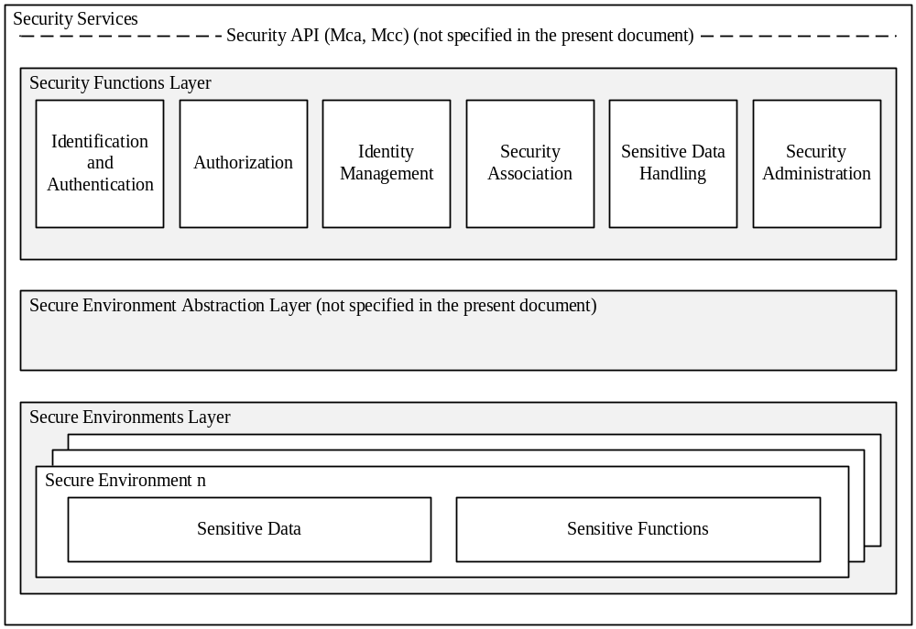
Figure 5.1-1: High level overview of the Security architecture

Design principles:
- Security Services are modular and configurable according to the needs of the hosting CSE, its supported reference points and its purpose.
- The architecture is split into several components and sub-components providing a modular design. With this design, mapping of the architecture to different nodes and entities is enabled.
- Depending on the requirements of each entity, Security should consist of components relevant to fulfil the requirements of the respective node or entity and the intended use case.
- The architecture may need to be adapted to be suitable for implementation in different entities. For example, the architecture can be mapped to different device classes.
- The security administration component shall enable administration of all sensitive resources (data and functions) and shall also allow configuration and extension of Security services itself.
- The Secure Environment within the CSE is accessed via the Secure Environment Abstraction layer and shall hold all sensitive resources.

5.1.1 Identification and Authentication
The Identification and Authentication function is in charge of identification and mutual authentication of CSEs and AEs.
Identification is the process of checking if the identity provided for authentication is valid. How to perform an identification process will depend on the purpose of authentication. For example, in the case of resource access, the authentication function may require the identification to check if the AE or CSE has registered with the local CSE; in the case of AE or CSE registration, the authentication function may require the identification to check if the identity provided by an AE or CSE fits a certificate. Once passing this checking process, the AE or CSE is identified, and the identified identity will be supplied to authentication process.
Authentication is the process of validating if the identity supplied in the identification step is associated with a trustworthy credential. How to perform an authentication process will depend on using which mutual authentication mechanism. For example, in the case of using certificate based authentication mechanism, the authentication function may require the authentication to verify a digital signature; in the case of using symmetric key based authentication mechanism, the authentication function may require the authentication to verify a Message Authentication Code (MAC). When this validating process has been completed, the AE or CSE is authenticated.

5.1.2 Authorization
The Authorization function is responsible for authorizing services and data access to authenticated entities according to provisioned access control policies and assigned roles.
Access control policy is defined as sets of conditions that define whether entities should be permitted access to a protected resource. The authorization function may support different authorization mechanisms, such as Access Control List (ACL), Role Based Access Control (RBAC), etc. The Authorization function may need to evaluate multiple access control policies in an authorization process in order to get a finial access control decision. This process is further described in clause X “Authorization”.
Authorization evaluation process is based on the Service Subscription resource which specifies what M2M Services and M2M Service roles the authenticated entity has subscribed to and the access control policies associated with the protected resource. The authorization evaluation process may also need to consider contextual attributes such as time or geographic location.
Prior to authorization mutual authentication between the originator CSE or AE and hosting CSE shall be performed.

5.1.3 Identity Management
The Identity Management function provides oneM2M identities/identifiers to the requesting entity in case those identities are stored within the secure environment. oneM2M identifiers as defined in the oneM2M Architecture [1] may also be treated as sensitive data that are accessible to AEs or CSEs and used independently of Authentication or Authorization functions.

5.3 Security Layers

5.3.1 Security Service Layer
The security service layer provides the following services:
- Access Management
- Authorization
- Authentication
- Access Control
- Sensitive Data Handling
- Sensitive Functions protection
- Secure Storage
- Security Association Establishment
- Secure Connection via secure session establishment
- Secure Connection via object security
- Security Administration (including security bootstrapping)
- Identity Protection
Each of these services provides functions and resources on the Security Service and Administration API.

5.3.2 Secure Environment Abstraction Layer
The Secure Environment Abstraction Layer (not specified in the present document) provides access to the Secure Environment via a general Security Transport API. A Plug-in associated to the type of Secure Environment shall provide physical/logical connectivity to the secure environment. The Secure Environment Abstraction Layer shall also be accessible on the Service Layer.

5.4 Integration within overall oneM2M architecture
Security services may be provided within the following architectural components and interacts on the different reference points as described in TS-0001[1].
:
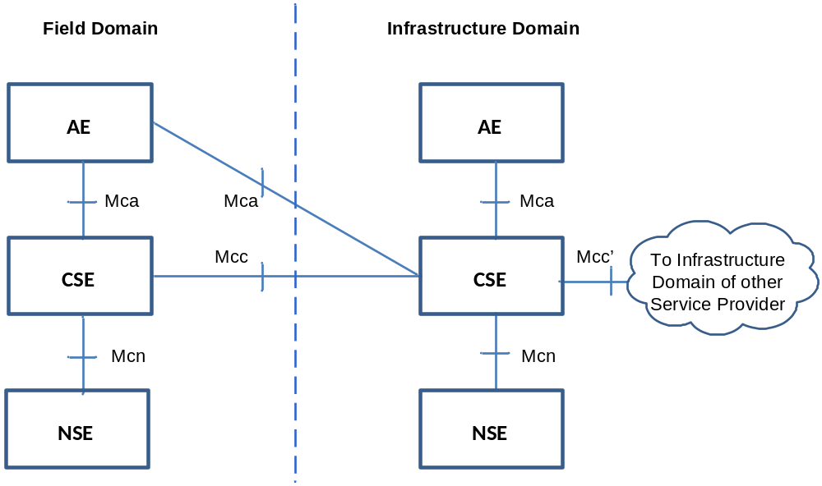

Figure 5.2.1-1: oneM2M Functional Architecture
The present document addresses the security over Mcc and Mca in hop-by hop scenario
Editor’s note: The security over Mcc’ has to be addressed if possible before publication (ACTION all).

6 Security Services and Interactions

6.1 Security Service Layer

6.1.1 Access Management

6.1.1.1 Authentication
This component provides authentication services to the Application Layer. Annex B provides a general description of Authentication mechanisms.

6.1.2 Authorization Architecture
Figure 6.1.2-1 provides a high level overview of the authorization architecture. This architecture comprises four subcomponents that are described as follows:
- Policy Enforcement Point (PEP)
- PEP intercepts resource access requests, makes access control decision requests, and enforces access control decisions. The PEP coexists with the entity that need authorization services.
- Policy Decision Point (PDP)
- PDP interacts with the PAP and PIP to get applicable authorization polices and attributes needed for evaluating authorization policies respectively, and then evaluates access request using authorization policies for rendering an access control decision. The PDP is located in the Authorization service.
- Policy Access Point (PAP)
- PAP obtains applicable authorization policies according to an access control decision request. These applicable policies should be combined in order to get a finial access control decision. The PAP is located in the Authorization service.
- Policy Information Point (PIP)
- PIP provides attributes that are needed for evaluating authorization policies, for example the IP address of the requester, creation time of the resource, current time or location information of the requester. The PIP is located in the Authorization service.
The Authorization service may comprise any of the subcomponents: PDP, PAP and/or PIP. This means that the subcomponents PEP, PAP, PDP and PIP could be distributed across different nodes. For example the PEP is located in an ASN/MN and the PDP is located in the IN.
NOTE: Release 1 does not support separation of PAP and PIP on different CSE from PDP.
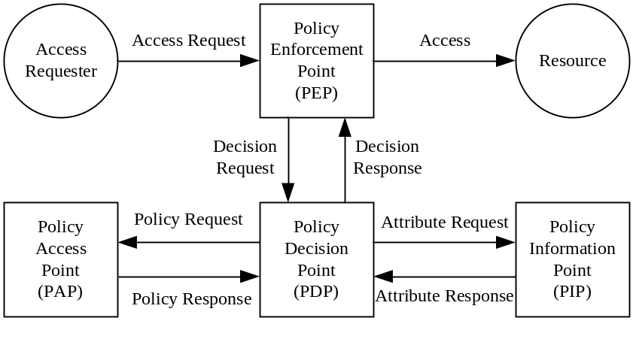
Figure 6.1.2-1: Overview of the authorization architecture
The authorization procedure is shown in figure 6.3.2-2.
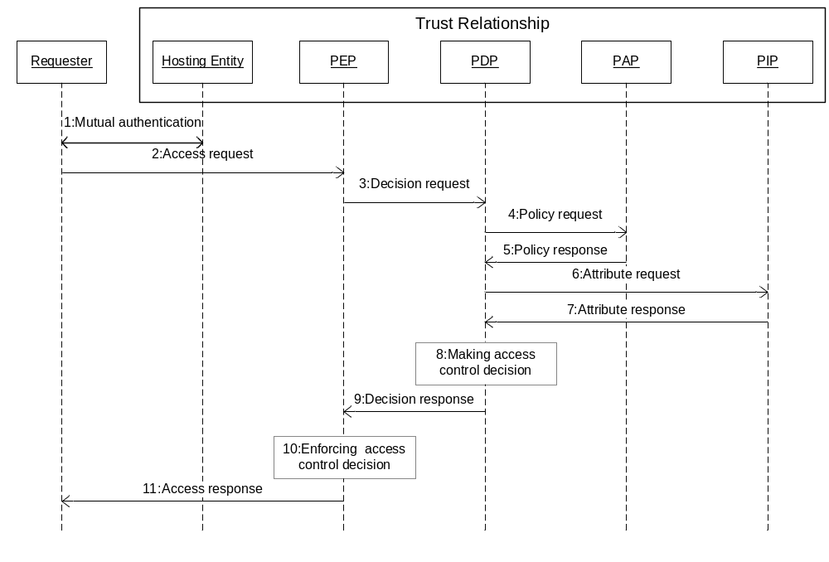
Figure 6.3.2-2: Authorization Procedure
Step 001: Mutual authentication (Pre-requisite).
Step 002: Access Requester sends an Access Request to the PEP.
Step 003: PEP makes an Access Control Decision Request according to the requester's Access Request, and sends the Access Control Decision Request to the PDP.
Step 004: PDP sends an Access Control Policy Request that is generated based on the Access Control Decision Request to the PAP.
Step 005: PAP finds all applicable access control policies to the access request and sends them back to the PDP. When multiple access control polices are involved, the PAP also provides a policy combination algorithm for combining multiple evaluation results into one finial result.
Step 006 PDP sends Attribute Request to the PIP if any attributes are required for evaluating these access control policies.
Step 007: PIP gets required attributes and sends them back to the PDP.
Step 008: PDP evaluates Access Request using access control policies. When there are multiple applicable access control policies, the PEP needs to calculate a final Access Control Decision using the policy combination algorithm.
Step 009: PDP returns the Access Control Decision back to the PEP.
Step 010: PEP enforces the access control decision, i.e. either forwards the Access Request to the resource or denies this access.
Step 011: PEP returns access result back to the Access Requester.

6.1.3 Security Association Establishment
This service shall provide functions to establish secure connections between CSEs in the Field Domain and IN-CSE, to protect the infrastructure of an M2M Service Provider.
NOTE 1: Such secure connections provide hop-by-hop protection to information exchange by M2M applications.
NOTE 2 : Use of hop-by-hop connection by AEs assumes trust in the M2M SP. For AEs affiliated with different M2M SP, this also implies that M2M SPs are part of a circle of trust.

In addition, the Security Association Establishment component shall be able to use an existing security association to set up a
Secure Connection via secure session establishment.

- The Security Association Establishment component may rely on an external M2M Authentication Function to establish security associations.
Editor's note: to be completed.

6.1.3.1 Security association based on pre-existing (network layers) credentials
In case of scenario where the M2M Service Provider and the operator of the underlying network have an agreement to use the underlying network credentials as the basis for establishing a secure connection between a M2M Application Service/Middle Node and Infrastructure Node (including the case that the M2M Service Provider and the operator of an underlying network are actually the same entity), GBA procedure could be used to perform the security association establishment procedure, as specified in [13].
It is important that this feature is used only within the scope of an appropriate agreement between the M2M Service Provider and the operator of the underlying network. The normative text in clause 8.1 implicitly assumes that such an agreement is already in place. Since the present document is a technical specification, it does not address the details of such an agreement.

6.1.3.1.1 GBA-based security association
The GBA procedure shall be applied as specified in [13] for scenarios where the operator of an underlying network supports GBA, e.g. 3GPP or 3GPP2, and the underlying network credentials are to be used as the basis for establishing a secure connection between a M2M Application Service/Middle Node and Infrastructure Node
The Secure Connection relies on a symmetric shared short term key used for M2M Service Connection to establish a secure session between a M2M Application Service/Middle Node and Infrastructure Node.

Clause 8.2.3 specifies how the short term key used for M2M Service Connection is obtained using the GBA framework.

6.1.4 Security Administration
The Security Administration service shall provide functions to manage the Security functions, resources and attributes. This shall include management of resources provided via the secure environment. In addition it should provide functions to manage sensitive data with their associated identifiers and subscriptions on behalf of other entities. Security administration is therefore dependent upon the type of secure environment being used (independent hardware module, integrated trusted execution environment or software protection). Depending on the type of Secure Environment, distinct existing standards may be used for remote administration of those SEs.

6.1.4.1 Security Pre-Provisioning
Several sensitive data and associated objects are often configured by pre-provisioning the secure environment prior to deploying the M2M device it is associated with.
UICCs specified in ETSI TS 102 671 [23] are comonly used for such purpose because their use is required to access some underlying networks, they provide a high security level, and they offer an interoperable transport interface specified in ETSI TS 102 221 [24]. An interoperable oneM2M provisioning framework relying on this interface is specified in Annex D.

6.1.4.2 Remote security administration of SE
The Security Administration service may provide mechanisms for remote security administration of sensitive data and security functions of M2M field domain nodes, reusing mechanisms provided by existing standards where appropriate. However, since remote security administration requires the target information to be remotely modifiable, hardware based protection is required to protect such security information from remote software hacking of the device: This is the purpose of the Secure Environment. Remote security administration differs from standard device management by the requirement that the secure channel established with the administration server shall have its endpoint in the Secure Environment of the M2M Node.
The choice of a Secure Environments is guided by a risk analysis considering all layers of an M2M application, though it should leverage where possible on capabilities provided by the M2M Service Layer or the Underlying Network, e.g. UICC in 3GPP networks. Applicable remote administration protocols are therefore dependent on the risk level of each M2M application and not just on the underlying network technologies. Widespread technologies that enable remote security administration for the different security levels distinguished in oneM2M TR-0008 [i.6] are considered in Annex C.
In case the Secure Environment relies on software protection only, remote security administration of the following data should be possible only when remote access by potential attackers can be controlled:
- Private key and associated identifiers
- Long-term shared symmetric key (compared to expected lifetime of the M2M node) and associated identifiers
- Any process and parameters thereof that manipulates to the above information, i.e. security functions.

6.1.4.3 Bootstrapping
Bootstrapping is the post-provisioning of the essential information for the service layer security between an Application Service/Middle Node and the Infrastructure Node of a chosen M2M Service Provider. The essential security information includes the security credentials, the identifiers and access control information. The bootstrapping component relies on an external M2M Enrolment Function to establish appropriate credentials.

6.1.4.3.1 Network-based Bootstrapping
For scenarios where the M2M Service Provider and the operator of an underlying network have an agreement to use the underlying network credentials as the basis for the bootstrapping of a root credential shared between an Application Service/Middle Node and an Infrastructure Node (including the case that the M2M Service Provider and the operator of an underlying network are actually the same entity), GBA procedure specified in [13] may be used to perform bootstrapping with that M2M Service Provider.
It is important that this feature is used only within the scope of an appropriate agreement between the M2M Service Provider and the operator of the underlying network. The normative text in clause 8.3.3 implicitly assumes that such an agreement is already in place. Since the present document is a technical specification, it does not address the details of such an agreement.
6.1.4.3.1.1 GBA-based Bootstrapping
The GBA procedure as specified in [13] shall be used for scenarios where the operator of an underlying network supports GBA infrastructure, e.g. 3GPP or 3GPP2, and the underlying network credentials are to be used as the basis for the post-provisioning of root credential shared between an Application Service/Middle Node and an Infrastructure Node.
The root credential shared between an M2M Application Service/Middle Node and an Infrastructure Node is a symmetric shared long term master credential.

Clause 8.3.3 specifies how the long term master credential is obtained using the GBA framework.

6.1.4.3.2 PKI-Based Bootstrapping
For scenarios where post- provisioning of a root credential should be independent of underlying network credentials, a Public Key Infrastructure (PKI)-based Bootstrap may be used for the post- provisioning of a master credential shared between an Application Service/Middle Node and an Infrastructure Node.
PKI-Based bootstrap applies TLS (RFC 5246 [5]) or DTLS (RFC 6347 [6]) using both server Certificates and client Certificates to perform mutual authentication and derivation of the resulting master credential.

6.1.5 Identity Protection
Identity Protection provides services to the Application Layer such as pseudonyms and protecting the anonymity of transactions.

6.1.6 Sensitive Data Handling
The Sensitive Data Handling service provides certain Sensitive Functions to the Application Layer.
Sensitive Functions shall include following functions:
- Secure Storage.
In addition the service should support the following sensitive functions
- Cryptographic operations.
- Methods for bootstrapping initial secrets (e.g. GBA).
Editor's note: to be completed.

6.1.6.1 Sensitive Functions
This service shall provide AEs and CSEs with access to Sensitive Functions of the SE.

6.1.6.2 Secure Storage
This service shall provide AEs and CSEs with access to the secure storage capability of the SE. Data securely stored by the AE or CSE shall only be accessible through the Security API and by authorized entities. Secure Storage should be managed by the Secure Environment. Stored data shall be associated with the entity owning the data, i.e. the entity that requested the data to be stored within the secure storage.

6.1.7 Trust Enabler security functions
OneM2M Trust Enabling Architecture requires the presence of three security functionalities within the Infrastructure Domain: the M2M Authentication Function (MAF) and the M2M Enrolment Function (MEF). They can be either under M2M Service Provider control or delegated to a M2M Trust Enabler.
- M2M Enrolment Function (MEF)
- The MEF supports the security bootstrap procedure enabling the provisioning of the Master Credentials to be used to mutually authenticate entities accessing the infrastructure of an M2M Service Provider. The MEF relies on an initial credential pre-provisioned in the M2M node (e.g. during manufacturing). In case of M2M Security Remote Provisioning procedure, the MEF provides the M2M Master Credential both to the MAF and the ASN/MN-CSE.
- M2M Authentication Function (MAF)
- M2M Master Credentials, used to mutually authenticate CSEs/AEs before granting them access to M2M services, shall be securely stored. M2M Master Credentials shall be securely stored in a specific infrastructure functionality named M2M Authentication Function (MAF).
- The MAF securely contains the set of M2M Master Credentials that are used for authenticating CSEs/AEs that have been enrolled for M2M services. The MAF stores the M2M Master Credentials and possibly the identifiers of the associated CSE/AE. The MAF is identified by its MAF-ID.
- When M2M Security Remote Provisioning procedure takes place to share a M2M Master Credential between an ASN/MN CSE and the M2M Authentication Function, the M2M Enrolment Function (MEF) communicates with the MAF through an appropriate secure interface, if not co-located.
- The MAF is also in charge of all security operations involving the usage of the M2M Master Credentials.

- 6.2 Secure Environment AbstractionLayer Components

6.2.1 Secure Environment
The Secure Environment component is a logical entity that provides Sensitive Functions operating on Sensitive Data, Secure Storage and other resources/functions.
There is no assumption made on the particular implementation of the Secure Environment. A SE may be implemented as an independent HW Security Element or as an integrated SW function. Each Secure Environment shall be associated with one certain Security Level depending on the particular implementation of the SE. Different Secure Environments may provide different Security Levels.
There shall be at least one Secure Environment within or accessible via the Security API, however there may be multiple.

6.2.2 SE Plug-in
The SE Plug-in enables physical access to the respective Secure Environment. Depending on the type of Secure Environment, the SE Plug-in may be implemented differently for each Secure Environment.
NOTE: Specification of the SE Plug-in is out of scope of the present document.

6.2.3 Secure Environment Abstraction
This component is not specified in the present document.

7 Authorization and Access Control

7.1 Applying Access Control Policies: High Level Description
The present clause describes the process for authorization of (resource access) requests using <accessControlPolicy> resources (described in clause 9.6.2 "Resource Type accessControlPolicy" of TS-0001 [13]). For requests to an <accessControlPolicy> resource, the request is evaluated against the selfPrivileges attribute in that <accessControlPolicy> resource. For other resource types, the resource access request is evaluated against the privileges attributes of the <accessControlPolicy> resources associated with the targeted resource (clause 9.6.2 "Resource Type accessControlPolicy"of TS-0001 [13] describes how to determine the <accessControlPolicy> resources associated with the targeted resource). For other resource types, authorization is granted if the request is evaluated to "Granted" for at least one such privileges attribute.
There is no difference between the procedure for evaluating a request against a privileges attribute and the procedure for evaluating a request against a selfPrivileges attribute, so this high level description describes only the evaluation against a privileges attribute.
A privileges attribute is a set of access-control-rule-tuples. If a request evaluates to "Granted" against at least one access-control-rule-tuple, then the request evaluates to "Granted" against the privileges. In other words, each access-control-rule-tuple provides one acceptable combination of constraints in order for the request to be allowed. Alternatively, a privileges attribute represents the logical OR of the constraints in its access-control-rule-tuples.
An access-control-rule-tuple is comprised of three component parameters. A request evaluates to "Granted" against an access-control-rule-tuple only if the request evaluates to "Granted" for all of the component parameters. In other words, an access-control-rule-tuple represents the logical AND of constraints in its components. The three component parameters of an access-control-rule-tuple supported in this specification are:
- accessContolOriginators: which represents the set of Originators that can be authorized using this access-control-rule-tuple;
- accessControlOperations: which represents the set of operations that can be authorized using this access-control-rule-tuple;
- accessControlContexts: which represents a set of request contexts that are allowed using this access-control-rule-tuple.
The accessControlOriginators component parameter contains a set of parameters of varying type: each type is a different way of describing one or more Originators (see clause 9.6.2.1 of TS-0001 [1] for details). The request evaluates to "Granted" against the accessControlOriginators parameter if the Originator matches any of those descriptions. In other words, accessControlOriginators represents the logical OR of the constraints in its set of parameters.
The accessControlOperations component parameter contains the set of operations (e.g. Create, Retrieve, Delete etc.) which are allowed to be applied on the requested resource (the types of operations are defined in clause 9.6.2.3 of TS-0001 [1]). The request evaluates to "Granted" against the accessControlOperations component parameter if the requested operation is indicated in accessControlOperations. In other words, accessControlOriginators represents the logical OR of the constraints in its set of parameters.
The accessControlContexts contains a set, where each element of the set represents a set of constraints on the request context. A request evaluates to "Granted" against the accessControlContexts parameter if the request context is allowed according to the constraints of at least one resource context constraint. In other words, accessControlContexts represents the logical OR of the request context constraints.
Each element representing a request context constraint contains three parameters (see clause 9.6.2.2 "accessControlContexts" of TS-0001 [1] for details):
- accessControlTimeWindows: Represents a set of time windows which are compared against the time that Authorization Decision is made;
- accessControlLocationRegions: Represents a set of location regions which are compared against the location of the Originator of the request;
- accessControlIpAddresses: Represents a set of IP addresses and/or IP address blocks which are compared against the IP address of the Originator of the request.
A request evaluates to "Granted" against a request context constraint if each of the following conditions are met.
- The time of the Authorization Decision is within one of the time windows described by the accessControlTimeWindows parameter;
- The location of the Originator is within at least one of the location regions described by the accessControlLocationRegions parameter;
- The IP address of the Originator matches at least one of the IP addresses or IP address blocks represented by the accessControlIpAddresses parameter.
In other words, for each parameter (accessControlTimeWindows, accessControlLocationRegions, accessControlIpAddresses) the request has to match at least one of the constraints. Alternatively, for each parameter (accessControlTimeWindows, accessControlLocationRegions, accessControlIpAddresses), take the logical OR of the constraints within that parameter; and then take the logical AND of the result for the three parameters.
The logic for evaluating a request against a privilege can be described mathematically as follows. A privileges or selfPrivileges attribute included in an <accessControlPolicy> resource represents a set of access control rules, acrs, which is built as in the graph below:
acrs = { acr(1), acr(2), ..., acr(k), ..., acr(K) }
acr(k) = {acr(k)_accessControlOriginators, acr(k)_accessControlOperations, acr(k)_accessControlContexts} }
Set of originator parameters of any type defined in
TS-0001 Table 9.6.2.1-1. Examples:
{CSE-ID1, AE-ID1, AE-ID2, entityGroup1, entityGroup2}
{all}
Set of allowed operations of any type defined in TS-0001 Table 9.6.2.3-1. Examples:
{Create, Retrieve, Update, Delete, Discover, Notify}
{Retrieve, Discover, Notify}

Set of time windows defined by start and end time
Example:
{04:30 – 06:00, 11:30 – 12:30, 22:15 – 00:30}
Set of location regions defined by list of objects representing geographical regions
Example:
{geoRegion1, geoRegion2, geoRegion3}
Set of IP addresses or address blocks
Example (IPv4):
{212.75.201.105, 88.77.0.0/16, 116.27.123.0/24}
Set (list) of M_k context constraints (number of elements M_k can be different for each acr(k)):
{acr(k)_accessControlContext(k, 1), …
…, acr(k)_accessControlContext(k, m), …
…, acr(k)_accessControlContext(k, M_k)}

Set of context constraints consisting of the 3 elements defined in TS-0001 Table 9.6.2.2-1:
{accessControlTimeWindows(k, m), accessControlLocationRegions(k,m), accessControlIpAddresses(k, m)}
Figure 7.3.1-1 Logic to evaluate privileges
The parameters associated with a request, which are evaluated against the parameters contained in the access control rules, are denoted as follows:
rq_orig: originator of the request (i.e. URI of the originating entity)
Editor's Note: It needs to be reviewed how to represent accessContolOriginators in the access control rules and the rq_orig parameter in requests. The used parameters require adequately long life time.
rq_op: operation requested (i.e. Create, Retrieve, Update, etc.)
rq_time: time when the request was received (e.g. time in hh:mm:ss UTC, exact format TBD)
rq_ip: IP address of the originator (i.e. set of IPv4/IPv6 addresses, address blocks or address prefixes)
Editor's Note: It needs to be reviewed whether use of IP addresses or use of FQDN representations is more appropriate for such constraint..
rq_loc: location information about the originating entity (format TBD)
The access decision is the result of evaluating a given set of access control rules, acrs. It is denoted:
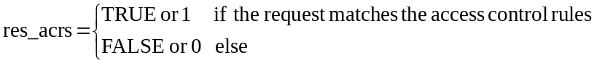
The access decision res_acrs is derived by evaluating each access control rule as follows:
res_acrs = res_acr(1) OR res_acr(2) ... OR res_acr(k) … OR res_acr(K),
where res_acr(k) represents the logical evaluation result (i.e. TRUE/FALSE or 1/0) of the request parameters against the k^{th} access control rule in the set acrs, which can be expressed as follows:
res_acr(k) = res_origs(k) AND res_ops(k) AND res_ctxts(k), k = 1…K.
The 3 partial logical result variables on the right side of above equation can be defined by using the following set function:
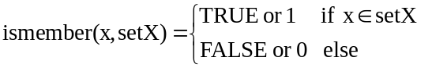
With this definition:
res_origs(k) = ismember(rq_orig, acr(k)_accessControlOriginators)
res_ops(k) = ismember(rq_op, acr(k)_ accessControlOperations)
The third partial logical result res_ctxts(k) is derived as follows
res_ctxts(k) = res_context(k, 1) ... OR res_context(k, m) ... OR res_context (k, M_k),
where,
res_context(k, m) = res_time(k, m) AND res_ip(k, m) AND res_loc (k, m), k = 1…K, m = 1…M_k
and
res_time(k, m) = ismember(rq_time, acr(k)_accessControlTimeWindows(m))
res_ip(k, m) = ismember(rq_ip, acr(k)_accessControlIpAddresses(m))
res_loc (k, m) = ismember(rq_loc, acr(k)_accessControlLocationRegions(m))

8 Security Frameworks

8.1 General Introductions to the Security Frameworks

The security frameworks can be categorized into two main types
- Direct Security Frameworks: where the entities authenticate each other directly, without assistance from a Central Key Distribution Server
- Centralized Security Frameworks: where the entities authenticate each other with the assistance of a Central Key Distribution Server.
Editor's Note: Text is needed here to guide reader through the appropriate framework (ACTION Gemalto).

8.1.1 General Introduction to the Direct Security Frameworks

8.1.1.1 General Introduction to the Pre-Provisioned Symmetric Key Framework
Editor's Note: Text is needed here (ACTION Gemalto).

8.1.1.2 General Introduction to the Certificate-Based Security Frameworks

This clause describes the Credential Configuration and Certificate Verification used in the Certificate-Based Security Association Establishment Framework and Certificate-Based Security Bootstrap Framework.

8.1.1.2.1 Credential Configuration for Certificate-Based Security Frameworks
If an entity is to authenticate itself using a Certificate-Based Security Framework, then the entity shall be pre-provisioned with the following information
- The entity's Private Signing Key and the corresponding Public Verification Key.
NOTE 1: An entity authenticates itself to other entities by proving that it knows the Private Signing Key corresponding to a particular Public Verification Key.
Editor's Note: In some cases the Private Signing Key is unique to a single entity. In other cases, the Private Signing Key might be used to authenticate all entity's executing on a particular piece of hardware or used to authenticate all AEs executing a particular piece of software. This needs clarification text. (ACTION Qualcomm)
- The entity's Certificate containing the entity Public Verification Key and the entity's Certificate Name (a unique identity) provided in a name field of the Certificate (e.g. in the X.509 "Subject" or "Subject Alternative Name" attribute). Two options are available:
- The entity is configured with a valid Certificate Chain from the entity's Certificate to a Root Certificate. The entity's Root of Trust is the cryptographic hash of the Public Verification Key in this Root Certificate.
- Alternatively, the entity's Certificate is a self-signed certificate, for which the entity's Private Signing Key is used to generate the Certificate signature (the certificate is verified using the entity's Public Verification Key). In this case the cryptographic hash of entity's Public Verification Key is both the entity's Root of Trust and the entity's Certificate Name. This implies that the cryptographic hash of the entity's Public Verification Key must be present in a name field of the entity's Certificate.
Editor's Note: Conditions under which a self-signed certificate can be trusted or possible means to verify it (e.g. OCSP) are FFS. (ACTION Qualcomm)
NOTE 2: This pre-provisioning (by definition) uses mechanisms not specified by oneM2M.
Editor's Note: Details for OCSP [RFC2560] and Certificate Revocation Lists (CRLs) are FFS.

8.1.1.2.2 Certificate Verification
This clause describes how an entity authenticates the other entity in the Security Handshake of a Certificate-Based Security Framework.
The other entity's Certificate is received during the Security Handshake.
The other entity's Certificate is verified as follows:
- If the other entity's Certificate is a self-signed certificate, then verify each of the following:
- The other entity's Certificate Name and other entity's Root of Trust (received during Association Configuration or Bootstrap Instruction Configuration) are identical.
- The other entity's Certificate Name (received during Association Configuration or Bootstrap Instruction Configuration) is identical to a value in a name field (e.g. in the X.509 "Subject" or "Subject Alternative Name" attribute) of other entity's Certificate (received during the Security Handshake).
- The other entity's Root of Trust (received during Association Configuration or Bootstrap Instruction Configuration) is identical to the Public Verification Key (or hash thereof) in the other entity's Certificate (received during the Security Handshake).
- If the other entity's Certificate is not a self-signed certificate, then verify each of the following:
- The other entity's Certificate Name (received during Association Configuration or Bootstrap Instruction Configuration) is identical to a value in a name field (e.g. in the X.509 "Subject" or "Subject Alternative Name" attribute) of the other entity's Certificate (received during the Security Handshake)..
- The other entity Certificate has a valid Certificate Chain (received during the Security Handshake) to a Certificate whose Public Verification Key (or hash thereof) is identical to the other entity' Root of Trust (received during Association Configuration or Bootstrap Instruction Configuration).
NOTE: After a successful Security Handshake in which the other entity provides a Certificate Chain, the other entity's identity (received during Association Configuration or Bootstrap Instruction Configuration) can be associated with additional information extracted from the other entity's Certificate Chain (e.g. the other entity Manufacturer, other entity owner, or conformance criteria). These details are not described in the present document.
Editor's Note: Details of credentials for OCSP [RFC2560] may be required here.

8.1.2 General Introduction to the Centralized Security Frameworks

8.1.2.1 General Introduction to the M2M Authentication Function Framework
Editor's Note: Text is needed here (ACTION Gemalto).

8.1.2.2 General Introduction to the GBA (Generic Bootstrapping Architecture) Framework
A general introduction to GBA is included in TR-0008 [i.6].
After a successful GBA bootstrapping, the M2M Application Service/Middle Node and the BSF share a security association which consists of a bootstrapping transaction identifier (B-TID) and key material (GBA bootstrap Ks).
This security association may be used by the M2M Application Service/Middle Node to derive NAF keys (Ks_(ext/int)_NAF) shared between a M2M Application Service/Middle Node and a M2M Infrastructure Node or an M2M Authentication Framework.
There are two modes of GBA: ME-based GBA (GBA_ME) and UICC-based GBA (GBA_U). In case of GBA_ME, one NAF-specific key is derived: the key Ks_NAF. In case of GBA_U, two NAF-specific keys are derived: Ks_ext_NAF (available in the ME) and Ks_int_NAF (which remains inside the UICC).
GBA_U requires that the UICC is GBA aware.
The BSF determines which mode to run based on the UICC capability indicated in the GBA User Security Settings (GUSS).
The usage of GBA_U is recommended since it provides a higher level of security than GBA_ME. The implication of this recommendation is that the entity, AE or CSE, using the GBA_U-based NAF keys should be resident in the UICC.


Figure 8.1.2.2-1: GBA framework. Note that the Network application Function (NAF)
may be an Infrastructure Node or an M2M Authentication Function

8.2 Security Association Establishment Frameworks

8.2.1 Overview on Security Association Establishment Frameworks
In the present document, security associations are restricted to single hop on Mcc or Mca reference point.
Editor’s Note: To be clarified throughout existing text (ACTION Qualcomm).
The oneM2M system supports the following Security Association Establishment Frameworks:
- Direct Security Association Establishment Frameworks:
- Pre-Provisioned M2M Secure Connection Key Security Association Establishment. A symmetric key is pre-provisioned to the entities: this is called the Pre-Provisioned M2M Secure Connection Key, and denoted Kpsa. The entities authenticate each other by verifying Message Integrity Codes (MIC) in the Security Handshake which were generated using the symmetric key. For more details see clause 8.2.2.1.
- Certificate-Based Security Association Establishment: The entities are each issued with
- a Private Signing Key that is known only to that entity,
- a Certificate containing the corresponding Public Verification Key, and
- (Optionally) a Certificate Chain from the entity's Certificate to a Root Certificate.
The entities must validate each other's Certificate before trusting the Public Verification Keys in the Certificate. Within the Security Handshake, entity A creates a digital signature of the session parameters using its private signing key and entity B verifies the digital signature using entity A's public verification key. Then the roles are reversed: entity B creates a digital signature and entity A verifies it. For more details see clause 8.2.2.2.
- Centralized Security Association Establishment Frameworks: In such schemes, entity A and a Central Key Distribution Server authenticate each other and derive a M2M Secure Connection key (Kc) that the Central Key Distribution Server delivers to entity B. The entities then authenticate each other using the M2M Secure Connection key (Kc). The oneM2M authentication Frameworks using centralized key distribution are:
- GBA based Security Association Establishment. This Security Association Establishment Framework uses 3GPP or 3GPP2 symmetric keys to authenticate entity A and the Central Key Distribution Server. The details are specified by 3GPP [13] and 3GPP2 [14]. For more details see clause 8.2.2.
- M2M Authentication Function (MAF)-based Security Association Establishment. This Security Association Establishment Framework uses symmetric keys to authenticate the entity A and the Central Key Distribution Server. For more details see clause 8.2.3.1.
For a more detailed description of the above Security Association Establishment Frameworks, it is useful to compare the following aspects of the Security Association Establishment Frameworks:
- Credential Configuration:
- For Central Key Distribution Security Association Establishment Frameworks:
- Entity A is configured with (or otherwise establishes) the Master Credential (Km) that the entity A will use to authenticate the entity A to the Central Key Distribution Server.
- The Central Key Distribution Server is configured with the Master Credential (Km) that will be used to authenticate the Central Key Distribution Server to entity A.
The details for the GBA-Based Security Association Establishment Framework are out of scope.
- For other Security Association Establishment Frameworks, each entity is pre-provisioned with the Credential that the entity will use to authenticate itself to the other entity.
- Association Configuration: Configuration of entity identifiers (that is, CSE-ID or AE-ID) for the entities to be authenticated.
Additionally, in the case of Certificate-Based Authentication Framework: each entity is configured with the Certificate Name and Root of Trust that the entity will use to verify the other entity.

- Association Security Handshake: Identification, authentication and security context establishment between the entities.
  - Central Key Distribution Server Handshake: When a Centralized Security Association Establishment Framework is used, entity A and the Central Key Distribution Server (MAF or GBA-BSF) perform mutual authentication and generate a M2M Secure Connection Key (Kc) which is then used in the Security Handshake for mutual authentication between entity A and entity B. This is not applicable to Direct Security Association Establishment Frameworks.

Figure 8.2.1-1 provides a summary of the above defined four Security Association Establishment Frameworks.

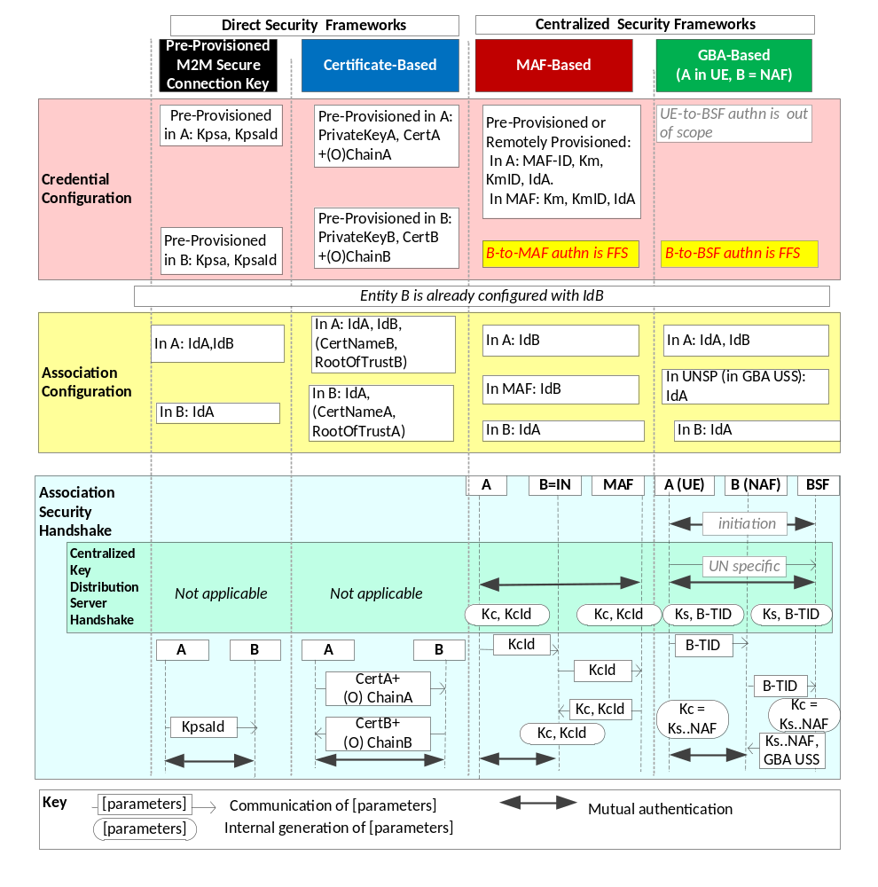
Figure 8.2.1-1: Overview of the Security Association Establishment Frameworks
supported by oneM2M.
Editor's note: In the above figure, the illustrations of the MAF-based centralized security frameworks may need to be updated when the detailed flows have been agreed.

8.2.2 Direct Security Association Establishment Frameworks

8.2.2.1 Pre-Provisioned Symmetric Key Security Association Establishment Frameworks
This clause describes the Pre-Provisioned Secure Connection Key Security Association Establishment Framework. This framework enables mutual authentication of two entities corresponding to either two CSEs or a CSE and an AE. The Credential for this framework is a long-term symmetric key that has been pre-provisioned into the entities to be authenticated. This key is called a Pre-Provisioned Secure Connection Key and is denoted Kpsa. The entities authenticate each other by verifying message authentication codes in the Security Handshake which were generated using the Pre-Provisioned Secure Connection Key.
NOTE: Long term Pre-Provisioned Secure Connection Keys can pose a security risk if not adequately secured, and for this reason long term Pre-Provisioned Secure Connection Keys are recommended to be stored in Secure Environments.
Figure 8.2.2.1-1 illustrates the sequence of events when using the Pre-Provisioned Secure Connection Key Security Association Establishment Framework. In this description, "Entity A" and "Entity B" correspond to either two CSEs or a CSE and an AE or an AE and a CSE (respectively).
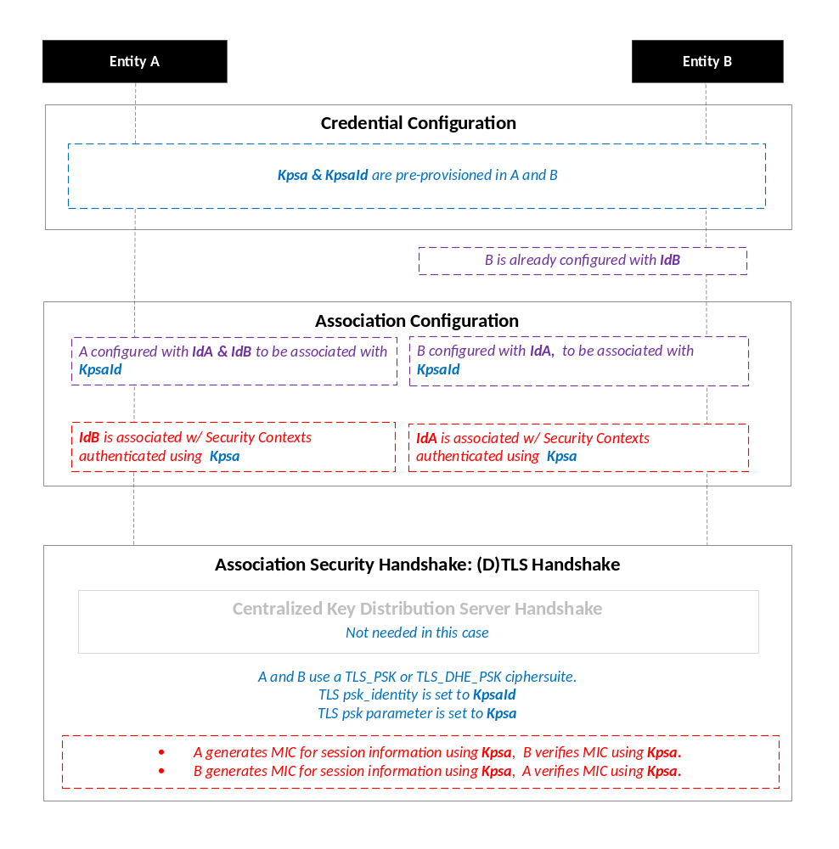
NOTE: The following font colours differentiate the general topic that the text relates to:
Blue italic text highlights details specific to this particular Security Association Establishment Framework.
Purple italic text highlights technical actions that may include steps not specified by oneM2M.
Red italic text highlights security-related properties.

Figure 8.2.2.1-1: The sequence of events when using the Pre-Provisioned Secure Connection Key
Security Association Establishment Framework

Credential Configuration: The Pre-Provisioned Secure Connection Key (Kpsa) and the corresponding Pre-Provisioned Secure Connection Key Identifier, denoted KpsaId, are pre-provisioned to both entities.
NOTE 1: This pre-provisioning (by definition) uses mechanisms not specified by oneM2M.
Association Configuration: Each entity is configured with the information needed for mutual authentication and identification:
- Entity A is commanded to initiate Security Context Establishment, and includes the following arguments:
- The Pre-Provisioned Secure Connection Key Identifier KpsaId.
- Entity A identity (IdA). Entity A is to assume this identity when interacting with Entity B.
- Entity B identity (IdB). Entity A is to use this identity for Entity B authenticating using the above arguments. This identity is also used to route the (D)TLS exchange.
The mechanisms for achieving this are discussed in clause 8.4.1.2 (for the cases where Entity A is in the Field Domain) and Clause 8.4.2 (for the cases where Entity A is in the Infrastructure Domain).
NOTE 2: Entity A will associate Entity B's identity with messages secured within Security Contexts established using the Pre-Provisioned Secure Connection Key Kpsa associated with the Pre-Provisioned Secure Connection Key Identifier KpsaId.
- Entity B is configured with the following arguments describing Entity A authorized to perform Security Context Establishment with the Registrar:
- The Pre-Provisioned Secure Connection Key Identifier KpsaId.
- Entity A identity (IdA). Entity B is to use this identity for Entity A authenticating using the above arguments..
- Entity B Identity (IdB), if not already configured to Entity B. Entity B is to assume this identity when interacting with Entity A.
The mechanisms for achieving this are discussed in clause 8.4.1.2 (for the cases where Entity B is in the Field Domain) and Clause 8.4.2 (for the cases where Entity B is in the Infrastructure Domain).
NOTE 3: Entity B will associate the configured Entity A identity with messages secured within Security Contexts established using the Pre-Provisioned Secure Connection Key Kpsa associated with the Pre-Provisioned Secure Connection Key Identifier KpsaId.
NOTE 4: In many scenarios, the entity identities will be configured when the Pre-Provisioned Secure Connection Key Kpsa is established, so a separate configuration is not required in those scenarios.

Association Security Handshake: The entities perform a (D)TLS-PSK handshake [15] to establish a secure session.
- Centralized Key Distribution Server Handshake: There is no Centralized Key Distribution Server Handshake applied in the Pre-Provisioned Secure Connection Key Security Association Establishment Framework.
- The "psk_identity" parameter [15] is set to the value of the Pre-Provisioned Secure Connection Key Identifier KpsaId.
- The "psk" parameter [15] is set to the value of the Pre-Provisioned Secure Connection Key Kpsa.
- Mandatory and optional (D)TLS cipher suites for this phase are specified in clause 9.2.

8.2.2.2 Certificate-Based Security Association Establishment Frameworks
This clause describes the Certificate-Based Security Association Establishment Framework.
Figure 8.2.2.2-1 illustrates the sequence of events when using the Certificate-Based Security Association Establishment Framework. In this description, "Entity A" and "Entity B" correspond to either two CSEs or a CSE and an AE.
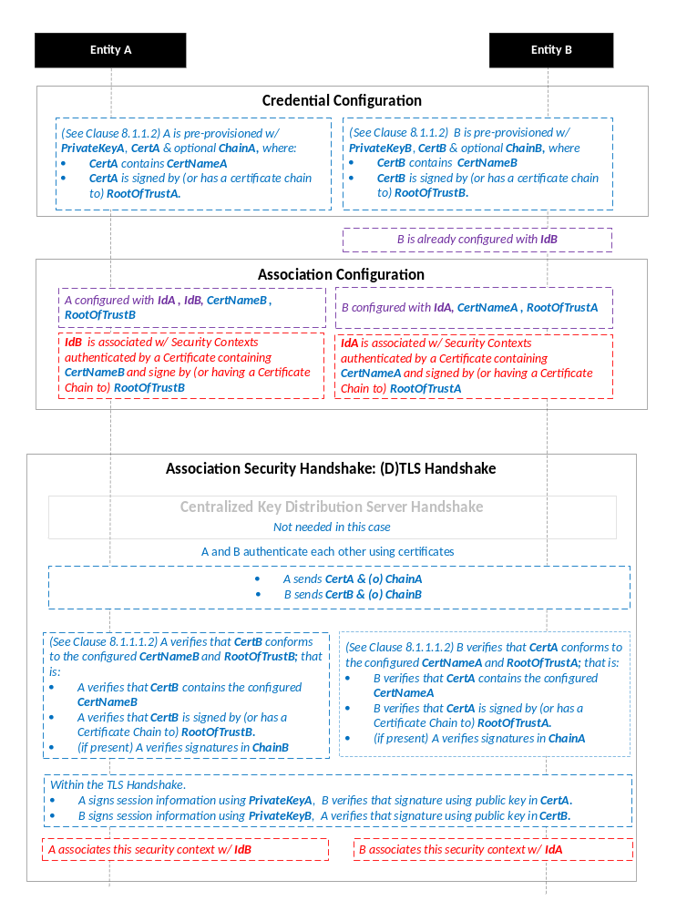
NOTE: The following font colours differentiate the general topic that the text relates to:
Blue italic text highlights details specific to this particular Security Association Establishment Framework.
Purple italic text highlights technical actions that may include steps not specified by oneM2M.
Red italic text highlights security-related properties.

Figure 8.2.2.2-1: The sequence of events when using the Certificate-Based Security
Association Establishment Framework

Credential Configuration: The master credentials for each entity are pre-provisioned as described in clause 8.1.1.2.1 "Credential Configuration for Certificate-Based Security Frameworks".
Association Configuration: Entity A and Entity B are configured with the information needed for the authentication and identification (during Security Handshake) of Entity B and Entity A respectively:
- Entity A is commanded to initiate a Security Handshake, and the command includes the following arguments:
- The Entity B Certificate Name (Entity B Certificate must include this value in a name field).
- The Entity B Root of Trust (Entity B Certificate must be self-signed using this root of trust, or have a Certificate Chain to this root of trust).
- The Entity A identity (IdA) Entity A is to use this entity identity with Entity B.
- The Entity B identity (IdB). Entity A is to use this identity for Entity B authenticating using the above arguments. This is used to route the (D)TLS exchange).
The mechanisms for achieving this are discussed in clause 8.4.1.2 (for the cases where Entity A is in the Field Domain) and clause 8.4.2 (for the cases where Entity A is in the Infrastructure Domain).
NOTE 1: The Entity A will associate Entity B's identity with messages secured within Security Contexts established in accordance with the configured Entity B Certificate Name and Entity B Root of Trust.
- The Entity B is configured with the following arguments describing Entity A authorized to perform Security Handshake with Entity B:
- The Entity A Certificate Name. The Entity A Certificate must include this value in a name field.
- The Entity A Root of Trust. The Entity A Certificate must be self-signed using this root of trust, or have a Certificate Chain to this root of trust.
- The Entity A identity (IdA). Entity B is to use this entity identity for Entity A authenticating using the above arguments.
- The Entity B Identity (IdB), if not already configured to Entity B. Entity B is to assume this identity when interacting with Entity A.
The mechanisms for achieving this are discussed in clause 8.4.1.2 (for the cases where Entity A is in the Field Domain) and Clause 8.4.2 (for the cases where Entity A is in the Infrastructure Domain).
NOTE 2: Entity B will associate Entity A's identity with messages secured within Security Contexts established in accordance with the configured Entity A Certificate Name and Entity A Root of Trust.

Association Security Handshake:
- Centralized Key Distribution Server Handshake: There is no Centralized Key Distribution Server Handshake applied in the Certificate-Based Security Association Establishment Framework.
- Each entity verifies the other entity's certificate as described in clause 8.1.1.2.2 "Certificate Verification".
- The entities authenticate each other using the validated certificates as specified in TLS 1.2 RFC 5246 [16] and DTLS 1.2 RFC 6347 [17] specifications.
- Mandatory and optional (D)TLS cipher suites for this phase are specified in clause 9.2.

8.2.3 Centralized Security Association Establishment Frameworks

8.2.3.1 MAF-Based Symmetric Key Security Association Establishment Frameworks
This clause describes the MAF-based Security Association Establishment Framework.
This release addresses the scenario where the Entity B is an Infrastructure Node.
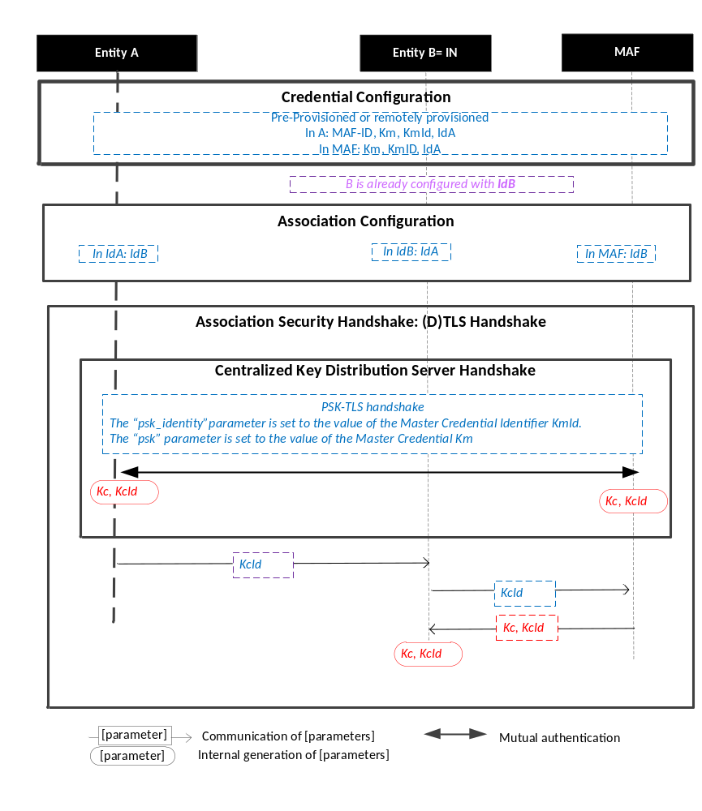
Figure 8.2.3.1-1: The sequence of events when using the MAF-Based Security Association Establishment Framework.
NOTE: The following font colours differentiate the general topic that the text relates to:
Blue italic text highlights details specific to this particular Security Association Establishment Framework.
Purple italic text highlights technical actions that may include steps not specified by oneM2M.
Red italic text highlights security-related properties.

Credential Configuration: The Master Credential (Km) and corresponding Master Credential Identifier (KmId) are either pre-provisioned for Entity A and the MAF or remotely provisioned thanks to Security Bootstrap Frameworks described in Clause 8.3.
Association Configuration: Entity A, Entity B, and the BSF shall be configured with the information needed for the authentication and identification during Centralized Key Distribution Server Handshake and Association Security Handshake:
  - Entity A has to know Entity B Identity (IdB)
  - Entity B has to know Entity A Identity (IdA)
  - The MAF has to know Entity B Identity (IdB). In this case, IdB corresponds to IN Identity.
Association Security Handshake with Centralized Key Distribution Server Handshake:

- Centralized Key Distribution Server Handshake
  - The Centralized Key Distribution Server Handshake in MAF-based Security Association Establishment framework enables the establishment of a M2M Secure Connection Key (Kc) and associated M2M Secure Connection Key Identifier (KcId) shared between the Entity A and the MAF thanks to (D)TLS-PSK handshake [15]
    - The “psk_identity” parameter [15] is set to the value of the Master Credential Identifier KmId.
    - The “psk” parameter [15] is set to the value of the Master Credential Km.
- Entity A sends KcId to Entity B (Infrastructure Node).
- Entity B (Infrastructure Node) can retrieve the M2M Secure Connection Key (Kc) from the MAF.

8.2.3.2 GBA-Based Security Association Establishment Frameworks
This clause describes the GBA-based Security Association Establishment Framework.
To obtain a short term key (Kc) used for M2M Service Connection between a M2M Application Service/Middle Node and a M2M Infrastructure Node, the M2M Application Service/Middle Node shall perform a successful GBA bootstrapping and derive NAF keys (Ks_(ext/int)_NAF). This NAF key is the M2M Secure Connection Key (Kc) used for M2M Service Connection.
In case of GBA, ME, Kc = Ks_NAF.
In case of GBA_U, Kc = Ks_int_NAF, if the application resides in the UICC. Otherwise, Kc = Ks_ext_NAF.

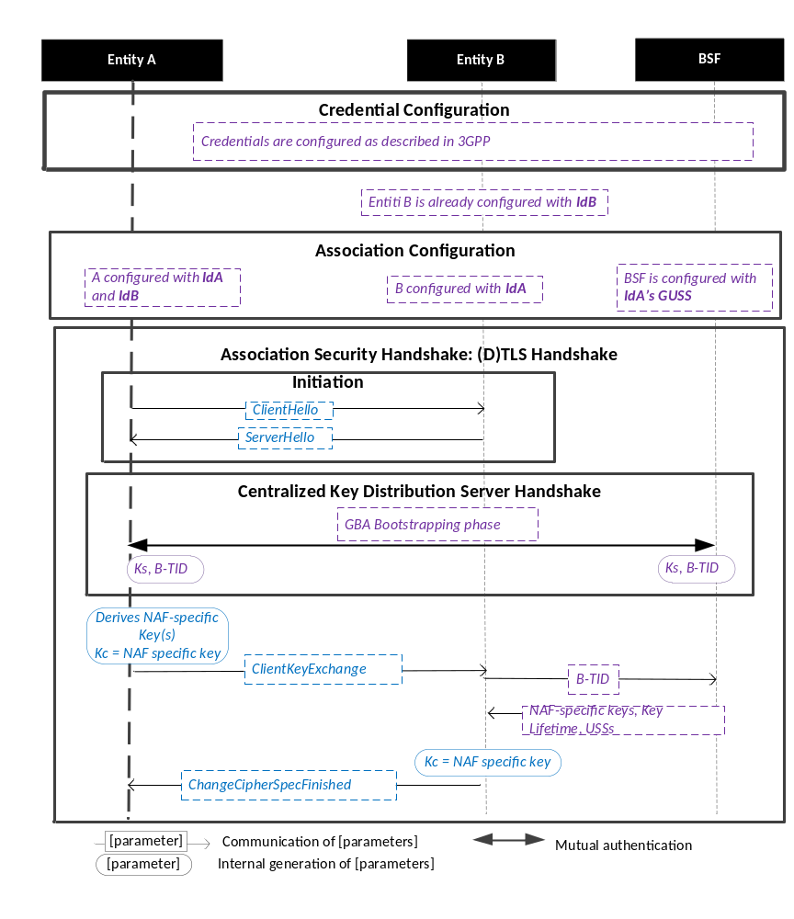
Figure 8.2.3.2-1: The sequence of events when using the GBA-Based Security Association Establishment Framework.
NOTE: The following font colours differentiate the general topic that the text relates to:
Blue italic text highlights details specific to this particular Security Association Establishment Framework.
Purple italic text highlights technical actions that may include steps not specified by oneM2M.

Credential Configuration: The credentials configuration for Entity A, Entity B and the BSF is described in 3GPP specification TS 33.220 [13]. The credentials used to perform mutual authentication between Entity A and BSF are UNSP specific.
Association Configuration: Entity A, Entity B, and the BSF shall be configured with the information needed for the authentication and identification during Centralized Key Distribution Server Handshake and Association Security Handshake:
  - Entity A’s GBA User Security Settings (GUSS) enables to indicate if Entity A is allowed to establish a NAF-specific key with Entity B (NAF) or/and if the BSF can distribute a NAF specific key to Entity B.
Association Security Handshake with Centralized Key Distribution Server Handshake:
- Initiation
  - Entity A and Entity B shall initiate TLS handshake thanks to procedure described in 3GPP TS 33.222 [28]. Informative Annex F of 3GPP TS 24.109 [29] gives signalling flows for TLS-PSK with GBA bootstrapped security association
  - Entity A shall indicate to Entity B that it supports PSK-based TLS by adding one or more PSK ciphersuites to the ClientHello message. This message shall also contain the hostname of Entity B in the server_name extension.
  - Entity B selects one of the PSK-based ciphersuites offered by Entity A and sends it back in the ServerHello message. If UICC is used as M2M Secure Environment supporting Security Association Establishment, GBA-U with Kc = Ks_int_NAF shall be used for authentication and key exchange, In this case the ServerKeyExchange message shall contain a constant string "3GPP-bootstrapping-uicc" as the PSK-identity hint, indicating use of Kc=Ks_int_NAF. Otherwise the ServerKeyExchange message shall contain a constant string "3GPP-bootstrapping" as the PSK-identity hint to indicate that Kc=Ks_NAF in the case of GBA_ME or Kc=Ks_ext_NAF in the case of GBA_U is used for authentication and key exchange. Entity B shall finish the reply to Entity A by sending a ServerHelloDone message.
- Centralized Key Distribution Server Handshake
  - The Centralized Key Distribution Server Handshake in Security Association Establishment framework enables the establishment of a GBA bootstrapped key (Ks) shared between the Entity A and the BSF with associated Bootstrapping Transaction Identifier ( B-TID) and key lifetime, by performing to the GBA Bootstrapping phase described in 3GPP TS 33.220 [13].
  - If a bootstrapped key Ks is already shared between the Entity A and the BSF and still valid, then the Centralized Key Distribution Server Handshake phase is not needed. The Association Security Handshake can take place with the existing GBA Bootstrapped key Ks.
  - Entity A shall derive the NAF-specific keys by performing the procedure described in 3GPP TS 33.220 [13] using the GBA bootstrapped key Ks and B-TID obtained during Centralized Key Distribution Server Handshake. In case of GBA, ME, the M2M Secure Connection Key (Kc) shall be Ks_NAF. In case of GBA_U, the M2M Secure Connection Key (Kc) shall be Ks_int_NAF if HTTP Client application resides in the UICC. Otherwise, Kc = Ks_ext_NAF.
- Entity A then sends a ClientKeyExchange message with PSK-identity containing a prefix "3GPP-bootstrapping-uicc" if Entity A resides in the UICC is used as the M2M Secure Environment supporting Security Association Establishment procedure or "3GPP-bootstrapping" otherwise, a separator character ";" and the B-TID. Entity A shall conclude the TLS handshake by sending the ChangeCipherSpec and Finished messages to the Network M2M Node.
- Entity B shall extract B-TID from the ClientKeyExchange message and use it to retrieve Kc=Ks_NAF or Kc=Ks_ext_NAF or Kc=Ks_int_NAF, and associated key lifetime from the BSF. The retrieval shall be done over the Zn interface as specified in 3GPP TS 29 109 [30]. As a result, Entity A and Entity B share the NAF-specific key which is to be used as the M2M Secure Connection Key (Kc).
- Entity A shall conclude the TLS handshake by sending the ChangeCipherSpec and Finished message to Entity A.
- Entity A and Entity B shall support following TLS profile :
  - TLS_PSK_WITH_AES_128_CCM (RFC 6655) [21]: Mandatory to support;
  - TLS_PSK_WITH_AES_128_CCM_8 (RFC 6655) [21]: Mandatory to support;
  - TLS_DHE_PSK_WITH_AES_128_CCM (RFC 6655) [21]: Optional to support;
  - TLS_DHE_PSK_WITH_AES_128_CCM_8 (RFC 6655) [21]: Optional to support.

8.3 Security Bootstrap Frameworks

8.3.1 Overview on Security Bootstrap Frameworks

8.3.1.1 Purpose of Security Bootstrap Frameworks
The MAF-based Security Association Establishment Framework uses a Master Credential (Km) and corresponding Master Credential Identifier (KmId), shared by a CSE/AE and an M2M Authentication Function, to establish security associations between the CSE/AE and other CSEs and/or AEs as described in clause 8.2.3.
The Master Credential (Km) and corresponding Master Credential Identifier (KmId) shall either be pre-provisioned or remotely provisioned to the CSE/AE and M2M Authentication Function.
The details for pre-provisioning are not described in this specification.
Clause 8.3 describes the set of remotely provisioning mechanisms; called Security Bootstrap Frameworks. An M2M Enrolment Function facilitates the remote provisioning.

8.3.1.2 Overview on Security Bootstrap Frameworks
An AE or CSE that requires remote provisioning of a Master Credential and Master Credential Identifier is called an Enrolee.
The oneM2M system supports the following Security Bootstrap Frameworks:
- Direct Security Bootstrap Frameworks
- Pre-Provisioned Symmetric Enrolee Key Security Bootstrap Framework: A symmetric key is pre-provisioned to the Enrolee and M2M Enrolment Function for the mutually authentication of those entities. For more details, see clause 8.3.2.1.
- Certificate-Based Security Bootstrap Framework: The Enrolee and M2M Enrolment Function are each issued with
- a Private Signing Key that is known only to that entity,
- a Certificate containing the corresponding Public Verification Key, and
- (Optionally) a Certificate Chain from the entity's Certificate to a Root Certificate.
The Enrolee and M2M Enrolment Function shall validate each other's Certificate before trusting the Public Verification Keys in the Certificate. Within the Security Handshake, the M2M Enrolment Function creates a digital signature of the session parameters using its private signing key and the Enrolee verifies the digital signature using the M2M Enrolment Function's public verification key. Then the roles are reversed: the Enrolee creates a digital signature and the M2M Enrolment Function verifies it. For more details see clause 8.3.2.2.
- Centralized Security Bootstrap Frameworks
- GBA-based Security Bootstrap Framework. In this case, the M2M Enrolment Function includes the functionality of a GBA Bootstrap Server Function. This framework uses 3GPP or 3GPP2 symmetric keys to authenticate the Enrolee and the M2M Enrolment Function (which is also a GBA BSF). The details are specified by 3GPP [13] and 3GPP2 [14]. For more details see clause 8.3.3.1.
For a more detailed description of the above Security Bootstrap Frameworks, it is useful to compare the following aspects of the Security Bootstrap Frameworks.
- Bootstrap Credential Configuration: The Enrolee and M2M Enrolment Function are pre-provisioned with the Bootstrap Credential that the entity will use to authenticate itself to the other entity. The mechanisms for this pre-provisioning are not described in this specification.
- Bootstrap Instruction Configuration: The Enrolee and M2M Enrolment Function are provided with
- The M2M Authentication Function Identifier (MAF-ID) identifying the M2M Authentication Function for which the Enrolee is to be remotely provisioned.
NOTE 1: The identity of the M2M Authentication Function is assumed to have been configured prior to the Bootstrap Instruction Configuration phase.
- The CSE-ID or AE-ID that the M2M Authentication Function is to associate with the Enrolee.
Additionally, in the case of Certificate-Based Security Bootstrap Framework:
- The Enrolee is configured with the M2M Enrolment Function URI (for the purpose of routing the (D)TLS messages to the M2M Enrolment Function), M2M Enrolment Function Certificate Name and M2M Enrolment Function Root of Trust that the Enrolee will use to verify the M2M Enrolment Function.
- The M2M Enrolment Function is configured with the Enrolee Certificate Name and Enrolee Root of Trust that the M2M Enrolment Function will use to verify the Enrolee.

- Bootstrap Enrolment Handshake: Identification, authentication and security context establishment between the Enrolee and M2M Enrolment Function.
- Enrolment Key Generation: generating a symmetric Enrolment Key,(Ke) and corresponding Enrolment Key Identifier (KeId) shared by the Enrolee and M2M Enrolment Function, which is used for subsequent generation of the Master Credential (Km).
- Usage in Centralized Key Distribution Server Handshake: During the Centralized Key Distribution Server Handshake of the MAF-Based Security Association Establishment, the following steps occurs
- The Enrolee derives the Master Credential (Km) from the Enrolment Key (Ke) and M2M Authentication Function Identifier (MAF-ID). Details of the derivation are provided in clause 9.4.
- The Enrolee generates the Master Credential Identifier (KmId) from Master Credential (Km) as described in clause 9.1, and stores Km and KmId.
- The Enrolee passes the Enrolment Key Identifier (KeId) to the M2M Authentication Function (see "Centralized Key Distribution Server Handshake" in clause 8.2.3.1)
NOTE 2: When the Enrolee first communicates with the M2M Authentication Function, then the M2M Authentication Function has not yet retrieved the Km from the M2M Enrolment Function. Consequently, the Enrolee provides the KeId to the M2M Authentication function, which is then passed to the M2M Enrolment Function to identify the Enrolment Key. The M2M Enrolment Function then returns the Km from which the M2M Authentication Function can derive the KmId. In subsequent Security Establishments, the Enrolee may provide the KmId or the KeId, and the M2M Authentication Function will know that both identifiers indicate the retrieved Km. For more details, see "Centralized Key Distribution Server Handshake" in clause 8.2.3.1.
- Upon receipt of the KeId, the M2M Authentication Function determines if it already has the corresponding Km and CSE-ID or AE-ID of the Enrolee
- If the M2M Authentication Function already has the corresponding Km and CSE-ID or AE-ID of the Enrolee, then the Km is used for mutual authentication (see "Centralized Key Distribution Server Handshake" in clause 8.2.3.1)
- If the M2M Authentication Function does not have the corresponding Master Credential (Km) and CSE-ID or AE-ID of the Enrolee, then the following steps are followed.
- The M2M Authentication Function (securely) passes the KeId to the M2M Enrolment Function, along with the M2M Authentication Function's URI.
- The M2M Enrolment Function derives the Km from the Ke and MAF-ID. Details of the derivation are provided in clause 9.4.
- The M2M Enrolment Function returns the Km to the M2M Authentication Function. The M2M Enrolment Function also passes the USS, including the CSE-ID or AE-ID of the Enrolee. More details are provided in clause 8.6.
- The M2M Authentication Function generates the Master Credential Identifier (KmId) from Master Credential (Km) as described in clause 9.1, and stores Km and KmId.
- The Master Credential (Km) is used for mutual authentication (see "Centralized Key Distribution Server Handshake" in clause 8.2.3.1).
Figure 8.3.1.2-1 provides a summary of the above defined Security Bootstrap Frameworks.
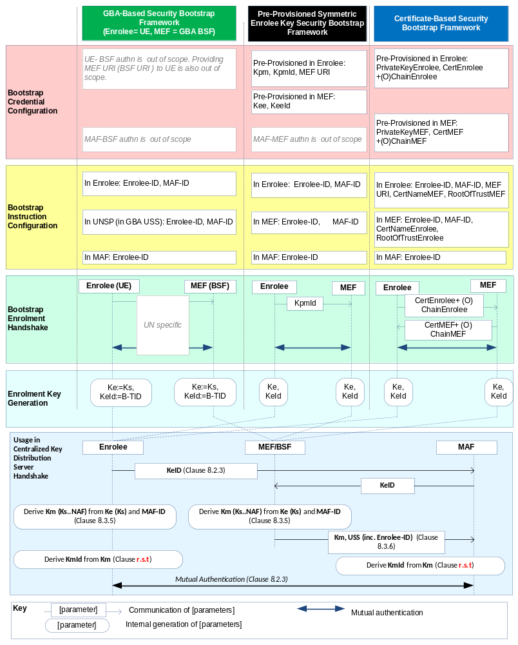
Figure 8.3.1.2-1: Overview of the Security Bootstrap Frameworks supported by oneM2M
Editor's note: In the above figure and other similar ones, more parameters may need to be transferred from MAF to MEF in the "Usage in Centralized Key Distribution Server Handshake". This is FFS. (ACTION Qualcomm)

8.3.2 Direct Security Bootstrap Framework

8.3.2.1 Pre-Provisioned Symmetric Key Security Bootstrap Framework
This clause describes the Pre-Provisioned Symmetric Key Security Bootstrap Framework. The Bootstrap Credential for this framework is a long-term symmetric key that has been pre-provisioned into the Enrolee and M2M Enrolment Function; this key is called a Pre-Provisioned Symmetric Enrolee Key and is denoted Kpm.
NOTE: Long term Pre-Provisioned Symmetric Enrolee Keys can pose a security risk if not adequately secured, and for this reason it is recommended that Long term Pre-Provisioned Symmetric Enrolee Keys are stored in Secure Environments.
Figure 8.3.2.1-1 illustrates the sequence of events when using the Pre-Provisioned Symmetric Enrolee Key Security Bootstrap Framework.
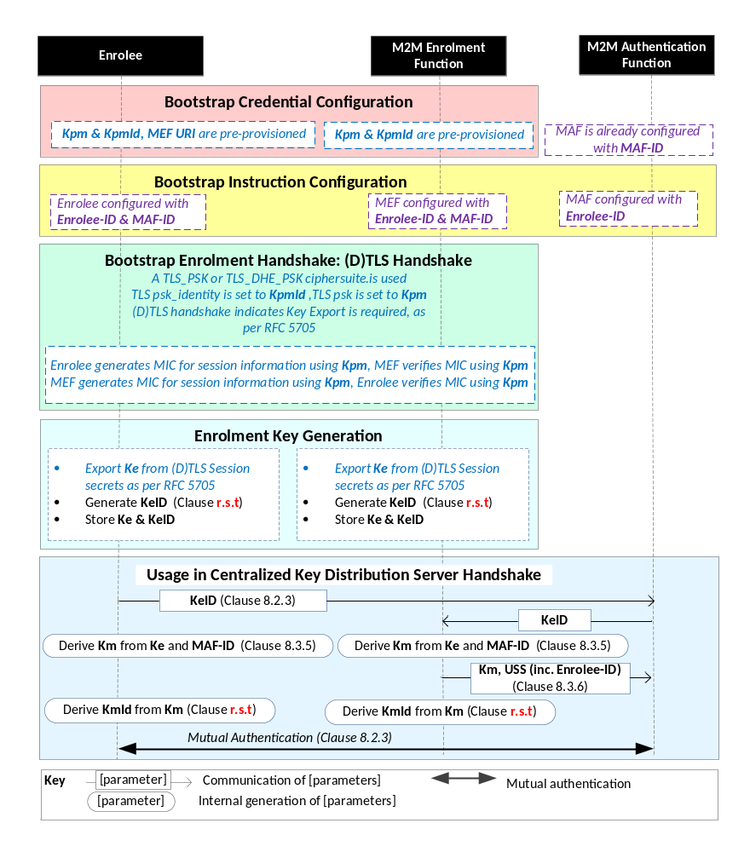
NOTE: The following font colours differentiate the general topic that the text relates to:
Black text contains Security-Bootstrap-Framework-independent details
Blue italic text highlights details specific to this particular Security Bootstrap Framework.
Purple italic text highlights technical actions that may include steps not specified by oneM2M.

Figure 8.3.2.1-1: The sequence of events when using
the Pre-Provisioned Symmetric Key Security Bootstrap Framework

Bootstrap Credential Configuration: The Pre-Provisioned Symmetric Enrolee Key (Kpm) and the corresponding Pre-Provisioned Symmetric Enrolee Key Identifier, denoted KpmId, are pre-provisioned to both entities. The Enrolee is also provisioned with the M2M Enrolment Function's URI (MEF URI), for the purpose of routing the (D)TLS exchange.
NOTE 1: This pre-provisioning (by definition) uses mechanisms not specified by oneM2M.
Bootstrap Instruction Configuration: The Enrolee and M2M Enrolment Function are configured with the information needed for authorizing the remote provisioning:
- The Enrolee is configured with (or otherwise obtains) the following arguments to initiate remote provisioning :
- M2M Authentication Function identity (MAF-ID): Identifying the M2M Authentication Function for which the Enrolee is to be provisioned.
- Enrolee identity (Enrolee-ID): the Enrolee is to use this identity with the identified M2M Authentication Function.
- The Enrolee associates these arguments with the M2M Enrolment Function. The M2M Enrolment Function can be identified to the Enrolee using the Pre-Provisioned Symmetric Enrolee Key Identifier (KpmId) or the M2M Enrolment Function URI.
The mechanisms for achieving this are discussed in clause 8.4.1.3.
- M2M Enrolment Function is configured with the following arguments to authorize the M2M Enrolment Function to remotely provision the Enrolee for a M2M Authentication Function:
- M2M Authentication Function Identity (MAF-ID) of the M2M Authentication Function for which the Enrolee is to be provisioned.
- Enrolee identity (Enrolee-ID). The M2M Enrolment Function is to provide this entity identity for the Enrolee with the Master Credential (Km) to the target M2M Authentication Function, when requested by the M2M Authentication Function.
- The M2M Enrolment Function associates these arguments with an Enrolee. The Enrolee can be identified to the M2M Enrolment Function using the Pre-Provisioned Symmetric Enrolee Key Identifier (KpmId).
The mechanisms for achieving this are discussed in clause 8.4.2.
Bootstrap Security Handshake: The Enrolee and M2M Enrolment Function perform a (D)TLS-PSK handshake [15] to establish a secure session.
- The "psk_identity" parameter [15] is set to the value of the Pre-Provisioned Symmetric Enrolee Key Identifier (KpmId).
- The "psk" parameter [15] is set to the value of the Pre-Provisioned Symmetric Enrolee Key (Kpm).
- Mandatory and optional (D)TLS cipher suites for this phase are specified in clause 9.2.
Enrolment Key Generation:
- The Enrolment Key (Ke) is generated from the (D)TLS session secrets by the Enrolee and M2M Enrolment Function using TLS Key Export (RFC 5705) [18], as described in clause 9.3.
- The Enrolment Key Identifier (KeId) is generated by the Enrolee and M2M Enrolment Function, as described in clause 9.1.
- The Enrolee and M2M Enrolment store the Enrolment Key (Ke) and Enrolment Key Identifier (KeId).
NOTE 2: The Enrolment Key Generation for the Pre-Provisioned Symmetric Enrolee Key Security Bootstrap Framework is identical to the Enrolment Key Generation for the Certificate-Based Security Bootstrap Framework.
Usage in Centralized Key Distribution Server Handshake: See "Overview of Security Frameworks" in clause 8.3.1.

8.3.2.2 Certificate-Based Security Bootstrap Framework
This clause describes the Certificate-Based Security Bootstrap Framework. The Bootstrap Credentials for this framework are Certificates.
Figure 8.3.2.2-1 illustrates the sequence of events when using the Certificate-Based Security Bootstrap Framework.
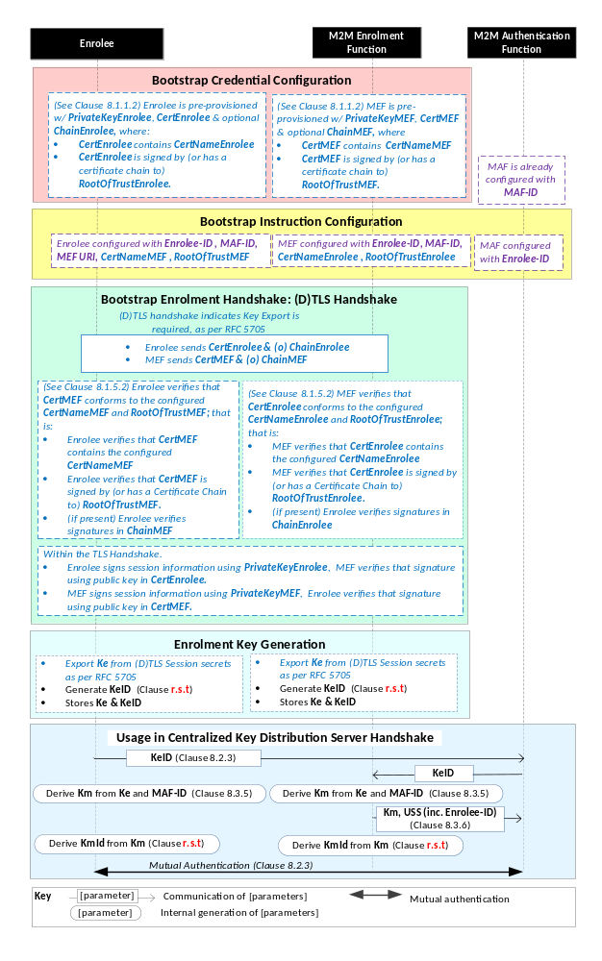
NOTE: The following font colours differentiate the general topic that the text relates to:
Black text contains Security Bootstrap-Framework-independent details.
Blue italic text highlights details specific to this particular Security Bootstrap Framework.
Purple italic text highlights technical actions that may include steps not specified by oneM2M.
Red italic text highlights security-related properties.

Figure 8.3.2.2-1: The sequence of events when using
the Certificate-Based Security Bootstrap Framework.

Bootstrap Credential Configuration: For this Security Bootstrap Framework, Enrolee and M2M Enrolment Function authenticate each other using a Public Key Certificate. The Bootstrap Credentials for the Enrolee and M2M Enrolment Function are pre-provisioned as described in clause 8.1.1.2.1 "Credential Configuration for Certificate-Based Security Frameworks".
NOTE 1: The identities of the M2M Enrolment Function and M2M Authentication Function are assumed to have been configured prior to this phase.

Bootstrap Instruction Configuration: The Enrolee and M2M Enrolment Function are configured with the information needed for authorizing the remote provisioning:
- The Enrolee is configured with (or otherwise obtains) the following arguments to initiate remote provisioning:
- The URI of the M2M Enrolment Function which will facilitate the remote provisioning, for the purpose of routing the (D)TLS exchange.
- The M2M Enrolment Function Certificate Name (M2M Enrolment Function Certificate must include this value in a name field);
- The M2M Enrolment Function Root of Trust (M2M Enrolment Function Certificate must be self-signed using this root of trust, or have a Certificate Chain to this root of trust);
- The target M2M Authentication Function Identity (MAF-ID), with whom the Enrolee is to be provisioned using Security Bootstrap.
- The Enrolee identity (Enrolee-ID): The Enrolee is to use this entity identity with the identified M2M Authentication Function.
The mechanisms for achieving this are discussed in clause 8.4.1.2.
- The M2M Enrolment Function is configured with the following arguments describing Enrolee authorized to perform Security Handshake with M2M Enrolment Function:
- The Enrolee Certificate Name. The Enrolee Certificate must include this value in a name field.
- The Enrolee Root of Trust. The Enrolee Certificate must be self-signed using this root of trust, or have a Certificate Chain to this root of trust.
- The target M2M Authentication Function Identity (MAF-ID), with whom the Enrolee (authenticated using the above Enrolee Certificate Name and Enrolee Root of Trust) is to be provisioned using Security Bootstrap.
- The Enrolee identity (Enrolee-ID). The M2M Enrolment Function is to provide this entity identity for the Enrolee with the Master Credential (Km) to the target M2M Authentication Function, when requested by the M2M Authentication Function.
The mechanisms for achieving this are discussed in clause 8.4.2.
Bootstrap Security Handshake: The Enrolee and M2M Enrolment Function perform a (D)TLS handshake as specified in TLS 1,2 RFC 5246 [16] and DTLS 1.2 RFC 6347 [17] specifications.to establish a secure session.
- Each entity (Enrolee and M2M Enrolment Function) verifies the other entity's certificate as described in clause 8.1.1.2.2 "Certificate Verification".
- The Enrolee and M2M Enrolment Function authenticate each other using the validated certificates as specified in TLS 1.2 RFC 5246 [16] and DTLS 1.2 RFC 6347 [17] specifications.
- Mandatory and optional TLS cipher suites for this phase are specified in clause 9.2.
Enrolment Key Generation:
- The Enrolment Key (Ke) is generated from the (D)TLS session secrets by the Enrolee and M2M Enrolment Function using TLS Key Export (RFC 5705) [18], as described in clause 9.3.
- The Enrolment Key Identifier (KeId) is generated by the Enrolee and M2M Enrolment Function, as described in clause 9.1.
- The Enrolee and M2M Enrolment store the Enrolment Key (Ke) and Enrolment Key Identifier (KeId).
NOTE 2: The Enrolment Key Generation for the Pre-Provisioned Symmetric Enrolee Key Security Bootstrap Framework is identical to the Enrolment Key Generation for the Certificate-Based Security Bootstrap Framework.
Usage in Centralized Key Distribution Server Handshake: See "Overview of Security Frameworks" in clause 8.3.1.

8.3.3 Centralized Security Bootstrap Framework

8.3.3.1 GBA-Based Security Bootstrap Framework
To share a long term Master Credential (Km) between an Application Service/Middle Node and an M2M Authentication Function, the M2M Application Service/Middle Node shall perform a successful GBA bootstrapping and derive a NAF key (Ks_(ext/int)_NAF). This NAF key is the Master Credential (Km).
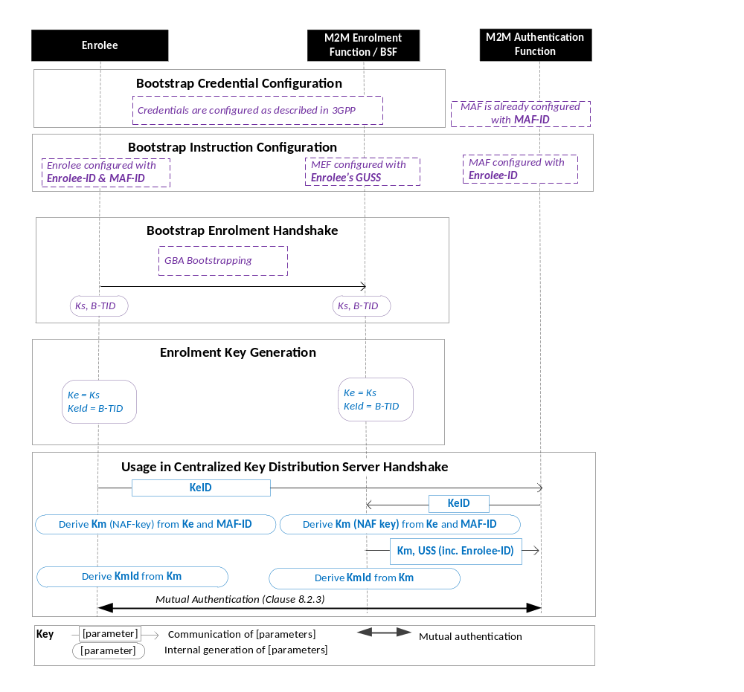
Figure 8.3.3.1-1: The sequence of events when using the GBA-Based Security Bootstrap Framework.
NOTE: The following font colours differentiate the general topic that the text relates to:
Black text contains Security Bootstrap-Framework-independent details.
Blue italic text highlights details specific to this particular Security Bootstrap Framework.
Purple italic text highlights technical actions that may include steps not specified by oneM2M.
Bootstrap Credential Configuration: The credentials configuration for Enrolee and M2M Enrolment Function (MEF) is described in 3GPP specification TS 33.220 [13]. The MEF plays the role of the BSF. The credentials used to perform mutual authentication between Enrolee and MEF are UNSP specific.
Bootstrap Instruction Configuration: the Enrolee, the MEF and the MAF shall be configured with the information needed for authorizing the remote provisioning.
  - The Enrolee shall be configured with Enrolee-Id and MAF-ID.
  - The MEF shall be configured with the Enrolee-ID and the MAF-ID
  - Enrolee’s GBA User Security Settings (GUSS) enables to indicate if Enrolee is allowed to establish a NAF-specific key with the MAF or/and if the BSF can distribute a NAF specific key to the MAF.
- The MAF shall be configured with the Enrolee-ID

Bootstrap Enrolment Handshake:

The Bootstrap Enrolment Handshake enables the establishment of a GBA bootstrapped key (Ks) shared between the Enrolee and the MEF with associated Bootstrapping Transaction Identifier ( B-TID) and key lifetime, by performing to the GBA Bootstrapping phase described in 3GPP TS 33.220 [13].

If a bootstrapped key Ks is already shared between Enrolee and the MEF and still valid, then the Bootstrap Enrolment Handshake phase is not needed. The Enrolment Key Generation phase can take place with the existing GBA Bootstrapped key Ks.

Enrolment Key Generation phase

The Enrolment Key (Ke) shall be the GBA Bootstrapped key (Ks) established during the Bootstrap Enrolment Handshake.

The Enrolment Key Identifier (Ke-ID) shall be the Bootstrapping Transaction Identifier ( B-TID) generated during the Bootstrap Enrolment Handshake.

Usage in Centralized Key Distribution Server Handshake:
- The Enrolee and the MAF shall establish the Master Credential (Km) thanks to procedures described in 3GPP TS 33.220 [13] using the using the Enrolment Key (Ke) as GBA bootstrapped key Ks and the Enrolment Key Identifier (Ke-ID) as B-TID. The MAF plays the role of a NAF.
  - The Enrolee and the MAF shall establish NAF-specific key(s) as described in 3GPP TS 33.220 [13]. A key lifetime is associated to the NAF-specific keys. The MAF also receives the Enrolee’s User Security Settings (USS) from the MEF/BSF.
    - In case of GBA_ME, NAF-specific key is Ks_NAF
    - In case of GBA_U, NAF-specific keys are Ks_int_NAF and Ks_ext_NAF.
  - The Master Credential (Km) shall be the NAF-specific key:
    - In case of GBA_ME, Km = Ks_NAF
    - In case of GBA_U, Km = Ks_int_NAF if HTTP Client application resides in the UICC. Otherwise, Km = Ks_ext_NAF.
  - The Enrolee and the MAF shall derive Master Credential Identifier (Km-Id) from Master Credential (Km).
- Enrolee and MAF shall shall perform (D)TLS-PSK handshake (RFC 4279 [15]) with the Master Credential (Km) as Pre-Shared Key and one of the following TLS ciphersuites:
  - TLS_PSK_WITH_AES_128_CCM (RFC 6655) [21]: Mandatory to support;
  - TLS_DHE_PSK_WITH_AES_128_CCM (RFC 6655) [21]: Recommended to support (optional);
If UICC is used as Secure Environment supporting Security Bootstrap, GBA-U with Kc = Ks_int_NAF shall be used for authentication and key exchange.

9 Security Framework Procedures and Parameters
This clause specifies procedures and parameters of the phases of Security Association Establishment Frameworks (clause 8.2) and Security Bootstrap Frameworks (clause 8.3).

9.1 Security Association Establishment Framework Procedures and Parameters

9.1.1 Credential Configuration Procedures and Parameters
The following Credential Configuration procedures are described in the present clause:
- Credential Configuration of Field-Domain Security Association End-Points (except for the GBA-Based case as discussed above), see Clause 9.1.1.1,
- Credential Configuration of Infrastructure-Domain Security Association End-Points, see Clause 9.1.1.2,
- Credential Configuration of M2M Authentication Functions, see Clause 9.1.1.3,
The following Credential Configuration procedures are specified by other organizations:
- Credential Configuration of Underlying Network Service Provider authentication server (e.g. HLR, HSS or AAA) for the GBA-Based Security Association Establishment Framework. These details are specified by 3GPP, 3GPP2 and ETSI specifications.
- Credential Configuration of Field-Domain Security Association End-Points for the GBA-Based Security Association Establishment Framework. These details are specified by 3GPP, 3GPP2 and ETSI specifications.
Editor’s Note: List any relevant 3GPP, 3GPP2 or IETF specifications.

9.1.1.1 Credential Configuration of Field-Domain Security Association End-Points
Table 9.1.1.1-1 lists the parameters configured to a Field-Domain Security Association End-Points in the Credential Configuration phase.
Table 9.1.1.1-1 Parameters configured to a Field Domain Security Association end-point during the Credential Configuration phase.
Security Association Establishment Framework | Parameter | Mandatory /Optional for this Security Association Establishment Framework
Pre-Provisioned M2M Secure Connection Key | kpsaKey | Mandatory
Pre-Provisioned M2M Secure Connection Key | kpsaId | Mandatory
Certificate Based | thisEntityPrivateKey | Mandatory
Certificate Based | thisEntityCertificate | Mandatory
Certificate Based | thisEntityCertificateChain | Optional
MAF-Based | mafIdentifier | Mandatory
MAF-Based | thisEntityIdentifier | Mandatory
MAF-Based | masterCredential | Mandatory
MAF-Based | masterCredentialIdentifier | Mandatory
MAF-Based | masterCredentialExpiry | Optional
The Credential Configuration of Field-Domain Security Association End-Points for the MAF-Based Security Association Establishment Framework is achieved through either:
- Pre-provisioning via out of band mechanisms which are not specified in the present document.
- Remote provisioning via one of the Security Bootstrap Frameworks in Clause 8.3.
The Credential Configuration phases of other Security Association Establishment Frameworks are performed by pre-provisioning via out of band mechanisms which are not specified in the present document .

9.1.1.2 Credential Configuration of Infrastructure-Domain Security Association End-Points
Table 9.1.1.2-1 lists the parameters configured to Infrastructure-Domain Security Association End-Points in the Credential Configuration phase.
Table 9.1.1.2-1 Parameters configured to an Infrastructure Domain Security Association end-point during the Credential Configuration phase. In the GBA-Based framework, the Infrastructure Domain Security Association end-point plays the role of a GBA NAF.
Security Association Establishment Framework | Parameter | Mandatory /Optional for this Security Association Establishment Framework
Pre-Provisioned M2M Secure Connection Key | kpsaKey | Mandatory
Pre-Provisioned M2M Secure Connection Key | kpsaId | Mandatory
Certificate Based | thisEntityPrivateKey | Mandatory
Certificate Based | thisEntityCertificate | Mandatory
Certificate Based | thisEntityCertificateChain | Optional
MAF-Based | Editor’s note: FFS | Editor’s note: FFS
GBA-Based  Entity plays role of NAF. Details specified in 3GPP 33.220 [13]. Where this description differs from [13], [13] takes precedence | nafPrivateKey | See 3GPP 33.220 [13].
 | nafCertificate | See 3GPP 33.220 [13].
 | nafCertificateChain | See 3GPP 33.220 [13].
 | rootCertificateBSF | See 3GPP 33.220 [13].
The procedure for the Credential Configuration of Infrastructure-Domain Security Association End-Points is expected to use business logic of the M2M Service Provider, and the details are not described in this specification.

9.1.1.3 Credential Configuration of M2M Authentication Functions
Table 9.1.1.3-1 lists the parameters configured to M2M Authentication Functions in the Credential Configuration phase. The M2M Authentication Function’s identifier (MAF-ID) is presumed to have been configured prior to the Credential Configuration phase.
Table 9.1.1.3-1 Parameters configured to a M2M Authentication Functions during the Credential Configuration phase.
Security Association Establishment Framework |  | Parameter | Mandatory /Optional for this Security Association Establishment Framework
MAF-Based | A-to-MAF Authentication | thisEntityIdentifier | Mandatory
MAF-Based | A-to-MAF Authentication | masterCredential | Mandatory
MAF-Based | A-to-MAF Authentication | masterCredentialIdentifier | Mandatory
MAF-Based | A-to-MAF Authentication | masterCredentialExpiry | Optional
MAF-Based | B-to-MAF Authentication | Editor’s note: FFS
The Credential Configuration of M2M Authentication Framework shall be achieved through either:
- Business logic of the Stakeholder operating the M2M Authentication Function, and the details are not described in this specification.
- Remote provisioning via one of the Security Bootstrap Frameworks in Clause 8.3.

9.1.2 Association Configuration Procedures and Parameters
The following Association Configuration procedures are described in this clause:
- Association Configuration of Field-Domain Security Association End-points, see Clause 9.1.2.1,
- Association Configuration of Infrastructure Domain Security Association End-points, see Clause 9.1.2.2,
- Association Configuration of M2M Authentication Functions and Underlying Network Service Provider authentication servers (e.g. HLR, HSS or AAA), see Clause 9.1.2.3.

9.1.2.1 Association Configuration of Field-Domain Security Association End-Points
Table 9.1.2.1-1 lists the parameters configured to Field-Domain Security Association End-Points in the Credential Configuration phase of all Security Association Establishment Frameworks.
Table 9.1.2.1-1 Parameters configured to a Field-Domain Security Association End-Point during the Credential Configuration phase of all Security Association Establishment Frameworks.
Parameters common to all Security Association Establishment Frameworks | Mandatory /Optional for all Security Association Establishment Frameworks
otherEntityIdentifier | Mandatory
associationConfigurationExpiry | Optional
securityAssociationLifespan | Optional
Table 9.1.2.1-2 lists the Security Association Establishment Framework-specific parameters configured to Field-Domain Security Association End-Points in the Credential Configuration phase.
Table 9.1.2.1-2 Security Association Establishment Framework-specific parameters configured to a Field-Domain Security Association End-Point during the Credential Configuration phase.
Security Association Establishment Framework | Parameters specific to the Security Association Establishment Frameworks | Mandatory /Optional for this Security Association Establishment Framework
Pre-Provisioned M2M Secure Connection Key | thisEntityIdentifier | Mandatory
Certificate Based | thisEntityIdentifier | Mandatory
Certificate Based | otherEntityCertificateName | Mandatory
Certificate Based | otherEntityRootOfTrust | Mandatory
MAF-Based | None: the Security Association End-Point is assumed to already know its CSE-ID/AE-ID in this case.
GBA-Based | thisEntityIdentifier |  | Mandatory
This specification provides two procedures for Association Configuration of Field Domain Security Association End-points:
- Integrating Association Configuration with Credential Configuration. Implementation and use of this procedure is optional.
NOTE: This approach has limited flexibility, but can be useful in many cases.
Editor’s Note: We need to determine where and how we describe this procedure.
- A remote management protocols or security administration protocol that provides at least integrity protection and authentication of the configuration source.
Other mechanisms are not prohibited.
NOTE: For example, in some cases it is appropriate to use manual entry via user interface integrated to the Field Domain equipment (provided there is appropriate user authentication).
Editor’s Note: Stage 3 details of the data model are needed.
Editor’s Note: We need to interact with MAS WG5 to determine how to describe the data modelhow to “associate’ the MO with the Security Association End-point – e.g. does the MO path including the identity of the Security Association End-point?

9.1.2.2 Association Configuration of Infrastructure-Domain Security Association End-Points
Table 9.1.2.2-1 lists the parameters configured to Infrastructure-Domain Security Association End-Points in the Association Configuration phase of all Security Association Establishment Frameworks. It is assumed that an Infrastructure-Domain Security Association End-Point knows its CSE-ID/AE-ID prior to Association Configuration.
Table 9.1.2.2-1 Parameters configured to an Infrastructure Domain Security Association end-point during the Association Configuration phase of all Security Association Establishment Frameworks.
Parameter common to all Security Association Establishment Frameworks | Mandatory /Optional for all Security Association Establishment Frameworks
otherEntityIdentifier | Mandatory
associationConfigurationExpiry | Optional
securityAssociationLifespan | Optional
Table 9.1.2.2-2 lists the parameters configured to Infrastructure-Domain Security Association End-Points in the Association Configuration phase.
Table 9.1.2.2-2 Security Association Establishment Framework –specific parameters configured to an Infrastructure Domain Security Association end-point during the Association Configuration phase.
Security Association Establishment Framework | Parameters specific to the Security Association Establishment Framework | Mandatory /Optional for this Security Association Establishment Framework
Pre-Provisioned M2M Secure Connection Key | None
Certificate Based | otherEntityCertificateName | Mandatory
Certificate Based | otherEntityRootOfTrust | Mandatory
MAF-Based | None
GBA-Based | None
The Association Configuration of Infrastructure-Domain Security Association End-Points is expected to use business logic of the M2M Service Provider, and the details are not described in this specification.

9.1.2.3 Association Configuration of M2M Authentication Functions
Table 9.1.2.3-1 lists the parameters configured to M2M Authentication Functions in the Association Configuration phase.
Table 9.1.2.3-1 Parameters configured to a M2M Authentication Functions during the Association Configuration phase.
Security Association Establishment Framework |  | Parameter | Mandatory /Optional for this Security Association Establishment Framework
MAF-Based | A-to-MAF Authentication | otherEntityIdentifier | Mandatory
MAF-Based | A-to-MAF Authentication | associationConfigurationExpiry | Optional
MAF-Based | A-to-MAF Authentication | securityAssociationLifespan | Optional
MAF-Based | B-to-MAF Authentication | Editor’s note: FFS.
This specification assumes that Association Configuration of the M2M Authentication Functions will utilize business logic of the Stakeholder that operates the M2M Authentication Function, and the details are not described in this specification.

9.1.2.4 Association Configuration of UNSP Authentication Servers
Table 9.1.2.4-1 lists the parameters configured to an Underlying Network Service Provider authentication server (e.g. HLR, HSS or AAA) in the Association Configuration phase.
Table 9.1.2.4-1 Parameters configured to an Underlying Network Service Provider authentication server (e.g. HLR, HSS or AAA) during the Association Configuration phase.
Security Association Establishment Framework | Parameter | Mandatory /Optional for this Security Association Establishment Framework
GBA-Based.  Parameters are configured to UE’s GBA User Security Settings (GUSS). GUSS details are specified in 3GPP 33.220 [13]. Where this description differs from [13], [13] takes precedence | thisEntityIdentifier | Mandatory
 | otherEntityIdentifier | Mandatory
 | associationConfigurationExpiry | Optional
 | securityAssociationLifespan | Optional
The Association Configuration of the Underlying Network Service Provider authentication server is achieved by updating the GBA User Security Settings (GUSS) (3GPP 33.220 [13]) of the User Equipment (UE) upon which the Enrolee is executed. This specification assumes that this Association Configuration will utilize business logic of the Underlying Network Service Provider, and the details are not described in this specification.
Editor’s Note: List any relevant 3GPP, 3GPP2 or IETF specifications.

9. 2 Security Bootstrap Framework Procedures and Parameters

9.2.1 Bootstrap Credential Configuration Procedures and Parameters
The following Bootstrap Credential Configuration procedures are described in this clause:
- Bootstrap Credential Configuration of Field-Domain Security Association End-Points (except for the GBA-Based case as discussed above), see Clause 9.2.1.1,
- Bootstrap Credential Configuration of M2M Enrolment Functions (except for the GBA-Based case as discussed above), see Clause 9.2.1.2,
- Bootstrap Credential Configuration of M2M Association Functions, see Clause 9.2.1.3.
The following Bootstrap Credential Configuration procedures are specified by other organizations:
- Bootstrap Credential Configuration of Underlying Network Service Provider authentication servers (e.g. HLR, HSS or AAA) for the GBA-Based Security Association Establishment Framework. These details are specified by 3GPP, 3GPP2 and ETSI specifications.
- Bootstrap Credential Configuration of Field-Domain Security Association End-Points for the GBA-Based Security Association Establishment Framework. These details are specified by 3GPP, 3GPP2 and ETSI specifications.
Editor’s Note: List any relevant 3GPP, 3GPP2 or IETF specifications.

9.2.1.1 Bootstrap Credential Configuration of Enrolees
Table 9.2.1.1-1 lists the parameters configured to Enrolees in the Bootstrap Credential Configuration phase.
Table 9.2.1.1-1 Parameters configured to Enrolees during the Bootstrap Credential Configuration phase.
Security Association Establishment Framework | Parameter | Mandatory /Optional for this Security Framework
Pre-Provisioned M2M Secure Connection Key | kpmKey | Mandatory
Pre-Provisioned M2M Secure Connection Key | kpmId | Mandatory
Pre-Provisioned M2M Secure Connection Key | mefURI | Mandatory
Certificate Based | thisEntityPrivateKey | Mandatory
Certificate Based | thisEntityCertificate | Mandatory
Certificate Based | thisEntityCertificateChain | Optional
The Bootstrap Credential Configuration of Enrolees for the Pre-Provisioned Symmetric Enrolee Key Security Bootstrap Framework and Certificate-Based Security Bootstrap Framework is performed by pre-provisioning via out-of-band mechanisms which are not specified in the present document.

9.2.1.2 Bootstrap Credential Configuration of M2M Enrolment Functions
Table 9.2.1.2-1 lists the parameters assumed to be configured to M2M Enrolment Functions prior to the Bootstrap Credential Configuration phase of the Pre-Provisioned Symmetric Enrolee Key Security Bootstrap Framework and Certificate-Based Security Bootstrap Framework.
Table 9.2.1.2-1 Parameters assumed to be configured to M2M Enrolment Functions prior to the Bootstrap Credential Configuration phase in both of the Pre-Provisioned Symmetric Enrolee Key Security Bootstrap Framework and Certificate-Based Security Bootstrap Framework.
Parameter common to all Security Bootstrap Frameworks | Mandatory /Optional for the Pre-Provisioned Symmetric Enrolee Key Security Bootstrap Framework and Certificate-Based Security Bootstrap Framework
mefUri | Mandatory
Table 9.2.1.2-2 lists the parameters configured to M2M Enrolment Functions in the Bootstrap Credential Configuration phase of the Pre-Provisioned Symmetric Enrolee Key Security Bootstrap Framework and Certificate-Based Security Bootstrap Framework.
Table 9.2.1.2-2 Security Bootstrap Framework –specific parameters configured to the M2M Enrolment Function during the Bootstrap Credential Configuration phase of the Pre-Provisioned Symmetric Enrolee Key Security Bootstrap Framework and Certificate-Based Security Bootstrap Framework.
Security Bootstrap Framework | Parameters specific to the Security Bootstrap Frameworks | Mandatory /Optional for this Security Framework
Pre-Provisioned Symmetric Enrolment Key | kpmKey | Mandatory
Pre-Provisioned Symmetric Enrolment Key | kpmId | Mandatory
Certificate Based | mefPrivateKey | Mandatory
Certificate Based | mefCertificate | Mandatory
Certificate Based | mefCertificateChain | Mandatory
The Bootstrap Credential Configuration of M2M Enrolment Functions is expected to use business logic of the stakeholder operating the M2M Enrolment Function, and the details are not described in this specification.

9.2.1.3 Bootstrap Credential Configuration of M2M Authentication Functions
Table 9.2.1.3-1 lists the parameters assumed to be configured to M2M Authentication Functions prior to the Bootstrap Credential Configuration phase of all Security Bootstrap Frameworks.
Table 9.2.1.3-1 Parameters assumed to be configured to the M2M Authentication Functions prior to or during the Bootstrap Credential Configuration phase for all Security Frameworks.
Parameter common to all Security Bootstrap Frameworks | Mandatory /Optional for all Security Bootstrap Frameworks
mafIdentifier | Mandatory
The Bootstrap Credential Configuration of M2M Authentication Functions is expected to use business logic of the Stakeholder operating the MAF, and the details are not described in this specification.

9.2.2 Bootstrap Instruction Configuration Procedures and Parameters
The following Bootstrap Instruction Configuration procedures are described in this clause:
- Bootstrap Instruction Configuration of Enrolees, see Clause 9.2.2.1,
- Bootstrap Instruction Configuration of M2M Authentication Functions, see Clause 9.2.2.2,
- Bootstrap Instruction Configuration of M2M Enrolment Functions, see Clause 9.2.2.3
- Bootstrap Instruction Configuration of Underlying Network Service Provider authentication servers (e.g. HLR, HSS or AAA), see Clause 9.2.2.4.

9.2.2.1 Bootstrap Instruction Configuration of Enrolees
Table 9.2.2.1-1 lists the common parameters configured to Enrolees during the Bootstrap Instruction Configuration phase of a Security Bootstrap Framework.
Table 9.2.2.1-1 Parameters configured to Enrolees during the Bootstrap Instruction Configuration phase of a Security Bootstrap Framework.
Parameter common to all Security Bootstrap Frameworks | Mandatory /Optional for this Security Bootstrap Framework
thisEntityIdentifier | Mandatory
mafIdentifier | Mandatory
Table 9.2.2.1-2 lists the Security Bootstrap Framework–specific parameters configured to Enrolees in the Bootstrap Instruction Configuration phase of the Pre-Provisioned Symmetric Enrolee Key Security Bootstrap Framework and Certificate-Based Security Bootstrap Framework.
Table 9.2.2.1-2 Security Bootstrap Framework –specific parameters configured to an Enrolee during the Instruction Instruction Configuration phase of the Pre-Provisioned Symmetric Enrolee Key Security Bootstrap Framework and Certificate-Based Security Bootstrap Framework.
Security Bootstrap Framework | Security Bootstrap Framework-specific Parameters | Mandatory /Optional for this Security Bootstrap Framework
Pre-Provisioned Symmetric Enrolment Key | None
Certificate Based | mefURI | Mandatory
Certificate Based | mefCertificateName | Mandatory
Certificate Based | mefRootOfTrust | Mandatory
GBA-Based | None
This specification provides two mechanisms for Bootstrap Instruction Configuration of Field Domain Security Association End-points:
- Integrating Bootstrap Instruction Configuration with Bootstrap Credential Configuration. Implementation and use of this mechanism is optional.
NOTE: This approach has limited flexibility, but can be useful in many cases.
Editor’s Note: We need to determine where and how we describe this procedure.
- A remote management protocol or security administration protocol that provides at least integrity protection and authentication of the configuration source
Other mechanisms are not prohibited.
Editor’s Note: Stage 3 details of the data model are needed.
Editor’s Note: We need to interact with MAS WG5 to determine how to “associate’ the MO with the Enrolee– e.g. does the MO path including the identity of the Enrolee?

9.2.2.2 Bootstrap Instruction Configuration of M2M Authentication Functions
Table 9.2.2.2-1 lists the common parameters configured to M2M Authentication Functions during the Bootstrap Instruction Configuration phase of the Pre-Provisioned Symmetric Enrolee Key Security Bootstrap Framework and Certificate-Based Security Bootstrap Framework.
Table 9.2.2.2-1 Common parameters configured to M2M Authentication Functions during the Bootstrap Instruction Configuration phase of the Pre-Provisioned Symmetric Enrolee Key Security Bootstrap Framework and Certificate-Based Security Bootstrap Framework.
Parameter common to all Security Bootstrap Frameworks | Mandatory /Optional for all Security Bootstrap Frameworks
thisEntityIdentifier | Mandatory
mefRootOfTrust | Mandatory
This specification assumes that Bootstrap Instruction Configuration of the M2M Authentication Functions utilizes business logic of the Stakeholder that operates the M2M Authentication Function, and the details are not described in this specification.

9.2.2.3 Bootstrap Instruction Configuration of M2M Enrolment Functions
Editor’s Note: TO DO - list parameters that may be configured to this entity in this phase.
Table 9.2.2.3-1 lists the parameters configured to an M2M Enrolment Function during the Bootstrap Instruction Configuration phase of the Pre-Provisioned Symmetric Enrolee Key Security Bootstrap Framework and Certificate-Based Security Bootstrap Framework.
Table 9.2.2.3-1 Parameters configured to M2M Enrolment Functions during the Bootstrap Instruction Configuration phase of the Pre-Provisioned Symmetric Enrolee Key Security Bootstrap Framework and Certificate-Based Security Bootstrap Framework.
Parameter common to all Security Bootstrap Frameworks | Mandatory /Optional for all Security Bootstrap Frameworks
thisEntityIdentifier | Mandatory
mafIdentifier | Mandatory
Table 9.2.2.3-2 lists the Security Bootstrap Framework–specific parameters configured to an M2M Enrolment Functions in the Bootstrap Instruction Configuration phase of the Pre-Provisioned Symmetric Enrolee Key Security Bootstrap Framework and Certificate-Based Security Bootstrap Framework.
Table 9.2.2.3-2 Security Bootstrap Framework–specific parameters configured to an M2M Enrolment Function during the Instruction Instruction Configuration phase of the Pre-Provisioned Symmetric Enrolee Key Security Bootstrap Framework and Certificate-Based Security Bootstrap Framework.
Security Bootstrap Framework | Security Bootstrap Framework-specific Parameters | Mandatory /Optional for this Security Bootstrap Framework
Pre-Provisioned Symmetric Enrolment Key | None
Certificate Based | thisEntityCertificateName | Mandatory
Certificate Based | thisEntityRootOfTrust | Mandatory
This specification assumes that Bootstrap Instruction Configuration of the M2M Enrolment Functions utilizes business logic of the Stakeholder that operates the M2M Enrolment Function, and the details are not described in this specification.

9.2.2.4 Bootstrap Instruction Configuration of UNSP Authentication Server
Table 9.2.2.4-1 lists the parameters configured to an Underlying Network Service Provider authentication server (e.g. HLR, HSS or AAA) during the Bootstrap Instruction Configuration phase of the GBA-Based Security Bootstrap Framework.
Table 9.2.2.4-1 Parameters configured to M2M Enrolment Functions during the Bootstrap Instruction Configuration phase of the GBA-Based Security Bootstrap Framework.
Parameter | Mandatory /Optional for all Security Bootstrap Frameworks
thisEntityIdentifier | Mandatory
mafIdentifier | Mandatory

The Bootstrap Instruction Configuration of the Underlying Network Service Provider authentication server is achieved by updating the GBA User Security Settings (GUSS) (3GPP 33.220 [13]) of the User Equipment (UE) upon which the Enrolee is executed. This specification assumes that this Bootstrap Instruction Configuration utilizes business logic of the Underlying Network Service Provider, and the details are not described in this specification.
Editor’s Note: List any relevant 3GPP, 3GPP2 or IETF specifications.

Annex A (informative):
Mapping of 3GPP GBA terminology
Table A.1 provides a mapping of terminology and abbreviations used in GBA according to 3GPP specification [13] to corresponding oneM2M terminology and abbreviations as used within the present document.
Table A.1
GBA entities, keys and processes | oneM2M Security Bootstrap entities, keys & processes
UE | Enrolee
BSF | MEF
NAF | MAF
Bootstrapping Procedure | Bootstrap Security Handshake + Temporary Enrolment Key Generation
Ks | Ke
B-TID | KeId
Bootstrapping Usage Procedure | Usage in Centralized Key Distribution Server Handshake
NAF FQDN | IdMAF
Ks_(ext/int)_NAF | Km (Master Credential)

Annex B (informative):
General Mutual Authentication Mechanism
oneM2M mutual authentication schemes allow oneM2M entities to prove that they know related credentials such as Master Credentials, without having to exchange value of those credentials, and sensitive data such as identities and identifiers. To prevent reading and copying of credentials, a secure environment within the Security CSF provides protection against tampering of those credentials and related processed information.

A general mutual authentication protocol is applied to both symmetric and asymmetric key based schemes. Precise protocol messages and parameters depend on the chosen scheme and the security parameters selected. Typically it consists of following steps as shown in figure B.1.
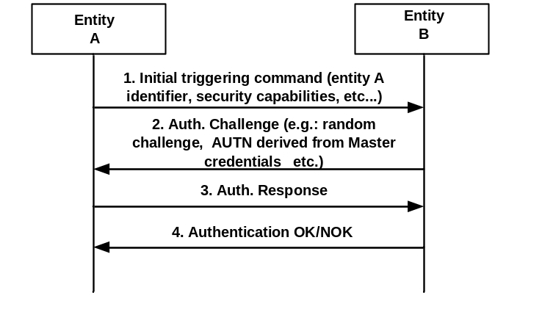
Figure B.1: Mutual Authentication

1. An initial step where an entity A is securely identified to an entity B with whom previous or no previous contact has been made. In this step entity A identifies itself to an entity B protected against eavesdropping, i.e. no exchange of key material (Master Credential).
2. In the second step entity B sends a challenge to entity A. The Authentication challenge consists of random challenge, authentication token of entity B derived from Master credentials, etc. The authentication challenge depends on the chosen scheme and the security parameters selected for symmetric and asymmetric key based schemes.
3. The entity A replies with an authentication response derived from its known Master Credentials and the received Athentication challenge. This response is sent if entity B has been successfully authenticated by entity A.
4. Entity B then verifies the relation between entity A's identity and the response received in step 3, which gives a high probability that the entity B knows a secret value associated with the entity A's identity provided in step 1.

B.1. Group Authentication

The oneM2M transactions may naturally involve groups of M2M entities rather than individual ones. A number of entities are classified as a group due to their proximate locations, having the same features, belonging to the same owner, or any other reasons [i.10]. To get services, all entities in such a group should be authenticated first. The traditional authentication mechanism has two main solutions, the first authentication mechanism is that the service provider authenticates each entity in the group one by one; the second authentication mechanism is that each entity makes mutual authentication with a group agent, then the group agent makes mutual authentication with the service provider. If the first authentication mechanism is used, the resulting authentication overheads of computation and communication may be too high to afford. If the second authentication mechanism is used, it has the following security weaknesses:
- It may exist the man-in-the-middle attack by the group agent: The group agent would be placed in unsecure place or owned by different provider rather than the service provider. If the group agent is compromised or lie to service provider, group agent would act as a middle attacker to make fake authentication to entities and report fake identity to service provider since there is no direct authentication from service provider to each M2M entity.
- Privacy concern: All information from M2M entities is transferred through the group agent, and the group agent knows all information generated by each entity. Based on security consideration, if the group agent is owned by different owner other than the entities' and service providers' owner, the group agent should not get the message.
Hence, the M2M entities (e.g., ASN or ADN) with the same feature can utilize group authentication to service provider (e.g., infrastructure node) in order to provide end-to-end secure tunnel as well as reducing the communication overhead.
Editor’s Note: The detailed procedure of Group Authentication is ffs in Release 2.

Annex C (informative): Security protocols associated to specific SE technologies
The Secure Environment supporting security functions specified by oneM2M provides a level and a type of protection (e .g. integrity protection, confidentiality, tamper resistance) to the information it contains, independently of the method of protection (e.g. UICC, embedded security element, TEE, etc..). Administration of their content is implementation dependent and relies on existing standards within specific Secure Environment technologies. Some of them are listed below for information:

C.1 UICC
In case of UICC (SE compliant with ETSI TS 102 671 [23]), OTA mechanisms as specified in [7] and [8], and its extensions [9], [10] for 3GPP underlying networks or [11] and [12] for 3GPP2 underlying networks are used to securely administrate the sensitive data of the M2M Service Layer.

C.2 Other secure element and embedded secure element with ISO 7816 interface
In case the Secure Environment is implemented as a security element or as an embedded security element supporting an ISO/IEC 7816 interface [26], example of remote administration can be according to GlobalPlatform Remote Administration [a].

C.3 Trusted Execution Environment
In case the secure environment is implemented as a Trusted Execution Environment (TEE) according to GlobalPlatform [b], remote administration is provided according to GlobalPlatform Remote Administration [21].

C.4 SE to CSE binding
In case the SE is implemented as an independent security element supporting ETSI TS 102 221 [24], the secure channel specified in ETSI TS 102 484 [25] provides logical binding of the SE to a specific CSE or AE. This also protects the information exhanged between the SE and the associated entity on physically exposed interfaces, and is therefore recommended for devices that are physically exposed to attackers.

Annex D (normative):
UICC security framework to support oneM2M Services
This annex is applicable when UICC (a type of Independent Security Element compliant with TS 102 221 [24] and TS 102 671 [23]) is involved in M2M service layer security, whether it only serves as a mean to pre-provision M2M Service layer material in M2M Devices/Gateways, or it is further used as Secured Environment in an M2M Device/Gateway.
Specifically, the involvement of UICC in oneM2M security may include any of the following steps:
- Pre-provisioning of initial credentials in M2M nodes by any of the following methods:
- simple pre-provisioning and administration of M2M Service material (initial credentials and other pre-provisioned parameters), i.e. UICC-based M2M service provisioning;
- support for infrastructure assisted bootstrapping of the M2M symmetric credentials by derivation from symmetric Access Network credentials stored in the UICC, using GBA.
- Derivation of a security association key directly derived from symmetric Access Network Credentials, using GBA. Note that this process can be supported by a Network Access Application on the UICC independently of the presence of the information structure specified in the present annex.
The support of UICC provisioning of M2M service subscription information shall be indicated in the M2M Service Table for the corresponding M2M Service Subscription as specified in the present annex.
The support of key derivation using GBA that may be used for bootstrapping or security association shall always be indicated in the Service Table of the UICC application of the Access Network Operator supporting the GBA infrastructure.
At the most basic level, UICC-based M2M pre-provisioning requires an interoperable framework to store and administrate related information in the UICC. Further involvement requires a framework for discovery of available services offered by the UICC for the hosting M2M field node. The purpose of the present annex is to specify this framework, which enables both initial service provisioning and remote security administration of the subscription information during the subscription lifetime.
A common scenario is where an M2M field node holds a UICC application protecting Access Network security credentials, and these credentials are used to derive M2M Service Layer security credentials used for M2M service bootstrapping or security association establishment in the service layer . As these scenarios require a trust agreement between the involved Access Network operator and M2M Service Provider, UICC support for M2M services in such situation shall be handled within the context of the associated Network Access application on the UICC. In particular, the UICC support for M2M credentials derivation using GBA shall be indicated within the UICC application of the Access Network operator. This is specified in clause D.1.
Even when the M2M Service Layer credentials are not derived from Access Network Credentials, the UICC may be used as a secure environment that securely protects the symmetric or asymmetric credential used to root security in an M2M field node. In such cases, the M2M subscription information and related methods constitute an independent application that resides on a UICC, in the sense of TS 102 221 [24]. In particular, TS 102 221 [24] specifies the application independent properties of the UICC/terminal interface such as the physical characteristics and the logical structure.
NOTE: A terminal in the sense of TS 102 221 [24] is the part of the M2M field node that holds the UICC, e.g. a communication modem or an M2M Node processing environment.
The specific properties of the M2M Service Provider Identity Module application holding symmetric credentials is specified in clause D.2.
The storage of M2M information elements in the UICC and the procedures used for communication between the hosting M2M field node and the UICC shall be as specified in the present annex. The present annex uses abbreviations and coding conventions defined in TS 102 221 [24].

D.1 Access Network UICC-based oneM2M Service Framework

D.1.1 Access Network UICC-based oneM2M Service Framework characteristics
An Access Network UICC-based oneM2M Service Framework is always associated with a single M2M Service Subscription and consists of a single DF, DF_{1M2M}, complying with the specifications in D.1.3, implemented in the ADF of a Network Access Application on the UICC. This situation addresses the case where a trust relationship has been established between the M2M SP and the AN operator owning the hosting ADF.
NOTE 1: This does not necessarily imply that the Access Network credentials of the corresponding ADF are used to derive the M2M Service Layer Credentials: e.g. an Access Network operator may refuse derivation from Access Network credentials to an M2M Service Provider, but may still accept to provide space on its UICC to pre-provision independent credentials or support service infrastructure-assisted bootstrapping.
There may be several oneM2M service frameworks (DF_{1M2M}) within the ADF of a single Access Network subscription, in case this Access Network subscription is used by several independent M2M Service subscriptions. The file IDs of the DF_{1M2M} in any ADF shall be listed under the corresponding entry in EF_{DIR} as specified in D.1.2.
NOTE 2: A single M2M service layer subscription can also use multiple access networks: such subscriptions are best provisioned in a dedicated ADF as specified in clause D.2.
The content of any DF_{1M2M} in an Access Network application ADF shall be as specified in clause D.1.3.

D.1.2 M2M Service Framework discovery for Access Network UICC
When a UICC Network Access application supports one or more M2M Service subscription, with a DF_{1M2M}, the EF_{DIR} entry corresponding to this UICC Network Access Application shall contain the following M2M related Data Objects:
- oneM2M Service Framework DO: defining the association between the identifier of one M2M Service Subscription provisioned in the ADF and the related DF corresponding to this M2M subscription. Likewise, each M2M Service Subscription is associated to one DF. Each of these DFs is hereafter referred as DF_{1M2M}.
There shall be as many oneM2M Service Framework Data Objects as there are M2M Service Subscriptions provisioned in the ADF.
Table J.1: Coding of oneM2M related DOs
Bytes | Length | Description | Status
1 | 1 | Discretionary template tag = '73' | M
2 | 1 | Length of the discretionary template = X | M
3 to (2+X) | X | Discretionary Template | X

Table J.2: Coding of oneM2M Discretionary Template related DOs
Bytes | Length | Description | Status
1 | 1 | oneM2M service specific data content tag = [TO BE ASSIGNED BY ETSI SCP] | M
2 | 1 | M2M service specific data content length = Y | M
3 to (2+Y) | Y | M2M service specific data content | M

Table J.3: Coding of oneM2M Service Specific Data Content related DOs
Bytes | Length | Description | Status
1 | 1 | oneM2M supported service provisioning tag = '80' | M
2 | 1 | Length of the M2M supported service provisioning tag = A | M
3 to 4 | 2 | M2M Dedicated File Identifier for following M2M service subscription | M
5 to (A+2) | (A-2) | M2M Subscription Identifier | M

Coding:
- M2M Dedicated File identifier:
- Contain the file identifier of the DF1M2M associated to the provisioning of the M2M Service subscription identified in the DO.
- M2M Subscription Identifier:
- The identifier of the M2M service subscription provisioned in the DF_{1M2M} indicated in the Data Object, encoded in binary format.

D.1.3 Content of files at the DF_{1M2M} level
This clause specifies the EFs for the M2M service provisioning specific to a single M2M service provider, defining access conditions, data items and coding. A data item is a part of an EF which represents a complete logical entity.
The file structure for DF_{1M2M} is illustrated in figure D.1:

 | ADF_{hosting AN}
DF_{M1M2M}
(FID in EF_{DIR})
 |  |  |  | EF_{1M2MST} |  |  | EF_{1M2MSID} |  |  | EF_{1N2MSPID}
 |  |  |  | '6F0A' |  |  | '6F02' |  |  | '6F03'
 |  |  |  | EF_{M2MCSEID} |  |  | EF_{M2MAEID} |  |  | EF_{M2MINCSEIDS} |  |  | EF_{MAFFQDN}
 |  |  |  | '6F05' |  |  | '6F06' |  |  | '6F08' |  |  | '6F09'
 |  |  |  | EF_{M2MMEFID}
 |  |  |  | '6F07'

Figure D.1: File identifiers and directory structures of DF_{1M2M} in an hosting
Access Network application ADF

D.1.3.1 EF_{1M2MST} (oneM2M Service Table)
This EF indicates which optional oneM2M services are available for the corresponding subscription. If a service is not indicated as available in the oneM2M DF, the hosting M2M field node shall not select this service. The presence of this file is mandatory if optional services are provided by the subscription.

Identifier: '6F0A' |  | Structure: transparent |  |  | Mandatory
SFI: '0A'
File size: X bytes, X > 1 |  |  | Update activity: low
Access Conditions:
READ ALW
UPDATE ADM
DEACTIVATE ADM
ACTIVATE ADM

Bytes | Description |  |  | M/O |  | Length
1 | Services n1 to n8 |  |  | M |  | 1 byte
2 | Services n9 to n16 |  |  | O |  | 1 byte
3 | Services n17 to n24 |  |  | O |  | 1 byte
4 | Services n25 to n32 |  |  | O |  | 1 byte
etc.
X | Services n(8X-7) to n(8X) |  |  | O |  | 1 byte

-Services
Contents: | Service n°1: | Local CSE-ID provisioning
 | Service n°2 | IN-CSE-ID list provisioning
 | Service n°3 | MAF FQDN provisioning
 | Service n°4 | Local M2M AE-ID list provisioning
 | Service n°5 | Bootstrapping: MEF address provisioning
 | Service n°11  Service n°12 | GBA Service Bootstrapping – Kmr derivation (see Note)  GBA Service Connection – Kmc derivation (see Note)

NOTE: Services n° 11 and 12 can only be available in a oneM2M Service Table located in a DF_{1M2M} hosted in the ADF of the Network Access Application from which the M2M Service Layer credentials are expected to be derived.
The EF shall contain at least one byte. Further bytes may be included, but if the EF includes an optional byte, then it is mandatory for the EF to also contain all bytes before that byte. Other services are possible in the future and will be coded on further bytes in the EF. Coding:
1 bit is used to code each service:
bit = 1: service available;
bit = 0: service not available.
- Service available means that the M2M Service Subscription provisioned in the current DF or ADF has the capability to support the service and that the service is available for the user of the M2M Service Subscription.
Service not available means that the service shall not be used by the M2M Service Subscription user, even if the M2M Service Subscription has the capability to support the service.
First byte:

 |  | b8 |  | b7 |  | b6 |  | B5 |  | b4 |  | b3 |  | b2 |  | b1
 |  |  |  |  |  |  |  |  |  |  |  |  |  |  |  |  |  |  | Service n°1
 |  |  |  |  |  |  |  |  |  |  |  |  |  |  |  |  |  |  | Service n°2
 |  |  |  |  |  |  |  |  |  |  |  |  |  |  |  |  |  |  | Service n°3
 |  |  |  |  |  |  |  |  |  |  |  |  |  |  |  |  |  |  | Service n°4
 |  |  |  |  |  |  |  |  |  |  |  |  |  |  |  |  |  |  | Service n°5
 |  |  |  |  |  |  |  |  |  |  |  |  |  |  |  |  |  |  | Service n°6
 |  |  |  |  |  |  |  |  |  |  |  |  |  |  |  |  |  |  | Service n°7
 |  |  |  |  |  |  |  |  |  |  |  |  |  |  |  |  |  |  | Service n°8

Second byte:

 |  | b8 |  | b7 |  | b6 |  | B5 |  | b4 |  | b3 |  | b2 |  | b1
 |  |  |  |  |  |  |  |  |  |  |  |  |  |  |  |  |  |  | Service n°9
 |  |  |  |  |  |  |  |  |  |  |  |  |  |  |  |  |  |  | Service n°10
 |  |  |  |  |  |  |  |  |  |  |  |  |  |  |  |  |  |  | Service n°11
 |  |  |  |  |  |  |  |  |  |  |  |  |  |  |  |  |  |  | Service n°12
 |  |  |  |  |  |  |  |  |  |  |  |  |  |  |  |  |  |  | Service n°13
 |  |  |  |  |  |  |  |  |  |  |  |  |  |  |  |  |  |  | Service n°14
 |  |  |  |  |  |  |  |  |  |  |  |  |  |  |  |  |  |  | Service n°15
 |  |  |  |  |  |  |  |  |  |  |  |  |  |  |  |  |  |  | Service n°16

etc.

D.1.3.2 EF_{1M2MSID} (oneM2M Subscription Identifier)
This EF contains the oneM2M Subscription Identifier.
Identifier: '6F02' |  | Structure: transparent |  |  | Mandatory
SFI: '02'
File size: X bytes |  |  | Update activity: low
Access Conditions:
READ ALW
UPDATE ADM
DEACTIVATE ADM
ACTIVATE ADM

Bytes | Description |  |  | M/O |  | Length
1 | M2M Subscription Identifier TLV data object |  |  | M |  | X bytes

The oneM2M subscription identifier shall be binary encoded. The tag value of the oneM2M Subscription Identifier TLV data object shall be '80'.

D.1.3.3 EF_{1M2MSPID} (oneM2M Service Provider Identifier)
This EF contains the oneM2M Service Provider Identifier of the M2M Service Provider related to the subscription in EF_{1M2MSID}.
Identifier: '6F03' |  | Structure: transparent |  |  | Mandatory
SFI: '03'
File size: X bytes |  |  | Update activity: low
Access Conditions:
READ ALW
UPDATE ADM
DEACTIVATE ADM
ACTIVATE ADM

Bytes | Description |  |  | M/O |  | Length
1 | M2M-SP-ID TLV data object |  |  | M |  | X bytes

The content and coding is (TBD to align with Stage 3). The tag value of the M2M-SP-ID TLV data object shall be '80'.

D.1.3.5 EF_{M2MCSEID} (M2M local CSE Identifier)
This EF contains the local CSE Identifier, CSE-ID, for the M2M field node associated to the subscription in EF_{1M2MSID}. If present, this file is used by the M2M field node to pre-provision the SCL-ID. If service n°1 is "available", this file shall be present.
Identifier: '6F05' |  | Structure: transparent |  |  | Optional
SFI: '05'
File size: X bytes |  |  | Update activity: low
Access Conditions:
READ ALW
UPDATE ADM
DEACTIVATE ADM
ACTIVATE ADM

Bytes | Description |  |  | M/O |  | Length
1 | CSE-ID TLV data object |  |  | M |  | X bytes

The content and coding is as defined for CSE-ID. The tag value of the M2M-CSE-ID TLV data object shall be '80'.

D.1.3.6 EF_{M2MAE-ID} (M2M Application Identifiers list)
This EF contains the list of M2M Application Identifiers (AE-IDs) for the local M2M applications supported by the subscription in EF_{1M2MSID}. If service n°4 is "available", this file shall be present.
Identifier: '6F06' |  | Structure: Linear fixed |  |  | Optional
SFI: '06'
Record length: X bytes |  |  | Update activity: low
Access Conditions:
READ ALW
UPDATE ADM
DEACTIVATE ADM
ACTIVATE ADM

Bytes | Description |  |  | M/O |  | Length
1 to X | M2M AE-ID TLV data object |  |  | M |  | X bytes

M2M App-ID URI
- Contents:
- - M2M AE-ID formatted as a TBD.
- Coding:
- TBD
- The tag value of the M2M AE-ID TLV data object shall be '80'.

D.1.3.7 EF_{M2MNSCLIDS} (M2M IN-CSE IDs list)
This EF contains a list of pre-provisioned M2M IN-CSE-ID used to determine the next point of contact after provisioning or M2M Service Bootstrapping. If service n°2 is "available", this file shall be present.
Identifier: '6F08' |  | Structure: Linear fixed |  |  | Optional
Record length: X bytes |  |  | Update activity: low
Access Conditions:
READ ALW
UPDATE ADM
DEACTIVATE ADM
ACTIVATE ADM

Bytes | Description |  |  | M/O |  | Length
1 to X | M2M IN-CSE-ID TLV data object |  |  | M |  | X bytes

M2M NSCL-ID URI
- Contents:
- - M2M IN-CSE-ID formatted as TBD.
- Coding:
- - TBD
- The tag value of the URI TLV data object shall be '80'.

D.1.3.8 EF_{MAFFQDN} (MAF-FQDN)
This EF is used to pre-provision the FQDN of the MAF to be used for M2M Service Connection after M2M Service Bootstrapping. If service n°3 is "available", this file shall be present.
Identifier: '6F09' |  | Structure: Transparent |  |  | Optional
Length: X bytes |  |  | Update activity: low
Access Conditions:
READ ALW
UPDATE ADM
DEACTIVATE ADM
ACTIVATE ADM

Bytes | Description |  |  | M/O |  | Length
1 | MAF FQDN TLV data object |  |  | M |  | X bytes

MAF FQDN
- Contents:
- - MAF-FQDN
- Coding:
- - The MAF-FQDN shall be encoded to an octet string according to UTF-8 encoding rules as specified in RFC 3629 [19]. The tag value of the MAS FQDN TLV data object shall be '80'.

D.1.3.9 EF_{1M2MMEFID} (M2M Enrolment Function Identifier)
This EF contains one or more M2M Enrolment Function addresses. The first record in the EF shall be considered to be of the highest priority. The last record in the EF shall be considered to be the lowest priority. If service n°5 is "available", this file shall be present.

Identifier: '6F07' |  | Structure: linear fixed |  |  | Optional
Record length: X bytes |  |  | Update activity: low
Access Conditions:
READ ALW
UPDATE ADM
DEACTIVATE ADM
ACTIVATE ADM

Bytes | Description |  |  | M/O |  | Length
1 to X | MEF Address TLV data object |  |  | M |  | X bytes

MEF Address
- Contents:
- Address of MEF, in the format of a FQDN, an IPv4 address, or an IPv6 address.
- Coding:
- The tag value of this MEF address TLV data object shall be '80'. The format of the data object is as follows:

Field | Length (bytes)
Tag | 1
Length | 1
Address Type | 1
MEF Address | Address Length

- Address Type: Type of the MEF address.
- This field shall be set to the type of the MEF address according to the following:

Value | Name
0x00 | FQDN
0x01 | IPv4
0x02 | IPv6
All other values are reserved

- MEF Address: Address of the M2M Service Bootstrap Function.
- This field shall be set to the address of the M2M Enrolment Function. When the MEF type is set to 0x00, the corresponding MEF Address shall be encoded to an octet string according to UTF-8 encoding rules as specified in RFC 3629 [19].
Unused bytes shall be set to 'FF'.

D.2 oneM2M Service Module application for symmetric credential on UICC (1M2MSM)
This clause defines the oneM2M Service Module (1M2MSM), an application used for oneM2M Service Layer security functionalities and subscription provisioning based on symmetric credentials. This application resides on the UICC, an IC card specified in TS 102 221 [24]. In particular, TS 102 221 [24] specifies the application independent properties of the UICC/terminal interface such as the physical characteristics and the logical structure. There may be several 1M2MSM ADFs on a single UICC, corresponding to independent oneM2M Service Subscriptions.

D.2.1 oneM2M Service Module application file structure
This clause specifies the EFs for the oneM2M service Layer defining access conditions, data items and coding. A data item is a part of an EF which represents a complete logical entity.

D.2.1.1 Content of UICC files at the Master File (MF) level
Files at the UICC MF level are application independent as specified in TS 102 221 [24]. Only the EF_{DIR} and EF_{ICCID} files are mandatory on UICC for the purpose of 1M2MSM applications. In any case all files shall be as specified in TS 102 221 [24].

D.2.1.2 Content of files at the 1M2MSM ADF (Application DF) level
The EFs in the 1M2MSM ADF contain oneM2M subscription related information that is required for M2M field nodes operating in an oneM2M environment. This ADF shall be selected using its AID and information in EF_{DIR}. The AID for 1M2MSM applications shall be constructed as specified in TS 101 220 [27].
The File IDs '6F1X' (for EFs), '5F1X' and '5F2X' (for DFs) with X ranging from '0' to 'F' are reserved under the 1M2MSM ADF for administrative use by the card issuer.
The DF_{1M2M} substructure used to isolate the provisioning of network access dependent M2M service related information in a Network Access Application ADF is not needed for access network independent provisioning of an M2M service subscription in a 1M2MSM ADF. Therefore, all the EFs specified in clause D.1.3 shall be present at the 1M2MSM ADF level. The file structure of the ADF_{M2MSM} is illustrated in figure D.2.
 | ADF_{1M2MSM}
 |  |  |  | EF_{1M2MST} |  |  | EF_{1M2MSID} |  |  | EF_{1M2MSPID}
 |  |  |  | '6F0A' |  |  | '6F02' |  |  | '6F03'
 |  |  |  | EF_{M2MCSEID} |  |  | EF_{M2MAEID} |  |  | EF_{M2MINCSEIDS} |  |  | EF_{MAFFQDN}
 |  |  |  | '6F05' |  |  | '6F06' |  |  | '6F08' |  |  | '6F09'
 |  |  |  | EF_{M2MMEFID}
 |  |  |  | '6F07'

Figure D.2: File identifiers and directory structures of ADF_{1M2MSM}

D.2.2 oneM2M Subscription related procedures for M2M Service
This clause specifies the procedures that shall be executed by M2M field nodes to interact with a oneM2M Service Subscription on UICC. They are applicable independently of the file structure supporting the oneM2M Service Subscription (1M2MSM ADF or DF_{1M2M} under a Network Access Application ADF), unless otherwise indicated.

D.2.2.1 Initialization – 1M2MSM Application selection
This procedure only applies to an M2M subscription supported in a 1M2MSM ADF.
If the M2M field node wants to engage in M2M operation, then after UICC activation (see TS 102 221 [24]), the M2M field node shall select a 1M2MSM application, if a 1M2MSM application is listed in the EF_{DIR} file, using the SELECT by DF name as defined in TS 102 221 [24].
After a successful oneM2M application selection, the selected oneM2M AID is stored on the UICC. This application is referred to as the last selected 1M2MSM application. The last selected 1M2MSM application shall be available on the UICC after a deactivation followed by an activation of the UICC.
If a oneM2M application is selected using partial DF name, the partial DF name supplied in the command shall uniquely identify a 1M2MSM application. Furthermore if a 1M2M application is selected using a partial DF name as specified in TS 102 221 [24] indicating in the SELECT command the last occurrence, the UICC shall select the oneM2M application stored as the last oneM2M application. If, in the SELECT command, the options first, next/previous are indicated, they have no meaning if an application has not been previously selected in the same session and shall return an appropriate error code.

D.2.2.2 1M2MSM session termination
This procedure only applies to a oneM2M subscription supported in a 1M2MSM ADF.
The oneM2M UICC session is terminated by the M2M field node as follows:
- The M2M field node shall indicate to the oneM2M UICC application that the termination procedure is starting, by sending a particular STATUS command.
- Finally, the M2M field node deletes all the M2M subscription related information elements from its memory.
- To actually terminate the session, the M2M field node shall then use one of the mechanisms described in TS 102 221 [24].

D.2.2.3 oneM2M Service discovery procedure
This procedure is used to discover the oneM2M related services offered by a oneM2M UICC.
The M2M field node shall perform the reading procedure with EF_{1M2MST}. If no oneM2M related service is indicated as available, the M2M field node shall assume that only the provisioning of mandatory parameters is available in DF_{1M2M}.

D.2.2.4 oneM2M Service provisioning procedures
These procedures are used by an M2M field node in order to bootstrap an M2M service subscription provisioned on the UICC.
The M2M field node shall perform the reading procedure with EF_{1M2MSID} and EF_{1M2MSPID,} and EF_{CSEID}, EF_{INCSEID}, EF_{MAFFQDN} according to available services indicated in EF_{1M2MST}.

D.2.2.5 oneM2M Application Identifiers provisioning procedure
This procedure provisions a list of M2M Application Identifiers that may be enabled on the M2M node in relation with the oneM2M Service Subscription.
Condition: Service number 4 shall be available in the oneM2M Service Table.
Under this condition, the M2M field node shall perform the reading procedure with EF_{M2MAEID}.

D.2.2.6 oneM2M Service bootstrapping related procedures
These procedures are used by the M2M field node to perform M2M Service Bootstrapping with the assistance of the UICC, depending on available services in EF_{1M2MST} and the supported AUTHENTICATE commands contexts (e.g. GBA support by a Network Access Application) indicated for the hosting ADF.
MEF ID Provisioning:
Condition: Service number 5 shall be available in the oneM2M Service Table.
Under this condition, the M2M field node shall perform the reading procedure with EF_{MEFID}, if the related service is available.
Key derivation:
This procedure is dependent on the Authentication Framework supported by the UICC and indicated in the Service Table of the hosting ADF.
After identifying the supported authentication framework, the M2M field node shall check availability of Service number 11 in EF_{1M2MST}: If the service is available, the D/G M2M Node shall perform a GBA AUTHENTICATE with the parameters for GBA bootstrapping.

D.2.2.7 oneM2M Security Association related procedures
Key derivation:
This procedure is dependent on the Authentication Framework supported by the UICC and indicated in the Service Table of the hosting Network Access Application ADF.
After identifying the supported authentication framework, the M2M field node shall check availability of Service number 12 in EF_{1M2MST}: If the service is available, the M2M field node shall perform a GBA AUTHENTICATE with the parameters for GBA Security Association.

History
Draft history (to be removed on publication)
V.0.0.0 | 07 Aug 2013 | Initial version agreed at SEC#4 in oneM2M-SEC-2013-0026R01-Skeleton_TS_Security_Solutions
V0.1.0 | 18 Oct 2013 | Incorporates following contributions agreed at SEC 7.0:  oneM2M-SEC-2013-0041R01-SecurityCSF_Architecture  oneM2M-SEC-2013-0044R04-Network-based_bootstrap  oneM2M-SEC-2013-0050R03-PKI-Based_Post_Provisioning  oneM2M-SEC-2013-0051R01-secure_remote_administration
V0.2.0 | 21 Jan 2014 | Incorporates following contributions agreed at SEC 8.0:  oneM2M-SEC-2013-0066R01-Bootstrapping_Definition  oneM2M-SEC-2013-0070R03-GBA_framework  oneM2M-SEC-2013-0073R04-Security_CSF_Architecture_Figure  oneM2M-SEC-2013-0075R01-Clean_up_Security_TS
V0.3.0 | 25 Mar 2014 | Incorporates following contributions agreed at SEC 9.0:  SEC-2014-0044R03-SEC_CSF_Architecture_Figure_Update_for_Security_TS  SEC-2014-0045R02-SEC_CSF_Authorization_Description_Update_for_Security_TS  SEC-2014-0055R04-MAS_and_MTF_description
V0.4.0 | 15 Apr 2014 | Incorporates following contributions agreed at SEC 10.0:  SEC-2014-0240R02-SEC_CSF_Authorization_Procedure_for_Security_TS  SEC-2014-0241R03-SEC_CSF_Architecture_General_Description_for_Security_TS  SEC-2014-0259R01-Credentials_definitions  SEC-2014-0260R01-Credentials_abbreviations  SEC-2014-0243R03-Overview_of_Security_Frameworks  SEC-2014-0242R03-Certificate-Based_Security_Framework_Common_Details
SEC-2014-0247R03-Overview_of_Security_Bootstrap_Frameworks
SEC-2014-0244R04-Certificate-Based_Security_Bootstrap_Framework
SEC-2014-0252R03-Pre-Provisioned_Symmetric_Enrolee_Key_Security_Bootstrap_Framework
SEC-2014-0224R07-Overview_of_Security_Association_Establishment_Frameworks
SEC-2014-0227R05-Certificate-Based_Security_Association_Establishment_Framework
SEC-2014-0226R05-Pre-Provisioned_Symmetric_Association_Key_Framework
SEC-2014-0254R02-Precisions_on_M2M_Trust_Functions
SEC-2014-0239R01-Clarifications_to_TS-0003
Following actions have been resolved and changes incorporated into this version of the document:
A-WG4-TP10_006: extract table from document SEC-2014-0263-Temporary_Enrolment_Key_Terminology and add to TS 0003 as an informative Annex
A-WG4-TP10_A02: make the necessary alignments regarding "Master Credential" when integrating the agreed contributions into the TS
Several editorial corrections incorporated.
V0.5.0 | 02 June 2014 | Incorporates following documents agreed during conference calls  SEC-2014-0288R01-TS0003_V0_4_0_CSFcleanup  SEC-2014-0277R03-cleanup_TS0003_clause8  SEC-2014-0249R05-General_Mutual_Authentication_Mechanism  SEC-2014-0285R05-AccessControlPolicy_Processing_Summary
V0.6.0 | 23 June 2014 | Incorporates following contributions agreed at SEC 11.0:  SEC-2014-0274R03-SA_Security_Association  SEC-2014-0276R05-Remote_Admin_Clarification  SEC-2014-0308R01-Clause_9_1_1_Credential_Configuration  SEC-2014-0309R02-Clause_9_1_2_Association_Configuration  SEC-2014-0310R02-Clause_9_2_1_Bootstrap_Credential_Configuration  SEC-2014-0311R02-Clause_9_2_2_Bootstrap_Instruction_Configuration  SEC-2014-0313R03-Group_Authentication_Necessity_for_Security_TS  SEC-2014-0320-GBA-based_Security_Bootstrap  SEC-2014-0329R02-SE_pre-provisioning_framework  SEC-2014-0330R01-Completion_of_generic_description_of_GBA  SEC-2014-0332R03-Stage3_GBA-based_Security_Association  SEC-2014-0338-MAF-based_Security_Association  SEC-2014-0340R01-Centralized_Key_Distribution_Server_Handshake_in_Security_Association  SEC-2014-0342-Cleaned-up_baseline_for_R1_freeze  Note: SEC-2014-0299-Identity_Protection_Description_for_Security_TS was agreed to be incorporated into the next release of the specification. It is therefore not yet implemented in this version of the document.

