

oneM2M
Technical Report
Document Number | TR-0013-V1.0.0
Document Name: | Home Domain Enablement
Date: | 2016-Mar-17
Abstract: | This technical report examines how the release 1 oneM2M System can be used in the home vertical domain and includes a study of advanced features which the next oneM2M release(s) could support for this domain.

This Specification is provided for future development work within oneM2M only. The Partners accept no liability for any use of this Specification.
The present document has not been subject to any approval process by the oneM2M Partners Type 1. Published oneM2M specifications and reports for implementation should be obtained via the oneM2M Partners' Publications Offices.

About oneM2M
The purpose and goal of oneM2M is to develop technical specifications which address the need for a common M2M Service Layer that can be readily embedded within various hardware and software, and relied upon to connect the myriad of devices in the field with M2M application servers worldwide.
More information about oneM2M may be found at: http//www.oneM2M.org
Copyright Notification
No part of this document may be reproduced, in an electronic retrieval system or otherwise, except as authorized by written permission.
The copyright and the foregoing restriction extend to reproduction in all media.
© 2016, oneM2M Partners Type 1 (ARIB, ATIS, CCSA, ETSI, TIA, TSDSI, TTA, TTC).
All rights reserved.
Notice of Disclaimer & Limitation of Liability
The information provided in this document is directed solely to professionals who have the appropriate degree of experience to understand and interpret its contents in accordance with generally accepted engineering or other professional standards and applicable regulations. No recommendation as to products or vendors is made or should be implied.
NO REPRESENTATION OR WARRANTY IS MADE THAT THE INFORMATION IS TECHNICALLY ACCURATE OR SUFFICIENT OR CONFORMS TO ANY STATUTE, GOVERNMENTAL RULE OR REGULATION, AND FURTHER, NO REPRESENTATION OR WARRANTY IS MADE OF MERCHANTABILITY OR FITNESS FOR ANY PARTICULAR PURPOSE OR AGAINST INFRINGEMENT OF INTELLECTUAL PROPERTY RIGHTS. NO oneM2M PARTNER TYPE 1 SHALL BE LIABLE, BEYOND THE AMOUNT OF ANY SUM RECEIVED IN PAYMENT BY THAT PARTNER FOR THIS DOCUMENT, WITH RESPECT TO ANY CLAIM, AND IN NO EVENT SHALL oneM2M BE LIABLE FOR LOST PROFITS OR OTHER INCIDENTAL OR CONSEQUENTIAL DAMAGES. oneM2M EXPRESSLY ADVISES ANY AND ALL USE OF OR RELIANCE UPON THIS INFORMATION PROVIDED IN THIS DOCUMENT IS AT THE RISK OF THE USER.

Contents
Contents 3
1 Scope 5
2 References 5
2.1 Normative references 5
2.2 Informative references 5
3 Definitions, symbols, abbreviations and acronyms 5
3.1 Definitions 5
3.2 Symbols 6
3.3 Abbreviations 6
3.4 Acronyms 6
4 Conventions 6
5 Introduction to Home Domain Enablement 6
5.1 Home Domain Overview 6
5.2 Overview of oneM2M Release 1 Enablement 7
6 Home Domain Use Cases 8
6.1 Use case for Device Pairing in Home Domain 8
6.1.1 Overview 8
6.1.1.1 Description 8
6.1.1.2 Source 9
6.1.1.3 Actors 9
6.1.1.4 Pre-condition 9
6.1.1.5 Triggers 9
6.1.1.6 Normal Flow 9
6.1.1.7 Post-conditions 9
6.1.1.8 High Level Illustration 10
6.1.2 High Level Analysis 10
6.1.2.1 Functional Impacts 10
6.1.2.2 High Level Information Flows 11
6.1.3 Potential Requirements 11
6.2 Use case for Triggering in Field Domain 12
6.2.1 Overview 12
6.2.1.1 Description 12
6.2.1.2 Source 12
6.2.1.3 Actors 12
6.2.1.4 Pre-condition 13
6.2.1.5 Triggers 13
6.2.1.6 Normal Flow 13
6.2.1.7 Post-conditions 13
6.2.1.8 High Level Illustration 13
6.2.2 High Level Analysis 14
6.2.2.1 Functional Impacts 14
6.2.2.2 High Level Information Flows 15
6.2.3 Potential Requirements 16
6.3 Use case for automatically switching between remote access and local access 16
6.3.1 Overview 16
6.3.1.1 Description 16
6.3.1.2 Source 16
6.3.1.3 Actors 16
6.3.1.4 Pre-condition 17
6.3.1.5 Triggers 17
6.3.1.6 Normal Flow 17
6.3.1.7 Post-conditions 17
6.3.1.8 High Level Illustration 17
6.3.2 High Level Analysis 18
6.3.2.1 Functional Impacts 18
6.3.2.2 High Level Information Flows 19
6.3.3 Potential Requirements 19
6.4 Use case for Event management in Home Automation System 20
6.4.1 Overview 20
6.4.1.1 Description 20
6.4.1.2 Source 20
6.4.1.3 Actors 20
6.4.1.4 Pre-condition 21
6.4.1.5 Triggers 21
6.4.1.6 Normal Flow 21
6.4.1.7 Post-conditions 21
6.4.1.8 High Level Illustration 21
6.4.2 High Level Analysis 22
6.4.2.1 Functional Impacts 22
6.4.2.2 High Level Information Flows 23
6.4.3 Potential Requirements 23
6.5 Use case for Device Caching in Home Domain 24
6.5.1 Overview 24
6.5.1.1 Description 24
6.5.1.2 Source 24
6.5.1.3 Actors 24
6.5.1.4 Pre-condition 24
6.5.1.5 Triggers 24
6.5.1.6 Normal Flow 24
6.5.1.7 Post-conditions 25
6.5.1.8 High Level Illustration 25
6.5.2 High Level Analysis 26
6.5.2.1 Functional Impacts 26
6.5.2.2 High Level Information Flows 27
6.5.3 Potential Requirements 27
6.6 Event Priority Management 27
6.6.1 Overview 27
6.6.1.1 Description 28
6.6.1.2 Source 28
6.6.1.3 Actors 28
6.6.1.4 Pre-conditions 28
6.6.1.5 Triggers 28
6.6.1.6 Normal Flow 29
6.6.1.7 Post-conditions 29
6.6.1.8 High Level Illustration 29
6.6.2 High Level Analysis 30
6.6.2.1 Functional Impacts 30
6.6.2.2 High Level Information Flows 30
6.6.2.3 Potential requirements 31
7 Overview of Potential Requirements 31
8 Conclusions 32
History 33

1 Scope
This Technical Report examines how the release 1 oneM2M system can be used in the home vertical domain and includes a study of advanced features which the next oneM2M release(s) could support for this domain.
To this end, a collection of new home domain use cases with potential requirements, including those provided by related PT2s, i.e., smart home related groups such as HGI and BBF, will be analysed to investigate if the release 1 oneM2M system needs to be enhanced in the architecture, security, semantics and management areas. The missing requirements and the corresponding enhanced features derived though this process are detailed for the next oneM2M release(s) enablement of the home vertical domain.

2 References
References are either specific (identified by date of publication and/or edition number or version number) or non-specific. For specific references, only the cited version applies. For non-specific references, the latest version of the referenced document (including any amendments) applies.

2.1 Normative references
The following referenced documents are necessary for the application of the present document.
Not applicable.

2.2 Informative references
The following referenced documents are not necessary for the application of the present document but they assist the user with regard to a particular subject area.
[i.1] oneM2M TS0011, “Definitions and Acronyms” (http://member.onem2m.org/Application/documentapp/downloadLatestRevision/?docId=5309)
[i.2] oneM2M TS-0001, “Requirements” .
[i.3] HGI website, http://www.homegatewayinitiative.org/.
[i.4] OIC website, http://openinterconnect.org/.
[i.5] Energy@Home website, http://www.energy-home.it/.
[i.6] Broad Band Forum, https://www.broadband-forum.org/.
[i.7] WiFi Alliance website, http://www.wi-fi.org/.
[i.8] ZigBee Document, “ ZigBee Home Automation Application Profile “, Feb. 2010.

3 Definitions, symbols, abbreviations and acronyms

3.1 Definitions
For the purposes of the present document, the terms and definitions given in oneM2M TS0011, “Definitions and Acronyms” [i.1] and the following apply. A term defined in the present document takes precedence over the definition of the same term, if any, in [i.1].

3.2 Symbols
For the purposes of the present document, the [following] symbols [given in ... and the following] apply:

3.3 Abbreviations
For the purposes of the present document, the [following] abbreviations [given in ... and the following] apply:

3.4 Acronyms
For the purposes of the present document, the [following] abbreviations [given in ... and the following] apply:

4 Conventions
The key words “Shall”, ”Shall not”, “May”, ”Need not”, “Should”, ”Should not” in this document are to be interpreted as described in the oneM2M Drafting Rules [i.1]

5 Introduction to Home Domain Enablement

5.1 Home Domain Overview
Home domain can be described as one of the oneM2M application service domains which is capable of applying oneM2M common functionality such as registration, discovery, group, device/software mangement, subscription/notification etc. within home environment to provide convenience, comfort, security, automation and energy efficiency to its residents.
Home appliances may be comprised of various devices e.g. lights, refrigerator, air conditioning, home audio, television, waching machine etc. which act as providing home resident with more convenient life. In the home domain environment, the home appliances are connected to gateway or server via wireless or wireline communication technology, which is then accessed and controlled by the smart phone or smart control devices in remote domain or local domain.
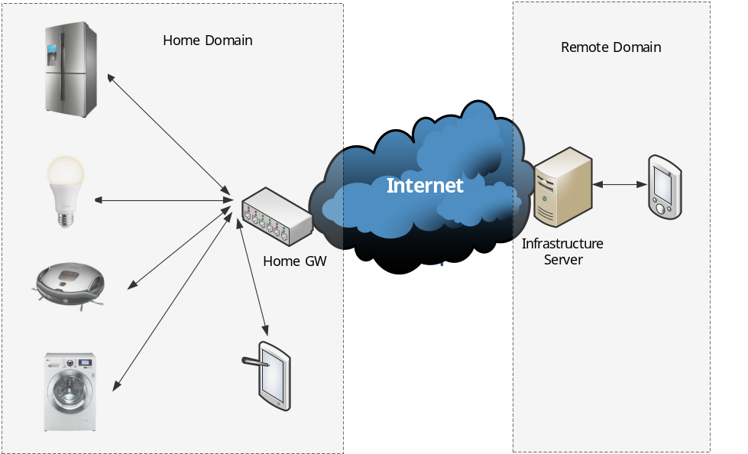
Figure 5.1-1 Home Domain Use Case Model
Figure 5,1-1 shows device and network configuration for general home domain use cases. In the home domain, there might be a home gateway which provides wireless (WiFi, Bluetooth, Zigbee) or wireline (Ethernet) connectivity with various home appliances. Home appliance registers its information with the home gateway or home infra server and reports its status or data to the home gateway or infra server. In the remote domain, the home controller e.g. smart phone, smart tablet enable controlling home appliances in the home domain via infra server and home gateway.

5.2 Overview of oneM2M Release 1 Enablement
The following table illustrates oneM2M common service functionality (CSF) and its relation to the applicable features to the home domain enablement.
oneM2M CSF | Applicable Home Domain Features
Registration | In order to receive M2M services, home appliances need to register their information with home gateway or home infra server. Based on this information, home appliances can be identified and managed in the oneM2M domain.
Discovery | Home appliances registered in the oneM2M domain can be discovered via searching for information about applications and services which are contained in oneM2M attributes and resources.
Data Management and Repository | Home appliance send their data to the home gateway or remote server. The stored data enables management of data and provides information to the service appliacation regarding home appliance’s status or data information.
Device Management | Home appliance’s specific function may be managed by oneM2M DM(device management) CSF which may include monitoring, diagnostics and troubleshooting, etc.
Group Management | Home appliances and devices can be managed via group-based e.g. category1, category2, etc. Leveraging oneM2M Group CSF enables bulk operations to the group members about home appliances.
Subscription and Notification | Home monitoring application can subscribe to an event regarding home appliances (e.g. lights on/off) and receive notification when matching the event, which enables home automation services.
Security | oneM2M provides security functionalites including authentication, authorization, encrytion, secure association establishment, etc. Home domain can utilize theses features for security mechanism among home appliances and home services.
Table 5.2-1 Applicable oneM2M Features to the Home Domain

6 Home Domain Use Cases

6.1 Use case for Device Pairing in Home Domain

6.1.1 Overview

6.1.1.1 Description
In home domain environments, there exist many kinds of home appliances such as air conditioner, refrigerator, smart plug, washing machine, lighting equipment, audio player, television, etc., that may be capable of M2M communication.
In this use case it is proposed that under certain circumstances two physically distinct devices in the home domain are correlated to each other.
A refrigerator is a home appliance which is used for storing vegetable, meat, or perishable food such as milk, egg etc. In this use case the refrigerator can provide M2M services (e.g. indicate a shortness of milk) but does not monitor and report its own energy consumption.
A smart plug is a home appliance used for measuring the consumed energy level of a connected home appliance. That is, if a smart plug is connected to a refrigerator, we can interpret that data generated from a smart plug in relation to the consumed energy level of the refrigerator. Therefore, we can conceptually regard the two physically separate devices as one device.
The physical relationship among the two devices (the smart plug is connected to the refrigerator) can be detected – either manually by the user or automatically by some non-oneM2M technology – through a smart device (e.g. smart phone and tablet device). This relationship is called “pairing” of the two devices.
The smart device sends the information about the pairing relationship configuration to the home server.
In addition, it is supposed that the smart plug connected to the refrigerator is later disconnected from the refrigerator and then is connected to another home appliance such as a washing machine. In this situation, the data from smart plug are no more related to the refrigerator but are related to the washing machine.
The oneM2M System should support this kind of pairing relationship between physically separate home appliances. As the home appliance connected with the smart plug can dynamically be changed the oneM2M System needs to be able to dynamically change the pairing relationship between home appliances.

6.1.1.2 Source
- KETI

6.1.1.3 Actors
- Home appliances
(include air conditioner, refrigerator, washing machine, smart plug, lightening equipment, etc.). Every home appliance needs to register its registration information with a home server.
- Home server
is an oneM2M platform provided by a service provider in the infrastructure domain.
- A smart device
(e.g. smart phone and tablet device) detects and configures the relationship between the smart plug and the refrigerator

6.1.1.4 Pre-condition
- A smart plug and a refrigerator are registered with a home server. In addition, the smart plug is connected to the refrigerator and reports the consumed energy level of the refrigerator to the home server.

6.1.1.5 Triggers
- None

6.1.1.6 Normal Flow
A smart device (e.g. smart phone and tablet device) detects and configures the relationship between the smart plug and the refrigerator. It sends the information about relationship configuration to the home server.
In this scenario, the configuration information includes the pairing information between the smart plug and the refrigerator and it implies that the smart plug is connected to the refrigerator and the data from the smart plug is related to the energy consumption of the refrigerator.
Receiving the configuration information, the home server checks its registered device list and makes a pairing/relationship between devices based on the configuration information.
Later, it is supposed that the refrigerator is pulled out of the smart plug and the smart plug is connected to different home appliance e.g. a washing machine.
The smart device detects the new pairing relationship and sends this information to the home server.
The home server receives the updated relationship information and then changes the pairing relationship among its registered devices.

6.1.1.7 Post-conditions
- In the home server, the information about the pairing relationship between home appliances is reflected.
- A smart home application can discover and use this kind of pairing information between devices.

6.1.1.8 High Level Illustration
The following figure illustrates that at time t1 the smart socket is connected to the refrigerator and then at time t2 the smart socket is disconnected from the refrigerator and connected to the washing machine. Home server manages the pairing information between home appliances.
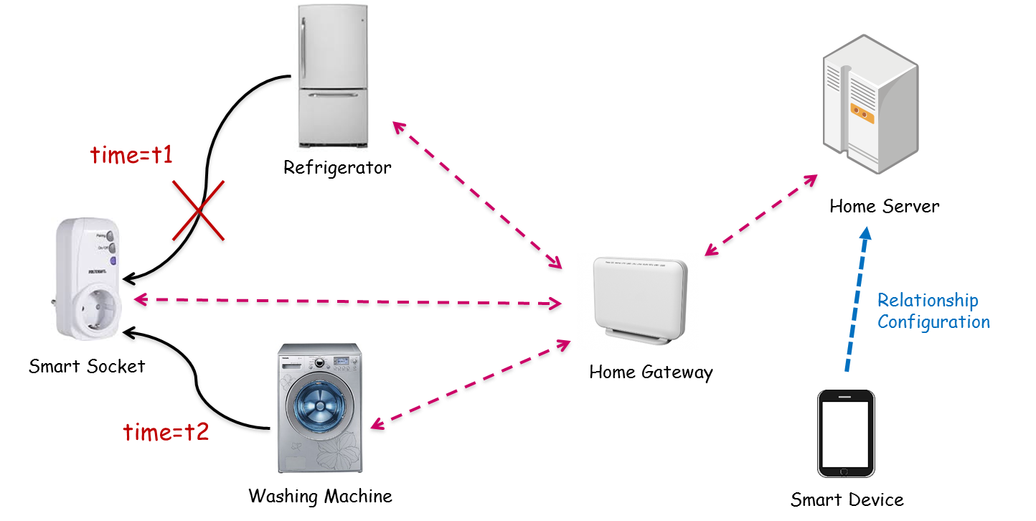

6.1.2 High Level Analysis

6.1.2.1 Functional Impacts
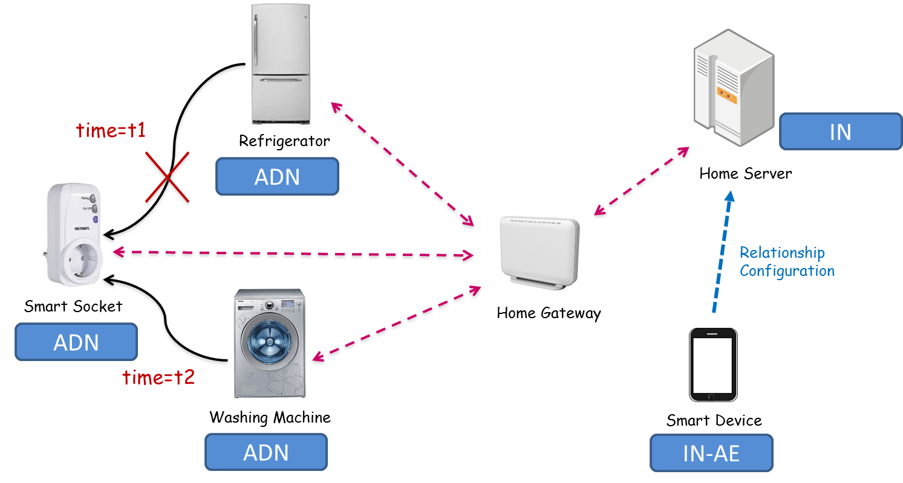
- In oneM2M configurations, the smart socket, the refrigerator, and the washing machine can be interpreted as ADN (Application Dedicated Node). The home server can be interpreted as IN (Infrastructure Node) and Smart device as IN-AE.
- For enabling this kind of service, first of all, each device needs to register its information with the server. (Registration)
- Using smart device, all the registered home appliances can be discovered. (Discovery)
- The smart device can make the pairing information between home appliances (Making Pairing information)
- The home server needs to store the pairing information in its registered device information. (Storing Pairing information)
- The home server needs to update the pairing information in its registered device information (Updating Pairing information)

6.1.2.2 High Level Information Flows
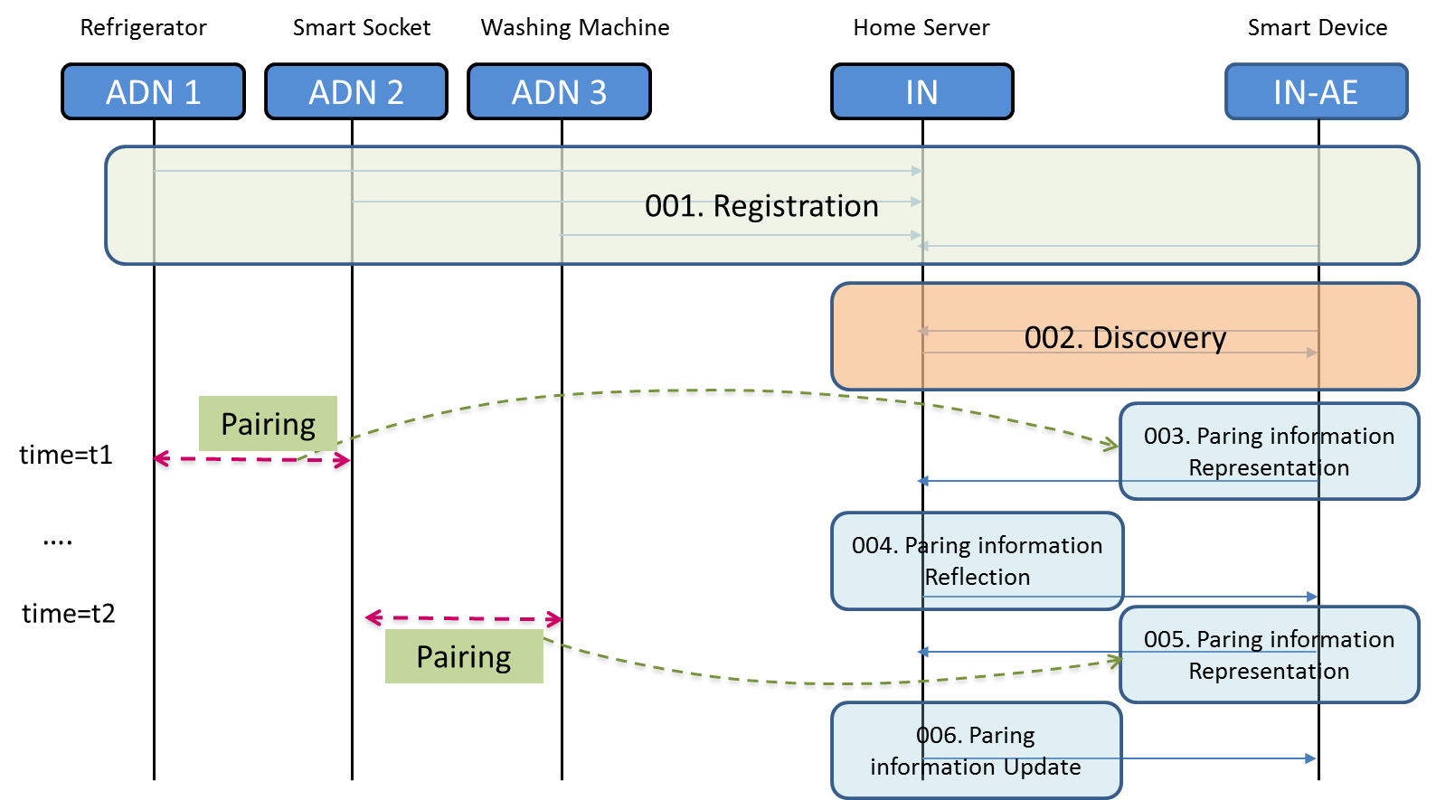
- 001: ADN1,2,3, and IN-AE register its information with IN. ADN 1,2,3 send their generated data to the IN.
- 002: IN-AE discovers the registered device list from the IN.
- 003: The pairing information between ADN 1 and 2 can be represented in the IN-AE and the IN-AE send the pairing information as oneM2M message to the IN.
- 004: IN receives the pairing information message and stores the pairing information in its database i.e. oneM2M resource tree.
- 005: When the connection of the ADN2 is changed from ADN1 to ADN 3, IN-AE sends new pairing information as oneM2M message to the IN.
- 006: IN received new pairing information message and updates the pairing information in its database i.e. oneM2M resource tree.
Note: We assume that IN-AE can acquire the pairing information from ADNs1,2,3 through a mechanism that is out of scope of oneM2M.

6.1.3 Potential Requirements
- The oneM2M System shall support a semantic relation (“Is Paired To”) between two M2M Devices.
- The oneM2M System shall be able to store/update information about pairing between two M2M Devices as a relation (“Is Paired To”) between M2M Devices.
- The oneM2M System shall enable the creation and deletion of a semantic pairing relation (“Is Paired To”) between M2M Devices by M2M applications, subject to access rights.
- The oneM2M System shall be able to make information about pairing between M2M Devices available to M2M Applications.

6.2 Use case for Triggering in Field Domain

6.2.1 Overview

6.2.1.1 Description
Smart Home is an important scenario that should be considered in OneM2M, in a general smart home scenario, home appliances such as air-conditioner, refrigerator, TV, etc. are managed by a home gateway, the home gateway connects to the infrastructure node which is provided by the service provider.
Most of the home appliances are not always power on, except the refrigerator. And for refrigerator, although it is always power on, but it may often shut off its wifi module, e.g. for power saving, when there’s no requirement to interact with the home gateway. This means the connection between a home appliance and the home gateway is often lost.
However, the user may want to control a home appliance through OneM2M system at any time, even when the communication connection between the home appliance and the home gateway is lost, e.g. the home appliance is power off or the home appliance has shut off its wifi module.
OneM2M has defined the triggering feature to wake up a device, to establish communication from the field domain towards the infrastructure domain when the device is not reachable by the infrastructure domain. However, the triggering feature defined in Rel-1 is only applicable to the devices or gateway which is directly registered to the infrastructure node.
But in the smart home scenario, the home gateway which is directly registered to the infrastructure node may always keep the connection with the infrastructure domain. The home appliances are registered to the home gateway, and the connection between the home appliance and the home gateway is often lost. When a user wants to control a home appliance which is not reachable by the home gateway, the field domain triggering is needed.
From our view, the smart home appliance could be assumed to support the infrared control, as people wants to control smart home appliances as well as traditional home appliances in their home. The smart home appliance also needs to support wifi to setup IP connection with home gateway in the OneM2M system.
So if the user wants to control a home appliance which is not reachable, e.g. the wifi module is shut off when the home appliance power off or sleep, the home gateway can use the infrared control to power on or wake up the home appliance, this will trigger the home appliance to restart its wifi module to establish communication from the home appliance towards the home gateway. Of course, the infrared control could also directly restart the wifi module in the home appliance.
After the communication between the home appliance and the home gateway is recovered, the home appliance is reachable and could be controlled by the user via OneM2M system.

6.2.1.2 Source
- Haier

6.2.1.3 Actors
- User
is one of the family members, which has privilege to control the home appliances in the home. User uses an application equipment to initiate the request to control a target home applicant in the home, and sends the request to the infrastructure node.
- Infrastructure node
which is an OneM2M Platform provide by a SP in the infrastructure domain.
- Home gateway
is deployed in the field domain, used to manage the home appliances registered to the home gateway.
- Home appliance
includes Air-conditioner, refrigerator, TV, etc. the home appliance uses wifi to setup IP connection between itself and the home gateway. The home appliance support more than communication protocols, e.g. wifi, infrared, Bluetooth, etc.

6.2.1.4 Pre-condition
- A smart air-conditioner registers its communication capability, e.g. wifi and infrared, to the home gateway. The home gateway and the AE are registered to the IN (Infrastructure Node). The IP connection between the gateway and the IN exists. The infrastructure node configures the home gateway for the purpose of triggering devices behind the gateway.

6.2.1.5 Triggers
- None

6.2.1.6 Normal Flow
The user powers off the air-conditioner and leaves home. Thus the IP connection between the air-conditioner and the home gateway is lost.
After one day’s work, the user is on the road back home, he wants to power on the air-conditioner remotely, so the rooms will be in comfortable condition when he arrives home. The user uses his mobile phone as the application entity to send a request to the IN.
IN forwards the request to the home gateway.
After receiving the request from IN, Home gateway finds the IP connection between itself and the air-conditioner is lost, so it stores the received request locally.
Home gateway tries to trigger the air-conditioner to be online. Home gateway knows the air-conditioner support both wifi and infrared communication methods, home gateway sends the infrared control command to the air-conditioner to power on the air-conditioner.
After the air-conditioner power on, its wifi module establishes the IP communication towards the home gateway.
Home gateway finds the air-conditioner is online, it forwards the request message locally stored to the air-conditioner.

6.2.1.7 Post-conditions
- The user successfully controls the home appliance via OneM2M system.

6.2.1.8 High Level Illustration
<Text>

6.2.2 High Level Analysis
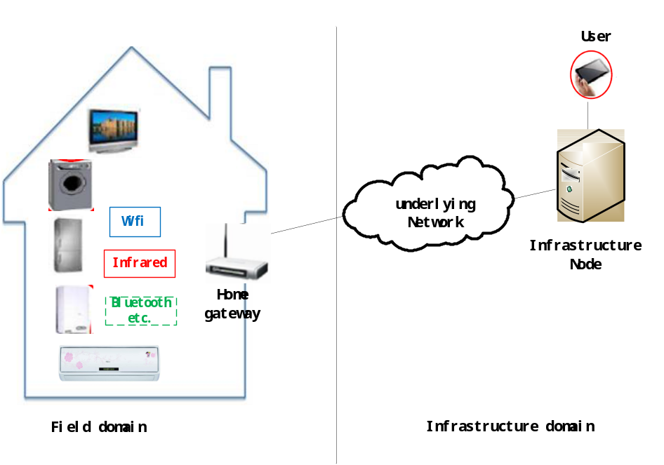

6.2.2.1 Functional Impacts
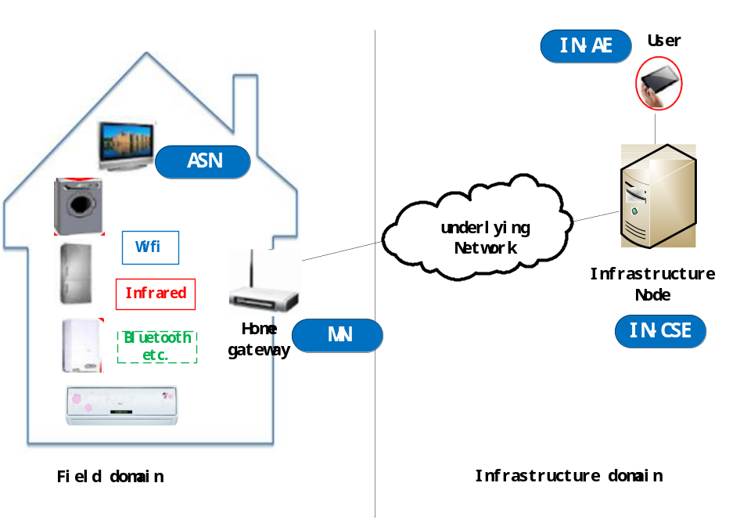
- In oneM2M configurations, home appliances, for example the TV can be interpreted as the ASN (Application Service Node). The home gateway can be interpreted as the MN (Middle Node). The user device such as the user’s smart phone that is registered with the IN can be interpreted as the IN-AE (Infrastructure Node-AE). The cloud server can be interpreted as the IN (Infrastructure Node).
- To enable this service, the IN configures the MN for the purpose of triggering devices behind the MN and the ASN should provide its communication capabilities to the MN. The communication capabilities include the information for example, supporting Infrared and the Infrared control code; supporting Wifi and the SSID; supporting SMS and the MSISDN.
- The MN keeps the communication capabilities received from the ASN-CSE.
- With the configurations of ASN triggering configured by the IN, when the MN receives the request to ASN, but the ASN is not online, the MN triggers the ASN to be online (e.g. by Infrared control) or ask the IN-CSE to trigger the ASN to be online (e.g. by SMS).

6.2.2.2 High Level Information Flows
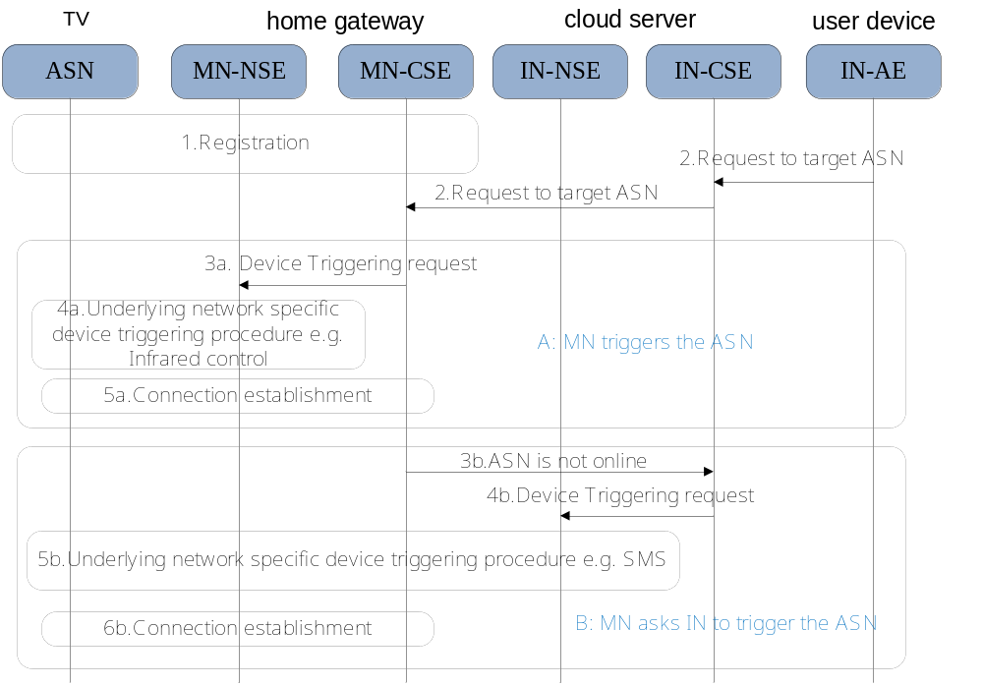
- 1. When the ASN registers with the MN successfully, the ASN provides its communication capabilities e.g., the information of supporting Infrared and the Infrared control code; supporting Wifi and the SSID; supporting SMS and the MSISDN, to the MN.
- 2. The MN receives a request towards the target ASN, but the ASN is not online.
- 3a. The MN determines it can trigger the ASN directly based on the configurations of ASN triggering configured by the IN. The MN-CSE sends the Device Triggering request to MN-NSE over Mcn.
- 4a. The MN-NSE performs underlying network specific device triggering procedure to trigger the ASN to setup IP connection with the MN-CSE. For example, the ASN supports both Wifi and Infrared control, but the Wifi connection is lost. The MN sends Infrared control command to control the ASN restart its Wifi module and reconnect to the MN again.
- 5a.The connection between the MN and the ASN is reestablished.
- 3b. Alternatively, when the ASN can’t be triggered by the MN, the MN can request the IN to trigger the ASN. The ASN’s communication capabilities may also be notified. One example of this scenario: the ASN supports both wifi and SMS, when the Wifi connection is lost, the MN requests the IN to trigger the ASN by SMS.
- 4b. The IN-CSE sends the Device Triggering request to the IN-NSE over Mcn.
- 5b. The IN-NSE performs underlying network specific device triggering procedure to trigger the ASN to setup IP connection with the MN-CSE. For example, the IN-NSE sends a SMS to control the ASN restart its Wifi module and reconnect to the MN again.
- 6b. The connection between the MN and the ASN is reestablished.

6.2.3 Potential Requirements
- The M2M system shall provide mechanisms to communicate with M2M gateways for the purpose of triggering devices behind the gateway.
- The M2M system shall support the M2M device to register its communication capabilities to the M2M gateway for the purpose of device triggering.
- If the M2M device supports multiple communication channels, one of the communication channels could be used by the M2M system to trigger the setup of another communication channel in the field domain.

6.3 Use case for automatically switching between remote access and local access

6.3.1 Overview

6.3.1.1 Description
In smart home system, it is very common that the mobile devices such as smart phones play the role of home controller to access and control home appliances operating in the local home network. It is very likely that the home controller moves in and out of the home network as the user moves, e.g., when the user stays at home, the home controller is connected to the same local network as the home appliances, or when the user takes a walk in the park, the home controller disconnects from the local home network. However, it is necessary to guarantee that home appliances can be controlled by the home controller regardless of where the home controller is.
In the gateway-centric smart home system, the smart home gateway can be configured as the smart home centre which manages local access of home appliances through home gateway and also enables remote access of home appliances through the cloud server.
When the home controller is out of the local home network, it communicates with the home appliances through the cloud server. But when the home controller returns to the local home network, normally the smart home user prefers to control home appliances directly through the home gateway.
The user experience would be bad if this feature is supported based on the user’s manual switch. To meet the user’s requirement of automatically switching between local access and remote access, in this use case, the user preference can be configured as enabling local access when the home controller is connected to the local home network and enabling remote access when the home controller disconnects from the local home network. So when the user is at home, the home controller performs local access mode to control home appliances through the home gateway. When the user goes out, the home controller automatically switches to the remote access mode to control home appliances through the cloud server and when the user get home, the home controller automatically switches to the local access mode again.
This use case provides an easy way for the user wherever he is to control home appliances according to the user preference.

6.3.1.2 Source
- Haier (CCSA)

6.3.1.3 Actors
- Home appliances
are networked home appliances such as smart air conditioner, smart refrigerator, smart washing machine, smart plug, smart lighting, etc.
- Home gateway
is an oneM2M enabled smart home centre in the home domain, used to manage home appliances registered with the home gateway.
- Home Controller
is an oneM2M device that manipulates home appliances regardless of whether it is in or out of the local home network.

6.3.1.4 Pre-condition
- The home gateway registers with the cloud server. The home appliances registers with the home gateway. The local access of home appliance is configured as the user preference when the home controller is in the local home network.

6.3.1.5 Triggers
- None

6.3.1.6 Normal Flow
The smart home user goes out. The user wants to control home appliances remotely. The home controller accesses to the remote cloud server and the home controller remotely controls home appliances through the cloud server.
The user returns home. The home controller detects and joins the local home network.
The oneM2M service layer of the home controller get the information of the underlying network and determines the underlying network is its local home network.
As the user has pre-configured the user preference that enables local access of home appliances when the home controller is in the local home network, the home controller automatically switches from the remote access mode to the local access mode, i.e., the home controller accesses and controls home appliances through the home gateway instead of through the cloud server.

6.3.1.7 Post-conditions
- The home controller controls the home appliance directly through the home gateway.

6.3.1.8 High Level Illustration
The following figure illustrates, at the time of t1, the home controller registers with the cloud server as it is out of the local home network. At the time of t2, the home controller deregisters with the cloud server and registers with home gateway as it is in the local home network.
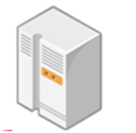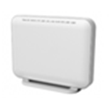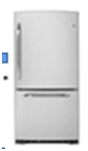
Home Gateway
Home Controller
Cloud Server
Refrigerator
Washing Machine
Time = t1
Time = t2

6.3.2 High Level Analysis

6.3.2.1 Functional Impacts
Home Gateway
Home Controller
Cloud Server
Refrigerator
Washing Machine
Time = t1
Time = t2
IN
ASN
MN
ADN
ADN
- In oneM2M configurations, home appliances such as the refrigerator, the washing machine can be interpreted as the ADN (Application Dedicated Node). The home gateway can be interpreted as the MN (Middle Node) and the home controller can be interpreted as the ASN (Application Service Node). The cloud server can be interpreted as the IN (Infrastructure Node).
- To enable this service, the home appliance operating in the local home network needs to register its information to the registration point, i.e., home gateway. Upon successful registration, the home gateway creates the device resources that can be manipulated by other devices such as the home controller. The home gateway provides the security and privacy preservation of the home appliance. The home gateway is not exposed to the home controller directly if the controller is out of the local home network due to security implementation. The home controller needs to register its information to the registration point, i.e., cloud server and the remote access of device resources can be handled by the cloud server.. (Registration)
- The home gateway is accessible for the home controller in the case of local access. The home controller can detect the home gateway in the local home network. The home controller connects with the home gateway through which it can access device resources of home appliances locally. (Detection)
- The home controller deregisters with the old registration point, i.e., the cloud server and registers with the new registration point, i.e., the home gateway. The device state and data information are transferred from the IN to the MN. The home controller switches its access mode of the home appliance from remote access to local access.

6.3.2.2 High Level Information Flows
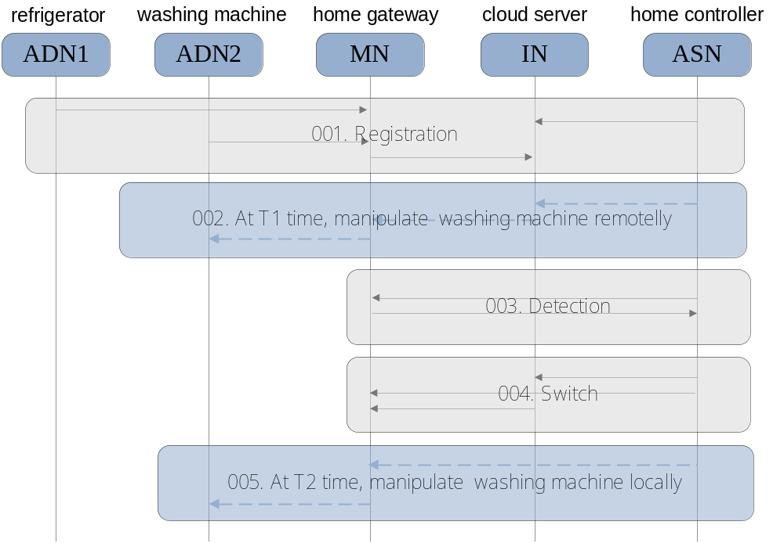
- 001. ADN1 and ADN2 register its information with the registration point, i.e., the MN. The MN and the ASN register its information with the registration point, i.e., the IN. Upon successful registration, the MN creates the device resources of ADN1 and AND2 that can be manipulated by the ASN.
- 002. At the time of T1, if the ASN needs to manipulate ADN2, it issues the request to the MN through the IN and then the MN transfers the request to ADN2.
- 003. The MN is accessible for the ASN in the case the ASN is in the local home network. The ASN detects its local home network and connects to the MN through which it can locally access home appliances.
- 004. The ASN deregisters with the IN while maintaining device state and data information. The ASN registers its information with the MN. With the device state and data information transferred from the IN to the MN, the ASN automatically switch the access model from remote access to local access.
- 005. At the time of T2, the ASN issues the request to the MN for manipulating ADN2, and then the MN transfers the request to ADN2.

6.3.3 Potential Requirements
- The oneM2M System shall provide the capability to notify M2M devices of the availability of alternative registration points (e.g., via different underlying networks) through which the M2M device can register.
- The oneM2M System shall enable a M2M device to de-register at an old registration point and re-register at a new registration point while maintaining device state and data information

6.4 Use case for Event management in Home Automation System

6.4.1 Overview

6.4.1.1 Description
Smart home service is usually provided using home automation system along with home monitoring system. For example, in the smart home system, the lights in a room turn on and off automatically as a person enters or leaves the room.
In home domain environment, there are various home appliances that are connected to a home gateway or a home server. Those home appliances can be managed and controlled through the home automation system/application.
The oneM2M gateway/server can manage a number of registered home appliances such as window blinds, doors, thermostats, sprinklers, etc. Each home appliance should be managed and controlled by the oneM2M gateway/server in a harmonized way, in order to provide users with comfortable home environments.
For example, let us consider a home automation system which includes sprinkler, temperature sensor, moisture sensor, water main valve controller, etc. Let’s suppose that a fire breaks out in the house, and the temperature sensor detects the fire. As soon as this situation occurs, the home automation system activates the sprinkler to extinguish the fire. However, if the sprinkler sprays water for some time, this causes the moisture sensor to detect flooding of the floor.
The information from the moisture sensor is regarded by the home automation system as flood conditions. The home automation system controls the water main to close. This causes the sprinkler not to work, and the house may be damaged by the fire. This kind of situation is not a desired situation in the home automation system. Therefore, when the home automation system is adapted in the oneM2M system, it should have some means to control home devices harmoniously.

6.4.1.2 Source
- KETI, InterDigital

6.4.1.3 Actors
- Home appliances
include temperature sensors, moisture sensors, sprinklers, water main pumps, refrigerators, washing machines, etc. Every home appliance needs to register its registration information with a home server.
- Home gateway
enables each home appliance to be connected through Zigbee, Bluetooth, Wifi, etc. and delivers data from the home appliances to the home server. It manages the resources based on the registration information of the home appliances.
- Home server
Is an oneM2M platform provided by a service provider in the infrastructure domain.
- Smart Pad
is able to gather sensing information from sensor installed in home environments and is a controller for actuators in home.
- Emergency system
Is a detection system regarding emergency situation and enables equipment and appliances to be controlled via the system

6.4.1.4 Pre-condition
- Every home appliance is registered with a home gateway, and the home gateway is registered with the home server. Each home appliance is controlled via the home gateway from smart pad and emergency system. The home gateway or home server manages the resources of home appliances.

6.4.1.5 Triggers
- None

6.4.1.6 Normal Flow
A fire breaks out in one of the rooms at home. In this situation, a temperature sensor detects the fire from one of the rooms.
Application in smart pad detects fire situation and control the sprinkler to be activated and spray water over the fire.
At this time, the floor of the room is getting flooded because of the water from sprinkler. A moisture sensor detects the water in the floor.
Application in smart pad detects water alarm and controls the water main valve to close.
Because the application in smart pad does not support the capability of conflict resolving function regarding control of resources in home automation system
However, emergency system supports the conflict resolving capability and the emergency systems send control message with high priority and then water main valve opens and sprinkler is activated again.
Application in smart pad detects the water main open and try to control the water main close but the priority of control message from application in smart pad is lower than emergency system and hence, the control message from the smart pad is ignored and water main valve open until the fire is extinguished.

6.4.1.7 Post-conditions
- The fire is successfully extinguished, and home appliances are managed and controlled in a harmonious way.

6.4.1.8 High Level Illustration
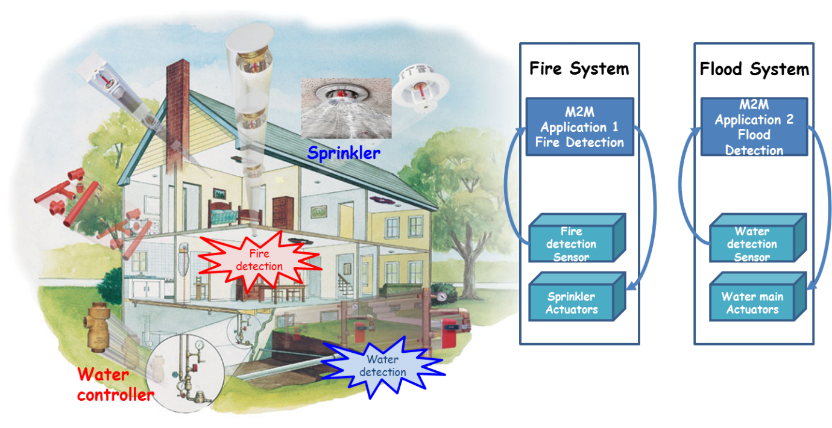

6.4.2 High Level Analysis

6.4.2.1 Functional Impacts
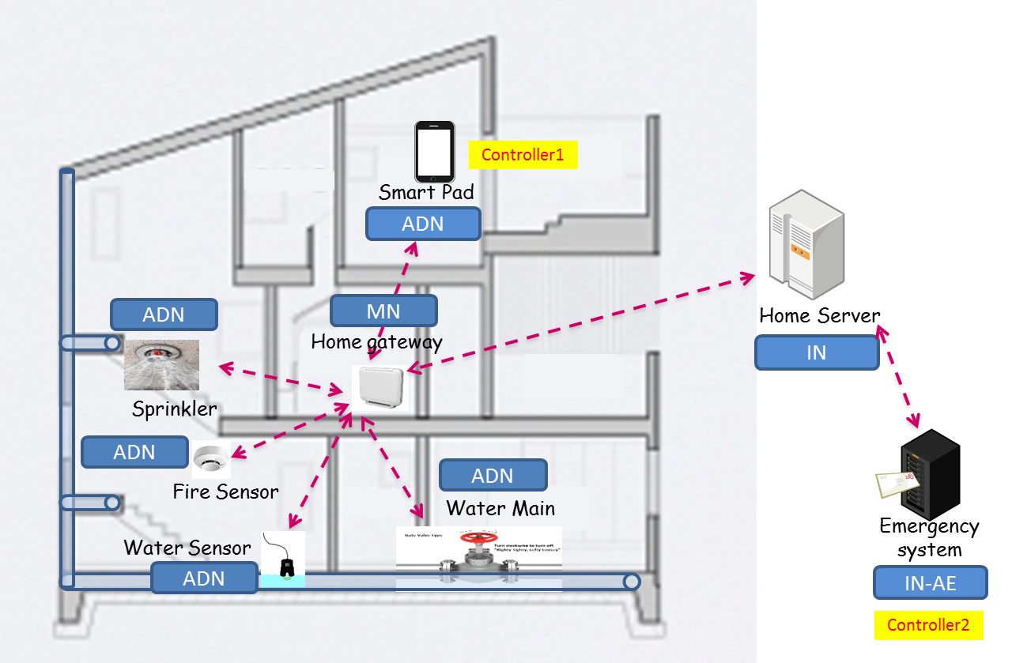
- In oneM2M configurations, the sprinkler, the water main, the fire sensor, the water sensor, and the smart pad can be interpreted as ADNs (Application Dedicated Nodes). The home gateway and the home server can be interpreted as MN (Middle Node) and IN (Infrastructure Node). Emergency system can be interpreted as IN-AE.
- Each device registers its information with the home gateway and the home gate way and emergency system are registered with home server (Registration).
- The fire sensor and the water sensor report sensing information to the home gateway (Container creation, contentInstance creation).
- The sprinkler and the water main are connected to the home gateway and can be actuated by device management technology via the home gateway (Device control/device status check).
- The fire sensor sends information about fire detection in the room. The application in smart pad subscribed the fire sensor information and is notified with fire alarm. Using this information, the application in smart pad sends control message to activate the sprinkler (Device control based on sensing data).
- The water sensor detects water in the floor, and this information is also notified to the application in smart pad. Using this information, the application in smart pad sends control message and this causes the water main to close (Device control based on sensing data).
- The emergency system subscribed the resources in the gateway and is notified with deactivation of sprinkler and water main valve close. Since the emergency system supports conflict resolving capability and hence, send the control message with high priority to activate sprinkler and water main valve open before the fire is extinguished. (Priority-based resource control)
- If oneM2M system support priority based resource control, the control message from emergency system is higher than the application in smart pad and hence the water main valve opens, and the sprinkler is activated again (Conflict management of control resources).

6.4.2.2 High Level Information Flows
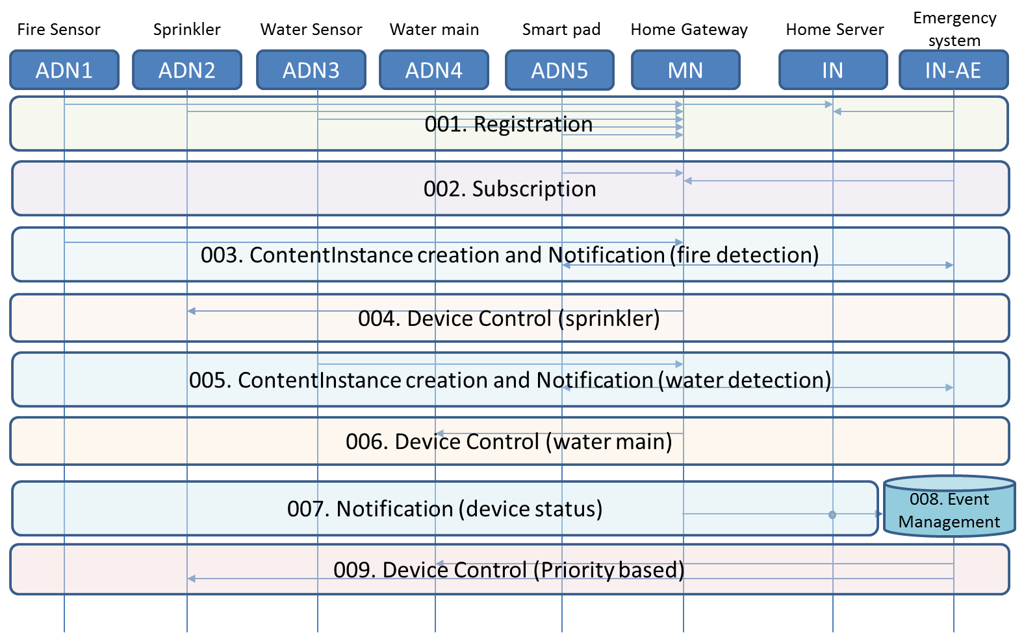
- 001: ADNs 1, 2, 3, 4, and 5 register their information with MN. MN is registered with IN and IN-AE also is registered with IN. ADNs 1 and 2 create container for their respective data in MN.
- 002: ADN5 and IN-AE create subscription resource in the MN in order to receive notification when new contentInstance is created.
- 003: The fire sensor (ADN1) detects fire, generates sensing data, and delivers the data to MN. This leads to the delivery of notification message to ADN5 and IN-AE.
- 004: Based on the delivered information, i.e. fire detection, the application in smart pad sent control message to the MN and the sprinkler (ADN2) is activated and sprays water over the fire.
- 005: The water sensor (ADN3) detects water on the floor, generates sensing data, and delivers the data to MN. This leads to the delivery of notification message to ADN5 and IN-AE.
- 006: Based on the delivered information, i.e. water detection, the application in smart pad sent control message to the MN and the water main (ADN4) valve is closed. This causes deactivation of the sprinkler.
- 007: The fire sensor (ADN1) and the water sensor (ADN3) report their data to MN repeatedly. The status of sprinkler and water main valve is reported to the MN. This information can be delivered to the IN-AE which previously subscribed to resources in MN.
- 008: Based on the sensing data from both fire and water sensors and the status of the sprinkler and water main valve, the IN-AE recognizes a conflicting situation regarding device control and resolves the conflict
- 009: The emergency system (IN-AE) sends the control message with high priority. The MN receives this message and then the water main valve open and sprinkler is activated. The control message (i.e. water main close) from ADN5 can be ignored because the priority is lower than the emergency system.

6.4.3 Potential Requirements
- The oneM2M system shall support capabilities for event management, e.g. capability for arbitration of the resulting processing.

6.5 Use case for Device Caching in Home Domain

6.5.1 Overview

6.5.1.1 Description
In home environments, various home appliances are used. Among the home appliances, some appliances such as fans, heaters, and air conditioners are only used during certain seasons of the year.
In oneM2M system, every device registers its information with the oneM2M system in order to receive oneM2M services. Therefore, when a device is powered on, the device needs to check whether it is registered with the oneM2M system or not.
For example, consider a scenario where an air conditioner is registered with a home gateway, and the home gateway is registered with a home server in infrastructure domain. Usually, the air conditioner is actively used in summer, rarely used in autumn, and never used in winter.
The air conditioner will be inactive in winter. Since the device is not used, it would be beneficial to remove the air conditioner related resources from the home gateway so that it is not discovered or accessed.
If the air conditioner is to be used again next summer, the air conditioner needs to register its information with the gateway or server again because the registration information was deleted.
However, this will be a reoccurring process of deleting and reinstating the same resources repeatedly over time. Hence, this kind of re-registration process can be an additional overhead to oneM2M system.

6.5.1.2 Source
- KETI

6.5.1.3 Actors
- Home appliances
are common, general home appliances, such as lighting, refrigerator, washing machine, etc. Specific home appliances are actively used during certain seasons of the year only (e.g. fan, air conditioner, heater, hot-air blower).
- Home gateway
is a device which supports communication technology enabling each home appliance to be connected via Zigbee, Wifi, Bluetooth, etc. and each home appliance can register its information with the home gateway.
- Home server
is a oneM2M platform provided by a service provider in the infrastructure domain. The home gateway registers its information with the home server.

6.5.1.4 Pre-condition
- An air conditioner is registered with a home gateway, and it is actively used in the summer. The home gateway is registered with home server.

6.5.1.5 Triggers
- None

6.5.1.6 Normal Flow
The air conditioner is rarely used in autumn and not used at all in winter. Since the air conditioner is not used in winter, the air conditioner related registration information in the home gateway is not accessed.
In this situation, it would be beneficial from the resource usage point of view to remove the air conditioner related information from the home gateway since there is no need to discover or access the air conditioner resources in winter. However, in summer, the air conditioner resources need to be reinstated. This would be a cyclic processes, repeating every year. Therefore, the registration information should not be deleted permanently.
If the home gateway supports caching mechanism regarding its registered information, the inactive device’s information can be moved to a temporary repository. (Home server also supports caching mechanism regarding its registration information e.g. home gateway or home appliances directly registered with home server)
In this scenario, to support cache mechanism, the home gateway may move the resources regarding the air conditioner to a cache-bin.
When summer comes, the air conditioner is used again and starts running. At this time, the home gateway becomes aware of the re-activation of the air conditioner and recovers the resources regarding the air conditioner from the cache-bin.
After restoring all cached information, the air conditioner provides oneM2M services by using the recovered registration information.

6.5.1.7 Post-conditions
- The air conditioner provides oneM2M services by using its registered information, and it also updates its resources. It runs normally as part of the oneM2M system.

6.5.1.8 High Level Illustration
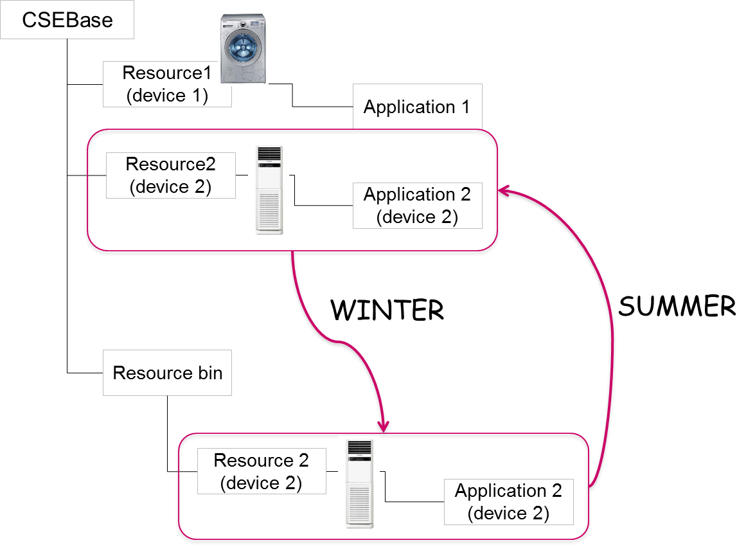

6.5.2 High Level Analysis

6.5.2.1 Functional Impacts
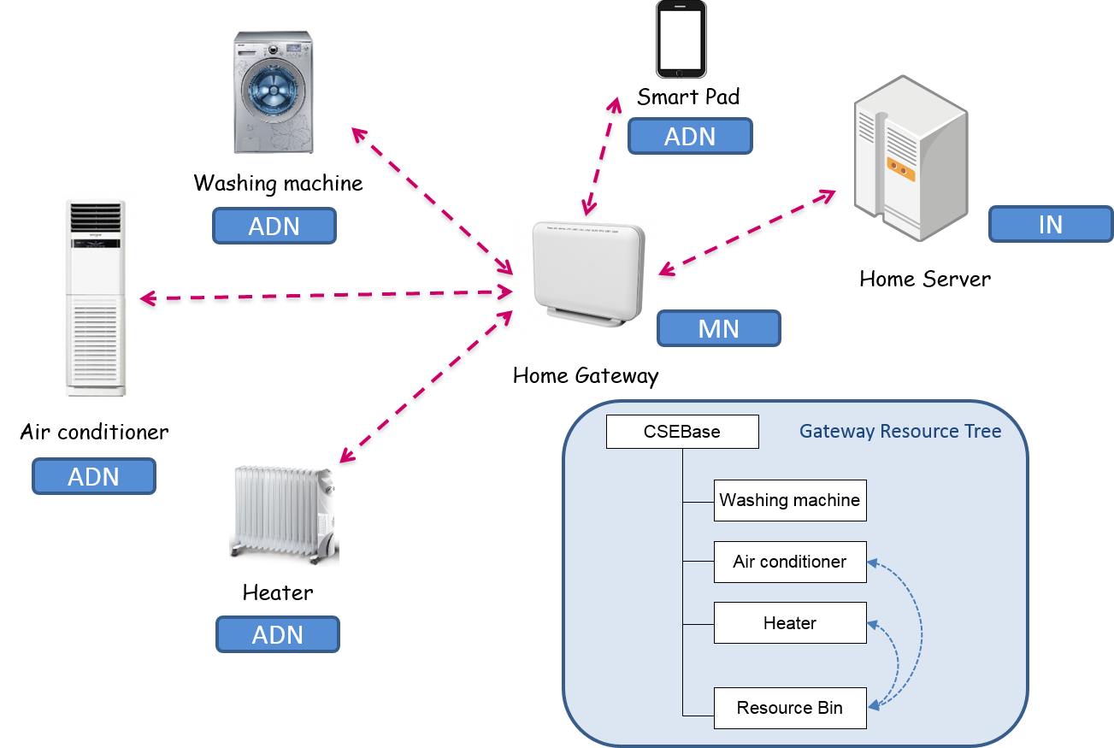
- In oneM2M configurations, the washing machine, the air conditioner, and the heater can be interpreted as ADN (Application Dedicated Node). The home gateway and the home server can be interpreted as MN (Middle Node) and IN (Infrastructure Node), respectively.
- Each home appliance needs to register its information with the home gateway. The relevant resources are created in the resource tree of the home gateway. When the registration resource is created in the home gateway, the attribute value related to its cache intention is set. (Registration).
- The resource tree of the home gateway supports a cache bin structure which can be used for saving resources temporarily (Resource cache bin).
- When the registered resources need to be deleted due to its inactivity, the home gateway checks the attribute value representing cache intention. If the attribute value is set, the home gateway moves the registered information relevant to the air conditioner to the cache bin (Resource Caching).
- When the air conditioner is used again, the home gateway recovers the relevant registered information from the cache bin (Resource Recovery).

6.5.2.2 High Level Information Flows
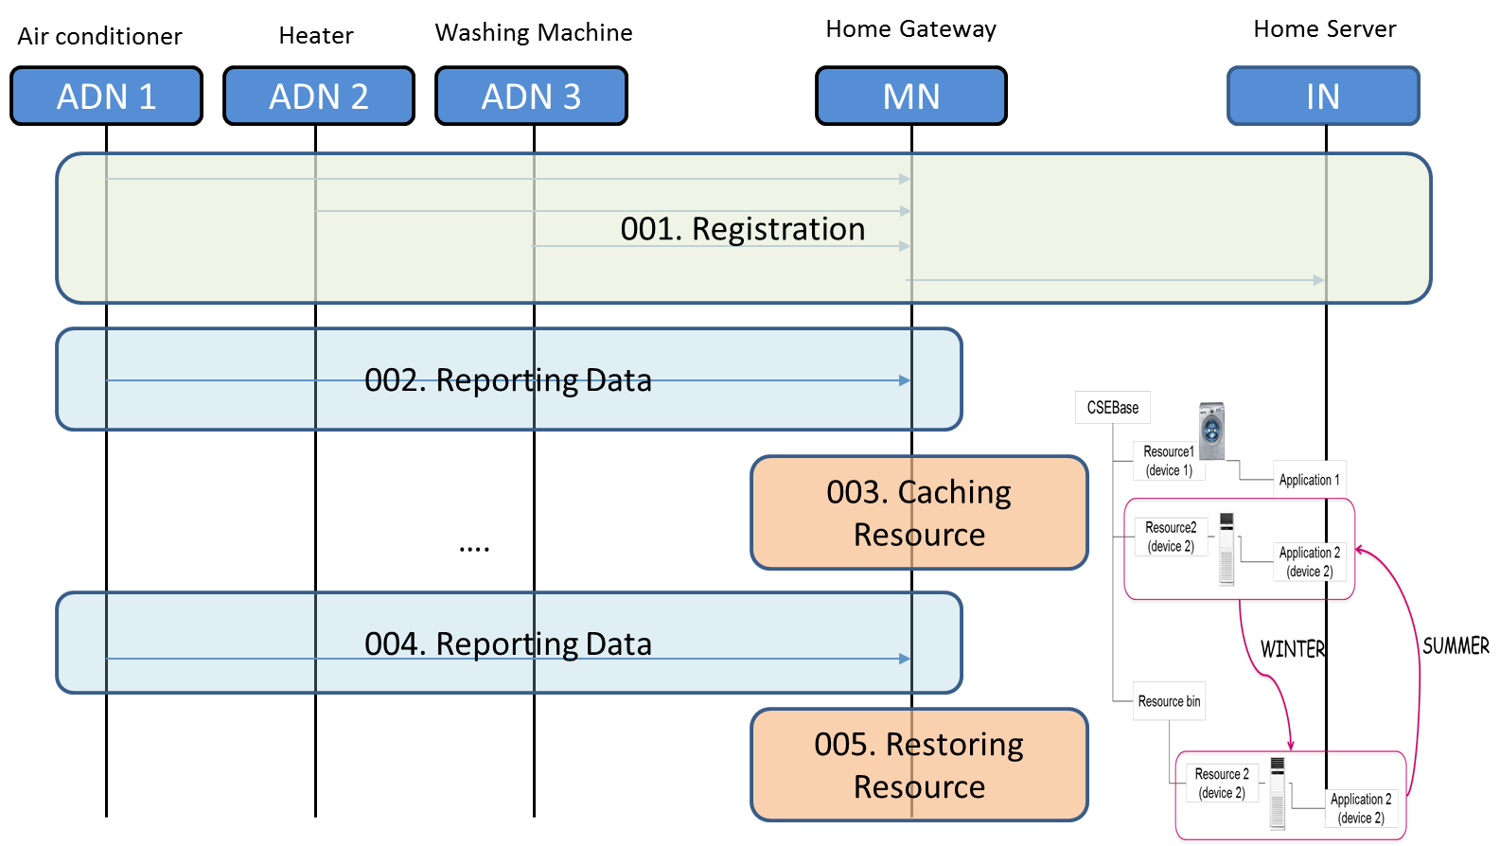
- 001: ADNs1, 2, and 3 register their respective information with MN. In addition, MN registers its information to the IN.
- 002: The air conditioner (ADN1) generates data and sends its data to the home gateway (MN). The resource regarding ADN1 in the MN is updated and refreshed.
- 003: The air conditioner is not used for some period of time (e.g. winter season). The MN detects this situation and caches the resources relevant to the air conditioner to its cache bin.
- 004: When the air conditioner (ADN1) is used again (e.g. summer season), the air conditioner sends its data to the home gateway (MN)
- 005: The home gateway (MN) detects that the air conditioner is active again and restores the resources relevant to the air conditioner (ADN1) from the cache bin.

6.5.3 Potential Requirements
- The oneM2M system shall support resource caching of registered M2M Devices. Resource caching is a mechanism through which the oneM2M system retains resources of a registered M2M Device in temporarily inactive state by moving the resources to a temporary storage e.g. cache bin.
- When a M2M Device registers to the oneM2M system, the M2M Device shall be able to provide information on its intention to cache resources.
- When a M2M Device becomes active again, the oneM2M system shall be able to restore all previously cached resources.

6.6 Event Priority Management

6.6.1 Overview

6.6.1.1 Description
Smart Home systems on oneM2M-based platforms may integrate a variety of applications on a home gateway system. The gateway is registered to an infrastructure node provided by a Service Provider which enables all the services available on the platform.
Several services are integrated on the gateway-based platform including, but not limited to, the ones described as follows:
A home management assistive service, which complements restrictions in mobility of the home owner/patient by providing centralized control for lighting, appliances, etc. using touchpads and gestures. It uses cameras distributed around the home to identify the gestures, but these are turned on/off selectively based on occupancy/presence.
A second service provides security by video-monitoring the surroundings of the house, with several feeds for doors and windows, garage, gates, surrounding gardens.
A Senior Care service is provided by an expert provider using a specialized application which enables remote monitoring of vitals. As an added benefit, the service provides direct access to medical and emergency services e.g. after a fall. Such an emergency might be detected by analysis of the gathered data, or enabled via call button functionality.
In an emergency situation such as the fall of the patient, the resources of the home gateway should be used to attend to the critical situation. For example the large amount of memory allocated to video-monitoring the surroundings is better allocated instead to the assistive cameras around the patient, which may be turned on for assistance while the outdoor information is not needed.

6.6.1.2 Source
InterDigital

6.6.1.3 Actors
- Home owner/user: Person using the services included in this use case or a family member representative, might also be the administrator/manager of the home gateway-based platform
- Smart sensors/ devices/ appliances: Devices integrated in the home gateway based platform, providing measurements or services to the owner.
- Home M2M gateway: home based device receiving data from the sensors and devices and communicating with application servers located on infrastructure nodes.
- M2M Service Providers: Companies providing M2M services for the user through the M2M Service Platform and via specialized infrastructure nodes. They enable infrastructure-based applications such as the one used by thesenior care expert providerto collect and analyze patient data or to respond to emergency calls.

6.6.1.4 Pre-conditions
The home gateway is registered with a Service Provider enabling the home based platform and the home owner has a relationship with a Service Provider enabling services such as the Senior Care service provider.

6.6.1.5 Triggers
N/A

6.6.1.6 Normal Flow
Each device registers its information with the home gateway, which in turn is registered with a home server. Each individual service is configured by the user via user interfaces e.g. on the individual devices or on a smart phone
The user provides the home gateway with event priority configuration. Typical configurations may be made available to aid the user in providing priorities with various granularity and functional levels.
Each service creates containers, resources, notification subscriptions, etc. as necessary to enable the requested functionality.
An event (fall) occurs, with related processing including operations on the gateway hosted resources and associated notifications, etc.
When a fall of the home owner/patient occurs, the platform resources should be allocated to attend to the critical situation. Event management based on priority is performed on the home gateway. The priority is given to the Senior Care application and devices for use of the gateway resource. Depending of priority settings, the cameras belonging to the security monitoring service are de-prioritized in favour of the ones enabling the assistive devices.
The gateway triggers Event/Priority based actions for device control, such as turning on all cameras enabling assistive services to monitor locations close to the fall. At the same time some security monitoring cameras are turned off to allow memory use by the cameras assisting the critical situation. Related notifications to the Smart Phone and remote monitoring application may be provided.

6.6.1.7 Post-conditions
N/A

6.6.1.8 High Level Illustration
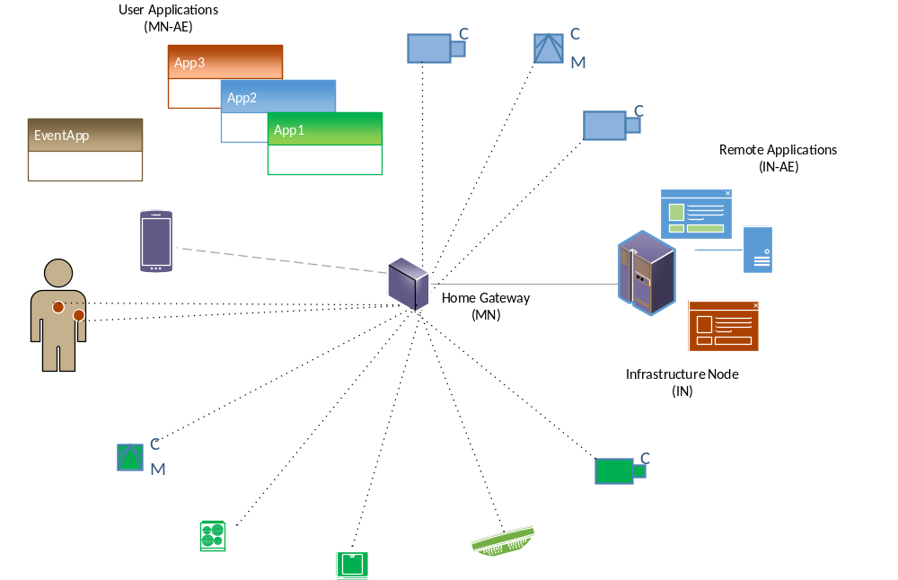

6.6.2 High Level Analysis

6.6.2.1 Functional Impacts
oneM2M platforms supporting this usecase may implement the home gateway as MN (Middle Node) and the Service Provider’s home server as IN (Infrastructure Node).The Service Provider enables the application used by the Home Care Emergency services, which is implemented as IN-AE.
All home-based devices in this usecase are implemented as Application Dedicated Nodes (ADNs). This includes the smart phone, assistive devices and cameras, body sensors and security cameras, which register with the MN-CSE.
The assistive service camera monitoring uses container creation at MN-CSE, to which the assistive devices and smart phone applications subscribe. Notifications are received based on resource updates.
The security camera monitoring uses also container creation at MN-CSE, to which the smart phone applications may subscribe to receive notifications.
The body sensor and call button create their own resources at the MN-CSE. In this case, in addition to the smart phone ADN-SP a subscription may be made by the IN-AE
The home gateway may be involved in other device operations, such as control, status checks, etc., which are not detailed within this use case. It can also be configured by the AND-SP to provide event management for all or some of the services it hosts. In this usecase the Home Care services are prioritized such that in case of an emergency button call it can turn all the assistive cameras on while the security ones are turned off.
When the patient fall event occurs, the call button provides an update which results in notifications to the smart phone ADN-SP and the remote application IN-AE. It also results in device control actions to the cameras AND-SC and ADN-AC. Event-management related notifications to AND-SP and IN-AE may be provided.

6.6.2.2 High Level Information Flows
- The Service Provider enables a home gateway platform as a MN-CSE which registers at the IN-CSE. An IN-AE for providing Senior Care services for via monitoring and emergency response also registers at the IN-CSE.
- Each device (ADN-SP, ADN-AD, ADN-AC, ADN-SC, ADN-CB, ADN-BS) registers its information with the home gateway,. Each individual service is configured by the user via user interfaces e.g. on the individual devices or on a smart phone.
- The user provides the home gateway with event priority configuration via AND-SP. Typical configurations may be made available to aid the user in providing priorities with various granularity and functional levels.
- Each service creates containers, resources, notification subscriptions, etc. as necessary to enable the requested functionality.
- ADN-AC contentInstance creation is followed by subscriptions from ADN-SP and ADN-AD. After an example update notifications are sent to ADN-SP and ADN-AD .
- ADN-SC contentInstance creation is followed by subscriptions from ADN-SP which is notified after example updates.
- ADN-CB and ADN-BS contentInstance creation are followed by subscriptions from ADN-SP and IN-AE.
- An event (fall) occurs, with the call button activation producing a related contentInstance update from ADN-CB. This in turn results in notifications to ADN-SP and IN-AE based on the previous subscriptions.
- Event management based on priority is performed on the MN-CSE. The priority is given to the Senior Care application and devices for use of the gateway resource. Depending of priority settings, the cameras belonging to the security monitoring service are de-prioritized in favour of the ones enabling the assistive devices.
- Event/Priority based actions for device control may be triggered via messages to ADN-SC, to monitor locations close to the fall. Some security monitoring cameras are also turned off via messages to ADN-SC to allow memory use by the cameras assisting the critical situation.
- Based on subscriptions, event-management related notifications to ADN-SP and IN-AE may be provided.

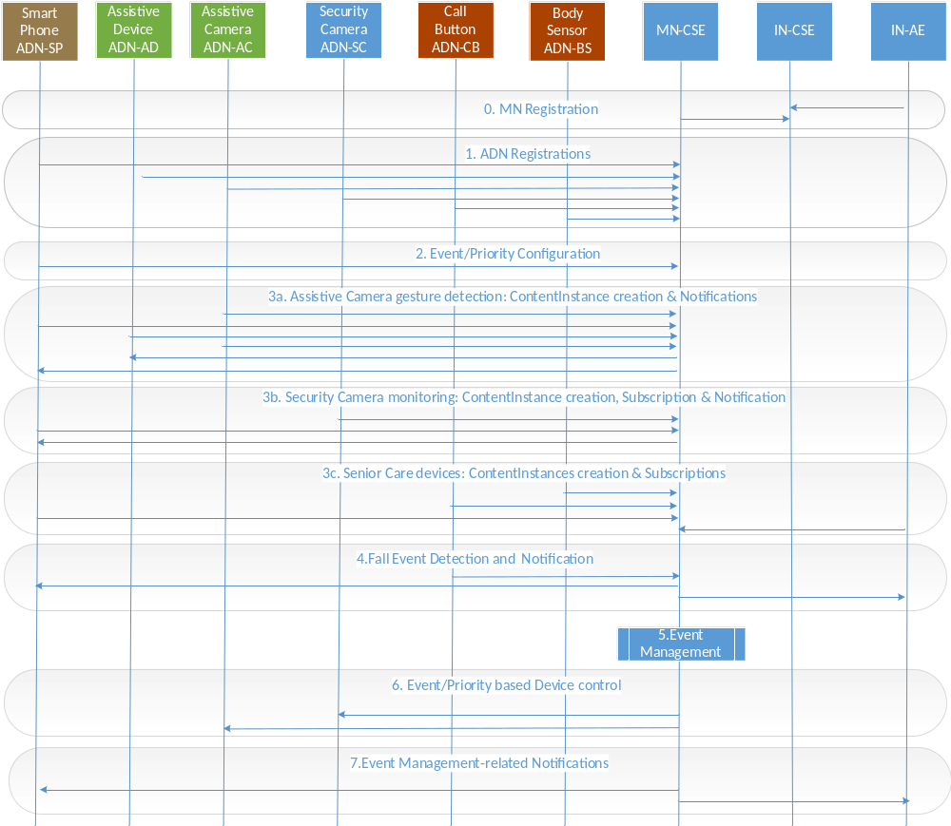

6.6.2.3 Potential requirements
- The oneM2M system shall support gateway-based capabilities for event management, e.g. capability for arbitration of the resulting processing.

7 Overview of Potential Requirements
Potential Requimrents derived from Home Domain Use Cases are summarized as follows:
- The oneM2M System shall support a semantic relation (“Is Paired To”) between two M2M Devices.
- The oneM2M System shall be able to store/update information about pairing between two M2M Devices as a relation (“Is Paired To”) between M2M Devices.
- The oneM2M System shall enable the creation and deletion of a semantic pairing relation (“Is Paired To”) between M2M Devices by M2M applications, subject to access rights.
- The oneM2M System shall be able to make information about pairing between M2M Devices available to M2M Applications.
- The M2M system shall provide mechanisms to communicate with M2M gateways for the purpose of triggering devices behind the gateway.
- The M2M system shall support the M2M device to register its communication capabilities to the M2M gateway for the purpose of device triggering.
- If the M2M device supports multiple communication channels, one of the communication channels could be used by the M2M system to trigger the setup of another communication channel in the field domain.
- The oneM2M System shall provide the capability to notify M2M devices of the availability of alternative registration points (e.g., via different underlying networks) through which the M2M device can register.
- The oneM2M System shall enable a M2M device to de-register at an old registration point and re-register at a new registration point while maintaining device state and data information.
- The oneM2M system shall support capabilities for event management, e.g. capability for arbitration of the resulting processing.
- The oneM2M System shall define a structure of an Information Model for the purpose of exchanging data. (ABR-001 [i.2])
- The oneM2M system shall support resource caching of registered M2M Devices. Resource caching is a mechanism through which the oneM2M system retains resources of a registered M2M Device in temporarily inactive state by moving the resources to a temporary storage e.g. cache bin.
- When a M2M Device registers to the oneM2M system, the M2M Device shall be able to provide information on its intention to cache resources.
- When a M2M Device becomes active again, the oneM2M system shall be able to restore all previously cached resources.

8 Conclusions
Regarding the home environement, many standards for M2M services (HGI [i.3], OIC [i.4], Energy@Home [i.5], BBF [i.6], WIFI [i.7], Zigbee Home Automation Profile [i.8] etc.) have been developed and utilized from network connectivity to platform technology to applications. In this document, various home domain use cases have been studied and provides methods related to how the oneM2M system can be adapted to accommodate home domain uses.
In the home domain environment, the home gateway acts as a crucial role for setting up connectivity with home appliances but also the methods of managing home appliances. Additionally, home intelligence services utilize home appliance’s data and manage/control home appliances automatically. To this end, the method for organizing home device’s resources can be considered as an important feature and points out the systematic hamornization of resources is required. In order to provide interoperability between home appliances manufactured from various companies, the home domain information model needs to be defined within the oneM2M scope.

The following text is to be used when appropriate:
Annex <A>:
Title of annex
<Text>
Annex <B>:
Title of annex
<Text>
B.1 First clause of the annex
<Text>
B.1.1 First subdivided clause of the annex
<Text>

History
Publication history
V.1.1.1 | <dd Mmm yyyy> | <Milestone>

Draft history (to be removed on publication)
V.0.1.0 | 15-Sep-2014 | Initial Draft Version
V.0.1.1 | 28-Sep-2014 | Change document style by WPM guideline
V.0.2.1 | 06-Nov-2014 | Incorporates: REQ-2014-0469R03 (with elimination of guideline text)
V.0.3.0 | 18-May-2015 | Incorporates: REQ-2015-0502R01, REQ-2015-0505R01, REQ-2014-0471R06, REQ-2014-0470R06
V.0.4.0 | 22-May-2015 | Incorporates: REQ-2015-0524R03
V.0.5.0 | 04-Mar-2016 | Incorporates: REQ-2016-0011R02
V1.0.0 | 17-Mar-2016 | Change version to 1.0.0 for approval

