

oneM2M
Technical Specification
Document Number | TS-0016-V-0.8.0
Document Name: | Secure Environment Abstraction
Date: | 2018-01-25
Abstract: | Defines an API that abstracts from the technical implementation of the secure environment
Template Version:23 February 2015 (Dot not modify)

This Specification is provided for future development work within oneM2M only. The Partners accept no liability for any use of this Specification.
The present document has not been subject to any approval process by the oneM2M Partners Type 1. Published oneM2M specifications and reports for implementation should be obtained via the oneM2M Partners' Publications Offices.

About oneM2M
The purpose and goal of oneM2M is to develop technical specifications which address the need for a common M2M Service Layer that can be readily embedded within various hardware and software, and relied upon to connect the myriad of devices in the field with M2M application servers worldwide.
More information about oneM2M may be found at: http//www.oneM2M.org
Copyright Notification
© 2016, oneM2M Partners Type 1 (ARIB, ATIS, CCSA, ETSI, TIA, TSDSI, TTA, TTC).
All rights reserved.
The copyright extends to reproduction in all media.

Notice of Disclaimer & Limitation of Liability
The information provided in this document is directed solely to professionals who have the appropriate degree of experience to understand and interpret its contents in accordance with generally accepted engineering or other professional standards and applicable regulations. No recommendation as to products or vendors is made or should be implied.
NO REPRESENTATION OR WARRANTY IS MADE THAT THE INFORMATION IS TECHNICALLY ACCURATE OR SUFFICIENT OR CONFORMS TO ANY STATUTE, GOVERNMENTAL RULE OR REGULATION, AND FURTHER, NO REPRESENTATION OR WARRANTY IS MADE OF MERCHANTABILITY OR FITNESS FOR ANY PARTICULAR PURPOSE OR AGAINST INFRINGEMENT OF INTELLECTUAL PROPERTY RIGHTS. NO oneM2M PARTNER TYPE 1 SHALL BE LIABLE, BEYOND THE AMOUNT OF ANY SUM RECEIVED IN PAYMENT BY THAT PARTNER FOR THIS DOCUMENT, WITH RESPECT TO ANY CLAIM, AND IN NO EVENT SHALL oneM2M BE LIABLE FOR LOST PROFITS OR OTHER INCIDENTAL OR CONSEQUENTIAL DAMAGES. oneM2M EXPRESSLY ADVISES ANY AND ALL USE OF OR RELIANCE UPON THIS INFORMATION PROVIDED IN THIS DOCUMENT IS AT THE RISK OF THE USER.

Contents
Contents 3
1 Scope 6
2 References 6
2.1 Normative references 6
2.2 Informative references 7
3 Definitions, symbols and abbreviations 7
3.1 Definitions 7
3.2 Abbreviations 7
4 Conventions 8
5 SE Abstraction Architecture 8
5.1 Introduction 8
5.2 AE and CSE access security services within the SE 10
5.3 AE residing within the SE 10
6 Secure Environments 11
6.1 Secure Environments capabilities 11
6.2 Secure Environments security levels 11
6.3 Tamper resistant hardware SE implementation 12
6.4 Hardware isolated SE implementation 12
6.5 Software based SE implementation 12
7 Logical Abstraction – McsReference point 12
7.1 Overview 12
7.2 Mcs reference point 13
7.2.1 Secure Environment Identifier (M2M-SE-ID) 13
7.3 Resource SE 13
7.3.0 Overview 13
14
7.3.1 Resource SEReboot 16
7.4 Sensitive Data Storage 17
7.4.1 <sensitiveDataObject> resource 17
7.4.2 <sensitiveDataObject> Resource Procedures 19
7.4.2.1 CREATE <sensitiveDataObject> 19
7.4.2.2 RETRIEVE <sensitiveDataObject> 20
7.4.2.3 UPDATE <sensitiveDataObject> 20
7.4.2.4 DELETE <sensitiveDataObject> 21
7.5 Sensitive Cryptographic Functions 22
7.5.1 <cipher> resource 22
7.5.1.1 <cipher> Resource Procedures 25
7.5.1.1.1 CREATE <cipher> 25
7.5.1.1.2 RETRIEVE <cipher> 25
7.5.1.1.3 UPDATE <cipher> 26
7.5.1.1.4 DELETE <cipher> 26
7.5.1.2 <encrypt> Resource 27
7.5.1.3 <decrypt> Resource 27
7.5.1.4 <generateKey> Resource 27
7.5.1.5 <algorithmSpecificParameter> Resource 27
7.5.2 <rand> resource 28
7.5.2.1 <rand> Resource Procedures 30
7.5.2.1.1 CREATE <rand> 30
7.5.2.1.2 RETRIEVE <rand> 31
7.5.2.1.3 UPDATE <rand> 32
7.5.2.1.4 DELETE <rand> 32
7.5.2.2 <generateRand> Resource 32
7.5.3 <hash> resource 32
7.5.3.1 <hash> Resource Procedures 34
7.5.3.1.1 CREATE <hash> 34
7.5.3.1.2 RETRIEVE <hash> 35
7.5.3.1.3 UPDATE <hash> 35
7.5.3.1.4 DELETE <hash> 36
7.5.3.2 <calculateHash> Resource 36
7.5.4 <signature> resource 37
7.5.4.1 <signature> Resource Procedures 39
7.5.4.1.1 CREATE <signature> 39
7.5.4.1.2 RETRIEVE <signature> 39
7.5.4.1.3 UPDATE <signature> 40
7.5.4.1.4 DELETE <signature> 40
7.5.4.2 <calculateSignature> Resource 41
7.5.4.3 <verifySignature> Resource 41
7.5.4.4 <generateKey> Resource 41
7.6 Secure Connection Establishment 41
7.6.1 <secureConnection> resource 41
7.6.2 <secureConnection> Resource Procedures 44
7.6.2.1 CREATE <secureConnection> 44
7.6.2.2 RETRIEVE <secureConnection> 45
7.6.2.3 UPDATE <secureConnection> 45
7.6.2.4 DELETE <secureConnection> 46
7.6.3 <connectionInstance> resource 46
7.6.4 <connectionInstance> Resource Procedures 49
7.6.4.1 CREATE <connectionInstance> 49
7.6.4.2 RETRIEVE <connectionInstance> 49
7.6.4.3 UPDATE <connectionInstance> 50
7.6.4.4 DELETE <connectionInstance> 51
7.6.5 <connect> Resource 51
7.6.6 <send> Resource 51
7.6.7 <generateKey> Resource 51
7.7 Authentication and Identification 51
7.7.1 <identity> resource 51
7.7.2 <identity> Resource Procedures 54
7.7.2.1 CREATE <identity> 54
7.7.2.2 RETRIEVE <identity> 54
7.7.2.3 UPDATE <identity> 55
7.7.2.4 DELETE <identity> 56
7.7.3 <authenticate> Resource 56
7.7.4 <generateKey> Resource 56
8 Physical Interface 56
9 Resource type definitions for the Mcs reference point 56
9.1 SEType 56
9.2 securityLevel 57
9.3 rebootType 57
9.4 cipherLabel 57
9.5 cipherAlgorithm 57
9.6 rngType 58
9.7 hashAlgorithm 58
9.8 signatureAlgorithm 58
9.9 connectionTypeID 58
9.10 lifeCycleID 58
9.11 profileTypeID 59
History 59

1 Scope
The present document specifies mechanisms and interfaces to abstract from different technical implementations of a secure environment as defined in [1].

2 References
References are either specific (identified by date of publication and/or edition number or version number) or non-specific. For specific references,only the cited version applies. For non-specific references, the latest version of the referenced document (including any amendments) applies.

2.1 Normative references
The following referenced documents are necessary, partially or totally, for the application of the present document. Their use in the context of this TS is specified by the normative statements that are referring back to this clause.
[1] TS-0003, oneM2M Security Solutions
[2] TS-0001, oneM2M Architecture
[3] ETSI TS 102 221 “Smart Cards; UICC-Terminal Interface; Physical and Logical Characteristics”
[4] GlobalPlatform Device Technology TEE System Architecture, version 1.0
[5] GlobalPlatform Card Specification, version 2.3 (including its Amendments)
[6] IETF RFC 5705 "Keying Material Exporters for Transport Layer Security (TLS)".
[7] ISO/IEC 7816-3 "Identification cards - Integrated circuit cards - Part 3: Electronic signals and transmission protocols”
[8] IETF RFC 5116 “An interface and algorithms for Authenticated Encryption”
[9] IETF RFC 6655 "AES-CCM Cipher Suites for Transport Layer Security (TLS)".
[10] ISO 9797 “Information Technology – Security Techniques – Message Authentication Codes (MACs)”, 2011.
[11] NIST FIPS PUB 186-2: Digital Signature Standard (DSS)
[12] IETF RFC 2104 “HMAC: Keyed-Hashing for Message Authentication”
[13] ISO/IEC 18031, Information Technology – Security Techniques – Random Bit Generation (2011)

2.2 Informative references
The following referenced documents are not necessary for the application of the present document but they assist the user with regard to a particular subject area.
[i.1] oneM2M Drafting Rules (http://member.onem2m.org/Static_pages/Others/Rules_Pages/oneM2M-Drafting-Rules-V1_0.doc)
[i.2] oneM2M TR-0008, “Security Analysis” (Release 2)

3 Definitions, symbols and abbreviations
.

3.1 Definitions
For the purposes of the present document, the following terms and definitions apply:
SE-resource: A resource that resides within the Secure Environment and that does not have a representation within an external CSE.

3.2 Abbreviations
For the purposes of the present document, the following abbreviations apply:
AE Application Entity
AE-ID Application Entity Identifier
AEAD Authenticated Encryption with Associated Data
API Application Programming Interface
CRUD Create, Retrieve, Update, Delete (operation)
CSE Common Services Entity
CSE-ID Common Services Entity Identifier
IV Initialization Vector
MAF M2M Authentication Function
MEF M2M Enrolment Function
RFU Reserved for future use
RNG Random Number Generator
RO Read-Only
RW Read-Write
SE Secure Environment
SEC Security
SP Service Provider
SP-ID Service Provider Identifier
SUID Security Usage Identifier
TLS Transport Layer Security
WO Write-Only
XML Extensible Markup Language

4 Conventions
The key words “Shall”, ”Shall not”, “May”, ”Need not”, “Should”, ”Should not” in this document are to be interpreted as described in the oneM2M Drafting Rules [i.1]

5 SE Abstraction Architecture

5.1 Introduction
As defined in oneM2M TS-0003 [1], a Secure Environment (SE) provides protected sensitive functions and sensitive data to entitities within the M2M system via the Mcs reference point. It serves the purpose of protecting secret or sensitive information (code or data) at rest and in use (i.e., while being used in computing processes). An SE is either implemented on a dedicated hardware component or on a trusted logical entity represented by a set of software functions on the supporting M2M node. An SE shall provide process isolation with respect to code and data residing outside of the SE.
In most M2M ecosystems, multiple stakeholders that do not necessarily trust each other (e.g. Underlying network operator, M2M Service Provider, M2M application provider and end user) need to protect their own sensitive data and functions, M2M nodes should therefore support multiple secure environments that shall provide process isolation between each other. Depending on deployment models, secure environments may be either pre-provisioned before deployment, or created dynamically during the enrolment phase, relying on SE management functionalities provided by the SE Abstraction Layer specified in the present document.
Depending on risk assessment specific to the use case and its associated security requirements several different integration scenarios are possible. They are described within this clause.
Regardless of the underlying instantiation(s) of secure environments implemented on an M2M node, the capability to create, personalize and manage secure environment areas shall be exposed by the local CSE to local AEs via the SE Abstraction Layer, as detailed in the present document. Furthermore, the local CSE itself shall use the locally available secure environment capabilities to protect sensitive information (see TS-0003 [1]).
In general the following high level architecture as depicted in figure 5.1-1 applies. However AEs and CSEs may be spread between different processing environments within a node, including security sensitive parts running in local secure environments. The SE Abstraction Layer exposes over Mcs a common security interface to AEs and CSEs components within devices, facilitating independent deployment and management of such components in heterogeneous scenarios.
When an Mcs upstream API is exposed to a oneM2M entity, the CSE components shall rely on secure environment capabilities exposed over Mcs to implement their security services: The Mcs API enables a CSE to implement high level security services exposed on Mcc or Mca by relying on lower level services exposed to the SE Abstraction Layer by locally available secure environment implementations. Bindings of the Mcs functionalities to specific SE implementations can be specified by other organizations or provided as annex to the current document.
Additionally, CSEs may rely on CSE_sec components running inside the secure environment to expose additional optional capabilities through the Mcs layer, to expose further domain specific functionalities over Mca or Mcc. Such extensions are not specified in the present document.
Similarly, AEs may rely on AE_sec components running inside the secure environment to expose additional application specific capabilities to the Mcs layer. Such services are application specific and therefore not specified by oneM2M.

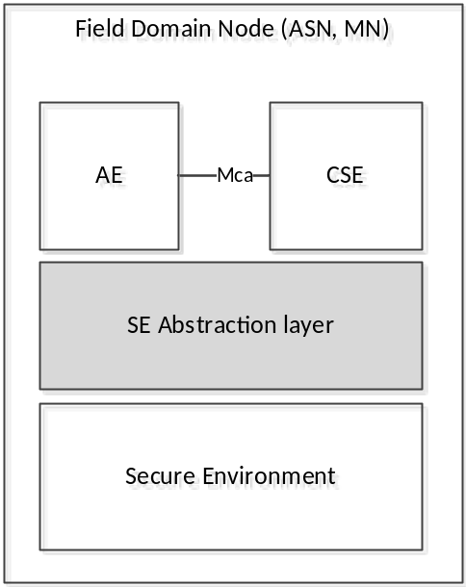
Figure 5.1-1: Secure Environment interworking on Field Domain Node

5.2 AE and CSE access security services within the SE
In this scenario, both the AE and the CSE reside within a Node as depicted in figure 5.2-1. The AE (or CSE) is split into a secure and a non secure part whereas the security relevant part AE_sec (respectively CSE_sec) resides within the SE and the corresponding non security relevant part AE_ (respectively CSE_) resides within the application space of the node. The AE_ (respectively CSE_ accesses AE_sec (respectively CSE_sec) via the Maa reference point. In addition the AE and the CSE can access security services offered by the SE via the Mcs reference point.
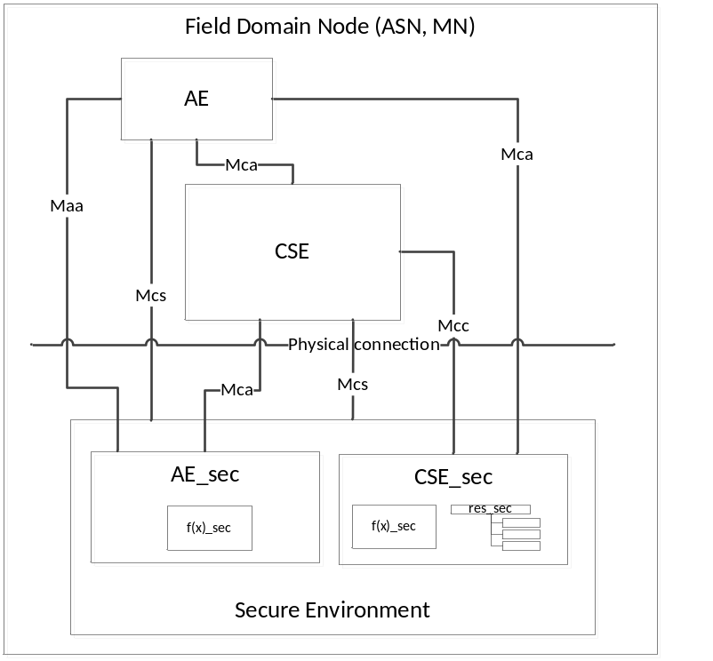
Figure 5.2-1: Secure Environment architecture of a Field Domain Node
The SE is integrated into the node as follows:
- Logically: the SE offers its sensitive functions f(x)_sec and its security resources res_sec to AEs and CSEs residing within the field domain node via the Mcs reference point. In addition the AE_sec or CSE_sec may offer corresponding services to the AE_ or CSE_ via a proprietary Maa reference point. AE_sec may also access the CSE via the Mca reference point.
- Physically: in case the SE is a dedicated hardware component, it has to be integrated into the node physically including low level drivers that enable logical access to the SE. The physical connection is superfluous in case the SE is implemented in software.

5.3 AE residing within the SE
In this scenario, the entire AE resides within the SE and utilizes security services provided by the SE. In addition the CSE may access the SE for dedicated security services via the Mcs reference point as depicted in figure 5.3-1. The AE may additionally access CSE resources via the Mca reference point.
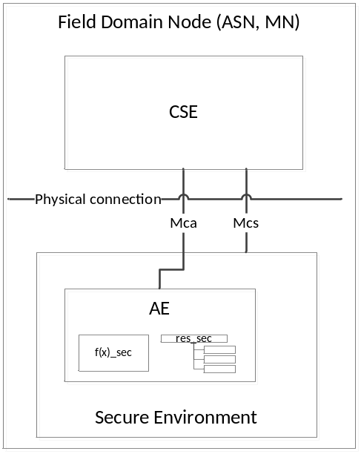
Figure 5.3-1: Secure Environment architecture in a Field Domain Node
The SE is integrated into the node as follows:
- Logically: the SE offers sensitive functions f(x)_sec and security resources res_sec to CSEs residing within the field domain node via the Mcs reference point. The AE is integrated within the SE such that it uses SE internal interfaces and methods.
- Physically: in case the SE is a dedicated hardware component, it has to be integrated into the field domain node physically including low level drivers that enable logical access to the SE. The physical connection is superfluous in case the SE is implemented in software.

6 Secure Environments

6.1 Secure Environments capabilities
A Secure Environment is an abstraction of a secure area within a computing system that provides a defined level of protection for code and data at rest, i.e. in storage, and in use, i.e. during process execution or data manipulation. A Secure Environment shall provide an authenticated entity (e.g. M2M Service Provider, M2M application provider or end user) with exclusive access to manage an isolated area of process space and memory within the host node that provides confidentiality and integrity of the contained instructions code and data during storage and process execution.
Each M2M node containing a CSE shall support instantiation of at least one SE by pre-provisioning, and may preferably support instantiation of SEs remotely on the field by means specified below. An SE shall be uniquely identifiable within a node and shall provide indication of the security level associated with the implementation it relies on.

6.2 Secure Environments security levels
According to TS-0003 [1], an SE can be implemented in different ways that can be associated with different security levels, according to the type of attacks they have been designed to provide protection against. For example, an SE can be implemented as an independent security engine, as an exclusive CPU/Memory mode on a general purpose chip, or as an enclave providing memory encryption and code/data execution isolation. Within the scope of this specification the following security levels and associated categories of implementation are distinguished:
- Security Level 3 (highest), able to provide tamper resistance against attackers that have physical access to the supporting hardware, e.g. having the ability to dismantle a device and implement sophisticated attacks such as playing with out-of-boundary operating conditions or perpetrating power analysis. This security level shall rely on a tamper resistant hardware SE implementation dedicated to security storage and processing (e.g. a GlobalPlatform eSE) and should be associated with application specific security assessment or certification process.
- Security Level 2 (medium), intended to provide strong protection against all kind of remote attacks but not targeting protection against attacks requiring physical control of the hardware. This security level shall rely at least on a hardware isolated SE implementation which may be integrated within the general purpose processing environment running the device software (e.g. a GlobalPlatform TEE [4]).
- Security Level 1 (low) which can be supported by pure software based SE implementations, providing confidence that the software design process followed best practice cybersecurity recommendations to provide reasonable resistance against software based attacks such as trojans or viruses.
When none of the above security levels can reasonably be claimed, Security Level 0 (no particular security attention) shall be indicated.

6.3 Tamper resistant hardware SE implementation
The following tamper resistant hardware SE implementations are considered within the current release of the specification:
- Implementation as Secure Elements in different form factors including
  - UICC according to [3]. In this case, multiple SE may be supported by means of multiple UICC ADFs (Application Directory File) and remotely managed accordingly, see ETSI TS 102 221 [3].
  - other variants of it such as eSE according to GlobalPlatform Card Specification [5]. In this case, multiple SE may be implemented as multiple GlobalPlatform Security Domains and remotely managed accordingly.
As outlined in TR-0008 [i.2], such implementations are recommended as countermeasures against key discovery and device cloning for devices that are physically exposed to potential attackers.

6.4 Hardware isolated SE implementation
The following hardware isolated SE implementations are considered within the current release of the specification:
- Trusted Execution Environment according to GlobalPlatform [4]. In this case, multiple SE may be implemented as multiple GlobalPlatform Security Domains and remotely managed accordingly.
According to the security analysis in TR-0008 [i.2], such implementations are appropriate for devices likely to be the target of remote attacks, without being physically accessible to attackers.

6.5 Software based SE implementation
An SE as defined in [1] provides security services to applications and guarantee process isolation. In addition to hardware based solutions this can also be provided by dedicated software implementations such as White Box Cryptography. Such implementations are only appropriate when the value or lifetime of the protected asset is limited and the risks of compromission are otherwise mitigated.

7 Logical Abstraction – McsReference point

7.1 Overview
The Mcs reference point shall enable applications and service layer entities which are outside of Secure Environments to make use of sensitive functions, sensitive data and applications residing within the Secure Environment, independently of the technical implementation of the Secure Environment, via a logical abstract interface. The logical abstraction interface is between the physical or logical Secure Environments and any external service layer entities and applications. The logical abstraction interface shall provide access to the sensitive functions, sensitive data and applications residing within the Secure Environments regardless of their number and Secure Environment architecture scenarios.

7.2 Mcs reference point

7.2.1 Secure Environment Identifier (M2M-SE-ID)
M2M nodes may contain multiple Secure Environments each associated with a corresponding Secure Environment Identifier (M2M-SE-ID). Each SE contains several M2M Security Services, i.e. sensitive functions execution environment and associated sensitive data storage area for code and data. An M2M-SE-ID is assigned to each Secure Environment.
Table 7.2.1-1: Secure Environment Identifier
Identifier | Assigned by | Assigned to | Assigned during | Lifetime | Uniqueness | Used during
M2M Secure Environment Identifier | M2M SE issuer or delegated stakeholder | Secure Environment | Pre- or remote Provisioning or during manufacturing | Lifetime of the contract with the stakeholder to whom the SE is assigned . | Global per SE and per type of SE | communication establishment with and selection of SE;

M2M-SE-ID is structured as follows:
Type of SE followed by unique ID, where type of SE is defined as given in table 7.1.1-2 and the unique ID is defined as described in Table 7.1.1-1.
Table 7.2.1-2: Type of Secure Environment
Class of SE | Type of Secure Environment | Coding
Independent hardware | UICC as per ETSI | 1
Independent hardware | GlobalPlatform Secure Element | 2
Integrated hardware | TEE as per GlobalPlatform | 3
Software | Security Library | 4

NOTE: Other values are RFU.

7.3 Resource SE

7.3.0 Overview
An <SE> resource shall represent information about a Secure Environment available in a node. There could be multiple <SE> resources in one node.
One Secure Environment may be represented in the <CSEbase> resource and multiple <AE> resources of that node. Concurrent accesses to the Secure Environment are resolved in the SE abstraction layer.
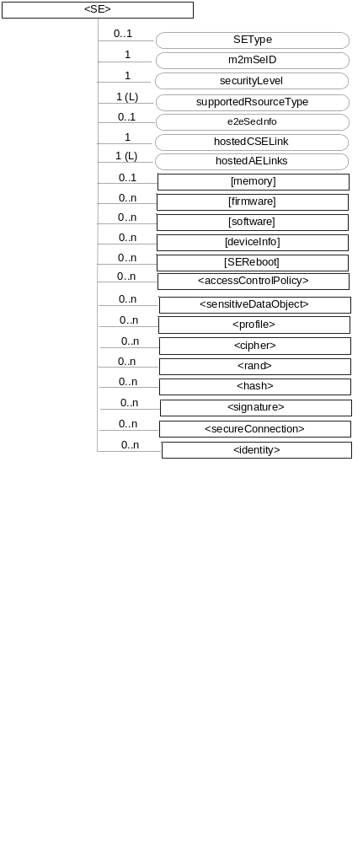
Figure 7.3.0-1: Structure of <SE> resource
The <SE> resource shall contain the child resources specified in table 7.3.0-1.
Table 7.3.0-1: Child resources of <SE> resource
Child Resources of <SE> | Child Resource Type | Multiplicity | Description
memory | <mgmtObj> as defined in the specialization [memory] | 0..1 | This resource provides the non volatile memory information of the Secure Environment. See clause D.4. of [2]
firmware | <mgmtObj> as defined in the specialization [firmware] | 0..n | This resource describes the information about the firmware of the Secure Environment include name, version etc. See clause D.2 of [2].
software | <mgmtObj> as defined in the specialization [software] | 0..n | This resource describes the information about the software of the Secure Environment. See clause D.3 of [2].
deviceInfo | <mgmtObj> as defined in the specialization [deviceInfo] | 0..n | The resource contains information about the Secure Environment, like identity, manufacturer and model number, if applicable. See clause D.8 of [2].
SEReboot | <mgmtObj> as defined in the specialization [SEReboot] | 0..n | The resource is the place to reboot the Secure Environment, if it is a rebootable hardware. In the case of secure elements there would be two resources, one for a cold reset and one for a warm reset of the secure element, defined in ISO/IEC 7816-3 [7].
accessControlPolicy | <accessControlPolicy> | 0..n | The Access Control Policies (ACPs) shall be used by the SE to control access to the resources
sensitiveDataObject | <sensitiveDataObject> | 0..n | See clause 7.4.1
profile | <profile> | 0..n | See clause 7.4.3
cipher | <cipher> | 0..n | See clause 7.5.1
rand | <rand> | 0..n | See clause 7.5.2
hash | <hash> | 0..n | See clause 7.5.3
signature | <signature> | 0..n | See clause 7.5.4
secureConnection | <secureConnection> | 0..n | See clause 7.6.1
identity | <identity> | 0..n | See clause 7.7.1

The <SE> resource shall contain the attributes specified in table 7.3.0-2.
Table 7.3.0-2: Attributes of <SE> resource
Attributes of <SE> | Multiplicity | RW/  RO/  WO | Description
resourceType | 1 | RO | Defines the resource type.
resourceID | 1 | RO | Defines an identifier for the resource.  This attribute shall be provided by the creator. The creator shall assign a resourceID which is unique within its context.
resourceName | 1 | WO | This attribute is the name for the resource that is used for 'hierarchical addressing method' to represent the parent-child relationships of resources.
parentID | 1 | RO | This attribute is the resourceID of the parent of this resource.
creationTime | 1 | RO | Time/date of creation of the resource.
lastModifiedTime | 1 | RO | Last modification time/date of the resource.
accessControlPolicyIDs | 0..1 (L) | RW | Is used to control access to the resource.
SEType | 0..1 | RO | See table 7.2.1-2
m2mSeID | 1 | WO | See tables 7.2.1-1 and 7.2.1-2
securityLevel | 1 | WO | See clause 6.2
supportedResourceType | 1 (L) | RW | List of the resource types which are supported in the SE.
e2eSecInfo | 0..1 (L) | RW | Indicates the end-to-end security capabilities
hostedCSELink | 0..1 | RW | This attribute allows to find the <CSEBase> resource representing the CSE that is residing on the Secure Environment that is represented by this <se> resource. The attribute contains the resource ID of that <CSEBase> resource.
hostedAELinks | 0..1 (L) | RW | This attribute allows to find the AEs hosted by this Secure Environment. The attribute contains a list of resource identifiers of <AE> resources representing the AEs residing on the specific Secure Environment that is represented by the current <se> resource.

7.3.1 Resource SEReboot
The [SEReboot] resource shall be used to reboot a Secure Environment. The [SEReboot] resource is a specialization of the <mgmtObj> resource.
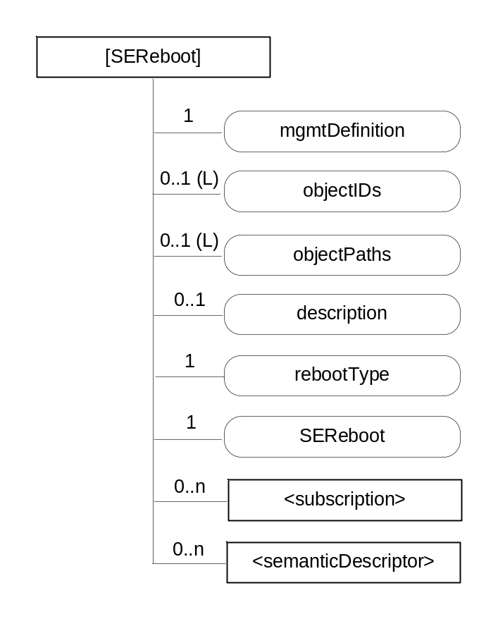
Figure 7.3.1-1: Structure of [SEReboot] resource
The [SEReboot] resource shall contain the child resources specified in table 7.3.1-1.
Table 7.3.1-1: Child resources of [SEReboot] resource
Child Resources of [SEReboot] | Child Resource Type | Multiplicity | Description
[variable] | <subscription> | 0..n | See clause 9.6.8 of [2] where the type of this resource is described.
[variable] | <semanticDescriptor> | 0..n | See clause 9.6.30 of [2]

The [SEReboot] resource shall contain the attributes specified in table 7.3.1-2.
Table 7.3.1-2: Attributes of [SEReboot] resource
Attributes of  [seReboot] | Multiplicity | RW/  RO/  WO | Description
resourceType | 1 | RO | See clause 9.6.1.3 of [2].
resourceID | 1 | RO | See clause 9.6.1.3 of [2].
resourceName | 1 | WO | See clause 9.6.1.3 of [2].
parentID | 1 | RO | See clause 9.6.1.3 of [2].
expirationTime | 1 | RW | See clause 9.6.1.3 of [2].
accessControlPolicyIDs | 0..1 (L) | RW | See clause 9.6.1.3 of [2].
creationTime | 1 | RO | See clause 9.6.1.3 of [2].
lastModifiedTime | 1 | RO | See clause 9.6.1.3 of [2].
Labels | 0..1(L) | RW | See clause 9.6.1.3 of [2].
mgmtDefinition | 1 | WO | See clause 9.6.15 of [2]. This attribute shall have the fixed value "seReboot".
objectIDs | 0..1 (L) | WO | See clause 9.6.15 of [2].
objectPaths | 0..1 (L) | WO | See clause 9.6.15 of [2].
Description | 0..1 | RW | See clause 9.6.15 of [2].
rebootType | 1 | RO | The type of reboot supported by the Secure Environment. This attribute is a specialization of [objectAttribute] attribute. Type of reboots could be such as Cold Reset or Warm Reset as defined in ISO/IEC 7816-3 [7].
SEReboot | 1 | RW | The action that allows rebooting the device. The action is triggered by assigning value "TRUE" to this attribute. This attribute is a specialization of [objectAttribute] attribute.

7.4 Sensitive Data Storage

7.4.1 <sensitiveDataObject> resource
Secure Environments shall provide a service to store and protect sensitive data. Sensitive data objects are represented as SE-resources and are created and managed within the Secure Environment. Requests to SE-resources are using absolute addressing. A <sensitiveDataObject> resource shall represent sensitive data and related information owned by a creator as shown in figure 7.4-1.

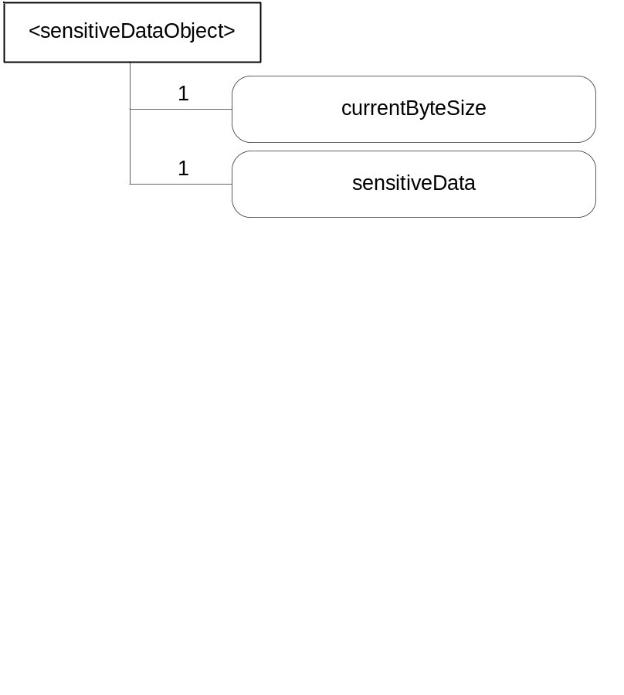
Figure 7.6-1: <sensitiveDataObject>representation

Attributes in <sensitiveDataObject> are shown in table 7.4-1.
Table 7.4-1: Attributes of <sensitiveDataObject> resource
Attributes of <sensitiveDataObject> | Multiplicity | RW/  RO/  WO | Description
resourceType | 1 | RO | Defines the resource type.
resourceID | 1 | RO | Defines an identifier for the resource.  This attribute shall be provided by the creator. The creator shall assign a resourceID which is unique within its context.
creationTime | 1 | RO | Time/date of creation of the resource.  The creationTime is set by the CSE hosting the SE when the resource is created.
lastModifiedTime | 1 | RO | Last modification time/date of the resource.  This attribute is mandatory. The lastModifiedTime value is set by the Hosting CSE when the resource is created,and the lastModifiedTime value is updated when the resource is updated.
Creator | 1 | RO | The AE-ID or CSE-ID of the AE or CSE creating the resource.
currentByteSize | 1 | RO | Current size in bytes of sensitive data.
sensitiveData | 1 | RW | Contains sensitive data and required information to access and manage sensitive data owned by a dedicated creator
accessControlPolicyID | 0..1 (L) | RW | Is used to control access to the resource. If no accessControlPolicyIDs value is configured, the accessControlPolicyIDs of the parent resource shall be applied for privilege checking.

7.4.2 <sensitiveDataObject> Resource Procedures

7.4.2.1 CREATE <sensitiveDataObject>
This procedure shall be used for creating a <sensitiveDataObject> resource.
Table 7.4.2.1-1: <sensitiveDataObject> CREATE
<sensitiveDataObject> CREATE request message parameters
Associated Reference Point | Mcs
Information in Request message | Following parameters shall exist within the Create request:  Operation  To: contains M2M-SE-ID  From Registree AE or CSE  Request Identifier  Content: <sensitveData>  Name: name of resource
Processing at Originator before sending Request | Establish security association between creator and SE  Requests from an AE or CSE includes their AE-ID or CSE-ID
Processing at Receiver | Check seAccessPrivileges and validate request
Information in Response message | Response status codes: ack;  successful operation = CREATE;  Unsuccessful Operation = C;  Request Identifier
Processing at Originator after receiving Response | n/a
Exceptions | According to [2]

7.4.2.2 RETRIEVE <sensitiveDataObject>
This procedure shall be used for retrieving a <sensitiveDataObject> resource.
Table 7.4.2.2-1: <sensitiveDataObject> RETRIEVE
<sensitiveDataObject> RETRIEVE request message parameters
Associated Reference Point | Mcs
Information in Request message | Following parameters shall exist within the RETRIEVE request:  Operation  To: contains M2M-SE-ID  From Registree AE or CSE  Request Identifier
Processing at Originator before sending Request | Establish security association between creator and SE  Requests from an AE or CSE includes their AE-ID or CSE-ID
Processing at Receiver | Check seAccessPrivileges and validate request
Information in Response message | Response status codes: ack;  successful operation = RETRIEVE;  Unsuccessful Operation = R;  Request Identifier  Content = Sensitive Data
Processing at Originator after receiving Response | As defined in [2]
Exceptions | As defined in [2]

7.4.2.3 UPDATE <sensitiveDataObject>
This procedure shall be used for updating the attributes and actual data of a <sensitiveDataObject> resource.
Table 7.4.2.3-1: <sensitiveDataObject> UPDATE
<sensitiveDataObject> UPDATE request message parameters
Associated Reference Point | Mcs
Information in Request message | Following parameters shall exist within the UPDATE request:  Operation  To: contains M2M-SE-ID  From Registree AE or CSE  Request Identifier  Name  Content: sensitive data and / or attributes
Processing at Originator before sending Request | Establish security association between creator and SE  Requests from an AE or CSE includes their AE-ID or CSE-ID
Processing at Receiver | Check seAccessPrivileges and validate request
Information in Response message | Response status codes: ack;  successful operation = UPDATE;  Unsuccessful Operation = R;  Request Identifier
Processing at Originator after receiving Response | As defined in [2]
Exceptions | As defined in [2]

7.4.2.4 DELETE <sensitiveDataObject>
This procedure shall be used for deleting a <sensitiveDataObject> resource.
Table 7.4.2.4-1: <sensitiveDataObject> DELETE
<sensitiveDataObject> DELETE request message parameters
Associated Reference Point | Mcs
Information in Request message | Following parameters shall exist within the DELETE request:  Operation  To: contains M2M-SE-ID  From Registree AE or CSE  Request Identifier  Name
Processing at Originator before sending Request | Establish security association between creator and SE  Requests from an AE or CSE includes their AE-ID or CSE-ID
Processing at Receiver | Check seAccessPrivileges and validate request
Information in Response message | Response status codes: ack; successful operation = DELETE; Unsuccessful Operation = D;  Request Identifier
Processing at Originator after receiving Response | As defined in [2]
Exceptions | As defined in [2]

7.5 Sensitive Cryptographic Functions

7.5.1 <cipher> resource
Secure Environments shall provide a service for cryptographic operations. A <cipher> resource shall represent sensitive data and related information owned by a creator as shown in figure 7.5.1-1.
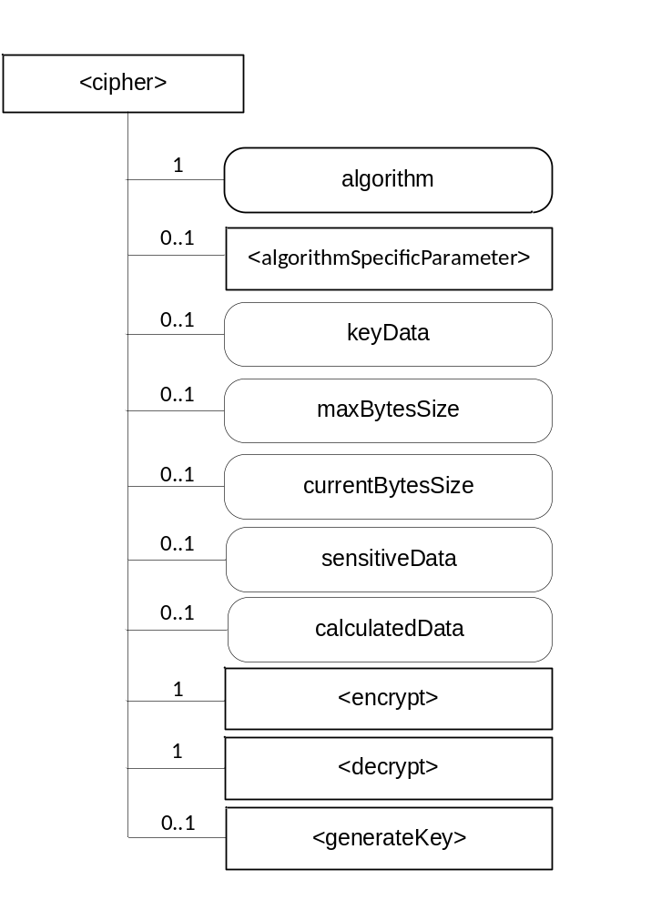
Figure 7.5.1-1: <cipher> representation
The <cipher> resource shall contain the child resources specified in table 7.5.1-1.
Table 7.5.1-1: Child resources of <cipher> resource
Child Resources of <cipher> | Child Resource Type | Multiplicity | Description
encrypt | <encrypt> | 1 | See clause 7.5.1.2
decrypt | <decrypt> | 1 | See clause 7.5.1.3
generateKey | <generateKey> | 0..1 | See clause 7.5.1.4
algorithmSpecificParameter | <algorithmSpecificParameter> | 0..1 | See clause 7.5.1.5

Attributes in <cipher> are shown in table 7.5.1-2.
Table 7.5-2: Attributes of <cipher> resource
Attributes of <signature> | Multiplicity | RW/  RO/  WO | Description
resourceType | 1 | RO | Defines the resource type.
resourceID | 1 | RO | Defines an identifier for the resource.  This attribute shall be provided by the creator. The creator shall assign a resourceID which is unique within its context.
resourceName | 1 | WO | This attribute is the name for the resource that is used for 'hierarchical addressing method' to represent the parent-child relationships of resources.
parentID | 1 | RO | This attribute is the resourceID of the parent of this resource.
expirationTime | 1 | RW | Time/date after which the resource will be deleted by the Hosting CSE.
accessControlPolicyIDs | 0..1 (L) | RW | Is used to control access to the resource. If no accessControlPolicyIDs are provided at the time of creation, the accessControlPolicyIDs of the parent resource is linked to this attribute
creationTime | 1 | RO | Time/date of creation of the resource.  The creationTime is set by the CSE hosting the SE when the resource is created.
lastModifiedTime | 1 | RO | Last modification time/date of the resource.  This attribute is mandatory. The lastModifiedTime value is set by the Hosting CSE when the resource is created,and the lastModifiedTime value is updated when the resource is updated.
message | 0..1 | RW | Message either to be signed or to be used to verify a signature, this could be alternatively a hash value
algorithm | 1 | WO | Contains the algorithm type of the resource instance
keyData | 0..1 | WO | Contains the value of the key
keyInformation | 0..1 | RW | Contains information about the key like a certificate
signature | 0..1 | RW | Contains the signature either to be calculated or to be verified
verificationResult | 0..1 | RO | Contains the result of a signature verification operation

The following types are defined for the algorithm attribute:
- ALG_AEAD_AES_128_GCM: The AEAD_AES_128_GCM authenticated encryption algorithm works as specified in RFC 5116 [8], using AES-128 as the block cipher, by providing the key, nonce, and plaintext, and associated data to that mode of operation.
- ALG_AEAD_AES_256_GCM: This algorithm is identical to AEAD_AES_128_GCM, but with the following differences: K_LEN is 32 octets, instead of 16 octets, and AES-256 GCM is used instead of AES-128 GCM.
- ALG_AEAD_AES_128_CCM: The AEAD_AES_128_CCM authenticated encryption algorithm works as specified in RFC5116 [8], using AES-128 as the block cipher, by providing the key, nonce, associated data, and plaintext to that mode of operation.
- ALG_AEAD_AES_256_CCM: This algorithm is identical to AEAD_AES_128_CCM, but with the following differences: K_LEN is 32 octets, instead of 16, and AES-256 CCM is used instead of AES-128 CCM.
- ALG_AEAD_AES_128_CCM_8: The AEAD_AES_128_CCM_8 authenticated encryption algorithm is identical to the AEAD_AES_128_CCM algorithm (see Section 5.3 of RFC 5116 [8]), except that it uses 8 octets for authentication, instead of the full 16 octets used by AEAD_AES_128_CCM (see Section 6.1 of RFC 6655 [9]).
- ALG_AEAD_AES_256_CCM_8: The AEAD_AES_256_CCM_8 authenticated encryption algorithm is identical to the AEAD_AES_256_CCM algorithm (see Section 5.4 of RFC 5116 [8]), except that it uses 8 octets for authentication, instead of the full 16 octets used by AEAD_AES_256_CCM (see Section 6.2 of [RFC 6655]).
- ALG_AES_BLOCK_128_CBC_NOPAD : Cipher algorithm ALG_AES_BLOCK_128_CBC_NOPAD provides a cipher using AES with block size 128 in CBC mode and does not pad input data.
- ALG_AES_CBC_ISO9797_M1: Cipher algorithm ALG_AES_CBC_ISO9797_M1 provides a cipher using AES with block size 128 in CBC mode, and pads input data according to the ISO 9797 [10] method 1 scheme.
- ALG_AES_CBC_ISO9797_M2: Cipher algorithm ALG_AES_CBC_ISO9797_M2 provides a cipher using AES with block size 128 in CBC mode, and pads input data according to the ISO 9797 [10] method 2 (ISO 7816-4, EMV'96) scheme.
- ALG_AES_CBC_PKCS5: Cipher algorithm ALG_AES_CBC_PKCS5 provides a cipher using AES with block size 128 in CBC mode, and pads input data according to the PKCS#5 scheme.

7.5.1.1 <cipher> Resource Procedures

7.5.1.1.1 CREATE <cipher>
This procedure shall be used for creating a <cipher> resource.
Table 7.5.1.1.1-1: <cipher> CREATE
<cipher> CREATE request message parameters
Associated Reference Point | Mcs
Information in Request message | All parameters defined in table 8.1.2-3 of [2] apply with the specific details for:  To: contains M2M-SE-ID or SE hosted AE-ID / CSE-ID  Content: The resource content shall provide the information as defined in clause 7.5.1.
Processing at Originator before sending Request | According to clause 10.1.1.1.of [2]
Processing at Receiver | According to clause 10.1.1.1.of [2]
Information in Response message | All parameters defined in table 8.1.3-1 of [2] apply with the specific details for:  Content: Address of the created <cipher> resource, according to clause 10.1.1.1.of [2]
Processing at Originator after receiving Response | According to clause 10.1.1.1. of [2]
Exceptions | According to clause 10.1.1.1. of [2]

If <generateKey> is created, the key to be used will be generated and stored in keyData.

7.5.1.1.2 RETRIEVE <cipher>
This procedure shall be used for retrieving the generated output from all/last input data of the <Cipher> resource.
Table 7.5.1.1.2-1: <cipher> RETRIEVE
<cipher> RETRIEVE request message parameters
Associated Reference Point | Mcs
Information in Request message | According to clause 10.1.2. of [2] with the specific details for:  To: contains M2M-SE-ID or SE hosted AE-ID / CSE-ID
Processing at Originator before sending Request | According to clause 10.1.2. of [2]
Processing at Receiver | According to clause 10.1.2. of [2]
Information in Response message | All parameters defined in table 8.1.3-1 of [2] apply with specific details for:  Content: Attributes of the <cipher> resources as defined in clause 7.5.1.
Processing at Originator after receiving Response | According to clause 10.1.2. of [2]
Exceptions | According to clause 10.1.2. of [2]

7.5.1.1.3 UPDATE <cipher>
This procedure shall be used for updating the <cipher> resource with data to encrypt or decrypt. It may be necessary to use this procedure several times until all data is transmitted.
Table 7.5.1.1.3-1: <cipher> UPDATE
<cipher> UPDATE request message parameters
Associated Reference Point | Mcs
Information in Request message | All parameters defined in table 8.1.2-3 of [2] apply with the specific details for:  To: contains M2M-SE-ID or SE-hosted AE-ID / CSE-ID  Content: attributes of the <cipher> resource as defined in clause 7.5.1 which need be updated
Processing at Originator before sending Request | According to clause 10.1.3. of [2]
Processing at Receiver | According to clause 10.1.3. of [2]
Information in Response message | According to clause 10.1.3. of [2]
Processing at Originator after receiving Response | According to clause 10.1.3. of [2]
Exceptions | According to clause 10.1.3. of [2]

7.5.1.1.4 DELETE <cipher>
This procedure shall be used for deleting a <cipher> resource.
Table 7.5.1.1.4-1: <cipher> DELETE
<cipher> DELETE request message parameters
Associated Reference Point | Mcs
Information in Request message | All parameters defined in table 8.1.2-3 of [2] apply with the specific details for:  To: contains M2M-SE-ID or SE hosted AE-ID / CSE-ID
Processing at Originator before sending Request | According to clause 10.1.4.1 of [2]
Processing at Receiver | According to clause 10.1.4.1 of [2]
Information in Response message | According to clause 10.1.4.1 of [2]
Processing at Originator after receiving Response | According to clause 10.1.4.1 of [2]
Exceptions | According to clause 10.1.4.1 of [2]

7.5.1.2 <encrypt> Resource
The <encrypt> resource is a virtual resource because it does not have a representation. It is the child resource of a <cipher> resource. When a RETRIEVE request addresses the <encrypt> resource, the sensitiveData of the <cipher> resource shall be encrypted and the result shall be stored in calculatedData.
The <encrypt> resource inherits access control policies that apply to the parent <cipher> resource.

7.5.1.3 <decrypt> Resource
The <decrypt> resource is a virtual resource because it does not have a representation. It is the child resource of a <cipher> resource. When a RETRIEVE request addresses the <decrypt> resource, the sensitiveData of the <cipher> resource shall be decrypted and the result shall be stored in calculatedData.
The <decrypt> resource inherits access control policies that apply to the parent <cipher> resource.

7.5.1.4 <generateKey> Resource
The <generateKey> resource is a virtual resource because it does not have a representation. When a RETRIEVE request addresses the <generateKey> resource, the keyData attribute shall be filled with a key generated according to the algorithm attribute.
The <generateKey> resource inherits access control policies that apply to the parent resource.

7.5.1.5 <algorithmSpecificParameter> Resource
The <algorithmSpecificParameter> contains parameter required for the different algorithm.
The <algorithmSpecificParameter> resource shall inherit the same access control policies of the parent <cipher> resource, and shall not have its own accessControlPolicyIDs attribute.
The <algorithmSpecificParameter> resource is shown in figure 7.5.1.5-1.
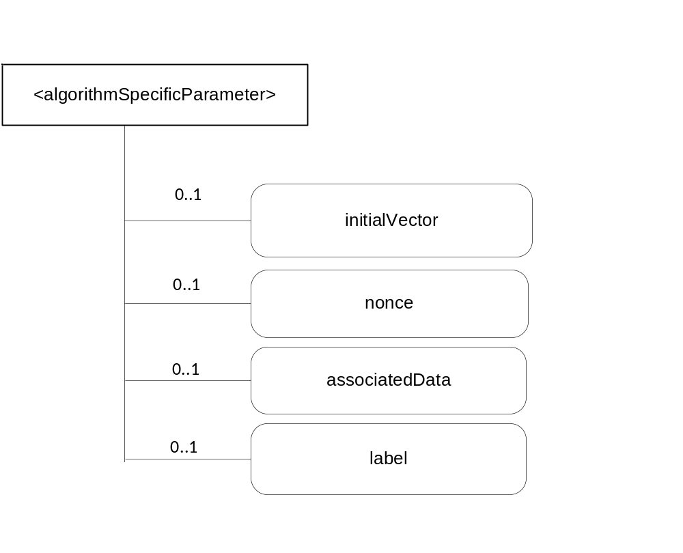
Figure 7.5.1.5-1: <algorithmSpecificParameter> representation
Attributes in <algorithmSpecificParameter> are shown in table 7.5.1.5-1.
Attributes of <algorithmSpecificParameter> | Multiplicity | RW/  RO/  WO | Description
resourceType | 1 | RO | Defines the resource type.
resourceID | 1 | RO | Defines an identifier for the resource.  This attribute shall be provided by the creator. The creator shall assign a resourceID which is unique within its context.
resourceName | 1 | WO | This attribute is the name for the resource that is used for 'hierarchical addressing method' to represent the parent-child relationships of resources.
parentID | 1 | RO | This attribute is the resourceID of the parent of this resource.
expirationTime | 1 | RW | Time/date after which the resource will be deleted by the Hosting CSE.
accessControlPolicyIDs | 0..1 (L) | RW | Is used to control access to the resource. If no accessControlPolicyIDs are provided at the time of creation, the accessControlPolicyIDs of the parent resource is linked to this attribute
creationTime | 1 | RO | Time/date of creation of the resource.  The creationTime is set by the CSE hosting the SE when the resource is created.
lastModifiedTime | 1 | RO | Last modification time/date of the resource.  This attribute is mandatory. The lastModifiedTime value is set by the Hosting CSE when the resource is created,and the lastModifiedTime value is updated when the resource is updated.
initialVector | 0..1 | RW | AES algorithms, except for ALG_AES_CMAC_128, in CBC mode expect a 16-byte parameter value for the initialization vector (IV).
Nonce | 0..1 | RW | a value for the nonce as expected by AEAD algorithm
associatedData | 0..1 | RW | The associated data for AEAD algorithm, which contains the data to be authenticated, but not encrypted.
Label | 0..1 | RW | "EXPORTER-oneM2M-Bootstrap" for TLS Key Export for Enrolment Key.  "EXPORTER-oneM2M-Connection" for TLS Key Export for M2M Secure Connection Key.
Table 7.5.1.5-1: Attributes of <algorithmSpecificParameter> resource

7.5.2 <rand> resource
A <rand> resource shall represent random data owned by a creator as shown in figure 7.5.2-1.

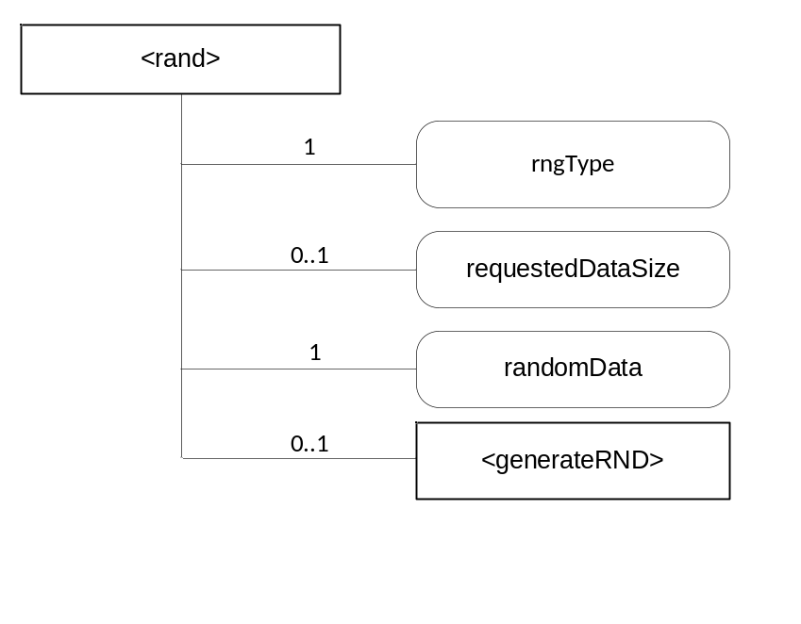
Figure 7.5.2-1: <rand> representation

The <rand> resource shall contain the child resources specified in table 7.5.2-1.
Table 7.5.2-1: Child resources of <rand> resource
Child Resources of <rand> | Child Resource Type | Multiplicity | Description | <randAnnc> Child Resource Types
generateRand | <generateRand> | 1 | See clause 7.5.2.2 | None

Attributes in <rand> are shown in table 7.5.2-2.
Table 7.5.2-2: Attributes of <rand> resource
Attributes of <rand> | Multiplicity | RW/  RO/  WO | Description
resourceType | 1 | RO | Defines the resource type.
resourceID | 1 | RO | Defines an identifier for the resource.  This attribute shall be provided by the creator. The creator shall assign a resourceID which is unique within its context.
resourceName | 1 | WO | This attribute is the name for the resource that is used for 'hierarchical addressing method' to represent the parent-child relationships of resources.
parentID | 1 | RO | This attribute is the resourceID of the parent of this resource.
expirationTime | 1 | RW | Time/date after which the resource will be deleted by the Hosting CSE.
accessControlPolicyIDs | 0..1 (L) | RW | Is used to control access to the resource. If no accessControlPolicyIDs are provided at the time of creation, the accessControlPolicyIDs of the parent resource is linked to this attribute
creationTime | 1 | RO | Time/date of creation of the resource.  The creationTime is set by the CSE hosting the SE when the resource is created.
lastModifiedTime | 1 | RO | Last modification time/date of the resource.  This attribute is mandatory. The lastModifiedTime value is set by the Hosting CSE when the resource is created,and the lastModifiedTime value is updated when the resource is updated.
randomData | 0..1 | RO | Contains random data which can be retrieved by the creator
rngType | 1 | WO | The following types of RNGs can be requested according to ISO/IEC 18031 [13]: pseudo RNG, physical RNG, Hybrid RNG
requestedDataSize | 0..1 | RW | Requested amount of randomData in Bytes
Editor’s note: Search for a more appropriate reference for the definition of RNG types

7.5.2.1 <rand> Resource Procedures

7.5.2.1.1 CREATE <rand>
This procedure shall be used for creating a <rand> resource.
Table 7.5.2.1.1-1: <rand> CREATE
<rand> CREATE request message parameters
Associated Reference Point | Mcs
Information in Request message | All parameters defined in table 8.1.2-3 of [2] apply with the specific details for:  To: contains M2M-SE-ID or SE hosted AE-ID or CSE-ID  Content: The resource content shall provide the information as defined in clause 7.5.2.
Processing at Originator before sending Request | According to clause 10.1.1.1.of [2]
Processing at Receiver | According to clause 10.1.1.1.of [2]
Information in Response message | All parameters defined in table 8.1.3-1 of [2] apply with the specific details for:  Content: Address of the created <cipher> resource, according to clause 10.1.1.1.of [2]
Processing at Originator after receiving Response | According to clause 10.1.1.1. of [2]
Exceptions | According to to clause 10.1.1.1. of [2]

7.5.2.1.2 RETRIEVE <rand>
This procedure shall be used for retrieving the random numbers.
Table 7.5.2.1.2-1: <rand> RETRIEVE
<rand> RETRIEVE request message parameters
Associated Reference Point | Mcs
Information in Request message | According to clause 10.1.2. of [2] with the specific details for  To: contains M2M-SE-ID or SE hosted AE-ID or CSE-ID
Processing at Originator before sending Request | According to clause 10.1.2. of [2]
Processing at Receiver | According to clause 10.1.2. of [2]
Information in Response message | All parameters defined in table 8.1.3-1 of [2] apply with specific details for:  Content: Attributes of the <rand> resources as defined in clause 7.5.2
Processing at Originator after receiving Response | According to clause 10.1.2. of [2]
Exceptions | According to clause 10.1.2. of [2]

7.5.2.1.3 UPDATE <rand>
This procedure shall be used for setting the amount of random data which is requested.
Table 7.5.2.1.3-1: <rand> UPDATE
<rand> UPDATE request message parameters
Associated Reference Point | Mcs
Information in Request message | All parameters defined in table 8.1.2-3 of [2] apply with the specific details for:  To: contains M2M-SE-ID or SE hosted AE-ID or CSE-ID  Content: attributes of the <rand> resource as defined in clause 7.5.2 which need be updated
Processing at Originator before sending Request | According to clause 10.1.3. of [2]
Processing at Receiver | According to clause 10.1.3. of [2]
Information in Response message | According to clause 10.1.3. of [2]
Processing at Originator after receiving Response | According to clause 10.1.3. of [2]
Exceptions | According to clause 10.1.3. of [2]

7.5.2.1.4 DELETE <rand>
This procedure shall be used for deleting a <rand> resource.
Table 7.5.2.1.4-1: <rand> DELETE
<rand> DELETE request message parameters
Associated Reference Point | Mcs
Information in Request message | All parameters defined in table 8.1.2-3 of [2] apply with the specific details for:  To: contains M2M-SE-ID or SE hosted AE-ID or CSE-ID
Processing at Originator before sending Request | According to clause 10.1.4.1 of [2]
Processing at Receiver | According to clause 10.1.4.1 of [2]
Information in Response message | According to clause 10.1.4.1 of [2]
Processing at Originator after receiving Response | According to clause 10.1.4.1 of [2]
Exceptions | According to clause 10.1.4.1 of [2]

7.5.2.2 <generateRand> Resource
The <generateRand> resource is a virtual resource because it does not have a representation. When a RETRIEVE request addresses the <generateRand> resource, the randomData attribute shall be filled with random numbers from a random number generator according to the rngType attribute.
The <generateRand> resource inherits access control policies that apply to the parent resource.

7.5.3 <hash> resource
Secure Environments shall provide a service for calculating hashes. A <hash> resource shall represent sensitive data and related information owned by a creator as shown in figure 7.5.3-1.
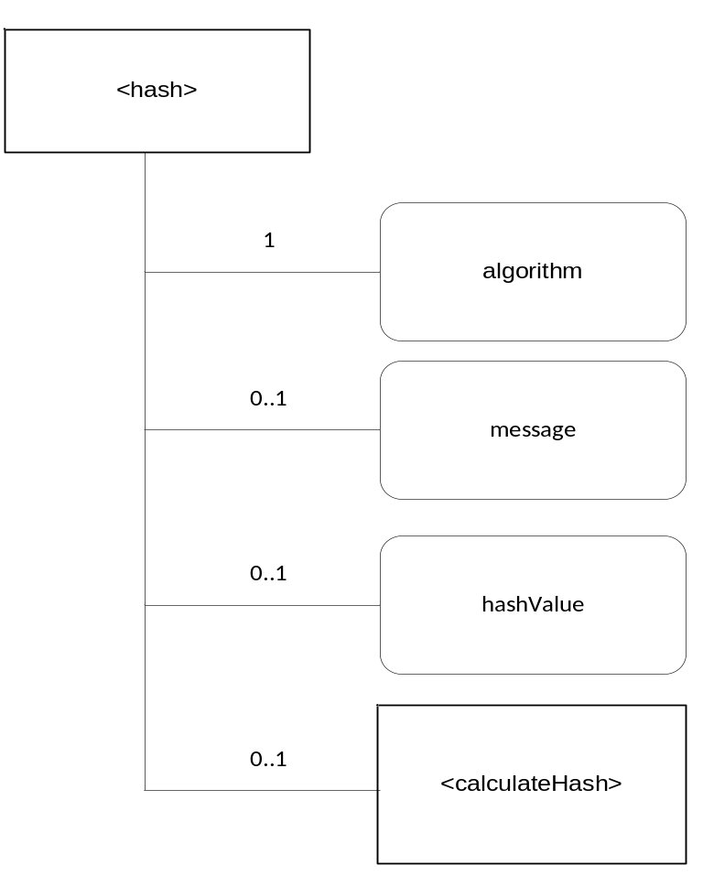
Figure 7.5.3-1: <hash> representation
The <hash> resource shall contain the child resources specified in table 7.5.1-1.
Table 7.5.3-1: Child resources of <hash> resource
Child Resources of <hash> | Child Resource Type | Multiplicity | Description | <hashAnnc> Child Resource Types
calculateHash | <calculateHash> | 1 | See clause 7.5.3.2 | None

Attributes in <hash> are shown in table 7.5.3-2.
Table 7.5.3-2: Attributes of <hash> resource
Attributes of <hash> | Multiplicity | RW/  RO/  WO | Description
resourceType | 1 | RO | Defines the resource type.
resourceID | 1 | RO | Defines an identifier for the resource.  This attribute shall be provided by the creator. The creator shall assign a resourceID which is unique within its context.
resourceName | 1 | WO | This attribute is the name for the resource that is used for 'hierarchical addressing method' to represent the parent-child relationships of resources.
parentID | 1 | RO | This attribute is the resourceID of the parent of this resource.
expirationTime | 1 | RW | Time/date after which the resource will be deleted by the Hosting CSE.
accessControlPolicyIDs | 0..1 (L) | RW | Is used to control access to the resource. If no accessControlPolicyIDs are provided at the time of creation, the accessControlPolicyIDs of the parent resource is linked to this attribute
creationTime | 1 | RO | Time/date of creation of the resource.  The creationTime is set by the CSE hosting the SE when the resource is created.
lastModifiedTime | 1 | RO | Last modification time/date of the resource.  This attribute is mandatory. The lastModifiedTime value is set by the Hosting CSE when the resource is created,and the lastModifiedTime value is updated when the resource is updated.
algorithm | 1 | WO | Specfies the algorithm for the hash
message | 0..1 | RW | The message which is to be hashed
hashValue | 0..1 | RO | Is the calculated Hash

The following types are defined as algorithm types: SHA256, SHA384, SHA512

7.5.3.1 <hash> Resource Procedures

7.5.3.1.1 CREATE <hash>
This procedure shall be used for creating a <hash> resource.
Table 7.5.3.1.1-1: <hash> CREATE
<hash> CREATE request message parameters
Associated Reference Point | Mcs
Information in Request message | All parameters defined in table 8.1.2-3 of [2] apply with the specific details for:  To: contains M2M-SE-ID or SE hosted AE-ID or CSE-ID  Content: The resource content shall provide the information as defined in clause 7.5.3.
Processing at Originator before sending Request | According to clause 10.1.1.1.of [2]
Processing at Receiver | According to clause 10.1.1.1.of [2]
Information in Response message | All parameters defined in table 8.1.3-1 of [2] apply with the specific details for:  Content: Address of the created <hash> resource, according to clause 10.1.1.1.of [2]
Processing at Originator after receiving Response | According to clause 10.1.1.1. of [2]
Exceptions | According to clause 10.1.1.1. of [2]

7.5.3.1.2 RETRIEVE <hash>
This procedure shall be used for retrieving the calculated hash.
Table 7.5.3.1.2-1: <hash> RETRIEVE
<hash> RETRIEVE request message parameters
Associated Reference Point | Mcs
Information in Request message | According to clause 10.1.2. of [2] with the specific details for:  To: contains M2M-SE-ID or SE hosted AE-ID or CSE-ID
Processing at Originator before sending Request | According to clause 10.1.2. of [2]
Processing at Receiver | According to clause 10.1.2. of [2]
Information in Response message | All parameters defined in table 8.1.3-1 of [2] apply with specific details for:  Content: Attributes of the <hash> resources as defined in clause 7.5.3
Processing at Originator after receiving Response | According to clause 10.1.2. of [2]
Exceptions | According to clause 10.1.2. of [2]

7.5.3.1.3 UPDATE <hash>
This procedure shall be used for updating the <hash> resource with data to be hashed.
Table 7.5.3.1.3-1: <hash> UPDATE
<hash> UPDATE request message parameters
Associated Reference Point | Mcs
Information in Request message | All parameters defined in table 8.1.2-3 of [2] apply with the specific details for:  To: contains M2M-SE-ID or SE hosted AE-ID or CSE-ID  Content = attributes of the <hash> resource as defined in clause 7.5.3 which need be updated
Processing at Originator before sending Request | According to clause 10.1.3. of [2]
Processing at Receiver | According to clause 10.1.3. of [2]
Information in Response message | According to clause 10.1.3. of [2]
Processing at Originator after receiving Response | According to clause 10.1.3. of [2]
Exceptions | According to clause 10.1.3. of [2]

7.5.3.1.4 DELETE <hash>
This procedure shall be used for deleting a <hash> resource.
Table 7.5.3.1.4-1: <hash> DELETE
<hash> DELETE request message parameters
Associated Reference Point | Mcs
Information in Request message | All parameters defined in table 8.1.2-3 of [2] apply with the specific details for:  To: contains M2M-SE-ID or SE hosted AE-ID or CSE-ID
Processing at Originator before sending Request | According to clause 10.1.4.1 of [2]
Processing at Receiver | According to clause 10.1.4.1 of [2]
Information in Response message | According to clause 10.1.4.1 of [2]
Processing at Originator after receiving Response | According to clause 10.1.4.1 of [2]
Exceptions | According to clause 10.1.4.1 of [2]

7.5.3.2 <calculateHash> Resource
The <calculateHash> resource is a virtual resource because it does not have a representation. When a RETRIEVE request addresses the <calculateHash> resource, the hashValue attribute shall be filled with the hash calculated over the data in the message attribute according to the algorithm attribute.
The <calculateHash> resource inherits access control policies that apply to the parent resource.

7.5.4 <signature> resource
Secure Environments shall provide a service for signing messages and verifying signatures. A <signature> resource shall represent sensitive data and related information owned by a creator as shown in figure 7.5.4-1.
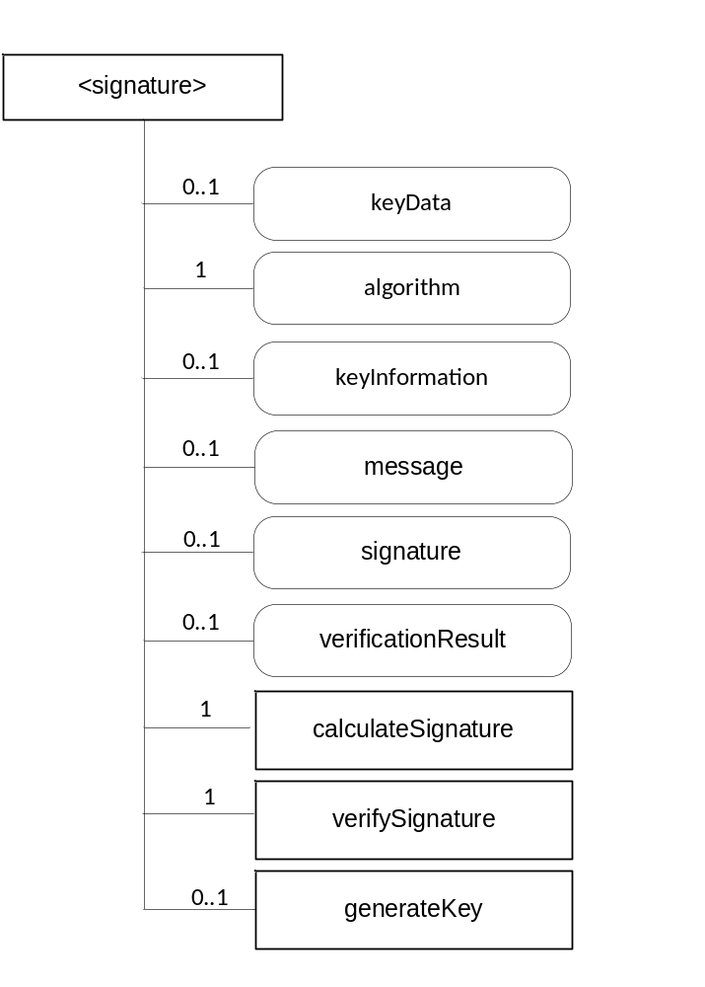
Figure 7.5.4-1: <signature> representation

The <signature> resource shall contain the child resources specified in table 7.5.4-1.
Table 7.5.4-1: Child resources of <signature> resource
Child Resources of <signature> | Child Resource Type | Multiplicity | Description | <signatureAnnc> Child Resource Types
calculateSignature | <calculateSignature> | 1 | See clause 7.5.4.2 | None
verifySignature | <verifySignature> | 1 | See clause 7.5.4.3 | None
generateKey | <generateKey> | 0..1 | See clause 7.5.4.4 | None

Attributes in <Signature> are shown in table 7.5.4-2.
Table 7.5.4-2: Attributes of <signature> resource
Attributes of <signature> | Multiplicity | RW/  RO/  WO | Description
resourceType | 1 | RO | Defines the resource type.
resourceID | 1 | RO | Defines an identifier for the resource.  This attribute shall be provided by the creator. The creator shall assign a resourceID which is unique within its context.
resourceName | 1 | WO | This attribute is the name for the resource that is used for 'hierarchical addressing method' to represent the parent-child relationships of resources.
parentID | 1 | RO | This attribute is the resourceID of the parent of this resource.
expirationTime | 1 | RW | Time/date after which the resource will be deleted by the Hosting CSE.
accessControlPolicyIDs | 0..1 (L) | RW | Is used to control access to the resource. If no accessControlPolicyIDs are provided at the time of creation, the accessControlPolicyIDs of the parent resource is linked to this attribute
creationTime | 1 | RO | Time/date of creation of the resource.  The creationTime is set by the CSE hosting the SE when the resource is created.
lastModifiedTime | 1 | RO | Last modification time/date of the resource.  This attribute is mandatory. The lastModifiedTime value is set by the Hosting CSE when the resource is created,and the lastModifiedTime value is updated when the resource is updated.
message | 0..1 | RW | Message either to be signed or to be used to verify a signature, this could be alternatively a hash value
algorithm | 1 | WO | Contains the algorithm type of the resource instance
keyData | 0..1 | WO | Contains the value of the key
keyInformation | 0..1 | RW | Contains information about the key like a certificate
signature | 0..1 | RW | Contains the signature either to be calculated or to be verified
verificationResult | 0..1 | RO | Contains the result of a signature verification operation

The following types are defined for the algorithm attribute:
ALG_AES_CMAC_128 : Signature algorithm ALG_AES_CMAC_128 generates a 16-byte Cipher-based MAC (CMAC) using AES with blocksize 128 in CBC mode with ISO9797_M2 padding scheme.
ALG_AES_MAC_128_NOPAD :Signature algorithm ALG_AES_MAC_128_NOPAD generates a 16-byte MAC using AES with blocksize 128 in CBC mode and does not pad input data.
ALG_ECDSA_SHA_256 :Signature algorithm ALG_ECDSA_SHA_256 generates a 32-byte SHA-256 digest and signs/verifies the digest using ECDSA with the curve defined in the ECKey parameters - such as the P-256 curve specified in the Digital Signature Standards specification NIST FIPS PUB 186-2 [11].
ALG_ECDSA_SHA_384 :Signature algorithm ALG_ECDSA_SHA_384 generates a 48-byte SHA-384 digest and signs/verifies the digest using ECDSA with the curve defined in the ECKey parameters - such as the P-384 curve specified in the Digital Signature Standards specification NIST FIPS PUB 186-2 [11].
ALG_ECDSA_SHA_512 :Signature algorithm ALG_ECDSA_SHA_512 generates a 64-byte SHA-512 digest and signs/verifies the digest using ECDSA with the curve defined in the ECKey parameters - such as the P-521 curve specified in the Digital Signature Standards specification NIST FIPS PUB 186-2 [11].
ALG_HMAC_SHA_256 :HMAC message authentication algorithm ALG_HMAC_SHA_256 This algorithm generates an HMAC following the steps found in RFC 2104 [12] using SHA-256 as the hashing algorithm.
ALG_HMAC_SHA_384 :HMAC message authentication algorithm ALG_HMAC_SHA_384 This algorithm generates an HMAC following the steps found in RFC 2104 [12] using SHA-384 as the hashing algorithm.
ALG_HMAC_SHA_512 :HMAC message authentication algorithm ALG_HMAC_SHA_512 This algorithm generates an HMAC following the steps found in RFC 2104 [12] using SHA-512 as the hashing algorithm.

7.5.4.1 <signature> Resource Procedures

7.5.4.1.1 CREATE <signature>
This procedure shall be used for creating a <signature> resource.
Table 7.5.4.1.1-1: <signature> CREATE
<Signature> CREATE request message parameters
Associated Reference Point | Mcs
Information in Request message | All parameters defined in table 8.1.2-3 of [2] apply with the specific details for:  To: contains M2M-SE-ID or SE hosted AE-ID or CSE-ID  Content: The resource content shall provide the information as defined in clause 7.5.1.
Processing at Originator before sending Request | According to clause 10.1.1.1.of [2]
Processing at Receiver | According to clause 10.1.1.1.of [2]
Information in Response message | All parameters defined in table 8.1.3-1 of [2] apply with the specific details for:  • Content: Address of the created <signature> resource, according to clause 10.1.1.1.of [2]
Processing at Originator after receiving Response | According to clause 10.1.1.1. of [2]
Exceptions | According to clause 10.1.1.1. of [2]

If <generateKey> is created, the key to be used shall be generated and stored in keyData, in such a case keyInformation shall be filled with the public part of the generated key.

7.5.4.1.2 RETRIEVE <signature>
This procedure shall be used for retrieving either the calculated signature of the <Signature> resource or the result of the verification of a signature.
Table 7.5.4.1.2-1: <signature> RETRIEVE
<signature> RETRIEVE request message parameters
Associated Reference Point | Mcs
Information in Request message | According to clause 10.1.2. of [2] with the specific details for:  To: contains M2M-SE-ID or SE hosted AE-ID or CSE-ID
Processing at Originator before sending Request | According to clause 10.1.2. of [2]
Processing at Receiver | According to clause 10.1.2. of [2]
Information in Response message | All parameters defined in table 8.1.3-1 of [2] apply with specific details for:  Content: Attributes of the <signature> resources as defined in clause 7.5.4.
Processing at Originator after receiving Response | According to clause 10.1.2. of [2]
Exceptions | According to clause 10.1.2. of [2]

7.5.4.1.3 UPDATE <signature>
This procedure shall be used for updating the <signature> resource with the message to be signed or to be verified and in the case of verification the signature to be verified.
Table 7.5.4.1.3-1: <signature> UPDATE
<signature> UPDATE request message parameters
Associated Reference Point | Mcs
Information in Request message | All parameters defined in table 8.1.2-3 of [2] apply with the specific details for:  To: contains M2M-SE-ID or SE hosted AE-ID or CSE-ID  Content: attributes of the <signature> resource as defined in clause 7.5.4 which need be updated
Processing at Originator before sending Request | According to clause 10.1.3. of [2]
Processing at Receiver | According to clause 10.1.3. of [2]
Information in Response message | According to clause 10.1.3. of [2]
Processing at Originator after receiving Response | According to clause 10.1.3. of [2]
Exceptions | According to clause 10.1.3. of [2]

7.5.4.1.4 DELETE <signature>
This procedure shall be used for deleting a <signature> resource.
Table 7.5.4.1.4-1: <signature> DELETE
<signature> DELETE request message parameters
Associated Reference Point | Mcs
Information in Request message | All parameters defined in table 8.1.2-3 of [2] apply with the specific details for:  To: contains M2M-SE-ID or SE hosted AE-ID or CSE-ID
Processing at Originator before sending Request | According to clause 10.1.4.1 of [2]
Processing at Receiver | According to clause 10.1.4.1 of [2]
Information in Response message | According to clause 10.1.4.1 of [2]
Processing at Originator after receiving Response | According to clause 10.1.4.1 of [2]
Exceptions | According to clause 10.1.4.1 of [2]

7.5.4.2 <calculateSignature> Resource
The <calculateSignature> resource is a virtual resource because it does not have a representation. It is the child resource of a <signature> resource. When a RETRIEVE request addresses the <calculateSignature> resource, the signature shall be calculated and written in the signature attribute of the <signature> resource.
The <calculateSignature> resource inherits access control policies that apply to the parent <signature> resource.

7.5.4.3 <verifySignature> Resource
The <verifySignature> resource is a virtual resource because it does not have a representation. It is the child resource of a <signature> resource. When a RETRIEVE request addresses the <verifySignature> resource, signature attribute of the <signature> resource shall be verified and the result shall be stored in verificationResult.
The <verifySignature> resource inherits access control policies that apply to the parent <cipher> resource.

7.5.4.4 <generateKey> Resource
The <generateKey> resource is a virtual resource because it does not have a representation. When a RETRIEVE request addresses the <generateKey> resource, the keyData attribute shall be filled with a key generated according the algorithm attrbute.
The <generateKey> resource inherits access control policies that apply to the parent resource.

7.6 Secure Connection Establishment

7.6.1 <secureConnection> resource
Secure Environments shall provide a service to AEs or CSEs to establish a secure connection to a dedicated communication partner. The <secureConnection> resource shall represent the services offered by the Secure Environment to enable the establishment of a secure connection to a communication partner. The services include the following:
- generation of key material within the secure environment that can be used for the establishment of a secure connection by the requesting entity (creator) outside of the secure environment
- acting as secure connection endpoint and sending the data provided by the requesting entity (creator) from within the secure environment with the key material generated and kept inside the secure environment
The <secureConnection> resource is shown in figure 7.6.1-1.

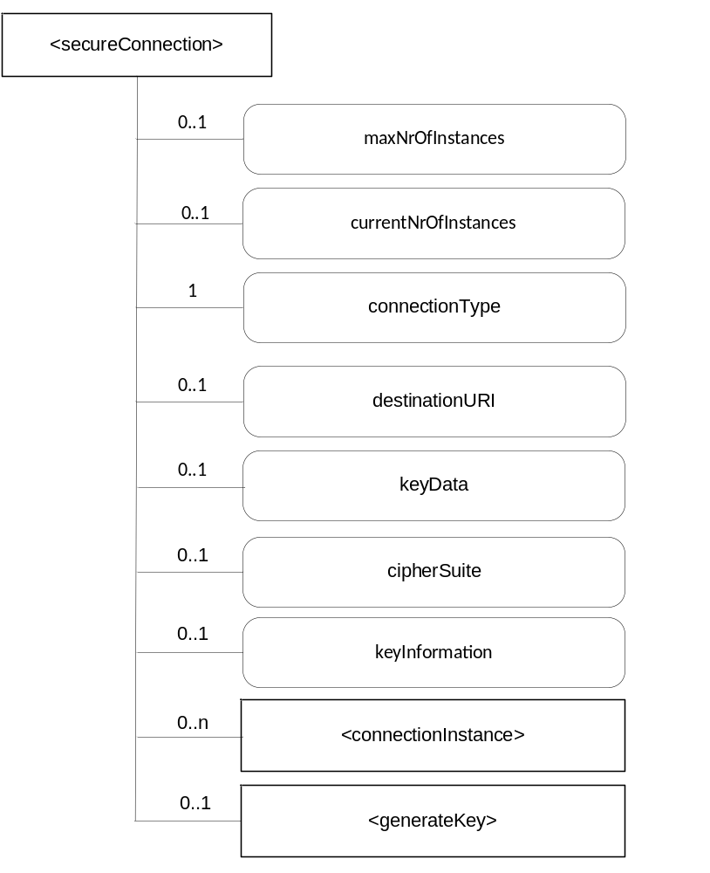
Figure 7.6.1-1: <secureConnection> representation

The <secureConnection> resource shall contain the child resources specified in table 7.6.1-1.
Table 7.6.1-1: Child resources of <secureConnection> resource
Child Resources of <secureConnection> | Child Resource Type | Multiplicity | Description
connectionInstance | <connectionInstance> | 0..n | See clause 7.6.3
generateKey | <generateKey> | 0..1 | See clause 7.6.7

Attributes in <secureConnection> are shown in table 7.6.1-2.
Attributes of <secureConnection> | Multiplicity | RW/  RO/  WO | Description
resourceType | 1 | RO | Defines the resource type.
resourceID | 1 | RO | Defines an identifier for the resource.  This attribute shall be provided by the creator. The creator shall assign a resourceID which is unique within its context.
resourceName | 1 | WO | This attribute is the name for the resource that is used for 'hierarchical addressing method' to represent the parent-child relationships of resources.
parentID | 1 | RO | This attribute is the resourceID of the parent of this resource.
expirationTime | 1 | RW | Time/date after which the resource will be deleted by the Hosting CSE.
accessControlPolicyIDs | 0..1 (L) | RW | Is used to control access to the resource. If no accessControlPolicyIDs are provided at the time of creation, the accessControlPolicyIDs of the parent resource is linked to this attribute
creationTime | 1 | RO | Time/date of creation of the resource.  The creationTime is set by the CSE hosting the SE when the resource is created.
lastModifiedTime | 1 | RO | Last modification time/date of the resource.  This attribute is mandatory. The lastModifiedTime value is set by the Hosting CSE when the resource is created,and the lastModifiedTime value is updated when the resource is updated.
maxNrOfInstances | 0..1 | RW | Maximum number of direct child <connectionInstance> resources in the <secureConnection> resource.
currentNrOfInstances | 0..1 | RO | Current number of direct child <connectionInstance> resource in the <secureConnection> resource. It is limited by the maxNrOfInstances.
connectionType | 1 | RW | Contains the type of connection that has to be supported.  Supported types are:  TLS; DTLS; SMS; E2EKey
keyData | 0..1 | WO | Contains the key material
keyInformation | 0..1 | RW | Specifies the additional information required for the key and the ciphersuite, e.g. Certificates, rootkeys, the public part of keyData
cipherSuite | 0..1 | RW | Specifies the ciphersuites that are supported.  Supported cipher suites are given in [1]
Table 7.6.1-2: Attributes of <secureConnection> resource

7.6.2 <secureConnection> Resource Procedures

7.6.2.1 CREATE <secureConnection>
This procedure shall be used for creating a <secureConnection> resource.
Table 7.6.2.1-1: <secureConnection> CREATE
<secure Connection> CREATE request message parameters
Associated Reference Point | Mcs
Information in Request message | All parameters defined in table 8.1.2-3 of [2] apply with the specific details for:  To: contains M2M-SE-ID or SE hosted AE-ID or CSE-ID  Content: The resource content shall provide the information as defined in clause 7.6.1.
Processing at Originator before sending Request | According to clause 10.1.1.1.of [2]
Processing at Receiver | According to clause 10.1.1.1.of [2]
Information in Response message | All parameters defined in table 8.1.3-1 of [2] apply with the specific details for:  Content: Address of the created <cipher> resource, according to clause 10.1.1.1.of [2]
Processing at Originator after receiving Response | According to clause 10.1.1.1. of [2]
Exceptions | According to clause 10.1.1.1. of [2]

If <generateKey> is created, the key to be used shall be generated and stored in keyData, in such a case keyInformation shall be filled with the public part of the generated key.

7.6.2.2 RETRIEVE <secureConnection>
This procedure shall be used for retrieving information about the <secureConnection> resource.

Table 7.6.2.2-1: <secureConnection> RETRIEVE
<secureConnection> RETRIEVE request message parameters
Associated Reference Point | Mcs
Information in Request message | According to clause 10.1.2. of [2] with the specific details for:  To: contains M2M-SE-ID or SE hosted AE-ID or CSE-ID
Processing at Originator before sending Request | According to clause 10.1.2. of [2]
Processing at Receiver | According to clause 10.1.2. of [2]
Information in Response message | All parameters defined in table 8.1.3-1 of [2] apply with specific details for:  Content: Attributes of the <secureConnection> resources as defined in clause 7.6.1.
Processing at Originator after receiving Response | According to clause 10.1.2. of [2]
Exceptions | According to clause 10.1.2. of [2]

7.6.2.3 UPDATE <secureConnection>
This procedure shall be used for sending payload data via an established secure connection.
Table 7.6.2.3-1: <secureConnection> UPDATE
<secureConnection> UPDATE request message parameters
Associated Reference Point | Mcs
Information in Request message | All parameters defined in table 8.1.2-3 of [2] apply with the specific details for:  To: contains M2M-SE-ID or SE hosted AE-ID or CSE-ID  Content: attributes of the <cipher> resource which is to be updated as defined in clause 7.5.1
Processing at Originator before sending Request | According to clause 10.1.3. of [2]
Processing at Receiver | According to clause 10.1.3. of [2]
Information in Response message | According to clause 10.1.3. of [2]
Processing at Originator after receiving Response | According to clause 10.1.3. of [2]
Exceptions | According to clause 10.1.3. of [2]

7.6.2.4 DELETE <secureConnection>
This procedure shall be used for deleting a <secureConnection> resource. Deleting a <secureConnection> resource shall close an established secure connection between the originator (creator) and the destination.
Table 7.6.2.4-1: <secureConnection> DELETE
<secureConnection> DELETE request message parameters
Associated Reference Point | Mcs
Information in Request message | All parameters defined in table 8.1.2-3 of [2] apply with the specific details for:  To: contains M2M-SE-ID or SE hosted AE-ID or CSE-ID
Processing at Originator before sending Request | According to clause 10.1.4.1 of [2]
Processing at Receiver | According to clause 10.1.4.1 of [2]
Information in Response message | According to clause 10.1.4.1 of [2]
Processing at Originator after receiving Response | According to clause 10.1.4.1 of [2]
Exceptions | According to clause 10.1.4.1 of [2]

7.6.3 <connectionInstance> resource
The <connectionInstance> resource represents a data instance in the <secureConnection> resource.
The <connectionInstance> resource inherits the same access control policies of the parent <secureConection> resource, and does not have its own accessControlPolicyIDs attribute.
The services shall include the following:
- generation of key material within the secure environment that can be used for the establishment of a secure connection by the requesting entity (creator) outside of the secure environment
- acting as secure connection endpoint and sending the data provided by the requesting entity (creator) from within the secure environment with the key material generated and kept inside the secure environment
The <connectionInstance> resource is shown in figure 7.6.3-1.

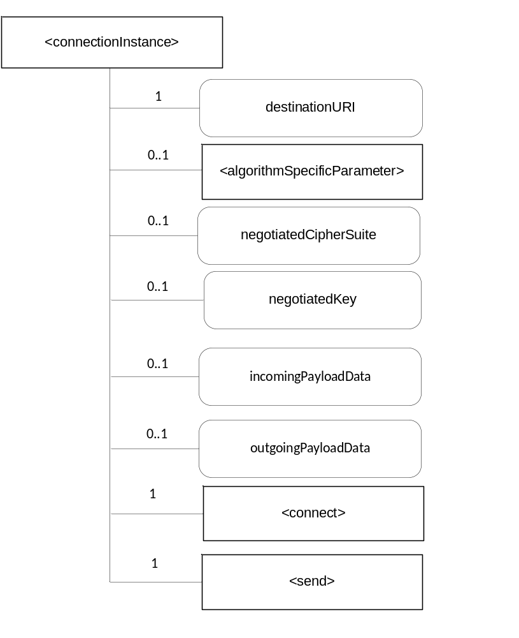
Figure 7.6.3-1: <connectionInstance> representation

The <connectionInstance> resource shall contain the child resources specified in table 7.6.3-1.
Table 7.6.3-1: Child resources of <connectionInstance> resource
Child Resources of <connectionInstance> | Child Resource Type | Multiplicity | Description
algorithmSpecificParameter | <algorithmSpecificParameter> | 0..1 | See clause 7.5.1.5
connect | <connect> | 1 | See clause 7.6.5
send | <send> | 1 | See clause 7.6.6

Attributes in <connectionInstance> are shown in table 7.6.3-2.
Attributes of <connectionInstance> | Multiplicity | RW/  RO/  WO | Description
resourceType | 1 | RO | Defines the resource type.
resourceID | 1 | RO | Defines an identifier for the resource.  This attribute shall be provided by the creator. The creator shall assign a resourceID which is unique within its context.
resourceName | 1 | WO | This attribute is the name for the resource that is used for 'hierarchical addressing method' to represent the parent-child relationships of resources.
parentID | 1 | RO | This attribute is the resourceID of the parent of this resource.
expirationTime | 1 | RW | Time/date after which the resource will be deleted by the Hosting CSE.
accessControlPolicyIDs | 0..1 (L) | RW | Is used to control access to the resource. If no accessControlPolicyIDs are provided at the time of creation, the accessControlPolicyIDs of the parent resource is linked to this attribute
creationTime | 1 | RO | Time/date of creation of the resource.  The creationTime is set by the CSE hosting the SE when the resource is created.
lastModifiedTime | 1 | RO | Last modification time/date of the resource.  This attribute is mandatory. The lastModifiedTime value is set by the Hosting CSE when the resource is created,and the lastModifiedTime value is updated when the resource is updated.
destinationURI | 1 | RW | Specifies the end point to which the secure connection shall be established
outgoingPayloadData | 0..1 | RW | Contains the data that has to be sent via the established secure connection
incomingPayloadData | 0..1 | RO | Contains the data that has to be sent via the established secure connection
negotiatedKey | 0..1 | RO | Contains the negotiated key e.g. the pairwiseE2EKey using TLS Exporter specification (RFC 5705 [6]).
negotiatedCipherSuite | 0..1 | RO | Is the cipher suite negotiated between the Secure Environment and the remote entity

Table 7.6.3-2: Attributes of <connectionInstance> resource

7.6.4 <connectionInstance> Resource Procedures

7.6.4.1 CREATE <connectionInstance>
This procedure shall be used for creating a <connectionInstance> resource.
Table 7.6.4.1-1: <connectionInstance> CREATE
<connectionInstance> CREATE request message parameters
Associated Reference Point | Mcs
Information in Request message | All parameters defined in table 8.1.2-3 of [2] apply with the specific details for:  To: contains M2M-SE-ID or SE hosted AE-ID or CSE-ID  Content: The resource content shall provide the information as defined in clause 7.6.3.
Processing at Originator before sending Request | According to clause 10.1.1.1.of [2]
Processing at Receiver | According to clause 10.1.1.1.of [2]
Information in Response message | All parameters defined in table 8.1.3-1 of [2] apply with the specific details for:  • Content: Address of the created <connectionInstance> resource, according to clause 10.1.1.1.of [2]
Processing at Originator after receiving Response | According to clause 10.1.1.1. of [2]
Exceptions | According to clause 10.1.1.1. of [2]

7.6.4.2 RETRIEVE <connectionInstance>
This procedure shall be used for retrieving payload data from a communication partner or to retrieve the negotiated key.

Table 7.6.4.2-1: <connectionInstance> RETRIEVE
<connectionInstance> RETRIEVE request message parameters
Associated Reference Point | Mcs
Information in Request message | According to clause 10.1.2. of [2] with the specific details for:  To: contains M2M-SE-ID or SE hosted AE-ID or CSE-ID
Processing at Originator before sending Request | According to clause 10.1.2. of [2]
Processing at Receiver | According to clause 10.1.2. of [2]
Information in Response message | All parameters defined in table 8.1.3-1 of [2] apply with specific details for:  Content: Attributes of the <connectionInstance> resources as defined in clause 7.6.3.
Processing at Originator after receiving Response | According to clause 10.1.2. of [2]
Exceptions | According to clause 10.1.2. of [2]

7.6.4.3 UPDATE <connectionInstance>
This procedure shall be used for sending payload data via an established secure connection.
Table 7.6.4.3-1: <connectionInstance> UPDATE
<connectionInstance> UPDATE request message parameters
Associated Reference Point | Mcs
Information in Request message | All parameters defined in table 8.1.2-3 of [2] apply with the specific details for:  To: contains M2M-SE-ID or SE hosted M2M-AE-ID or CSE-ID  Content: attributes of the <connectionInstance> resource which is to be updated as defined in clause 7.6.3
Processing at Originator before sending Request | According to clause 10.1.3. of [2]
Processing at Receiver | According to clause 10.1.3. of [2]
Information in Response message | According to clause 10.1.3. of [2]
Processing at Originator after receiving Response | According to clause 10.1.3. of [2]
Exceptions | According to clause 10.1.3. of [2]

7.6.4.4 DELETE <connectionInstance>
This procedure shall be used for deleting a <connectionInstance> resource. Deleting a <connectionInstance> resource closes an established secure connection between the originator (creator) and the destination.
Table 7.6.4.4-1: <connectionInstance> DELETE
<connectionInstance> DELETE request message parameters
Associated Reference Point | Mcs
Information in Request message | All parameters defined in table 8.1.2-3 of [2] apply with the specific details for:  To: contains M2M-SE-ID or SE hosted AE-ID or CSE-ID
Processing at Originator before sending Request | According to clause 10.1.4.1 of [2]
Processing at Receiver | According to clause 10.1.4.1 of [2]
Information in Response message | According to clause 10.1.4.1 of [2]
Processing at Originator after receiving Response | According to clause 10.1.4.1 of [2]
Exceptions | According to clause 10.1.4.1 of [2]

7.6.5 <connect> Resource
The <connect> resource is a virtual resource because it does not have a representation. When a RETRIEVE request addresses the <connect> resource, a connection shall be established to the destination URI. If <negotiatedKey> exists the negotiated key shall be stored in this attribute.
The <connect> resource inherits access control policies that apply to the parent resource.

7.6.6 <send> Resource
The <send> resource is a virtual resource because it does not have a representation. When a RETRIEVE request addresses the <send> resource, the value of outgoingPayloadData shall be sent to the destination URI.
The <send> resource inherits access control policies that apply to the parent resource.

7.6.7 <generateKey> Resource
The <generateKey> resource is a virtual resource because it does not have a representation. When a RETRIEVE request addresses the <generateKey> resource, the keyData attribute shall be filled with a key generated according the algorithm attrbute.
The <generateKey> resource inherits access control policies that apply to the parent resource.

7.7 Authentication and Identification

7.7.1 <identity> resource
Secure Environments shall provide a service to AEs or CSEs to establish an Identity and provide authentication of this Identity. The <identity> resource shall represent the services offered by the Secure Environment to enable the establishment of a secure Identity. The services include the following:
- generation of an Identity and associated key material within the secure environment
- using the associated key material for authenticating the generated Identity
The <identity> resource is shown in figure 7.7.1-1.

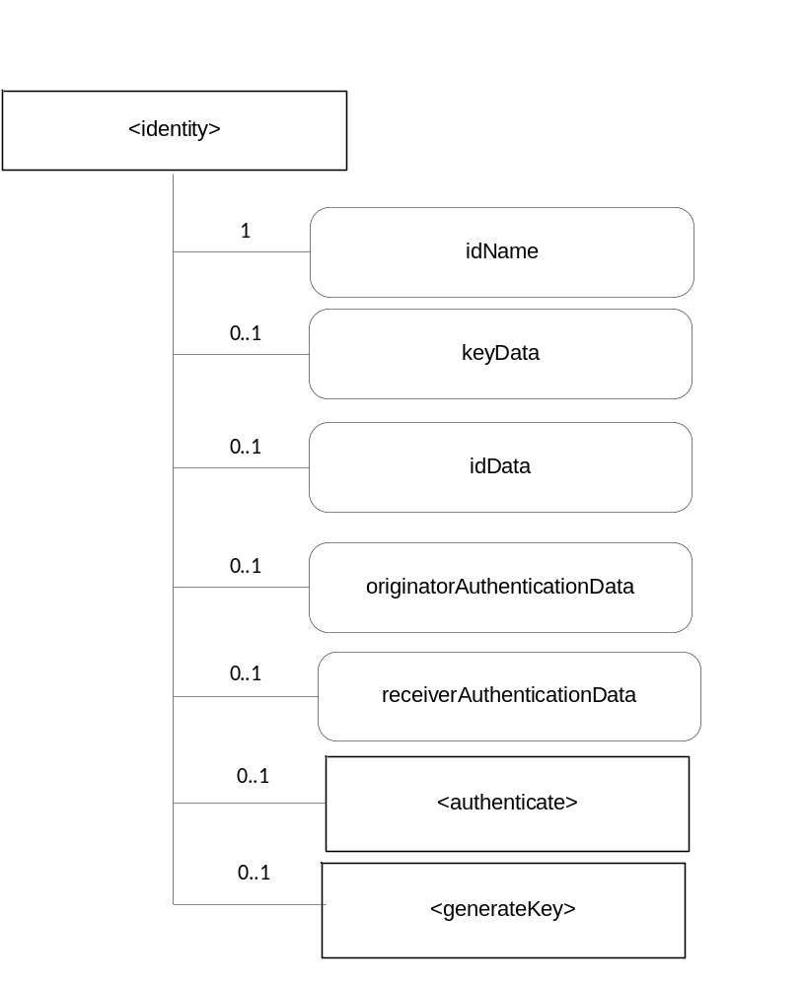
Figure 7.7.1-1: <identity> representation

The <identity> resource shall contain the child resources specified in table 7.7-1.
Table 7.7.1-1: Child resources of <identity> resource
Child Resources of <identity> | Child Resource Type | Multiplicity | Description
authenticate | <authenticate> | 0..1 | See clause 7.7.3
generateKey | <generateKey> | 0..1 | See clause 7.7.4

Attributes in <Identity> are shown in table 7.7-2.
Table 7.7.1-2: Attributes of <identity> resource
Attributes of <identity> | Multiplicity | RW/  RO/  WO | Description
resourceType | 1 | RO | Defines the resource type.
resourceID | 1 | RO | Defines an identifier for the resource.  This attribute shall be provided by the creator. The creator shall assign a resourceID which is unique within its context.
resourceName | 1 | WO | This attribute is the name for the resource that is used for 'hierarchical addressing method' to represent the parent-child relationships of resources.
parentID | 1 | RO | This attribute is the resourceID of the parent of this resource.
expirationTime | 1 | RW | Time/date after which the resource will be deleted by the Hosting CSE.
accessControlPolicyIDs | 0..1 (L) | RW | Is used to control access to the resource. If no accessControlPolicyIDs are provided at the time of creation, the accessControlPolicyIDs of the parent resource is linked to this attribute
creationTime | 1 | RO | Time/date of creation of the resource.  The creationTime is set by the CSE hosting the SE when the resource is created.
lastModifiedTime | 1 | RO | Last modification time/date of the resource.  This attribute is mandatory. The lastModifiedTime value is set by the Hosting CSE when the resource is created,and the lastModifiedTime value is updated when the resource is updated.
idName | 1 | WO | Contains the name of the identity
keyData | 0..1 | WO | Contains the value of a key
idData | 0..1 | RW | Contains information associated to the identity and which is necessary for the authentication protocol.  The detailed structure depends on the authentication protocol and could comprise among others public key material, protocol identifier, certificates
originatorAuthenticationData | 0..1 | RW | Contains information provided by the Originator and which is necessary for the authentication protocol.  The detailed structure depends on the authentication protocol and could comprise among others nonces, certificates, signatures
receiverAuthenticationData | 0..1 | RO | Contains information provided by the Receiver and which is necessary for the authentication protocol.  The detailed structure depends on the authentication protocol and could comprise among others nonces, certificates, signatures

7.7.2 <identity> Resource Procedures

7.7.2.1 CREATE <identity>
This procedure shall be used for creating a <identity> resource.
Table 7.7.2.1-1: <identity> CREATE
<identity> CREATE request message parameters
Associated Reference Point | Mcs
Information in Request message | All parameters defined in table 8.1.2-3 of [2] apply with the specific details for:  To: contains M2M-SE-ID or SE hosted AE-ID or CSE-ID  Content: The resource content shall provide the information as defined in clause 7.7.1
Processing at Originator before sending Request | According to clause 10.1.1.1.of [2]
Processing at Receiver | According to clause 10.1.1.1.of [2]
Information in Response message | All parameters defined in table 8.1.3-1 of [2] apply with the specific details for:  Content: Address of the created <identity> resource, according to clause 10.1.1.1.of [2]
Processing at Originator after receiving Response | According to clause 10.1.1.1. of [2]
Exceptions | According to clause 10.1.1.1. of [2]

If <generateKey> is created, the key to be used shall be generated and stored in keyData, in such a case keyInformation shall be filled with the public part of the generated key.

7.7.2.2 RETRIEVE <identity>
This procedure shall be used for retrieving the identity and retrieve authentication data according the used authentication protocol.

Table 7.7.2.2-1: <identity> RETRIEVE
<identity> RETRIEVE request message parameters
Associated Reference Point | Mcs
Information in Request message | According to clause 10.1.2. of [2] with the specific details for:  To: contains M2M-SE-ID or SE hosted AE-ID or CSE-ID
Processing at Originator before sending Request | According to clause 10.1.2. of [2]
Processing at Receiver | According to clause 10.1.2. of [2]
Information in Response message | All parameters defined in table 8.1.3-1 of [2] apply with specific details for:  Content: Attributes of the <identity> resources as defined in clause 7.7.1.
Processing at Originator after receiving Response | According to clause 10.1.2. of [2]
Exceptions | According to clause 10.1.2. of [2]

7.7.2.3 UPDATE <identity>
This procedure shall be used for updating the <identity resource> and sending authentication data according the used authentication protocol.
Table 7.7.2.3-1: <identity> UPDATE
<identity> UPDATE request message parameters
Associated Reference Point | Mcs
Information in Request message | All parameters defined in table 8.1.2-3 of [2] apply with the specific details for:  To: contains M2M-SE-ID or SE hosted AE-ID or CSE-ID  Content: attributes of the <cipher> resource which is to be updated as defined in clause 7.5.1
Processing at Originator before sending Request | According to clause 10.1.3. of [2]
Processing at Receiver | According to clause 10.1.3. of [2]
Information in Response message | According to clause 10.1.3. of [2]
Processing at Originator after receiving Response | According to clause 10.1.3. of [2]
Exceptions | According to clause 10.1.3. of [2]

7.7.2.4 DELETE <identity>
This procedure shall be used for deleting an <identity> resource.
Table 7.7.2.4-1: <identity> DELETE
<Identity> DELETE request message parameters
Associated Reference Point | Mcs
Information in Request message | All parameters defined in table 8.1.2-3 of [2] apply with the specific details for:  To: contains M2M-SE-ID or SE hosted AE-ID or CSE-ID
Processing at Originator before sending Request | According to clause 10.1.4.1 of [2]
Processing at Receiver | According to clause 10.1.4.1 of [2]
Information in Response message | According to clause 10.1.4.1 of [2]
Processing at Originator after receiving Response | According to clause 10.1.4.1 of [2]
Exceptions | According to clause 10.1.4.1 of [2]

7.7.3 <authenticate> Resource
The <authenticate> resource is a virtual resource because it does not have a representation. It is the child resource of an <identity> resource. When a RETRIEVE request addresses the <authenticate> resource, the originatorAuthenticationData, keyData and idData shall be used to calculate a value which shall be stored in retrieverAuthenticationData.
Depending on the authentication protocol it may be necessary to repeat the process of UPDATE originatorAuthenticationData , RETRIEVE <authenticate> and RETRIEVE retrieverAuthenticationData several times.
The <authenticate> resource inherits access control policies that apply to the parent <identity> resource.

7.7.4 <generateKey> Resource
The <generateKey> resource is a virtual resource because it does not have a representation. When a RETRIEVE request addresses the <generateKey> resource, the keyData attribute shall be filled with a key generated according the algorithm attrbute.
The <generateKey> resource inherits access control policies that apply to the parent resource.

8 Physical Interface
The present release does not specify how the Mcs reference point can be bound to physical interfaces used by specific Secure Environments. Organizations specifying technologies applicable for Secure Environments, such as GlobalPlatform, specify bindings that can be applicable.

9 Resource type definitions for the Mcs reference point

9.1 SEType
The following values are defined as per Table 7.2.1-2:
“1” UICC as per ETSI
“2” GlobalPlatform Secure Element
“3” TEE as per GlobalPlatform
“4” Software cryptographic library

9.2 securityLevel
The following values are defined as per clause 6.2:
“1” Low security
“2” Medium security
“3” High Security

9.3 rebootType
The following values are defined:
“1” Cold Reset as defined in ISO/IEC 7816-3
“2” Warm Reset as defined in ISO/IEC 7816-3

9.4 cipherLabel
The following values are defined:
“1” EXPORTER-oneM2M-Bootstrap
“2” EXPORTER-oneM2M-Connection

9.5 cipherAlgorithm
The below values are defined:
NOTE: Values for AEAD algorithms were taken from IANA with an offset of 1000. Values for other algorithms were taken from JavaCard API.
“1001” ALG_AEAD_AES_128_GCM
“1002” ALG_AEAD_AES_256_GCM
“1003” ALG_AEAD_AES_128_CCM
“1004” ALG_AEAD_AES_256_CCM
“1018” ALG_AEAD_AES_128_CCM_8
“1019” ALG_AEAD_AES_256_CCM_8
“13” ALG_AES_BLOCK_128_CBC_NOPAD
“22” ALG_AES_CBC_ISO9797_M1
“23” ALG_AES_CBC_ISO9797_M2
“24” ALG_AES_CBC_PKCS5

9.6 rngType
The following values are defined:
“1” pseudo RNG
“2” physical RNG
“3” hybrid RNG

9.7 hashAlgorithm
The following values are defined:
NOTE: These values were taken from the JavaCard API
“4” SHA256
“5” SHA384
“6” SHA512

9.8 signatureAlgorithm
The following values are defined:
NOTE: These values were taken from the JavaCard API
“49” ALG_AES_CMAC_128
“18” ALG_AES_MAC_128_NOPAD
“33” ALG_ECDSA_SHA_256
“34” ALG_ECDSA_SHA_384
“38” ALG_ECDSA_SHA_512
“25” ALG_HMAC_SHA_256
“26” ALG_HMAC_SHA_384
“27” ALG_HMAC_SHA_512

9.9 connectionTypeID
The following values are defined:
“1” TLS
“2” DTLS
“3” SMS
“4” E2EKey

9.10 lifeCycleID
The following values are defined:
“1” created
“2” activated
“3” deactivated

9.11 profileTypeID
The following values are defined:
“1” SE Profile
“2” AE_SEC profile
“3” CSE_SEC profile

History
This clause shall be the last one in the document and list the main phases (all additional information will be removed at the publication stage).
Publication history
V1.1.1 | <dd-Mmm-yyyy> | <Milestone>

Draft history (to be removed on publication)
V0.0.1 | 26-03-2015 | Initial skeleton
V0.0.2 | 11-06-2015 | Includes following CRs agreed at SEC#17:  SEC-2015-0528R05-TS-0016_SE_reference_points_overview
V0.1.0 | 24-07-2015 | Includes following CRs agreed at SEC#18:  SEC-2015-0554R01-SE_abstraction_architecture  SEC-2015-0555R02-Types_of_SEs  SEC-2015-0553R02-SE_reference_point
V0.2.0 | 11-09-2015 | Includes following CRs agreed at SEC#19:  SEC-2015-0604R01-TS-0016_sensitive_data_storage_resource
V0.3.0 | 03-12-2015 | Includes following CRs agreed at SEC#20:  SEC-2015-0651R06-TS-0016_AE_discovery_and_selection  SEC-2015-0653R03-TS-0016_Profile_Management
V0.4.0 | 24-02-2016 | Includes following CRs agreed at by email following SEC#20.2:  SEC-2016-0015R04-TS-0016_Secure_Connection  SEC-2016-0016R04-TS-0016_CR_Identity  SEC-2016-0017R04-TS-0016_CR_Cipher  SEC-2016-0031R02-CR_TS-0016_Improvements
V0.5.0 | 18-03-2016 | Includes following CRs agreed at SEC#22:  SEC-2016-0064R01-TS-0016_pCR_cipher  SEC-2016-0072R01-CR_TS-0016_Editorial_changes
V0.6.0 | 21-02-2017 | Apply new TS Template as of 09/02/2017 (affects Clause 3)  Includes following CRs agreed at SEC#27:  SEC-2017-0010R01-CR TS-0016 Clause 5 Clarifications  SEC-2017-0011R01-CR TS-0016 Clause 6 SE and Security Levels  SEC-2017-0012R01-CR TS-0016 Clause 7 clarifications
V0.7.0 | 09-10-2017 | Includes following CR agreed at SEC#31:  SEC-2017-0139R03-TS-0016 CR SE Resource
V0.8.0 | 25-01-2018 | Includes following CR agreed at SEC#33:  SEC-2018-0016R01-TS-0016 clean-up CR

