|  |
| --- |
| C:\Users\grayv\Desktop\oneM2M-Logo.gif |

|  |  |
| --- | --- |
| **oneM2M**  **Technical Report** | |
| Document Number | oneM2M-TR-0018-V-0.2.0 |
| Document Name: | Industrial Domain Enablement |
| Date: | 2015-June-01 |
| Abstract: | This oneM2M Technical Report collects the use cases of the industrial domain and the requirements needed to support the use cases collectivly. Furthermore, the Technical Report also identifies necessary technical works need to be addressed while enhancing the oneM2M specifications in the future. |

This Specification is provided for future development work within oneM2M only. The Partners accept no liability for any use of this Specification.

The present document has not been subject to any approval process by the oneM2M Partners Type 1. Published oneM2M specifications and reports for implementation should be obtained via the oneM2M Partners' Publications Offices.

About oneM2M

The purpose and goal of oneM2M is to develop technical specifications which address the need for a common M2M Service Layer that can be readily embedded within various hardware and software, and relied upon to connect the myriad of devices in the field with M2M application servers worldwide.

More information about oneM2M may be found at: http//www.oneM2M.org

Copyright Notification

© 2015, oneM2M Partners Type 1 (ARIB, ATIS, CCSA, ETSI, TIA, TTA, TTC).

All rights reserved.

The copyright and the foregoing restriction extend to reproduction in all media.

Notice of Disclaimer & Limitation of Liability

The information provided in this document is directed solely to professionals who have the appropriate degree of experience to understand and interpret its contents in accordance with generally accepted engineering or other professional standards and applicable regulations. No recommendation as to products or vendors is made or should be implied.

NO REPRESENTATION OR WARRANTY IS MADE THAT THE INFORMATION IS TECHNICALLY ACCURATE OR SUFFICIENT OR CONFORMS TO ANY STATUTE, GOVERNMENTAL RULE OR REGULATION, AND FURTHER, NO REPRESENTATION OR WARRANTY IS MADE OF MERCHANTABILITY OR FITNESS FOR ANY PARTICULAR PURPOSE OR AGAINST INFRINGEMENT OF INTELLECTUAL PROPERTY RIGHTS. NO oneM2M PARTNER TYPE 1 SHALL BE LIABLE, BEYOND THE AMOUNT OF ANY SUM RECEIVED IN PAYMENT BY THAT PARTNER FOR THIS DOCUMENT, WITH RESPECT TO ANY CLAIM, AND IN NO EVENT SHALL oneM2M BE LIABLE FOR LOST PROFITS OR OTHER INCIDENTAL OR CONSEQUENTIAL DAMAGES. oneM2M EXPRESSLY ADVISES ANY AND ALL USE OF OR RELIANCE UPON THIS INFORMATION PROVIDED IN THIS DOCUMENT IS AT THE RISK OF THE USER.

# Contents

Contents 3

1 Scope 4

2 References 4

2.1 Normative references 4

2.2 Informative references 4

3 Definitions, symbols, abbreviations and acronyms 4

3.1 Definitions 4

3.2 Symbols 4

3.3 Abbreviations 5

3.4 Acronyms 5

4 Conventions, 5

5 Introduction to Industrial Domain 5

5.1 Industrial Domain Overview 5

5.2 Technology Trends in Industrial Domain 5

6 Use Cases 6

7 Overview of Potential Requirements 6

8 High Level Architecture 6

9 Security Analysis 6

10 Conclusion 6

*Proforma copyright release text block* 6

*Annexes* 6

Annex <y>: Bibliography 7

History 7

# 1 Scope

This Technical Report collects the use cases of the industrial domain and the requirements needed to support the use cases collectivly. Furthermore, the Technical Report also identifies necessary technical works need to be addressed while enhancing the oneM2M specifications in the future.

# 2 References

References are either specific (identified by date of publication and/or edition number or version number) or non‑specific. For specific references,only the cited version applies. For non-specific references, the latest version of the referenced document (including any amendments) applies.

## 2.1 Normative references

Not applicable.

## 2.2 Informative references

The following referenced documents are not necessary for the application of the present document but they assist the user with regard to a particular subject area.

[i.1] oneM2M Drafting Rules

[i.2] oneM2M TS0011, “Definitions and Acronyms”

# 3 Definitions, symbols, abbreviations and acronyms

For the purposes of the present document, the terms and definitions given in oneM2M TS0011, “Definitions and Acronyms” [i.2] and the following apply. A term defined in the present document takes precedence over the definition of the same term, if any, in [i.2].

## 3.1 Definitions

## 3.2 Symbols

Clause numbering depends on applicability.

For the purposes of the present document, the [following] symbols [given in ... and the following] apply:

Symbol format

<symbol> <Explanation>

<2nd symbol> <2nd Explanation>

<3rd symbol> <3rd Explanation>

## 3.3 Abbreviations

Abbreviations should be ordered alphabetically.

Clause numbering depends on applicability.

For the purposes of the present document, the [following] abbreviations [given in ... and the following] apply:

Abbreviation format

<ABBREVIATION1> <Explanation>

<ABBREVIATION2> <Explanation>

<ABBREVIATION3> <Explanation>

## 3.4 Acronyms

Acronyms should be ordered alphabetically.

Clause numbering depends on applicability.

For the purposes of the present document, the [following] abbreviations [given in ... and the following] apply:

Acronym format

<ACRONYM1> <Explanation>

<ACRONYM2> <Explanation>

<ACRONYM3> <Explanation>

# 4 Conventions,

The key words “Shall”, ”Shall not”, “May”, ”Need not”, “Should”, ”Should not” in this document are to be interpreted as described in the oneM2M Drafting Rules [i.1]

# 5 Introduction to Industrial Domain

<Text>

## 5.1 Industrial Domain Overview

In previous industrial domain, the information exchange from factory-to-factory or centre-to-factory needs support from human. Normally the exchange is non-synchronous, discrete and inefficient to be unable to achieve the capacity to respond rapidly to market changes.

Currently M2M technologies are considered to achieve the communication and interaction from machine-to-machine without human’s support. It brings opportunities to achieve synchronous, continuous and effective information exchange in manufacturing. Based on M2M, new manufacturing method can be suitable for increasing complex requirements of future market.

Many industrial companies have been aware of the potential power to update traditional manufacturing system by introducing M2M technologies, not only because of the technical requirements such as improving the performance of productivity, quality, delivery, cost reduction and security, but also new opportunities to cooperate with other domains for mass production, and furthermore, to build the new architecture for next generation industry. Figure 5.1-1 is an example architecture.

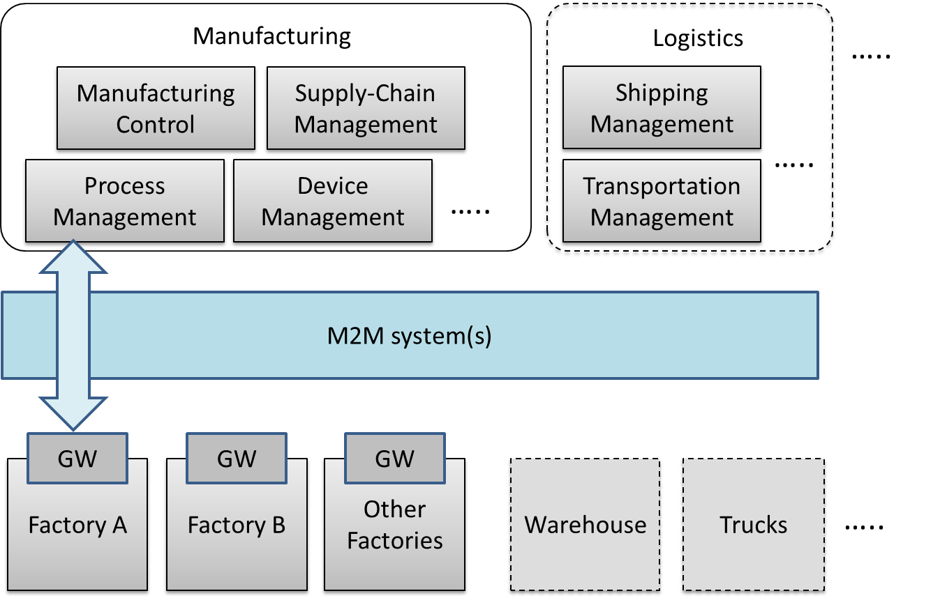

**Figure 5.1-1 Industrial Domain Architecture**

In Figure 5.1-1, factories will be connected with manufacturing services via M2M system(s). Generally, the gateway in factory will collect data from factory and send to manufacturing services in management centre. The service will be initiated by different management modules and sent to factories.

In addition, with the M2M system(s), the complex service can be sent to several factories synchronously, to realize the effective collaborations between factories. Every factory is expected be able to make accurate decisions and to do effective operation, because it can work based on analysis result from data of all factories rather than from itself. Management centre with manufacturing services also is expected to be able to make accurate decision by utilizing field data of all factories, and also via other support, such as cloud computing, to improve efficiency of local or global services.

In the future, if more and more industry related domains, such as logistics and power management system, can be connected into the M2M system, resources (warehouses, trucks, ships, power, etc.) can be integrated efficiently. Therefore more flexible services will be created to face the complex situation.

As oneM2M architecture provides general Application Layer, Common Services Layer and the Underlying Network Services Layer, and will be connected with other vertical systems, it is meaningful to consider the integration of industrial domain system with the oneM2M architecture.

Editor’s note: paragraph is expected to show the role of oneM2M.

## 5.2 Technology Trends in Industrial Domain

To accelerate the update of manufacturing systems, many worldwide organizations have been established and started making efforts.

In IEC (International Electrotechnical Commission), Standardization Management Board (SMB) of IEC set up a Strategy Group, SG8 to deal with a number of tasks related to Smart Manufacturing on June 2014. [1]

**Table 5.2-1 Industrial Domain Research in IEC SMB SG8 [2]**

|  |  |
| --- | --- |
| **Mission & Scope** | • Develp a function model/reference architecture that helps to identify gaps in standardization based on to-be-collected use cases  • Develop a common strategy for the implementation of Industry 4.0  • Extend standards towards: environmental conditions, security, properties, energy efficiency, product and functional safety |
| **Technical Keywords** | • Industrial process measurement, control and automation  • Application: semantics relationships descriptive technologies  • Services: web services /SOA repositories /clouds dependable connections  • Communication: data access real-time communications |

IIC (Industrial Internet Consortium) was founded in March 2014 to bring together the organizations and technologies necessary to accelerate growth of the Industrial Internet by identifying, assembling and promoting best practices. [3]

**Table 5.2-2 Industrial Domain Research in IIC [4] [5]**

|  |  |
| --- | --- |
| **Mission & Scope** | • Productivity and efficiencies can be improved by production process governing themselves with intelligent machines and devices  • Real time data report from handheld digital device  • Wearable sensors track location of employees in case of emergency  • Future scenarios: new steering instruments will interlink things to ensure the entire value chain and trigger adjustments on the factory floor in case of chain changing; raw materials will be programmed to record standard process and their customer to realize automatic customization. |
| **Technical Keywords** | • Representative use case areas include connectivity, logistics, transportation, and healthcare  • Key capabilities system characteristics including resilience, safety and security. (such as key system characteristic, intelligent and resilient control, operations support, connectivity, integration and orchestration, security, trust and privacy, and business viewpoint)  • Data management and analytics  • Security: endpoint security, secure communications and security management and monitoring (currently focused on general security use case) |

IEEE P2413 defines an architectural framework for the Internet of Things (IoT), including descriptions of various IoT domains including industrial domain and is sponsored by the IEEE-SA. [6]

**Table 5.2-3 Industrial Domain Research in IEEE P2413 [7] [8]**

|  |  |
| --- | --- |
| **Mission & Scope** | • Ranges from the connected consumer to smart home & buildings, e-health, smart grids, next generation manufacturing and smart cities  • Promote cross-domain interaction instead of being confined to specific domains |
| **Technical Keywords** | • Energy efficiency during data transmission  • Areas of interest: industrial Internet, cross sector common areas, common architecture, security safety privacy |

SMLC (Smart Manufacturing Leadership Coalition) is a non-profit organization committed to the development and deployment of Smart Manufacturing Systems. SMLC activities are built around industry-driven development, application and scaling of a shared infrastructure that will achieve economic-wide impact and manufacturing innovation. [9]

**Table 5.2-4 Industrial Domain Research in SMLC [10]**

|  |  |
| --- | --- |
| **Mission & Scope** | • To build a cloud-based, open-architecture platform that integrates existing and future plant level data, simulations and systems across manufacturing seams and orchestrate business real time action. |
| **Technical Keywords** | • Cloud-based networked data  • Enterprise real-time  • Plant level data  • Information & action  • Security |

Based on the information above and current oneM2M architecture, below techology trends are becoming more and more important:

* Data management and analytics

In some industrial organizations, data management and data analytics are independent layers for data processing (such as filtering and catalogue management) and data analytics. Since large amounts of data are generating in industrial scenarios, further functionality design for data management and data analytics CSFs may need to be considered in oneM2M.

* Real-time command and control

M2M technologies enabled real-time response manufacturing practices in complex supplier networks. Realizing real-time command and control by highly available and time critical technologies will bring benefits to process automation and supply chains optimization. Use cases with real-time command and control feature may need to be considered in oneM2M. Additionally, requirements from these use cases may need to be noticed.

* Connectivity

Since connectivity in industrial domain must co-exist and evolve with legacy protocols, legacy connectivity (both wired and wireless) and legacy wiring, connectivity for manufacturing processes need to be considered, which may impact on NSE functionalities.

* Security

Increased networking and wireless technologies are the main security concerns for industrial companies. Undoubtedly, the risk trade-off will not stop companies from manufacturing evolution. Thus a renewed risk management and security ensuring for industrial domain may need to be considered.

Meanwhile more trends such as web services over M2M devices and protocols in industrial domain will be further tracked and analyzed.

Reference

1. IEC TC News, <http://www.iec.ch/tcnews/2014/tcnews_0214.htm>
2. <http://www.is-inotek.or.jp/archive/05_Ishikuma_Smart_Manufacturing.pdf>, Dec 2014.
3. IIC website, <http://www.industrialinternetconsortium.org/>
4. IIC document ‘Engineering: The First Steps’, Sep 2014.
5. IIC report ‘Engineering Update: November 2014’, Nov 2014.
6. IEEE P2413 website, <http://grouper.ieee.org/groups/2413/>
7. IEEE P2413 presentation ‘Standard for an Architectural Framework for the Internet of Things (IoT)’, Sep 2014.
8. IEEE P2413 report ‘oneM2M Specification Comment Collection’, Oct 2014.
9. SMLC website, <https://smartmanufacturingcoalition.org/>
10. SMLC presentation, <https://smartmanufacturingcoalition.org/sites/default/files/savannah_rivers_03-10-2014.pdf>, March 2014.

# 6 Use Cases

<Text> memo: Convert use cases in ppt at REQ on 19th January into oneM2M use case format.

## 6.1 An industrial use case for on-demand data collection for factories

### 6.1.1 Description

In factories, a lot of data are created from Programmable logic controllers (PLCs) every second and data are utilised to monitor production lines. These data are available via industrial bus systems, e.g. Real-time Ethernet. In order to monitor remotely, data are gathered by the M2M service platform, that needs to interface with such industrial bus systems via M2M gateways. However, it is difficult to gather all data to M2M service platform because sometimes more than 1M bit data are created per second. In such cases, only necessary data are gathered depending on situations and filtering / pre-processing of the raw data needs to be performed at the gateway.

This use case proposes that the oneM2M System offers pre-processing capabilities, e.g. rule-based collection policies (averages, thresholds …). These rules (e.g. in XML format) are called “data catalogues”.

### 6.1.2 Source

Hitachi

### 6.1.3 Actors

* PLC (Programmable logic controller): It controls sensors and devices in a production line according to embedded programs. It also has interface to Real-time Ethernet. It broadcasts data related to the production line to Real-time Ethernet.
* M2M Gateway: It provides an interface from the Real-time Ethernet to the OneM2M System. An application on the gateway collects necessary data from Real-time Ethernet according to the configuration called data catalogue, and send collected/pre-processed data to M2M service platform.
* M2M service platform: It stores data gathered from gateway(s), and provide data to applications. It also manages data catalogue in gateway(s).
* Application: An M2M Application in the Infrastructure Domain that monitors production lines by using collected data in M2M service platform, and send change request of data catalogue depending on situations.
* Real-time Ethernet: A technology standardized in IEC TC65. Ethernet is used at physical layer, but upper protocol is designed for industry purpose. In this use case, broad cast protocol is assumed. On top of Ethernet cable, data are broadcasted with ID. Address configuration is not necessary here.
* Internet connection: M2M service platform and gateway(s) are connected by the Internet physically.

### 6.1.4 Pre-conditions

* PLCs and gateway are connected to Real-time Ethernet. PLCs broadcast data to Real-time Ethernet. Gateway is configured to pick up necessary data from Real-time Ethernet.
* On top of the internet, VPN connection is established between M2M service platform and gateway(s).
* The data catalogue is managed by M2M service platform

### 6.1.5 Triggers

* Data catalogue is configured for gateway to pick up data in the Real-time Ethernet

### 6.1.6 Normal Flow

* Gateway picks up broadcasted data. It picks up only data that matches condition described in the data catalogue. If data does not match the condition, gateway neglects the data.
* Gateway send collected data to M2M service platform.
* M2M service platform receives data and store.
* Application utilise the data. For example, it monitors the status of production line.
* If application user finds some trouble in a production line, he/she changes the data catalogue in M2M service platform to collect all data related to the production line, and sends the data catalogue to the target gateway.

### 6.1.7 Alternative Flow

None

### 6.1.8 Post-conditions

None

### 6.1.9 High Level Illustration

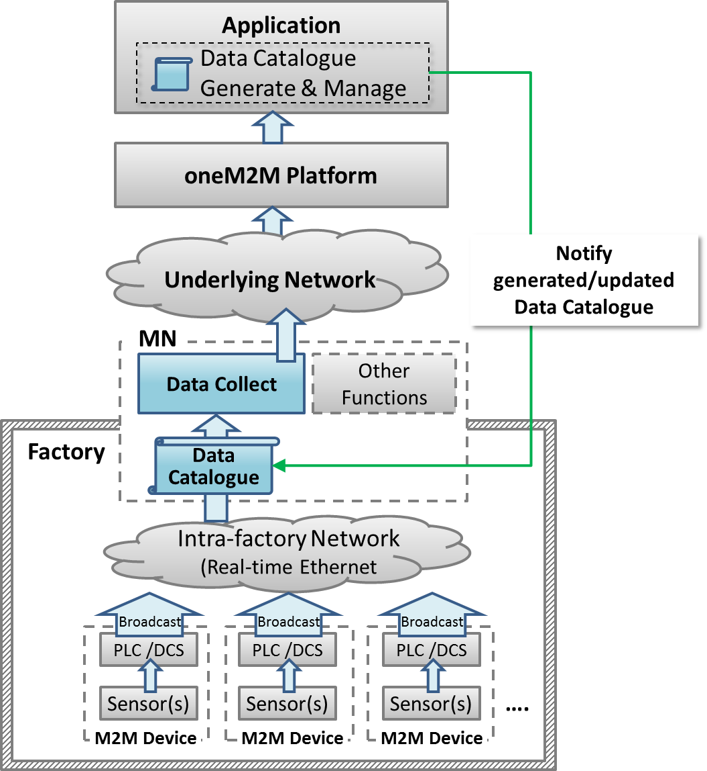

### 6.1.10 Potential requirements

1. The gateway shall be able to collect data from field area network (e.g. industrial bus systems) according to data collection policy stored in the gateway.
2. The data collection policy shall be manageable (configured, updated, deleted..) by M2M Applications on the M2M service platform

## 6.2 Integrity of Data Collection Monitoring

### 6.2.1 Description

In factories, a lot of data are created from Programmable logic controllers (PLCs) every second and data are utilised to monitor production lines. These data are available via industrial bus systems, e.g. Real-time Ethernet.

This type of data is called time series data which is a sequence of data points, typically consisting of successive measurements made over a time interval.

In order to monitor remotely, data are gathered by the oneM2M service platform that needs to interface with such industrial bus systems via M2M gateway (MN)s.

However, when some of data are lost due to some reasons, such as, damage of product line, temporal network delay, continuous network capacity overload and so on, some actions will be required immediately for safety. Furthermore, some considerations may be necessary, for example, switching to a new network service with more capacity, changing to the backup network, or adjusting data collecting policy for addressing an original reason of data loss. Other considerations may be effective when remote monitoring application inquires the oneM2M platform about condition of network traffic, e.g. temporal delay, continuous capacity overflow, or connection failure.

Similarly, from remote monitoring application, M2M gateway (MN) in each factory receives analysis result or some kinds of commands, which can be lost due to some reasons, such as, failure in analysis process, temporal network delay, or continuous network capacity overflow. M2M gateway (MN) can detect the loss when the analysis result or the commands in form of time series data, or it can detect potential loss with the help of monitoring condition of network traffic. When temporal network delay or continuous network capacity overflow occur, analysis result or commands may be lost. This loss will also require immediate decision and addressing a root cause.

This use case proposes that the oneM2M System shall be able to provide capability to collect, store time series data as well as monitor the integrity of data.

Moreover, the oneM2M System shall be able to provide the capability to monitor condition of network traffic.

### 6.2.2 Source

Hitachi and Huawei Technologies, CO., LTD

### 6.2.3 Actors

* PLC (Programmable logic controller): It controls sensors and devices in a production line according to embedded programs. It also has interface to Real-time Ethernet. It broadcasts data related to the production line to Real-time Ethernet.
* M2M Gateway (MN): It provides an interface from the Real-time Ethernet to the oneM2M System. The gateway collects and stores time series data from Real-time Ethernet then sends them to oneM2M service platform. It also receives analysis results or commands from oneM2M service platform. Furthermore, the gateway monitors the integrity of received analysis result or command by monitoring condition of network. It can detect the loss when the analysis result or the commands in form of time series data, or it can detect potential loss with the help of monitoring condition of network traffic when temporal network delay or continuous network capacity overflow occur.
* oneM2M service platform: It stores data gathered from gateway(s), and provides data to applications.
* Application: An M2M Application in the Infrastructure Domain monitors production lines by using collected data in oneM2M service platform and sends analysis results or commands depending on situations.
* Real-time Ethernet: A technology standardized in IEC TC65. Ethernet is used at physical layer. However the upper protocol is designed for industry purpose. In this use case, broadcast protocol is assumed.
* Internet connection: oneM2M service platform and gateway(s) are connected by the Internet physically.

### 6.2.4 Pre-conditions

* PLCs and gateway are connected to Real-time Ethernet. PLCs broadcast data to Real-time Ethernet. Gateway is configured to pick up necessary data from Real-time Ethernet.
* On top of the internet, VPN connection is established between oneM2M service platform and gateway(s).

### 6.2.5 Triggers

* The gateway starts to receive time series data.

### 6.2.6 Normal Flow

Gateway picks up time series data which is broadcasted at Real-time Ethernet. The gateway sends collected data to oneM2M service platform.

oneM2M service platform receives data, then stores and sends them to application.

The application monitors the integrity of time series data which is sent from gateway. If data loss occurs, application user will decide to send a command for some control action immediately. Then the application user will check the condition of network traffic to determine which means are used to solve the data loss.

### 6.2.7 Alternative flow

None

### 6.2.8 Post-conditions

None

### 6.2.9 High Level Illustration

### 6.2.10 Potential requirements

1. The oneM2M System shall be able to collect, store time series data as well as monitor the integrity of these data.
2. The oneM2M System shall be able to provide the capability to monitor condition of network traffic.

Time Series Data : is a sequence of data points which typically consist of successive measurements made over a time interval.

Editor’s Note: this definition of Time Series Data should be moved to TS-0011 Common Terminology.

## 6.3 Data Process for Inter-factory manufacturing

### 6.3.1 Description

To achieve remote manufacturing, numerous sensors are placed at product lines in factories and a significant amount of data is generated for monitoring purposes. This data is broadcast via intra-factory network (e.g. real-time Ethernet) through PLCs (Programmable logic controller) or DCSs (Distributed Control System), etc. For monitoring product lines efficiently and effectively, MNs (Middle Node which means the gateway) will selectively collect necessary data from intra-factory network, and then send this data to oneM2M services platform for use by manufacturing control applications. The data collection policy (named data catalogue) utilized at MNs is generated and managed by the application layer and may vary based on the specific monitoring purpose (e.g. collect only temperature data for purpose of monitoring device temperature; or collect both humidity and gas data for purpose of monitoring product quality). Also, data process functionality is needed at MNs in order to filter out error data or for summarizing percentage of data exceeding a threshold.

To respond rapidly to market changes, new factories may be needed for sufficient productivity. Thus inter-factory collaboration provides significant benefit and efficiency, which can be used in establishing a new factory where reference data catalogue can be used to establish new environment.

### 6.3.2 Actors

**M2M Device**: Sensors, controllers etc. located in factories (e.g. located at product lines) which measure and generate data. PLC (Programmable Logic Controller) /DCS (Distributed Control System) control sensors in production lines according to embedded programs. Both PLC and DCS can broadcast data related to production lines to intra-factory networks.

**Intra-factory Network:** In this use case, real-time Ethernet is assumed. It is standardized in IEC TC65 for which Ethernet is used at physical layer, but upper protocol is designed for industrial purpose. Meanwhile, broadcast protocol is assumed and data is broadcast with unique identifier/parameter (e.g. device ID).

**oneM2M MN:** Middle Node (gateway) provides an interface from the intra-factory network to oneM2M System. MN collects data from intra-factory network according to data catalogue, which is the data collection policy. The MN may process collected data and send the data to oneM2M services platform through underlying network.

**oneM2M Services Platform:** oneM2M services platform stores data gathered from MNs, and provides data to applications.

**oneM2M Application:** An oneM2M application in the Infrastructure Domain that monitors production lines for remote manufacturing control by using collected data from oneM2M services platform. For monitoring purposes, the M2M application defines and generates the data catalogue. Then, the application provides the data catalogue to MNs. M2M application also shares data catalogue in MNs with other factories.

### 6.3.3 Pre-conditions

PLCs or DCSs control sensors in production lines according to embedded programs. Both PLC and DCS can broadcast data related to production lines into an intra-factory network.

Real-time Ethernet is assumed as the intra-factory network. Meanwhile, broadcast protocol is assumed and in real-time Ethernet data is broadcast with unique identifier/parameter (e.g. device ID).

### 6.3.4 Triggers

A remote manufacturing control application generates a data catalogue for collecting data from product lines in factories.

### 6.3.5 Normal Flow

The normal flow steps are as follows:

1. The application generates the data collection policy into a data catalogue, or updates the data catalogue when the monitoring purpose has changed. Then, the application notifies the data catalogue to MNs in a factory.

The application providing the data catalogue to the MNs may include the following condition:

* In some inter-factory collaboration cases, the application also provides the data catalogue to the MNs in other collaborating factories, e.g. a newly built factory.

1. MNs start to selectively collect data from real-time Ethernet according to the data catalogue.
2. OneM2M services platform receives, stores, and provides the data to manufacturing control applications.
3. The application analyzes collected data for remote manufacturing control.

### 6.3.6 Post-conditions

The application utilizes (e.g. monitor and analyze) the data collected according to the data catalogue.

### 6.3.7 High Level Illustration

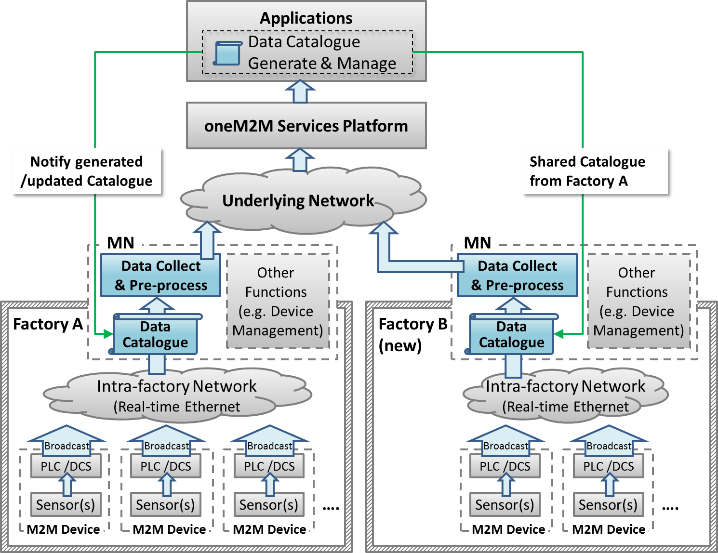

### 6.3.8 Potential requirements

1. The oneM2M system shall be able to share data collection policies among different applications.

## 6.4 Aircraft construction and maintenance

### 6.4.1 Description

In aircraft construction, there are precise regulations that specify the kind of screw and the amount of force that must be used to join specific parts. When it comes to passenger aircraft, there are thousands of such screws that must be tightened and precisely documented. Joints on the wings naturally require a different amount of force than those on an aircraft window.

The tools are wifi-enabled and can identify their precise location on the shop floor. The position of the aircraft in the hangar is also fixed. With fixed coordinates and wifi connectivity, we know, for example, that a particular tool is located at the vertical stabilizer. Instructions that specify the force it should use to tighten screws can automatically be sent to the tool.

Although this use case focuses on aircraft construction and maintenance, the connected power tool technology is expected to be effective in more applications:

* Safety-critical work processes are closely monitored and analyzed. Anomalies are automatically detected through the central processing, analysis, and visualization of production process data in near real time. Role-specific alerts can be triggered automatically.
* The power tool fleet manager has an exact overview of the power tool fleet status and utilization thanks to central access to process data. Organizational processes can be triggered automatically.
* Quality controls are automated and shifted to earlier stages of the production process. For example, hundreds of thousands of torque recordings are made available in their entirety for quality monitoring.
* Indoor geofencing alarms ensure that power tools are used according to regulations. Not all tools are allowed for all production and maintenance steps, e.g. in aircraft maintenance. As soon as power tools know their location, they can switch off when used in error.

### 6.4.2 Source

An article “First European testbed for the Industrial Internet Consortium” in Bosch’s ConnectedWorld Blog

<http://blog.bosch-si.com/categories/manufacturing/2015/02/first-european-testbed-for-the-industrial-internet-consortium/>

### 6.4.3 Actors

* Power tools: People in a shop floor utilize them to tighten screws of the airplane. They are wifi-enabled, and can identify their precise location on the shop floor. They receive instruction for amount of power for tightening screws.
* Indoor localization technology: The technology is utilized to identify location of power tools.
* oneM2M service platform: oneM2M service platform receives location information of power tools, and sends them to application. It also receives instructions for amount of power for tightening screws and sends them to each one of power tools.
* Application: In this use case, the application is for aircraft construction and maintenance. It holds the position of the aircraft in the hangar, and matches them to location information of power tools to calculate which power tool is utilized for which part of the aircraft. Then, it gets instructions that specify the force a power tool should use to tighten screws by utilizing regulations that specify the kind of screw and the amount of force that must be used to joint specific parts. Finally, it sends the instructions to each one of power tools.
* Underline network: In this use case, wifi is assumed.

### 6.4.4 Pre-conditions

* Application holds the position of the aircraft in the hanger and regulations that specify the kind of screw and the amount of force that must be used to joint specific parts.
* Power tools are wifi-enabled.

### 6.4.5 Triggers

* A person on a shop floor starts to use a power tool.

### 6.4.6 Normal Flow

1. The power tool identifies precise location information with use of indoor localization technology and sends the information to oneM2M platform.
2. oneM2M service platform receives the location information and sends them to application.
3. The application matches position of the aircraft in the hanger to location information of the power tool to calculate for which part of the aircraft the power tool is used.
4. The application gets instruction that specify the force the power tool should be use to tighten screws by utilizing regulations that specify the kind of screw and the amount of force that must be used to join specific parts.
5. The application sends the instruction to oneM2M platform.
6. oneM2M platform receives the instruction and sends it to the power tool.
7. The power tool uses the specified amount of force to tighten a screw.

### 6.4.7 Alternative flow

None

### 6.4.8 Post-conditions

None

### 6.4.9 High Level Illustration



### 6.4.10 Potential requirements

* The oneM2M System shall be able to support mechanism for the M2M Devices and/or Gateways to report their geographical location information to M2M Applications. (OSR-047)
* The oneM2M System shall support the ability for single or multiple M2M Applications to interact with a single or multiple M2M Devices/Gateways (application in the device/gateway) (OSR-009)

# 7 Overview of Potential Requirements

<Text> memo: Rearrange requirements in above use cases chapter in detail.

# 8 High Level Architecture

<Text> memo: Mapping objects in industrial domain (e.g. Production line, Programmable Logic Controller, Gateway, factory building, factory site, cloud server, headquarters, whole supply chain, ...) and objects in oneM2M (e.g. “ASN-AE”, “ADN-AE”, ...).

# 9 Security Analysis

<Text> memo: Security analysis of above use cases

# 10 Conclusion

<Text> memo: summarize above contents and potential requirements

# Proforma copyright release text block

This text box shall immediately follow after the heading of an element (i.e. clause or annex) containing a proforma or template which is intended to be copied by the user. Such an element shall always start on a new page.

Notwithstanding the provisions of the copyright clause related to the text of the present document, oneM2M grants that users of the present document may freely reproduce the <proformatype> proforma in this {clause|annex} so that it can be used for its intended purposes and may further publish the completed <proformatype>.

<PAGE BREAK>

## *Annexes*

Each annex **shall** start on a new page (insert a page break between annexes A and B, annexes B and C, etc.).

Use the **Heading 9** style for the title and the Normal style for the text.

Annex <A>:  
Title of annex *(style H9)*

<Text>

<PAGE BREAK>

Annex <B>:  
Title of annex *(style H9)*

<Text>

B.1 First clause of the annex *(style H1)*

<Text>

B.1.1 First subdivided clause of the annex *(style H2)*

<Text>

<PAGE BREAK>

Annex <y>:  
Bibliography

The annex entitled "Bibliography" is optional.

It shall contain a list of standards, books, articles, or other sources on a particular subject which are not mentioned in the document itself.

It shall not include references mentioned in the document.

Use the **Heading 9 style** for the title and B1+ or Normal for the text.

* <Publication>: "<Title>".

OR

<Publication>: "<Title>".

<PAGE BREAK>

# History

This clause shall be the last one in the document and list the main phases (all additional information will be removed at the publication stage).

|  |  |  |
| --- | --- | --- |
| **Publication history** | | |
| V.1.1.1 | <dd Mmm yyyy> | <Milestone> |
|  |  |  |
|  |  |  |
|  |  |  |
|  |  |  |

|  |  |  |
| --- | --- | --- |
| **Draft history** (to be removed on publication) | | |
| V.1.1.1 | <dd Mmm yyyy> | <CR ID> applied – <Summary of changes> |
|  |  |  |
|  |  |  |
|  |  |  |
|  |  |  |