

oneM2M
Technical Report
Document Number | oneM2M-TR-0057-V-0.5.0
Document Name: | Getting Started with oneM2M
Date: | 2021-02-11
Abstract:
Template Version: January 2017 (Do not modify)

The present document is provided for future development work within oneM2M only. The Partners accept no liability for any use of this report.
The present document has not been subject to any approval process by the oneM2M Partners Type 1. Published oneM2M specifications and reports for implementation should be obtained via the oneM2M Partners' Publications Offices.

About oneM2M
The purpose and goal of oneM2M is to develop technical specifications which address the need for a common M2M Service Layer that can be readily embedded within various hardware and software, and relied upon to connect the myriad of devices in the field with M2M application servers worldwide.
More information about oneM2M may be found at: http//www.oneM2M.org
Copyright Notification
© 2021, oneM2M Partners Type 1 (ARIB, ATIS, CCSA, ETSI, TIA, TSDSI, TTA, TTC).
All rights reserved.
The copyright and the foregoing restriction extend to reproduction in all media.

Notice of Disclaimer & Limitation of Liability
The information provided in this document is directed solely to professionals who have the appropriate degree of experience to understand and interpret its contents in accordance with generally accepted engineering or other professional standards and applicable regulations. No recommendation as to products or vendors is made or should be implied.
NO REPRESENTATION OR WARRANTY IS MADE THAT THE INFORMATION IS TECHNICALLY ACCURATE OR SUFFICIENT OR CONFORMS TO ANY STATUTE, GOVERNMENTAL RULE OR REGULATION, AND FURTHER, NO REPRESENTATION OR WARRANTY IS MADE OF MERCHANTABILITY OR FITNESS FOR ANY PARTICULAR PURPOSE OR AGAINST INFRINGEMENT OF INTELLECTUAL PROPERTY RIGHTS. NO oneM2M PARTNER TYPE 1 SHALL BE LIABLE, BEYOND THE AMOUNT OF ANY SUM RECEIVED IN PAYMENT BY THAT PARTNER FOR THIS DOCUMENT, WITH RESPECT TO ANY CLAIM, AND IN NO EVENT SHALL oneM2M BE LIABLE FOR LOST PROFITS OR OTHER INCIDENTAL OR CONSEQUENTIAL DAMAGES. oneM2M EXPRESSLY ADVISES ANY AND ALL USE OF OR RELIANCE UPON THIS INFORMATION PROVIDED IN THIS DOCUMENT IS AT THE RISK OF THE USER.

Contents
Contents 3
1 Scope 5
2 References 5
2.1 Normative references 5
2.2 Informative references 5
3 Definitions of terms, symbols and abbreviations 5
3.1 Terms 5
3.2 Symbols 6
3.3 Abbreviations 6
4 Conventions, 6
5 oneM2M Overview 6
5.1 Introduction 6
5.1.1 oneM2M Service Layer 6
5.1.2 Functional Architecture description 9
5.1.3 Common Service functions 13
5.1.4 Benefits of using oneM2M 13
5.2 REST Architecture 15
5.3 Application Program Interfaces (API) 16
5.3.1 Introduction 16
5.3.2 oneM2M Primitives 16
5.3.2.1 Overview 16
5.3.2.2 Primitive structure 17
5.3.3 oneM2M Resources 19
5.3.3.1 Resource template 19
5.3.3.2 Resource structure 20
5.3.3.3 Resource attributes 21
5.3.3.4 Resource Schema 22
5.3.4 oneM2M Procedures 24
5.3.4.1 Access Resources in Local CSE 24
5.3.4.2 Access Resources in Remote CSE 24
5.3.4.3 CREATE operation 25
5.3.4.4 RETRIEVE operation 26
5.3.4.5 UPDATE operation 26
5.3.4.6 DELETE operation 27
5.2.4.7 NOTIFY operation 27
5.4 Data collection principles 27
5.4.1 Container 27
5.4.2 Access Control Policy 28
5.4.3 Subscription and Notification 30
5.4.4 Discovery 31
5.5 Data collection example 31
6 Core Functionalities 31
6.1 Introduction 31
6.2 Addressing modes 31
6.3 Retargeting 32
6.4 Long Polling 32
6.4.1 Introduction 32
6.4.2 Long polling example 33
6.5 Location policy 35
6.5.1 Introduction 35
6.5.2 Obtaining Location Information 35
6.x IPE 37
6.x Group management 37
6.x App-ID 37
6.x Announcement 37
6.x Block/NB sync/async modes 37
7 Main feature descriptions 38
7.1 Introduction 38
7.2 3GPP Interworking 38
7.2.1 Introduction 38
7.2.2 IoT Device Enrollment 39
7.2.3 IoT Device Sleep Schedule Management 40
7.2.4 IoT Device Location Tracking 41
7.2.5 IoT Device Message Delivery Handling 42
7.2.6 Network Congestion Control 42
7.2.7 Non-IP Data Delivery (NIDD) 42
7.2.8 IoT Device Tampering Detection 42
7.2.9 Management of Groups of IoT Devices 42
7.2.10 IoT Roaming Device Services 43
7.3 FlexContainer 43
7.4 Semantics 43
7.5 Industrial Domain 43
7.5.1 Time Series 43
7.5.2 Transaction 43
7.x Security 43
7.x SDT 43
Proforma copyright release text block 43
Annexes 44
Annex <y>: Bibliography 44
History 45

1 Scope
The present document …
EXAMPLE: The present document provides the necessary adaptions to the endorsed document.
The Scope shall not contain requirements.

2 References
The following text block applies.
References are either specific (identified by date of publication and/or edition number or version number) or non-specific. For specific references,only the cited version applies. For non-specific references, the latest version of the referenced document (including any amendments) applies.

2.1 Normative references
As a Technical Report (TR) is entirely informative it shall not list normative references.
The following referenced documents are necessary for the application of the present document.
Not applicable.

2.2 Informative references
Clause 2.2 shall only contain informative references which are cited in the document itself.
The following referenced documents are not necessary for the application of the present document but they assist the user with regard to a particular subject area.
[i.1] oneM2M Drafting Rules (http://member.onem2m.org/Static_pages/Others/Rules_Pages/oneM2M-Drafting-Rules-V1_0.doc)

3 Definitions of terms, symbols and abbreviations
Delete from the above heading the word(s) which is/are not applicable.

3.1 Terms
Clause numbering depends on applicability.
- A definition shall not take the form of, or contain, a requirement.
- The form of a definition shall be such that it can replace the term in context. Additional information shall be given only in the form of examples or notes (see below).
- The terms and definitions shall be presented in alphabetical order.
For the purposes of the present document, the [following] terms and definitions [given in ... and the following] apply:
Definition format
<defined term>: <definition>
If a definition is taken from an external source, use the format below where [N] identifies the external document which must be listed in Section 2 References.
<defined term>[N]: <definition>
example 1: text used to clarify abstract rules by applying them literally
NOTE: This may contain additional information.

3.2 Symbols
Clause numbering depends on applicability.
For the purposes of the present document, the [following] symbols [given in ... and the following] apply:
Symbol format
<symbol> <Explanation>
<2nd symbol> <2nd Explanation>
<3rd symbol> <3rd Explanation>

3.3 Abbreviations
Abbreviations should be ordered alphabetically.
Clause numbering depends on applicability.
For the purposes of the present document, the [following] abbreviations [given in ... and the following] apply:
Abbreviation format
<ABBREVIATION1> <Explanation>
<ABBREVIATION2> <Explanation>
<ABBREVIATION3> <Explanation>

4 Conventions,
The key words “Shall”, ”Shall not”, “May”, ”Need not”, “Should”, ”Should not” in this document are to be interpreted as described in the oneM2M Drafting Rules [i.1]

5 oneM2M Overview

5.1 Introduction

5.1.1 oneM2M Service Layer
The architecture standardized by oneM2M defines an IoT Service Layer, i.e. a software Middleware sitting between processing / communication hardware and IoT applications providing a rich set of functions needed by many IoT applications.
It supports among others:
- secure end-to-end data/control exchange between IoT devices and custom applications by providing functions for proper identification
- authentication, authorization, encryption
- remote provisioning & activation
- connectivity setup
- buffering
- scheduling
- synchronization
- aggregation
- group communication
- device management
- etc…

oneM2M’s Service Layer is typically implemented as a software layer and sits between IoT applications and processing or communication hardware and operating system elements that provide data storage, processing and transport, normally riding on top of IP. However, non-IP transports are also supported via interworking proxies. The oneM2M Service Layer provides commonly needed functions for IoT applications across different industry segments.

- oneM2M defines a horizontal architecture providing common services functions that enable applications in multiple domains, using a common framework and uniform APIs.
Using these standardized APIs make it much simpler for M2M/IoT solution providers to cope with complex and heterogeneous connectivity choices by abstracting out the details of using underlying network technologies, underlying transport protocols and data serialization. This is all handled by the oneM2M Service Layer without a need for the programmer to become an expert in each of these layers. Therefore, the application developer can focus on the process / business logic of the use case to be implemented and does not need to worry about how exactly the underlying layers work. This is very much like writing a file to a file system without worrying how hard disks and their interfaces actually work.
Therefore, the IoT Service Layer specified in oneM2M can be understood as a distributed operating system for IoT providing uniform APIs to IoT applications in a similar way as a mobile OS does for the smart phone eco system.
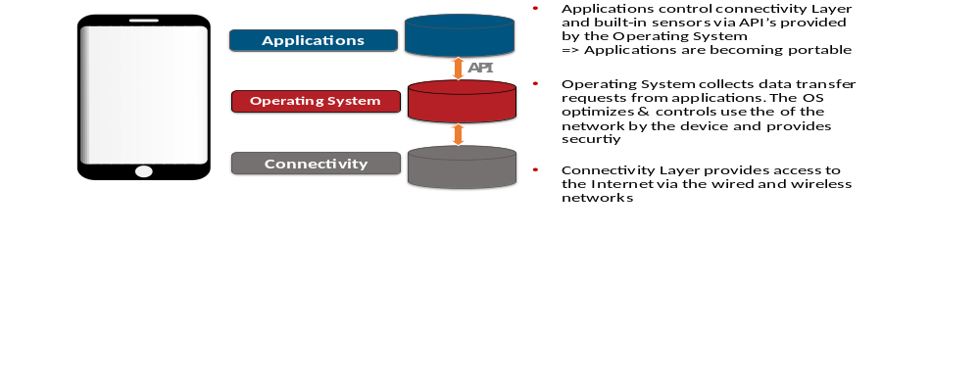 Figure 5.1.1-1: IoT Service layer

For example, the following “vertical” domains are isolated silos which makes it difficult to exchange data between each other. Using a “horizontal” architecture allows the providion of a seamless interaction between applications and devices. In the below use case, a security application detects that when noboby is in the building, it triggers the switching off of the light and it stops the air conditioning.

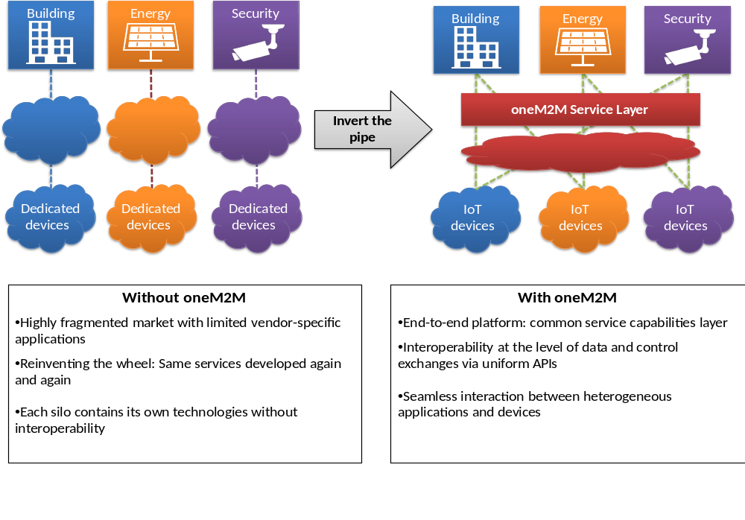Figure 5.1.1-2: IoT Cross-domain interoperability

- Cloud provider independent: From Fragmentation to Standards ➔ decoupling device, cloud, and application by open interfaces
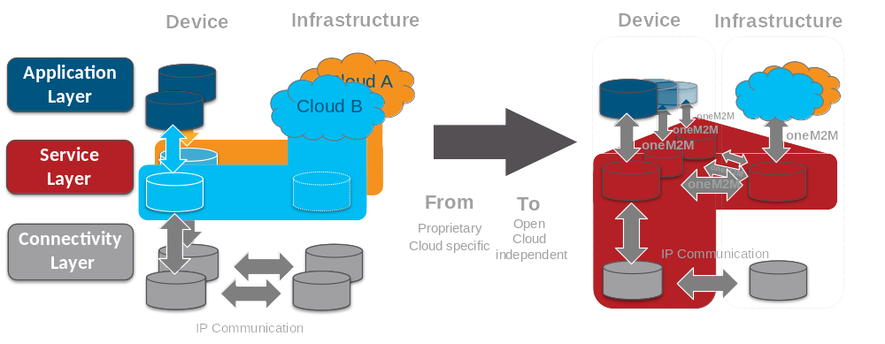
Figure 5.1.1-3: Cloud provider independent

- Common IoT key problems solved by oneM2M
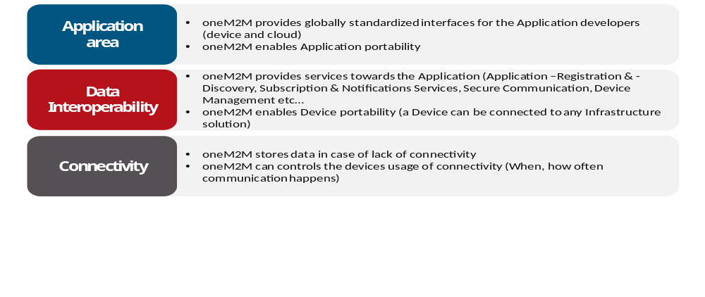Figure 5.1.1-4: Common IoT key problems

- oneM2M in a nutshell:
oneM2M’s Service Layer corresponds to a software “framework”, located between the IoT applications and communication HW/SW that provide storage/connectivity/data transport.
It provides functions that IoT applications across different industry segments commonly need (eg. data transport, security/encryption, scheduling, event notifications, remote software update...)
It supports cooperative intelligence in distributed applications i.e. in devices, gateways and back-end/cloud applications
It supports a selection of underlying transport protocols and serialization formats
It is like an Operating System for the Internet of Things, sitting on field devices/sensors, gateways and in servers.
And, it is a standard – not controlled by a single private company.

5.1.2 Functional Architecture description
oneM2M Layered Model comprises three layers:
- the Application Layer,
- the Common Services Layer
- the underlying Network Services Layer.
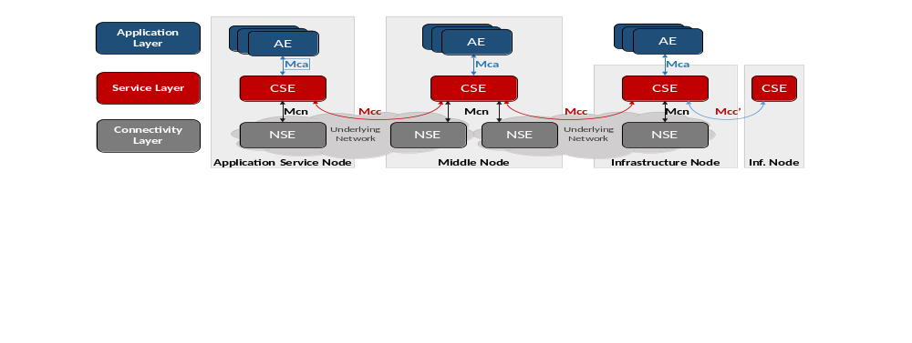Figure 5.1.2-1: oneM2M Layered Model
oneM2M entities:
The oneM2M functional architecture comprises the following functions:
- Application Entity (AE): The Application Entity is an entity in the application layer that implements an M2M application service logic. Each application service logic can be resident in a number of M2M nodes and/or more than once on a single M2M node. Each execution instance of an application service logic is termed an "Application Entity" (AE) and is identified with a unique AE-ID.
Examples of the AEs include an instance of a fleet tracking application, a remote blood sugar measuring application, a power metering application or a pump controlling application.
- Common Services Entity (CSE): A Common Services Entity represents an instantiation of a set of "common service functions" of the oneM2M Service Layer. A CSE is actually the entity that contains the collection of oneM2M-specified common service functions that AEs are able to use. Such service functions are exposed to other entities through the Mca (exposure to AEs) and Mcc (exposure to other CSEs) reference points. Reference point Mcn is used for accessing services provided by the underlying Network Service Entities such as waking up a sleeping device. Each CSE is identified with a unique CSE-ID.
Examples of service functions offered by the CSE include: data storage & sharing with access control and authorization, event detection and notification, group communication, scheduling of data exchanges, device management, and location services.
- Underlying Network Services Entity (NSE): A Network Services Entity provides services from the underlying network to the CSEs.
Examples of such services include location services, device triggering, certain sleep modes like PSM in 3GPP based networks or long sleep cycles.

oneM2M Reference Points:

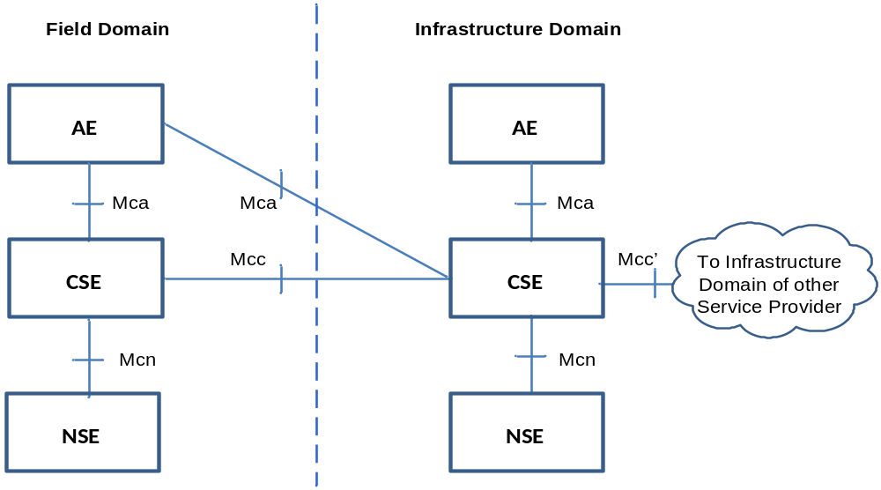
Figure 5.1.2-2: oneM2M Functional Architecture
The oneM2M functional architecture defines the following reference points:
- Mca: Reference point for the communication flows between an Application Entity (AE) and a Common Services Entity (CSE). These flows enable the AE to use the services supported by the CSE, and for the CSE to communicate with the AE. The AE and the CSE may or may not be co-located within the same physical entity.
- Mcc: Reference point for the communication flows between two Common Services Entities (CSEs). These flows enable a CSE to use the services supported by another CSE.
- Mcn: Reference point for the communication flows between a Common Services Entity (CSE) and the Network Services Entity (NSE). These flows enable a CSE to use the supported services provided by the NSE. While the oneM2M Service Layer is, usually independent of the underlying network – as long as it supports IP transport – it leverages specific M2M/IoT optimization such as 3GPP’s eMTC features (e.g. device triggering, power saving mode, long sleep cycles, etc).
- Mcc’: Reference point for the communication flows between two Common Services Entities (CSEs) in Infrastructure Nodes (IN) that are oneM2M compliant and that reside in different M2M Service Provider domains.
- Additional reference points are defined in oneM2M for specific purposes such as enrolment functions etc. and are not detailed in this overview.

oneM2M Nodes:
oneM2M has defined a set of Nodes that are logical entities identifiable in the oneM2M System. oneM2M Nodes typically contain CSEs and/or AEs. For the definition of Node types, oneM2M distinguishes between Nodes in the “Field Domain” – i.e. the domain in which sensors / actors / aggregators / gateways are deployed – and the “Infrastructure Domain” – i.e. the domain in which servers and applications on larger computers reside.

Application
Service
Node
Application
Dedicated
Node
Application
Dedicated
Node
Application
Dedicated
Node
Middle Node
Middle Node
Middle Node
Infrastructure Node
AE
AE
AE
AE
AE
CSE
CSE
CSE
AE
CSE
AE
AE
CSE
CSE
Figure 5.1.2-3: oneM2M node topology

Nodes can be of the following types:
- Application Dedicated Node (ADN): a Node that contains at least one AE and does not contain a CSE. It is located in the Field Domain. An ADN would typically be implemented on a resource constraint device that may not have access to rich storage or processing resources and – therefore – may be limited to only host a oneM2M AE and not a CSE. Examples for devices that would be represented by ADNs: simple sensor or actor devices.
- Application Service Node (ASN): a Node that contains one CSE and contains at least one Application Entity (AE), located in the Field Domain. An ASN could be implemented on a range of different devices ranging from resource constraint devices up to much richer HW. Examples for devices that would be represented by ASNs: data collection devices, more capable sensors and actors including simple server functions.
- Middle Node (MN): a Node that contains one CSE and could contain AEs. MNs are located in the Field Domain. There could be several MNs in the Field Domain of the oneM2M System. Typically an MN would reside in an M2M Gateway. MNs would be used to establish a logical tree structure of oneM2M nodes, e.g. to hierarchically aggregate data of buildings / neighborhoods / cities / counties / states etc.
- Infrastructure Node (IN): a Node that contains one CSE and could contain AEs. There is exactly one IN in the Infrastructure Domain per oneM2M Service Provider. An example of physical mapping, an IN could reside in an M2M Service Enablement Infrastructure.
- Non-oneM2M Node (NoDN): This Node type is not shown in the figure above. oneM2M specifications also define a Node Type for non-oneM2M Nodes which are Nodes that do not contain oneM2M Entities (neither AEs nor CSEs). Typically such Nodes would host some non-oneM2M IoT implementations or legacy technology which can be connected to the oneM2M system via interworking proxies.

5.1.3 Common Service functions
As a horizontal architecture providing a common framework for IoT, oneM2M has identified a set of common functionnalities, that are applicable to all the IoT domains. Think of these functions as a large toolbox with special tools to solve a number of IoT problems across many different domains. Very much like a screw driver can be used to fasten screws in a car as well as in a plane, the oneM2M CSFs are applicable to different IoT use cases in different industry domains.
In its first phase, oneM2M went through a large number of IoT use cases and identified a set of common requirements which resulted in the design of this set of tools termed Common Service Functions. Furthermore, oneM2M has standardized how these functions are being executed, i.e. is has defined uniform APIs to access these functions. Figure 5.3.1-1 shows a grouping of these functions into a few different scopes.
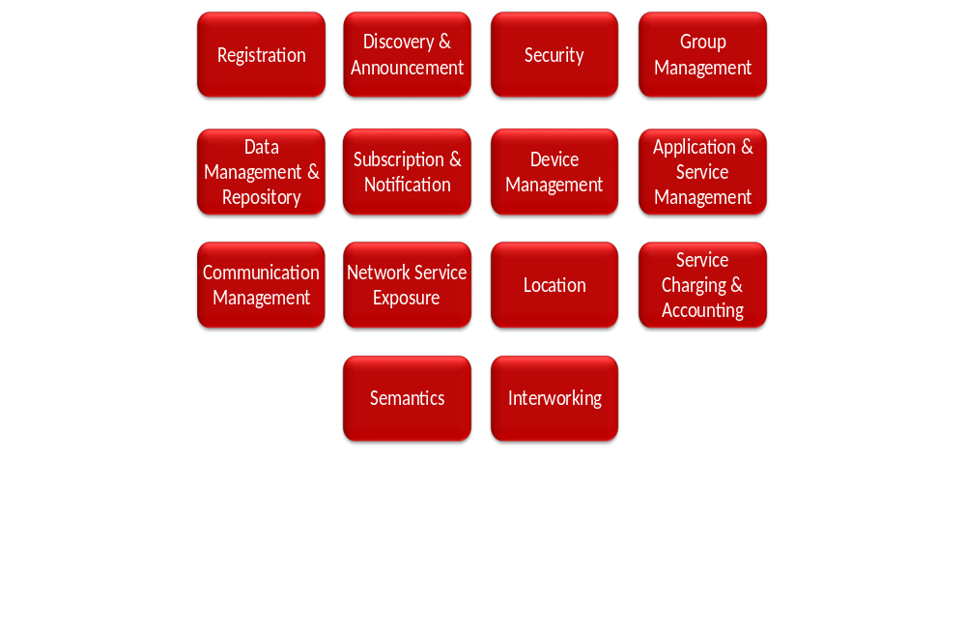
Figure 5.1.3-1: Common Service Functions
The services above reside within a CSE and are referred to as Common Services Functions (CSFs). The CSFs provide services to the AEs via the Mca reference point and to other CSEs via the Mcc reference point.
All these services are not specific to any IoT domain in particular. It enables each domain to build on the top of this service layer and really focus on its specific industrial needs. This is similar to functions of a generic operating system (OS) exposed to applications running on that OS. For instance, many applications read and write to files. File I/O is typically provided by the OS. oneM2M’s Service Layer provides similar functions in a generic way to many different IoT Applications.

5.1.4 Benefits of using oneM2M
- Service Layer on top of transport network supporting a choice of transport protocols and serializations of data/messages
- Flexibility: it can be deployed on all domains, not tied to a particular protocol technology.
- IP based: relies on known existing APIs to handle IP communications.
- Aware of optimizations if underlying network is 3GPP-based: can make use of policy-based scheduling, power saving mode, triggering /wakeup of devices, non-IP data transport, etc without the need for the developer to be aware of these terms.
- Enhances data sharing efficiency: communications over an underlying network are policed by provisioned policies that govern the use of network resources based on configurable categories of events/messages. Avoids storm of low-value messages in netoworks with costly resources. Lowers Opex.
- For example, in use cases with a need for fast & compact message exchanges one may want to rely on TCP sockets (opened via web sockets) and use binary serialization (e.g. CBOR) whereas in other cases a combination of HTTPS/JSON may be preferable for simpler debugging.
- Evolution: supported transport protocols and/or message serialization can evolve while the oneM2M code will not change. This allows for easy adaptation to future transport technologies.

- Horizontal platform provides common service functions that enable multiple IoT domains
- One investment/deployment serves multiple domains, does not re-invent the wheel. Lowers Capex.
- No need to maintain domain-specific platforms, reduction in Capex
- Cross-domain service/application innovation with a common framework and uniform APIs, allows for sharing of information and processes across domains that were isolated thus far (e.g. home security system versus heating system), Supports new business opportunities.
- Re-use of the code whatever the domain was. Increases reusability / lowers Capex.

- Easy interworking/integration with existing & evolving deployments paves the way to long term evolution and sustainable economy.
- Does not disrupt existing “vertical deployment”, but evolves it. Supports interworking with legacy technology.
- Interworking with a rich set of proximal IoT technologies, embracing different ecosystems.
- Takes advantage of the operators’ network capabilities and existing management technologies.

- Data sharing and semantic interoperability brings the real value.
- Data oriented RESTful API design.
- Semantic data annotation, discover and reasoning facilitates intelligent analytics and service mashups.
- Security protection at both channel and object level, with static and dynamic access control.

- Open standards to avoid lock-in to a platform or a cloud provider.
- No single party or company controls the technology / features.

- Several open source implementations available (CSE or AE).

- oneM2M is an international standard.
- Developed using standardization methodology that has insured successful interoperability in many technical domains, using the same process as in 3GPP.
- Developed by many companies based on consensus: it does not depend on a single or a small number of companies; not using a closed proprietary technology.
- It is an open standard: transparent development process & open access to all deliverables; all the specifications, even the drafts are available at http://www.onem2m.org/technical/latest-drafts
In summary, the oneM2M initiative can remove fragmentation of the IoT world. Because it is independent of the access or protocol technology that is used for transport, it is designed to be a long term solution for IoT deployment.

5.2 REST Architecture
Representational State Transfer (REST) is a software architectural style that defines a set of constraints to be used for creating web services.
RESTful services allow the requesting systems to access and manipulate textual representations of resources by using a uniform and predefined set of stateless operations. A stateless protocol operation does not require the server to retain session information or status about each communicating partner for the duration of multiple requests.
REST is not a protocol. It is about manipulating resources, uniquely identified by URIs. A resource is stateful and contains a link pointing to another resource. All the actions on resources are done through a Uniform Interface.
As REST is an architecture style, it can be mapped to multiple protocols such as HTTP, CoAP, etc…

Six guiding constraints define a RESTful system. These constraints restrict the ways in which the server can process and respond to client requests
- Client-server: separation of concerns is the principle behind the client-server constraints.
- Stateless server: request from client to server contains all of the information necessary to understand the request, and cannot take advantage of any stored context on the server.
- Cache: the client can reuse response data, sent by the server, by storing it in a local cache.
- Layered system: allows an architecture to be composed of hierarchical layers. It enables the addition of features like a gateway, a load balancer, or a firewall to accommodate system scaling.
- Code-on-demand: (optional) REST allows client functionality to be extended by downloading and executing code in the form of scripts (e.g. JavaScript).
- Uniform interface
  - Identification of resources: resource identifier enables the identification of the particular resource involved in an interaction between components.
  - Manipulation of resources through representations: resource representations are the state of a resource that is transferred between components.
  - Self-descriptive messages: contain metadata to describe the meaning of the message.
  - Hypermedia as the engine of application state or HATEOAS: Clients find their way through the API by following links available in the resource representations.

5.3 Application Program Interfaces (API)

5.3.1 Introduction
The oneM2M REST APIs are used to manipulate data generated by the Application Entity (AE) to the oneM2M Service platform (CSE) as well as data retrieve services. The oneM2M REST APIs are developed for handling CRUD+N (Create, Retrieve, Update, Delete and Notification) operations for oneM2M resources specified in oneM2M standards.
The oneM2M API includes the following components:
- Primitives.
- Resources + Attributes.
- Data Types.
- Protocol Bindings .
- Procedures (CRUD+N).
The oneM2M API is used by CSEs and AEs to communicate with one another. The communication can be originated from an AE or CSE depending on the operation.
Communication is done via the exchange of oneM2M primitives across the oneM2M defined reference points (Mca/Mcc/Mcc’).
Primitives are used to perform CRUD+N operations on resources hosted by CSEs or to send notifications to AEs. Each CRUD+N operation is comprised of a pair of Request and Response primitives.
Access and manipulation of the resources is subject to access control privileges.

oneM2M Primitives

5.3.2.1 Overview
Primitives are service layer messages transmitted over the Mca/Mcc/Mcc’ reference points.
Originators send requests to Receivers via primitives. Originator and Receiver can be an AE or a CSE.
Each CRUD+N operation consists of one request and one response primitive.

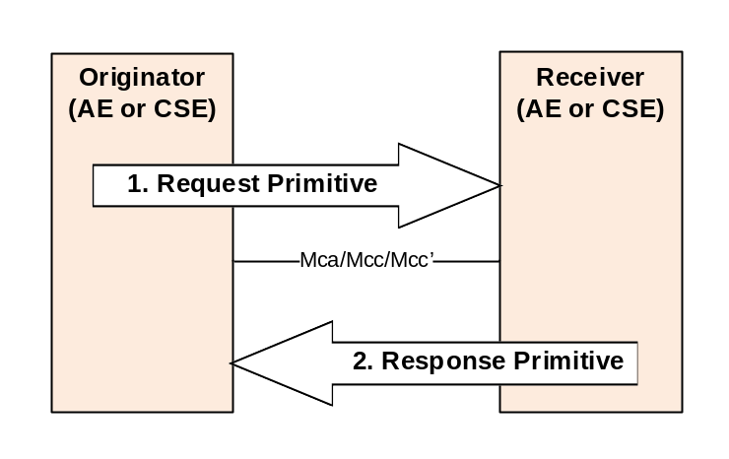
Figure 5.3.2.1-1: General primitives flow

Primitives are binded to underlying transport layer protocols such as HTTP, CoAP , MQTT or WebSocket. Primitives are generic with respect to underlying network transport protocols. Each primitive is binded to zero or more messages in the transport layer.

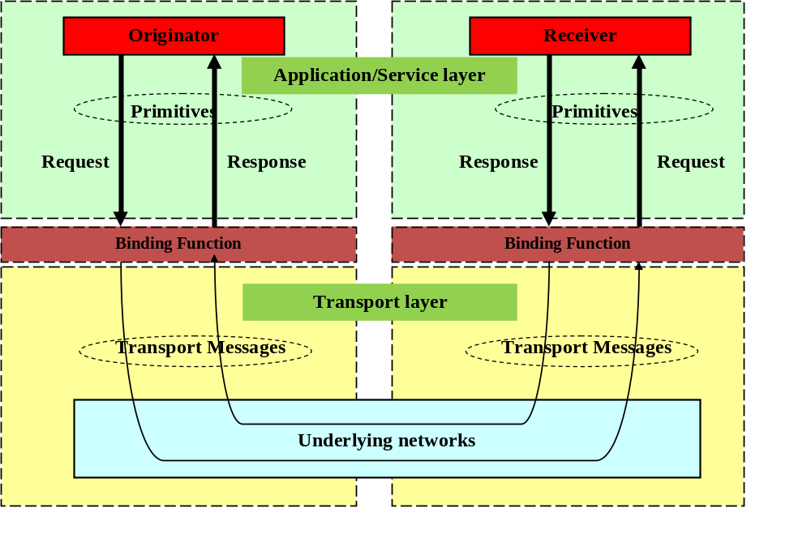
Figure 5.3.2.1-2: oneM2M Communications

5.3.2.2 Primitive structure
A primitive consists of two parts; control and content.
- The control part: contains parameters required for the processing of the primitive itself (e.g. request or response parameters).
- The content part is optional based on the type of primitive and contains the representation of the resource consisting of all or a subset of the resource attributes.
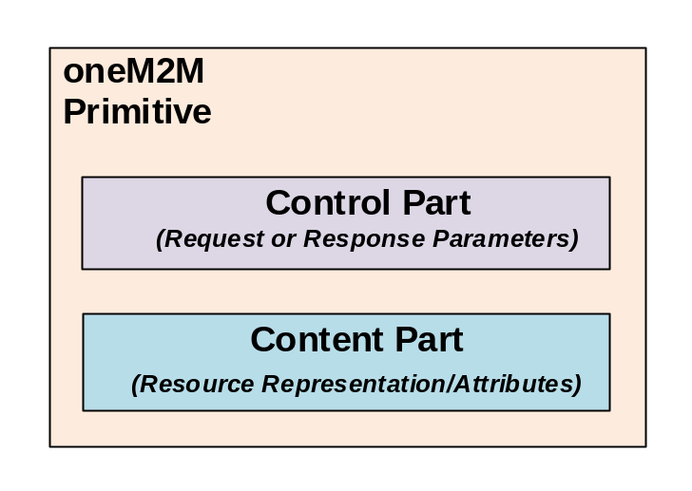
Figure 5.3.2.2-1: Primitive structure
Primitives are encoded and serialized based on the particular oneM2M protocol binding being used.
The originator and receiver of each primitive use the same binding, and thus use compatible forms of encoding/ decoding and serialization/de-serialization.
During transfer, the control part is encoded based on the protocol binding being used and the content portion is serialized using XML, JSON and CBOR.
oneM2M Request Primitive: oneM2M short names
HTTP/1.1
Method: POST ➔ op : Operation
URI: m2msp1.com/CSE01Base ➔ to : To
URI Query String: ?rcn=1 ➔ rcn : Result content
From: ae01.com ➔ fr : From
X-M2M-RI:0001 ➔ rqi : Request identifier
X-M2M-RVI: 2a ➔ rvi : Release Version Indicator
Content: <AE> representation ➔ pc: primitive content

oneM2M Response Primitive:
Status: Created ➔ rsc :Response Status Code
Location: http//m2msp1.com/CSE01Base/ae01 ➔ uri : URI
X-M2M-RI:0001 ➔ rqi : Request identifier
Content: <AE> representation created ➔ pc: primitive content

Figure 5.3.2.2-2: Example of Control part binded to HTTP

The Content part of a primitive contains serialized representation of a resource. oneM2M supports XML, JSON or CBOR serializations of resources.
This is an example of a oneM2M <container> resource representation in JSON format.

{
"m2m:cnt": {
"cbs": 0,
"cni": 0,
"ct": "20180406T085712",
"et": "99991231T235959",
"lt": "20180406T085712",
"mbs": 60000000,
"mia": 1600,
"mni": 10000,
"pi": "CAE0120180406T084680_cse01",
ri": "cnt20180406T08571214_cse01",
"rn": "cont_temp",
"st": 0,
"ty": 3
}
}

cnt : container
cbs : currentByteSize
cni : currentNrOfInstances
ct : creationTime
et : expirationTime
lt : lastModifiedTime
mbs : maxByteSize
mia : maxInstanceAge
mni : maxNrOfInstance
pi : parentID
ri : resourceID
rn :resourceName
st : stateTag
ty : resourceType

This is an example of a oneM2M <container> resource representation in XML format.
<?xml version="1.0" encoding="UTF-8"?>
<m2m:cnt xmlns:m2m="http://www.onem2m.org/xml/protocols" rn="cont_temp">
<ty>3</ty>
<ri>server/cnt-2951972863155866584</ri>
<pi>server</pi>
<ct>20181114T145000</ct>
<lt>20181114T145000</lt>
<et>20181114T145000</et>
<st>0</st>
<mni>10000</mni>
<mbs>0</mbs>
<mia>0</mia>
<cni>0</cni>
<cbs>0</cbs>
</m2m:cnt>

oneM2M Resources

Resource template
All entities in the oneM2M System, such as AEs, CSEs, application data representing sensors, commands, etc. are represented as resources in the CSE. Each resource has its own specific type.
Each resource type has a defined set of mandatory and optional attributes as well as child resources.
A resource can contain child resources.
Each resource is addressable and can be the target of CRUD operations specified in oneM2M primitives.

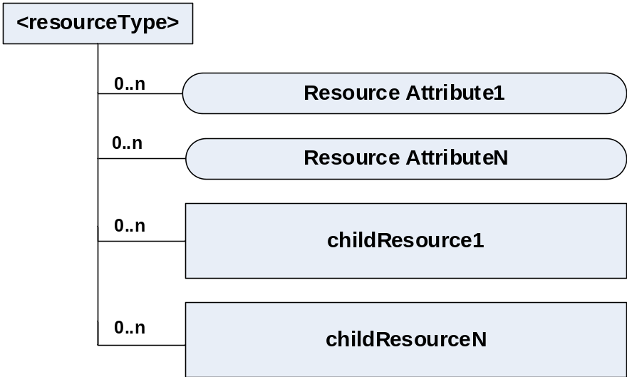
Figure 5.3.3.1-1 : Resource template

Resource Type | Short Description
accessControlPolicy | Controls "who" is allowed to do "what" and the context in which it can be used for accessing the resources
AE | Stores information about the AE. It is created as a result of successful registration of an AE with the registrar CSE
container | Used to shares data instances among entities
contentInstance | Represents a data instance in the <container> resource.
CSEBase | The structural root for all the resources that are residing on a CSE. It stores information about the CSE itself
delivery | Forwards requests from CSE to CSE
eventConfig | Defines events that trigger statistics collection
execInstance | The Execution Instance resource contains all execution instances of the same management command mgmtCmd
fanOutPoint | Used for addressing bulk operations to all the resources that belong to a group.
group | Stores information about resources of the same type that need to be addressed as a Group.
locationPolicy | Includes information to obtain and manage geographical location.
mgmtCmd | Represents a method to execute management procedures required by existing management protocols
mgmtObj | Represents management functions that provides an abstraction to be mapped to external management technology.
node | Represents specific Node information
pollingChannel | Represent a channel that can be used for a request-unreachable entity
remoteCSE | Represents a remote CSE for which there has been a registration procedure with the registrar CSE
schedule | Contains scheduling information for delivery of messages
statsCollect | Defines triggers for the IN-CSE to collect statistics for applications
statsConfig | Stores configuration of statistics for applications
subscription | Represents subscription information related to a resource.

Table 5.3.3.1-1 : Resource type examples

5.3.3.2 Resource structure
The root of the oneM2M resource structure is <CSEBase>.
The <CSEBase> is assigned an absolute address. All other child resources are addressed relative to <CSEBase>.
Depending on the type of child resource it is instantiated 0..n times.
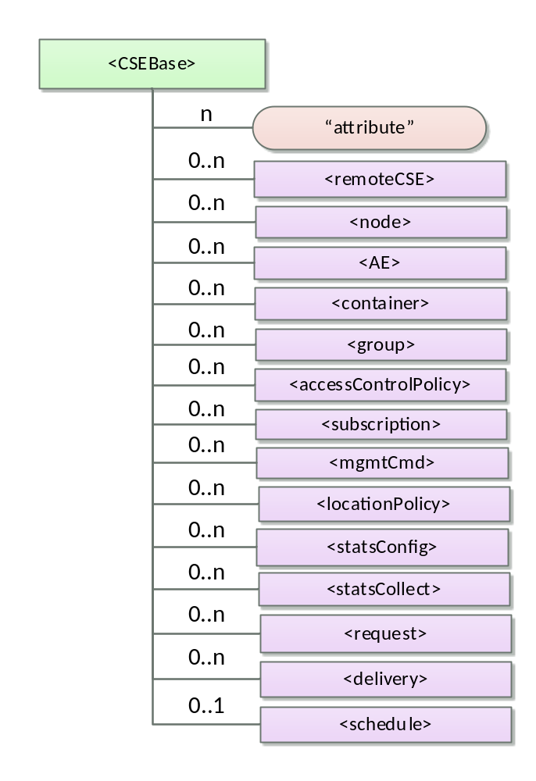
Figure 5.3.3.2-1 : <CSEBase> Resource example

5.3.3.3 Resource attributes
Each resource contains attributes that store information pertaining to the resource itself.
The attributes are :
- Universal Attributes : which appear in all resources
- Common Attributes : which appear in more than one resource and have the same meaning whenever they do appear.
- Resource-specific attributes

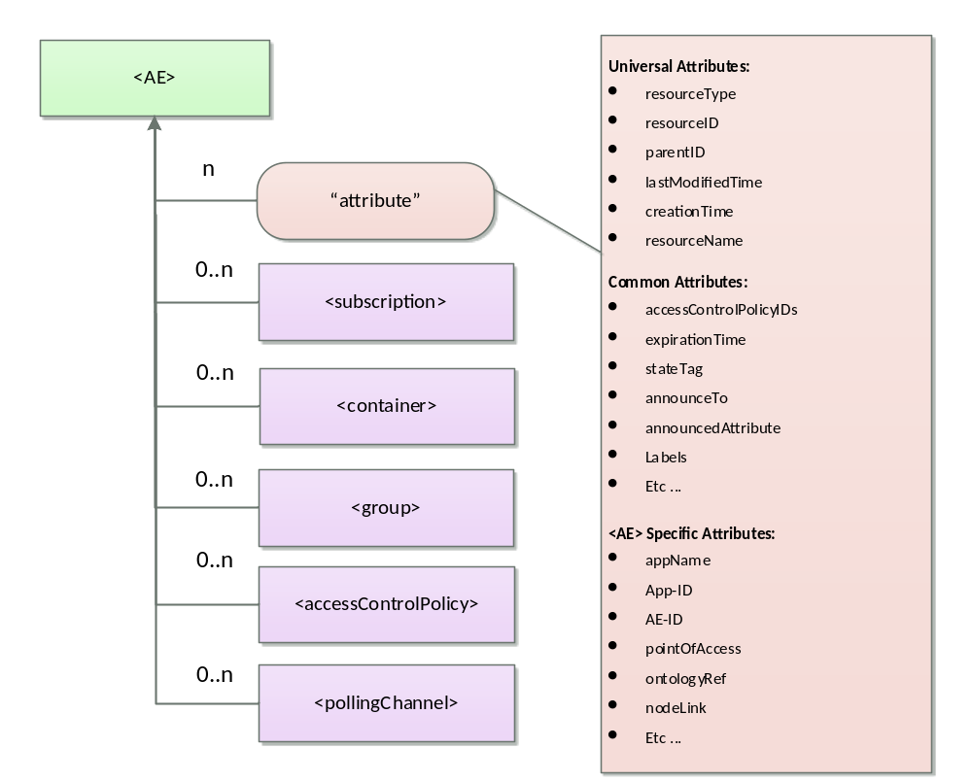
Figure 5.3.3.3-1: <AE> Resource example

Universal Attribute | Description
resourceType | Identifies the type of resource
parentID | resourceID of the parent of this resource.
creationTime | Time/date of creation of the resource.
lastModifiedTime | Last modification time/date of the resource.
resourceID | Identifier for resource.
resourceName | Name of the resource

Table 5.3.3.3-1 : Universal resource attributes

5.3.3.4 Resource Schema
oneM2M defines XML, JSON and CBOR schemas which define the attributes of each resource type.
Schemas bind oneM2M attributes to well-known data types defined by XML Schema definitions (e.g. xs:string, xs:anyURI, etc …).
Schemas also bind oneM2M attributes to oneM2M defined data types (e.g. m2m:id, m2m:stringList, etc ...).

<xs:schema xmlns="http://www.w3.org/2001/XMLSchema" targetNamespace="http://www.onem2m.org/xml/protocols"
xmlns:m2m="http://www.onem2m.org/xml/protocols" xmlns:xsi="http://www.w3.org/2001/XMLSchema-instance"
elementFormDefault="unqualified" xmlns:xs="http://www.w3.org/2001/XMLSchema">

<xs:include schemaLocation="CDT-commonTypes-v3_8_0.xsd" />
<xs:include schemaLocation="CDT-subscription-v3_8_0.xsd" />

<xs:element name="request" substitutionGroup="m2m:sg_regularResource">
<xs:complexType>
<xs:complexContent>
<!-- Inherit common attributes -->
<xs:extension base="m2m:regularResource">
<xs:sequence>
<!-- Common Attribute, specific to <container>, <contentInstance>, <request> and <delivery> resources -->
<xs:element name="stateTag" type="xs:nonNegativeInteger" />
<!-- Resource Specific Attributes -->
<xs:element name="operation" type="m2m:operation" />
<xs:element name="target" type="xs:anyURI" />
<xs:element name="originator" type="m2m:ID" />
<xs:element name="requestID" type="m2m:requestID" />
<xs:element name="metaInformation" type="m2m:metaInformation" />
<xs:element name="primitiveContent" type="m2m:primitiveContent" minOccurs="0" />
<xs:element name="requestStatus" type="m2m:requestStatus" />
<xs:element name="operationResult" type="m2m:operationResult" />

<!-- Child Resources -->
<xs:choice minOccurs="0" maxOccurs="1">
<xs:element name="childResource" type="m2m:childResourceRef" minOccurs="1" maxOccurs="unbounded" />
<xs:choice minOccurs="1" maxOccurs="unbounded">
<xs:element ref="m2m:subscription"></xs:element>
</xs:choice>
</xs:choice>
</xs:sequence>
</xs:extension>
</xs:complexContent>
</xs:complexType>
</xs:element>
</xs:schema>

Figure 5.3.3.4-1: Example of schema

5.3.4 oneM2M Procedures

5.3.4.1 Access Resources in Local CSE
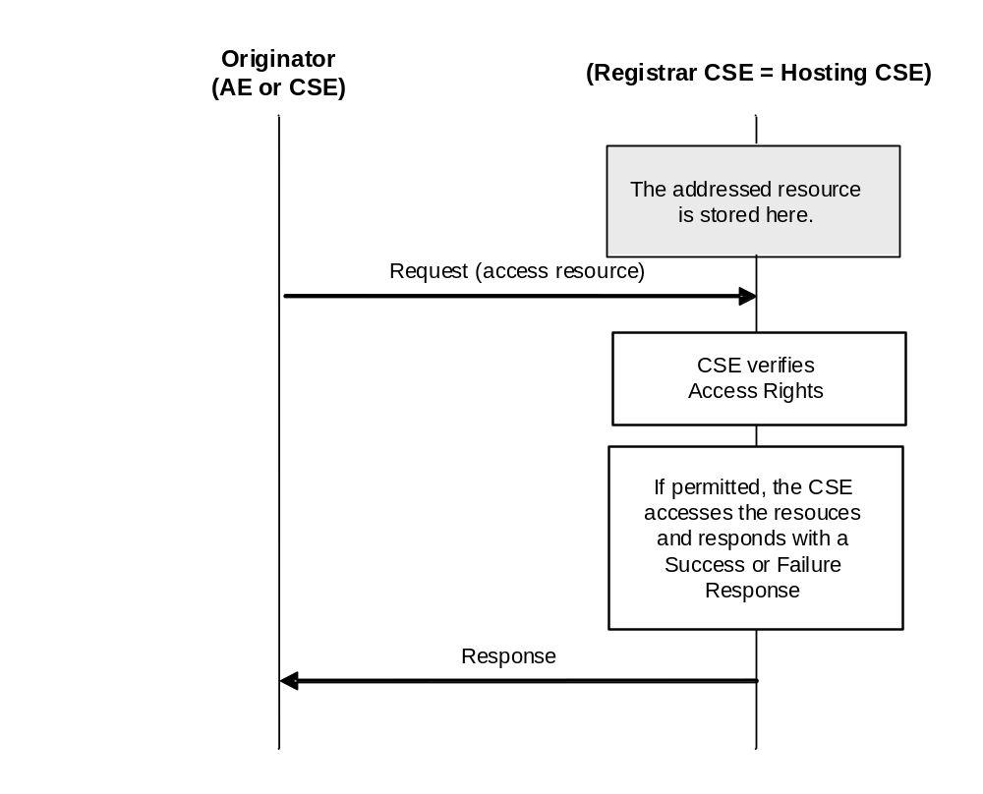
Figure 5.3.4.1-1 : Access Resources in Local CSE

5.3.4.2 Access Resources in Remote CSE

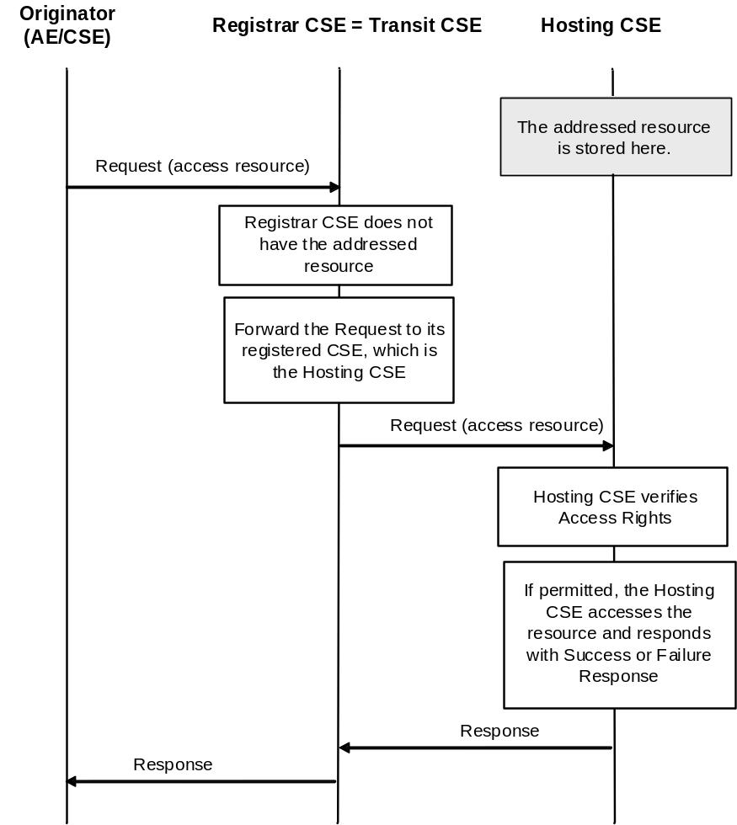
Figure 5.3.4.2-1 : Access Resources in Remote CSE

5.3.4.3 CREATE operation

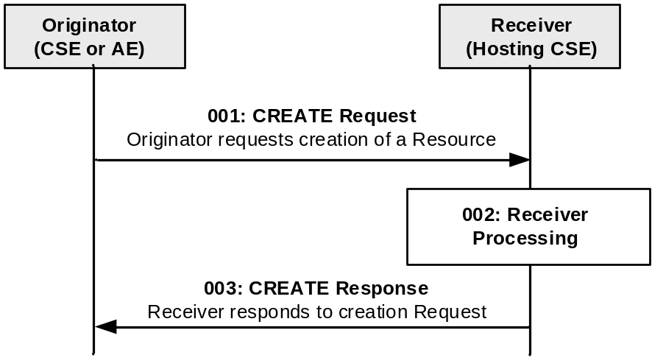
Figure 5.3.4.3-1 : CREATE operation

5.3.4.4 RETRIEVE operation

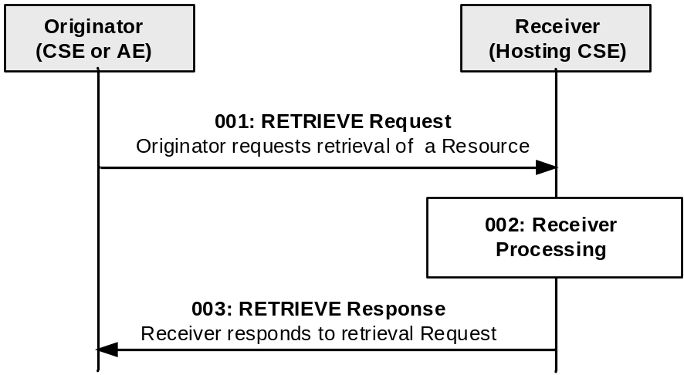
Figure 5.3.4.4-1 : RETRIEVE operation

5.3.4.5 UPDATE operation

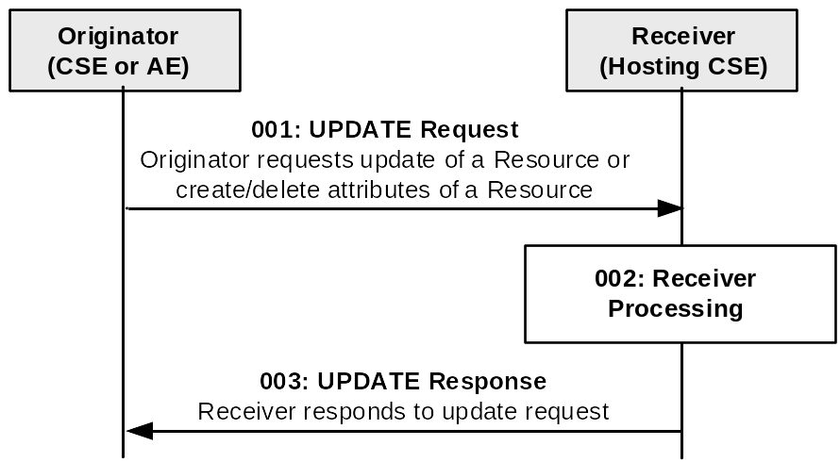
Figure 5.3.4.5-1 : UPDATE operation

5.3.4.6 DELETE operation
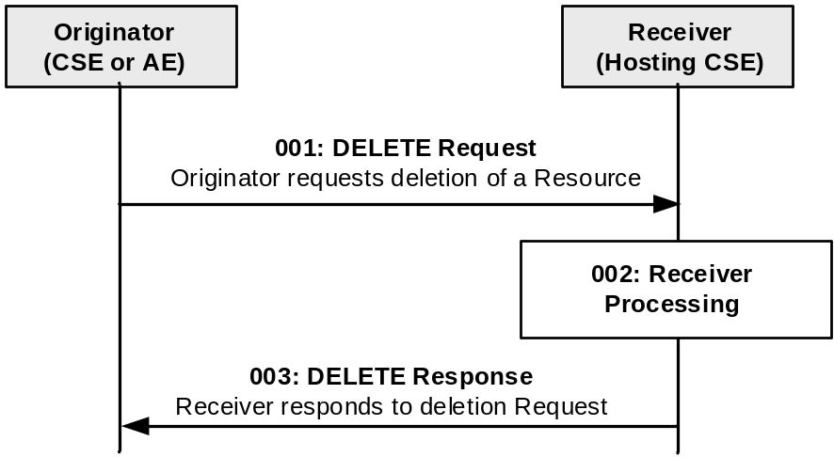
Figure 5.3.4.6-1 : DELETE operation

5.2.4.7 NOTIFY operation

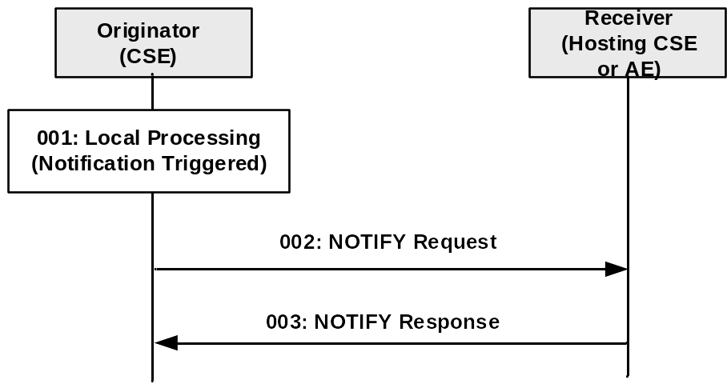
Figure 5.3.4.7-1 : NOTIFY operation

5.4 Data collection principles

5.4.1 Container
- Container for data instances is represented by the <container> resource.
  - Data storage used to share information with other entities and track data.
- <container> resource has no associated content.
  - Only attributes and child resources are available.
  - Actual data/content is stored in <contentInstance> child resource.
- <container> is the only resource allowed to have recursive child resources.
  - <container> resource can have other <container> as child resources.
  - useful for representing hierarchical data structure.

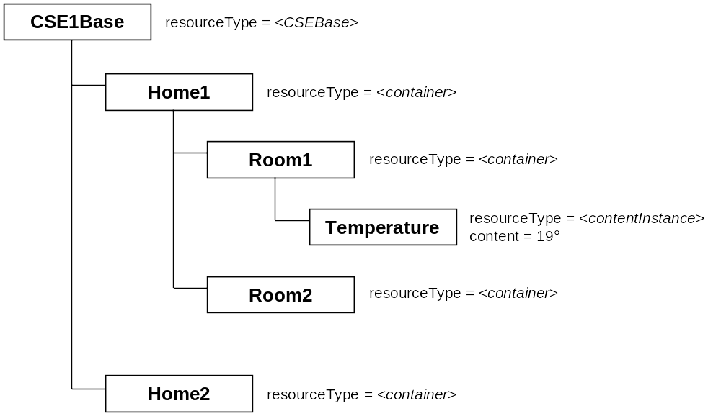
Figure 5.4.1-1: Example of resources tree

5.4.2 Access Control Policy
- Access Control Policies (ACPs) are used by the CSE to control access to the resources.
- The resources are always linked to Access Control Policies. ACPs are shared between several resources
- Access Control Policies contain the rules (Privileges) defining:
  - WHO can access the Resource (e.g. Identifiers of authorized AE/CSE).
  - For WHAT operation (CREATE / RETRIEVE / UPDATE / DELETE…).
  - Under WHICH contextual circumstances (Time, Location, IP address).
- ACPs are represented by <accessControlPolicy> resources.
  - Comprised of attributes privileges and selfPrivileges that represent a set of access control rules for entities.

<accessControlPolicy> resource content:

<m2m:acp xmlns:m2m="…" rn="">
<pv>
<acr>
Privileges:
Manage the right for resources of this ACP
<acor></acor>
<acop></acop>
</acr>
</pv>
<pvs>
Self-privileges:
Manage the right to access or modify this resource. It defines who can set an Access Control Policy
<acr>
<acor></acor>
<acop></acop>
</acr>
</pvs>
</m2m:acp>

Signification
- acr = « Access Control Rule »
- acor = « Access Control Originators »
- acop = « Access Control Operations »

Operation Code
- CREATE 1
Combinations of these values are specified by adding them together. For example the value 5 is interpreted as "CREATE and UPDATE".
- RETRIEVE 2
- UPDATE 4
- DELETE 8
- NOTIFY 16
- DISCOVERY 32

Example:
<pv>
<acr>
<acor>admin</acor>
63 grants all rights
<acop>63</acop>
</acr>
</pv>
<pvs>
<acr>
<acor>guest</acor>
34 grants Retrieve and Discovery rights
<acop>34</acop>
</acr>
<pvs>

- Common attribute accessControlPolicyIDs link resources that are not <accessControlPolicy> resources to <accessControlPolicy> resources.
  - All resources are accessible only if the privileges from the ACP grants it.
  - All resources have an associated accessControlPolicyIDs attribute, either explicitly or implicitly.

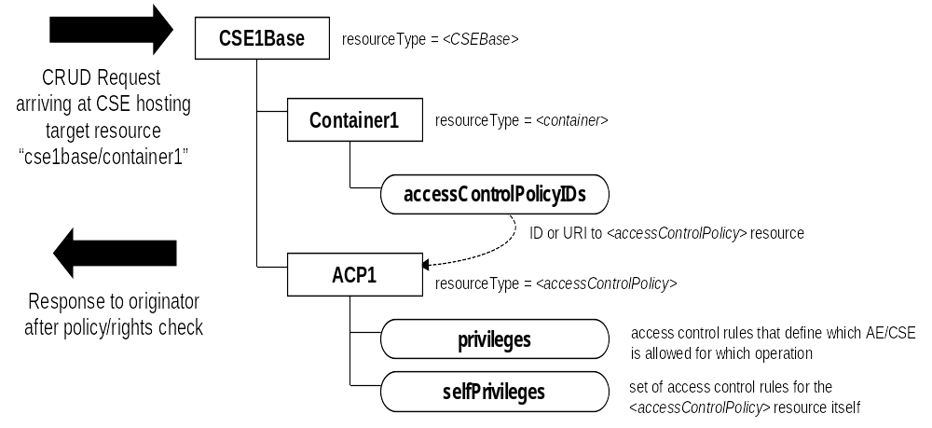
Figure 5.4.2-1 : Access control policy verification example

5.4.3 Subscription and Notification
- Events generated by resources can be received using the <subscription> resource.
- The <subscription> resource contains subscription information for its "subscribed-to" resource.
  - <subscription> resource is a child resource of the "subscribed-to" resource.
- The originator (resource subscriber) has RETRIEVE privileges to the "subscribed-to" resource in order to create the <subscription> resource.
- Notification policies specified in the attributes can be applied to the <subscription>.
  - Specify which, when, and how notifications are sent.
  - Example: batchNotify – receive batches of notification rather than one at a time.

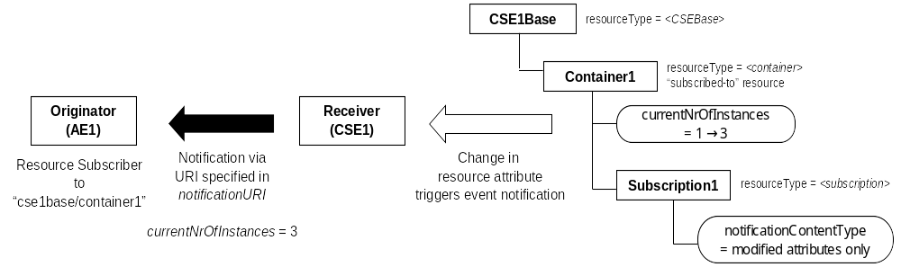
Figure 5.4.3-1 : Subcription and notification example

5.4.4 Discovery
- Resource Discovery Capabilities
  - Under the RESTful architecture, Resource Discovery can be accomplished using RETRIEVE operation by an Originator.
  - The use of the filterCriteria parameter allows limiting the scope of the results.
    - Type, Labels, Content Size and so on can be configured in the parameter.

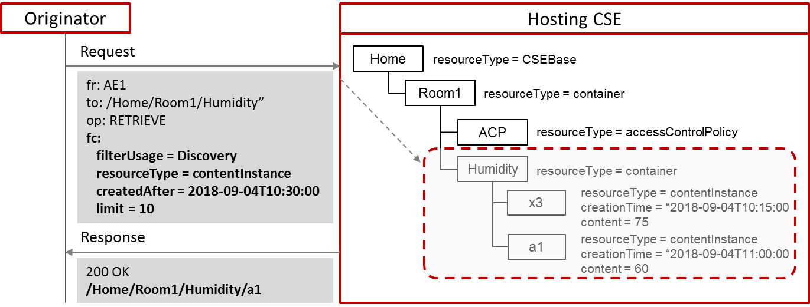

Figure 5.4.4-1 : Discovery example

5.5 Data collection example
Editor note: to provide a basic example scenario using data collection + Subscription/Notification

6 Core Functionalities

6.1 Introduction
Editor notes: here are examples clauses that could be addressed to simply describe Core Fonctionalities. It is here for information and the list could be revised.

6.2 Addressing modes

6.3 Retargeting

6.4 Long Polling

6.4.1 Introduction
In some cases, an AE or a CSE cannot receive a notification directly from other entities. The reason could be the entity is non-server capable or that it is located behind a NAT or a firewall and therefore cannot be accessed from an external network.
The Long Polling channel feature is defined to solve this issue. The request-unreachable AE/CSE creates a <pollingChannel> resource on its hosting CSE, and then polls this resource for any type of request(s) targeted towards itself.
A typical use case is an AE retrieves notifications by polling a <pollingChannel> resource to receive notifications from a subscription Hosting CSE.
When the <pollingChannel> resource is created, a virtual <pollingChannelURI> resource is automatically created by the Hosting CSE as a child resource of the <pollingChannel> resource. To poll the <pollingChannel> resource, retrieves are targeted towards this <pollingChannelURI> resource by the AE or CSE which created the <pollingChannel> resource. The Hosting CSE delays responding to the long polling request until there is a request that requires re-targeting towards to the AE/CSE or the long polling request reaches its request expiration time.
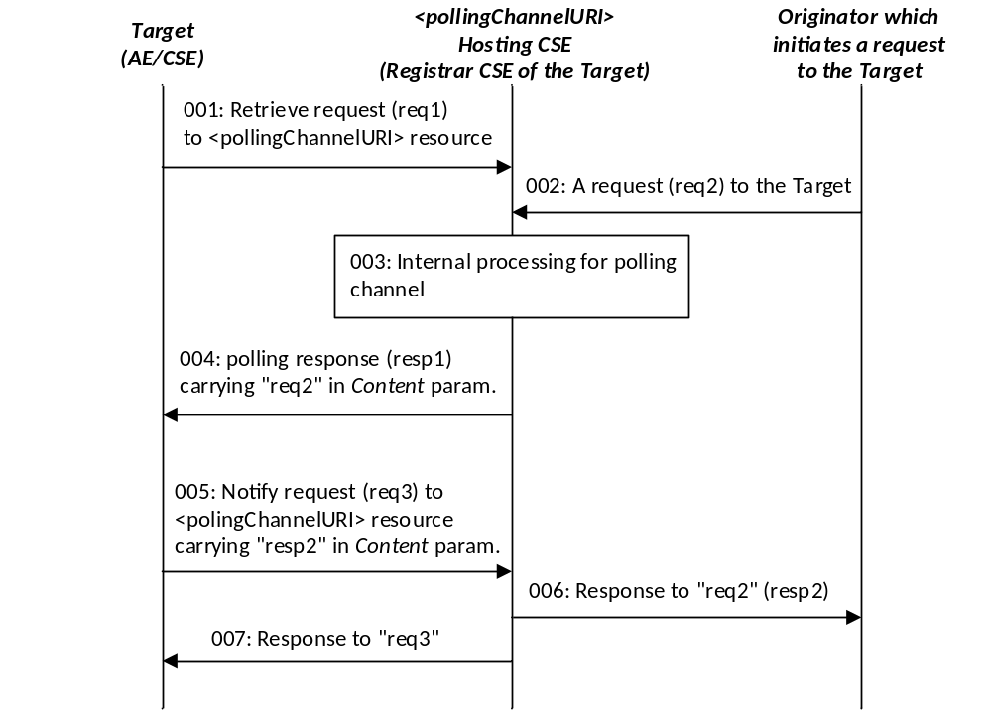
Figure 6.4.1-1: Long polling channel call flows
- The Target (AE/CSE), which is a request-unreachable entity, polls the <pollingChannel> resource Hosting CSE by sending a RETRIEVE requests periodically ( “req1”) that target the virtual <pollingChannelURI> child resource.
The Receiver, which is the <pollingChannel> Hosting CSE, holds the request until it has any requests to return to the Originator.
If the request expires and there is no available request to return, the Hosting CSE sends the response with a status indicating a timeout has occurred to inform the AE/CSE that a new polling request should be generated again.
- The Originator sends a request “req2” to the Target. If the Target is an AE , “req2” is a NOTIFY. If the Target is a CSE, it could be any CRUDN request primitive.
- The Hosting CSE internally processes the polling channel RETRIEVE.
- The Hosting CSE replies to the polling request in a response “resp1” (RETRIEVE response) , carrying the req2 in the content parameter.
- The Target sends a NOTIFY request "req3" containing the "resp2", which is the response to the "req2" sent in step 2) and step 4).
- The "resp2" is forwarded to the Originator.
- The Hosting CSE sends to the Target a reponse to “req3” (NOTIFY response).

6.4.2 Long polling example
An AE actuator ADN-AE1 (eg a garden water spray) is behind a NAT and cannot receive notifications requests from its Hosting CSE. Instead, it has to retrieve notifications by long polling on the polling channel it has created.
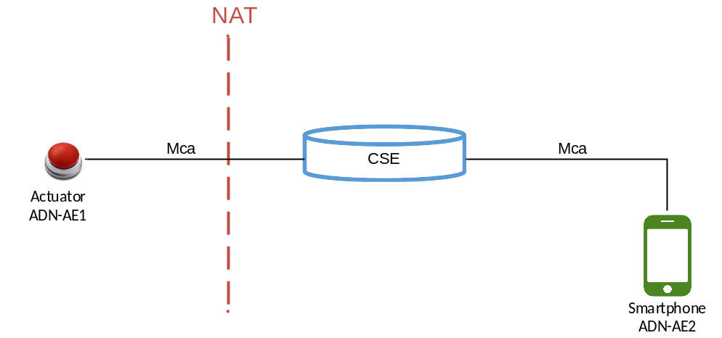
Figure 6.4.2-1: Actuator remote control using polling channel
The ADN-AE1 Actuator registers to the CSE and creates a <container> resource (e.g. named <cont_actuator_status>). <contentInstance> child resources are created in this <container> resource to issue commands to the Actuator (e.g. turn it ON or OFF). The ADN-AE1 creates a <subscription> child resource of the <container> to receive notifications when <contentInstance> child resources are created within the <container> resource. However, due to the NAT, the ADN-AE1 cannot receive notifications directly sent to it from the CSE. Therefore, it creates a <pollingChannel> resource on the CSE and configures its <subscription> resource to have the CSE send the notifications via this <pollingChannel> resource which the ADN-AE1 polls.
The ADN-AE2 is able to remotely change the status of the actuator by creating a new <contentInstance> child resource of the <cont_actuator_status> container resource. Within the content of the <contentInstance> an ‘ON ‘or ‘OFF’ command is configured. As a subscription has been created on the <cont_actuator_status> container resource, a notification is generated by the CSE for each <contentInstance> resource created. These notifications are delivered to ADN-AE2 via the polling channel functionality.

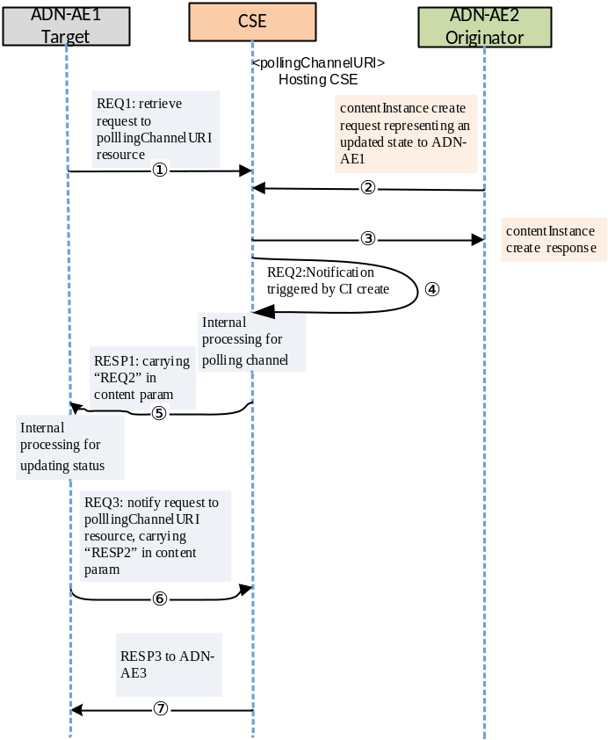

Figure 6.4.2-2: Actuator remote control example call flows

A call flow for remote control is depicted in Figure 6.4.2-2 and the steps are ordered as follows:
- The Actuator (i.e. ADN-AE1) sends RETRIEVE requests (REQ1) periodically to a CSE in order to retrieve notification requests,.
- When a smartphone user updates the actuator state on the smartphone, ADN-AE2 generates a <contentInstance> create request to the <cont_actuator_status> container resource hosted on the CSE. The <contentInstance> contains the command to turn the Actuator ON or OFF.
- The CSE sends a response to the smartphone application (ADN-AE2), to indicate that the <contentInstance> resource is created.
- As the <cont_actuator_status> container resource hosted on the CSE has a subscription, the CSE generates a notification request (REQ2) when the <contentInstance> resource is created. The notification request is targeted to ADN-AE1 (i.e. the subscriber).
- Since ADN-AE1 is not able to receive a notification request (REQ2) directly from the CSE, the polling channel is used. The notification request is sent to ADN-AE1 by returning it encapsulated within the payload of the <pollingChannelURI> Retrieve response (RESP1).
- After processing the notification, (e.g. turning on the water spray), then ADN-AE1 sends a separate notification request (REQ3) to the gateway CSE that includes a response (RESP2) encapsulated in the content parameter to indicate that REQ2 was received and processed successfully (e.g. water spray was turned on).
- The CSE returns a notification response (RESP3) to ADN-AE1, to indicate that the response (RESP2) was successfully received.

6.5 Location policy

6.5.1 Introduction
Geographical location information of M2M entities is one of most significant exposed service capabilities in oneM2M system for services. It allows applications AE to obtain geographical location information of Nodes (e.g. ASN, MN) for Location-based services. Such information could be more than just longitude and the latitude.

In the CSE, the LOC Common Service Function obtains and manages the geographical location information of oneM2M entities.
On a request of AEs, a dedicated resource <locationPolicy> is created into the CSE. This resource does not contain the location information itself of the target nodes. Based on its specific attributes, the <locationPolicy> contains the configuration on how to obtain the location information of a target M2M node (Update period, target ID, location server, target area, etc…)
When a policy is set, a data container(<container> resource) is created and is linked to the <locationPolicy> by its attribute locationContainerID. Then the CSE stores the location information in the target <container> resource as <contentInstance> resource. The data are updated depending of the policy. Any AE can then get access to the geographical location information.
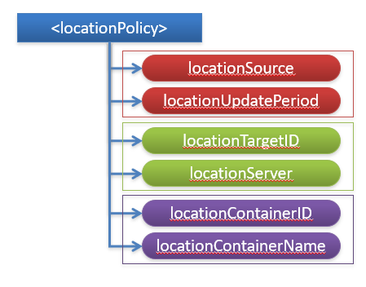
Basic Information
- Source (Network/Device/Sharing)
- Period to obtain location information
For Network-based Location Information
- ID of the Target M2M Node
- ID of the Location Server located in Underlying Network

How to link with a <container> resource
- URI of the created <container>
- Name of the container

Figure 6.5.1-1: <locationPolicy> resource

6.5.2 Obtaining Location Information
The CSE has 3 methods for obtaining location information of an M2M Node . This information is stored in the locationSource attribute of the <locationPolicy> resource.
- Network-based method: where the CSE on behalf of the AE obtains the target M2M Node's location information from an Underlying Network.
- Device-based method: where the ASN is equipped with any location capable modules or technologies (e.g. GPS) and is able to position itself.
- Sharing-based method: where the ADN has no GPS nor an Underlying Network connectivity. Its location information can be retrieved from either the associated ASN or a MN.

Network-based method:

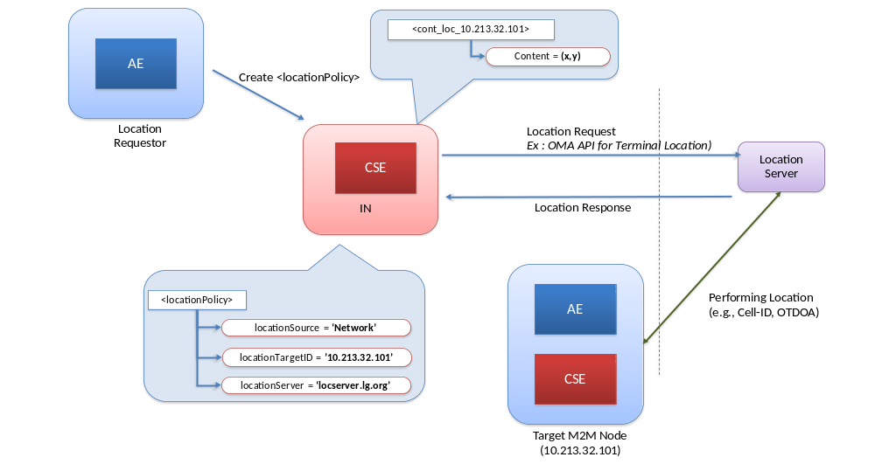 Figure 6.5.2-1: Network-based method

Device-based method

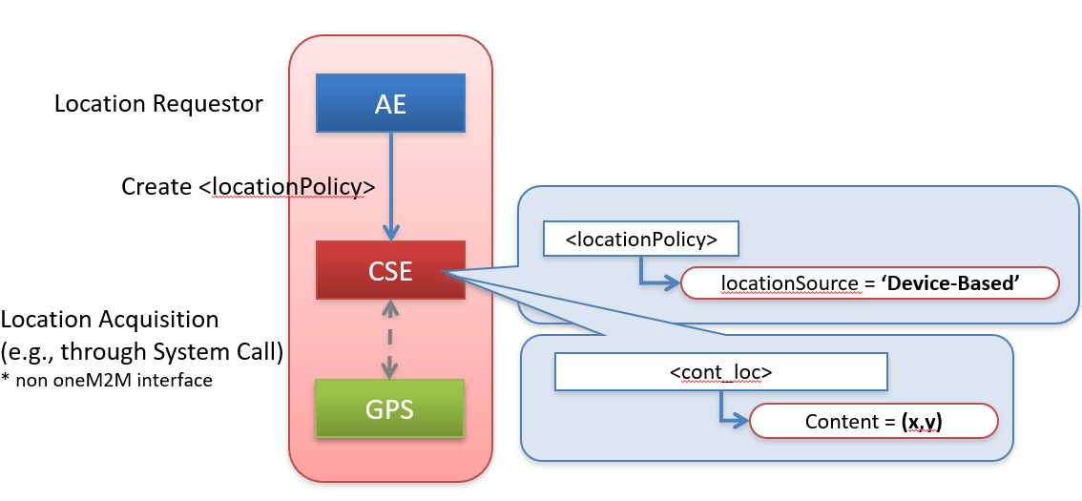

Figure 6.5.2-2: Device-based method

Sharing-based method
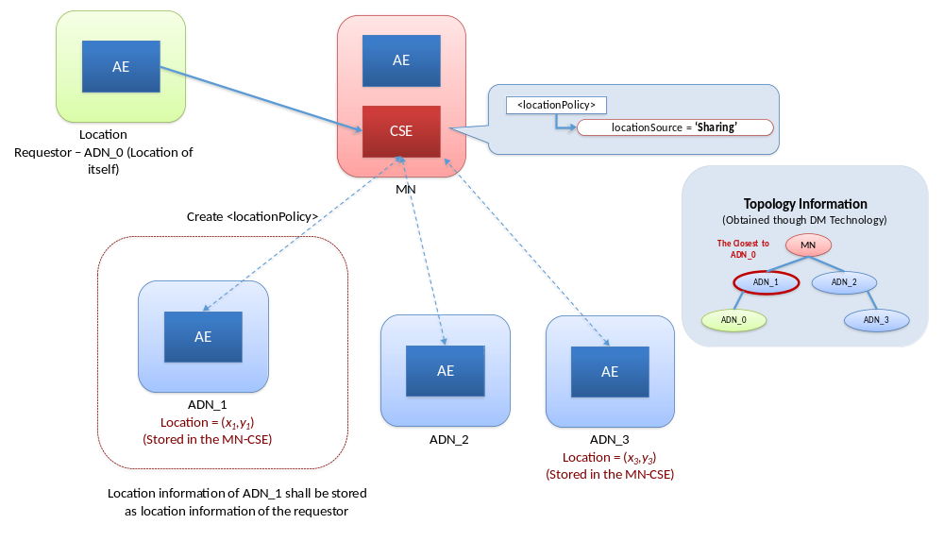Figure 6.5.2-3: Sharing-based method

6.x IPE

6.x Group management

6.x App-ID

6.x Announcement

6.x Block/NB sync/async modes

7 Main feature descriptions

7.1 Introduction

7.2 3GPP Interworking

7.2.1 Introduction
The oneM2M Service Layer can operate over a variety of underlying network connections, including LPWAN Cellular IoT. The northbound API for applications to interface to a oneM2M Service Layer facilitates horizontal sharing of data across different domains. The services exposed by the oneM2M Service Layer allow working with many types of devices and treating different devices as if they are all the same.

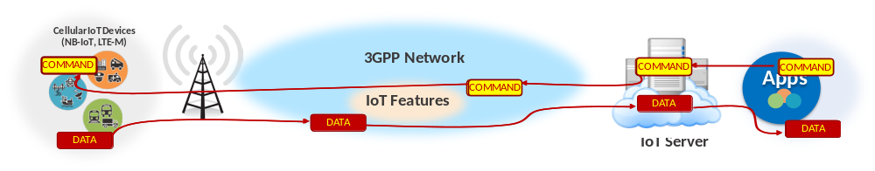Figure 7.2.1-1: Typical Cellular IoT Deployment

- Use of 3GPP IoT features requires low-level knowledge of 3GPP and a business relationship with operator (E.g. Configuration of IoT device sleep times requires intimate knowledge of 3GPP Power Savings Mode (PSM) or extended Idle Mode DRX (eDRX)
➔ This presents a high barrier of use and adoption by typical IoT device manufacturers and app developers
- If devices and apps do not properly use these features, cellular IoT deployments are destined to fail
- Inefficient use of network resources → higher costs and less scalability for operators
- Shortened battery life of devices → inability to deploy cellular IoT devices in many IoT use cases
- Security threats to the network → network, devices and application security will be compromised

3GPP has been adding several IoT centric features to their standard starting in Release 10. For instance, the IoT features are:
- Features to avoid network congestion resulting from massive numbers of IoT devices such that operators can continue to provide a high quality of service to all their subscribers
- Features to enable more efficient use of network resources by IoT devices such that an operator can minimize network deployment and management costs
- Features to help keep an operator’s network secure from the increased threats of IoT devices
- Features that allow IoT devices to sleep for long periods of time such that they can maximize their battery lives

Since Release 3, oneM2M includes additional support for interworking to underlying 3GPP network services , allowing IoT devices to operate in constraint environement where low power and long battery life is necessary.
oneM2M can be deployed internal (or external) to an operator’s network and enable an operator to move up the value-chain to offer not just connectivity but also additional value-add IoT services.
oneM2M interacts with a 3GPP operator’s network to mitigate congestion, enable efficient use of network resources, and help keep network secure. The 3GPP features are exposed to oneM2M service layer for the benefit of IoT applications, and vice-versa.
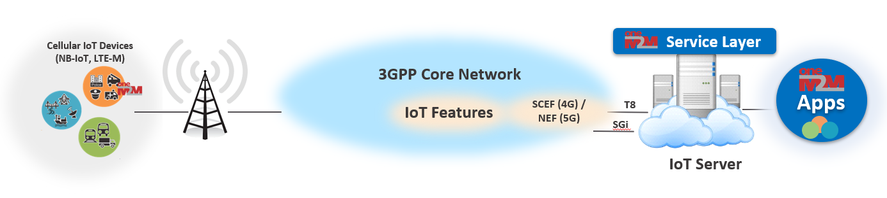
Figure 7.2.1-2: oneM2M - 3GPP Interworking using SCEF / NEF

oneM2M supports interworking to underlying 3GPP network services:
- Sending/Receiving request to/from UE over 3GPP control plane (Non-IP Data Delivery NIDD) rather than data plane
- Configuration of UE’s Power Savings Mode or extended Idle Mode DRX (PSM/eDRX) parameters based on App requirements
- Scheduling and buffering of messages based on UE’s reachability and/or App’s backgroung data policies
- Triggering of UE to establish a network connection and/or register or enrol based on App requirements
- Configuration of network QoS parameters based on App requirements
- Querying of UE location and making it available to Apps
- Receiving notifications when the network is congested and scheduling messages to UE accordingly
- Receiving notifications when UE has been tampered with and disabling communication with UE

7.2.2 IoT Device Enrollment
One of the main challenges when deploying an IoT network is to get unmanned IoT devices to enroll to an IoT Service Provider, provision the devices with essential security IDs, Credentials and contact information required to allow the devices to connect, authenticate and securely register to an IoT Gateway or Server such that they can use services offered by the Service Provider.
Once enrolled and registered, and in order to save battery life, a 3GPP IoT devices does not maintain long-lived network connections. Before a request can be sent to a 3GPP IoT device, it first re-connects to the 3GPP network.
With the standardized interworking with 3GPP network, oneM2M Service Layer initiates the triggering of cellular IoT devices to connect to an operator’s network, be bootstrapped with proper security credentials and authenticate and securely register.

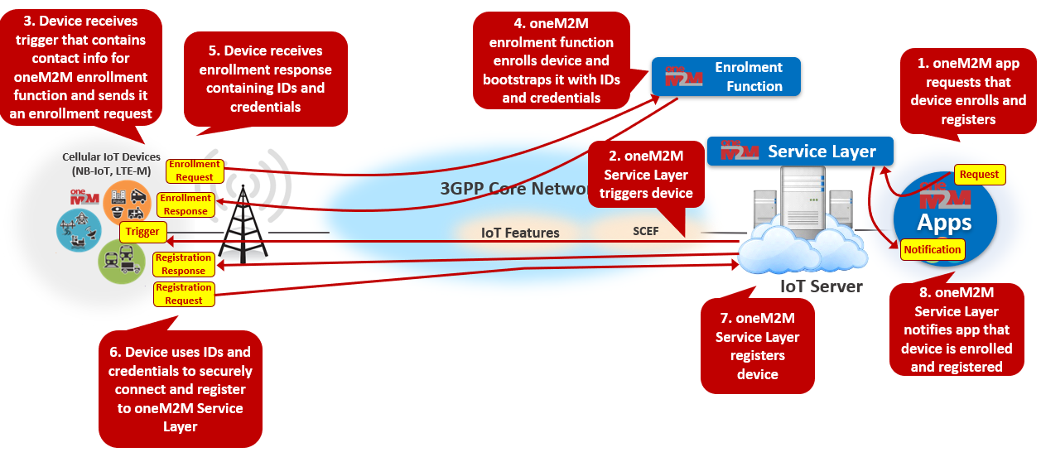
Figure 7.2.2-1: IoT device Enrollement
3GPP T8 supports the capability to allow Service Capability Server to initiate sending a trigger message to a specified UE to perform application specific actions. The underlying 3GPP network routes the trigger request message to the appropriate UE and UE routes the message to the appropriate application
oneM2M defines a trigger payload structure that supports triggering a UE to perform the following actions:
- Contact a oneM2M enrollment server MEF to be provisioned with the necessary IDs and credentials needed for authentication and use of services in a oneM2M Service Provider’s domain.
- Register to a specified oneM2M server (i.e. IN-CSE)
- Establish an IP connection to the oneM2M server that the UE is registered to and update the UE’s point-of-contact information (e.g. IP address and port)
- Perform an specified operation on a specified resource hosted by a specified oneM2M server (e.g. create a new child <contentInstance> resource in a specified parent <container> resource).
oneM2M exposes a trigger API to oneM2M applications that allows them to initiate triggering a UE to perform any of the above actions
- This API is supported via the oneM2M defined <triggerRequest> resource
- This API is layered on top of the SCEF T8 device triggering

7.2.3 IoT Device Sleep Schedule Management
Battery life is crucial for IoT devices. NB-IoT and CAT-M1 devices can supposedly run on 2 double AA batteries for 10 years. 3GPP has defined “deep state” mode (Power Savings Mode or extended Idle Mode DRX) in order to save IoT device battery. But in deep sleep, data can not be sent to the device, thus the device can not be reached. Devices need to sleep for hours if they want to achieve a battery life of multiple years. An IoT Server that collects data from cellular devices needs to understand that the device will be unreachable for long stretches of time.
oneM2M Service Layer optimizes the sleep schedule of cellular IoT devices such that battery life can be maximized. This can be done based on the schedule requirements of IoT devices and the apps that interact with the devices and the requirements of the cellular network operator.
oneM2M supports managing UE schedules based on application requirements:
- oneM2M server (IN-CSE) aggregates schedule requirements for a given UE
  - oneM2M allows each application (AE or CSE) hosted on a UE to specify its schedule of when requests need to be sent or received
  - oneM2M also allows applications that communicate with a UE to specify schedule of when they need to communicate with the UE
- oneM2M server keeps the underlying 3GPP network informed (via T8) of UE schedule requirements

oneM2M exposes a device communication schedule API to oneM2M applications that allows them to configure schedule requirements, retrieve schedule information and receive notifications of schedule changes.
- This API is supported via the oneM2M defined <schedule> resource
- This API is simpler and more user friendly than 3GPP API. It hides complexity of 3GPP T8 API
  - E.g. UE needs to be reachable from 1:00 – 1:30pm every Tuesday
- This API is layered on top of the SCEF T8 Network Parameter Configuration, Reachability Monitoring, and Communication Pattern Configuration APIs

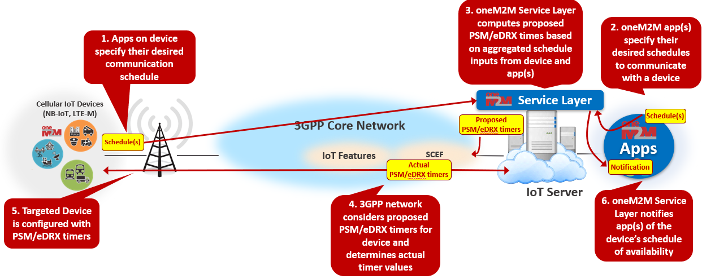

Figure 7.2.3-1: IoT Device Sleep Schedule Management

7.2.4 IoT Device Location Tracking
Certain IoT use cases require awareness of an IoT device location, however many IoT devices lack location reporting capability.
oneM2M Service Layer supports the capability to interwork to the 3GPP T8 for the following Device Location operations :
- A oneM2M server supports the capability to interwork to the 3GPP T8 location monitoring API to retrieve the current location of a UE and to subscribe to receive notifications if a UE’s location changes.
- A oneM2M server supports storing location history of a UE.
- A oneM2M server supports geo-fencing capabilities used to generate events if/when a UE’s location enters or leaves a specified boundary.
- A oneM2M server supports location-based authorization used to grant/deny access to resources based on the location of the originator of a request.
- oneM2M exposes a location API to oneM2M applications :
- Application can retrieve the current location of a UE, instruct the oneM2M server to track the location of a UE or can define a geo-fence boundary.
- This API is supported via the oneM2M defined <locationPolicy> resource
- This API is layered on top of the SCEF T8 location monitoring API

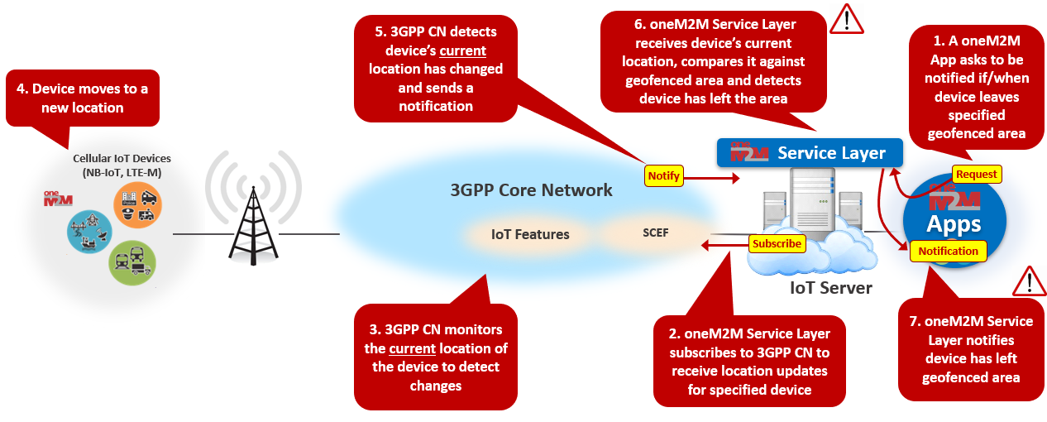
Figure 7.2.4-1: IoT Device Location Tracking

7.2.5 IoT Device Message Delivery Handling

7.2.6 Network Congestion Control

7.2.7 Non-IP Data Delivery (NIDD)

7.2.8 IoT Device Tampering Detection

7.2.9 Management of Groups of IoT Devices

7.2.10 IoT Roaming Device Services

7.3 FlexContainer

7.4 Semantics

7.5 Industrial Domain

7.5.1 Time Series

7.5.2 Transaction

7.x Security
- 7.x.1 Introduction
- Dynamic Authorization
- Distributed Authorization
- End to end

7.x SDT

Proforma copyright release text block
This text box shall immediately follow after the heading of an element (i.e. clause or annex) containing a proforma or template which is intended to be copied by the user. Such an element shall always start on a new page.
Notwithstanding the provisions of the copyright clause related to the text of the present document, oneM2M grants that users of the present document may freely reproduce the <proformatype> proforma in this {clause|annex} so that it can be used for its intended purposes and may further publish the completed <proformatype>.
<PAGE BREAK>

Annexes
Each annex shall start on a new page (insert a page break between annexes A and B, annexes B and C, etc.).
Use the Heading 9 style for the title and the Normal style for the text.
Annex <A>:
Title of annex (style H9)
<Text>
<PAGE BREAK>
Annex <B>:
Title of annex (style H9)
<Text>
B.1 First clause of the annex (style H1)
<Text>
B.1.1 First subdivided clause of the annex (style H2)
<Text>
<PAGE BREAK>

Annex <y>:
Bibliography
The annex entitled "Bibliography" is optional.
It shall contain a list of standards, books, articles, or other sources on a particular subject which are not mentioned in the document itself.
It shall not include references mentioned in the document.
Use the Heading 9 style for the title and B1+ or Normal for the text.
- <Publication>: "<Title>".
OR
<Publication>: "<Title>".
<PAGE BREAK>

History
This clause shall be the last one in the document and list the main phases (all additional information will be removed at the publication stage).
Publication history
V1.1.1 | <yyyy-mm-dd> | <Milestone>

Draft history (to be removed on publication)
V0.0.1 | 2018-11-10 | Initial draft
V0.1.0 | 2018-12-10 | Implemented contribution agreed at ARC#38  ARC-2018-0317R01-TR-0057-oneM2M-overview_clause_5
V0.2.0 | 2019-02-26 | Implemented contribution agreed at SDS#39  SDS-2019-0110R03-TR-0057_oneM2M_overview
V0.3.0 | 2019-05-04 | Implemented contribution agreed at SDS#39.8  SDS-2019-0103R01-TR-0057_Long_Polling_description
V0.4.0 | 2021-01-15 | Implemented contribution agreed at SDS#48  SDS-2020-0329-TR-0057_Location_Policy
V0.5.0 | 2021-02-11 | Implemented contribution agreed at SDS#49  SDS-2020-0375-TR-0057_3GPP_interworking_-_part_1

