Source: CoU AHG
Title: “Compilation of Understanding” for the oneM2M Initiative for M2M Standardization – V10 Internal Living Document
Agenda item: {?} (For Discussion and Action)

Foreword
This living document is intended to reflect the compilation of agreements after each meeting of the Potential Partners. This version 10 reflects the agreements till the conclusion of May 07 and May 10, 2012 Virtual Meetings.
Note: Revisions compared with previous version are made visible.
Note: The Plenary is also invited to comment and give guidance on the structure and approach of this document, in addition to assessing the correctness of the content.
Note: The CoU document will record “contentwise” agreed results, views and targets but not actions and processes (e.g. setting up adhoc groups etc.) for achieving the results and agreements.
Note: Main version numbers like x (x=1,2,3, …) are used for Plenary level documents. Interim versions x.y (y=0…9) are used for the CoU AdHoc group internal process during the Plenary meetings/calls.

oneM2M Initiative for Global M2M Standardization
“Compilation of Understanding”

This Compilation is an expression of the joint understanding of status of the common work toward mutually agreed upon goals; however, this Compilation of Understanding, as such, is not an Agreement to be signed and binding upon the associations.

Introduction
ARIB, ATIS, CCSA, ETSI, TIA, TTA, and TTC (the “SDOs”) recognize that M2M services often rely upon telecommunications providers for connectivity between the myriad of devices in the field and the M2M application servers. There is a need for a common efficient, easily and widely available M2M Service Layer, which can be readily embedded within various hardware and software. Thus, the SDOs have identified the need for a cooperative M2M community standards activity which leads to regularly enhanced releases of the M2M Service Layer specifications. This standards activity is known as “oneM2M”.

Definitions
The SDOs have agreed on the following definitions for the purposes of this initiative:
0. Machine-to-Machine and Name of this initiative
Machine-to machine is related to control/monitoring system comprising of sensor/actuator/processing nodes that are connected via communication networks, designed in such a way that exchange of information can e triggered without human interaction. oneM2M is the agreed name for this collaboration initiative.
1 Technical Specifications and Technical Reports
Technical Specifications and Technical Reports are deliverables developed by oneM2M that are globally applicable, access-independent M2M Solutions with the initial focus on the M2M Service Layer.
2 Steering Committee
The Steering Committee has total responsibility for providing strategic direction and management to the organization. Among the responsibilities of the Steering Committee are the review and approval of changes to the Partnership’s scope, modifications of the working procedures, and Partnership funding and budget. The Steering Committee will not take part in technical discussions.
3 Technical Plenary
The Technical Plenary has total responsibility for the oneM2M technical activities. It is also responsible for the organization of the technical work and it can autonomously create sub groups.
4 Machine-to-Machine Solution
A Machine-to-Machine Solution is a combination of devices, software and services that operate with little or no human interaction.
5 Partner, Partnership
The terms “Partner” and “Partnership” are used to express voluntary, mutual cooperation. The Partnership is not to be construed as a legal entity of any sort or by any definition.
The term “Partners” is used to collectively describe Partners Type 1 and Partners Type 2.
6. oneM2M Participants
The term “oneM2M Participant” refers to oneM2M Partners, Members and Associate Members.
7. Affiliate
An Affiliate of a first legal entity means any other legal entity which controls, is controlled by, or is under common control with such a first legal entity but any such legal entity shall be deemed to be an Affiliate only as long as such control exists, and for the purposes of this definition, "control" shall mean direct or indirect ownership of more than fifty percent (50%) of the voting power, capital or other securities of the controlled or commonly controlled entity.
8 Partner Type 1
A Partner Type 1 is a legal entity and is any member-based organization that has acknowledged competency in the area of the work and is willing to:
• Provide strategic direction to the Partnership;
• Encourage its members to participate in the technical work of the Partnership as oneM2M Members; and
• Commit itself to the undertakings included in this Agreement.
9 Partner Type 2
A Partner Type 2 is a legal entity and is any member-based organization that has acknowledged competency in the area of the work and is capable of, and willing to:
• Provide strategic direction and technical input to the Partnership; and
• Commit itself to the undertakings included in this Agreement.
10. Members
A oneM2M Member:
• Is any organization which is a legal entity and admitted through a specific Partner Type 1;
• Has an interest in the development and/or implementation of oneM2M Technical Specifications and Technical Reports;
• Has agreed to abide by the IPR Policy of the specific Partner Type 1; and
• Is willing to commit itself to the undertakings included in this Agreement.
The list of the Members will be maintained by the Secretariat and visible to all oneM2M Participants.
11. Associate Members
An Associate Member is any government or regulatory agency that has an interest in the development of oneM2M Technical Specifications and Technical Reports.
The list of the Associate Members will be maintained by the Secretariat and visible to all oneM2M Participants.

Objectives and Purpose
The SDOs have reached a common understanding on the benefits to form a M2M initiative, and agree to proceed forward in the formal establishment of “oneM2M” with a common understanding on its purpose as being a global initiative to:
- Develop one globally agreed M2M specifications with initial focus on Service Layer, using common use cases and end-to-end architecture principles across several vertical M2M applications.
- Interface this Service Layer to higher layer applications and underlying network transport capabilities through a standardized adaptation layer, if necessary.
- Develop or leverage existing work in other fora for Service Layer network and device APIs, as desired.
- Consolidate current M2M Service Layer standards activities into the oneM2M initiative.
- Identify a common Service Layer architecture and identify gaps where existing standards do not fulfill the requirements and provide or initiate the creation of specifications to fill these gaps.
- Develop and maintain Technical Specifications and Technical Reports in support of the M2M common Service Layer architecture framework.
- Partner/Collaborate with wireless and wireline SDOs and fora responsible for developing standards for Core and Access Networks.
- Partner/Collaborate with SDOs and fora in charge of developing the vertical markets (i.e., domain-specific) aspects of M2M applications.
- Partner/Collaborate with SDOs and fora in charge of developing auxiliary specifications (e.g., OMA Device Management and Device APIs, W3C for Device APIs).
- Develop specifications that will help drive the industry towards a goal of lower operating expenses, lower capital expenses, faster time-to-market, and mass-market economies of scale.
Scope
The SDOs have reached a common understanding on the scope of the oneM2M initiative to include:
- Use cases and requirements for a common set of Service Layer capabilities
- Service Layer aspects with high level and detailed service architecture, in light of an access independent view of end-to-end services
- Protocols/APIs/standard objects based on this architecture (open interfaces & protocols)
- Security and privacy aspects (authentication, encryption, integrity verification)
- Reachability and discovery of applications
- Interoperability, including test and conformance specifications
- Collection of data for charging records (to be used for billing and statistical purposes)
- Identification and naming of devices and applications
- Information models and data management (including store and subscribe/notify functionality)
- Management aspects (including remote management of entities)
- Common use cases, terminal/module aspects, including Service Layer interfaces/APIs between:
  - Application and Service Layers
  - Service Layer and communication functions
Responsibility
The SDOs have reached a common understanding that the oneM2M initiative shall have the responsibility to develop and maintain specifications and reports related to a globally interoperable framework, taking an end-to-end view, to facilitate Machine-to-Machine (M2M) business, with attention to Service aspects, specifically:
- To identify areas where standardization would facilitate M2M business and to develop, approve and maintain the necessary set of Technical Specifications and Technical Reports within Scope above.
- To consider the evolution of M2M
- To facilitate dissemination and usage of the developed Technical Specifications and Technical Reports
- To facilitate awareness of its activities and of solutions it develop

Principles
The SDOs agree that participation in the oneM2M initiative will be open and well balanced; provide opportunities for various levels of participation; accommodate companies and organizations, and provide flexibility for inputs from all market segments.
The oneM2M initiative will avoid overlap with existing work and focus on cooperative efforts, and prioritize work efforts based upon importance and work assignments.

Participation
Note: The text below is a copy of the Participation related text in draft Partnership Agreement (chapters 3, 4, 5 and 6) as agreed in Plenary on May 10.
3 Partner Type 1
3.1 Undertakings of a Partner Type 1
A Partner Type 1 shall undertake to all the following points:
- Avoid development of work that overlaps with the work of oneM2M, preventing fragmentation of the standardization of a global M2M solution;
- Submit for potential transfer, work that overlaps with the work of oneM2M to oneM2M as a contribution to oneM2M. Complementary work that may be referenced by oneM2M can continue;
- Encourage its members to contribute to the common set of Technical Specifications and Technical Reports and to avoid duplication of work;
- Identify as early as possible, any national/regional regulatory requirements that may lead to options within the Technical Specifications and Technical Reports;
- Make its IPR Policy available for consideration for compatibility by the other Partners;
- Maintain, and make available to the other Partners and to the Secretariat, a list of Members that it admits to participate in the technical work of oneM2M. Such admittance shall require that the Member has agreed to abide by the IPR Policy of the Partner Type 1;
- Convert/transpose/publish all relevant Technical Specifications and Technical Reports resulting from the work in oneM2M into its own relevant deliverables through its normal processes. To avoid unnecessary duplication, Partners Type 1 in the same geographic region may coordinate the conversion/transposition/publication of relevant Technical Specifications and Technical Reports in that region; and
- Contribute to the operation of oneM2M.

3.2 Rights of a Partner Type 1
Partner Type 1 has the right to:
- Attend, participate and vote in meetings of the Steering Committee;
- Admit organizations as oneM2M Members to facilitate the technical work of the Partnership; and
- Attend meetings of the Technical Plenary and its sub-groups.
4 Partner Type 2
4.1 Undertakings of a Partner Type 2
A Partner Type 2 shall undertake to all the following points:
- Contribute to the common set of Technical Specifications and Technical Reports representing input from its members that are not also oneM2M Members;
- Adopt oneM2M Technical Specifications and Technical Reports;
- Identify as early as possible, any national/regional regulatory requirements that may lead to options within the Technical Specifications and Technical Reports;
- Make its IPR Policy available for consideration for compatibility by the other Partners or provide written assurance that:
a) its oneM2M contributions are made in accordance with a Partner Type 1 IPR Policy; and
b) its members are bound by such an IPR Policy relative to any oneM2M contributions;
- Contribute to the operation of oneM2M.

4.2 Rights of a Partner Type 2
A Partner Type 2 has the right to:
- Attend, participate and vote in meetings of the Steering Committee; and
- Attend, participate and vote in meetings of the Technical Plenary and its sub-groups.

5 Member
5.1 Undertakings of a Member
A Member shall undertake to all the following points:
- Abide by the IPR Policy of a specific Partner Type 1;
- Contribute to the common set of Technical Specifications and Technical Reports; and
- Contribute to the operation of oneM2M via their specific Partner Type 1.

5.2 Rights of a Member
A Member has the right to:
- Attend the meetings of the Steering Committee;
- Attend and participate in meetings of the Technical Plenary and its sub-groups;
- Vote in meetings of the Technical Plenary and its subgroups, as appropriate, and
- Have one vote per admitting Partner Type 1. If an organization and one or more of its Affiliates are admitted as oneM2M Members by a specific Partner Type 1, the organization and its Affiliates may cast only one vote per admitting Partner Type 1 at each voting event.

6 Associate Member

6.1 Undertakings of an Associate Member

An Associate Member is not obligated to specific undertakings in oneM2M.
6.2 Rights of an Associate Member
An Associate Member has the right to attend and provide input to meetings of the Technical Plenary and its sub-groups. However, such input shall be limited to clarifications regarding regulatory matters and informational contributions.

.
Structure
The SDOs have a common understanding to:
- Establish a simple and effective operational structure
- Be responsive to the needs of the vertical market stakeholders (individual and organizational), SDOs, and service providers
- Balance regional requirements and differences
- Address timeframe objectives across the regions
- Support global harmonization and consolidation
- Afford a level playing field for all stakeholders
- Constrain resource and travel commitments, and leverage electronic tools as much as possible
- Develop common procedures, including common policy for essential IPR, using existing FRAND/RAND IPR policies of the participating partners.

Note: There is an agreement amongst the SDOs that oneM2M is a non-legal entity.

The SDOs agree that the organizational structure of one M2M will include a Steering Committee and a Technical Plenary which reports to the Steering Committee.
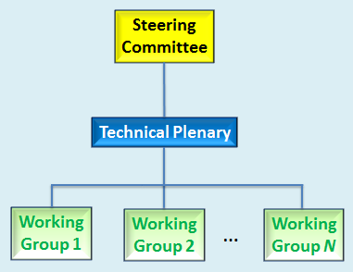

Possible Steering Committee Responsibilities:
- Manages work scope & direction
  - Approves Terms of Reference (ToR)
  - Approves scope of Technical Plenary
- Develops and Maintains Working Procedures
  - Defines procedures for resolving deadlocks at technical plenary level
  - Approves new liaison relationships
  - Deals with other organizational issues as they arise
  - May create task groups with responsibility to handle issues as they arise
- Organizational Oversight
  - Handles appeals of process issues
  - Elects Steering Committee leadership
  - Approves Technical Plenary leadership
  - Develops and manages budget
  - Manages secretariat
  - Handles marketing and public relationship

Possible Technical Plenary Responsibilities:
- Technical Program Management
  - Responsible for technical program and its management
  - Manages and approves Work Items and Study Items (scope, timeline, responsible groups)
  - Determines whether specific regional requirements will be addressed
  - Handles release process and change process
  - Creates Working Groups (WGs) and Ad Hoc Groups (AHGs) as needed
- Technical Oversight
  - Elects leadership (subject to Steering Committee approval)
  - Approves WG leadership
  - Approves Terms of Reference (ToR) and scope of WGs and AHGs
  - Resolves deadlocks within WGs

Note: Partners agreed on March 5th to add Working Procedures in the scope of work.
At the Tokyo meeting on 28-29 March 2012 the SDOs agreed in principle on the following oneM2M related aspects
1: Votings in technical groups
- in case an organization controlling more than one oneM2M membership 1 vote per “company”/ per Partner Type 1

2: Definition of “Company” and “Affiliate”

- “Company” – the set of corporate entities and affiliates.
- Any corporate entity and/or its affiliates may be a oneM2M member.
- "Affiliate" of a first legal entity means any other legal entity:
  - directly or indirectly owning or controlling the first legal entity, or
  - under the same direct or indirect ownership or control as the first legal entity, or
  - directly or indirectly owned or controlled by the first legal entity
3: Technical contributions and IPR policies for member based organizations
- IPR policies for technical contribution for Partner Type 2
  - Agreed that it is enough for a Partner type 2 to assure that it has an IPR policy compatible with Partner type 1.
- IPR policy for technical contribution for members of Partner Type 1 that are associations
  - Agreed that this case is covered in the current Partner type 1 IPR policies

- IPR policies for technical contribution by Partner Type 2
  - At a minimum, a Partner Type 2 must:
  - Have an IPR policy that is compatible with a Partner Type 1 IPR Policy; or
  - Provide written assurance that: (i) its oneM2M contributions are made in accordance with a Partner Type 1 IPR Policy; and (ii) its members are bound by such an IPR policy relative to any oneM2M contributions.

Agreed Figure for clarifying some Issues concerning IPR
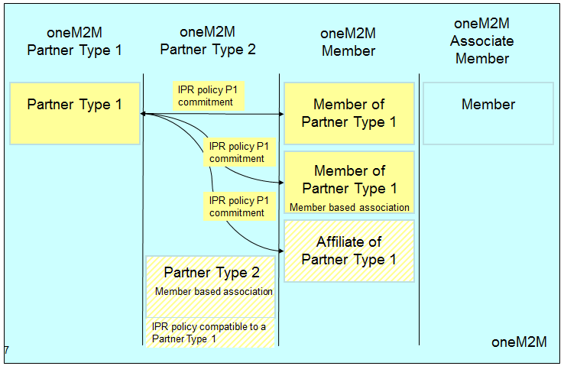

4: Partner Type 1 Publishing
- Agreed that Partner Type 1 should be requested to be capable to publish Standards in the context oneM2M scope
  - At least one Type 1 Partner per region shall publish.
  - More Type 1 Partners can publish.
Note. A Partner using or publishing a oneM2M technical specification or technical report shall not impose an IPR policy more restrictive than that described in the oneM2M IPR statement attached to this Partnership Agreement.
- It was noted and agreed that regional requirements are to be included in the oneM2M specifications

5: Meeting hosting
Note: Long term aspects were not concluded
Short term: By rotation per region (arrangements as for meetings 1-4)

6: Funding Principles - Long Term (Including core secretariat functions but excluding meeting hosting)
- Agreed funding formula to share the costs
  - fixed part (flat fee or a percentage of the total budget) equal to all Type 1 Partners and
  - variable part which is proportional to number of Members admitted to oneM2M by Type 1 Partners
- Agreed that Type 1 Partner will provide funding for oneM2M
  - Members; will not pay a fee directly to oneM2M
  - Allocation of the variable part of the funding to their individual Members is at the discretion of each Type 1 Partner
- Type 2 Partners
  - Free of charge participation to the end of 2012
  - Funding to be provided by Type 2 Partners after 2012 is subject to further discussions
- Associate Members
  - Agreed to limit Associate Membership to: regulatory agencies, government agencies
  - Free of charge participation for Associate Members
- It was noted that guest status will be defined in the Working Procedures.

- Agreed that funding by means of monetary and/or by resources
  - Each Type 1 Partner shall have a funding requirement, the value of which can be satisfied by monetary contribution and/or commitment
of resources according to the funding formula.
  - The resources are subject to acceptance by the Steering Committee.
- Short term voluntary resources until end of 2012 were agreed
    - 2013 resourcing is for further discussion
      - TIA, ATIS, TTA: voluntary resources not for 2013
      - ARIB, TTC, ETSI, CCSA: voluntary resources till end of 2013
      - ETSI is committed to provide 2 full time resources to the end of 2013 for support of secretariat functions

Timeline
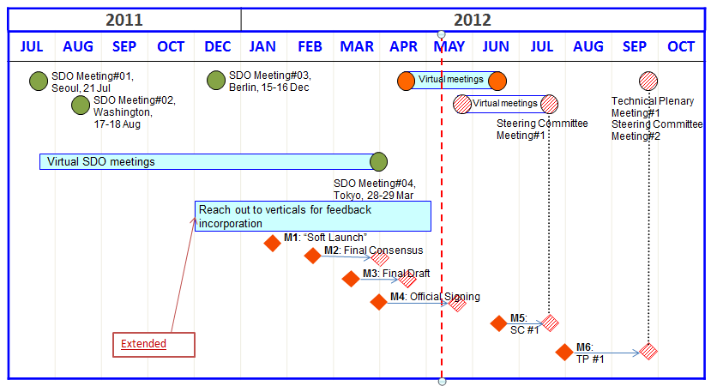

Events | Targeted Date | Completed Date | Note/Current Outlook
Milestone M1 | Jan 18, 2012 | Jan 18, 2012 | “Soft Launch”
Milestone M2 | Mar 29, 2012 | Mar 29, 2012 | Final Consensus
Milestone M3 | Apr 20, 2012 | Apr 20, 2012 | Final Draft of founding documents  Note 1: Convenor arrangements for SC were further clarified (see details in M3).  Note2: ´Invitation to Verticals to join oneM2M at the official signing´ was moved over to Milestone M4.
Milestone M4 | May 21, 2012 |  | Official Signing  Note: Following endorsement of the Patnership Agreement text, the formal approval processes of each Potential Partner could take some time e.g. until mid June.
Milestone M5 | Jul 24-26, 2012 |  | SC #1
Milestone M6 | Sep 24-28, 2012 |  | TP #1

Table 1: Key Dates for Milestones

Milestone M1 – “Soft Launch”
- IPR regime agreed
- Communiqué released
- Material for communication with verticals updated to include Berlin meeting results
- Target date: 18 Jan 2012 - Completed
Milestone M2 – Final Consensus

- Final consensus reached and documented on all major principles (scope, partnership and participation principles, structure, legal status, participation rules, rights and responsibilities, level of secretariat services, funding principles)
- Initial Organizations identified and start work on drafting the founding documents
- Target date: 29 March 2012 - Completed
Milestone M3 – Final Draft

- Final draft of founding documents available
(Participation rules, IPR policy and anti-trust policy, funding model / membership fee structure and initial 2012 resources including schedule agreed upon)
- Partnership Agreement (ready to be signed, for internal approval)
- Draft Working Procedures available
- Secretariat support activities identified
(e.g. online web presence, on-site meeting support, document editing, document management, branding/publicity)

- Planning of the first meetings of SC and TP
  - Convenor of Steering Committee nominated – Note: In Plenary on April 20 the Partners agreed that the Convenor arrangements for the first SC meeting should follow the same procedure as for the Potential Partner meetings that had taken place to date. This would mean thatSC#1 would be Convened by David Foote and Co-Convened by Jonas Sundborg and Yong Chang. It was expected that a call for candidates would be issued during SC#1 so that a Chairman and Vice-Chairmen can be duly elected at SC#2. It was also noted that the Convenors for the SC would not be eligible to stand for the position of SC Chairman.
- Target date: 20 Apr 2012 - Completed
Milestone M4 – Official Signing
- Draft Agenda for the first SC meeting (2 weeks before M4)
- 2013 proposed budget (high and low) and funding model / membership fee structure and initial resources including schedule available
- Provision of secretariat functions agreed upon
- Founding agreement signed (Clarified on May 07 that this means virtual signing)
- Steering Committee Members identified, call for SC chair candidates
- Preliminary list of members of the initiative identified
- Invitation to Verticals to join oneM2M at the official signing (handed over from Milestone M3)
- Invitations issued to participate
- Target date: 21 May 2012
Milestone M5 – SC #1
- Kick-off event and ceremony of signing
- First Steering Committee meeting
  - Convenor of Technical Plenary nominated by Steering Committee
  - Number of Participants of Technical Plenary identified
  - Working Procedures approved by Steering Committee
  - Draft Agenda of the first TP meeting
- Partners Type 1 may provide first list of proposed candidate standards/specifications to be transferred into oneM2M
- Target date: 24-26 Jul 2012 (3 days), hosted by ATIS and TIA in North America
Milestone M6 – TP #1 (& SC #2)
- Analysis of the potential candidate standards/specifications to be transferred into oneM2M and potential agreement
- Initial discussion on Work Plan
- Initial Working Groups defined
- Convenors of Working Groups nominated by Technical Plenary
- Meeting schedule defined
- Target date: 24-28 Sep 2012 (5 days), hosted by ETSI in Europe

Note: In March 28-29 Plenary it was also agreed:
- SC #2 (half day) can be co-located with the TP #1
  - 2013 budget available
- TP #2: 10-14 Dec 2012 (5 days), hosted by CCSA in China

Note from CoU group leader: Below the ToR agreed in the Berlin meeting has been inserted. We have already sections in this document with similar content. In the discussion both views have been expressed to keep the ToR in this document and to remove the ToR. As a result, for the time being we keep the ToR text in the CoU document.
Term of Reference
- Definitions
  - Machine-to-Machine (M2M) is related to control/monitoring system comprising of sensor/actuator/processing nodes that are connected via communication networks, designed in such a way that exchange of information can be triggered without human interaction.
  - oneM2M is the agreed name for this M2M Collaboration Initiative
- Scope
  - Use cases and requirements for a common set of Service Layer capabilities
  - Service Layer aspects with high level and detailed service architecture, in light of an access independent view of end-to-end services
  - Protocols/APIs/standard objects based on this architecture (open interfaces & protocols)
  - Security and privacy aspects (authentication, encryption, integrity verification)
  - Reachability and discovery of applications
  - Interoperability, including test and conformance specifications
  - Charging aspects (charging data, not billing)
  - Identification and naming of devices and applications
  - Information models and data management (including store and subscribe/notify functionality)
  - Management aspects (including remote management of entities)
  - Common use cases, terminal/module aspects, including Service Layer interfaces/APIs between:
    - Application and Service Layers
    - Service Layer and communication functions
- Responsibility
  - oneM2M shall have the responsibility to develop and maintain specifications and reports related to a globally interoperable framework, taking an end-to-end view, to facilitate Machine-to-Machine (M2M) business, with attention to Service aspects, specifically:
    - To identify areas where standardization would facilitate M2M business and to develop, approve and maintain the necessary set of Technical Specifications and Technical Reports within Scope above.
    - To consider the evolution of M2M
    - To facilitate dissemination and usage of the developed Technical Specifications and Technical Reports
    - To facilitate awareness of its activities and of solutions it develops
- Organization and working methods
  - oneM2M and groups operating within oneM2M shall work in accordance with the Working Procedures – a document to be developed during the start-up phase

Summary of Commitment to the Global Initiative for M2M Standardization
The SDOs have agreed to collaborate in the formation of oneM2M initiative. The SDOs have reviewed the proposed purpose, scope, and principles of oneM2M and will progress the initiative as defined in the timeline within this Compilation of Understanding.
In Berlin meeting the SDOs agreed to make a public statement (jointly agreed and issued Communique) in January. Final draft of the communiqué was approved during January 18, 2012 Virtual Meeting. The communiqué has since been released by various SDOs.
In Tokyo meeting the SDOs agreed target date for Official Signing of the Founding Agreement to be 21 May 2012. The oneM2M Kick-off event, Ceremony of Signing and first Steering Committee meeting will be held on 24-26 July 2012, hosted by ATIS and TIA in North America. The first Technical Plenary meeting will be held on 24-28 September, hosted by ETSI in Europe. The second Technical Plenary will be held on 10-14 Dec 2012, hosted by CCSA in China.

