INPUT CONTRIBUTION
Group Name:* | ARC WG
Title:* | Functional Architecture Update
Source:* | Intel, NTT DOCOMO, KT, Qualcomm, Telecom Italia, Sierra Wireless, Cisco, AT&T, ZTE, Ericsson, Telxxis, NEC?
Contact: | Puneet Jain (puneet.jain@intel.com)
Date:* | 2013-12-11
Abstract:* | This contribution proposes to update oneM2M Functional Architecture.
Agenda Item:* | Contribution
Work item(s): | WI 0002 - oneM2M Architecture
Document(s)  Impacted* | oneM2M-TS-0001 Technical Specification - M2M Architecture
Intended purpose of  document:* | Decision  Discussion  Information  Other <specify>
Decision requested or recommendation:* | Agree to incorporate this text into the TS (oneM2M-TS-0001)

oneM2M IPR STATEMENT
Participation in, or attendance at, any activity of oneM2M, constitutes acceptance of and agreement to be bound by all provisions of IPR policy of the admitting Partner Type 1 and permission that all communications and statements, oral or written, or other information disclosed or presented, and any translation or derivative thereof, may without compensation, and to the extent such participant or attendee may legally and freely grant such copyright rights, be distributed, published, and posted on oneM2M’s web site, in whole or in part, on a non-exclusive basis by oneM2M or oneM2M Partners Type 1 or their licensees or assignees, or as oneM2M SC directs.

Introduction
The latest version of oneM2M Functional Architecture is V0.2.2 which is announced 8th November.
This contribution is based on problem highlighted in oneM2M-ARC-2013-525-Functional_Architetcure_Discussion.
This contribution merges the proposal from oneM2M-ARC-2013-554R01-Clarification_of_Mcc_Reference_Point and oneM2M-ARC-2013-553- Clarification_of_Mcn_and_Mcc’.

Proposal
--------------------------------------------------Start 1st Change -------------------------------------------------

5 Architecture Model
Editor's Note: Definitions are FFS. As definitions get refined and agreed to, the following text to be adjusted to eflect the agreements

5.1 General Concepts
Figure 5.1-1 depicts the oneM2M Layered Model for supporting end-to-end (E2E) M2M Services. This layered model comprises three layers: Application Layer, Common Services Layer and the Underlying Network Services Layer.

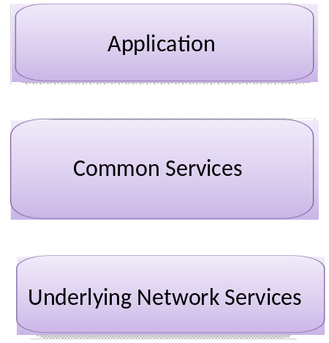
Figure 5.1-1: oneM2M Layered Model

5.2 Architecture Reference Model

5.2.1 Functional Architecture
Figure 5.2.1-1illustrates oneM2M functional architecture.

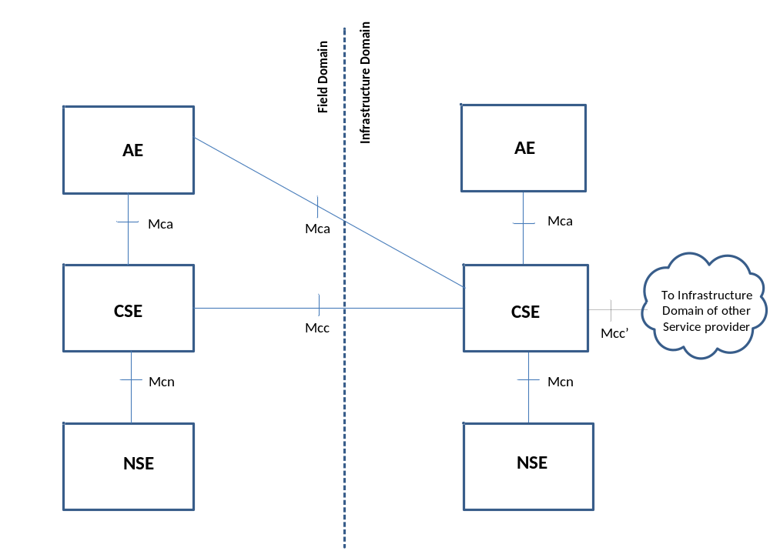
Figure 5.2.1-1: oneM2M Functional Architecture

The oneM2M functional Architecture in Figure 5.2.1-1 comprises of the following functions:
1. Application Entity (AE): Application Entity provides Application logic for the end-to-end M2M solutions. Examples of the Application Entities can be fleet tracking application, remote blood sugar monitoring application, or remote power metering and controlling application.
2. Common Services Entity (CSE): A Common Services Entity comprises the set of "service functions" that are common to the M2M environments and specified by oneM2M. Such service functions are exposed to other entities through Reference Points Mca and Mcc. Reference point Mcn is used for accessing Underlying Network Service Entities.
Examples of service functions offered by CSE are: Data Management, Device Management, M2M Subscription Management, Location Services etc. Such "subfunctions" offered by a CSE may be logically apprehended as Common Services Functions (CSFs). Inside a Common Services Entity (CSE), some of the CSFs can be mandatory and others can be optional. Also, inside a CSF, some subfunctions can be mandatory or optional (e.g., inside a "Device Management" CSF, some of the subfunctions like "Application Software Installation", "Firmware Updates", "Logging", "Monitoring", etc. can be mandatory or optional).
3. Underlying Network Services Entity (NSE): An Underlying Network Services Entity provides services to the CSEs. Examples of such services include device management, location services and device triggering. No particular organization of the NSEs is assumed.
NOTE: Underlying Networks provide data transport services between entities in the oneM2M system. Such data transport services are not included in the NSE.

5.2.2 Reference Points
The following reference points are supported by the Common Service Entity (CSE). The "Mc(-) nomenclature is based on the mnemonic "M2M communications".

5.2.2.1 Mca Reference Point
The Mca reference point designates communication flows between an Application Entity (AE) and a Common Services Entity (CSE). The Mca reference point shall allow an AE to use the services provided by the CSE, and for the CSE to communicate with the AE.
The services offered via the Mca reference point are dependent on the functionality supported by the CSE.
NOTE: The AE and the CSE it invokes may or may not be co-located within the same physical entity.

5.2.2.2 Mcc Reference Point
The Mcc reference point designates communication flows between two Common Service Entities (CSEs). The Mcc reference point shall allow a CSE to use the services of another CSE in order to provide needed functionality. The services offered via the Mcc reference point are dependent on the functionality supported by the CSEs.
NOTE: The Mcc reference point between two CSEs may be supported between different M2M nodes.
Editor’s Note: In the event oneM2M develops specifications for more than one CSE implementation, the use of the Mcc reference point between them (for both intra-domain and inter-domain instances) would need elaboration, and is FFS. This requires coordination between the ARC and PRO working groups.

5.2.2.3 Mcn Reference Point
The Mcn reference point designates communication flows between a Common Service Entity (CSE) and the Underlying Network Services Entity (NSE). The Mcn reference point shall allow a CSE to use the services (other than transport and connectivity services) provided by the Underlying NSE in order to provide the needed functionality.
The services offered via the Mcn reference point are dependent on the services provided by the Underlying NSE.
Editor's Note: The following NOTE should be moved into clause 6.x.
NOTE: Information exchange between two M2M nodes assumes the usage of the transport and connectivity services of the Underlying Network Services Entity, which are considered to be the basic services.
Editor's Note: While allowing for different instantiations of the CS Function into different functional Entities, this specification follows the following guidelines/principles while specifying the interfaces on Mca, Mcc and Mcn reference points:
• Specification of the interfaces on reference points Mca and Mcc are independent of the functionality provided by the CSE.
• Specification of the interfaces on reference point Mcn may take into account the functionality provided by the CSE.

6. Configurations supported by oneM2M Architecture
Figure 6-1 illustrates the some configurations supported by oneM2M architecture, illustrating the relations amongst the functional entities in relation to the reference points identified in Figure 5.2.1-1.
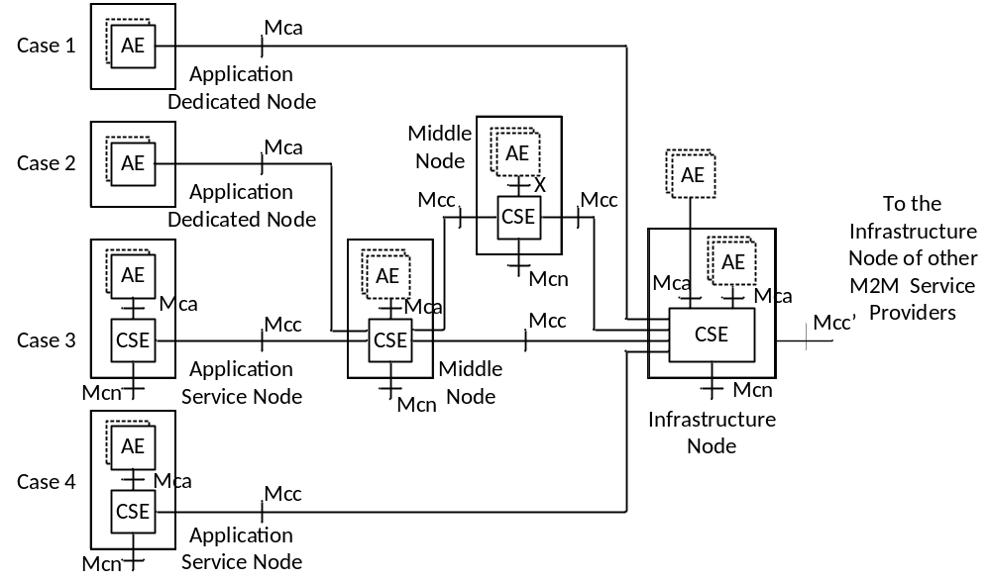
Figure 6-1: Configurations supported by oneM2M Architecture

Node: A oneM2M Node is a functional entity that shall contain at least one oneM2M Common Services Entity and/or one oneM2M Application Entity. A oneM2M Node may be contained in a physical object e.g., M2M Device, Gateway or Server Infrastructure.
NOTES:
1. CSEs resident in different Nodes are not identical and are dependent on the services supported by the CSE in that Node.
2. Mcc' reference point aims to be as similar as possible to the Mcc reference point. But due to the nature of inter-M2M Service Provider communications, some differences are anticipated.
Editor's Notes:
• The illustration above does not provide an exhaustive list of possible configurations and is subject to qualifications. Other possible functions/configurations are FFS.
• Mcc' reference point aims to be as similar as possible to the Mcc reference point. But due to the nature of inter-M2M Service Provider communications, some differences are anticipated.
Editor's Note:
- In Figure 6-1, should we explain how Application Entity (AE) and Application (A) relate?
-
Description of Nodes:
oneM2M architecture foresees the following types of Nodes. It is important that as functional objects, such Nodes are not necessarily mapped to actual physical objects, although they may be mapped to actual physical objects.
Application Service Node (ASN):
An Application Service Node is a Node that contains one Common Services Entity and contains at least one Application Entity.
An Application Service Node may communicate over a Mcc reference point with either:
- exactly one Middle Node;
- or exactly one Infrastructure Node.
Example of physical mapping: an Application Service Node could reside in an M2M Device.
Application Dedicated Node (ADN):
An Application Dedicated Node is a Node that contains at least one Application Entity and does not contain a Common Services Entity.
An Application Dedicated Node communicates with a Middle Node or an Infrastructure Node over an Mca reference point.
Example of physical mapping: an Application Dedicated Node could reside in a constrained M2M Device.
Middle Node (MN):
A Middle Node is a Node that contains one Common Services Entity and contains zero or more Application Entities.
A Middle Node communicates over respective Mcc references point with at least two other Nodes among either (not exclusively):
- one or more Application Services Nodes;
- one or more Middle Nodes;
- one Infrastructure Node.
In addition, a Middle Node communicates with zero or more Application Dedicated Nodes over respective Mca reference points.
Example of physical mapping: a Middle Node could reside in an M2M Gateway.
Infrastructure Node (IN):
An Infrastructure Node is a Node that contains one Common Services Entity and contains zero or more Application Entities.
An Infrastructure Node communicates over respective Mcc reference points with:
- one or more Middle Node(s); and/or
- one or more Application Service Node(s).
In addition, an Infrastructure Node communicates with one or more Application Dedicated Nodes over respective Mca reference points.
Example of physical mapping: an Infrastructure Node could reside in an M2M Server Infrastructure.
Editor’s Note: It is not clear what differentiates an Infrastructure Node from an Application Service Node or from a Middle Node. It could be a minimum feature scope of its CSE that would be bigger, or a particular requirement on its Mcn reference point. It could also be the cardinality of this Node in a deployment. Typically there would be just one Infrastructure Node in a deployment.

6.1 Deployment Scenarios
In this clause various deployment scenarios are introduced based on the functional architecture in Figure 6-1.

6.1.1 Single Middle Node case
A single Middle Node is placed between an Application Dedicated Node and/or Application Service Node and an Infrastructure Node.

6.1.2 Multiple Middle Nodes
A Middle Node can be connected to one or more other Middle Nodes. In this deployment scenario, the CSE in a Middle Node can communicate with the CSE in another Middle Node over the Mcc reference point.

6.1.3 Applications located outside of Application Service Node
For a node such as that illustrated in Case 3 and Case 4, Applications can be located outside of the Application Service Node.
--------------------------------------------------End 1st Change -------------------------------------------------

