INPUT CONTRIBUTION
Group Name:* | ARC WG
Title:* | Subscription Resource Refinement
Source:* | LG Electronics
Contact: | Heedong Choi, LG Electronics, heedong.choi@lge.com
Date:* | 2014-01-22
Abstract:* | This contribution provides clarification of the resource specification for the <subscription> resource.
Agenda Item:* | Contributions
Work item(s): | WI 0002 - oneM2M Architecture
Document(s)  Impacted* | oneM2M-TS-0001 Technical Specification - M2M Architecture
Intended purpose of  document:* | Decision  Discussion  Information  Other <specify>
Decision requested or recommendation:* | Agree to incorporate this into the TS (oneM2M-TS-0001)

oneM2M IPR STATEMENT
Participation in, or attendance at, any activity of oneM2M, constitutes acceptance of and agreement to be bound by all provisions of IPR policy of the admitting Partner Type 1 and permission that all communications and statements, oral or written, or other information disclosed or presented, and any translation or derivative thereof, may without compensation, and to the extent such participant or attendee may legally and freely grant such copyright rights, be distributed, published, and posted on oneM2M’s web site, in whole or in part, on a non-exclusive basis by oneM2M or oneM2M Partners Type 1 or their licensees or assignees, or as oneM2M SC directs.
- Rationale

Although great developments in the current specification have been made from now on, there are still some notable omissions in the resource structure. One of them is the <subscription> resource. So, this contribution provides clarification of the resource specification for the <subscription> resource.
To track changes on a resource, the <subscription> resource is positively necessary. Therefore, most of proposed resources shall have <subscription> resource as a sub resource. (Because the <Members> resource is a virtual resource, only the <Members> resource is excluded.) The following table shows all resource types and summarizes the necessity of <subscription> resource for each resource type.
Resource name | Necessity of <subscription> resource |  | Resource name | Necessity of <subscription> resource
accessRight | Yes |  | execInstance | Yes
container | Yes |  | chargingPolicy | Yes
delivery | Yes |  | chargeableEvent | Yes
group | Yes |  | chargingRule | Yes
instance | Yes |  | schedule | Yes
locationPolicy | Yes |  | node | Yes
request | Yes |  | application | Yes
mgmtObj | Yes |  | remoteCSE | Yes
parameters | Yes |  | m2mServiceSubscription | Yes
mgmtCmd | Yes |  | Members | No
execInstances | Yes

Also, this contribution provides some editorial corrections such as spelling mistakes, titles of the resource name, table and figure.

- Proposed

================================= Start of 1st Change =================================

9.6.2 Resource Type accessRight
Access rights are defined as "white lists" or permissions, i.e. each permission defines "allowed" entities (defined as permissionHolders) for certain access modes (defined as permissionFlags). Sets of permissions are handled such that the resulting permissions for a group of permissions are the sum of the individual permissions; i.e., an action is permitted if it is permitted by some / any permission in the set. The selfPermission attribute lists those that have the rights to Read/Update/Delete for the resource <accessRight>.
By setting an accessRightID attribute on a resource, the permissions for accessing that resource are then defined by the permissions defined in the <accessRight> resource.
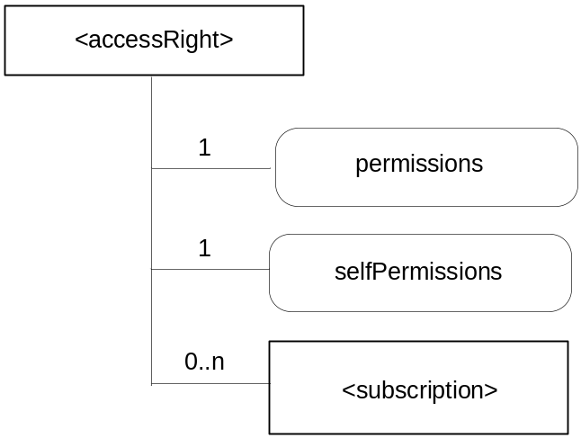
Figure 9.6.2-1: Structure of <accessRight> resource
(only child resource and resource specific attributes are shown)

Table 9.6.2-1: Child resource of <accessRight> resource
Child Resource Name of <accessRight> | Child Resource Type | Multiplicity | Description
[variable] | <subscription> | 0..n | See section 9.6.9

This resource shall contain the attributes according to their multiplicitly in Table 9.6.2-2 (0 indicates the optionality of the attribute).
Table 9.6.2-2: Attributes of <accessRight> resource
Attribute Name of <accessRight> | Multiplicity | RW/  RO/  WO | Description
resourceType (rT) | 1 | RO | See section 9.6.1 where this common attribute is described.
parentID (pID) | 1 | RO | See section 9.6.1 where this common attribute is described.
expirationTime (eT) | 1 | RW | See section 9.6.1 where this common attribute is described.
labels (lBs) | 0..1 | RW | See section 9.6.1 where this common attribute is described.
creationTime (cT) | 1 | RO | See section 9.6.1 where this common attribute is described.
lastModifiedTime (lMT) | 1 | RO | See section 9.6.1 where this common attribute is described.
permissions (ps) | 1 | RW | The list of permissions defined by this <accessRight> resource. These permissions are applied to resources referencing this <accessRight> resource using the accessRightID attribute.
selfPermissions (sP) | 1 | RW | Defines the list of permissions for the <accessRight> resource itself.

Editor’s Note: Mechanisms for announcing are FFS.
The permissions could then be generalised to actions (which might be granting access, but might also be more specific, like granting access to a subset, i.e. filtering part of the data). The permissions could be generalised to conditions, which may include things like the identity of the requestor, everybody except specified identities, but it might also include time based conditions etc.

9.6.3 Resource Type container
This resource represents a container for data instances. It is used to share information among other entities and potentially to track the data. A <container> resource has no associated content, only attributes and child resources.
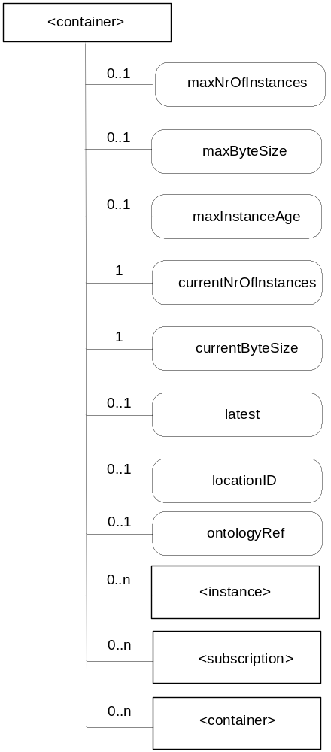
Figure 9.6.3-1: Structure of <container> resource
(only child resources and resource specific attributes are shown)

This resource shall contain the child resources according to their multiplicitly in Table 9.6.3-1 (0 indicates the optionality of the child resource).
Editor’s Note: Susbscription relation with this resource is for FFS.
Editor’s Note: location resource relation with containers is for FFS.

Table 9.6.3-1: Child resources of <container> resource
Child Resource Name of <container> | Child Resource Type | Multiplicity | Description
[variable] | <instance> | 0..n | See section 9.6.6
[variable] | <subscription> | 0..n | See section 9.6.9
[variable] | <container> | 0..n | See section 9.6.3

This resource shall contain the attributes according to their multiplicitly in Table 9.6.3-2 (0 indicates the optionality of the attribute).
Table 9.6.3-2: Attributes of <container> resource
Attribute Name of <container> | Multiplicity | RW/  RO/  WO | Description
resourceType (rT) | 1 | RO | See section 9.6.1 where this common attribute is described.
parentID (pID) | 1 | RO | See section 9.6.1 where this common attribute is described.
expirationTime (eT) | 1 | RW | See section 9.6.1 where this common attribute is described.
accessRightID (aRI) | 0..1 | RW | See section 9.6.1 where this common attribute is described. If no accessRightID is given at the time of creation, the accessRightID of the parent resource is linked to this attribute
labels (lBs) | 0..1 | RO | See section 9.6.1 where this common attribute is described.
creationTime (st) | 1 | RW | See section 9.6.1 where this common attribute is described.
creator (cr) | 1 | RW | See section 9.6.1 where this common attribute is described.
lastModifiedTime (lMT) | 1 | RO | See section 9.6.1 where this common attribute is described.
maxNrOfInstances (mi) | 0..1 | RW | Maximum number of instances of <instance> child resources.
maxByteSize (mb) | 0..1 | RW | Maximum number of bytes that are allocated for a <container> resource for all instances in the <container> resource.
maxInstanceAge (ma) | 0..1 | RW | Maximum age of the instances of <instance> resources within the <container>. The value is expressed in seconds.
currentNrOfInstances (ni) | 1 | RO | Current number of instances in a <container> resource. It is limited by the maxNrOfInstances.
currentByteSize (nb) | 1 | RO | Current size in bytes of data stored in a <container> resource. It is limited by the maxNrOfBytes.
latest (lt) | 0..1 | RO | Reference to latest instance, when present.
locationID (LID ) | 0..1 | RW | URI of the resource where the attributes/policies that define how location information are obtained and managed. This attribute is defined only when the <container> resource is used for containing location information.
ontologyRef (oR) | 0..1 | RW | A reference (URI) of the ontology used to represent the information that is stored in the instances of the container.  NOTE: the access to this URI is out of scope of oneM2M

Editor’s Note: Mechanisms for announcing are FFS.
Editor’s Note: The container type is FFS.
Editor’s Note: The following attributes are FFS depending on resource structure discussions:
- child: resources with child relation with the considered resource
- parent: resources with paren relation with the considered resource

9.6.4 Resource Type delivery
When a CSE is requested to initiate an operation (CRUD) targeting resources on another CSE, then it needs to involve the CMDH CSF in order to do proper scheduling and execution of delivery of data from the source CSE to the target CSE in line with provisioned policies. It is possible to do that in two different ways: Using delivery aggregation ("da" information set to on) or by forwarding the original request as a separate request on the Mcc reference point without changes.
In order to be able to initiate and manage the execution of data delivery in a resource-based manner, the resource type delivery is defined. This resource type needs to be used for forwarding requests from one CSE to another CSE when "da" information in the request is set to ON. If the "da" information is set to OFF, the original request shall be forwarded without change to the next CSE.
Operations to Retrieve, Update or Delete a <delivery> resource will allow authorized entities to inquire the status of a delivery, change delivery attributes or cancel a delivery.
Editor’s Note: Further details on mechanisms how to do delivery handling are FFS.
Editor’s Note: The particular position in the addressable space of resources id FFS.

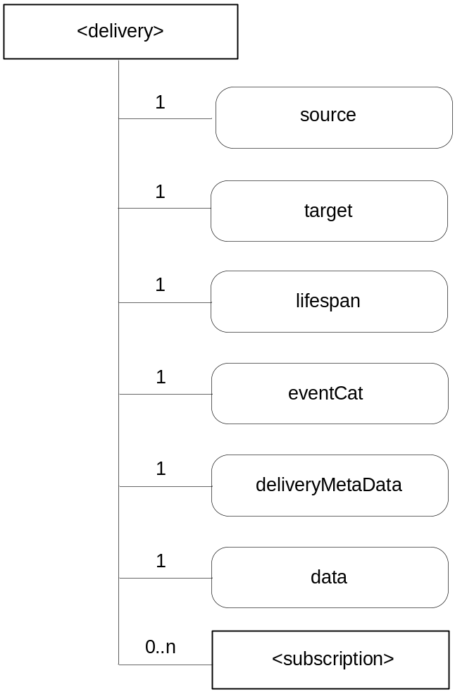
Figure 9.6.4-1: Structure of resource <delivery>
(only child resource and resource specific attributes are shown)

This resource shall contain the child resource according to their multiplicitly in Table 9.6.4-1.
Table 9.6.4-1: Child resource of <delivery> resource
Child Resource Name of <group> | Child Resource Type | Multiplicity | Description
[variable] | <subscription> | 0..n | See section 9.6.9

The resource <delivery> shall contain the attributes according to their multiplicity shown in Table 9.6.4-2.
Table 9.6.4-2: Attributes of <delivery> resource
Attribute Name of <delivery> | Multiplicity | RW/  RO/  WO | Description
expirationTime (eT) | 1 | RW | See section 9.6.1 where this common attribute is described.
parentID (pID) | 1 | RO | See section 9.6.1 where this common attribute is described.
creationTime (cT) | 1 | RO | See section 9.6.1 where this common attribute is described.
lastModifiedTime (lMT) | 1 | RO | See section 9.6.1 where this common attribute is described.
source | 1 | WO | The CSE-ID of the CSE that initiated the delivery process represented by this <delivery> resource.
target | 1 | WO | A list of CSE-IDs that defines one or more target CSEs for delivering the data contained in the data attribute
lifespan | 1 | RW | Defines the time limit until when the delivery of the information in the data attribute needs to complete. If the lifespan is expired before successful delivery, no further attempts to deliver the information in the data attribute need to be executed. If the delivery fails, a feedback may be expected by the source CSE depending on options reflected in the deliveryMetaData attribute.
eventCat | 1 | RW | Defines the category of the event that triggered the delivery request represented by this <delivery> resource
deliveryMetaData | 1 | RW | Contains meta information on the delivery process represented by this <delivery> resource, such as delivery status, delivery options, tracing information, etc
data | 1 | WO | Attribute containing the data to be delivered to the target CSE(s). This data represents one or more original requests that were targeting the same CSE(s).

9.6.5 Resource Type group
The <group> resource represents a group of resources of the same or mixed types. The <group> resource can be used to do bulk manipulations on the resources represented by the members. The <group> resource contains an attribute that represents the members of the group and a virtual resource (the members) that allows verbs to be applied to the resources represented by those members.
When used as one of the permission holders in an <accessRight> resource, the group can be used to grant a collection of applications (represented by <application> resources) or CSEs (represented by <remoteCSE> resources) permissions for accessing (Creating children, Retrieving, etc.) a resource.

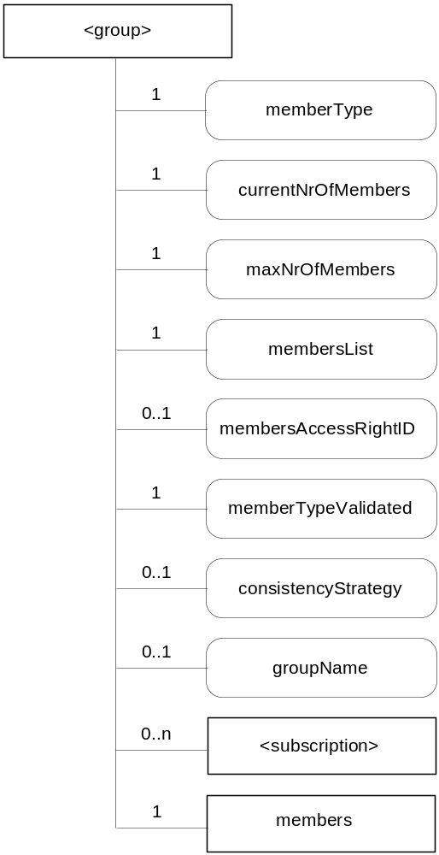
Figure 9.6.5-1: Structure of <group> resource
(only child resources and resource specific attributes are shown)

This resource shall contain the child resources according to their multiplicitly in Table 9.6.5-1.
Table 9.6.5-1: Child resources of <group> resource
Child Resource Name of <group> | Child Resource Type | Multiplicity | Description
[variable] | <subscription> | 0..n | See section 9.6.9
members | <Members> | 1 | See section 9.6.21

The <group> resource shall contain the attributes with the indicated multiplicity in Table 9.6.5-2

Table 9.6.5-2: Attributes of <group> resource
Attribute Name of <group> | Multiplicity | RW/  RO/  WO | Description
resourceType (rT) | 1 | RO | See section 9.6.1 where this common attribute is described.
expirationTime (eT) | 1 | RW | See section 9.6.1 where this common attribute is described.
parentID (pID) | 1 | RO | See section 9.6.1 where this common attribute is described.
accessRightID (aRI) | 0..1 | RW | See section 9.6.1 where this common attribute is described.
labels (lBs) | 0..1 | RO | See section 9.6.1 where this common attribute is described.
creationTime (cT) | 1 | RO | See section 9.6.1 where this common attribute is described.
creator (cr) | 0..1 | RW | See section 9.6.1 where this common attribute is described.
lastModifiedTime (lMT) | 1 | RO | See section 9.6.1 where this common attribute is described.
memberType (mT) | 1 | WO | It is the resource type of the member resources of the group if all member resources (including the member resources in any sub-groups) are of the same type. Otherwise, it’s a type of ‘mixed’.
currentNrOfMembers (nM) | 1 | RO | Current number of members in a group. It is limited by the maxNrOfMembers.
maxNrOfMembers (mM) | 1 | RW | Maximum number of members in the group.
membersList (mL) | 1 | RW | List of zero or more member URIs referred to in the remaining of this specification as memberID. Each URI (memberID) should refer to a member resource or a (sub-) group resource of the group.
membersAccessRightID(mAR) | 0..1 | RW | URI of the accessRight resource defining who is allowed to access the membersresource.
memberTypeValidated(mTV) | 1 | RO | Denotes if memberType of all member resources of the group has been validated.
consistencyStrategy (cS) | 0..1 | WO | This attribute determines how to deal with the <group> resource if the memberType validation fails.Which means delete the inconsistent member if the attribute is ABANDON_MEMBER; delete the group if the attribute is ABANDON_GROUP; set the memberType to “mixed” if the attribute is SET_MIXED.
groupName (gN) | 0..1 | RW | Human readable name of the group.

9.6.6 Resource Type instance
The <instance> resource represents a data instance in the container. The content of the instance is opaque to the M2M platform and it might even be encrypted. However, there is meta-data associated with an instance which shall be accessible.
Contrary to other resources, the <instance> resource cannot be modified once created, regardless of the accessRightID associated with the parent resource. An instance may be deleted explicitly or it may be deleted by the platform based on policies. If the platform has policies for the instance retention these shall be represented by the attributes maxByteSize, maxNrOfInstances and/or maxInstanceAge on the <container> resource. If multiple policies are in effect, the strictest policy shall apply.
The <instance> resource inherits the same access rights of the parent <container> resource, and does not have its own <accessRight> attribute.

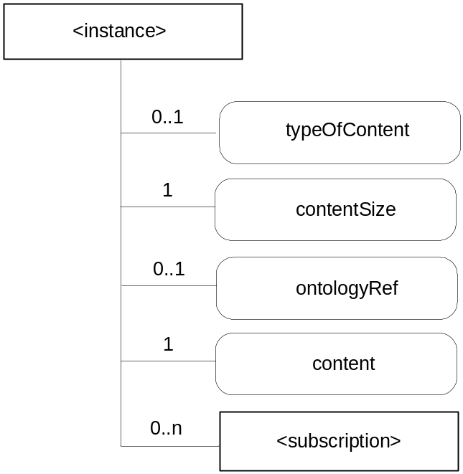
Figure 9.6.6-1: Structure of <instance> resource
(only child resource and resource specific attributes are shown)

This resource shall contain the child resource according to their multiplicitly in Table 9.6.6-1.
Table 9.6.6-1: Child resource of <instance> resource
Child Resource Name of <group> | Child Resource Type | Multiplicity | Description
[variable] | <subscription> | 0..n | See section 9.6.9

This resource shall contain the attributes according to their multiplicity in Table 9.6.6-2 (0 indicates the optionality of the attribute).
Table 9.6.6-2: Attributes of <instance> resource
Attribute Name of <instance> | Multiplicity | RW/  RO/  WO | Description
resourceType (rT) | 1 | RO | See section 9.6.1 where this common attribute is described.
parentID (pID) | 1 | RO | See section 9.6.1 where this common attribute is described.
labels (lBs) | 0..1 | RW | See section 9.6.1 where this common attribute is described.
creationTime (cT) | 1 | RO | See section 9.6.1 where this common attribute is described.
lastModifiedTime (lMT) | 1 | RO | See section 9.6.1 where this common attribute is described.
typeOfContent (tOC) | 0..1 | WO | Optional type of the content included in the content attribute. This is media-type as defined in <reference to stage 3 document>.
contentSize (cS) | 1 | WO | Size in bytes of the content attribute.
ontologyRef | 0..1 | RW | A reference (URI) of the ontology used to represent the information that is stored in the instances of the container. If this attribute is not present, the instance inherits the ontologyRef from the parent <container> resource if present  NOTE: Access to this URI is out of scope of oneM2M
content (c) | 1 | WO | Actual opaque content of an instance. This may for example be an image taken by a security camera, or a temperature measurement taken by a temperature sensor.

9.6.7 Resource Type locationPolicy
The <locationPolicy> resource in LOC CSF represents the method for obtaining and managing geographical location information of an M2M Nide.
The actual location information shall be stored in the <instance> resource, a child resource of <container> resource. The <container> resource has the locationId attribute which holds the URI of this <locationPolicy> resource as a linkage. The LOC CSF can obtain location information based on the attributes defined under <locationPolicy> resource, and store the location information in the target <container> resource.
Based on the locationSource attribute, the way of obtaining location information of an M2M Node can be differentiated: Network-based where the CSE on behalf of the AE obtains the target M2M Node’s location information from Underlying Network, Device-based where the ASN is equipped with any location capable modules or technologies (e.g., GPS) and is able to position itself, and Sharing-based where the ADN has no GPS and Underlying Network connection capability, but its location information can be retrieved from either ASN or MN.
NOTE: Geographical location information is more than longitude and latitude.
Editor’s Note: The specific information where this resource is created is FFS.

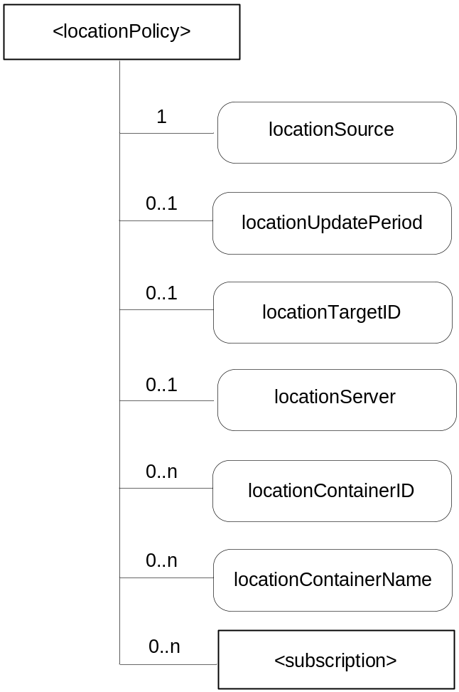
Figure 9.6.7-1: Structure of <locationPolicy> resource
(only child resource and resource specific attributes are shown)

This resource shall contain the child resource according to their multiplicitly in Table 9.6.7-1.
Table 9.6.7-1: Child resource of <locationPolicy> resource
Child Resource Name of <group> | Child Resource Type | Multiplicity | Description
[variable] | <subscription> | 0..n | See section 9.6.9

This resource shall contain the attributes according to their multiplicity in Table 9.6.7-2 (0 indicates the optionality of the attribute).
Table 9.6.7-2: Attributes of <locationPolicy> resource
Attribute Name of <locationPolicy> | Multiplicity | RW/  RO/  WO | Description
resourceType (rT) | 1 | RO | See section 9.6.1 where this common attribute is described.
expirationTime (eT) | 1 | RW | See section 9.6.1 where this common attribute is described.
parentID (pID) | 1 | RO | See section 9.6.1 where this common attribute is described.
accessRightID (aRI) | 1..n | RW | See section 9.6.1 where this common attribute is described.
creationTime (cT) | 1 | RO | See section 9.6.1 where this common attribute is described.
lastModifiedTime (lMT) | 1 | RO | See section 9.6.1 where this common attribute is described.
labels (lBs) | 0..1 | RW | See section 9.6.1 where this common attribute is described.
locationSource | 1 | RW | Indicates the source of location information  Network Based  GPS Based  Sharing Based
locationUpdatePeriod | 0..1 | RW | Indicates the period for updating location information. If the value is marked ‘0’ or not defined, location information is updated only when a retrieval request is triggered.
locationTargetId | 0..1 | RW | The identifier to be used for retrieving the location information of a remote Node and this attribute is only used in the case that location information is provided by a location server.
locationServer | 0..1 | RW | Indicates the identity of the location server. This attribute is only used in that case location information is provided by a location server.
locationContainerID_[i] | 0..n | RO | URI of the <container> resource where the actual location information of a M2M Node is stored.
locationContainerName_[i] | 0..n | RW | Name of the <container> resource where the actual location information of a M2M Node is stored. If it is not assigned, the Hosting CSE automatically assigns a name of the resource.  Editor’s Note: The association between multiple container resources and a location policy resource is FFS.

Editor’s Note: The naming convention of locationContainerID and locationContainerName that have multiplicty more than 1 is just following what WG2 discussed in the drafting session. If the convention or the rule is changed in the template section, the notation will be changed.

9.6.8 Resource Type request
The use of this resource type is optional depending on the configuration.
When a CSE is requested to initiate an operation for which the result should be available to the Originator by reference (‘rt’ information of the request set to ‘Acknowledgement'), the local CSE which received the Request directly from the Originator may need to provide a reference back to the Originator so that the Originator can access attributes of the Request at a later time – for instance in order to retrieve the result of an operation that was taking a longer time. The Originator (or any other authorized entity depending on access rights) can access the request status and the requested operation result through it.
The <request> resource may get deleted by the CSE that is hosting it:
- when the result of the requested operation (if any result was requested at all) has been sent back to the Originator (either by notification to the Originator or by retrieval initiated by the Originator);
- when the expiration time of the <request> resource is reached;
- at any other time - depending on local settings in the CSE that hosts the <request> resource.
Editor’s Note: The exact way how to define that setting (e.g. via DM) is FFS.
For the purpose of providing a standardized structure for expressing and accessing the context of a previously issued Request, the resource type request is defined.

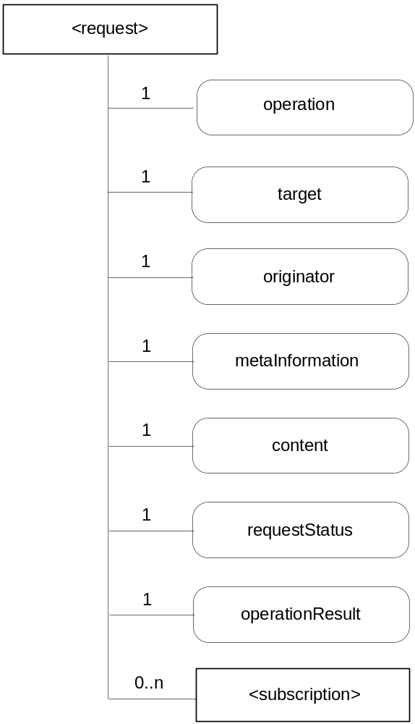
Figure 9.6.8-1: Structure of <request> resource
(only child resource and resource specific attributes are shown)

This resource shall contain the child resource according to their multiplicitly in Table 9.6.8-1.
Table 9.6.8-1: Child resource of <request> resource
Child Resource Name of <group> | Child Resource Type | Multiplicity | Description
[variable] | <subscription> | 0..n | See section 9.6.9

The resource <request> shall contain the attributes according to their multiplicity shown in Table 9.6.8-2.

Table 9.6.8-2: Attributes of <request> resource
Attribute Name of <request> | Multiplicity | RW/  RO/  WO | Description
expirationTime (et) | 1 | RW | See section 9.6.1 where this common attribute is described.
parentID (pID) | 1 | RO | See section 9.6.1 where this common attribute is described.
creationTime (cT) | 1 | RO | See section 9.6.1 where this common attribute is described.
lastModifiedTime (lMT) | 1 | RO | See section 9.6.1 where this common attribute is described.
operation | 1 | RO | The operation requested by the Originator, e.g. modifying the content of a container, registering an Application.
target | 1 | RO | The address or the target resource for the requested operation.
originator | 1 | RO | The originating entity for the request.
metaInformation | 1 | RO | Meta information about the request. The content of this attribute is equivalent to the “mi” information in section 8.1.
content | 1 | RO | Contains the content that is supposed to be sent to the target resource.
requestStatus | 1 | RO | Contains information on the current status of the Request, e.g. “accepted and pending”.
operationResult | 1 | RO | Contains information on the result of the requested action, e.g. “Resource created with URI: XXX”.

Creation of a <request> resource can only be done on a local CSE implicitly by an AE issuing a generic CRUD request for any other resource type to the Local CSE. A Local CSE cannot accept requests to create a <request> resource directly.
Retrieving of <request> resources or attributes of a <request> resource is allowed for authorized entities.
Update of a <request> resource can only be done by the CSE that hosts the <request> resource or by CSEs that provide operation results pertaining to the request (for instance when the result of an operation requested for a remote CSE becomes available).
Deletion of a <request> resource is possible by authorized entities. If the execution of the request was still pending at the time of deletion, the hosting CSE should to stop any further attempts to execute the request.

9.6.9 Resource Type subscription
The <subscription> resource contains subscription information for its subscribed-to resource. The subscribable resource is the resource that has the <subscription> resource as a child resource.

- Editor’s Note: It is not yet clear how or where to best to explain the applicability of the resource <subscription>. Subscribable resources can be added to the list above, Non-subscribable resources can also be added to the list above, and/or we could ensure that the applicability of the resource <subscription> is clearly described with each resource, removing or keeping the list here.
The relationship between a subscribed-to resource and a <subscription> resource shall be represented as parent-child resource in each subscribable resource. For example, <container> resource has <subscription> resource as a child resource (see section 9.6.3). A <subscription> resource shall be deleted when a parent subscribed-to resource is deleted.
The <subscription> resource shall represent a subscription to a subscribed-to resource. An Originator shall be able to create a resource of <subscription> resource type when the originator has RETRIEVE permission to the subscribable resource. The Originator of a <subscription> resource becomes a resource subscriber.
When a modification to the subscribed-to resource occurs, that modification is compared to the criteria attribute to determine whether a notification is to be sent to the resource subscriber.
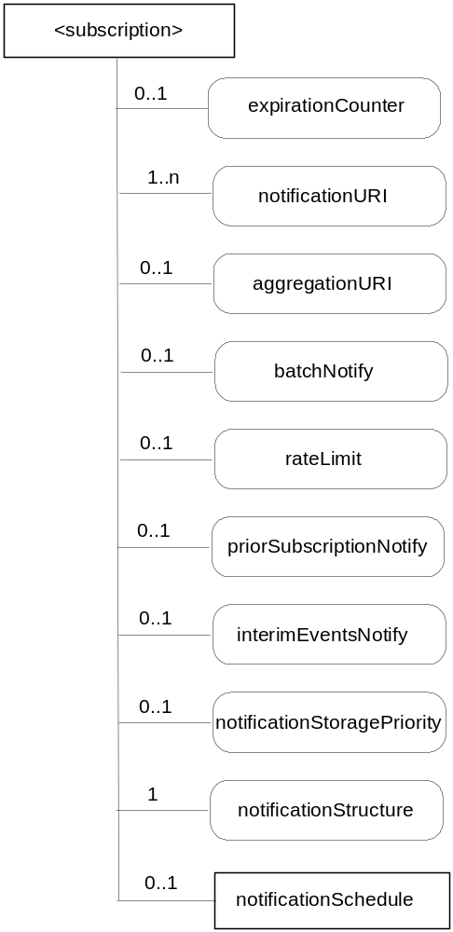
Figure 9.6.9-1: Structure of <subscription> resource
(only child resource and resource specific attributes are shown)

This resource shall contain the child resource according to their multiplicitly in Table 9.6.9-1.
Table 9.6.9-1: Child resource of <subscription> resource
Child Resource Name of <subscription> | Child Resource Type | Multiplicity | Description
notificationSchedule | <schedule> | 0..1 | See section 9.6.16

Editor’s Note: criteria is shown as an attribute, However, whether we need a separate attribute or child resource for notification policy is FFS.
The <subscription> resource shall contain the attributes described in Table 9.6.9-2.
Table 9.6.9-2: Attributes of <subscription> resource
Attribute Name of <subscription> | Multiplicity | RW/  RO/  WO | Description
resourceType (rT) | 1 | WO | See section 9.6.1 where this common attribute is described.
parentID (pID) | 1 | RO | See section 9.6.1 where this common attribute is described.
expirationTime (eT) | 1 | RW | See section 9.6.1 where this common attribute is described.
creationTime (cT) | 1 | RO | See section 9.6.1 where this common attribute is described.
lastModifiedTime (lMT) | 1 | RO | See section 9.6.1 where this common attribute is described.
filterCriteria (fC) | 0..1 | RW | See section 9.6.1 where this common attribute is described.
labels (lBs) | 1 | RW | See section 9.6.1 where this common attribute is described.
accessRightID (aRI) | 0..1 | RW | See section 9.6.1 where this common attribute is described.  If no accessRightID is given at the time of creation, the accessRightID of the parent resource is linked to this attribute.
expirationCounter | 0..1 | RW | When the number of notifications becomes the same as this counter, the <subscription> resource shall be deleted.
notificationURI | 1..n | RW | URI where the resource subscriber will receive notifications.
aggregationURI | 0..1 | RW | URI to aggregate notifications from group members of a <group> resource.
batchNotify | 0..1 | RW | Indicates that notifications should be batched for delivery. When set, notification events are temporarily stored until either a specified number is ready to send or until a duration after the first noticifaction event has expired.
rateLimit | 0..1 | RW | Indicates that notifications should be rate-limited. When set, notification events that exceed a specified number within a specified time are temporarily stored then sent when the number of events sent per specified time falls below the limit.
priorSubscriptionNotify | 0..1 | WO | Indicates that when this subscription is created, whether notification events prior to subscription should be sent, e.g. send prior “n” notifications, if available.
interimEventsNotify | 0..1 | RW | Indicates the notification action to be taken following a period of unreachability, when the resource subscriber becomes reachable (e.g. send “n” interim notifications, if available.)
notificationStoragePriority | 0..1 | RW | Indicates a priority for this subscription relative to other subscriptions belonging to this same subscriber for retention of notification events when storage is congested. The storage congestion policy which uses this attribute as input is specified in section TBD.
notificationStructure | 1 | RW | Type of information that shall be contained in notifications. E.g., modified attribute only of a subscribed-to resource, a whole subscribed-to resource, and/or URI of a corresponding <subscription> resource.

Editor’s Note: In the case when there are Intermediate Nodes between the Originator and a Receiver, the Intermediate Nodes may not act in accordance with the subscription notification policy. Examples include: a policy of batching subscribed events for up to 30 seconds then deliver immediately, but an intermediate node may decide to delay or further aggregate the subscription notifications. The solution to this problem is FFS, but may include sending a representation of policy with the subscription notifications, which is to be considered by Intermediate Nodes (e.g. Request Expiration Time).

9.6.10 Resource Type mgmtObj
The mgmtObj resource contains management data which represents individual M2M management functions. It represents a general structure to map to external management technology (e.g. OMA DM, BBF TR-069 and LWM2M) data models.

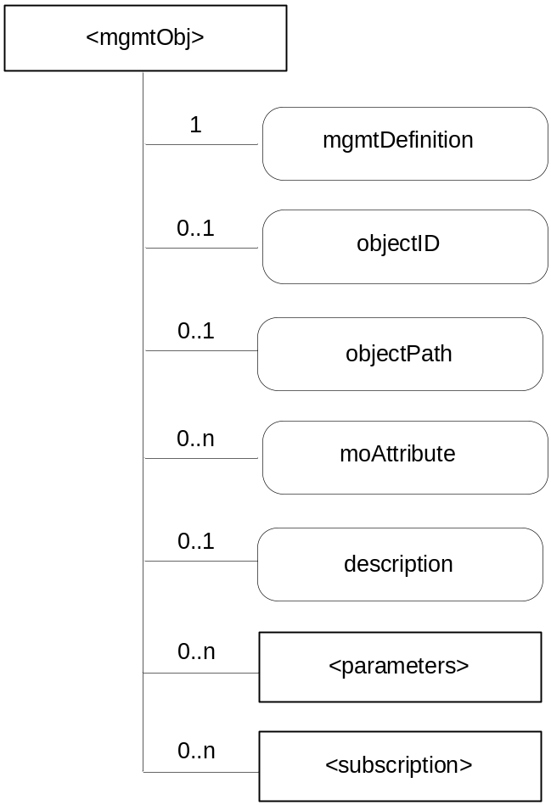
Figure 9.6.10-1: Structure of <mgmtObj> resource
(only child resources and resource specific attributes are shown)
This resource shall contain the child resources according to their multiplicitly in Table 9.6.10-1 (0 indicates the optionality of the child resource).
Table 9.6.10-1: Child resources of <mgmtObj> resource
Child Resource Name of <mgmtObj> | Child Resource Type | Multiplicity | Description
[variable] | <subscription> | 0..n | See section 9.6.9
[variable] | <parameters> | 0..n | See section 9.6.11. Collects multiple parameters or attributes for management purpose. A <parameters> resource can have zero or more other <parameters> sub resources so as to form hierarchical structure, i.e. the management data for this specific <mgmtObj>. Such structure helps to import existing management objects as defined in OMA DM, BBF TR-069, LWM2M, or any other technology.

The <mgmtObj> resource shall contain the attributes described in Table 9.6.10-2.

Table 9.6.10-2: Attributes of <mgmtObj> resource
Attribute Name of <mgmtObj> | Multiplicity | RW/  RO/  WO | Description
resourceType (rT) | 1 | WO | See section 9.6.1 where this common attribute is described
parentID (pID) | 1 | RO | See section 9.6.1 where this common attribute is described.
expirationTime (eT) | 1 | RW | See section 9.6.1 where this common attribute is described
accessRightID (aRI) | 1 | RW | See section 9.6.1 where this common attribute is described
creationTime (cT) | 1 | RO | See section 9.6.1 where this common attribute is described
lastModifiedTime (lMT) | 1 | RO | See section 9.6.1 where this common attribute is described
mgmtDefinition | 1 | WO | Indicates specific device management functionalities.  Editor’s Note: Description needed.
objectID | 0..1 | WO | Contains a URN that uniquely identifies the external management technology data model used for this <mgmtObj> resource as well as the managed function and version it represents. This attribute shall be provided during the creation of the <mgmtObj> resource and shall not be modifiable afterwards.  This is mandatory for the <mgmtObj>, for which the data model is not specified by oneM2M but mapped from external management technology data model specified in other device management protocols (e.g. OMA-DM, BBF TR-069 and LWM2M).
objectPath | 0..1 | WO | Contains the local path of the external management object instance on the managed entity which is represented by the <mgmtObj> resource in the hosting CSE.  This attribute shall be provided during the creation of the <mgmtObj>, so that the hosting CSE can correlate the created <mgmtObj> with the external management object instance on the managed entity for further management operations. It shall not be modifiable after creation.  The format of this attribute shall be a local external management object path in the form as specified by existing management protocols. (e.g. "./anyPath/Fw1" in OMA DM, "Device.USBHosts.Host.3." in BBF TR-069).
moAttribute | 0..n | RW | Each moAttribute is mapped from a leaf node of a hierarchical structured management object (including oneM2M data model and the existing management data models) based on the mapping rules below the table.
description | 0..1 | RW | Text format description of mgmtObj.

When mapping resources from management technologies to a corresponding <mgmtObj> resource, the following rules shall apply:
- The root resource of external management objects maps to the <mgmtObj> resource
- For child resource of the root resource of specific technology:
- Rule1: If the child external management object cannot have child external management object, the external management object maps to the "moAttribute" attribute of the <mgmtObj> resource with the same resource name;
- Rule2: If the child external management object can have another child external management object, the external management object maps to the <parameters> resource with the same resource name.
- For the external management object that is mapped to the <parameters> resource, the child external management object of the external management object are mapped to the "moAttribute" attribute or to the <parameter> resource according to the Rule1 and Rule2.

9.6.11 Resource Type parameters

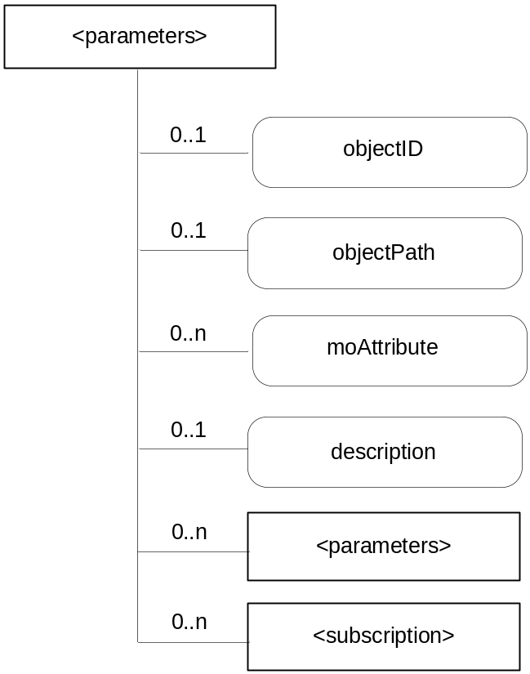
Figure 9.6.11-1: Structure of <parameters> resource
(only child resources and resource specific attributes are shown)

This resource shall contain the child resources according to their multiplicitly in Table 9.6.11-1 (0 indicates the optionality of the child resource).
Table 9.6.11-1: Child resources of <parameters> resource
Child Resource Name of <parameters> | Child Resource Type | Multiplicity | Description
[variable] | <subscription> | 0..n | See section 9.6.9
[variable] | <parameters> | 0..n | See section 9.6.11

The <parameters> resource shall contain the attributes described in Table 9.6.11-2.
Table 9.6.11-2: Attributes of <parameters> resource
Attribute Name of <parameters> | Multiplicity | RW/  RO/  WO | Description
accessRightID (aRI) | 1 | RW | See section 9.6.1 where this common attribute is described
parentID (pID) | 1 | RO | See section 9.6.1 where this common attribute is described.
creationTime (cT) | 1 | RO | See section 9.6.1 where this common attribute is described
lastModifiedTime (lMT) | 1 | RO | See section 9.6.1 where this common attribute is described
objectID | 0..1 | WO | See Table 9.6.10.1
objectPath | 0..1 | WO | See Table 9.6.10.1
<moAttribute> | 0..n | RW | See Table 9.6.10.1
description | 0..1 | RW | Text format description of mgmtObj.

9.6.12 Resource Type mgmtCmd
The <mgmtCmd> resource represents a method to execute management procedures or to model commands and remote procedure calls (RPC) required by existing management protocols (e.g. BBF TR-069), and enables AEs to request management procedures to be executed on a remote entity. It also enables cancellation of cancellable and initiated yet unfinished management procedures or commands.

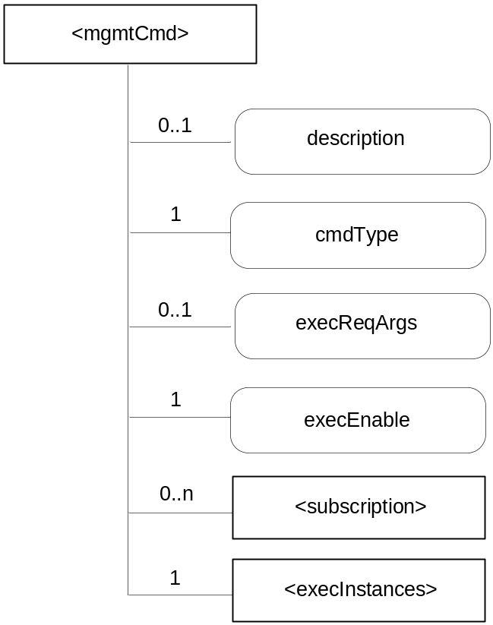
Figure 9.6.12-1: Structure of <mgmtCmd> resource
(only child resources and resource specific attributes are shown)

Each <mgmtCmd> corresponds to a specific type of management command, as defined by its attribute cmdType. For multiple requests of the same management command, <mgmtCmd> may use the sub-resource (i.e. execInstances) to contain all execution instances. The execution of the management procedure represented by <mgmtCmd> shall be triggered using the UPDATE method to its attribute "execEnable".
This resource shall contain the child resources according to their multiplicity in Table 9.6.12-1 (0 indicates the optionality of the child resource).
Table 9.6.12-1: Child resources of <mgmtCmd> resource
Child Resource Name of <mgmtCmd> | Child Resource Type | Multiplicity | Description
[variable] | <subscription> | 0..n | See section 9.6.9
[variable] | <execInstances> | 1 | See section 9.6.13. A collection resource as the placeholder to contain all execution instances of the same <mgmtCmd>.

The <mgmtCmd> resource shall contain the attributes described in Table 9.6.12-2.

Table 9.6.12-2: Attributes of <mgmtCmd> resource
Attribute Name of <mgmtCmd> | Multiplicity | RW/  RO/  WO | Description
resourceType (rT) | 1 | WO | See section 9.6.1 where this common attribute is described
parentID (pID) | 1 | RO | See section 9.6.1 where this common attribute is described.
expirationTime (eT) | 1 | RW | See section 9.6.1 where this common attribute is described
accessRightID (aRI) | 1 | RW | See section 9.6.1 where this common attribute is described
labels (lBs) | 1 | RW | See section 9.6.1 where this common attribute is described
creationTime (cT) | 1 | RO | See section 9.6.1 where this common attribute is described
lastModifiedTime (lMT) | 1 | RO | See section 9.6.1 where this common attribute is described
description | 0..1 | RW | The text-format description of this resource
cmdType | 1 | WO | The type to identify the management operation (e.g. download).
execReqArgs | 0..1 | RW | Structured attribute (e.g. abstract type) to contain any command-specific arguments of the request.
execEnable | 1 | RO | The attribute can be blank without any value or it can contain a URI that can be used to trigger execution of <mgmtCmd> using UPDATE method.

Editor’s Note: The types of management operations (e.g. cmdType) to be used by mgmtCmd are FFS.

9.6.13 Resource Type execInstances
The <execInstances> resource contains all execution instances of the same management command <mgmtCmd>. Each <execInstance> is a sub-resource of <execInstances>. When <mgmtCmd> is successfully triggered by an M2M network application using UPDATE method, a corresponding <execInstance> sub-resource shall be generated.

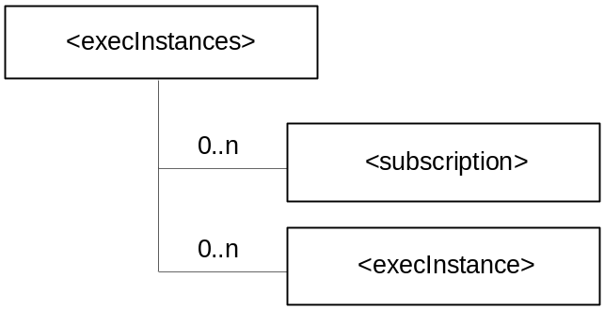
Figure 9.6.13-1: Structure of <execInstances> resource
(only child resources are shown)

This resource shall contain the child resources according to their multiplicitly in Table 9.6.13-1 (0 indicates the optionality of the child resource).
Table 9.6.13-1: Child resources of <execInstances> resource
Child Resource Name of <execInstances> | Child Resource Type | Multiplicity | Description
[variable] | <subscription> | 0..n | See section 9.6.9
[variable] | <execInstance> | 0..n | See section 9.6.14. An execution instance of <mgmtCmd>.

The <execInstances> resource shall contain the attributes described in Table 9.6.13-2.
Table 9.6.13-2: Attributes of <execInstances> resource
Attribute Name of <execInstances> | Multiplicity | RW/  RO/  WO | Description
creationTime (cT) | 1 | RO | See section 9.6.1 where this common attribute is described
parentID (pID) | 1 | RO | See section 9.6.1 where this common attribute is described.
lastModifiedTime (lMT) | 1 | RO | See section 9.6.1 where this common attribute is described

9.6.14 Resource Type execInstance
The <execInstance> resource represents a successful instance of <mgmtCmd> execution request, which had been triggered by a M2M network application using the UPDATE method to the attribute "execEnable" of <mgmtCmd>.

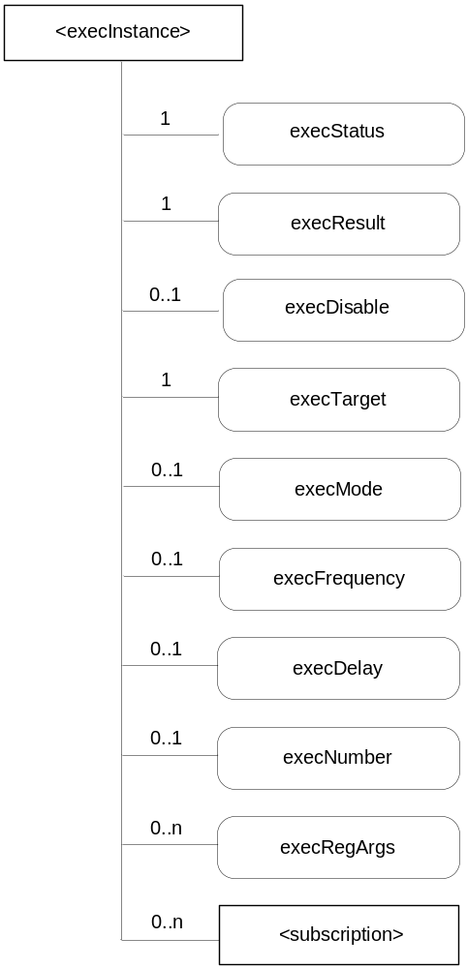
Figure 9.6.14-1: Structure of <execInstance> resource
(only child resource and resource specific attributes are shown)

This resource shall contain the child resource according to their multiplicitly in Table 9.6.14-1.
Table 9.6.14-1: Child resource of <execInstance> resource
Child Resource Name of <group> | Child Resource Type | Multiplicity | Description
[variable] | <subscription> | 0..n | See section 9.6.9

The <execInstance> resource shall contain the attributes described in Table 9.6.14-2.
Table 9.6.14-2: Attributes of <execInstances> resource
Attribute Name of <execInstance> | Multiplicity | RW/  RO/  WO | Description
expirationTime (eT) | 1 | RO | See section 9.6.1 where this common attribute is described
parentID (pID) | 1 | RO | See section 9.6.1 where this common attribute is described.
accessRightID (aRI) | 1 | RW | See section 9.6.1 where this common attribute is described
creationTime (cT) | 1 | RO | See section 9.6.1 where this common attribute is described
lastModifiedTime (lMT) | 1 | RO | See section 9.6.1 where this common attribute is described
execStatus | 1 | RO | The status of <execInstance>. It can be Initiated, Started, Finished, Cancelled, or Deleted.
execResult | 1 | RO | The execution result of <execInstance>.
execDisable | 0..1 | RW | The attribute is used to cancel <execInstance> using UPDATE method.
execTarget | 1 | RW | M2M-Node-ID of the target.
execMode | 0..1 | RW | Modes used to specify how the command will be executed (e.g. Immediate Once, Immediate and Repeatedly, Random Once, Random and Repeatedly). May be used together with execFrequency, execDelay and execNumber to provide the scheduling information.
execFrequency | 0..1 | RW | The interval between two executions, to be used in conjunction with execMode.
execDelay | 0..1 | RW | The delay before the instance should be executed
execNumber | 0..1 | RW | The number of times the instance should be executed, to be used in conjunction with execMode.
execReqArgs | 0..n | RW | Structured attribute (e.g. abstract type) to contain any command-specific arguments used to trigger this <execInstance>.

Editor’s note: the relationships between execMode, execFrequncy and execNumber are FFS.

9.6.15 Resources for Service Charging and Accounting
The <chargingPolicy> and <chargingRule> resources enable the SCA CSF to generate accounting information for particular services based on policies provided by the Service Provider. The SCA CSF and its resources residing on one CSE can be used by other CSEs and applications that subscribed to this CSE.

9.6.15.1 Resource Type chargingPolicy
The <chargingPolicy> resource shall be used to store charging related policies. The policy may be established by the oneM2M service provider. It may be provisioned using device management. The <chargingPolicy> resource may be used by the charging management function in one node to configure charging policies at another node. For example, a Service Provider may only keep the charging policy at the Infrastructure Node, or it may decide to pass the policy to the Middle Nodes. The <chargingPolicy> shall be applied to the Infrastructure Node. Whether or not it is applied to the Middle Node or Application Service Node shall depend on the configuration of the Service Provider.
Editor’s Note: Only chargeable events and subscriber based charging policy are shown. More charging policies, such as chargeable services can be added using the same resource model.

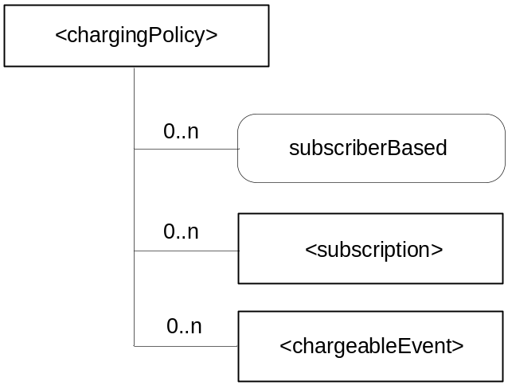
Figure 9.6.15.1-1: Structure of <chargingPolicy> resource
(only child resources and resource specific attribute are shown)

This resource shall contain the child resources according to their multiplicity in Table 9.6.15.1-1 (0 indicates the optionality of the child resource).
Table 9.6.15.1-1: Child resources of <chargingPolicy> resource
Child Resource Name of <chargingPolicy> | Child Resource Type | Multiplicity | Description
[variable] | <subscription> | 0..n | See section 9.6.9
[variable] | <chargeableEvent> | 0..n | See section 9.6.15.2. This resource defines the charging policy for a chargeable event. It is conditionally mandatory when the charging model is ‘Event Based’.

The <chargingPolicy> resource shall contain the attributes described in Table 9.6.15.1-2.
Table 9.6.15.1-2: Attributes of <chargingPolicy> resource
Attribute Name of <chargingPolicy> | Multiplicity | RW/  RO/  WO | Description
resourceType (rT) | 1 | RO | See section 9.6.1 where this common attribute is described
parentID (pID) | 1 | RO | See section 9.6.1 where this common attribute is described.
accessRightID (aRI) | 1..n | RW | See section 9.6.1 where this common attribute is described
creator (cr) | 1 | RW | See section 9.6.1 where this common attribute is described
creationTime (cT) | 1 | RO | See section 9.6.1 where this common attribute is described
expirationTime (eT) | 1 | RW | See section 9.6.1 where this common attribute is described
lastModifiedTime (lMT) | 1 | RO | See section 9.6.1 where this common attribute is described
labels (lBs) | 0..1 | RW | See section 9.6.1 where this common attribute is described
subscriberBased | 0..1 | RW | If this attribute is set to “ON”, it enables the subscriber based charging policy. Charging is done by service subscription contract, not by service layer operations.

9.6.15.2 Resource Type chargeableEvent

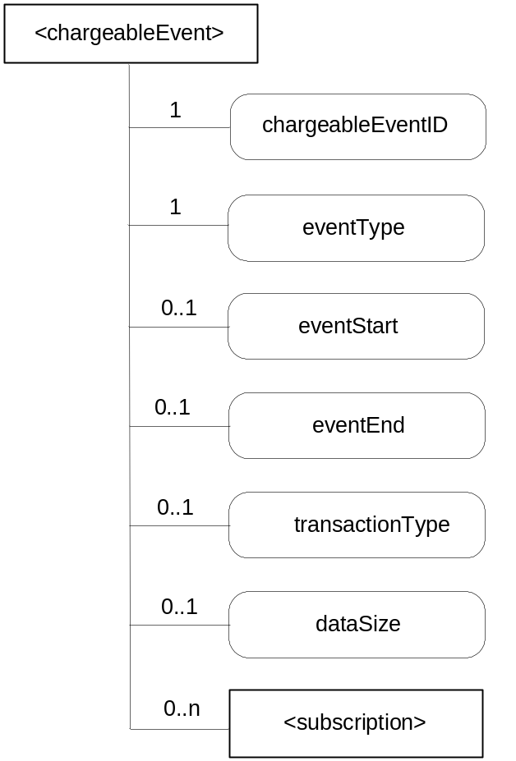
Figure 9.6.15.2-1: Structure of <chargeableEvent> resource
(only child resource and resource specific attributes are shown)

This resource shall contain the child resource according to their multiplicitly in Table 9.6.15.2-1.
Table 9.6.15.2-1: Child resource of <chargeableEvent> resource
Child Resource Name of <group> | Child Resource Type | Multiplicity | Description
[variable] | <subscription> | 0..n | See section 9.6.9

The <chargeableEvent> resource shall contain the attributes described in Table 9.6.15.2-2.
Table 9.6.15.2-2: Attributes of <chargeableEvent> resource
Attribute Name of <chargeableEvent> | Multiplicity | RW/  RO/  WO | Description
resourceType (rT) | 1 | RO | See section 9.6.1 where this common attribute is described
parentID (pID) | 1 | RO | See section 9.6.1 where this common attribute is described.
accessRightID (aRI) | 1..n | RW | See section 9.6.1 where this common attribute is described
creator (cr) | 1 | RW | See section 9.6.1 where this common attribute is described
creationTime (cT) | 1 | RO | See section 9.6.1 where this common attribute is described
expirationTime (eT) | 1 | RW | See section 9.6.1 where this common attribute is described
lastModifiedTime (lMT) | 1 | RO | See section 9.6.1 where this common attribute is described
labels (lBs) | 0..1 | RW | See section 9.6.1 where this common attribute is described
chargeableEventID | 1 | RO | This attribute uniquely identifies the chargeable event
eventType | 1 | RW | This attribute indicates the type of the event, such as timer based, data operation, storage based charging, etc.
eventStart | 0..1 | RW | This attribute indicates the start time of the event.
eventEnd | 0..1 | RW | This attribute indicates the end time of the event
transactionType | 0..1 | RW | This attribute defines the type of the chargeable operation, such as CREATE, RETRIEVE.
dataSize | 0..1 | RW | This attribute defines the data size if an event is triggered when the stored data exceeded a certain size.

9.6.15.3 Resource Type chargingRule
The resource type <chargingRule> shall be used to define different rules for charging purpose. One node may setup multiple rules. One rule may be activated or de-activated.

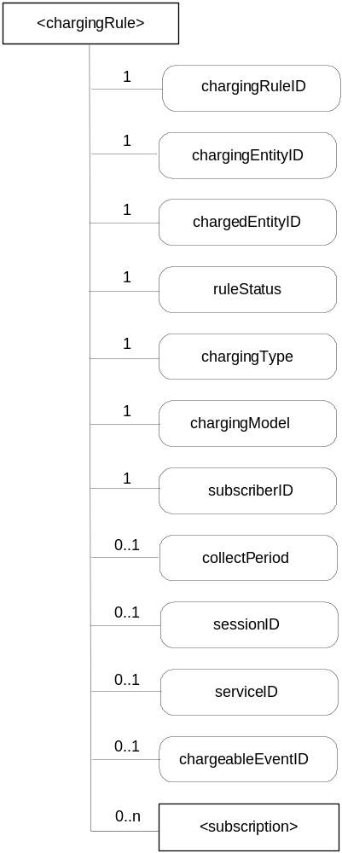
Figure 9.6.15.3-1: Structure of <chargingRule> resource
(only child resource and resource specific attributes are shown)

This resource shall contain the child resource according to their multiplicitly in Table 9.6.15.3-1.
Table 9.6.15.3-1: Child resource of <chargingRule> resource
Child Resource Name of <group> | Child Resource Type | Multiplicity | Description
[variable] | <subscription> | 0..n | See section 9.6.9

The <chargingRule> resource shall contain the attributes described in Table 9.6.15.3-2.

Table 9.6.15.3-2: Attributes of <chargingRule> resource
Attribute Name of <chargingRule> | Multiplicity | RW/  RO/  WO | Description
resourceType (rT) | 1 | RO | See section 9.6.1 where this common attribute is described
parentID (pID) | 1 | RO | See section 9.6.1 where this common attribute is described.
accessRightID (aRI) | 1..n | RW | See section 9.6.1 where this common attribute is described
creator (cr) | 1 | RW | See section 9.6.1 where this common attribute is described
creationTime (cT) | 1 | RO | See section 9.6.1 where this common attribute is described
expirationTime (eT) | 1 | RW | See section 9.6.1 where this common attribute is described
lastModifiedTime (lMT) | 1 | RO | See section 9.6.1 where this common attribute is described
labels (lBs) | 0..1 | RW | See section 9.6.1 where this common attribute is described
chargingRuleID | 1 | RO | This is the unique ID of the charging rule. It is created by the CSE when the charging rule resource is first created.
chargingEntityID | 1 | WO | This is the unique ID of the entity that charges another entity. For example, it can be an application ID (App-ID) or a CSE ID (CSE-ID).
chargedEntityID | 1 | WO | This is the unique ID of the entity that is being charged. For example, it can be an application ID (App-ID) or a CSE ID (CSE-ID) or a resource ID.
ruleStatus | 1 | RW | This attribute indicates whether the rule is “active” or “inactive”, or “information recording only” which means no charging is performed.
chargingType | 1 | RW | This attribute indicates whether the charging rule applies for ONLINE or OFFLINE charging.
chargingModel | 1 | RW | This attribute indicates the charging model, such as “Subscriber based charging”, “event based charging”, “service based charging”, “session based charging”, etc.
subscriberID | 1 | WO | This attribute indicates the service subscriber (M2M-Sub-ID) being charged.
collectPeriod | 0..1 | RW | This attribute defines the duration for the SCA to collect service charging information.
sessionID | 0..1 | RW | This attribute indicates the unique service session ID, if the chargingType is “session based charging”. It is mandatory of the chargingModel is session based charging.
serviceID | 0..1 | RW | This attribute indicates the unique ID of the service being charged. A service provider can define its own services. It is mandatory if the charging model is service based charging.
chargeableEventID | 0..1 | RW | This attribute refers to the resource that defines the chargeable event that should be applied to this charging rule. It is mandatory if the charging model is event based charging.

Editor’s Note: The table above includes the basic parameters needed to configure charging rules. More parameters may be added when the feature is further developed. Online charging is FFS.

9.6.16 Resource Type schedule
The <schedule> resource contains scheduling information for delivery of messages.
Editor’s Note: It is expected that the reachability period will be extended by the duration of a transaction which is currently occurring, but the details need further study.
The list of resources, which use <schedule> resource, is as follows.
- TBD
Editor’s Note: This list will be revised as resources are further progressed
The <schedule> resource shall represent scheduling information in the context of its parent resource. An Originator shall have the same access rights to the <schedule> resource as it has to its parent resource.

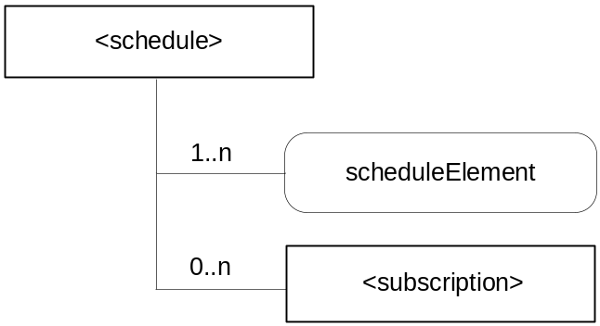
Figure 9.6.16-1: Structure of <schedule> resource
(only child resource and resource specific attribute are shown)

This resource shall contain the child resource according to their multiplicitly in Table 9.6.16-1.
Table 9.6.16.1-1: Child resource of <schedule> resource
Child Resource Name of <group> | Child Resource Type | Multiplicity | Description
[variable] | <subscription> | 0..n | See section 9.6.9

The <schedule> resource shall contain the attributes described in Table 9.6.16-2.
Table 9.6.16-2: Attributes of <schedule> resource
Attribute Name of <schedule> | Multiplicity | RW/  RO/  WO | Description
expirationTime (eT) | 1 | RW | See section 9.6.1 where this common attribute is described.
parentID (pID) | 1 | RO | See section 9.6.1 where this common attribute is described.
creationTime (cT) | 1 | RO | See section 9.6.1 where this common attribute is described.
lastModifiedTime (lMT) | 1 | RO | See section 9.6.1 where this common attribute is described.
scheduleElement | 1..n | RW | Expresses time periods defined by seconds, minutes, day of month, month, day of month, and year. Supporting repeating periods, and wildcards.

Editor’s Note: The multiplicity of attribute must be aligned to the new understanding.

9.6.17 Resource Type node
The <node> resource represents specific information of a M2M Node that can be utilized by other oneM2M operations. For example, the CMDH CSF can determine when the CSE sends a request message to the target CSE based on the target CSE’s reachability schedule. This resource type mainly contains the properties of an M2M node such as reachability schedule, context information (e.g., memory and storage) and network topology.
This node specific information such as memory and storage can be obtained either by the existing device management technologies (OMA DM, BBF TR-069) or any other way (e.g., through JNI (Java Native Interface)). Since <mgmtObj> resource type represents the management functions including both ways, the type of sub-resources are <mgmtObj> resource type.
The location of <node> resource can be differentiated according to the type of node.
- ASN: under <baseURI> of the local CSE
- ADN: under <Application> resource of the hosting CSE
- MN: under <baseURI> of the local CSE
Editor’s Note: More specific information regarding a node can be added.

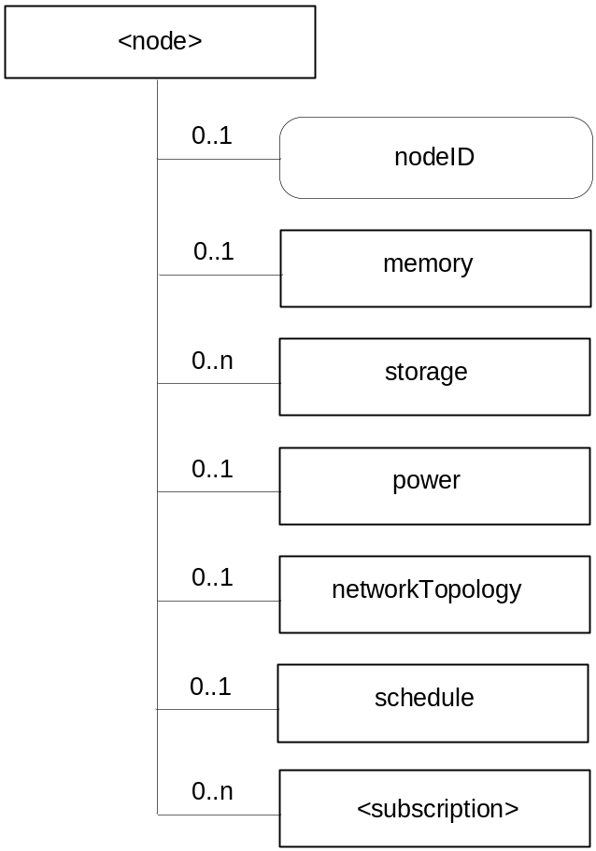
Figure 9.6.17-1: Structure of <node> resource
(only child resources and resource specific attribute are shown)

This resource shall contain the child resources according to their multiplicity in Table 9.6.17-1 (0 indicates the optionality of the child resource).
Table 9.6.17-1: Child resources of <node> resource
Child Resource Name of <node> | Child Resource Type | Multiplicity | Description
memory | <mgmtObj> | 0..1 | This resource provides the memory (typically RAM) information of the node. (e.g. the amount of total volatile memory), See section 9.6.10 for <mgmtObj>.
storage_[i] | <mgmtObj> | 0..n | This resource provides the storage (typically flash or disk) information of the node. (e.g. the amount of total writable persistent storage). See section 9.6.10 for <mgmtObj>.
power | <mgmtObj> | 0..1 | The resource provides the power information of the node. (e.g. remaining battery charge). See section 9.6.10 for <mgmtObj>.
networkTopology | <mgmtObj> | 0..1 | This resource describes the list of Nodes attached behind the MN node and its relation among the nodes. This attribute is defined in case the Node is MN. See section 9.6.10 for <mgmtObj>.
schedule | <schedule> | 0..1 | This resource defines the reachability schedule information of the node. See section 9.6.16 for <schedule>.
[variable] | <subscription> | 0..n | See section 9.6.9

The <node> resource shall contain the attributes described in Table 9.6.17-2.

Table 9.6.17-2: Attributes of <node> resource
Attribute Name of <node> | Multiplicity | RW/  RO/  WO | Description
resourceType (rT) | 1 | RO | See section 9.6.1 where this common attribute is described.
parentID (pID) | 1 | RO | See section 9.6.1 where this common attribute is described.
expirationTime (eT) | 1 | RW | See section 9.6.1 where this common attribute is described.
accessRightID_[i] (aRI_[i]) | 1..n | RW | See section 9.6.1 where this common attribute is described.
creationTime (cT) | 1 | RO | See section 9.6.1 where this common attribute is described.
lastModifiedTime (lMT) | 1 | RO | See section 9.6.1 where this common attribute is described.
labels (lBs) | 0..1 | RW | See section 9.6.1 where this common attribute is described.
nodeID | 1 | RW | The ID of the Node which is specified in the resource type.

9.6.18 Resource Type application
The <application> resource represents information about an Application Entity known to a given Common Services Entity.

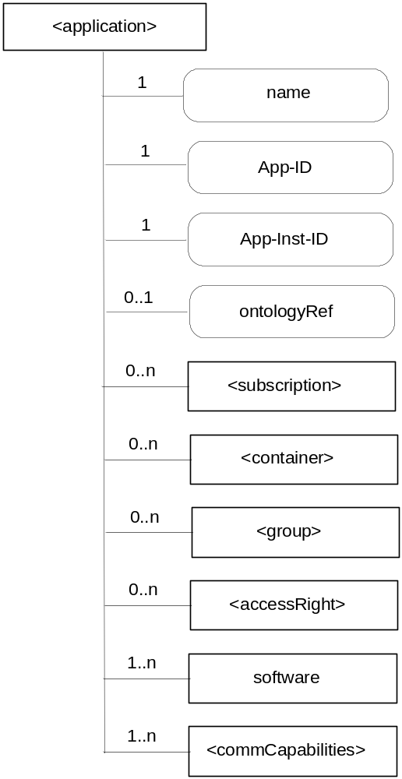
Figure 9.6.18-1: Structure of <application> resource
(only child resources and resource specific attributes are shown)

This resource shall contain the child resources according to their multiplicity in Table 9.6.18-1 (0 indicates the optionality of the child resource).
Table 9.6.18-1: Child resources of <application> resource
Child Resource Name of <application> | Child Resource Type | Multiplicity | Description
[variable] | <subscription> | 0..n | See section 9.6.9.
[variable] | <container> | 0..n | See section 9.6.3.
[variable] | <group> | 0..n | See section 9.6.5.
[variable] | <accessRight> | 0..n | See section 9.6.2.
software_[i] | <mgmtObj> | 1..n | See section 9.6.10 for <mgmtObj>. This resource represents the software component (or components, if the multiplicity is greater than 1) that compose the application. This mgmtObj shall have at least the following <parameters> child resources of its “parameters” subresource:  - name (multiplicity 1)  - version (multiplicity 1)  - state (multiplicity 1)
[variable] | <commCapabilities> | 1..n | Resource <commCapabilities> needs to be defined.  This resource describes the communication capabilities (essentially the protocols) supported and used by the corresponding Application Entity over the Mca reference point to this CSE.

The <application> resource shall contain the attributes described in Table 9.6.18-2.
Table 9.6.18-2: Attributes of <application> resource
Attribute Name of <application> | Multiplicity | RW/  RO/  WO | Description
resourceType (rT) | 1 | RO | See section 9.6.1 where this common attribute is described.
parentID (pID) | 1 | RO | See section 9.6.1 where this common attribute is described.
expirationTime (eT) | 0..1 | RW | See section 9.6.1 where this common attribute is described.
accessRightID (aRI) | 1 | RW | See section 9.6.1 where this common attribute is described.
creationTime (cT) | 1 | RW | See section 9.6.1 where this common attribute is described.
lastModifiedTime (lMT) | 1 | RO | See section 9.6.1 where this common attribute is described.
labels (lBs) | 0..1 | RO | See section 9.6.1 where this common attribute is described.
name | 1 | RO | The (usually human readable) name of the application, as declared by the application developer (eg. “HeatingMonitoring”)
App-ID | 1 | RO | Application Identifier
App-Inst-ID | 1 | RO | When the application resource refers to an actual application instance in the executing environment.
ontologyRef | 0..1 | RW | A reference (URI) of the ontology used to represent the information that is managed and understood by the application; to be passed to the application

9.6.19 Resource Type remoteCSE
A <remoteCSE> resource shall represent a remote CSE that is registered to the local CSE. CSE resources shall be located directly under the <baseRoot>.
Conversely each registered CSE shall also be represented as a sub-set of <remoteCSE> resource in the registering CSE's <baseRoot>.
For example, when CSE1 registers with CSE2, there will be two <remoteCSE> resources created: one in CSE1 <baseRoot1>/<remoteCSE2> and one in CSE2 <baseRoot2>/<remoteCSE1>.
Note that the creation of the two resources does not imply mutual registration. The <baseRoot1>/<remoteCSE2> is only local to CSE1 and is for its internal use.
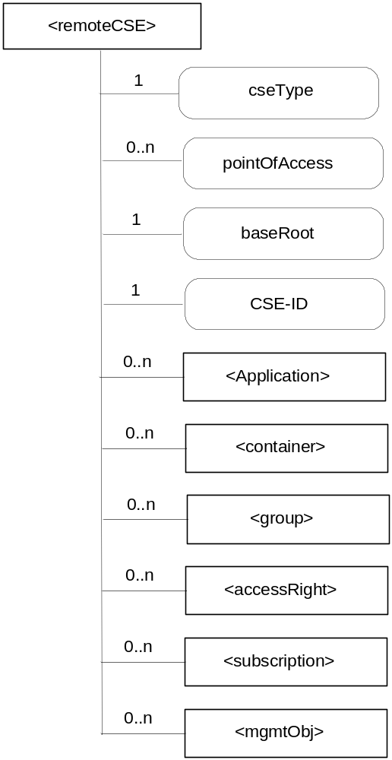
Figure 9.6.19-1: Structure of <remoteCSE> resource
(only child resources and resource specific attributes are shown)

This resource shall contain the child resources according to their multiplicitly in Table 9.6.19-1 (0 indicates the optionality of the child resource).

Table 9.6.19-1: Child resources of <remoteCSE> resource
Child Resource Name of <remoteCSE> | Child Resource Type | Multiplicity | Description
[variable] | <Application> | 0..n | See section 9.6.18.
[variable] | <container> | 0..n | See section 9.6.3.
[variable] | <group> | 0..n | See section 9.6.5.
[variable] | <accessRight> | 0..n | See section 9.6.2.
[variable] | <subscription> | 0..n | See section 9.6.9.
[variable] | <mgmtObj> | 0..n | See section 9.6.10.

The <remoteCSE> resource shall contain the attributes described in Table 9.6.19-2.
Table 9.6.19-2: Attributes of <remoteCSE> resource
Attribute Name of <remoteCSE> | Multiplicity | RW/  RO/  WO | Description
resourceType (rT) | 1 | RO | See section 9.6.1 where this common attribute is described.
parentID (pID) | 1 | RO | See section 9.6.1 where this common attribute is described.
creationTime (cT) | 1 | RO | See section 9.6.1 where this common attribute is described.
lastModifiedTime (lMT) | 1 | RO | See section 9.6.1 where this common attribute is described.
expirationTime (eT) | 0..1 | RW | See section 9.6.1 where this common attribute is described.
accessRightID_[i] (aRI_[i]) | 0..n | RW | See section 9.6.1 where this common attribute is described.
labels (lBs) | 0..1 | RW | See section 9.6.1 where this common attribute is described.
cseType (csT) | 1 | WO | Indicates the type of CSE node represented by the created resource.
pointOfAccess_[i] (poA_[i]) | 0..n | RW | For server capable remote CSE it represents the list of physical addresses to be used to connect to it (e.g. IP address, FQDN). The attribute is absent if the remote CSE is not server capable.
baseRoot (bRt) | 1 | WO | The URI of the baseRoot.
CSE-ID | 1 | WO | The globally unique CSE identifier.

<remoteCSE> and announced <remoteCSE> shall have different resourceType coding.
Editor’s Note on CSE-ID: an alignment between CSE-ID and baseURI is needed.
Editor’s Note on baseURI: the alignment with naming convention proposed for inter-M2M service provider is needed.
Editor’s Note on child resources: child resources of <remoteCSE> resource can accommodate listed resources and their announced versions.

9.6.20 Resource Type m2mServiceSubscription
This resource represents an M2M Service Subscription. It is used to represent all data pertaining to the M2M Service Subscription (the technical part of the contract between an M2M Application provider and an M2M Service Provider).
Editor’s Note: The link between the M2M Service Subscription resource and RBAC will be added once RBAC is included in the specification.

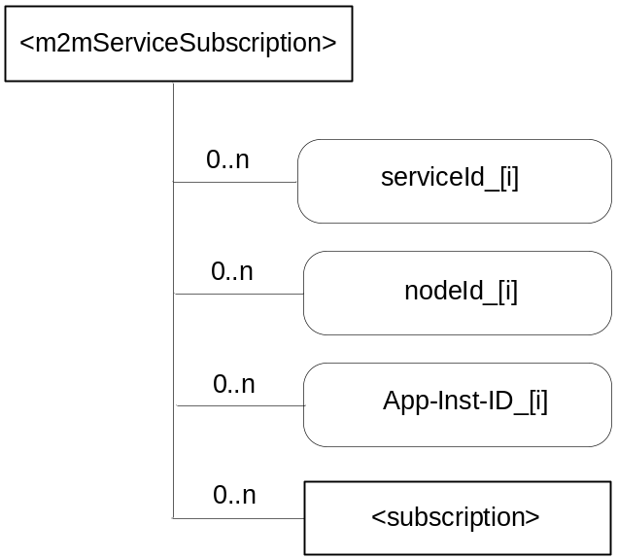
Figure 9.6.20-1: Structure of <m2mServiceSubscription> resource
(only child resource and resource specific attributes are shown)

Editor’s Note: The actual node resource shall include information such as, extID, profile, device specific ID if applicable and link to CSE and Applications running on the node.
Editor’s Note: the M2M-Sub-ID storage is FFS
This resource shall contain the child resource according to their multiplicitly in Table 9.6.20-1.
Table 9.6.20.1-1: Child resource of <m2mServiceSubscription> resource
Child Resource Name of <group> | Child Resource Type | Multiplicity | Description
[variable] | <subscription> | 0..n | See section 9.6.9

The <m2mServiceSubscription> resource shall contain the attributes described in Table 9.6.20-2.
Table 9.6.20-2: Attributes of <m2mServiceSubscription> resource
Attribute Name of <m2mServiceSubscription> | Multiplicity | RW/  RO/  WO | Description
resourceType (rT) | 1 | RO | See section 9.6.1 where this common attribute is described.
parentID (pID) | 1 | RO | See section 9.6.1 where this common attribute is described.
expirationTime (eT) | 1 | RW | See section 9.6.1 where this common attribute is described.
accessRightID (aRI) | 0..1 | RW | See section 9.6.1 where this common attribute is described. If no accessRightID is given at the time of creation, the accessRightID of the parent resource is linked to this attribute
creationTime (cT) | 1 | RW | See section 9.6.1 where this common attribute is described.
creator (cr) | 1 | RW | See section 9.6.1 where this common attribute is described.
lastModifiedTime (lMT) | 1 | RO | See section 9.6.1 where this common attribute is described.
serviceId_[i] | 0..n | RW | This attribute indicates the unique ID of the service being subscribed to. A service provider can define its own services.
nodeId_[i] | 0..n | RW | Identifier of a node pertaining to the M2M Service Subscription. The node identifier is specified in section 7.1.5 . The nodeId attributes link to the actual node resource that provides information pertaining to the node such as the external identifier, etc.
App-Inst-ID_<i> | 0..n | RW | Identifier of an application instance identifier as defined in section 7.1.2. It shall link to an application resource.

================================= End of 1st Change =================================

