INPUT CONTRIBUTION
Group Name:* | WG2
Title:* | TS-0007 Mca Registration Services
Source:* | George Foti, Ericsson, George.Foti@ericsson.com
Contact: | George Foti, Ericsson, George.Foti@ericsson.com
Date:* | 2014-09-15
Abstract:*
Agenda Item:*
Work item(s): | TS-0007 WI
Document(s)  Impacted* | TS-0007
Intended purpose of  document:* | Decision  Discussion  Information  Other <specify>
Decision requested or recommendation:* | Update TS for inclusion

oneM2M Notice
The document to which this cover statement is attached is submitted to oneM2M. Participation in, or attendance at, any activity of oneM2M, constitutes acceptance of and agreement to be bound by terms of the Working Procedures and the Partnership Agreement, including the Intellectual Property Rights (IPR) Principles Governing oneM2M Work found in Annex 1 of the Partnership Agreement.

Contents
6 M2M Services 3
6.1 Introduction 3
6.X Registration Services 4
6.X.1 Overview 4
6.X.2 Service Capabilities 4
6.X.2.1 registerAE 4
6.X.2.2 refreshAERegistration 6
6.X.2.3 deregisterAE 8
6.Y Registration Administration Services 10
6.Y.1 Overview 10
6.Y.2 Service Capabilities 10
6.Y.2.1 getRegistrationStatus 11
6.Y.2.2 revokeAERegistration 13
6.Y.2.3. subscribeInitialAERegistrationEvent 15
6.Y.2.4 unsubscribeInitialAERegistrationEvent 17
6.X.2.5 getInitialSubscriptionAERegistrationEvents 19
7.3 Infrastructure Component (INF) 20
7.3.1 INF to Service Cross Reference 20
7.7 Service Exposure (SE) 20
7.7.1 Service Exposure to Service Cross Reference 20

s

-----------------------Start of change 1---------------------------

6 M2M Services
This clause describes the M2M Services provided by the M2M Services Platform.

6.1 Introduction
The M2M Services defined in this clause are utilized by the Business Services described in the Annexes of this specification.
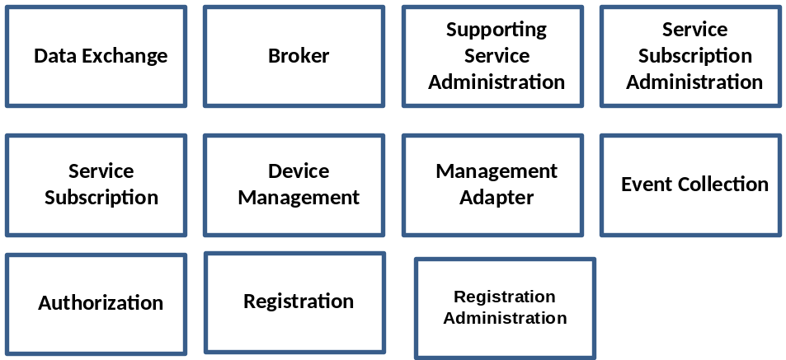
Figure 6.1-1: oneM2M Services

6.X Registration Services

6.X.1 Overview
The Registration service provides the ability for:
- Initial Registration of an AE
- Refresh an existing Registration of an AE
- AE initiated termination of an existing Registration

6.X.2 Service Capabilities
Editors Note: The fetching of the service profile is FFS in all operations involving such a step
Editors Note: The validation that the AE-ID is associated with the service profile is FFS in all operations involving such a step

6.X.2.1 registerAE
This service capability enables an AE or a third party provisioned with the proper authorization to register with the M2M System. This service capability shall be restricted across the Mca reference point.

6.X.2.1.1 Pre-conditions
The AE has not registered with the M2M System.
The common request attributes for the Mca reference point contains the Application Entity (AE-ID) that the Originator has requested to be used for future exchanges between the AE and the M2M System.

6.X.2.1.2 Signature
Parameter name | Direction | Optional | Description
pointOf Access | IN | NO | The point of Access of the registered AE.
applicationId | IN | NO | The Application Identifer (App-ID).
expirationTime | IN | NO | The expiration time of the registration as requested by the Originator
aeId | OUT | NO | AE-ID is provided back in the response
responseType | OUT | NO | Unique response types for this service:  - AE successfully registered  - AE not successfully registered
Table 6.X.2.1.2-1 Registration – registerAE capability

6.X.2.1.3 Services Interaction
The interactions of service capabilities required for this service capability:
- Issue the request to Supporting Services to validate the service profile, authorize the request and record the event.
- Send a notification for a first-time application registration on the device in the event there is a subscription

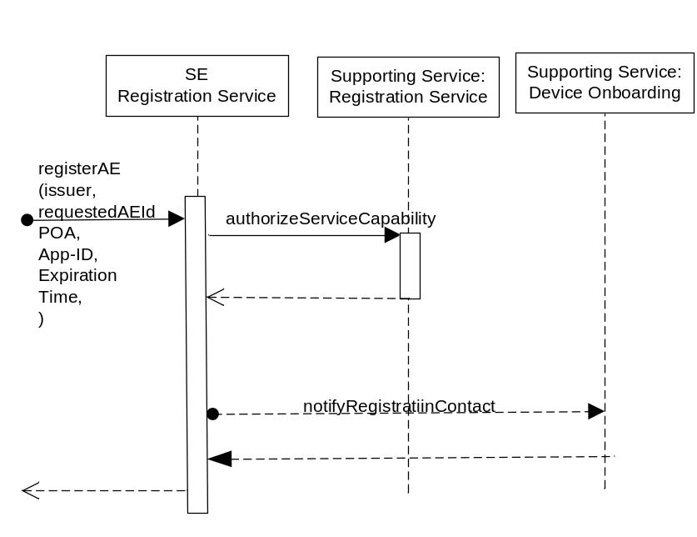
Figure 6.X.2.1.3-1 Registration – registerAE Diagram

6.X.2.1.4 Post-Conditions
AE is registered and can start using service capabilities
The returned AE-ID shall be used in any subsequent operation related to that application

6.X.2.1.5 Exceptions
Not Applicable

6.X.2.1.6 Policies for Use
Message Exchange Patterns: In-Out
Transaction Pattern: Participation allowed

6.X.2.1.7 oneM2M Resource Interworking
This service capability interworks with the following oneM2M Resource operations:
- Create AE

6.X.2.2 refreshAERegistration
This service capability enables an AE or a third party provisioned with the proper authorization to refresh an existing registration with the M2M System. This service capability shall be restricted to the Mca and Msc reference points.

6.X.2.2.1 Pre-conditions
The AE has successfully registered with the M2M System.
The common request attributes for the Mca and Msc reference points contains the Application Entity (AE-ID) that the Originator has requested to be used for future exchanges between the AE and the M2M System.

6.X.2.2.2 Signature
Parameter name | Direction | Optional | Description
pointOfAccess | IN | YES | The point of Access of the registered AE. POA is optional only if identical to the one in the refreshed registration
expirationTime | IN | NO | The expiration time of the registration as requested by the Originator.
responseType | OUT | NO | Unique response types for this service:  - AE successfully refreshed  - Registration Does not exist
Table 6.X.2.2.2-1 refreshAERegistration capability

6.X.2.2.3 Service Interactions
The interactions of service capabilities required for this service capability:
- Issue the request to Supporting Services to validate the service profile, authorize the service request and record the event.

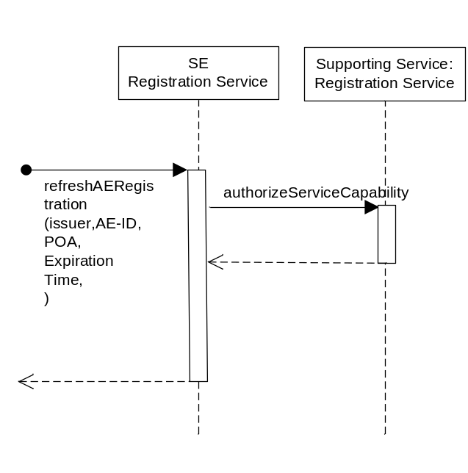
Figure 6.X.2.2.3-1 Registration – refreshAERegistration Diagram

6.X.2.2.4 Post-Conditions
Not Applicable

6.X.2.2.5 Exceptions
Not Applicable

6.X.2.2.6 Policies for Use
Message Exchange Patterns: In-Out
Transaction Pattern: Participation allowed

6.X.2.2.7 oneM2M Resource Interworking
This service capability interworks with the following oneM2M Resource operations:
- Update AE

6.X.2.3 deregisterAE
This service capability enables an AE or a third party provisioned with the proper ACP to deregister from the M2M System. This service capabaility shall be restricted to the Mca reference points.

6.X.2.3.1 Pre-conditions
The AE successfully registered with the M2M System.
The common request attributes for the Mca and Msc reference points contains the Application Entity (AE-ID) that the Originator has requested to be used for future exchanges between the AE and the M2M System.

6.X.2.3.2 Signature
Parameter name | Direction | Optional | Description
responseType | OUT | NO | Unique response types for this service:  - AE successfully De-registsred  - Registration Does not exist
Table 6.X.2.3.2-1 Registration – deregisterAE capability

6.X.2.3.3 Service Interactions
The interactions of service capabilities required for this service capability:
- Issue the request to Supporting Services to validate the service peofile, authorize the request and record the event.

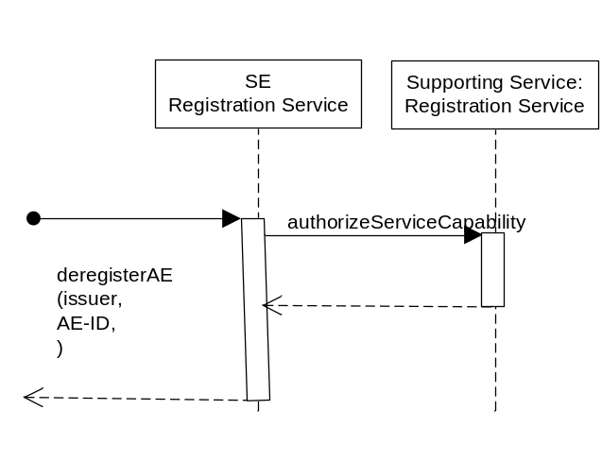
Figure 6.X.2.3.3-1 Registration – deregisterAE Diagram

6.X.2.3.4 Post-Conditions
AE is no longer registsred and cannot use any services.

6.X.2.3.5 Exceptions
Not Applicable
Transaction Pattern: Participation allowed

6.X.2.3.6 oneM2M Resource Interworking
This service capability interworks with the following oneM2M Resource operations:
- Delete AE

6.Y Registration Administration Services

6.Y.1 Overview
The Registration administration service provides the ability for:
- Retrieve the AE’s Registration status
- Revoke an AE existing Registration
- Permit subscriptions to AE Registration events

6.Y.2 Service Capabilities
Editors Note: The fetching of the service profile is FFS in all operations involving such a step
Editors Note: The validation that the AE-ID is associated with the service profile is FFS in all operations involving such a step

6.Y.2.1 getRegistrationStatus
This service capability enables a third party authorized for this operation, to retrieve the registration status for an AE. This service capability is limited to the Msc reference point

6.Y.2.1.1 Pre-conditions
The common request attributes for the Msc reference point contains the Application Entity (AE-ID) that the Originator has requested to be used for future exchanges between the AE and the M2M System.

6.Y.2.1.2 Signature
Parameter name | Direction | Optional | Description
pointOf Access | OUT | NO | The point of Access of the registered AE.
applicationId | OUT | NO | The Application Identifer (App-ID).
expirationTime | OUT | NO | The expiration time of the registration as requested by the Originator.
responseType | OUT | NO | Unique response types for this service:  - AE successfully Retrieved  - Registration does not exist
Table 6.Y.2.1.2-1 Registration – getRegistrationStatus capability

6.Y.2.1.3 Service Interaction
The interactions of service capabilities required for this service capability:
- Issue the request to Service Subscription Adminstration to fetch the service profile for the registered AE-ID

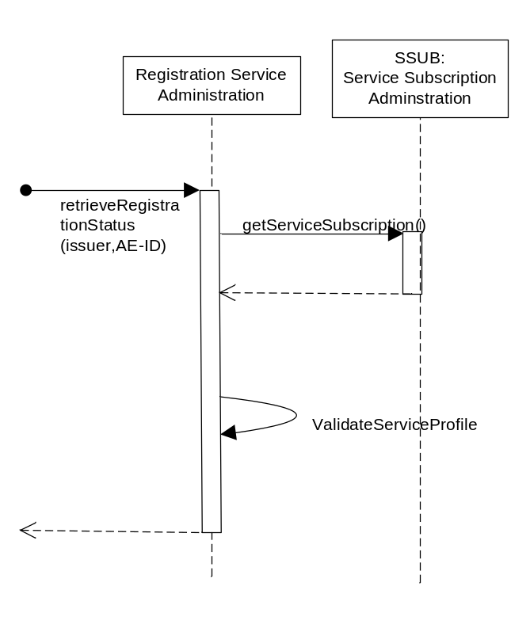
Figure 6.Y.2.1.3-1 Registration – getRegistrationStatus Diagram

6.Y.2.1.4 Post-Conditions
Not Applicable

6.Y.2.1.5 Exceptions
Not Applicable

6.Y.2.1.6 Policies for Use
Message Exchange Patterns: In-Out
Transaction Pattern: Participation allowed

6.Y.2.1.7 oneM2M Resource Interworking
This service capability interworks with the following oneM2M Resource operations:
- Read AE

6.Y.2.2 revokeAERegistration
This service capability enables a third party authorized for this operation to revoke an existing AE registration. This service capabaility shall be restricted to the Msc reference points

6.Y.2.2.1 Pre-conditions
The AE successfully registered with the M2M System.
The common request attributes for the Msc reference point contains the Application Entity (AE-ID) that the Originator has requested to be used for future exchanges between the AE and the M2M System.

6.Y.2.2.2 Signature
Parameter name | Direction | Optional | Description
responseType | OUT | NO | Unique response types for this service:  - AE successfully De-registsred  - Registration does not exist
Table 6.Y.2.2.2-1 revokeAERegistration capability

6.Y.2.2.3 Service Interaction
The interactions of service capabilities required for this service capability:
- Issue the request to the Service Subscription Adminstration to fetch the service profile.
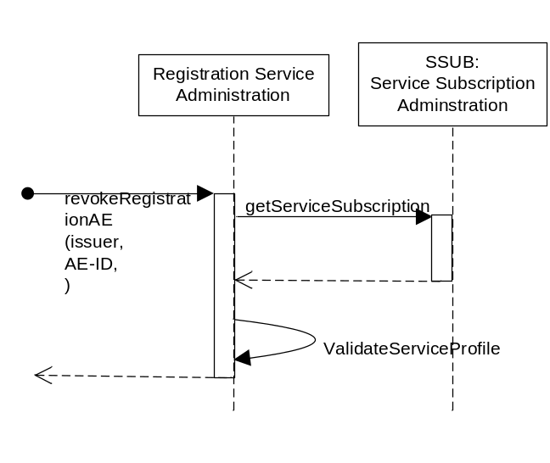

Figure 6.Y.2.2.3-1 Registration – revokeAERegistration Diagram

6.Y.2.2.4 Post-Conditions
AE is no longer registsred and cannot use any services

6.Y.2.2.5 Exceptions
Not Applicable

6.Y.2.2.6 Policies for Use
Message Exchange Patterns: In-Out
Transaction Pattern: Participation allowed

6.Y.2.2.7 oneM2M Resource Interworking
This service capability interworks with the following oneM2M Resource operations:
- Delete AE

6.Y.2.3. subscribeInitialAERegistrationEvent
This service capability enables a third party that is authorized to subscribe to the initial (first time ony) registration of an AE on all devices. This capability shall be restricted to the Msc reference point

6.Y.2.3.1 Pre-conditions
Not Applicable

6.Y.2.3.2 Signature
Parameter name | Direction |  | Optional | Description
applicationId | IN |  | NO | The Application Identifier (App-ID)
subscriptionId |  | OUT | YES | Return subscriptionId in case of a success.
responseType |  | OUT | NO | Unique response types for this service:  - successfully subscribed  - not successfully subscribed
6.Y.2.3.2-1 subscribeInitialAERegistrationEvent capabilty

6.Y.2.3.3 Service Interaction
The interactions of service capabilities required for this service capability:
- Issue the request to the Service Subscription Adminsitration to retrieve the service profile.

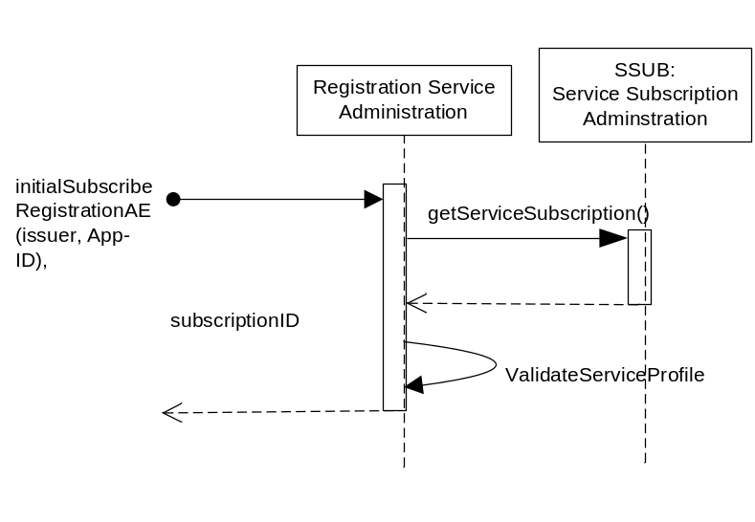
Figure 6.Y.2.3.3-1 Registration – subscribeInitialAERegistrationEvent Diagram

6.Y.2.3.4 Post-Conditions
An event is created

6.Y.2.3.5 Exceptions
Not Applicable

6.Y.2.3.6 Policies for Use
Message Exchange Patterns: In-Out
Transaction Pattern: Participation allowed

6.Y.2.3.7 oneM2M Resource Interworking
Not Applicable

6.Y.2.4 unsubscribeInitialAERegistrationEvent
This service capability enables a third party having the ACP for this operation to remove an existing subscription against an AE initial registration. This capability shall be restricted to the Msc reference point.

6.X.2.4.1 Pre-conditions
Not Applicable

6.X.2.4.2 Signature

Parameter name | Direction | Optional | Description
subscriptionId | IN | NO | The subscriptionId for the AE initial registration event.
responseType | OUT | NO | Unique response types for this service:  - Successfully unsubscribed  - Subscription does not exist
Table 6.Y.2.4.2-1 unsubscribeInitialAERegistrationEvent capability

6.X.2.4.3 Service Interaction
The interactions of service capabilities required for this service capability:
- Issue the request to the Service Subscription Adminstration tofetch the service profile.

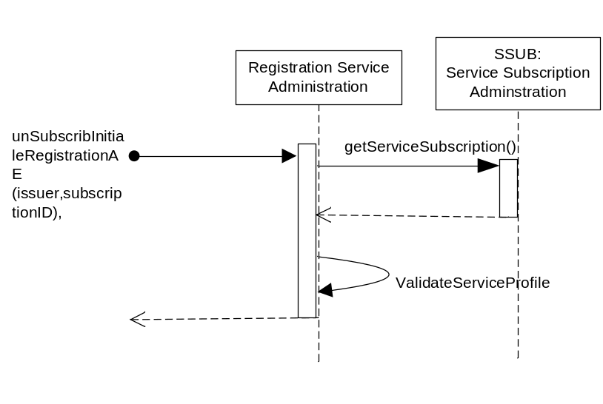
Figure 6.Y.2.4.3-1 Registration – unsubscribeInitialAERegistrationEvent Diagram

6.X.2.4.4 Post-Conditions
Subscription to AE no longer exists for the originator

6.X.2.4.5 Exceptions
Not Applicable

6.X.2.4.6 Policies for Use
Message Exchange Patterns: In-Out
Transaction Pattern: Participation allowed

6.X.2.4.7 oneM2M Resource Interworking
Not Applicable

6.X.2.5 getInitialSubscriptionAERegistrationEvents
This service capability enables a third party authorized for this operation to request a list of subscriptions against an initial registration AE. This capability shall be restricted to the Msc reference point.

6.X.2.5.1 Pre-conditions
Not applicable

6.X.2.5.2 Signature - getInitialSubscriptionAERegistrationEvents
Parameter name | Direction | Optional | Description
applicationId | IN | NO | The Application Instance Identifier (App-ID)
subscriptionIds | OUT | NO | List of subscriptionIds associated with that event
responseType | OUT | NO | Unique response types for this service:  - AE successfully de-registered  - Registration does not exist
Table 6.Y.2.5.2-1 Registration - getInitialSubscriptionAERegistrationEvents capability

6.X.2.5.3 Service Interaction
The interactions of service capabilities required for this service capability:
- Issue the request to the Service Subscription Administration to fetch the service profile
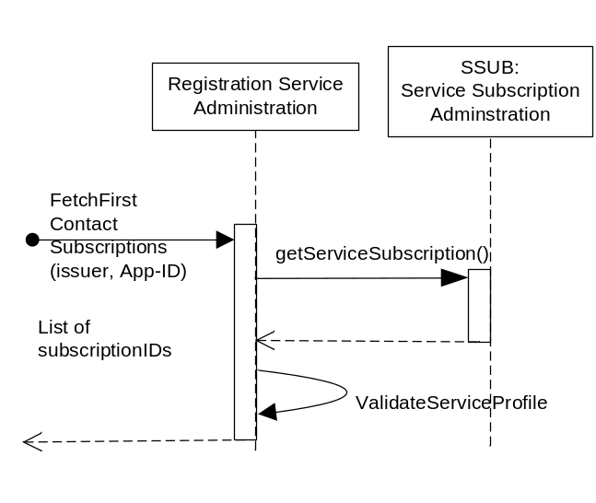
Figure 6.Y.2.5.3-1 Registration – getInitialSubscriptionAERegistrationEvents Diagram

6.X.2.5.4 Post-Conditions
Not Applicable

6.X.2.5.5 Exceptions
Not Applicable

6.X.2.5.6 Policies for Use
Message Exchange Patterns: In-Out
Transaction Pattern: Participation allowed

6.X.2.5.7 oneM2M Resource Interworking
Not Applicable

-----------------------Start of change 2 ------------------------

7.3 Infrastructure Component (INF)
The INF Component provides Services that are exposed to other M2M Service Components across the Msc reference point. The Services within the INF Component are common and utility type Services needed to enable other M2M Services.

7.3.1 INF to Service Cross Reference
Authorization: All Service Capabilities
ServiceSubscription: retrieveAuthorization
Registration Services: registerAE, refreshAERegistration, deregisterAE

7.7 Service Exposure (SE)
The SE Component acts as the primary interface for AEs to interact with the M2M Service Layer across the Mca reference point.

7.7.1 Service Exposure to Service Cross Reference
SE Data Exchange: All Service Capabilities
Service Subscription: getBroker
Broker: publish, subscribe
Service Subscription Administration: getServiceSubscription, addDeviceToServiceSubscription, deleteDeviceFromServiceSubscription, getDevicesForServiceSubscription, addApplicationsToServiceSubscription, deleteApplicationsFromServiceSubscription, getApplicationsForServiceSubscription
Management Adapter: All Service Capabilities
Registration Services: registerAE, refreshAERegistration, deregisterAE

-----------------------Start of change 3---------------------------
Remove service-Subscription-ID from the entire TS

