CHANGE REQUEST
Group Name:* | WG2 - Architecture
Source:* | KT
Format:* | ARC 14.0 Face-to-Face Meeting
Date:* | 2014-11-02
Contact:* | Francisco Sang-Eon Kim (kim.sangeon@kt.com)
Reason for Change/s:* | Architectual support to agreed use case for pairing device
CR against: Release* | v.1.2.0
CR against: TS/TR* | TS-0001
Clauses/Sub Clauses* | 9.6.1.1 Resource Type Summary  9.6.5 Resource Type AE
Type of change: * | Editorial change  Bug Fix or Correction  Change/correction to existing feature or functionality  New feature or functionality
Post Freeze checking:* | This CR contains only essential changes and corrections  YES NO

oneM2M Notice
The document to which this cover statement is attached is submitted to oneM2M. Participation in, or attendance at, any activity of oneM2M, constitutes acceptance of and agreement to be bound by terms of the Working Procedures and the Partnership Agreement, including the Intellectual Property Rights (IPR) Principles Governing oneM2M Work found in Annex 1 of the Partnership Agreement.
GUIDELINES for Change Requests:
Provide an informative introduction containing the problem(s) being solved, and a summary list of proposals.
Each CR should contain changes related to only one particular issue/problem.
Follow the principle of completeness, where all changes related to the issue or problem within a deliverable are simultaneously proposed to be made E.g. A change impacting 5 tables should not only include a proposal to change only 3 tables. Includes any changes to references, definitions, and acronyms in the same deliverable.
Follow the drafting rules.
All pictures must be editable.
Check spelling and grammar to the extent practicable.
Use Change bars for modifications.
The change should include the current and surrounding clauses to clearly show where a change is located and to provide technical context of the proposed change. Additions of complete sections need not show surrounding clauses as long as the proposed section number clearly shows where the new section is proposed to be located.
Multiple changes in a single CR shall be clearly separated by horizontal lines with embedded text such as, start of change 1, end of change 1, start of new clause, end of new clause.
When subsequent changes are made to content of a CR, then the accepted version should not show changes over changes. The accepted version of the CR should only show changes relative to the baseline approved text.

Introduction
The “Use case for Device Pairing in Home Domain”, REQ-2014-0469R03, is agreed at REQ 13.1 meetig.
REQ-2014-0469R03 describes functional impacts at high level analysis as shown in Figure 1.
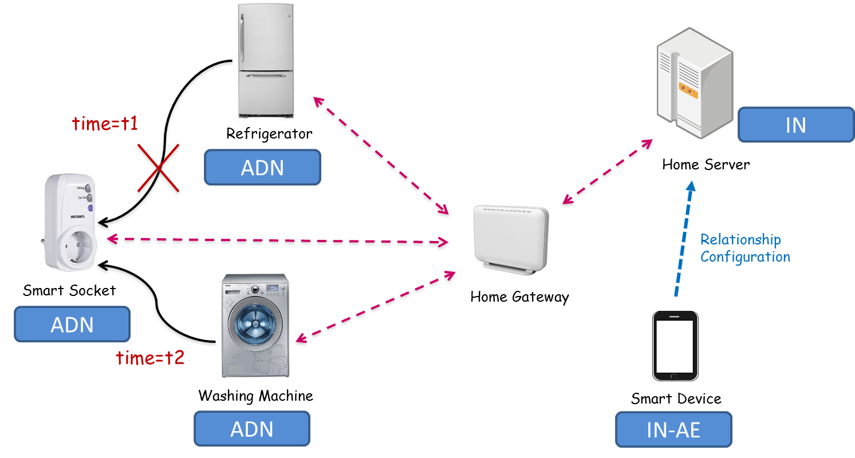
Figure 1 Concept of device pairing

A home domain devices such as refrigerator, washing machine are Application Dedicated Node (ADN) in the M2M aspects. The refrigerator and washing machine may not have communication interface. When the refrigerator plugs in smart socket to provide power supply, the refrigerator may communicate to Infrastructure Node (IN) through home gateway and smart socket.
The home gateway plays a role to provide Common Service Entity (CSE) with communication interface towards both IN and smart socket. The smart socket also may provide CSE optionally. In this case, a CSE in the home gateway or smart socket have to Application Entity (AE) of refrigerator and washing machine.
There are several possible scenarios of communication in the point of functional architecture and reference point.
Scenario A
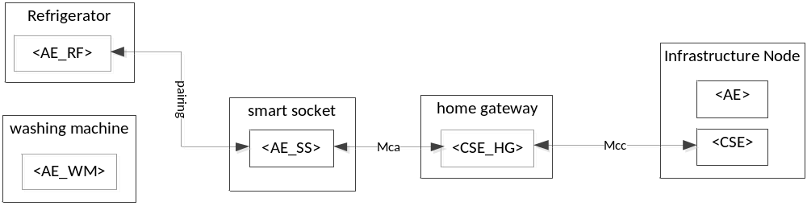Figure 2 Multiple <AEs> in paired environment via Mca between smart socket and home gateway

A possible AE resource tree for Figure 2 is Figure 3. The <AE_SS> is Application Entity resource for smart socket. The <AE_RF> is Application Entity resource for refrigerator.
When the home gateway creates resource tree, the <AE_SS> is used for Application Entity for parent to the <AE_RF>. The <AE_RF> is a child resource of the <AE_SS>
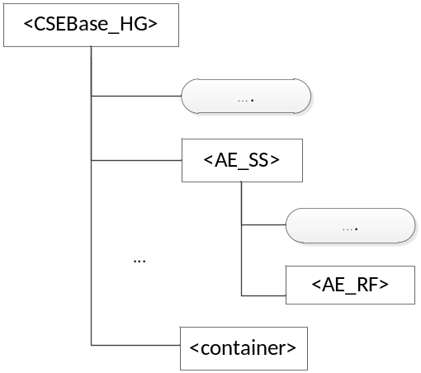
Figure 3 Concept of paired <AE> Resource at CSE of home gateway without <AE>

Scenario B
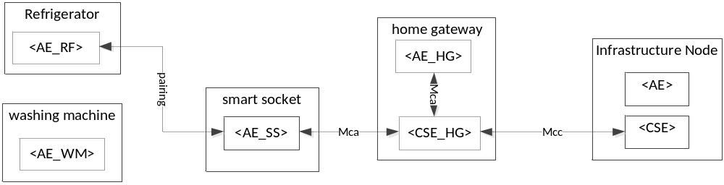Figure 4 Multiple AE in paired environment via Mca between smart socket and home gateway

A possible AE resource tree for Figure 4 is Figure 5. The <AE_HG> is Application Entity resource for home gateway. The <AE_SS> is Application Entity resource for smart socket. The <AE_RF> is Application Entity resource for refrigerator.
When the home gateway creates resource tree, the <CSEBase_HG> has two Application Entity: <AE_HG> and <AE_SS>. The <AE_HG> has no child resource of Application Entity. The <AE_SS> however can have child resource of Application Entity such as <AE_RF> and <AE_WM>
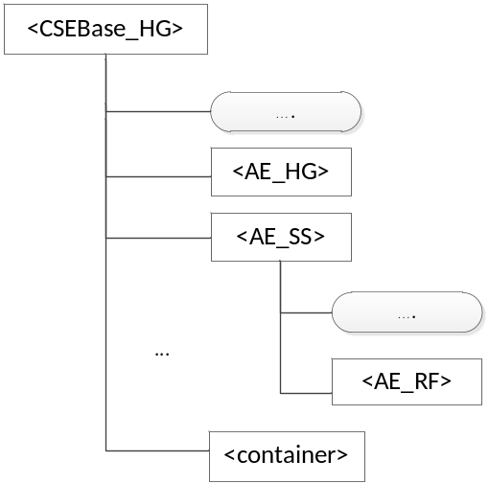
Figure 5 Concept of paired <AE> Resource at CSE of home gateway with <AE>
Scenario C

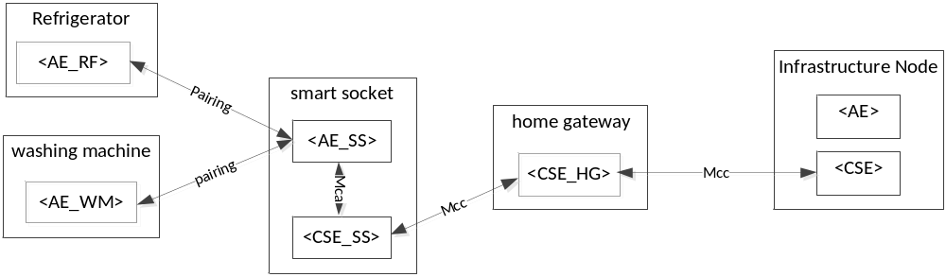 Figure 6 Multiple AE in paired environment via Mcc between smart socket and home gateway
A possible AE resource tree for Figure 6 is Figure 7. The <AE_HG> is Application Entity which has a child resource of Application Entity of paired device such as <AE_RF> and <AE_WM>.
When the smart socket creates resource tree, the <CSEBase_SS> has a child resource of Application Entity: <AE_RF> and <AE_WM>.
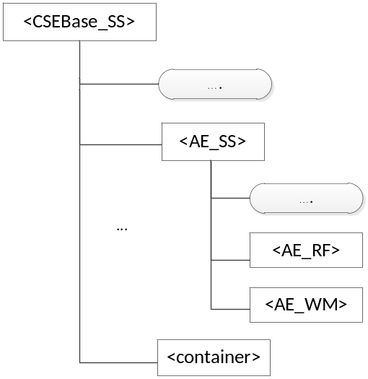
Figure 7 Concept of paired <AE> Resource at CSE of smart socket

---------------------------- Start of change 1 --------------------------------

9.6.1.1 Resource Type Summary
Table 9.6.1.1-1 introduces the normal and virtual resource types and their related child or parent resource types. Details of each resource type follow in the remainder of this clause.
Table 9.6.1.1-1 lists each specified <resourceType>. An addition of suffix "Annc" to such <resourceTypes> indicates the associated announced resource type.
Table 9.6.1.1-1 Resource Types
Resource Type | Short Description | Child Resource Types | Parent Resource Types | Clause
accessControlPolicy | Stores a representation of privileges. It is associated with resources that shall be accessible to entities external to the Hosting CSE. It controls "who" is allowed to do "what" and the context in which it can be used for accessing the resources | subscription | AE, remoteCSE, CSEBase | 9.6.2
AE | Stores information about the AE. It is created as a result of successful registration of an AE with the registrar CSE | subscription, container, group, accessControlPolicy, pollingChannel  AE | remoteCSE, CSEBase | 9.6.5
container | Shares data instances among entities. Used as a mediator that takes care of buffering the data to exchange "data" between AEs and/or CSEs. The exchange of data between AEs (e.g. an AE on a Node in a field domain and the peer-AE on the infrastructure domain) is abstracted from the need to set up direct connections and allows for scenarios where both entities in the exchange do not have the same reachability schedule | container, contentInstance, subscription, | AE, container, remoteCSE, CSEBase | 9.6.6
contentInstance | Represents a data instance in the <container> resource. | subscription | container | 9.6.7
CSEBase | The structural root for all the resources that are residing on a CSE. It shall store information about the CSE itself | remoteCSE, node, AE, container, group, accessControlPolicy, subscription,, mgmtCmd, locationPolicy, statsConfig, statsCollect, request, delivery,  schedule | None specified | 9.6.3
delivery | Forwards requests from CSE to CSE | subscription | CSEBase | 9.6.11
eventConfig | Defines events that trigger statistics collection | subscription | statsConfig | 9.6.24
execInstance | The Execution Instance resource contains all execution instances of the same management command mgmtCmd | subscription | mgmtCmd | 9.6.17
fanOutPoint | Virtual resource containing target fro group request.  It is used for addressing bulk operations to all the resources that belong to a group. | None specified | Group | 9.6.14
group | Stores information about resources of the same type that need to be addressed as a Group. Operations addressed to a Group resource shall be executed in a bulk mode for all members belonging to the Group | fanOutPoint,  subscription | AE, remoteCSE, CSEBase | 9.6.13
locationPolicy | Includes information to obtain and manage geographical location. It is only referred from container, the contentInstances of the container provides location information | subscription | CSEBase | 9.6.10
mgmtCmd | Management Command resource represents a method to execute management procedures required by existing management protocols | execInstance,  subscription | CSEBase | 9.6.16
mgmtObj | Management Object resource represents management functions that provides an abstraction to be mapped to external management technology. It represents the node and the software installed in the node.  NOTE: See clause 9.6.12 for a summary of specializations of <mgmtObj> | subscription, mgmtObj | node, mgmtObj | 9.6.15  Annex D
m2mServiceSubscriptionProfile | Data pertaining to the M2M Service Subscription | serviceSubscribedNode,  subscription | None specified | 9.6.19
node | Represents specific Node information | mgmtObj,  subscription | AE, CSEBase, remoteCSE | 9.6.18
pollingChannel | Represent a channel that can be used for a request-unreachable entity | pollingChannelURI | remoteCSE, AE | 9.6.21
remoteCSE | Represents a remote CSE for which there has been a registration procedure with the registrar CSE identified by the CSEBase resource | AE, container, group, accessControlPolicy, subscription, pollingChannel, schedule | CSEBase | 9.6.4
request | Expresses/access context of an issued Request | subscription | CSEBase | 9.6.12
schedule | Contains scheduling information for delivery of messages | subscription | subscription,mgmtObj, CSEBase, remoteCSE | 9.6.39  Annex D
serviceSubscribedNode | Node information | Subscription | m2mServiceSubscriptionProfile | 9.6.20
statsCollect | Defines triggers for the IN-CSE to collect statistics for applications | subscription | CSEBase (in IN-CSE) | 9.6.25
statsConfig | Stores configuration of statistics for applications | eventConfig,  subscription | CSEBase (in IN-CSE) | 9.6.23
subscription | Subscription resource represents the subscription information related to a resource. Such a resource shall be a child resource for the subscribe-to resource | schedule | accessControlPolicy, container, CSEBase, delivery, eventConfig, execInstance, group, contentInstance, locationPolicy, mgmtCmd, mgmtObj, m2mServiceSubscriptionProfile, node, serviceSubscribedNode, remoteCSE, request, schedule, statsCollect, statsConfig | 9.6.8

---------------------------- End of change 1 --------------------------------

---------------------------- Start of change 2 --------------------------------

9.6.5 Resource Type AE
An <AE> resource shall represent information about an Application Entity registered to a CSE.

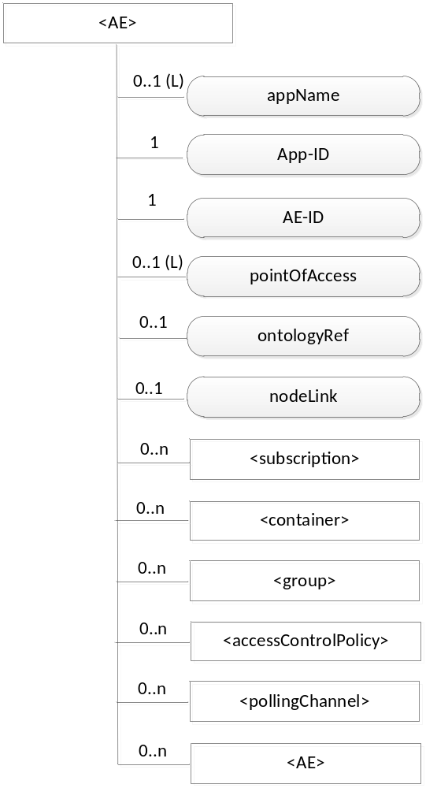
Figure 9.6.5-1: Structure of <AE> resource
The <AE> resource shall contain the child resources specified in table 9.6.5-1.

Table 9.6.5-1: Child resources of <AE> resource
Child Resources of <AE> | Child Resource Type | Multiplicity | Description | <AEAnnc> Child Resource Types
[variable] | <subscription> | 0..n | See clause 9.6.8 | <subscription>
[variable] | <container> | 0..n | See clause 9.6.6 | <container> <containerAnnc>
[variable] | <group> | 0..n | See clause 9.6.13 | <group>  <groupAnnc>
[variable] | <accessControlPolicy> | 0..n | See clause 9.6.2 | <accessControlPolicy>  <accessControlPolicyAnnc>
[variable] | <pollingChannel> | 0..n | See clause 9.6.21.  When the registrar CSE of this AE is request-unreachable, the AE should create this <pollingChannel> resource and perform long polling. | <pollingChannel>
[variable] | <AE> | 0..n | See clause 9.6.5 | <AE>  <AEAnnc>

The <AE> resource shall contain the attributes specified in table 9.6.5-2.

Table 9.6.5-2: Attributes of <AE> resource
Attributes of  <AE> | Multiplicity | RW/  RO/  WO | Description | <AEAnnc> Attributes
resourceType | 1 | RO | See clause 9.6.1.3 where this common attribute is described. | NA
parentID | 1 | RO | See clause 9.6.1.3 where this common attribute is described. | NA
expirationTime | 1 | RW | See clause 9.6.1.3 where this common attribute is described. | MA
accessControlPolicyIDs | 0..1 (L) | RW | See clause 9.6.1.3 where this common attribute is described. | MA
creationTime | 1 | RW | See clause 9.6.1.3 where this common attribute is described. | NA
lastModifiedTime | 1 | RO | See clause 9.6.1.3 where this common attribute is described. | NA
labels | 0..1 (L) | RO | See clause 9.6.1.3 where this common attribute is described. | MA
announceTo | 0..1 | RW | See clause 9.6.1.3 where this common attribute is described. | NA
announcedAttribute | 0..1 | RW | See clause 9.6.1.3 where this common attribute is described. | NA
appName | 0..1 | RW | The name of the application, as declared by the application developer(e.g. "HeatingMonitoring") | OA
App-ID | 1 | WO | The identifier of the Application (see clause 7.1.2). | OA
AE-ID | 1 | RO | The identifier of the Application Entity (see clause 7.1.2). | OA
pointOfAccess | 0..1 (L) | RW | The list of addresses for communicating with the registered Application Entity over Mca reference point via the transport services provided by Underlying Network (e.g. IP address, FQDN, URI). This attribute shall be accessible only by the AE and the Hosting CSE.  If this information is not provided, the AE should use <pollingChannel> resource. Then the Hosting CSE can forward a request to the AE without using the PoA. | OA
ontologyRef | 0..1 | RW | A URI of the ontology used to represent the information that is managed and understood by the AE. | OA
nodeLink | 0..1 | RO | A URI of a <node> resource that stores the node specific information. | OA

---------------------------- End of change 2 --------------------------------

CHECK LIST
- Does this change request include an informative introduction containing the problem(s) being solved, and a summary list of proposals.?
- Does this CR contain changes related to only one particular issue/problem?
- Does this change request make all the changes necessary to address the issue or problem? E.g. A change impacting 5 tables should not only include a proposal to change only 3 tables. Includes any changes to references, definitions, and acronyms in the same deliverable?
- Does this change request follow the drafting rules?
- Are all pictures editable?
- Have you checked the spelling and grammar?
- Have you used change bars for all modifications?
- Does the change include the current and surrounding clauses to clearly show where a change is located and to provide technical context of the proposed change? (Additions of complete sections need not show surrounding clauses as long as the proposed section number clearly shows where the new section is proposed to be located.)
- Are multiple changes in this CR clearly separated by horizontal lines with embedded text such as, start of change 1, end of change 1, start of new clause, end of new clause.?

