CHANGE REQUEST
Group Name:* | ARC
Source:* | LG Electronics
Format:*
Date:* | 2014-11-03
Contact:* | SeungMyeong JEONG (seungmyeong.jeong@lge.com)
Reason for Change/s:* | Replace “URI” term into address or ID in the ARC TS
CR against: Release*
CR against: TS/TR* | oneM2M-TS-0001
Clauses/Sub Clauses*
Type of change: * | Editorial change  Bug Fix or Correction  Change/correction to existing feature or functionality  New feature or functionality
Post Freeze checking:* | This CR contains only essential changes and corrections  YES NO

oneM2M Notice
The document to which this cover statement is attached is submitted to oneM2M. Participation in, or attendance at, any activity of oneM2M, constitutes acceptance of and agreement to be bound by terms of the Working Procedures and the Partnership Agreement, including the Intellectual Property Rights (IPR) Principles Governing oneM2M Work found in Annex 1 of the Partnership Agreement.
GUIDELINES for Change Requests:
Provide an informative introduction containing the problem(s) being solved, and a summary list of proposals.
Each CR should contain changes related to only one particular issue/problem.
Follow the principle of completeness, where all changes related to the issue or problem within a deliverable are simultaneously proposed to be made E.g. A change impacting 5 tables should not only include a proposal to change only 3 tables. Includes any changes to references, definitions, and acronyms in the same deliverable.
Follow the drafting rules.
All pictures must be editable.
Check spelling and grammar to the extent practicable.
Use Change bars for modifications.
The change should include the current and surrounding clauses to clearly show where a change is located and to provide technical context of the proposed change. Additions of complete sections need not show surrounding clauses as long as the proposed section number clearly shows where the new section is proposed to be located.
Multiple changes in a single CR shall be clearly separated by horizontal lines with embedded text such as, start of change 1, end of change 1, start of new clause, end of new clause.
When subsequent changes are made to content of a CR, then the accepted version should not show changes over changes. The accepted version of the CR should only show changes relative to the baseline approved text.

Introduction
This contribution basically replaces “URI” to “address” when it is used as to parameter of a request. For example, we put the address of a resource into to parameter when we send a request and also return the address of the created resource, not URIs, respectively.

Also some “URI”s used as a link between resources needs to be replaced by “ID”s, for example:
attributes of <group> resource
membersList | 1 | RW | List of zero or more member URIs IDs referred to in the remaining of this specification as memberID. Each URI ID(memberID) should refer to a members resource or a (sub-) <group> resource of the <group>.
membersAccessControlPolicyIDs | 0..1 (L) | RW | List of URIs IDs of the <accessControlPolicy> resources defining who is allowed to access the <fanOutPoint> resource.

Summary of changes/no-changes
- Clause 9.3.1 is deliverately not changed by this contribution, there’s the pending contribution for this (ARC-2014-1622-Resource_Addressing).
- In change 3: Addressing related text is removed since it will be specified/updated in clause 9.3.1 with ARC-2014-1622.
- In change 4: It makes alignment with ARC-2014-1622 assuming that it will get agreed.
- Clause 9.3.2.2 regarding PoA, it does not need to be changed
- In change 7: It makes alignment for “resourceID” with ARC-2014-1622 assuming that it will get agreed. There are also some changes to accesscontrolPolicyIDs attribute.
- In change 8: ontologyRef is a URI since it is an external URI, while nodeLink is an ID since it refers an oneM2M resource like accessControlPolicyIDs.
- In change 11, notificationURI includes addresses without scheme of URI. groupName is changed by groupID since it is the ID of a <group> resource.
- Regarding <pollingChannelURI> virtual resource, it will be covered by the other contribution which does cleanup for that resource type.
- Cleanup for clause 10.2.7 ( <group> and <fanOutPoint> procedures) is not covered by this contribution. Rather, see the contribution “ARC-2014-1624R01-cleanup_group_fanOutPoint” for this cleanup.
- Cleanup for clause 10.2.13 (<pollingChannel> and <pollingChannelURI> procedures) is not covered by this contribution. Rather, see the contribution “ARC-2014-1639” for this cleanup.

----------------------- Start of change 1 -----------------------

6.2.5 Discovery

6.2.5.1 General Concepts
The Discovery (DIS) CSF searches information about applications and services as contained in attributes and resources. The result of a discovery request from an Originator depends upon the filter criteria and is subject to access control policy allowed by M2M Service Subscription. An Originator could be an AE or another CSE. The scope of the search could be within one CSE, or in more than one CSE. The discovery results are returned back to the Originator.

6.2.5.2 Detailed Descriptions
The DIS CSF uses the Originator provided filter criteria (e.g. a combination of keywords, identifiers, location and semantic information) that can limit the scope of information returned to the Originator.
The discovery request indicates the address of the resource where the discovery is to be performed. Upon receiving such request, the DIS CSF discovers, identifies, and returns the matching information regarding discovered resources according to the filter criteria.
A successful response includes the discovered information or address(es) pertaining to the discovered resources. In the latter case the Originator can retrieve the resources using such discovered address. Based on the policies or Originator request, the CSE which received the discovery request can forward the request to other registered ASN-CSEs, MN-CSEs or IN-CSEs.

----------------------- End of change 1 -----------------------

----------------------- Start of change 2 -----------------------

6.2.6 Group Management

6.2.6.1 General Concepts
The Group Management (GMG) CSF is responsible for handling group related requests. The request is sent to manage a group and its membership as well as for the bulk operations supported by the group. When adding or removing members to/from a group, it is necessary to validate whether the group member complies with the purpose of the group. Bulk operations include read, write, subscribe, notify, device management, etc. Whenever a request or a subscription is made via the group, the group is responsible for aggregating its responses and notifications. The members of a group can have the same role with regards to access control policy control towards a resource. In this case, access control is facilitated by grouping. When the Underlying Network provides broadcasting and multicasting capability, the GMG CSF is able to utilize such capability.

6.2.6.2 Detailed Descriptions
The GMG CSF enables the M2M System to perform bulk operations on multiple devices, applications or resources that are part of a group. In addition, the GMG CSF supports bulk operations to multiple resources of interest and aggregates the results. It facilitates access control based on grouping. When needed and available, the GMG CSF can leverage the existing capabilities of the Underlying Network including broadcasting/multicasting.
When facilitating access control using a group, only members with the same access control policy towards a resource are included in the same group. Also, only AEs or CSEs which have a common role with regards to access control policy are included in the same group. This is used as a representation of the role when facilitating role based access control.
The service functions supported by the GMG CSF are as follows:
- Handles the requests to create, retrieve, update, and delete a group. An AE or a CSE may request the creation/retrieve/update/deletion of a group as well as the addition and deletion of members of the group.
- Creates one or more groups in CSEs in any of the Nodes in oneM2M System for a particular purpose (e.g. facilitation of access control, device management, fan-out common operations to a group of devices, etc.).
- Handles the requests to retrieve the information (e.g. address, metadata, etc.) of a group and its associated members.
- Manages group membership and handles requests to add or remove members to and from a group's member list. A member may belong to one or more groups. A group may be a member of another group. When new members are added to a group, the GMG CSF validates if the member complies with the purpose of the group.
- Leverages the capabilities of other CSFs in order to fulfill the functionalities supported by the GMG CSF service functions. Examples include: Security CSF for authentication and authorization.
- Forwards requests to all members in the group. In case the group contains another group as a member, the forwarding process is done recursively, i.e. the nested group forwards the request to its members. After forwarding the request to all members in the group, the GMG CSF generates an aggregated response by aggregating the corresponding responses from the Group members.
- Supports subscriptions to individual groups. Subscriptions to a group is made only if the subscriber is interested in all members of the group. If subscription to a group is made, the GMG CSF aggregates the notifications from the group members, and notifies the subscriber with the aggregated notification. Responses and event notifications relevant to a subscription may be selectively filtered by filtering criteria.

----------------------- End of change 2 -----------------------

----------------------- Start of change 3 -----------------------

7.1 M2M Identifiers
This clause provides a list of identifiers required for the purpose of interworking within the oneM2M architectural model.
An M2M identifier is a sequence of characters used to refer to an entity (such as CSE or an AE), a resource (such as defined in clause 9) or an object (such as an M2M Service Provider or an M2M Node) defined in oneM2M. An M2M identifier has a consistent meaning when applied (i.e. it refers consistently to the same resource, entity or object for the duration of their lifetime, as defined in the clause 7.2) in a particular context.

----------------------- End of change 3 -----------------------

----------------------- Start of change 4 -----------------------

8.1.2 Request
The Request from an Originator to a Receiver includes the following parameters:
- to: Address of the target resource for the operation. The to parameter shall conform to clause 9.3.1
NOTE 1: to parameter can be known either by pre-provisioning (clause 11.2) or by discovery (clause 10.2.6 for discovery). Discovery of <CSEBase> resource is not supported in this release of the document. It is assumed knowledge of <CSEBase> resource is by pre-provisioning only.
NOTE 2: The term target resource refers to the resource which is addressed for the specific operation. For example the to parameter of a Create operation for a resource <example> would be "/m2m.provider.com/exampleBase". The to parameter for the Retrieve operation of the same resource <example> is "/m2m.provider.com/exampleBase/example".
NOTE 3: For Retrieve operation (clause 10.1.2), the to parameter can be the URI of an attribute to be retrieved.
- fr: Identifier representing the Originator.
NOTE 4: The fr parameter shall be used by the Receiver to check the Originator identity for access privilege verification.
- cn: resource content to be transferred.
- role: optional, required when role based access control is applied <associated text and procedure TBD>
[8.1.2.0a] Editor's Note: Need to figure out the impact of Role in different procedures.
- op: operation to be executed: Create (C), Retrieve (R), Update (U), Delete (D), Notify (N)
The op parameter shall indicate the operation to be executed at the Receiver:
- Create (C): to is the address of the target resource where the new resource (parent resource)
- Retrieve (R): an existing to addressable resource is read and provided back to the Originator.
- Update (U): the content of an existing to addressable resource is replaced with the new content as in cn parameter. If some attributes in the cn parameter do not exist at the target resource, such attributes are created with the assigned values. If some attributes in the cn parameter are set to NULL, such attributes are deleted from the addressed resource.
- Delete (D): an existing to addressable resource and all its sub-resources are deleted from the Resource storage.
- Notify (N): information to be sent to the Receiver, processing on the Receiver is not indicated by the Originator.
The ty parameter shall be present in Request for the following operations:
- Create: ty is the type of the resource to be created.
- cn: resource content to be transferred.
The cn parameter shall be present in Request for the following operations:
- Create: cn is the content of the new resource with the resource type ty.
- Update: cn is the content to be replaced in an existing resource. For attributes to be updated at the resource, cn includes the names of such attributes with their new values. For attributes to be created at the resource, cn includes names of such attributes with their associated values. For attributes to be deleted at the resource, cn includes the names of such attributes with their value set to NULL.
- Notify: cn is the notification information.
The cn parameter may be present in Request for the following operations:
- Retrieve: cn is the list of attribute names from the resource that needs to be retrieved. The values associated with the attribute names shall be returned.
Other allowed parameters shall be as follows:
- nm: optional name of the resource to be created.
Example usage of the name includes a name that the Originator of the Create resource wishes to be used as the identifier of the newly created resource. For creating a <container> resource with the name "myContainer" the request will provide the parameter nm with the value "myContainer" and the created resource would be: /<CSEBase>/myContainer.
- ot: optional originating timestamp of when the message was built.
Example usage of the originating timestamp includes: to measure and enable operation (e.g. message logging, correlation, message prioritization/scheduling, accept performance requests, charging, etc.) and to measure performance (distribution and processing latency, closed loop latency, SLAs, analytics, etc.)
- rqet: optional request message expiration timestamp.
Example usage of the request expiration timestamp includes to indicate when request messages (including delay-tolerant) should expire due to their staleness being no longer of value, and to inform message scheduling/prioritization. When a request has set request expiration timestamp to a specific time and the Request demands an operation on a Hosting CSE that is not the CSE currently processing the request, then the current CSE shall keep on trying to deliver the Request to the Hosting CSE until the request expiration timestamp time, in line with provisioned policies.
- rset: optional result message expiration timestamp.
Example usage of the result expiration timestamp includes to indicate when result messages (including delay-tolerant) should expire due to expected staleness of the result, being no longer of value, and to inform message scheduling/prioritization. It can be used to set the maximum allowed total request/result message sequence round trip deadline.
- rt: optional response message type: Indicates what type of response shall be sent to the issued request and when the response is sent to the Originator:
- nonBlockingRequestSynch: In case the request is accepted by the Receiver CSE, the Receiver CSE responds after acceptance with an Acknowledgement confirming that the Receiver CSE will further process the request. The Receiver CSE includes in the response to an accepted request a reference that can be used to access the status of the request and the result of the requested operation at a later time. Processing of Non-Blocking Requests is defined in clause 8.2.2 and in particular for the synchronous case in clause 8.2.2.2.
- nonBlockingRequestAsynch {optional list of notification targets}: In case the request is accepted by the Receiver CSE, the Receiver CSE shall respond after acceptance with an Acknowledgement confirming that the Receiver CSE will further process the request. The result of the requested operation needs to be sent as notification(s) to the notification target(s) provided optionally within this parameter as a list of entities or to the Originator when no notification targets are provided. Processing of Non-Blocking Requests is defined in clause 8.2.2 and in particular for the asynchronous case in clause 8.2.2.3.
- blockingRequest: In case the request is accepted by the Receiver CSE, the Receiver CSE responds with the result of the requested operation after completion of the requested operation. Processing of Blocking Requests is defined in clause 8.2.1.
Example usage of the response type set to nonBlockingRequestSynch: An Originator that is optimized to minimize communication time and energy consumption wants to express a Request to the receiver CSE and get an acknowledgement on whether the Request got accepted. After that the Originator may switch into a less power consuming mode and retrieve a Result of the requested Operation at a later time.
Further example usage of response type set to nonBlockingRequestSynch includes when the result content is extremely large, or when the result consists of multiple content parts from a target group which are to be aggregated asynchronously over time.
- rc: optional result content: Indicates what are the expected components of the result of the requested operation. The Originator of a request may not need to get back a result of an operation at all. This shall be indicated in the rc parameter. Which exact settings of rc are possible depends on the requested operation specified in op. Possible values of rc are:
- attributes: Representation of the requested resource shall be returned as content, without the address(es) of the child resource(s). This is the default value. For example, if the request is to retrieve a <container> resource, the address(es) of the <contentInstance> child-resource(s) is not provided. This setting is not valid for a Notify operation.
- attributes+child-resources: Representation of the requested resource, along with the address(es) of the child resource(s), possibly limited by a maximum number of retrieved links, shall be returned as content. For example, if the request is to retrieve a <container> resource, the <container> resource and the address(es) of the <contentInstance> child-resource(s) are provided. This setting is not valid for a Notify operation
- child-resource: Address(es) of the child resources, possibly limited by a maximum number of retrieved address(es), without any representation of the actual requested resource shall be returned as content. For example, if the request is to retrieve a <container> resource, only the address(es) of the <contentInstance> child-resource(s) is provided. This setting is not valid for a Notify operation
- nothing: Nothing shall be returned as operational result content. This setting is not valid for a retrieve operation. This setting is the default when a Notification was requested by the op parameter.
- original-resource: Representation of the original resource pointed by the link attribute in the announced resource shall be returned as content, without the address(es) of the child resource(s). This setting is only valid when the to parameter in the RETRIEVE Request targets the announced resource.

[8.1.2.f0] Editor's Note: Example usage of all rc enumerated values needed. What is the use case for "nothing"?
[8.1.2.f1] Editor's Note: Do we need to support use case for "no response expected" in this release.
- rp: optional response persistence: indicates the duration for which the address containing the responses is to persist.
Example usage of response persistence includes requesting sufficient persistence for analytics to process the response content aggregated asynchronously over time. If a result expiration timestamp is specified then the response persistence should last beyond the result expiration time.
- ri: request Identifier.
Example usage of request identifier includes enabling the correlation between a Request and one of the many received Responses.
- oet: optional operation execution time: indicates the time when the specified operation op is to be executed by the target CSE. A target CSE shall execute the specified operation of a Request having its operational execution time indicator set, starting at the operational execution time. If the execution time has already passed or if the indicator is not set, then the specified operation shall be immediately executed, unless the request expiration time, if set, has been reached.
Example usage of operational execution time includes asynchronous distribution of flows, which are to be executed synchronously at the operational execution time.
NOTE 5: Time-based flows could not supported depending upon time services available at CSEs.
- ec: optional event category: Indicates the event category that should be used to handle this request. Event categories are impacting how Requests to access remotely hosted resources are processed in the CMDH CSF. Selection and scheduling of connections via CMDH are driven by policies that can differentiate event categories.
Example usage of "event category" set to specific value X: When the request is demanding an operation to be executed on a Hosting CSE that is different from the current Receiver CSE, the request may be stored in the current Receiver CSE that is currently processing the request on the way to the Hosting CSE until it is allowed by provisioned policies for that event category X to use a communication link to reach the next CSE on a path to the Hosting CSE or until the request expiration timestamp is expired.
The following values for ‘ec’ shall have a specified pre-defined meaning:
  - ec = immediate: Requests of this category shall be sent as soon as possible and shall not be subject to any further CMDH processing, i.e. the request will not be subject to storing in CMDH buffers when communication over an underlying network is possible. In particular, CMDH processing will respect values for rqet, rset given in the original request and not fill in any default values if they are missing.
  - ec = bestEffort: Requests of this category can be stored in CDMH buffers at the discretion of the CSE that is processing the request for an arbitrary time and shall be forwarded via Mcc on a best effort basis. The CSE does not assume any responsibility to meet any time limits for delivering the information to the next CSE. Also the maximum amount of buffered requests for this category is at the discretion of the processing CSE.
  - ec = latest:
    - If this category is used in a request asking for a CRUD operation on a resource, the following shall apply:
CRUD requests using this category shall undergo normal CMDH processing as outlined further below in this specification and in [i.2] with a maximum buffer size of one pending request for a specific pair of fr and to parameters that appear in the request. If a new request message is received by the CSE with a pair of parameters fr and to that has already been buffered for a pending request, the newer request will replace the buffered older request.
    - If this category is used in a notification request triggered by a subscription, the following shall apply:
Notification requests triggered by a subscription using this category shall undergo normal CMDH processing as outlined further below in this specification and in TS-0004 [i.2] with a maximum buffer size of one pending notification request per subscription reference that appears in a notification request. If a new notification request is received by the CSE with a subscription reference that has already been buffered for a pending notification request, the newer request will replace the buffered older request.
- If no further CMDH policies are provisioned for this event category, the forwarding process shall follow the ‘bestEffort’ rules defined above.
- The M2M Service Provider shall be able to provision CMDH policies describing details for the usage of the specific Underlying Network(s) and the applicable rules as defined in the [cmdhPolicy] resource type for other ec values not listed above.
- da: optional delivery aggregation on/off: Use CRUD operations of <delivery> resources to express forwarding of one or more original requests to the same target CSE(s).
NOTE 6: Since da is optional, there could be a default value to be used when not present in the Request. This parameter could not be exposed to AEs via Mca.
Example usage of delivery aggregation set on: The CSE processing a request shall use aggregation of requests to the same target CSE by requesting CREATE of a <delivery> resource on the next CSE on the path to the target CSE.
- gid: optional group request identifier: Identifier optionally added to the group request that is to be fanned out to each member of the group in order to detect loops and avoid duplicated handling of operation in case of loops of group and common members between groups that have parent-child relationship.
- fc: optional filter criteria: conditions for filtered retrieve operation are described in table 8.1.2-1. This is used for resource discovery (clause 10.2.6) and general retrieve, update, delete requests (clause 10.1.2, 10.1.3 and 10.1.4).
Example usage of retrieve requests with filter criteria using modifiedSince condition tag: if a target resource is modified since 12:00 then the Hosting CSE will send a resource representation.
- Disrestype: Optional Discovery result format. This parameter applies to discovery related requests (see clause 10.2.6) to indicate the preference of the Originator for the format of returned information in the result of the operation. This parameter shall take on one of the following values reflecting the options in clause 9.3.1:
- Hierarchical addressingmethod.
- Non-hierarchical addressingmethod.

For example if Disrestype is set to Non-hierarchical addressing method, then the request Originator indicates that the discovered resources should be in the form of Non-hierarchical address.
The absence of the parameter implies that the result shall be in Hierarchical URI address.
Table 8.1.2-1: filterCriteria conditions
Condition tag | Multiplicity | Matching condition
createdBefore | 0..1 | The creationTime attribute of the resource is chronologically before the specified value.
createdAfter | 0..1 | The creationTime attribute of the resource is chronologically after the specified value.
modifiedSince | 0..1 | The lastModifiedTime attribute of the resource is chronologically after the specified value.
unmodifiedSince | 0..1 | The lastModifiedTime attribute of the resource is chronologically before the specified value.
stateTagSmaller | 0..1 | The stateTag attribute of the resource is smaller than the specified value.
stateTagBigger | 0..1 | The stateTag attribute of the resource is bigger than the specified value.
expireBefore | 0..1 | The expirationTime attribute of the resource is chronologically before the specified value.
expireAfter | 0..1 | The expirationTime attribute of the resource is chronologically after the specified value.
labels | 0..n | The labels attributes of the resource matches the specified value.
resourceType | 0..n | The resourceType attribute of the resource is the same as the specified value. It also allows differentiating between normal and announced resources.
sizeAbove | 0..1 | The contentSize attribute of the <contentInstance> resource is equal to or greater than the specified value.
sizeBelow | 0..1 | The contentSize attribute of the <contentInstance> resource is smaller than the specified value.
contentType | 0..n | The typeOfContent attribute of the <contentInstance> resource matches the specified value.
limit | 0..1 | Limitation the number of matching resources to the specified value.
attribute | 0..n | This is an attribute of resource types (clause 9.6). Therefore, a real tag name is variable and depends on its usage. E.g. creator of container resource type can be used as a filter criteria tag as “creator=Sam”.
filterUsage | 0..1 | Indicates how the filter criteria is used. E.g. if this parameter is not provided, the Retrieve operation is for generic retrieve operation. If filterUsage is provided, the Retrieve operation is for resource <discovery> (clause 10.2.6).

The rules when multiple conditions are used together shall be as follows:
- different conditions shall use the "AND" logical operation
- same conditions shall use the "OR" logical operation
Below is an example usage of filter criteria conditions in a HTTP query: an HTTP GET operation can be requested applying also a filter in the query part of the request itself:
GET /root?label=one&label=two&createdBefore=2014-01-01T00:00:00&limit=128&filterUsage=discovery
The example discovers a maximum of 128 resources matching the following logical condition: createdBefore < 2014-01-01T00:00:00 AND (label = one OR label = two).
Once the Request is delivered, the Receiver shall analyze the Request to determine the target resource.
If the target resource is addressing another M2M Node, the Receiver shall route the request appropriately.
If the target resource is addressing the Receiver, it shall:
- Check the existence of to addressed resource.
- Identify the resource type by ty.
- Check the privileges for fr Originator to perform the requested operation.
- Perform the requested operation (using cn content when provided) according to the provided request parameters as described above.
- Depending on the request result content, respond to the Originator with indication of successful or unsuccessful operation results. In some specific cases (e.g. limitation in the binding protocol or based on application indications), the Response could be avoided.

----------------------- End of change 4 -----------------------

----------------------- Start of change 5 -----------------------

Resource Management
All entities in the oneM2M System, such as AEs, CSEs, data, etc. are represented as resources. A resource structure is specified as a representation of such resources. Such resources are uniquely addressable. Procedures for accessing such resources are also specified.

9.1 General Principles
The following are the general principles for the design of the resource model.
- The "type" of each resource shall be specified. New resource types shall be supported as the need for them is identified.
- The root of the resource structure in a CSE shall be assigned an absolute address. See clause 9.3.1 for additional information.
- The attributes for all resource type shall be specified.
- Each resource type may be instantiated as multiple resources via Create procedure (clause 10.1.1).
- All resources and associated attributes shall be addressable as specified in clause 9.3.1.

- Both hierarchical and non-hierarchical addresses shall be supported by all CSEs.

----------------------- End of change 5 -----------------------

----------------------- Start of change 6 -----------------------

9.4 Resource Structure

9.4.1 Relationships between Resources
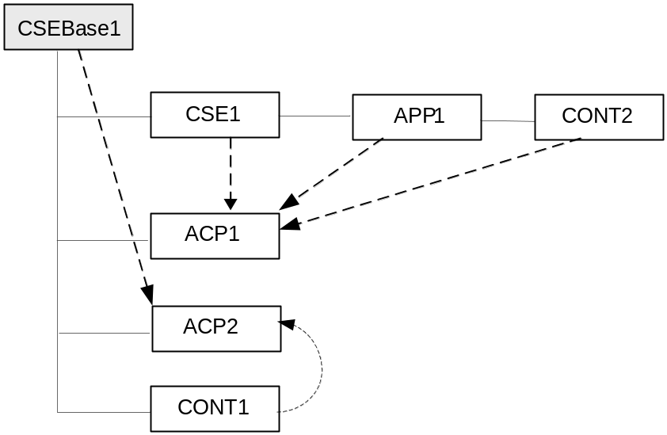

Figure 9.4.1-1: Resource Relationships Example in a CSE
NOTE: The resources shown in the above figure are:
- CSEBase1 is the name of a resource of type <CSEBase>
- CSE1 is the name of a resource of type <remoteCSE>
- APP1 is the name of a resource of type <AE>
- CONT1 and CONT2 are the names of resources of type <container>
- ACP1 and ACP2 are the names of resources of type <accessControlPolicy>
The solid line in Figure 9.4.1-1 represents parent-child relation, which is supported by a link (e.g. parentID) in the non-hierarchical addressing method, and by the hierarchical addressing method.
Dashed line in Figure 9.4.1-1 represents a link i.e. a relationship between the resources (e.g. relationship between the APP1 resource and the ACP1).
Figure 9.4.1-1 provides an example of a resource structure. The represented resources can be addressed by using one of the methods described in clause 9.3.1. Resources in the oneM2M System are linked with each other and they respect the containment relationship. The methods for linking resources are described in clause 9.4.2.
A link shall contain the following information:
- linkedResource: The target linked resource is given by using the ID of that resource.
- linkRelation: Describes the relationship that the current resource has with the linked resource (only in one direction, i.e. from this resource to the linked resource).

----------------------- End of change 6 -----------------------

----------------------- Start of change 7 -----------------------

9.6.1.3.2 Common attributes
The following attributes are commonly used in multiple, but not all, resource types.
NOTE: The list of attributes in Table 9.6.1.3-2 is not exhaustive.

Table 9.6.1.3.2-1: Common Attributes
Attribute Name | Description
resourceID | This attribute is an identifier for resource that is used for ‘non-hierarchical addressing method’.  This attribute shall be provided by the Hosting CSE when it accepts a resource creation procedure. The Hosting CSE shall assign a resourceID which is unique in that CSE.
accessControlPolicyIDs | The attribute contains a list of identifiers of an <accessControlPolicy> resource. The privileges defined in the <accessControlPolicy> resource that are referenced determine who is allowed to access the resource containing this attribute for a specific purpose (e.g. Retrieve, Update, Delete, etc.).  If a resource type does not have an accessControlPolicyIDs attribute definition, then the accessControlPolicyIDs for that resource is governed in a different way, for example, the accessControlPolicIDsy associated with the parent may apply to a child resource that does not have an accessControlPolicyIDs attribute definition, or the privileges for access are fixed by the system. Refer to the corresponding resourceType and procedures to see how permissions are handled in such cases.  If a resource type does have an accessControlPolicyIDs attribute definition, but the (optional) accessControlPolicyIDs attribute is not set, or it is set to a value that does not correspond to a valid, existing <accessControlPolicy> resource, or it refers to an <accessControlPolicy> resource that is not reachable (e.g. because it is located on a remote CSE that is offline or not reachable), then the system default access permissions shall apply.  All resources are accessible only if the privileges from the Access Control Policy grants it, therefore all resources shall have an associated AccessControlPolicyIDs attribute, either explicitly (setting the attribute in the resource itself) or implicitly (either by using the parent privileges or the system defaults). Which means that the system shall provide a default access privileges in case that the Originator does not provide a specific AccessControlPolicyIDs during the creation of the resource, Default access grants the configured privileges to the Originator (e.g. depending on the prefix of address of the resource).  This attribute is absent from the resource in some cases, especially if the resource shall have the same privileges of the parent resource; such an attribute is therefore not needed.  To update this attribute, a Hosting CSE shall check whether an Originator has Update permission in any selfPrivileges of the <accessControlPolicy> resources which this attribute originally indicates.
expirationTime | Time/date after which the resource will be deleted by the Hosting CSE. This attribute can be provided by the Originator, and in such a case it will be regarded as a hint to the Hosting CSE on the lifetime of the resource. The Hosting CSE can however decide on the real expirationTime. If the Hosting CSE decides to change the expirationTime attribute value, this is communicated back to the Originator.  The lifetime of the resource can be extended by providing a new value for this attribute in an UPDATE operation. Or by deleting the attribute value, e.g. by not providing the attribute when doing a full UPDATE, in which case the Hosting CSE can decide on a new value.  This attribute is mandatory when specified. If the Originator does not provide a value in the CREATE operation the system shall assign an appropriate value depending on its local policies and/or M2M service subscription agreements.
stateTag | An incremental counter of modification on the resource. When a resource is created, this counter is set to 0, and it will be incremented on every modification of the resource.  NOTE 1: In order to enable detection of overflow, the counter needs to be capable of expressing sufficiently long numbers. .  NOTE 2: This attribute has the scope to allow identifying changes in resources within a time interval that is lower than the one supported by the attribute lastModifiedTime (e.g. less than a second or millisecond). This attribute can also be used to avoid race conditions in case of competing modifications.  Modifications (e.g. Update/Delete) can be made on the condition that this attribute has a given value.
link | This attribute shall be present only on the announced resource. This attribute shall provide the link (address) to the original resource.
announceTo | This attribute may be included in a CREATE or UPDATE Request in which case it contains a list of addresses/CSE-IDs which the resource being created/updated shall be announced to.  This attribute shall only be present at the original resource if it has been successfully announced to other CSEs. This attribute maintains the list of URIs to the successfully announced resources. Updates on this attribute will trigger new resource announcement or de-announcement.
announcedAttribute | This attributes shall only be present at the original resource if some Optional Announced (OA) type attributes have been announced to other CSEs. This attribute maintains the list of the announced Optional Attributes (OA type attributes) in the original resource. Updates to this attribute will trigger new attribute announcement if a new attribute is added or de-announcement if the existing attribute is removed.

----------------------- End of change 7 -----------------------

----------------------- Start of change 8 -----------------------

9.6.4 Resource Type remoteCSE

Table 9.6.4-2: Attributes of <remoteCSE> resource
Attributes of <remoteCSE> | Multiplicity | RW/  RO/  WO | Description | <remoteCSEAnnc> Attributes
resourceType | 1 | RO | See clause 9.6.1.3 where this common attribute is described. | NA
resourceID | 1 | WO | See clause 9.6.1.3 where this common attribute is described. | MA
parentID | 1 | RO | See clause 9.6.1.3 where this common attribute is described. | NA
creationTime | 1 | RO | See clause 9.6.1.3 where this common attribute is described. | NA
lastModifiedTime | 1 | RO | See clause 9.6.1.3 where this common attribute is described. | NA
expirationTime | 1 | RW | See clause 9.6.1.3 where this common attribute is described. | MA
accessControlPolicyIDs | 0..1 (L) | RW | See clause 9.6.1.3 where this common attribute is described. | MA
labels | 0..1 (L) | RW | See clause 9.6.1.3 where this common attribute is described. | MA
announceTo | 0..1 | RW | See clause 9.6.1.3 where this common attribute is described. | NA
announcedAttribute | 0..1 | RW | See clause 9.6.1.3 where this common attribute is described. | NA
cseType | 0..1 | WO | Indicates the type of CSE represented by the created resource.  - Mandatory for an IN-CSE, hence multiplicity (1).  - Its presence is subject to SP configuration in case of an ASN-CSE or a MN-CSE. | OA
pointOfAccess | 0..1 (L) | RW | For request-reachable remote CSE it represents the list of physical addresses to be used to connect to it (e.g. IP address, FQDN). The attribute is absent if the remote CSE is not request-reachable.  If this information is not provided, the CSE should use <pollingChannel> resource. Then the Hosting CSE can forward a request to the CSE without using the PoA. | OA
CSEBase | 1 | WO | The address of the <CSEBase> resource represented by this <remoteCSE> resource. | OA
CSE-ID | 1 | WO | The CSE identifier in SP-relative CSE-ID format (clause 7.2). | OA
M2M-Ext-ID | 0..1 | RW | Supported when Registrar is IN-CSE.  See clause 7.1.8 where this attribute is described. This attribute is used only for the case of dynamic association of M2M-Ext-ID and CSE-ID. | NA
Trigger-Recipient-ID | 0..1 | RW | Supported when Registrar is IN-CSE.. See clause 7.1.10 where this attribute is described. This attribute is used only for the case of dynamic association of M2M-Ext-ID and CSE-ID. | NA
requestReachability | 1 | RW | If the CSE that created this <remoteCSE> resource can receive a request from other AE/CSE(s), this attribute is set to "TRUE" otherwise "FALSE".  NOTE: Even if this attribute is set to "FALSE", it does not mean it AE/CSE is always unreachable by all entities. E.g. the requesting AE/CSE is behind the same NAT, so it can communicate within the same NAT. | OA
nodeLink | 0..1 | RO | The resourceID of a <node> resource that is hosted as a child of the parent <CSEBase> instance resource and stores the node specific information for the node that hosts the CSE represented by the <remoteCSE> resource. | OA

----------------------- End of change 8 -----------------------

----------------------- Start of change 9 -----------------------

9.6.5 Resource Type AE

Table 9.6.5-2: Attributes of <AE> resource
Attributes of  <AE> | Multiplicity | RW/  RO/  WO | Description | <AEAnnc> Attributes
resourceType | 1 | RO | See clause 9.6.1.3 where this common attribute is described. | NA
parentID | 1 | RO | See clause 9.6.1.3 where this common attribute is described. | NA
expirationTime | 1 | RW | See clause 9.6.1.3 where this common attribute is described. | MA
accessControlPolicyIDs | 0..1 (L) | RW | See clause 9.6.1.3 where this common attribute is described. | MA
creationTime | 1 | RW | See clause 9.6.1.3 where this common attribute is described. | NA
lastModifiedTime | 1 | RO | See clause 9.6.1.3 where this common attribute is described. | NA
labels | 0..1 (L) | RO | See clause 9.6.1.3 where this common attribute is described. | MA
announceTo | 0..1 | RW | See clause 9.6.1.3 where this common attribute is described. | NA
announcedAttribute | 0..1 | RW | See clause 9.6.1.3 where this common attribute is described. | NA
appName | 0..1 | RW | The name of the application, as declared by the application developer(e.g. "HeatingMonitoring") | OA
App-ID | 1 | WO | The identifier of the Application (see clause 7.1.2). | OA
AE-ID | 1 | RO | The identifier of the Application Entity (see clause 7.1.2). | OA
pointOfAccess | 0..1 (L) | RW | The list of addresses for communicating with the registered Application Entity over Mca reference point via the transport services provided by Underlying Network (e.g. IP address, FQDN, URI). This attribute shall be accessible only by the AE and the Hosting CSE.  If this information is not provided, the AE should use <pollingChannel> resource. Then the Hosting CSE can forward a request to the AE without using the PoA. | OA
ontologyRef | 0..1 | RW | A URI of the ontology used to represent the information that is managed and understood by the AE. | OA
nodeLink | 0..1 | RO | An ID of a <node> resource that stores the node specific information. | OA

----------------------- End of change 9 -----------------------

----------------------- Start of change 10 -----------------------

9.6.6 Resource Type container

Table 9.6.6-2: Attribute of <container> resource
Attributes of  <container> | Multiplicity | RW/  RO/  WO | Description | <containerAnnc> Attributes
resourceType | 1 | RO | See clause 9.6.1.3 where this common attribute is described. | NA
resourceID | 1 | WO | See clause 9.6.1.3 where this common attribute is described. | MA
parentID | 1 | RO | See clause 9.6.1.3 where this common attribute is described. | NA
expirationTime | 1 | RW | See clause 9.6.1.3 where this common attribute is described. | MA
accessControlPolicyIDs | 0..1 (L) | RW | See clause 9.6.1.3 where this common attribute is described. If no accessControlPolicyIDs are provided at the time of creation, the accessControlPolicyIDs of the parent resource is linked to this attribute | MA
creationTime | 1 | RW | See clause 9.6.1.3 where this common attribute is described. | NA
lastModifiedTime | 1 | RO | See clause 9.6.1.3 where this common attribute is described. | NA
stateTag | 1 | RO | See clause 9.6.1.3 where this common attribute is described. | OA
announceTo | 0..1 | RW | See clause 9.6.1.3 where this common attribute is described. | NA
announcedAttribute | 0..1 | RW | See clause 9.6.1.3 where this common attribute is described. | NA
creator | 1 | RW | The AE-ID or CSE-ID of the entity which created the resource. | NA
maxNrOfInstances | 0..1 | RW | Maximum number of instances of <contentInstance> child resources. | OA
maxByteSize | 0..1 | RW | Maximum number of bytes that are allocated for a <container> resource for all instances in the <container> resource. | OA
maxInstanceAge | 0..1 | RW | Maximum age of the instances of <contentInstance> resources within the <container>. The value is expressed in seconds. | OA
currentNrOfInstances | 1 | RO | Current number of instances in a <container> resource. It is limited by the maxNrOfInstances. | OA
currentByteSize | 1 | RO | Current size in bytes of data stored in a <container> resource. It is limited by the maxNrOfBytes. | OA
latest | 0..1 | RO | Reference to latest <contentInstance> resource, when present. | OA
locationID | 0..1 | RW | An ID of the resource where the attributes/policies that define how location information are obtained and managed. This attribute is defined only when the <container> resource is used for containing location information. | OA
ontologyRef | 0..1 | RW | A reference (URI) of the ontology used to represent the information that is stored in the instances of the container.  NOTE: The access to this URI is out of scope of oneM2M. | OA

----------------------- End of change 10 -----------------------

----------------------- Start of change 11 -----------------------

9.6.8 Resource Type subscription

Table 9.6.8-2: Attributes of <subscription> resource
Attributes of <subscription> | Multiplicity | RW/  RO/  WO | Description
resourceType | 1 | WO | See clause 9.6.1.3 where this common attribute is described.
resourceID | 1 | WO | See clause 9.6.1.3 where this common attribute is described.
parentID | 1 | RO | See clause 9.6.1.3 where this common attribute is described.
expirationTime | 1 | RW | See clause 9.6.1.3 where this common attribute is described.
creationTime | 1 | RO | See clause 9.6.1.3 where this common attribute is described.
lastModifiedTime | 1 | RO | See clause 9.6.1.3 where this common attribute is described.
labels | 1 | RW | See clause 9.6.1.3 where this common attribute is described.
accessControlPolicyIDs | 0..1 (L) | RW | See clause 9.6.1.3 where this common attribute is described.  If no accessControlPolicyIDs is given at the time of creation, the accesControlPolicies of the parent resource is linked to this attribute.
eventNotificationCriteria | 0..1 (L) | RW | This notification policy indicates the event criteria for which a notification is to be generated.
expirationCounter | 0..1 | RW | This notification policy indicates that the subscriber wants to set the life of this subscription to a limit of a maximum number of notifications. When the number of notifications sent reaches the count of this counter, the <subscription> resource shall be deleted, regardless of any other policy.
notificationURI | 1 (L) | RW | List of URI(s) and/or address(es) where the resource subscriber will receive notifications. URI(s) in the list may not represent the resource subscriber entity. For a group-related subscription, the notificationURI shall be the URI that is generated by the group Hosting CSE to receive notifications. In this case, the resource subscriber notification URI shall be included in the notificationForwardingURI.
groupID | 0..1 | RW | The ID of a <group> resource in case the subscription is made through a group.
notificationForwardingURI | 0..1 | RW | The attribute is a forwarding attribute that shall be present only for group related subscriptions. It represents the resource subscriber notification URI. It shall be used by group Hosting CSE for forwarding aggregated notifications. See clauses 10.2.6.10 and 10.2.6.11.
batchNotify | 0..1 | RW | This notification policy indicates that the subscriber wants to receive batches of notifications rather than receiving them one at a time. This attribute expresses the subscriber’s notification policy and may include two values: the number of notifications to be batched for delivery and a duration. When either value is set, notification events are temporarily stored until either the specified number of notifications have been batched, or, until a duration which starts after the first notification was generated has expired. Following which the batched notifications are sent. If batchNotify is used simultaneously with latestNotify, only the latest notification shall be sent and have the ec set to “latest”.
rateLimit | 0..1 | RW | This notification policy indicates that the subscriber wants to limit the rate at which it receives notifications. This attribute expresses the subscriber’s notification policy and includes two values: a maximum number of events that may be sent within some duration, and the rateLimit window duration. When the number of generated notifications within the ratelimit window duration exceeds the maximum number, notification events are temporarily stored, until the end of the window duration, when the sending of notification events restarts in the next window duration. The sending of notification events continues as long as the maximum number of notification events is not exceeded during the window duration. The ratelimit policy may be used simultaneously with other notification policies.
preSubscriptionNotify | 0..1 | WO | This notification policy indicates that the subscriber wants to be sent notifications for events that were generated prior to the creation of this subscription. This attribute has a value of the number of prior notification events requested. If up-to-date caching of retained events is supported on the Hosting CSE and contains the subscribed events then prior notification events will be sent up to the number requested. The preSubscriptionNotify policy may be used simultaneously with any other notification policy.
pendingNotification | 0..1 | RW | This notification policy, if set, indicates how missed notifications due to a period of connectivity (according to the reachability and notification schedules). The possible values for pendingNotification are:  - “sendLatest”  - “sendAllPending”  This policy depends upon caching of retained notifications on the hosted CSE. When this attribute is set, only the last notification shall be sent and it shall have the ec set to “latest”. If this attribute is not present, the Hosting CSE sends no missed notifications. This policy applies to all notifications regardless of the selected delivery policy (batching, latestNotification, etc..) Note that unreachability due to reasons other than scheduling is not covered by this policy.
notificationStoragePriority | 0..1 | RW | Indicates that the subscriber wants to set a priority for this subscription relative to other subscriptions belonging to this same subscriber. This attribute sets a number within the priority range. When storage of notifications exceeds the allocated size, this policy is used as an input with the storage congestion policy specified in clause 9.6.3 to determine which stored and generated notifications to drop and which ones to retain.
latestNotify | 0..1 | RW | This notification policy indicates if the subscriber wants only the latest notification. If multiple notifications of this subscription are buffered, and if the value of this attribute is set to true, then only the last notification shall be sent and it shall have the ec value set to “latest”.
notificationContentType | 1 | RW | Indicates a notification content type that shall be contained in notifications. The allowed values are: .  - modified attributes only  - whole resource  - optionally the reference to this subscription resource.
notificationEventCat | 0..1 | RW | This notification policy indicates the subscriber’s requested ec to be used for notification messages generated by this subscription.
creator | 0..1 | WO | AE-ID or CSE-ID which created the <subscription> resource.
subscriberURI | 0..1 | WO | URI that is sent a notification when this <subscription> is deleted.

----------------------- End of change 11 -----------------------

----------------------- Start of change 12 -----------------------

9.6.10 Resource Type locationPolicy
The <locationPolicy> resource represents the method for obtaining and managing geographical location information of an M2M Node.
The actual location information shall be stored in a <contentInstance> resource which is a child resource of the <container> resource. The <container> resource includes the locationID attribute which holds the ID of this <locationPolicy> resource. A CSE can obtain location information based on the attributes defined under <locationPolicy> resource, and store the location information in the target <container> resource.
Based on the locationSource attribute, the method for obtaining location information of an M2M Node can be differentiated. The methods for obtaining location information shall be as follows:
- Network-based method: where the CSE on behalf of the AE obtains the target M2M Node's location information from an Underlying Network.
- Device-based method: where the ASN is equipped with any location capable modules or technologies (e.g. GPS) and is able to position itself.
- Sharing-based method: where the ADN has no GPS nor an Underlying Network connectivity. Its location information can be retrieved from either the associated ASN or a MN.
NOTE: Geographical location information could include more than longitude and latitude.
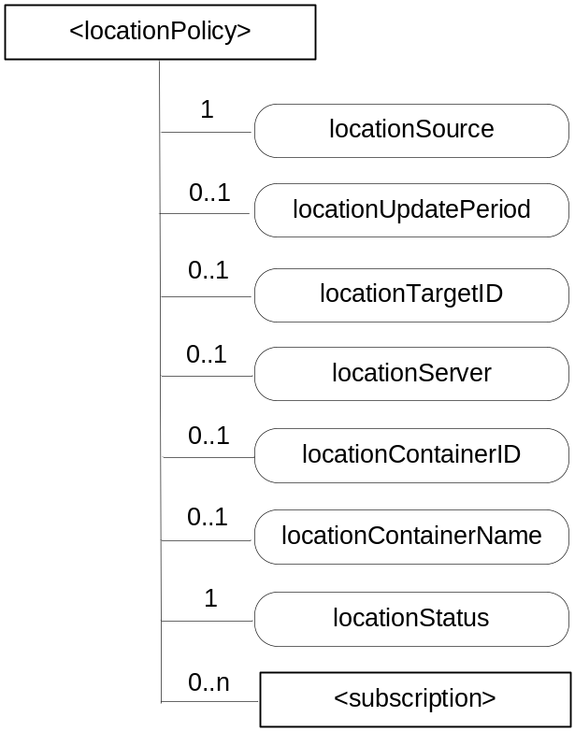
Figure 9.6.10-1: Structure of <locationPolicy> resource
The <locationPolicy> resource shall contain the child resources specified in table 9.6.10-1.

Table 9.6.10-1: Child resources of <locationPolicy> resource
Child Resources of <locationPolicy> | Child Resource Type | Multiplicity | Description | <locationPolicyAnnc> Child Resource Types
[variable] | <subscription> | 0..n | See clause 9.6.8 | None

The <locationPolicy> resource shall contain the attributes specified in table 9.6.10-2.

Table 9.6.10-2: Attributes of <locationPolicy> resource
Attributes of <locationPolicy> | Multiplicity | RW/  RO/  WO | Description | <locationPolicyAnnc> Attributes
resourceType | 1 | RO | See clause 9.6.1.3 where this common attribute is described. | NA
resourceID | 1 | WO | See clause 9.6.1.3 where this common attribute is described. | MA
parentID | 1 | RO | See clause 9.6.1.3 where this common attribute is described. | NA
expirationTime | 1 | RW | See clause 9.6.1.3 where this common attribute is described. | MA
accessControlPolicyIDs | 0..1 (L) | RW | See clause 9.6.1.3 where this common attribute is described. | MA
creationTime | 1 | RO | See clause 9.6.1.3 where this common attribute is described. | NA
lastModifiedTime | 1 | RO | See clause 9.6.1.3 where this common attribute is described. | NA
labels | 0..1 | RW | See clause 9.6.1.3 where this common attribute is described. | MA
announceTo | 0..1 | RW | See clause 9.6.1.3 where this common attribute is described. | NA
announcedAttribute | 0..1 | RW | See clause 9.6.1.3 where this common attribute is described. | NA
locationSource | 1 | RW | Indicates the source of location information  - Network Based  - Device Based  - Sharing Based | OA
locationUpdatePeriod | 0..1 | RW | Indicates the period for updating location information. If the value is marked '0' or not defined, location information is updated only when a retrieval request is triggered. | OA
locationTargetId | 0..1 | RW | The identifier to be used for retrieving the location information of a remote Node and this attribute is only used in the case that location information is provided by a location server. | OA
locationServer | 0..1 | RW | Indicates the identity of the location server. This attribute is only used in that case location information is provided by a location server. | OA
locationContainerID | 0..1 | RO | A ID of the <container> resource where the actual location information of a M2M Node is stored. | OA
locationContainerName | 0..1 | RW | A Name of the <container> resource where the actual location information of a M2M Node is stored. If it is not assigned, the Hosting CSE automatically assigns a name of the resource.  Note: The created <container> resource related to this policy shall be stored only in the Hosting CSE. | OA
locationStatus | 1 | RO | Contains the information on the current status of the location request. (e.g. location server fault) | OA

----------------------- End of change 12 -----------------------

change 13 is removed in R01.

----------------------- Start of change 14 -----------------------

9.6.15 Resource Type mgmtObj
When mapping resources from management technologies to a corresponding <mgmtObj> resource, the following rules shall apply:
- The root resource of external management objects maps to the <mgmtObj> resource
- For the child resource of the root resource of specific technology:
- Rule1: If the child external management object cannot have another child external management object, the external management object maps to the [objectAttribute] attribute of the <mgmtObj> resource with the same resource name.
- Rule2: If the child external management object can have another child external management object, the external management object maps to a new <mgmtObj> resource. The ID of the new <mgmtObj> resource is stored as an mgmtLink attribute of the <mgmtObj> resource which is mapped from the parent external management object.

----------------------- End of change 14 -----------------------

----------------------- Start of change 15 -----------------------

9.6.16 Resource Type mgmtCmd

Table 9.6.16-2: Attributes of <mgmtCmd> resource
Attributes of <mgmtCmd> | Multiplicity | RW/  RO/  WO | Description
resourceType | 1 | WO | See clause 9.6.1.3 where this common attribute is described
resourceID | 1 | WO | See clause 9.6.1.3 where this common attribute is described.
parentID | 1 | RO | See clause 9.6.1.3 where this common attribute is described.
expirationTime | 1 | RW | See clause 9.6.1.3 where this common attribute is described
accessControlPolicyIDs | 0..1 (L) | RW | See clause 9.6.1.3 where this common attribute is described
labels | 0..1 | RW | See clause 9.6.1.3 where this common attribute is described
creationTime | 1 | RO | See clause 9.6.1.3 where this common attribute is described
lastModifiedTime | 1 | RO | See clause 9.6.1.3 where this common attribute is described
description | 0..1 | RW | The text-format description of this resource.
cmdType | 1 | WO | The type to identify the management operation (e.g. download).
execReqArgs | 0..1 | RW | Structured attribute (e.g. abstract type) to contain any command-specific arguments of the request.
execEnable | 1 | RO | The attribute can be blank without any value or it can contain a address that can be used to trigger execution of <mgmtCmd> using UPDATE method.
execTarget | 1 | RW | ID of the <node> resource of the target on which this <mgmtCmd> will be executed. It may be the ID of a <group> resource in which case the <mgmtCmd> will be executed on all members in the memberList attribute of the addressed <group> resource.
execMode | 0..1 | RW | The mode used to specify how the command will be executed (e.g. Immediate Once, Immediate and Repeatedly, Random Once, Random and Repeatedly). May be used together with execFrequency, execDelay and execNumber to provide the scheduling information.
execFrequency | 0..1 | RW | The minimum interval between two executions, to be used in conjunction with execMode. Modes involving random execution can be used to add random values between individual executions.
execDelay | 0..1 | RW | The minimum delay before the instance should be executed. Modes involving random execution can be used to increase this delay randomly.
execNumber | 0..1 | RW | The number of times the instance should be executed, to be used when execMode indicates a repetition pattern.

----------------------- End of change 15 -----------------------

----------------------- Start of change 16 -----------------------

9.6.17 Resource Type execInstance

Table 9.6.17-2: Attributes of <execInstance> resource
Attributes of <execInstance> | Multiplicity | RW/  RO/  WO | Description
resourceType | 1 | RO | See clause 9.6.1.3 where this common attribute is described
resourceID | 1 | WO | See clause 9.6.1.3 where this common attribute is described.
expirationTime | 1 | RO | See clause 9.6.1.3 where this common attribute is described
parentID | 1 | RO | See clause 9.6.1.3 where this common attribute is described.
accessControlPolicyIDs | 1 (L) | RW | See clause 9.6.1.3 where this common attribute is described
creationTime | 1 | RO | See clause 9.6.1.3 where this common attribute is described
lastModifiedTime | 1 | RO | See clause 9.6.1.3 where this common attribute is described
labels | 0..1 | RO | See clause 9.6.1.3 where this common attribute is described
execStatus | 1 | RO | The status of <execInstance>. It can be Initiated, Started, Finished, Cancelled, or Deleted.
execResult | 1 | RO | The execution result of <execInstance>.
execDisable | 0..1 | RW | The attribute is used to cancel <execInstance> using UPDATE method.
execTarget | 1 | RO | ID of <node> resource of the target on which the <execInstance> will be executed.
execMode | 0..1 | RO | Modes used to specify how the command will be executed (e.g. Immediate Once, Immediate and Repeatedly, Random Once, Random and Repeatedly). May be used together with execFrequency, execDelay and execNumber to provide the scheduling information.
execFrequency | 0..1 | RO | The minimum interval between two executions, to be used in conjunction with execMode. Modes involving random execution can be used to add random values between individual executions.
execDelay | 0..1 | RO | The minimum delay before the instance should be executed. Modes involving random execution can be used to increase this delay randomly.
execNumber | 0..1 | RO | The number of times the instance should be executed, to be used when execMode indicates a repetition pattern.
execReqArgs | 0..1 (L) | RO | Structured attribute (e.g. abstract type) to contain any command-specific arguments (as a list) used to trigger this <execInstance>.

----------------------- End of change 16 -----------------------

----------------------- Start of change 17 -----------------------

10.1.1.1 Non-registration related CREATE procedure
This procedure is valid for all resources which are not related to registration.
Originator requests to create a resource by using the CREATE method. See clause 8.1.2 for the parameters to be included in the Request message.
Registrar CSE, when the Originator is an AE, shall validate the create request based on the resource type (ty) against the M2M Service Subscription Profile of the AE (validation is done against serviceRoles attribute).
Hosting CSE If the request is allowed by the given privileges, the Receiver shall create the resource.

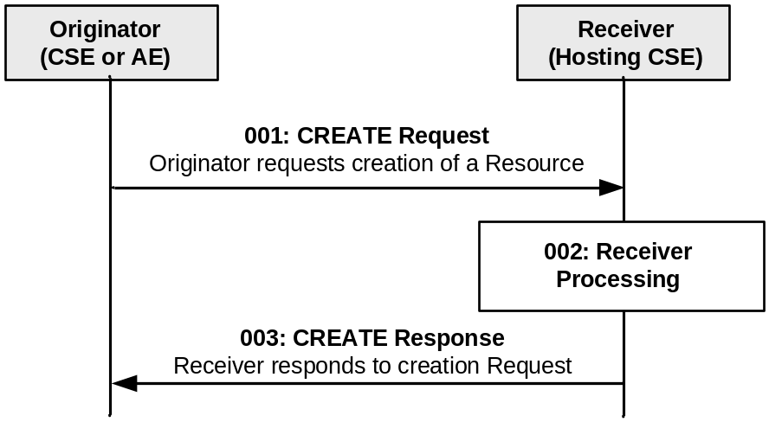

Figure 10.1.1.1-1: Procedure for CREATEing a Resource
Step 001: The Originator shall send the following parameters in the CREATE Request message:
op: C (Create);
to: Address of the target resource where the new resource should be created (identifies the parent resource);

fr: ID of the Originator (either the AE-ID or CSE-ID);
ty: Type of resource to be created;
ri: Request identifier. Identifier provided by the Originator. Needed for correlation of responses regarding this Request.
nm: optional name of the resource to be provided by the Originator, where permitted by the resource type as specified in clause 9.6.
NOTE: Some of the resources defined in clause 9.6 have a predefined name. For these resources the parameter nm is not applicable and will be ignored if provided.
cn: attributes of the resource to be provided by the Originator. All attributes with a multiplicity greater or equal to one and an access mode of RW or WO in the definition of the resource type for which a resource shall be created by the issued CREATE Request shall be present in the cn parameter of the Request, except for the following common attributes that are only optionally present:
- expiration time
[10.1.1.1.d] Editor's Note: references to elements defined in sect 8 have been added here. They may be removed if we decide to move sect 8.1.2-4 to stage 3 doc. In this case, these references will be removed and sect 1 of this document would replace sect 8.1.2-4 in the TS-0001.

----------------------- End of change 17 -----------------------

----------------------- Start of change 18 -----------------------

10.1.1.2.1 CSE Registration procedure
The procedure for CSE Registration follows the procedure described in clause 10.1.1.1, but with some deviations. Below is the detailed description on how to perform the CSE Registration and which part of the procedure deviates from the one described in clause 10.1.1.1.
The Registration procedure requires the creation of two resources (a <remoteCSE> on the Receiver CSE and a <remoteCSE> on the Originator CSE) rather than one resource. The Registration procedure is always initiated by a CSE in the field domain except in the inter-domain case described in clause 6.3.
Originator: The Originator shall be the registering CSE.
Receiver: The Receiver shall create the <remoteCSE> resource.
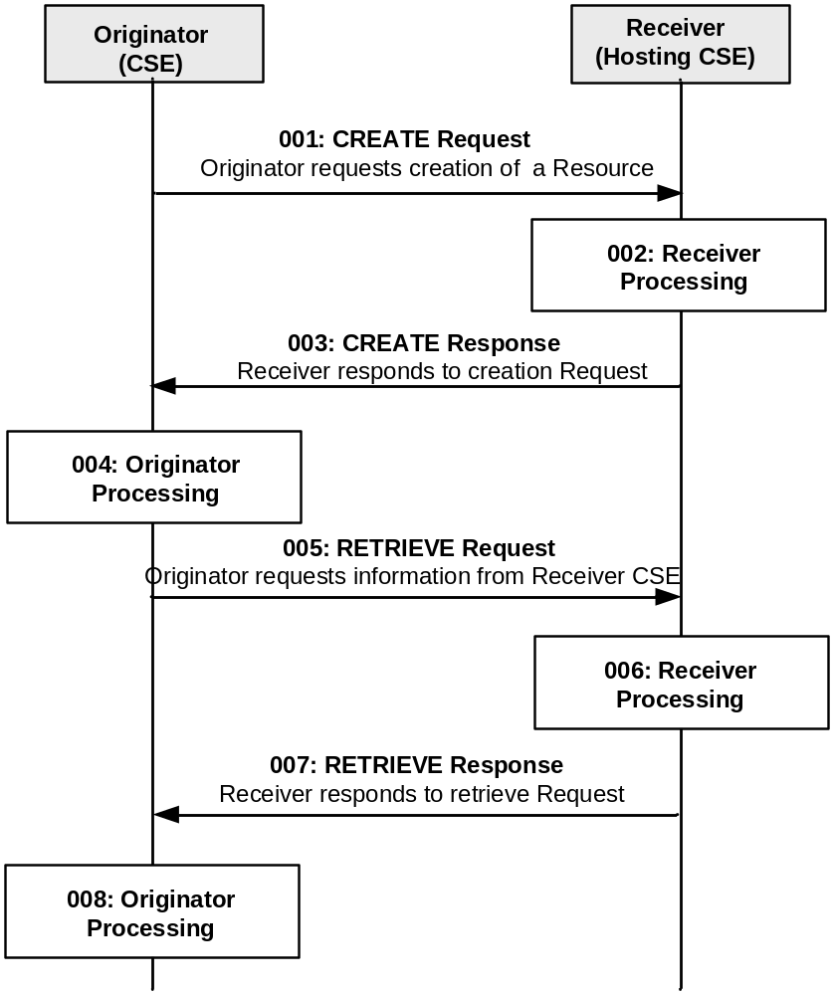
Figure 10.1.1.2.1-1: Procedure for CREATEing a <remoteCSE> Resource
Rappoterur Note: The picture designed for CSE is referenced also for AE in 10.1.1.2, but for AE is incorrect. Duplicate and correct it in 10.1.1.2 ?
Rapporteur Observation: The above stated Rapporteur Note added via contribution ARC-2014-1427. We need to have a contribution to correct the picture for clause 10.1.1.2. Fix the associated descriptions as well.
All the parameters of the request and steps that are not indicated do not deviate from clause 10.1.1.1.
Step 001: The Originator shall send the following information in the CREATE Request message:
fr: CSE-ID.
cn: Attributes of the resource to be provided by the Originator. Of particular importance for the CREATE Request message is the common attribute resourceType from clause 9.6.1.3, which identifies the type of resource; and the attributes CSE-ID and CSEBase. The CSEBase shall contain the absolute address of the <CSEBase> resource at the Receiver.
Step 002: The Receiver shall:
- This step from 10.1.1.1 cannot be performed for the creation of <remoteCSE> resource.
All the other steps: 2-6, from step 002 from clause 10.1.1.1 are still applicable.
NOTE: Optionally, if the M2M Service Provider supports inter-domain communication, the Receiver could perform this step if the attribute CSEBase (part of the cn parameter of the request) contains the public domain of the CSE. The Receiver could construct the domain as described in clause 6.4 and 6.5. The Receiver could add an AAA or AAAA record in DNS with the public domain name of the Originator CSE and the IP address of the IN-CSE associated with the Originator.
Step 003: See clause 10.1.1.1.
Step 004: The Originator, upon receipt of the CREATE response message, shall create a <remoteCSE> resource locally under its <CSEBase> resource. This resource is representing the Receiver CSE. The Originator shall provide the appropriate values to all mandatory parameters as described in clause 9.6.4.
Step 005: The Originator may issue a RETRIEVE Request towards the Receiver (same to as for the CREATE request message) to obtain the optional parameters of the <remoteCSE> resource created at the Receiver as for step 004 (e.g. labels, accessControlPolicyIDs attributes). The RETRIEVE procedure is described in clause 10.1.2.
See clauses 8.1.2 for the information to be included in the Request message.
Step 006: The Receiver verifies that the Originator has the appropriate privileges to access the information.
Step 007: The Receiver sends a RETRIEVE response message, according to the procedure described in clause 10.1.2.
See clauses 8.1.3 and 8.1.4 for the information to be included in the Response message.
Step 008: The Originator shall update the created <remoteCSE> resource for the Receiver with the information obtained in step 007.
General Exceptions:
All exceptions from clause 10.1.1.1 are applicable; in addition the following exception may occur:
- The Originator does not have the privileges to retrieve the attributes of the Receiver CSE. The Receiver responds with an error.

----------------------- End of change 18 -----------------------

----------------------- Start of change 19 -----------------------

10.1.2 RETRIEVE (R)
The RETRIEVE operation shall be used for retrieving the information stored for any of the attributes for a resource at the Receiver CSE. The Originator CSE or AE may request to retrieve a specific attribute by including the name of such attribute in the cn parameter in the request message.
Originator requests retrieval of all attributes or a specific attributes of the target resource by using RETRIEVE Request. See clause 8.1.2 for the information to be included in the Request message. If only some specific attributes need to be retrieved, the name of such attributes shall be included in the cn parameter of the Request message.
Receiver The Receiver performs local processing to verify the existence of requested resource and checks privileges for retrieving the information related to the resource. After successful verification, the Receiver shall return the requested information, otherwise an error indication shall be returned.
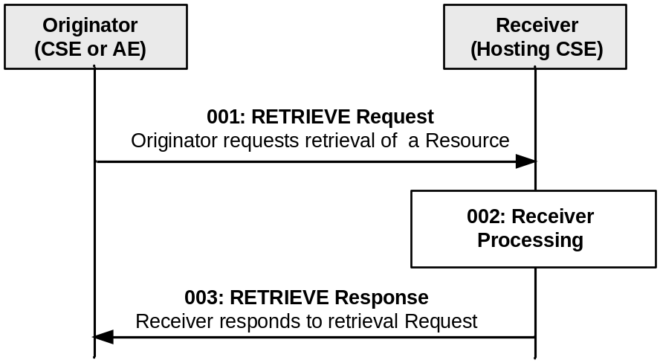
Figure 10.1.2-1: Procedure for RETRIEVing a Resource
Step 001: The Originator shall request to RETRIEVE a resource or a specific attribute within a resource at the Receiver.
op: R (Retrieve).
to: Address of the target resource or the target attribute.

fr: ID of the Originator (either the AE or CSE).

cn: Optional. If included, cn includes the name of the attributes that need to be retrieved.

----------------------- End of change 19 -----------------------

----------------------- Start of change 20 -----------------------

10.1.3 UPDATE (U)

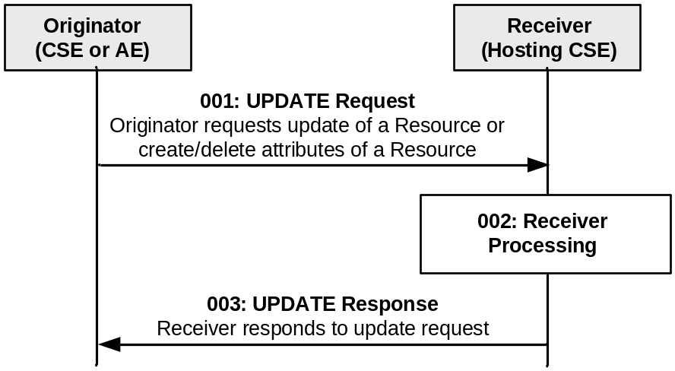

Figure 10.1.3-1: Procedure for UPDATing a Resource
Step 001: The Originator shall send the following parameters in the UPDATE Request message:
op: U (Update).
to: Address of the target resource.

fr: ID of the Originator (either the AE or CSE).

ri: Request Identifier provided by the Originator.
cn: Information related to the attribute(s) to be updated, created or deleted at the target resource, e.g. the name of such attribute(s) and associated updated or assigned values in the cn parameter.

----------------------- End of change 20 -----------------------

----------------------- Start of change 21 -----------------------

10.1.4.1 Non-deregistration related DELETE procedure
This procedure is valid for all resources which are not related to deregistration.
The DELETE operation shall be used by an Originator CSE or AE to delete a resource at a Receiver CSE. For such operation, the DELETE procedure shall consist of the deletion of all related information of the target resource.
Originator requests deletion of a resource by using a DELETE Request message. See clause 8.1.2 for the information to be included in the Request message.
Receiver The Receiver verifies the existence of the requested resource, and the privileges for deleting the resource.

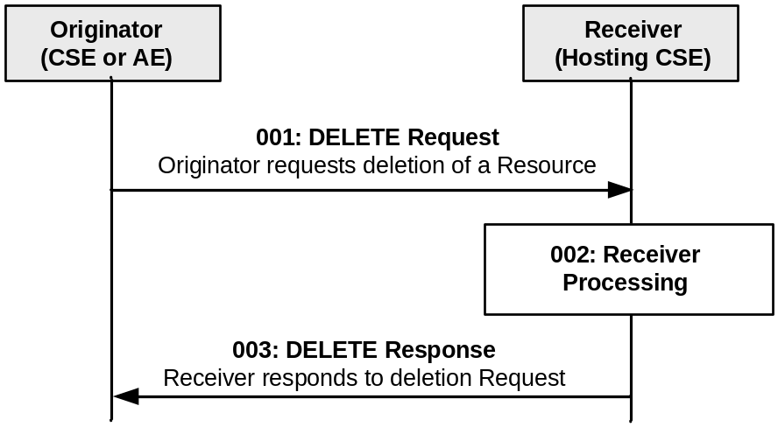

Figure 10.1.4-1: Procedure for DELETING a Resource
Step 001: The Originator shall send a DELETE Request message to the Receiver.
op: D (Delete).
to: Address of the target resource.

fr: ID of the Originator (either the AE or CSE).

----------------------- End of change 21 -----------------------

----------------------- Start of change 22 -----------------------

10.1.5 NOTIFY (N)
The NOTIFY operation shall be used for notifying information.
Originator: The Originator requests to notify an entity by using NOTIFY method. See clause 8.1.2 for the information to be included in a Request message.
Receiver: The Receiver responds to the Originator with the operation results as specified in clause 8.1.3.
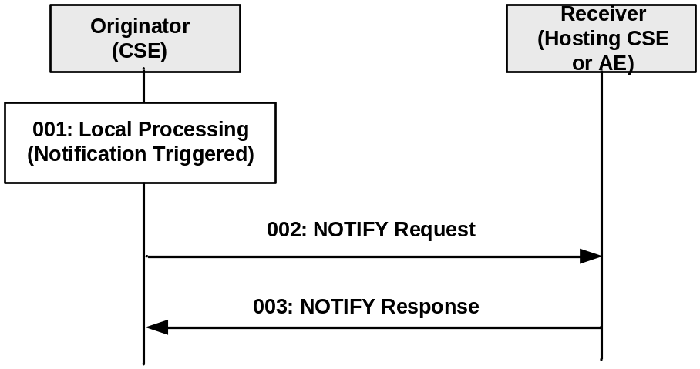

Figure 10.1.5-1: Procedure for NOTIFYing Information
[10.1.5.a] Editor's Note: not sure how to align this procedure with the other ones. The Receiver should also have a local processing, but if the address of the resource in the to is not one of the defined resource types what the receiver does is out of scope. However if the NOTIFY will corresponds to a create instance then the procedures described in the create should apply. This operation needs more refining.
Step 001: A notification to be sent to the Receiver is triggered in the Originator.
Step 002: The Originator shall send the following parameters in the NOTIFY Request message:
op: N (Notify).
to: URI/Address where the notification should be sent to.

fr: ID of the Originator (only a CSE).
cn: Notification data and/or Notification reference.
Step 003: The Receiver responds with a Response message that shall contain the following information:
rs: operation result.

General Exceptions:
- None identified.

----------------------- End of change 22 -----------------------

----------------------- Start of change 23 -----------------------

10.2.2.1 Create <remoteCSE>, aka CSE Registration
This procedure shall be used for creating a <remoteCSE> resource. It is part of the registration procedure for remote CSEs on the Registrar CSE (which is also the Hosting CSE), as described in clause 10.1.1.2.1.
Table 10.2.2.1-1 <remoteCSE> CREATE
<remoteCSE> CREATE
Associated Reference Point | Mcc and Mcc’ only
Information in Request message | All parameters defined in table 8.1.2.1-1 apply with the specific details for:  fr: Originator CSE-ID  cn: The resource content shall provide the information as defined in clause 9.6.4.
Processing at Originator before sending Request | According to clause 10.1.1.2.1
Processing at Receiver | According to clause 10.1.1.2.1  If the IN-CSE is the receiver and if the M2M SP policies do allow access to the CSEs across multiple domains, then the IN shall create the appropriate entry in the M2M SP's DNS for successfully registered CSE.
Information in Response message | All parameters defined in table 8.1.2.1-1 apply with the specific details for:  cn: Address of the created <remoteCSE> resource, according to clause 10.1.1.2.1
Processing at Originator after receiving Response | According to clause 10.1.1.2.1. the Originator starts a Retrieve operation and uses the result to create a remoteCSE representation of the Receiver
Exceptions | According to clause 10.1.1.2.1

----------------------- End of change 23 -----------------------

----------------------- Start of change 24 -----------------------

10.2.4.1 Create <container>
This procedure shall be used for creating a <container> resource.

Table 10.2.4.1-1: <container> CREATE
<container> CREATE
Associated Reference Point | MCA, Mcc and Mcc’
Information in Request message | All parameters defined in table 8.1.2.1-1 apply with the specific details for:  cn: The resource content shall provide the information as defined in clause 9.6.6.
Processing at Originator before sending Request | According to clause 10.1.1.1
Processing at Receiver | According to clause 10.1.1.1
Information in Response message | All parameters defined in table 8.1.2.1-1 apply with the specific details for:  cn: Address of the created <Container> resource, according to clause 10.1.1.1
Processing at Originator after receiving Response | According to clause 10.1.1.1
Exceptions | According to clause 10.1.1.1

----------------------- End of change 24 -----------------------

----------------------- Start of change 25 -----------------------

10.2.5.2 Create <delivery>

Table 10.2.5.2-1: <delivery> CREATE
<delivery> CREATE
Information in Response message | All parameters defined in table 8.1.2.1-1 apply, with the following specific information:  In case the Originator CSE has not asked for a Result of the requested Operation (rc set to "nothing"), the Response only contains an Acknowledgement indicator. This only indicates that the Receiver CSE received the Request. It does NOT indicate whether the Receiver CSE was able to take on responsibility for delivery of the data.  In case the Originator CSE asked for the status of the requested Operation to be contained in the Result of the requested Operation (rc not set to "nothing"), the  Receiver CSE shall respond with a Success or Failure indicator.  In case the Originator CSE asked for the status of the requested Operation and the address of the created Resource to be contained in the Result of the Request, the Receiver CSE shall respond with a Success indicator including the address of the created <delivery> resource in case it has taken on responsibility to deliver the data to the target CSE or with Failure indicator including an error indication otherwise.

----------------------- End of change 25 -----------------------

----------------------- Start of change 26 -----------------------

10.2.5.4 Update <delivery>
This procedure shall be used for requesting a CSE to update information on a previously created <delivery> resource which represents a pending delivery of data to a target CSE. The update may have impact on further processing of the delivery.
Rapporteur Note: The following table needs to be fixed.

Table 10.2.5.4-1: <delivery> UPDATE
<delivery> UPDATE
Associated Reference Point | Mcc, Mcc’
Information in Request message | All parameters defined in table 8.1.2.1-1 apply with the specific details for:  - Address of the <delivery> resource  - Content of a <delivery> resource in line with the definition in clause 9.6.11 representing a valid request for delivery of data to a target CSE
Processing at Originator before sending Request | According to clause 10.1.3. According to clause 10.1.1.1 with the following specific processing:  Originator needs to modify information about a previously issued delivery that is still pending, i.e. it has not yet been forwarded to another CSE
Processing at Receiver | According to clause 10.1.3 wit According to clause 10.1.1.1 with the following specific processing:  Receiver CSE checks if the requested changes to the delivery process can actually be accomplished  If possible, the Receiver CSE modifies the previously established delivery process and changes the respective content of the <delivery> resource
Information in Response message | According to clause 10.1.3
Processing at Originator after receiving Response | According to clause 10.1.3
Exceptions | According to clause 10.1.3 According to clause 10.1.1.1 with the following:  - The Originator CSE is not authorized to modify the <delivery> resource or the addressed parts of it  - The addressed <delivery> resource does not exist  - The responsibility for the further processing of the delivery process represented by the addressed <delivery> process was already forwarded to another CSE

----------------------- End of change 26 -----------------------

----------------------- Start of change 27 -----------------------

10.2.6.2 Discovery procedure via Retrieve Operation
This procedure shall be used for the discovery of resources under <CSEBase> that match the provided filterCriteria parameter. The discovery result shall be returned to the Originator using a successful Response message.

Table 10.2.6.2-1: Discovery procedure via Retrieve Operation
<resource> RETRIEVE
Associated Reference Point | Mca, Mcc, Mcc’
Information in Request message | All parameters defined in table 8.1.2.1-1 apply with the specific details for:  - to: Address of the root of where the discovery begins  - fc: Filter criteria for searching and expected returned result  - Disrestype: optional, format of discovery results returned
Processing at Originator before sending Request | According to clause 10.1.2 with the following:  - Setup the RETRIEVE operation in the Request  - Include the conditions in the filter criterion to limit the scope of the discovery results  - Specify the desired format of returned discovery results
Processing at Receiver | According to clause 10.1.2 with the following specific processing:  - Checks the validity of the Request (e.g. format of filterCriteria)  - Checks if the request is in accordance with the M2M service subscription  - May change the filter criteria according to local policies  - Searches matched resources from the addressed resource hierarchy  - Limits the discovery result according to DISCOVER privileges of the discovered resources  - Limits the discovery result according to the upper limit on the size of the answer  - Sorts the results according to the sorting criteria  The Hosting CSE shall read the values of all attributes belonging to the addressed resource structure and the references of all sub-resources and it shall build a representation of these. The Hosting CSE shall use the appropriate addressing (see clause 9.3.1) form for each element included in the list in accordance with the incoming request. If filterCriteria is provided in the request, the Hosting CSE uses it identifying the resources whose attributes match the filterCriteria. The Hosting CSE shall respond to the Originator with the appropriate list of discovered resources in the Hosting CSE. If sorting criteria has been provided by the Originator, the list of discovered resources shall be sorted in that order.  The Hosting CSE may modify the filterCriteria including upper limit provided by the Originator or the discovery results based on the local policies.  If the size of the result list is bigger than the upper limit or the scope of discoverable resources, according to the Originator's access control policy or service subscription has been modified by the Hosting CSE, the full list is not returned. Instead, an incomplete list is returned and an indication is added in the response for warning the device.
Information in Response message | All parameters defined in table 8.1.2.1-1 apply with the specific details for:  - Contains the address list of discovered resources expressed in any of the methods depicted in clause 9.3.1. The address list may be empty if no result matching the filter criterion is discovered  - Contains an incomplete list warning if the full list is not returned
Processing at Originator after receiving Response | According to clause 10.1.2.
Exceptions | According to clause 10.1.2, with the following:  - The requesting M2M AE or CSE is not registered  - The request contains invalid parameters

----------------------- End of change 27 -----------------------

----------------------- Start of change 28 -----------------------

10.2.8.2 Create <mgmtObj>
This procedure shall be used to create a specific <mgmtObj> resource in the Hosting CSE to expose the corresponding management function of a managed entity (i.e. M2M Device/Gateway) over the Mca reference point. Depending on the data model being used, the created <mgmtObj> resource may be a partial or complete mapping from the external management object onto the managed entity. If such an external management object is missing from the managed entity, it shall be added to the managed entity. Further operations performed on the created <mgmtObj> resource shall be converted by the Hosting CSE into a corresponding device management action performed on the mapped external management object on the managed entity using external management technologies (e.g. OMA-DM [Error: Reference source not found] or BBF TR-069 [Error: Reference source not found]). The procedure in the following table shall be used when management is performed using external management technologies. If the management is performed by service layer entities, the procedure is the same as generic create procedure defined in 10.1.1.

Table 10.2.8.2-1: <mgmtObj> CREATE
<mgmtObj> CREATE
Associated Reference Point | Mcc and Mca
Information in Request message | fr: Identifier of the AE or the CSE that initiates the Request  to: The address of the <node> where the <mgmtObj> resource is intended to be Created  cn: The representation of the <mgmtObj> resource for which the attributes are described in clause 9.6.15
Processing at Originator before sending Request | The Originator shall be an IN-AE, or a CSE on a managed entity:  - The Originator is a CSE: In this case, the CSE first collects the original external management object (the management tree structure or also the value of the tree nodes if needed) of the local device and transforms the data into the <mgmtObj> resource representation, then requests the Hosting CSE to create the corresponding <mgmtObj> resource.  - The Originator is an AE: In this case, the AE requests the Hosting CSE to add the corresponding external management object to the managed entity by creating an <mgmtObj> resource in the Hosting CSE.  NOTE 1: The IN-CSE can create the <mgmtObj> resource locally by itself. The details are out of scope. In this case, the Hosting CSE first collects the original external management object on the managed entity via external management technology (e.g. OMA DM [i.5], BBF TR-069 [i.4] or LWM2M [i.6]), then transforms the object into the <mgmtObj> resource representation and create the <mgmtObj> resource locally in the IN-CSE.  NOTE 2: The <mgmtObj> resource can be created in the Hosting CSE by other offline provisioning means which are out of scope.
Processing at Receiver | For the CREATE operation, the Receiver shall:  - Check if the Originator has the CREATE privilege on the addressed <node> resource. Then check the validity of the provided attributes.  - Upon successful validation, create a new <mgmtObj> resource in the Hosting CSE with the provided attributes.  - If the Originator is an AE: Check if there is existing management session between the management server and the managed entity. If not, request the management server to establish a management session towards the managed entity. Send the management request to the managed entity or to the management server to add the corresponding external management object to the managed entity based on external management technology.  - Maintain the mapping relationship between the created <mgmtObj> resource and the external management object on the managed entity.  - Respond to the Originator with the appropriate responses based on the response from the external management technologies. It shall also provide in the response the address of the created new resource.
Information in Response message | Error code if the new external management object is not created
Processing at Originator after receiving Response | None
Exceptions | The creation of the external management object is not allowed  The created external management object already exists  Corresponding external management object cannot be added to the managed entity for some reason (e.g. not reachable, memory shortage)

10.2.8.3 Retrieve <mgmtObj>
This procedure shall be used to retrieve information from an existing <mgmtObj> resource. The procedure in the following table shall be used when management is performed using external management technologies. If the management is performed by service layer entities, the procedure is the same as generic retrieve procedure defined in 10.1.2.

Table 10.2.8.3-1: <mgmtObj> RETRIEVE
<mgmtObj> RETRIEVE
Associated Reference Point | Mcc and Mca
Information in Request message | fr: Identifier of the AE or the CSE that initiates the Request  to: The address of the <mgmtObj> resource
Processing at Originator before sending Request | The Originator shall be an AE, or a CSE on the managed entity.
Processing at Receiver | For the RETRIEVE operation, the Receiver shall:  - Check if the Originator has the READ privilege on the addressed <mgmtObj> resource.  - Upon successful validation, retrieve the corresponding <mgmtObj> resource.  - Respond to the Originator with the appropriate response.  - If the Originator is an AE and if the requested information of the <mgmtObj> resource is not available, identify the corresponding external management object on the managed entity according to the mapping relationship that the IN-CSE maintains. Check if there is an existing management session between the management server and the managed entity. If not, request the management server to establish a management session towards the managed entity. Send the management request to get the corresponding external management object from the managed entity based on the external management technology, then return the result to the Originator based on the response from the external management technology.
Information in Response message | Error code if the new external management object can not be retrieved.
Processing at Originator after receiving Response | None
Exceptions | Corresponding external management object data cannot be retrieved from the managed entity (e.g. external management object not found).

10.2.8.4 Update <mgmtObj>
This procedure shall be used to update information of an existing <mgmtObj> resource. The procedure in the following table shall be used when management is performed using external management technologies. If the management is performed by service layer entities, the procedure is the same as generic update procedure defined in 10.1.3.

Table 10.2.8.4-1: <mgmtObj> UPDATE
<mgmtObj> UPDATE
Associated Reference Point | Mcc and Mca
Information in Request message | fr: Identifier of the AE or the CSE that initiates the Request  to: The address of the <mgmtObj> resource  cn: The representation of the <mgmtObj> resource for which the attributes are described in clause 9.6.15
Processing at Originator before sending Request | The Originator shall be an IN-AE, or a CSE on a managed entity.
Processing at Receiver | For the UPDATE operation, the Receiver shall:  - Check if the Originator has the WRITE privilege on the address <mgmtObj> resource. Check the validity of provided attributes if any.  - Upon successful validation, update the corresponding attribute(s) of the <mgmtObj> resource accordingly.  - If the Originator is an IN-AE, identify the corresponding external management object on the managed entity according to the mapping relationship it maintains. Check if there is an existing management session between the management server and the managed entity. If not, request the management server to establish a management session towards the managed entity. Send the management request to update the corresponding external management object in the managed entity accordingly based on external management technology.  - Respond to the Originator with the appropriate response based on the response from the external management technology.
Information in Response message | Error code if the external management object can not be updated
Processing at Originator after receiving Response | None
Exceptions | Corresponding external management object cannot be updated to managed entity (e.g. not reachable, external management object not found)

10.2.8.5 Delete <mgmtObj>
This procedure shall be used to delete an existing <mgmtObj> resource. An IN-AE uses this procedure to remove the corresponding external management object (e.g. an obsolete software package) from the managed entity. The procedure in the following table shall be used when management is performed using external management technologies. If the management is performed by service layer entities, the procedure is the same as generic delete procedure defined in 10.1.4.

Table 10.2.8.5-1: <mgmtObj> DELETE
<mgmtObj> DELETE
Associated Reference Point | Mcc and Mca
Information in Request message | fr: Identifier of the IN-AE, or the CSE that initiates the Request  to: The address of the <mgmtObj> resource.
Processing at Originator before sending Request | The Originator shall be an IN-AE or CSE on a managed entity.  - The Originator is a CSE on the managed entity: In this case, the CSE issues the request to the Hosting CSE to hide the corresponding management function from being exposed by the <mgmtObj> resource.  - The Originator is an IN-AE: In this case, the IN-AE requests the Hosting CSE to delete the <mgmtObj> resource from the Hosting CSE and to remove the corresponding external management object from the managed entity.  NOTE 1: The Hosting IN-CSE can delete the <mgmtObj> resource locally by itself. This internal procedure is out of scope.  NOTE 2: The <mgmtObj> resource can be deleted in the Hosting CSE by offline provisioning means which are out of scope.
Processing at Receiver | For the DELETE operation, the Receiver shall:  - If the Originator is an IN-AE, identify the corresponding external management object on the managed entity according to the mapping relationship IN-CSEmaintains. Check if there is an existing management session between the management server and the managed entity. If not, request the management server to establish a management session towards the managed entity. The IN-CSE sends management request to remove the corresponding external management object from the managed entity based on external management technology.  - Respond to the Originator with the appropriate generic responses based on the response from the external management technology.
Information in Response message | Error code if the external management object can not be deleted.
Processing at Originator after receiving Response | None
Exceptions | Corresponding external management object cannot be deleted from managed entity (e.g. not reachable, external management object not found).

10.2.8.6 Execute <mgmtObj>
This procedure shall be used to execute a management command on a managed entity through an existing <mgmtObj> resource on the Hosting CSE.

Table 10.2.8.6-1: <mgmtObj> EXECUTE
<mgmtObj> EXECUTE
Associated Reference Point | Mcc and Mca
Information in Request message | fr: Identifier of the IN-AE, or the CSE that initiates the Request  to: The address of the <mgmtObj> resource.
Processing at Originator before sending Request | The Originator shall be an IN-AE. The Originator shall request to execute a management command which is represented by a <mgmtObj> resource or its attribute by using an UPDATE operation.  The request shall address the executable <mgmtObj> resource. For an execute operation on an attribute(s), the cn parameter shall be included with the name of such attribute(s) with predefined value(s) to trigger the respective action.  After the execution request, the Originator shall request to retrieve the execution result or status from the executable <mgmtObj> resource or its attribute/child resource by using a RETRIEVE operation as specified in clause 10.2.7.3.
Processing at Receiver | For the EXECUTE operation , the Receiver shall:  - Check if the Originator has the WRITE privilege on the addressed <mgmtObj> resource or its attribute.  - Check if there is an existing management session between the management server and the managed entity. If not, request the management server to establish a management session towards the managed entity. Send the management request to execute the corresponding management command (e.g. "Exec" in OMA DM [i.5]) on the managed entity based on external management technology.  - Respond to the Originator with the appropriate response based on the response from the external management technology. If available, the response shall contain execution results.  - Retrieve the execution result or status from the executable <mgmtObj> resource or its attribute, perform the procedures as described in clause 10.2.7.3.  - Upon receiving a management notification (e.g. OMA-DM [i.5] "Generic Alert" message or BBF TR-069 [i.4] "Inform" message) from a managed entity regarding the execution result or status, the Receiver shall send the management request to retrieve the execution result or status of the external management object information received from the managed entity and update the corresponding <mgmtObj> resource or its attribute.
Information in Response message | Error code if the external management technology procedure can not be executed
Processing at Originator after receiving Response | None
Exceptions | Corresponding external management technology procedure cannot be executed in managed entity (e.g. not reachable, external management object not found)

----------------------- End of change 28 -----------------------

----------------------- Start of change 29 -----------------------

10.2.9.2 Create <mgmtCmd>
A CREATE request shall be used by an Originator to create a specific <mgmtCmd> resource in a Hosting CSE.
The created <mgmtCmd> resource will be mapping a RESTful method to management commands and/or procedures which may be translated from existing management protocols (e.g. BBF TR-069 [Error: Reference source not found]). At run-time the Hosting CSE can expose the translated commands, over the Mcc reference point, to the managed entities (i.e. ASN/MN-CSE).
The Originator may be:
- An AE registered to the IN-CSE.
- The CSE on the managed entity: In this case, the CSE transforms supported management command into the <mgmtCmd> resource representation, then requests the Hosting CSE to create the corresponding <mgmtCmd> resource.
NOTE 1: The Hosting IN-CSE in the network domain may also create the <mgmtCmd> resource locally by itself. The details are out of scope. Then an AE can discover the created <mgmtCmd> and manipulate it.
NOTE 2: The <mgmtCmd> resource could also be created in the Hosting CSE by other offline provisioning means which are out of scope.
The Receiver shall be an IN-CSE.

Table 10.2.9.2-1: <mgmtCmd> CREATE
<mgmtCmd> CREATE
Associated reference point | Mcc, Mca
Information in Request message | The attributes of the <mgmtCmd> resource. The mandatory and/or optional attributes defined in clause 9.6.16, as needed
Processing at Originator before sending Request | According to clause 10.1.1 with the following:  The CSE on the originating node shall first collect local management command.
Processing at the Receiver | According to clause 10.1.1 with the following:  The Receiver CSE shall maintain the mapping between the created <mgmtCmd> resource and the corresponding nonRESTful commands represented by the cmdType attribute of <mgmtCmd> resource
Information in Response message | According to clause 10.1.1 with the following specific information:  cn: Address of created <mgmtCmd> resource
Processing at Originator after receiving Response | According to clause 10.1.1
Exceptions | According to clause 10.1.1

----------------------- End of change 29 -----------------------

----------------------- Start of change 30 -----------------------

10.2.10.1.1 Create <locationPolicy>
This procedure shall be used for creating a <locationPolicy> resource.
Originator: The Originator shall request to CREATE a <locationPolicy> resource including the relevant attributes and the address <CSEBase> resource of a Hosting CSE. Minimally, the Request shall provide the mandatory attributes defined in the table 9.6.10-1. The Originator in this case is an AE or CSE.

Receiver: For the CREATE procedure, the Receiver (Hosting CSE) shall:
- Check whether the Originator is authorized to request the procedure.
- Check whether the provided attributes of the <locationPolicy> resource represent a valid Request.
- Upon successful validation of the above procedures, the Hosting CSE creates the <locationPolicy> resource and automatically creates <container> resource where the actual location information is/are stored and the resources shall contain cross-reference between the both resources: locationContainerID attribute for <locationPolicy> resource and locationID attribute for <container> resource.
- Check the defined locationSource attribute to determine which method is used.. The locationSource attribute shall be set based on the capabilities of a target M2M Node, the required location accuracy of the Originator and the Underlying Network in which a target M2M Node resides:
- For the Network-based case, the Hosting CSE shall transform the Request from the Originator into Location Server request following the attributes (e.g. locationTargetID, locationServer) defined in the <locationPolicy> resource. Additionally, the Hosting CSE shall also provide default values for other parameters (e.g. required quality of position) in the Location Server request [i.7] according to local policies. The request towards the Location Server crosses over the Mcn reference point. Then the Location Server in the Underlying Network performs positioning procedures, and returns the results over the Mcn reference point.
- The specific mechanism used to communicate with the network Location Server depends on the capabilities of the Underlying Network and other factors. For example, it could be either the OMA Mobile Location Protocol [i.7] or OMA RESTful NetAPI for Terminal Location [Error: Reference source not found].
NOTE: The details of the mechanisms are addressed in the oneM2M Core Protocol Specification [Error: Reference source not found].
- For the Device-based case, this case is applicable if the Originator is ASN-AE and the ASN has location determination capabilities (e.g. GPS). The Hosting CSE is capable of performing positioning procedure using the module or technologies. For example, if the ASN has a GPS module itself, the ASN-CSE obtains the location information of Node from the GPS module through internal interfaces (e.g. System call or JNI [i.21]). The detail procedure is out-of-scope.
- For the Sharing-based case, this case shall be applicable if the Originator is an ADN-AE and the Hosting CSE is MN-CSE and the ADN is a resource constrained node, no location determination capabilities (e.g. GPS) and Network-based positioning capabilities. Also according to the required location accuracy of the AE, the Originator may choose this case.
When the Hosting CSE receives the CREATE request and if the Hosting CSE can find the closest Node that is registered with the Hosting CSE and has location information from the Originator in the M2M Area Network, the location information of the closest Node shall be stored as the location information of the Originator, or if the Hosting CSE cannot find any closest Node or has no topology information, the location information of the Node of the Hosting CSE (MN) shall be stored as the location information of the Originator. The closest Node can be determined by the minimum hop based on the topology information stored in the <node> resource.

Table 10.2.10.1.1-1: <locationPolicy> CREATE
CREATE: Description
Pre-Conditions | None
Information on Request message | op: C  fr: Identifier of the AE or the CSE that initiates the Request  to: the address of the <CSEBase> resource  cn: The representation of the <locationPolicy> resource described in clause 9.6.10
Local processing on Hosting CSE | Detail procedure for the Hosting CSE of the CREATE request described above
Information on Response message | The representation of the created <locationPolicy> resource
Post-Conditions | Detail steps for the Hosting CSE after the CREATE request are described above
Exceptions | No change from the generic procedure

10.2.10.1.2 Retrieve <locationPolicy>
This procedure shall be used for retrieving an existing <locationPolicy> resource.
Originator: The Originator shall request to obtain <locationPolicy> resource information by using RETRIEVE operation. The Originator is either an AE or a CSE.
Receiver: The Receiver shall check if the Originator has RETRIEVE permission on the <locationPolicy> resource. Upon successful validation, the Hosting CSE shall respond to the Originator with the appropriate responses.

Table 10.2.10.1.2-1: <locationPolicy> RETRIEVE
RETRIEVE: Description
Pre-Conditions | None
Information on Request message | op: R  fr: Identifier of the AE or the CSE that initiates the Request  to: the address of the target <locationPolicy> resource
Local processing on Hosting CSE | No change from the generic procedure
Information on Response message | No change from the generic procedure
Post-Conditions | None
Exceptions | No change from the generic procedure

10.2.10.1.3 Update <locationPolicy>
This procedure shall be used for updating an existing <locationPolicy> resource.
Originator: The Originator shall request to update attributes of an existing <locationPolicy> resource by using an UPDATE operation. The request shall address the specific <locationPolicy> resource of a CSE. The Originator may be either an AE or a CSE.
Receiver: The Receiver of an UPDATE request shall check whether the Originator is authorized to request the operation. The receiver shall further check whether the provided attributes of the <locationPolicy> resource represent a valid request for updating <locationPolicy> resource. The updatable attributes are (excluding common attributes):
- locationUpdatePeriod: This value is updated to change the period for updating location information.

Table 10.2.10.1.3-1: <locationPolicy> UPDATE
UPDATE: Description
Pre-Conditions | None
Information on Request message | op: U  fr: Identifier of the AE or the CSE that initiates the Request  to: the address of the target <locationPolicy resource  cn: The attributes which are to be updated.
Local processing on Hosting CSE | No change from the generic procedure
Information on Response message | No change from the generic procedure
Post-Conditions | None
Exceptions | No change from the generic procedure

10.2.10.1.4 Delete <locationPolicy>
This procedure shall be used for deleting an existing <locationPolicy> resource.
Originator: The Originator shall request to delete an existing <locationPolicy> resource by using the DELETE operation. The Originator may be either an AE or a CSE.
Receiver: The Receiver shall check if the Originator has DELETE permission on the <locationPolicy> resource. Upon successful validation, the CSE shall remove the resource from its repository and shall respond to the Originator with appropriate responses.
Once the <locationPolicy> resource is deleted, the Receiver shall delete the associated resources (e.g. <container>, <contentInstance> resources). If the locationSource attribute and the locationUpdatePeriod attribute of the <locationPolicy> resource has been set with appropriate value, the Receiver shall tear down the session. The specific mechanism used to tear down the session depends on the support of the Underlying Network and other factors.

Table 10.2.10.1.4-1: <locationPolicy> DELETE
DELETE: Description
Pre-Conditions | When the locationSource of the created <locationPolicy> resource is "sharing-based" and the AE disconnects from the registered MN-CSE
Information on Request message | op: D  fr: Identifier of the AE or the CSE that initiates the Request  to: the address of the target <locationPolicy resource
Local processing on Hosting CSE | No change from the generic procedure
Information on Response message | No change from the generic procedure
Post-Conditions | None
Exceptions | No change from the generic procedure

----------------------- End of change 30 -----------------------

----------------------- Start of change 31 -----------------------

10.2.11.2 Create <subscription>
This procedure shall be used to request the creation of a new <subscription> resource to be notified for the modifications of a subscribed-to resource. The generic create procedure is described in clause 10.1.1.1.

Table 10.2.11.2-1: <subscription> CREATE
<subscription> CREATE
Associated Reference Point | Mca, Mcc and Mcc’
Information in Request message | All parameters defined in table 8.1.2.1-1 apply with the specific details for:  - cn: The resource content shall provide the information as defined in clause 9.6.8.
Processing at Originator before sending Request | According to clause 10.1.1.1 with the following additions:  The Request shall address a subscribable resource.  The Request shall include notificationURI(s).  If the request includes notificationURI(s) which is not the Originator, the Originator should send the request as non-blocking request (see clause 8.2.2 and clause 9.6.12).
Processing at Receiver | According to clause 10.1.1.1 with the following  Which is also the Hosting CSE shall validate the followings:  - Check if the subscribed-to resource, addressed in the to parameter in the Request, is a subscribable resource;  - Check if the Originator has privileges for retrieving the subscribed-to resource;  - If a notificationURI is not the Originator, the Hosting CSE should send a Notify request to the notificationURI to verify this <subscription> creation request. If it cannot initiate the verification, the Hosting CSE shall return an unsuccessful response. If the Hosting CSE initiate the verification, then it shall check if the verification result in the Notify response is successful or not. If any notificationURI contained in a list fails verification then the <subscription> create process fails;  If any of the checks above fails, the Hosting CSE shall send an unsuccessful responseto the Originator with corresponding error information. Otherwise, the Hosting CSE shall create the <subscription> resource and send a successful response to the Originator.
Information in Response message | All parameters defined in table 8.1.2.1-1 apply with the specific details for:  - cn: Address of the created <subscription> resource, according to clause 10.1.1.1
Processing at Originator after receiving Response | According to clause 10.1.1.1.
Exceptions | According to clause 10.1.1.1.

----------------------- End of change 31 -----------------------

----------------------- Start of change 32 -----------------------

10.2.12.1 Procedure for Originator of Notifications
The notificationContentType indicates the notification content type that shall be contained in notifications. The notificationContentType values shall be “modifiedAttribute” (i.e. send a modified attribute only), “wholeResource” (i.e. send a whole subscribed-to resource), or optionally “referenceOnly” (i.e. send an address of a corresponding <subscription> resource). The scope of the notificationContentType policy is the Hosting CSE for all of a subscriber’s subscriptions, it does not extend to transit CSEs.
The notificationEventCat policy indicates an Event Category of the subscription that will be included in the notification request to be able for the Receiver to correctly handle the notification. When the notificationEventCat policy is not configured by the subscriber, it shall be determined as a default value by the CMDH policy. The scope of the notificationEventCat policy is the Hosting CSE for all of a subscriber’s subscriptions, it does not extend to transit CSEs.
When the Originator receives unsuccessful Notify response with subscription verification failure information, the Originator of the notification shall send unsuccessful result to the Originator of the corresponding <subscription> creation procedure if it has not created the <subscription> resource, otherwise the Originator may delete the corresponding <subscription> resource.

Table 10.2.12-1: Notification Procedure
Description
Associated Reference Point | Mca, Mcc and Mcc’
Information in Request message | According to clause 10.1.5 with the following additions:  cn:  - notification data that represents the content of subscribed-to resource may be included. The content is decided by notificationContentType attribute.  - subscription reference (i.e. address of the corresponding <subscription> resource) that generates this notification shall be included  - changed resource status shall be included when resourceStatus eventNotificationCriteria condition is configured  - monitored operation and its Originator information shall be included when operationMonitor eventNotificationCriteria condition is configured  - notificationForwardingURI in case the subscriber intends the group to aggregate the notifications.
Processing at Originator before sending Request | Notification is triggered regarding subscription information in a <subscription> resource
Processing at Receiver | According to clause 10.1.5.
Information in Response message | According to clause 10.1.5.
Processing at Originator after receiving Response | According to clause 10.1.5.
Exceptions | According to clause 10.1.5.

----------------------- End of change 32 -----------------------

----------------------- Start of change 33 -----------------------

10.2.14 <node> Resource Procedures

10.2.14.1 Create <node>
This procedure shall be used for creating a <node> resource.
NOTE: The creation of the <node> resource is on discretion of the Originator. In general the resource is created when the Originator is not always reachable and therefore it is convenient that the entity that the Originator is registered to is aware of the characteristic of the node, in particular the reachability schedule. It is assumed that the Originator of this <node> resource can be M2M Service Provider or the M2M Application Provider using Mca reference point. In this latter case an IN-AE adds a list of nodes which are then declared to be part of an M2M Service Subscription.

Table 10.2.14.1-1: <node> CREATE
<node> CREATE
Associated Reference Point | Mca, Mcc and Mcc’
Information in Request message | All parameters defined in Table 8.1.2.1-1 apply with the specific details for:  cn: The representation of the <node> resource described in clause 9.6.18.  The following attributes from clause 9.6.18 are mandatory for the request:  - resourceType which shall be set to the appropriate tag that identify the <node> resource as defined in clause 9.6.1.3.  NOTE: if the Originator is a CSE, it could take the information that is stored in the <node> resource under its own <CSEBase> resource and provide the information in the cn.
Processing at Originator before sending Request | According to clause 10.1.1.1 with the following specific processing:  The Originator shall request to create a new <node> resource. The request shall address different resources depending on the type of node that is issuing the request, as described in 9.6.18. Following that, the Originator can create the child resources (defined in the 9.6.18) to acquire node specific information as occasion demands of the Originator. The Originator shall be an AE or a CSE.
Processing at Receiver | According to clause 10.1.1.1 with the following specific processing:  - Check whether the provided attributes of the <node> resource represent a valid Request.
Information in Response message | All parameters defined in Table 8.1.2.1-1 apply with the specific details for:  cn: Address of the created <node> resource, according to clause 10.1.1.1
Processing at Originator after receiving Response | According to clause 10.1.1.1.
Exceptions | According to clause 10.1.1.1

----------------------- End of change 33 -----------------------

----------------------- Start of change 34 -----------------------

10.2.15.2 Create <statsConfig>
This procedure shall be used for the Originator to establish a set of configurations for statistics collection at the Receiver.
The configurations shall be stored at the <statsConfig> resource and each instance of the <statsConfig> resource shall represent a specific configuration.
The Originator shall be an AE that wants to set up the statistics collection configurations.
The Receiver shall be an IN-CSE.
Table 10.2.15.2-1: <statsConfig> CREATE
<statsConfig> CREATE
Associated Reference Points | Mca
Information in Request message | fr: Identifier of the AE that initiates the Request  to: The address of the <CSEBase> where the <statsConfig> resource is intended to be Created.  cn: The representation of the <statsConfig> resource for which the attributes are described in clause 9.6.23.  Other information in the Request message is defined according to clause 10.1.1.1.
Processing at Originator before sending Request | The Originator shall request to Create a new <statsConfig> resource by addressing to the <CSEBase> resource of a Hosting CSE. The Request shall also provide the AE-ID as the creator of the resource. The Originator shall be an AE.
Processing at Receiver | According to clause 10.1.1.1.
Information in Response message | According to clause 10.1.1.1.
Processing at Originator after receiving Response | None
Exceptions | According to clause 10.1.1.1.

10.2.15.3 Retrieve <statsConfig>
The RETRIEVE procedure shall be used for the Originator to retrieve the existing <statsConfig> resource from the Receiver.
The Originator shall be an AE that is allowed to retrieve configuration information available for AEs within an IN-CSE.
The Receiver shall be the IN- CSE containing the <statsConfig> resource.
Table 10.2.15.3-1: <statsConfig> RETRIEVE
<statsConfig> RETRIEVE
Associated Reference Points | Mca
Information in Request message | op: Retrieve  fr: ID of the Originator  to: Address of the <statsConfig> resource or its attribute to be retrieved
Processing at Originator before sending Request | The Originator shall request to obtain <statsConfig> resource information by using the RETRIEVE operation. The request shall address the specific <statsConfig> resource or its attributes of a Hosting CSE. The Originator shall be an AE.
Processing at Receiver | According to clause 10.1.2.
Information in Response message | According to clause 10.1.2.
Processing at Originator after receiving Response | According to clause 10.1.2.
Exceptions | According to clause 10.1.2.

10.2.15.4 Update <statsConfig>
This procedure shall be used for updating <statsConfig> resource.
An UPDATE procedure on the <statsConfig> resource is used for the Originator to update charging related policies at the Receiver.
The Originator shall be the AE that created the <statsConfig> resource. The same AE shall be able to update the resource.
The Receiver shall be a CSE containing the <statsConfig> resource.
Table 10.2.15.4-1: <statsConfig> UPDATE
<statsConfig> UPDATE
Associated Reference Points | Mca
Information in Request message | fr: ID of the Originator  to: Address of the <statsConfig> resource to be updated  cn: the Originator provides the attributes of <statsConfig> to be updated
Processing at Originator before sending Request | According to clause 10.1.3.
Processing at Receiver | According to clause 10.1.3.
Information in Response message | According to clause 10.1.3.
Processing at Originator after receiving Response | None
Exceptions | According to clause 10.1.3.

10.2.15.5 Delete <statsConfig>
This procedure shall be used for deleting <statsConfig> resource.
The Originator shall be the AE that created the <statsConfig> resource.
The Receiver shall be a CSE containing the <statsConfig> resource.
Table 10.2.15.5-1: <statsConfig> DELETE
<statsConfig> DELETE
Associated Reference Points | Mca
Information in Request message | fr: ID of the Originator  to: Address of the <statsConfig> resource to be deleted
Processing at Originator before sending Request | According to clause 10.1.4.1.
Processing at Receiver | According to clause 10.1.4.1.
Information in Response message | According to clause 10.1.4.1.
Processing at Originator after receiving Response | None
Exceptions | According to clause 10.1.4.1.

10.2.15.6 Create <eventConfig>
This procedure shall be used to create <eventConfig> resource.
Table 10.2.15.6-1: <eventConfig> CREATE
<eventConfig> CREATE
Associated Reference Points | Mca
Information in Request message | fr: Identifier of the AE that initiates the Request  to: The address of the <statsConfig> resource where the <eventConfig> sub-resource is intended to be Created.  cn: The representation of the <eventConfig> resource for which the attributes are described in clause 9.6.24.  Other information in the Request message is defined according to clause 10.1.1.1.
Processing at Originator before sending Request | The Originator shall be an AE. The Originator shall request to Create a new <eventConfig> resource by addressing to the <statsConfig> resource of a Hosting CSE.
Processing at Receiver | The Receiver shall be an IN-CSE.  - The Receiver shall verify whether the eventID is unique or not, and if not, provides a new value.  - The Receiver shall verify that the eventEnd time is greater than the eventStart time if these two attributes are present.  - The Receiver shall verify that the dataSize attribute is present and contains a value greater to zero if the eventType is set to “Storage based”
Information in Response message | According to clause 10.1.1.1.
Processing at Originator after receiving Response | None
Exceptions | According to clause 10.1.1.1.

10.2.15.7 Retrieve <eventConfig>
The RETRIEVE procedure shall be used for the Originator to retrieve the existing <eventConfig> resource from the Receiver.
The Originator shall be an AE that is allowed to retrieve configuration information available for AEs within an IN-CSE.
The Receiver shall be the IN-CSE containing the <eventConfig> resource.
Table 10.2.15.7-1: <eventConfig> RETRIEVE
<eventConfig> RETRIEVE
Associated Reference Points | Mca
Information in Request message | fr: ID of the Originator  to: Address of the <eventConfig> resource or its attributes to be retrieved.
Processing at Originator before sending Request | The Originator shall request to obtain <eventConfig> resource information by using the RETRIEVE operation. The request shall address the specific <eventConfig> resource or its attributes of a Hosting CSE. The Originator shall be an AE.
Processing at Receiver | According to clause 10.1.2.
Information in Response message | According to clause 10.1.2.
Processing at Originator after receiving Response | According to clause 10.1.2.
Exceptions | According to clause 10.1.2.

10.2.15.8 Update <eventConfig>
This procedure shall be used for updating an existing <eventConfig> resource.
The Originator shall be the AE that created the <eventConfig> resource. The same AE shall be able to update the resource.
The Receiver shall be the IN-CSE containing the <eventConfig> resource.
Table 10.2.15.8-1: <eventConfig> UPDATE
<eventConfig> UPDATE
Associated Reference Points | Mca
Information in Request message | fr: ID of the Originator  to: Address of the <eventConfig> resource to be updated  cn: the Originator provides the attributes of <eventConfig> to be updated  The Originator can update attributes under <eventConfig> to update event-based configuration for statistics collection
Processing at Originator before sending Request | According to clause 10.1.3.
Processing at Receiver | According to clause 10.1.3.
Information in Response message | According to clause 10.1.3.
Processing at Originator after receiving Response | None
Exceptions | According to clause 10.1.3.

10.2.15.9 Delete <eventConfig>
This procedure shall be used for deleting <eventConfig> resource.
The Originator shall be the AE that created the <eventConfig> resource.
The Receiver shall be the IN-CSE containing the <eventConfig> resource.
Table 10.2.15.9-1: <eventConfig> DELETE
<eventConfig> DELETE
Associated Reference Points | Mca
Information in Request message | fr: ID of the Originator  to: Address of the <eventConfig> resource to be deleted
Processing at Originator before sending Request | According to clause 10.1.4.1.
Processing at Receiver | According to clause 10.1.4.1.
Information in Response message | According to clause 10.1.4.1.
Processing at Originator after receiving Response | None
Exceptions | According to clause 10.1.4.1.

10.2.15.6 Create <statsCollect>
This procedure shall be used for the Originator to establish collection scenarios at the Receiver.
The collection scenarios are stored at the <statsCollect> resource. Multiple collection scenarios can be created based on one instance of <statsConfig>.
The Receiver shall be an IN-CSE. The Receiver shall validate whether the Originator has proper permissions for creating a <statsCollect> resource. Upon successful validation, create a new <statsCollect> resource with the provided attributes. The IN-CSE shall also create a unique statsCollectID.

Table 10.2.15.6-1: <statsCollect> CREATE
<statsCollect> CREATE
Associated Reference Points | Mca
Information in Request message | fr: Identifier of the AE that initiates the Request  to: The address of the <CSEBase> where the <statsCollect> resource is intended to be Created.  cn: contain the resource representation of <statsCollect>  Other information in the Request message is defined according to clause 10.1.1.1.
Processing at Originator before sending Request | The Originator shall be an AE that wants to set up the collection scenarios to an IN-CSE. The Originator shall request to Create a new <statsCollect> resource by addressing to the <CSEBase> resource of a Hosting CSE. The Request shall also provide the AE-ID as the creator attribute of the resource.  The Originator shall populate the attributes for the <statsCollect> resource as defined in clause 9.6.25, except for statsCollectID.
Processing at Receiver | In addition to procedures defined in clause 10.1.1.1, the Receiver shall perform the following specific operations:  - Create statsCollectID which shall be unique in the same service provider domain.  - Once a <statsCollect> resource instance is created and the status is "ACTIVE", the IN-CSE shall generate service statistics collection records when the conditions defined by the <statsCollect> are met.
Information in Response message | According to clause 10.1.1.1.
Processing at Originator after receiving Response | None
Exceptions | According to clause 10.1.1.1.

10.2.15.7 Retrieve <statsCollect>
The RETRIEVE procedure shall be used for the Originator to retrieve the existing <statsCollect> resource from the Receiver.
The Originator shall be an AE that is allowed to retrieve the collection scenario information from the IN-CSE.
The Receiver shall be the IN- CSE containing the <statsCollect> resource.
Table 10.2.15.7-1: <statsCollect> RETRIEVE
<statsCollect> RETRIEVE
Associated Reference Points | Mca
Information in Request message | fr: ID of the Originator  to: Address of the <statsCollect> resource or its attribute to be retrieved
Processing at Originator before sending Request | The Originator shall request to obtain <statsCollect> resource information by using the RETRIEVE operation. The request shall address the specific <statsCollect> resource or its attributes of a Hosting CSE. The Originator shall be an AE.
Processing at Receiver | According to clause 10.1.2.
Information in Response message | According to clause 10.1.2.
Processing at Originator after receiving Response | According to clause 10.1.2.
Exceptions | According to clause 10.1.2.

10.2.15.8 Update <statsCollect>
An UPDATE procedure on the <statsCollect> resource shall be used for the Originator to update chargeable scenarios at the Receiver.
The Originator shall be the AE that created the <statsCollect> resource. The same AE shall be able to update the resource.
The Receiver shall be the IN-CSE containing the <statsCollect> resource.
Table 10.2.15.8-1: <statsCollect> UPDATE
<statsCollect> UPDATE
Associated Reference Points | Mca
Information in Request message | fr: ID of the Originator  to: Address of the <statsCollect> resource to be updated  cn: the Originator provides the attributes of <statsCollect> to be updated
Processing at Originator before sending Request | According to clause 10.1.3.
Processing at Receiver | According to clause 10.1.3.
Information in Response message | According to clause 10.1.3.
Processing at Originator after receiving Response | None
Exceptions | According to clause 10.1.3.

10.2.15.9 Delete <statsCollect>
This procedure shall be used for deleting <statsCollect> resource.
The Originator shall be the AE that created the <statsCollect> resource.
The Receiver shall be a CSE containing the <statsCollect> resource.
Table10. 2.15.9-1: <statsCollect> DELETE
<statsCollect> DELETE
Associated Reference Points | Mca
Information in Request message | fr: ID of the Originator  to: Address of the <statsCollect> resource to be deleted
Processing at Originator before sending Request | According to clause 10.1.4.1.
Processing at Receiver | According to clause 10.1.4.1.
Information in Response message | According to clause 10.1.4.1.
Processing at Originator after receiving Response | None
Exceptions | According to clause 10.1.4.1.

----------------------- End of change 34 -----------------------

----------------------- Start of change 35 -----------------------

10.2.16.1 Create <m2mServiceSubscriptionProfile>
This procedure shall be used for creating a <m2mServiceSubscriptionProfile> resource.
Table 10.2.16.1-1: <m2mServiceSubscriptionProfile> CREATE
<m2mServiceSubscriptionProfile> CREATE
Associated Reference Point | Mca, Mcc
Information in Request message | All parameters defined in table 8.1.2.1-1 apply with the specific details for:  to: the Receiver or Hosting CSE shall be an IN-CSE  cn: The resource content shall provide the information as defined in clause 9.6.19.
Processing at Originator before sending Request | According to clause 10.1.1.1
Processing at Receiver | According to clause 10.1.1.1
Information in Response message | All parameters defined in table 8.1.2.1-1 apply with the specific details for:  cn: Address of the created <m2mServiceSubscriptionProfile> resource, according to clause 10.1.1
Processing at Originator after receiving Response | According to clause 10.1.1.1
Exceptions | According to clause 10.1.1.1

----------------------- End of change 35 -----------------------

----------------------- Start of change 36 -----------------------

10.2.17.1 Create <serviceSubscribedNode>
This procedure shall be used for creating a <serviceSubscribedNode> resource which is sub-resource of <m2mServiceSubscriptionProfile> resource.
Table 10.2.17.1-1: <serviceSubscribedNode> CREATE
<serviceSubscribedNode> CREATE
Associated Reference Point | Mca, Mcc
Information in Request message | All parameters defined in table 8.1.2.1-1 apply with the specific details for:  to: the Receiver or Hosting CSE shall be an IN-CSE  cn: The resource content shall provide the information as defined in clause 9.6.20.
Processing at Originator before sending Request | According to clause 10.1.1.1
Processing at Receiver | According to clause 10.1.1.1
Information in Response message | All parameters defined in table 8.1.2.1-1 apply with the specific details for:  cn: Address of the created <serviceSubscribedNode> resource, according to clause 10.1.1
Processing at Originator after receiving Response | According to clause 10.1.1.1
Exceptions | According to clause 10.1.1.1

----------------------- End of change 36 -----------------------

----------------------- Start of change 37 -----------------------

10.2.18 Resource Announcement Procedures

10.2.18.1 Procedure for AE and CSE to initiate Creation of an Announced Resource
This clause describes the procedure for an AE or a CSE to initiate the creation of an announced resource.
The Originator of a Request for initiating resource announcement can be either an AE or a CSE. Two methods are supported for initiating the creation of an announced resource.
- CREATE: The Originator can initiate the creation of an announced resource during the creation of the original resource by providing announceTo attribute in the CREATE Request.
- UPDATE: The Originator can initiate the creation of an announced resource by using the UPDATE Request to update the announceTo attribute at the original resource.
Table 10.2.18.1-1: Initiate Resource Announcement: UPDATE or CREATE
Initiate Resource Announcement: CREATE or UPDATE
Associated Reference Points | Mca, Mcc
Information in Request message | All parameters defined in Table 8.1.2.1-1 are applicable as indicated in that table. In addition, for the case of the CREATE procedure for a specific resource is described in clause 10.2. The Originator suggests the address(es) or the CSE-ID(s) to which the resource will be announced in the cn parameter.
Processing at the Originator before sending Request | cn: contains address where the resource needs to be announced (within announceTo attribute)  The Originator provides either the address(es) for the announced resource or the list of CSE-IDs of the remote CSEs where the original resource needs to be announced by including such information within the announceTo attribute of the UPDATE or CREATE Request.  In case of the CSE-IDs, the Receiver (original resource Hosting CSE) shall decide the exact location for the announced resource at the remote CSE identified by the CSE-ID.
Processing at the Receiver | Once the Originator has been successfully authorized, the Receiver (which shall be the original resource Hosting CSE) shall grant the Request after successful validation of the Request.  If the Request provides address(es) for the announced resource that are not already stored in the announceTo attribute or for newly created announceTo attribute, the Receiver shall announce the resource to the location identified by the address(es) as per procedures in clause 10.2.18.4.  If the Request provides a list of CSE-IDs of the remote CSEs that are not already stored in the announceTo attribute of for the newly created or updated announceTo attribute, the Receiver shall decide the location at the remote CSE(s) identified by CSE-ID(s) for announcing the resource and shall perform the procedures in clause 10.2.18.4.
Information in Response message | On successful completion of resource announcement as in clause 10.2.18.4, the Receiver shall provide all parameters defined in Table 8.1.2.1-1 that are applicable as indicated in that table in the Response message.  The Receiver shall provide the address(es) of the announced resource to the Originator by updating the content of the announceTo attribute in the original resource and by providing it in the UPDATE or CREATE Response message depending on the type of the Request.
Processing at Originator after receiving Response | According to clause 10.1.1.1 in case of CREATE Request.  According to clause 10.1.3 in case of UPDATE Request
Exceptions | All exceptions described in the basic procedures (clause 10.1.1) are applicable.

10.2.18.2 Procedure at AE or CSE to Retrieve information from an Announced Resource
This clause describes the procedures that shall be use for an AE or a CSE to retrieve information about an announced resource or the corresponding original resource.
The Originator of a Request for initiating retrieval of information about a resource can be either an AE or a CSE. The Originator initiates this procedure by using RETRIEVE Request.
Table 10.2.18.2-1: Announced Resource Information Retrieval: RETRIEVE
Resource Retrieval: RETRIEVE
Associated Reference Points | Mca, Mcc
Information in Request message | Clause 8.1.2 specifies the information to be included in the Request message. Table 8.1.2.1-1 also describes the parameters that are applicable in the Request message.  Specifically, the to parameter is set to the address of the announced resource to be retrieved.  If a specific attribute is to be retrieved, the address of such attribute is included in the to parameter.  The Originator can specify one of the values for the optional rc parameter.  The Originator can request retrieval of the original resource by targeting the announced resource at the Hosting CSE by setting the rc parameter to the "original-resource".
Processing at the Originator before sending Request | The Originator can request retrieval of information from an announced resource at the Hosting CSE. Optionally, the Originator can request retrieval of the original resource by targeting the announced resource at the Hosting CSE by setting the rc parameter to the "original-resource.
Processing at the Receiver | Once the Originator has been successfully authorized, the Receiver (Hosting CSE) shall grant the Request after successful validation of the Request.  Information from the identified announced resource (at Hosting CSE) shall be returned to Originator via RETRIEVE Response, as described in clause 8.1.2,  If rc request message parameter set to "original-resource" is included in the Request message, the Receiver shall provide the representation of the original resource indicated by the link attribute in the announced resource. The Receiver shall retrieve the original resource to return the representation of the original resource to the Originator..
Information in Response message | Information from the identified announced resource (at Hosting CSE), or the original resource shall be returned to Originator via RETRIEVE Response, as described in clause 8.1.2,
Exceptions | All exceptions described in the basic procedure (clause 10.1.2) are applicable.

10.2.18.3 Procedure for AE and CSE to initiate Deletion of an Announced Resource
This clause describes the procedure that shall be used for an AE or a CSE (not the original resource Hosting CSE) to initiate the deletion of an announced resource.
The Originator of a Request for initiating resource de-announcement can be either an AE or a CSE. Two methods are supported for initiating resource de-announcement.
- UPDATE: The Originator can request to initiate the deletion of an announced resource by using UPDATE Request to the announceTo attribute at the original resource Hosting CSE.
- DELETE: Resource de-announcement (deletion) shall also be performed when the Originator deletes the original resource at the original resource Hosting CSE by using DELETE Request.
Table 10.2.18.3-1: Initiate Resource De-Announcement: UPDATE and DELETE
Initiate Resource De-Announcement: UPDATE or DELETE
Associated Reference Points | Mca, Mcc
Information in Request message | All parameters defined in Table 8.1.2.1-1 are applicable as indicated in that table.
Processing at the Originator before sending Request | The Originator shall perform one of the following for the deletion of an announced resource:  The Originator shall update the announceTo attribute at the original resource Hosting CSE by providing new content of the announceTo attribute which does not include the address of the announced resource that needs to be de-announced (deleted) by the UPDATE operation.  The Originator shall delete the announceTo attribute at the original resource Hosting CSE by sending UPDATE Request that sets the value of the announceTo attribute to NULL for the deletion of all announced resources.  For DELETE operation, the Originator shall include the address of the original resource Hosting CSE that needs to be deleted, in the DELETE Request.  cn: void
Processing at the Receiver | Once the Originator has been successfully authorized, the Receiver (which shall be the original resource Hosting CSE) shall grant the Request after successful validation of the Request. The Receiver shall be the resource Hosting CSE. On receiving the UPDATE or DELETE Request, the Receiver shall perform as follows:  For UPDATE Request, the Receiver shall request to delete the announced resource(s) whose address(es) is/are not included in the announceTo attribute of the request as per procedures in clause 10.2.18.5.  For DELETE Request, the Receiver shall request to delete all announced resources in the announceTo attribute as per procedures in clause 10.2.18.5.
Information in Response message | On successful completion of resource de-announcement procedure in clause 10.2.18.5, the Receiver knows that the announced resource has been deleted.  The Receiver shall provide confirmation of resource de-announcement to the Originator.  The content of the updated announceTo attribute shall be provided to the Originator to indicate the successfully deleted announced resource, if the announceTo attribute is not deleted by the Originator in the Request message.
Exceptions | All exceptions described in the basic procedure (clause 10.1.2) are applicable for UPDATE operation.  All exceptions described in the basic procedure (clause 10.1.4) are applicable for DELETE operation

10.2.18.4 Procedure for original resource Hosting CSE to Create an Announced Resource
This clause explains the resource announcement procedure that shall be used by the original resource Hosting CSE to announce the original resource to the remote CSE(s).
The Originator of this Request shall be the original resource Hosting CSE. The Originator shall request to create the announced resource by using CREATE Request.
Table 10.2.18.4-1: Resource Hosting CSE to Announce Resource: CREATE
Resource Announcement: CREATE
Associated Reference Points | Mcc
Information in Request message | All parameters defined in table 8.1.2.1-1 are applicable as indicated in that table.  cn: contains MA attributes and OA attributes that are included in announcedAttribute attribute  The following attributes from clause 9.6.26 are mandatory for the Request:  resourceType which shall be set to the appropriate tag that identifies the <Annc> resource.  accessControlPolicyIDs which contains the value provided by the Originator.  expirationTime provided by the Originator equal to the one for the original resource.  labels provided by the Originator equal to the one for the original resource, if present
Processing at the Originator before sending Request | Other details for the information in the Request message shall be as follows:  Attributes marked with MA and attributes marked with OA that are included in the announcedAttribute attribute at the original resource shall be provided in the CREATE Request. Such attributes shall have the same value as for the original resource.  Attributes marked with NA for the original resource shall not be provided in the CREATE Request.  The link attribute of the announced resource shall have the ID of the original resource.  The labels attribute of the announced resource shall have the same value as for the original resource.  The accessControlPolicyIDs attribute shall always be provided in the CREATE Request even if it is not present in the original resource. In this case the original resource shall include accessControlPolicyIDs from its parent resource or from the local policy at the original resource, as needed.  accessControlPolicyIDs and labels attributes, if present at the original resource, shall be marked MA and shall be provided by the original resource Hosting CSE in the CREATE Request. Such attributes shall have the same value at the original resource and at the announced resource(s).
Processing at the Receiver | Once the Originator has been successfully authorized, the Receiver shall grant the Request after successful validation of the Request. The Receiver shall perform as follows:  The basic procedure (clause 10.1.1) for the Receiver of the CREATE Request apply.  The created announced resource shall include the common attributes specified in clause 9.6.26.1. The created announced resource shall contain the additional attributes that are provided by the Originator; i.e. attributes marked with MA and the attributes marked with OA that are included in the announcedAttribute attribute.  The created announced resource shall set the accessControlPolicyIDs attribute to the value received in the Request message, and shall set the labels attribute (if present) and the link attribute to the value received in the Request message.  Respond to the Originator with the CREATE Response. In this Response, the address of the successfully announced resource shall be provided.
Information in Response message | All parameters defined in table 8.1.2.1-1 are applicable as indicated in that table with the specific details for:  cn: address where the announced resource is created according to clause 10.1.1
Processing at Originator after receiving Response | The Originator after receiving the Response from the Receiver shall perform the following steps:  If the announced resource has been successfully created, the announceTo attribute of the original resource shall be updated to include the address for the successfully announced resource at the Receiver. The announcedAttribute attribute shall be updated as well to represent the successfully announced attributes as received in the Response.  For the attributes marked as MA and for the attributes marked as OA that are included in the announcedAttribute attribute, the Originator shall further take the responsibility to keep their values synchronized at the announced resource by using UPDATE operation (clause 10.1.3).
Exceptions | All exceptions described in the basic procedures (clause 10.1.1) are applicable.

10.2.18.5 Procedure for original resource Hosting CSE to Delete an Announced Resource
This clause explains the procedure that shall be used for deleting an announced resource (i.e. the resource de-announcement). This procedure shall be used by the original resource Hosting CSE for deleting the announced resource that resides at the remote CSE.
The Originator of this Request shall be the original resource Hosting CSE.
Table 10.2.18.5-1: Resource Hosting CSE to De-Announce Resource: DELETE
Resource De-Announcement: DELETE
Associated Reference Points | Mcc
Information in Request message | All parameters defined in table 8.1.2.1-1 are applicable as indicate in that table.  fr: Identifier of the CSE that initiates the Request  to: the address where announced resource needs to be deleted
Processing at the Originator before sending Request | The Originator shall request to delete an announced resource by using the DELETE Request.  to parameter provides a address that identifies the announced resource to be deleted.
Processing at the Receiver | Once the Originator has been successfully authorized, the Receiver shall grant the Request after successful validation of the Request.  Delete the announced resource identified by the to parameter in the Request, as per basic procedure in clause 10.1.4.  Respond to the Originator with the appropriate DELETE Response, as per basic procedure in clause 10.1.4.
Information in Response message | No change from the basic procedure (clause 10.1.4)
Processing at Originator after receiving Response | The Originator after receiving the Response from the Receiver shall:  If the announced resource is successfully deleted, the announceTo attribute in the original resource shall be updated to delete the address for the deleted announced resource.
Exceptions | All exceptions described in the basic procedures (clause 10.1.4) are applicable.

----------------------- End of change 37 -----------------------

----------------------- Start of change 38 -----------------------

10.2.19.2 <contentInstance> CREATE
This procedures shall be used for creating a <contentInstance> resource.

Table 10.2.19.2-1: <contentInstance> CREATE
<contentInstance> CREATE
Associated Reference Point | Mca, Mcc and Mcc’
Information in Request message | All parameters defined in table 8.1.2.1-1 apply with the specific details for:  cn: The resource content shall provide the information as defined in clause 9.6.7.
Processing at Originator before sending Request | According to clause 10.1.1.1.
Processing at Receiver | According to clause 10.1.1.1.  If the newly created <contentInstance> resource violates any of the policies defined in the parent <container> resource (e.g. maxNrOfInstances or maxByteSize), then the oldest <contentInstance> resources shall be removed from the <container> to enable the creation of the new contentInstance.  The Receiver shall change the latest attribute of the <container> resource to refer to the newly created <contentInstance> resource.  Rapporteur Note: latest attribute has been removed
Information in Response message | All parameters defined in table 8.1.2.1-1 apply with the specific details for:  cn: Address of the created <contentInstance> resource, according to clause 10.1.1.1
Processing at Originator after receiving Response | According to clause 10.1.1.1.
Exceptions | According to clause 10.1.1.1.

----------------------- End of change 38 -----------------------

----------------------- Start of change 39 -----------------------

B.6.1.2 IN-CSE initiated connectivity establishment procedure over Tsp
Connection Establishment between IN-CSE and ASN/MN-CSE
Whenever the IN-CSE requires to establish a connection towards another entity (e.g. ASN/MN-CSE), Device Triggering procedure over the Tsp interface as described in TS 23 682 [Error: Reference source not found] shall be used.
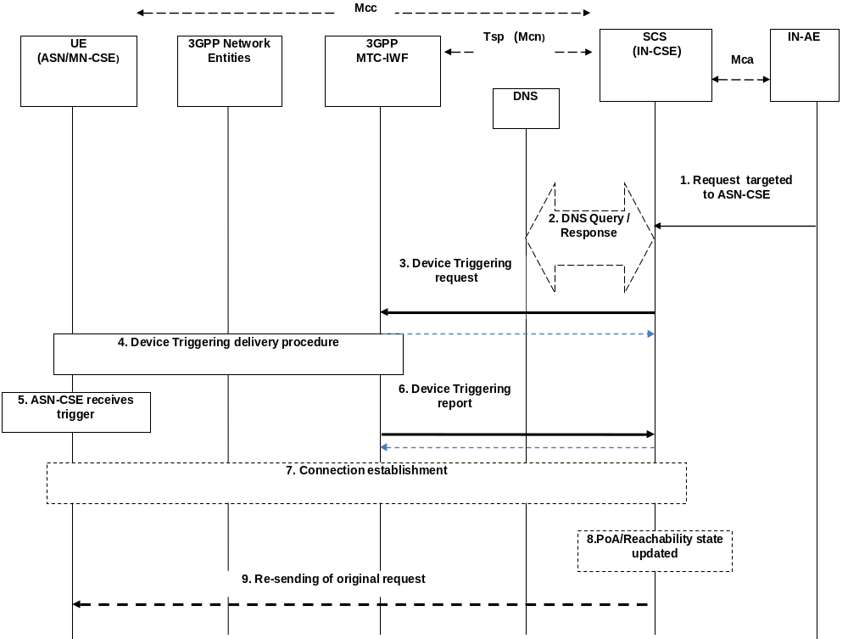

Figure B.6.1.2-1: IN-CSE initiated connectivity establishment
Pre-condition
The CSE which is the target of the device triggering has to be registered with the IN-CSE. The IN-CSE checks the state information of the target device. Some of this state information is the result of a previous connection establishment or triggering requests, such as the case of power-off, dormant and/or connected state. The IN-CSE decides its next action, e.g. if it needs to start device triggering or to report to IN-AE about the inability to perform the request.
The CSE-PoA for the ASN/MN-CSE either already contain an IP address which is not valid anymore or no IP address at all, or FQDN does not resolve to a valid IP address. This is a pre-requisite for performing the device triggering procedure.
[optional] Step 1: Request targeted to ASN/MN-CSE
The IN-AE requests to perform one of the CRUD operation on a resource residing on the ASN/MN-CSE, the request is sent via the Mca reference point to the IN-CSE. The request from IN-AE includes the address of the target resource.

----------------------- End of change 39 -----------------------

CHECK LIST
- Does this change request include an informative introduction containing the problem(s) being solved, and a summary list of proposals.?
- Does this CR contain changes related to only one particular issue/problem?
- Does this change request make all the changes necessary to address the issue or problem? E.g. A change impacting 5 tables should not only include a proposal to change only 3 tables. Includes any changes to references, definitions, and acronyms in the same deliverable?
- Does this change request follow the drafting rules?
- Are all pictures editable?
- Have you checked the spelling and grammar?
- Have you used change bars for all modifications?
- Does the change include the current and surrounding clauses to clearly show where a change is located and to provide technical context of the proposed change? (Additions of complete sections need not show surrounding clauses as long as the proposed section number clearly shows where the new section is proposed to be located.)
- Are multiple changes in this CR clearly separated by horizontal lines with embedded text such as, start of change 1, end of change 1, start of new clause, end of new clause.?

