CHANGE REQUEST
Group Name:* | WG2 (ARC)
Source:* | InterDigital, Sierra Wireless, ZTE
Format:* | ARC #14.0
Date:* | 2014-11-10
Contact:* | Guang Lu, Guang.Lu@Interdigital.com  Catalina Mladin, Catalina.Mladin@InterDigital.com  Phil Brown, Phil.Brown@InterDigital.com  Rajesh Bhalla, rabhalla@ztetx.com  Nicholas Darmour, ndamour@sierrawireless.com
Reason for Change/s:* | TS –0001 Cleanup of Section 8
CR against: Release* | 1
CR against: TS/TR* | TS-0001 v 1.2.0
Clauses/Sub Clauses*
Type of change: * | Editorial change  Bug Fix or Correction  Change/correction to existing feature or functionality  New feature or functionality
Post Freeze checking:* | This CR contains only essential changes and corrections  YES NO

oneM2M Notice
The document to which this cover statement is attached is submitted to oneM2M. Participation in, or attendance at, any activity of oneM2M, constitutes acceptance of and agreement to be bound by terms of the Working Procedures and the Partnership Agreement, including the Intellectual Property Rights (IPR) Principles Governing oneM2M Work found in Annex 1 of the Partnership Agreement.
GUIDELINES for Change Requests:
Provide an informative introduction containing the problem(s) being solved, and a summary list of proposals.
Each CR should contain changes related to only one particular issue/problem.
Follow the principle of completeness, where all changes related to the issue or problem within a deliverable are simultaneously proposed to be made E.g. A change impacting 5 tables should not only include a proposal to change only 3 tables. Includes any changes to references, definitions, and acronyms in the same deliverable.
Follow the drafting rules.
All pictures must be editable.
Check spelling and grammar to the extent practicable.
Use Change bars for modifications.
The change should include the current and surrounding clauses to clearly show where a change is located and to provide technical context of the proposed change. Additions of complete sections need not show surrounding clauses as long as the proposed section number clearly shows where the new section is proposed to be located.
Multiple changes in a single CR shall be clearly separated by horizontal lines with embedded text such as, start of change 1, end of change 1, start of new clause, end of new clause.
When subsequent changes are made to content of a CR, then the accepted version should not show changes over changes. The accepted version of the CR should only show changes relative to the baseline approved text.

Introduction
This CR proposes changes for cleanup of remaining editorial notes in clause 8.
Clause 8.1 (General Communication Flow Scheme on Mca and Mcc Reference Points) contains some truly spectacular hanging paragraphs. In fact, the first six pages of subclause 8.1.2 constitute a hanging paragraph. The representation of primitive parameters therein also needs to be made consistent.

-----------------------Start of change 1-------------------------------------------

8 Description and Flows of Reference Points

8.1 General Communication Flow Scheme on Mca and Mcc Reference Points
Procedures involving CSEs and AEs are driven by the exchange of messages across reference points according to the message flows described in this clause.
Depending on the message operation, procedures may manipulate information in a standardized resource structure as described in clause 9. Access and manipulation of the resources is subject to their associated privileges.

8.1.1 Description
Figure 8.1.1-1 shows the general flow that governs the information exchange within a procedure, which is based on the use of Request and Response messages. The message applies to communications such as:
- between an AE and a CSE (Mca reference point); and
- among CSEs (Mcc reference point).
Such communications can be initiated either by the AEs or by the CSEs depending upon the operation in the Request message.
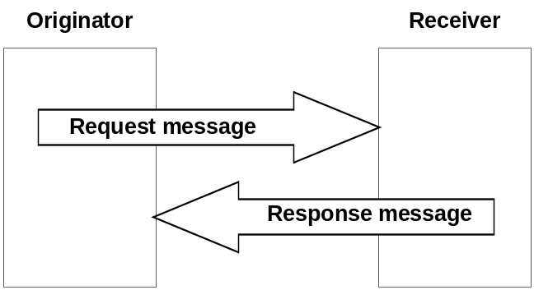

Figure 8.1.1-1: General Flow

8.1.2 Request
The Request from an Originator to a Receiver includes the following parameters:
- to: URI of the target resource for the operation. The to parameter shall conform to clause 9.3.1
NOTE 1: to parameter can be known either by pre-provisioning (clause 11.2) or by discovery (clause 10.2.6 for discovery). Discovery of <CSEBase> resource is not supported in this release of the document. It is assumed knowledge of <CSEBase> resource is by pre-provisioning only.
NOTE 2: The term target resource refers to the resource which is addressed for the specific operation. For example the to parameter of a Create operation for a resource <example> would be "/m2m.provider.com/exampleBase". The to parameter for the Retrieve operation of the same resource <example> is "/m2m.provider.com/exampleBase/example".
NOTE 3: For Retrieve operation (clause 10.1.2), the to parameter can be the URI of an attribute to be retrieved.
- fr: Identifier representing the Originator.
NOTE 4: The fr parameter shall be used by the Receiver to check the Originator identity for access privilege verification.
- cn: resource content to be transferred.
- role: optional, required when role based access control is applied

NOTE 5: The role parameter shall be used by the Receiver to check the Access Control priviledges of the Originator. As described in oneM2M TS-0003 [Error: Reference source not found] section 7.1.2., the use of this parameter is not supported in this release of the document.
- op: operation to be executed: Create (C), Retrieve (R), Update (U), Delete (D), Notify (N)
The op parameter shall indicate the operation to be executed at the Receiver:
- Create (C): to is the URI of the target resource where the new resource (parent resource)
- Retrieve (R): an existing to addressable resource is read and provided back to the Originator.
- Update (U): the content of an existing to addressable resource is replaced with the new content as in cn parameter. If some attributes in the cn parameter do not exist at the target resource, such attributes are created with the assigned values. If some attributes in the cn parameter are set to NULL, such attributes are deleted from the addressed resource.
- Delete (D): an existing to addressable resource and all its sub-resources are deleted from the Resource storage.
- Notify (N): information to be sent to the Receiver, processing on the Receiver is not indicated by the Originator.
The ty parameter shall be present in Request for the following operations:
- Create: ty is the type of the resource to be created.
- cn: resource content to be transferred.
The cn parameter shall be present in Request for the following operations:
- Create: cn is the content of the new resource with the resource type ty.
- Update: cn is the content to be replaced in an existing resource. For attributes to be updated at the resource, cn includes the names of such attributes with their new values. For attributes to be created at the resource, cn includes names of such attributes with their associated values. For attributes to be deleted at the resource, cn includes the names of such attributes with their value set to NULL.
- Notify: cn is the notification information.
The cn parameter may be present in Request for the following operations:
- Retrieve: cn is the list of attribute names from the resource that needs to be retrieved. The values associated with the attribute names shall be returned.
Other allowed parameters shall be as follows:
- nm: optional name of the resource to be created.
Example usage of the name includes a name that the Originator of the Create resource wishes to be used as the identifier of the newly created resource. For creating a <container> resource with the name "myContainer" the request will provide the parameter nm with the value "myContainer" and the created resource would be: /<CSEBase>/myContainer.
- ot: optional originating timestamp of when the message was built.
Example usage of the originating timestamp includes: to measure and enable operation (e.g. message logging, correlation, message prioritization/scheduling, accept performance requests, charging, etc.) and to measure performance (distribution and processing latency, closed loop latency, SLAs, analytics, etc.)
- rqet: optional request message expiration timestamp.
Example usage of the request expiration timestamp includes to indicate when request messages (including delay-tolerant) should expire due to their staleness being no longer of value, and to inform message scheduling/prioritization. When a request has set request expiration timestamp to a specific time and the Request demands an operation on a Hosting CSE that is not the CSE currently processing the request, then the current CSE shall keep on trying to deliver the Request to the Hosting CSE until the request expiration timestamp time, in line with provisioned policies.
- rset: optional result message expiration timestamp.
Example usage of the result expiration timestamp includes to indicate when result messages (including delay-tolerant) should expire due to expected staleness of the result, being no longer of value, and to inform message scheduling/prioritization. It can be used to set the maximum allowed total request/result message sequence round trip deadline.
- rt: optional response message type: Indicates what type of response shall be sent to the issued request and when the response is sent to the Originator:
- nonBlockingRequestSynch: In case the request is accepted by the Receiver CSE, the Receiver CSE responds after acceptance with an Acknowledgement confirming that the Receiver CSE will further process the request. The Receiver CSE includes in the response to an accepted request a reference that can be used to access the status of the request and the result of the requested operation at a later time. Processing of Non-Blocking Requests is defined in clause 8.2.2 and in particular for the synchronous case in clause 8.2.2.2.
- nonBlockingRequestAsynch {optional list of notification targets}: In case the request is accepted by the Receiver CSE, the Receiver CSE shall respond after acceptance with an Acknowledgement confirming that the Receiver CSE will further process the request. The result of the requested operation needs to be sent as notification(s) to the notification target(s) provided optionally within this parameter as a list of entities or to the Originator when no notification targets are provided. Processing of Non-Blocking Requests is defined in clause 8.2.2 and in particular for the asynchronous case in clause 8.2.2.3.
- blockingRequest: In case the request is accepted by the Receiver CSE, the Receiver CSE responds with the result of the requested operation after completion of the requested operation. Processing of Blocking Requests is defined in clause 8.2.1.
Example usage of the response type set to nonBlockingRequestSynch: An Originator that is optimized to minimize communication time and energy consumption wants to express a Request to the receiver CSE and get an acknowledgement on whether the Request got accepted. After that the Originator may switch into a less power consuming mode and retrieve a Result of the requested Operation at a later time.
Further example usage of response type set to nonBlockingRequestSynch includes when the result content is extremely large, or when the result consists of multiple content parts from a target group which are to be aggregated asynchronously over time.
- rc: optional result content: Indicates what are the expected components of the result of the requested operation. The Originator of a request may not need to get back a result of an operation at all. This shall be indicated in the rc parameter. Which exact settings of rc are possible depends on the requested operation specified in op. Possible values of rc are:
- attributes: Representation of the requested resource shall be returned as content, without the URI(s) of the child resource(s). This is the default value. For example, if the request is to retrieve a <container> resource, the URI(s) of the <contentInstance> child-resource(s) is not provided. This setting is not valid for a Notify operation.
- attributes+child-resources: Representation of the requested resource, along with the URI(s) of the child resource(s), possibly limited by a maximum number of retrieved links, shall be returned as content. For example, if the request is to retrieve a <container> resource, the <container> resource and the URI(s) of the <contentInstance> child-resource(s) are provided. This setting is not valid for a Notify operation
- child-resource: URI(s) of the child resources, possibly limited by a maximum number of retrieved URI(s), without any representation of the actual requested resource shall be returned as content. For example, if the request is to retrieve a <container> resource, only the URI(s) of the <contentInstance> child-resource(s) is provided. This setting is not valid for a Notify operation
- nothing: Nothing shall be returned as operational result content. This setting is not valid for a retrieve operation. This setting is the default when a Notification was requested by the op parameter. For example, if the request is to delete a resource, this setting indicates that the response shall not include any content.
- original-resource: Representation of the original resource pointed by the link attribute in the announced resource shall be returned as content, without the URI(s) of the child resource(s). This setting is only valid for aRETRIEVE Request where the to parameter targets the announced resource.

- rp: optional response persistence: indicates the duration for which the address containing the responses is to persist.
Example usage of response persistence includes requesting sufficient persistence for analytics to process the response content aggregated asynchronously over time. If a result expiration timestamp is specified then the response persistence should last beyond the result expiration time.
- ri: request Identifier.
Example usage of request identifier includes enabling the correlation between a Request and one of the many received Responses.
- oet: optional operation execution time: indicates the time when the specified operation op is to be executed by the target CSE. A target CSE shall execute the specified operation of a Request having its operational execution time indicator set, starting at the operational execution time. If the execution time has already passed or if the indicator is not set, then the specified operation shall be immediately executed, unless the request expiration time, if set, has been reached.
Example usage of operational execution time includes asynchronous distribution of flows, which are to be executed synchronously at the operational execution time.
NOTE 6: Time-based flows could not supported depending upon time services available at CSEs.
- ec: optional event category: Indicates the event category that should be used to handle this request. Event categories are impacting how Requests to access remotely hosted resources are processed in the CMDH CSF. Selection and scheduling of connections via CMDH are driven by policies that can differentiate event categories.
Example usage of "event category" set to specific value X: When the request is demanding an operation to be executed on a Hosting CSE that is different from the current Receiver CSE, the request may be stored in the current Receiver CSE that is currently processing the request on the way to the Hosting CSE until it is allowed by provisioned policies for that event category X to use a communication link to reach the next CSE on a path to the Hosting CSE or until the request expiration timestamp is expired.
The following values for ‘ec’ shall have a specified pre-defined meaning:
  - ec = immediate: Requests of this category shall be sent as soon as possible and shall not be subject to any further CMDH processing, i.e. the request will not be subject to storing in CMDH buffers when communication over an underlying network is possible. In particular, CMDH processing will respect values for rqet, rset given in the original request and not fill in any default values if they are missing.
  - ec = bestEffort: Requests of this category can be stored in CDMH buffers at the discretion of the CSE that is processing the request for an arbitrary time and shall be forwarded via Mcc on a best effort basis. The CSE does not assume any responsibility to meet any time limits for delivering the information to the next CSE. Also the maximum amount of buffered requests for this category is at the discretion of the processing CSE.
  - ec = latest:
    - If this category is used in a request asking for a CRUD operation on a resource, the following shall apply:
CRUD requests using this category shall undergo normal CMDH processing as outlined further below in this specification and in [i.2] with a maximum buffer size of one pending request for a specific pair of fr and to parameters that appear in the request. If a new request message is received by the CSE with a pair of parameters fr and to that has already been buffered for a pending request, the newer request will replace the buffered older request.
    - If this category is used in a notification request triggered by a subscription, the following shall apply:
Notification requests triggered by a subscription using this category shall undergo normal CMDH processing as outlined further below in this specification and in TS-0004 [i.2] with a maximum buffer size of one pending notification request per subscription reference that appears in a notification request. If a new notification request is received by the CSE with a subscription reference that has already been buffered for a pending notification request, the newer request will replace the buffered older request.
- If no further CMDH policies are provisioned for this event category, the forwarding process shall follow the ‘bestEffort’ rules defined above.
- The M2M Service Provider shall be able to provision CMDH policies describing details for the usage of the specific Underlying Network(s) and the applicable rules as defined in the [cmdhPolicy] resource type for other ec values not listed above.
- da: optional delivery aggregation on/off: Use CRUD operations of <delivery> resources to express forwarding of one or more original requests to the same target CSE(s).
NOTE 7: Since da is optional, there could be a default value to be used when not present in the Request. This parameter could not be exposed to AEs via Mca.
Example usage of delivery aggregation set on: The CSE processing a request shall use aggregation of requests to the same target CSE by requesting CREATE of a <delivery> resource on the next CSE on the path to the target CSE.
- gid: optional group request identifier: Identifier optionally added to the group request that is to be fanned out to each member of the group in order to detect loops and avoid duplicated handling of operation in case of loops of group and common members between groups that have parent-child relationship.
- fc: optional filter criteria: conditions for filtered retrieve operation are described in table 8.1.2-1. This is used for resource discovery (clause 10.2.6) and general retrieve, update, delete requests (clause 10.1.2, 10.1.3 and 10.1.4).
Example usage of retrieve requests with filter criteria using modifiedSince condition tag: if a target resource is modified since 12:00 then the Hosting CSE will send a resource representation.
- Disrestype: Optional Discovery result format. This parameter applies to discovery related requests (see clause 10.2.6) to indicate the preference of the Originator for the format of returned information in the result of the operation. This parameter shall take on one of the following values reflecting the options in clause 9.3.1:
- Hierarchical URI option.
- Non-hierarchical URI option.
- CSE-ID, and resource identifier option.
For example if Disrestype is set to Non-hierarchical URI option, then the request Originator indicates that the discovered resources should be in the form of Non-hierarchical URI.
The absence of the parameter implies that the result shall be in Hierarchical URI format.
Table 8.1.2-1: filterCriteria conditions
Condition tag | Multiplicity | Matching condition
createdBefore | 0..1 | The creationTime attribute of the resource is chronologically before the specified value.
createdAfter | 0..1 | The creationTime attribute of the resource is chronologically after the specified value.
modifiedSince | 0..1 | The lastModifiedTime attribute of the resource is chronologically after the specified value.
unmodifiedSince | 0..1 | The lastModifiedTime attribute of the resource is chronologically before the specified value.
stateTagSmaller | 0..1 | The stateTag attribute of the resource is smaller than the specified value.
stateTagBigger | 0..1 | The stateTag attribute of the resource is bigger than the specified value.
expireBefore | 0..1 | The expirationTime attribute of the resource is chronologically before the specified value.
expireAfter | 0..1 | The expirationTime attribute of the resource is chronologically after the specified value.
labels | 0..n | The labels attributes of the resource matches the specified value.
resourceType | 0..n | The resourceType attribute of the resource is the same as the specified value. It also allows differentiating between normal and announced resources.
sizeAbove | 0..1 | The contentSize attribute of the <contentInstance> resource is equal to or greater than the specified value.
sizeBelow | 0..1 | The contentSize attribute of the <contentInstance> resource is smaller than the specified value.
contentType | 0..n | The typeOfContent attribute of the <contentInstance> resource matches the specified value.
limit | 0..1 | Limitation the number of matching resources to the specified value.
attribute | 0..n | This is an attribute of resource types (clause 9.6). Therefore, a real tag name is variable and depends on its usage. E.g. creator of container resource type can be used as a filter criteria tag as “creator=Sam”.
filterUsage | 0..1 | Indicates how the filter criteria is used. E.g. if this parameter is not provided, the Retrieve operation is for generic retrieve operation. If filterUsage is provided, the Retrieve operation is for resource <discovery> (clause 10.2.6).

The rules when multiple conditions are used together shall be as follows:
- different conditions shall use the "AND" logical operation
- same conditions shall use the "OR" logical operation
Below is an example usage of filter criteria conditions in a HTTP query: an HTTP GET operation can be requested applying also a filter in the query part of the request itself:
GET /root?label=one&label=two&createdBefore=2014-01-01T00:00:00&limit=128&filterUsage=discovery
The example discovers a maximum of 128 resources matching the following logical condition: createdBefore < 2014-01-01T00:00:00 AND (label = one OR label = two).
Once the Request is delivered, the Receiver shall analyze the Request to determine the target resource.
If the target resource is addressing another M2M Node, the Receiver shall route the request appropriately.
If the target resource is addressing the Receiver, it shall:
- Check the existence of to addressed resource.
- Identify the resource type by ty.
- Check the privileges for fr Originator to perform the requested operation.
- Perform the requested operation (using cn content when provided) according to the provided request parameters as described above.
- Depending on the request result content, respond to the Originator with indication of successful or unsuccessful operation results. In some specific cases (e.g. limitation in the binding protocol or based on application indications), the Response could be avoided.

Table 8.1.2-1 summarises the parameters specified in this clause for the Request message, showing any differences as applied to C, R, U, D or N operations. "M" indicates mandatory, "O" indicates optional, "N/A" indicates "not applicable".

Table 8.1.2-1: Summary of Request Message Parameters
Request message parameter\Operation | Create | Retrieve | Update | Delete | Notify
Operation (op) - operation to be executed | M | M | M | M | M
To (to) - the address of the target resource on the target CSE | M | M | M | M | M
From (fr) - the identifier of the message Originator | M | M | M | M | M
Request Identifier (ri) - uniquely identifies a Request message | M | M | M | M | M
Resource Type (ty) - of resource to be created | M | N/A | N/A | N/A | N/A
Name (nm) - of resource to be created | O | N/A | N/A | N/A | N/A
Content (cn) - to be transferred | M | O | M | N/A | M
Originating Timestamp (ot) - when the message was built | O | O | O | O | O
Request Expiration Timestamp (rqet) - when the request message expires | O | O | O | O | O
Result Expiration Timestamp (rset) -when the result message expires | O | O | O | O | O
Operational Execution Time (oet) - the time when the specified operation is to be executed by the target CSE. | O | O | O | O | O
Response Type (rt) - type of response that shall be sent to the Originator | O | O | O | O | O
Result Persistence (rp) - the duration for which the reference containing the responses is to persist | O | O | O | O | N/A
Result Content (rc) - the expected components of the result | O | O | O | O | N/A
Event Category (ec) - indicates how and when the system should deliver the message | O | O | O | O | O
Delivery Aggregation (da) - aggregation of requests to the same target CSE is to be used | O | O | O | O | O
Group Request Identifier (gid) - Identifier added to the group request that is to be fanned out to each member of the group. | O | O | O | O | O
Filter Criteria (fc) - conditions for filtered retrieve operation | N/A | O | N/A | N/A | N/A
Discovery Result Type (Disrestype) - format of information returned for Discovery operation | N/A | O | N/A | N/A | N/A

8.1.3 Response
The Response received by the Originator of a Request accessing resources over the Mca and Mcc reference points shall contain mandatory and may contain optional parameters. Certain parameters may be mandatory or optional depending upon the Requested operation (CRUDN) or the mandatory response code. In this clause, the mandatory parameters are detailed first, following by those that are conditional, followed by those that are optional:
Mandatory Parameters:
- rs: response code: This parameter indicates whether the requested operation was successful, unsuccessful or is an acknowledgement:
- A successful code indicates to the Originator that the Requested operation has been executed successfully by the Hosting CSE.
- An unsuccessful code indicates to the Originator that the Requested operation has not been executed successfully by the Hosting CSE.
- An acknowledgement indicates to the Originator that the Request has been received and accepted by the attached CSE, i.e. by the CSE that received the Request from the issuing Originator directly, but the Request operation has not been executed yet. The success or failure of the execution of the Requested operation is to be conveyed later.
Details of successful, unsuccessful and acknowledge codes are provided in clause 6.8 of oneM2M Protocol Specification (TS-0004) [Error: Reference source not found].
- ri: Request Identifier. The ri in the Response shall match the ri in the corresponding Request.
Conditional Parameters:
- cn: resource content:
- If rs is successful then:
The cn parameter may be present in a Response in the following cases:
- Create: cn is the address and/or the content of the created resource.
- Update: cn is the content replaced in an existing resource. If attributes are created at an existing resource, cn includes the names of the attributes created and their associated values. If attributes are updated at an existing resource, cn includes the names of the attributes updated and their associated values. If attributes are deleted at an existing resource, cn includes the names of the attributes deleted.
- Delete: Optionally, cn is the content actually deleted.
The cn parameter shall be present in a Response in the following cases:
- Retrieve: cn is the retrieved resource content or aggregated contents of discovered resources.
If present in the Request, result contents rc, indicates which components of the result of the requested operation are to be included in the Response.
- If rs is unsuccessful then the cn parameter may be present in a Response to provide more error information.
- If rs is acknowledgment then the cn parameter:
  - Shall contain the address of a <request> resource if the response was an acknowledgement of a non-blocking request and the <request> resource type is supported by the Receiver CSE.
  - Is not present otherwise.
Optional parameters:
- to: ID of the Originator, or if the response is a reaction to a non-blocking request that was sent by that Transit CSE, the ID of the Transit CSE.
- fr: ID of the Receiver.
- ot: originating timestamp of when the message was built.
- rset: result expiration timestamp. The Receiver shall echo the result expiration timestamp if set in the Request message, or may set the result expiration timestamp itself.
Example usage of the Receiver setting the result expiration timestamp is when the value of the delivery time is dependent upon some changing Receiver context e.g. Result message deadline for aircraft position based upon velocity.
- ec: event category: Indicates the event category that should be used to handle this response. The definition of event category is the same as in the case of requests in clause 8.1.2.
Example usage of "event category" set to specific value X: When the response is targeted to an entity that is different from the Transit CSE currently processing the response message and is not an AE registered with the Transit CSE that is currently processing the response message, the response may be stored in the Transit CSE that is currently processing the response on the way to the destination of the response message until it is allowed by provisioned policies for that event category X to use a communication link to reach the next CSE on a path to the destination of the response message or until the result expiration timestamp is expired.
- cs: status codes (e.g. authorization timeout, etc.).

Table 8.1.3-1 summarises the parameters specified in this clause for the Response messages, showing any differences as applied to successful C, R, U, D or N operations, and unsuccessful operations. "M" indicates mandatory, "O" indicates optional, "N/A" indicates "not applicable".

Table 8.1.3-1: Summary of Response Message Parameters
Response message parameter \ success or not | rs = Ack | rs = successful: Op = Create | rs = successful: Op= Retrieve | rs =  successful. Op= Update | rs =  successful. Op = Delete |  | rs =  successful Op= Notify |  | rs = unsuccessful  Op = C,R,U,D or N
Response Code (rs) - successful, unsuccessful, ack | M | M | M | M |  | M |  | M |  | M
Request Identifier (ri) - uniquely identifies a Request message | M | M | M | M |  | M |  | M |  | M
Content (cn) - to be transferred | O  (address of <request> resource if response is ACK of a non-blocking request) | O  (The address and/or the content of the created resource) | M  (the retrieved resource content or aggregated contents of discovered resources) | O  (The content replaced in an existing resource. The content of the new attributes created. The name of the attributes deleted.) |  | O  (The content actually deleted) |  | N/A |  | O  (Additional error info)
To (to) -the identifier of the Originator or the Transit CSE that sent the corresponding non-blocking request | O | O | O | O |  | O |  | O |  | O
From (fr) - the identifier of the Receiver | O | O | O | O |  | O |  | O |  | O
Originating Timestamp (ot) - when the message was built | O | O | O | O |  | O |  | O |  | O
Result Expiration Timestamp (rset) - when the message expires | O | O | O | O |  | O |  | N/A |  | O
Event Category (ec) – what event category shall be used for the response message | O | O | O | O |  | O |  | O |  | O
Status codes (cs) - (e.g. authorization timeout, etc.) | O | O | O | O |  | O |  | O |  | O

8.2 Procedures for Accessing Resources
This clause describes the procedures for accessing the resources. The term "hop" in the descriptions here refers to the number of transit CSEs that forward a request from the Originator CSE to the Hosting CSE.
All the descriptions and message flows in this clause are illustrative for the direction from a Registree acting as an Originator to a Registrar acting as a Receiver only. The flows from a Registrar CSE to a Registree CSE are symmetric with respect to the one described in this section. Both IN-CSE and MN-CSE have ability to route a received request or response messages to one of its Registrees. If the Hosting CSE is not known by an MN-CSE that receives a request or response message, that MN-CSE shall forward the message to its own Registrar CSE by default.

8.2.1 Accessing Resources in CSEs - Blocking Requests
For the procedures described herein, the addressed resource can be stored in different CSEs. Table 8.2.1-1 describes the possible scenarios, where the addressed resource may be on the Registrar CSE or on a CSE located elsewhere in the oneM2M System.
In this clause - for simplicity - it is assumed that the Originator of a Request can always wait long enough to get a Response to the Request after the requested operation has finished. This implies potentially long or unknown blocking times (time for which a pending Request has not been responded to) for the Originator of a Request.
For scenarios that avoid such possibly long blocking times, clause 8.2.2 specifies mechanisms to handle synchronous and asynchronous resource access procedures via returning appropriate references.

Table 8.2.1-1: Accessing Resources in different CSEs, from Registree to Registrar CSE
Number of Transit CSEs | Description | Reference
No Hops | - The Originator of the Request accesses a resource.  - The Originator of the Request can be an AE or a CSE.  - Registrar CSE and Hosting CSE are the same entity.  - The Hosting CSE checks the Access Control Privileges for accessing the resource.  - Depending on the expected result content, the Hosting CSE responds to the Originator of the Request, either with a success or failure Response | Figure 8.2.1-1
1 Hop | - The Originator of the Request accesses a resource.  - The Originator of the Request may be an AE or a CSE.  - Registrar CSE and hosting CSEs are different entities.  - Registrar CSE forwards the Request to the Hosting CSE if the Registrar CSE is registered with the Hosting CSE, for accessing the resource  - Hosting CSE checks the Access Control Privileges for accessing the resource and depending on the expected result content respond with a success or failure Response. | Figure 8.2.1-2
Multi Hops | - The Originator of the Request accesses a resource.  - The Originator of the Request may be an AE or a CSE.  - Registrar CSE, Transit CSE(s) and the Hosting CSE are different entities.  - Registrar CSE:  - Forwards the Request to a Transit-1 CSE (e.g. MN-CSE) that the Registrar CSE is registered with, if configured through policies to do so or;  - Forwards the request to an IN-CSE if the Registrar CSE is registered with IN-CSE and if configured through policies to do so.  - Transit-N CSE:  - Forwards the request to the Hosting CSE if it is registered with the Hosting CSE or  - Forwards the Request to another Transit-(N+1) CSE (e.g. another MN-CSE) that the Transit-N CSE is registered with. or  - Forwards the request to an IN-CSE if the Transit-N CSE is registered with the IN-CSE.  - In case the Request reaches the IN-CSE, the IN-CSE:  - Performs the processing defined under 'Hosting CSE' below if the targeted resource is hosted on IN-CSE.  - Forwards the request to another IN-CSE if the resource belongs to another M2M SP or  - Forwards the request to the Hosting CSE if the latter is known (e.g. announcements) by the IN-CSE.  - Hosting CSE checks the Access Control Privileges for accessing the resource and depending on the expected result content respond with a success or failure Response. | Figure 8.2.1-3

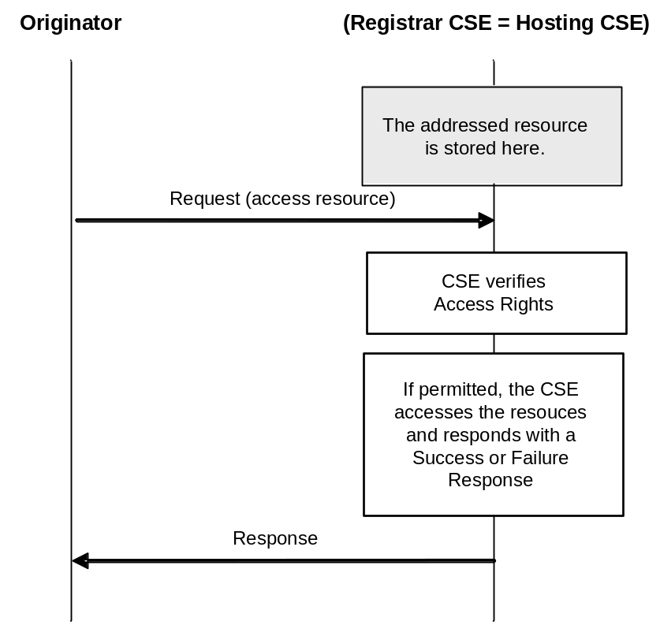

Figure 8.2.1-1: Originator accesses a resource on the Registrar CSE (No Hops)

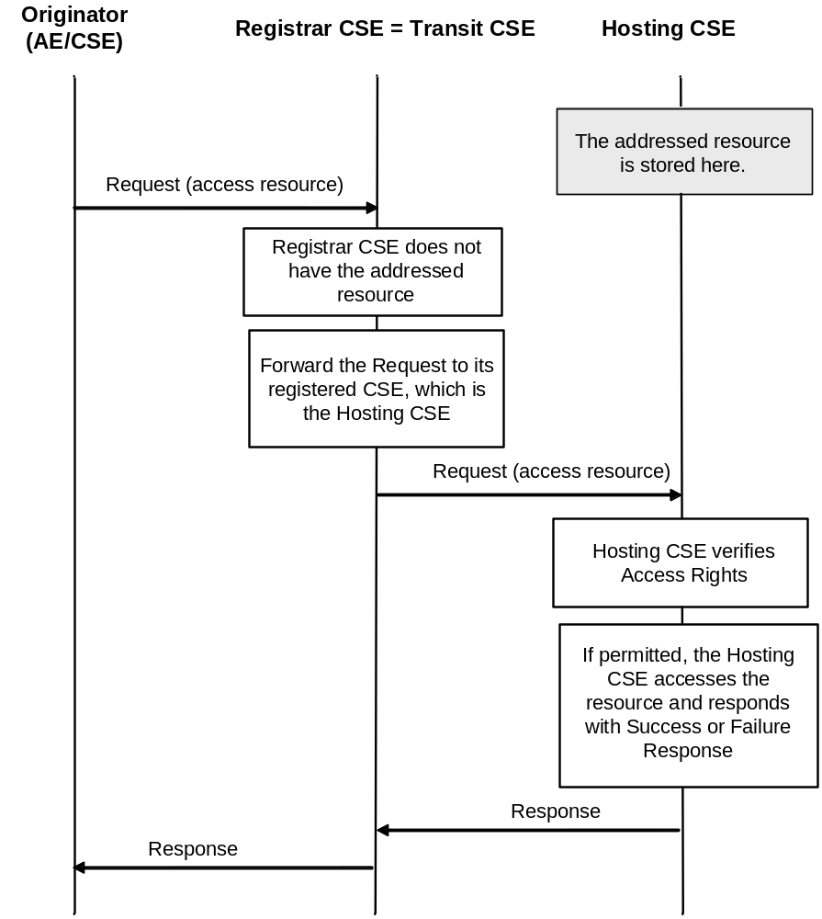

Figure 8.2.1-2: AE/CSE accesses a resource at the Hosting CSE (One Hop)
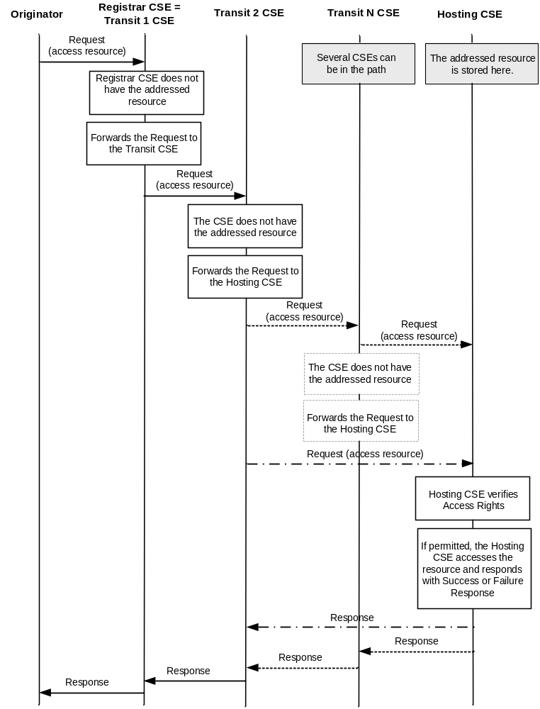

Figure 8.2.1-3: Originator accesses a resource at the Hosting CSE (Multi Hops)

8.2.1.1 M2M Requests Routing Policies
CSEs can use policies to govern routing of M2M requests to the next hop towards its target. Routing, through these policies, can be based, for example, on the target CSE, target M2M domain, specific types of resources if applicable, priority of a request, etc.
These policies are not defined in this release of this document. It is the responsibility of M2M SP and the CSE administrator to ensure the appropriateness of these policies for routing purposes.

8.2.2 Accessing Resources in CSEs - Non-Blocking Requests

8.2.2.1 Response with Acknowledgement and optional Reference to Request Context and Capturing Result of Requested Operation
In case the Originator of a Request has asked for only a response with an Acknowledgement indicating acceptance of the Request and an optional reference to the context where the result of the requested operation is expected - i.e. when the rt parameter of the request as defined in clause 8.1.2 is set to nonBlockingRequestSynch or to nonBlockingRequestAsynch - it is necessary to provide a prompt response to the Originator with an Acknowledgement - and in case the <request> resource type is supported by the Receiver CSE also, with a reference to an internal resource on the Receiver CSE, so that the Originator can retrieve the status of the request and the outcome of the requested operation at a later time. The details of such an internal resource are defined in clause 9.6.12. In case the <request> resource type is supported, the reference is provided in the response to the Request within the cn parameter of the Response. The abbreviation "Req-Ref" is used for simplicity in the figures of the following clauses.
Two different cases to allow the Originator of a non-blocking request to retrieve the result of a requested operation are defined in the following two clauses.

8.2.2.2 Synchronous Case
In the synchronous case, it is assumed that the Originator of a Request is not able to receive asynchronous messages, i.e. all exchange of information between Originator and Receiver CSE needs to be initiated by the Originator.
In that case the information flow depicted in figure 8.2.2.2-1 is applicable. For the flow depicted in figure 8.2.2.2-1 it is assumed that completion of the requested operation happens before the Originator is trying to retrieve the result of the requested operation with a second Request referring to the "Req-Ref" provided in the Response to the original Request.
Another variation of the information flow for the synchronous case is depicted in figure 8.2.2.2-2. In this variation it is assumed that the requested operation completes after the second request but before the third request sent by the Originator.
Equivalent information flows are valid also for cases where the target resource of the requested operation is not hosted on the Receiver CSE. From an Originator's perspective there is no difference as the later retrieval of the result of a requested operation would always be an exchange of Request/Response messages between the Originator and the Receiver CSE using the reference to the original request.
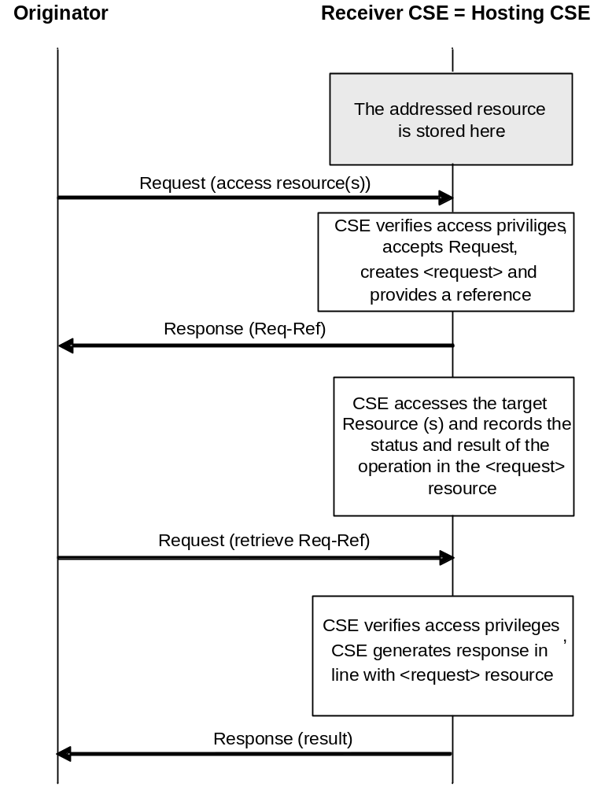
Figure 8.2.2.2-1: Non-blocking access to resource in synchronous mode
(Hosting CSE = Receiver CSE), requested operation completed before second request

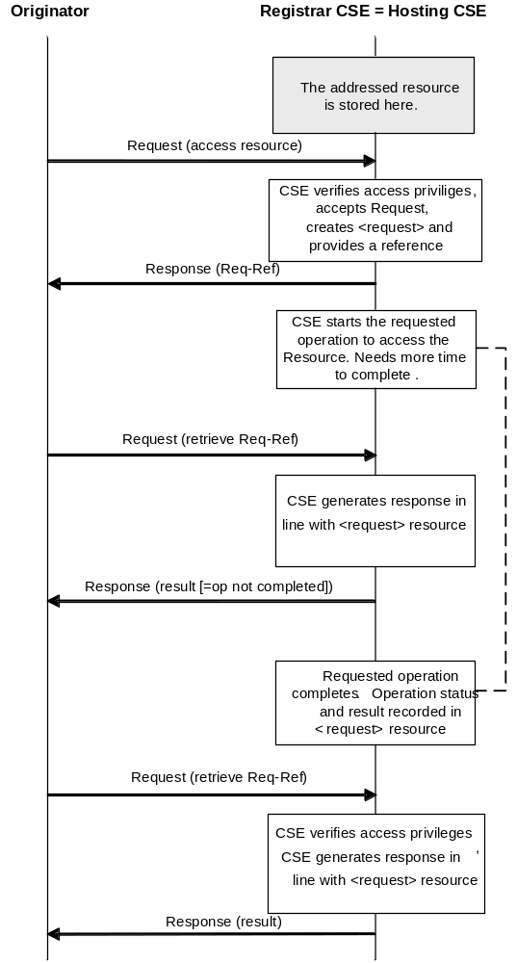
Figure 8.2.2.2-2: Non-blocking access to resource in synchronous mode
(Hosting CSE = Receiver CSE), requested operation completed after the second
but before the third request

8.2.2.3 Asynchronous Case
In the asynchronous case, it is assumed that the Originator or other entities that need to know about the outcome of a Request are able to receive notification messages, i.e. the CSE carrying out the requested operation can send an unsolicited message to the Originator or to other indicated entities at an arbitrary time to send the status and result of the requested operation to one or more notification target(s). The possible mechanisms for the notification to reach the Originator or the other notification targets are the same as in the case of a notification after a subscription to a resource got triggered.
In the asynchronous case, a Receiver CSE that does not support the <request> resource type shall be able to respond to an acceptable request with a response containing an Acknowledgement without a reference to a resource containing the context of the request.
In the asynchronous case the exemplary information flow depicted in figure 8.2.2.3-1 is applicable. In this case it is assumed that the Originator of the Request provided two notification targets. - the Originator and one other notification target - to which notification shall be sent when the result of the requested operation is available or when the request failed.
Equivalent information flows are valid also for cases where the target resource of the requested operation is hosted on the Receiver CSE itself. From an Originator's or notification target's perspective there is no difference as the later notification of the result of a requested operation would always be an exchange of request/response messages between the CSE carrying out the requested operation and the notification targets using reference to the original Request ID.

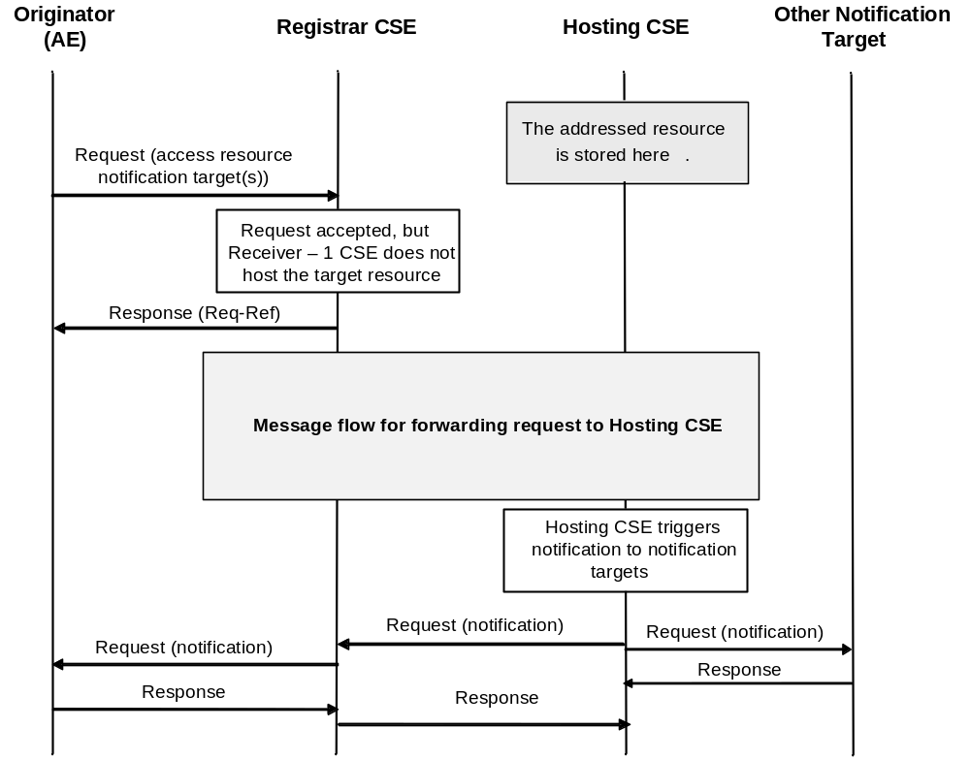
Figure 8.2.2.3-1: Non-blocking access to resource in asynchronous mode
(Hosting CSE not equal to Receiver - 1 CSE), Originator provided targets for notification

8.3 Description and Flows on Mcn Reference Point
Communications between the CSEs and the NSEs across the Mcn reference point and includes:
- The CSE(s) accessing network service functions provided by Underlying Networks; and
- Optimizing network service processing for Underlying Networks.
Such services normally are more than just the general transport services.
Communications which pass over the Mcn reference point to Underlying Networks include:
- Messaging services that are widely deployed by Applications and network operators using a number of existing mechanisms.
- Network APIs defined by other SDOs (e.g. OMA and GSMA) are used by network operators for their services.
- Interworking for services and security aspects for MTC (Machine Type Communications) has been defined by 3GPP.
Examples of service requests from a CSE towards the Underlying Networks are:
- Connection requests with/without QoS requirements.
- Payments, messages, location, bearer information, call control and other network capabilities (e.g. by using GSMA oneAPI, network APIs supporting protocols defined by other SDOs, or proprietary network APIs).
- Device triggering.
- Device management.
- Management information exchange such as charging/accounting records, monitoring and management data exchange.
- Location request.

8.4 Device Triggering

8.4.1 Definition and scope
Device Triggering is a means by which a node in the infrastructure domain (e.g. IN-CSE) sends information to a node in the field domain (e.g. ASN-CSE) to perform a specific task, e.g. to wake up the device, to establish communication from the field domain towards the infrastructure domain, or when IP address for the device is not available or reachable by the infrastructure domain.
Underlying Network functionality is used to perform device triggering for example, using alternate means of communication (e.g. SMS) with the Field Node.
NOTE: Device Triggering is applicable for the entities which are registered with IN-CSE.
Each Underlying Network type may provide different way of performing a device triggering, for example 3GPP has defined a dedicated interface for requesting device triggering. The normative references for applicable interfaces are as follows: TS 123 682 [Error: Reference source not found] and 3GPP2 X.S0068 [Error: Reference source not found]. Access specific mechanisms are covered in the annexes B and C.

8.4.2 General Procedure for Device Triggering
This clause covers different scenarios for device triggering.

8.4.2.1 Triggering procedure for targeting ASN/MN-CSE
This case describes the scenario where IN-CSE targets an ASN/MN-CSE (which is registered with the IN-CSE) for the Device Triggering request.
Figure 8.4.2 1-1 shows the general procedure for Device Triggering and, if required, for establishment of connectivity between IN-CSE and the Field Node.
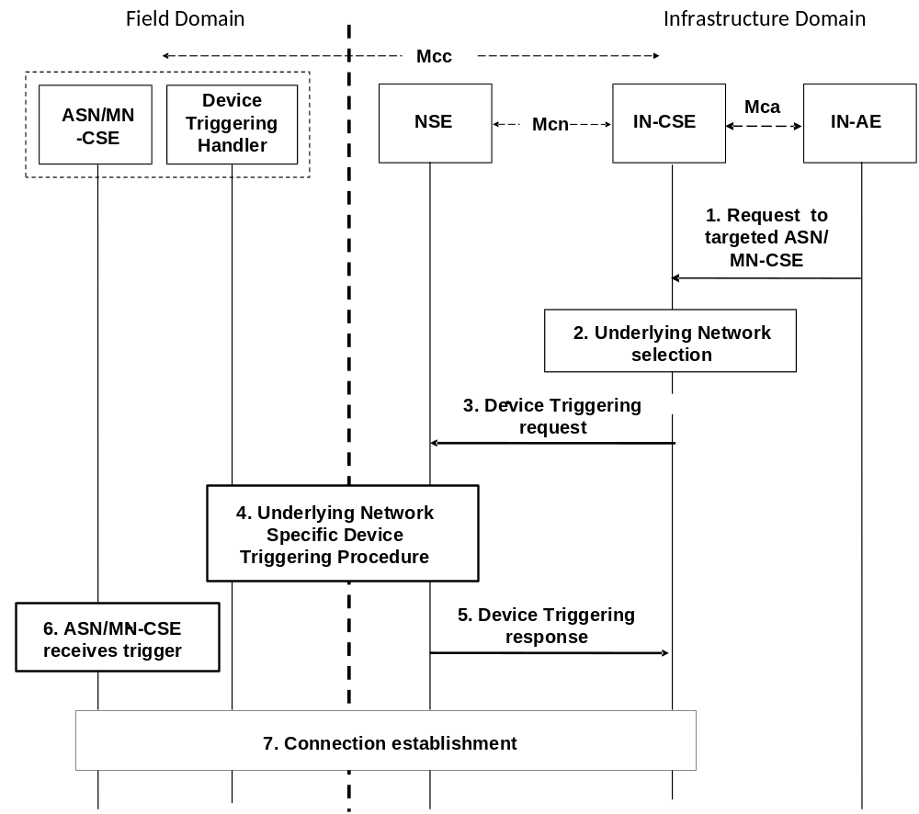
Figure 8.4.2 1-1: Device Triggering general procedure for CSE
NOTE 1: The IN and ASN/MN are assumed to be connected through the same Underlying Network.
NOTE 2: The Device Triggering Handler is a functional entity that receives the device triggering request, and it is dependent on the Underlying Network. The Device Triggering Handler is out of scope of this specification.
Pre-condition
The CSE which is the target of the device triggering has to be registered with the IN-CSE.
The CSE-PoA for the ASN/MN-CSE already contains either an IP address or none.
[optional] Step-1: Request to targeted ASN/MN-CSE
The IN-AE requests to perform one of the CRUD operations on a resource residing on the ASN/MN-CSE, the request is sent via the Mca reference point to the IN-CSE.
Step-2: Underlying network selection
The IN-CSE selects the Underlying Network and the mechanism to deliver the triggering request to the Underlying Network according to the configuration for connected Underlying Networks.
For example for 3GPP access network IN-CSE can use Tsp, Tsms and GSMA OneAPI, but the preferred mechanism is Tsp.
Step-3: Device Triggering request
IN-CSE issues the device triggering request to the selected Underlying Network.
NOTE 1: The Underlying Network dependent Device Triggering procedure for 3GPP and 3GPP2 systems are described in annexes B and Annex C respectively.
Some information provided to the selected Underlying Network for performing device triggering includes:
- M2M-Ext-ID associated with the ASN/MN-CSE as the target of the triggering request (see clause 7.1.8).
- Trigger-Recipient-ID associated with the ASN/MN-CSE (see clause 7.1.10). For example when 3GPP Underlying Network is used this identifier could map to Application-Port-ID.
- IN-CSE ID which could be used by the Underlying Network to authorize the IN-CSE for device triggering.
NOTE 2: The M2M-Ext-ID may be pre-provisioned at the IN-CSE along with the associated CSE-ID, or may be sent at registration (see clause 7.1.8 )
NOTE 3: The above Trigger-Recipient-ID is sent at registration.

Step-4: Underlying Network Specific Device Triggering procedure
Device Triggering processing procedure is performed between the Underlying Network and the target Node which hosts the ASN/MN-CSE.
Step-5: Device Triggering response
The IN-CSE receives a response for the Device Triggering request via the Mcn reference point.
Step-6: ASN/MN-CSE Receives Device Trigger
[optional] Step-7 Connection establishment
In case that it is required by the Device Triggering request, connectivity is established between the ASN/MN-CSE and the IN-CSE and the renewal of the CSE-PoA might be needed.

8.5 Location Request

8.5.1 Definition and Scope
Location Request is a means by which a CSE requests the geographical or physical location information of a target CSE or AE hosted in a M2M Node to the location server located in the Underlying Network over Mcn reference point. This clause describes only the case of location request when the attribute locationSource is set to Network Based.

8.5.2 General Procedure for Location Request
This procedure describes a scenario wherein an AE sends a request to obtain the location information of a target AE or CSE hosted in an M2M Node to the location server NSE, and the location server responses to the CSE with location information.
Figure 8.5.2.1-1 shows the general procedure for Location Request.
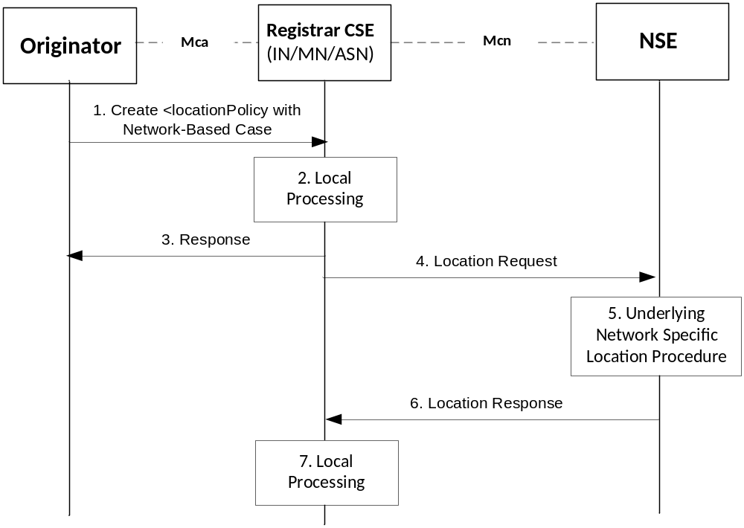
Figure 8.5.2 1-1: General Procedure for Location Request
NOTE 1: Detailed descriptions for Step-1 to the Step-3 are described in the clause 10.2.11.1.
Step-1: Create <locationPolicy>
The Originator requests to CREATE <locationPolicy> resource at the Registrar CSE. The locationSource attribute of the <locationPolicy> resource shall be set to 'Network-Based' and the value for locationTargetID and locationServer attributes shall be set properly set for the Location Request.
Step-2: Local Processing for creating <locationPolicy> resource
After verifying the privileges and the given attributes, the Registrar CSE shall create the <locationPolicy> resource. Linked <container> resource can be created after successful creation of <locationPolicy> resource.
Step-3: Response for creating <locationPolicy>
The Registrar CSE shall respond with a Response message.
Step-4: Location Request
The Registrar CSE issues Location Request to the selected Underlying Network. For doing this, the Registrar CSE shall transform the location configuration information received from the Originator into Location Request that is acceptable for the Underlying Network. For example, the Location Request can be one of existing location acquisition protocols such as OMA Mobile Location Protocol [Error: Reference source not foundError: Reference source not found] or OMA RESTful NetAPI for Terminal Location [Error: Reference source not found]. Additionally, the Registrar CSE shall provide default values for other parameters (e.g. required quality of position) in the Location Request according to local policies.
NOTE 2: The Location Request can be triggered by the given conditions, e.g.:
1) when the locationUpdatePeriod attribute has expired, or if the locationUpdatePeriod attribute is not given from the Step-1;
2) the <locationPolicy> is created; or
3) the linked <container> has been retrieved.
Step-5: Performing Location Procedure
The Underlying Network specific procedures are performed. This may involve getting location information from the target device or the network node. These procedures are outside the scope of oneM2M specifications.
Step-6: Location Response
The NSE responds to the Registrar CSE with location information if the Registrar CSE is authorized. If not, the NSE sends an error code back to the Registrar CSE.
Step-7: Local Processing after Location Response
The received response shall be contained in the <container> resource that is related the <locationPolicy> resource.
NOTE 3: Please see the clause 10.2.11.2 for detail information.
NOTE 4: For notification regarding the location response towards the Originator, the subscription mechanism is used.

8.6 Connection Request
Connection request service is not defined in the present document.

8.7 Device Management
See clause 6.2.4 for a detailed description on the interaction with a Device Management

-----------------------End of change 1-------------------------------------------

CHECK LIST
- Does this change request include an informative introduction containing the problem(s) being solved, and a summary list of proposals.?
- Does this CR contain changes related to only one particular issue/problem?
- Does this change request make all the changes necessary to address the issue or problem? E.g. A change impacting 5 tables should not only include a proposal to change only 3 tables. Includes any changes to references, definitions, and acronyms in the same deliverable?
- Does this change request follow the drafting rules?
- Are all pictures editable?
- Have you checked the spelling and grammar?
- Have you used change bars for all modifications?
- Does the change include the current and surrounding clauses to clearly show where a change is located and to provide technical context of the proposed change? (Additions of complete sections need not show surrounding clauses as long as the proposed section number clearly shows where the new section is proposed to be located.)
- Are multiple changes in this CR clearly separated by horizontal lines with embedded text such as, start of change 1, end of change 1, start of new clause, end of new clause.?

