CHANGE REQUEST
Group Name:* | WG2 (ARC)
Source:* | InterDigital
Format:* | ARC #14.0
Date:* | 2014-11-10
Contact:* | Phil Brown, Phil.Brown@InterDigital.com  Guang Lu, Guang.Lu@Interdigital.com  Hao Wu (wu.hao18@zte.com.cn)  SeungMyeong Jeong@lge.com  Catalina Mladin, Catalina.Mladin@InterDigital.com
Reason for Change/s:* | TS-0001 Cleanup of Section 9.5, 9.6.x, 10.2.18 re: announced resources
CR against: Release* | 1
CR against: TS/TR* | TS-0001 v 1.2.0
Clauses/Sub Clauses* | 9.5, 9.6.1, 9.6.3, 9.6.4, 9.6.13, 9.6.26, 10.2.18
Type of change: * | Editorial change  Bug Fix or Correction  Change/correction to existing feature or functionality  New feature or functionality
Post Freeze checking:* | This CR contains only essential changes and corrections  YES NO

oneM2M Notice
The document to which this cover statement is attached is submitted to oneM2M. Participation in, or attendance at, any activity of oneM2M, constitutes acceptance of and agreement to be bound by terms of the Working Procedures and the Partnership Agreement, including the Intellectual Property Rights (IPR) Principles Governing oneM2M Work found in Annex 1 of the Partnership Agreement.
GUIDELINES for Change Requests:
Provide an informative introduction containing the problem(s) being solved, and a summary list of proposals.
Each CR should contain changes related to only one particular issue/problem.
Follow the principle of completeness, where all changes related to the issue or problem within a deliverable are simultaneously proposed to be made E.g. A change impacting 5 tables should not only include a proposal to change only 3 tables. Includes any changes to references, definitions, and acronyms in the same deliverable.
Follow the drafting rules.
All pictures must be editable.
Check spelling and grammar to the extent practicable.
Use Change bars for modifications.
The change should include the current and surrounding clauses to clearly show where a change is located and to provide technical context of the proposed change. Additions of complete sections need not show surrounding clauses as long as the proposed section number clearly shows where the new section is proposed to be located.
Multiple changes in a single CR shall be clearly separated by horizontal lines with embedded text such as, start of change 1, end of change 1, start of new clause, end of new clause.
When subsequent changes are made to content of a CR, then the accepted version should not show changes over changes. The accepted version of the CR should only show changes relative to the baseline approved text.

Introduction
This CR proposes changes for cleanup of text pertaining to announced resources in clause 9. Most significantly, announced resource types are added to Table 9.6.1.1-1 (Resource Types).
R01: Added split for Universal/Common attributes in cl. 9.6.26, added <locationPolicyAnnc> as child resource under <remoteCSE> in Table 9.6.4-1.
R02: Added <subscription> to <groupAnnc> in Table 9.6.13-1 (per offline comment from Huawei).
R03: Split <m2mServiceSubscriptionProfile> changes into separate CR. Added missing virtual resource types into Table 9.6.1.1-1.
R04: Additional corrections to Table 9.6.1.1-1 overlooked previously:
- Added <node> and <locationPolicyAnnc> as child resources under <remoteCSE>
- Changed <schedule> to <scheduleAnnc> and added <nodeAnnc> as child resource under <remoteCSEAnnc>
- Added <AE>, <AEAnnc> and <groupAnnc> as parent resources for <subscription>
R05: Moved <locationPolicyAnnc> to be child resource under <remoteCSEAnnc> (instead of <remoteCSE>) in Table 9.6.4-1, and made corresponding update to Table 9.6.1.1-1.
Moved <remoteCSEAnnc> under <remoteCSE>; added texts to clarify
Changed <contentInstance> announce
Example 1: announced resource is stored under <remoteCSE>
AE1 registers to ASNCSE
<ASNCSEBase>/AE1
AE1 indicates that it can be announced to any other CSEs by ASNCSE
ASNCSE registers to IN-CSE
<IN-CSEBase>/<remoteCSE-ASNCSE>
ASNCSE announces AE1 to IN-CSE
<IN-CSEBase>/<remoteCSE-ASNCSE>/AE1Annc
Example 2: announced resource is stored under <remoteCSEAnnc>
AE1 registers to ASNCSE
<ASNCSEBase>/AE1
ASNCSE registers to MN-CSE
<MN-CSEBase>/<remoteCSE-ASNCSE>
ASNCSE announces AE1 to MN-CSE
<MN-CSEBase>/<remoteCSE-ASNCSE>/AE1Annc
MN-CSE registers to IN-CSE
<IN-CSEBase>/<remoteCSE-MNCSE>
MN CSE announces AE1 to IN-CSE
<IN-CSEBase>/<remoteCSE-MNCSE>/<remoteCSE-MNCSEAnnc>/AE1Annc

-----------------------Start of change 1-------------------------------------------

9.5 Resource Type Specification Conventions
The following conventions are used for the specification of resources.
Resources are specified via a tabular notation and the associated graphical representation as follows:
- The resources are specified in association with a CSE. The resources are the representation in the CSE of the components and elements within the oneM2M System. Other CSEs, AEs, application data representing sensors, commands, etc. are known to the CSE by means of their resource representation. Resource, Child Resource and Attributes are defined in clause 3.1 and are restated below for readability.
- Resource: A Resource is a uniquely addressable entity in oneM2M architecture. A resource is transferred and manipulated using CRUD operations (see clause 10.1). A resource can contain child resource(s) and attribute(s).
- Child Resource: A sub-resource of another resource that is its parent resource. The parent resource contains references to the child resources(s).
- Attribute: Stores information pertaining to the resource itself.
- The set of attributes, which are common to all resources, are not detailed in the graphical representation of a resource.
- Resource names and attribute names are strings in lower case. In case of a composed name, the subsequent word(s) start with a capital letter; e.g. accessControlPolicy, creationTime, expirationTime.
- Resource type names and attribute names are written in italic form in this document.
- A string containing resource type name in italic delimited with '<' and '>' e.g. <resourceType> is used as an abbreviation referring to the type of a resource. For example the text "a <container> resource" could be used as an abbreviation for "a resource of type container".
- A string containing a resource type name delimited with '[' and ']' e.g. [resourceType] is an abbreviation referring to a specialization of a resource type.
  - Specialization of a resource type is done by defining specific names and descriptions of the attributes that can be specialized from the base resource type. For example the text “a [battery] resource” could be used as an abbreviation for “a resource of type battery”, where battery is a specialization of base resource type mgmtObj.
- A string containing an attribute type name in italic delimited with '[' and ']', e.g. [objectAttribute] is used as an abbreviation referring to a type of an attribute that can be specialized. Attributes that can be specialized only occur in resource types that can be specialized.
The resources are specified as shown below.
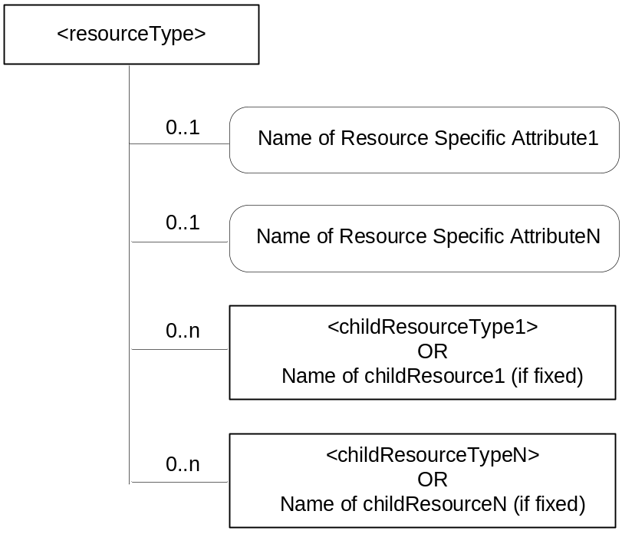
Figure 9.5-1: <resourceType> representation convention
The resource specification provides the graphical representation for the resource as in Figure 9.5-1. The graphical representation of a resource shows the multiplicity of the attributes and child resources. The set of attributes, which are common to all resources are not detailed in the graphical representation of a resource. The following graphical representations are used for representing the attributes and child resources:
- Square boxes are used for the resources;
- Square boxes with round corners are used for attributes.
Child resources in a <resourceType> are detailed as shown in Table 9.5-1.
The child resource table for an announce-able <resourceType> resource includes an additional column titled '<resourceTypeAnnc> Child Resource Types', indicating the type of announced resources. See clause 9.6.26 for further details.
An announced resource may have child resources, and such child resources can be of type "normal" or "announced". Child resources are of type "announced" when the child resources are announced independently of the original resource, as needed by the resource announcing CSE. Child resources are of type "normal" when child resources at the announced resource are created locally by the remote CSE.

Table 9.5-1: Child Resources of <resourceType>
Child Resources of <resourceType> | Child Resource Type | Multiplicity | Description | <resourceTypeAnnc>  Child Resource Types
<Fill in the name of Child Resource1 if a fixed name is required or [variable] if no fixed name is required> | <Fill in the type of Child Resource1> | <Fill in Multiplicity> | See clause <XRef> <clause> where the type of this child resource is described. | <Fill the child resource type for the announced resource. It can be none or <crTypeAnnc> or <crType>; where the <crType> is the child resource type of the original Child Resource1.
<Fill in the name of Child ResourceN if a fixed name is required or [variable] if no fixed name is required> | <Fill in the type of Child ResourceN> | <Fill in Multiplicity> | See clause <XRef> <clause> where the type of this child resource is described. | <Fill the child resource type for the announced resource. It can be none or <crTypeAnnc> or <crType>; where the <crType> is the child resource type of the original Child ResourceN.

Attributes in a <resourceType> are detailed as shown in Table 9.5-2
The attributes table for announce-able <resourceType> resource includes an additional column titled 'Attributes for <resourceTypeAnnc>', indicating the attributes that are to be announced for that <resourceType>. See the clause 9.6.26 for further details.

Table 9.5-2: Attributes of <resourceType> resource
Attributes of <resourceType> | Multiplicity | RW/  RO/  WO | Description | <resourceTypeAnnc> (MA/OA/NA)
<Fill in name of Common Attribute1> | <Fill in Multiplicity> | <Fill in RW or RO or WO> | Provide description of this attribute - to be moved later to a common attribute clause. | <Fill in MA or OA or NA>
<Fill in name of Common AttributeN> | <Fill in Multiplicity> | <Fill in RW or RO or WO> | Provide description of this attribute - to be moved later to a common attribute clause. | <Fill in MA or OA or NA>
<Fill in name of Resource Specific Attribute1> | <Fill in Multiplicity> | <Fill in RW or RO or WO> | Provide description of this attribute - to be moved later to a central attribute table that also defines the type of the attribute, allowed ranges etc. | <Fill in MA or OA or NA>
<Fill in name of Resource-Specific AttributeN> | <Fill in Multiplicity> | <Fill in RW or RO or WO> | Provide description of this attribute - to be moved later to a central attribute table that also defines the type of the attribute, allowed ranges etc. | <Fill in MA or OA or NA>

In case of misalignment of the graphical representation of a resource and the associated tabular representation, tabular representation shall take precedence.
The access modes for attributes can assume the following values:
- Read/Write (RW): the value of the attribute is set when the resource is Created or Updated based on information from the Originator (i.e. cn parameter). Such attributes are allowed for Create/Update/Retrieve/ Delete/Notify operations.
- Read Only (RO): the value of the attribute is set by the Hosting CSE internally. Such an attribute is allowed for Retrieve operation only.
- Write Once (WO): the value of the attribute is set when the resource is Created based on information from the Originator (i.e. cn parameter). Such an attribute is allowed for Retrieve operation after the creation.
The multiplicity, both for the child resources and the attributes can have the following values:
- A value of "0" indicates that the child resource/attribute is not present.
- A value of "1" indicates that the child resource/attribute is present.
- A value of "0..1" indicates that the child resource/attribute could not be present. If present, it can have an instance of one only.
- A value of "0..n" indicates that the child resource could not be present. If present, multiple instances are supported.
- A value of "1..n" indicates that the child resource is always present. It has at least one instance and can have multiple instances.
- An attribute multiplicity post-fixed with (L) indicates that it is a list of values.
The attributes for <resourceTypeAnnc> in the attribute table can have the following set of values:
- MA (Mandatory Announced): The attribute in the original resource is announced to the announced resource. The content of such an announced attributes is the same as the content of the original attribute.
- OA (Optional Announced): The attribute in the original resource may be announced to the announced resource depending on the contents of the announcedAttribute attribute at the original resource. The content of such an announced attribute is the same as the content of the original attribute.
- NA (Not Announced): The original attribute is not announced to the announced resource. However, the remote CSE may create and provide content for the equivalent attribute in the announced resource (see clause 9.6.26 for further details).

-----------------------End of change 1-------------------------------------------

-----------------------Start of change 2-------------------------------------------

9.5.1 Handling of Unsupported Resources/Attributes/Sub-resources within the M2M System
A CSE shall respond to a received request targeted to it and that includes resource(s), resource attribute(s) or sub-resource(s) that are not supported by it, by sending an appropriate error code back to the request Originator.
When a CSE is not the target entity of a received request, the CSE shall attempt to forward the received request to the targeted entity. If the CSE cannot forward the received request for any reason, it shall respond to the received request by sending an appropriate error code back to the request Originator. This specification includes both mandatory and optional functionalities for interfaces between oneM2M entities. Thus, the functionality implemented for the interfaces may not include all the functionalities specified in this document.

-----------------------End of change 2-------------------------------------------

-----------------------Start of change 3-------------------------------------------

9.6 Resource Types

9.6.1 Overview

9.6.1.1 Resource Type Summary
Table 9.6.1.1-1 introduces the normal and virtual resource types and their related child or parent resource types. Details of each resource type follow in the remainder of this clause.
Table 9.6.1.1-1 lists each specified <resourceType>. An addition of suffix "Annc" to such <resourceTypes> indicates the associated announced resource type.
Table 9.6.1.1-1 Resource Types
Resource Type | Short Description | Child Resource Types | Parent Resource Types | Clause
accessControlPolicy | Stores a representation of privileges. It is associated with resources that shall be accessible to entities external to the Hosting CSE. It controls "who" is allowed to do "what" and the context in which it can be used for accessing resources. | subscription | AE,,  AEAnnc,  remoteCSE,  remoteCSEAnnc,  CSEBase | 9.6.2
accessControlPolicyAnnc | Announced variant of accessControlPolicy | subscription | AEAnnc,  remoteCSEAnnc  remoteCSE | 9.6.2
AE | Stores information about the AE. It is created as a result of successful registration of an AE with the Registrar CSE | subscription,  container,  group,  accessControlPolicy,  pollingChannel | remoteCSE,  remoteCSEAnnc,  CSEBase | 9.6.5
AEAnnc | Announced variant of AE | subscription,  container,  containerAnnc,  group,  groupAnnc,  accessControlPolicy,  accessControlPolicyAnnc,  pollingChannel | remoteCSEAnnc  remoteCSE | 9.6.5
container | Shares data instances among entities. Used as a mediator that bufferis data exchanged between AEs and/or CSEs. The exchange of data between AEs (e.g. an AE on a Node in a field domain and the peer-AE on the infrastructure domain) is abstracted from the need to set up direct connections and allows for scenarios where both entities in the exchange do not have the same reachability schedule. | container,  contentInstance,  subscription,  latest,  oldest | AE,  AEAnnc,  container,  containerAnnc,  remoteCSE,  remoteCSEAnnc,  CSEBase | 9.6.6
containerAnnc | Announced variant of container | container,  containerAnnc,  contentInstance,  subscription, | AEAnnc,  containerAnnc,  remoteCSEAnnc  remoteCSE | 9.6.6
contentInstance | Represents a data instance in the <container> resource. | None specified | container, | 9.6.7
CSEBase | The structural root for all the resources that are residing on a CSE. Stores information about the CSE itself. | remoteCSE,  remoteCSEAnnc,  node,  AE,  container,  group,  accessControlPolicy,  subscription,,  mgmtCmd,  locationPolicy,  statsConfig,  statsCollect,  request,  delivery,  schedule | None specified | 9.6.3
delivery | Forwards requests from CSE to CSE | subscription | CSEBase | 9.6.11
eventConfig | Defines events that trigger statistics collection | subscription | statsConfig | 9.6.24
execInstance | Contains all execution instances of the same Management Command | subscription | mgmtCmd | 9.6.17
fanOutPoint (V) | Virtual resource containing target for group request.  It is used for addressing bulk operations to all the resources that belong to a group. | None specified | group | 9.6.14
group | Stores information about resources of the same type that need to be addressed as a Group. Operations addressed to a Group resource shall be executed in a bulk mode for all members belonging to the Group. | fanOutPoint,  subscription | AE,  AEAnnc,  remoteCSE,  remoteCSEAnnc,  CSEBase | 9.6.13
groupAnnc | Announced variant of group | subscription | AEAnnc,  remoteCSEAnnc  remoteCSE | 9.6.13
latest (V) | Virtual resource that points to most recently created <contentInstance> child resource within a <container> resource | None specified | container | 9.6.27
locationPolicy | Includes information to obtain and manage geographical location. It is only referenced within a container; the contentInstances of the container provide location information. | subscription | CSEBase | 9.6.10
locationPolicyAnnc | Announced variant of locationPolicy | None specified | remoteCSEAnnc  remoteCSE | 9.6.10
mgmtCmd | Management Command resource represents a method to execute management procedures required by existing management protocols | execInstance,  subscription | CSEBase | 9.6.16
mgmtObj | Management Object resource represents management functions that provides an abstraction to be mapped to external management technology. It represents the node and the software installed in the node.  NOTE: See clause 9.6.12 for a summary of specializations of <mgmtObj> | subscription,  mgmtObj,  schedule | node,  mgmtObj,  mgmtObjAnnc | 9.6.15  Annex D
mgmtObjAnnc | Announced variant of mgmtObj | subscription,  mgmtObj,  mgmtObjAnnc,  scheduleAnnc | nodeAnnc,  mgmtObjAnnc | 9.6.15
m2mServiceSubscriptionProfile | Data pertaining to the M2M Service Subscription | serviceSubscribedNode,  subscription | None specified | 9.6.19
node | Represents specific Node information | mgmtObj,  subscription | CSEBase,  remoteCSE | 9.6.18
nodeAnnc | Announced variant of node | mgmtObjAnnc,  subscription | remoteCSEAnnc  remoteCSE | 9.6.18
oldest (V) | Virtual resource that points to first created <contentInstance> child resource within a <container> resource | None specified | container | 9.6.28
pollingChannel | Represent a channel that can be used for a request-unreachable entity | pollingChannelURI | remoteCSE,  remoteCSEAnnc,  AE,  AEAnnc | 9.6.21
pollingChannelURI (V) | Virtual resource used to perform service layer long polling of a resource Hosting CSE by a request-unreachable entity | None specified | pollingChannelURI | 9.6.22
remoteCSE | Represents a remote CSE for which there has been a registration procedure with the registrar CSE identified by the CSEBase resource | AE,  container,  group,  accessControlPolicy,  subscription,  pollingChannel,  schedule,  node | CSEBase | 9.6.4
remoteCSEAnnc | Announced variant of remoteCSE | AE,  AEAnnc,  container,  containerAnnc,  group,  groupAnnc,  accessControlPolicy,  accessControlPolicyAnnc,  subscription,  pollingChannel,  scheduleAnnc,  nodeAnnc,  locationPolicyAnnc | remoteCSE | 9.6.4
request | Expresses/access context of an issued Request | subscription | CSEBase | 9.6.12
schedule | Contains scheduling information for delivery of messages | subscription | subscription,  mgmtObj,  CSEBase,  remoteCSE | 9.6.39  Annex D
scheduleAnnc | Announced variant of schedule | None specified | mgmtObjAnnc,  remoteCSEAnnc  remoteCSE | 9.6.39  Annex D
serviceSubscribedNode | Node information | subscription | m2mServiceSubscriptionProfile | 9.6.20
statsCollect | Defines triggers for the IN-CSE to collect statistics for applications | subscription | CSEBase (in IN-CSE) | 9.6.25
statsConfig | Stores configuration of statistics for applications | eventConfig,  subscription | CSEBase (in IN-CSE) | 9.6.23
subscription | Subscription resource represents the subscription information related to a resource. Such a resource shall be a child resource for the subscribed-to resource. | schedule | accessControlPolicy,  accessControlPolicyAnnc,  AE,  AEAnnc,  container,  containerAnnc,  CSEBase,  delivery,  eventConfig,  execInstance,  group,  groupAnnc,  locationPolicy,  mgmtCmd,  mgmtObj,  mgmtObjAnnc,  m2mServiceSubscriptionProfile,  node,  nodeAnnc,  serviceSubscribedNode,  remoteCSE,  remoteCSEAnnc,  request,  schedule,  statsCollect,  statsConfig | 9.6.8

-----------------------End of change 3-------------------------------------------

-----------------------Start of change 4-------------------------------------------

9.6.1.2 Resource Type Specializations
Table 9.6.1.2-1 lists specializations of the <mgmtObj> Resource Type in which the mgmtDefinition attribute contains an enumerated value that provides further definition of the resource.
Table 9.6.1.2-1 Resource Types Specializations
Resource specialization | Short Description | Child Resource Types | Parent Resource Types | Clause
activeCmdhPolicy | Provides a link to the currently active set of CMDH policies. | cmdhPolicy,  subscription | node | D.12.1
areaNwkDeviceInfo | Provides information about the Node in the M2M Area Network | subscription | node | D.6
areaNwkInfo | Describes the list of Nodes attached behind the MN node and its physical or underlying relation among the nodes in the M2M Area Network | subscription | node | D.5
battery | Provides the power information of the node. (e.g. remaining battery charge) | subscription | node | D.7
cmdhBuffer | Defines CMDH buffer usage limits | subscription | cmdhPolicy | D.12.8
cmdhDefaults | Defines CMDH default values | cmdhDefEcValue,  cmdhEcDefParamValues  subscription | cmdhPolicy | D.12.2
cmdhEcDefParamValues | Represent a specific set of default values for the CMDH related parameters | subscription | cmdhDefaults | D.12.4
cmdhDefEcValue | Defines a value for the ec (event category) parameter of an incoming request when it is not defined | subscription | cmdhDefaults | D.12.3
cmdhLimits | Defines limits for CMDH related parameter values | subscription | cmdhPolicy | D.12.5
cmdhNetworkAccessRules | Defines rules for the usage of underlying networks | cmdhNwAccessRule,  subscription | cmdhPolicy | D.12.6
cmdhNwAccessRule | Defines a rule for the usage of underlying networks | schedule  subscription | cmdhNetworkAccessRules | D.12.7
cmdhPolicy | A set of rules defining which CMDH parameters will be used by default | cmdhDefaults, cmdhLimits, cmdhNetworkAccessRules, cmdhBuffer,  subscription | node | D.12
deviceCapability | Contains information about the capability supported by the Node | subscription | node | D.9
deviceInfo | Contains information about the identity, manufacturer and model number of the device | subscription | node | D.8
eventLog | Contains information about the log of events of the Node | subscription | node | D.11
firmware | Provides information about the firmware of the Node (e.g., name, version) | subscription | node | D.2
memory | Provides the memory (typically RAM) information of the node. (e.g. the amount of total volatile memory) | subscription | node | D.4
reboot | Used to reboot or reset the Node | subscription | node | D.10
software | Provides information about the software of the Node | subscription | node | D.3

-----------------------End of change 4-------------------------------------------

-----------------------Start of change 5-------------------------------------------

9.6.1.3 Commonly Used Attributes
Some attributes described herein are present in all <resourceTypes>. Such attributes are described in clause 9.6.1.3.1 once in order to avoid duplicating the description for every <resourceType> and are referred to as “universal attributes”.
Some other attributes described herein are commonly used in multiple, but not all, <resourceTypes>. Such attributes are described in clause 9.6.1.3.2 once in order to avoid duplicating the description for every <resourceType> that contains it and are referred to as “common attributes”.
Remaining attributes are described in the clause specific for that resource type.

9.6.1.3.1 Universal attributes
The following attributes are universal to all resource types.

Table 9.6.1.3.1-1: Universal Attributes
Attribute Name | Description
resourceType | Resource Type. This Write Once (assigned at creation time. and then cannot be changed) attribute identifies the type of the resource as specified in clause 9.6. Each resource shall have a resourceType attribute.
creationTime | Time/date of creation of the resource.  This attribute is mandatory for all resources and the value is assigned by the system at the time when the resource is locally created. Such an attribute cannot be changed.
lastModifiedTime | Last modification time/date of the resource.  This attribute is mandatory and its value is assigned automatically by the system each time that the addressed resource is modified by means of the UPDATE operation.
labels | Tokens used as keys for discovering resources.  This attribute is optional and if not present it means that the resource cannot be found by means of discovery procedure which uses labels as key parameter of the discovery.

9.6.1.3.2 Common attributes
The following attributes are commonly used in multiple, but not all, resource types.
NOTE: The list of attributes in Table 9.6.1.3-2 is not exhaustive.

Table 9.6.1.3.2-1: Common Attributes
Attribute Name | Description
resourceID | This attribute is an identifier for the resource that is used for ‘non-hierarchical URI method’ or ‘IDs based method’ cases.  This attribute shall be provided by the Hosting CSE when it accepts a resource creation procedure. The Hosting CSE shall assign a resourceID which is unique in that CSE.
parentID | This attribute is the resourceID of the parent of this resource. This attribute is specified in all resource types except <CSEBase>.
accessControlPolicyIDs | The attribute contains a list of identifiers (either an ID or a URI depending if it is a local resource or not) of an <accessControlPolicy> resource. The privileges defined in the <accessControlPolicy> resource that are referenced determine who is allowed to access the resource containing this attribute for a specific purpose (e.g. Retrieve, Update, Delete, etc.).  If a resource type does not have an accessControlPolicyIDs attribute definition, then the accessControlPolicy for that resource is governed in a different way, for example, the accessControlPolicy associated with the parent may apply to a child resource that does not have an accessControlPolicyIDs attribute definition, or the privileges for access are fixed by the system. Refer to the corresponding resourceType and procedures to see how permissions are handled in such cases.  If a resource type does have an accessControlPolicyIDs attribute definition, but the (optional) accessControlPolicyIDs attribute is not set, or it is set to a value that does not correspond to a valid, existing <accessControlPolicy> resource, or it refers to an <accessControlPolicy> resource that is not reachable (e.g. because it is located on a remote CSE that is offline or not reachable), then the system default access permissions shall apply.  All resources are accessible only if the privileges from the Access Control Policy grants it, therefore all resources shall have an associated AccessControlPolicyIDs attribute, either explicitly (setting the attribute in the resource itself) or implicitly (either by using the parent privileges or the system defaults). Which means that the system shall provide a default access privileges in case that the Originator does not provide a specific AccessControlPolicyIDs during the creation of the resource, Default access grants the configured privileges to the Originator (e.g. depending on the prefix of URI of the resource).  This attribute is absent from the resource in some cases, especially if the resource shall have the same privileges of the parent resource; such an attribute is therefore not needed.  To update this attribute, a Hosting CSE shall check whether an Originator has Update permission in any selfPrivileges of the <accessControlPolicy> resources which this attribute originally indicates.
expirationTime | Time/date after which the resource will be deleted by the Hosting CSE. This attribute can be provided by the Originator, and in such a case it will be regarded as a hint to the Hosting CSE on the lifetime of the resource. The Hosting CSE can however decide on the real expirationTime. If the Hosting CSE decides to change the expirationTime attribute value, this is communicated back to the Originator.  The lifetime of the resource can be extended by providing a new value for this attribute in an UPDATE operation. Or by deleting the attribute value, e.g. by not providing the attribute when doing a full UPDATE, in which case the Hosting CSE can decide on a new value.  This attribute is mandatory when specified. If the Originator does not provide a value in the CREATE operation the system shall assign an appropriate value depending on its local policies and/or M2M service subscription agreements.
stateTag | An incremental counter of modification on the resource. When a resource is created, this counter is set to 0, and it will be incremented on every modification of the resource.  NOTE 1: In order to enable detection of overflow, the counter needs to be capable of expressing sufficiently long numbers. .  NOTE 2: This attribute has the scope to allow identifying changes in resources within a time interval that is lower than the one supported by the attribute lastModifiedTime (e.g. less than a second or millisecond). This attribute can also be used to avoid race conditions in case of competing modifications.  Modifications (e.g. Update/Delete) can be made on the condition that this attribute has a given value.
link | This attribute shall be present only on the announced resource. This attribute shall provide the link (URI) to the original resource.
announceTo | This attribute may be included in a CREATE or UPDATE Request in which case it contains a list of URIs/CSE-IDs which the resource being created/updated shall be announced to.  This attribute shall only be present at the original resource if it has been successfully announced to other CSEs. This attribute maintains the list of URIs to the successfully announced resources. Updates on this attribute will trigger new resource announcement or de-announcement.
announcedAttribute | This attributes shall only be present at the original resource if some Optional Announced (OA) type attributes have been announced to other CSEs. This attribute maintains the list of the announced Optional Attributes (OA type attributes) in the original resource. Updates to this attribute will trigger new attribute announcement if a new attribute is added or de-announcement if the existing attribute is removed.

-----------------------End of change 5-------------------------------------------

-----------------------Start of change 6-------------------------------------------

9.6.3 Resource Type CSEBase
A <CSEBase> resource shall represent a CSE. The <CSEBase> resource shall be the root for all resources that are residing in the CSE.
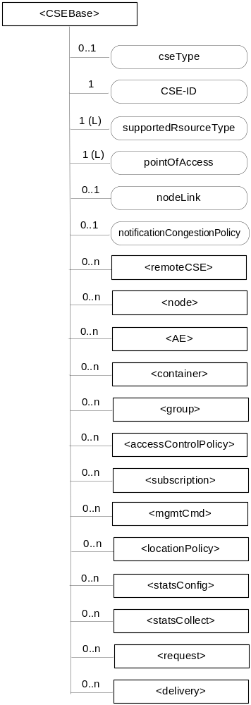
Figure 9.6.3-1: Structure of <CSEBase> resource
The <CSEBase> resource shall contain the child resources specified in table 9.6.3-1.
Table 9.6.3-1: Child resources of <CSEBase> resource
Child Resources of <CSEBase> | Child Resource Type | Multiplicity | Description
[variable] | <remoteCSE> | 0..n | See clause 9.6.4
[variable] | <node> | 0..n | See clause 9.6.18
[variable] | <AE> | 0..n | See clause 9.6.5
[variable] | <container> | 0..n | See clause 9.6.6
[variable] | <group> | 0..n | See clause 9.6.13
[variable] | <accessControlPolicy> | 0..n | See clause 9.6.2
[variable] | <subscription> | 0..n | See clause 9.6.8
[variable] | <mgmtCmd> | 0..n | See clause 9.6.16
[variable] | <locationPolicy> | 0..n | See clause 9.6.10
[variable] | <statsConfig> | 0..n | See clause 9.6.23
[variable] | <statsCollect> | 0..n | See clause 9.6.25
[variable] | <request> | 0..n | See clause 9.6.12
[variable] | <delivery> | 0..n | See clause 9.6.11
[variable] | <schedule> | 0..1 | See clause 9.6.9

The <CSEBase> resource shall contain the attributes specified in table 9.6.3-2.
Table 9.6.3-2: Attributes of <CSEBase> resource
Attributes of <CSEBase> | Multiplicity | RW/  RO/  WO | Description
resourceType | 1 | RO | See clause 9.6.1.3 where this common attribute is described.
creationTime | 1 | RO | See clause 9.6.1.3 where this common attribute is described.
lastModifiedTime | 1 | RO | See clause 9.6.1.3 where this common attribute is described.
accessControlPolicyIDs | 0..1 (L) | RO | See clause 9.6.1.3 where this common attribute is described.
labels | 0..1 (L) | RO | See clause 9.6.1.3 where this common attribute is described.
cseType | 0..1 | RO | Indicates the type of CSE represented by the created resource.  - Mandatory for an IN-CSE, hence multiplicity (1).  - Its presence is subject to SP configuration in case of an ASN-CSE or a MN-CSE.
CSE-ID | 1 | RO | The CSE identifier in SP-relative CSE-ID format (clause 7.2).
supportedResourceType | 1 (L) | RO | List of the resource types which are supported in the CSE. This attribute contains subset of resource types listed in clause 9.2. This also includes the supported optional attributes for each supported resource type.
pointOfAccess | 1 (L) | RO | Represents the list of physical addresses to be used by remote CSEs to connect to this CSE (e.g. IP address, FQDN). This attribute is exposed to its Registree.
nodeLink | 0..1 | RO | The resourceID of a <node> resource that is hosted as a child of the present <CSEBase> instance resource and represents the node specific information for the node on which this <CSEBase> instance resides.
notificationCongestionPolicy | 0..1 | RO | This attribute applies to CSEs generating subscription notifications. It specifies the rule which is applied when the storage of notifications for each subscriber (an AE or CSE) reaches the maximum storage limit for notifications for that subscriber. E.g. Delete stored notifications of lower notificationStoragePriority to make space for new notifications of higher notificationStoragePriority, or delete stored notifications of older creationTime to make space for new notifications when all notifications are of the same notificationStoragePriority.

NOTE: All the attributes of this resource type can be changed by an offline configuration mechanism, but not over the reference points (all attributes are “RO”).

-----------------------End of change 6-------------------------------------------

-----------------------Start of change 7-------------------------------------------

9.6.4 Resource Type remoteCSE
A <remoteCSE> resource shall represent a Registree CSE that is registered to the Registrar CSE. <remoteCSE> resources shall be located directly under the <CSEBase> resource of Registrar CSE.
Similarly <remoteCSE> resource shall also represent a Registrar CSE. <remoteCSE> resource shall be located directly under the <CSEBase> resource of Registree CSE.
For example, when CSE1 (Registree CSE) registers with CSE2 (Registrar CSE), there will be two <remoteCSE> resources created: one in CSE1: <CSEBase1>/<remoteCSE2> and one in CSE2: <CSEBase2>/<remoteCSE1>.
Note that the creation of the two resources does not imply mutual registration. The <CSEBase1>/<remoteCSE2> does not mean CSE2 registered with CSE1 in the example above.

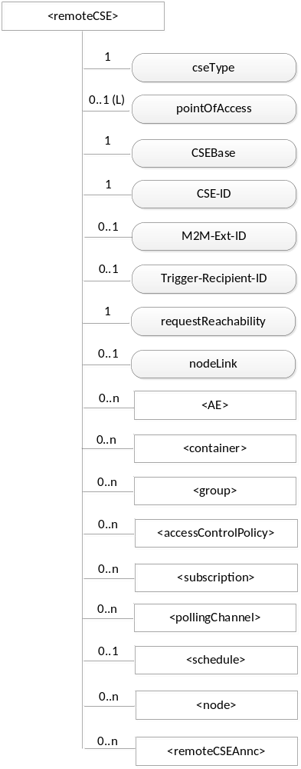

Figure 9.6.4-1: Structure of <remoteCSE> resource
The <remoteCSE> resource shall contain the child resources specified in table 9.6.4-1.<remoteCSE> may contain a <remoteCSEAnnc> child resource. The announced resources from a registree CSE shall be stored under the <remoteCSEAnnc> child resource.

Table 9.6.4-1: Child resources of <remoteCSE> resource
Child Resources of <remoteCSE> | Child Resource Type | Multiplicity | Description | <remoteCSEAnnc> Child Resource Types
[variable] | <AE> | 0..n | See clause 9.6.5 | AE  <AEAnnc>
[variable] | <container> | 0..n | See clause 9.6.6 | <container> <containerAnnc>
[variable] | <group> | 0..n | See clause 9.6.13 | <group>  <groupAnnc>
[variable] | <accessControlPolicy> | 0..n | See clause 9.6.2 | <accessControlPolicy>  <accessControlPolicyAnnc>
[variable] | <subscription> | 0..n | See clause 9.6.8 | <subscription>
[variable] | <pollingChannel> | 0..n | See clause 9.6.21. If requestReachability is FALSE, the CSE that created this <remoteCSE> resource should create a <pollingChannel> resource and perform long polling. | <pollingChannel>
[variable] | <schedule> | 0..1 | This resource defines the reachability schedule information of the node. See clause 9.6.9 for <schedule>. | <scheduleAnnc>
[variable] | <node> | 0..n | See clause 9.6.18 | <nodeAnnc>
n/a | n/a | 0..n | See clause 9.6.10 | <locationPolicyAnnc>
[variable] | <remoteCSEAnnc> | 0..n | This resource stores announced resources from the remote CSE | n/a

The <remoteCSE> resource shall contain the attributes specified in table 9.6.4-2.

Table 9.6.4-2: Attributes of <remoteCSE> resource
Attributes of <remoteCSE> | Multiplicity | RW/  RO/  WO | Description | <remoteCSEAnnc> Attributes
resourceType | 1 | RO | See clause 9.6.1.3 where this common attribute is described. | NA
resourceID | 1 | WO | See clause 9.6.1.3 where this common attribute is described. | MA
parentID | 1 | RO | See clause 9.6.1.3 where this common attribute is described. | NA
creationTime | 1 | RO | See clause 9.6.1.3 where this common attribute is described. | NA
lastModifiedTime | 1 | RO | See clause 9.6.1.3 where this common attribute is described. | NA
expirationTime | 1 | RW | See clause 9.6.1.3 where this common attribute is described. | MA
accessControlPolicyIDs | 0..1 (L) | RW | See clause 9.6.1.3 where this common attribute is described. | MA
labels | 0..1 (L) | RW | See clause 9.6.1.3 where this common attribute is described. | MA
announceTo | 0..1 | RW | See clause 9.6.1.3 where this common attribute is described. | NA
announcedAttribute | 0..1 | RW | See clause 9.6.1.3 where this common attribute is described. | NA
cseType | 0..1 | WO | Indicates the type of CSE represented by the created resource.  - Mandatory for an IN-CSE, hence multiplicity (1).  - Its presence is subject to SP configuration in case of an ASN-CSE or a MN-CSE. | OA
pointOfAccess | 0..1 (L) | RW | For request-reachable remote CSE it represents the list of physical addresses to be used to connect to it (e.g. IP address, FQDN). The attribute is absent if the remote CSE is not request-reachable.  If this information is not provided, the CSE should use <pollingChannel> resource. Then the Hosting CSE can forward a request to the CSE without using the PoA. | OA
CSEBase | 1 | WO | The URI of the CSEBase of the original CSE represented by remote CSE. | OA
CSE-ID | 1 | WO | The CSE identifier in SP-relative CSE-ID format (clause 7.2). | OA
M2M-Ext-ID | 0..1 | RW | Supported when Registrar is IN-CSE.  See clause 7.1.8 where this attribute is described. This attribute is used only for the case of dynamic association of M2M-Ext-ID and CSE-ID. | NA
Trigger-Recipient-ID | 0..1 | RW | Supported when Registrar is IN-CSE.. See clause 7.1.10 where this attribute is described. This attribute is used only for the case of dynamic association of M2M-Ext-ID and CSE-ID. | NA
requestReachability | 1 | RW | If the CSE that created this <remoteCSE> resource can receive a request from other AE/CSE(s), this attribute is set to "TRUE" otherwise "FALSE".  NOTE: Even if this attribute is set to "FALSE", it does not mean it AE/CSE is always unreachable by all entities. E.g. the requesting AE/CSE is behind the same NAT, so it can communicate within the same NAT. | OA
nodeLink | 0..1 | RO | The resourceID of a <node> resource that is hosted as a child of the parent <CSEBase> instance resource and stores the node specific information for the node that hosts the CSE represented by the <remoteCSE> resource. | OA

<remoteCSE> and the announced <remoteCSE> resources shall have different resourceType coding.

-----------------------End of change 7-------------------------------------------

-----------------------Start of change 8-------------------------------------------

9.6.13 Resource Type group
The <group> resource represents a group of resources of the same or mixed types. The <group> resource can be used to do bulk manipulations on the resources represented by the membersList attribute. The <group> resource contains an attribute that represents the members of the group and a virtual resource (the <fanOutPoint>) that allows operations to be applied to the resources represented by those members.
When used as one of the permission holders in an <accessControlPolicy> resource, the group can be used to grant a collection of AEs (represented by <AE> resources) or CSEs (represented by <remoteCSE> resources) permissions for accessing (e.g. creating child resources, retrieving, etc.) a resource.
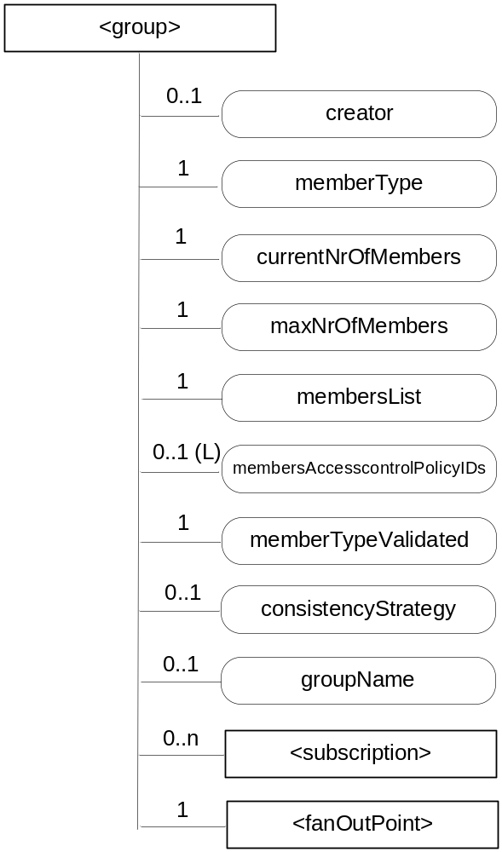
Figure 9.6.13-1: Structure of <group> resource
The <group> resource shall contain the child resources specified in table 9.6.13-1.

Table 9.6.13-1: Child resources of <group> resource
Child Resources of <group> | Child Resource Type | Multiplicity | Description | <groupAnnc> Child Resource Types
[variable] | <subscription> | 0..n | See clause 9.6.8 | <subscription>
fanOut | <fanOutPoint> | 1 | See clause 9.6.14 | none

The <group> resource shall contain the attributes specified in table 9.6.13-2

Table 9.6.13-2: Attributes of <group> resource
Attributes of  <group> | Multiplicity | RW/  RO/  WO | Description | <groupAnnc> Attributes
resourceType | 1 | RO | See clause 9.6.1.3 where this common attribute is described. | NA
resourceID | 1 | WO | See clause 9.6.1.3 where this common attribute is described. | MA
parentID | 1 | RO | See clause 9.6.1.3 where this common attribute is described. | NA
expirationTime | 1 | RW | See clause 9.6.1.3 where this common attribute is described. | MA
accessControlPolicyIDs | 0..1 (L) | RW | See clause 9.6.1.3 where this common attribute is described. | MA
labels | 0..1 | RO | See clause 9.6.1.3 where this common attribute is described. | MA
creationTime | 1 | RO | See clause 9.6.1.3 where this common attribute is described. | NA
lastModifiedTime | 1 | RO | See clause 9.6.1.3 where this common attribute is described. | NA
announceTo | 0..1 | RW | See clause 9.6.1.3 where this common attribute is described. | NA
announcedAttribute | 0..1 | RW | See clause 9.6.1.3 where this common attribute is described. | NA
creator | 0..1 | RW | The AE-ID or CSE-ID of the entity which created the resource. | NA
memberType | 1 | WO | It is the resource type of the members resources of the group if all members resources (including the members resources in any sub-groups) are of the same type. Otherwise, it is of type 'mixed'. | OA
currentNrOfMembers | 1 | RO | Current number of members in a group. It shall not be larger than maxNrOfMembers. | OA
maxNrOfMembers | 1 | RW | Maximum number of members in the <group>. | OA
membersList | 1 | RW | List of zero or more member URIs referred to in the remaining of this specification as memberID. Each URI (memberID) should refer to a members resource or a (sub-) <group> resource of the <group>. | OA
membersAccessControlPolicyIDs | 0..1 (L) | RW | List of URIs of the <accessControlPolicy> resources defining who is allowed to access the <fanOutPoint> resource. | OA
memberTypeValidated | 1 | RO | Denotes if memberType of all members resources of the group has been validated. | OA
consistencyStrategy | 0..1 | WO | This attribute determines how to deal with the <group> resource if the memberType validation fails. Which means delete the inconsistent member if the attribute is ABANDON_MEMBER; delete the group if the attribute is ABANDON_GROUP; set the memberType to "mixed" if the attribute is SET_MIXED. | OA
groupName | 0..1 | RW | Human readable name of the <group>. | OA

-----------------------End of change 8-------------------------------------------

-----------------------Start of change 9-------------------------------------------

9.6.26 Resource Announcement

9.6.26.1 Overview
A resource can be announced to one or more remote CSEs to inform the remote CSEs of the existence of the original resource. An announced resource can have a limited set of attributes and a limited set of child resources from the original resource. The announced resource includes a link to the original resource hosted by the original resource-Hosting CSE.
In case that the original resource is deleted, all announced resources for the original resource shall be deleted. If the announced resource is not deleted promptly (e.g. the announced resource is not reachable), the announced resource can be deleted later either by the original resource Hosting CSE or by the expiration of the announced resource itself. The original resource shall store the list of links for the announced resources for those purposes.
Synchronization between the attributes announced by the original resource and the announced resource is the responsibility of the original resource Hosting CSE. The access control policy for the announced resource shall synchronize with the one from the original resource. In case that the attribute accessControlPolicyIDs is not present in the original resource it is the responsibility of the original resource Hosting CSE to choose the appropriate value depending on the policy for the original resource (e.g. take the parent accessControlPolicyIDs value).
The original resource shall have at least announceTo attribute present if the resource itself has been announced. If any of the Optional Announced (OA) attributes are also announced, then announcedAttribute attribute shall also be present. An AE or other CSE can request the original resource Hosting CSE for announcing the original resource to the list of CSE-IDs or the URI(s) listed in the announceTo attribute in the announcing request. An Update to the announceTo attribute will trigger new resource announcement(s) or the de-announcement(s) of the announced resource. After a successful announcement procedure the attribute announceTo contains only the list of URI(s) of the announced resources.
In order to announce an attribute marked as OA (see clause 9.5.1.1), the attribute shall be included in the announcedAttribute attribute list at the original resource. The attributes included in the announcedAttribute attribute are announced to the announced resource. On successful announcement of the resource, such attributes shall be created at the announced resource; otherwise they shall not be present in the announced resource. Update to the announcedAttribute attribute in the original resource will trigger new attribute announcement or the de-announcement of the announced attribute(s). The announced attributes shall have the same value as the original resource, and synchronization between the value of the announced attributes at the original resource and the announced resource is the responsibility of the original resource Hosting CSE.
An announced resource may have child resources. The child resource shall be of the same type as the original child resource or its associated Announce type.
Child resources of the original resource can be announced independently as needed. In this case, the child resources at the announced resource shall be of the child resource "Announced" type. When a child resource at the announced resource is created locally at the remote CSE, the child resource shall be of normal child resource type.

9.6.26.2 Universal Attributes for Announced Resources
Table 9.6.26.2-1 lists the universal attributes for the announced resources. If an attribute is marked “NA” in the original resource type or it is marked “OA” and is not provided by the Originator, then the value for the corresponding attribute in the announced resource is provided by the remote CSE.
Table 9.6.26.2-1: Universal Attributes for Announced Resources
Attribute Name | Mandatory /Optional | Description
resourceType | Mandatory | Resource Type.  As specified in clause 9.2, a suffix of "Annc" to the name of the original resource type shall be used to indicate the name for the associated announced resource type.
creationTime | Mandatory | See clause 9.6.1.3.1 for information on this attribute.
lastModifiedTime | Mandatory | See clause 9.6.1.3.1 for information on this attribute.
labels | Conditionally Mandatory | Tokens used as keys for discovering resources as announced by the original resource. See clause 9.6.1.3.1 for further information on this attribute.  The attribute is conditionally mandatory, which means that the attribute shall exist in the announced resource if it is present in the original resource.
link | Mandatory | Provides the URI to the original resource.

9.6.26.3 Common Attributes for Announced Resources
Table 9.6.26.3-1 lists the common attributes for the announced resources. If an attribute is marked “NA” in the original resource type or it is marked “OA” and is not provided by the Originator, then the value for the corresponding attribute in the announced resource is provided by the remote CSE.
Table 9.6.26.3-1: Commonly Used Attributes for Announced Resources
Attribute Name | Mandatory /Optional | Description
resourceID | Conditionally Mandatory | Resource Identifier  See clause 9.6.1.3.2 for further information on this attribute.
parentID | Mandatory | Identifies the parent resource at the remote CSE.
accessControlPolicyIDs | Conditionally Mandatory | The list of identifiers (either an ID or a URI) of an <accessControlPolicy> resource announced by the original resource See clause 9.6.1.3.2 for further information on this attribute.  If this attribute was not present in the original resource, the original resource shall include this attribute by providing the accessControlPolicyIDs from the original resource's parent resource or from the local policy according at the original resource.
expirationTime | Conditionally Mandatory | See clause 9.6.1.3.2 for information on this attribute.  This attribute is limited by the value received from the original resource but it can be overridden by the policies of the remote CSE hosting the announced resource.
stateTag | Conditionally Mandatory | An incremental counter of modification on the resource.  See clause 9.6.1.3.2 for information on this attribute.

-----------------------End of change 9-------------------------------------------

-----------------------Start of change 10-------------------------------------------

10.2.18.4 Procedure for original resource Hosting CSE to Create an Announced Resource
This clause explains the resource announcement procedure that shall be used by the original resource Hosting CSE to announce the original resource to the remote CSE(s).
The Originator of this Request shall be the original resource Hosting CSE. The Originator shall request to create the announced resource by using CREATE Request.
Table 10.2.18.4-1: Resource Hosting CSE to Announce Resource: CREATE
Resource Announcement: CREATE
Associated Reference Points | Mcc
Information in Request message | All parameters defined in table 8.1.2.1-1 are applicable as indicated in that table.  - cn: contains MA attributes and OA attributes that are included in announcedAttribute attribute  The following attributes from clause 9.6.26 are mandatory for the Request:  - resourceType which shall be set to the appropriate tag that identifies the <Annc> resource.  - accessControlPolicyIDs which contains the value provided by the Originator.  - expirationTime provided by the Originator equal to the one for the original resource.  - labels provided by the Originator equal to the one for the original resource, if present
Processing at the Originator before sending Request | Other details for the information in the Request message shall be as follows:  - Attributes marked with MA and attributes marked with OA that are included in the announcedAttribute attribute at the original resource shall be provided in the CREATE Request. Such attributes shall have the same value as for the original resource.  - Attributes marked with NA for the original resource shall not be provided in the CREATE Request.  - The link attribute of the announced resource shall have the URI of the original resource.  - The labels attribute of the announced resource shall have the same value as for the original resource.  - The accessControlPolicyIDs attribute shall always be provided in the CREATE Request even if it is not present in the original resource. In this case the original resource shall include accessControlPolicyIDs from its parent resource or from the local policy at the original resource, as needed.  - accessControlPolicyIDs and labels attributes, if present at the original resource, shall be provided by the original resource Hosting CSE in the CREATE Request. Such attributes shall have the same value at the original resource and at the announced resource(s).
Processing at the Receiver | Once the Originator has been successfully authorized, the Receiver shall grant the Request after successful validation of the Request. The Receiver shall perform as follows:  - The basic procedure (clause 10.1.1) for the Receiver of the CREATE Request apply.  - The created announced resource shall include the common attributes specified in clause 9.6.26.1. The created announced resource shall contain the additional attributes that are provided by the Originator; i.e. attributes marked with MA and the attributes marked with OA that are included in the announcedAttribute attribute.  - The created announced resource shall set the accessControlPolicyIDs attribute to the value received in the Request message, and shall set the labels attribute (if present) and the link attribute to the value received in the Request message.  - Respond to the Originator with the CREATE Response. In this Response, the URI of the successfully announced resource shall be provided.
Information in Response message | All parameters defined in table 8.1.2.1-1 are applicable as indicated in that table with the specific details for:  - cn: URI where the announced resource is created according to clause 10.1.1
Processing at Originator after receiving Response | The Originator after receiving the Response from the Receiver shall perform the following steps:  - If the announced resource has been successfully created, the announceTo attribute of the original resource shall be updated to include the URI for the successfully announced resource at the Receiver. The announcedAttribute attribute shall be updated as well to represent the successfully announced attributes as received in the Response.  - For the attributes marked as MA and for the attributes marked as OA that are included in the announcedAttribute attribute, the Originator shall further take the responsibility to keep their values synchronized at the announced resource by using UPDATE operation (clause 10.1.3).
Exceptions | All exceptions described in the basic procedures (clause 10.1.1) are applicable.

-----------------------End of change 10-------------------------------------------

-----------------------Start of change 11-------------------------------------------

9.6.7 Resource Type contentInstance
The <contentInstance> resource represents a data instance in the <container> resource. The content of the contentInstance can be encrypted.
Unlike other resources, the <contentInstance> resource shall not be modified once created. An AE shall be able to delete a contentInstance resource explicitly or it may be deleted by the platform based on policies. If the platform has policies for contentInstance retention, these shall be represented by the attributes maxByteSize, maxNrOfInstances and/or maxInstanceAge attributes in the <container> resource. If multiple policies are in effect, the strictest policy shall apply.
The <contentInstance> resource inherits the same access control policies of the parent <container> resource, and does not have its own accessControlPolicyIDs attribute.
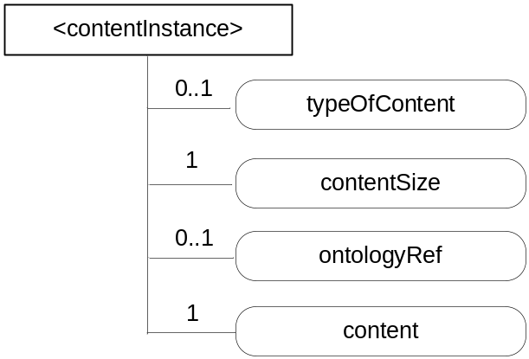
Figure 9.6.7-1: Structure of <contentInstance> resource

The <contentInstance> resource shall contain the attributes specified in table 9.6.7-1.

Table 9.6.7-1: Attributes of <contentInstance> resource
Attributes of <contentInstance> | Multiplicity | RW/  RO/  WO | Description
resourceType | 1 | RO | See clause 9.6.1.3 where this common attribute is described.
resourceID | 1 | WO | See clause 9.6.1.3 where this common attribute is described.
parentID | 1 | RO | See clause 9.6.1.3 where this common attribute is described.
labels | 0..1 | WO | See clause 9.6.1.3 where this common attribute is described.
creator | 0..1 | WO | See clause 9.6.1.3 where this common attribute is described.
creationTime | 1 | RO | See clause 9.6.1.3 where this common attribute is described.
lastModifiedTime | 1 | RO | See clause 9.6.1.3 where this common attribute is described.
stateTag | 1 | RO | See clause 9.6.1.3 where this common attribute is described.  The stateTag attribute of the parent resource should be incremented first and copied into this stateTag attribute when a new instance is added to the parent resource.
announceTo | 0..1 | RW | See clause 9.6.1.3 where this common attribute is described.
announcedAttribute | 0..1 | RW | See clause 9.6.1.3 where this common attribute is described.
typeOfContent | 0..1 | WO | Type of the content included in the content attribute. This is media-type as defined in [Error: Reference source not found].
contentSize | 1 | WO | Size in bytes of the content attribute.
ontologyRef | 0..1 | WO | A reference (URI) of the ontology used to represent the information that is stored in the contentInstances resources of the <container> resource. If this attribute is not present, the contentInstance resource inherits the ontologyRef from the parent <container> resource if present  NOTE: Access to this URI is out of scope of oneM2M.
content | 1 | WO | Actual opaque content of a contentInstance. This may for example be an image taken by a security camera, or a temperature measurement taken by a temperature sensor.

-----------------------End of change 11-------------------------------------------

CHECK LIST
- Does this change request include an informative introduction containing the problem(s) being solved, and a summary list of proposals.?
- Does this CR contain changes related to only one particular issue/problem?
- Does this change request make all the changes necessary to address the issue or problem? E.g. A change impacting 5 tables should not only include a proposal to change only 3 tables. Includes any changes to references, definitions, and acronyms in the same deliverable?
- Does this change request follow the drafting rules?
- Are all pictures editable?
- Have you checked the spelling and grammar?
- Have you used change bars for all modifications?
- Does the change include the current and surrounding clauses to clearly show where a change is located and to provide technical context of the proposed change? (Additions of complete sections need not show surrounding clauses as long as the proposed section number clearly shows where the new section is proposed to be located.)
- Are multiple changes in this CR clearly separated by horizontal lines with embedded text such as, start of change 1, end of change 1, start of new clause, end of new clause.?

