INPUT CONTRIBUTION
Group Name:* | oneM2M WG2(ARC)
Title:* | Rules based multimedia service description & composition and deployment in IoT system
Source:* | NIPA (TTA)
Contact: | Rashid Ahmad, DoHyeun Kim, YoonKyoung Chae, JaePil Seo (jpseo@nipa.kr)
Date:* | 2014-11-03
Abstract:*
  This input document proposes a service description and composition structure. Also, it describes the deployment of service composition in Internet of Things (IoT) architecture. The user-centric service composition is carried out using the rules set. The adaptive rules are updated in accordance with the user queries, profiles and history. This approach helps in server side service composition.
Agenda Item:* | TBD
Work item(s): | TBD
Document(s)  Impacted* | N/A
Intended purpose of  document:* | Decision  Discussion  Information  Other <specify>
Decision requested or recommendation:* | N/A
oneM2M Notice
The document to which this cover statement is attached is submitted to oneM2M. Participation in, or attendance at, any activity of oneM2M, constitutes acceptance of and agreement to be bound by terms of the Working Procedures and the Partnership Agreement, including the Intellectual Property Rights (IPR) Principles Governing oneM2M Work found in Annex 1 of the Partnership Agreement.

1. Introduction
Service-Oriented Computing (SOC) has emerged as an important computing paradigm in recent years. Its main feature is that it utilizes one or more inter-operable services (software components which implement specific functionalities) as fundamental building blocks to support rapid, low-cost development of distributed applications in heterogeneous environments. More recently, web services have been advanced as the technology of choice for realizing service oriented computing and its associated set of strategic goals. Web services are self-contained, modular business applications with open, Internet-oriented, standards-based interfaces. The communication between web services is via standards-based technologies which give users the opportunity to access different web services independent of their hardware, operating system, or even programming environment. This supports organizations with a technology to create services which can be easily discovered and consumed by external users.
Although a single web service has its own value for its users, the functionality offered by the individual web services is limited. The true potential of web services can only be realized through assembling multiple web services into more powerful applications with more sophisticated functionalities; i.e. Web Service Composition (WSC). Manual composition of web services is a time consuming, error-prone, and generally hard procedure and not scalable. Hence, a family of approaches to web service composition aims to fully or partially automate the process of composition in order to deal with the high level of complexity. The two main streams in the automatic WSC approaches are: workflow-based approaches and AI planning-based approaches.
Rule based service composition in IoT architecture
2.1 Service composition architecture
Figure 2.1 shows the architecture of our proposed rules based service composition system. The system composed of service description, service profile, and rules set for each service. The two services are added together to form a composite service. The service composition is made based on the composition rules. We will explain each part of the composition in the subsequent sections.
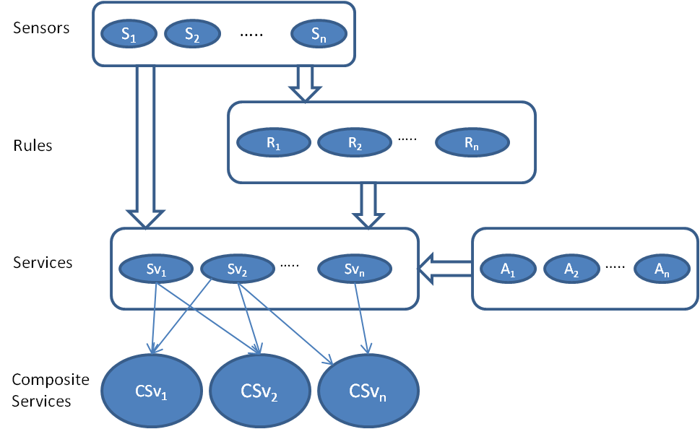
Figure 1.1: Service Composition architecture
Service description mechanism
There are lots of heterogeneous resources and services in pervasive computing environment. Therefore, in order to make such resources work properly, how to describe such resources becomes one of the most important problems. At present there are many research works in this field, such as UPnP, SLP, Salutation, etc. Different knowledge representation methods, such as ontology, XML and attribute/value, have been used to solve this problem. However, most research methods are syntax-level. Semantic-level information is little considered.
In this study we design a XML based service description mechanism as shown in figure 2.2. The figure shows the structure of a service which is composed of four objects i.e. associated sensors, service definition, rules definition, and associated actuators.
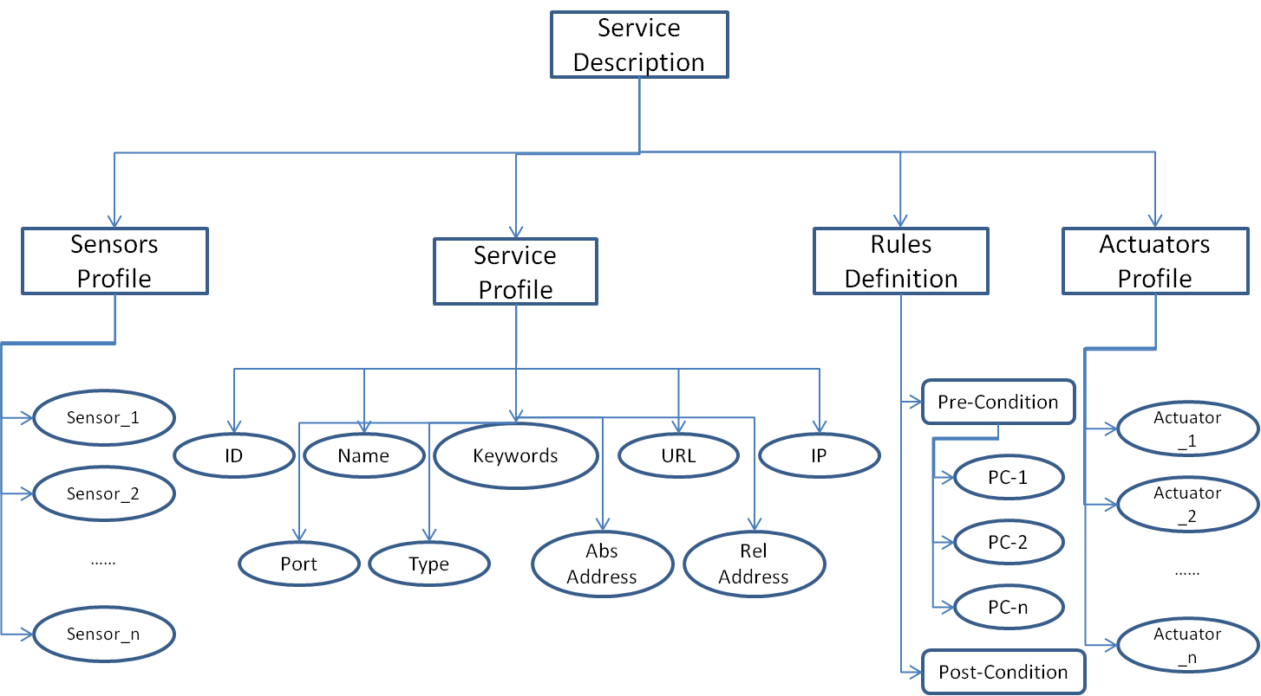
Figure 2.2: Service description mechanism diagram
Sensors profile
The sensors profile means the sensors which are registered in the system and are providing the data to the defined service. The sensor profile keeps the basic information about the registered sensors in the system such as Id, name, type, latitude, longitude, absolute (abs) address, and relative (rel) address. The sensors are binded with service along with actuators. Every service is binded to different number of sensors. For example, service A is controlling the temperature of the room A, which will require the temperature sensors in the room to send data to the service. Besides the sensor’s configuration file will be saved at the application server so that all the registered sensors are visible to the application server and can be used during the service configuration and service composition. Figure 2.3 shows the attributes of sensor profile.
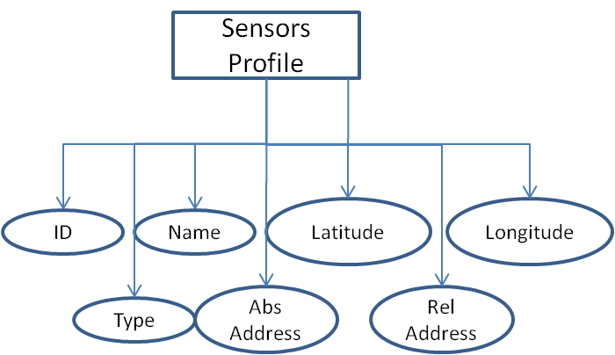
Figure 2.3: Sensor's profile with attributes
Service profile
The service profile refers to the basic information of the service. As shown in the figure 2.1, the service definition part consists of basic information and addresses of the service host. The ID, Name, and Keywords attributes are useful for discovery/findability the service and the IP, Port, and URL can be used for subscription of the service. However the Absolute (Abs) address and Relative (Rel) addresses are the physical or area of the service. These addresses can be used for location/area specific services, which can restrict subscription to the service in a specific geographical area.
Rules definition
The important part of the service description is the service behavior, which is defined through the rules set associated with the service. The rule set defined by the user or some artificial intelligence mechanism is stored in the service profile. The service uses this rule set for decision in the service execution.
Actuators profile
Associated actuators refer to the actuators which are registered in the system and are associated with the services. When rules are triggers for an event, the system take some action either through the associated actuators or recommend other conclusions as defined in the rules set. Figure 2.4 shows the actuator profile attributes.
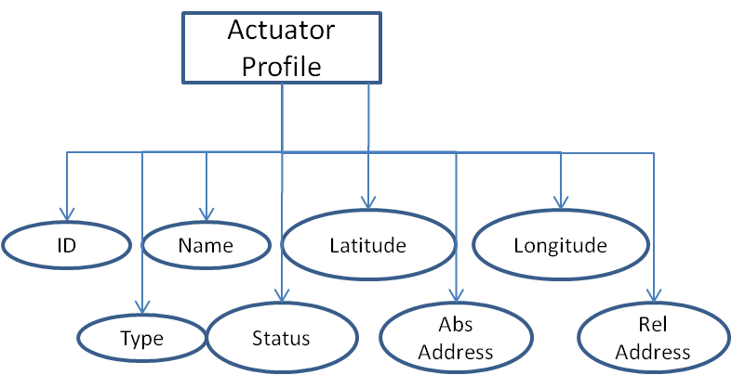
Figure 2.4: Actuator profile’s attributes
2.2 Service Generation Mechanism
The service generation mechanism is shown as a flow diagram in figure 2.5. The figure shows the dependencies of the proposed system’s units on each other. The sensors profile along with service definition is used to make a rules set for pattern identification and activity recognition. Based on the recognized activity and service rules the actuator control rule set is defined.
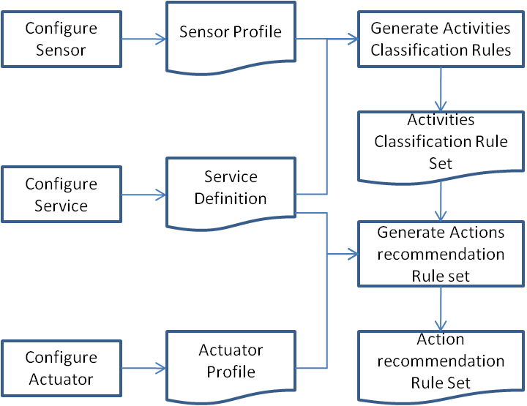
Figure 2.5: Atomic Service Generation Mechanism
Activity Classification
The important part of the service generation mechanism is activity classification. The activity classification is based on the association rules. The rules comprised of pre-condition and post-condition as follow:
If {s₁=x_{1,} s₂=x₂ ………….. s₃=x} Then {a=y} (1)
The rule set is created manually by the administrator of the system using activities rules section of the prototype. The rules are generated based on threshold values of the sensors and class label for activities.
Figure 2.6 shows the flow diagram for both the classification rules generation and consumption mechanism. The figure 2.6.a shows the rules generation mechanism, which is based on sensors, and services. When the user initializes the classification module, the system looks for the registered sensors, and services. If any of dependent module is missing, then the system give message and exit the module. And when all the modules are configured then the system allows the user to configure a new rule. When the user configure a new rule, the system checks the rules set file, if it exists then the new rule is appended otherwise it create a new rule set and save the rule in this rule set. Figure 2.6.b shows the utilization of the activities rule set. When the system is initialized for activity classification, it is presented with a pattern of sensors values. The system checks the pattern in the classifier’s rule set which is stored as an xml file. If the system finds the pattern then it checks the values to match the condition. When the pattern values matches the rule, the system triggers that rule, and assign the class label otherwise a pattern miss message is issued and the pattern is stored in a temporary file. The system keeps track of the miss patterns, if the number of miss patterns increases a certain threshold values, then the system initiates a message to the administrator to assign a class label or discard the patterns. The system administrator then decides whether to discard the patterns or assign a new class label to that pattern.
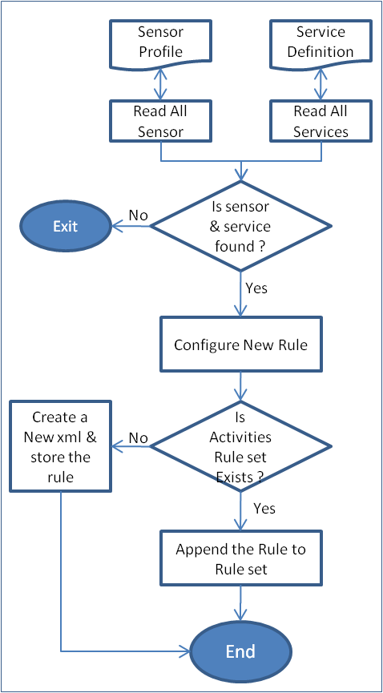  Figure 2.6.a: Activity rules generation flow diagram | 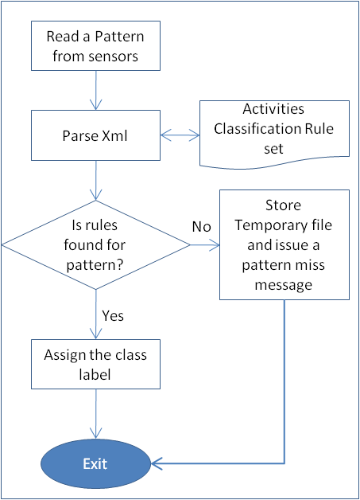  Figure 2.6.b: Rules utilization flow diagram
Service Composition Mechanism
The service composition is an important part of this work. The service composition mechanism is to combine the functionality of multiple services which are depended on each other for performing some specific tasks. Service composition can be automatic in which the system selects multiple services to make a composite service for certain task. Besides, service composition can also be static in which the system designer knows the dependencies of the service on each other for making a composite service. For example weather service is composed of multiple service i.e. temperature service, humidity service, air quality service and rain prediction service.
We used a hybrid approach for service composition in our prototype system which is a rules based composition. In the first case, the user selects the services to compose on run time and we make a composite service of the selected services. In the second case, a rule set is used to make composite service based on pre-defined conditions.
Deployment of Service Composition in Internet of Things (IoT) System
The IoT system
Figure 3.1 shows the IoT system architecture for indoor intelligent control. This architecture consists of virtual world and physical world parts. Virtual world part is composed of modules called as application server, Actuator Web provider, Sensor Web provider, sensor middleware and actuator middleware. Actuator middleware and sensor middleware are parts to interoperate with real world device. Sensor middleware is responsible for sensing data and the actuator middleware perform actuator state info collection and sending control command to the actuators. Service Provider’s service offers contents to application server. Application server monitors sensing data which is received in real-time from indoor sensor nodes and judge the indoor environment. Physical World part is the indoor environmental state sensing sensors and indoor environment control appliances.
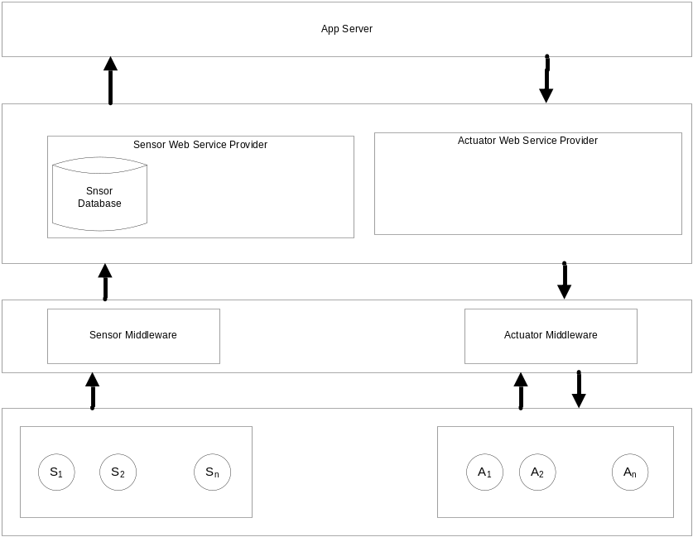
Figure 3.1: Indoor intelligence control IoT system architecture
This distributed processing system is implemented with SOAP and APIs are implemented using Microsoft .NET environment WCF technology.
Deployment of service composition to IoT
The service composition is deployed into IoT system. Basically the IoT system was having a service named smart service which is used to control the actuators of the building with certain parameters or values calculated through fuzzy logic. The main problem with the existing approach is that it is hard coded rules system which cannot be modified by external entity or the clients. All the parameters are configured inside the code by the system administrator. This is a static configuration of rules and actuator control mechanism. The system modification requires domain experts.
We proposed a dynamic service configuration mechanism for IoT smart control system. Our approach allows the users to modify the rules configuration and vary the threshold values for different parameters. Besides, our approach is also adaptive to the environmental changes as we maintain a separate knowledge base in the form of xml files. Our knowledge base (xml rule set) can be modified by an external machine learning algorithm which can adapt the environmental changes and suggest new rules. Furthermore our knowledge base is accessible to all the units of the IoT system which can be utilized as the system requirement. Also our approach does not need any domain knowledge to modify the rule set.
Figure 3.2 shows the architecture is used to deploy the service composition mechanism to the IoT system.
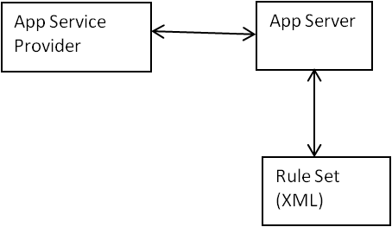
Figure 3.2: Service composition in IoT system
The rule set is stored at the App server and is available to the smart service of the app server. The smart control has two options to carry out smart control:
- Actuator control using Fuzzy Logic
- Actuator control using xml knowledge base
The fuzzy logic control is already tested in the existing system which has been thoroughly tested in the early studies of this system. As mentioned before, the modification in the fuzzy rules and threshold values needs domain expertise. Therefore we deployed a more sophisticated approach of xml rules set for smart actuator control. This xml rules set based approach gives the user the opportunity to define a user oriented rule set. Every user of the system can define different rules for different context. For example the user of room#1 may need high temperature value in the room which a user of room#2 may require a low temperature in his room. Therefore our approach is more adaptive and user centric than the existing fuzzy logic based approach.
We tested our service composition architectures as shown figure 3.3. The deployment with IoT system is carried out at the application server level. The smart service of the application server is modified for the service composition. The numbers of services are registered under the umbrella of smart service, which are then composed for certain tasks. The composition configuration of service composition module is used by the app server. This xml based configuration can be modified by the service composition module without the intervention of the app server.
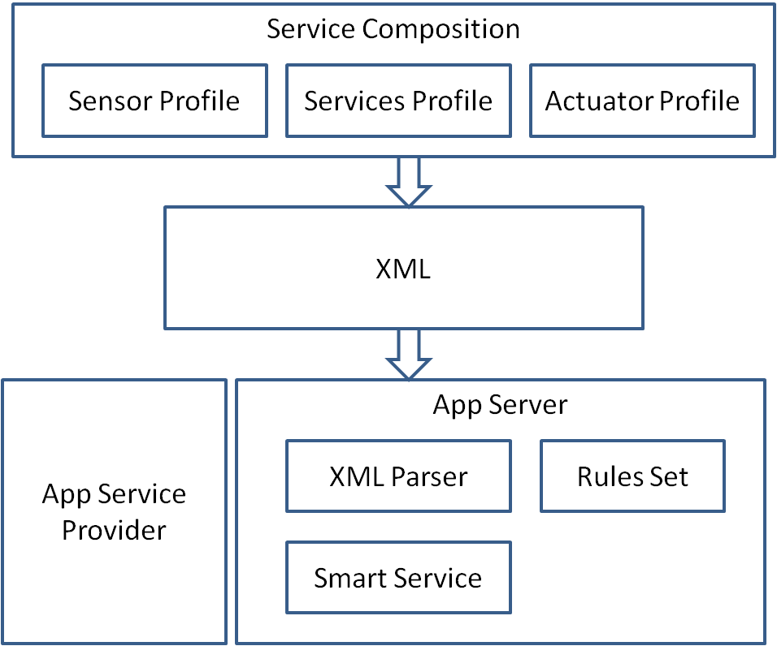
Rule Set
Figure 3.3: Service Composition deployment in IoT system
Benefits of the Proposed Architecture
- The proposed system is based on user profile based services composition which allow user ease and simplicity.
- The service composition is carried out at the application server level on the IoT system which enables complex task carried out by composite services rather than atomic service.

Annex: Simulation and Results

Implementation Setup and Results

Implementation setup
Table 1 shows the implementation setup of the system. As shown in table 1, the system is implemented in visual studio 2013 with xml and sql server 2008 r2. The processor and RAM is not that much affects the results of the system, however the communication channels affects the results.
Table 1: Implementation configuration
Division | Detail
Operating System | Microsoft Windows 8(X64)
Development Environment | .Net Framework 3.5, 4.0
Development Tool | Visual Studio .Net 2013
Programming Language | C#, XML
DBMS | Microsoft SQL Server 2008 R2
Hardware | CPU: Intel® Core™ i5-3570 @ 3.40GHz 3.39GHz  RAM: 8GB

Implementation results of service composition
We developed a prototype of our proposed service description mechanism. Our prototype consist of modules for sensors configuration, actuator configuration, services configuration, rules set generation for activities classification, rule set for actuator control, and making composite services. The implementation environment we used is visual studio 2013 with xml. Figure A.1 shows the User interface of our prototype. The user interface gives a link to each module of the system.
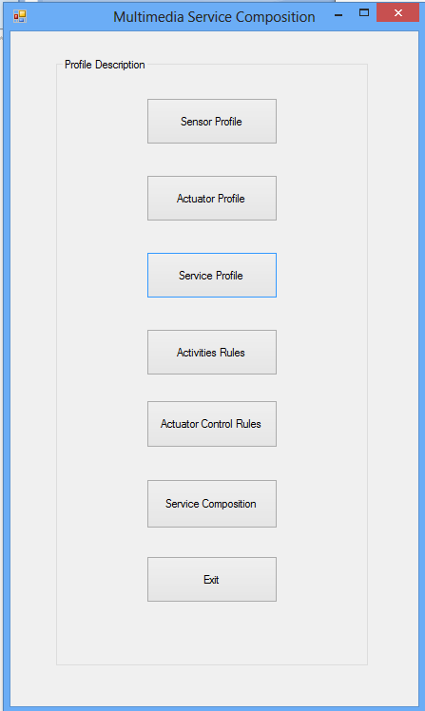
- User view of the service composition toolbox
Figure A.2 shows the sensor profile module. This module is used to register new sensors, update registered sensors and delete registered sensors. The registered sensors will also be displayed to the user on the user’s demand.
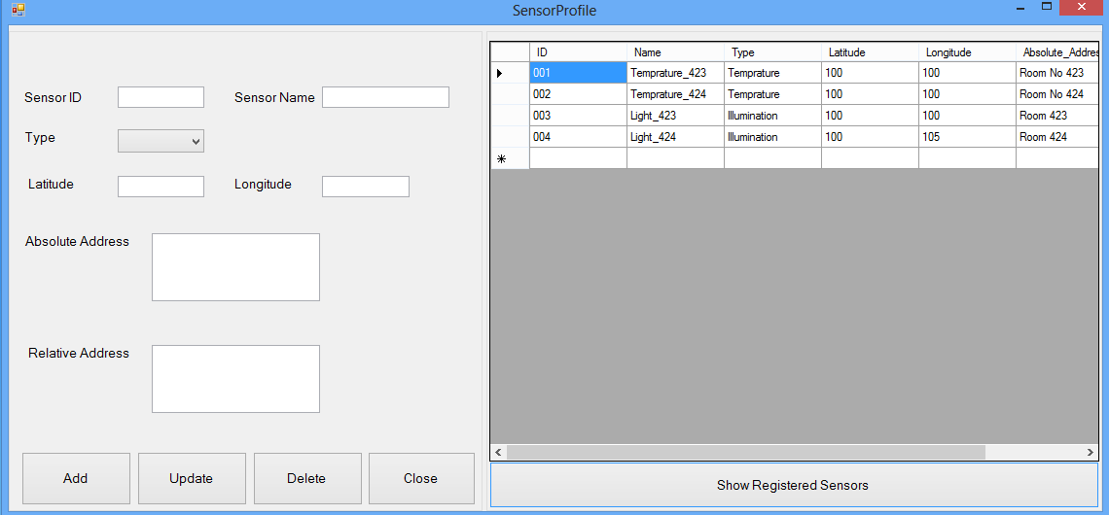
- Sensor Profile
Figure A.3 shows the results of the sensor profile. All the information provided in the sensor module is shown in figure 13. The resulted figure shows that there are 3 sensors registered which is shown along with the provided information.
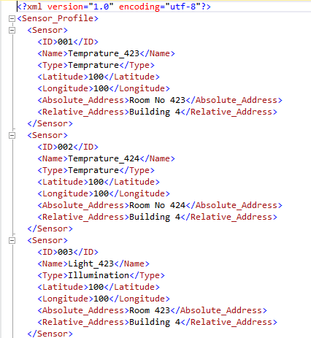
- Sensor profile result
Figure A.4 shows the actuator profile module. This module is used to register new actuators, delete already registered actuators and update the information of registered actuators. The actuator list is shown in the view to the users. When the users want to see the status of the actuators, it can be seen in the view at column 4 of the actuator view.
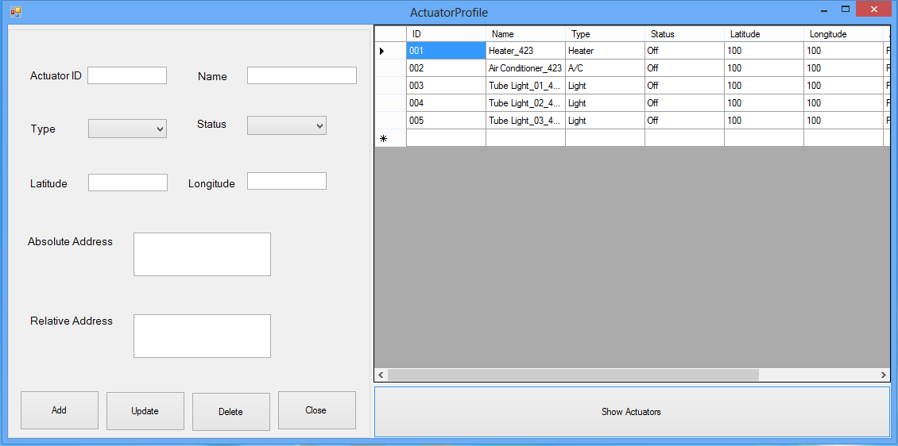
- Actuator Profile
Figure A.5 shows the result of actuator profile module. This file is resulted after the user configures actuators in the system. This file is later used by the actuator control module.
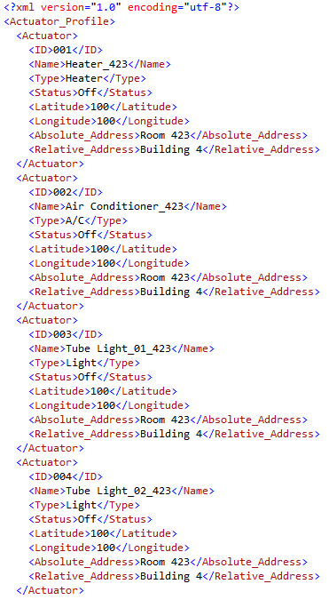
- Actuator profile result
Figure A.6 shows the service definition module. This module is used to register new service, modify existing services and also delete existing services. The module also provides a view of the existing services. The user needs to give all information which is mandatory for service configuration.
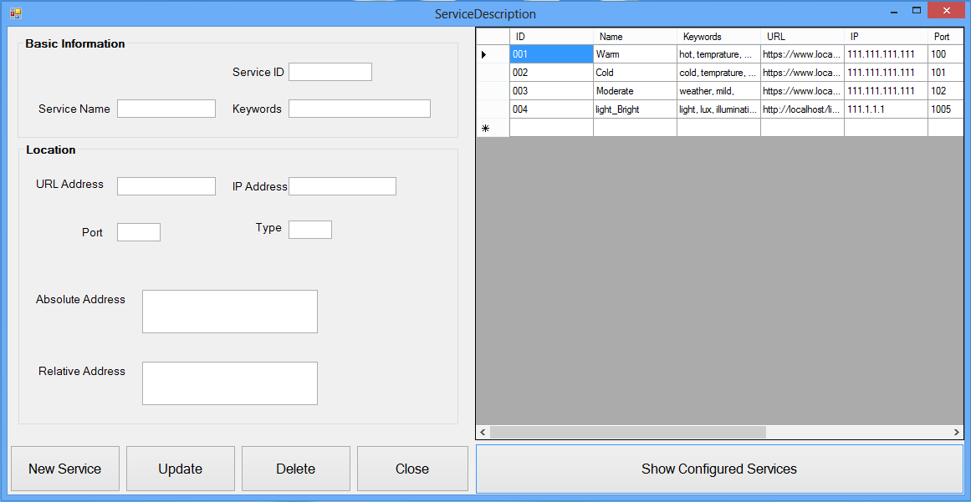
- Service Definition
Figure A.7 shows the result of service definition module. It is evident from the resulted figure that there are 4 services registered in the system. When the user will make rules set for activity classification and actuator control, this resulted xml will be utilized.
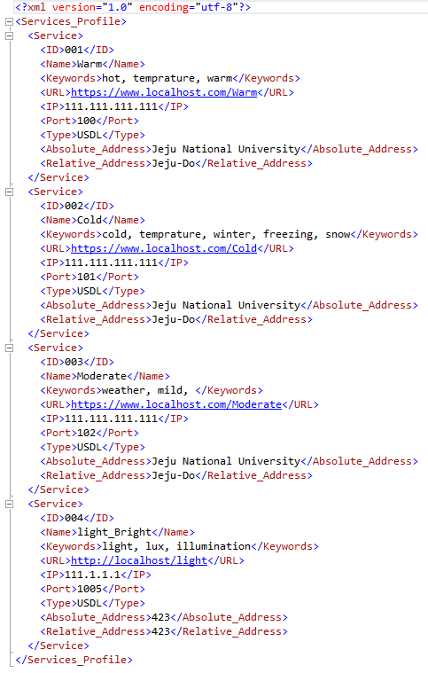
- Service definition result
Figure A.8 shows the rules configuration module for activity classification. All the rules are linked with services as these rules are part of the service behaviour. Therefore the registered services must be loaded to the system and one service must be selected for rules definition. Besides, all the rules are based on some pre-condition values of the sensors; therefore the registered sensors are also loaded to the system. After loading and selecting a sensor along with the conditional operator, the threshold value must be defined for sensors to define a rule. The users have the option extend the rules precondition to the nested level 4. The contextual information like time and location for the rules is also part of the rule. Furthermore rules set can also be viewed in the rules configuration module.
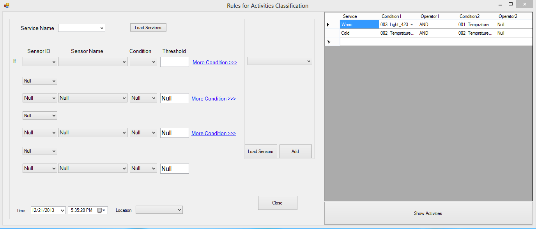
- Rules for activities classification module
The figure A.9 shows the resulted file of the activity classification rule. The figure shows that there are two rules configured in the system. The rule is a combination of conditions and operators along with contextual information (location, time) and a resulted class label.
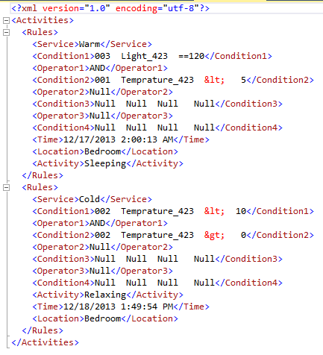
- Activities classification results
Figure A.10 shows the actuator control rules configuration module. This module consist of services, and rule set based on activity and actuator control based on activities. The user can configure rules for actuator control based on user selected activities. These activities will be taken from the registered activities in the configured rule set for activities.
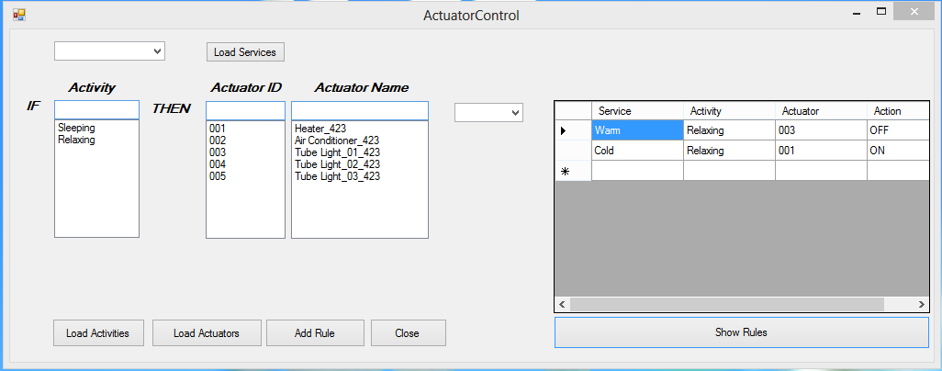
- Rules Configuration for actuator control

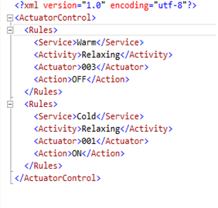
- Actuator control rule set result
Figure A.11 shows the configuration file for actuator profile and actuator control. This information is provided from the user interface of actuator rule and actuator profile modules.
Figure A.12 shows the service composition module user interface. This user interface allow user to select the number of service used to make composite service. Based on the number of selected services, we allowed the user to select the services which are already registered in the system for making a composite service. When the user select the service for composite service, we collect the basic information about the service like, id, name, address and the associated sensors and associated actuators along with activities rules and actuator control rule set.
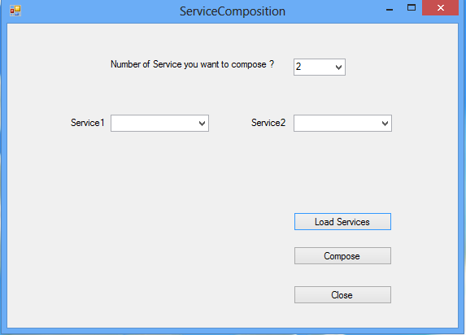
- Service Composition User Interface
Figure A.13 shows the resulted xml file for service composition. It is evident from the figure that two services are composed for service providing in a room. The 1st service is to control the temperature in the room and the 2nd service is to control the light in the room. So let’s suppose a user is sleeping in the room and temperature is within a certain threshold, then adjust temperature actuators i.e. heater, air conditioner, and fan. Also, if the user is sleeping then the light actuators control the light in the room.

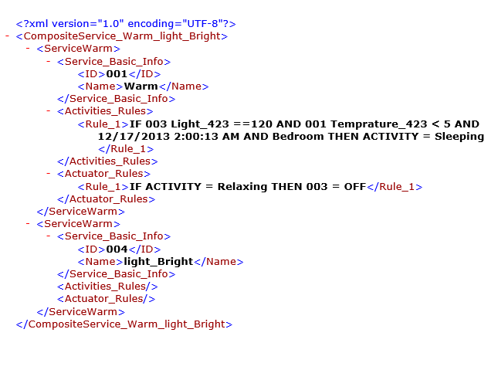
- Resulted xml of service composition for two services

Implementation Results of Deployment in IoT
The service composition is deployed in the IoT system with the architecture shown in figure A.14. The application server accesses the rules generation mechanism of our service composition module. As shown in figure A.14, the rules generation module initiated by the app server, communicates the app server for registered sensors and actuators. The app server requests the registered sensors and actuators from the SensorWeb and ActuatorWeb providers respectively. The rules generation module then specifies the threshold values for sensors and respective action of actuators to build a rule. These rules are then utilized by the smart service in the app server for controlling the actuators dynamically. The rules can be updated and can also be deleted by the rules configuration module. These rules are used by the smart service in the app server. When the smart service gets started, listen to the listed sensors. When the data is received from the sensors; the smart service calls upon the rules module to find the rule which meets the sensors readings. The rules module parse the xml rule base and look for the rule which meets the sensor reading. When the module finds the rule which meets the sensor reading, it looks for the associated actuator and action within the rule body. The rules module returns the actuator along with associated actions from the rule. The communication module of the smart service; reads the actuators status from the local history about the actuator. If the actuator status is different than the suggested actuator’s status then the communication module communicates the new status to the actuators middleware where the middleware change the set the new status of the actuator.
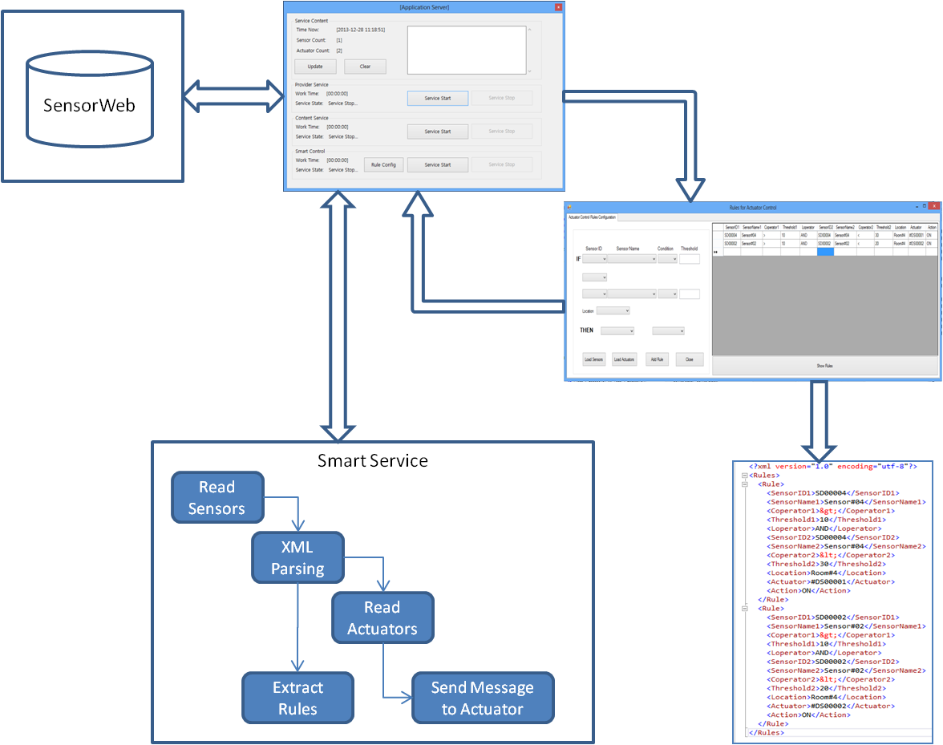
- Service composition toolbox in IoT app server
The rules configuration module is shown in figure A.15. The user will load the registered sensors and registered actuators to configure new rules. When the sensors and actuators are loaded to the sensor and actuator controls, the user will be able to configure a new rule. When the user configures a new rule, a message will be displayed to the user about the confirmation of rule configuration.
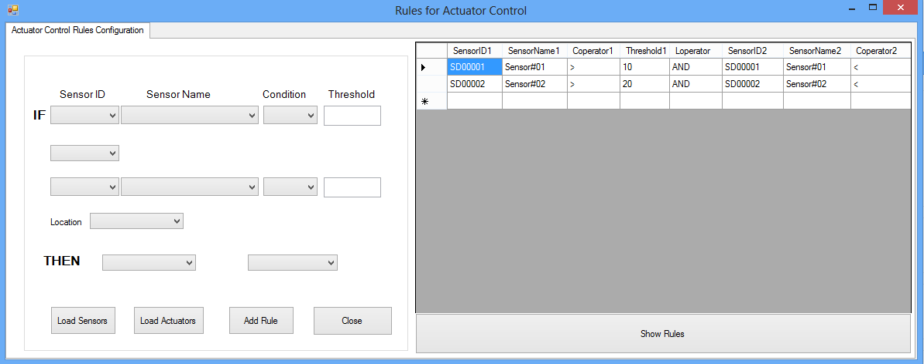
- Rules configuration for smart control
The actuator emulator shown in figure A.16 is the fan emulator. This actuator is given the id DS00001 which is controlled by our smart control system. The actuator is dependent on the temperature of the room, if the temperature of the room exceeds certain threshold, then our smart control turn on the fan based on the defined rules in the system as shown in figure 25.
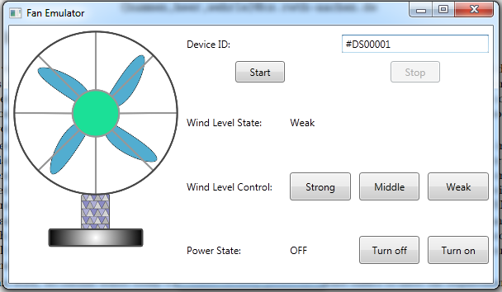
- Resulted actuator simulator

