CHANGE REQUEST
Group Name:* | WG2 (ARC)
Source:* | InterDigital
Format:* | ARC #15
Date:* | 2015-01-10
Contact:* | Guang Lu (Guang.Lu@InterDigital.com)
Reason for Change/s:* | TS-0007 clean up actions
CR against: Release*
CR against: TS/TR* | TS-0007 0.6.0
Clauses/Sub Clauses* | 6.10
Type of change: * | Editorial change  Bug Fix or Correction  Change/correction to existing feature or functionality  New feature or functionality
Post Freeze checking:* | This CR contains only essential changes and corrections  YES NO

oneM2M Notice
The document to which this cover statement is attached is submitted to oneM2M. Participation in, or attendance at, any activity of oneM2M, constitutes acceptance of and agreement to be bound by terms of the Working Procedures and the Partnership Agreement, including the Intellectual Property Rights (IPR) Principles Governing oneM2M Work found in Annex 1 of the Partnership Agreement.
GUIDELINES for Change Requests:
Provide an informative introduction containing the problem(s) being solved, and a summary list of proposals.
Each CR should contain changes related to only one particular issue/problem.
Follow the principle of completeness, where all changes related to the issue or problem within a deliverable are simultaneously proposed to be made E.g. A change impacting 5 tables should not only include a proposal to change only 3 tables. Includes any changes to references, definitions, and acronyms in the same deliverable.
Follow the drafting rules.
All pictures must be editable.
Check spelling and grammar to the extent practicable.
Use Change bars for modifications.
The change should include the current and surrounding clauses to clearly show where a change is located and to provide technical context of the proposed change. Additions of complete sections need not show surrounding clauses as long as the proposed section number clearly shows where the new section is proposed to be located.
Multiple changes in a single CR shall be clearly separated by horizontal lines with embedded text such as, start of change 1, end of change 1, start of new clause, end of new clause.
When subsequent changes are made to content of a CR, then the accepted version should not show changes over changes. The accepted version of the CR should only show changes relative to the baseline approved text.

Introduction
This is part of TS 0007 clean up. Previouly filterCriteria was pointed to one section, and this does not apply anymore and there are specific filterCriteria defined for different service capabilities. This contribution updated the definition of filterCriteria in section 6.10 Event Collection to align with the current TS 0007, and also to remove a pending Editor’s Note.
R01: editorial updates to figures and a few cross references.
R02:further editorial updates of figures

-----------------------Start of change 1-------------------------------------------

6.10 Event Collection

6.10.1 Overview
The Event Collection service provides the capability to record events for accounting purposes.

6.10.1.1 Event Collection Types

6.10.1.1.1 Event Collection Record
Information Element | Optional | Description
eventRecordID | NO | It is the unique ID that identifies a specific event record.
eventCollectionTriggerID | NO | It is the unique ID that identifies a specific event collection triggering scenario, which triggers information recording for a specific event.
collectingEntityID | NO | This is the unique ID of the entity that collects the statistics. It can be an AE-ID or M2M Service Capability Identifier (M2M-Serv-Cap-ID)
collectedEntityID | NO | This is the unique ID of the entity whose service layer operation statistics are being collected. It can be an AE-ID or M2M Service Capability Identifier (M2M-Serv-Cap-ID).
serviceProfileID | YES | An M2M Service Profile Identifier defines M2M Services and/or M2M Service Roles and AEs applicable to M2M Nodes.
eventDescription | NO | Describes the event triggered at the service. It is a subset of the eventConfig data structure. The specific structure depends on the specific event defined by the Event Collection Trigger.
Vendor Specific Information | YES | Defines Vendor specific information
Table 6.10.1.1-1 Type: Event Record Template

6.10.1.1.2 Event Configuration Type

Parameter name | Optional | Description
eventType | NO | This attribute indicates the type of the event, such as “subscribeComplete”, “downloadFirmware “, “timer based”,, “storage based”, etc. The eventType can be a combination of multiple sub-types, for example, it can be based on both “subscribeComplete” and a timer.
serviceRoleIds | YES | Defines the specific service role.
eventStart | YES | This attribute indicates the start time of the event. It is mandatory if the eventType includes “timer based”.
eventEnd | YES | This attribute indicates the end time of the event. It is mandatory if the eventType includes “timer based”.
dataSize | YES | This attribute defines the data size if an event is triggered when the stored data exceeds a certain size. It is mandatory if the eventType is “storage based”.
Table 6.10.1.1.2-1 Type: Event Collection – eventConfig

6.10.1.1.3 getEventCollectionPolicy Filter Criteria
Criterion name | Description
eventType | See Table 6.10.1.1.2-1
eventStart | See Table 6.10.1.1.2-1. This criterion may only be used when the eventType criterion is set to “timer based”.
eventEnd | See Table 6.10.1.1.2-1. This criterion may only be used when the eventType criterion is set to “timer based”.
dataSize | See Table 6.10.1.1.2-1. This criterion may only be used when the eventType criterion is set to “storage based”.

Table 6.10.1.1.3-1 getEventCollectionPolicy Filter Criteria

6.10.1.1.4 getEventCollectionTriggers Filter Criteria
Criterion name | Description
eventCollectionPolicyID | See Table 6.10.2.3.2-1.
collectingEntityID | See Table 6.10.2.3.2-1.
collectedEntityID | See Table 6.10.2.3.2-1.
eventReceiverID | See Table 6.10.2.3.2-1.
serviceID | See Table 6.10.2.3.2-1.
triggerStatus | See Table 6.10.2.3.2-1.

Table 6.10.1.1.4-1 getEventCollectionTriggers Filter Criteria

6.10.1.1.5 getEventRecords Filter Criteria

Criterion name | Description
eventCollectionTriggerID | See Table 6.10.1.1-1.
collectingEntityID | See Table 6.10.1.1-1.
collectedEntityID | See Table 6.10.1.1-1.
serviceProfileID | See Table 6.10.1.1-1.
eventDescription | See Table 6.10.1.1-1. In the filterCriteria, the eventDescription can be a string that partially matches the eventDescription parameter in the record.

Table 6.10.1.1.5-1 getEventRecords Filter Criteria

6.10.2 Service Capabilities

6.10.2.1 setEventCollectionPolicy
This service capability provides the ability for AEs to configure event collection policies for statistics and charging purposes. This service capability applies to the Mca Reference Point.

6.10.2.1.1 Pre-conditions
The Originator can be an AE, and the Originator wants to configure event collection policies at a receiving service capability. The receiving service capability conducts event collection according to the policies. The receiving service capability may establish its own event collection policies.
The Originator, if different from the receiving service capability, is subscribed and registered to the receiving service capability.

6.10.2.1.2 Signature – setEventCollectionPolicy
Parameter name | Direction | Optional | Description
serviceId | IN | NO | The M2M Service Identifier (M2M-Serv-ID)
eventConfig | IN | NO | The configuration of the event collection policy. Defined in Table 6.10.1.1.2-1.
eventCollectionPolicyID | OUT | NO | The receiving service capability generates a unique policy ID for each policy.
responseType | OUT | YES | Unique response types for this service. Exception:  - Policy already exists

Table 6.10.2.1.2-1 Event Collection – setEventCollectionPolicy capability

6.10.2.1.3 Post-Conditions
Not Applicable

6.10.2.1.4 Exceptions
- The Originator has no access right to create the policy

6.10.2.1.5 Policies for Use
Message Exchange Patterns: In-Out

6.10.2.1.6 Service Interactions
The interactions of service capabilities required for this service capability:
- Issue the request to the Supporting Service to perform the operation

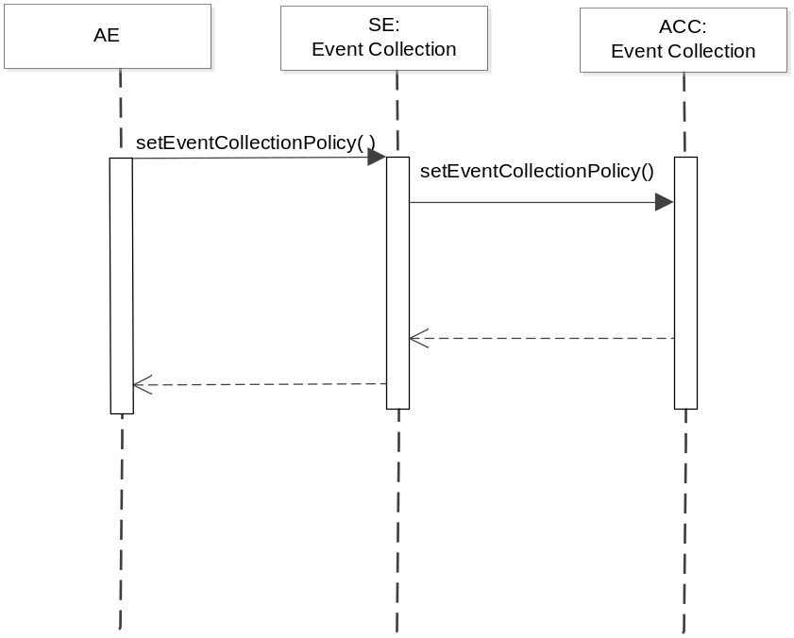
Figure 6.10.2.1.6-1 setEventCollectionPolicy Diagram

6.10.2.1.7 oneM2M Resource Interworking
The service capability aligns with the <eventConfig> resource and maps to the CREATE procedure for the resource.

6.10.2.2 getEventCollectionPolicy
This service capability provides the ability for entities, such as an AE or a service capability, to retrieve the existing policies stored at a service capability. This service capability applies to the Mca and Msc Reference Point.

6.10.2.2.1 Pre-conditions
The Originator can be an AE or a service capability, and the Originator wants to retrieve event collection policies at a receiving service capability.
The Originator, if different from the receiving service capability, is subscribed and registered to the receiving service capability. The Originator is only allowed to retrieve with the proper access right.

6.10.2.2.2 Signature – getEventCollectionPolicy
Parameter name | Direction | Optional | Description
eventCollectionPolicyID | IN | NO | See Table 6.10.2.1.2-2. The eventCollectionPolicyID specifies the specific event collection policy to retrieve, if the Originator has such information. If the Originator does not have the information regarding eventCollectionPolicyID, it indicates eventCollectionPolicyID with a specific value that represents “any IDs”, and uses the filterCriteria to filter selected policies.
filterCriteria | IN | YES | See Table 6.10.1.1.3-1.
responseType | OUT | YES | Unique response types for this service. Exception:  - eventCollectionPolicyID does not exist

Table 6.10.2.2.2-1 Event Collection – getEventCollectionPolicy capability

6.10.2.2.3 Post-Conditions
Not Applicable

6.10.2.2.4 Exceptions
The Originator has no access right to retrieve the policy

6.10.2.2.5 Policies for Use
Message Exchange Patterns: In-Out

6.10.2.2.6 Service Interactions
The interactions of service capabilities required for this service capability:
- Issue the request to the Supporting Service to perform the operation
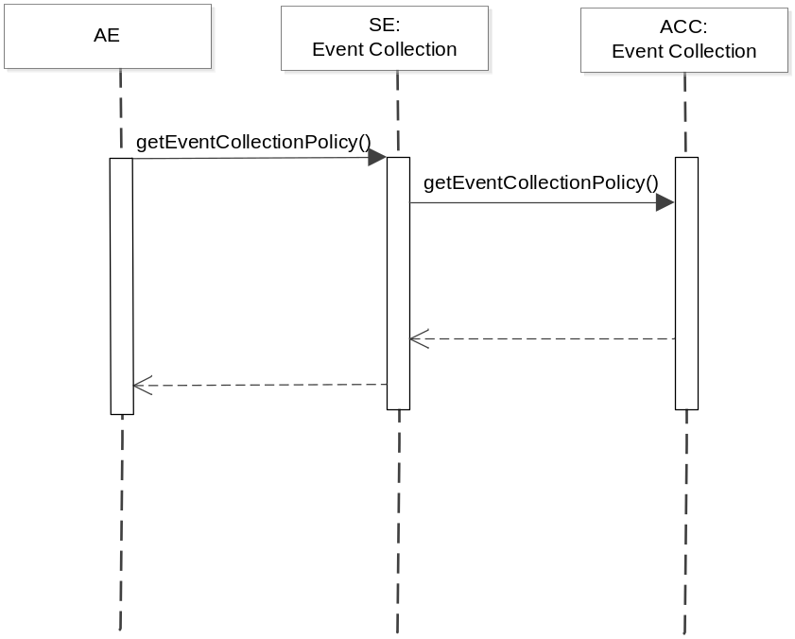
Figure 6.10.2.2.6-1 getEventCollectionPolicy Diagram

6.10.2.2.7 oneM2M Resource Interworking
The service capability aligns with the <eventConfig> resource and maps to the RETRIEVE procedure for the resource.

6.10.2.3 setEventCollectionTriggers
This service capability provides the ability for AEs and service capabilities to configure specific triggers for event collection, based on the Event Collection Policy. This service capability applies to the Mca and Msc Reference Point.

6.10.2.3.1 Pre-conditions
The Originator can be an AE or a service capability, and the Originator wants to configure event collection triggers based on existing event collection policy available at the collecting service capability.

6.10.2.3.2 Signature – setEventCollectionTriggers
Parameter name | Direction | Optional | Description
eventCollectionPolicyID | IN | NO | This attribute specify the policy used to define the specific event collection trigger.
collectingEntityID | IN | NO | This is the ID of the entity where the event is being collected. If not specified, the default collecting entity is the receiving service capability.
collectedEntityID | IN | NO | This is the ID of the entity that triggered the event collection. If not specified, the default is all entities triggered the event at the collecting entity.
eventReceiverID | IN | YES | In cases when there is another entity, other than the collecting entity (such as a service capability), wants to receive the collected event, this attribute provides the unique ID of this entity.
serviceRoleIds | IN | YES | Specifies the service roles that trigger the event collection.
serviceId | IN | YES | Specifies the services that trigger the event collection.
triggerStatus | IN | YES | This attribute indicates if the trigger is activated or not. If not defined, the trigger is activated.
eventCollectionTriggerID | OUT | NO | The receiving service capability generates a unique ID for each event collection trigger.
responseType | OUT | YES | Unique response types for this service. Exception:  - eventCollectionPolicyID is invalid  - collectingEntityID is invalid  - collectedEntityID is invalid  - eventReceiverID is invalid  - triggerStatus is invalid

Table 6.10.2.3.2-1 Event Collection – setEventCollectionTriggers capability

6.10.2.3.3 Post-Conditions
After the successful creation of event collection triggers, when the defined event happens at the collectingEntity, and when the event collection trigger status is ACTIVE, the collectingEntity shall collect the event. The supporting service shall send a recordEvent message to the Event Collection entity.

6.10.2.3.4 Exceptions
The Originator has no access right to create the event collection triggers

6.10.2.3.5 Policies for Use
Message Exchange Patterns: In-Out

6.10.2.3.6 Service Interactions
The interactions of service capabilities required for this service capability:
- Issue the request to the Supporting Service to perform the operation

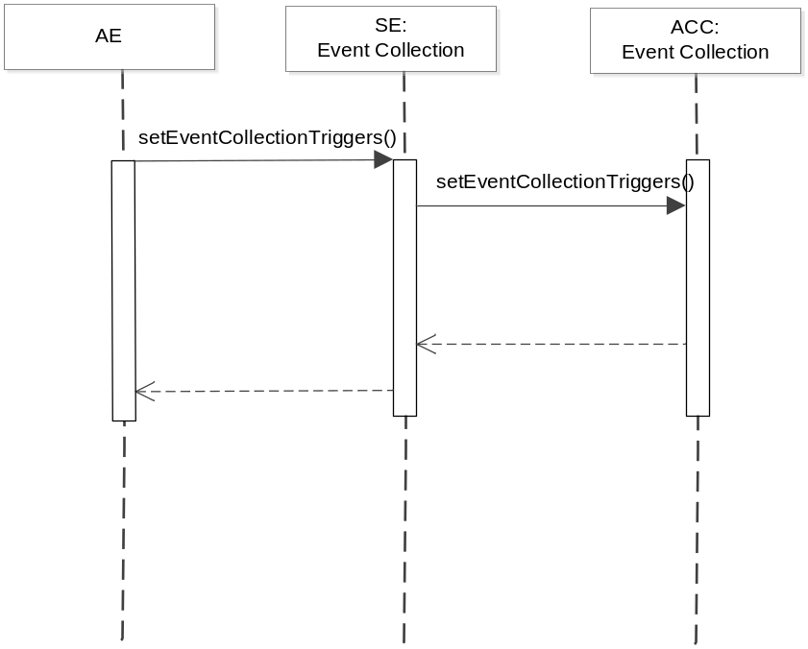
Figure 6.10.2.3.6-1 setEventCollectionTriggers Diagram

6.10.2.3.7 oneM2M Resource Interworking
The service capability aligns with the <statsCollect> resource and maps to the CREATE procedure for the resource.

6.10.2.4 getEventCollectionTriggers
This service capability provides the ability for AEs and service capabilities to retrieve event collection triggers at a receiving service capability. This service capability applies to the Mca and Msc Reference Point.

6.10.2.4.1 Pre-conditions
Originating AEs and service capabilities are subscribed and registered to the receiving service capability. Originator has the access right to retrieve.

6.10.2.4.2 Signature – getEventCollectionTriggers
Parameter name | Direction | Optional | Description
eventCollectionTriggerID | IN | YES | This attribute specifies which event collection triggers to retrieve. If not specified, any event collection trigger matching the filter criteria should be retrieved. If the Originator does not have the information regarding eventCollectionTriggerID, it indicates with a specific value that represents “any IDs”, and uses the filterCriteria to filter selected event triggers.
filterCriteria | IN | YES | See Table 6.10.1.1.4-1.
responseType | OUT | YES | Unique response types for this service. Exception:  - eventCollectionTriggerID does not exist

Table 6.10.2.4.2-1 Event Collection – getEventCollectionTriggers capability

6.10.2.4.3 Post-Conditions
Not Applicable

6.10.2.4.4 Exceptions
The Originator has no access right to retrieve the event collection triggers

6.10.2.4.5 Policies for Use
Message Exchange Patterns: In-Out

6.10.2.4.6 Service Interactions
The interactions of service capabilities required for this service capability:
- Issue the request to the Supporting Service to perform the operation
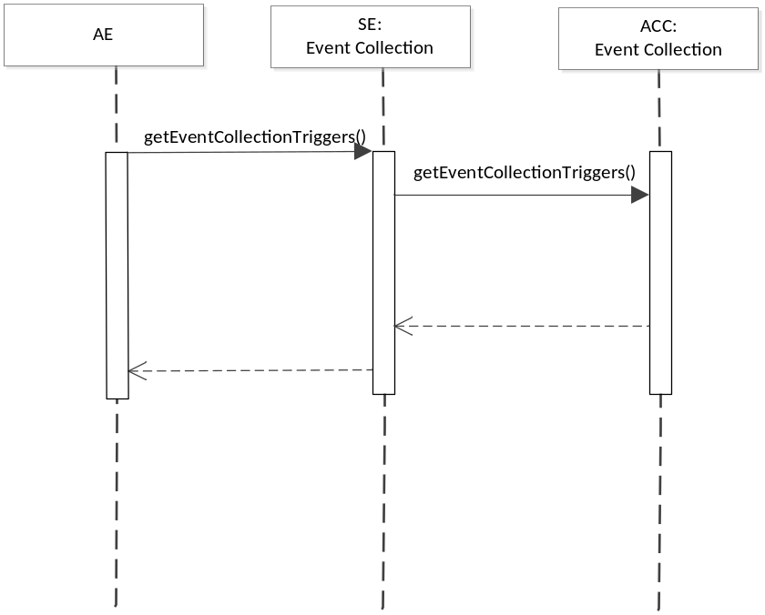
Figure 6.10.2.4.6-1 getEventCollectionTriggers Diagram

6.10.2.4.7 oneM2M Resource Interworking
The service capability aligns with the <statsCollect> resource and maps to the RETRIEVE procedure for the resource.

6.10.2.5 recordEvent
This service capability provides the ability for a service (such as Data Exchange service) to trigger the event collection service to record an event. This service applies to the Msc Reference Point.

6.10.2.5.1 Pre-conditions
Event Collection Triggers have been created by the setEventCollectionTriggers capability.

6.10.2.5.2 Signature – recordEvent
Parameter name | Direction | Optional | Description
eventCollectionPolicyID | IN | YES | This attribute specify the policy used to define the specific event collection trigger.
eventCollectionTriggerID | IN | NO | The service where the trigger happens provides the eventCollectionTriggerID being used.
eventDescription | IN | NO | This attribute describes the event triggered at the service. It is a subset of the eventConfig data structure. It contains one or more parameters defined in the eventConfig data type.
recordID | OUT | NO | The event collection service generates a unique ID.
responseType | OUT | YES | Unique response types for this service. Exception:.  - Event recording cannot be completed

Table 6.10.2.5.2-1 Event Collection – recordEvent capability

6.10.2.5.3 Post-Conditions
Not Applicable

6.10.2.5.4 Exceptions
Not Applicable

6.10.2.5.5 Policies for Use
Message Exchange Patterns: In-Out

6.10.2.5.6 Service Interactions
The request comes from the service where the event was triggered to the Event Collection entity.

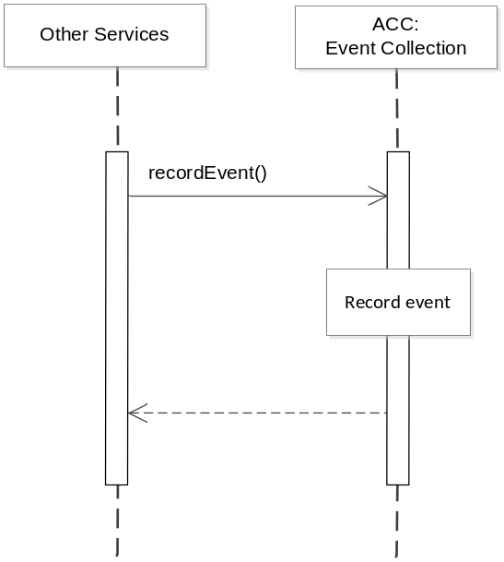
Figure 6.10.2.5.6-1 recordEvent Diagram

6.10.2.5.7 oneM2M Resource Interworking
Not Applicable

6.10.2.6 getEventRecords
This service capability provides the ability for AEs and service capabilities to retrieve the recorded events for statistical or charging purposes. This service capability applies to the Mca and Msc Reference Point.

6.10.2.6.1 Pre-conditions
Originating AEs and service capabilities are subscribed and registered to the receiving service capability.

6.10.2.6.2 Signature – getEventRecords
Parameter name | Direction | Optional | Description
eventRecordID | IN | NO | This attribute specifies which record to retrieve. If not specified, any event records matching the filter criteria should be retrieved. If the Originator does not have the information regarding the eventRecordID, it indicates with a specific value that represents “any IDs”, and use the filterCriteria to filter selected records of events.
filterCriteria | IN | YES | See Table 6.10.1.1.5-1
responseType | OUT | YES | Unique response types for this service. Exception:  - The eventRecordID

Table 6.10.2.6.2-1 Event Collection – getRecords capability

6.10.2.6.3 Post-Conditions
Not Applicable

6.10.2.6.4 Exceptions
Not Applicable

6.10.2.6.5 Policies for Use
Message Exchange Patterns: In-Out

6.10.2.6.6 Service Interactions
The Originator sends the request to the Event Collection entity to obtain the event records that it is
interested in.

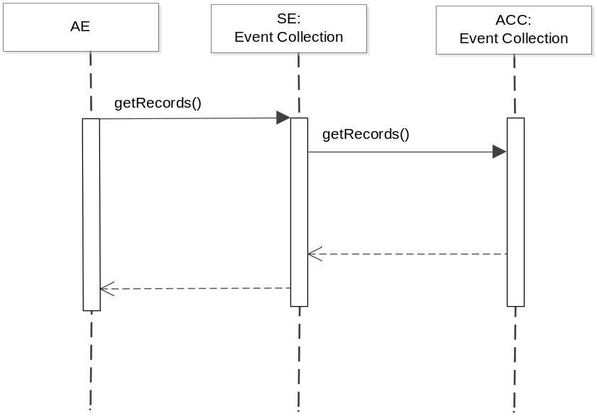
Figure 6.10.2.6.6-1 getEventRecords Diagram

6.10.2.6.7 oneM2M Resource Interworking
Not Applicable

-----------------------End of change 1-------------------------------------------
CHECK LIST
- Does this change request include an informative introduction containing the problem(s) being solved, and a summary list of proposals.?
- Does this CR contain changes related to only one particular issue/problem?
- Does this change request make all the changes necessary to address the issue or problem? E.g. A change impacting 5 tables should not only include a proposal to change only 3 tables. Includes any changes to references, definitions, and acronyms in the same deliverable?
- Does this change request follow the drafting rules?
- Are all pictures editable?
- Have you checked the spelling and grammar?
- Have you used change bars for all modifications?
- Does the change include the current and surrounding clauses to clearly show where a change is located and to provide technical context of the proposed change? (Additions of complete sections need not show surrounding clauses as long as the proposed section number clearly shows where the new section is proposed to be located.)
- Are multiple changes in this CR clearly separated by horizontal lines with embedded text such as, start of change 1, end of change 1, start of new clause, end of new clause.?

