CHANGE REQUEST
Meeting:* | WG2 Architecture - ARC 17
Source:* | Ericsson
Date:* | 2015-04-16
Contact:* | George Foti  SeungMyeong Jeong (seungmyeong.jeong@lge.com)  Yu Qi (yuqi@huawei.com)
Reason for Change/s:* | New text to be included in the TR on “Enhancements to Subscription/Notification Framework” WI
CR against: Release*
CR against: WI* | Active <Work Item number> Subscription/Notification Enhancement  MNT Maintenace / < Work Item number(optional)>  STE Small Technical Enhancements / < Work Item number (optional)>  Only ONE of the above shall be ticked
CR against: TS/TR* | TS-0001 V 2.0
Clauses/Sub Clauses*
Type of change: * | Editorial change  Bug Fix or Correction  Change/correction to existing feature or functionality  New feature or functionality
Post Freeze checking:* | This CR contains only essential changes and corrections? YES NO  This CR is a mirror CR? YES NO if YES, please indicate the document number of the original CR:  <Document Number)<CR Number of the original CR to the current Release>

oneM2M Notice
The document to which this cover statement is attached is submitted to oneM2M. Participation in, or attendance at, any activity of oneM2M, constitutes acceptance of and agreement to be bound by terms of the Working Procedures and the Partnership Agreement, including the Intellectual Property Rights (IPR) Principles Governing oneM2M Work found in Annex 1 of the Partnership Agreement.
GUIDELINES for Change Requests:
Provide an informative introduction containing the problem(s) being solved, and a summary list of proposals.
Each CR should contain changes related to only one particular issue/problem.
Follow the principle of completeness, where all changes related to the issue or problem within a deliverable are simultaneously proposed to be made E.g. A change impacting 5 tables should not only include a proposal to change only 3 tables. Includes any changes to references, definitions, and acronyms in the same deliverable.
Follow the drafting rules.
All pictures must be editable.
Check spelling and grammar to the extent practicable.
Use Change bars for modifications.
The change should include the current and surrounding clauses to clearly show where a change is located and to provide technical context of the proposed change. Additions of complete sections need not show surrounding clauses as long as the proposed section number clearly shows where the new section is proposed to be located.
Multiple changes in a single CR shall be clearly separated by horizontal lines with embedded text such as, start of change 1, end of change 1, start of new clause, end of new clause.
When subsequent changes are made to content of a CR, then the accepted version should not show changes over changes. The accepted version of the CR should only show changes relative to the baseline approved text.

Introduction
In R03:
- added change 2 to define two new child resource types for <subscription> resource. this was the beginning of change 1 in R02.
- added change 3 to define a new child virtual resource of subscription resource type, notificationTargetRemoval.
- added missing figure titles and corrected table titles in change 1.
- added “creator” attribute in <notificationDeletionPolicy> resource in change 1.
- added CRUD procedures for the new resource types proposed in this CR in change 4.
- added change 5 to add <notificationDeletionPolicy> resource as a child of <CSEBase> resource. and modified the text in the clause 9.6.Z
NOTE that the entire change1 is the new text.
In R04:
- added change 6 to reflect new resource types in the resource type summary table.
In R05:
Editoral changes

-----------------------Start of change 1-------------------------------------------

9.6.X Resource Type notificationTargetDisposition
The <notificationTargteDisposition> resource is a child resource of a <subscription> resource and lists a reference to the policy to be followed by the hosting CSE for every Target Notification of a subscription. The policy is applied by the hosting CSE when it receives a request to stop receiving a notification from a Target Notification. If no policy is defined for the Target Notification, then the hosting CSE shall apply the default policy
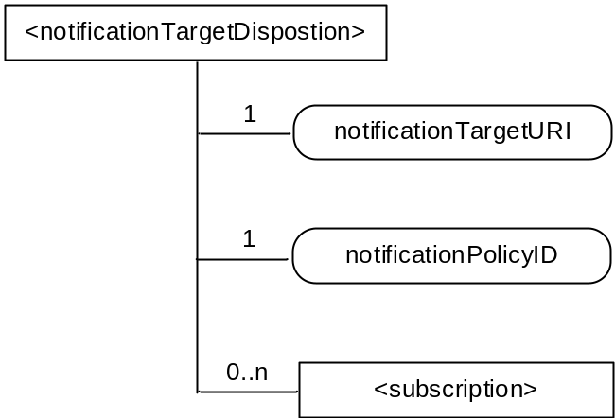
Figure 9.6.X-1: Structure of <notificationTargetDisposition> resource

Table 9.6.X-1: Child resources of <notificationTargetDisposition> resource
Child Resources of <notifcatioonTargetDisposition> | Child Resource Type | Multiplicity | Description
[variable] | <subscription> | 0..n | See clause 9.6.8

Table 9.6.X-2: Attributes of <notificationTargetDisposition> resource
Attributes of <notificationTargets> | Multiplicity | RW/  RO/  WO | Description
resourceType | 1 | RO | See clause 9.6.1.3 where this common attribute is described.
resourceID | 1 | RO | See clause 9.6.1.3 where this common attribute is described.
resourceName | 1 | WO | See clause 9.6.1.3 where this common attribute is described.
parentID | 1 | RO | See clause 9.6.1.3 where this common attribute is described.
expirationTime | 1 | RW | See clause 9.6.1.3 where this common attribute is described.
accessControlPolicyIDs | 0..1 (L) | RW | See clause 9.6.1.3 where this common attribute is described. If no accessControlPolicyIDs is given at the time of creation, the accessControlPolicyIDs of the parent resource is linked to this attribute.
creationTime | 1 | RO | See clause 9.6.1.3 where this common attribute is described.
labels | 0..1 (L) | RW | See clause 9.6.1.3 where this common attribute is described
lastModifiedTime | 1 | RO | See clause 9.6.1.3 where this common attribute is described.
notificationTargetURI | 1 (L) | RW | address(es) of the resource subscriber receiving a notification.The notificationTarget URI must be listed in the subscription resource attribute notificationURI, otherwise the subscription shall be rejected.
notificationlPolicyID | 1 | RW | A link to the <notificationDeletionPolicy> resource applicable to the notificationTargetURI. If none is specified than the default policy shall apply to the targetNotificationURI. See clause 9.6.Z for an explanation of the <notificationDeletionPolicy > resource.

9.6.Z Resource Type notificationDeletionPolicy
The <notificationDeletionPolicy> resource is a child resource of <CSEBase> resource and lists the policies to be applied by the hosting CSE. A policy has a rules(s), representd by the <policyDeletionRules> and an action. The action is applied when the rules in the policy are fulfilled.
Rules are grouped in 2 groups to support a combination of rules for flexbiblilty eg. ((rule 1 AND rule 2) OR rule 3) A maximum of two groups of <policyDeletionRules> can be defined. The relationship to be applied between the 2 groups (AND/OR) shall be defined in the ruleRelationShip attribute. If no rules are defined for a <notificationDeletionPolicy> then the action is executed
Each policy has a label which can take any form. There shall be at minimum a single notificationDeletionPolicy defined with the label “default” to be applied when no specific policy is defined for a Target Notification.

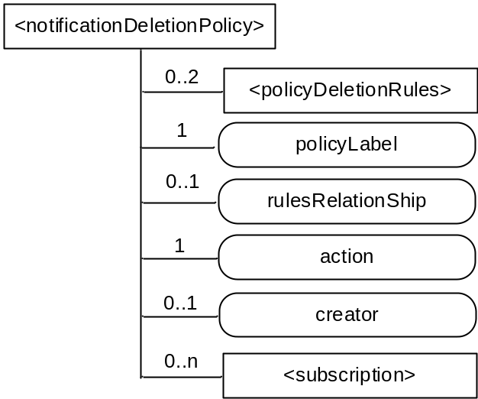
Figure 9.6.Z-1: Structure of <notificationDeletionPolicy> resource

Table 9.6.Z-1:: Child resources of <notificationDeletionPolicy> resource
Child Resources of <notifcatioonTarget> | Child Resource Type | Multiplicity | Description
[variable] | <policyDeletionRules> | 0..2 | Groups listing the of rules that apply to this policy and that needs to be fulfilled for the listed action to take place, Only two groups of rules shall be supported. See 9.6.Y
[variable] | <subscription> | 0..n | See clause 9.6.8

Table 9.6.Y-2: Attributes of <notificationDeletionPolicy> resource
Attributes of <notificationTargets> | Multiplicity | RW/  RO/  WO | Description
resourceType | 1 | RO | See clause 9.6.1.3 where this common attribute is described.
resourceID | 1 | RO | See clause 9.6.1.3 where this common attribute is described.
resourceName | 1 | WO | See clause 9.6.1.3 where this common attribute is described.
parentID | 1 | RO | See clause 9.6.1.3 where this common attribute is described.
expirationTime | 1 | RW | See clause 9.6.1.3 where this common attribute is described.
accessControlPolicyIDs | 0..1 (L) | RW | See clause 9.6.1.3 where this common attribute is described. If no accessControlPolicyIDs is given at the time of creation, the accessControlPolicyIDs of the parent resource is linked to this attribute.
creationTime | 1 | RO | See clause 9.6.1.3 where this common attribute is described.
labels | 0..1 (L) | RW | See clause 9.6.1.3 where this common attribute is described
lastModifiedTime | 1 | RO | See clause 9.6.1.3 where this common attribute is described.
action | 1 | RW | Defines the action to be performed if the groups of rules are fulfilled.  The action includes at least one of the following; accept request, reject request, seek authorization from subscription originator before responding, or inform the subscription originator without taking any action; the subscription originator may update the subscription at a later time to remove the Target Notification
policyLabel | 1 | RW | At minimum a default policy must be specified. The policyLabel “Default” must be used in this case.
rulesRelationship | 0..1 | RW | Shall be either AND or OR This attribute is mandatory if more than on policy DeletionRule is specified
creator | 0..1 | RO | The AE-ID or CSE-ID of the entity which created the resource.

9.6.Y Resource Type policyDeletionRules
The <policyDeletionRules> resource lists the rules to be applied by the hosting CSE during policy execution. Each <policyDeletionRules> can define any number of rules with an AND or OR relationship to be applied between them. The attribute deletionRules Relation define the relationship between rules. It can have an AND or OR value

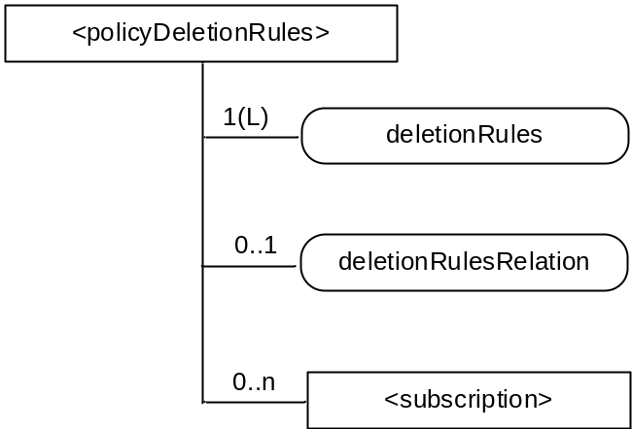
Figure 9.6.Y-1: Structure of <policyDeletionRules> resource

Table 9.6.Y-1:: Child resources of <policyDeletionRules> resource
Child Resources of <notifcatioonTarget> | Child Resource Type | Multiplicity | Description
[variable] | <subscription> | 0..n | See clause 9.6.8

Table 9.6.Y-2: Attributes of <rules> resource
Attributes of <notificationTargets> | Multiplicity | RW/  RO/  WO | Description
resourceType | 1 | RO | See clause 9.6.1.3 where this common attribute is described.
resourceID | 1 | RO | See clause 9.6.1.3 where this common attribute is described.
resourceName | 1 | WO | See clause 9.6.1.3 where this common attribute is described.
parentID | 1 | RO | See clause 9.6.1.3 where this common attribute is described.
expirationTime | 1 | RW | See clause 9.6.1.3 where this common attribute is described.
accessControlPolicyIDs | 0..1 (L) | RW | See clause 9.6.1.3 where this common attribute is described. If no accessControlPolicyIDs is given at the time of creation, the accessControlPolicyIDs of the parent resource is linked to this attribute.
creationTime | 1 | RO | See clause 9.6.1.3 where this common attribute is described.
labels | 0..1 (L) | RW | See clause 9.6.1.3 where this common attribute is described
lastModifiedTime | 1 | RO | See clause 9.6.1.3 where this common attribute is described.
deletionRule | 0..1(L) | RW | Lists the applicable rules. The rules include at minimum ; time of the day, geaographical location of the Target Notification. Where the rule applies
deletionRuleRelation | 0..1 | RW | Defines the relation to be applied between the deletionrule Can take the value AND or OR.

-----------------------End of change 1---------------------------------------------

-----------------------Start of change 2-------------------------------------------

9.6.8 Resource Type subscription
The <subscription> resource contains subscription information for its subscribed-to resource. The <subscription> resource is a child of the subscribed-to resource.
The <subscription> resource shall be represented as child resource of the subscribed-to resource. For example, <container> resource has <subscription> resource as a child resource (see clause 9.6.6). A <subscription> resource shall be deleted when the parent subscribed-to resource is deleted.
The <subscription> resource shall represent a subscription to a subscribed-to resource. An Originator shall be able to create a resource of <subscription> resource type when the Originator has RETRIEVE privilege to the subscribe-to resource. The Originator which creates a <subscription> resource becomes the resource subscriber.
Each <subscription> may include notification policies that specify which, when, and how notifications are sent. These notification policies may work in conjunction with CMDH policies.
When a <subscription> resource is deleted, a Notify request shall be sent to the subscriberURI if it is provided by the Originator.
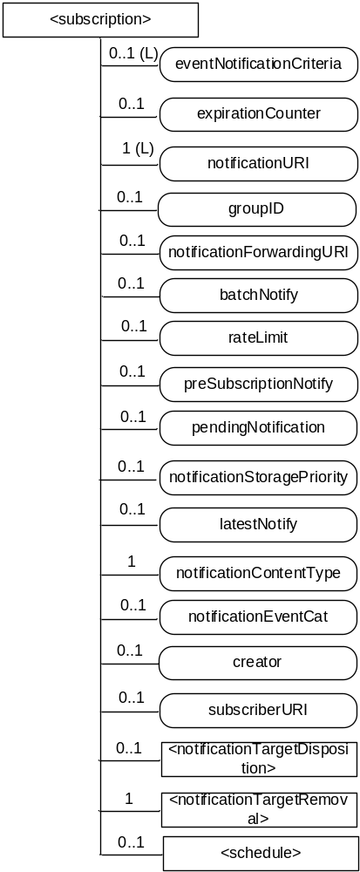
Figure 9.6.8-1: Structure of <subscription> resource
The <subscription> resource shall contain the child resources specified in table 9.6.8-1.
Table 9.6.8-1: Child resources of <subscription> resource
Child Resources of <subscription> | Child Resource Type | Multiplicity | Description
notificationSchedule | <schedule> | 0..1 | In the context of the <subscription> resource, the notificationSchedule specifies when notifications may be sent by the Hosting CSE to the notificationURI(s). See clause 9.6.9.
[variable] | <notificationTargetDispostion> | 0..n | See 9.6.X for this type of resource.
notificationTargetRemoval | <notificationTargetRemoval> | 1 | See 9.6.W for this type of resource.

The <subscription> resource shall contain the attributes specified in table 9.6.8-2.
Table 9.6.8-2: Attributes of <subscription> resource
Attributes of <subscription> | Multiplicity | RW/  RO/  WO | Description
resourceType | 1 | RO | See clause 9.6.1.3 where this common attribute is described.
resourceID | 1 | RO | See clause 9.6.1.3 where this common attribute is described.
resourceName | 1 | WO | See clause 9.6.1.3 where this common attribute is described.
parentID | 1 | RO | See clause 9.6.1.3 where this common attribute is described.
expirationTime | 1 | RW | See clause 9.6.1.3 where this common attribute is described.
creationTime | 1 | RO | See clause 9.6.1.3 where this common attribute is described.
lastModifiedTime | 1 | RO | See clause 9.6.1.3 where this common attribute is described.
labels | 1 (L) | RW | See clause 9.6.1.3 where this common attribute is described.
accessControlPolicyIDs | 0..1 (L) | RW | See clause 9.6.1.3 where this common attribute is described.  If no accessControlPolicyIDs is given at the time of creation, the accesControlPolicies of the parent resource is linked to this attribute.
eventNotificationCriteria | 0..1 (L) | RW | This attribute (notification policy) indicates the event criteria for which a notification is to be generated.
expirationCounter | 0..1 | RW | This attribute (notification policy) indicates that the subscriber wants to set the life of this subscription to a limit of a maximum number of notifications. When the number of notifications sent reaches the count of this counter, the <subscription> resource shall be deleted, regardless of any other policy.
notificationURI | 1 (L) | RW | List of URI(s) and/or address(es) where the resource subscriber will receive notifications. URI(s) in the list may not represent the resource subscriber entity. For a group-related subscription, the notificationURI shall be the URI that is generated by the group Hosting CSE to receive notifications. In this case, the resource subscriber notification URI shall be included in the notificationForwardingURI.
groupID | 0..1 | RW | The ID of a <group> resource in case the subscription is made through a group.
notificationForwardingURI | 0..1 | RW | The attribute is a forwarding attribute that shall be present only for group related subscriptions. It represents the resource subscriber notification URI. It shall be used by group Hosting CSE for forwarding aggregated notifications. See clauses 10.2.7.11 and 10.2.7.12.
batchNotify | 0..1 | RW | This attribute (notification policy) indicates that the subscriber wants to receive batches of notifications rather than receiving them one at a time. This attribute expresses the subscriber's notification policy and may include two values: the number of notifications to be batched for delivery and a duration. When either value is set, notification events are temporarily stored until either the specified number of notifications have been batched, or, until a duration which starts after the first notification was generated has expired. Following which the batched notifications are sent. If batchNotify is used simultaneously with latestNotify, only the latest notification shall be sent and have the Event Category set to "latest".
rateLimit | 0..1 | RW | This attribute (notification policy) indicates that the subscriber wants to limit the rate at which it receives notifications. This attribute expresses the subscriber's notification policy and includes two values: a maximum number of events that may be sent within some duration, and the rateLimit window duration. When the number of generated notifications within the rateLimit window duration exceeds the maximum number, notification events are temporarily stored, until the end of the window duration, when the sending of notification events restarts in the next window duration. The sending of notification events continues as long as the maximum number of notification events is not exceeded during the window duration. The rateLimit policy may be used simultaneously with other notification policies.
preSubscriptionNotify | 0..1 | WO | This attribute (notification policy) indicates that the subscriber wants to be sent notifications for events that were generated prior to the creation of this subscription. This attribute has a value of the number of prior notification events requested. If up-to-date caching of retained events is supported on the Hosting CSE and contains the subscribed events then prior notification events will be sent up to the number requested. The preSubscriptionNotify policy may be used simultaneously with any other notification policy.
pendingNotification | 0..1 | RW | This attribute (notification policy), if set, indicates how missed notifications due to a period of connectivity (according to the reachability and notification schedules). The possible values for pendingNotification are:  "sendLatest"  "sendAllPending"  This policy depends upon caching of retained notifications on the hosted CSE. When this attribute is set to " sendLatest ", only the last notification shall be sent and it shall have the Event Category set to "latest". If this attribute is not present, the Hosting CSE sends no missed notifications. This policy applies to all notifications regardless of the selected delivery policy (batchNotify, latestNotify, etc.) Note that unreachability due to reasons other than scheduling is not covered by this policy.
notificationStoragePriority | 0..1 | RW | Indicates that the subscriber wants to set a priority for this subscription relative to other subscriptions belonging to this same subscriber. This attribute sets a number within the priority range. When storage of notifications exceeds the allocated size, this policy is used as an input with the storage congestion policy (notificationCongestionPolicy) specified in clause 9.6.3 to determine which stored and generated notifications to drop and which ones to retain.
latestNotify | 0..1 | RW | This attribute (notification policy) indicates if the subscriber wants only the latest notification. If multiple notifications of this subscription are buffered, and if the value of this attribute is set to true, then only the last notification shall be sent and it shall have the Event Category value set to "latest".
notificationContentType | 1 | RW | Indicates a notification content type that shall be contained in notifications. The allowed values are:  - “attributes”: modified attributes only of the subscribed-to resource  - “resource”: the representation of the subscribed-to resource  - “child-resource”: the representation of the newly created child resource  - “resource-ID”: the ID of the subscribed-to resource  - “child-resource-ID”: the ID of the newly created child resource
notificationEventCat | 0..1 | RW | This attribute (notification policy) indicates the subscriber's requested Event Category to be used for notification messages generated by this subscription.
creator | 0..1 | WO | AE-ID or CSE-ID which created the <subscription> resource.
subscriberURI | 0..1 | WO | URI that is sent a notification when this <subscription> is deleted.

Table 9.6.8-3 describes the eventNotificationCriteria conditions.
Table 9.6.8-3: eventNotificationCriteria conditions
Condition tag | Multiplicity | Matching condition
createdBefore | 0..1 | The creationTime attribute of the resource is chronologically before the specified value.
createdAfter | 0..1 | The creationTime attribute of the resource is chronologically after the specified value.
modifiedSince | 0..1 | The lastModifiedTime attribute of the resource is chronologically after the specified value.
unmodifiedSince | 0..1 | The lastModifiedTime attribute of the resource is chronologically before the specified value.
stateTagSmaller | 0..1 | The stateTag attribute of the resource is smaller than the specified value.
stateTagBigger | 0..1 | The stateTag attribute of the resource is bigger than the specified value.
expireBefore | 0..1 | The expirationTime attribute of the resource is chronologically before the specified value.
expireAfter | 0..1 | The expirationTime attribute of the resource is chronologically after the specified value.
sizeAbove | 0..1 | The contentSize attribute of the <contentInstance> resource is equal to or greater than the specified value.
sizeBelow | 0..1 | The contentSize attribute of the <contentInstance> resource is smaller than the specified value.
operationMonitor | 0..n | The operations accessing the subscribed-to resource matches with the specified value. It allows monitoring which operation is attempted to the subscribed-to resource regardless of whether the operation is performed. This feature is useful when to find malicious AEs. Possible string arguments are: create, retrieve, update, delete.
attribute | 0..n | This is an attribute name of resource types (clause 9.6). E.g. creator of container resource type can be used as "creator=Sam". When multiple attributes are set then the result is based upon the AND of all attributes.

-----------------------End of change 2-------------------------------------------

-----------------------Start of change 3-------------------------------------------

9.6.W Resource Type notificationTargetRemoval
The <notificationTargetRemoval> resource is a virtual resource, which does not have a representation and it is the child resource of a <subscription> resource. Whenever a Delete Request is sent to the <notificationTargetRemoval> resource from a Notification Target which wants to remove itself from the Notification Target list (i.e., notificationURI) later, the Notifier shall act accroding to the action attribute defined in the <notificationDeletionPolicy> resource which is linked from the <notificationTargteDisposition> resource.
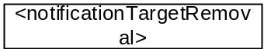
Figure 9.6.w-1: Structure of <notificationTargetRemoval> resource

-----------------------End of change 3-------------------------------------------

-----------------------Start of change 4-------------------------------------------

10.2.X <notificationTargetDisposition> Resource Procedures

10.2.X.1 Create <notificationTargetDisposition>
This procedure shall be used for creating a <notificationTargetDisposition> resource.
Table 10.2.X.1-1: <notificationTargetDisposition> CREATE
<notificationTargetDisposition> CREATE
Associated Reference Point | Mca, Mcc and Mcc'
Information in Request message | All parameters defined in table 8.1.2-2 apply with the specific details for:  Content: The resource content shall provide the information as defined in clause 9.6.6
Processing at Originator before sending Request | According to clause 10.1.1.1
Processing at Receiver | According to clause 10.1.1.1
Information in Response message | According to clause 10.1.1.1
Processing at Originator after receiving Response | According to clause 10.1.1.1
Exceptions | According to clause 10.1.1.1

10.2.X.2 Retrieve <notificationTargetDisposition>
This procedure shall be used for retrieving the attributes of a <notificationTargetDisposition> resource.
Table 10.2.X.2-1: <notificationTargetDisposition> RETRIEVE
<notificationTargetDisposition> RETRIEVE
Associated Reference Point | Mca, Mcc and Mcc'
Information in Request message | All parameters defined in table 8.1.2-2 apply.
Processing at Originator before sending Request | According to clause 10.1.2
Processing at Receiver | According to clause 10.1.2
Information in Response message | All parameters defined in table 8.1.3-1 apply.
Processing at Originator after receiving Response | According to clause 10.1.2
Exceptions | According to clause 10.1.2

10.2.X.3 Update <notificationTargetDisposition>
This procedure shall be used for updating attributes of a <notificationTargetDisposition> resource.
Table 10.2.X.3-1: <notificationTargetDisposition> UPDATE
<notificationTargetDisposition> UPDATE
Associated Reference Point | Mca, Mcc and Mcc'
Information in Request message | All parameters defined in table 8.1.2-2 apply.
Processing at Originator before sending Request | According to clause 10.1.3
Processing at Receiver | According to clause 10.1.3
Information in Response message | According to clause 10.1.3
Processing at Originator after receiving Response | According to clause 10.1.3
Exceptions | According to clause 10.1.3

10.2.X.4 Delete <notificationTargetDisposition>
This procedure shall be used for deleting a <notificationTargetDisposition> resource .
Table 10.2.X.4-1: <notificationTargetDisposition> DELETE
<notificationTargetDisposition> DELETE
Associated Reference Point | Mca, Mcc and Mcc'
Information in Request message | All parameters defined in table 8.1.2-2 apply
Processing at Originator before sending Request | According to clause 10.1.4.1
Processing at Receiver | According to clause 10.1.4.1
Information in Response message | According to clause 10.1.4.1
Processing at Originator after receiving Response | According to clause 10.1.4.1
Exceptions | According to clause 10.1.4.1

10.2.Y <notificationDeletionPolicy> Resource Procedures

10.2.Y.1 Create <notificationDeletionPolicy>
This procedure shall be used for creating a <notificationDeletionPolicy> resource.
Table 10.2.Y.1-1: <notificationDeletionPolicy> CREATE
<notificationDeletionPolicy> CREATE
Associated Reference Point | Mca, Mcc and Mcc'
Information in Request message | All parameters defined in table 8.1.2-2 apply with the specific details for:  Content: The resource content shall provide the information as defined in clause 9.6.6
Processing at Originator before sending Request | According to clause 10.1.1.1
Processing at Receiver | According to clause 10.1.1.1
Information in Response message | According to clause 10.1.1.1
Processing at Originator after receiving Response | According to clause 10.1.1.1
Exceptions | According to clause 10.1.1.1

10.2.Y.2 Retrieve <notificationDeletionPolicy>
This procedure shall be used for retrieving the attributes of a <notificationDeletionPolicy> resource.
Table 10.2.Y.2-1: <notificationDeletionPolicy> RETRIEVE
<notificationDeletionPolicy> RETRIEVE
Associated Reference Point | Mca, Mcc and Mcc'
Information in Request message | All parameters defined in table 8.1.2-2 apply.
Processing at Originator before sending Request | According to clause 10.1.2
Processing at Receiver | According to clause 10.1.2
Information in Response message | All parameters defined in table 8.1.3-1 apply.
Processing at Originator after receiving Response | According to clause 10.1.2
Exceptions | According to clause 10.1.2

10.2.Y.3 Update <notificationDeletionPolicy>
This procedure shall be used for updating attributes of a <notificationDeletionPolicy> resource.
Table 10.2.Y.3-1: <notificationDeletionPolicy> UPDATE
<notificationDeletionPoiicy> UPDATE
Associated Reference Point | Mca, Mcc and Mcc'
Information in Request message | All parameters defined in table 8.1.2-2 apply.
Processing at Originator before sending Request | According to clause 10.1.3
Processing at Receiver | According to clause 10.1.3
Information in Response message | According to clause 10.1.3
Processing at Originator after receiving Response | According to clause 10.1.3
Exceptions | According to clause 10.1.3

10.2.Y.4 Delete <notificationDeletionPolicy>
This procedure shall be used for deleting a <notificationDeletionPolicy> resource .
Table 10.2.Y.4-1: <notificationDeletionPolicy> DELETE
<notificationDeletionPolicy> DELETE
Associated Reference Point | Mca, Mcc and Mcc'
Information in Request message | All parameters defined in table 8.1.2-2 apply
Processing at Originator before sending Request | According to clause 10.1.4.1
Processing at Receiver | According to clause 10.1.4.1
Information in Response message | According to clause 10.1.4.1
Processing at Originator after receiving Response | According to clause 10.1.4.1
Exceptions | According to clause 10.1.4.1

10.2.Z <policyDeletionRules> Resource Procedures

10.2.Z.1 Create <policyDeletionRules>
This procedure shall be used for creating a <policyDeletionRules> resource.
Table 10.2.Z.1-1: <policyDeletionRules> CREATE
<policyDeletionRules> CREATE
Associated Reference Point | Mca, Mcc and Mcc'
Information in Request message | All parameters defined in table 8.1.2-2 apply with the specific details for:  Content: The resource content shall provide the information as defined in clause 9.6.6
Processing at Originator before sending Request | According to clause 10.1.1.1
Processing at Receiver | According to clause 10.1.1.1
Information in Response message | According to clause 10.1.1.1
Processing at Originator after receiving Response | According to clause 10.1.1.1
Exceptions | According to clause 10.1.1.1

10.2.Z.2 Retrieve <policyDeletionRules>
This procedure shall be used for retrieving the attributes of a <policyDeletionRules> resource.
Table 10.2.Z.2-1: <policyDeletionRules> RETRIEVE
<policyDeletionRules> RETRIEVE
Associated Reference Point | Mca, Mcc and Mcc'
Information in Request message | All parameters defined in table 8.1.2-2 apply.
Processing at Originator before sending Request | According to clause 10.1.2
Processing at Receiver | According to clause 10.1.2
Information in Response message | All parameters defined in table 8.1.3-1 apply.
Processing at Originator after receiving Response | According to clause 10.1.2
Exceptions | According to clause 10.1.2

10.2.Z.3 Update <policyDeletionRules>
This procedure shall be used for updating attributes of a <policyDeletionRules> resource.
Table 10.2.Z.3-1: <policyDeletionRules> UPDATE
<poiicyDeletionRules> UPDATE
Associated Reference Point | Mca, Mcc and Mcc'
Information in Request message | All parameters defined in table 8.1.2-2 apply.
Processing at Originator before sending Request | According to clause 10.1.3
Processing at Receiver | According to clause 10.1.3
Information in Response message | According to clause 10.1.3
Processing at Originator after receiving Response | According to clause 10.1.3
Exceptions | According to clause 10.1.3

10.2.Z.4 Delete <policyDeletionRules>
This procedure shall be used for deleting a <policyDeletionRules> resource .
Table 10.2.Z.4-1: <policyDeletionRules> DELETE
<policyDeletionRules> DELETE
Associated Reference Point | Mca, Mcc and Mcc'
Information in Request message | All parameters defined in table 8.1.2-2 apply
Processing at Originator before sending Request | According to clause 10.1.4.1
Processing at Receiver | According to clause 10.1.4.1
Information in Response message | According to clause 10.1.4.1
Processing at Originator after receiving Response | According to clause 10.1.4.1
Exceptions | According to clause 10.1.4.1

-----------------------End of change 4-------------------------------------------

-----------------------Start of change 5-------------------------------------------

9.6.3 Resource Type CSEBase
A <CSEBase> resource shall represent a CSE. The <CSEBase> resource shall be the root for all resources that are residing in the CSE.
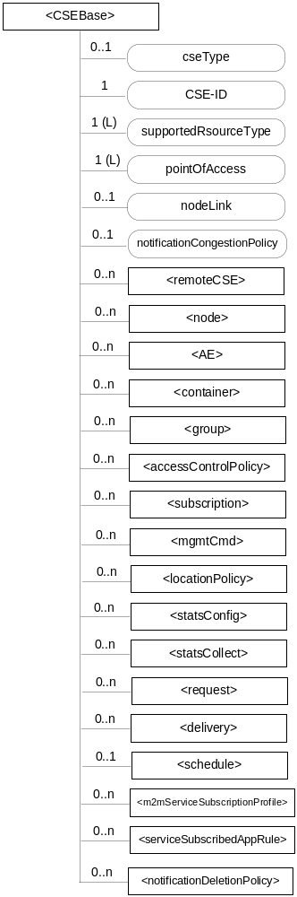
Figure 9.6.3-1: Structure of <CSEBase> resource
Figure 9.6.3-1 does not show the child announce resource types defined in table 9.6.3-2.
The <CSEBase> resource shall contain the child resources specified in table 9.6.3-1.
Table 9.6.3-1: Child resources of <CSEBase> resource
Child Resources of <CSEBase> | Child Resource Type | Multiplicity | Description
[variable] | <remoteCSE> | 0..n | See clause 9.6.4
[variable] | <node> | 0..n | See clause 9.6.18
[variable] | <AE> | 0..n | See clause 9.6.5
[variable] | <container> | 0..n | See clause 9.6.6
[variable] | <group> | 0..n | See clause 9.6.13
[variable] | <accessControlPolicy> | 0..n | See clause 9.6.2
[variable] | <subscription> | 0..n | See clause 9.6.8
[variable] | <mgmtCmd> | 0..n | See clause 9.6.16
[variable] | <locationPolicy> | 0..n | See clause 9.6.10
[variable] | <statsConfig> | 0..n | See clause 9.6.23
[variable] | <statsCollect> | 0..n | See clause 9.6.25
[variable] | <request> | 0..n | See clause 9.6.12
[variable] | <delivery> | 0..n | See clause 9.6.11
[variable] | <schedule> | 0..1 | This resource defines the reachability schedule information of the entity. The absence of this resource implies the entity is always reachable. See clause 9.6.9
[variable] | <m2mServiceSubscriptionProfile> | 0..n | See clause 9.6.19
[variable] | <serviceSubscribedAppRule> | 0..n | See clause 9.6.29
[variable] | <notificationDeletionPolicy> | 0..n | See clause 9.6.Z

Table 9.6.3-2: Child announced resources of <CSEBase> resource
Child Announced Resources of <CSEBase> | Child Announced Resource Type | Multiplicity | Description
[variable] | Refer Table 9.6.26.1-1 Announced Resource Types | 0..n

The child announced resources of <CSEBase> resource defined in table 9.6.3-2 should be created when an Originator CSE (i.e. original resource Hosting CSE) and a Hosting CSE (i.e. announced resource Hosting CSE) have no registration relationship (e.g. the Originator CSE has not created <remoteCSE> resource on the Hosting CSE).
The <CSEBase> resource shall contain the attributes specified in table 9.6.3-3.
Table 9.6.3-3: Attributes of <CSEBase> resource
Attributes of <CSEBase> | Multiplicity | RW/  RO/  WO | Description
resourceType | 1 | RO | See clause 9.6.1.3 where this common attribute is described.
resourceID | 1 | RO | See clause 9.6.1.3 where this common attribute is described.
resourceName | 1 | WO | See clause 9.6.1.3 where this common attribute is described.
creationTime | 1 | RO | See clause 9.6.1.3 where this common attribute is described.
lastModifiedTime | 1 | RO | See clause 9.6.1.3 where this common attribute is described.
accessControlPolicyIDs | 0..1 (L) | RO | See clause 9.6.1.3 where this common attribute is described.
Labels | 0..1 (L) | RO | See clause 9.6.1.3 where this common attribute is described.
cseType | 0..1 | RO | Indicates the type of CSE represented by the created resource.  - Mandatory for an IN-CSE, hence multiplicity (1).  - Its presence is subject to SP configuration in case of an ASN-CSE or a MN-CSE.
CSE-ID | 1 | RO | The CSE identifier in SP-relative CSE-ID format (clause 7.2).
supportedResourceType | 1 (L) | RO | List of the resource types which are supported in the CSE. This attribute contains subset of resource types listed in clause 9.2. This also includes the supported optional attributes for each supported resource type.
pointOfAccess | 1 (L) | RO | Represents the list of physical addresses to be used by remote CSEs to connect to this CSE (e.g. IP address, FQDN). This attribute is exposed to its Registree.
nodeLink | 0..1 | RO | The resourceID of a <node> resource that represents the node specific information.
notificationCongestionPolicy | 0..1 | RO | This attribute applies to CSEs generating subscription notifications. It specifies the rule which is applied when the storage of notifications for each subscriber (an AE or CSE) reaches the maximum storage limit for notifications for that subscriber. E.g. Delete stored notifications of lower notificationStoragePriority to make space for new notifications of higher notificationStoragePriority, or delete stored notifications of older creationTime to make space for new notifications when all notifications are of the same notificationStoragePriority.
NOTE: All the attributes of this resource type can be changed by an offline configuration mechanism, but not over the reference points (all attributes are "RO").

-----------------------End of change 5-------------------------------------------

-----------------------Start of change 6-------------------------------------------

9.6.1.1 Resource Type Summary
Table 9.6.1.1-1 introduces the normal and virtual resource types and their related child or parent resource types. Details of each resource type follow in the remainder of this clause.
Table 9.6.1.1-1 lists each specified <resourceType>. An addition of suffix "Annc" to such <resourceTypes> indicates the associated announced resource type.
Table 9.6.1.1-1 Resource Types
Resource Type | Short Description | Child Resource Types | Parent Resource Types | Clause
accessControlPolicy | Stores a representation of privileges. It is associated with resources that shall be accessible to entities external to the Hosting CSE. It controls "who" is allowed to do "what" and the context in which it can be used for accessing resources | subscription | AE, AEAnnc, remoteCSE, remoteCSEAnnc, CSEBase | 9.6.2
AE | Stores information about the AE. It is created as a result of successful registration of an AE with the Registrar CSE | subscription, container, group, accessControlPolicy,  schedule, pollingChannel | remoteCSE, remoteCSEAnnc, CSEBase | 9.6.5
Container | Shares data instances among entities. Used as a mediator that buffers data exchanged between AEs and/or CSEs. The exchange of data between AEs (e.g. an AE on a Node in a field domain and the peer-AE on the infrastructure domain) is abstracted from the need to set up direct connections and allows for scenarios where both entities in the exchange do not have the same reachability schedule | container, contentInstance, subscription, latest, oldest | AE, AEAnnc, container, containerAnnc, remoteCSE, remoteCESAnnc, CSEBase | 9.6.6
contentInstance | Represents a data instance in the <container> resource | None specified | Container, containerAnnc | 9.6.7
CSEBase | The structural root for all the resources that are residing on a CSE. Stores information about the CSE itself | remoteCSE, remoteCSEAnnc, node, AE, container, group, accessControlPolicy, subscription,, mgmtCmd, locationPolicy, statsConfig, statsCollect, request, delivery,  schedule,  notificationDeletionPolicy | None specified | 9.6.3
Delivery | Forwards requests from CSE to CSE | subscription | CSEBase | 9.6.11
eventConfig | Defines events that trigger statistics collection | subscription | statsConfig | 9.6.24
execInstance | Contains all execution instances of the same Management Command | subscription | mgmtCmd | 9.6.17
fanOutPoint (V) | Virtual resource containing target for group request  It is used for addressing bulk operations to all the resources that belong to a group | None specified | group | 9.6.14
Group | Stores information about resources of the same type that need to be addressed as a Group. Operations addressed to a Group resource shall be executed in a bulk mode for all members belonging to the Group | fanOutPoint,  subscription | AE, AEAnnc, remoteCSE, remoteCSEAnnc, CSEBase | 9.6.13
latest (V) | Virtual resource that points to most recently created <contentInstance> child resource within a <container> resource | None specified | container | 9.6.27
locationPolicy | Includes information to obtain and manage geographical location. It is only referenced within a container, the contentInstances of the container provide location information | subscription | CSEBase | 9.6.10
mgmtCmd | Management Command resource represents a method to execute management procedures required by existing management protocols | execInstance,  subscription | CSEBase | 9.6.16
mgmtObj | Management Object resource represents management functions that provides an abstraction to be mapped to external management technology. It represents the node and the software installed in the node (see note) | subscription, mgmtObj, schedule | node, mgmtObj, mgmtObjAnnc | 9.6.15  Annex D
m2mServiceSubscriptionProfile | Data pertaining to the M2M Service Subscription | serviceSubscribedNode,  subscription | CSEBase | 9.6.19
Node | Represents specific Node information | mgmtObj,  subscription | CSEBase, remoteCSE | 9.6.18
notificationTargetDisposition | Represents a list of notification targets and the deletion policy | subscription | subscription | 9.6.X
notificationDeletionPolicy | Represents a notification target deletion policy with pre-defined action and deletion rules | subscription, policyDeletionRules | CSEBase | 9.6.Z
notificationTargetRemoval(V) | Virtual resource used to remove the Notification Target | None specified | subscription | 9.6.W
oldest (V) | Virtual resource that points to first created <contentInstance> child resource within a <container> resource | None specified | container | 9.6.28
pollingChannel | Represent a channel that can be used for a request-unreachable entity | pollingChannelURI | remoteCSE, AE | 9.6.21
pollingChannelURI (V) | Virtual resource used to perform service layer long polling of a resource Hosting CSE by a request-unreachable entity | None specified | pollingChannel | 9.6.22
policyDeletionRules | Represents a set of rules which is associated with notification target removal policy | subscription | notificationDeletionPolicy | 9.6.Y
remoteCSE | Represents a remote CSE for which there has been a registration procedure with the registrar CSE identified by the CSEBase resource | AE, container, group, accessControlPolicy, subscription, pollingChannel, schedule, node | CSEBase | 9.6.4
Request | Expresses/access context of an issued Request | subscription | CSEBase | 9.6.12
Schedule | Contains scheduling information for delivery of messages | subscription | subscription, CSEBase, remoteCSE,AE | 9.6.9
serviceSubscribedNode | Node information | subscription | m2mServiceSubscriptionProfile | 9.6.20
statsCollect | Defines triggers for the IN-CSE to collect statistics for applications | subscription | CSEBase (in IN-CSE) | 9.6.25
statsConfig | Stores configuration of statistics for applications | eventConfig,  subscription | CSEBase (in IN-CSE) | 9.6.23
Subscription | Subscription resource represents the subscription information related to a resource. Such a resource shall be a child resource for the subscribe-to resource | Schedule,notificationTargetRemoval, notificationTargetDisposition | accessControlPolicy,accessControlPolicyAnnc, AE, AEAnnc, container, CSEBase, delivery, eventConfig, execInstance, group, groupAcce, locationPolicy, mgmtCmd, mgmtObj, mgmtObjAnnc, m2mServiceSubscriptionProfile, node, nodeAnnc, serviceSubscribedNode, remoteCSE, remoteCSEAnnc, request, schedule, statsCollect, statsConfig | 9.6.8
serviceSubscribedAppRule | Represents a rule that defines allowed App-ID and AE-ID combinations that are acceptable for registering an AE on a Registrar CSE | Subscription | CSEBase | 9.6.29
NOTE: See clause 9.6.12 for a summary of specializations of <mgmtObj>.

-----------------------End of change 6-------------------------------------------

CHECK LIST
- Does this change request include an informative introduction containing the problem(s) being solved, and a summary list of proposals.?
- Does this CR contain changes related to only one particular issue/problem?
- Does this change request make all the changes necessary to address the issue or problem? E.g. A change impacting 5 tables should not only include a proposal to change only 3 tables. Includes any changes to references, definitions, and acronyms in the same deliverable?
- Does this change request follow the drafting rules?
- Are all pictures editable?
- Have you checked the spelling and grammar?
- Have you used change bars for all modifications?
- Does the change include the current and surrounding clauses to clearly show where a change is located and to provide technical context of the proposed change? (Additions of complete sections need not show surrounding clauses as long as the proposed section number clearly shows where the new section is proposed to be located.)
- Are multiple changes in this CR clearly separated by horizontal lines with embedded text such as, start of change 1, end of change 1, start of new clause, end of new clause.?

