CHANGE REQUEST
Meeting:* | ARC#18
Source:* | Dongjoo Kim (dongjoo7.kim@lge.com)
Date:* | 2015-07-13
Contact:* | Dongjoo Kim (dongjoo7.kim@lge.com)
Reason for Change/s:* | See the introduction below
CR against: Release* | Rel-1
CR against: WI* | Active <Work Item number>  MNT Maintenace / < Work Item number(optional)>  STE Small Technical Enhancements / < Work Item number (optional)>  Only ONE of the above shall be ticked
CR against: TS/TR* | TS-0001 v1.9.0
Clauses/Sub Clauses* | 10.1.1.2.2
Type of change: * | Editorial change  Bug Fix or Correction  Change to existing feature or functionality  New feature or functionality  Only ONE of the above shall be ticked
Post Freeze checking:* | This CR contains only essential changes and corrections? YES NO  This CR may break backwards compatibility with the last approved version of the TS? YES NO  This CR is a mirror CR? YES if YES, please indicate the document number of the original CR: <Document Number) : NO
Template Version:27 May 2015 (Dot not modify)

oneM2M Notice
The document to which this cover statement is attached is submitted to oneM2M. Participation in, or attendance at, any activity of oneM2M, constitutes acceptance of and agreement to be bound by terms of the Working Procedures and the Partnership Agreement, including the Intellectual Property Rights (IPR) Principles Governing oneM2M Work found in Annex 1 of the Partnership Agreement.
GUIDELINES for Change Requests:
Provide an informative introduction containing the problem(s) being solved, and a summary list of proposals.
Each CR should contain changes related to only one particular issue/problem.
In case of a correction, and the change apply to previous releases, a separated “mirror CR” should be posted at the same time of this CR
Follow the principle of completeness, where all changes related to the issue or problem within a deliverable are simultaneously proposed to be made E.g. A change impacting 5 tables should not only include a proposal to change only 3 tables. Includes any changes to references, definitions, and acronyms in the same deliverable.
Follow the drafting rules.
All pictures must be editable.
Check spelling and grammar to the extent practicable.
Use Change bars for modifications.
The change should include the current and surrounding clauses to clearly show where a change is located and to provide technical context of the proposed change. Additions of complete sections need not show surrounding clauses as long as the proposed section number clearly shows where the new section is proposed to be located.
Multiple changes in a single CR shall be clearly separated by horizontal lines with embedded text such as, start of change 1, end of change 1, start of new clause, end of new clause.
When subsequent changes are made to content of a CR, then the accepted version should not show changes over changes. The accepted version of the CR should only show changes relative to the baseline approved text.

Introduction
There are several changes about AE registration procedure in this contribution.
- The From parameter can be set to AE-ID-Stem or NULL. In the first case, it can be either a fully specified AE-ID-Stem value or just a character (‘S’ or ‘C’) to show its intention to get assigned a proper AE-ID-Stem in a particular bound. However the description of the case that the From parameter to the character ‘C’ is missed in this version of specification.
- In case that the From parameter is NULL, the registrar CSE shall assign an appropriate AE-ID-Stem based on the system provider’s policy.
- Service subscription policy should always be checked at the Receiver.
- Miscellaneous corrections.

-----------------------Start of change 1-------------------------------------------

10 Information Flows

10.1 Basic Procedures

10.1.1 CREATE (C)

10.1.1.2 Registration related CREATE procedure

10.1.1.2.2 Application Entity Registration procedure
The procedure for AE registration follows the message flow description depicted in figure 10.1.1.2.2-1. It defines in which cases additional procedures need to be initiated by the Registrar CSE for creating or updating of <AEAnnc> resources hosted on the M2M SP's IN-CSE in case an AE-ID-Stem starting with an 'S' character shall be used, see table 7.2-1 for the definition of AE-ID-Stem.
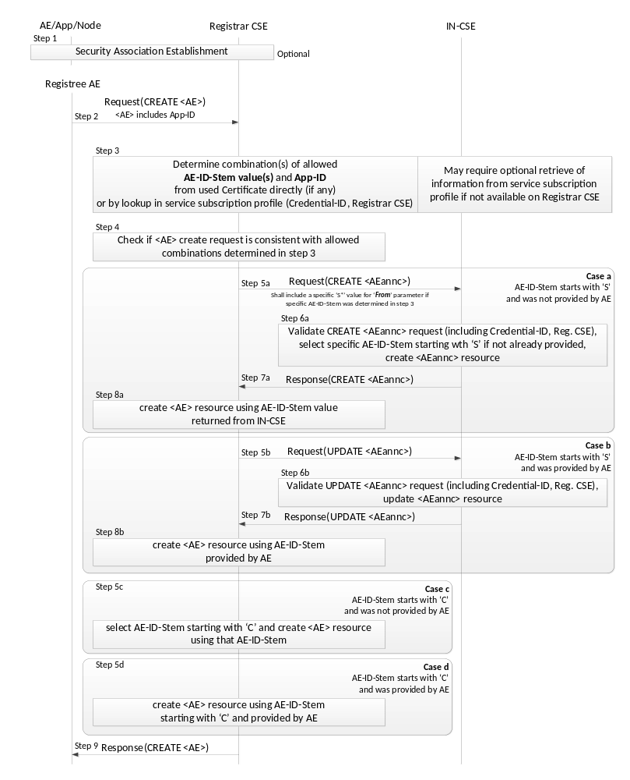
Figure 10.1.1.2.2-1: Procedure for Creating an <AE> Resource
Originator: The Originator shall be the Registree AE.
Receiver: The Receiver shall allow the creation of the <AE> resource according to the access control policy and information in the applicable service subscription profile. The Receiver shall derive the applicable M2M-Service-Profile-ID from the CSE-ID of the Registrar CSE.
Step 001: Optional: In case the Registree AE intends to use a Security Association to perform the registration, a Security Association Establishment procedure (see clause 11.2.2) shall get carried out first. In some cases (e.g. registration of AE internal to an MN or ASN), this may not be required depending on deployment choices of the M2M SP. Therefore, this step is optional. This optional Security Association can be established between the following entities:
- The Registree AE and the Registrar CSE - in which case the specific AE that is subsequently sending the request to get registered shall be authenticated.
- The Node on which the Registree AE is hosted and the Registrar CSE - in which case only the Node from which the registration request is received at the Registrar CSE shall be authenticated. In this case one or more AEs hosted on the authenticated node may communicate over either a single Security Association or over individual Security Associations.
NOTE: The Node authentication should be used only when the M2M Service Provider trusts the AE (on the Node) to provide the correct AE-ID and App-ID. The present document does not provide mechanisms by which the M2M Service Provider can obtain assurance about the trustworthiness of the AE when using Node authentication. For example, such a mechanism (by which the M2M Service Provider can obtain assurance about the trustworthiness of the AE) could be provided by executing the M2M Application on a secure environment.
The identifier of the security credentials used for establishing the Security Association in this step shall be termed 'Credential-ID' for the remainder of this procedure description. If no Security Association has been performed the Credential-ID shall be assumed to have the value 'None'.
Step 002: The Originator shall send the information defined in clause 10.1.1.1 for the registration CREATE procedure with the following specific information in the CREATE Request message:
From: AE-ID-Stem or NULL.
- In case the Registree AE has already registered successfully before, then deregistered and intends to register again with the same AE-ID-Stem value as before, the Registree AE shall include that AE-ID-Stem value into the From parameter.
- In case the Registree AE has not registered successfully before and intends to get an M2M-SP-assigned AE-ID-Stem starting with an 'S' character assigned to itself but it does not have any specific value to suggest, it shall set the From parameter to the character 'S'.
- In case the Registree AE has not registered successfully before and intends to get a Registrar CSE-assigned AE-ID-Stem starting with an ‘C’ character assigned to itself but it does not have any specific value to suggest, it shall set the From parameter to the character ‘C’.
- In case the Registree AE intends to initiate a fresh registration and has no preference for the AE-ID-Stem value, the From parameter shall be set to NULL.
Step 003: The Receiver shall determine whether the request to register the Registree AE meets any of the following conditions:

- In case the Security Association Establishment in Step 001 was performed using security credentials in form of a Certificate that included an App-ID and an AE-ID-Stem attribute, check if they match with the App-ID attribute in the Content parameter of the request and the AE-ID-Stem in the From parameter of the request.
- Check if the applicable service subscription profile lists a combination (allowed AE-ID-Stem value and allowed App-ID value) for the Credential-ID and the Registrar CSE-ID (see clause 11.2.2) that match with the App-ID attribute in the Content parameter of the request and the AE-ID-Stem in the From parameter of the request. If the information needed to perform that checking is not available to the Registrar CSE locally, the Registrar CSE shall retrieve that information from the applicable service subscription profile(s) from the IN-CSE. If the From parameter of the request is Null and the allowed AE-ID-Stem has wild card (“*”) in service subscription profile, the Registrar CSE shall decide the starting character (‘S’, ‘C’) in accordance with provisioned Service Provider policy. The applicable rules for this checking are contained in the <serviceSubscribedAppRule> resource(s) which are linked to by the ruleLinks attribute of the <m2mServiceSubscribedNode> resource(s) associated with the Registrar CSE. The <m2mServiceSubscribedNode> resource(s) associated with the Registrar CSE can be retrieved from the IN-CSE by applying the Filter Criteria parameter set to "CSE-ID={Registrar-CSE-ID}"where {Registrar-CSE-ID} needs to be substituted by the actual CSE-ID of the Registrar-CSE. shall check the applicable service subscription profile using an App-ID and an AE-ID-Stem attributes in that Certificate.
If none of the conditions are met, the registration is not allowed and the Receiver shall respond with an error.
Step 004: If the From parameter of the request provides an AE-ID-Stem value, the Registrar CSE shall check whether an <AE> resource with an Unstructured-CSE-relative-Resource-ID identical to the AE-ID-Stem value provided in the From parameter of the request does already exist. If so, there is still an active registration using the same AE-ID-Stem on the Registrar CSE and the Registrar CSE shall respond with an error. If not, the Registrar CSE shall perform action (3) in Step 002 of clause 10.1.1.1.
The procedure continues with one for the following cases a) - d) depending on the listed conditions:
Case a) AE-ID-Stem starts with 'S' and AE does not include an AE-ID-Stem (initial registration):
Condition: In Step 003 it was determined that the AE-ID-Stem value to be used for the Registree AE starts with an 'S' character but no specific AE-ID-Stem was provided with the CREATE request of the Registree AE. This case applies when the Registrar AE is supposed to use an M2M-SP-assigned AE-ID and wants to perform the initial registration:
Step 005a: The Receiver shall send a CREATE request for an <AEAnnc> resource to the IN-CSE in order to create an <AEAnnc> resource on the IN-CSE that is associated with the Registree AE. The following information shall be sent with that CREATE request:
- In case no specific AE-ID-Stem value to be used for the Registree AE was determined during Step 003, the value 'S' shall be used in what follows for the AE-ID-Stem. Otherwise use the value determined in step 003.
- The From parameter of the CREATE request for the <AEAnnc> resource shall be set to the SP-relative-AE-ID format of the AE-ID. The SP-relative-AE-ID format of the AE-ID (see table 7.2-1) shall be constructed using that AE-ID-Stem.
- The link attribute of the <AEAnnc> resource to be created shall be set to the SP-Relative-Resource-ID format of a - not yet existent - <AE> resource hosted on the Registrar CSE constructed with a Unstructured-CSE-relative-Resource-ID that is equal to the AE-ID-Stem value used for the Registree AE.
- The App-ID attribute of the <AEAnnc> resource to be created shall be present and set to the App-ID attribute value of the Registree AE.
- The concatenation of the string 'Credential-ID:' and the actual Credential-ID of the Security Association used by the Registree AE - if any - shall be placed into the labels attribute of the <AE Annc> resource. If no noSecurity Association was used by the Registree AE, a value of 'None' shall be used for Credential-ID.
Step 006a: Upon reception of the CREATE <AEAnnc> request, the IN-CSE shall validate the request and verify whether the provided values of the App-ID attribute and the AE-ID-Stem in the From parameter is allowed for the combination of Credential-ID included in the labels attribute and the CSE-ID of the Registrar CSE included in the link attribute, according to the applicable service subscription profile. If that verification is successful and no specific AE-ID-Stem is provided, i.e. if the From parameter contains only the character 'S', the IN-CSE shall select an AE-ID-Stem in line with the applicable service subscription profile.
Step 007a: When the validation and verification in Step 006a completed successfully, the IN-CSE shall create <AEAnnc> resource with an Unstructured-CSE-relative-Resource-ID equal to the value of the AE-ID-Stem, insert the AE-ID-Stem into the link attribute if it was selected by the IN-CSE, and send a successful response to the Registrar CSE.
Step 008a: Upon reception of a successful response from the IN-CSE, the Registrar CSE shall use the Unstructured-CSE-relative-Resource-ID that was used for the <AEAnnc> resource on the IN-CSE also as the assigned Unstructured-CSE-relative-Resource-ID for the <AE> resource to be created on the Registrar CSE and continue with action (4) of Step 002 of the non-registration related CREATE procedure in clause 10.1.1.1.
Case b) AE-ID-Stem starts with 'S' and AE includes an AE-ID-Stem (re-registration):
Condition: In Step 003 it was determined that the AE-ID-Stem value to be used for the Registree AE starts with an 'S' character and a specific AE-ID-Stem was provided with the CREATE request of the Registree AE. This case applies when the Registrar AE is supposed to use an M2M-SP-assigned AE-ID and wants to perform a re-registration using its already assigned AE-ID-Stem:
Step 005b: The Receiver shall send an UPDATE request for an <AEAnnc> resource to the IN-CSE in order to update the already existing <AEAnnc> resource on the IN-CSE that is associated with the Registree AE. The following information shall be sent with that CREATE request:
- The To parameter shall contain the SP-relative-Resource-ID format of the Resource ID for the <AEAnnc> resource which shall be constructed from the CSE-ID of the IN-CSE and the AE-ID-Stem that the Registree AE provided.
- The From parameter of the UPDATE request for the <AEAnnc> resource shall be set to the SP-relative-AE-ID format of the AE-ID. The SP-relative-AE-ID format of the AE-ID (see table 7.2-1) shall be constructed using that AE-ID-Stem.
- The link attribute of the <AEAnnc> resource shall be updated to the SP-Relative-Resource-ID format of a - not yet existent - <AE> resource hosted on the Registrar CSE constructed with an Unstructured-CSE-relative-Resource-ID that is equal to the AE-ID-Stem value used for the Registree AE.
- The labels attribute of the <AEAnnc> resource shall be updated with the concatenation of the string 'Credential-ID:' and the Credential-ID of the Security Association used by the Registree AE, replacing the existing entry starting with 'Credential-ID:'. If no Security Association was used by the Registree AE, a value of 'None' shall be used for Credential-ID.
Step 006b: Upon reception of the UPDATE <AEAnnc> request, the IN-CSE shall validate the request and verify whether the values suggested to be updated for the Credential-ID included in the labels attribute - if any - and the CSE-ID of the Registrar CSE included in the link attribute still match with any of the allowed combinations of App-ID attribute and the AE-ID-Stem in the From parameter according to the applicable service subscription profile.
Step 007b: When the validation and verification in Step 006b completed successfully, the IN-CSE shall update the <AEAnnc> resource.
Step 008b: Upon reception of a successful response from the IN-CSE, the Registrar CSE shall use the Unstructured-CSE-relative-Resource-ID equal to the AE-ID-Stem in the From parameter for the <AE> resource to be created on the Registrar CSE and continue with action (4) of Step 002 of the non-registration related CREATE procedure in clause 10.1.1.1.
Case c) AE-ID-Stem starts with 'C' and AE does not include an AE-ID-Stem (initial registration):
Condition: In Step 003 it was determined that the AE-ID-Stem value to be used for the Registree AE starts with an 'C' character but no specific AE-ID-Stem was provided with the CREATE request of the Registree AE. This case applies when the Registrar AE is not supposed to use an M2M-SP-assigned AE-ID and wants to perform the initial registration:
Step 005c: The Registrar CSE shall select an AE-ID-Stem starting with a 'C' character and use it for the Unstructured-CSE-relative-Resource-ID for the <AE> resource to be created on the Registrar CSE and continue with action (4) of Step 002 of the non-registration related CREATE procedure in clause 10.1.1.1.
Case d) AE-ID-Stem starts with 'C' and AE includes an AE-ID-Stem (re-registration):
Condition: In Step 003 it was determined that the AE-ID-Stem value to be used for the Registree AE starts with an 'C' character and a specific AE-ID-Stem was provided with the CREATE request of the Registree AE. This case applies when the Registrar AE is not supposed to use an M2M-SP-assigned AE-ID and wants to perform a re-registration:
Step 005d: The Registrar CSE shall use the Unstructured-CSE-relative-Resource-ID equal to the AE-ID-Stem in the From parameter for the <AE> resource to be created on the Registrar CSE and continue with action (4) of Step 002 of the non-registration related CREATE procedure in clause 10.1.1.1.
The RegistrCSE

----------------------End of change 1---------------------------------------------

