CHANGE REQUEST
Meeting:* | ARC#18
Source:* | Dongjoo Kim (dongjoo7.kim@lge.com)
Date:* | 2015-07-13
Contact:* | Dongjoo Kim (dongjoo7.kim@lge.com)
Reason for Change/s:* | See the introduction below
CR against: Release* | Rel-1
CR against: WI* | Active <Work Item number>  MNT Maintenace / < Work Item number(optional)>  STE Small Technical Enhancements / < Work Item number (optional)>  Only ONE of the above shall be ticked
CR against: TS/TR* | TS-0001 v1.9.0
Clauses/Sub Clauses* | 10.1.1.2.1
Type of change: * | Editorial change  Bug Fix or Correction  Change to existing feature or functionality  New feature or functionality  Only ONE of the above shall be ticked
Post Freeze checking:* | This CR contains only essential changes and corrections? YES NO  This CR may break backwards compatibility with the last approved version of the TS? YES NO  This CR is a mirror CR? YES if YES, please indicate the document number of the original CR: <Document Number) : NO
Template Version:27 May 2015 (Dot not modify)

oneM2M Notice
The document to which this cover statement is attached is submitted to oneM2M. Participation in, or attendance at, any activity of oneM2M, constitutes acceptance of and agreement to be bound by terms of the Working Procedures and the Partnership Agreement, including the Intellectual Property Rights (IPR) Principles Governing oneM2M Work found in Annex 1 of the Partnership Agreement.
GUIDELINES for Change Requests:
Provide an informative introduction containing the problem(s) being solved, and a summary list of proposals.
Each CR should contain changes related to only one particular issue/problem.
In case of a correction, and the change apply to previous releases, a separated “mirror CR” should be posted at the same time of this CR
Follow the principle of completeness, where all changes related to the issue or problem within a deliverable are simultaneously proposed to be made E.g. A change impacting 5 tables should not only include a proposal to change only 3 tables. Includes any changes to references, definitions, and acronyms in the same deliverable.
Follow the drafting rules.
All pictures must be editable.
Check spelling and grammar to the extent practicable.
Use Change bars for modifications.
The change should include the current and surrounding clauses to clearly show where a change is located and to provide technical context of the proposed change. Additions of complete sections need not show surrounding clauses as long as the proposed section number clearly shows where the new section is proposed to be located.
Multiple changes in a single CR shall be clearly separated by horizontal lines with embedded text such as, start of change 1, end of change 1, start of new clause, end of new clause.
When subsequent changes are made to content of a CR, then the accepted version should not show changes over changes. The accepted version of the CR should only show changes relative to the baseline approved text.

Introduction
In CSE Registration procedure, it is hard to find the reason why <accessContolPolicy> procedure cannot be performed for the creation of <remoteCSE> resource. If it is true, a note explaining the reason needs to be written at least.
However generally there would be no issue if <accessControlPolicy> is performed when creating <remoteCSE> resource.
So this CR proposes to change that sentence.

-----------------------Start of change 1-------------------------------------------

10.1.1.2 Registration related CREATE procedure
This clause describes the CREATE procedure for <remoteCSE> and <AE> resource type.

10.1.1.2.1 CSE Registration procedure
The procedure for CSE Registration follows the procedure described in clause 10.1.1.1, but with some deviations. Below is the detailed description on how to perform the CSE Registration and which part of the procedure deviates from the one described in clause 10.1.1.1.
The Registration procedure requires the creation of two resources (a <remoteCSE> on the Receiver CSE and a <remoteCSE> on the Originator CSE) rather than one resource. The Registration procedure is always initiated by a CSE in the field domain except in the inter-domain case described in clause 6.3.
Originator: The Originator shall be the registering CSE.
Receiver: The Receiver shall create the <remoteCSE> resource.
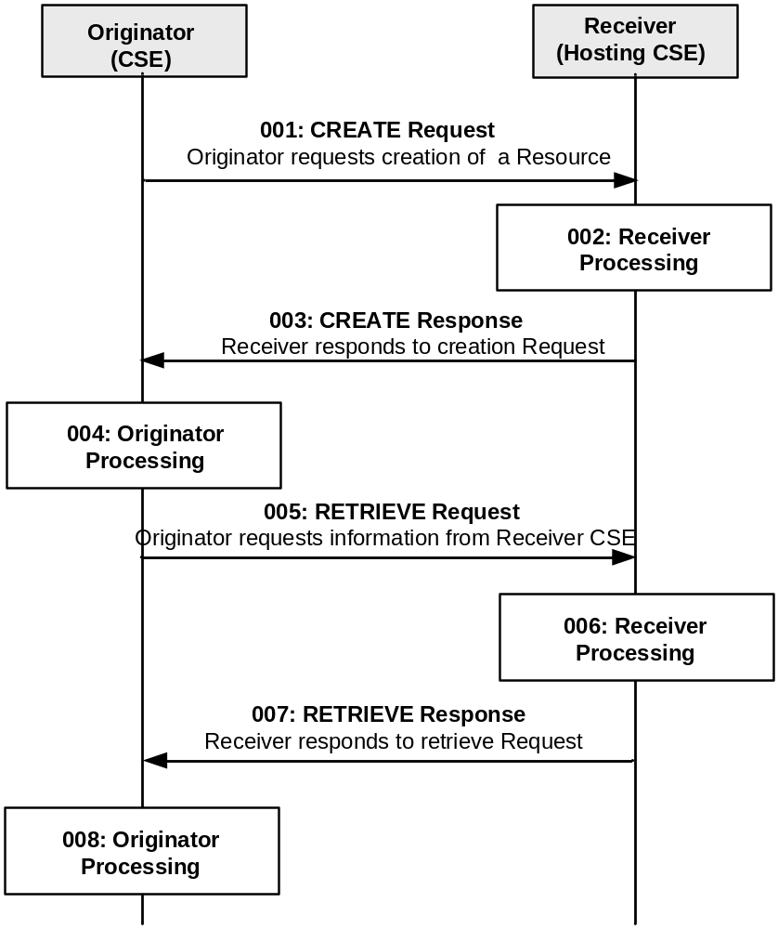
Figure 10.1.1.2.1-1: Procedure for CREATEing a <remoteCSE> Resource
All the parameters of the request and steps that are not indicated do not deviate from clause 10.1.1.1.
Step 001: The Originator shall send mandatory parameters and may send optional parameters in Request message for CREATE operation as specified in clause 8.1.2

Step 002: The Receiver shall:

All sub-steps: 1)-8), from step 002 from clause 10.1.1.1 are applicable.
NOTE: Optionally, if the M2M Service Provider supports inter-domain communication, the Receiver could perform this step if the attribute CSEBase (part of the Content parameter of the request) contains the public domain of the CSE. The Receiver could construct the domain as described in clause 6.4 and 6.5. The Receiver could add an AAA or AAAA record in DNS with the public domain name of the Originator CSE and the IP address of the IN-CSE associated with the Originator.
Step 003: See clause 10.1.1.1.
Step 004: The Originator, upon receipt of the CREATE response message, shall create a <remoteCSE> resource locally under its <CSEBase> resource. This resource is representing the Receiver CSE. The Originator shall provide the appropriate values to all mandatory parameters as described in clause 9.6.4.
Step 005: The Originator may issue a RETRIEVE Request towards the Receiver (same To as for the CREATE request message) to obtain the optional parameters of the <remoteCSE> resource created at the Receiver as for step 004 (e.g. labels, accessControlPolicyIDs attributes). The RETRIEVE procedure is described in clause 10.1.2.
See clauses 8.1.2 for the information to be included in the Request message.
Step 006: The Receiver verifies that the Originator has the appropriate privileges to access the information.
Step 007: The Receiver sends a RETRIEVE response message, according to the procedure described in clause 10.1.2.
See clauses 8.1.3 and 8.1.4 for the information to be included in the Response message.
Step 008: The Originator shall update the created <remoteCSE> resource for the Receiver with the information obtained in step 007.
General Exceptions:
All exceptions from clause 10.1.1.1 are applicable; in addition the following exception may occur:
- The Originator does not have the privileges to retrieve the attributes of the Receiver CSE. The Receiver responds with an error.

----------------------End of change 1---------------------------------------------

