CHANGE REQUEST
Meeting:* | ARC#19.1
Source:* | C-DOT
Date:* | 2015-09-21
Contact:* | Anupama Chopra anupama@cdot.in
Reason for Change/s:* | See the introduction
CR against: Release* | Rel-2
CR against: WI* | Active <Work Item number>  MNT Maintenace / < Work Item number(optional)>  STE Small Technical Enhancements / < Work Item number (optional)>  Only ONE of the above shall be ticked
CR against: TS/TR* | oneM2M-TS-0001-v2.2.0
Clauses/Sub Clauses* | 10.1.1.2.3 added
Type of change: * | Editorial change  Bug Fix or Correction  Change to existing feature or functionality  New feature or functionality  Only ONE of the above shall be ticked
Post Freeze checking:* | This CR contains only essential changes and corrections? YES NO  This CR is a mirror CR? YES NO if YES, please indicate the document number of the original CR:  <Document Number)<CR Number of the original CR to the current Release>

oneM2M Notice
The document to which this cover statement is attached is submitted to oneM2M. Participation in, or attendance at, any activity of oneM2M, constitutes acceptance of and agreement to be bound by terms of the Working Procedures and the Partnership Agreement, including the Intellectual Property Rights (IPR) Principles Governing oneM2M Work found in Annex 1 of the Partnership Agreement.
GUIDELINES for Change Requests:
Provide an informative introduction containing the problem(s) being solved, and a summary list of proposals.
Each CR should contain changes related to only one particular issue/problem.
In case of a correction, and the change apply to previous releases, a separated “mirror CR” should be posted at the same time of this CR
Follow the principle of completeness, where all changes related to the issue or problem within a deliverable are simultaneously proposed to be made E.g. A change impacting 5 tables should not only include a proposal to change only 3 tables. Includes any changes to references, definitions, and acronyms in the same deliverable.
Follow the drafting rules.
All pictures must be editable.
Check spelling and grammar to the extent practicable.
Use Change bars for modifications.
The change should include the current and surrounding clauses to clearly show where a change is located and to provide technical context of the proposed change. Additions of complete sections need not show surrounding clauses as long as the proposed section number clearly shows where the new section is proposed to be located.
Multiple changes in a single CR shall be clearly separated by horizontal lines with embedded text such as, start of change 1, end of change 1, start of new clause, end of new clause.
When subsequent changes are made to content of a CR, then the accepted version should not show changes over changes. The accepted version of the CR should only show changes relative to the baseline approved text.

Introduction

Refer Section 10.1.1.2.2 : In “Application Entity Registration Procedure”, it is mentioned that when AE-ID-Stem starting with an 'S' character, <AEAnnc> resource shall be created at IN-CSE. But when Registrar CSE=IN-CSE then <AEAnnc> resource shall not be created as <AE> is being created on IN-CSE only. So this case has been depicted clearly by introducing a new section 10.1.1.2.3 and mentioning the special handling in it.
This CR proposes to handle Registrar CSE=IN-CSE case separately to improve understanding.

-----------------------Start of change 1-------------------------------------------

10.1.1.2.3 Application Entity Registration procedure on IN-CSE
The procedure for AE registration on IN-CSE follows the message flow description depicted in figure 10.1.1.2.3-1.

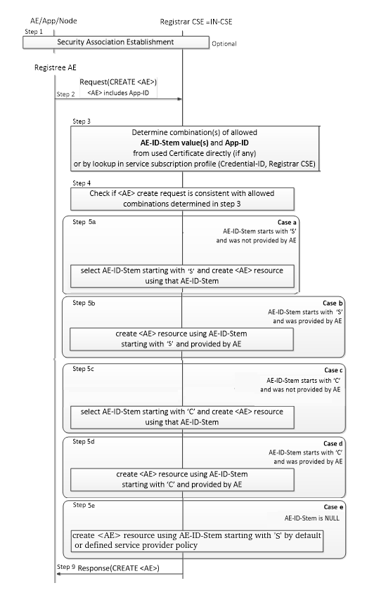

Figure 10.1.1.2.3-1: Procedure for Creating an <AE> Resource on IN-CSE
For Step 1 to Step 4 refer section 10.1.1.2.2

The procedure continues with one for the following cases a) - d) depending on the listed conditions:
Case a) AE-ID-Stem starts with 'S' and AE does not include an AE-ID-Stem (initial registration):
Condition: In Step 003 it was determined that the AE-ID-Stem value to be used for the Registree AE starts with an 'S' character but no specific AE-ID-Stem was provided with the CREATE request of the Registree AE. This case applies when the Registree AE is supposed to use an M2M-SP-assigned AE-ID and wants to perform the initial registration:
Step 005a: The Registrar CSE shall select an AE-ID-Stem starting with a 'S' character and use it for the Unstructured-CSE-relative-Resource-ID for the <AE> resource to be created on the Registrar CSE and continue with action (4) of Step 002 of the non-registration related CREATE procedure in clause 10.1.1.1.
Case b) AE-ID-Stem starts with 'S' and AE includes an AE-ID-Stem (re-registration):
Condition: In Step 003 it was determined that the AE-ID-Stem value to be used for the Registree AE starts with an 'S' character and a specific AE-ID-Stem was provided with the CREATE request of the Registree AE. This case applies when the Registree AE wants to perform a re-registration:
Step 005b: The Registrar CSE shall use the Unstructured-CSE-relative-Resource-ID equal to the AE-ID-Stem in the From parameter for the <AE> resource to be created on the Registrar CSE and continue with action (4) of Step 002 of the non-registration related CREATE procedure in clause 10.1.1.1.
For Step 5c and Step 5e refer section 10.1.1.2.2

-----------------------End of change 1---------------------------------------------

CHECK LIST
- Does this change request include an informative introduction containing the problem(s) being solved, and a summary list of proposals.?
- Does this CR contain changes related to only one particular issue/problem?
- Have any mirror crs been posted?
- Does this change request make all the changes necessary to address the issue or problem? E.g. A change impacting 5 tables should not only include a proposal to change only 3 tables. Includes any changes to references, definitions, and acronyms in the same deliverable?
- Does this change request follow the drafting rules?
- Are all pictures editable?
- Have you checked the spelling and grammar?
- Have you used change bars for all modifications?
- Does the change include the current and surrounding clauses to clearly show where a change is located and to provide technical context of the proposed change? (Additions of complete sections need not show surrounding clauses as long as the proposed section number clearly shows where the new section is proposed to be located.)
- Are multiple changes in this CR clearly separated by horizontal lines with embedded text such as, start of change 1, end of change 1, start of new clause, end of new clause.?

