CHANGE REQUEST
Meeting:* | ARC#19.2
Source:* | Samsung Electronics
Date:* | 2015-10-08
Contact:* | Kiran Vedula, Samsung Electronics, kiran.vedula@samsung.com  Jieun Keum, Samsung Electronics, je.keum@samsung.com  Jinhyeock Choi, Samsung Electronics, jinchoe@samsung.com
Reason for Change/s:* | There are minor corrections in the diagrams and some text updated to reflect the new changes
CR against: Release* | Rel-2
CR against: WI* | Active <WI-0044>  MNT maintenace / < Work Item number(optional)>  STE Small Technical Enhancements / < Work Item number (optional)>  Only ONE of the above shall be ticked
CR against: TS/TR* | TR-0023 v0.1.0
Clauses/Sub Clauses* | 7
Type of change: * | Editorial change  Bug Fix or Correction  Change to existing feature or functionality  New feature or functionality  Only ONE of the above shall be ticked
Post Freeze checking:* | This CR contains only essential changes and corrections? YES NO  This CR may break backwards compatibility with the last approved version of the TS? YES NO  This CR is a mirror CR? YES if YES, please indicate the document number of the original CR: <Document Number) : NO
Template Version:27 May 2015 (Dot not modify)

oneM2M Notice
The document to which this cover statement is attached is submitted to oneM2M. Participation in, or attendance at, any activity of oneM2M, constitutes acceptance of and agreement to be bound by terms of the Working Procedures and the Partnership Agreement, including the Intellectual Property Rights (IPR) Principles Governing oneM2M Work found in Annex 1 of the Partnership Agreement.
GUIDELINES for Change Requests:
Provide an informative introduction containing the problem(s) being solved, and a summary list of proposals.
Each CR should contain changes related to only one particular issue/problem.
In case of a correction, and the change apply to previous releases, a separated “mirror CR” should be posted at the same time of this CR
Follow the principle of completeness, where all changes related to the issue or problem within a deliverable are simultaneously proposed to be made E.g. A change impacting 5 tables should not only include a proposal to change only 3 tables. Includes any changes to references, definitions, and acronyms in the same deliverable.
Follow the drafting rules.
All pictures must be editable.
Check spelling and grammar to the extent practicable.
Use Change bars for modifications.
The change should include the current and surrounding clauses to clearly show where a change is located and to provide technical context of the proposed change. Additions of complete sections need not show surrounding clauses as long as the proposed section number clearly shows where the new section is proposed to be located.
Multiple changes in a single CR shall be clearly separated by horizontal lines with embedded text such as, start of change 1, end of change 1, start of new clause, end of new clause.
When subsequent changes are made to content of a CR, then the accepted version should not show changes over changes. The accepted version of the CR should only show changes relative to the baseline approved text.

Introduction
The architecture diagrams included in the previous baseline has some issues like
- There was a hanging paragraph and some editorial issues with that text
- IPE which is a special kind of AE includes another AE which is not correct. Also some terminology like oneM2M CSE was used which is not clear
- Section 7.2 is not related to Resource Model mapping
The following changes are made to handle the issues:
- Added Section number newly 7.1 Introduction and updated text in introduction
- Updated Figure 7-1 and 7-2 and related text. Terminology was corrected
- Content in Section 7.2 deleted and section number changed to 7.3. Added new section 7.4 possible operational procedures
There is no risk of backward compatibility with any published TS.

-----------------------Start of change 1-------------------------------------------

7.1 Introduction
This clause presents tentative solutions for oneM2M and OIC interworking and provides:
1) Functional architecture
2) Resource Model Mapping and
3) Operational procedures
The first describes functional architecture with main entities. The second describes possible resource model mapping. The third describes operation procedures, i.e. interaction between main entities. This functional architecture can address all scenarios from clause 6 where OIC devices are controlled by the oneM2M system.

-----------------------End of change 1---------------------------------------------

-----------------------Start of change 2-------------------------------------------

7.2. Functional Architecture for Interworking
The OIC interworking scheme is based on Interworking Proxy Entity (IPE), which, as an intermediary, facilitates oneM2M & OIC interworking by translating between oneM2M and OIC resources. The IPE interacts with OIC devices and expose those as oneM2M resources. The oneM2M CSE accesses IPE via the oneM2M interface to manipulate oneM2M resources, then the resulting representation change is reflected to the corresponding OIC devices via the OIC interface.

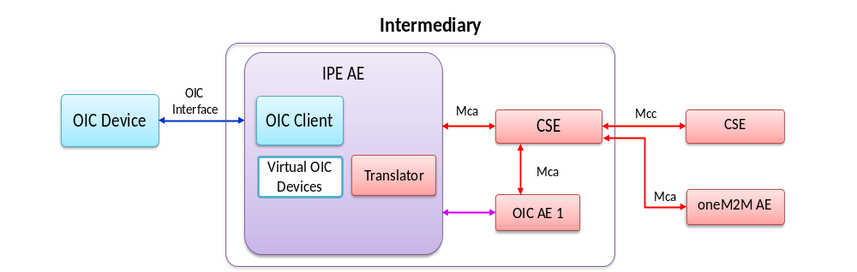
Figure 7.1-1 Functional Architecture with IPE
The main entities and their characteristics are as below.
- IPE AE: a specialized AE, characterized by the support of a non-oneM2M reference point, and by the capability of remapping the related data model to the oneM2M resources exposed via the Mca reference point
- OIC AE: a oneM2M application entity mirroring OIC Device
- CSE : oneM2M common service entity (CSE)
- OIC device : a logical entity which plays either OIC client or OIC server roles or both. The OIC Server hosts OIC resources. OIC Client accesses the OIC Server to manipulate OIC resources, i.e. monitoring & controlling.
The figure 7.2-2 demonstrates a possible deployment model which describes the main entities and their interworking via reference points.

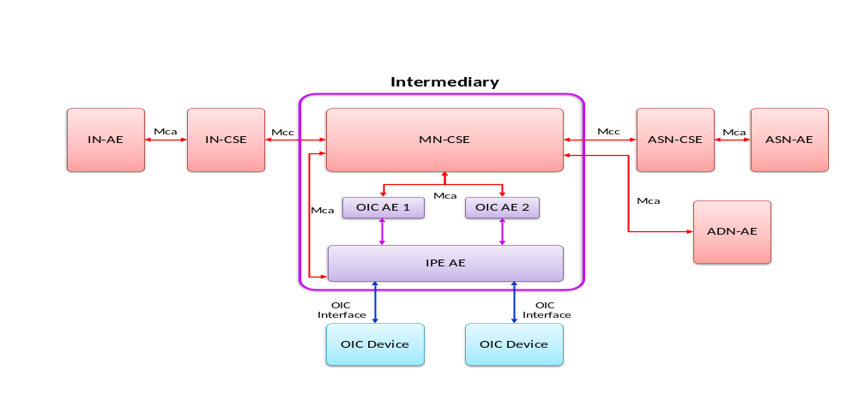
Figure 7.2-2 Deployment model based on functional architecture

-----------------------End of change 2---------------------------------------------

-----------------------Start of change 3-------------------------------------------

7.3. Resource Model Mapping

7.4. Possible Operational Procedures

-----------------------End of change 3---------------------------------------------

CHECK LIST
- Does this change request include an informative introduction containing the problem(s) being solved, and a summary list of proposals.?
- Does this CR contain changes related to only one particular issue/problem?
- Have any mirror crs been posted?
- Does this change request make all the changes necessary to address the issue or problem? E.g. A change impacting 5 tables should not only include a proposal to change only 3 tables. Includes any changes to references, definitions, and acronyms in the same deliverable?
- Does this change request follow the drafting rules?
- Are all pictures editable?
- Have you checked the spelling and grammar?
- Have you used change bars for all modifications?
- Does the change include the current and surrounding clauses to clearly show where a change is located and to provide technical context of the proposed change? (Additions of complete sections need not show surrounding clauses as long as the proposed section number clearly shows where the new section is proposed to be located.)
- Are multiple changes in this CR clearly separated by horizontal lines with embedded text such as, start of change 1, end of change 1, start of new clause, end of new clause.?

