Input Contribution
Meeting ID* | ARC19.0
Title:* | OIC Interworking Procedure Addressing and Discovery
Source:* | Kiran Vedula, Samsung Electronics, kiran.vedula@samsung.com  Jieun Keum, Samsung Electronics, je.keum@samsung.com  Jinhyeock Choi, Samsung Electronics, jinchoe@samsung.com  Sungchan Choi, KETI, sungchan.keti@gmail.com  SeonHyang Kim, DT&C, shkim@dtnc.net
Uploaded Date:* | 2015-10-13
Document(s)  Impacted* | WI-0044 OIC-Interworking  TR-0023 v0.1.0
Intended purpose of  document:* | Decision  Discussion  Information  Other <specify>
Decision requested or recommendation:* | Include the proposed text into TR-0023
Template Version:23 February 2015 (Dot not modify)

oneM2M Notice
The document to which this cover statement is attached is submitted to oneM2M. Participation in, or attendance at, any activity of oneM2M, constitutes acceptance of and agreement to be bound by terms of the Working Procedures and the Partnership Agreement, including the Intellectual Property Rights (IPR) Principles Governing oneM2M Work found in Annex 1 of the Partnership Agreement.

================ Start of Text Proposal 1 =======================

7.4. Possible Operational Procedures

7.4.1 Addressing
To perform operations on entities/ resources they have to be addressed. OIC and oneM2M have their own addressing mechanisms. The addressing mecahnisms as defined are reused with some mapping for OIC resources represented in oneM2M.
In oneM2M the “To” parameter in a request/ notification is used as a target for the request/ notification. To address a resource first the CSE is to be addressed and then the resource under the CSE. The CSE-ID is used to address the CSE. The originator of the request is recommended to use “Absolute” or “SP-relative” format of addressing when sending requests. This is just to ensure that the MN-CSE hosting OIC AE resources always receives the request without any scoping issues.
The details of addressing in case of Request/ Response and Notification scenarios is described below.
- Request Target
  - Requests are targeted to AEs but via CSE which hosts them
  - The MN CSE-PoA is used by IN to reach the CSE which is hosting the OIC AE resource
  - Specific AE under the MN CSE is addressed using the AE-ID attribute of the <AE>

- Notification Target
  - Notifications are usually targeted to AEs
  - A hosting CSE which receives notification request, can retarget the request to AE-PoA

7.4.2 Initialization of Entities
In order for the OIC and oneM2M interworking to work there is a need to initialize this functionality. In the figure below a possible initialization procedure is depicted. The MN (Gateway) acts as a logical entity which is having this functionality.

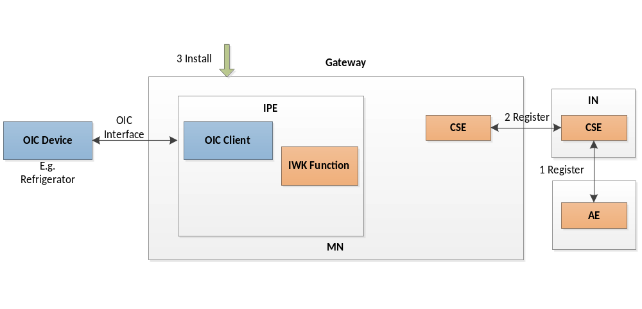
Figure 7.4.2-1 Intialization of Entities
Below are the possible steps for initialization as depicted in the figure:
- The IN supports a CSE. An AE (Smartphone) is registered to the IN CSE.
- Similarly MN supports a CSE.
- IN CSE also registers with MN CSE
- Intermediary Device is installed with an IPE based on an out of band mechanism
  - Triggered by a user action e.g. user subscribing to some service or
  - Based on business logic of service provider

7.4.3 Discovery
Once the initialization is finished, the next step is discovery wherein oneM2M entities try to discover OIC entities. There could be 2 modes of discovery
  - Request-response Mode
  - Notification Mode

7.4.3.1 Request-response Mode
In request-response mode, AE’s explicitly request a CSE to provide details about any newly registered AE’s. In the figure below a possible request-response mode procedure is depicted.

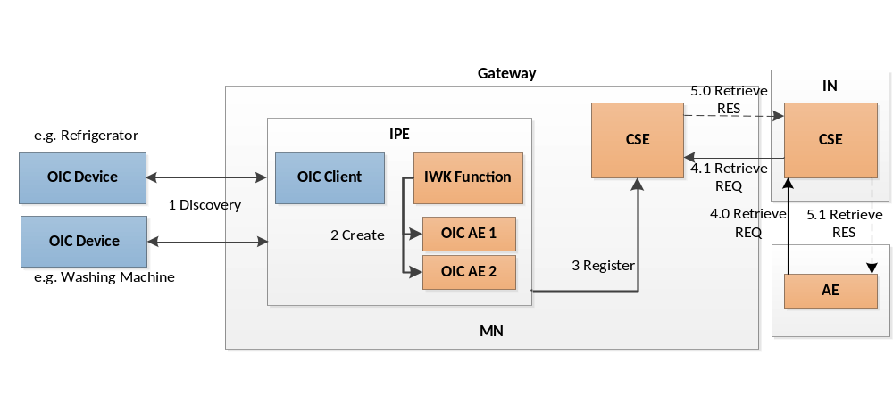
Figure 7.4.3.1-1 Request-response Mode
Below are the possible steps for request-response mode of discovery:
- The IPE discovers OIC devices using its OIC Client functionality as soon as it is installed on MN. It uses OIC mechanisms for the discovery
- After the discovery, IPE uses its IWK (Interworking) function to map the discovered OIC devices and resources into oneM2M resources and creates them on MN
- For each discovered OIC Device an OIC AE is created and registered with MN CSE
- (4.0/ 4.1) After that an AE through an IN CSE can anytime discover OIC AE resources by sending a RETRIEVE REQ with appropriate filter criteria to the MN CSE where they are registered
- (5.0/ 5.1) The MN CSE sends a RETRIEVE RES to IN CSE with the OIC AE’s information which in turn is sent to the AE

7.4.3.2 Notification Mode
In notification mode, AE’s subscribe to any changes in registration details of a CSE and gets notified whenever new OIC AE’s are registered to CSE. In the figure below a possible notification mode preocedure is depicted.

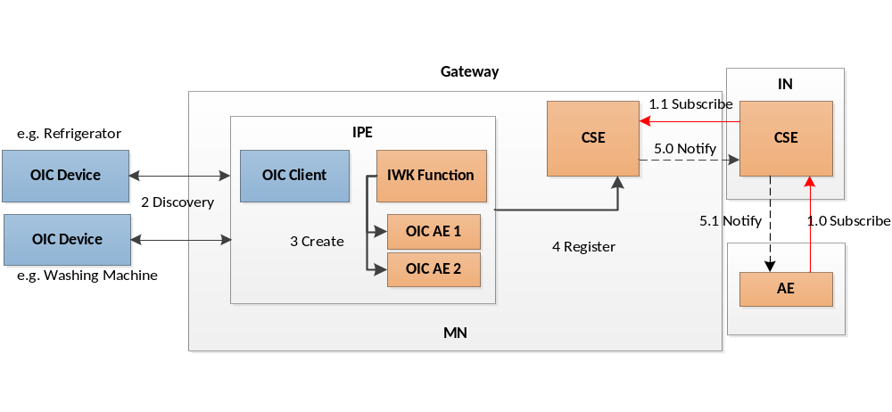
Figure 7.4.3.2-1 Notification Mode
Below are the possible steps for notification mode of discovery:
- (1.0/ 1.1) AE subscribes to IN CSE for any changes in registered AE’s on MN CSE. This request is forwarded to MN CSE
- The IPE AE discovers OIC devices using its OIC Client functionality as soon as it is installed on MN. It uses OIC mechanisms for the discovery
- After the discovery, IPE AE uses its IWK (Interworking) function to map the discovered OIC devices and resources into oneM2M resources and creates them on MN
- For each discovered OIC Device an OIC AE is created and registered with MN CSE
- (5.0/5.1) IN CSE and In-Turn AE is notified of the newly registered AE’s based on the earlier subscription

================ End of Text Proposal 1 =====================

