CHANGE REQUEST
Meeting:* | ARC#19.4
Source:* | Dongjoo Kim (dongjoo7.kim@lge.com)
Date:* | 2015-10-27
Contact:* | Dongjoo Kim (dongjoo7.kim@lge.com)
Reason for Change/s:* | See the introduction below
CR against: Release* | Rel-1
CR against: WI* | Active <Work Item number>  MNT Maintenace / < Work Item number(optional)>  STE Small Technical Enhancements / < Work Item number (optional)>  Only ONE of the above shall be ticked
CR against: TS/TR* | TS-0001 v1.11.0
Clauses/Sub Clauses* | 9.6
Type of change: * | Editorial change  Bug Fix or Correction  Change to existing feature or functionality  New feature or functionality  Only ONE of the above shall be ticked
Post Freeze checking:* | This CR contains only essential changes and corrections? YES NO  This CR may break backwards compatibility with the last approved version of the TS? YES NO  This CR is a mirror CR? YES if YES, please indicate the document number of the original CR: ) : NO
Template Version:27 May 2015 (Dot not modify)

oneM2M Notice
The document to which this cover statement is attached is submitted to oneM2M. Participation in, or attendance at, any activity of oneM2M, constitutes acceptance of and agreement to be bound by terms of the Working Procedures and the Partnership Agreement, including the Intellectual Property Rights (IPR) Principles Governing oneM2M Work found in Annex 1 of the Partnership Agreement.
GUIDELINES for Change Requests:
Provide an informative introduction containing the problem(s) being solved, and a summary list of proposals.
Each CR should contain changes related to only one particular issue/problem.
In case of a correction, and the change apply to previous releases, a separated “mirror CR” should be posted at the same time of this CR
Follow the principle of completeness, where all changes related to the issue or problem within a deliverable are simultaneously proposed to be made E.g. A change impacting 5 tables should not only include a proposal to change only 3 tables. Includes any changes to references, definitions, and acronyms in the same deliverable.
Follow the drafting rules.
All pictures must be editable.
Check spelling and grammar to the extent practicable.
Use Change bars for modifications.
The change should include the current and surrounding clauses to clearly show where a change is located and to provide technical context of the proposed change. Additions of complete sections need not show surrounding clauses as long as the proposed section number clearly shows where the new section is proposed to be located.
Multiple changes in a single CR shall be clearly separated by horizontal lines with embedded text such as, start of change 1, end of change 1, start of new clause, end of new clause.
When subsequent changes are made to content of a CR, then the accepted version should not show changes over changes. The accepted version of the CR should only show changes relative to the baseline approved text.

Introduction
This contribution proposes to remove the sentence “where this common attribute is described” from the description of universal attributes for the every resource type.
The universal attributes are different from the common attributes. That sentence does not make sense.
It was already agreed that the sentence should be deleted with the contribution ARC-2015-2004R01.

-----------------------Start of change 1-------------------------------------------

9.6.2 Resource Type accessControlPolicy

9.6.2.0 Introduction
The Access Control Policies (ACPs) shall be used by the CSE to control access to the resources as specified in the present document and in oneM2M TS-0003 [Error: Reference source not found].
The ACP is designed to fit different access control models such as access control lists, role or attribute based access control.
The <accessControlPolicy> resource is comprised privileges and selfPrivileges attributes which represent a set of access control rules defining which entities (defined as accessControlOriginators) have the privilege to perform certain operations (defined as accessContolOperations) within specified contexts (defined as accessControlContexts) and are used by the CSEs in making Access Decision to specific resources.
In a privilege, each access control rule defines which AE/CSE is allowed for which operation. So for sets of access control rules an operation is permitted if it is permitted by one or more access control rules in the set.
For a resource that is not of <accessControlPolicy> resource type, the common attribute accessControlPolicyIDs for such resources (defined in table 9.6.1.3.2-1) contains a list of identifiers which link that resource to <accessControlPolicy> resources. The CSE Access Decision for such a resource shall follow the evaluation of the set of access control rules expressed by the privileges attributes defined in the <accessControlPolicy> resources.
The selfPrivileges attribute shall represent the set of access control rules for the <accessControlPolicy> resource itself.
The CSE Access Decision for <accessControlPolicy> resource shall follow the evaluation of the set of access control rules expressed by the selfPrivileges attributes defined in the <accessControlPolicy> resource itself.
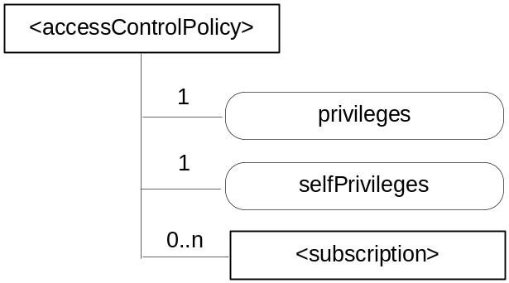
Figure 9.6.2-1: Structure of <accessControlPolicy> resource
The <accessControlPolicy> resource shall contain the child resource specified in table 9.6.2-1.
Table 9.6.2-1: Child resources of <accessControlPolicy> resource
Child Resources of <accessControlPolicy> | Child Resource Type | Multiplicity | Description | <accessControlPolicyAnnc> Child Resource Types
[variable] | <subscription> | 0..n | See clause 9.6.8 | <subscription>

The <accessControlPolicy> resource shall contain the attributes specified in table 9.6.2-2.
Table 9.6.2-2: Attributes of <accessControlPolicy> resource
Attributes of <accessControlPolicy> | Multiplicity | RW/  RO/  WO | Description | <accessControlPolicyAnnc> Attributes
resourceType | 1 | RO | See clause 9.6.1.3 | NA
resourceID | 1 | RO | See clause 9.6.1.3 | NA
resourceName | 1 | RO | See clause 9.6.1.3 | NA
parentID | 1 | RO | See clause 9.6.1.3 | NA
expirationTime | 1 | RW | See clause 9.6.1.3 | MA
labels | 0..1 | RW | See clause 9.6.1.3 | MA
creationTime | 1 | RO | See clause 9.6.1.3 | NA
lastModifiedTime | 1 | RO | See clause 9.6.1.3 | NA
announceTo | 0..1 (L) | RW | See clause 9.6.1.3 | NA
announcedAttribute | 0..1 (L) | RW | See clause 9.6.1.3 | NA
privileges | 1 | RW | A set of access control rules that applies to resources referencing this <accessControlPolicy> resource using the accessControlPolicyID attribute. | MA
selfPrivileges | 1 | RW | A set of access control rules that apply to the <accessControlPolicy> resource itself. | MA

The set of access control rules represented in privileges and selfPrivileges attributes are comprised of 3-tuples (accessControlOriginators, accessControlContexts, accessControlOperations) with parameters shown in table 9.6.2-3 which are further described in the following clauses.
If privileges attribute contains no 3-tuples then this represent an empty set of the access control rules.
The selPrivileges attribute shall contain at least one 3-tuples.
The CSE access granting mechanism shall follow the procedure described in oneM2M TS-0003 [Error: Reference source not found] in clause 7.1 (Access Control Mechanism).
Table 9.6.2-3: Parameters in access-control-rule-tuples
Name | Description
accessControlOriginators | See clause 9.6.2.1
accessControlContexts | See clause 9.6.2.2
accessControlOperations | See clause 9.6.2.3

9.6.2.1 accessControlOriginators
The accessControlOriginators is a mandatory parameter in an access-control-rule-tuple. It represents the set of Originators that shall be allowed to use this access control rule. The set of Originators is described as a list of parameters, where the types of the parameter can vary within the list. Table 9.6.2.1-1 describes the supported types of parameters in accessControlOriginators. The following Originator privilege types shall be considered for access control policy check by the CSE.
Table 9.6.2.1-1: Types of Parameters in accessControlOriginators
Name | Description
domain | A SP domain or SP sub-domain
originatorID | CSE-ID or AE-ID which represent an Originator identity
all | Any Originators are allowed to access the resource within the accessControlOriginators constraints

9.6.2.2 accessControlContexts
The accessControlContexts is an optional parameter in an access-control-rule-tuple that contains a list, where each element of the list, when present, represents a context that is permitted to use this access control rule. Each request context is described by a set of parameters, where the types of the parameters can vary within the set. Table 9.6.2.2-1 describes the supported types of parameters in accessControlContexts.
The following Originator accessControlContexts shall be considered for access control policy check by the CSE.
Table 9.6.2.2-1: Types of Parameters in accessControlContexts
Name | Description
accessControlTimeWindow | Represents a time window constraint which is compared against the time that the request is received at the Hosting CSE.
accessControlLocationRegion | Represents a location region constraint which is compared against the location of the Originator of the request.
accessControlIpIPAddress | Represents an IP address constraint or IP address block constraint which is compared against the IP address of the Originator of the request.

9.6.2.3 accessControlOperations
The accessControlOperations is a mandatory parameter in an access-control-rule-tuple that represents the set of operations that are authorized using this access control rule. Table 9.6.2.3-1 describes the supported set of operations that are authorized by accessControlOperations.
The following accessControlOperations shall be considered for access control policy check by the CSE.
Table 9.6.2.3-1: Types of parameters in accessControlOperations
Name | Description
RETRIEVE | Privilege to retrieve the content of an addressed resource
CREATE | Privilege to create a child resource
UPDATE | Privilege to update the content of an addressed resource
DELETE | Privilege to delete an addressed resource
DISCOVER | Privilege to discover the resource
NOTIFY | Privilege to receive a notification

9.6.3 Resource Type CSEBase
A <CSEBase> resource shall represent a CSE. The <CSEBase> resource shall be the root for all resources that are residing in the CSE.
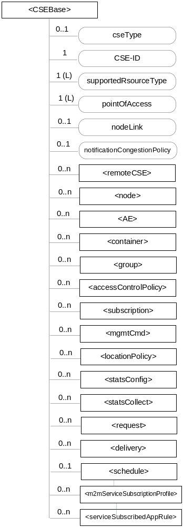
Figure 9.6.3-1: Structure of <CSEBase> resource
Figure 9.6.3-1 does not show the child announce resource types defined in table 9.6.3-2.
The <CSEBase> resource shall contain the child resources specified in table 9.6.3-1.
Table 9.6.3-1: Child resources of <CSEBase> resource
Child Resources of <CSEBase> | Child Resource Type | Multiplicity | Description
[variable] | <remoteCSE> | 0..n | See clause 9.6.4
[variable] | <node> | 0..n | See clause 9.6.18
[variable] | <AE> | 0..n | See clause 9.6.5
[variable] | <container> | 0..n | See clause 9.6.6
[variable] | <group> | 0..n | See clause 9.6.13
[variable] | <accessControlPolicy> | 0..n | See clause 9.6.2
[variable] | <subscription> | 0..n | See clause 9.6.8
[variable] | <mgmtCmd> | 0..n | See clause 9.6.16
[variable] | <locationPolicy> | 0..n | See clause 9.6.10
[variable] | <statsConfig> | 0..n | See clause 9.6.23
[variable] | <statsCollect> | 0..n | See clause 9.6.25
[variable] | <request> | 0..n | See clause 9.6.12
[variable] | <delivery> | 0..n | See clause 9.6.11
[variable] | <schedule> | 0..1 | This resource defines the reachability schedule information of the entity. The absence of this resource implies the entity is always reachable. See clause 9.6.9
[variable] | <m2mServiceSubscriptionProfile> | 0..n | See clause 9.6.19
[variable] | <serviceSubscribedAppRule> | 0..n | See clause 9.6.29

Table 9.6.3-2: Child announced resources of <CSEBase> resource
Child Announced Resources of <CSEBase> | Child Announced Resource Type | Multiplicity | Description
[variable] | Refer Table 9.6.26.1-1 Announced Resource Types | 0..n

The child announced resources of <CSEBase> resource defined in table 9.6.3-2 should be created when an Originator CSE (i.e. original resource Hosting CSE) and a Hosting CSE (i.e. announced resource Hosting CSE) have no registration relationship (e.g. the Originator CSE has not created <remoteCSE> resource on the Hosting CSE).
The <CSEBase> resource shall contain the attributes specified in table 9.6.3-3.
Table 9.6.3-3: Attributes of <CSEBase> resource
Attributes of <CSEBase> | Multiplicity | RW/  RO/  WO | Description
resourceType | 1 | RO | See clause 9.6.1.3
resourceID | 1 | RO | See clause 9.6.1.3
resourceName | 1 | RO | See clause 9.6.1.3
creationTime | 1 | RO | See clause 9.6.1.3
lastModifiedTime | 1 | RO | See clause 9.6.1.3
accessControlPolicyIDs | 0..1 (L) | RO | See clause 9.6.1.3
labels | 0..1 (L) | RO | See clause 9.6.1.3
cseType | 0..1 | RO | Indicates the type of CSE represented by the created resource.  - Mandatory for an IN-CSE, hence multiplicity (1).  - Its presence is subject to SP configuration in case of an ASN-CSE or a MN-CSE.
CSE-ID | 1 | RO | The CSE identifier in SP-relative CSE-ID format (clause 7.2).
supportedResourceType | 1 (L) | RO | List of the resource types which are supported in the CSE. This attribute contains subset of resource types listed in clause 9.2. This also includes the supported optional attributes for each supported resource type.
pointOfAccess | 1 (L) | RO | Represents the list of physical addresses to be used by remote CSEs to connect to this CSE (e.g. IP address, FQDN). This attribute is exposed to its Registree.
nodeLink | 0..1 | RO | The resourceID of a <node> resource that represents the node specific information.
notificationCongestionPolicy | 0..1 | RO | This attribute applies to CSEs generating subscription notifications. It specifies the rule which is applied when the storage of notifications for each subscriber (an AE or CSE) reaches the maximum storage limit for notifications for that subscriber. E.g. Delete stored notifications of lower notificationStoragePriority to make space for new notifications of higher notificationStoragePriority, or delete stored notifications of older creationTime to make space for new notifications when all notifications are of the same notificationStoragePriority.
NOTE: All the attributes of this resource type can be changed by an offline configuration mechanism, but not over the reference points (all attributes are "RO").

9.6.4 Resource Type remoteCSE
A <remoteCSE> resource shall represent a Registree CSE that is registered to the Registrar CSE. <remoteCSE> resources shall be located directly under the <CSEBase> resource of Registrar CSE.
Similarly <remoteCSE> resource shall also represent a Registrar CSE. <remoteCSE> resource shall be located directly under the <CSEBase> resource of Registree CSE.
For example, when CSE1 (Registree CSE) registers with CSE2 (Registrar CSE), there will be two <remoteCSE> resources created: one in CSE1: <CSEBase1>/<remoteCSE2> and one in CSE2: <CSEBase2>/<remoteCSE1>.
Note that the creation of the two resources does not imply mutual registration. The <CSEBase1>/<remoteCSE2> does not mean CSE2 registered with CSE1 in the example above.
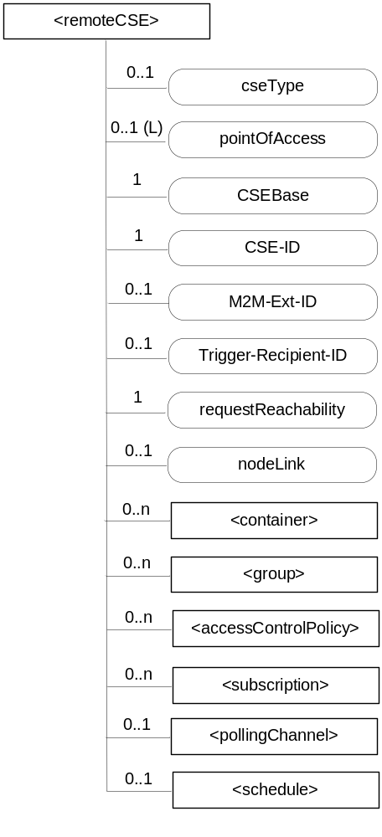
Figure 9.6.4-1: Structure of <remoteCSE> resource
The <remoteCSE> resource shall contain the child resources specified in table 9.6.4-1. The <remoteCSE> resource may contain <remoteCSEAnnc> child resources.
Table 9.6.4-1: Child resources of <remoteCSE> resource
Child Resources of <remoteCSE> | Child Resource Type | Multiplicity | Description | <remoteCSEAnnc> Child Resource Types
[variable] | <container> | 0..n | See clause 9.6.6 | <container> <containerAnnc>
[variable] | <group> | 0..n | See clause 9.6.13 | <group>  <groupAnnc>
[variable] | <accessControlPolicy> | 0..n | See clause 9.6.2 | <accessControlPolicy>  <accessControlPolicyAnnc>
[variable] | <subscription> | 0..n | See clause 9.6.8 | <subscription>
[variable] | <pollingChannel> | 0..1 | See clause 9.6.21. If requestReachability is FALSE, the CSE that created this <remoteCSE> resource should create a <pollingChannel> resource and perform long polling. The <pollingChannel> shall be utilized by the parent resource. | None
[variable] | <schedule> | 0..1 | This resource defines the reachability schedule information of the node. See clause 9.6.9 for <schedule>. | <scheduleAnnc>
[variable] | <nodeAnnc> | 0..n | This resource is the <nodeAnnc> resource representing the node where the CSE represented by this <remoteCSE> resource resides. | <nodeAnnc>

Table 9.6.4-2: Child announced resources of <remoteCSE> resource
Child Announced Resources of <remoteCSE> | Child Announced Resource Type | Multiplicity | Description
[variable] | Refer to table 9.6.26.1-1 Announced Resource Types | 0..n

The <remoteCSE> resource shall contain the attributes specified in table 9.6.4-3.
Table 9.6.4-3: Attributes of <remoteCSE> resource
Attributes of <remoteCSE> | Multiplicity | RW/  RO/  WO | Description | <remoteCSEAnnc> Attributes
resourceType | 1 | RO | See clause 9.6.1.3 | NA
resourceID | 1 | RO | See clause 9.6.1.3 | NA
resourceName | 1 | RO | See clause 9.6.1.3 | NA
parentID | 1 | RO | See clause 9.6.1.3 | NA
creationTime | 1 | RO | See clause 9.6.1.3 | NA
lastModifiedTime | 1 | RO | See clause 9.6.1.3 | NA
expirationTime | 1 | RW | See clause 9.6.1.3 | MA
accessControlPolicyIDs | 0..1 (L) | RW | See clause 9.6.1.3 | MA
labels | 0..1 (L) | RW | See clause 9.6.1.3 | MA
announceTo | 0..1 (L) | RW | See clause 9.6.1.3 | NA
announcedAttribute | 0..1 (L) | RW | See clause 9.6.1.3 | NA
cseType | 0..1 | WO | Indicates the type of CSE represented by the created resource.  - Mandatory for an IN-CSE, hence multiplicity (1).  - Its presence is subject to SP configuration in case of an ASN-CSE or a MN-CSE. | OA
pointOfAccess | 0..1 (L) | RW | For request-reachable remote CSE it represents the list of physical addresses to be used to connect to it (e.g. IP address, FQDN). The attribute is absent if the remote CSE is not request-reachable.  If this information is not provided, the CSE should use <pollingChannel> resource. Then the Hosting CSE can forward a request to the CSE without using the PoA. | OA
CSEBase | 1 | WO | The address of the CSEBase resource represented by this <remoteCSE> resource. | OA
CSE-ID | 1 | WO | The CSE identifier in SP-relative CSE-ID format (clause 7.2). | OA
M2M-Ext-ID | 0..1 | RW | Supported when Registrar is IN-CSE.  See clause 7.1.8 where this attribute is described. This attribute is used only for the case of dynamic association of M2M-Ext-ID and CSE-ID. | NA
Trigger-Recipient-ID | 0..1 | RW | Supported when Registrar is IN-CSE. See clause 7.1.10 where this attribute is described. This attribute is used only for the case of dynamic association of M2M-Ext-ID and CSE-ID. | NA
requestReachability | 1 | RW | If the CSE that created this <remoteCSE> resource can receive a request from other AE/CSE(s), this attribute is set to "TRUE" otherwise "FALSE" (see note) | OA
nodeLink | 0..1 | RW | The resourceID of a <node> resource that hosts the CSE represented by the <remoteCSE> resource. | OA
NOTE: Even if this attribute is set to "FALSE", it does not mean it AE/CSE is always unreachable by all entities. E.g. the requesting AE/CSE is behind the same NAT, so it can communicate within the same NAT.

9.6.5 Resource Type AE
An <AE> resource shall represent information about an Application Entity registered to a CSE.
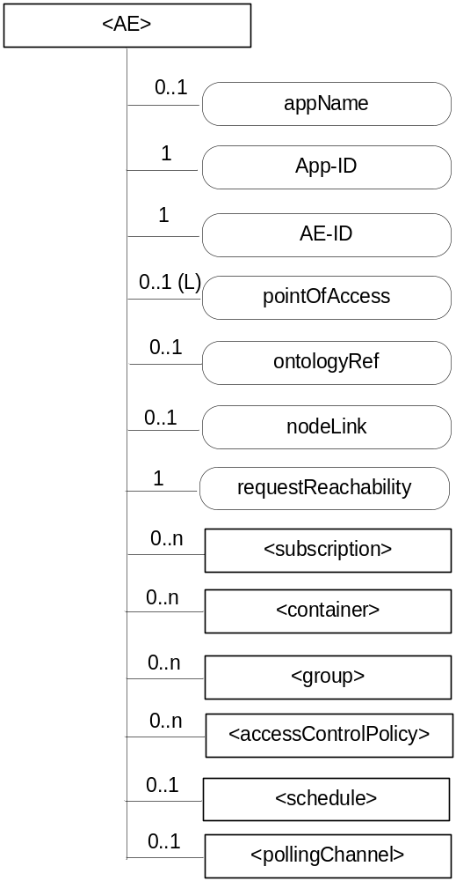
Figure 9.6.5-1: Structure of <AE> resource
The <AE> resource shall contain the child resources specified in table 9.6.5-1.
Table 9.6.5-1: Child resources of <AE> resource
Child Resources of <AE> | Child Resource Type | Multiplicity | Description | <AEAnnc> Child Resource Types
[variable] | <subscription> | 0..n | See clause 9.6.8 | <subscription>
[variable] | <container> | 0..n | See clause 9.6.6 | <container> <containerAnnc>
[variable] | <group> | 0..n | See clause 9.6.13 | <group>  <groupAnnc>
[variable] | <accessControlPolicy> | 0..n | See clause 9.6.2 | <accessControlPolicy>  <accessControlPolicyAnnc>
[variable] | <schedule> | 0..1 | See clause 9.6.9 | <scheduleAnnc>
[variable] | <pollingChannel> | 0..1 | See clause 9.6.21.  When the AE is request-unreachable, the AE should create this <pollingChannel> resource and perform long polling. The <pollingChannel> shall be utilized by the parent resource. | None

The <AE> resource shall contain the attributes specified in table 9.6.5-2.
Table 9.6.5-2: Attributes of <AE> resource
Attributes of  <AE> | Multiplicity | RW/  RO/  WO | Description | <AEAnnc> Attributes
resourceType | 1 | RO | See clause 9.6.1.3 | NA
resourceID | 1 | RO | See clause 9.6.1.3. Contains the AE-ID-Stem of the AE (see clause 7.2 on identifier formats and clause 10.1.1.2.2 for AE registration procedure). | NA
resourceName | 1 | RO | See clause 9.6.1.3. | NA
parentID | 1 | RO | See clause 9.6.1.3. | NA
expirationTime | 1 | RW | See clause 9.6.1.3. | MA
accessControlPolicyIDs | 0..1 (L) | RW | See clause 9.6.1.3. | MA
creationTime | 1 | RO | See clause 9.6.1.3. | NA
lastModifiedTime | 1 | RO | See clause 9.6.1.3. | NA
labels | 0..1 (L) | RW | See clause 9.6.1.3. | MA
announceTo | 0..1 (L) | RW | See clause 9.6.1.3. | NA
announcedAttribute | 0..1 (L) | RW | See clause 9.6.1.3. | NA
appName | 0..1 | RW | The name of the application, as declared by the application developer(e.g. "HeatingMonitoring").  Several sibling resources may share the appName. | OA
App-ID | 1 | WO | The identifier of the Application (see clause 7.1.2). | OA
AE-ID | 1 | RO | The identifier of the Application Entity (see clause 7.1.2). | OA
pointOfAccess | 0..1 (L) | RW | The list of addresses for communicating with the registered Application Entity over Mca reference point via the transport services provided by Underlying Network (e.g. IP address, FQDN, URI). This attribute shall be accessible only by the AE and the Hosting CSE.  If this information is not provided, the AE should use <pollingChannel> resource. Then the Hosting CSE can forward a request to the AE without using the PoA. | OA
ontologyRef | 0..1 | RW | A URI of the ontology used to represent the information that is managed and understood by the AE. | OA
requestReachability | 1 | RW | If the AE that created this <AE> resource can receive a request, this attribute is set to "TRUE" otherwise "FALSE" | OA
nodeLink | 0..1 | RO | The resourceID of a <node> resource that stores the node specific information where the AE resides. | OA

9.6.6 Resource Type container
The <container> resource represents a container for data instances. It is used to share information with other entities and potentially to track the data. A <container> resource has no associated content. It has only attributes and child resources.
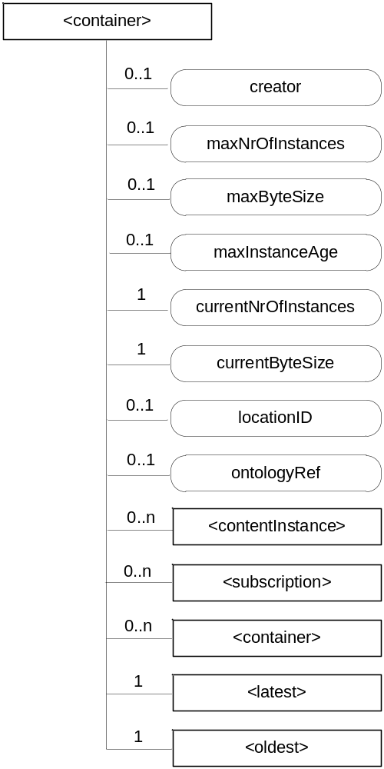
Figure 9.6.6-1: Structure of <container> resource
The <container> resource shall contain the child resources specified in table 9.6.6-1.
Table 9.6.6-1: Child resources of <container> resource
Child Resources of <container> | Child Resource Type | Multiplicity | Description | <containerAnnc> Child Resource Types
[variable] | <contentInstance> | 0..n | See clause 9.6.7 | <contentInstance>, <contentInstanceAnnc>
[variable] | <subscription> | 0..n | See clause 9.6.8 | <subscription>
[variable] | <container> | 0..n | See clause 9.6.6 | <container>  <containerAnnc>
latest | <latest> | 1 | See clause 9.6.27 | None
oldest | <oldest> | 1 | See clause 9.6.28 | None

The <container> resource shall contain the attributes specified in table 9.6.6-2.
Table 9.6.6-2: Attribute of <container> resource
Attributes of  <container> | Multiplicity | RW/  RO/  WO | Description | <containerAnnc> Attributes
resourceType | 1 | RO | See clause 9.6.1.3 | NA
resourceID | 1 | RO | See clause 9.6.1.3 | NA
resourceName | 1 | RO | See clause 9.6.1.3 | NA
parentID | 1 | RO | See clause 9.6.1.3 | NA
expirationTime | 1 | RW | See clause 9.6.1.3 | MA
accessControlPolicyIDs | 0..1 (L) | RW | See clause 9.6.1.3 If no accessControlPolicyIDs are provided at the time of creation, the accessControlPolicyIDs of the parent resource is linked to this attribute | MA
labels | 0..1 (L) | RW | See clause 9.6.1 | MA
creationTime | 1 | RO | See clause 9.6.1.3 | NA
lastModifiedTime | 1 | RO | See clause 9.6.1.3 | NA
stateTag | 1 | RO | See clause 9.6.1.3 | OA
announceTo | 0..1 (L) | RW | See clause 9.6.1.3 | NA
announcedAttribute | 0..1 (L) | RW | See clause 9.6.1.3 | NA
creator | 0..1 | RO | The AE-ID or CSE-ID of the entity which created the resource. | NA
maxNrOfInstances | 0..1 | RW | Maximum number of direct child <contentInstance> resources in the <container> resource. | OA
maxByteSize | 0..1 | RW | Maximum size in bytes of data (i.e. content attribute of a <contentIstance> resource) that is allocated for the <container> resource for all direct child <contentIsstance> in the <container> resource. | OA
maxInstanceAge | 0..1 | RW | Maximum age of a direct child <contentInstance> resource in the <container> resource. The value is expressed in seconds. | OA
currentNrOfInstances | 1 | RO | Current number of direct child <contentInstance> resource in the <container> resource. It is limited by the maxNrOfInstances. | OA
currentByteSize | 1 | RO | Current size in bytes of data(i.e. content attribute of a <contentInstance> resource) stored in all direct child <contentInstance> resources of the <container> resource. This is the summation of contentSize attribute values of the <contentInstance> resource. It is limited by the maxNrOfBytes. | OA
locationID | 0..1 | RW | An ID of the resource where the attributes/policies that define how location information are obtained and managed. This attribute is defined only when the <container> resource is used for containing location information. | OA
ontologyRef | 0..1 | RW | A reference (URI) of the ontology used to represent the information that is stored in the direct child <contentInstance> resources of the present <container> resource (see note). | OA
NOTE: The access to this URI is out of scope of oneM2M.

9.6.7 Resource Type contentInstance
The <contentInstance> resource represents a data instance in the <container> resource. The content of the contentInstance can be encrypted.
Unlike other resources, the <contentInstance> resource shall not be modified once created. An AE shall be able to delete a contentInstance resource explicitly or it may be deleted by the platform based on policies. If the platform has policies for contentInstance retention, these shall be represented by the attributes maxByteSize, maxNrOfInstances and/or maxInstanceAge attributes in the <container> resource. If multiple policies are in effect, the strictest policy shall apply.
The <contentInstance> resource inherits the same access control policies of the parent <container> resource, and does not have its own accessControlPolicyIDs attribute.
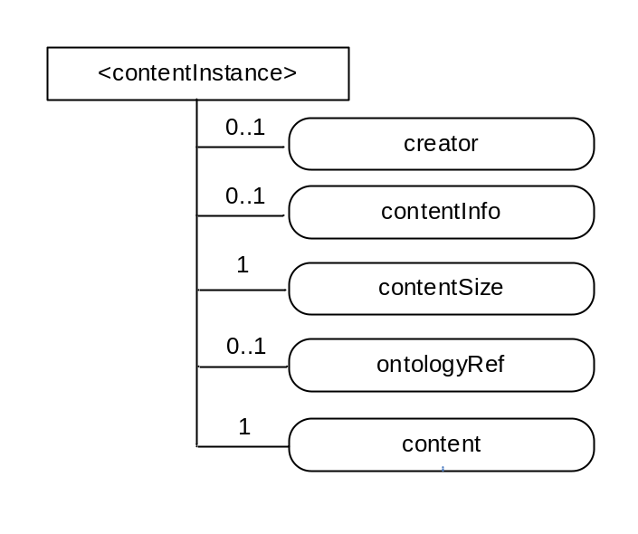
Figure 9.6.7-1: Structure of <contentInstance> resource
The <contentInstance> resource shall contain the attributes specified in table 9.6.7-1.
Table 9.6.7-1: Attributes of <contentInstance> resource
Attributes of <contentInstance> | Multiplicity | RW/  RO/  WO | Description | <contentInstanceAnnc> Attributes
resourceType | 1 | RO | See clause 9.6.1.3 | NA
resourceID | 1 | RO | See clause 9.6.1.3 | NA
resourceName | 1 | RO | See clause 9.6.1.3 | NA
parentID | 1 | RO | See clause 9.6.1.3 | NA
labels | 0..1 (L) | WO | See clause 9.6.1.3 | MA
expirationTime | 1 | WO | See clause 9.6.1.3 | MA
creationTime | 1 | RO | See clause 9.6.1.3 | NA
lastModifiedTime | 1 | RO | See clause 9.6.1.3 | NA
stateTag | 1 | RO | See clause 9.6.1.3  The stateTag attribute of the parent resource should be incremented first and copied into this stateTag attribute when a new instance is added to the parent resource. | OA
announceTo | 0..1 (L) | WO | See clause 9.6.1.3 | NA
announcedAttribute | 0..1 (L) | WO | See clause 9.6.1.3 | NA
creator | 0..1 | RO | The AE-ID or CSE-ID of the entity which created the resource. | NA
contentInfo | 0..1 | WO | Information on the content that is needed to understand the content. This attribute is a composite attribute. It is composed first of an Internet Media Type (as defined in the IETF RFC 6838 [i.28]) describing the type of the data, and second of an encoding information that specifies how to first decode the received content. Both elements of information are separated by a separator defined in oneM2M TS-0004 [Error: Reference source not found]. | OA
contentSize | 1 | RO | Size in bytes of the content attribute. | OA
ontologyRef | 0..1 | WO | A reference (URI) of the ontology used to represent the information that is stored in the contentInstances resources of the <container> resource. If this attribute is not present, the contentInstance resource inherits the ontologyRef from the parent <container> resource if present.  NOTE: Access to this URI is out of scope of oneM2M. | OA
content | 1 | WO | Actual content of a contentInstance. This content may be opaque data for understandable with the help of the contentInfo. This may, for example, be an image taken by a security camera, or a temperature measurement taken by a temperature sensor. | OA

9.6.8 Resource Type subscription
The <subscription> resource contains subscription information for its subscribed-to resource. The <subscription> resource is a child of the subscribed-to resource.
The <subscription> resource shall be represented as child resource of the subscribed-to resource. For example, <container> resource has <subscription> resource as a child resource (see clause 9.6.6). A <subscription> resource shall be deleted when the parent subscribed-to resource is deleted.
The <subscription> resource shall represent a subscription to a subscribed-to resource. An Originator shall be able to create a resource of <subscription> resource type when the Originator has RETRIEVE privilege to the subscribe-to resource. The Originator which creates a <subscription> resource becomes the resource subscriber.
Each <subscription> may include notification policies that specify which, when, and how notifications are sent. These notification policies may work in conjunction with CMDH policies.
When a <subscription> resource is deleted, a Notify request shall be sent to the subscriberURI if it is provided by the Originator.
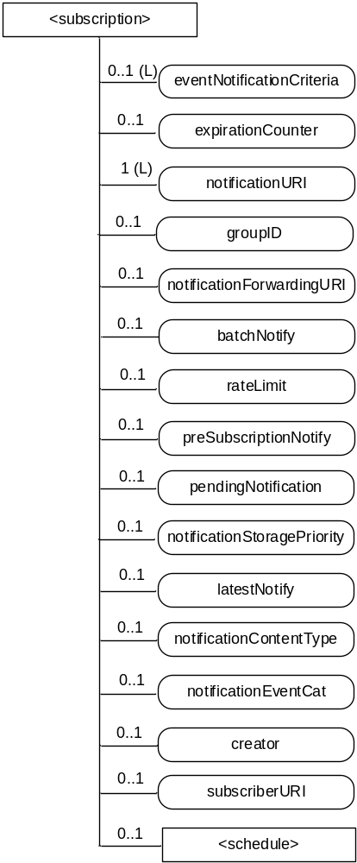
Figure 9.6.8-1: Structure of <subscription> resource
The <subscription> resource shall contain the child resources specified in table 9.6.8-1.
Table 9.6.8-1: Child resources of <subscription> resource
Child Resources of <subscription> | Child Resource Type | Multiplicity | Description
notificationSchedule | <schedule> | 0..1 | In the context of the <subscription> resource, the notificationSchedule specifies when notifications may be sent by the Hosting CSE to the notificationURI(s). See clause 9.6.9.

The <subscription> resource shall contain the attributes specified in table 9.6.8-2.
Table 9.6.8-2: Attributes of <subscription> resource
Attributes of <subscription> | Multiplicity | RW/  RO/  WO | Description
resourceType | 1 | RO | See clause 9.6.1.3
resourceID | 1 | RO | See clause 9.6.1.3
resourceName | 1 | RO | See clause 9.6.1.3
parentID | 1 | RO | See clause 9.6.1.3
expirationTime | 1 | RW | See clause 9.6.1.3
creationTime | 1 | RO | See clause 9.6.1.3
lastModifiedTime | 1 | RO | See clause 9.6.1.3
labels | 0..1 (L) | RW | See clause 9.6.1.3
accessControlPolicyIDs | 0..1 (L) | RW | See clause 9.6.1.3  If no accessControlPolicyIDs is given at the time of creation, the accesControlPolicies of the parent resource is linked to this attribute.
eventNotificationCriteria | 0..1 (L) | RW | This attribute (notification policy) indicates the event criteria for which a notification is to be generated.
expirationCounter | 0..1 | RW | This attribute (notification policy) indicates that the subscriber wants to set the life of this subscription to a limit of a maximum number of notifications. When the number of notifications sent reaches the count of this counter, the <subscription> resource shall be deleted, regardless of any other policy.
notificationURI | 1 (L) | RW | List of URI(s) and/or address(es) where the resource subscriber will receive notifications. URI(s) in the list may not represent the resource subscriber entity. For a group-related subscription, the notificationURI shall be the URI that is generated by the group Hosting CSE to receive notifications. In this case, the resource subscriber notification URI shall be included in the notificationForwardingURI.
groupID | 0..1 | RW | The ID of a <group> resource in case the subscription is made through a group.
notificationForwardingURI | 0..1 | RW | The attribute is a forwarding attribute that shall be present only for group related subscriptions. It represents the resource subscriber notification URI. It shall be used by group Hosting CSE for forwarding aggregated notifications. See clauses 10.2.7.11 and 10.2.7.12.
batchNotify | 0..1 | RW | This attribute (notification policy) indicates that the subscription originator wants to receive batches of notifications rather than receiving them one at a time. This attribute includes : the number of notifications to be batched for delivery and the duration. When only the number is specified by the subscription originator, the Hosting CSE shall set the default duration given by M2M Service Provider.  If batchNotify is used simultaneously with latestNotify, only the latest notification shall be sent and have the Event Category set to "latest".
rateLimit | 0..1 | RW | This attribute (notification policy) indicates that the subscriber wants to limit the rate at which it receives notifications. This attribute expresses the subscriber's notification policy and includes two values: a maximum number of events that may be sent within some duration, and the rateLimit window duration. When the number of generated notifications within the rateLimit window duration exceeds the maximum number, notification events are temporarily stored, until the end of the window duration, when the sending of notification events restarts in the next window duration. The sending of notification events continues as long as the maximum number of notification events is not exceeded during the window duration. The rateLimit policy may be used simultaneously with other notification policies.
preSubscriptionNotify | 0..1 | WO | This attribute (notification policy) indicates that the subscriber wants to be sent notifications for events that were generated prior to the creation of this subscription. This attribute has a value of the number of prior notification events requested. If up-to-date caching of retained events is supported on the Hosting CSE and contains the subscribed events then prior notification events will be sent up to the number requested. The preSubscriptionNotify policy may be used simultaneously with any other notification policy.
pendingNotification | 0..1 | RW | This attribute (notification policy), if set, indicates how missed notifications due to a period of connectivity (according to the reachability and notification schedules). The possible values for pendingNotification are:  - "sendLatest"  - "sendAllPending"  This policy depends upon caching of retained notifications on the hosted CSE. When this attribute is set to " sendLatest ", only the last notification shall be sent and it shall have the Event Category set to "latest". If this attribute is not present, the Hosting CSE sends no missed notifications. This policy applies to all notifications regardless of the selected delivery policy (batchNotify, latestNotify, etc.) Note that unreachability due to reasons other than scheduling is not covered by this policy.
notificationStoragePriority | 0..1 | RW | Indicates that the subscriber wants to set a priority for this subscription relative to other subscriptions belonging to this same subscriber. This attribute sets a number within the priority range. When storage of notifications exceeds the allocated size, this policy is used as an input with the storage congestion policy (notificationCongestionPolicy) specified in clause 9.6.3 to determine which stored and generated notifications to drop and which ones to retain.
latestNotify | 0..1 | RW | This attribute (notification policy) indicates if the subscriber wants only the latest notification. If multiple notifications of this subscription are buffered, and if the value of this attribute is set to true, then only the last notification shall be sent and it shall have the Event Category value set to "latest".
notificationContentType | 0..1 | RW | Indicates a notification content type that shall be contained in notifications. The allowed values are:  - "modified attributes"  - "all attributes"  - "ID" of the resource indicated in the eventType condition  If it is not given by the Originator at the creation procedure, default is "all attributes".
notificationEventCat | 0..1 | RW | This attribute (notification policy) indicates the subscriber's requested Event Category to be used for notification messages generated by this subscription.
creator | 0..1 | WO | AE-ID or CSE-ID which created the <subscription> resource.
subscriberURI | 0..1 | WO | URI that is sent a notification when this <subscription> is deleted.

Table 9.6.8-3 describes the eventNotificationCriteria conditions.
Table 9.6.8-3: eventNotificationCriteria conditions
Condition tag | Multiplicity | Matching condition
createdBefore | 0..1 | The creationTime attribute of the resource is chronologically before the specified value.
createdAfter | 0..1 | The creationTime attribute of the resource is chronologically after the specified value.
modifiedSince | 0..1 | The lastModifiedTime attribute of the resource is chronologically after the specified value.
unmodifiedSince | 0..1 | The lastModifiedTime attribute of the resource is chronologically before the specified value.
stateTagSmaller | 0..1 | The stateTag attribute of the resource is smaller than the specified value.
stateTagBigger | 0..1 | The stateTag attribute of the resource is bigger than the specified value.
expireBefore | 0..1 | The expirationTime attribute of the resource is chronologically before the specified value.
expireAfter | 0..1 | The expirationTime attribute of the resource is chronologically after the specified value.
sizeAbove | 0..1 | The contentSize attribute of the <contentInstance> resource is equal to or greater than the specified value.
sizeBelow | 0..1 | The contentSize attribute of the <contentInstance> resource is smaller than the specified value.
eventType | 0..n | The type of event. Possible event type values are:  - Update to attributes of the subscribed-to resource  - Deletion of the subscribed-to resource ,  - Creation of a direct child of the subscribed-to resource ,  - Deletion of a direct child of the subscribed-to resource  The other conditions in eventNotificationCriteria conditions apply to the selected eventType.  For example, if eventType is "Creation of a direct child of the subscribed-to resource" then other eventNotificationCriteria conditions is applied to the direct child resources of the subscribed-to resource.  If this condition is not specified, the default value is "Update to attributes of the subscribed-to resource"
operationMonitor | 0..n | The operations accessing the subscribed-to resource matches with the specified value. It allows monitoring which operation is attempted to the subscribed-to resource regardless of whether the operation is performed. This feature is useful when to find malicious AEs. Possible string arguments are: create, retrieve, update, delete.
attribute | 0..n | This is an attribute name of resource types (clause 9.6). E.g. creator of container resource type can be used as "creator=Sam". When multiple attributes are set then the result is based upon the AND of all attributes.

9.6.9 Resource Type schedule
The <schedule> resource contains scheduling information. The usage of the <schedule> resource is slightly different depending on the associated resource type, such as follows:
- A child <schedule> resource of the <CSEBase> and <remoteCSE> resources shall indicate the time periods when the CSE can send and receive the request.
- A child <schedule> resource of the <AE> resource shall indicate the time periods when the application of a node can be accessed.
- A child <schedule> resource of the <subscription> resource shall indicate the time periods when the notifications can be sent to be Receiver.
- A <schedule> resource linked as mgmtLink attribute of the <cmdhNwAccessRule> resource shall indicate the time periods when use of specific underlying networks is allowed.
An Originator shall have the same access control privileges to the <schedule> resource as it has to its parent resource.
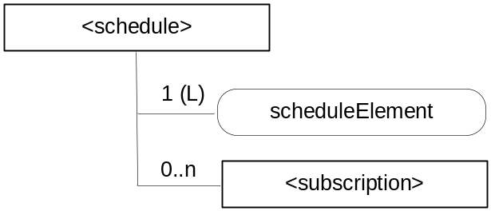
Figure 9.6.9-1: Structure of <schedule> resource
The <schedule> resource shall contain the child resource specified in table 9.6.9-1.
Table 9.6.9-1: Child resources of <schedule> resource
Child Resources of <schedule> | Child Resource Type | Multiplicity | Description | <scheduleAnnc> Child Resource Types
[variable] | <subscription> | 0..n | See clause 9.6.8 | None

The <schedule> resource shall contain the attributes specified in table 9.6.9-2.
Table 9.6.9-2: Attributes of <schedule> resource
Attributes of  <schedule> | Multiplicity | RW/  RO/  WO | Description | <scheduleAnnc> Attributes
resourceType | 1 | RO | See clause 9.6.1.3 | NA
resourceID | 1 | RO | See clause 9.6.1.3 | NA
resourceName | 1 | RO | See clause 9.6.1.3 | NA
parentID | 1 | RO | See clause 9.6.1.3 | NA
expirationTime | 1 | RW | See clause 9.6.1.3 | MA
creationTime | 1 | RO | See clause 9.6.1.3 | NA
lastModifiedTime | 1 | RO | See clause 9.6.1.3 | NA
labels | 0..1 (L) | RW | See clause 9.6.1.3 | MA
announceTo | 0..1 (L) | RW | See clause 9.6.1.3 | NA
announcedAttribute | 0..1 (L) | RW | See clause 9.6.1.3 | NA
scheduleElement | 1 (L) | RW | A scheduleElement shall be composed by seven fields of second, minute, hour, day of month, month, day of week and year. | OA

9.6.10 Resource Type locationPolicy
The <locationPolicy> resource represents the method for obtaining and managing geographical location information of an M2M Node.
The actual location information shall be stored in a <contentInstance> resource which is a child resource of the <container> resource. The <container> resource includes the locationID attribute which holds the ID of this <locationPolicy> resource. A CSE can obtain location information based on the attributes defined on a <locationPolicy> resource, and store the location information in the target <container> resource.
Based on the locationSource attribute, the method for obtaining location information of an M2M Node can be differentiated. The methods for obtaining location information shall be as follows:
- Network-based method: where the CSE on behalf of the AE obtains the target M2M Node's location information from an Underlying Network.
- Device-based method: where the ASN is equipped with any location capable modules or technologies (e.g. GPS) and is able to position itself.
- Sharing-based method: where the ADN has no GPS nor an Underlying Network connectivity. Its location information can be retrieved from either the associated ASN or a MN.
NOTE: Geographical location information could include more than longitude and latitude.
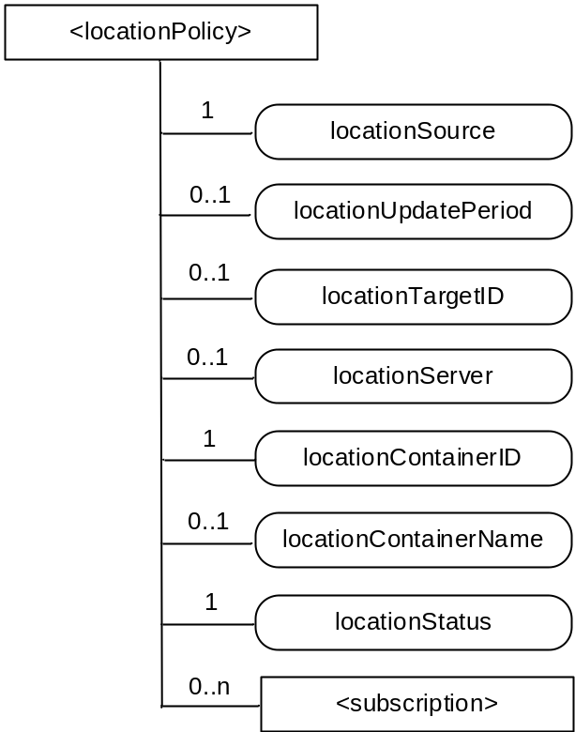
Figure 9.6.10-1: Structure of <locationPolicy> resource
The <locationPolicy> resource shall contain the child resources specified in table 9.6.10-1.
Table 9.6.10-1: Child resources of <locationPolicy> resource
Child Resources of <locationPolicy> | Child Resource Type | Multiplicity | Description | <locationPolicyAnnc> Child Resource Types
[variable] | <subscription> | 0..n | See clause 9.6.8 | None

The <locationPolicy> resource shall contain the attributes specified in table 9.6.10-2.
Table 9.6.10-2: Attributes of <locationPolicy> resource
Attributes of <locationPolicy> | Multiplicity | RW/  RO/  WO | Description | <locationPolicyAnnc> Attributes
resourceType | 1 | RO | See clause 9.6.1.3 | NA
resourceID | 1 | RO | See clause 9.6.1.3 | NA
resourceName | 1 | RO | See clause 9.6.1.3 | NA
parentID | 1 | RO | See clause 9.6.1.3 | NA
expirationTime | 1 | RW | See clause 9.6.1.3 | MA
accessControlPolicyIDs | 0..1 (L) | RW | See clause 9.6.1.3 | MA
creationTime | 1 | RO | See clause 9.6.1.3 | NA
lastModifiedTime | 1 | RO | See clause 9.6.1.3 | NA
labels | 0..1 (L) | RW | See clause 9.6.1.3 | MA
announceTo | 0..1 (L) | RW | See clause 9.6.1.3 | NA
announcedAttribute | 0..1 (L) | RW | See clause 9.6.1.3 | NA
locationSource | 1 | RW | Indicates the source of location information:  - Network Based  - Device Based  - Sharing Based | OA
locationUpdatePeriod | 0..1 | RW | Indicates the period for updating location information. If the value is marked '0' or not defined, location information is updated only when a retrieval request is triggered. | OA
locationTargetID | 0..1 | RW | The identifier to be used for retrieving the location information of a remote Node and this attribute is only used in the case that location information is provided by a location server. | OA
locationServer | 0..1 | RW | Indicates the identity of the location server. This attribute is only used in that case location information is provided by a location server. | OA
locationContainerID | 1 | RO | ID of the <container> resource where the actual location information of a M2M Node is stored. | OA
locationContainerName | 0..1 | RW | A name of the <container> resource where the actual location information of a M2M Node is stored. If it is not assigned, the Hosting CSE automatically assigns a name of the resource.  NOTE: The created <container> resource related to this policy shall be stored only in the Hosting CSE. | OA
locationStatus | 1 | RO | Contains the information on the current status of the location request (e.g. location server fault). | OA

9.6.11 Resource Type delivery
When a CSE is requested to initiate an operation (CRUDN) targeting resources on another CSE, then it needs to do scheduling and execution of delivery of data from the source CSE to the target CSE in line with the provisioned policies. It shall be in one of the following ways:
- Using delivery aggregation (Delivery Aggregation information set to ON); or
- Forwarding the original request as a separate request on the Mcc reference point without changes.
In order to be able to initiate and manage the execution of data delivery in a resource-based manner, resource type <delivery> is defined. This resource type shall be used for forwarding requests from one CSE to another CSE when the Delivery Aggregation parameter in the request is set to ON. If the Delivery Aggregation parameter is set to OFF, the original request shall be forwarded without change to the next CSE, i.e. without the use of <delivery> resource. If the Delivery Aggregation parameter is not present, the latter method shall be used.
Operations to Retrieve, Update or Delete a <delivery> resource shall allow authorized entities to inquire the status of a delivery, change delivery attributes or cancel a delivery.
As defined in clause 10.2.4, <delivery> resource can only be created by a CSE. A request for the creation of a <delivery> resource can only be issued to a registrar or registree CSE from a registree or registrar CSE with a direct registration relationship among each other (i.e. no transit CSE). <delivery> resource is deleted on successful delivery of the data in the aggregatedRequest attribute to the next hop CSE.
The parent of a <delivery> resource is the <CSEBase> resource of the CSE that accepted the request for the creation of the <delivery> resource.
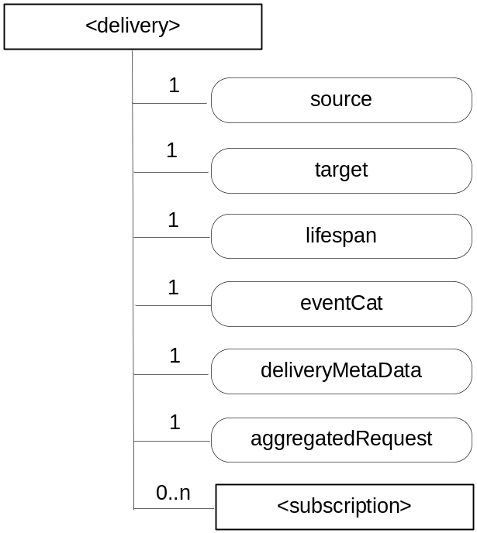
Figure 9.6.11-1: Structure of <delivery> resource
The <delivery> resource shall contain the child resource specified in table 9.6.11-1.
Table 9.6.11-1: Child resources of <delivery> resource
Child Resources of <delivery> | Child Resource Type | Multiplicity | Description
[variable] | <subscription> | 0..n | See clause 9.6.8

The <delivery> resource shall contain the attributes specified in table 9.6.11-2.
Table 9.6.11-2: Attributes of <delivery> resource
Attributes of  <delivery> | Multiplicity | RW/  RO/  WO | Description
resourceType | 1 | RO | See clause 9.6.1.3
resourceID | 1 | RO | See clause 9.6.1.3
resourceName | 1 | RO | See clause 9.6.1.3
expirationTime | 1 | RW | See clause 9.6.1.3
parentID | 1 | RO | See clause 9.6.1.3
creationTime | 1 | RO | See clause 9.6.1.3
lastModifiedTime | 1 | RO | See clause 9.6.1.3
accessControlPolicyIDs | 0..1 (L) | RW | See clause 9.6.1.3
labels | 0..1 (L) | RW | See clause 9.6.1.3
stateTag | 1 | RO | See clause 9.6.1.3
source | 1 | WO | The CSE-ID of the CSE that initiated the delivery process represented by this <delivery> resource.
target | 1 | WO | CSE-ID that defines the Hosting CSE for delivering the data contained in the aggregatedRequest attribute
lifespan | 1 | RW | Defines the time limit when the delivery of the information in the aggregatedRequest attribute needs to complete. If the lifespan expires before successful delivery, no further attempts to deliver the information in the aggregatedRequest attribute need to be executed. If the delivery fails, a feedback may be expected by the source CSE depending on options reflected in the deliveryMetaData attribute. The lifespan attribute of a <delivery> resource shall be set consistent with the Request Expiration Timestamp parameters of the set of original requests contained in the aggregatedRequest attribute, i.e. lifespan shall not extend beyond the earliest expiring Request Expiration Timestamp parameter in the set of the original requests contained in the aggregatedRequest attribute.
eventCat | 1 | RW | Defines the category of the event that triggered the delivery request represented by this <delivery> resource.
deliveryMetaData | 1 | RW | Contains meta information on the delivery process represented by this <delivery> resource, such as delivery status, delivery options, tracing information, etc.
aggregatedRequest | 1 | WO | Attribute containing the request(s) to be delivered to the Hosting CSE. This represents one or more original requests that were targeting the same Hosting CSE.

9.6.12 Resource Type request
The use of <request> resource type is optional depending on the configuration.
Creation of a <request> resource can only be done on a Receiver CSE implicitly when a Registree AE or a Registree/Registrar CSE issues a request to the Receiver CSE targeting any other resource type or requesting a notification. Creation of a <request> resource instance is only permitted by the Receiver CSE as a result of a request from an Originator which contains the Response Type parameter in the request message and where Response Type parameter is set to 'nonBlockingReqeustSynch' or 'nonBlockingRequestAsynch'.
When a CSE is requested to initiate an operation for which the result should be available to the Originator by reference (Request Expiration Timestamp information of the request set to 'nonBlockingReqeustSynch' or 'nonBlockingRequestAsynch'), the Receiver CSE which received the request directly from the Originator shall provide a reference of the created <request> resource back to the Originator so that the Originator can access attributes of the <request> at a later time - for instance in order to retrieve the result of an operation that was taking a longer time. If the Receiver CSE uses resources of type <request> to keep such context information, the reference that shall be given back to the Originator as part of the acknowledgment that is the address of the <request> resource. The Originator (or any other authorized entity depending on access control) can access the request status and the requested operation result through it.
The <request> resource may be deleted by the CSE that is hosting it when the expiration time of the <request> resource is reached. So after the expiration time of a <request> resource is reached it cannot be assumed that that particular <request> resource is still accessible. Depending on implementation of the CSE that is hosting it, a <request> resource may also get deleted earlier than the expiration time, when the result of the requested operation (if any result was requested at all) has been sent back to the Originator.
For the purpose of providing a standardized structure for expressing and accessing the context of a previously issued request, the resource type <request> is defined. The parent resource of a <request> resource shall be the <CSEBase> resource of the Hosting CSE.
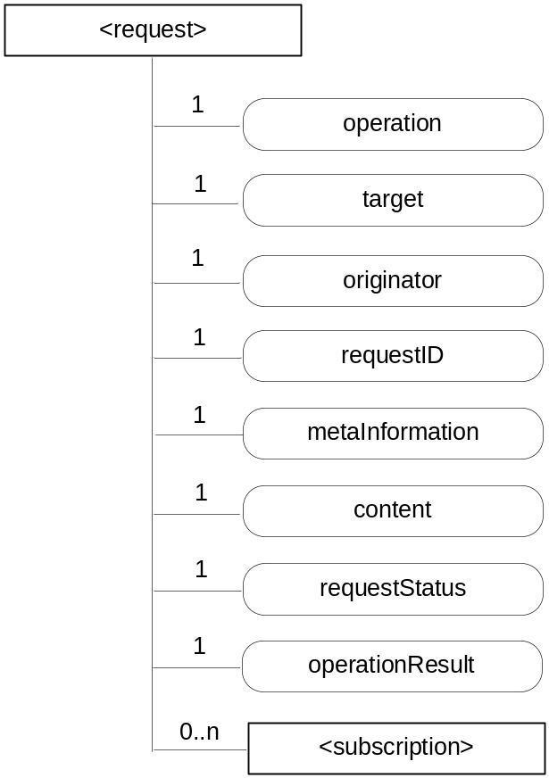
Figure 9.6.12-1: Structure of <request> resource
The <request> resource shall contain the child resources specified in table 9.6.12-1.
Table 9.6.12-1: Child resources of <request> resource
Child Resources of <request> | Child Resource Type | Multiplicity | Description
[variable] | <subscription> | 0..n | See clause 9.6.8

The <request> resource shall contain the attributes specified in table 9.6.12-2.
Table 9.6.12-2: Attributes of <request> resource
Attributes of  <request> | Multiplicity | RW/  RO/  WO | Description
resourceType | 1 | RO | See clause 9.6.1.3
resourceID | 1 | RO | See clause 9.6.1.3
resourceName | 1 | RO | See clause 9.6.1.3
expirationTime | 1 | RW | See clause 9.6.1.3 The value of the expirationTime is chosen by the CSE dependent on the Request Expiration Timestamp, Result Expiration Timestamp, Result Persistence and Operation Execution Time parameters associated with the original request.
parentID | 1 | RO | See clause 9.6.1.3
creationTime | 1 | RO | See clause 9.6.1.3
lastModifiedTime | 1 | RO | See clause 9.6.1.3
accessControlPolicyIDs | 0..1 (L) | RO | See clause 9.6.1.3
labels | 0..1 (L) | RO | See clause 9.6.1.3
stateTag | 1 | RO | See clause 9.6.1.3
operation | 1 | RO | It contains the value of the parameter Operation in the original request message.
target | 1 | RO | It contains the value of the parameter To in the original request message.
originator | 1 | RO | It contains the value of the parameter From in the original request message.
requestID | 1 | RO | It contains the value of the parameter Request Identifier in the original request message.
metaInformation | 1 | RO | Meta information about the request. The content of this attribute is equivalent to information in any other optional parameters described in clause 8.1.
content | 1 | RO | Contains the content that is carried in the Content parameter of the original request message.
requestStatus | 1 | RO | Contains information on the current status of the Request, e.g. "accepted and pending".
operationResult | 1 | RO | Contains the result of the originally requested operation in line with the Result Content parameter associated with the original request.

All operations on <request> resources except for the CREATE operations - which can only be triggered implicitly by a request for which a <request> resource shall capture the context - are controlled by the access control policy.

9.6.13 Resource Type group
The <group> resource represents a group of resources of the same or mixed types. The <group> resource can be used to do bulk manipulations on the resources represented by the memberIDs attribute. The <group> resource contains an attribute that represents the members of the group and a virtual resource (the <fanOutPoint>) that allows operations to be applied to the resources represented by those members.
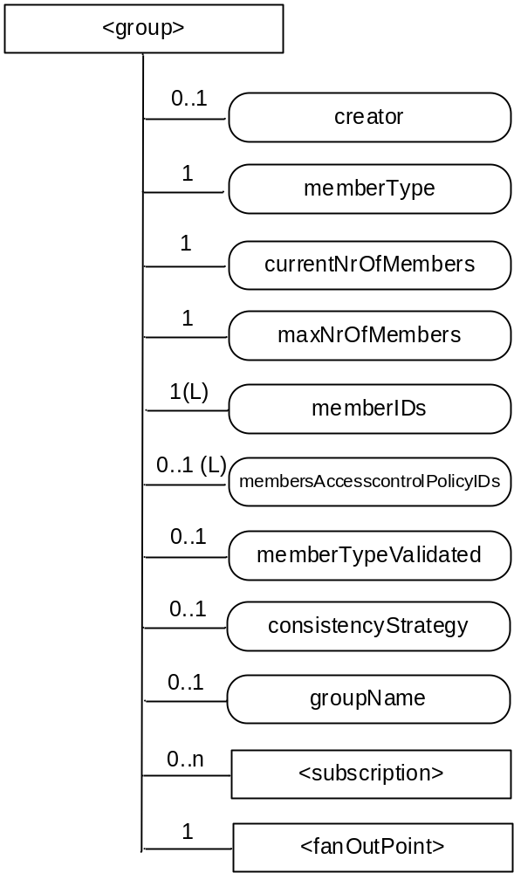
Figure 9.6.13-1: Structure of <group> resource
The <group> resource shall contain the child resources specified in table 9.6.13-1.
Table 9.6.13-1: Child resources of <group> resource
Child Resources of <group> | Child Resource Type | Multiplicity | Description | <groupAnnc> Child Resource Types
[variable] | <subscription> | 0..n | See clause 9.6.8 | <subscription>
fanOutPoint | <fanOutPoint> | 1 | See clause 9.6.14 | none

The <group> resource shall contain the attributes specified in table 9.6.13-2.
Table 9.6.13-2: Attributes of <group> resource
Attributes of  <group> | Multiplicity | RW/  RO/  WO | Description | <groupAnnc> Attributes
resourceType | 1 | RO | See clause 9.6.1.3 | NA
resourceID | 1 | RO | See clause 9.6.1.3 | NA
resourceName | 1 | RO | See clause 9.6.1.3 | NA
parentID | 1 | RO | See clause 9.6.1.3 | NA
expirationTime | 1 | RW | See clause 9.6.1.3 | MA
accessControlPolicyIDs | 0..1 (L) | RW | See clause 9.6.1.3 | MA
labels | 0..1 (L) | RW | See clause 9.6.1.3 | MA
creationTime | 1 | RO | See clause 9.6.1.3 | NA
lastModifiedTime | 1 | RO | See clause 9.6.1.3 | NA
announceTo | 0..1 (L) | RW | See clause 9.6.1.3 | NA
announcedAttribute | 0..1 (L) | RW | See clause 9.6.1.3 | NA
creator | 0..1 | RO | The AE-ID or CSE-ID of the entity which created the resource. | NA
memberType | 1 | WO | It is the resource type of the members resources of the group, if all members resources (including the members resources in any sub-groups) are of the same type. Otherwise, it is of type 'mixed'. | OA
currentNrOfMembers | 1 | RO | Current number of members in a group. It shall not be larger than maxNrOfMembers. | OA
maxNrOfMembers | 1 | RW | Maximum number of members in the <group>. | OA
memberIDs | 1 (L) | RW | List of member resource IDs referred to in the remaining of the present document as memberID. Each ID (memberID) should refer to a members resource or a (sub-) <group> resource of the <group>. | OA
membersAccessControlPolicyIDs | 0..1 (L) | RW | List of IDs of the <accessControlPolicy> resources defining who is allowed to access the <fanOutPoint> resource. | OA
memberTypeValidated | 0..1 | RO | Denotes if the resource type of all members resources of the group has been validated by the Hosting CSE. In the case that the memberType attribute of the <group> resource is not ‘mixed’, then this attribute shall be set. | OA
consistencyStrategy | 0..1 | WO | This attribute determines how to deal with the <group> resource if the memberType validation fails. Which means delete the inconsistent member if the attribute is ABANDON_MEMBER; delete the group if the attribute is ABANDON_GROUP; set the memberType to "mixed" if the attribute is SET_MIXED. | OA
groupName | 0..1 | RW | Human readable name of the <group>. | OA

9.6.14 Resource Type fanOutPoint
The <fanOutPoint> resource is a virtual resource because it does not have a representation. It is the child resource of a <group> resource. Whenever a request is sent to the <fanOutPoint> resource, the request is fanned out to each of the members of the <group> resource indicated by the membersIDs attribute of the <group> resource. The responses (to the request) from each member are then aggregated and returned to the Originator. A timer should be set for the aggregation. The responses are aggregated if all the responses expected have been received or when the timer expires. The responses received after the time expires should be discarded. If the Result Expiration Timestamp parameter is received from the Originator, the timer should be set to enforce this parameter, otherwise, the timer is set based on the local policy configured at the Hosting CSE.
The <fanOutPoint> resource does not have a resource representation by itself and consequently it does not have an accessControlPolicyIDs attribute. The <accessControlPolicy> resource used for access control policy validation is indicated by the membersAccessControlPolicyIDs attribute in the parent <group> resource.

9.6.15 Resource Type mgmtObj
The <mgmtObj> resource contains management data which represents individual M2M management functions. It represents a general structure to map to external management technology e.g. OMA DM [i.3], BBF TR-069 [i.2] and LWM2M [i.4] data models. Each instance of <mgmtObj> resource shall be mapped to single external management technology.
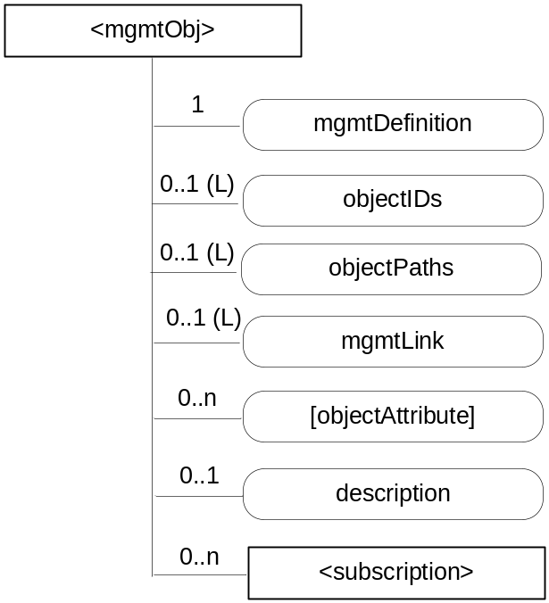
Figure 9.6.15-1: Structure of <mgmtObj> resource
The <mgmtObj> resource shall contain the child resource specified in table 9.6.15-1.
Table 9.6.15-1: Child resources of <mgmtObj> resource
Child Resources of <mgmtObj> | Child Resource Type | Multiplicity | Description | <mgmtObjAnnc> Child Resource Type
[variable] | <subscription> | 0..n | See clause 9.6.8 | <subscription>

The <mgmtObj> resource shall contain the attributes specified in table 9.6.15-2.
Table 9.6.15-2: Attributes of <mgmtObj> resource
Attributes of <mgmtObj> | Multiplicity | RW/  RO/  WO | Description | <mgmtObjAnnc> Attributes
resourceType | 1 | RO | See clause 9.6.1.3 | NA
resourceID | 1 | RO | See clause 9.6.1.3 | NA
resourceName | 1 | RO | See clause 9.6.1.3 | NA
parentID | 1 | RO | See clause 9.6.1.3 | NA
expirationTime | 1 | RW | See clause 9.6.1.3 | MA
accessControlPolicyIDs | 1 (L) | RW | See clause 9.6.1.3 | MA
creationTime | 1 | RO | See clause 9.6.1.3 | NA
lastModifiedTime | 1 | RO | See clause 9.6.1.3 | NA
labels | 0..1 (L) | RW | See clause 9.6.1.3 | MA
announceTo | 0..1 (L) | RW | See clause 9.6.1.3 | NA
announcedAttribute | 0..1 (L) | RW | See clause 9.6.1.3 | NA
mgmtDefinition | 1 | WO | Specifies the type of <mgmtObj> resource e.g. software, firmware, memory. The list of the value of the attribute can be seen in Annex D. | MA
objectIDs | 0..1 (L) | RW | Contains the list URNs that uniquely identify the external management technology data models used for this <mgmtObj> resource as well as the managed function and version it represents. This attribute shall be provided during the creation of the <mgmtObj> resource and shall not be modifiable afterwards.  If the <mgmtObj> resource is mapped to multiple external management technology data models, this attribute shall list all URNs for each mapped external management technology data model. This is mandatory for the <mgmtObj>, for which the data model is not specified by oneM2M but mapped from external management technology data model specified in other device management protocols. | OA
objectPaths | 0..1 (L) | RW | Contains the list of local paths of the external management object instances on the managed entity which is represented by the <mgmtObj> resource in the Hosting CSE.  This attribute shall be provided during the creation of the <mgmtObj>, so that the Hosting CSE can correlate the created <mgmtObj> with the external management object instance on the managed entity for further management operations. It shall not be modifiable after creation.  The format of this attribute shall be a local external management object path in the form as specified by existing management protocols. (e.g. "./anyPath/Fw1" in OMA DM [i.3], "Device.USBHosts.Host.3." in BBF TR-069 [i.2]).  The combination of the objectPath and the objectID attribute, allows to address the external technology data models. | OA
mgmtLink | 0..1 (L) | RW | This attribute contains reference to a list of other <mgmtObj> resources in case a hierarchy of <mgmtObj> is needed | OA
[objectAttribute] | 0..n | RW | Each [objectAttribute] is mapped from a leaf node of a hierarchical structured management object (including oneM2M data model and the existing management data models) based on the mapping rules below the table. | OA
description | 0..1 | RW | Text format description of <mgmtObj>. | OA

When mapping resources from management technologies to a corresponding <mgmtObj> resource, the following rules shall apply:
- The root resource of external management objects maps to the <mgmtObj> resource.
- For the child resource of the root resource of specific technology:
- Rule1: If the child external management object cannot have another child external management object, the external management object maps to the [objectAttribute] attribute of the <mgmtObj> resource with the same resource name.
- Rule2: If the child external management object can have another child external management object, the external management object maps to a new <mgmtObj> resource. The ID of the new <mgmtObj> resource is stored as an mgmtLink attribute of the <mgmtObj> resource which is mapped from the parent external management object.

9.6.16 Resource Type mgmtCmd
The <mgmtCmd> resource represents a method to execute management procedures or to model commands and remote procedure calls (RPC) required by existing management protocols (e.g. BBF TR-069 [i.2]), and enables AEs to request management procedures to be executed on a remote entity. It also enables cancellation of cancellable and initiated but unfinished management procedures or commands.
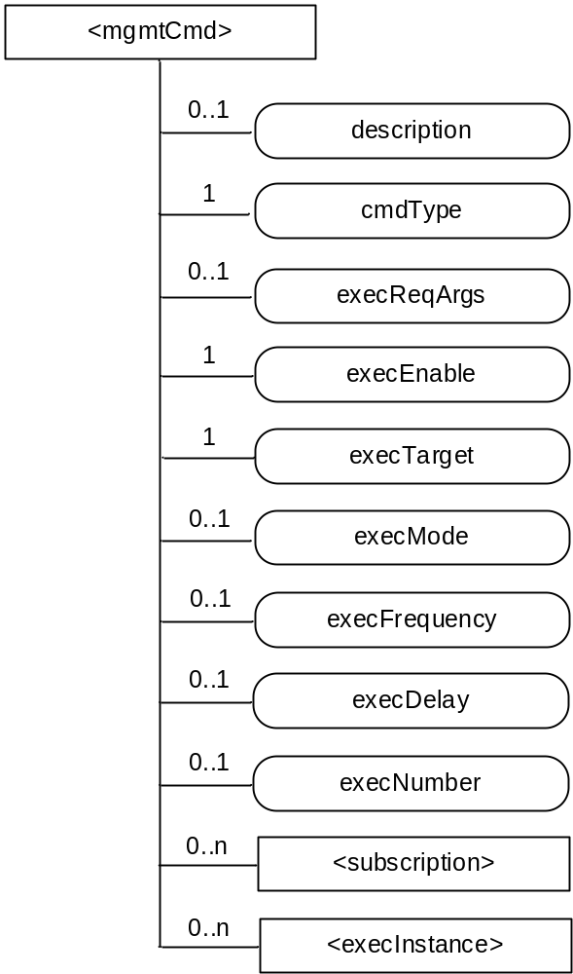
Figure 9.6.16-1: Structure of <mgmtCmd> resource
Each <mgmtCmd> corresponds to a specific type of management command, as defined by its attribute cmdType. For multiple requests of the same management command, <mgmtCmd> shall use sepatate child-resources (i.e. <execInstance>) to contain each execution instance. The execution of the management procedure represented by <mgmtCmd> shall be triggered using the UPDATE method to its attribute execEnable.
The <mgmtCmd> resource shall contain the child resources specified in table 9.6.16-1.
Table 9.6.16-1: Child resources of <mgmtCmd> resource
Child Resources of <mgmtCmd> | Child Resource Type | Multiplicity | Description
[variable] | <subscription> | 0..n | See clause 9.6.8
[variable] | <execInstance> | 0..n | See clause 9.6.17

The <mgmtCmd> resource shall contain the attributes specified in table 9.6.16-2.
Table 9.6.16-2: Attributes of <mgmtCmd> resource
Attributes of <mgmtCmd> | Multiplicity | RW/  RO/  WO | Description
resourceType | 1 | RO | See clause 9.6.1.3
resourceID | 1 | RO | See clause 9.6.1.3
resourceName | 1 | RO | See clause 9.6.1.3
parentID | 1 | RO | See clause 9.6.1.3
expirationTime | 1 | RW | See clause 9.6.1.3
accessControlPolicyIDs | 0..1 (L) | RW | See clause 9.6.1.3
labels | 0..1 (L) | RW | See clause 9.6.1.3
creationTime | 1 | RO | See clause 9.6.1.3
lastModifiedTime | 1 | RO | See clause 9.6.1.3
description | 0..1 | RW | The text-format description of this resource.
cmdType | 1 | WO | The type to identify the management operation (e.g. download).
execReqArgs | 0..1 | RW | Structured attribute (e.g. abstract type) to contain any command-specific arguments of the request.
execEnable | 1 | RO | The attribute can be blank without any value or it can contain an address that can be used to trigger execution of <mgmtCmd> using UPDATE method.
execTarget | 1 | RW | ID of the <node> resource of the target on which this <mgmtCmd> will be executed. It may be the URI of a <group> resource in which case the <mgmtCmd> will be executed on all members in the memberList attribute of the addressed <group> resource.
execMode | 0..1 | RW | The mode used to specify how the command will be executed (e.g. Immediate Once, Immediate and Repeatedly, Random Once, Random and Repeatedly). May be used together with execFrequency, execDelay and execNumber to provide the scheduling information.
execFrequency | 0..1 | RW | The minimum interval between two executions, to be used in conjunction with execMode. Modes involving random execution can be used to add random values between individual executions.
execDelay | 0..1 | RW | The minimum delay before the instance should be executed. Modes involving random execution can be used to increase this delay randomly.
execNumber | 0..1 | RW | The number of times the instance should be executed, to be used when execMode indicates a repetition pattern.

9.6.17 Resource Type execInstance
The <execInstance> resource represents a successful instance of <mgmtCmd> execution request, which had been triggered by a M2M network application using the UPDATE method to the attribute execEnable of <mgmtCmd> resource.
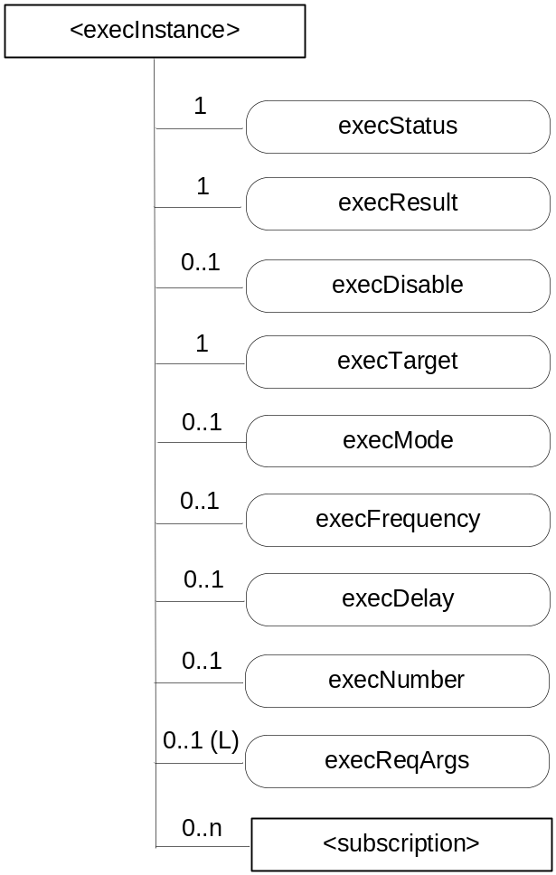
Figure 9.6.17-1: Structure of <execInstance> resource
The <execInstance> resource shall contain the child resources specified in table 9.6.17-1.
Table 9.6.17-1: Child resources of <execInstance> resource
Child Resources of <execInstance> | Child Resource Type | Multiplicity | Description
[variable] | <subscription> | 0..n | See clause 9.6.8

The <execInstance> resource shall contain the attributes specified in table 9.6.17-2.
Table 9.6.17-2: Attributes of <execInstance> resource
Attributes of <execInstance> | Multiplicity | RW/  RO/  WO | Description
resourceType | 1 | RO | See clause 9.6.1.3
resourceID | 1 | RO | See clause 9.6.1.3
resourceName | 1 | RO | See clause 9.6.1.3
expirationTime | 1 | RO | See clause 9.6.1.3
parentID | 1 | RO | See clause 9.6.1.3
accessControlPolicyIDs | 1 (L) | RW | See clause 9.6.1.3
creationTime | 1 | RO | See clause 9.6.1.3
lastModifiedTime | 1 | RO | See clause 9.6.1.3
labels | 0..1 (L) | RW | See clause 9.6.1.3
execStatus | 1 | RO | The status of <execInstance>. It can be Initiated, Started, Finished, Cancelled, or Deleted.
execResult | 1 | RO | The execution result of <execInstance>.
execDisable | 0..1 | RW | The attribute is used to cancel <execInstance> using UPDATE method.
execTarget | 1 | RO | ID of <node> resource of the target on which the <execInstance> will be executed.
execMode | 0..1 | RO | Modes used to specify how the command will be executed (e.g. Immediate Once, Immediate and Repeatedly, Random Once, Random and Repeatedly). May be used together with execFrequency, execDelay and execNumber to provide the scheduling information.
execFrequency | 0..1 | RO | The minimum interval between two executions, to be used in conjunction with execMode. Modes involving random execution can be used to add random values between individual executions.
execDelay | 0..1 | RO | The minimum delay before the instance should be executed. Modes involving random execution can be used to increase this delay randomly.
execNumber | 0..1 | RO | The number of times the instance should be executed, to be used when execMode indicates a repetition pattern.
execReqArgs | 0..1 (L) | RO | Structured attribute (e.g. abstract type) to contain any command-specific arguments (as a list) used to trigger this <execInstance>.

9.6.18 Resource Type node
The <node> resource represents specific information that provides properties of an M2M Node that can be utilized by other oneM2M operations. The <node> resource has specialization of the <mgmtObj> as its child resources. These resources represent the Node's context information (e.g. memory and battery), network topology, device information, device capability etc. The specialized <mgmtObj> resources are used to perform management of the Node.
This node specific information stored in these resources such as [memory] and [battery] can be obtained either by the existing device management technologies (OMA DM [i.3], BBF TR-069 [i.2]) or any other way (e.g. JNI [i.18]).
For the case when the <node> resource belongs to an ADN, please see figure 9.6.18-1 in conjunction with the description of nodeLink attribute in the <AE> resource (clause 9.6.5).
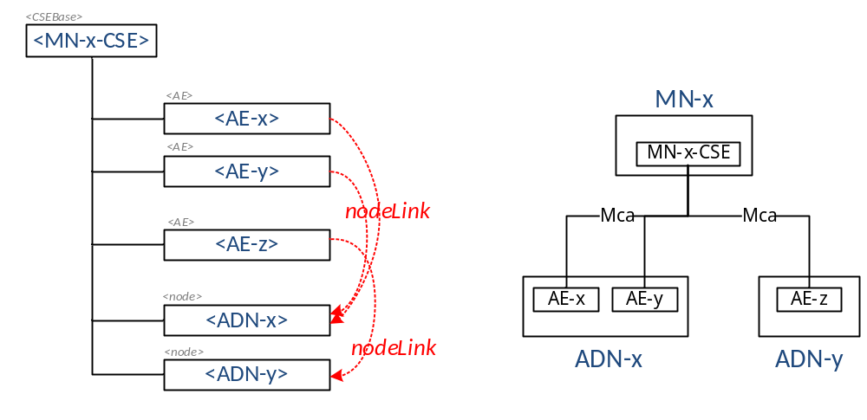
Figure 9.6.18-1: Relationship between MN and ADN
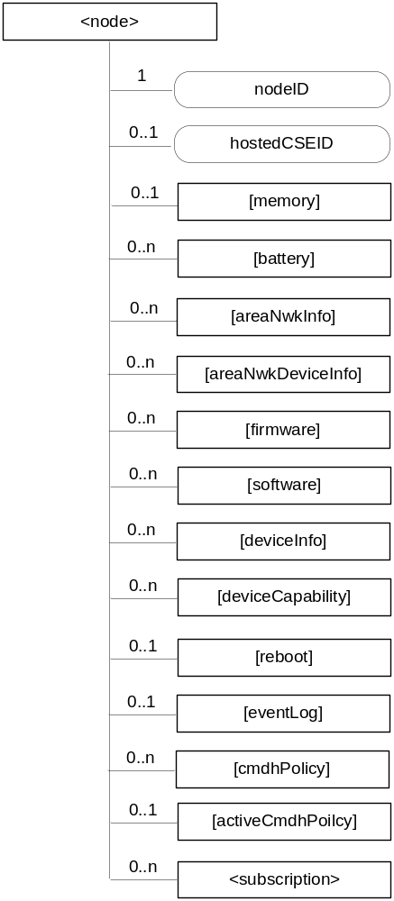
Figure 9.6.18-2: Structure of <node> resource
The <node> resource shall contain the child resources specified in table 9.6.18-1.
Table 9.6.18-1: Child resources of <node> resource
Child Resources of <node> | Child Resource Type | Multiplicity | Description | <nodeAnnc> Child Resource Type
[variable] | <mgmtObj> as defined in the specialization [memory] | 0..1 | This resource provides the memory (typically RAM) information of the node. (E.g. the amount of total volatile memory), See clause D.4. | <mgmtObjAnnc>
[variable] | <mgmtObj> as defined in the specialization [battery] | 0..n | The resource provides the power information of the node. (E.g. remaining battery charge). See clause D.7. | <mgmtObjAnnc>
[variable] | <mgmtObj> as defined in the specialization [areaNwkInfo] | 0..n | This resource describes the list of Nodes attached behind the MN node and its physical or underlying relation among the nodes in the M2M Area Network. This attribute is defined in case the Node is MN. See clause D.5. | <mgmtObjAnnc>
[variable] | <mgmtObj> as defined in the specialization [areaNwkDeviceInfo] | 0..n | This resource describes the information about the Node in the M2M Area Network. See clause D.6. | <mgmtObjAnnc>
[variable] | <mgmtObj> as defined in the specialization [firmware] | 0..n | This resource describes the information about the firmware of the Node include name, version etc. See clause D.2. | <mgmtObjAnnc>
[variable] | <mgmtObj> as defined in the specialization [software] | 0..n | This resource describes the information about the software of the Node. See clause D.3. | <mgmtObjAnnc>
[variable] | <mgmtObj> as defined in the specialization [deviceInfo] | 0..n | The resource contains information about the identity, manufacturer and model number of the device. See clause D.8. | <mgmtObjAnnc>
[variable] | <mgmtObj> as defined in the specialization [deviceCapability] | 0..n | The resource contains information about the capability supported by the Node. See clause D.9. | <mgmtObjAnnc>
[variable] | <mgmtObj> as defined in the specialization [reboot] | 0..1 | The resource is the place to reboot or reset the Node. See clause D.10. | <mgmtObjAnnc>
[variable] | <mgmtObj> as defined in the specialization [eventLog] | 0..1 | The resource contains the information about the log of events of the Node. See clause D.11. | <mgmtObjAnnc>
[variable] | <mgmtObj> as defined in the specialization [cmdhPolicy] | 0..n | The resource(s) contain(s) information about CMDH policies that are applicable to the CMDH processing on the CSE hosted on the node represented by this <node> resource and identified by the hostedCSEID attribute of this <node> resource. See clause D.12. | NA
[variable] | <mgmtObj> as defined in the specialization [activeCmdhPolicy] | 0..1 | This resource defines which of the present [cmdhPolicy] resource(s) shall be active for the CMDH processing on the CSE hosted on the node represented by this <node> resource and identified by the hostedCSELink attribute of this <node> resource. See clause D.12. | NA
[variable] | <subscription> | 0..n | See clause 9.6.8. | <subscription>

The <node> resource shall contain the attributes specified in table 9.6.18-2.
Table 9.6.18-2: Attributes of <node> resource
Attributes of  <node> | Multiplicity | RW/  RO/  WO | Description | <nodeAnnc> attributes
resourceType | 1 | RO | See clause 9.6.1.3 | NA
resourceID | 1 | RO | See clause 9.6.1.3 | NA
resourceName | 1 | RO | See clause 9.6.1.3 | NA
parentID | 1 | RO | See clause 9.6.1.3 | NA
expirationTime | 1 | RW | See clause 9.6.1.3 | MA
accessControlPolicyIDs | 0..1 (L) | RW | See clause 9.6.1.3 | MA
creationTime | 1 | RO | See clause 9.6.1.3 | NA
lastModifiedTime | 1 | RO | See clause 9.6.1.3 | NA
labels | 0..1 (L) | RW | See clause 9.6.1.3 | MA
announceTo | 0..1 (L) | RW | See clause 9.6.1.3 | NA
announcedAttribute | 0..1 (L) | RW | See clause 9.6.1.3 | NA
nodeID | 1 | RW | The M2M-Node-ID of the node which is represented by this <node> resource. | MA
hostedCSELink | 0..1 | RW | The resource ID of a resource where all of the following applies:  - The resource is a <CSEBase> resource or a <remoteCSE> resource.  - The resource is hosted on the same CSE as the present <node> resource.  - The resource represents the CSE which resides on the specific node that is represented by the current <node> resource. | OA

9.6.19 Resource Type m2mServiceSubscriptionProfile
The <m2mServiceSubscriptionProfile> resource represents an M2M Service Subscription. It is used to represent all data pertaining to the M2M Service Subscription, i.e. the technical part of the contract between an M2M Application Service Provider and an M2M Service Provider and is only stored on IN-CSE. The data is also represented in <serviceSubscribedNode> and <serviceSubscribedAppRule> resources as well as <m2mServiceSubscriptionProfile> resource. The relationship among those three resource types are depicted as follows. Note that the diagram does not capture all attributes and child resources. Those resource types shall only be instanciated on IN-CSE.
Editor’s Note: The relationship between this resource type and the M2M Service Profile Identifier will be specified (see clause 7.1.13)..
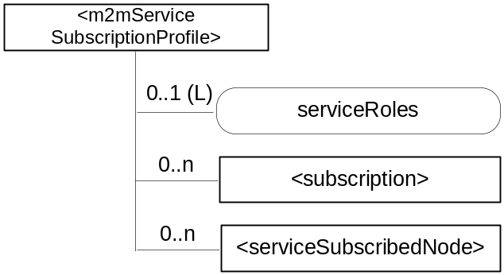
Figure 9.6.19-1: Structure of <m2mServiceSubscriptionProfile> resource
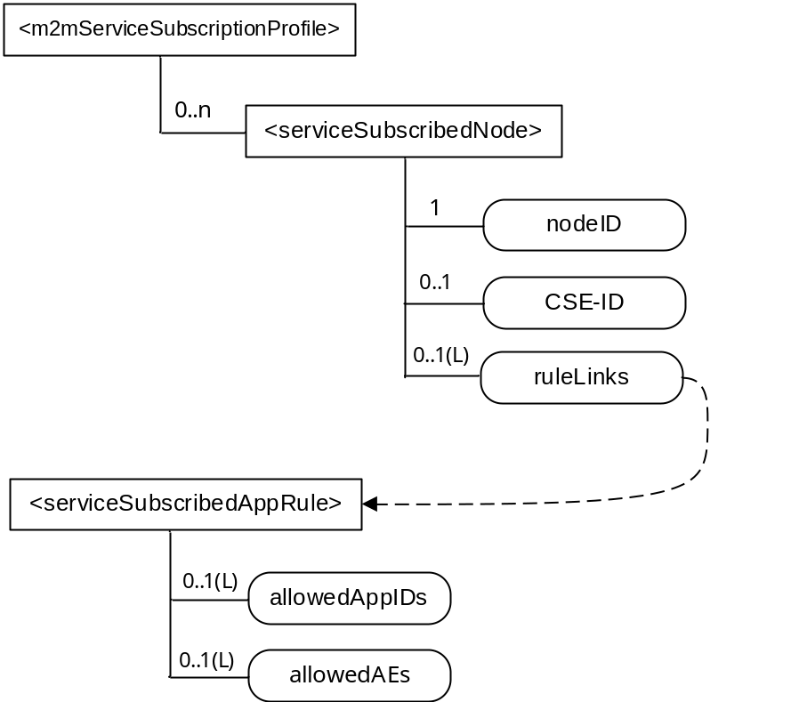
Figure 9.6.19-2: Relationship among M2M Service Subscription related resources
The <m2mServiceSubscriptionProfile> resource shall contain the child resources specified in table 9.6.19-1.
Table 9.6.19-1: Child resources of <m2mServiceSubscriptionProfile> resource
Child Resources of <m2mServiceSubscriptionProfile> | Child Resource Type | Multiplicity | Description
[variable] | <subscription> | 0..n | See clause 9.6.8
[variable] | <serviceSubscribedNode> | 0..n | See clause 9.6.20

The <m2mServiceSubscriptionProfile> resource shall contain the attributes specified in table 9.6.19-2.
Table 9.6.19-2: Attributes of <m2mServiceSubscriptionProfile> resource
Attributes of <m2mServiceSubscriptionProfile> | Multiplicity | RW/  RO/  WO | Description
resourceType | 1 | RO | See clause 9.6.1.3
resourceID | 1 | RO | See clause 9.6.1.3
resourceName | 1 | RO | See clause 9.6.1.3
parentID | 1 | RO | See clause 9.6.1.3
expirationTime | 1 | RW | See clause 9.6.1.3
accessControlPolicyIDs | 0..1 (L) | RW | See clause 9.6.1.3 If no accessControlPolicyIDs is given at the time of creation, the accessControlPolicyIDs of the parent resource is linked to this attribute.
creationTime | 1 | RO | See clause 9.6.1.3
labels | 0..1 (L) | RW | See clause 9.6.1.3
lastModifiedTime | 1 | RO | See clause 9.6.1.3
serviceRoles | 0..1 (L) | RW | This attribute contains a list of Service Role IDs (S-RoleID) that are subscribed to in this service subscription. If the multiplicity of this attribute is 0, the role does not apply.

9.6.20 Resource Type serviceSubscribedNode
The <serviceSubscribedNode> resource represents M2M Node information that is needed as part of the M2M Service Subscription resource and is only stored on IN-CSE. It contains M2M-Node-ID and optionally CSE-ID running on that Node.
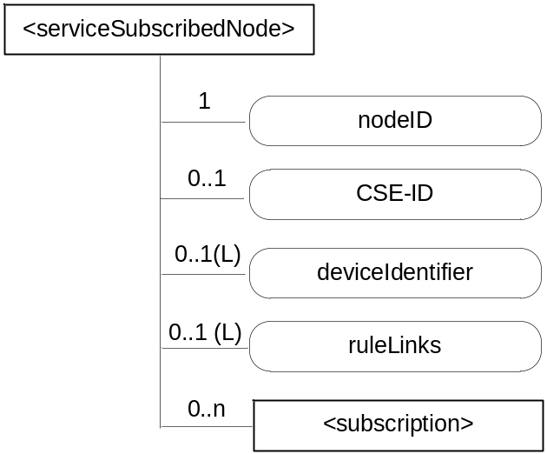
Figure 9.6.20-1: Structure of <serviceSubscribedNode> resource
The <serviceSubscribedNode> resource shall contain the child resource specified in table 9.6.20-1.
Table 9.6.20-1: Child resources of <serviceSubscribedNode> resource
Child Resources of <serviceSubscribedNode> | Child Resource Type | Multiplicity | Description
[variable] | <subscription> | 0..n | See clause 9.6.8

The <serviceSubscribedNode> resource shall contain the attributes specified in table 9.6.20-2.
Table 9.6.20-2: Attributes of <serviceSubscribedNode> resource
Attributes of <serviceSubscribedNode> | Multiplicity | RW/  RO/  WO | Description
resourceType | 1 | RO | See clause 9.6.1.3
resourceID | 1 | RO | See clause 9.6.1.3
resourceName | 1 | RO | See clause 9.6.1.3
parentID | 1 | RO | See clause 9.6.1.3
expirationTime | 1 | RW | See clause 9.6.1.3
accessControlPolicyIDs | 0..1 (L) | RW | See clause 9.6.1.3 If no accessControlPolicyIDs is given at the time of creation, the accessControlPolicyIDs of the parent resource is linked to this attribute.
creationTime | 1 | RO | See clause 9.6.1.3
labels | 0..1 (L) | RW | See clause 9.6.1.3
lastModifiedTime | 1 | RO | See clause 9.6.1.3
nodeID | 1 | WO | M2M-Node-ID of the node that is represented by this instance.
CSE-ID | 0..1 | WO | CSE-ID pertaining to this node (for nodes that have a CSE).
deviceIdentifier | 0..1 (L) | WO | A list of device identifiers. A deviceIdentifier identifies a device using a Universally Unique IDentifier (UUID). The UUID specifies a valid, hex digit character string as defined in IETF RFC 4122 [i.26]. The format of the URN is one of the following:  - Case 1: Identify a device using the format <OUI> "-" <ProductClass> "-" <SerialNumber> as defined in section 3.4.4 of TR-069 [i.2]. The format of the URN is urn:dev:ops:<OUI> "-" <ProductClass> "-" <SerialNumber>.  - Case 2: Identify a device using the format <OUI> "-"<SerialNumber> as defined in section 3.4.4 of TR-069 [Error: Reference source not found]. The format of the URN is urn:dev:os:<OUI> "-"<SerialNumber>.  - Case 3: Identify a device using an International Mobile Equipment Identifiers of 3GPP TS 23.003 [i.23]. This URN specifies a valid, 15 digit IMEI. The format of the URN is urn:imei:###############.  - Case 4: Identify a device using an Electronic Serial Number. The ESN specifies a valid, 8 digit ESN. The format of the URN is urn:esn:########.  - Case 5: Identify a device using a Mobile Equipment Identifier. This URN specifies a valid, 14 digit MEID. The format of the URN is urn:meid:##############.
ruleLinks | 0..1 ((L) | RW | This attribute contains a list of links towards <serviceSubscribedAppRule> resources pertaining to this <serviceSubscribedNode>. See clause 9.6.29 for an explanation of the <serviceSubscribedAppRule> resource. This attribute shall exist only when the CSE-ID attribute is present. When the list is empty, it means no applications are allowed to register on the CSE which is indicated by the CSE-ID attribute.

9.6.21 Resource Type pollingChannel
The <pollingChannel> resource represents a channel that can be used for a request-unreachable entity (i.e. an AE or a CSE which is behind NAT so it cannot receive a request from other Nodes). The request-unreachable entity creates a <pollingChannel> resource on a request-reachable CSE, and then polls any type of request(s) for itself from the <pollingChannel> Hosting CSE. For example, an AE can retrieve notifications by long polling on the channel when it cannot receive notifications asynchronously from a subscription Hosting CSE.
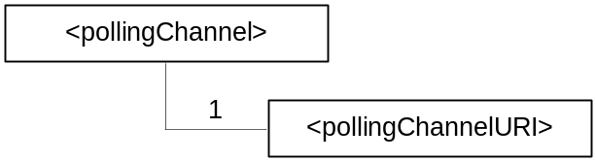
Figure 9.5.21-1: Structure of <pollingChannel> resource
The <pollingChannel> resource shall contain the child resource specified in table 9.6.21-1.
Table 9.6.21-1: Child resources of <pollingChannel> resource
Child Resources of <pollingChannel> | Child Resource Type | Multiplicity | Description
pollingChannelURI | <pollingChannelURI> | 1 | See clause 9.6.22

The <pollingChannel> resource shall contain the attributes specified in table 9.6.21-2.
Table 9.6.21-2: Attributes of <pollingChannel> resource
Attributes of <pollingChannel> | Multiplicity | RW/  RO/  WO | Description
resourceType | 1 | RO | See clause 9.6.1.3
resourceID | 1 | RO | See clause 9.6.1.3
resourceName | 1 | RO | See clause 9.6.1.3
parentID | 1 | RO | See clause 9.6.1.3
creationTime | 1 | RO | See clause 9.6.1.3
lastModifiedTime | 1 | RO | See clause 9.6.1.3
expirationTime | 1 | RO | See clause 9.6.1.3
accessControlPolicyIDs | 0..1 (L) | RW | See clause 9.6.1.3
labels | 0..1 (L) | RW | See clause 9.6.1.3

9.6.22 Resource Type pollingChannelURI
The <pollingChannelURI> virtual resource is the child resource of the <pollingChannel> resource and is used to perform service layer long polling. The AE or CSE which created of the <pollingChannel> resource on its Registrar CSE sends a Retrieve request targeting the <pollingChannelURI> resource as a service layer long polling request. The response to the long polling request shall be pending until there are any requests received on the channel or the request reaches the request expiration time.
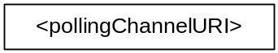
Figure 9.5.22-1: Structure of <pollingChannelURI> resource

9.6.23 Resource Type statsConfig
The <statsConfig> resource is used to store policies of statistics for AEs. The <statsConfig> resource may be established by the IN-CSEs or by IN-AEs. The <statsConfig> resource shall be located directly under <CSEBase>.
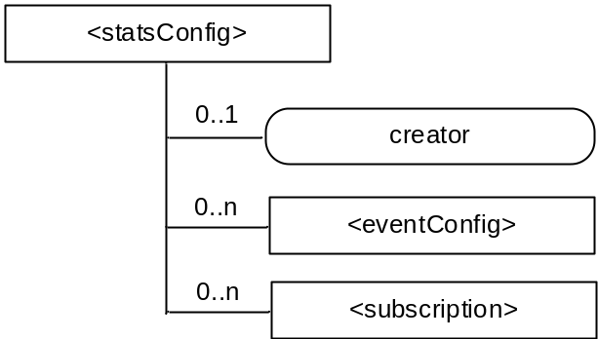
Figure 9.6.23-1: Structure of <statsConfig> resource
The <statsConfig> resource shall contain the child resources specified in table 9.6.23-1.
Table 9.6.23-1: Child resources of <statsConfig> resource
Child Resources of <statsConfig> | Child Resource Type | Multiplicity | Description
[variable] | <eventConfig> | 0..n | See clause 9.6.24. This resource configures an event for statistics collection.
[variable] | <subscription> | 0..n | See clause 9.6.8 where the type of this resource is described.

The <statsConfig> resource shall contain the attributes specified in table 9.6.23-2.
Table 9.6.23-2: Attributes of <statsConfig> resource
Attributes of <statsConfig> | Multiplicity | RW/  RO/  WO | Description
resourceType | 1 | RO | See clause 9.6.1.3
resourceID | 1 | RO | See clause 9.6.1.3
resourceName | 1 | RO | See clause 9.6.1.3
parentID | 1 | RO | See clause 9.6.1.3
accessControlPolicyIDs | 1 (L) | RW | See clause 9.6.1.3
creationTime | 1 | RO | See clause 9.6.1.3
expirationTime | 1 | RW | See clause 9.6.1.3
lastModifiedTime | 1 | RO | See clause 9.6.1.3
labels | 0..1 (L) | RW | See clause 9.6.1.3
creator | 0..1 | RO | The AE-ID of the entity which created the resource. This can also be the CSE-ID of the IN-CSE if the IN-CSE created the resource.

9.6.24 Resource Type eventConfig
<eventConfig> sub-resource shall be used to define events that trigger statistics collection. Below are some examples of events that can be generated:
- Collection based on a certain operation: collects any RETRIEVE operations on the data (i.e. resources) stored in the IN-CSE.
- Collection based on storage size: collects the size of storage when a <container> resource stored in the IN-CSE exceeds a quota.
- Combined configuration: collects all RETRIEVE operations on the data stored in the IN-CSE during a period of time.
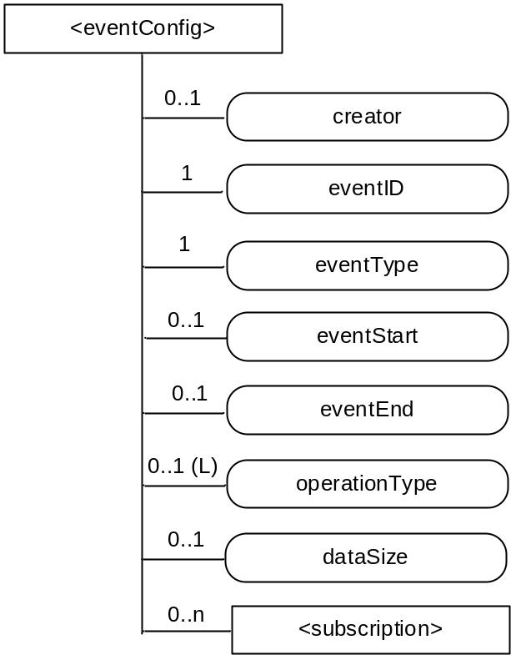
Figure 9.6.24-1: Structure of <eventConfig> resource
The <eventConfig> resource shall contain the child resource specified in table 9.6.24-1.
Table 9.6.24-1: Child resources of <eventConfig> resource
Child Resources of <eventConfig> | Child Resource Type | Multiplicity | Description
[variable] | <subscription> | 0..n | See clause 9.6.8 where this type of resource is described.

The <eventConfig> resource shall contain the attributes specified in table 9.6.24-2.
Table 9.6.24-2: Attributes of <eventConfig> resource
Attributes of <eventConfig> | Multiplicity | RW/  RO/  WO | Description
resourceType | 1 | RO | See clause 9.6.1.3
resourceID | 1 | RO | See clause 9.6.1.3
resourceName | 1 | RO | See clause 9.6.1.3
parentID | 1 | RO | See clause 9.6.1.3
accessControlPolicyIDs | 1 (L) | RW | See clause 9.6.1.3
creationTime | 1 | RO | See clause 9.6.1.3
expirationTime | 1 | RW | See clause 9.6.1.3
lastModifiedTime | 1 | RO | See clause 9.6.1.3
labels | 0..1 (L) | RW | See clause 9.6.1.3
creator | 0..1 | RO | The AE-ID of the entity which created the resource. This can also be the CSE-ID of the IN-CSE if the IN-CSE created the resource.
eventID | 1 | RO | This attribute uniquely identifies the event to be collected for statistics for AEs.
eventType | 1 | RW | This attribute indicates the type of the event, such as timer based, data operation, storage based, etc.
eventStart | 0..1 | RW | This attribute indicates the start time of the event.
eventEnd | 0..1 | RW | This attribute indicates the end time of the event
operationType | 0..1 (L) | RW | This attribute defines the type of the operation to be collected by statistics, such as CREATE, RETRIEVE.
dataSize | 0..1 | RW | This attribute defines the data size if an event is triggered when the stored data exceeds a certain size.

9.6.25 Resource Type statsCollect
The <statsCollect> resource shall be used to collect information for AEs using the <eventConfig> resource as the triggers in the IN-CSE. Multiple triggers can be established at IN-CSE for the same AE. . Each trigger may be activated or de-activated independently of others. The <statsCollect> resource shall be located directly under <CSEBase> of IN-CSE.
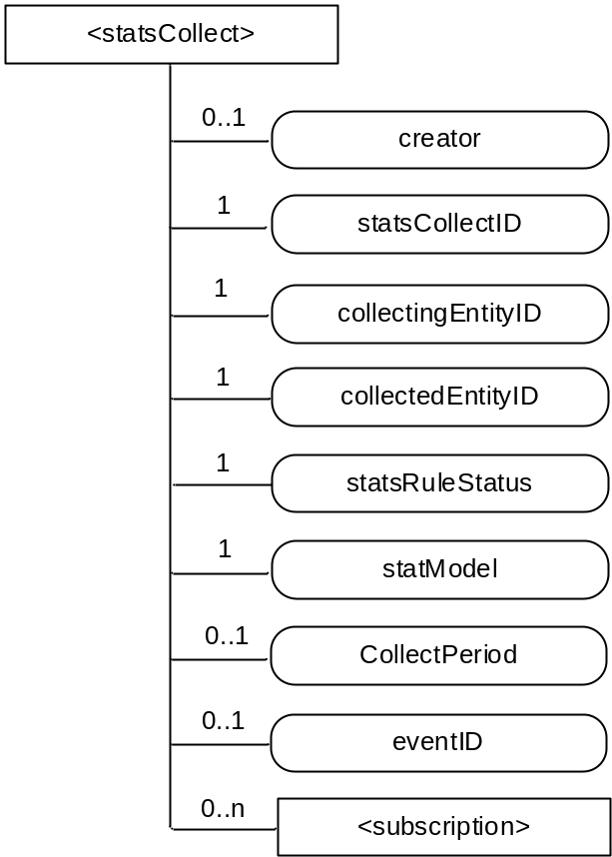
Figure 9.6.25-1: Structure of <statsCollect> resource
The <statsCollect> resource shall contain the child resource specified in table 9.6.25-1.
Table 9.6.25-1: Child resources of <statsCollect> resource
Child Resources of <statsCollect> | Child Resource Type | Multiplicity | Description
[variable] | <subscription> | 0..n | See clause 9.6.8 where the type of this resource is described.

The <statsCollect> resource shall contain the attributes specified in table 9.6.25-2.
Table 9.6.25-2: Attributes of <statsCollect> resource
Attributes of <statsCollect> | Multiplicity | RW/  RO/  WO | Description
resourceType | 1 | RO | See clause 9.6.1.3
resourceID | 1 | RO | See clause 9.6.1.3
resourceName | 1 | RO | See clause 9.6.1.3
parentID | 1 | RO | See clause 9.6.1.3
accessControlPolicyIDs | 1 (L) | RW | See clause 9.6.1.3
creationTime | 1 | RO | See clause 9.6.1.3
expirationTime | 1 | RW | See clause 9.6.1.3
lastModifiedTime | 1 | RO | See clause 9.6.1.3
labels | 0..1 (L) | RW | See clause 9.6.1.3
creator | 0..1 | RO | The AE-ID of the entity which created the resource. This can also be the CSE-ID of the IN-CSE if the IN-CSE created the resource.
statsCollectID | 1 | RO | This is the unique ID to identify a specific statistics collection scenario. It is created by the IN-CSE when the <statsCollect> resource is first created.
collectingEntityID | 1 | WO | This is the unique ID of the entity that requests the collection of statistics. For example, it can be an AE-ID or CSE-ID.
collectedEntityID | 1 | WO | This is the unique ID of the entity whose request triggered the configured event for statistics collection. For example, it can be an AE-ID or IN-CSE-ID.  If no specific value is provided for this attribute, the IN-CSE interprets it as "any entity".
statsRuleStatus | 1 | RW | This attribute indicates whether the rule is "active" or "inactive".
statModel | 1 | RW | This attribute indicates the collection model, such as "Subscriber based", "event based", etc.
collectPeriod | 0..1 | RW | Expresses time periods defined by second, minute, hour day of month, month, and year. Supports repeating periods, and wildcards expressed as a list.
eventID | 0..1 | RW | This attribute refers to the <eventConfig> resource that defines the events that can be collected by the IN-CSE. It is mandatory if the statModel attribute is set to "event based".

9.6.26 Resource Announcement

9.6.26.1 Overview
A resource can be announced to one or more remote CSEs to inform the remote CSEs of the existence of the original resource. An announced resource can have a limited set of attributes and a limited set of child resources from the original resource. The announced resource includes a link to the original resource hosted by the original resource-Hosting CSE.
In case that the original resource is deleted, all announced resources for the original resource shall be deleted, except for <AEAnnc> resources that were created during the registration of an AE with AE-ID-Stem starting with "S", which shall not be deleted. If the announced resource is not deleted promptly (e.g. the announced resource is not reachable), the announced resource can be deleted later either by the original resource Hosting CSE or by the expiration of the announced resource itself. The original resource shall store the list of links for the announced resources for those purposes.
Synchronization between the attributes announced by the original resource and the announced resource shall be the responsibility of the original resource Hosting CSE. There shall not be any synchronization for children created at the original resource and the announced resource. The access control policy for the announced resource shall synchronize with the one from the original resource. In case that the attribute accessControlPolicyIDs is not present in the original resource it is the responsibility of the original resource Hosting CSE to choose the appropriate value depending on the policy for the original resource (e.g. take the parent accessControlPolicyIDs value).
The original resource shall have at least announceTo attribute present if the resource itself has been announced. If any of the Optional Announced (OA) attributes are also announced, then announcedAttribute attribute shall also be present. An AE or other CSE can request the original resource Hosting CSE for announcing the original resource to the list of CSE-IDs or the address(es) listed in the announceTo attribute in the announcing request. An Update to the announceTo attribute will trigger new resource announcement(s) or the de-announcement(s) of the announced resource. After a successful announcement procedure the attribute announceTo contains only the list of address(es) of the announced resources.
In order to announce an attribute marked as OA (see clause 9.5.1.1), the attribute shall be included in the announcedAttribute attribute list at the original resource. The attributes included in the announcedAttribute attribute are announced to the announced resource. On successful announcement of the resource, such attributes shall be created at the announced resource; otherwise they shall not be present in the announced resource. Update to the announcedAttribute attribute in the original resource will trigger new attribute announcement or the de-announcement of the announced attribute(s). The announced attributes shall have the same value as the original resource, and synchronization between the value of the announced attributes at the original resource and the announced resource is the responsibility of the original resource Hosting CSE.
An announced resource may have child resources. The child resource shall be of the same type as the original child resource or its associated Announce type.
Child resources of the original resource can be announced independently as needed. In this case, the child resources at the announced resource shall be of the child resource "Announced" type. When a child resource at the announced resource is created locally at the remote CSE, the child resource shall be of normal child resource type.
When a Hosting CSE of an original resource is initiating an announcement, it shall first check if the parent resource of the original resource has a representation at the announcement target CSE. If that is the case, the announced resource shall be created as a child resource of that representation of the parent resource. If that is not the case, the announced resource shall be created as a child of the <CSEBase> resource of the announcement target CSE.
If an attribute is marked as RO and also marked as MA or OA, then only the attribute of the original resource shall be interpreted as RO. The corresponding attribute of the announced resource shall be always writable to the original resource hosting CSE to allow it to properly announce and de-announce the attribute and keep the announced attribute synchronized with the original one. Only the original resource Hosting CSE shall be allowed to update and delete the announced attribute which is created by the original resource Hosting CSE.
Table 9.6.26.1-1: Announced Resource Types
Announced Resource Type | Short Description | Child Resource Types | Clause
accessControlPolicyAnnc | Announced variant of accessControlPolicy | subscription | 9.6.2
AEAnnc | Announced variant of AE | subscription,  container,  containerAnnc,  group,  groupAnnc,  accessControlPolicy,  accessControlPolicyAnnc | 9.6.5
containerAnnc | Announced variant of container | container,  containerAnnc,  contentInstance,  contentInstanceAnnc,  subscription, | 9.6.6
contentInstanceAnnc | Announced variant of contentInstance | None specified | 9.6.7
groupAnnc | Announced variant of group | subscription | 9.6.13
locationPolicyAnnc | Announced variant of locationPolicy | None specified | 9.6.10
mgmtObjAnnc | Announced variant of mgmtObj | subscription,  mgmtObj,  mgmtObjAnnc,  scheduleAnnc | 9.6.15
nodeAnnc | Announced variant of node | mgmtObjAnnc,  subscription | 9.6.18
remoteCSEAnnc | Announced variant of remoteCSE | AE,  AEAnnc,  container,  containerAnnc,  group,  groupAnnc,  accessControlPolicy,  accessControlPolicyAnnc,  subscription,  scheduleAnnc,  nodeAnnc,  locationPolicyAnnc | 9.6.4
scheduleAnnc | Announced variant of schedule | None specified | 9.6.39  Annex D

9.6.26.2 Universal Attributes for Announced Resources
Table 9.6.26.2-1 lists the universal attributes for the announced resources. If an attribute is marked "NA" in the original resource type or it is marked "OA" and is not provided by the Originator, then the value for the corresponding attribute in the announced resource is provided by the <remote CSE> resource.
Table 9.6.26-1: Universal Attributes for Announced Resources
Attributes Name | Mandatory /Optional | Description
resourceType | Mandatory | Resource Type.  As specified in clause 9.2, a suffix of "Annc" to the name of the original resource type shall be used to indicate the name for the associated announced resource type.
resourceID | Conditionally Mandatory | See clause 9.6.1.3 for information on this attribute
resourceName | Conditionally Mandatory | See clause 9.6.1.3 for information on this attribute
creationTime | Mandatory | See clause 9.6.1.3 for information on this attribute.
lastModifiedTime | Mandatory | See clause 9.6.1.3 for information on this attribute.
labels | Conditionally Mandatory | Tokens used as keys for discovering resources as announced by the original resource. See clause 9.6.1.3 for further information on this attribute.  The attribute is conditionally mandatory, which means that the attribute shall exist in the announced resource if it is present in the original resource.
link | Mandatory | Provides the URI to the original resource.

9.6.26.3 Common Attributes for Announced Resources
Table 9.6.26.3-1 lists the common attributes for the announced resources. If an attribute is marked "NA" in the original resource type or it is marked "OA" and is not provided by the Originator, then the value for the corresponding attribute in the announced resource is provided by the <remote CSE> resource.
Table 9.6.26.3-1: Commonly Used Attributes for Announced Resources
Attribute Name | Mandatory /Optional | Description
parentID | Mandatory | Identifies the parent resource at the remote CSE.
accessControlPolicyIDs | Conditionally Mandatory | The list of identifiers (either an ID or a URI) of an <accessControlPolicy> resource announced by the original resource See clause 9.6.1.3.2 for further information on this attribute.  If this attribute was not present in the original resource, the original resource shall include this attribute by providing the accessControlPolicyIDs from the original resource's parent resource or from the local policy according at the original resource.
expirationTime | Conditionally Mandatory | See clause 9.6.1.3.2 for information on this attribute.  This attribute is limited by the value received from the original resource but it can be overridden by the policies of the remote CSE hosting the announced resource.
stateTag | Conditionally Mandatory | An incremental counter of modification on the resource.  See clause 9.6.1.3.2 for information on this attribute.

9.6.27 Resource Type latest
The <latest> resource is a virtual resource because it does not have a representation. It is the child resource of a <container> resource. When a request addresses the <latest> resource, the Hosting CSE shall apply the request to the latest <contentInstance> resource among all existing <contentInstance> resources of the <container> resource.
The <latest> resource inherits access control policies that apply to the parent <container> resource.

9.6.28 Resource Type oldest
The <oldest> resource is a virtual resource because it does not have a representation. It is the child resource of a <container> resource. When a request addresses the <oldest> resource, the Hosting CSE shall apply the request to the oldest <contentInstance> resource among all existing <contentInstance> resources of the <container> resource.
The <oldest> resource inherits access control policies that apply to the parent <container> resource.

9.6.29 Resource Type serviceSubscribedAppRule
The <serviceSubscribedAppRule> resource represents a rule that defines allowed App-ID and AE-ID combinations that are acceptable for registering an AE on a Registrar CSE and is only stored on IN-CSE. The rule in a <serviceSubscribedAppRule> resource shall apply for CSEs for which the associated <serviceSubscribeNode> resource is linked with the <serviceSubscribedAppRule> via the ruleLinks attribute of the <serviceSubscribedNode> resource. The rule contained in a <serviceSubscribedAppRule> resource defines a mapping between:
- one or more Credential-ID(s); and
- combinations of one or more App-ID(s) and one or more AE-ID(s) which are allowed to be used for registering AE(s) that issued a registration request via a Security Association established with the credentials associated with the Credential-ID(s) listed in (a).
When applications shall be allowed in situations where no Security Association has been established prior to issuing the registration request, the Credential-ID 'None' shall be used in the rule.
The parent resource of a <serviceSubscribedAppRule> resource is the <CSEBase> resource of the IN-CSE hosting the <serviceSubscribedNode> resource(s) that point to the <serviceSubscribedAppRule> resource.
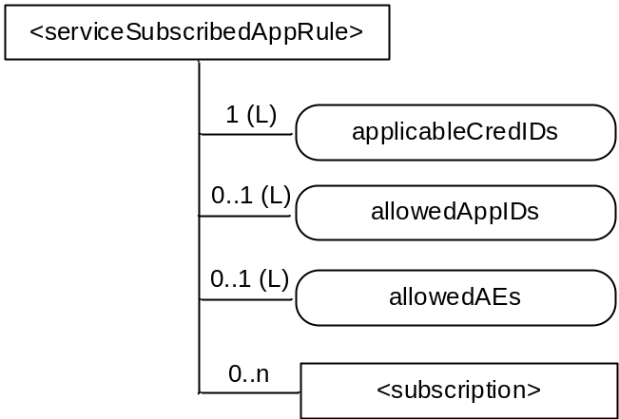
Figure 9.6.29-1: Structure of <serviceSubscribedAppRule> resource
The <serviceSubscribedAppRule> resource shall contain the child resource specified in table 9.6.29-1.
Table 9.6.29-1: Child resources of <serviceSubscribedAppRule> resource
Child Resources of <serviceSubscribedAppRule> | Child Resource Type | Multiplicity | Description
[variable] | <subscription> | 0..n | See clause 9.6.8 where the type of this resource is described.

The <serviceSubscribedAppRule> resource shall contain the attributes specified in table 9.6.29-2.
Table 9.6.29-2: Attributes of <serviceSubscribedAppRule> resource
Attributes of <serviceSubscribedAppRule> | Multiplicity | RW/  RO/  WO | Description
resourceType | 1 | RO | See clause 9.6.1.3
resourceID | 1 | RO | See clause 9.6.1.3
resourceName | 1 | RO | See clause 9.6.1.3
parentID | 1 | RO | See clause 9.6.1.3
expirationTime | 1 | RW | See clause 9.6.1.3
accessControlPolicyIDs | 0..1 (L) | RW | See clause 9.6.1.3 If no accessControlPolicyIDs is given at the time of creation, the accessControlPolicyIDs of the parent resource is linked to this attribute.
creationTime | 1 | RO | See clause 9.6.1.3
labels | 0..1 (L) | RW | See clause 9.6.1.3
lastModifiedTime | 1 | RO | See clause 9.6.1.3
applicableCredIDs | 1 (L) | RW | List of credential IDs for which this rule is applicable, i.e. for registration requests coming into a CSE via a Security Association Endpoint (SEA) [Error: Reference source not found], that was authenticated using credentials that match with any of these credential-IDs, the current rule applies. This can contain a '*' for any credential ID or 'None' for not authenticated case. Also Wildcards within an element of this list are possible (e.g. 'C123*X' for any Credential ID that starts with 'C123' and ends with 'X') to define sets or ranges of Credential-IDs.
allowedApp-IDs | 0..1 (L) | RW | List of App-IDs that shall be considered to be allowed for AE registration requests received via Security Association Endpoint (SEA) [Error: Reference source not found] associated with credentialID stored in the attribute applicableCredID. This can contain '*' for any App-ID. Also Wildcards within an element of this list are possible (e.g. 'C123*X' for any App-ID that starts with 'C123' and ends with 'X') to define sets or ranges of App-IDs.
allowedAEs | 0..1 (L) | RW | List of allowed AE-ID-Stems to be used for the registering AEs. This can contain zero or more specific AE-ID-Stem values, 'S*' for any SP-Assigned AE-ID-Stem, 'C*' for any CSE-assigned AE-ID-Stem, or '*' for any AE-ID-Stem. Also Wildcards within an element of this list are possible (e.g. 'C123*X' for any AE-ID that starts with 'C123' and ends with 'X') to define sets or ranges of AE-ID-Stems.

-----------------------End of change 1---------------------------------------------

