CHANGE REQUEST
Meeting:* | WG2 Architecture - ARC 20
Source:* | Ericsson
Date:* | 2015-10-20
Contact:* | George Foti
Reason for Change/s:* | There are requirements to support streaming session
CR against: Release*
CR against: WI* | Active <WI-0034>  MNT Maintenace / <Work Item number(optional)>  STE Small Technical Enhancements / <Work Item number (optional)>  Only ONE of the above shall be ticked
CR against: TS/TR* | TR-0020
Clauses/Sub Clauses*
Type of change: * | Editorial change  Bug Fix or Correction  Change/correction to existing feature or functionality  New feature or functionality
Post Freeze checking:* | This CR contains only essential changes and corrections? YES NO  This CR is a mirror CR? YES NO if YES, please indicate the document number of the original CR:  <Document Number)<CR Number of the original CR to the current Release>

oneM2M Notice
The document to which this cover statement is attached is submitted to oneM2M. Participation in, or attendance at, any activity of oneM2M, constitutes acceptance of and agreement to be bound by terms of the Working Procedures and the Partnership Agreement, including the Intellectual Property Rights (IPR) Principles Governing oneM2M Work found in Annex 1 of the Partnership Agreement.
GUIDELINES for Change Requests:
Provide an informative introduction containing the problem(s) being solved, and a summary list of proposals.
Each CR should contain changes related to only one particular issue/problem.
Follow the principle of completeness, where all changes related to the issue or problem within a deliverable are simultaneously proposed to be made E.g. A change impacting 5 tables should not only include a proposal to change only 3 tables. Includes any changes to references, definitions, and acronyms in the same deliverable.
Follow the drafting rules.
All pictures must be editable.
Check spelling and grammar to the extent practicable.
Use Change bars for modifications.
The change should include the current and surrounding clauses to clearly show where a change is located and to provide technical context of the proposed change. Additions of complete sections need not show surrounding clauses as long as the proposed section number clearly shows where the new section is proposed to be located.
Multiple changes in a single CR shall be clearly separated by horizontal lines with embedded text such as, start of change 1, end of change 1, start of new clause, end of new clause.
When subsequent changes are made to content of a CR, then the accepted version should not show changes over changes. The accepted version of the CR should only show changes relative to the baseline approved text.

Introduction

The CR provides a solution for the following use cases:
- Secure remote patient care and monitoring (see TR-0001, section 7.3).
- Real Time Audio/Video Communication (see TR-000, section 9.4).

-----------------------Start of change 1-------------------------------------------

8.3 Support for Realtime Streaming Sessions
Streaming sessions refer to a session where two peers communicating with the oneM2M system, typically, two AEs, exchange media that has to be streamed between them and that requires specific Quality of Service (QoS). The streamed media will not traverse the oneM2M control nodes but will go directly between the two peers. The oneM2M system role is to ensure that the underlying network nodes that the streamed media traverse shall be provisioned with the proper QoS for the session. The required QoS for the streamed media shall be negotiated between the two AEs through the oneM2M system.
Negotiation between AEs requiring a streaming session shall be based on SDP as defined in [i.31]. Two modes for negotiation shall be supported by oneM2M:
- In the first mode, the originating AE provides only one offer that the target AE can reject or accept as is.
- In the second mode, the originating AE provides multiple offers and the target AE can reject all offers or accept one and return the accepted offer in the response.
A streaming session has typically 3 states: session initialization; session modification, and session termination.
To modify (UPDATE) an ongoing session, the session shall be put on hold first, and after successful updating, it shall be resumed. Note that SDP as defined [i.31] specifies all these aspects.

8.3.1 Roles of M2M Nodes to support streaming sessions
There are two main scenarios involving streaming sessions. They are as follows:
- Scenario 1 where two MN-CSEs or ASNs or one of each is involved.
- Scenario 2 where one MN-CSE or ASN is involved and an IN-CSE is involved

For scenario 1, the IN-CSE has to be involved to ensure that the proper QoS shall be set in the core network nodes connecting the two M2M nodes. It is the responsibility of the target M2M Node to create the streaming session resources in the IN-CSE before an offer can be accepted by the target AE and before responding to the originating M2M node.
Should a streaming session be updated in scenario 1, regardless of which AE initiated the update of the streaming session the target M2M node, in relation to session initiation, shall ensure the IN-CSE is updated . This implies that the target M2M node shall update the IN-CSE before sending a response to the originating AE if the originating AE initiated the session modification or before sending the request to the originating AE if the target AE initaed the session modification.
The figures below depict the above concepts using 3GPP as an underlying network
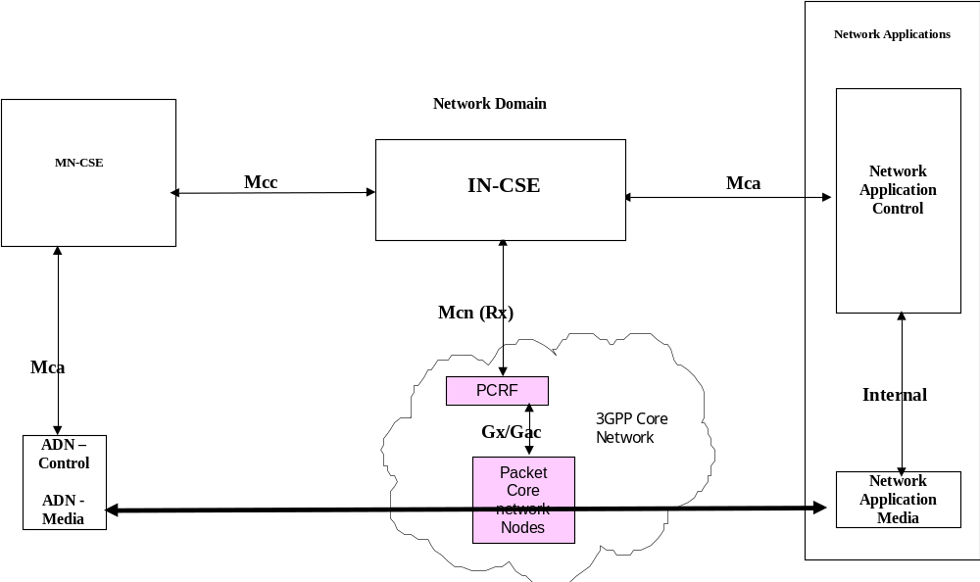

Figure 8.3.1-1: 2 peers in a real time streaming session communicating via an MN-CSE and an IN-CSE

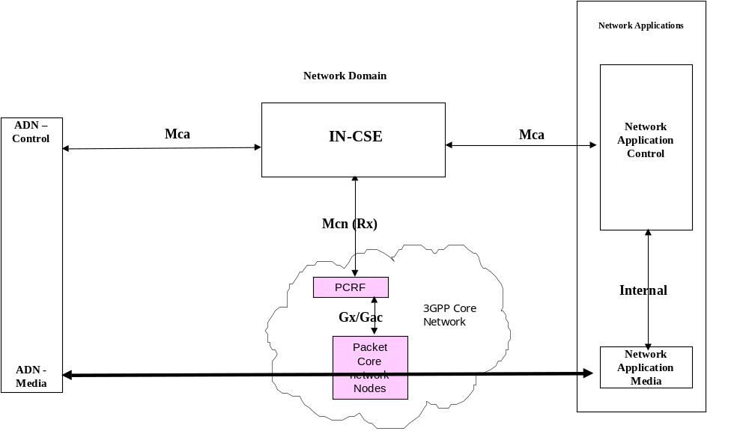
Figure 8.3.1-2: 2 peers in a real time streaming session communicating via an IN-CSE
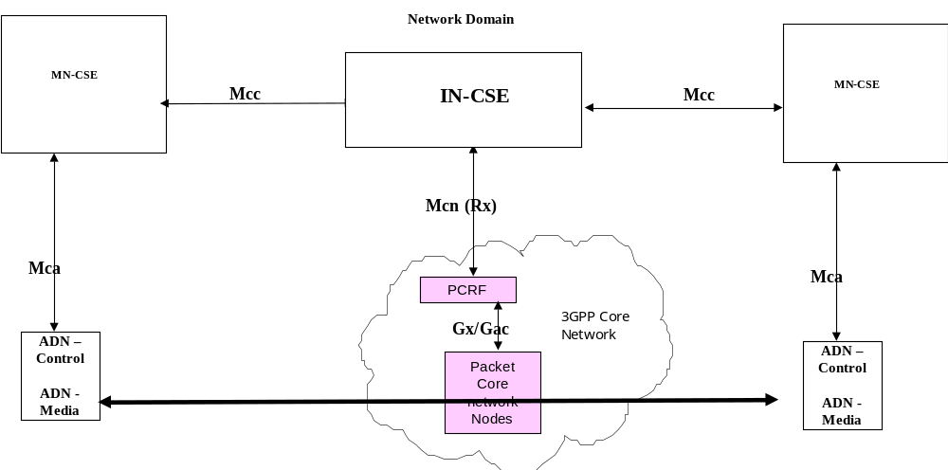
Figure 8.3.1-3: 2 peers in a real time streaming session communicating via 2 MN-CSEs
More generically the architecture looks as follows.

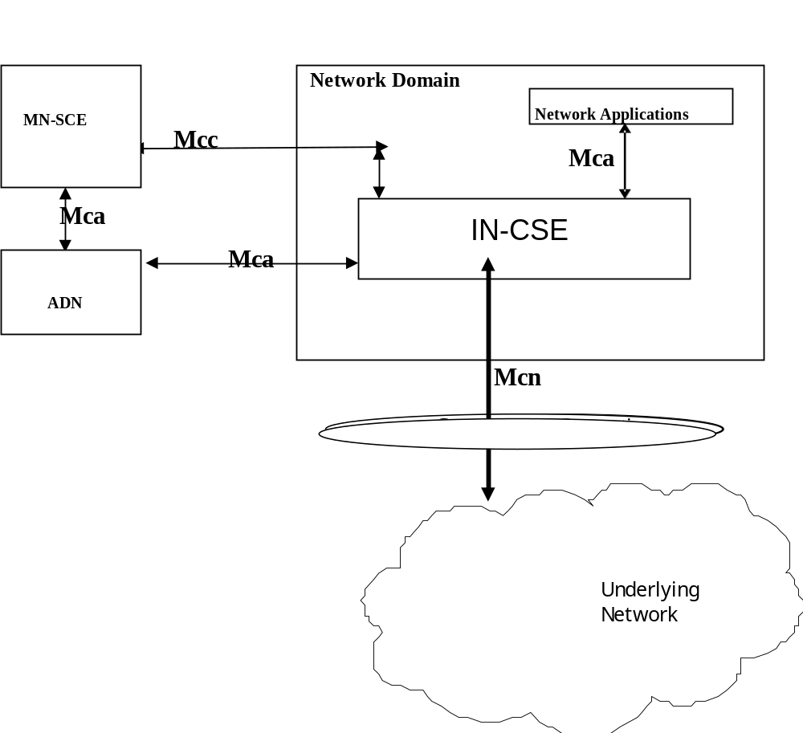
Figure 8.3.1-4: Generic Architecture to Suport Real time streaming

8.3.2 Real time Streaming Session examples
This section provides some examples for the establishment/update of a streaming session to clarify the usage of applicable resources and the service description decpicted above

8.3.2.1 Example 1 - Establishing Streaming Session (ADN-ADN)
This example below shows the scenario where an AE registered with an MN-CSE desires to establish a streaming session with a target AE that is registered to another MN-CSE. In this scenario the IN-CSE has to be involved as described before to ensure that the wide area network resources are configured with the proper QoS for the negotiated session.
The following is a brief description of the steps in the call flow:
- In steps 1a and 1b, the originating and target AE are registered with the corresponding MN-CSE
- In Step 2 the originating AE creates the proper resources for a streaming session in the MN-CSE with whom it is registered. This is shown as one step in the call flow but there are multiple steps that are not shown for brevity. All necessary resources have to be created in the proper order for the SS resource to be properly created. All requests have to be non-blocking
- In step 3, the MN-CSE creates temporary resources that will be confirmed when the final response is received.
- In step 4, the MN-CSE sends the request to the target MN-CSE. Again here this is shown as one step in the call flow but there are multiple steps that are not shown for brevity. All necessary resources have to be created in the proper order for the SS resource to be properly created in the target MN-CSE. Note that the originating MN-CSE has to maintain the necssary information for the resources it created in the target CSE so it can update/delete/retrieve information later.
- In step 5, the target MN-CSE shall also create the necessary temporary streaming session resources based on the incoming requests.
- In step 6, the MN-CSE sends a NOTIFY request to the target AE including the originator AE offer for the streaming session, as well as the needed streaming session resource IDs information so the AE can update the created resources in the target MN-CSE.
- In step 7, the AE acknowledges the NOTIFY request
- In step 8, the target AE updates the necessary streaming session resources based on the incoming offer and what it desires to accept.
- In Step 9, the target MN-CSE needs to invoke the IN-CSE since the original request came from another MN-CSE. Hence it sends a CREATE Request based on the accepted offer to the IN-CSE to create the iNStreaming Session resource
- In steps 10a and 10b, and in this example of a 3GPP underlying LTE network, the IN-CSE interfaces with the PCRF to configure the proper QoS for the session using the Rx reference point. The IN-CSE updates the resources if needed.
- In step 11, the IN-CSE returns the response to MN-CSE.
- In step 12, the MN-CSE updates the resources if needed
- In step 13a, the target MN-CSE forwards the accepted offer to the originating MN-CSE.
- In step 13b the MN-CSE sends the response to the target AE.
- In step 14, the originating MN-CSE updates its resources based on received response in step 13a
- In step 15, the originating MN-CSE returns the response to the originating AE
- In step 16, the originating AE many needs to reserve access bearers. This is optional
Following that streaming can start between the two ADNs
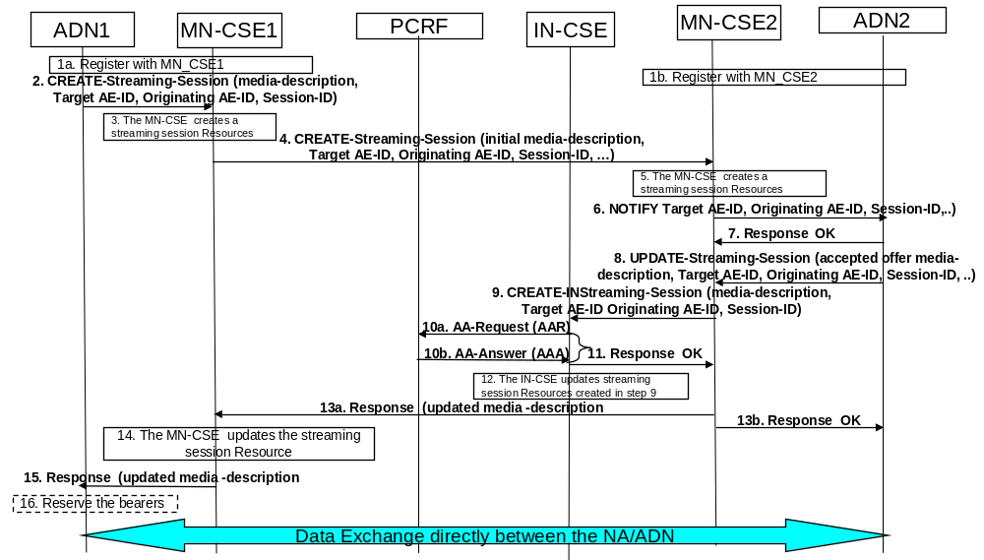
Figure 8.3.2.1-1: Establishing Real time streaming session (ADN-ADN)

8.3.2.2 Example 2 - Establishing Streaming Session (ADN-NA)
This example below shows the scenario where an AE registered win an MN-CSE desires to establish a streaming session with a target NA that is registered with the IN-CSE.
The following is a brief description of the steps in the call flow:
- In steps 1a and 1b, the originating AE and target NA are registered with the corresponding MN-CSE and IN-CSE respectively
- In Step 2 the originating AE creates the proper resources for a streaming session in the MN-CSE with whom it is registered. This is shown as one step in the call flow but there are multiple steps that are not shown for brevity. All necsseary resources have to be created in the proper order for the SS resource to be properly created. All requests have to be non-blocking
- In step 3, the MN-CSE creates temporary resources that will be confirmed when the final response is received.
- In step 4, the MN-CSE sends the request to the target IN-CSE. Again here this is shown as one step in the call flow but there are multiple steps that are not shown for brevity. All necsseary resources have to be created in the proper order for the SS resource to be properly created in the IN-CSE. Note that the originating MN-CSE has to maintain the necessary information for the resources it created in the IN-CSE so it can update/delete/retrieve information later.
- In step 5, the target IN-CSE shall also create the necessary temporary streaming session resources based on the incoming requests.
- In step 6, the IN-CSE sends a NOTIFY request to the target AE including the originator AE offer for the streaming session, as well as the needed streaming session resource IDs so the AE can update the created resources in the target IN-CSE.
- In step 7, the AE acknowledges the NOTIFY request
- In step 8, the target AE updates the necessary streaming session resources based on the incoming offer and what it desires to accept.
- In steps 9a and 9b, and in this example of a 3GPP underlying LTE network, the IN-CSE interacts with the PCRF to configure the proper OoS using the Rx reference point. The IN-CSE update the resources if needed.
- In step 10, the target IN-CSE forwards the accepted offer to the originating MN-CSE.
- In step 11, the target IN-CSE forwards the response to the target AE..
- In step 12, the originating MN-CSE updates its resources based on received response in step 10
- In step 13, the orioginating MN-CSE retunrs the response to the originating AE
- In step 14, the originating AE many needs to reserve access bearers. This is optional
Following that streaming can start between the two AEs
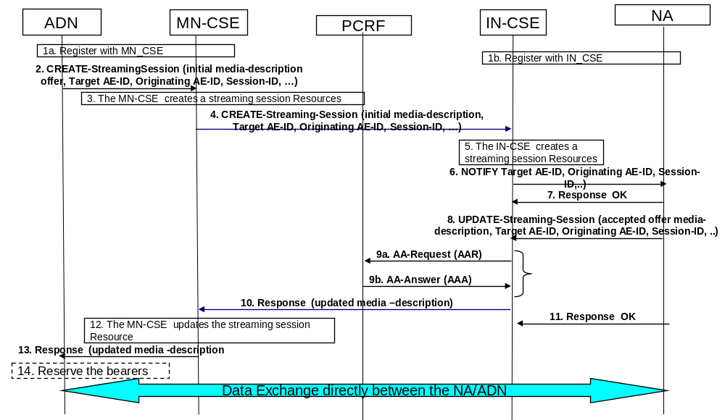
Figure 8.3.2.2-1: Establishing Real time streaming session (ADN-NA)

8.3.2.3 Example 3 – Updating an Established Streaming Session
This example below shows the scenario where an established session between two ADNs have to be updated. Streaming has to stop or be put on hold first to enable the session to be updated.
The following is a brief description of the steps in the call flow:
- In step 1 ,a streaming session is already been established between two ADNs. The session has to be put on hold by updating the session. This is not shown explicitly, but the steps below can be used for that purpose as well. The SDP enables a session to be put hold for updating the QoS, then be resumed once the update is successfully done.
- In Step 2 the originating AE sends an UPDATE request for the resources of the established session. This is shown as one step in the call flow but there are multiple steps that are not shown for brevity. All necessary resources have to be updated in the proper order for the SS resource to be properly updated. All requests have to be non-blocking
- In step 3, the MN-CSE updates the corresponding target MN-CSE for the updated streaming session and sends the request to the target MN-CSE. Again this is shown as one step in the call flow but there are multiple steps that are not shown for brevity. All necessary resources have to be updated in the proper order for the SS resource to be properly updated. All requests have to be non-blocking.
- In step 4, the MN-CSE sends a NOTIFY request to the target AE including the originator AE updated offer for the streaming session.
- In step 5, the AE acknowledges the NOTIFY request
- In step 6, the target AE updates the necessary streaming session resources based on the incoming offer and what it desires to accept. Again this is shown as one step in the call flow but there are multiple steps that are not shown for brevity. All necessary resources have to be updated in the proper order for the SS resource to be properly updated
- In step 7, the target MN-CSE updates the IN-CSE streaming session resource
- In steps 8a and 8b, and in this example of a 3GPP underlying LTE network, the IN-CSE interfaces with the PCRF to set the proper QoS using the Rx reference point. The IN-CSE updates the resources if needed.
- In step 9, the IN-CSE updates is resources accordingly .
- In step 10, the IN-CSE sends the response to the target MN-CSE.
- In step 11, the MN-CSE updates the resources if needed
- In step 12a, the target MN-CSE forwards the accepted offer to the originating MN-CSE.
- In step 12b the MN-CSE sends the response to the target AE.
- In step 13, the originating MN-CSE updates its resources based on received response in step 13a
- In step 14, the originating MN-CSE returns the response to the originating AE
- In step 15, the originating AE may need to update the reserved access bearers. This is optional
Following that streaming can start between the two ADNs

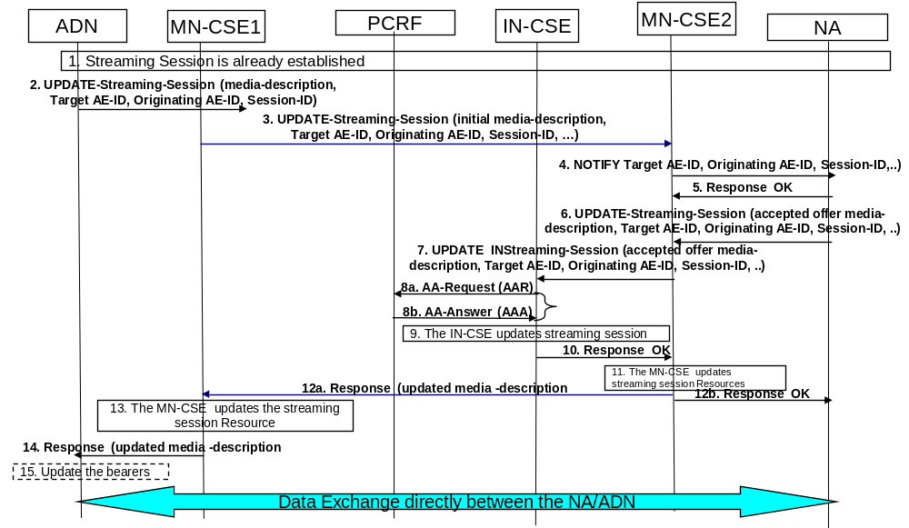
Figure 8.3.2.3-1: Updating a Real time streaming session

8.3.4 Resource Types To Support Real Time Streaming Sessions
Note that references to clauses within the attribute and children Resource Tables for existing resources not new for real time streaming sessions are for TS-0001.

8.3.4.1 Resource Type (SS)
An <SS> resource shall represent information about a streaming session involving two AEs.

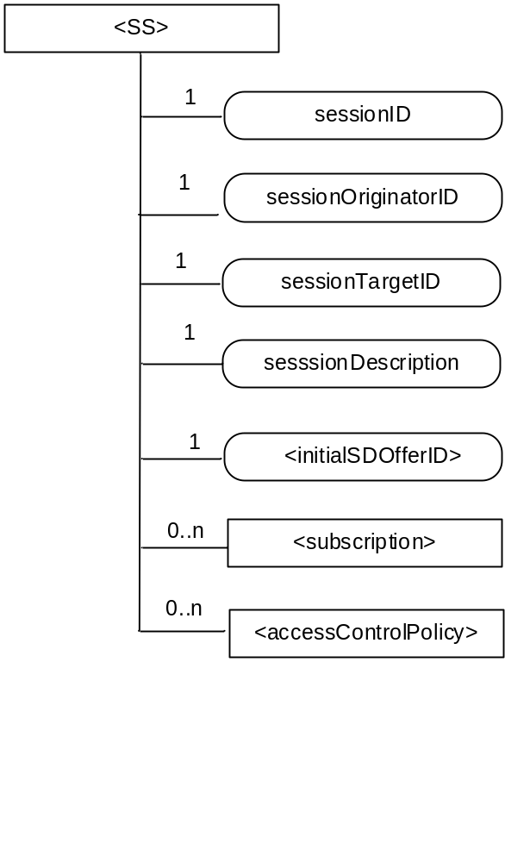
Figure 8.3.4.1-1: Structure of <SS> resource
The <SS> resource shall contain the child resources specified in table 8.3.4.1-1.

Table 8.3.4.11: Child resources of <SS> resource
Child Resources of <SS> | Child Resource Type |  |  | Multiplicity | Description | <SSAnnc> Child Resource Types
[variable] |  | <subscription> | 0..n |  | See clause 9.6.8 | <subscription>
[variable] |  | <accessControlPolicy> | 0..n |  | See clause 9.6.2 | <accessControlPolicy>  <accessControlPolicyAnnc>

The <SS> resource shall contain the attributes specified in table 8.3.4.1-2.

Table 8.3.4.1-2: Attributes of <SS> resource
Attributes of  <SS> | Multiplicity | RW/  RO/  WO | Description | <SSAnnc> Attributes
resourceType | 1 | RO | See clause 9.6.1.3 where this common attribute is described. | NA
resourceID | 1 | RO | See clause 9.6.1.3 where this common attribute is described. | MA
resourceName | 1 | WO | See clause 9.6.1.3 where this common attribute is described. | MA
parentID | 1 | RO | See clause 9.6.1.3 where this common attribute is described. | NA
expirationTime | 1 | RW | See clause 9.6.1.3 where this common attribute is described. | MA
accessControlPolicyIDs | 0..1 (L) | RW | See clause 9.6.1.3 where this common attribute is described. | MA
creationTime | 1 | RW | See clause 9.6.1.3 where this common attribute is described. | NA
lastModifiedTime | 1 | RO | See clause 9.6.1.3 where this common attribute is described. | NA
labels | 0..1 (L) | RO | See clause 9.6.1.3 where this common attribute is described. | MA
sessionID | 1 | RO | The sessionID shall be the same as the resourceID | NA
sessionOriginator ID | 1 | WO | The M2M identifier of the originator of the streaming session. | NA
SessionTargetID | 1 | WO | The M2M identifier of the target of the streaming session. | NA
sessionDescription | 1 | RW | Session description, including charateristics of the session that is the subject of streaming. The sessionDescription attribute is compliant to [i.31]. This is the the final agreed upon session description based on the received response from the target of the streaming session. | NA
initialSDOfferID | 1 | RW | The attribute contains the identifier of an <initialSDOffer> resource. See 8.3.4.2 | NA

8.3.4.2 Resource Type initialSDOffer
An <initialSDOffer> resource shall represent information about an initial offer for a streaming session.

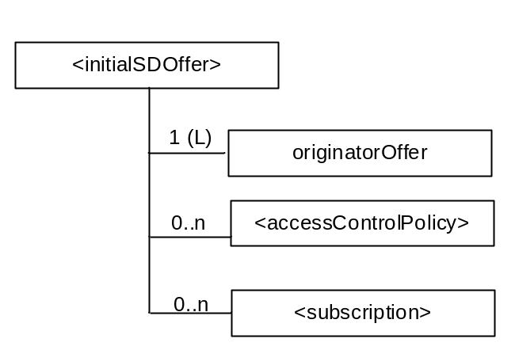

Figure 8.3.4.2-1: Structure of <initialSDOffer> resource
The <initialSDOffer> resource shall contain the child resources specified in table 8.3.4.2-1

Table 8.3.4.2-1: Child Resources of <initialSDOffer> resource

Child Resources of <initialSDOffer> | Child Resource Type |  |  | Multiplicity | Description | <SSAnnc> Child Resource Types
[variable] |  | <subscription> | 0..n |  | See clause 9.6.8 | <subscription>
[variable] |  | <accessControlPolicy> | 0..n |  | See clause 9.6.2 | <accessControlPolicy>  <accessControlPolicyAnnc>
[variable] |  | <originatorOffer> | 1 (L) |  | See clause 8.3.4.3 | NA

The <initialSDOffer> resource shall contain the attributes specified in table 8.3.4.2-2.

Table 8.3.4.2-2: Attributes of <initialSDOffer> resource
Attributes of  <originatorOffer> | Multiplicity | RW/  RO/  WO | Description | <AEAnnc> Attributes
resourceType | 1 | RO | See clause 9.6.1.3 where this common attribute is described. | NA
resourceID | 1 | RO | See clause 9.6.1.3 where this common attribute is described. | MA
resourceName | 1 | WO | See clause 9.6.1.3 where this common attribute is described. | MA
parentID | 1 | RO | See clause 9.6.1.3 where this common attribute is described. | NA
expirationTime | 1 | RW | See clause 9.6.1.3 where this common attribute is described. | MA
accessControlPolicyIDs | 0..1 (L) | RW | See clause 9.6.1.3 where this common attribute is described. | MA
creationTime | 1 | RW | See clause 9.6.1.3 where this common attribute is described. | NA
lastModifiedTime | 1 | RO | See clause 9.6.1.3 where this common attribute is described. | NA
labels | 0..1 (L) | RO | See clause 9.6.1.3 where this common attribute is described. | MA

8.3.4.3 Resource Type originatorOffer
An <originatorOffer> resource shall represent session description information about an initial offer from an originating AE.

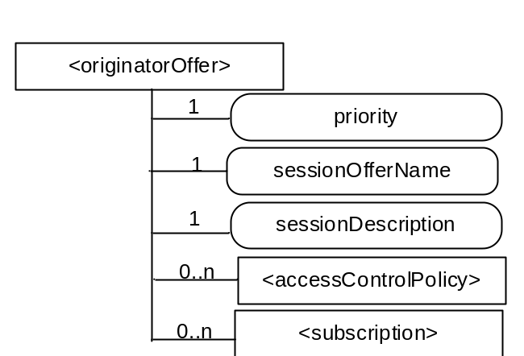

Figure 8.3.4.3-1: Structure of <originatorOffer> resource
The <originatorOffer> resource shall contain the child resources specified in table 8.3.4.3-1 .

Table 8.3.4.3-1: Vhild Resources of <originatorOffer> resource

Child Resources of <originatorOffer> | Child Resource Type |  |  | Multiplicity | Description | <SSAnnc> Child Resource Types
[variable] |  | <subscription> | 0..n |  | See clause 9.6.8 | <subscription>
[variable] |  | <accessControlPolicy> | 0..n |  | See clause 9.6.2 | <accessControlPolicy>  <accessControlPolicyAnnc>

The <originatorOffer> resource shall contain the attributes specified in table 8.3.4.3-2.

Table 8.3.4.3-2: Attributes of <originatorOffer> resource
Attributes of  <originatorOffer> | Multiplicity | RW/  RO/  WO | Description | <AEAnnc> Attributes
resourceType | 1 | RO | See clause 9.6.1.3 where this common attribute is described. | NA
resourceID | 1 | RO | See clause 9.6.1.3 where this common attribute is described. | MA
resourceName | 1 | WO | See clause 9.6.1.3 where this common attribute is described. | MA
parentID | 1 | RO | See clause 9.6.1.3 where this common attribute is described. | NA
expirationTime | 1 | RW | See clause 9.6.1.3 where this common attribute is described. | MA
accessControlPolicyIDs | 0..1 (L) | RW | See clause 9.6.1.3 where this common attribute is described. | MA
creationTime | 1 | RW | See clause 9.6.1.3 where this common attribute is described. | NA
lastModifiedTime | 1 | RO | See clause 9.6.1.3 where this common attribute is described. | NA
labels | 0..1 (L) | RO | See clause 9.6.1.3 where this common attribute is described. | MA
priroity | 1 | RW | The prioriy alliocated to the offer | NA
sessionOfferName | 1 | WO | The name allocated to the offer | NA
sesssionDescription | 1 | RW | The session Desciption information shall be compliant to [i.31] | NA

8.3.4.4 Resource Type (iNStreamingSession)
An <iNStreamingSession> resource shall represent information about a streaming session involving two AEs. This resource shall be created only in an IN-CSE node.

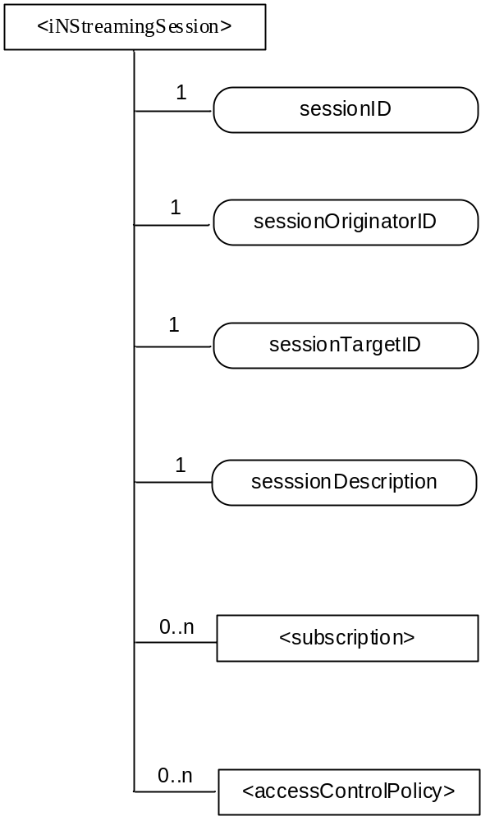
Figure 8.3.4.4-1: Structure of <iNStreamingSession> resource
The <iNStreamingSession> resource shall contain the child resources specified in table 8.3.4.4-1

Table 8.3.4.4-1 : Child resources of <iNStreamingSession> resource
Child Resources of <SS> | Child Resource Type |  |  | Multiplicity | Description | <SSAnnc> Child Resource Types
[variable] |  | <subscription> | 0..n |  | See clause 9.6.8 | <subscription>
[variable] |  | <accessControlPolicy> | 0..n |  | See clause 9.6.2 | <accessControlPolicy>  <accessControlPolicyAnnc>

The <iNStreamingSession> resource shall contain the attributes specified in table 8.3.4.4-2.

Table 8.3.4.4-2: Attributes of <iNStreamingSession> resource
Attributes of  <SS> | Multiplicity | RW/  RO/  WO | Description | <SSAnnc> Attributes
resourceType | 1 | RO | See clause 9.6.1.3 where this common attribute is described. | NA
resourceID | 1 | RO | See clause 9.6.1.3 where this common attribute is described. | MA
resourceName | 1 | WO | See clause 9.6.1.3 where this common attribute is described. | MA
parentID | 1 | RO | See clause 9.6.1.3 where this common attribute is described. | NA
expirationTime | 1 | RW | See clause 9.6.1.3 where this common attribute is described. | MA
accessControlPolicyIDs | 0..1 (L) | RW | See clause 9.6.1.3 where this common attribute is described. | MA
creationTime | 1 | RW | See clause 9.6.1.3 where this common attribute is described. | NA
lastModifiedTime | 1 | RO | See clause 9.6.1.3 where this common attribute is described. | NA
labels | 0..1 (L) | RO | See clause 9.6.1.3 where this common attribute is described. | MA
sessionID | 1 | RO | The sessionID shall be the same as the resourceID | NA
sessionOriginator ID | 1 | WO | The M2M identifier of the originator of the streaming session. | NA
SessionTargetID | 1 | WO | The M2M identifier of the originator of the streaming session. | NA
sessionDescription | 1 | RW | The description, including charateristics of the session that is the subject of streaming. The sessionDescription attribute is compliant to [i.31] | OA

8.3.5 Procedures
Note that references to clauses within theses tables are for existing prcoedures in TS-0001 and that are applicable here as well.

8.3.5.1 <SS> Resource Procedures

8.3.5.1.1 Create <SS>
This procedure shall be used for creating an <SS> resource.
Table 8.3.5.1.1-1: <SS> CREATE
<SS> CREATE
Associated Reference Point | Mca, and Mcc
Information in Request message | All parameters defined in table 8.1.2-2 apply with the specific details for:  To: Address of <AE>. Only an originating AE can create an originatorOffer resource over Mca.  For Mcc, the To address shall be set to the Address of <remote CSE> of the originating CSE . Only a registered CSE can create an originatorOffer resource over Mcc.  Content: The resource content shall provide the information as defined in clause 9.6.35  Only blocking request shall be allowed. All intermediate M2M nodes shall comply to this.
Processing at Originator before sending Request | According to clause 10.1.1.1
Processing at Receiver | According to clause 10.1.1.1 with the replacement for sub-step 1) of Step 002 as follows:  For a request over Mca, the Hosting CSE shall check if the Originator ID is the same as the AE-ID of the parent resource which is the <AE> resource and If the check fails, the request shall be rejected.  For a request over Mcc, the Hosting CSE shall check if the Originator ID is the same as the CSE-ID of the parent resource which is the <remoteCSE> resource and If the check fails, the request shall be rejected
Information in Response message | According to clause 10.1.1.1
Processing at Originator after receiving Response | According to clause 10.1.1.1
Exceptions | According to clause 10.1.1.1

8.3.5.1.2 Retrieve <SS>
This procedure shall be used for retrieving the attributes of an <SS> resource.
Table 8.3.5.1.2-1: <SS> RETRIEVE
<SS> RETRIEVE
Associated Reference Point | Mca, and Mcc
Information in Request message | All parameters defined in table 8.1.2-2 apply.
Processing at Originator before sending Request | According to clause 10.1.2
Processing at Receiver | According to clause 10.1.2
Information in Response message | All parameters defined in table 8.1.3-1 apply.
Processing at Originator after receiving Response | According to clause 10.1.2
Exceptions | According to clause 10.1.2

8.3.5.1.3 Update <SS>
This procedure shall be used for updating attributes of an <SS> resource.
Table 8.3.5.1.3-1: <SS> UPDATE
<SS> UPDATE
Associated Reference Point | Mca, and Mcc
Information in Request message | All parameters defined in table 8.1.2-2 apply.  To modify (UPDATE) an ongoing session, the session shall be put on hold first, and after successful updating, it shall be resumed. Note that SDP as defined [i.31] specifies all these aspects.
Processing at Originator before sending Request | According to clause 10.1.3
Processing at Receiver | According to clause 10.1.3  The Hosting CSE shall enforce the session state (hold, modify) principles for UPDATES as defined in as defined [i.31]
Information in Response message | According to clause 10.1.3
Processing at Originator after receiving Response | According to clause 10.1.3
Exceptions | According to clause 10.1.3

8.3.5.1.4 Delete <SS>
This procedure shall be used for deleting an <SS> resource .
Table 8.3.5.1.4-1: <SS> DELETE
<SS> DELETE
Associated Reference Point | Mca, and Mcc
Information in Request message | All parameters defined in table 8.1.2-2 apply
Processing at Originator before sending Request | According to clause 10.1.4.1
Processing at Receiver | According to clause 10.1.4.1
Information in Response message | According to clause 10.1.4.1
Processing at Originator after receiving Response | According to clause 10.1.4.1
Exceptions | According to clause 10.1.4.1

8.3.5.2 <initialSDOffer> Resource Procedures

8.3.5.2.1 Create <initialSDOffer>
This procedure shall be used for creating an <initialSDOffer> resource.
Table 8.3.5.2.1-1: <initialSDOffer> CREATE
<initialSDOffer> CREATE
Associated Reference Point | Mca, and Mcc
Information in Request message | All parameters defined in table 8.1.2-2 apply with the specific details for:  To: Address of <AE>. Only an originating AE can create an originatorOffer resource over Mca  For Mcc, the To: address shall be set to the Address of <remote CSE> of the originating CSE . Only a registered CSE can create an originatorOffer resource over Mcc.  Content: The resource content shall provide the information as defined in clause 9.6.36  Only blocking request shall be allowed. All intermediate M2M nodes shall comply to this.
Processing at Originator before sending Request | According to clause 10.1.1.1
Processing at Receiver | According to clause 10.1.1.1 with the replacement for sub-step 1) of Step 002 as follows:  For a request over Mca, the Hosting CSE shall check if the Originator ID is the same as the AE-ID of the parent resource which is the <AE> resource and If the check fails, the request shall be rejected  For a request over Mcc, the Hosting CSE shall check if the Originator ID is the same as the CSE-ID of the parent resource which is the <remoteCSE> resource and If the check fails, the request shall be rejected.
Information in Response message | According to clause 10.1.1.1
Processing at Originator after receiving Response | According to clause 10.1.1.1
Exceptions | According to clause 10.1.1.1

8.3.5.2.2 Retrieve <initialSDOffer>
This procedure shall be used for retrieving the attributes of an <initialSDOffer> resource.
Table 8.3.5.2.2-1: <initialSDOffer> RETRIEVE
<initialSDOffer> RETRIEVE
Associated Reference Point | Mca, and Mcc
Information in Request message | All parameters defined in table 8.1.2-2 apply.
Processing at Originator before sending Request | According to clause 10.1.2
Processing at Receiver | According to clause 10.1.2
Information in Response message | All parameters defined in table 8.1.3-1 apply.
Processing at Originator after receiving Response | According to clause 10.1.2
Exceptions | According to clause 10.1.2

8.3.5.2.3 Update <initialSDOffer>
This procedure shall be used for updating attributes of an <initialSDOffer> resource.
Table 8.3.5.2.3-1: <initialSDOffer> UPDATE
<initialSDOffer> UPDATE
Associated Reference Point | Mca, and Mcc
Information in Request message | All parameters defined in table 8.1.2-2 apply.  To modify (UPDATE) an ongoing session, the session shall be put on hold first, and after successful updating, it shall be resumed. Note that SDP as defined [i.31] specifies all these aspects.
Processing at Originator before sending Request | According to clause 10.1.3
Processing at Receiver | According to clause 10.1.3  The Hosting CSE shall enforce the session state (hold, modify) principles for UPDATES as defined in as defined [i.31]
Information in Response message | According to clause 10.1.3
Processing at Originator after receiving Response | According to clause 10.1.3
Exceptions | According to clause 10.1.3

8.3.5.2.4 Delete <initialSDOffer>
This procedure shall be used for deleting an <initialSDOffer> resource .
Table 8.3.5.2.4-1: <initialSDOffer> DELETE
<initialSDOffer> DELETE
Associated Reference Point | Mca, and Mcc
Information in Request message | All parameters defined in table 8.1.2-2 apply
Processing at Originator before sending Request | According to clause 10.1.4.1
Processing at Receiver | According to clause 10.1.4.1
Information in Response message | According to clause 10.1.4.1
Processing at Originator after receiving Response | According to clause 10.1.4.1
Exceptions | According to clause 10.1.4.1

8.3.5.3 <originatorOffer> Resource Procedures

8.3.5.3.1 Create <originatorOffer>
This procedure shall be used for creating an <originatorOffer> resource. Only a registered AE can create such a resource
Table 8.3.5.3.3-1: <originatorOffer> CREATE
<originatorOffer> CREATE
Associated Reference Point | Mca, and Mcc
Information in Request message | All parameters defined in table 8.1.2-2 apply with the specific details for:  To: Address of <AE>. Only an originating AE can create an originatorOffer resource over Mca.  For Mcc, the To: address shall be set to the Address of <remote CSE> of the originating CSE . Only a registered CSE can create an originatorOffer resource over Mcc.  Content: The resource content shall provide the information as defined in clause 9.6.37  Only blocking request shall be allowed. All intermediate M2M nodes shall comply to this.
Processing at Originator before sending Request | According to clause 10.1.1.1.  Since AE is the Originator, it shall address the <AE> resource that it already created.
Processing at Receiver | According to clause 10.1.1.1
Information in Response message | According to clause 10.1.1.1 with the replacement for sub-step 1) of Step 002 as follows:  For a request over Mca,the Hosting CSE shall check if the Originator ID is the same as the AE-ID of the parent resource which is the <AE> resource and If the check fails, the request shall be rejected  For a request over Mcc, the Hosting CSE shall check if the Originator ID is the same as the CSE-ID of the parent resource which is the <remoteCSE> resource and If the check fails, the request shall be rejected
Processing at Originator after receiving Response | According to clause 10.1.1.1
Exceptions | According to clause 10.1.1.1

8.3.5.3.2 Retrieve <originatorOffer>
This procedure is used for retrieving the attributes of a <originatorOffer> resource.
Table 8.3.5.3.2-1: <originatorOffer> RETRIEVE
<originatorOffer> RETRIEVE
Associated Reference Point | Mca, and Mcc
Information in Request message | All parameters defined in table 8.1.2-2 apply.
Processing at Originator before sending Request | According to clause 10.1.2
Processing at Receiver | According to clause 10.1.2
Information in Response message | All parameters defined in table 8.1.3-1 apply.
Processing at Originator after receiving Response | According to clause 10.1.2
Exceptions | According to clause 10.1.2

8.3.5.3.3 Update <originatorOffer>
This procedure shall be used for updating attributes of a <originatorOffer> resource.
Table 8.3.5.3.3-1: originatorOffer> UPDATE
<originatorOffer> UPDATE
Associated Reference Point | Mca, and Mcc
Information in Request message | All parameters defined in table 8.1.2-2 apply.
Processing at Originator before sending Request | According to clause 10.1.3  To modify (UPDATE) an ongoing session, the session shall be put on hold first, and after successful updating, it shall be resumed. Note that SDP as defined [i.31] specifies all these aspects.
Processing at Receiver | According to clause 10.1.3  The Hosting CSE shall enforce the session state (hold, modify) principles for UPDATES as defined in as defined [i.31]
Information in Response message | According to clause 10.1.3
Processing at Originator after receiving Response | According to clause 10.1.3
Exceptions | According to clause 10.1.3

8.3.5.3.4 Delete <originatorOffer>
This procedure shall be used for deleting a <originatorOffer> resource .
Table 8.3.5.3.4-1: <originatorOffer> DELETE
<originatorOffer> DELETE
Associated Reference Point | Mca,and Mcc
Information in Request message | All parameters defined in table 8.1.2-2 apply
Processing at Originator before sending Request | According to clause 10.1.4.1
Processing at Receiver | According to clause 10.1.4.1
Information in Response message | According to clause 10.1.4.1
Processing at Originator after receiving Response | According to clause 10.1.4.1
Exceptions | According to clause 10.1.4.1

8.3.5.5 < iNStreamingSession > Resource Procedures

8.3.5.5.1 Create <iNStreamingSession>
This procedure shall be used for creating an <iNStreamingSession> resource. Only a registered CSE can create such a resource in an IN-CSE on behalf of an AE
Table 8.3.5.5.1-1: <iNStreamingSession> CREATE
<iNStreamingSession> CREATE
Associated Reference Point | Mcc
Information in Request message | All parameters defined in table 8.1.2-2 apply with the specific details for:  To: Address of <remoteCSE> of originating CSE. Only an originating CSE can create an originatorOffer resource  Content: The resource content shall provide the information as defined in clause 9.6.37  Only blocking request shall be allowed
Processing at Originator before sending Request | According to clause 10.1.1.1.  Since CSE is the Originator, it shall address the <remoteCSE> resource that it already created.
Processing at Receiver | According to clause 10.1.1.1  The IN-CSE shall check if the Originating CSE is the same as the of the parent resource which is the <remoteCES> resource and If the check fails, the request shall be rejected
Information in Response message | According to clause 10.1.1.1 with the replacement for sub-step 1) of Step 002 as follows:
Processing at Originator after receiving Response | According to clause 10.1.1.1
Exceptions | According to clause 10.1.1.1

8.3.5.5.2 Retrieve <iNStreamingSession>
This procedure is used for retrieving the attributes of a <iNStreamingSession> resource.
Table 8.3.5.5.2-1 <iNStreamingSession> RETRIEVE
<iNStreamingSession> RETRIEVE
Associated Reference Point | Mcc
Information in Request message | All parameters defined in table 8.1.2-2 apply.
Processing at Originator before sending Request | According to clause 10.1.2
Processing at Receiver | According to clause 10.1.2
Information in Response message | All parameters defined in table 8.1.3-1 apply.
Processing at Originator after receiving Response | According to clause 10.1.2
Exceptions | According to clause 10.1.2

8.3.5.5.3 Update <iNStreamingSession>
This procedure shall be used for updating attributes of a <iNStreamingSession> resource.
Table 8.3.5.5.3-1: <iNStreamingSession> UPDATE
<iNStreamingSession> UPDATE
Associated Reference Point | Mcc
Information in Request message | All parameters defined in table 8.1.2-2 apply.
Processing at Originator before sending Request | According to clause 10.1.3.  To modify (UPDATE) an ongoing session, the session shall be put on hold first, and after successful updating, it shall be resumed. Note that SDP as defined [i.31] specifies all these aspects.
Processing at Receiver | According to clause 10.1.3  The Hosting CSE shall enforce the session state (hold, modify) principles for UPDATES as defined in as defined [i.31]
Information in Response message | According to clause 10.1.3
Processing at Originator after receiving Response | According to clause 10.1.3
Exceptions | According to clause 10.1.3

8.3.5.5.4 Delete <iNStreamingSession>
This procedure shall be used for deleting a <iNStreamingSession> resource.
Table 8.3.5.5.4-1: <iNStreamingSession> DELETE
<iNStreamingSession> DELETE
Associated Reference Point | Mcc
Information in Request message | All parameters defined in table 8.1.2-2 apply
Processing at Originator before sending Request | According to clause 10.1.4.1
Processing at Receiver | According to clause 10.1.4.1
Information in Response message | According to clause 10.1.4.1
Processing at Originator after receiving Response | According to clause 10.1.4.1
Exceptions | According to clause 10.1.4.1

-----------------------End of change 1-------------------------------------------

-----------------------Start of change 2-------------------------------------------

8.3.6 Changes to existing Resources in TS-0001
This section includes the changes needed in TS-0001 in existing resources and Tables to support the above. Imapcted sections in TS-0001 will be shown using the applicable section number.

9.6 Resource Types

Add the following info in Table 9.6.1.1-1 Resource Types

Table 9.6.1.1-1 Resource Types
Resource Type | Short Description | Child Resource Types | Parent Resource Types | Clause
SS | Stores a representation of a streaming Session information requested by a registering AE | Subscription, accessControlPolicy | AE for request over Mca, or remoteCSE for request over Mcc | 9.6.35
initialSDffer | Stores the session information describing all offers submitted by the registering AE at streaming session creation. | originatorOffer,  subscription, accessControlPolicy | AE for request over Mca, or remoteCSE for request over Mcc | 9.6.36
originatorOffer | Stores an offer information for a streaming session | Subscription,  accessControlPolicy | AE for request over Mca, or remoteCSE for request over Mcc | 9.6.37
iNStreamingSession | Stores a representation of a streaming Session information requested by a CSE on behalf of an AE | Subscription,  accessControlPolicy | CSEBase | 9.6.38

9.6.4 Resource Type remoteCSE

A <remoteCSE> resource shall represent a Registree CSE that is registered to the Registrar CSE. <remoteCSE> resources shall be located directly under the <CSEBase> resource of Registrar CSE.
Similarly <remoteCSE> resource shall also represent a Registrar CSE. <remoteCSE> resource shall be located directly under the <CSEBase> resource of Registree CSE.
For example, when CSE1 (Registree CSE) registers with CSE2 (Registrar CSE), there will be two <remoteCSE> resources created: one in CSE1: <CSEBase1>/<remoteCSE2> and one in CSE2: <CSEBase2>/<remoteCSE1>.
Note that the creation of the two resources does not imply mutual registration. The <CSEBase1>/<remoteCSE2> does not mean CSE2 registered with CSE1 in the example above.
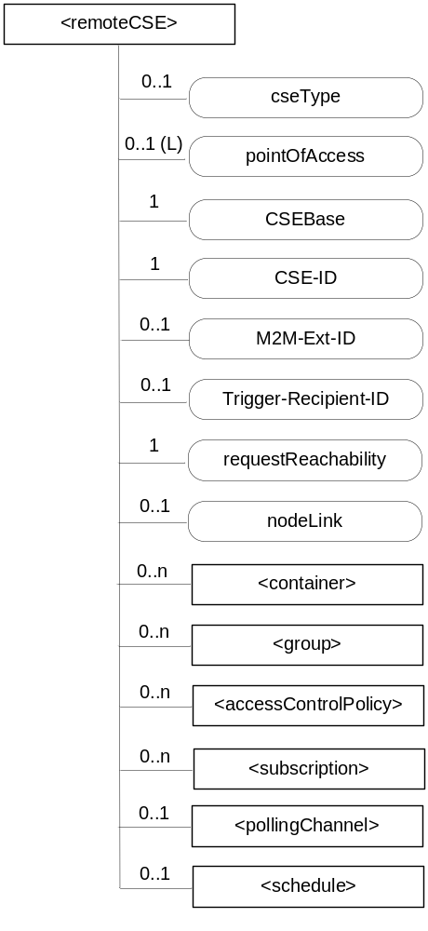
Figure 9.6.4-1: Structure of <remoteCSE> resource
Instruction to Editor: Please udpdate the Figure

The <remoteCSE> resource shall contain the child resources specified in table 9.6.4-1. The <remoteCSE> resource may contain <remoteCSEAnnc> child resources.
Table 9.6.4-1: Child resources of <remoteCSE> resource
Child Resources of <remoteCSE> | Child Resource Type | Multiplicity | Description | <remoteCSEAnnc> Child Resource Types
[variable] | <container> | 0..n | See clause 9.6.6 | <container> <containerAnnc>
[variable] | <group> | 0..n | See clause 9.6.13 | <group>  <groupAnnc>
[variable] | <accessControlPolicy> | 0..n | See clause 9.6.2 | <accessControlPolicy>  <accessControlPolicyAnnc>
[variable] | <subscription> | 0..n | See clause 9.6.8 | <subscription>
[variable] | <pollingChannel> | 0..1 | See clause 9.6.21. If requestReachability is FALSE, the CSE that created this <remoteCSE> resource should create a <pollingChannel> resource and perform long polling. The <pollingChannel> shall be utilized by the the parent resource. | None
[variable] | <schedule> | 0..1 | This resource defines the reachability schedule information of the node. See clause 9.6.9 for <schedule>. | <scheduleAnnc>
variable] | <SS,> |  | See Clause 9.6.35. This resources holds information describing the established streamed session | NA
variable] | <initialSDOffer> |  | See Clause 9.6.36. This resource holds information describing the originator initial offer for the streamed session. This can include multiple offers | NA
variable] | <originatorOffer> |  | See Clause 9.6.36. This resource holds information describing an originator signle offer. | NA
variable] | <iNStreamingSession> |  | Stores a representation of a streaming Session information requested by a CSE on behalf of an AE. This is only available in an IN-CSE node | NA
[variable] | <nodeAnnc> | 0..n | This resource is the <nodeAnnc> resource representing the node where the CSE represented by this <remoteCSE> resource resides. | <nodeAnnc>

Table 9.6.4-2: Child announced resources of <remoteCSE> resource
Child Announced Resources of <remoteCSE> | Child Announced Resource Type | Multiplicity | Description
[variable] | Refer to table 9.6.26.1-1 Announced Resource Types | 0..n

The <remoteCSE> resource shall contain the attributes specified in table 9.6.4-3.
Table 9.6.4-3: Attributes of <remoteCSE> resource
Attributes of <remoteCSE> | Multiplicity | RW/  RO/  WO | Description | <remoteCSEAnnc> Attributes
resourceType | 1 | RO | See clause 9.6.1.3 where this common attribute is described. | NA
resourceID | 1 | RO | See clause 9.6.1.3 where this common attribute is described. | NA
resourceName | 1 | WO | See clause 9.6.1.3 where this common attribute is described. | NA
parentID | 1 | RO | See clause 9.6.1.3 where this common attribute is described. | NA
creationTime | 1 | RO | See clause 9.6.1.3 where this common attribute is described. | NA
lastModifiedTime | 1 | RO | See clause 9.6.1.3 where this common attribute is described. | NA
expirationTime | 1 | RW | See clause 9.6.1.3 where this common attribute is described. | MA
accessControlPolicyIDs | 0..1 (L) | RW | See clause 9.6.1.3 where this common attribute is described. | MA
labels | 0..1 (L) | RW | See clause 9.6.1.3 where this common attribute is described. | MA
announceTo | 0..1 (L) | RW | See clause 9.6.1.3 where this common attribute is described. | NA
announcedAttribute | 0..1 (L) | RW | See clause 9.6.1.3 where this common attribute is described. | NA
cseType | 0..1 | WO | Indicates the type of CSE represented by the created resource.  - Mandatory for an IN-CSE, hence multiplicity (1).  - Its presence is subject to SP configuration in case of an ASN-CSE or a MN-CSE. | OA
pointOfAccess | 0..1 (L) | RW | For request-reachable remote CSE it represents the list of physical addresses to be used to connect to it (e.g. IP address, FQDN). The attribute is absent if the remote CSE is not request-reachable.  If this information is not provided, the CSE should use <pollingChannel> resource. Then the Hosting CSE can forward a request to the CSE without using the PoA. | OA
CSEBase | 1 | WO | The address of the CSEBase resource represented by this <remoteCSE> resource. | OA
CSE-ID | 1 | WO | The CSE identifier in SP-relative CSE-ID format (clause 7.2). | OA
M2M-Ext-ID | 0..1 | RW | Supported when Registrar is IN-CSE.  See clause 7.1.8 where this attribute is described. This attribute is used only for the case of dynamic association of M2M-Ext-ID and CSE-ID. | NA
Trigger-Recipient-ID | 0..1 | RW | Supported when Registrar is IN-CSE. See clause 7.1.10 where this attribute is described. This attribute is used only for the case of dynamic association of M2M-Ext-ID and CSE-ID. | NA
requestReachability | 1 | RW | If the CSE that created this <remoteCSE> resource can receive a request from other AE/CSE(s), this attribute is set to "TRUE" otherwise "FALSE" (see note) | OA
nodeLink | 0..1 | RW | The resourceID of a <node> resource that hosts the CSE represented by the <remoteCSE> resource. | OA
NOTE: Even if this attribute is set to "FALSE", it does not mean it AE/CSE is always unreachable by all entities. E.g. the requesting AE/CSE is behind the same NAT, so it can communicate within the same NAT.

9.6.5 Resource Type AE

An <AE> resource shall represent information about an Application Entity registered to a CSE.
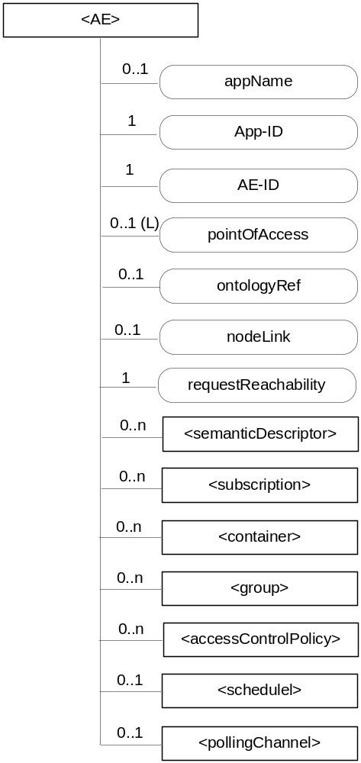
Figure 9.6.5-1: Structure of <AE> resource
Instruction to Editor: Please udpdate the Figure
The <AE> resource shall contain the child resources specified in table 9.6.5-1.
Table 9.6.5-1: Child resources of <AE> resource
Child Resources of <AE> | Child Resource Type | Multiplicity | Description | <AEAnnc> Child Resource Types
semanticDescriptor | <semanticDescriptor> | 0..n | See clause 9.6.30 | <semanticDescriptor>, <semanticDescriptorAnnc>
[variable] | <subscription> | 0..n | See clause 9.6.8 | <subscription>
[variable] | <container> | 0..n | See clause 9.6.6 | <container> <containerAnnc>
[variable] | <group> | 0..n | See clause 9.6.13 | <group>  <groupAnnc>
[variable] | <accessControlPolicy> | 0..n | See clause 9.6.2 | <accessControlPolicy>  <accessControlPolicyAnnc>
[variable] | <schedule> | 0..1 | See clause 9.6.9 | <scheduleAnnc>
[variable] | <pollingChannel> | 0..1 | See clause 9.6.21.  When the AE is request-unreachable, the AE should create this <pollingChannel> resource and perform long polling. The <pollingChannel> shall be utilized by the the parent resource. | None
variable] | <SS,> |  | See Clause 9.6.35. This resources holds information describing the established streamed session | NA
variable] | <initialSDOffer> |  | See Clause 9.6.36. This resource holds information describing the originator initial offer for the streamed session. This can include multiple offers | NA
variable] | <originatorOffer> |  | See Clause 9.6.36. This resource holds information describing an originator offer. | NA

The <AE> resource shall contain the attributes specified in table 9.6.5-2.
Table 9.6.5-2: Attributes of <AE> resource
Attributes of  <AE> | Multiplicity | RW/  RO/  WO | Description | <AEAnnc> Attributes
resourceType | 1 | RO | See clause 9.6.1.3. | NA
resourceID | 1 | RO | See clause 9.6.1.3. Contains the AE-ID-Stem of the AE (see clause 7.2 on identifier formats and clause 10.1.1.2.2 for AE registration procedure). | NA
resourceName | 1 | WO | See clause 9.6.1.3. | NA
parentID | 1 | RO | See clause 9.6.1.3. | NA
expirationTime | 1 | RW | See clause 9.6.1.3. | MA
accessControlPolicyIDs | 0..1 (L) | RW | See clause 9.6.1.3. | MA
creationTime | 1 | RO | See clause 9.6.1.3. | NA
lastModifiedTime | 1 | RO | See clause 9.6.1.3. | NA
labels | 0..1 (L) | RW | See clause 9.6.1.3. | MA
announceTo | 0..1 (L) | RW | See clause 9.6.1.3. | NA
announcedAttribute | 0..1 (L) | RW | See clause 9.6.1.3. | NA
appName | 0..1 | RW | The name of the application, as declared by the application developer(e.g. "HeatingMonitoring").  Several sibling resources may share the appName. | OA
App-ID | 1 | WO | The identifier of the Application (see clause 7.1.2). | OA
AE-ID | 1 | RO | The identifier of the Application Entity (see clause 7.1.2). | OA
pointOfAccess | 0..1 (L) | RW | The list of addresses for communicating with the registered Application Entity over Mca reference point via the transport services provided by Underlying Network (e.g. IP address, FQDN, URI). This attribute shall be accessible only by the AE and the Hosting CSE.  If this information is not provided, the AE should use <pollingChannel> resource. Then the Hosting CSE can forward a request to the AE without using the PoA. | OA
ontologyRef | 0..1 | RW | A URI of the ontology used to represent the information that is managed and understood by the AE. | OA
requestReachability | 1 | RW | If the AE that created this <AE> resource can receive a request, this attribute is set to "TRUE" otherwise "FALSE" | OA
nodeLink | 0..1 | RO | The resourceID of a <node> resource that stores the node specific information where the AE resides. | OA

CHECK LIST
- Does this change request include an informative introduction containing the problem(s) being solved, and a summary list of proposals.?
- Does this CR contain changes related to only one particular issue/problem?
- Does this change request make all the changes necessary to address the issue or problem? E.g. A change impacting 5 tables should not only include a proposal to change only 3 tables. Includes any changes to references, definitions, and acronyms in the same deliverable?
- Does this change request follow the drafting rules?
- Are all pictures editable?
- Have you checked the spelling and grammar?
- Have you used change bars for all modifications?
- Does the change include the current and surrounding clauses to clearly show where a change is located and to provide technical context of the proposed change? (Additions of complete sections need not show surrounding clauses as long as the proposed section number clearly shows where the new section is proposed to be located.)
- Are multiple changes in this CR clearly separated by horizontal lines with embedded text such as, start of change 1, end of change 1, start of new clause, end of new clause.?

