CHANGE REQUEST
Meeting:* | ARC#21
Source:* | InterDigital, NEC
Date:* | 2016-01-07
Contact:* | Catalina Mladin, Catalina.Mladin@InterDigital.com  Qing Li, Qing.Li@InterDigital.com  Martin Bauer, Martin.Bauer@neclab.eu
Reason for Change/s:* | Implementing TR-0007 V.2.8.0. section 8.5.5
CR against: Release* | Rel-2
CR against: WI* | Active WI-5  MNT Maintenance / < Work Item number(optional)>  STE Small Technical Enhancements / < Work Item number (optional)>  Only ONE of the above shall be ticked
CR against: TS/TR* | TS-0001 V.2.5.0
Clauses/Sub Clauses*
Type of change: * | Editorial change  Bug Fix or Correction  Change to existing feature or functionality  New feature or functionality  Only ONE of the above shall be ticked
Post Freeze checking:* | This CR contains only essential changes and corrections? YES NO  This CR may break backwards compatibility with the last approved version of the TS? YES NO  This CR is a mirror CR? YES if YES, please indicate the document number of the original CR: <Document Number) : NO
Template Version:27 May 2015 (Dot not modify)

oneM2M Notice
The document to which this cover statement is attached is submitted to oneM2M. Participation in, or attendance at, any activity of oneM2M, constitutes acceptance of and agreement to be bound by terms of the Working Procedures and the Partnership Agreement, including the Intellectual Property Rights (IPR) Principles Governing oneM2M Work found in Annex 1 of the Partnership Agreement.

GUIDELINES for Change Requests:
Provide an informative introduction containing the problem(s) being solved, and a summary list of proposals.
Each CR should contain changes related to only one particular issue/problem.
In case of a correction, and the change apply to previous releases, a separated “mirror CR” should be posted at the same time of this CR
Follow the principle of completeness, where all changes related to the issue or problem within a deliverable are simultaneously proposed to be made E.g. A change impacting 5 tables should not only include a proposal to change only 3 tables. Includes any changes to references, definitions, and acronyms in the same deliverable.
Follow the drafting rules.
All pictures must be editable.
Check spelling and grammar to the extent practicable.
Use Change bars for modifications.
The change should include the current and surrounding clauses to clearly show where a change is located and to provide technical context of the proposed change. Additions of complete sections need not show surrounding clauses as long as the proposed section number clearly shows where the new section is proposed to be located.
Multiple changes in a single CR shall be clearly separated by horizontal lines with embedded text such as, start of change 1, end of change 1, start of new clause, end of new clause.
When subsequent changes are made to content of a CR, then the accepted version should not show changes over changes. The accepted version of the CR should only show changes relative to the baseline approved text.

Introduction
This CR introduces the resources and attributes necessary for implementing semantic discovery, given that an overall semantic description (logical tree) may be distributed across the <semanticDescriptor> resources. These proposals correspond to the solutions agreed in TR-0007 V.2.8.0. section 8.5.5
Change 1 reflects the update of the resource type summary table based on the proposals later in the document, as well as a couple of corrections to the table, mainly related to the semanticDescriptor resource.
Change 2 provides the addition of the attribute relatedSemantics to the semanticDescriptor resource. The use of this attribute is detailed later in the document, in the semantic discovery procedures.
Change 3 introduces new clauses corresponding to two new resources, namely semanticGroup and its virtual child semanticFanOutPoint. The corresponding flows for semantic group management are described in the new clauses introduced by Change 4.
Change 5 details the semantic discovery procedures in order to provide a detailed overview of the various methods which may be employed. Finally, a new reference is introduced in the section on changes to the Reference Section.
R01 corrects cover page only.

R02 introduces the following figures in the introduction, for comparison between group-based and semantic-discovery procedures.
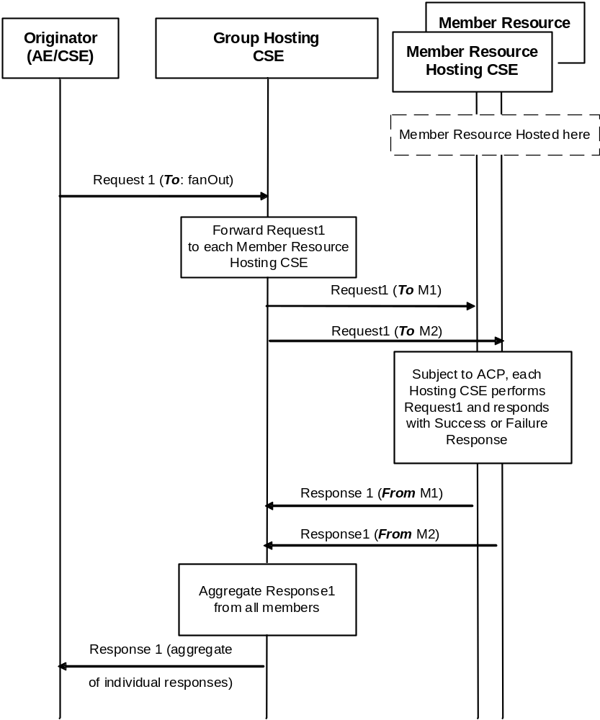
Figure 1 Processing of requests targeting <group/fanOutPoint>
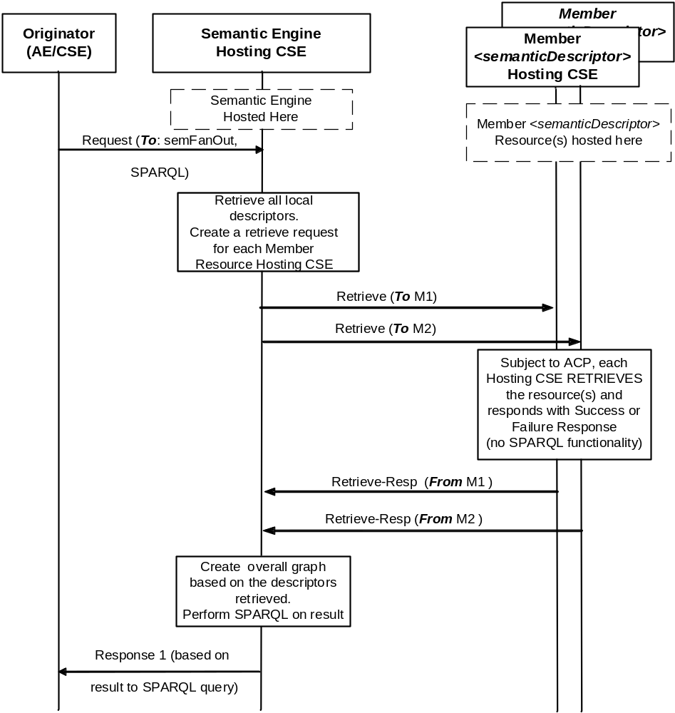
Figure 2 Processing of requests targeting <semanticGroup/semanticFanOutPoint>

R03 implements joint ARC-MAS agreements:
- Merge of semanticFanOutPoint into <group>, <semanticGroup> no longer needed.
- Adding semanticDescriptor as member type: Stage 3 CR needed, some functional description changes here
R04 corrects multiplicity and can/shall
R05 editorial permission->privilege, introduces semanticSupportIndicator

-----------------------Start of change 1-------------------------------------------

9.6.1 Overview

9.6.1.1 Resource Type Summary
Table 9.6.1.1-1 introduces the normal and virtual resource types and their related child or parent resource types. Details of each resource type follow in the remainder of this clause.
Table 9.6.1.1-1 lists each specified <resourceType>. An addition of suffix "Annc" to such <resourceTypes> indicates the associated announced resource type.
Among the resource types listed in Table 9.6.1.1-1, the following are termed “Content Sharing Resources” in oneM2M Specifications for the purpose of referring to any of those resource types:
- container
- contentInstance
- flexContainer

Table 9.6.1.1-1 Resource Types
Resource Type | Short Description | Child Resource Types | Parent Resource Types | Clause
accessControlPolicy | Stores a representation of privileges. It is associated with resources that shall be accessible to entities external to the Hosting CSE. It controls "who" is allowed to do "what" and the context in which it can be used for accessing resources | Subscription | AE, AEAnnc, remoteCSE, remoteCSEAnnc, CSEBase | 9.6.2
AE | Stores information about the AE. It is created as a result of successful registration of an AE with the Registrar CSE | subscription, container, group, accessControlPolicy,  schedule, pollingChannel，semanticDescriptor | remoteCSE, remoteCSEAnnc, CSEBase | 9.6.5
container | Shares data instances among entities. Used as a mediator that buffers data exchanged between AEs and/or CSEs. The exchange of data between AEs (e.g. an AE on a Node in a field domain and the peer-AE on the infrastructure domain) is abstracted from the need to set up direct connections and allows for scenarios where both entities in the exchange do not have the same reachability schedule | container,  flexContainer, contentInstance, subscription, latest, oldest，semanticDescriptor | AE, AEAnnc, container, containerAnnc, remoteCSE, remoteCSEAnnc, CSEBase,  flexContainer, flexContainerAnnc | 9.6.6
contentInstance | Represents a data instance in the <container> resource | semanticDescriptor | Container, containerAnnc | 9.6.7
flexContainer | A template which allows to define specialized (customizable) versions of containers with a flexible and lightweight structure | container,  flexContainer, subscription, semanticDescriptor, | AE, AEAnnc, container, containerAnnc,  flexContainer, flexContainerAnnc, remoteCSE, remoteCSEAnnc, CSEBase | 9.6.35
CSEBase | The structural root for all the resources that are residing on a CSE. Stores information about the CSE itself | remoteCSE, remoteCSEAnnc, node, AE, container, group, accessControlPolicy, subscription,, mgmtCmd, locationPolicy, statsConfig, statsCollect, request, delivery,  schedule,  notificationTargetPolicy,  flexContainer, | None specified | 9.6.3
delivery | Forwards requests from CSE to CSE | Subscription | CSEBase | 9.6.11
eventConfig | Defines events that trigger statistics collection | Subscription | statsConfig | 9.6.24
execInstance | Contains all execution instances of the same Management Command | Subscription | mgmtCmd | 9.6.17
fanOutPoint (V) | Virtual resource containing target for group request  It is used for addressing bulk operations to all the resources that belong to a group | None specified | group | 9.6.14
group | Stores information about resources of the same type that need to be addressed as a Group. Operations addressed to a Group resource shall be executed in a bulk mode for all members belonging to the Group | fanOutPoint,  subscription,  semanticFanOutPoint | AE, AEAnnc, remoteCSE, remoteCSEAnnc, CSEBase | 9.6.13
latest (V) | Virtual resource that points to most recently created <contentInstance> child resource within a <container> resource | None specified | container | 9.6.27
locationPolicy | Includes information to obtain and manage geographical location. It is only referenced within a container, the contentInstances of the container provide location information | Subscription | CSEBase | 9.6.10
mgmtCmd | Management Command resource represents a method to execute management procedures required by existing management protocols | execInstance,  subscription | CSEBase | 9.6.16
mgmtObj | Management Object resource represents management functions that provides an abstraction to be mapped to external management technology. It represents the node and the software installed in the node (see note) | subscription, mgmtObj, schedule | node, mgmtObj, mgmtObjAnnc | 9.6.15  Annex D
m2mServiceSubscriptionProfile | Data pertaining to the M2M Service Subscription | serviceSubscribedNode,  subscription | CSEBase | 9.6.19
node | Represents specific Node information | mgmtObj,  subscription | CSEBase, remoteCSE | 9.6.18
notificationTargetMgtPolicyRefs | Represents a list of notification targets and the deletion policy | subscription | subscription | 9.6.31
notificationTargetPolicy | Represents a notification target deletion policy with pre-defined action and deletion rules | subscription, policyDeletionRules | CSEBase | 9.6.32
notificationTargetSelfReference (V) | Virtual resource used to remove the Notification Target | None specified | subscription | 9.6.34
oldest (V) | Virtual resource that points to first created <contentInstance> child resource within a <container> resource | None specified | container | 9.6.28
pollingChannel | Represent a channel that can be used for a request-unreachable entity | pollingChannelURI | remoteCSE, AE | 9.6.21
pollingChannelURI (V) | Virtual resource used to perform service layer long polling of a resource Hosting CSE by a request-unreachable entity | None specified | pollingChannel | 9.6.22
policyDeletionRules | Represents a set of rules which is associated with notification target removal policy | Subscription | notificationTargetPolicy | 9.6.33
remoteCSE | Represents a remote CSE for which there has been a registration procedure with the registrar CSE identified by the CSEBase resource | AE, container, group, accessControlPolicy, subscription, pollingChannel, schedule, node, | CSEBase | 9.6.4
request | Expresses/access context of an issued Request | Subscription | CSEBase | 9.6.12
schedule | Contains scheduling information for delivery of messages | Subscription | subscription, CSEBase, remoteCSE, AE | 9.6.9
serviceSubscribedNode | Node information | Subscription | m2mServiceSubscriptionProfile | 9.6.20
statsCollect | Defines triggers for the IN-CSE to collect statistics for applications | Subscription | CSEBase (in IN-CSE) | 9.6.25
statsConfig | Stores configuration of statistics for applications | eventConfig,  subscription | CSEBase (in IN-CSE) | 9.6.23
subscription | Subscription resource represents the subscription information related to a resource. Such a resource shall be a child resource for the subscribe-to resource | schedule, notificationTargetSelfReference, notificationTargetMgtPolicyRefs | accessControlPolicy, accessControlPolicyAnnc, AE, AEAnnc, container, CSEBase, delivery, eventConfig, execInstance, group, locationPolicy, mgmtCmd, mgmtObj, mgmtObjAnnc, m2mServiceSubscriptionProfile, node, nodeAnnc, serviceSubscribedNode, remoteCSE, remoteCSEAnnc, request, schedule, semanticDescriptor, statsCollect, statsConfig,  flexContainer, flexContainerAnnc, | 9.6.8
serviceSubscribedAppRule | Represents a rule that defines allowed App-ID and AE-ID combinations that are acceptable for registering an AE on a Registrar CSE | Subscription | CSEBase | 9.6.29
semanticDescriptor | Stores semantic description pertaining to a resource and potentially sub-resources. | Subscription | AE, container, contentInstance | 9.6.30
semanticFanOutPoint | Virtual resource used as target for semantic discovery aimed at a logical graph distributed over multiple semanticDescriptor resources, which belong to the corresponding group parent resource | None specified | group | 9.6.14a
NOTE: See clause 9.6.12 for a summary of specializations of <mgmtObj>.

-----------------------End of change 1-------------------------------------------

-----------------------Start of change 2-------------------------------------------

9.6.30 Resource Type semanticDescriptor
The <semanticDescriptor> resource is used to store a semantic description pertaining to a resource and potentially sub-resources. Such a description may be provided according to ontologies. The semantic information is used by the semantic functionalities of the oneM2M system and is also available to applications or CSEs. [i.28] provides an informative example of a descriptor attribute.
Editor’s note: There might be a need to make a normative reference to a stage 3 TS, depending how far PRO goes in standardizing semantic descriptors using RDF or OWL formats.

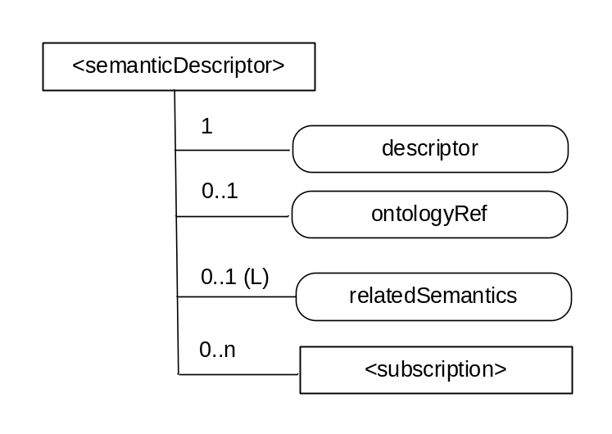
Figure 9.6.30-1: Structure of <semanticDescriptor> resource
The <semanticDescriptor> resource shall contain the child resources specified in table 9.6.30-1.
Table 9.6.30-1: Child resources of <semanticDescriptor> resource
Child Resources of <semanticDescriptor> | Child Resource Type | Multiplicity | Description
[variable] | <subscription> | 0..n | See clause 9.6.8 where the type of this resource is described.

The <semanticDescriptor> resource shall contain the attributes specified in table 9.6.23-2.
Table 9.6.30-2: Attributes of <semanticDescriptor> resource
Attributes of <semanticDescriptor> | Multiplicity | RW/  RO/  WO | Description
resourceType | 1 | RO | See clause 9.6.1.3
resourceID | 1 | RO | See clause 9.6.1.3
resourceName | 1 | WO | See clause 9.6.1.3
parentID | 1 | RO | See clause 9.6.1.3
accessControlPolicyIDs | 0..1 (L) | RW | See clause 9.6.1.3
creationTime | 1 | RO | See clause 9.6.1.3
expirationTime | 1 | RW | See clause 9.6.1.3
lastModifiedTime | 1 | RO | See clause 9.6.1.3
Labels | 0..1 (L) | RW | See clause 9.6.1.3
Creator | 0..1 | RO | The AE-ID of the entity which created the resource. This can also be the CSE-ID of the IN-CSE if the IN-CSE created the resource.
Descriptor | 1 | RW | Stores a semantic description pertaining to a resource and potentially sub-resources. Such a description shall be according to subject-predicate-object triples as defined in the RDF graph-based data model [4].The elements of such triples may be provided according to ontologies.
ontologyRef | 0..1 | WO | A reference (URI) of the ontology used to represent the information that is stored in the descriptor attribute. If this attribute is not present, the ontologyRef from the parent resource is used if present.
relatedSemantics | 0..1(L) | WO | List of URIs for resources containing related semantic information to be used in processing semantic queries. The URI(s) may reference either a <group> resource or other <semanticDescriptor> resources.

----------------------- End of change 2-------------------------------------------

--------------------Start of change 3 ---------------------------

roup> resource

resource

9.6.13 Resource Type group
The <group> resource represents a group of resources of the same or mixed types. The <group> resource can be used to do bulk manipulations on the resources represented by the memberIDs attribute. The <group> resource contains an attribute that represents the members of the group and the <fanOutPoint> virtual resource (that enables generic operations to be applied to all the resources represented by those members By grouping <semanticDescriptor> resources across which a semantic description is distributed , another virtual resource ( <semanticFanOutPoint>) enables semantic discovery procedures to be applied across the full logical tree in the description.

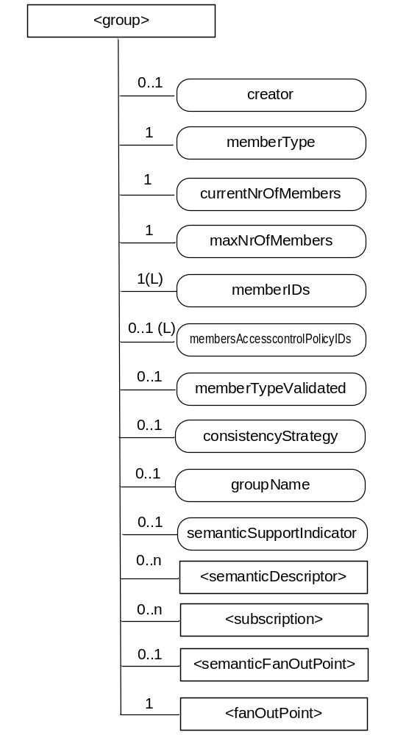
Figure 9.6.13-1: Structure of <group> resource
The <group> resource shall contain the child resources specified in table 9.6.13-1.
Table 9.6.13-1: Child resources of <group> resource
Child Resources of <group> | Child Resource Type | Multiplicity | Description | <groupAnnc> Child Resource Types
semanticDescriptor | <semanticDescriptor> | 0..n | See clause 9.6.30 | <semanticDescriptor>, <semanticDescriptorAnnc>
[variable] | <subscription> | 0..n | See clause 9.6.8 | <subscription>
fanOutPoint | <fanOutPoint> | 1 | See clause 9.6.14 | none
semanticFanOutPoint | <semanticFanOutPoint> | 0..1 | See clause 9.6.14a | none

The <group> resource shall contain the attributes specified in table 9.6.13-2
Table 9.6.13-2: Attributes of <group> resource
Attributes of  <group> | Multiplicity | RW/  RO/  WO | Description | <groupAnnc> Attributes
resourceType | 1 | RO | See clause 9.6.1.3 | NA
resourceID | 1 | RO | See clause 9.6.1.3 | NA
resourceName | 1 | WO | See clause 9.6.1.3 | NA
parentID | 1 | RO | See clause 9.6.1.3 | NA
expirationTime | 1 | RW | See clause 9.6.1.3 | MA
accessControlPolicyIDs | 0..1 (L) | RW | See clause 9.6.1.3 | MA
labels | 0..1 (L) | RW | See clause 9.6.1.3 | MA
creationTime | 1 | RO | See clause 9.6.1.3 | NA
lastModifiedTime | 1 | RO | See clause 9.6.1.3 | NA
announceTo | 0..1 (L) | RW | See clause 9.6.1.3 | NA
announcedAttribute | 0..1 (L) | RW | See clause 9.6.1.3 | NA
creator | 0..1 | RO | The AE-ID or CSE-ID of the entity which created the resource. | NA
memberType | 1 | WO | It is the resource type of the member resources of the group, if all member resources (including the member resources in any sub-groups) are of the same type. Otherwise, it is of type 'mixed'. | OA
currentNrOfMembers | 1 | RO | Current number of members in a group. It shall not be larger than maxNrOfMembers. | OA
maxNrOfMembers | 1 | RW | Maximum number of members in the <group>. | OA
memberIDs | 1 (L) | RW | List of member resource IDs referred to in the remaining of the present document as memberID. Each ID (memberID) should refer to a member resource or a (sub-) <group> resource of the <group>. | OA
membersAccessControlPolicyIDs | 0..1 (L) | RW | List of IDs of the <accessControlPolicy> resources defining who is allowed to access the <fanOutPoint> resource. | OA
memberTypeValidated | 0..1 | RO | Denotes if the resource types of all members resources of the group has been validated by the Hosting CSE. In the case that the memberType attribute of the <group> resource is not ‘mixed’, then this attribute shall be set.. | OA
consistencyStrategy | 0..1 | WO | This attribute determines how to deal with the <group> resource if the memberType validation fails. Which means delete the inconsistent member if the attribute is ABANDON_MEMBER; delete the group if the attribute is ABANDON_GROUP; set the memberType to "mixed" if the attribute is SET_MIXED. | OA
groupName | 0..1 | RW | Human readable name of the <group>. | OA
semanticSupportIndicator | 0..1 | RO | Indicator of support for sematic discovery functionality via <semanticFanOutPoint> | OA

9.6.14 Resource Type fanOutPoint
The <fanOutPoint> resource is a virtual resource because it does not have a representation. It is the child resource of a <group> resource. Whenever a request is sent to the <fanOutPoint> resource, the request is fanned out to each of the members of the <group> resource indicated by the membersIDs attribute of the <group> resource. The responses (to the request) from each member are then aggregated and returned to the Originator. A timer should be set for the aggregation. The responses are aggregated if all the responses expected have been received or when the timer expires. The responses received after the time expires should be discarded. If the Result Expiration Timestamp parameter is received from the Originator, the timer should be set to enforce this parameter, otherwise, the timer is set based on the local policy configured at the Hosting CSE.
The <fanOutPoint> resource does not have a resource representation by itself and consequently it does not have an accessControlPolicyIDs attribute. The <accessControlPolicy> resource used for access control policy validation is indicated by the membersAccessControlPolicyIDs attribute in the parent <group> resource.

9.6.14a Resource Type semanticFanOutPoint
The <semanticFanOutPoint> resource is a virtual resource because it does not have a representation. It is the child resource of a <group> resource with members of type <semanticDescriptor>.
Whenever a semantic discovery request is sent to the <semanticFanOutPoint> resource the host uses the memberIDs attribute of the parent <group> resource to retrieve all the related descriptors. If there are descriptors stored on different CSEs, individual RETRIEVE requests are sent to each CSE for retrieving the external descriptors. All semantic descriptors are accessed based on the respective access control policies.
Once all of the related <semanticDescriptor>(s) have been retrieved, the content of each of the descriptor attributes is added to the content on which the SPARQL request is being executed. The full/enlarged content subject to the SPARQL request is provided to the SPARQL engine for processing
The <semanticFanOutPoint> resource uses membersAccessControlPolicyIDs attribute in the parent <group> resource for access control policy validation.

-----------------------End of change 3---------------------------------------------

-----------------------Start of change 4---------------------------------------------

10.2.7 Group Management Procedures

10.2.7.1 Introduction
This clause describes different procedures for managing membership verification, creation, retrieval, update and deletion of the information associated with a <group> resource. Bulk management of all group member resources by invoking the corresponding operations upon the virtual resource <fanOutPoint> of a <group> resource are detailed. This clause also describes the use of retrieve operations in conjunction with the virtual resource <semanticFanOutPoint>, for the purpose of semantic discovery.

10.2.7.2 Create <group>
This procedure shall be used for creating a <group> resource.
Table 10.2.7.2-1: <group> CREATE
<group> CREATE
Associated Reference Point | Mcc, Mca and Mcc'
Information in Request message | From: Identifier of the AE or the CSE that initiates the Request  To: The address of the <CSEBase>, <AE>, or <remoteCSE> where the <group> resource is intended to be Created  Content: The representation of the <group> resource for which the attributes are described in clause 9.6.13
Processing at Originator before sending Request | The Originator shall request to Create a <group> resource by using the CREATE operation. The request shall address <CSEBase>, <remoteCSE> or <AE> resource of a Hosting CSE. The Request shall also provide memberIDs and may provide expirationTime attributes. The Originator may be an AE or a CSE
Processing at Receiver | For the CREATE procedure, the Receiver shall:  Check if the Originator has CREATE permissions on the <CSEBase> resource  Check the validity of the provided attributes  Validate that there are no duplicate members present in the memberIDs attribute  Validate that the resource type of every member on each member Hosting CSE conforms to the memberType attribute in the request, if the memberType attribute of the <group> resource is not 'mixed'. Set the memberTypeValidated attribute to TRUE upon successful validation.  Upon successful validation of the provided attributes, create a new group resource including the <fanOutPoint> child-resource in the Hosting CSE. If the CSE supports semantic discovery functionality the <semanticFanOutPoint> child-resource is also created.  Conditionally, in the case that the group resource contains temporarily. unreachable Hosting CSE of sub-group resources as member resource, set the memberTypeValidated attribute of the <group> resource to FALSE  Respond to the Originator with the appropriate generic Response with the representation of the <group> resource if the memberTypeValidated attribute is FALSE, and the address of the created <group> resource if the CREATE was successful  As soon as any Hosting CSE that hosts the unreachable resource becomes reachable, the memberType validation procedure shall be performed. If the memberType validation fails, the Hosting CSE shall deal with the <group> resource according to the policy defined by the consistencyStrategy attribute of the <group> resource provided in the request. or by default if the attribute is not provided
Information in Response message | The representation of the <group> resource if the memberTypeValidated attribute is FALSE
Processing at Originator after receiving Response | None
Exceptions | No change from the basic procedure in clause 10.1.1

10.2.7.3 Retrieve <group>
This procedure shall be used for retrieving <group> resource.
Table 10.2.7.3-1: <group> RETRIEVE
<group> RETRIEVE
Associated Reference Point | Mcc, Mca and Mcc'
Information in Request message | From: Identifier of the AE or the CSE that initiates the Request  To: The address of the <group> resource
Processing at Originator before sending Request | The Originator shall request to obtain <group> resource information by using the RETRIEVE operation. The request shall address the specific <group> resource of a Hosting CSE. The Originator may be an AE or a CSE
Processing at Receiver | No change from the basic procedure in clause 10.1.2
Information in Response message | No change from the basic procedure in clause 10.1.2
Processing at Originator after receiving Response | None
Exceptions | No change from the basic procedure in clause 10.1.2

10.2.7.4 Update <group>
This procedure shall be used for updating an existing <group> resource.
Table 10.2.7.4-1: <group> UPDATE
<group> UPDATE
Associated Reference Point | Mca, Mcc and Mcc'
Information in Request message | From: Identifier of the AE or the CSE that initiates the Request  To: The address of the <group> resource
Processing at Originator before sending Request | The Originator shall request to update attributes of an existing <group> resource by using an UPDATE operation. The Request shall address the specific <group> resource of a CSE. The Originator may be an AE or a CSE
Processing at Receiver | The UPDATE procedure shall be:  Check if the Originator has UPDATE permissions on the <group> resource.  Check the validity of provided attributes  Validate that there are no duplicated members present in the memberIDs attribute  Validate that the resource type of every member on each member Hosting CSE conforms to the memberType attribute in the request, if the memberType attribute of the <group> resource is not 'mixed'. Set the memberTypeValidated attribute to TRUE upon successful validation  Upon successful validation of the provided attributes, update the <group> resource in the Hosting CSE  Conditionally, in the case that the <group> resource contains temporarily unreachable Hosting CSE of sub-group resources as members resource set the memberTypeValidated attribute of the <group> resource to FALSE  Respond to the Originator with the appropriate generic response with the representation of the <group> resource if the memberTypeValidated attribute is FALSE, and the address of the created <group> resource if the UPDATE is successful  As soon as any Hosting CSE that hosts unreachable resource becomes reachable, the memberType validation procedure shall be performed. If the memberType validation fails, the Hosting CSE shall deal with the <group> resource according to the policy defined by the consistencyStrategy attribute of the <group> resource provided in the request, or by default if the attribute is not provided
Information in Response message | The representation of the <group> resource if the memberTypeValidated attribute is FALSE
Processing at Originator after receiving Response | None
Exceptions | No change from the basic procedure in clause 10.1.3

10.2.7.5 Delete <group>
This procedure shall be used for deleting an existing <group> resource.
Table 10.2.7.5-1: <group> DELETE
<group> DELETE
Associated Reference Point | Mcc, Mca and Mcc'
Information in Request message | From: Identifier of the AE or the CSE that initiates the Request  To: The address of the <group> resource
Processing at Originator before sending Request | The Originator shall request to delete an existing <group> resource by using the DELETE operation. The request shall address the specific <group> resource of a Hosting CSE. The Originator may be an AE or a CSE.  This operation shall also delete the child virtual resources <fanOutPoint> and <semanticFanOutPoint>.
Processing at Receiver | No change from the basic procedure in clause 10.1.4
Information in Response message | No change from the basic procedure in clause 10.1.4
Processing at Originator after receiving Response | None
Exceptions | No change from the basic procedure in clause 10.1.4

-------------------End of change 4 ---------------------------------------------------------

-------------------Start of change 5 (new clause)------------------------------------------

10.2.7.13 <semanticFanOutPoint> Procedures
The virtual resource <semanticFanOutPoint> is used for processing semantic discovery requests. As such, this virtual resource shall be the target of RETRIEVE requests only. The <semanticFanOutPoint> resource is created and deleted at the same time with the parent <group> resource.

10.2.7.14 Retrieve <semanticFanOutPoint>
This procedure shall be used for performing a semantic discovery procedure using the descriptor content of all member <semanticDescriptor> resources belonging to an existing <group> resource.
Table 10.2.7.14-1: <semanticFanOutPoint> RETRIEVE
<semanticFanOutPoint> RETRIEVE
Associated Reference Point | Mca, Mcc and Mcc'
Information in Request message | According to clause 10.1.2
Processing at Originator before sending Request | The Originator shall request a semantic discovery to be performed using the content of the semantic descriptors of all member resources belonging to an existing <group> resource. The Originator may be an AE or CSE
Processing at Receiver | The Receiver shall:  Check if the Originator has RETRIEVE privilege in the <accessControlPolicy> resource referenced by the membersAccessControlPolicyIDs in the parent <group> resource. In the case membersAccessControlPolicyIDs is not provided, the access control policy defined for the parent <group> resource shall be used  Upon successful validation, obtain the URIs of all the member <semanticDescriptor> resources from the memberIDs attribute of the parent<group> resource.  If there are <semanticDescriptor> resources stored on different CSEs, individual RETRIEVE requests are sent to each CSE for retrieving the descriptors, otherwise the descriptor attributes are simply retrieved for all the <semanticDescriptor> resources hosted locally. All semantic descriptors are accessed based on the respective access control policies.  Once all of the related descriptor attributes have been retrieved, the SPARQL request is being executed on the combined content.
Information in Response message | The result of the SPARQL request executed on the combined content of the members’ descriptors.
Processing at Originator after receiving Response | According to clause 10.1.2
Exceptions | According to clause 10.1.2

-----------------------End of change 5---------------------------------------------------------

---------------------Start of change 6 (new clause)---------------------------------------

10.2.z Semantic Discovery Procedures

10.2.z.1 Introduction
This clause describes semantic discovery procedures on semantic descriptions represented as RDF triples, given that an overall semantic description (logical tree) may be distributed across several <semanticDescriptor> resources.
Semantic discovery procedures may be performed using RETRIEVE operations as follows:
Targeting any resource other than <semanticFanOutPoint>:
- The receiver begins processing the request by retrieving the <semanticDescriptor> resource of the request target and its descriptor attribute. Related descriptors are discovered and accessed according to clause 10.2.z.2. The content of related descriptor attributes are added to the content on which the SPARQL request is being executed. Depending on which of the options described in 10.2.z.2.1 or 10.2.z.2.2 is chosen, all potentially relevant descriptor attributes are added before executing the SPARQL request or they are added when needed during the execution of the SPARQL request.
- The resulting content subject to the SPARQL request is provided to the SPARQL engine for processing.

Targeting a <semanticFanOutPoint> resource (see also clauses 10.2.7.14):
- In this case the related descriptors are the members of the <group> resource parent of the targeted <semanticFanOutPoint>. Based on the memberID attribute of the parent <group> resource all the related descriptors are discovered, and those on the <group> hosting CSE are retrieved together
- If there are descriptors stored on a different CSE, individual RETRIEVE requests are sent to each CSE for retrieving the external descriptors.
- All semantic descriptors are retrieved based on the respective access control policies.
- Once all of the related <semanticDescriptor>(s) have been accessed, the content of each of the descriptor attribute is added to the content on which the SPARQL request is being executed.
- The full/enlarged content subject to the SPARQL request is provided to the SPARQL engine for processing

10.2.z.2 Discovering and establishing the logical tree in the semantic discovery scope without the use of <semanticFanOutPoint>
Given that an overall semantic description (logical tree) may be distributed across the <semanticDescriptor> resources, there are two methods of constructing the logical tree in the scope of a semantic discovery targeting any resource other than <semanticFanOutPoint>.
- If the attribute relatedSemantics is empty or does not exist, the “Annotation-based method” (using resourceDescriptorLink) detailed in clause 10.2.z.2.1 shall be used
- If the attribute relatedSemantics is not empty the “Resource link-based method” (using relatedSemantics) detailed in clause 10.2.z.2.2 shall be used

10.2.z.2.1 Annotation-based method
In this option, the links to related <semanticDescriptor> resources are encoded in the semantic description itself, which is encoded as RDF triples [4] logically structured as <subject> <predicate> <object>. For this purpose, an annotation property called onem2m:resourceDescriptorLink is introduced. It is formally specified as part of the oneM2M Base Ontology defined in [6] and can be used as a predicate in any RDF triple with any subject and without further relation to the oneM2M Base Ontology. Only the use of the onem2m namespace is required to uniquely identify the annotation property.
Whenever further information about a semantic instance <X> is stored in another <semanticDescriptor> resource, a new RDF triple <X> onem2m:resourceDescriptorLink <SemanticDescriptorURL> may be added to this semantic description, where <SemanticDescriptorURL> is the URL of the other semanticDescriptor resource containing additional information related to <X>. If multiple <semanticDescriptor> resources contain relevant further information, these can be added to a <group> resource and the <SemanticDescriptorURL> then refers to the virtual <fanOutPoint> resource of this group, which will be used for retrieving the aggregated information.

Editor's Note: The RDF triple syntax in this paragraph is only used for illustration purposes. The actual encoding of the RDF triples will be defined in stage 3 documents. Once this is there, this editor's note should be replaced by a note including the actual reference to the stage 3 document.

To make use of the onem2m:resourceDescriptorLink property, the evaluation of semantic queries formulated as SPARQL requests by the SPARQL engine has to be adapted in the following way:

- The SPARQL request is executed on the content of the semantic description in the descriptor attribute of the semanticDescriptor resource.
- For each semantic instance matched in the SPARQL request, it is checked whether one or more onem2m:resourceDescriptorLink annotations exist.
- If this is the case, the execution of the SPARQL request is halted.
- The content of the descriptor attribute of each of the semanticDescriptor resources referenced by the onem2m:semanticDescriptorLink annotations is added to the content on which the SPARQL request is being executed. If the onem2m:semanticDescriptorLink annotation references a group, the additional descriptor content is accessed by performing a retrieve request to the virtual <fanOutPoint> resource referenced.
- The execution of the SPARQL request is continued on the enlarged content

10.2.z.2.2 Resource link-based method
In this option, the links to related <semanticDescriptor> resources are specified in the relatedSemantics attribute.
Processing of the SPARQL engine procedures at the receiver :
- The receiver retrieves the <semanticDescriptor> resource of the request target
- Based on the relatedSemantics attribute of the <semanticDescriptor> resource targeted, all the related descriptors are discovered, as follows:
  - If the relatedSemantics attribute includes a list of links, each of the linked Descriptors are accessed based on the respective access control policies.

  - If the relatedSemantics points to a <group> resource, the group members from the memberID attribute are used and each of their <semanticDescriptor>(s) are accessed based on the respective access control policies.
- Once all of the related <semanticDescriptor>(s) have been accessed, the content of each of the descriptor attribute is added to the content on which the SPARQL request is being executed.
- The full/enlarged content subject to the SPARQL request is provided to the SPARQL engine for processing.

-----------------------End of change 6----------------------------------------------------------

------------------- Start of changes to References Section------------------------------

2 References

2.1 Normative references
References are either specific (identified by date of publication and/or edition number or version number) or non-specific. For specific references, only the cited version applies. For non-specific references, the latest version of the reference document (including any amendments) applies.
The following referenced documents are necessary for the application of the present document.
[1] oneM2M TS-0011: “Common Terminology”
[2] oneM2M TS-0003: "Security Solutions"
[3] oneM2M TS-0004: "Service Layer Core Protocol Specification"
[4] W3C RDF 1.1 Concepts and Abstract Syntax
[5] W3C SPARQL 1.1 Query Language
[6] oneM2M TS-0012: "oneM2M Base Ontology"

--------------------End of changes to Reference Section --------------------------------

