CHANGE REQUEST
Meeting:* | ARC 22
Source:* | Catalina Mladin, InterDigital
Date:* | 2015-03-06
Contact:* | Catalina Mladin, Catalina.Mladin@InterDigital.com
Reason for Change/s:* | Changes related to making creator a common attribute
CR against: Release* | oneM2M R2
CR against: WI* | Active WI  MNT maintenace / < Work Item number(optional)>  STE Small Technical Enhancements / < Work Item number (optional)>  Only ONE of the above shall be ticked
CR against: TS/TR* | TS-0001 v2.6.0
Clauses/Sub Clauses* | 9.6.1.3.2, 9.6.6.-8, 9.6.13, 9.6.23-25, 9.6.30, 9.6.32, 9.6.35-35, 9.6.41
Type of change: * | Editorial change  Bug Fix or Correction  Change to existing feature or functionality  New feature or functionality  Only ONE of the above shall be ticked
Post Freeze checking:* | This CR contains only essential changes and corrections? YES NO  This CR may break backwards compatibility with the last approved version of the TS? YES NO  This CR is a mirror CR? YES if YES, please indicate the document number of the original CR: <Document Number) : NO
Template Version:27 May 2015 (Dot not modify)

oneM2M Notice
The document to which this cover statement is attached is submitted to oneM2M. Participation in, or attendance at, any activity of oneM2M, constitutes acceptance of and agreement to be bound by terms of the Working Procedures and the Partnership Agreement, including the Intellectual Property Rights (IPR) Principles Governing oneM2M Work found in Annex 1 of the Partnership Agreement.
GUIDELINES for Change Requests:
Provide an informative introduction containing the problem(s) being solved, and a summary list of proposals.
Each CR should contain changes related to only one particular issue/problem.
In case of a correction, and the change apply to previous releases, a separated “mirror CR” should be posted at the same time of this CR
Follow the principle of completeness, where all changes related to the issue or problem within a deliverable are simultaneously proposed to be made E.g. A change impacting 5 tables should not only include a proposal to change only 3 tables. Includes any changes to references, definitions, and acronyms in the same deliverable.
Follow the drafting rules.
All pictures must be editable.
Check spelling and grammar to the extent practicable.
Use Change bars for modifications.
The change should include the current and surrounding clauses to clearly show where a change is located and to provide technical context of the proposed change. Additions of complete sections need not show surrounding clauses as long as the proposed section number clearly shows where the new section is proposed to be located.
Multiple changes in a single CR shall be clearly separated by horizontal lines with embedded text such as, start of change 1, end of change 1, start of new clause, end of new clause.
When subsequent changes are made to content of a CR, then the accepted version should not show changes over changes. The accepted version of the CR should only show changes relative to the baseline approved text.

Introduction
TP21 Action Item: Given its repeated use throughout, the creator attribute should be made a common attribute. This CR implements the neccesary changes.

-----------------------Start of change 1-------------------------------------------

9.6.1.3.2 Common attributes
The following attributes are commonly used in multiple, but not all, resource types which are normal, not virtual or announced. Common attributes for announced resource types are independently defined in claused 9.6.26.3.
NOTE: The list of attributes in table 9.6.1.3.2-1 is not exhaustive.
Table 9.6.1.3.2-1: Common Attributes
Attribute Name | Description
accessControlPolicyIDs | The attribute contains a list of identifiers of an <accessControlPolicy> resource. The privileges defined in the <accessControlPolicy> resource that are referenced determine who is allowed to access the resource containing this attribute for a specific purpose (e.g. Retrieve, Update, Delete, etc.).  If a resource type does not have an accessControlPolicyIDs attribute definition, then the accessControlPolicyIDs for that resource is governed in a different way, for example, the accessControlPolicy associated with the parent may apply to a child resource that does not have an accessControlPolicyIDs attribute definition, or the privileges for access are fixed by the system. Refer to the corresponding resource type definitions and procedures to see how access control is handled in such cases.  If a resource type does have an accessControlPolicyIDs attribute definition, but the (optional) accessControlPolicyIDs attribute is not set, or it is set to a value that does not correspond to a valid, existing <accessControlPolicy> resource, or it refers to an <accessControlPolicy> resource that is not reachable (e.g. because it is located on a remote CSE that is offline or not reachable), then the system default access privileges shall apply.  All resources are accessible if and only if the privileges (i.e., shored as privileges or selfPrivileges attribute of <accessControlPolicy> resource) allow it, therefore all resources shall have an associated AccessControlPolicyIDs attribute, either explicitly (setting the attribute in the resource itself) or implicitly (either by using the parent privileges or the system default policies). Which means that the system shall provide a default access privileges in case that the Originator does not provide a specific accessControlPolicyIDs during the creation of the resource.  To update this attribute, a Hosting CSE shall check whether an Originator has Update permission in any selfPrivileges of the <accessControlPolicy> resources which this attribute originally indicates.
stateTag | An incremental counter of modification on the resource. When a resource is created, this counter is set to 0, and it will be incremented on every modification of the resource (see notes 1 and 2). The modification also includes direct child resource creation and deletion.
announceTo | This attribute may be included in a CREATE or UPDATE Request in which case it contains a list of addresses/CSE-IDs where the resource is to be announced. For the case that CSE-IDs are provided, the announced-to CSE shall decide the location of the announced resources based on the rules described in clause 9.6.26.  For the original resource, this attribute shall only be present if it has been successfully announced to other CSEs. This attribute maintains the list of the resource addresses to the successfully announced resources. Updates on this attribute will trigger new resource announcement or de-announcement.  If announceTo attribute includes resource address(s), the present document does not provide any means for validating these address(s) for announcement purposes. It is the responsibility of the Hosting-CSE referenced by the resource address(s) to validate the access privileges of the originator of the Request that triggers the announcement.
announcedAttribute | This attributes shall only be present at the original resource if some Optional Announced (OA) type attributes have been announced to other CSEs. This attribute maintains the list of the announced Optional Attributes (OA type attributes) in the original resource. Updates to this attribute will trigger new attribute announcement if a new attribute is added or de-announcement if the existing attribute is removed.
labels | Tokens used as keys for discovering resources.  This attribute is optional and if not present it means that the resource cannot be found by means of discovery procedure which uses labels as key parameter of the discovery.
e2ESecurityCapabilities | Present in a resource representing an AE or CSE. Indicates the end-to-end security capabilities supported by the AE or CSE. May indicate supported end-to-end security frameworks. May also contains a certificate or credential identifier used by the AE or CSE. May include random values for use in end-to-end security protocols. The details of this attributes are described in TS-0003 [2].  This attribute is optional and if not present it means that the represented entity does not support oneM2M end-to-end security procedures.
dynamicAuthorizationConsultationIDs | This attribute contains a list of identifiers of <dynamicAuthorizationConsultation> resources. The information defined in a <dynamicAuthorizationConsultation> resource is used by a CSE for initiating consultation-based dynamic authorization requests.  Consultation-based dynamic authorization is only performed for a targeted resource if and only if it is linked to an enabled <dynamicAuthorizationConsultation> resource.  If the attribute is not set or has a value that does not correspond to a valid <dynamicAuthorizationConsultation> resource(s), or it refers to an <dynamicAuthorizationConsultation> resource(s) that is not reachable, then the dynamicAuthorizationConsultationIDs associated with the parent may apply to the child resource if present, or a system default <dynamicAuthorizationConsultation> may apply if present.
creator | The AE-ID or CSE-ID of the entity which created the resource containing this attribute.
NOTE 1: In order to enable detection of overflow, the counter needs to be capable of expressing sufficiently long numbers.
NOTE 2: This attribute has the scope to allow identifying changes in resources within a time interval that is lower than the one supported by the attribute lastModifiedTime (e.g. less than a second or millisecond). This attribute can also be used to avoid race conditions in case of competing modifications.

-----------------------End of change 1---------------------------------------------

-----------------------Start of change 2-------------------------------------------

9.6.6 Resource Type container
The <container> resource represents a container for data instances. It is used to share information with other entities and potentially to track the data. A <container> resource has no associated content. It has only attributes and child resources.

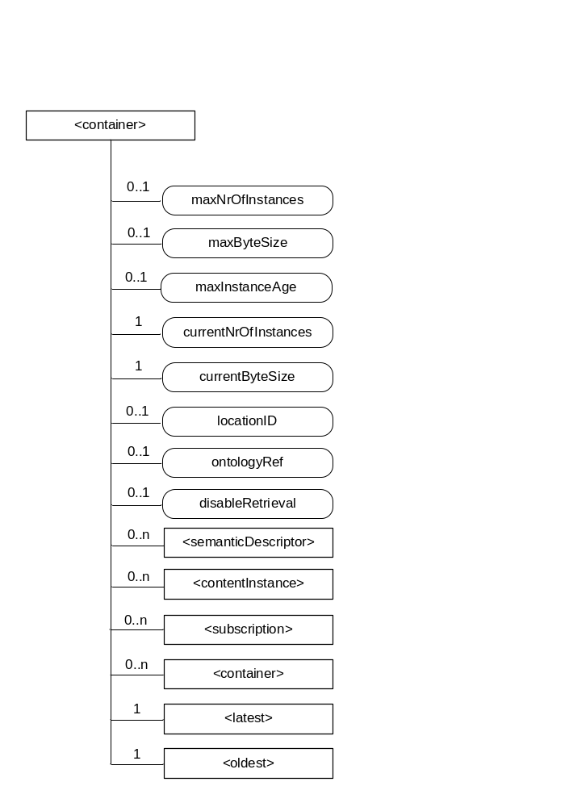
Figure 9.6.6-1: Structure of <container> resource
The <container> resource shall contain the child resources specified in table 9.6.6-1.
Table 9.6.6-1: Child resources of <container> resource
Child Resources of <container> | Child Resource Type | Multiplicity | Description | <containerAnnc> Child Resource Types
semanticDescriptor | <semanticDescriptor> | 0..n | See clause 9.6.30 | <semanticDescriptor>, <semanticDescriptorAnnc>
[variable] | <contentInstance> | 0..n | See clause 9.6.7 | <contentInstance>, <contentInstanceAnnc>
[variable] | <subscription> | 0..n | See clause 9.6.8 | <subscription>
[variable] | <container> | 0..n | See clause 9.6.6 | <container>  <containerAnnc>
latest | <latest> | 1 | See clause 9.6.27 | None
oldest | <oldest> | 1 | See clause 9.6.28 | None

The <container> resource shall contain the attributes specified in table 9.6.6-2.
Table 9.6.6-2: Attribute of <container> resource
Attributes of  <container> | Multiplicity | RW/  RO/  WO | Description | <containerAnnc> Attributes
resourceType | 1 | RO | See clause 9.6.1.3. | NA
resourceID | 1 | RO | See clause 9.6.1.3. | NA
resourceName | 1 | WO | See clause 9.6.1.3. | NA
parentID | 1 | RO | See clause 9.6.1.3. | NA
expirationTime | 1 | RW | See clause 9.6.1.3. | MA
accessControlPolicyIDs | 0..1 (L) | RW | See clause 9.6.1.3 . If no accessControlPolicyIDs are provided at the time of creation, the accessControlPolicyIDs of the parent resource is linked to this attribute | MA
labels | 0..1 (L) | RW | See clause 9.6.1.3. | MA
creationTime | 1 | RO | See clause 9.6.1.3. | NA
lastModifiedTime | 1 | RO | See clause 9.6.1.3. | NA
stateTag | 1 | RO | See clause 9.6.1.3. | OA
announceTo | 0..1 (L) | RW | See clause 9.6.1.3. | NA
announcedAttribute | 0..1 (L) | RW | See clause 9.6.1.3. | NA
dynamicAuthorizationConsultationIDs | 0..1 (L) | RW | See clause 9.6.1.3. | OA
creator | 0..1 | RO | See clause 9.6.1.3. | NA
maxNrOfInstances | 0..1 | RW | Maximum number of direct child <contentInstance> resources in the <container> resource. | OA
maxByteSize | 0..1 | RW | Maximum size in bytes of data(i.e., content attribute of a <contentInstance> resource) that is allocated for the <container> resource for all direct child <contentInstance> resources in the <container> resource. | OA
maxInstanceAge | 0..1 | RW | Maximum age of a direct child <contentInstance> resource in the <container> resource. The value is expressed in seconds. | OA
currentNrOfInstances | 1 | RO | Current number of direct child <contentInstance> resource in the <container> resource. It is limited by the maxNrOfInstances. | OA
currentByteSize | 1 | RO | Current size in bytes of data(i.e., content attribute of a <contentInstance> resource) stored in all direct child <contentInstance> resources of a <container> resource. This is the summation of contentSize attribute values of the <contentInstance> resources. It is limited by themaxByteSize. | OA
locationID | 0..1 | RW | An ID of the resource where the attributes/policies that define how location information are obtained and managed. This attribute is defined only when the <container> resource is used for containing location information. | OA
ontologyRef | 0..1 | RW | A reference (URI) of the ontology used to represent the information that is stored in the child <contentInstance> resources of the present <container> resource (see note). | OA
disableRetrieval | 0..1 | RW | Boolean value to control RETRIE/UPDATE/DELETE operation on the child <contentInsance> resource.  When the value is set to ‘TRUE’, RETRIEVE/DELETE/UPDATE operations for child <contentInstance> shall be rejected at all times.  When the value is updated from 'TRUE' to 'FALSE', all existing <contentInstance> are deleted immediately.  When the value is set to ‘FALSE’, all operations are permitted on the <contentInstance> resource as per existing procedures. | OA
NOTE: The access to this URI is out of scope of oneM2M.

9.6.7 Resource Type contentInstance
The <contentInstance> resource represents a data instance in the <container> resource. The content of the contentInstance can be encrypted.
Unlike other resources, the <contentInstance> resource shall not be modified once created. An AE shall be able to delete a contentInstance resource explicitly or it may be deleted by the platform based on policies. If the platform has policies for contentInstance retention, these shall be represented by the attributes maxByteSize, maxNrOfInstances and/or maxInstanceAge attributes in the <container> resource. If multiple policies are in effect, the strictest policy shall apply.
The <contentInstance> resource inherits the same access control policies of the parent <container> resource, and does not have its own accessControlPolicyIDs attribute.

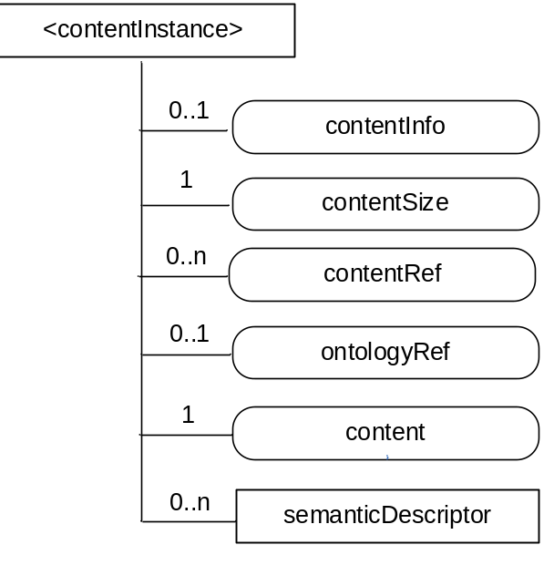
Figure 9.6.7-1: Structure of <contentInstance> resource
The <contentInstance> resource shall contain the child resources specified in table 9.6.7-1.
Table 9.6.7-1: Child resources of <container> resource
Child Resources of <contentInstance> | Child Resource Type | Multiplicity | Description | <contentInstanceAnnc> Child Resource Types
semanticDescriptor | <semanticDescriptor> | 0..n | See clause 9.6.30 | <semanticDescriptor>, <semanticDescriptorAnnc>

The <contentInstance> resource shall contain the attributes specified in table 9.6.7-2.
Table 9.6.7-2: Attributes of <contentInstance> resource
Attributes of <contentInstance> | Multiplicity | RW/  RO/  WO | Description | <contentInstanceAnnc> Attributes
resourceType | 1 | RO | See clause 9.6.1.3. | NA
resourceID | 1 | RO | See clause 9.6.1.3. | NA
resourceName | 1 | WO | See clause 9.6.1.3. | NA
parentID | 1 | RO | See clause 9.6.1.3. | NA
labels | 0..1 (L) | WO | See clause 9.6.1.3. | MA
expirationTime | 1 | WO | See clause 9.6.1.3. | NA
creationTime | 1 | RO | See clause 9.6.1.3. | NA
lastModifiedTime | 1 | RO | See clause 9.6.1.3. | NA
stateTag | 1 | RO | See clause 9.6.1.3.  The stateTag attribute of the parent resource should be incremented first and copied into this stateTag attribute when a new instance is added to the parent resource. | OA
announceTo | 0..1 (L) | WO | See clause 9.6.1.3. | NA
announcedAttribute | 0..1 (L) | WO | See clause 9.6.1.3. | NA
dynamicAuthorizationConsultationIDs | 0..1 (L) | RW | See clause 9.6.1.3. | OA
creator | 0..1 | RO | See clause 9.6.1.3. | NA
contentInfo | 0..1 | WO | Information on the content that is needed to understand the content. This attribute is a composite attribute. It is composed first of an Internet Media Type (as defined in the IETF RFC 6838) describing the type of the data, and second of an encoding information that specifies how to first decode the received content. Both elements of information are separated by a separator defined in oneM2M TS-0004 [3]. | OA
contentSize | 1 | RO | Size in bytes of the content attribute. | OA
contentRef | 0..1 | RW | This attribute contains a list of name-value pairs. Each entry expresses and associative reference to a <contentInstance> resource. The name of the entry indicates the relationship and the value of the entry the reference (URI) to the resource. | OA
ontologyRef | 0..1 | WO | A reference (URI) of the ontology used to represent the information that is stored in the contentInstances resources of the <container> resource. If this attribute is not present, the contentInstance resource inherits the ontologyRef from the parent <container> resource if present  NOTE: Access to this URI is out of scope of oneM2M. | OA
content | 1 | WO | Actual content of a contentInstance. This content may be opaque data for understandable with the help of the contentInfo. This may, for example, be an image taken by a security camera, or a temperature measurement taken by a temperature sensor. | OA

9.6.8 Resource Type subscription
The <subscription> resource contains subscription information for its subscribed-to resource. The <subscription> resource is a child of the subscribed-to resource.
The <subscription> resource shall be represented as child resource of the subscribed-to resource. For example, <container> resource has <subscription> resource as a child resource (see clause 9.6.6). A <subscription> resource shall be deleted when the parent subscribed-to resource is deleted.
The <subscription> resource shall represent a subscription to a subscribed-to resource. An Originator shall be able to create a resource of <subscription> resource type when the Originator has RETRIEVE privilege to the subscribe-to resource. The Originator which creates a <subscription> resource becomes the resource subscriber.
Each <subscription> may include notification policies that specify which, when, and how notifications are sent. These notification policies may work in conjunction with CMDH policies.
When a <subscription> resource is deleted, a Notify request shall be sent to the subscriberURI if it is provided by the Originator.

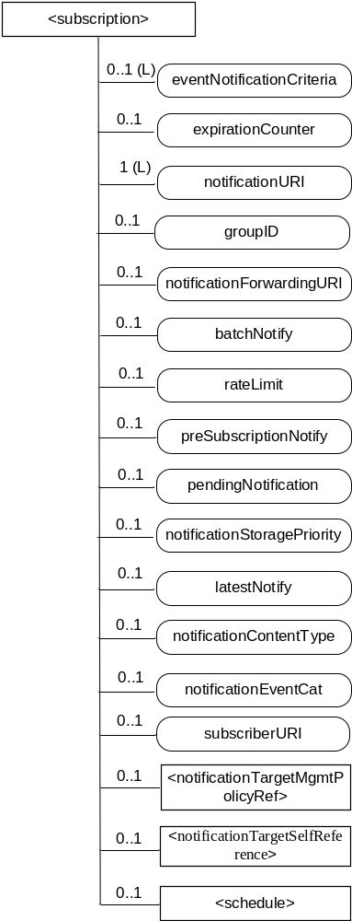
Figure 9.6.8-1: Structure of <subscription> resource
The <subscription> resource shall contain the child resources specified in table 9.6.8-1.
Table 9.6.8-1: Child resources of <subscription> resource
Child Resources | Child Resource Type | Multiplicity | Description
notificationSchedule | <schedule> | 0..1 | In the context of the <subscription> resource, the notificationSchedule specifies when notifications may be sent by the Hosting CSE to the notificationURI(s). See clause 9.6.9.
[variable] | < notificationTargetMgmtPolicyRef > | 0..n | See 9.6.31 for this type of resource.
notificationTargetSelfReference | < notificationTargetSelfReference> | 1 | See 9.6.34 for this type of resource.

The <subscription> resource shall contain the attributes specified in table 9.6.8-2.
Table 9.6.8-2: Attributes of <subscription> resource
Attributes of <subscription> | Multiplicity | RW/  RO/  WO | Description
resourceType | 1 | RO | See clause 9.6.1.3.
resourceID | 1 | RO | See clause 9.6.1.3.
resourceName | 1 | WO | See clause 9.6.1.3.
parentID | 1 | RO | See clause 9.6.1.3.
expirationTime | 1 | RW | See clause 9.6.1.3.
creationTime | 1 | RO | See clause 9.6.1.3.
lastModifiedTime | 1 | RO | See clause 9.6.1.3.
labels | 0..1 (L) | RW | See clause 9.6.1.3.
accessControlPolicyIDs | 0..1 (L) | RW | See clause 9.6.1.3.  If no accessControlPolicyIDs is given at the time of creation, the accesControlPolicies of the parent resource is linked to this attribute.
dynamicAuthorizationConsultationIDs | 0..1 (L) | RW | See clause 9.6.1.3.
creator | 0..1 | WO | See clause 9.6.1.3.
eventNotificationCriteria | 0..1 (L) | RW | This attribute (notification policy) indicates the event criteria for which a notification is to be generated.
expirationCounter | 0..1 | RW | This attribute (notification policy) indicates that the subscriber wants to set the life of this subscription to a limit of a maximum number of notifications. When the number of notifications sent reaches the count of this counter, the <subscription> resource shall be deleted, regardless of any other policy.
notificationURI | 1 (L) | RW | This attribute shall be configured as a list consisting of one or more targets that the Hosting CSE shall send notifications to. A target shall be formatted as a oneM2M compliant Resource-ID as defined in clause 7.2 or as an identifier compliant with a oneM2M supported protocol binding (e.g. http, coap, mqtt).  If a target is formatted as a oneM2M compliant Resource-ID, then the target shall be formatted as a structured or unstructured CSE-Relative-Resource-ID, SP-Relative-Resource-ID, and/or Absolute-Resource-ID. A Hosting CSE shall use this information to determine proper pointOfAccess, requestReqchability and/or pollingChannel information needed to send a notification to the target. The following is an example.  /CSE0001/AE0001  For a target that is formatted as an identifier compliant with a oneM2M supported protocol binding, the details of this format are defined by the respective oneM2M protocol specification. The following is an example of an HTTP URI compliant with oneM2M HTTP protocol binding.  https://172.25.30.25:7000/notification/handler  For a group-related subscription, the group hosting CSE shall configure the notificationForwardingURI of a fanout subscription request with the configured notificationURI of the original subscription request. The group hosting CSE shall also configure the notificationURI of the fanout subscription request with a Resource-ID specified by the group Hosting CSE.
groupID | 0..1 | RW | The ID of a <group> resource in case the subscription is made through a group. This attribute may be used in the Filter Criteria to discover all subscription resources created via a <fanoutPoint> resource to a specific groupID.
notificationForwardingURI | 0..1 | RW | The attribute is a forwarding attribute that shall be present only for group related subscriptions. It represents the resource subscriber notificationtarget. It shall be used by group Hosting CSE for forwarding aggregated notifications. See clauses 10.2.7.11 and 10.2.7.12.  This attribute shall be configured with target of the subscriber. The target is used by the Hosting CSE to determine where to send aggregated notifications. A target shall be formatted as a oneM2M compliant Resource-ID as defined in clause 7.2 or as an identifier compliant with one of the oneM2M supported protocol bindings (the detailed format of which are defined by each respective oneM2M protocol binding specification).
batchNotify | 0..1 | RW | This attribute (notification policy) indicates that the subscription originator wants to receive batches of notifications rather than receiving them one at a time. This attribute includes : the number of notifications to be batched for delivery and the duration. When only the number is specified by the subscription originator, the Hosting CSE shall set the default duration given by M2M Service Provider.  If batchNotify is used simultaneously with latestNotify, only the latest notification shall be sent and have the Event Category set to "latest".
rateLimit | 0..1 | RW | This attribute (notification policy) indicates that the subscriber wants to limit the rate at which it receives notifications. This attribute expresses the subscriber's notification policy and includes two values: a maximum number of events that may be sent within some duration, and the rateLimit window duration. When the number of generated notifications within the rateLimit window duration exceeds the maximum number, notification events are temporarily stored, until the end of the window duration, when the sending of notification events restarts in the next window duration. The sending of notification events continues as long as the maximum number of notification events is not exceeded during the window duration. The rateLimit policy may be used simultaneously with other notification policies.
preSubscriptionNotify | 0..1 | WO | This attribute (notification policy) indicates that the subscriber wants to be sent notifications for events that were generated prior to the creation of this subscription. This attribute has a value of the number of prior notification events requested. If up-to-date caching of retained events is supported on the Hosting CSE and contains the subscribed events then prior notification events will be sent up to the number requested. The preSubscriptionNotify policy may be used simultaneously with any other notification policy.
pendingNotification | 0..1 | RW | This attribute (notification policy), if set, indicates how missed notifications due to a period of connectivity (according to the reachability and notification schedules). The possible values for pendingNotification are:  "sendLatest"  "sendAllPending"  This policy depends upon caching of retained notifications on the hosted CSE. When this attribute is set to "sendLatest", only the last notification shall be sent and it shall have the Event Category set to "latest". If this attribute is not present, the Hosting CSE sends no missed notifications. This policy applies to all notifications regardless of the selected delivery policy (batchNotify, latestNotify, etc.) Note that unreachability due to reasons other than scheduling is not covered by this policy.
notificationStoragePriority | 0..1 | RW | Indicates that the subscriber wants to set a priority for this subscription relative to other subscriptions belonging to this same subscriber. This attribute sets a number within the priority range. When storage of notifications exceeds the allocated size, this policy is used as an input with the storage congestion policy (notificationCongestionPolicy) specified in clause 9.6.3 to determine which stored and generated notifications to drop and which ones to retain.
latestNotify | 0..1 | RW | This attribute (notification policy) indicates if the subscriber wants only the latest notification. If multiple notifications of this subscription are buffered, and if the value of this attribute is set to true, then only the last notification shall be sent and it shall have the Event Category value set to "latest".
notificationContentType | 0..1 | RW | Indicates a notification content type that shall be contained in notifications. The allowed values are:  - “modified attributes”  - “all attributes”  - “ID” of the resource indicated in the eventType condition  If it is not given by the Originator at the creation procedure, default is “all attributes”.
notificationEventCat | 0..1 | RW | This attribute (notification policy) indicates the subscriber's requested Event Category to be used for notification messages generated by this subscription.
subscriberURI | 0..1 | WO | This attribute shall be configured with the target of the subscriber. The target is used by the Hosting CSE to determine where to send a notification when the subscription is deleted. A target shall be formatted as a oneM2M compliant Resource-ID as defined in clause 7.2 or as an identifier compliant with one of the oneM2M supported protocol bindings (the detailed format of which are defined by each respective oneM2M protocol binding specification).

Table 9.6.8-3 describes the eventNotificationCriteria conditions.
Table 9.6.8-3: eventNotificationCriteria conditions
Condition tag | Multiplicity | Matching condition
createdBefore | 0..1 | The creationTime attribute of the resource is chronologically before the specified value.
createdAfter | 0..1 | The creationTime attribute of the resource is chronologically after the specified value.
modifiedSince | 0..1 | The lastModifiedTime attribute of the resource is chronologically after the specified value.
unmodifiedSince | 0..1 | The lastModifiedTime attribute of the resource is chronologically before the specified value.
stateTagSmaller | 0..1 | The stateTag attribute of the resource is smaller than the specified value.
stateTagBigger | 0..1 | The stateTag attribute of the resource is bigger than the specified value.
expireBefore | 0..1 | The expirationTime attribute of the resource is chronologically before the specified value.
expireAfter | 0..1 | The expirationTime attribute of the resource is chronologically after the specified value.
sizeAbove | 0..1 | The contentSize attribute of the <contentInstance> resource is equal to or greater than the specified value.
sizeBelow | 0..1 | The contentSize attribute of the <contentInstance> resource is smaller than the specified value.
eventType | 0..n | The type of event. Possible event type values are:  - Update to attributes of the subscribed-to resource  - Deletion of the subscribed-to resource ,  - Creation of a direct child of the subscribed-to resource ,  - Deletion of a direct child of the subscribed-to resource  - An attempt to retrieve a <contentInstance> direct-child-resource of a subscribed-to <container> resource is performed while this <contentInstance> child resource is an obsolete resource or the reference used for retrieving this resource is not assigned.This retrieval is performed by a RETRIEVE request targeting the subscribed-to resource with the Result Content parameter set to either “child-resources” or “attributes+child-resources”  The other conditions in eventNotificationCriteria conditions apply to the selected eventType.  For example, if eventType is “Creation of a direct child of the subscribed-to resource” then other eventNotificationCriteria conditions is applied to the direct child resources of the subscribed-to resource.  If this condition is not specified, the default value is “Update to attributes of the subscribed-to resource”.  The notion of “obsolete resource” is defined in clause 9.6.1.3.2 (Common attributes ).
operationMonitor | 0..n | The operations accessing the subscribed-to resource matches with the specified value. It allows monitoring which operation is attempted to the subscribed-to resource regardless of whether the operation is performed. This feature is useful when to find malicious AEs. Possible string arguments are: create, retrieve, update, delete.
attribute | 0..n | A list of attribute names of a subscribed-to-resource. This list is only applicable when eventType has a value of “Update to attributes of the subscribed-to resource”.  If this list is present, then it is used to specify a subset of a subscribed-to-resource’s attributes for which updates shall result in a notification. If ANY attribute specified on this list is updated, then a notification shall be generated. If an attribute that is not specified in this list is updated, then a notification shall not be generated.  If this list is not presented, then the default attribute list is the full set of a subscribed-to-resource’s attributes. If ANY attribute of a subscribed-to-resouce is updated, then a notification shall be generated.
missingData | 0..1 | The missingData includes two values, a minimum specified missing number of the Time Series Data within the specified window duration, and the window duration. The condition only applies to subscribed-to resources of type <timeSeries>.

-----------------------End of change 2---------------------------------------------

-----------------------Start of change 3-------------------------------------------

9.6.13 Resource Type group
The <group> resource represents a group of resources of the same or mixed types. The <group> resource can be used to do bulk manipulations on the resources represented by the memberIDs attribute. The <group> resource contains an attribute that represents the members of the group and the <fanOutPoint> virtual resource that enables generic operations to be applied to all the resources represented by those members. By grouping <semanticDescriptor> resources across which a semantic description is distributed, another virtual resource (<semanticFanOutPoint>) enables semantic discovery procedures to be applied across the full logical tree in the description.

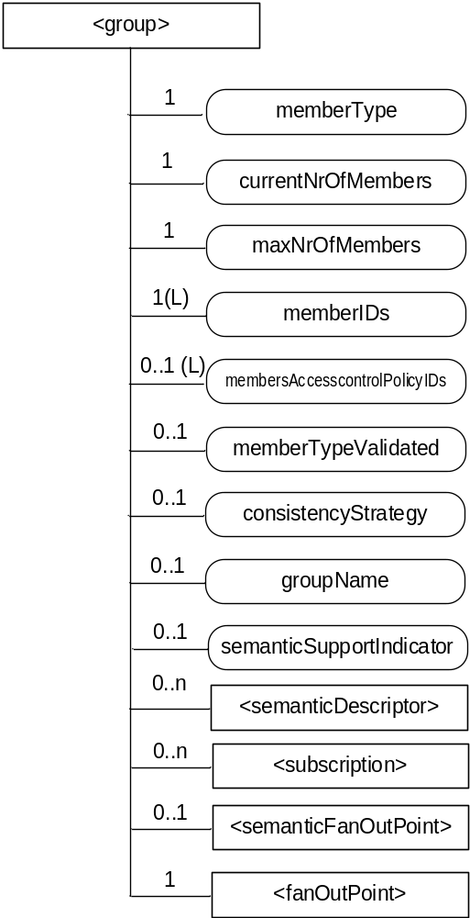
Figure 9.6.13-1: Structure of <group> resource
The <group> resource shall contain the child resources specified in table 9.6.13-1.
Table 9.6.13-1: Child resources of <group> resource
Child Resources of <group> | Child Resource Type | Multiplicity | Description | <groupAnnc> Child Resource Types
semanticDescriptor | <semanticDescriptor> | 0..n | See clause 9.6.30 | <semanticDescriptor>, <semanticDescriptorAnnc>
[variable] | <subscription> | 0..n | See clause 9.6.8 | <subscription>
fanOutPoint | <fanOutPoint> | 1 | See clause 9.6.14 | none
semanticFanOutPoint | <semanticFanOutPoint> | 0..1 | See clause 9.6.14a | none

The <group> resource shall contain the attributes specified in table 9.6.13-2
Table 9.6.13-2: Attributes of <group> resource
Attributes of  <group> | Multiplicity | RW/  RO/  WO | Description | <groupAnnc> Attributes
resourceType | 1 | RO | See clause 9.6.1.3. | NA
resourceID | 1 | RO | See clause 9.6.1.3. | NA
resourceName | 1 | WO | See clause 9.6.1.3. | NA
parentID | 1 | RO | See clause 9.6.1.3. | NA
expirationTime | 1 | RW | See clause 9.6.1.3. | MA
accessControlPolicyIDs | 0..1 (L) | RW | See clause 9.6.1.3. | MA
labels | 0..1 (L) | RW | See clause 9.6.1.3. | MA
creationTime | 1 | RO | See clause 9.6.1.3. | NA
lastModifiedTime | 1 | RO | See clause 9.6.1.3. | NA
announceTo | 0..1 (L) | RW | See clause 9.6.1.3. | NA
announcedAttribute | 0..1 (L) | RW | See clause 9.6.1.3. | NA
dynamicAuthorizationConsultationIDs | 0..1 (L) | RW | See clause 9.6.1.3. | OA
creator | 0..1 | RO | See clause 9.6.1.3. | NA
memberType | 1 | WO | It is the resource type of the member resources of the group, if all member resources (including the member resources in any sub-groups) are of the same type. Otherwise, it is of type 'mixed'. | OA
currentNrOfMembers | 1 | RO | Current number of members in a group. It shall not be larger than maxNrOfMembers. | OA
maxNrOfMembers | 1 | RW | Maximum number of members in the <group>. | OA
memberIDs | 1 (L) | RW | List of member resource IDs referred to in the remaining of the present document as memberID. Each ID (memberID) should refer to a member resource or a (sub-) <group> resource of the <group>. | OA
membersAccessControlPolicyIDs | 0..1 (L) | RW | List of IDs of the <accessControlPolicy> resources defining who is allowed to access the <fanOutPoint> resource. | OA
memberTypeValidated | 0..1 | RO | Denotes if the resource types of all members resources of the group has been validated by the Hosting CSE. In the case that the memberType attribute of the <group> resource is not ‘mixed’, then this attribute shall be set.. | OA
consistencyStrategy | 0..1 | WO | This attribute determines how to deal with the <group> resource if the memberType validation fails. Which means delete the inconsistent member if the attribute is ABANDON_MEMBER; delete the group if the attribute is ABANDON_GROUP; set the memberType to "mixed" if the attribute is SET_MIXED. | OA
groupName | 0..1 | RW | Human readable name of the <group>. | OA
semanticSupportIndicator | 0..1 | RO | Indicator of support for sematic discovery functionality via <semanticFanOutPoint> | OA

-----------------------End of change 3---------------------------------------------

-----------------------Start of change 4-------------------------------------------

9.6.23 Resource Type statsConfig
The <statsConfig> resource is used to store policies of statistics for AEs. The <statsConfig> resource may be established by the IN-CSEs or by IN-AEs. The <statsConfig> resource shall be located directly under <CSEBase>.

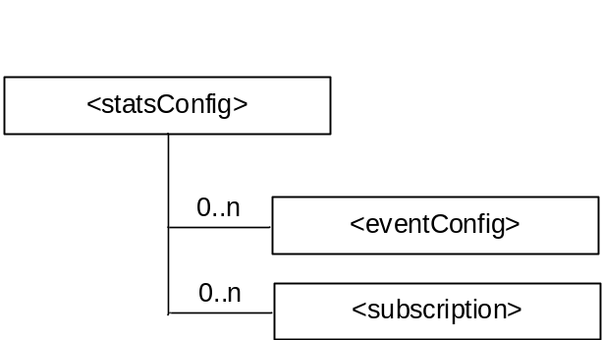
Figure 9.6.23-1: Structure of <statsConfig> resource
The <statsConfig> resource shall contain the child resources specified in table 9.6.23-1.
Table 9.6.23-1: Child resources of <statsConfig> resource
Child Resources of <statsConfig> | Child Resource Type | Multiplicity | Description
[variable] | <eventConfig> | 0..n | See clause 9.6.24. This resource configures an event for statistics collection.
[variable] | <subscription> | 0..n | See clause 9.6.8 where the type of this resource is described.

The <statsConfig> resource shall contain the attributes specified in table 9.6.23-2.
Table 9.6.23-2: Attributes of <statsConfig> resource
Attributes of <statsConfig> | Multiplicity | RW/  RO/  WO | Description
resourceType | 1 | RO | See clause 9.6.1.3
resourceID | 1 | RO | See clause 9.6.1.3.
resourceName | 1 | WO | See clause 9.6.1.3.
parentID | 1 | RO | See clause 9.6.1.3.
accessControlPolicyIDs | 1 (L) | RW | See clause 9.6.1.3
creationTime | 1 | RO | See clause 9.6.1.3
expirationTime | 1 | RW | See clause 9.6.1.3
lastModifiedTime | 1 | RO | See clause 9.6.1.3
labels | 0..1 (L) | RW | See clause 9.6.1.3
dynamicAuthorizationConsultationIDs | 0..1 (L) | RW | See clause 9.6.1.3.
creator | 0..1 | RO | See clause 9.6.1.3.

9.6.24 Resource Type eventConfig
<eventConfig> sub-resource shall be used to define events that trigger statistics collection. Below are some examples of events that can be generated:
- Collection based on a certain operation: collects any RETRIEVE operations on the data (i.e. resources) stored in the IN-CSE.
- Collection based on storage size: collects the size of storage when a <container> resource stored in the IN-CSE exceeds a quota.
- Combined configuration: collects all RETRIEVE operations on the data stored in the IN-CSE during a period of time.

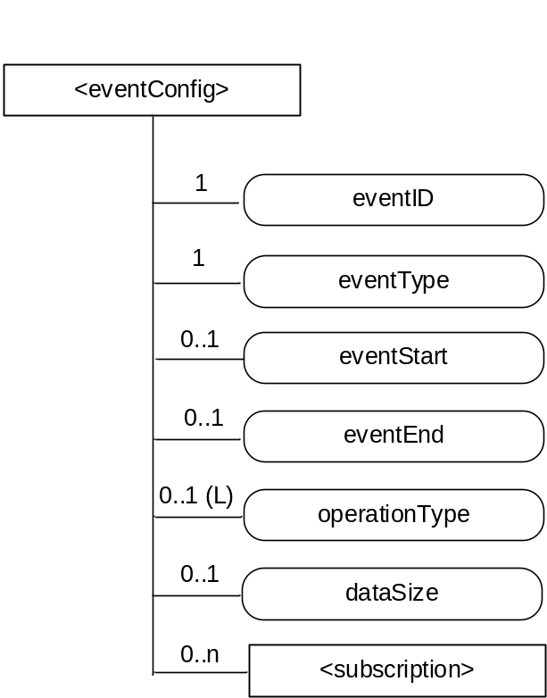
Figure 9.6.24-1: Structure of <eventConfig> resource
The <eventConfig> resource shall contain the child resource specified in table 9.6.24-1.
Table 9.6.24-1: Child resources of <eventConfig> resource
Child Resources of <eventConfig> | Child Resource Type | Multiplicity | Description
[variable] | <subscription> | 0..n | See clause 9.6.8 where this type of resource is described.

The <eventConfig> resource shall contain the attributes specified in table 9.6.24-2.
Table 9.6.24-2: Attributes of <eventConfig> resource
Attributes of <eventConfig> | Multiplicity | RW/  RO/  WO | Description
resourceType | 1 | RO | See clause 9.6.1.3.
resourceID | 1 | RO | See clause 9.6.1.3.
resourceName | 1 | WO | See clause 9.6.1.3.
parentID | 1 | RO | See clause 9.6.1.3.
accessControlPolicyIDs | 1 (L) | RW | See clause 9.6.1.3.
creationTime | 1 | RO | See clause 9.6.1.3.
expirationTime | 1 | RW | See clause 9.6.1.3.
lastModifiedTime | 1 | RO | See clause 9.6.1.3.
labels | 0..1 (L) | RW | See clause 9.6.1.3.
dynamicAuthorizationConsultationIDs | 0..1 (L) | RW | See clause 9.6.1.3.
creator | 0..1 | RO | T See clause 9.6.1.3.
eventID | 1 | RO | This attribute uniquely identifies the event to be collected for statistics for AEs.
eventType | 1 | RW | This attribute indicates the type of the event, such as timer based, data operation, storage based, etc.
eventStart | 0..1 | RW | This attribute indicates the start time of the event.
eventEnd | 0..1 | RW | This attribute indicates the end time of the event
operationType | 0..1 (L) | RW | This attribute defines the type of the operation to be collected by statistics, such as CREATE, RETRIEVE.
dataSize | 0..1 | RW | This attribute defines the data size if an event is triggered when the stored data exceeds a certain size.

9.6.25 Resource Type statsCollect
The <statsCollect> resource shall be used to collect information for AEs using the <eventConfig> resource as the triggers in the IN-CSE. Multiple triggers can be established at IN-CSE for the same AE. . Each trigger may be activated or de-activated independently of others. The <statsCollect> resource shall be located directly under <CSEBase> of IN-CSE.

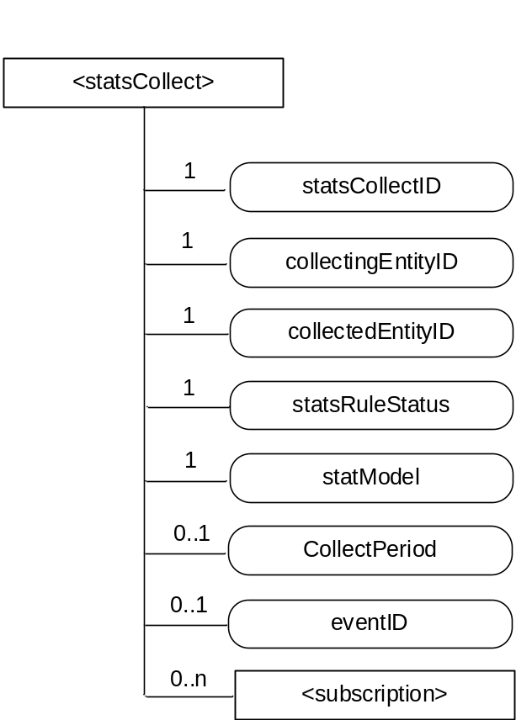
Figure 9.6.25-1: Structure of <statsCollect> resource
The <statsCollect> resource shall contain the child resource specified in table 9.6.25-1.
Table 9.6.25-1: Child resources of <statsCollect> resource
Child Resources of <statsCollect> | Child Resource Type | Multiplicity | Description
[variable] | <subscription> | 0..n | See clause 9.6.8 where the type of this resource is described.

The <statsCollect> resource shall contain the attributes specified in table 9.6.25-2.
Table 9.6.25-2: Attributes of <statsCollect> resource
Attributes of <statsCollect> | Multiplicity | RW/  RO/  WO | Description
resourceType | 1 | RO | See clause 9.6.1.3
resourceID | 1 | RO | See clause 9.6.1.3.
resourceName | 1 | WO | See clause 9.6.1.3.
parentID | 1 | RO | See clause 9.6.1.3.
accessControlPolicyIDs | 1 (L) | RW | See clause 9.6.1.3.
creationTime | 1 | RO | See clause 9.6.1.3.
expirationTime | 1 | RW | See clause 9.6.1.3.
lastModifiedTime | 1 | RO | See clause 9.6.1.3.
labels | 0..1 (L) | RW | See clause 9.6.1.3.
dynamicAuthorizationConsultationIDs | 0..1 (L) | RW | See clause 9.6.1.3.
creator | 0..1 | RO | See clause 9.6.1.3.
statsCollectID | 1 | RO | This is the unique ID to identify a specific statistics collection scenario. It is created by the IN-CSE when the <statsCollect> resource is first created.
collectingEntityID | 1 | WO | This is the unique ID of the entity that requests the collection of statistics. For example, it can be an AE-ID or CSE-ID.
collectedEntityID | 1 | WO | This is the unique ID of the entity whose request triggered the configured event for statistics collection. For example, it can be an AE-ID or IN-CSE-ID.  If no specific value is provided for this attribute, the IN-CSE interprets it as "any entity".
statsRuleStatus | 1 | RW | This attribute indicates whether the rule is "active" or "inactive".
statModel | 1 | RW | This attribute indicates the collection model, such as "Subscriber based", "event based", etc.
collectPeriod | 0..1 | RW | Expresses time periods defined by second, minute, hour day of month, month, and year. Supports repeating periods, and wildcards expressed as a list.
eventID | 0..1 | RW | This attribute refers to the <eventConfig> resource that defines the events that can be collected by the IN-CSE. It is mandatory if the statModel attribute is set to "event based".

-----------------------End of change 4---------------------------------------------

---------------------Start of change 5----------------------------------------------

9.6.30 Resource Type semanticDescriptor
The <semanticDescriptor> resource is used to store a semantic description pertaining to a resource and potentially sub-resources. Such a description may be provided according to ontologies. The semantic information is used by the semantic functionalities of the oneM2M system and is also available to applications or CSEs. [i.28] provides an informative example of a descriptor attribute.
Editor’s note: There might be a need to make a normative reference to a stage 3 TS, depending how far PRO goes in standardizing semantic descriptors using RDF or OWL formats.
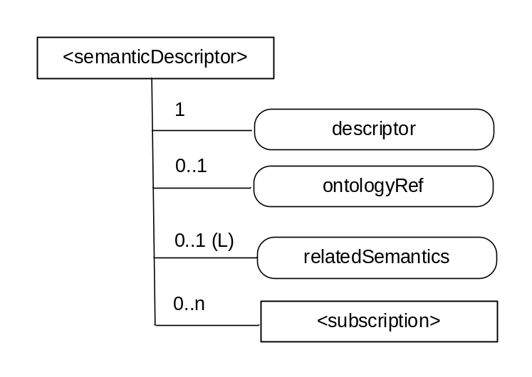
Figure 9.6.30-1: Structure of <semanticDescriptor> resource
The <semanticDescriptor> resource shall contain the child resources specified in table 9.6.30-1.
Table 9.6.30-1: Child resources of <semanticDescriptor> resource
Child Resources of <semanticDescriptor> | Child Resource Type | Multiplicity | Description
[variable] | <subscription> | 0..n | See clause 9.6.8 where the type of this resource is described.

The <semanticDescriptor> resource shall contain the attributes specified in table 9.6.23-2.
Table 9.6.30-2: Attributes of <semanticDescriptor> resource
Attributes of <semanticDescriptor> | Multiplicity | RW/  RO/  WO | Description
resourceType | 1 | RO | See clause 9.6.1.3
resourceID | 1 | RO | See clause 9.6.1.3.
resourceName | 1 | WO | See clause 9.6.1.3.
parentID | 1 | RO | See clause 9.6.1.3.
accessControlPolicyIDs | 0..1 (L) | RW | See clause 9.6.1.3
creationTime | 1 | RO | See clause 9.6.1.3
expirationTime | 1 | RW | See clause 9.6.1.3
lastModifiedTime | 1 | RO | See clause 9.6.1.3
labels | 0..1 (L) | RW | See clause 9.6.1.3
dynamicAuthorizationConsultationIDs | 0..1 (L) | RW | See clause 9.6.1.3.
creator | 0..1 | RO | See clause 9.6.1.3.
descriptor | 1 | RW | Stores a semantic description pertaining to a resource and potentially sub-resources. Such a description shall be according to subject-predicate-object triples as defined in the RDF graph-based data model [4]. The semantic description can be fully and partially updated by an Originator[7]. The elements of such triples may be provided according to ontologies. Examples of such descriptors in RDF can be found in [i.28].
ontologyRef | 0..1 | WO | A reference (URI) of the ontology used to represent the information that is stored in the descriptor attribute. If this attribute is not present, the ontologyRef from the parent resource is used if present.
relatedSemantics | 0..1(L) | WO | List of URIs for resources containing related semantic information to be used in processing semantic queries. The URI(s) may reference either a <group> resource or other <semanticDescriptor> resources.

Editor’s note: the possibility for the semantic descriptor attribute to link to other descriptor attributes is not excluded to optimize storage but it needs further study.

-----------------------End of change 5---------------------------------------------

----------------------Start of change 6--------------------------------------------

9.6.32 Resource Type notificationTargetPolicy
The <notificationTargetPolicy> resource is a child resource of <CSEBase> resource and lists the policies to be applied by the hosting CSE. A policy has a rules(s), representd by the <policyDeletionRules> and an action. The action is applied when the rules in the policy are fulfilled.
Rules are grouped in 2 groups to support a combination of rules for flexbiblilty eg. ((rule 1 AND rule 2) OR rule 3) A maximum of two groups of <policyDeletionRules> can be defined. The relationship to be applied between the 2 groups (AND/OR) shall be defined in the ruleRelationShip attribute. If no rules are defined for a <notificationTargetPolicy> then the action is executed
Each policy has the policyLabel which can take any form. There shall be at minimum a single notificationTargetPolicy which can be defined by the subscription originator with the label “default” to be applied when no specific policy is defined for a Target Notification. If a default policy is required and none is defined by the subscription originator then the syetem defined default policy shall be applied.

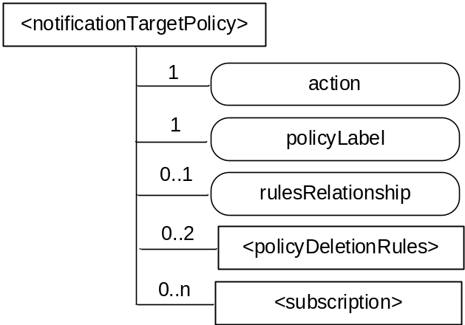
Figure 9.6.32-1: Structure of <notificationTargetPolicy> resource

Table 9.6.32-1: Child resources of <notificationTargetPolicy> resource
Child Resources | Child Resource Type | Multiplicity | Description
[variable] | <policyDeletionRules> | 0..2 | Groups listing the rules that apply to this policy and that needs to be fulfilled for the listed action to take place, Only two groups of rules shall be supported. See 9.6.33
[variable] | <subscription> | 0..n | See clause 9.6.8

Table 9.6.32-2: Attributes of <notificationTargetPolicy> resource
Attributes | Multiplicity | RW/  RO/  WO | Description
resourceType | 1 | RO | See clause 9.6.1.3.
resourceID | 1 | RO | See clause 9.6.1.3.
resourceName | 1 | WO | See clause 9.6.1.3.
parentID | 1 | RO | See clause 9.6.1.3.
expirationTime | 1 | RW | See clause 9.6.1.3.
accessControlPolicyIDs | 0..1 (L) | RW | See clause 9.6.1.3. If no accessControlPolicyIDs is given at the time of creation, the accessControlPolicyIDs of the parent resource is linked to this attribute.
creationTime | 1 | RO | See clause 9.6.1.3.
labels | 0..1 (L) | RW | See clause 9.6.1.3
lastModifiedTime | 1 | RO | See clause 9.6.1.3.
dynamicAuthorizationConsultationIDs | 0..1 (L) | RW | See clause 9.6.1.3.
creator | 0..1 | RO | See clause 9.6.1.3..
action | 1 | RW | Defines the action to be performed if the groups of rules are fulfilled.  The action includes one of the following; accept request, reject request, seek authorization from subscription originator before responding, or inform the subscription originator without taking any action;
policyLabel | 1 | RW | At minimum a default policy shall be specified. The policyLabel “Default” shall be used in this case.
rulesRelationship | 0..1 | RW | Shall be either AND or OR This attribute is mandatory if more than one policy DeletionRule is specified

-----------------------End of change 6---------------------------------------------

----------------------Start of change 7--------------------------------------------

9.6.35 Resource Type flexContainer
The <flexContainer> resource type is a customizable container for data instances. It is a template for the definition of flexible specializations of data containers. Like a <container> resource, specializations of this <flexContainer> resource type are used to share information with other entities and potentially to track the data. While the <container> resources includes data to be made accessible to oneM2M entities inside <contentInstance> children, a specialization of the <flexContainer> resource includes associated content directly inside the <flexContainer> by means of one or more [customAttribute] attribute(s). The attribute name and attribute data type of [customAttribute] attributes are defined explicitly for each specialization of <flexContainer>, i.e. the specific set of attribute name and type are defined in a corresponding XSD-file.
Example usage of <flexContainer>: As a specialization of <flexContainer> that includes two [customAttribute] attributes, named "temperature"(xs:float type) and "humidity"(xs:positiveInteger type) can be specified in some TS. The actual data types of [customAttribute] will be described both in the specification document or XSD file which are referred by the value of containerDefinition attribute.

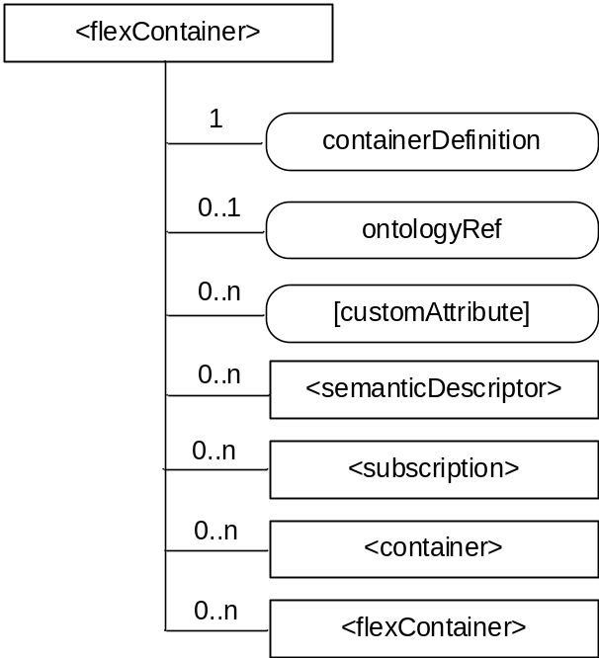
Figure 9.6.35-1: Structure of <flexContainer> resource
The <flexContainer> resource shall contain the child resource specified in table 9.6.35-1.
Table 9.6.35-1: Child resources of <flexContainer> resource
Child Resources of <flexContainer> | Child Resource Type | Multiplicity | Description | <flexContainerAnnc> Child Resource Type
semanticDescriptor | <semanticDescriptor> | 0..n | See clause 9.6.30 | <semanticDescriptor>, <semanticDescriptorAnnc>
[variable] | <subscription> | 0..n | See clause 9.6.8 | <subscription>
[variable] | <container> | 0..n | See clause 9.6.6 | <container>  <containerAnnc>
[variable] | <flexContainer> | 0..n | <flexContainer> resource can include any of its specializations as child resource | <flexContainer>  <flexContainerAnnc>

The <flexContainer> resource shall contain the attributes specified in table 9.6.35-2.
Table 9.6.35-2: Attributes of <flexContainer> resource
Attributes of  <flexContainer> | Multiplicity | RW/  RO/  WO | Description | <flexContainerAnnc> Attributes
resourceType | 1 | RO | See clause 9.6.1.3 | NA
resourceID | 1 | RO | See clause 9.6.1.3 | NA
resourceName | 1 | WO | See clause 9.6.1.3 | NA
parentID | 1 | RO | See clause 9.6.1.3 | NA
expirationTime | 0..1 (NOTE1) | RW | See clause 9.6.1.3 | MA
accessControlPolicyIDs | 0..1 (L) | RW | See clause 9.6.1.3 | MA
labels | 0..1 (L) | RW | See clause 9.6.1.3 | MA
creationTime | 0..1  (NOTE 1) | RO | See clause 9.6.1.3 | NA
lastModifiedTime | 0..1  (NOTE 1) | RO | See clause 9.6.1.3 | NA
stateTag | 1 | RO | See clause 9.6.1.3 | OA
announceTo | 0..1 (L) | RW | See clause 9.6.1.3 | NA
announcedAttribute | 0..1 (L) | RW | See clause 9.6.1.3 | NA
dynamicAuthorizationConsultationIDs | 0..1 (L) | RW | See clause 9.6.1.3. | OA
creator | 0..1 | RO | See clause 9.6.1.3. | NA
containerDefinition | 1 | WO | This contains a reference (URN) to the definition which shall be used by the CSE to statically validate the syntax of the <flexContainer> resource (see NOTE 2).  This URN shall refer to one of the following:  - AllJoyn Interworking  - OIC Interworking  - LWM2M Interworking  A list of possible URNs is provided in 9.6.1.2.2  Other URN may be specified. | MA
ontologyRef | 0..1 | RW | A reference (URI) of the ontology used to represent the information that is stored in the present <flexContainer> resource | OA
[customAttribute] | 0..n | RW | Specialization-specific attribute(s). Name and data type defined in each specialization of <flexContainer> resource. | OA
NOTE 1: When an instance of <flexContainer> is a child of a <flexContainer> resource, these attributes can be optional. Their presence is determined by the respective definition referred to by the containerDefinition attribute
NOTE 2: The reference is a URN and not URL: the CSE does not retrieve the definition of the <flexContainer> dynamically.

9.6.36 Resource Type timeSeries
The <timeSeries> resource represents a container for Time Series Data instances. It is used to share information with other entities and potentially to track, detect and report the missing data in Time Series. A <timeSeries> resource has no associated content. It has only attributes and child resources.

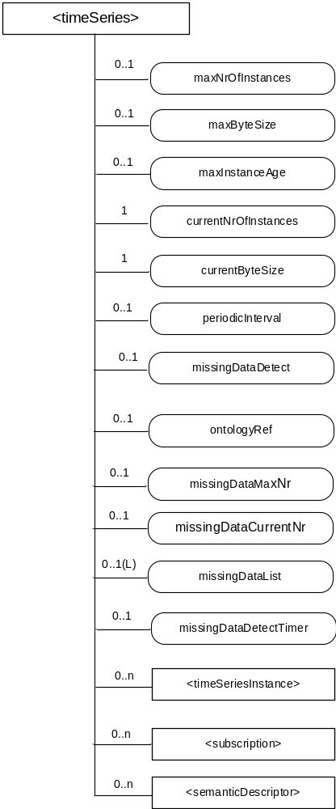
Figure 9.6.36-1: Structure of <timeSeries> resource

Table 9.6.36-1:Child resources of <timeSeries> resource
Child Resources of <timeSeries> | Child Resource Type | Multiplicity | Description | <timeSeriesAnnc> Child Resource Types
semanticDescriptor | <semanticDescriptor> | 0..n | See clause 9.6.30 | <semanticDescriptor>, <semanticDescriptorAnnc>
[variable] | <timeSeriesInstance> | 0..n | See clause 9.6.37 | <timeSeriesInstance>,  <timeSeriesInstanceAnnc>
[variable] | <subscription> | 0..n | See clause 9.6.8 | <subscription>

The <timeSeries> resource shall contain the attributes specified in table 9.6.36-2.
Table 9.6.36-2: Attributes of <timeSeries> resource
Attributes of  <timeSeries> | Multiplicity | RW/  RO/  WO | Description | <timeSeriesAnnc> Attributes
resourceType | 1 | RO | See clause 9.6.1.3. | NA
resourceID | 1 | RO | See clause 9.6.1.3. | NA
resourceName | 1 | WO | See clause 9.6.1.3. | NA
parentID | 1 | RO | See clause 9.6.1.3. | NA
expirationTime | 1 | RW | See clause 9.6.1.3 | MA
accessControlPolicyIDs | 0..1 (L) | RW | See clause 9.6.1.3. If no accessControlPolicyIDs are provided at the time of creation, the accessControlPolicyIDs of the parent resource is linked to this attribute | MA
labels | 0..1 (L) | RW | See clause 9.6.1.3. | MA
creationTime | 1 | RO | See clause 9.6.1.3. | NA
lastModifiedTime | 1 | RO | See clause 9.6.1.3. | NA
stateTag | 1 | RO | See clause 9.6.1.3. | OA
announceTo | 0..1 (L) | RW | See clause 9.6.1.3. | NA
announcedAttribute | 0..1 (L) | RW | See clause 9.6.1.3. | NA
dynamicAuthorizationConsultationIDs | 0..1 (L) | RW | See clause 9.6.1.3. | OA
creator | 1 | RO | See clause 9.6.1.3. | NA
maxNrOfInstances | 0..1 | RW | Maximum number of direct child <timeSeriesInstance> resources in the <timeSeries> resource. | OA
maxByteSize | 0..1 | RW | Maximum size in bytes of data that is allocated for the <timeSeriesInstance> resource for all direct child<timeSeriesInstance> resources. | OA
maxInstanceAge | 0..1 | RW | Maximum age of a direct child <timeSeriesInstance> resource in the <timeSeries> resource. The value is expressed in seconds. | OA
currentNrOfnstances | 1 | RO | Current number of direct child <timeSeriesInstance> resource in the <timeSeries> resource. It is limited by the maxNrOfInstances. | OA
currentByteSize | 1 | RO | Current size in bytes of data stored in all direct child <timeSeriesInstance> resources of a <timeSeries> resource. It is limited by the maxByteSize. | OA
periodicInterval | 0..1 | WO | If the Time Sereis Data is periodic, this attribute shall contain the expected amount of time between two instances of Time Series Data. | OA
missingDataDetect | 0..1 | WO | Indicates whether the Receiver shall detect the missing Time Series Data if it is periodic. | NA
ontologyRef | 0..1 | RW | A reference (URI) of the ontology used to represent the information that is stored in the child <timeSeriesInstance> resources of the present <timeSeriesData> resource (see note). | OA
missingDataMaxNr | 0..1 | RW | Maximum number of entries in the missingDataList if the periodicInterval is set and the missingDataDetect is TRUE. | OA
missingDataList | 0..1(L) | RO | The list of the dataGenerationTime value representing the missing Time Series Data in descending order by time if the periodicInterval is set and the missingDataDetect is TRUE. | OA
missingDataCurrentNr | 0..1 | RO | Current number of the missing Time Series Data in the missingDataList. | OA
missingDataDetectTimer | 0..1 | RW | The missingDataDetectTimer shall be set if the periodicInterval is set and the missingDataDetect is TRUE.  The expecting Time Series Data shall be considered to be lost when the amount of time equal to missingDataDetectTimer has passed. | OA
NOTE: The access to this URI is out of scope of oneM2M.

-----------------------End of change 7---------------------------------------------

-----------------------Start of change 8-------------------------------------------

9.6.41 Resource Type trafficCharacteristics
The <trafficCharacteristics> resource represents the characteristic information (e.g. communication pattern, mobility pattern, etc..) of a field domain node. These information may be detected or scheduled by an application level processing. This resource type is used to share information with other entities such as the underlying network entity (server NSE) of the field domain node which may optimize the processing of the underlying network for the specific field domain node.

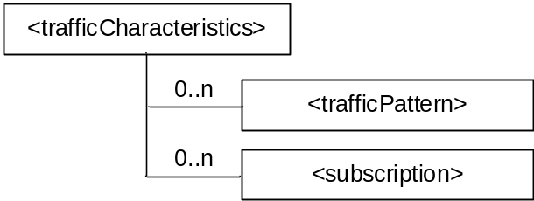
Figure 9.6.41-1: Structure of <trafficCharacteristics> resource
The <trafficCharacteristics> resource shall contain the child resources specified in table 9.6.41-1.
Table 9.6.41-1: Child resources of <trafficCharacteristics> resource
Child Resources of <trafficCharacteristics> | Child Resource Type | Multiplicity | Description
[variable] | <subscription> | 0..n | See clause 9.6.8
[variable] | <trafficPattern> | 0..n | See clause 9.6.42.  A source AE can create multiple number of <trafficPattern> resources for a single target AE of field domain node. In this case the source AE assures that different communication patterns are not overlapped in a point of time.

The <trafficCharacteristics> resource shall contain the attributes specified in table 9.6.41-2.
Table 9.6.41-2: Attributes of <trafficCharacteristics> resource
Attributes of <trafficCharacteristics> | Multiplicity | RW/  RO/  WO | Description
resourceType | 1 | RO | See clause 9.6.1.3.
resourceID | 1 | RO | See clause 9.6.1.3.
resourceName | 1 | WO | See clause 9.6.1.3.
parentID | 1 | RO | See clause 9.6.1.3.
creationTime | 1 | RO | See clause 9.6.1.3.
lastModifiedTime | 1 | RO | See clause 9.6.1.3.
expirationTime | 1 | RW | See clause 9.6.1.3.
accessControlPolicyIDs | 0..1 (L) | RW | See clause 9.6.1.3.
Labels | 0..1 (L) | RW | See clause 9.6.1.3.
creator | 1 | WO | See clause 9.6.1.3.

-----------------------End of change 8---------------------------------------------

CHECK LIST
- Does this change request include an informative introduction containing the problem(s) being solved, and a summary list of proposals.?
- Does this CR contain changes related to only one particular issue/problem?
- Have any mirror crs been posted?
- Does this change request make all the changes necessary to address the issue or problem? E.g. A change impacting 5 tables should not only include a proposal to change only 3 tables. Includes any changes to references, definitions, and acronyms in the same deliverable?
- Does this change request follow the drafting rules?
- Are all pictures editable?
- Have you checked the spelling and grammar?
- Have you used change bars for all modifications?
- Does the change include the current and surrounding clauses to clearly show where a change is located and to provide technical context of the proposed change? (Additions of complete sections need not show surrounding clauses as long as the proposed section number clearly shows where the new section is proposed to be located.)
- Are multiple changes in this CR clearly separated by horizontal lines with embedded text such as, start of change 1, end of change 1, start of new clause, end of new clause.?

