CHANGE REQUEST
Meeting:* | ARC#23
Source:* | NEC, InterDigital, KETI
Date:* | 2016-05-08
Contact:* | Martin Bauer, NEC, martin.bauer@neclab.eu  Catalina Mladin, Catalina.Mladin@InterDigital.com  Minwoo Ryu, KETI, minu@keti.re.kr
Reason for Change/s:* | Fixing missing entry for semanticDescriptorAnnc announced resource type, adding announceable attributes to SemanticDescriptor and aligning name of Semantic Descriptor child resource to be [variable] as in TS-0004, which is necessary for 0..n multiplicity.
CR against: Release* | Rel-2
CR against: WI* | Active WI-5  MNT Maintenance / < Work Item number(optional)>  STE Small Technical Enhancements / < Work Item number (optional)>  Only ONE of the above shall be ticked
CR against: TS/TR* | TS-0001 V.2.8.0
Clauses/Sub Clauses* | 9.6.26.1, 9.6.30, 9.6.1.1, 9.6.5, 9.6.6, 9.6.7, 9.6.13, 9.6.18, 9.6.35, 9.6.36
Type of change: * | Editorial change  Bug Fix or Correction  Change to existing feature or functionality  New feature or functionality  Only ONE of the above shall be ticked
Post Freeze checking:* | This CR contains only essential changes and corrections? YES NO  This CR may break backwards compatibility with the last approved version of the TS? YES NO  This CR is a mirror CR? YES if YES, please indicate the document number of the original CR: <Document Number) : NO
Template Version:27 May 2015 (Dot not modify)

oneM2M Notice
The document to which this cover statement is attached is submitted to oneM2M. Participation in, or attendance at, any activity of oneM2M, constitutes acceptance of and agreement to be bound by terms of the Working Procedures and the Partnership Agreement, including the Intellectual Property Rights (IPR) Principles Governing oneM2M Work found in Annex 1 of the Partnership Agreement.

GUIDELINES for Change Requests:
Provide an informative introduction containing the problem(s) being solved, and a summary list of proposals.
Each CR should contain changes related to only one particular issue/problem.
In case of a correction, and the change apply to previous releases, a separated “mirror CR” should be posted at the same time of this CR
Follow the principle of completeness, where all changes related to the issue or problem within a deliverable are simultaneously proposed to be made E.g. A change impacting 5 tables should not only include a proposal to change only 3 tables. Includes any changes to references, definitions, and acronyms in the same deliverable.
Follow the drafting rules.
All pictures must be editable.
Check spelling and grammar to the extent practicable.
Use Change bars for modifications.
The change should include the current and surrounding clauses to clearly show where a change is located and to provide technical context of the proposed change. Additions of complete sections need not show surrounding clauses as long as the proposed section number clearly shows where the new section is proposed to be located.
Multiple changes in a single CR shall be clearly separated by horizontal lines with embedded text such as, start of change 1, end of change 1, start of new clause, end of new clause.
When subsequent changes are made to content of a CR, then the accepted version should not show changes over changes. The accepted version of the CR should only show changes relative to the baseline approved text.

Introduction
This CR provides the missing content to make SemanticDescriptor resources announceable. It can clearly be seen that this was the original intention as semanticDescriptorAnnc is already listed as a possible child resource for all announced resource types whose non-announced versions can have SemanticDescriptor child resources. Also TS-0004 handles SemanticDescriptor as announceable. Missing in TS-0001 is the entry for semanticDescriptorAnnc in Table 9.6.26.1-1: Announced Resource Types and the attributes announceTo and announcedAttribute in the SemanticDescriptor resource itself.
In addition, we found out that the name of all child resources with 0..n multiplicity have to be [variable]. As SemanticDescriptor has 0..n multiplicity this CR changes the name to [variable] in all places where it can occur as a child resource. This is already the case in TS-0004, i.e we fix a mistake in TS-0001 and align it with TS-0004.
Rev. 01: Added columns <AEAnnc> Child Resource Types and <AEAnnc> Attributes to Table 9.6.30-1 and Table 9.6.30-2 respectively.

-----------------------Start of change 1-------------------------------------------

9.6.26 Resource Announcement

9.6.26.1 Overview
A resource can be announced to one or more remote CSEs to inform the remote CSEs of the existence of the original resource. An announced resource can have a limited set of attributes and a limited set of child resources from the original resource. The announced resource includes a link to the original resource hosted by the original resource-Hosting CSE.
In case that the original resource is deleted, all announced resources for the original resource shall be deleted, except for <AEAnnc> resources that were created during the registration of an AE with AE-ID-Stem starting with "S", which shall not be deleted. If the announced resource is not deleted promptly (e.g. the announced resource is not reachable), the announced resource can be deleted later either by the original resource Hosting CSE or by the expiration of the announced resource itself. The original resource shall store the list of links for the announced resources for those purposes.
Synchronization between the attributes announced by the original resource and the announced resource shall be the responsibility of the original resource Hosting CSE. There shall not be any synchronization for children created at the original resource and the announced resource. The access control policy for the announced resource shall synchronize with the one from the original resource. In case that the attribute accessControlPolicyIDs is not present in the original resource it is the responsibility of the original resource Hosting CSE to choose the appropriate value depending on the policy for the original resource (e.g. take the parent accessControlPolicyIDs value).
The original resource shall have at least announceTo attribute present if the resource itself has been announced. If any of the Optional Announced (OA) attributes are also announced, then announcedAttribute attribute shall also be present. An AE or other CSE can request the original resource Hosting CSE for announcing the original resource to the list of CSE-IDs or the address(es) listed in the announceTo attribute in the announcing request. An Update to the announceTo attribute will trigger new resource announcement(s) or the de-announcement(s) of the announced resource. After a successful announcement procedure the attribute announceTo contains only the list of address(es) of the announced resources.
In order to announce an attribute marked as OA (see clause 9.5.1.1), the attribute shall be included in the announcedAttribute attribute list at the original resource. The attributes included in the announcedAttribute attribute are announced to the announced resource. On successful announcement of the resource, such attributes shall be created at the announced resource; otherwise they shall not be present in the announced resource. Update to the announcedAttribute attribute in the original resource will trigger new attribute announcement or the de-announcement of the announced attribute(s). The announced attributes shall have the same value as the original resource, and synchronization between the value of the announced attributes at the original resource and the announced resource is the responsibility of the original resource Hosting CSE.
An announced resource may have child resources. The child resource shall be of the same type as the original child resource or its associated Announce type.
Child resources of the original resource can be announced independently as needed. In this case, the child resources at the announced resource shall be of the child resource "Announced" type. When a child resource at the announced resource is created locally at the remote CSE, the child resource shall be of normal child resource type.
When a Hosting CSE of an original resource is initiating an announcement, it shall first check if the parent resource of the original resource has a representation at the announcement target CSE. If that is the case, the announced resource shall be created as a child resource of that representation of the parent resource. If that is not the case, the announced resource shall be created as a child of the <CSEBase> resource of the announcement target CSE.
If an attribute is marked as RO and also marked as MA or OA, then only the attribute of the original resource shall be interpreted as RO. The corresponding attribute of the announced resource shall be always writable to the original resource hosting CSE to allow it to properly announce and de-announce the attribute and keep the announced attribute synchronized with the original one. Only the original resource Hosting CSE shall be allowed to update and delete the announced attribute which is created by the original resource Hosting CSE.
Table 9.6.26.1-1: Announced Resource Types
Announced Resource Type | Short Description | Child Resource Types | Clause
accessControlPolicyAnnc | Announced variant of accessControlPolicy | Subscription | 9.6.2
AEAnnc | Announced variant of AE | subscription,  container,  containerAnnc,  group,  groupAnnc,  accessControlPolicy,  accessControlPolicyAnnc  semanticDescriptor,  semanticDescriptorAnnc,  scheduleAnnc,  trafficCharacteristicsAnnc | 9.6.5
containerAnnc | Announced variant of container | container,  containerAnnc,  contentInstance,  contentInstanceAnnc,  subscription,  semanticDescriptor,  semanticDescriptorAnnc | 9.6.6
contentInstanceAnnc | Announced variant of contentInstance | semanticDescriptor,  semanticDescriptorAnnc | 9.6.7
groupAnnc | Announced variant of group | Subscription | 9.6.13
locationPolicyAnnc | Announced variant of locationPolicy | None specified | 9.6.10
mgmtObjAnnc | Announced variant of mgmtObj | Subscription | 9.6.15
nodeAnnc | Announced variant of node | mgmtObjAnnc,  subscription,  trafficCharacteristicsAnnc | 9.6.18
remoteCSEAnnc | Announced variant of remoteCSE | container,  containerAnnc,  group,  groupAnnc,  accessControlPolicy,  accessControlPolicyAnnc,  subscription,  scheduleAnnc,  nodeAnnc | 9.6.4
scheduleAnnc | Announced variant of schedule | None specified | 9.6.9
dynamicAuthorizationConsultationAnnc | Announced variant of dynamicAuthorizationConsultation | None specified | 9.6.43
trafficCharacteristicsAnnc | Announced variant of trafficCharacteristics | trafficPatternAnnc,  subscription | 9.6.41
trafficPatternAnnc | Announced variant of trafficPattern | scheduleAnnc  subscription | 9.6.42
semanticDescriptorAnnc | Announced variant of semanticDescriptor | Subscription | 9.6.30

----------------------- End of change 1---------------------------------------------

-----------------------Start of change 2-------------------------------------------

9.6.30 Resource Type semanticDescriptor
The <semanticDescriptor> resource is used to store a semantic description pertaining to a resource and potentially sub-resources. Such a description may be provided according to ontologies. The semantic information is used by the semantic functionalities of the oneM2M system and is also available to applications or CSEs. [Error: Reference source not found] provides an informative example of a descriptor attribute.
Editor's note: There might be a need to make a normative reference to a stage 3 TS, depending how far PRO goes in standardizing semantic descriptors using RDF or OWL formats.
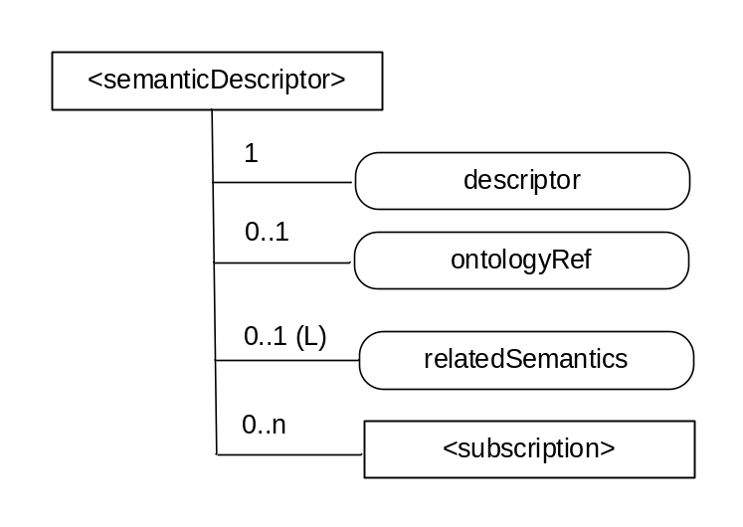
Figure 9.6.30-1: Structure of <semanticDescriptor> resource
The <semanticDescriptor> resource shall contain the child resources specified in table 9.6.30-1.
Table 9.6.30-1: Child resources of <semanticDescriptor> resource
Child Resources of <semanticDescriptor> | Child Resource Type | Multiplicity | Description | <AEAnnc> Child Resource Types
[variable] | <subscription> | 0..n | See clause 9.6.8 where the type of this resource is described. | <subscription>

The <semanticDescriptor> resource shall contain the attributes specified in table 9.6.23-2.
Table 9.6.30-2: Attributes of <semanticDescriptor> resource
Attributes of <semanticDescriptor> | Multiplicity | RW/  RO/  WO | Description | <AEAnnc> Attributes
resourceType | 1 | RO | See clause 9.6.1.3. | NA
resourceID | 1 | RO | See clause 9.6.1.3. | NA
resourceName | 1 | WO | See clause 9.6.1.3. | NA
parentID | 1 | RO | See clause 9.6.1.3. | NA
accessControlPolicyIDs | 0..1 (L) | RW | See clause 9.6.1.3. | MA
creationTime | 1 | RO | See clause 9.6.1.3. | NA
expirationTime | 1 | RW | See clause 9.6.1.3. | MA
lastModifiedTime | 1 | RO | See clause 9.6.1.3. | NA
labels | 0..1 (L) | RW | See clause 9.6.1.3. | MA
announceTo | 0..1 (L) | RW | See clause 9.6.1.3. | NA
announcedAttribute | 0..1 (L) | RW | See clause 9.6.1.3. | NA
dynamicAuthorizationConsultationIDs | 0..1 (L) | RW | See clause 9.6.1.3. | OA
creator | 0..1 | RO | The AE-ID of the entity which created the resource. This can also be the CSE-ID of the IN-CSE if the IN-CSE created the resource. | NA
descriptor | 1 | RW | Stores a semantic description pertaining to a resource and potentially sub-resources. Such a description shall be according to subject-predicate-object triples as defined in the RDF graph-based data model [Error: Reference source not found]. The semantic description can be fully and partially updated by an Originator [Error: Reference source not found]. The elements of such triples may be provided according to ontologies. Examples of such descriptors in RDF can be found in [Error: Reference source not found]. | OA
ontologyRef | 0..1 | WO | A reference (URI) of the ontology used to represent the information that is stored in the descriptor attribute. If this attribute is not present, the ontologyRef from the parent resource is used if present. | OA
relatedSemantics | 0..1(L) | WO | List of URIs for resources containing related semantic information to be used in processing semantic queries. The URI(s) may reference either a <group> resource or other <semanticDescriptor> resources. | OA

----------------------- End of change 2---------------------------------------------

9.6.1.1 Resource Type Summary
Table 9.6.1.1-1 introduces the normal and virtual resource types and their related child or parent resource types. Details of each resource type follow in the remainder of this clause.
Table 9.6.1.1-1 lists each specified <resourceType>. An addition of suffix "Annc" to such <resourceTypes> indicates the associated announced resource type.
Among the resource types listed in Table 9.6.1.1-1, the following are termed "Content Sharing Resources" in oneM2M Specifications for the purpose of referring to any of those resource types:
- container;
- contentInstance;
- flexContainer;
- timeSeries;
- timeSeriesInstance.
Table 9.6.1.1-1: Resource Types
Resource Type | Short Description | Child Resource Types | Parent Resource Types | Clause
accessControlPolicy | Stores a representation of privileges. It is associated with resources that shall be accessible to entities external to the Hosting CSE. It controls "who" is allowed to do "what" and the context in which it can be used for accessing resources | subscription | AE, AEAnnc, remoteCSE, remoteCSEAnnc, CSEBase | 9.6.2
AE | Stores information about the AE. It is created as a result of successful registration of an AE with the Registrar CSE | subscription, container,  flexContainer,  group, accessControlPolicy,  schedule, pollingChannelsemanticDescriptor,  timeSeries | CSEBase | 9.6.5
container | Shares data instances among entities. Used as a mediator that buffers data exchanged between AEs and/or CSEs. The exchange of data between AEs (e.g. an AE on a Node in a field domain and the peer-AE on the infrastructure domain) is abstracted from the need to set up direct connections and allows for scenarios where both entities in the exchange do not have the same reachability schedule | container,  flexContainer, contentInstance, subscription, latest, oldest，semanticDescriptor | AE, AEAnnc, container, containerAnnc, remoteCSE, remoteCSEAnnc,  CSEBase,  flexContainer, flexContainerAnnc | 9.6.6
contentInstance | Represents a data instance in the <container> resource | semanticDescriptor | Container, containerAnnc | 9.6.7
flexContainer | A template which allows to define specialized (customizable) versions of containers with a flexible and lightweight structure | container,  flexContainer, subscription, semanticDescriptor | AE, AEAnnc, container, containerAnnc,  flexContainer, flexContainerAnnc, remoteCSE, remoteCSEAnnc,  CSEBase | 9.6.35
CSEBase | The structural root for all the resources that are residing on a CSE. Stores information about the CSE itself | remoteCSE, remoteCSEAnnc, node, AE, container, group, accessControlPolicy, subscription,, mgmtCmd, locationPolicy, statsConfig, statsCollect, request, delivery,  schedule,  notificationTargetPolicy,  flexContainer,  timeSeries | None specified | 9.6.3
delivery | Forwards requests from CSE to CSE | subscription | CSEBase | 9.6.11
eventConfig | Defines events that trigger statistics collection | subscription | statsConfig | 9.6.24
execInstance | Contains all execution instances of the same Management Command | subscription | mgmtCmd | 9.6.17
fanOutPoint (V) | Virtual resource containing target for group request  It is used for addressing bulk operations to all the resources that belong to a group | None specified | Group | 9.6.14
group | Stores information about resources of the same type that need to be addressed as a Group. Operations addressed to a Group resource shall be executed in a bulk mode for all members belonging to the Group | fanOutPoint,  subscription,  semanticFanOutPoint, semanticDescriptor | AE, AEAnnc, remoteCSE, remoteCSEAnnc, CSEBase | 9.6.13
latest (V) | Virtual resource that points to most recently created <contentInstance> child resource within a <container> resource | None specified | Container | 9.6.27
locationPolicy | Includes information to obtain and manage geographical location. It is only referenced within a container, the contentInstances of the container provide location information | subscription | CSEBase | 9.6.10
mgmtCmd | Management Command resource represents a method to execute management procedures required by existing management protocols | execInstance,  subscription | CSEBase | 9.6.16
mgmtObj | Management Object resource represents management functions that provides an abstraction to be mapped to external management technology. It represents the node and the software installed in the node (see note) | subscription, mgmtObj, schedule | node, mgmtObj, mgmtObjAnnc | 9.6.15  Annex D
m2mServiceSubscriptionProfile | Data pertaining to the M2M Service Subscription | serviceSubscribedNode,  subscription | CSEBase | 9.6.19
node | Represents specific Node information | mgmtObj,  subscription, semanticDescriptor | CSEBase, remoteCSE | 9.6.18
notificationTargetMgmtPolicyRef | Represents a list of notification targets and the deletion policy | subscription | Subscription | 9.6.31
notificationTargetPolicy | Represents a notification target deletion policy with pre-defined action and deletion rules | subscription, policyDeletionRules | CSEBase | 9.6.32
notificationTargetSelfReference (V) | Virtual resource used to remove the Notification Target | None specified | Subscription | 9.6.34
oldest (V) | Virtual resource that points to first created <contentInstance> child resource within a <container> resource | None specified | Container | 9.6.28
pollingChannel | Represent a channel that can be used for a request-unreachable entity | pollingChannelURI | remoteCSE, AE | 9.6.21
pollingChannelURI (V) | Virtual resource used to perform service layer long polling of a resource Hosting CSE by a request-unreachable entity | None specified | pollingChannel | 9.6.22
policyDeletionRules | Represents a set of rules which is associated with notification target removal policy | subscription | notificationTargetPolicy | 9.6.33
remoteCSE | Represents a remote CSE for which there has been a registration procedure with the registrar CSE identified by the CSEBase resource | container,  flexContainer,  group, accessControlPolicy, subscription, pollingChannel, schedule, node,  timeSeries | CSEBase | 9.6.4
request | Expresses/access context of an issued Request | subscription | CSEBase | 9.6.12
schedule | Contains scheduling information for delivery of messages | subscription | subscription, CSEBase, remoteCSE,  AE | 9.6.9
serviceSubscribedNode | Node information | subscription | m2mServiceSubscriptionProfile | 9.6.20
statsCollect | Defines triggers for the IN-CSE to collect statistics for applications | subscription | CSEBase (in IN-CSE) | 9.6.25
statsConfig | Stores configuration of statistics for applications | eventConfig,  subscription | CSEBase (in IN-CSE) | 9.6.23
subscription | Subscription resource represents the subscription information related to a resource. Such a resource shall be a child resource for the subscribe-to resource | schedule, notificationTargetSelfReference, notificationTargetMgmtPolicyRef | accessControlPolicy,accessControlPolicyAnnc, AE, AEAnnc, container, CSEBase, delivery, eventConfig, execInstance, group, groupAcce, locationPolicy, mgmtCmd, mgmtObj, mgmtObjAnnc, m2mServiceSubscriptionProfile, node, nodeAnnc, serviceSubscribedNode, remoteCSE, remoteCSEAnnc, request, schedule,  semanticDescriptor, semanticDescriptorAnnc, statsCollect, statsConfig,  flexContainer, flexContainerAnnc | 9.6.8
serviceSubscribedAppRule | Represents a rule that defines allowed App-ID and AE-ID combinations that are acceptable for registering an AE on a Registrar CSE | subscription | CSEBase | 9.6.29
semanticDescriptor | Stores semantic description pertaining to a resource and potentially sub-resources. | subscription | AE, container, contentInstance, group, node, flexContainer, timeSeries | 9.6.30
semanticFanOutPoint | Virtual resource used as target for semantic discovery aimed at a logical graph distributed over multiple semanticDescriptor resources, which belong to the corresponding group parent resource | None specified | Group | 9.6.14a
trafficCharacteristics | Represents the characteristic information (e.g. communication pattern, mobility pattern, etc..) of a field domain node. | trafficPattern,  subscription | Node, AE | 9.6.41
trafficPattern | Represents the communication pattern and the mobility pattern of a field domain node. | schedule,  subscription | trafficCharacteristics | 9.6.42
dynamicAuthorizationConsultation | Represents consultation information used by a CSE when performing consultation-based dynamic authorization | None Specified | AE, AEAnnc, remoteCSE, remoteCSEAnnc, CSEBase | 9.6.43
timeSeries | Stores and Shares Time Series Data instances among entities. | timeSeriesInstance, subscription, semanticDescriptor | AE, AEAnnc, remoteCSE, remoteCESAnnc, CSEBase | 9.6.36
timeSeriesInstance | Represents a Time Series Data instance in the <timeSeries> resource | None specified | timeSeries, timeSeriesAnnc | 9.6.37
NOTE: See clause 9.6.12 for a summary of specializations of <mgmtObj>.

-----------------------Start of change 3-------------------------------------------

9.6.5 Resource Type AE
An <AE> resource shall represent information about an Application Entity registered to a CSE.
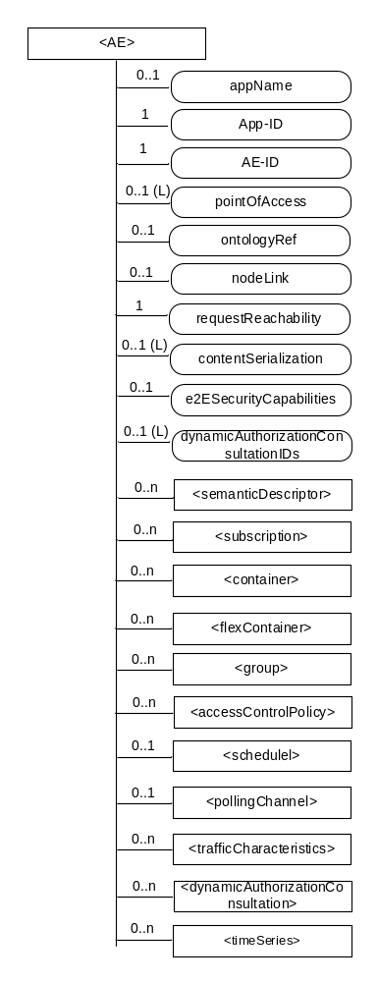
Figure 9.6.5-1: Structure of <AE> resource
The <AE> resource shall contain the child resources specified in table 9.6.5-1.
Table 9.6.5-1: Child resources of <AE> resource
Child Resources of <AE> | Child Resource Type | Multiplicity | Description | <AEAnnc> Child Resource Types
[variable] | <semanticDescriptor> | 0..n | See clause 9.6.30 | <semanticDescriptor>, <semanticDescriptorAnnc>
[variable] | <subscription> | 0..n | See clause 9.6.8 | <subscription>
[variable] | <container> | 0..n | See clause 9.6.6 | <container> <containerAnnc>
[variable] | <flexContainer> | 0..n | See clause 9.6.35 | <flexContainer>  <flexContainerAnnc>
[variable] | <group> | 0..n | See clause 9.6.13 | <group>  <groupAnnc>
[variable] | <accessControlPolicy> | 0..n | See clause 9.6.2 | <accessControlPolicy>  <accessControlPolicyAnnc>
[variable] | <schedule> | 0..1 | See clause 9.6.9 | <scheduleAnnc>
[variable] | <pollingChannel> | 0..1 | See clause 9.6.21  When the AE is request-unreachable, the AE should create this <pollingChannel> resource and perform long polling. The <pollingChannel> shall be utilized by the the parent resource | None
trafficCharacteristics | <trafficCharacteristics> | 0..n | See clause 9.6.41 | <trafficCharacteristicsAnnc>
[variable] | <dynamicAuthorizationConsultation> | 0..n | See clause 9.6.43 | <dynamicAuthorizationConsultationAnnc>
[variable] | <timeSeries> | 0..n | See clause 9.6.36 | <timeSeriesAnnc>

The <AE> resource shall contain the attributes specified in table 9.6.5-2.
Table 9.6.5-2: Attributes of <AE> resource
Attributes of  <AE> | Multiplicity | RW/  RO/  WO | Description | <AEAnnc> Attributes
resourceType | 1 | RO | See clause 9.6.1.3. | NA
resourceID | 1 | RO | See clause 9.6.1.3. Contains the AE-ID-Stem of the AE (see clause 7.2 on identifier formats and clause 10.1.1.2.2 for AE registration procedure). | NA
resourceName | 1 | WO | See clause 9.6.1.3. | NA
parentID | 1 | RO | See clause 9.6.1.3. | NA
expirationTime | 1 | RW | See clause 9.6.1.3. | MA
accessControlPolicyIDs | 0..1 (L) | RW | See clause 9.6.1.3. | MA
creationTime | 1 | RO | See clause 9.6.1.3. | NA
lastModifiedTime | 1 | RO | See clause 9.6.1.3. | NA
labels | 0..1 (L) | RW | See clause 9.6.1.3. | MA
announceTo | 0..1 (L) | RW | See clause 9.6.1.3. | NA
announcedAttribute | 0..1 (L) | RW | See clause 9.6.1.3. | NA
dynamicAuthorizationConsultationIDs | 0..1 (L) | RW | See clause 9.6.1.3. | OA
appName | 0..1 | RW | The name of the application, as declared by the application developer(e.g. "HeatingMonitoring").  Several sibling resources may share the appName. | OA
App-ID | 1 | WO | The identifier of the Application (see clause 7.1.2). | OA
AE-ID | 1 | RO | The identifier of the Application Entity (see clause 7.1.2). | OA
pointOfAccess | 0..1 (L) | RW | The list of addresses for communicating with the registered Application Entity over Mca reference point via the transport services provided by Underlying Network (e.g. IP address, FQDN, URI). This attribute shall be accessible only by the AE and the Hosting CSE.  If this information is not provided and the <pollingChannel> resource does exist, the AE should use <pollingChannel> resource. Then the Hosting CSE can forward a request to the AE without using the PoA. | OA
ontologyRef | 0..1 | RW | A URI of the ontology used to represent the information that is managed and understood by the AE. | OA
requestReachability | 1 | RW | If the AE that created this <AE> resource can receive a request, this attribute is set to "TRUE" otherwise "FALSE" | OA
nodeLink | 0..1 | RW | The resourceID of a <node> resource that stores the node specific information where this AE resides. | OA
contentSerialization | 0..1 (L) | RW | The list of supported serializations of the Content primitive parameter for receiving a request from its registrar CSE. (e.g. XML, JSON). The list shall be ordered so that the most preferred format comes first. | OA
e2ESecurityCapabilities | 0..1 | RW | See clause 9.6.1.3. | MA

----------------------- End of change 3---------------------------------------------

-----------------------Start of change 4-------------------------------------------

9.6.6 Resource Type container
The <container> resource represents a container for data instances. It is used to share information with other entities and potentially to track the data. A <container> resource has no associated content. It has only attributes and child resources.
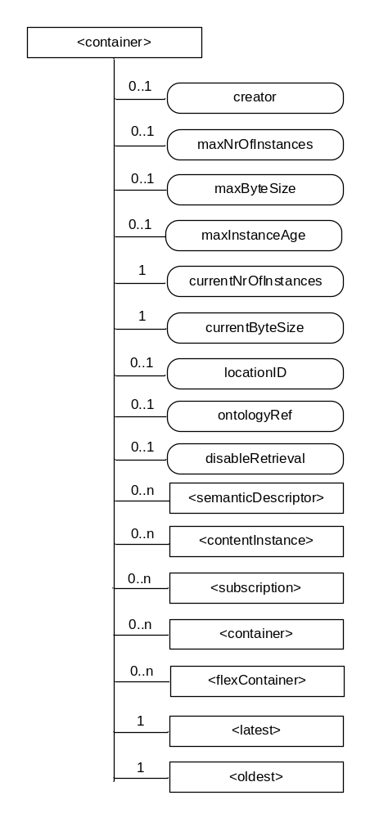
Figure 9.6.6-1: Structure of <container> resource
The <container> resource shall contain the child resources specified in table 9.6.6-1.
Table 9.6.6-1: Child resources of <container> resource
Child Resources of <container> | Child Resource Type | Multiplicity | Description | <containerAnnc> Child Resource Types
[variable] | <semanticDescriptor> | 0..n | See clause 9.6.30 | <semanticDescriptor>, <semanticDescriptorAnnc>
[variable] | <contentInstance> | 0..n | See clause 9.6.7 | <contentInstance>, <contentInstanceAnnc>
[variable] | <subscription> | 0..n | See clause 9.6.8 | <subscription>
[variable] | <container> | 0..n | See clause 9.6.6 | <container>  <containerAnnc>
[variable] | <flexContainer> | 0..n | See clause 9.6.35 | <flexContainer>  <flexContainerAnnc>
latest | <latest> | 1 | See clause 9.6.27 | None
oldest | <oldest> | 1 | See clause 9.6.28 | None

The <container> resource shall contain the attributes specified in table 9.6.6-2.
Table 9.6.6-2: Attribute of <container> resource
Attributes of  <container> | Multiplicity | RW/  RO/  WO | Description | <containerAnnc> Attributes
resourceType | 1 | RO | See clause 9.6.1.3. | NA
resourceID | 1 | RO | See clause 9.6.1.3. | NA
resourceName | 1 | WO | See clause 9.6.1.3. | NA
parentID | 1 | RO | See clause 9.6.1.3. | NA
expirationTime | 1 | RW | See clause 9.6.1.3. | MA
accessControlPolicyIDs | 0..1 (L) | RW | See clause 9.6.1.3. If no accessControlPolicyIDs are provided at the time of creation, the accessControlPolicyIDs of the parent resource is linked to this attribute. | MA
labels | 0..1 (L) | RW | See clause 9.6.1.3. | MA
creationTime | 1 | RO | See clause 9.6.1.3. | NA
lastModifiedTime | 1 | RO | See clause 9.6.1.3. | NA
stateTag | 1 | RO | See clause 9.6.1.3. | OA
announceTo | 0..1 (L) | RW | See clause 9.6.1.3. | NA
announcedAttribute | 0..1 (L) | RW | See clause 9.6.1.3. | NA
dynamicAuthorizationConsultationIDs | 0..1 (L) | RW | See clause 9.6.1.3. | OA
creator | 0..1 | RO | The AE-ID or CSE-ID of the entity which created the resource. | NA
maxNrOfInstances | 0..1 | RW | Maximum number of direct child <contentInstance> resources in the <container> resource. | OA
maxByteSize | 0..1 | RW | Maximum size in bytes of data (i.e. content attribute of a <contentInstance> resource) that is allocated for the <container> resource for all direct child <contentInstance> resources in the <container> resource. | OA
maxInstanceAge | 0..1 | RW | Maximum age of a direct child <contentInstance> resource in the <container> resource. The value is expressed in seconds. | OA
currentNrOfInstances | 1 | RO | Current number of direct child <contentInstance> resource in the <container> resource. It is limited by the maxNrOfInstances. | OA
currentByteSize | 1 | RO | Current size in bytes of data(i.e. content attribute of a <contentInstance> resource) stored in all direct child <contentInstance> resources of a <container> resource. This is the summation of contentSize attribute values of the <contentInstance> resources. It is limited by themaxByteSize. | OA
locationID | 0..1 | RW | An ID of the resource where the attributes/policies that define how location information are obtained and managed. This attribute is defined only when the <container> resource is used for containing location information. | OA
ontologyRef | 0..1 | RW | A reference (URI) of the ontology used to represent the information that is stored in the child <contentInstance> resources of the present <container> resource (see note). | OA
disableRetrieval | 0..1 | RW | Boolean value to control RETRIE/UPDATE/DELETE operation on the child <contentInsance> resource.  When the value is set to 'TRUE', RETRIEVE/DELETE/UPDATE operations for child <contentInstance> shall be rejected at all times.  When the value is updated from 'TRUE' to 'FALSE', all existing <contentInstance> are deleted immediately.  When the value is set to 'FALSE', all operations are permitted on the <contentInstance> resource as per existing procedures. | OA
NOTE: The access to this URI is out of scope of oneM2M.

----------------------- End of change 4---------------------------------------------

-----------------------Start of change 5-------------------------------------------

9.6.7 Resource Type contentInstance
The <contentInstance> resource represents a data instance in the <container> resource. The content of the contentInstance can be encrypted.
Unlike other resources, the <contentInstance> resource shall not be modified once created. An AE shall be able to delete a contentInstance resource explicitly or it may be deleted by the platform based on policies. If the platform has policies for contentInstance retention, these shall be represented by the attributes maxByteSize, maxNrOfInstances and/or maxInstanceAge attributes in the <container> resource. If multiple policies are in effect, the strictest policy shall apply.
The <contentInstance> resource inherits the same access control policies of the parent <container> resource, and does not have its own accessControlPolicyIDs attribute.
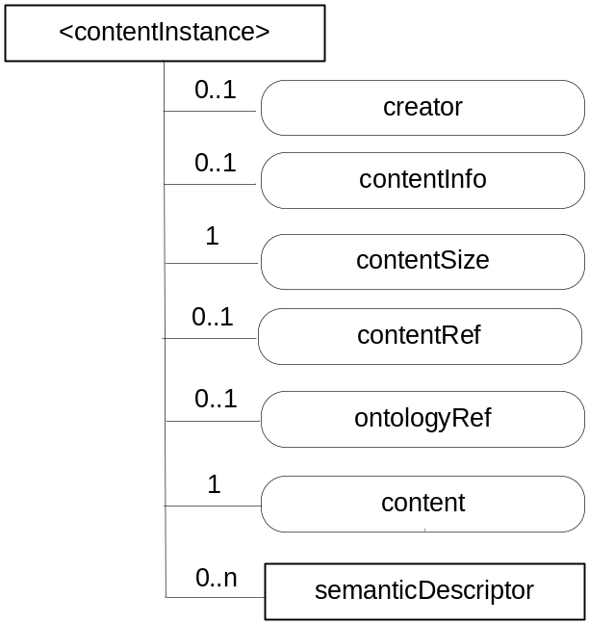
Figure 9.6.7-1: Structure of <contentInstance> resource
The <contentInstance> resource shall contain the child resources specified in table 9.6.7-1.
Table 9.6.7-1: Child resources of <container> resource
Child Resources of <contentInstance> | Child Resource Type | Multiplicity | Description | <contentInstanceAnnc> Child Resource Types
[variable] | <semanticDescriptor> | 0..n | See clause 9.6.30 | <semanticDescriptor>, <semanticDescriptorAnnc>

The <contentInstance> resource shall contain the attributes specified in table 9.6.7-2.
Table 9.6.7-2: Attributes of <contentInstance> resource
Attributes of <contentInstance> | Multiplicity | RW/  RO/  WO | Description | <contentInstanceAnnc> Attributes
resourceType | 1 | RO | See clause 9.6.1.3. | NA
resourceID | 1 | RO | See clause 9.6.1.3. | NA
resourceName | 1 | WO | See clause 9.6.1.3. | NA
parentID | 1 | RO | See clause 9.6.1.3. | NA
labels | 0..1 (L) | WO | See clause 9.6.1.3. | MA
expirationTime | 1 | WO | See clause 9.6.1.3. | NA
creationTime | 1 | RO | See clause 9.6.1.3. | NA
lastModifiedTime | 1 | RO | See clause 9.6.1.3. | NA
stateTag | 1 | RO | See clause 9.6.1.3.  The stateTag attribute of the parent resource should be incremented first and copied into this stateTag attribute when a new instance is added to the parent resource. | OA
announceTo | 0..1 (L) | WO | See clause 9.6.1.3. | NA
announcedAttribute | 0..1 (L) | WO | See clause 9.6.1.3. | NA
dynamicAuthorizationConsultationIDs | 0..1 (L) | RW | See clause 9.6.1.3. | OA
creator | 0..1 | RO | The AE-ID or CSE-ID of the entity which created the resource. | NA
contentInfo | 0..1 | WO | Information on the content that is needed to understand the content. This attribute is a composite attribute. It is composed first of an Internet Media Type (as defined in the IETF RFC 6838) describing the type of the data, and second of an encoding information that specifies how to first decode the received content. Both elements of information are separated by a separator defined in oneM2M TS-0004 [Error: Reference source not found]. | OA
contentSize | 1 | RO | Size in bytes of the content attribute. | OA
contentRef | 0..1 | RW | This attribute contains a list of name-value pairs. Each entry expresses and associative reference to a <contentInstance> resource. The name of the entry indicates the relationship and the value of the entry the reference (URI) to the resource. | OA
ontologyRef | 0..1 | WO | A reference (URI) of the ontology used to represent the information that is stored in the contentInstances resources of the <container> resource. If this attribute is not present, the contentInstance resource inherits the ontologyRef from the parent <container> resource if present (see note). | OA
content | 1 | WO | Actual content of a contentInstance. This content may be opaque data for understandable with the help of the contentInfo. This may, for example, be an image taken by a security camera, or a temperature measurement taken by a temperature sensor. | OA
NOTE: Access to this URI is out of scope of oneM2M.

----------------------- End of change 5---------------------------------------------

-----------------------Start of change 6-------------------------------------------

9.6.13 Resource Type group
The <group> resource represents a group of resources of the same or mixed types. The <group> resource can be used to do bulk manipulations on the resources represented by the memberIDs attribute. The <group> resource contains an attribute that represents the members of the group and the <fanOutPoint> virtual resource that enables generic operations to be applied to all the resources represented by those members. By grouping <semanticDescriptor> resources across which a semantic description is distributed, another virtual resource (<semanticFanOutPoint>) enables semantic discovery procedures to be applied across the full logical tree in the description.
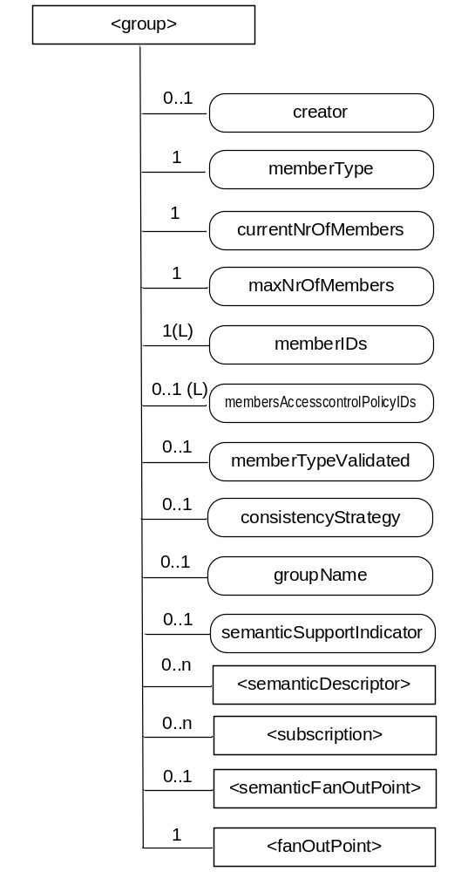
Figure 9.6.13-1: Structure of <group> resource
The <group> resource shall contain the child resources specified in table 9.6.13-1.
Table 9.6.13-1: Child resources of <group> resource
Child Resources of <group> | Child Resource Type | Multiplicity | Description | <groupAnnc> Child Resource Types
[variable] | <semanticDescriptor> | 0..n | See clause 9.6.30 | <semanticDescriptor>, <semanticDescriptorAnnc>
[variable] | <subscription> | 0..n | See clause 9.6.8 | <subscription>
fanOutPoint | <fanOutPoint> | 1 | See clause 9.6.14 | none
semanticFanOutPoint | <semanticFanOutPoint> | 0..1 | See clause 9.6.14a | none

The <group> resource shall contain the attributes specified in table 9.6.13-2.
Table 9.6.13-2: Attributes of <group> resource
Attributes of  <group> | Multiplicity | RW/  RO/  WO | Description | <groupAnnc> Attributes
resourceType | 1 | RO | See clause 9.6.1.3. | NA
resourceID | 1 | RO | See clause 9.6.1.3. | NA
resourceName | 1 | WO | See clause 9.6.1.3. | NA
parentID | 1 | RO | See clause 9.6.1.3. | NA
expirationTime | 1 | RW | See clause 9.6.1.3. | MA
accessControlPolicyIDs | 0..1 (L) | RW | See clause 9.6.1.3. | MA
labels | 0..1 (L) | RW | See clause 9.6.1.3. | MA
creationTime | 1 | RO | See clause 9.6.1.3. | NA
lastModifiedTime | 1 | RO | See clause 9.6.1.3. | NA
announceTo | 0..1 (L) | RW | See clause 9.6.1.3. | NA
announcedAttribute | 0..1 (L) | RW | See clause 9.6.1.3. | NA
dynamicAuthorizationConsultationIDs | 0..1 (L) | RW | See clause 9.6.1.3. | OA
creator | 0..1 | RO | The AE-ID or CSE-ID of the entity which created the resource. | NA
memberType | 1 | WO | It is the resource type of the member resources of the group, if all member resources (including the member resources in any sub-groups) are of the same type. Otherwise, it is of type 'mixed'. | OA
currentNrOfMembers | 1 | RO | Current number of members in a group. It shall not be larger than maxNrOfMembers. | OA
maxNrOfMembers | 1 | RW | Maximum number of members in the <group>. | OA
memberIDs | 1 (L) | RW | List of member resource IDs referred to in the remaining of the present document as memberID. Each ID (memberID) should refer to a member resource or a (sub-) <group> resource of the <group>. | OA
membersAccessControlPolicyIDs | 0..1 (L) | RW | List of IDs of the <accessControlPolicy> resources defining who is allowed to access the <fanOutPoint> resource. | OA
memberTypeValidated | 0..1 | RO | Denotes if the resource types of all members resources of the group has been validated by the Hosting CSE. In the case that the memberType attribute of the <group> resource is not 'mixed', then this attribute shall be set.. | OA
consistencyStrategy | 0..1 | WO | This attribute determines how to deal with the <group> resource if the memberType validation fails. Which means delete the inconsistent member if the attribute is ABANDON_MEMBER; delete the group if the attribute is ABANDON_GROUP; set the memberType to "mixed" if the attribute is SET_MIXED. | OA
groupName | 0..1 | RW | Human readable name of the <group>. | OA
semanticSupportIndicator | 0..1 | RO | Indicator of support for sematic discovery functionality via <semanticFanOutPoint>. | OA

----------------------- End of change 6---------------------------------------------

-----------------------Start of change 7-------------------------------------------

9.6.18 Resource Type node
The <node> resource represents specific information that provides properties of an M2M Node that can be utilized by other oneM2M operations. The <node> resource has specialization of the <mgmtObj> as its child resources. These resources represent the Node's context information (e.g. memory and battery), network topology, device information, device capability etc. The specialized <mgmtObj> resources are used to perform management of the Node.
This node specific information stored in these resources such as [memory] and [battery] can be obtained either by the existing device management technologies (OMA DM [Error: Reference source not found], BBF TR-069 [Error: Reference source not found]) or any other way (e.g. JNI [Error: Reference source not found]).
For the case when the <node> resource belongs to an ADN, please see figure 9.6.18-1 in conjunction with the description of nodeLink attribute in the <AE> resource (clause 9.6.5).
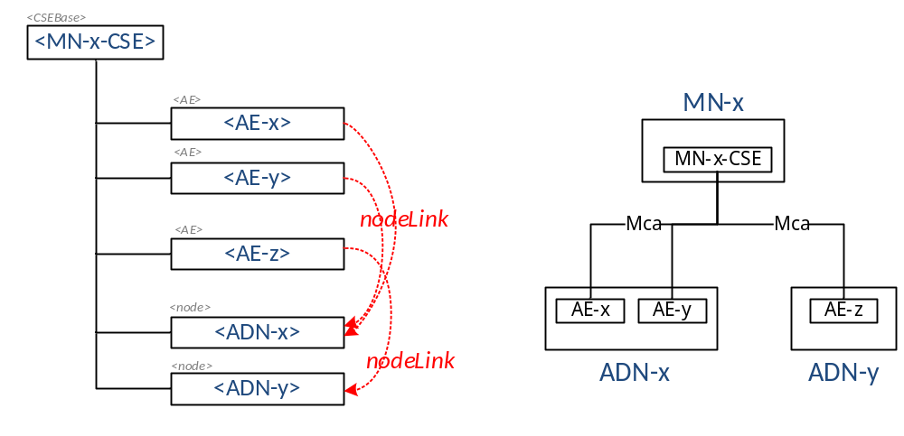
Figure 9.6.18-1: Relationship between MN and ADN
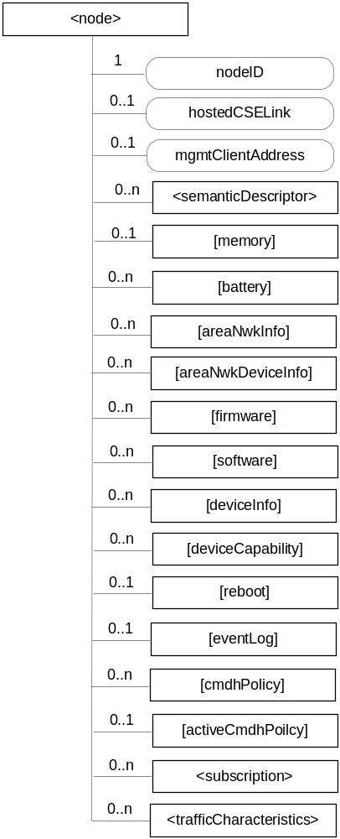
Figure 9.6.18-2: Structure of <node> resource
The <node> resource shall contain the child resources specified in table 9.6.18-1.
Table 9.6.18-1: Child resources of <node> resource
Child Resources of <node> | Child Resource Type | Multiplicity | Description | <nodeAnnc> Child Resource Type
[variable] | <semanticDescriptor> | 0..n | See clause 9.6.30. | <semanticDescriptor>, <semanticDescriptorAnnc>
[variable] | <mgmtObj> as defined in the specialization [memory] | 0..1 | This resource provides the memory (typically RAM) information of the node. (E.g. the amount of total volatile memory), See clause D.4. | <mgmtObjAnnc>
[variable] | <mgmtObj> as defined in the specialization [battery] | 0..n | The resource provides the power information of the node. (E.g. remaining battery charge). See clause D.7. | <mgmtObjAnnc>
[variable] | <mgmtObj> as defined in the specialization [areaNwkInfo] | 0..n | This resource describes the list of Nodes attached behind the MN node and its physical or underlying relation among the nodes in the M2M Area Network. This attribute is defined in case the Node is MN. See clause D.5. | <mgmtObjAnnc>
[variable] | <mgmtObj> as defined in the specialization [areaNwkDeviceInfo] | 0..n | This resource describes the information about the Node in the M2M Area Network. See clause D.6. | <mgmtObjAnnc>
[variable] | <mgmtObj> as defined in the specialization [firmware] | 0..n | This resource describes the information about the firmware of the Node include name, version etc. See clause D.2. | <mgmtObjAnnc>
[variable] | <mgmtObj> as defined in the specialization [software] | 0..n | This resource describes the information about the software of the Node. See clause D.3. | <mgmtObjAnnc>
[variable] | <mgmtObj> as defined in the specialization [deviceInfo] | 0..n | The resource contains information about the identity, manufacturer and model number of the device. See clause D.8. | <mgmtObjAnnc>
[variable] | <mgmtObj> as defined in the specialization [deviceCapability] | 0..n | The resource contains information about the capability supported by the Node. See clause D.9. | <mgmtObjAnnc>
[variable] | <mgmtObj> as defined in the specialization [reboot] | 0..1 | The resource is the place to reboot or reset the Node. See clause D.10. | <mgmtObjAnnc>
[variable] | <mgmtObj> as defined in the specialization [eventLog] | 0..1 | The resource contains the information about the log of events of the Node. See clause D.11. | <mgmtObjAnnc>
[variable] | <mgmtObj> as defined in the specialization [cmdhPolicy] | 0..n | The resource(s) contain(s) information about CMDH policies that are applicable to the CMDH processing on the CSE hosted on the node represented by this <node> resource and identified by the hostedCSELink attribute of this <node> resource. See clause D.12. | NA
[variable] | <mgmtObj> as defined in the specialization [activeCmdhPolicy] | 0..1 | This resource defines which of the present [cmdhPolicy] resource(s) shall be active for the CMDH processing on the CSE hosted on the node represented by this <node> resource and identified by the hostedCSELink attribute of this <node> resource. See clause D.12. | NA
[variable] | <subscription> | 0..n | See clause 9.6.8. | <subscription>
trafficCharacteristics | <trafficCharacteristics> | 0..n | See clause 9.6.41 | <trafficCharacteristicsAnnc>

The <node> resource shall contain the attributes specified in table 9.6.18-2.
Table 9.6.18-2: Attributes of <node> resource
Attributes of  <node> | Multiplicity | RW/  RO/  WO | Description | <nodeAnnc> attributes
resourceType | 1 | RO | See clause 9.6.1.3. | NA
resourceID | 1 | RO | See clause 9.6.1.3. | NA
resourceName | 1 | WO | See clause 9.6.1.3. | NA
parentID | 1 | RO | See clause 9.6.1.3. | NA
expirationTime | 1 | RW | See clause 9.6.1.3. | MA
accessControlPolicyIDs | 0..1 (L) | RW | See clause 9.6.1.3. | MA
creationTime | 1 | RO | See clause 9.6.1.3. | NA
lastModifiedTime | 1 | RO | See clause 9.6.1.3. | NA
labels | 0..1 (L) | RW | See clause 9.6.1.3. | MA
announceTo | 0..1 (L) | RW | See clause 9.6.1.3. | NA
announcedAttribute | 0..1 (L) | RW | See clause 9.6.1.3. | NA
dynamicAuthorizationConsultationIDs | 0..1 (L) | RW | See clause 9.6.1.3. | OA
nodeID | 1 | RW | The M2M-Node-ID of the node which is represented by this <node> resource. | MA
hostedCSELink | 0..1 | RW | The resource ID of a resource where all of the following applies:  - The resource is a <CSEBase> resource or a <remoteCSE> resource.  - The resource is hosted on the same CSE as the present <node> resource.  - The resource represents the CSE which resides on the specific node that is represented by the current <node> resource. | OA
mgmtClientAddress | 0..1 | RW | Represents the physical address of management client of the node which is represented by this <node> resource.  This attribute is absent if management server is able to acquire the physical address of the management client. | OA

----------------------- End of change 7---------------------------------------------

-----------------------Start of change 8-------------------------------------------

9.6.35 Resource Type flexContainer
The <flexContainer> resource type is a customizable container for data instances. It is a template for the definition of flexible specializations of data containers. Like a <container> resource, specializations of this <flexContainer> resource type are used to share information with other entities and potentially to track the data. While the <container> resources includes data to be made accessible to oneM2M entities inside <contentInstance> children, a specialization of the <flexContainer> resource includes associated content directly inside the <flexContainer> by means of one or more [customAttribute] attribute(s). The attribute name and attribute data type of [customAttribute] attributes are defined explicitly for each specialization of <flexContainer>, i.e. the specific set of attribute name and type are defined in a corresponding XSD-file.
Example usage of <flexContainer>: As a specialization of <flexContainer> that includes two [customAttribute] attributes, named "temperature"(xs:float type) and "humidity"(xs:positiveInteger type) can be specified in some TS. The actual data types of [customAttribute] will be described both in the specification document or XSD file which are referred by the value of containerDefinition attribute.
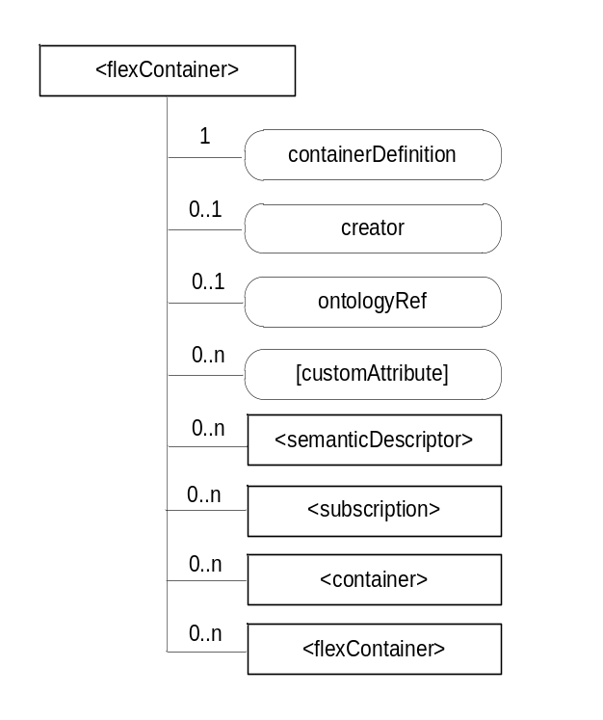
Figure 9.6.35-1: Structure of <flexContainer> resource
The <flexContainer> resource shall contain the child resource specified in table 9.6.35-1.
Table 9.6.35-1: Child resources of <flexContainer> resource
Child Resources of <flexContainer> | Child Resource Type | Multiplicity | Description | <flexContainerAnnc> Child Resource Type
[variable] | <semanticDescriptor> | 0..n | See clause 9.6.30 | <semanticDescriptor>, <semanticDescriptorAnnc>
[variable] | <subscription> | 0..n | See clause 9.6.8 | <subscription>
[variable] | <container> | 0..n | See clause 9.6.6 | <container>  <containerAnnc>
[variable] | <flexContainer> | 0..n | <flexContainer> resource can include any of its specializations as child resource | <flexContainer>  <flexContainerAnnc>

The <flexContainer> resource shall contain the attributes specified in table 9.6.35-2.
Table 9.6.35-2: Attributes of <flexContainer> resource
Attributes of  <flexContainer> | Multiplicity | RW/  RO/  WO | Description | <flexContainerAnnc> Attributes
resourceType | 1 | RO | See clause 9.6.1.3. | NA
resourceID | 1 | RO | See clause 9.6.1.3. | NA
resourceName | 1 | WO | See clause 9.6.1.3. | NA
parentID | 1 | RO | See clause 9.6.1.3. | NA
expirationTime | 0..1 (note 1) | RW | See clause 9.6.1.3. | MA
accessControlPolicyIDs | 0..1 (L) | RW | See clause 9.6.1.3. | MA
labels | 0..1 (L) | RW | See clause 9.6.1.3. | MA
creationTime | 0..1  (note 1) | RO | See clause 9.6.1.3. | NA
lastModifiedTime | 0..1  (note 1) | RO | See clause 9.6.1.3. | NA
stateTag | 1 | RO | See clause 9.6.1.3. | OA
announceTo | 0..1 (L) | RW | See clause 9.6.1.3. | NA
announcedAttribute | 0..1 (L) | RW | See clause 9.6.1.3. | NA
dynamicAuthorizationConsultationIDs | 0..1 (L) | RW | See clause 9.6.1.3. | OA
containerDefinition | 1 | WO | This contains a reference (URN) to the definition which shall be used by the CSE to statically validate the syntax of the <flexContainer> resource (see note 2).  This URN shall refer to one of the following:  - Generic Interworking [6]  - AllJoyn Interworking [7];  - Home Domain Information Model [8]  A list of possible URNs is provided in clausex.y [3].  Editor’s Note: The URN definition to the TS-0004 needs to be specified here.  Other URN may be specified. | MA
creator | 0..1 | RO | The AE-ID or CSE-ID of the entity which created the resource. | NA
ontologyRef | 0..1 | RW | A reference (URI) of the ontology used to represent the information that is stored in the present <flexContainer> resource. | OA
[customAttribute] | 0..n | RW | Specialization-specific attribute(s). Name and data type defined in each specialization of <flexContainer> resource. | OA
NOTE 1: When an instance of <flexContainer> is a child of a <flexContainer> resource, these attributes can be optional. Their presence is determined by the respective definition referred to by the containerDefinition attribute.
NOTE 2: The reference is a URN and not URL: the CSE does not retrieve the definition of the <flexContainer> dynamically.

----------------------- End of change 8---------------------------------------------

----------------------- Start of change 9---------------------------------------------

9.6.36 Resource Type timeSeries
The <timeSeries> resource represents a container for Time Series Data instances. It is used to share information with other entities and potentially to track, detect and report the missing data in Time Series. A <timeSeries> resource has no associated content. It has only attributes and child resources.
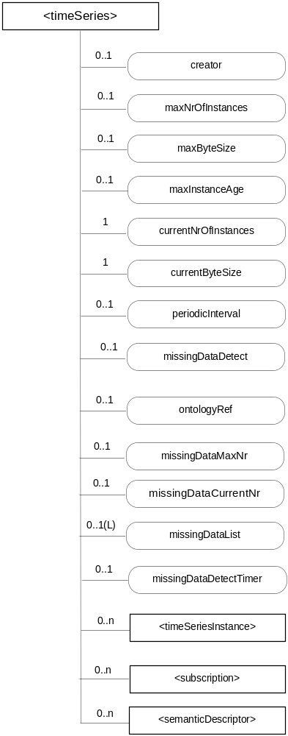
Figure 9.6.36-1: Structure of <timeSeries> resource
Table 9.6.36-1:Child resources of <timeSeries> resource
Child Resources of <timeSeries> | Child Resource Type | Multiplicity | Description | <timeSeriesAnnc> Child Resource Types
[variable] | <semanticDescriptor> | 0..n | See clause 9.6.30 | <semanticDescriptor>, <semanticDescriptorAnnc>
[variable] | <timeSeriesInstance> | 0..n | See clause 9.6.37 | <timeSeriesInstance>,  <timeSeriesInstanceAnnc>
[variable] | <subscription> | 0..n | See clause 9.6.8 | <subscription>

The <timeSeries> resource shall contain the attributes specified in table 9.6.36-2.
Table 9.6.36-2: Attributes of <timeSeries> resource
Attributes of  <timeSeries> | Multiplicity | RW/  RO/  WO | Description | <timeSeriesAnnc> Attributes
resourceType | 1 | RO | See clause 9.6.1.3. | NA
resourceID | 1 | RO | See clause 9.6.1.3. | NA
resourceName | 1 | WO | See clause 9.6.1.3. | NA
parentID | 1 | RO | See clause 9.6.1.3. | NA
expirationTime | 1 | RW | See clause 9.6.1.3 | MA
accessControlPolicyIDs | 0..1 (L) | RW | See clause 9.6.1.3. If no accessControlPolicyIDs are provided at the time of creation, the accessControlPolicyIDs of the parent resource is linked to this attribute. | MA
labels | 0..1 (L) | RW | See clause 9.6.1.3. | MA
creationTime | 1 | RO | See clause 9.6.1.3. | NA
lastModifiedTime | 1 | RO | See clause 9.6.1.3. | NA
stateTag | 1 | RO | See clause 9.6.1.3. | OA
announceTo | 0..1 (L) | RW | See clause 9.6.1.3. | NA
announcedAttribute | 0..1 (L) | RW | See clause 9.6.1.3. | NA
dynamicAuthorizationConsultationIDs | 0..1 (L) | RW | See clause 9.6.1.3. | OA
creator | 1 | RO | The AE-ID or CSE-ID of the entity which created the resource. | NA
maxNrOfInstances | 0..1 | RW | Maximum number of direct child <timeSeriesInstance> resources in the <timeSeries> resource. | OA
maxByteSize | 0..1 | RW | Maximum size in bytes of data that is allocated for the <timeSeriesInstance> resource for all direct child<timeSeriesInstance> resources. | OA
maxInstanceAge | 0..1 | RW | Maximum age of a direct child <timeSeriesInstance> resource in the <timeSeries> resource. The value is expressed in seconds. | OA
currentNrOfnstances | 1 | RO | Current number of direct child <timeSeriesInstance> resource in the <timeSeries> resource. It is limited by the maxNrOfInstances. | OA
currentByteSize | 1 | RO | Current size in bytes of data stored in all direct child <timeSeriesInstance> resources of a <timeSeries> resource. It is limited by the maxByteSize. | OA
periodicInterval | 0..1 | WO | If the Time Sereis Data is periodic, this attribute shall contain the expected amount of time between two instances of Time Series Data. | OA
missingDataDetect | 0..1 | WO | Indicates whether the Receiver shall detect the missing Time Series Data if it is periodic. | NA
ontologyRef | 0..1 | RW | A reference (URI) of the ontology used to represent the information that is stored in the child <timeSeriesInstance> resources of the present <timeSeriesData> resource (see note). | OA
missingDataMaxNr | 0..1 | RW | Maximum number of entries in the missingDataList if the periodicInterval is set and the missingDataDetect is TRUE. | OA
missingDataList | 0..1(L) | RO | The list of the dataGenerationTime value representing the missing Time Series Data in descending order by time if the periodicInterval is set and the missingDataDetect is TRUE. | OA
missingDataCurrentNr | 0..1 | RO | Current number of the missing Time Series Data in the missingDataList. | OA
missingDataDetectTimer | 0..1 | RW | The missingDataDetectTimer after which a missing Time Series Data shall be considered lost by the hosting CSE. Note that the setting of this value may not apply in certain transports such as TCP, and as such the hosting CSE may reject proposed values or suggest different values. | OA
NOTE: The access to this URI is out of scope of oneM2M.

----------------------- End of change 9---------------------------------------------

