Input Contribution
Meeting ID* | ARC #24
Title:* | Scenarios for DDS based direct change of data between oneM2M entities
Source:* | Jessie, Huawei, lijing80@huawei.com
Uploaded Date:* | 2016-07-08
Document(s)  Impacted* | WI-0047  TR-0027
Intended purpose of  document:* | Decision  Discussion  Information  Other <specify>
Decision requested or recommendation:* | This document adds some scenarios for DDS based direct change of data between oneM2M entities and it is proposed to agree the new added content of sub-clause 7.1.
Template Version:23 February 2015 (Dot not modify)

oneM2M Notice
The document to which this cover statement is attached is submitted to oneM2M. Participation in, or attendance at, any activity of oneM2M, constitutes acceptance of and agreement to be bound by terms of the Working Procedures and the Partnership Agreement, including the Intellectual Property Rights (IPR) Principles Governing oneM2M Work found in Annex 1 of the Partnership Agreement.

7 Possible Solutions for DDS based direct change of data between oneM2M entities

7.1 Senarios for DDS based direct change of data between oneM2M entities
This sub-clause describes the scenario for DDS based direct change of data between oneM2M entities. Figure 7-1 illustrates a high level architecture of data exchanging between oneM2M devices or nodes using DDS protocol in a smart city.
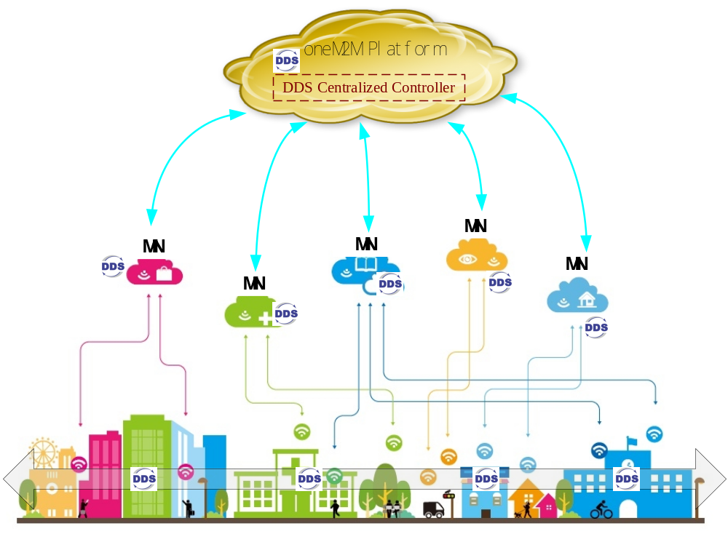
Figure 7-1: High Level Illustration
- DDS Centralized Controller: It is used to provide the centralized control and resource discovery sevice and can be deployed either on MN or on the oneM2M platform. Control policies may be configured on the DDS centralized controller to management the DDS topics, QoS policies and the establishing of publish/subscribe relations. When a node requests a subscription for a specific resource, the DDS centralized controller locates the existing publisher of the specific resource based on certain control policies and notifies the publisher and the subscriber the information of each other, e.g. IP address and identifier of the publisher and subscriber.
In this scenario, the whole smart city system is deployed based on the oneM2M architecture and protocol. Messages between oneM2M nodes in the smart city are transported across the DDS protocol. Sensors and devices registered to the MN or directly registered to oneM2M platform. The oneM2M platform have an overall knowledgement of the sensors and devices in the whole city, e.g. IP address and the kind of data the nodes can publishe or wants to receive.
When a sensor or device under a MN wants to receive certain resource published by other sensors or devices under the same MN or other MNs, it sends the interested resource information to the DDS centralized controller (oneM2M platform). The DDS centralized controller discovers the publisher of the specific resource and establishs the relationship of the publisher and the subscriber. Once the relationship of pub-sub is established, the sensors can communicate directly without transporting data through the oneM2M platform. For example, when an accident occurs , an ambulance is dispatched to the accident site. The ambulance can receive traffic information published by nearby smart city facilities, e.g. traffic lights, and thus can dynamicly choose the best path to reach the accident site.

