CHANGE REQUEST
Meeting:* | ARC#24
Source:* | Qualcomm Inc. (TIA)
Date:* | 2016-07-11
Contact:* | Josef Blanz, jblanz@qti.qualcomm.com
Reason for Change/s:* | Incorrect specification of <node> child resources under <remoteCSE> and announcement related errors discovered in this context
CR against: Release* | Rel-2
CR against: WI* | Active WI  MNT maintenace / < Work Item number(optional)>  STE Small Technical Enhancements / < Work Item number (optional)>  Only ONE of the above shall be ticked
CR against: TS/TR* | TS-0001 v 2.9.1
Clauses/Sub Clauses* | 9.6.1.1 Resource Type Summary  9.6.3 Resource Type CSEBase  9.6.4 Resource Type remoteCSE  9.6.5 Resource Type AE  9.6.18 Resource Type node  9.6.26.1 Overview
Type of change: * | Editorial change  Bug Fix or Correction  Change to existing feature or functionality  New feature or functionality  Only ONE of the above shall be ticked
Post Freeze checking:* | This CR contains only essential changes and corrections? YES NO  This CR may break backwards compatibility with the last approved version of the TS? YES NO  This CR is a mirror CR? YES if YES, please indicate the document number of the original CR: <Document Number> : NO
Template Version:27 May 2015 (Dot not modify)

oneM2M Notice
The document to which this cover statement is attached is submitted to oneM2M. Participation in, or attendance at, any activity of oneM2M, constitutes acceptance of and agreement to be bound by terms of the Working Procedures and the Partnership Agreement, including the Intellectual Property Rights (IPR) Principles Governing oneM2M Work found in Annex 1 of the Partnership Agreement.

Introduction
The specification of <remoteCSE> includes <nodeAnnc> as a possible child resource. This is probably a mistake due to cut & paste. The present CR suggests to remove that kind of child resource. The node on which a remote CSE represented by a give <remoteCSE> resource is residing can be identified by the nodeLink attribute of the <remoteCSE> resource.
Furthermore, the definition of the related nodeLink attribute is not prcise. This CR also suggests to define this attribute precisely.
Cahnge in R01:
- Keep the possibility to allow for a <nodeAnnc> resource to be a child of a <remoteCSE> resource.
- Added text on where allowed resource types of children of announced resources are specified.
- The literal <resourceType> is not referring to any specific resource type. Changed that to normal text.
- The TS does not contain information which resource types can be announced as children of <remoteCSE>, added that.
- Added missing announce resource types that could be children of announced resource types (was missing in table 9.6.26.1-1)
- Parents of certain resource types not listed in Table 9.6.1.1-1 correctly. Corrected that.
- Corrections to table 9.6.2.26.1-1 containing definitions of specified child resource types of announce resources

-----------------------Start of change 1-------------------------------------------

9.6.1.1 Resource Type Summary
Table 9.6.1.1-1 introduces the normal and virtual resource types and their related child or parent resource types. Details of each resource type follow in the remainder of this clause.
Table 9.6.1.1-1 lists each specified ordinary – i.e. not announced – resource type. An addition of suffix "Annc" to the respective resource type identifier indicates the associated announced resource type. Resource types that can occur as child resources of announced resources are summarized in Table 9.6.26.1-1 “Announced Resource Types”.
Among the resource types listed in Table 9.6.1.1-1, the following are termed "Content Sharing Resources" in oneM2M Specifications for the purpose of referring to any of those resource types:
- container;
- contentInstance;
- flexContainer;
- timeSeries;
- timeSeriesInstance.
Table 9.6.1.1-1: Resource Types
Resource Type | Short Description | Child Resource Types | Parent Resource Types | Clause
accessControlPolicy | Stores a representation of privileges. It is associated with resources that shall be accessible to entities external to the Hosting CSE. It controls "who" is allowed to do "what" and the context in which it can be used for accessing resources | subscription | AE, AEAnnc, remoteCSE, remoteCSEAnnc, CSEBase | 9.6.2
AE | Stores information about the AE. It is created as a result of successful registration of an AE with the Registrar CSE | subscription, container,  flexContainer,  group, accessControlPolicy,  schedule, pollingChannelsemanticDescriptor,  timeSeries | CSEBase | 9.6.5
container | Shares data instances among entities. Used as a mediator that buffers data exchanged between AEs and/or CSEs. The exchange of data between AEs (e.g. an AE on a Node in a field domain and the peer-AE on the infrastructure domain) is abstracted from the need to set up direct connections and allows for scenarios where both entities in the exchange do not have the same reachability schedule | container,  flexContainer, contentInstance, subscription, latest, oldest，semanticDescriptor | AE, AEAnnc, container, containerAnnc, remoteCSE, remoteCSEAnnc,  CSEBase,  flexContainer, flexContainerAnnc | 9.6.6
contentInstance | Represents a data instance in the <container> resource | semanticDescriptor | Container, containerAnnc | 9.6.7
flexContainer | A template which allows to define specialized (customizable) versions of containers with a flexible and lightweight structure | container,  flexContainer, subscription, semanticDescriptor | AE, AEAnnc, container, containerAnnc,  flexContainer, flexContainerAnnc, remoteCSE, remoteCSEAnnc,  CSEBase | 9.6.35
CSEBase | The structural root for all the resources that are residing on a CSE. Stores information about the CSE itself | remoteCSE, remoteCSEAnnc, node, AE, container, group, accessControlPolicy, subscription,, mgmtCmd, locationPolicy, statsConfig, statsCollect, request, delivery,  schedule,  notificationTargetPolicy,  flexContainer,  timeSeries | None specified | 9.6.3
delivery | Forwards requests from CSE to CSE | subscription | CSEBase | 9.6.11
eventConfig | Defines events that trigger statistics collection | subscription | statsConfig | 9.6.24
execInstance | Contains all execution instances of the same Management Command | subscription | mgmtCmd | 9.6.17
fanOutPoint (V) | Virtual resource containing target for group request  It is used for addressing bulk operations to all the resources that belong to a group | None specified | group | 9.6.14
group | Stores information about resources of the same type that need to be addressed as a Group. Operations addressed to a Group resource shall be executed in a bulk mode for all members belonging to the Group | fanOutPoint,  subscription,  semanticFanOutPoint，semanticDescriptor | AE, AEAnnc, remoteCSE, remoteCSEAnnc, CSEBase | 9.6.13
latest (V) | Virtual resource that points to most recently created <contentInstance> child resource within a <container> resource | None specified | container | 9.6.27
locationPolicy | Includes information to obtain and manage geographical location. It is only referenced within a container, the contentInstances of the container provide location information | subscription | CSEBase | 9.6.10
mgmtCmd | Management Command resource represents a method to execute management procedures required by existing management protocols | execInstance,  subscription | CSEBase | 9.6.16
mgmtObj | Management Object resource represents management functions that provides an abstraction to be mapped to external management technology. It represents the node and the software installed in the node (see note) | subscription, mgmtObj, schedule | node, mgmtObj, mgmtObjAnnc | 9.6.15  Annex D
m2mServiceSubscriptionProfile | Data pertaining to the M2M Service Subscription | serviceSubscribedNode,  subscription | CSEBase | 9.6.19
node | Represents specific Node information | mgmtObj,  subscription，semanticDescriptor | CSEBase | 9.6.18
notificationTargetMgmtPolicyRef | Represents a list of notification targets and the deletion policy | subscription | subscription | 9.6.31
notificationTargetPolicy | Represents a notification target deletion policy with pre-defined action and deletion rules | subscription, policyDeletionRules | CSEBase | 9.6.32
notificationTargetSelfReference (V) | Virtual resource used to remove the Notification Target | None specified | subscription | 9.6.34
oldest (V) | Virtual resource that points to first created <contentInstance> child resource within a <container> resource | None specified | container | 9.6.28
pollingChannel | Represent a channel that can be used for a request-unreachable entity | pollingChannelURI | remoteCSE, AE | 9.6.21
pollingChannelURI (V) | Virtual resource used to perform service layer long polling of a resource Hosting CSE by a request-unreachable entity | None specified | pollingChannel | 9.6.22
policyDeletionRules | Represents a set of rules which is associated with notification target removal policy | subscription | notificationTargetPolicy | 9.6.33
remoteCSE | Represents a remote CSE for which there has been a registration procedure with the registrar CSE identified by the CSEBase resource | container,  containerAnnc  flexContainer,  flexContainerAnnc,  group,  groupAnnc, accessControlPolicy,  accessControlPolicyAnnc, subscription, pollingChannel, schedule,  timeSeries,  timeSeriesAnnc,  remoteCSEAnnc,  nodeAnnc,  AEAnnc,  locationPolicyAnnc | CSEBase | 9.6.4
request | Expresses/access context of an issued Request | subscription | CSEBase | 9.6.12
schedule | Contains scheduling information for delivery of messages | subscription | subscription, CSEBase, remoteCSE,  AE | 9.6.9
serviceSubscribedNode | Node information | subscription | m2mServiceSubscriptionProfile | 9.6.20
statsCollect | Defines triggers for the IN-CSE to collect statistics for applications | subscription | CSEBase (in IN-CSE) | 9.6.25
statsConfig | Stores configuration of statistics for applications | eventConfig,  subscription | CSEBase (in IN-CSE) | 9.6.23
subscription | Subscription resource represents the subscription information related to a resource. Such a resource shall be a child resource for the subscribe-to resource | schedule, notificationTargetSelfReference, notificationTargetMgmtPolicyRef | accessControlPolicy,accessControlPolicyAnnc, AE, AEAnnc, container, containerAnnc, CSEBase, delivery, eventConfig, execInstance, group, groupAnnc, locationPolicy, locationPolicyAnnc, mgmtCmd, mgmtObj, mgmtObjAnnc, m2mServiceSubscriptionProfile, node, nodeAnnc, serviceSubscribedNode, remoteCSE, remoteCSEAnnc, request, schedule, scheduleAnnc,  semanticDescriptor, semanticDescriptorAnnc, statsCollect, statsConfig,  flexContainer, flexContainerAnnc,  timeSeries, timeSeriesAnnc | 9.6.8
serviceSubscribedAppRule | Represents a rule that defines allowed App-ID and AE-ID combinations that are acceptable for registering an AE on a Registrar CSE | subscription | CSEBase | 9.6.29
semanticDescriptor | Stores semantic description pertaining to a resource and potentially sub-resources. | subscription | AE, container, contentInstance，group, node, flexContainer, timeSeries | 9.6.30
semanticFanOutPoint | Virtual resource used as target for semantic discovery aimed at a logical graph distributed over multiple semanticDescriptor resources, which belong to the corresponding group parent resource | None specified | group | 9.6.14a
trafficCharacteristics | Represents the characteristic information (e.g. communication pattern, mobility pattern, etc..) of a field domain node. | trafficPattern,  subscription | Node, AE | 9.6.41
trafficPattern | Represents the communication pattern and the mobility pattern of a field domain node. | schedule,  subscription | trafficCharacteristics | 9.6.42
dynamicAuthorizationConsultation | Represents consultation information used by a CSE when performing consultation-based dynamic authorization | None Specified | AE, AEAnnc, remoteCSE, remoteCSEAnnc, CSEBase | 9.6.43
timeSeries | Stores and Shares Time Series Data instances among entities. | timeSeriesInstance, subscription, semanticDescriptor | AE, AEAnnc, remoteCSE, remoteCESAnnc, CSEBase | 9.6.36
timeSeriesInstance | Represents a Time Series Data instance in the <timeSeries> resource | None specified | timeSeries, timeSeriesAnnc | 9.6.37
NOTE: See clause 9.6.12 for a summary of specializations of <mgmtObj>.

-----------------------End of change 1---------------------------------------------

-----------------------Start of change 2-------------------------------------------

9.6.3 Resource Type CSEBase
A <CSEBase> resource shall represent a CSE. The <CSEBase> resource shall be the root for all resources that are residing in the CSE.
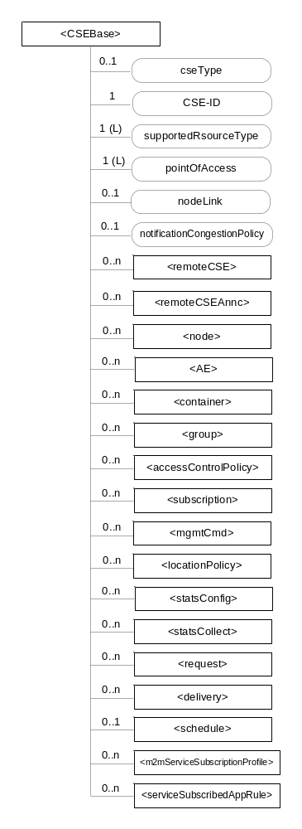
Figure 9.6.3-1: Structure of <CSEBase> resource
Figure 9.6.3-1 does not show the child announce resource types defined in table 9.6.3-2.
The <CSEBase> resource shall contain the child resources specified in table 9.6.3-1.
Table 9.6.3-1: Child resources of <CSEBase> resource
Child Resources of <CSEBase> | Child Resource Type | Multiplicity | Description
[variable] | <remoteCSE> | 0..n | See clause 9.6.4
[variable] | <remoteCSEAnnc> | 0..n | Announced variant of <remoteCSE>. Resource with CSE-specific information for a CSE that announced itself to another CSE with which it does not have a registration relationship.
[variable] | <node> | 0..n | See clause 9.6.18
[variable] | <AE> | 0..n | See clause 9.6.5
[variable] | <container> | 0..n | See clause 9.6.6
[variable] | <group> | 0..n | See clause 9.6.13
[variable] | <accessControlPolicy> | 0..n | See clause 9.6.2
[variable] | <subscription> | 0..n | See clause 9.6.8
[variable] | <mgmtCmd> | 0..n | See clause 9.6.16
[variable] | <locationPolicy> | 0..n | See clause 9.6.10
[variable] | <statsConfig> | 0..n | See clause 9.6.23
[variable] | <statsCollect> | 0..n | See clause 9.6.25
[variable] | <request> | 0..n | See clause 9.6.12
[variable] | <delivery> | 0..n | See clause 9.6.11
[variable] | <schedule> | 0..1 | This resource defines the reachability schedule information of the entity. The absence of this resource implies the entity is always reachable. See clause 9.6.9
[variable] | <m2mServiceSubscriptionProfile> | 0..n | See clause 9.6.19
[variable] | <serviceSubscribedAppRule> | 0..n | See clause 9.6.29

Table 9.6.3-2: Child announced resources of <CSEBase> resource

An instance of a <remoteCSEAnnc> resource shall be created as a child of a <CSEBase> resource when an Originator CSE of an announcement request (i.e. original resource Hosting CSE) and a targeted Hosting CSE of an announced resource (i.e. announced resource Hosting CSE) have no registration relationship (e.g. the Originator CSE has not created <remoteCSE> resource on the Hosting CSE), see clause 9.6.26.
The <CSEBase> resource shall contain the attributes specified in table 9.6.3-3.
Table 9.6.3-3: Attributes of <CSEBase> resource
Attributes of <CSEBase> | Multiplicity | RW/  RO/  WO | Description
resourceType | 1 | RO | See clause 9.6.1.3.
resourceID | 1 | RO | See clause 9.6.1.3.
resourceName | 1 | RO | See clause 9.6.1.3.
creationTime | 1 | RO | See clause 9.6.1.3.
lastModifiedTime | 1 | RO | See clause 9.6.1.3.
accessControlPolicyIDs | 0..1 (L) | RO | See clause 9.6.1.3.
labels | 0..1 (L) | RO | See clause 9.6.1.3.
cseType | 0..1 | RO | Indicates the type of CSE represented by the created resource.  - Mandatory for an IN-CSE, hence multiplicity (1).  - Its presence is subject to SP configuration in case of an ASN-CSE or a MN-CSE.
CSE-ID | 1 | RO | The CSE identifier in SP-relative CSE-ID format (clause 7.2).
supportedResourceType | 1 (L) | RO | List of the resource types which are supported in the CSE. This attribute contains subset of resource types listed in clause 9.2.
pointOfAccess | 1 (L) | RO | Represents the list of physical addresses to be used by remote CSEs to connect to this CSE (e.g. IP address, FQDN). This attribute is exposed to its Registree.
nodeLink | 0..1 | RO | The resource identifier of a <node> resource that stores the node specific information of the node on which the CSE, represented by this <CSEBase> resource, resides.
notificationCongestionPolicy | 0..1 | RO | This attribute applies to CSEs generating subscription notifications. It specifies the rule which is applied when the storage of notifications for each subscriber (an AE or CSE) reaches the maximum storage limit for notifications for that subscriber. E.g. Delete stored notifications of lower notificationStoragePriority to make space for new notifications of higher notificationStoragePriority, or delete stored notifications of older creationTime to make space for new notifications when all notifications are of the same notificationStoragePriority.
NOTE: All the attributes of this resource type can be changed by an offline configuration mechanism, but not over the reference points (all attributes are "RO").

-----------------------End of change 2---------------------------------------------

-----------------------Start of change 3-------------------------------------------

9.6.4 Resource Type remoteCSE
A <remoteCSE> resource shall represent a Registree CSE that is registered to the Registrar CSE. <remoteCSE> resources shall be located directly under the <CSEBase> resource of Registrar CSE.
Similarly <remoteCSE> resource shall also represent a Registrar CSE. <remoteCSE> resource shall be located directly under the <CSEBase> resource of Registree CSE.
For example, when CSE1 (Registree CSE) registers with CSE2 (Registrar CSE), there will be two <remoteCSE> resources created: one in CSE1: <CSEBase1>/<remoteCSE2> and one in CSE2: <CSEBase2>/<remoteCSE1>.
Note that the creation of the two resources does not imply mutual registration. The <CSEBase1>/<remoteCSE2> does not mean CSE2 registered with CSE1 in the example above.
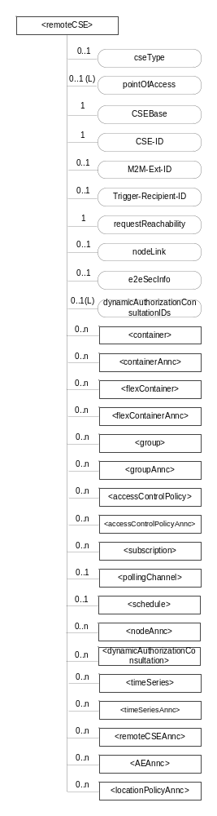
Figure 9.6.4-1: Structure of <remoteCSE> resource
The <remoteCSE> resource shall contain the child resources specified in table 9.6.4-1. The <remoteCSE> resource may contain <remoteCSEAnnc> child resources.
Table 9.6.4-1: Child resources of <remoteCSE> resource
Child Resources of <remoteCSE> | Child Resource Type | Multiplicity | Description | <remoteCSEAnnc> Child Resource Types
[variable] | <container> | 0..n | See clause 9.6.6 | <container>
[variable] | <containerAnnc> | 0..n | Announced variant of <container>. See clause 9.6.6 | <containerAnnc>
[variable] | <flexContainer> | 0..n | See clause 9.6.35 | <flexContainer>
[variable] | <flexContaineAnnc> | 0..n | Announced variant of <flexContainer>. See clause 9.6.35 | <flexContainerAnnc>
[variable] | <group> | 0..n | See clause 9.6.13 | <group>
[variable] | <groupAnnc> | 0..n | Announced variant of <group>. See clause 9.6.13 | <groupAnnc>
[variable] | <accessControlPolicy> | 0..n | See clause 9.6.2 | <accessControlPolicy>
[variable] | <accessControlPolicyAnnc> | 0..n | Announced variant of <accessControlPolicy>. See clause 9.6.2 | <accessControlPolicyAnnc>
[variable] | <subscription> | 0..n | See clause 9.6.8 | <subscription>
[variable] | <pollingChannel> | 0..1 | See clause 9.6.21. If requestReachability is FALSE, the CSE that created this <remoteCSE> resource should create a <pollingChannel> resource and perform long polling. The <pollingChannel> shall be utilized by the the parent resource. | None
[variable] | <schedule> | 0..1 | This resource defines the reachability schedule information of the node. See clause 9.6.9 for <schedule>. | <scheduleAnnc>
[variable] | <nodeAnnc> | 0..n | Announced variant of <node>. This announced resource is assoiated with a <node> resource that is hosted on a CSE which is represented by the parent <remoteCSE> or <remoteCSEAnnc> resource. See clause 9.6.18 for <node>. | <nodeAnnc>
[variable] | <dynamicAuthorizationConsultation> | 0..n | See clause 9.6.43
[variable] | <timeSeries> | 0..n | See clause 9.6.36 | <timeSeries>
[variable] | <timeSeriesAnnc> | 0..n | Announced variant of <timeSeries>. See clause 9.6.36 | <timeSeriesAnnc>
[variable] | <remoteCSEAnnc> | 0..n | Announced variant of <remoteCSE> defined in the present clause 9.6.4. | <remoteCSEAnnc>
[variable] | <AEAnnc> | 0..n | Announced variant of <AE>. See clause 9.6.5 | <AEAnnc>
[variable] | <locationPolicyAnnc> | 0..n | Announced variant of <locationPolicy>. See clause 9.6.10 | <locationPolicyAnnc>

resource

The <remoteCSE> resource shall contain the attributes specified in table 9.6.4-3.
Table 9.6.4-3: Attributes of <remoteCSE> resource
Attributes of <remoteCSE> | Multiplicity | RW/  RO/  WO | Description | <remoteCSEAnnc> Attributes
resourceType | 1 | RO | See clause 9.6.1.3. | NA
resourceID | 1 | RO | See clause 9.6.1.3. | NA
resourceName | 1 | WO | See clause 9.6.1.3. | NA
parentID | 1 | RO | See clause 9.6.1.3. | NA
creationTime | 1 | RO | See clause 9.6.1.3. | NA
lastModifiedTime | 1 | RO | See clause 9.6.1.3. | NA
expirationTime | 1 | RW | See clause 9.6.1.3. | MA
accessControlPolicyIDs | 0..1 (L) | RW | See clause 9.6.1.3. | MA
labels | 0..1 (L) | RW | See clause 9.6.1.3. | MA
announceTo | 0..1 (L) | RW | See clause 9.6.1.3. | NA
announcedAttribute | 0..1 (L) | RW | See clause 9.6.1.3. | NA
dynamicAuthorizationConsultationIDs | 0..1 (L) | RW | See clause 9.6.1.3. | OA
cseType | 0..1 | WO | Indicates the type of CSE represented by the created resource.  Mandatory for an IN-CSE, hence multiplicity (1).  Its presence is subject to SP configuration in case of an ASN-CSE or a MN-CSE. | OA
pointOfAccess | 0..1 (L) | RW | For request-reachable remote CSE it represents the list of physical addresses to be used to connect to it (e.g. IP address, FQDN).  If this information is not provided and <pollingChannel> resource does exis, the CSE should use <pollingChannel> resource. Then the Hosting CSE can forward a request to the CSE without using the PoA. | OA
CSEBase | 1 | WO | The address of the <CSEBase> resource represented by this <remoteCSE> resource. | OA
CSE-ID | 1 | WO | The CSE identifier of the remote CSE represented by this <remoteCSE> resource in SP-relative CSE-ID format (clause 7.2). | OA
M2M-Ext-ID | 0..1 | RW | Supported when Registrar is IN-CSE.  See clause 7.1.8 where this attribute is described. This attribute is used only for the case of dynamic association of M2M-Ext-ID and CSE-ID. | NA
Trigger-Recipient-ID | 0..1 | RW | Supported when Registrar is IN-CSE. See clause 7.1.10 where this attribute is described. This attribute is used only for the case of dynamic association of M2M-Ext-ID and CSE-ID. | NA
requestReachability | 1 | RW | If the CSE that created this <remoteCSE> resource can receive a request from other AE/CSE(s), this attribute is set to "TRUE" otherwise "FALSE" (see note) | OA
nodeLink | 0..1 | RW | The resource identifier of a <node> resource that stores the node specific information of the node on which the CSE represented by this <remoteCSE> resource resides. | OA
e2eSecInfo | 0..1 | RW | See clause 9.6.1.3. | MA
triggerReferenceNumber | 0..1 | RW | This is to identify device trigger procedure request. This attribute is used only for device trigger and assigned by the IN-CSE. | NA
NOTE: Even if this attribute is set to "FALSE", it does not mean it AE/CSE is always unreachable by all entities. E.g. the requesting AE/CSE is behind the same NAT, so it can communicate within the same NAT.

-----------------------End of change 3---------------------------------------------

-----------------------Start of change 4-------------------------------------------

9.6.5 Resource Type AE
An <AE> resource shall represent information about an Application Entity registered to a CSE.
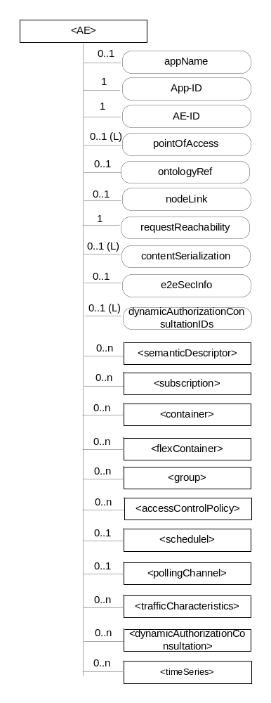
Figure 9.6.5-1: Structure of <AE> resource
The <AE> resource shall contain the child resources specified in table 9.6.5-1.
Table 9.6.5-1: Child resources of <AE> resource
Child Resources of <AE> | Child Resource Type | Multiplicity | Description | <AEAnnc> Child Resource Types
[variable] | <semanticDescriptor> | 0..n | See clause 9.6.30 | <semanticDescriptor>, <semanticDescriptorAnnc>
[variable] | <subscription> | 0..n | See clause 9.6.8 | <subscription>
[variable] | <container> | 0..n | See clause 9.6.6 | <container> <containerAnnc>
[variable] | <flexContainer> | 0..n | See clause 9.6.35 | <flexContainer>  <flexContainerAnnc>
[variable] | <group> | 0..n | See clause 9.6.13 | <group>  <groupAnnc>
[variable] | <accessControlPolicy> | 0..n | See clause 9.6.2 | <accessControlPolicy>  <accessControlPolicyAnnc>
[variable] | <schedule> | 0..1 | See clause 9.6.9 | <scheduleAnnc>
[variable] | <pollingChannel> | 0..1 | See clause 9.6.21  When the AE is request-unreachable, the AE should create this <pollingChannel> resource and perform long polling. The <pollingChannel> shall be utilized by the parent resource | None
trafficCharacteristics | <trafficCharacteristics> | 0..n | See clause 9.6.41 | <trafficCharacteristicsAnnc>
[variable] | <dynamicAuthorizationConsultation> | 0..n | See clause 9.6.43 | None
[variable] | <timeSeries> | 0..n | See clause 9.6.36 | <timeSeries>  <timeSeriesAnnc>

The <AE> resource shall contain the attributes specified in table 9.6.5-2.
Table 9.6.5-2: Attributes of <AE> resource
Attributes of  <AE> | Multiplicity | RW/  RO/  WO | Description | <AEAnnc> Attributes
resourceType | 1 | RO | See clause 9.6.1.3. | NA
resourceID | 1 | RO | See clause 9.6.1.3. Contains the AE-ID-Stem of the AE (see clause 7.2 on identifier formats and clause 10.1.1.2.2 for AE registration procedure). | NA
resourceName | 1 | WO | See clause 9.6.1.3. | NA
parentID | 1 | RO | See clause 9.6.1.3. | NA
expirationTime | 1 | RW | See clause 9.6.1.3. | MA
accessControlPolicyIDs | 0..1 (L) | RW | See clause 9.6.1.3. | MA
creationTime | 1 | RO | See clause 9.6.1.3. | NA
lastModifiedTime | 1 | RO | See clause 9.6.1.3. | NA
labels | 0..1 (L) | RW | See clause 9.6.1.3. | MA
announceTo | 0..1 (L) | RW | See clause 9.6.1.3. | NA
announcedAttribute | 0..1 (L) | RW | See clause 9.6.1.3. | NA
dynamicAuthorizationConsultationIDs | 0..1 (L) | RW | See clause 9.6.1.3. | OA
appName | 0..1 | RW | The name of the application, as declared by the application developer(e.g. "HeatingMonitoring").  Several sibling resources may share the appName. | OA
App-ID | 1 | WO | The identifier of the Application (see clause 7.1.2). | OA
AE-ID | 1 | RO | The identifier of the Application Entity (see clause 7.1.2). | OA
pointOfAccess | 0..1 (L) | RW | The list of addresses for communicating with the registered Application Entity over Mca reference point via the transport services provided by Underlying Network (e.g. IP address, FQDN, URI). This attribute shall be accessible only by the AE and the Hosting CSE.  If this information is not provided and the <pollingChannel> resource does exist, the AE should use <pollingChannel> resource. Then the Hosting CSE can forward a request to the AE without using the PoA. | OA
ontologyRef | 0..1 | RW | A URI of the ontology used to represent the information that is managed and understood by the AE. | OA
requestReachability | 1 | RW | If the AE that created this <AE> resource can receive a request, this attribute is set to "TRUE" otherwise "FALSE" | OA
nodeLink | 0..1 | RW | The resource identifier of a <node> resource that stores the node specific information of the node on which the AE represented by this <AE> resource resides. | OA
contentSerialization | 0..1 (L) | RW | The list of supported serializations of the Content primitive parameter for receiving a request from its registrar CSE. (e.g. XML, JSON). The list shall be ordered so that the most preferred format comes first. | OA
e2eSecInfo | 0..1 | RW | See clause 9.6.1.3. | MA

-----------------------End of change 4---------------------------------------------

-----------------------Start of change 5-------------------------------------------

9.6.18 Resource Type node
The <node> resource represents specific information that provides properties of an M2M Node that can be utilized by other oneM2M operations. The <node> resource has specialization of the <mgmtObj> as its child resources. These resources represent the Node's context information (e.g. memory and battery), network topology, device information, device capability etc. The specialized <mgmtObj> resources are used to perform management of the Node.
This node specific information stored in these resources such as [memory] and [battery] can be obtained either by the existing device management technologies (OMA DM [Error: Reference source not found], BBF TR-069 [Error: Reference source not found]) or any other way (e.g. JNI [Error: Reference source not found]).
For the case when the <node> resource belongs to an ADN, please see figure 9.6.18-1 in conjunction with the description of nodeLink attribute in the <AE> resource (clause 9.6.5).
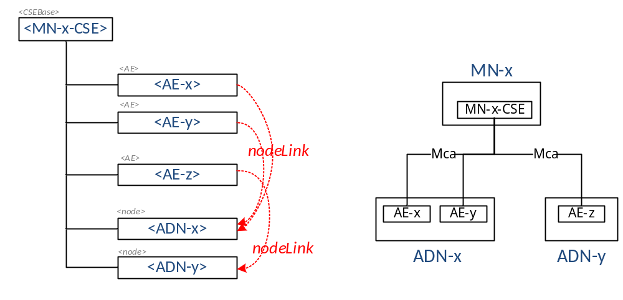
Figure 9.6.18-1: Relationship between MN and ADN
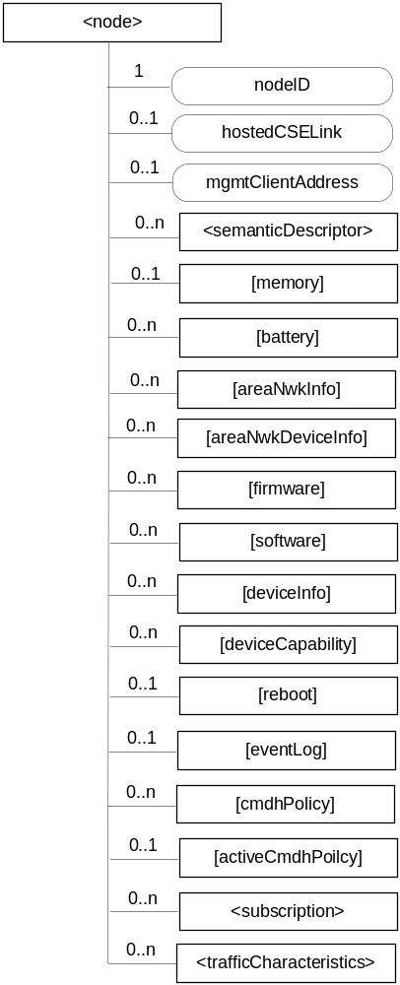
Figure 9.6.18-2: Structure of <node> resource
The <node> resource shall contain the child resources specified in table 9.6.18-1.
Table 9.6.18-1: Child resources of <node> resource
Child Resources of <node> | Child Resource Type | Multiplicity | Description | <nodeAnnc> Child Resource Type
[variable] | <semanticDescriptor> | 0..n | See clause 9.6.30. | <semanticDescriptor>, <semanticDescriptorAnnc>
[variable] | <mgmtObj> as defined in the specialization [memory] | 0..1 | This resource provides the memory (typically RAM) information of the node. (E.g. the amount of total volatile memory), See clause D.4. | <mgmtObjAnnc>
[variable] | <mgmtObj> as defined in the specialization [battery] | 0..n | The resource provides the power information of the node. (E.g. remaining battery charge). See clause D.7. | <mgmtObjAnnc>
[variable] | <mgmtObj> as defined in the specialization [areaNwkInfo] | 0..n | This resource describes the list of Nodes attached behind the MN node and its physical or underlying relation among the nodes in the M2M Area Network. This attribute is defined in case the Node is MN. See clause D.5. | <mgmtObjAnnc>
[variable] | <mgmtObj> as defined in the specialization [areaNwkDeviceInfo] | 0..n | This resource describes the information about the Node in the M2M Area Network. See clause D.6. | <mgmtObjAnnc>
[variable] | <mgmtObj> as defined in the specialization [firmware] | 0..n | This resource describes the information about the firmware of the Node include name, version etc. See clause D.2. | <mgmtObjAnnc>
[variable] | <mgmtObj> as defined in the specialization [software] | 0..n | This resource describes the information about the software of the Node. See clause D.3. | <mgmtObjAnnc>
[variable] | <mgmtObj> as defined in the specialization [deviceInfo] | 0..n | The resource contains information about the identity, manufacturer and model number of the device. See clause D.8. | <mgmtObjAnnc>
[variable] | <mgmtObj> as defined in the specialization [deviceCapability] | 0..n | The resource contains information about the capability supported by the Node. See clause D.9. | <mgmtObjAnnc>
[variable] | <mgmtObj> as defined in the specialization [reboot] | 0..1 | The resource is the place to reboot or reset the Node. See clause D.10. | <mgmtObjAnnc>
[variable] | <mgmtObj> as defined in the specialization [eventLog] | 0..1 | The resource contains the information about the log of events of the Node. See clause D.11. | <mgmtObjAnnc>
[variable] | <mgmtObj> as defined in the specialization [cmdhPolicy] | 0..n | The resource(s) contain(s) information about CMDH policies that are applicable to the CMDH processing on the CSE hosted on the node represented by this <node> resource and identified by the hostedCSELink attribute of this <node> resource. See clause D.12. | NA
[variable] | <mgmtObj> as defined in the specialization [activeCmdhPolicy] | 0..1 | This resource defines which of the present [cmdhPolicy] resource(s) shall be active for the CMDH processing on the CSE hosted on the node represented by this <node> resource and identified by the hostedCSELink attribute of this <node> resource. See clause D.12. | NA
[variable] | <subscription> | 0..n | See clause 9.6.8. | <subscription>
trafficCharacteristics | <trafficCharacteristics> | 0..n | See clause 9.6.41 | <trafficCharacteristicsAnnc>

The <node> resource shall contain the attributes specified in table 9.6.18-2.
Table 9.6.18-2: Attributes of <node> resource
Attributes of  <node> | Multiplicity | RW/  RO/  WO | Description | <nodeAnnc> attributes
resourceType | 1 | RO | See clause 9.6.1.3. | NA
resourceID | 1 | RO | See clause 9.6.1.3. | NA
resourceName | 1 | WO | See clause 9.6.1.3. | NA
parentID | 1 | RO | See clause 9.6.1.3. | NA
expirationTime | 1 | RW | See clause 9.6.1.3. | MA
accessControlPolicyIDs | 0..1 (L) | RW | See clause 9.6.1.3. | MA
creationTime | 1 | RO | See clause 9.6.1.3. | NA
lastModifiedTime | 1 | RO | See clause 9.6.1.3. | NA
labels | 0..1 (L) | RW | See clause 9.6.1.3. | MA
announceTo | 0..1 (L) | RW | See clause 9.6.1.3. | NA
announcedAttribute | 0..1 (L) | RW | See clause 9.6.1.3. | NA
dynamicAuthorizationConsultationIDs | 0..1 (L) | RW | See clause 9.6.1.3. | OA
nodeID | 1 | RW | The M2M-Node-ID of the node which is represented by this <node> resource. | MA
hostedCSELink | 0..1 | RW | The hostedCSELink attribute allows to find the <CSEBase> or <remoteCSE> resource representing the CSE that is residing on the node that is represented by this <node> resource. The attribute contains the resource ID of a resource where all of the following applies:  - The resource is a <CSEBase> resource or a <remoteCSE> resource.  - The resource represents the CSE which resides on the specific node that is represented by the current <node> resource.  In case the node that is represented by this <node> resource does not contain a CSE, this attribute must not be present. | OA
mgmtClientAddress | 0..1 | RW | Represents the physical address of management client of the node which is represented by this <node> resource.  This attribute is absent if management server is able to acquire the physical address of the management client. | OA

-----------------------End of change 5---------------------------------------------

-----------------------Start of change 6-------------------------------------------

9.6.26.1 Overview
A resource can be announced to one or more remote CSEs to inform the remote CSEs of the existence of the original resource. An announced resource can have a limited set of attributes and a limited set of child resources from the original resource. The announced resource includes a link to the original resource hosted by the original resource-Hosting CSE.
In case that the original resource is deleted, all announced resources for the original resource shall be deleted, except for <AEAnnc> resources that were created during the registration of an AE with AE-ID-Stem starting with "S", which shall not be deleted. If the announced resource is not deleted promptly (e.g. the announced resource is not reachable), the announced resource can be deleted later either by the original resource Hosting CSE or by the expiration of the announced resource itself. The original resource shall store the list of links for the announced resources for those purposes.
Synchronization between the attributes announced by the original resource and the announced resource shall be the responsibility of the original resource Hosting CSE. There shall not be any synchronization for children created at the original resource and the announced resource. The access control policy for the announced resource shall synchronize with the one from the original resource. In case that the attribute accessControlPolicyIDs is not present in the original resource it is the responsibility of the original resource Hosting CSE to choose the appropriate value depending on the policy for the original resource (e.g. take the parent accessControlPolicyIDs value).
The original resource shall have at least announceTo attribute present if the resource itself has been announced. If any of the Optional Announced (OA) attributes are also announced, then announcedAttribute attribute shall also be present. An AE or other CSE can request the original resource Hosting CSE for announcing the original resource to the list of CSE-IDs or the address(es) listed in the announceTo attribute in the announcing request. An Update to the announceTo attribute will trigger new resource announcement(s) or the de-announcement(s) of the announced resource. After a successful announcement procedure the attribute announceTo contains only the list of address(es) of the announced resources.
In order to announce an attribute marked as OA (see clause 9.5.1.1), the attribute shall be included in the announcedAttribute attribute list at the original resource. The attributes included in the announcedAttribute attribute are announced to the announced resource. On successful announcement of the resource, such attributes shall be created at the announced resource; otherwise they shall not be present in the announced resource. Update to the announcedAttribute attribute in the original resource will trigger new attribute announcement or the de-announcement of the announced attribute(s). The announced attributes shall have the same value as the original resource, and synchronization between the value of the announced attributes at the original resource and the announced resource is the responsibility of the original resource Hosting CSE.
An announced resource may have child resources. In general, a child resource of an announced resource shall be of one of the resource types that are specified as possible child resource types for the original resource or of one of their associated announced resource types. However, for specific announced resource types, specific exceptions apply regarding which child resource types can occur. The details on which shild resources are specified for each announced resource type are summarized in Table 9.6.26.1-1.
Child resources of the original resource can be announced independently as needed. In this case, the child resources at the announced resource shall be of the child resource’s associated announced type. When a child resource at the announced resource is created locally at the remote CSE, the child resource shall be of ordinary – i.e. not-announced – child resource type.
When a Hosting CSE of an original resource is initiating an announcement, it shall first check if the parent resource of the original resource has already been announced at the announcement target CSE. If that is the case, the announced resource shall be created as a child resource of that already announced representation of the parent resource. If that is not the case the Hosting CSE shall next check if it is registered to the announcement target CSE. If that is the case, the announced resource shall be created as a child of the <remoteCSE> resource representing the Hosting CSE of the original resource and hosted by the announcement target CSE. If that is not the case, the Hosting CSE shall announce itself to the announcement target CSE by creating a <remoteCSEAnnc> resource as a child of the <CSEBase> representing the announcement target CSE. The announced resource shall then be created as a child resource of the <remoteCSEAnnc> resource.
When a Hosting CSE of an original resource is initiating an announcement, the From parameter of the announce request shall contain either a SP-relative-CSE-ID of the Hosting CSE of the original resource if the announcement target CSE resides in the same SP domain or an Absolute-CSE-ID of the Hosting CSE of the original resource if the announcement target CSE resides in a different SP domain.
Note, parent child relationship of <remoteCSEAnnc> and the <CSEBase> resource of the announcement target CSE does not necessarily reflect the topology of the Hosting CSE of the original resource and the announcement target CSE.
If an attribute is marked as RO and also marked as MA or OA, then only the attribute of the original resource shall be interpreted as RO. The corresponding attribute of the announced resource shall be always writable to the original resource hosting CSE to allow it to properly announce and de-announce the attribute and keep the announced attribute synchronized with the original one. Only the original resource Hosting CSE shall be allowed to update and delete the announced attribute which is created by the original resource Hosting CSE.
Table 9.6.26.1-1: Announced Resource Types
Announced Resource Type | Short Description | Child Resource Types | Clause
accessControlPolicyAnnc | Announced variant of accessControlPolicy | subscription | 9.6.2
AEAnnc | Announced variant of AE | subscription,  container,  containerAnnc,  flexContainer,  flexContainerAnnc,  group,  groupAnnc,  accessControlPolicy,  accessControlPolicyAnnc  semanticDescriptor,  semanticDescriptorAnnc,  scheduleAnnc,  trafficCharacteristicsAnnc,  timeSeries,  timeSeriesAnnc | 9.6.5
containerAnnc | Announced variant of container | container,  containerAnnc,  flexContainer,  flexContainerAnnc,  contentInstance,  contentInstanceAnnc,  subscription,  semanticDescriptor,  semanticDescriptorAnnc | 9.6.6
contentInstanceAnnc | Announced variant of contentInstance | semanticDescriptor,  semanticDescriptorAnnc | 9.6.7
flexContainerAnnc | Announced variant of flexContainer | container,  containerAnnc,  flexContainer,  flexContainerAnnc,  subscription,  semanticDescriptor,  semanticDescriptorAnnc | 9.6.35
groupAnnc | Announced variant of group | subscription,  semanticDescriptor,  semanticDescriptorAnnc | 9.6.13
locationPolicyAnnc | Announced variant of locationPolicy | None specified | 9.6.10
mgmtObjAnnc | Announced variant of mgmtObj | subscription | 9.6.15
nodeAnnc | Announced variant of node | mgmtObjAnnc,  subscription,  semanticDescriptor,  semanticDescriptorAnnc,  trafficCharacteristicsAnnc | 9.6.18
remoteCSEAnnc | Announced variant of remoteCSE | container,  containerAnnc,  flexContainer,  flexContainerAnnc,  group,  groupAnnc,  accessControlPolicy,  accessControlPolicyAnnc,  subscription,  scheduleAnnc,  timeSeries,  timeSeriesAnnc,  remoteCSEAnnc,  nodeAnnc,  AEAnnc,  locationPolicyAnnc | 9.6.4
scheduleAnnc | Announced variant of schedule | None specified | 9.6.9
trafficCharacteristicsAnnc | Announced variant of trafficCharacteristics | trafficPatternAnnc,  subscription | 9.6.41
trafficPatternAnnc | Announced variant of trafficPattern | scheduleAnnc  subscription | 9.6.42
semanticDescriptorAnnc | Announced variant of semanticDescriptor | Subscription | 9.6.30

-----------------------End of change 6---------------------------------------------

