CHANGE REQUEST
Meeting:* | ARC 25
Source:* | Huawei
Date:* | 2016-08-30
Contact:* | Jessie, Huawei, lijing80@huawei.com
Reason for Change/s:* | <exact change/s to be provided below>
CR against: Release* | Release 3
CR against: WI* | Active < WI-0046>  MNT Maintenace / < Work Item number(optional)>  STE Small Technical Enhancements / < Work Item number (optional)>  Only ONE of the above shall be ticked
CR against: TS/TR* | TS-0001 <Version Number>
Clauses/Sub Clauses*
Type of change: * | Editorial change  Bug Fix or Correction  Change to existing feature or functionality  New feature or functionality  Only ONE of the above shall be ticked
Post Freeze checking:* | This CR contains only essential changes and corrections? YES NO  This CR may break backwards compatibility with the last approved version of the TS? YES NO  This CR is a mirror CR? YES if YES, please indicate the document number of the original CR: <Document Number) : NO
Template Version:27 May 2015 (Dot not modify)

oneM2M Notice
The document to which this cover statement is attached is submitted to oneM2M. Participation in, or attendance at, any activity of oneM2M, constitutes acceptance of and agreement to be bound by terms of the Working Procedures and the Partnership Agreement, including the Intellectual Property Rights (IPR) Principles Governing oneM2M Work found in Annex 1 of the Partnership Agreement.
GUIDELINES for Change Requests:
Provide an informative introduction containing the problem(s) being solved, and a summary list of proposals.
Each CR should contain changes related to only one particular issue/problem.
In case of a correction, and the change apply to previous releases, a separated “mirror CR” should be posted at the same time of this CR
Follow the principle of completeness, where all changes related to the issue or problem within a deliverable are simultaneously proposed to be made E.g. A change impacting 5 tables should not only include a proposal to change only 3 tables. Includes any changes to references, definitions, and acronyms in the same deliverable.
Follow the drafting rules.
All pictures must be editable.
Check spelling and grammar to the extent practicable.
Use Change bars for modifications.
The change should include the current and surrounding clauses to clearly show where a change is located and to provide technical context of the proposed change. Additions of complete sections need not show surrounding clauses as long as the proposed section number clearly shows where the new section is proposed to be located.
Multiple changes in a single CR shall be clearly separated by horizontal lines with embedded text such as, start of change 1, end of change 1, start of new clause, end of new clause.
When subsequent changes are made to content of a CR, then the accepted version should not show changes over changes. The accepted version of the CR should only show changes relative to the baseline approved text.

Introduction
When an application wants to send a message to the members of a certain group, it may send the request to the <fanOutPoint> resource, then the request is fanned out to each of the members of the <group> resource indicated by the membersIDs attribute of the <group> resource. This is how the group message is transferred from the application to the group members defined by the current specification.
However, the existing method applied to M2M group message communication only saves the communicatin between the application and the group management server, but the group management server still needs to communicate with each group member separately. If the group management server or the network has limited capability or bandwidth, then the communication between the group management server and the group members will be a high cost and is not economical. The communication cost between the group server and the group members can be decreased by reusing the existing underlying network technologies, for example, IP multicast. But not all the M2M devices and networks support IP multicast, so it is necessary for oneM2M to extend the group related resources to manage and reuse the IP multicast capability of the underlying network, in order to make the group communication more efficient and economical.
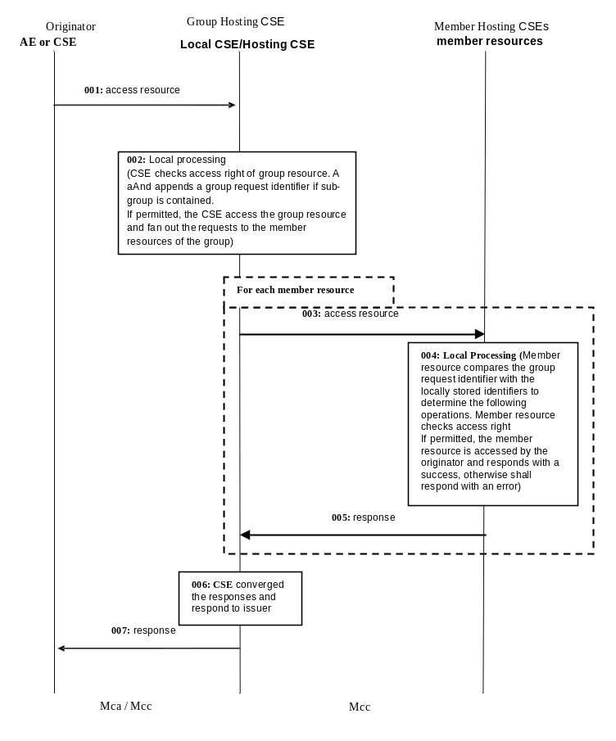

-----------------------Start of change 1-------------------------------------------

9.6.3 Resource Type CSEBase
A <CSEBase> resource shall represent a CSE. The <CSEBase> resource shall be the root for all resources that are residing in the CSE.

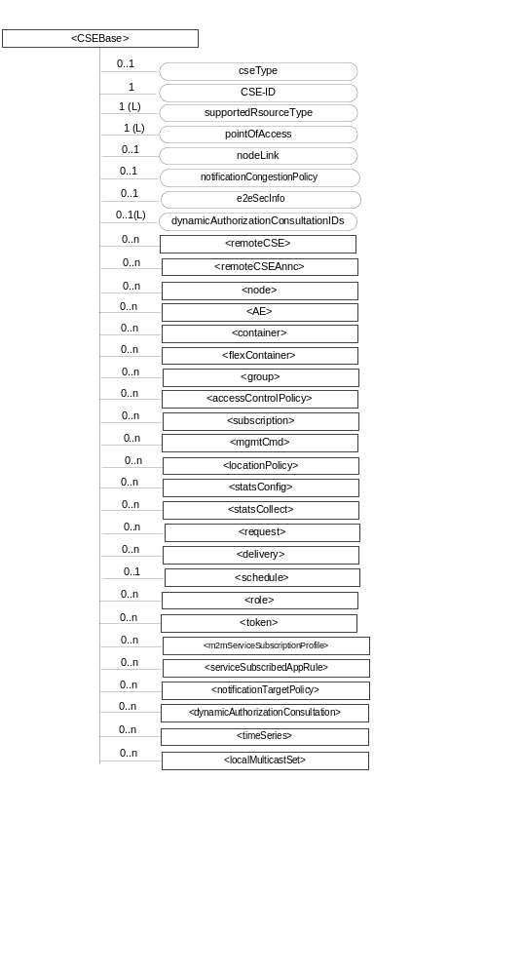
Figure 9.6.3-1: Structure of <CSEBase> resource
Figure 9.6.3-1 does not show the child announce resource types defined in table 9.6.3-2.
The <CSEBase> resource shall contain the child resources specified in table 9.6.3-1.
Table 9.6.3-1: Child resources of <CSEBase> resource
Child Resources of <CSEBase> | Child Resource Type | Multiplicity | Description
[variable] | <remoteCSE> | 0..n | See clause 9.6.4
[variable] | <remoteCSEAnnc> | 0..n | Announced variant of <remoteCSE>. Resource with CSE-specific information for a CSE that announced itself to another CSE with which it does not have a registration relationship.
[variable] | <node> | 0..n | See clause 9.6.18
[variable] | <AE> | 0..n | See clause 9.6.5
[variable] | <container> | 0..n | See clause 9.6.6
[variable] | <flexContainer> | 0..n | See clause 9.6.35
[variable] | <group> | 0..n | See clause 9.6.13
[variable] | <accessControlPolicy> | 0..n | See clause 9.6.2
[variable] | <subscription> | 0..n | See clause 9.6.8
[variable] | <mgmtCmd> | 0..n | See clause 9.6.16
[variable] | <locationPolicy> | 0..n | See clause 9.6.10
[variable] | <statsConfig> | 0..n | See clause 9.6.23
[variable] | <statsCollect> | 0..n | See clause 9.6.25
[variable] | <request> | 0..n | See clause 9.6.12
[variable] | <delivery> | 0..n | See clause 9.6.11
[variable] | <schedule> | 0..1 | This resource defines the reachability schedule information of the entity. The absence of this resource implies the entity is always reachable. See clause 9.6.9
[variable] | <role> | 0..n | See clause 9.6.38
[variable] | <token> | 0..n | See clause 9.6.39
[variable] | <m2mServiceSubscriptionProfile> | 0..n | See clause 9.6.19
[variable] | <serviceSubscribedAppRule> | 0..n | See clause 9.6.29
[variable] | <notificationTargetPolicy> | 0..n | See clause 9.6.32
[variable] | <dynamicAuthorizationConsultation> | 0..n | See clause 9.6.40
[variable] | <timeSeries> | 0..n | See clause 9.6.36
[variable] | <localMulticastSet> | 0..n | See clause 9.6.y

An instance of a <remoteCSEAnnc> resource shall be created as a child of a <CSEBase> resource when an Originator CSE of an announcement request (i.e. original resource Hosting CSE) and a targeted Hosting CSE of an announced resource (i.e. announced resource Hosting CSE) have no registration relationship (e.g. the Originator CSE has not created <remoteCSE> resource on the Hosting CSE), see clause 9.6.26.
The <CSEBase> resource shall contain the attributes specified in table 9.6.3-2.
Table 9.6.3-2: Attributes of <CSEBase> resource
Attributes of <CSEBase> | Multiplicity | RW/  RO/  WO | Description
resourceType | 1 | RO | See clause 9.6.1.3.
resourceID | 1 | RO | See clause 9.6.1.3.
resourceName | 1 | RO | See clause 9.6.1.3.
parentID | 1 | RO | See clause 9.6.1.3. Shall be NULL.
creationTime | 1 | RO | See clause 9.6.1.3.
lastModifiedTime | 1 | RO | See clause 9.6.1.3.
accessControlPolicyIDs | 0..1 (L) | RO | See clause 9.6.1.3.
labels | 0..1 (L) | RO | See clause 9.6.1.3.
dynamicAuthorizationConsultationIDs | 0..1 (L) | RO | See clause 9.6.1.3.
cseType | 0..1 | RO | Indicates the type of CSE represented by the created resource:  - Mandatory for an IN-CSE, hence multiplicity (1).  - Its presence is subject to SP configuration in case of an ASN-CSE or a MN-CSE.
CSE-ID | 1 | RO | The CSE identifier in SP-relative CSE-ID format (clause 7.2).
supportedResourceType | 1 (L) | RO | List of the resource types which are supported in the CSE. This attribute contains subset of resource types listed in clause 9.2.
pointOfAccess | 1 (L) | RO | Represents the list of physical addresses to be used by remote CSEs to connect to this CSE (e.g. IP address, FQDN). This attribute is exposed to its Registree.
nodeLink | 0..1 | RO | The resource identifier of a <node> resource that stores the node specific information of the node on which the CSE represented by this <CSEBase> resource resides.
notificationCongestionPolicy | 0..1 | RO | This attribute applies to CSEs generating subscription notifications. It specifies the rule which is applied when the storage of notifications for each subscriber (an AE or CSE) reaches the maximum storage limit for notifications for that subscriber. E.g. Delete stored notifications of lower notificationStoragePriority to make space for new notifications of higher notificationStoragePriority, or delete stored notifications of older creationTime to make space for new notifications when all notifications are of the same notificationStoragePriority.
e2eSecInfo | 0..1 | RO | See clause 9.6.1.3.

-----------------------End of change 1-------------------------------------------

-----------------------Start of change 2-------------------------------------------

9.6.5 Resource Type AE
An <AE> resource shall represent information about an Application Entity registered to a CSE.

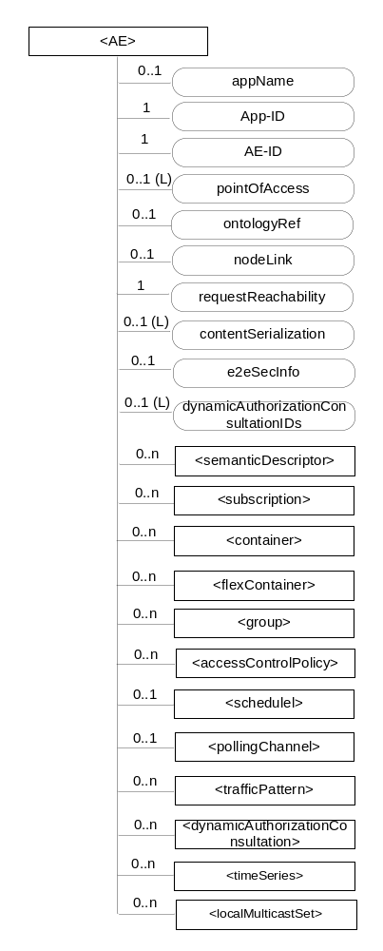
Figure 9.6.5-1: Structure of <AE> resource
The <AE> resource shall contain the child resources specified in table 9.6.5-1.
Table 9.6.5-1: Child resources of <AE> resource
Child Resources of <AE> | Child Resource Type | Multiplicity | Description | <AEAnnc> Child Resource Types
[variable] | <semanticDescriptor> | 0..n | See clause 9.6.30 | <semanticDescriptor>, <semanticDescriptorAnnc>
[variable] | <subscription> | 0..n | See clause 9.6.8 | <subscription>
[variable] | <container> | 0..n | See clause 9.6.6 | <container> <containerAnnc>
[variable] | <flexContainer> | 0..n | See clause 9.6.35 | <flexContainer>  <flexContainerAnnc>
[variable] | <group> | 0..n | See clause 9.6.13 | <group>  <groupAnnc>
[variable] | <accessControlPolicy> | 0..n | See clause 9.6.2 | <accessControlPolicy>  <accessControlPolicyAnnc>
[variable] | <schedule> | 0..1 | See clause 9.6.9 | <scheduleAnnc>
[variable] | <pollingChannel> | 0..1 | See clause 9.6.21  When the AE is request-unreachable, the AE should create this <pollingChannel> resource and perform long polling. The <pollingChannel> shall be utilized by the parent resource | None
trafficPattern | <trafficPattern> | 0..n | See clause 9.6.41 | <trafficPatternAnnc>
[variable] | <dynamicAuthorizationConsultation> | 0..n | See clause 9.6.40 | None
[variable] | <timeSeries> | 0..n | See clause 9.6.36 | <timeSeries>  <timeSeriesAnnc>
[variable] | <localMulticastSet> | 0..n | See clause 9.6.y | None

The <AE> resource shall contain the attributes specified in table 9.6.5-2.
Table 9.6.5-2: Attributes of <AE> resource
Attributes of  <AE> | Multiplicity | RW/  RO/  WO | Description | <AEAnnc> Attributes
resourceType | 1 | RO | See clause 9.6.1.3. | NA
resourceID | 1 | RO | See clause 9.6.1.3. Contains the AE-ID-Stem of the AE (see clause 7.2 on identifier formats and clause 10.1.1.2.2 for AE registration procedure). | NA
resourceName | 1 | WO | See clause 9.6.1.3. | NA
parentID | 1 | RO | See clause 9.6.1.3. | NA
expirationTime | 1 | RW | See clause 9.6.1.3. | MA
accessControlPolicyIDs | 0..1 (L) | RW | See clause 9.6.1.3. | MA
creationTime | 1 | RO | See clause 9.6.1.3. | NA
lastModifiedTime | 1 | RO | See clause 9.6.1.3. | NA
labels | 0..1 (L) | RW | See clause 9.6.1.3. | MA
announceTo | 0..1 (L) | RW | See clause 9.6.1.3. | NA
announcedAttribute | 0..1 (L) | RW | See clause 9.6.1.3. | NA
dynamicAuthorizationConsultationIDs | 0..1 (L) | RW | See clause 9.6.1.3. | OA
appName | 0..1 | RW | The name of the application, as declared by the application developer(e.g. "HeatingMonitoring").  Several sibling resources may share the appName. | OA
App-ID | 1 | WO | The identifier of the Application (see clause 7.1.3). | OA
AE-ID | 1 | RO | The identifier of the Application Entity (see clause 7.1.2). | OA
pointOfAccess | 0..1 (L) | RW | The list of addresses for communicating with the registered Application Entity over Mca reference point via the transport services provided by Underlying Network (e.g. IP address, FQDN, URI). This attribute shall be accessible only by the AE and the Hosting CSE.  If this information is not provided and the <pollingChannel> resource does exist, the AE should use <pollingChannel> resource. Then the Hosting CSE can forward a request to the AE without using the PoA. | OA
ontologyRef | 0..1 | RW | A URI of the ontology used to represent the information that is managed and understood by the AE. | OA
requestReachability | 1 | RW | If the AE that created this <AE> resource can receive a request, this attribute is set to "TRUE" otherwise "FALSE" | OA
nodeLink | 0..1 | RW | The resource identifier of a <node> resource that stores the node specific information of the node on which the AE represented by this <AE> resource resides. | OA
contentSerialization | 0..1 (L) | RW | The list of supported serializations of the Content primitive parameter for receiving a request from its registrar CSE. (e.g. XML, JSON). The list shall be ordered so that the most preferred format comes first. | OA
e2eSecInfo | 0..1 | RW | See clause 9.6.1.3. | MA

-----------------------End of change 2-------------------------------------------

-----------------------Start of change 3-------------------------------------------

9.6.13 Resource Type group
The <group> resource represents a group of resources of the same or mixed types. The <group> resource can be used to do bulk manipulations on the resources represented by the memberIDs attribute. The <group> resource contains an attribute that represents the members of the group and the <fanOutPoint> virtual resource that enables generic operations to be applied to all the resources represented by those members. By grouping <semanticDescriptor> resources across which a semantic description is distributed, another virtual resource (<semanticFanOutPoint>) enables semantic discovery procedures to be applied across the full logical tree in the description.

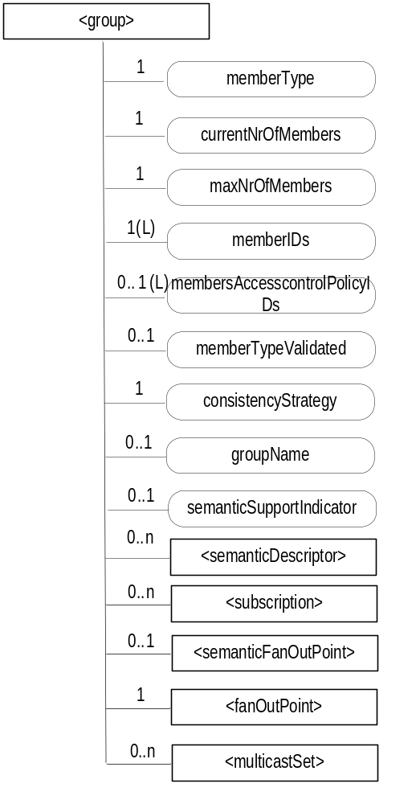
Figure 9.6.13-1: Structure of <group> resource
The <group> resource shall contain the child resources specified in table 9.6.13-1.
Table 9.6.13-1: Child resources of <group> resource
Child Resources of <group> | Child Resource Type | Multiplicity | Description | <groupAnnc> Child Resource Types
[variable] | <semanticDescriptor> | 0..n | See clause 9.6.30 | <semanticDescriptor>, <semanticDescriptorAnnc>
[variable] | <subscription> | 0..n | See clause 9.6.8 | <subscription>
fanOutPoint | <fanOutPoint> | 1 | See clause 9.6.14 | none
semanticFanOutPoint | <semanticFanOutPoint> | 0..1 | See clause 9.6.14a | none
multicastSet | <multicastSet> | 0..n | See clause 9.6.x | none

The <group> resource shall contain the attributes specified in table 9.6.13-2.
Table 9.6.13-2: Attributes of <group> resource
Attributes of  <group> | Multiplicity | RW/  RO/  WO | Description | <groupAnnc> Attributes
resourceType | 1 | RO | See clause 9.6.1.3. | NA
resourceID | 1 | RO | See clause 9.6.1.3. | NA
resourceName | 1 | WO | See clause 9.6.1.3. | NA
parentID | 1 | RO | See clause 9.6.1.3. | NA
expirationTime | 1 | RW | See clause 9.6.1.3. | MA
accessControlPolicyIDs | 0..1 (L) | RW | See clause 9.6.1.3. | MA
labels | 0..1 (L) | RW | See clause 9.6.1.3. | MA
creationTime | 1 | RO | See clause 9.6.1.3. | NA
lastModifiedTime | 1 | RO | See clause 9.6.1.3. | NA
announceTo | 0..1 (L) | RW | See clause 9.6.1.3. | NA
announcedAttribute | 0..1 (L) | RW | See clause 9.6.1.3. | NA
dynamicAuthorizationConsultationIDs | 0..1 (L) | RW | See clause 9.6.1.3. | OA
creator | 0..1 | RO | See clause 9.6.1.3. | NA
memberType | 1 | WO | It is the resource type of the member resources of the group, if all member resources (including the member resources in any sub-groups) are of the same type. Otherwise, it is of type 'mixed'. | OA
currentNrOfMembers | 1 | RO | Current number of members in a group. It shall not be larger than maxNrOfMembers. | OA
maxNrOfMembers | 1 | RW | Maximum number of members in the <group>. | OA
memberIDs | 1 (L) | RW | List of member resource IDs referred to in the remaining of the present document as memberID. Each ID (memberID) should refer to a member resource or a (sub-) <group> resource of the <group>. A <group> resource with an empty member list is allowed. | OA
membersAccessControlPolicyIDs | 0..1 (L) | RW | List of IDs of the <accessControlPolicy> resources defining who is allowed to access the <fanOutPoint> resource. | OA
memberTypeValidated | 0..1 | RO | Denotes if the resource types of all members resources of the group has been validated by the Hosting CSE. In the case that the memberType attribute of the <group> resource is not 'mixed', then this attribute shall be set.. | OA
consistencyStrategy | 1 | WO | This attribute determines how to deal with the <group> resource if the memberType validation fails. Its possible values are  - ABANDON_MEMBER  - ABANDON_GROUP  - SET_MIXED  Which means delete the inconsistent member if the attribute is ABANDON_MEMBER; delete the group if the attribute is ABANDON_GROUP; set the memberType to "mixed" if the attribute is SET_MIXED.  If it is not given by the Originator at the creation procedure, default is " ABANDON_MEMBER " | OA
groupName | 0..1 | RW | Human readable name of the <group>. | OA
semanticSupportIndicator | 0..1 | RO | Indicator of support for sematic discovery functionality via <semanticFanOutPoint>. | OA

-----------------------End of change 3---------------------------------------------

-----------------------Start of change 4-------------------------------------------

9.6.x Resource Type multicastSet
The <multicastSet> resource is used by the group management server, e.g. IN-CSE, to record the mapping relationship between the member resources, the multicast fanout URI, and the multicast address for multicast management in the group resource. One <group> resource may include multiple <multicastSet> child resources.
The <multicastSet> resource shall contain the attributes specified in table 9.6.x-1.
Table 9.6.x-1: Attributes of <multicastSet> resource
Attributes of <multicastSet> | Multiplicity | RW/  RO/  WO | Description | <multicastSetAnnc> Attributes
resourceType | 1 | RO | See clause 9.6.1.3. | NA
resourceID | 1 | RO | See clause 9.6.1.3. | NA
resourceName | 1 | WO | See clause 9.6.1.3. | NA
parentID | 1 | RO | See clause 9.6.1.3. | NA
creationTime | 1 | RO | See clause 9.6.1.3. | NA
lastModifiedTime | 1 | RO | See clause 9.6.1.3. | NA
expirationTime | 1 | RW | See clause 9.6.1.3. | MA
accessControlPolicyIDs | 0..1 (L) | RW | See clause 9.6.1.3. | MA
labels | 0..1 (L) | RW | See clause 9.6.1.3. | MA
dynamicAuthorizationConsultationIDs | 0..1 (L) | RW | See clause 9.6.1.3. | OA
announceTo | 0..1(L) | RW | See clause 9.6.1.3. | NA
announcedAttribute | 0..1(L) | RW | See clause 9.6.1.3. | NA
multicastAddress | 1 | RW | The multicast address allocated to the members in the memberlist. | NA
fanOutURI | 0..1 | RW | The destination URI of the member resource that the access request will be sent to by the group server. This attribute is optional in some cases. For example, when one <group> resource includes only one <multicastSet> resource, and access paths of all member resources on their member devices are the same, the fanOutURI may be definitely obtained from the URI of the member resources in the members attribute directly. In this case, this attribute may be omitted. | NA
addressType | 0..1 | RW | Optional information.it is used to describe that the address type in multicastAddress is IPv4 or IPv6, and other information. | NA
memberList | 0..1(L) | RW | memberList is optional information and used to describe the member resource list involved in the group mapping relationship, that is, the member devices having the member resources and the access paths of the member resources on the member devices. | NA

-----------------------End of change 4---------------------------------------------

-----------------------Start of change 5---------------------------------------------

9.6.y Resource Type localMulticastSet
The <localMulticastSet> resource is used by the M2M nodes to store the multicast group information, after the member resources of the M2M Devices/Gateways have joined the multicast group. <localMulticastSet> could be created as the child resource of either the <CSEBase> resource or the <AE> resource of the M2M nodes. And one M2M node may contain multiple <localMulticastSet> resources.
The <localMulticastSet> resource shall contain the attributes specified in table 9.6.y-1.
Table 9.6.y-1: Attributes of <localMulticastSet> resource
Attributes of <multicastSet> | Multiplicity | RW/  RO/  WO | Description | <multicastSetAnnc> Attributes
resourceType | 1 | RO | See clause 9.6.1.3. | NA
resourceID | 1 | RO | See clause 9.6.1.3. | NA
resourceName | 1 | WO | See clause 9.6.1.3. | NA
parentID | 1 | RO | See clause 9.6.1.3. | NA
creationTime | 1 | RO | See clause 9.6.1.3. | NA
lastModifiedTime | 1 | RO | See clause 9.6.1.3. | NA
expirationTime | 1 | RW | See clause 9.6.1.3. | MA
accessControlPolicyIDs | 0..1 (L) | RW | See clause 9.6.1.3. | MA
labels | 0..1 (L) | RW | See clause 9.6.1.3. | MA
dynamicAuthorizationConsultationIDs | 0..1 (L) | RW | See clause 9.6.1.3. | OA
announceTo | 0..1(L) | RW | See clause 9.6.1.3. | NA
announcedAttribute | 0..1(L) | RW | See clause 9.6.1.3. | NA
multicastAddress | 1 | RW | The multicast address of the multicast group that the local member resrouces in the memberList join. | NA
fanOutURI | 0..1 | RW | The fanOutURI corresponds to the multicast group that the local member resrouces in the memberList join. | NA
memberList | 0..1(L) | RW | A local member resource list corresponds to the fanOutURI. It may be a complete URI of local member resources or store only access paths of local member resources on the member device. | NA

-----------------------End of change 5---------------------------------------------

-----------------------Start of change 6-------------------------------------------

10.2.7.x1 <multicastSet> and <localMulticastSet> Management Procedures
Figure 10.2.7.x1-1 illustrates how the <multicastSet> and <localMulticastSet> resource works on the group Hosting CSE and the group members hosting CSEs.
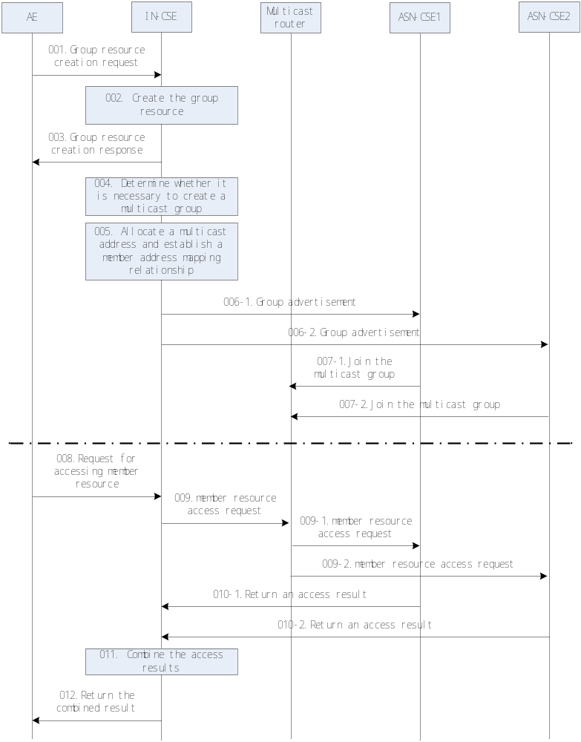
Figure 10.2.7.x1-1: Multicast resource related procedures
001: A network application AE requests to create a group resource Grp1 on an M2M platform IN-CSE, and sends a group resrouce creation request to IN-CSE. For example, the member resources m11, m12, m21 and m22 are respectively located on two M2M devices ASN-CSE1 and ASN-CSE2. The access path of the member resources are:
m11 = coap://d1.example.org/xx/aa
m12 = coap://d1.example.org/yy/bb
m21 = coap://d2.example.org/xx/aa
m22 = coap://d2.example.org/yy/bb
002: The IN-CSE creates the group resource Grp1 locally.
003: The IN-CSE return the group creation success response to the AE.
004: The IN-CSE parses the group resource creation request to obtain descriptions of characteristics of the group resource and descriptions of characteristics of the member resources thereof, including but not limited to characteristics such as the type attribute of the group resource (being a static, dynamic, or temporary group or not), the access paths of the member resources on the member devices, access interfaces of the member resources, the member devices having the member resources, and network features thereof (supporting multicast or not). Then the IN-CSE determines whether it is necessary to create a multicast group, based on the local configured criteria. Considering the IP multicast technical requirement and the multicast group maintenance overheads, only for the group that is relatively static, the access interfaces of the group member resources are consistent, the network to which the member devices having the member resources belong support multicast, and the quantity of the member devices having the member resources meeting the foreging conditions reaches a particular quantity, it is recommende to create multicast group. If the IN-CSE determines to create multicast group, then perform the following steps, otherwise, end the process.
005:The IN-CSE allocates a multicast address to the member resources according to the member devices having the member resources and the access paths of the member resources on the member devices, and establish a mapping relationship between the multicast address and the fanout URI according to the access paths of the member resources on the member devices. For a guide to an allocation scheme of IPv4 and IPv6 multicast address spaces, reference may be made to standard documents such as [RFC 3171] and [RFC 4291]. As a result, the IN-CSE create one or more <multicastSet> resources as the child resources of the group resource Grp1 requested by AE. In this example, the attributes of the <multicastSet> resources are illustrated in table 10.2.7.x1-1. Each <multicastSet> resource can be seen as a multicast group.
Table 10.2.7.x1-1: Group resource mapping
Group resource | multicastSet | Member list | Multicast address | fanout URI
Grp1 | multicastSet1 | m11, m21 | [FF32:30:3FFE:FFFF:1::1234] | xx/aa
Grp1 | multicastSet2 | m12, m22 | [FF32:30:3FFE:FFFF:1::1234] | yy/bb

006: The IN-CSE sends a group advertisement for joining a multicast group to the member devices ASN-CSE1 and ASN-CSE2 to instruct ASN-CSE1 and ASN-CSE2 to join the multicast group corresponding to the multicast address. The IN-CSE needs to respectively send a group advertisement for joining a multicast group to member devices corresponding to member resources in each mapping relationship having a fanout URI. In this example, the IN-CSE should send two group advertisement messages for xx/aa and yy/bb to ASN-CSE1 and ASN-CSE2 seperately. The group advertisement for joining the multicast group includes the multicast address, the fanout URI and the member resources. The group advertisement can be sent by different transmission protocol (for example, HTTP, CoAP, or SIP), and the message format itself may also use different encapsulation modes (for example, XML or binary encoding).
007: The member devices ASN-CSE1 and ASN-CSE2 use a multicast management protocol such as MLD or IGMP according to the method of the prior art to join the multicast group corresponding to the multicast address indicated in the multicast group advertisement. In this embodiment, assuming a local multicast router is shared by ASN-CSE1 and ASN-CSE2, ASN-CSE1 and ASN-CSE2 respectively send an MLD/IGMP report command to the multicast router to join the corresponding multicast group. As a result of this step, the both ASN-CSE1 and ASN-CSE2 create two <localMulticastSet> resources to record to which multicast group its local member resources have joined.
Table 10.2.7.x1-2: localMulticastSet resource in ASN-CSE1
localMulticastSet | Member list | Multicast address | fanout URI
localMulticastSet1 | m11 | [FF32:30:3FFE:FFFF:1::1234] | xx/aa
localMulticastSet2 | m12 | [FF32:30:3FFE:FFFF:1::1234] | yy/bb

008: The network application AE sends a request for accessing member resources to IN-CSE, asking to access member resources m11 and m21 in the group resource Grp1.
009: The IN-CSE determines, according to the group resource identifier Grp1, that a multicast mapping relationship is established for the member resources m11 and m21, constructs a member resource access request, and sends the member resource access request in multicast mode to the multicast address in the mapping relationship (namely, the multicast address).
009-1 and 009-2: Because the multicast router knows, in steps 007-1 and 007-2 that the member devices ASN-CSE1 and ASN-CSE2 have joined the multicast group corresponding to the multicast address, the multicast access request is forwarded to a local link.
010: The member devices ASN-CSE1 and ASN-CSE2 receive the multicast access request, and access the local member resources m11 and m21 indicated in the request, and then return access results to IN-CSE.
011: The IN-CSE combines the group member resource access results received from ASN-CSE1 and ASN-CSE2.
012: The IN-CSE returns the combined group member resource access result to the network application AE.

10.2.7.x2 <multicastSet> overview
Because the originator of the group creation doesn't need to know the capability of underlying network, the creation of the multicast group is implemented by the gourp management server and the group management server (e.g. IN-CSE) expose the retrieve, delete operations of the <multicastSet> resource.

10.2.7.x3 Retrieve <multicastSet>
This procedure shall be used for retrieving <multicastSet> resource.
Table 10.2.7.x3-1: <multicastSet> RETRIEVE
<multicastSet> RETRIEVE
Associated Reference Point | Mcc, Mca and Mcc'
Information in Request message | From: Identifier of the AE or the CSE that initiates the Request  To: The address of the <multicastSet> resource
Processing at Originator before sending Request | The Originator shall request to obtain <multicastSet> resource information by using the RETRIEVE operation. The request shall address the specific <multicastSet> resource of a Hosting CSE. The Originator may be an AE or a CSE
Processing at Receiver | No change from the basic procedure in clause 10.1.2
Information in Response message | No change from the basic procedure in clause 10.1.2
Processing at Originator after receiving Response | None
Exceptions | No change from the basic procedure in clause 10.1.2

10.2.7.x4 Delete <multicastSet>
This procedure shall be used for deleting an existing <multicastSet> resource.
Table 10.2.7.x4-1: <multicastSet> DELETE
<multicastSet> DELETE
Associated Reference Point | Mcc, Mca and Mcc'
Information in Request message | From: Identifier of the AE or the CSE that initiates the Request  To: The address of the <multicastSet> resource
Processing at Originator before sending Request | The Originator shall request to delete an existing <multicastSet> resource by using the DELETE operation. The request shall address the specific <multicastSet> resource of a Hosting CSE. The Originator may be an AE or a CSE.
Processing at Receiver | No change from the basic procedure in clause 10.1.4
Information in Response message | No change from the basic procedure in clause 10.1.4
Processing at Originator after receiving Response | None
Exceptions | No change from the basic procedure in clause 10.1.4

10.2.7.x5 <localMulticastSet> overview
Create and delete operations of <localMulticastSet> resource are used by the group management server to notice the group members to join or leave the multicast group.

10.2.7.x6 Create <localMulticastSet>
This procedure shall be used for creating <localMulticastSet> resource.
Table 10.2.7.x6-1: <localMulticastSet> CREATE
<localMulticastSet> CREATE
Associated Reference Point | Mcc, Mca and Mcc'
Information in Request message | From: Identifier of the AE or the CSE that initiates the Request  To: The address of the <AE>, or <remoteCSE> where the <localMulticastSet> resource is intended to be Created  Content: The representation of the <localMulticastSet> resource for which the attributes are described in clause 9.6.13
Processing at Originator before sending Request | The Originator should be a group management server. The <multicastSet> resource should be created inside the group management server first, and then the group management server notice the group members to join the multicast group using the CREATE operation.
Processing at Receiver | Besides the basic procedures decribed in clause 10.1.1.1, the receiver shall also comply with the multicast management protocol such as MLD or IGMP to join the multicast group.
Information in Response message | According to clause 10.1.1.1.
Processing at Originator after receiving Response | None
Exceptions | If the Receiver responds with an error, the originator should delete the receiver’s information from the <multicastSet> resource locally stored.

10.2.7.x7 Delete <localMulticastSet>
This procedure shall be used for deleting an existing <localMulticastSet> resource.
Table 10.2.7.x7-1: <localMulticastSet> DELETE
<localMulticastSet> DELETE
Associated Reference Point | Mcc, Mca and Mcc'
Information in Request message | From: Identifier of the AE or the CSE that initiates the Request  To: The address of the <localMulticastSet> resource
Processing at Originator before sending Request | The Originator shall request to delete an existing <localMulticastSet> resource by using the DELETE operation. The request shall address the specific <group> resource of a Hosting CSE. The Originator may be an AE or a CSE.
Processing at Receiver | No change from the basic procedure in clause 10.1.4
Information in Response message | No change from the basic procedure in clause 10.1.4
Processing at Originator after receiving Response | None
Exceptions | No change from the basic procedure in clause 10.1.4

-----------------------End of change 6---------------------------------------------

CHECK LIST
- Does this change request include an informative introduction containing the problem(s) being solved, and a summary list of proposals.?
- Does this CR contain changes related to only one particular issue/problem?
- Have any mirror crs been posted?
- Does this change request make all the changes necessary to address the issue or problem? E.g. A change impacting 5 tables should not only include a proposal to change only 3 tables. Includes any changes to references, definitions, and acronyms in the same deliverable?
- Does this change request follow the drafting rules?
- Are all pictures editable?
- Have you checked the spelling and grammar?
- Have you used change bars for all modifications?
- Does the change include the current and surrounding clauses to clearly show where a change is located and to provide technical context of the proposed change? (Additions of complete sections need not show surrounding clauses as long as the proposed section number clearly shows where the new section is proposed to be located.)
- Are multiple changes in this CR clearly separated by horizontal lines with embedded text such as, start of change 1, end of change 1, start of new clause, end of new clause.?

