CHANGE REQUEST
Meeting:* | ARC 25
Source:* | KT
Date:* | 2015-10-21
Contact:* | Francisco Sang-Eon Kim, kim.sangeon@kt.com
Reason for Change/s:* | An ‘e2eSecInfo’ should not stored as normal resource for security aspect.
CR against: Release* | Release 2
CR against: WI* | Active <Work Item number>  MNT Maintenace / < Work Item number(optional)>  STE Small Technical Enhancements / < Work Item number (optional)>  Only ONE of the above shall be ticked
CR against: TS/TR* | TS-0001-V2.10.1
Clauses/Sub Clauses* | 9.6.1.3.2 Common attributes  9.6.3 Resource Type CSEBase  9.6.4 Resource Type remoteCSE  9.6.5 Resource Type AE
Type of change: * | Editorial change  Bug Fix or Correction  Change to existing feature or functionality  New feature or functionality  Only ONE of the above shall be ticked
Post Freeze checking:* | This CR contains only essential changes and corrections? YES NO  This CR may break backwards compatibility with the last approved version of the TS? YES NO  This CR is a mirror CR? YES if YES, please indicate the document number of the original CR: <Document Number) : NO
Template Version:27 May 2015 (Dot not modify)

oneM2M Notice
The document to which this cover statement is attached is submitted to oneM2M. Participation in, or attendance at, any activity of oneM2M, constitutes acceptance of and agreement to be bound by terms of the Working Procedures and the Partnership Agreement, including the Intellectual Property Rights (IPR) Principles Governing oneM2M Work found in Annex 1 of the Partnership Agreement.
GUIDELINES for Change Requests:
Provide an informative introduction containing the problem(s) being solved, and a summary list of proposals.
Each CR should contain changes related to only one particular issue/problem.
In case of a correction, and the change apply to previous releases, a separated “mirror CR” should be posted at the same time of this CR
Follow the principle of completeness, where all changes related to the issue or problem within a deliverable are simultaneously proposed to be made E.g. A change impacting 5 tables should not only include a proposal to change only 3 tables. Includes any changes to references, definitions, and acronyms in the same deliverable.
Follow the drafting rules.
All pictures must be editable.
Check spelling and grammar to the extent practicable.
Use Change bars for modifications.
The change should include the current and surrounding clauses to clearly show where a change is located and to provide technical context of the proposed change. Additions of complete sections need not show surrounding clauses as long as the proposed section number clearly shows where the new section is proposed to be located.
Multiple changes in a single CR shall be clearly separated by horizontal lines with embedded text such as, start of change 1, end of change 1, start of new clause, end of new clause.
When subsequent changes are made to content of a CR, then the accepted version should not show changes over changes. The accepted version of the CR should only show changes relative to the baseline approved text.

Introduction
The ARC-2016-0443 concludes e2eSecInfo is not just an attributes. This security information should be stored secured environment not just as a normal resouces.
To resolve this issues, two possible solution can be considered.
First, define e2eSecInfoRef as an attribute. An e2eSecInfoRef attribute is a reference to e2eSecInfo which is stored in secured environment.
Second, e2eSecInfo defined as a virtual resource based on clause 8.4.3.1 in TS-0003. The second approach is proposed at ARC-2016-0443
This contribution is about e2eSecInfoRef attribute
A definition of e2eSecInfoRef is that “e2eSecInfoRef is a reference to end-to-end security information (e2eSecInfo) which is stored at secure environment (e.g. UICC). An AE or CSE may represent e2eSecInfoRef which indicates the end-to-end security capabilities supported by the AE or CSE. It may indicate supported end-to-end security frameworks. It may also contains a certificate or credential identifier used by the AE or CSE. It may include random values for use in end-to-end security protocols. The details of this attributes are specified at clause 8.4.3.1 in oneM2M TS-0003 [Error: Reference source not found].”
A change request is that e2eSecInfoRef is applied to common attributes at clause 9.6.1.3.2 and change from e2eSecInfo to e2eSecInfoRef at clause 9.6.3 CSEBase, remoteCSE and AE
R02 brings mainly two clarifications: sensitiveness of e2eSecInfo, how to use e2eSecInfoRef attribute
First, e2eSecInfo shall be considered sentative data by referring to clause 8.4.3.1.3 in TS-0003-V2.4.1

8.4.3.1 End-to-End Security of Primitives (ESPrim) Parameter Definitions

8.4.3.1.1 originatorESPrimRandObject parameter definition
The structure of the originator2ERandObject parameter is shown in Table 8.4.3.1.1-1. This parameter is used in establishing sessionESPrimKey as part of End-to-End Security of Primitives (ESPrim), described in clause 8.4.2. The data type of the originatorESPrimRandObject parameter is specified in clause oneM2M TS-0004 [Error: Reference source not found].
Table 8.4.3.1.1-1: Structure of the originatorESPrimRandObject parameter
Element Path | Multiplicity | Description
esprimRandID | 1 | An identifier for the originatorESPrimRandObject, assigned by the CSE or AE generating the originatorESPrimRandObject
esprimRandValue | 1 | A 128-bit randomly-generated value.
esprimRandExpiry | 1 | Time when the originatorESPrimRandObject expires
esprimKeyGenAlgID | 1 | The enumerated identifier of the algorithm selected for sessionESPrimKey generation by the CSE or AE generating the originatorESPrimRandObject
esprimProtocolAndAlgIDs | 1 | A list of enumerated identifiers for AEAD Algorithms supported by the CSE or AE generating the originatorESPrimRandObject

8.4.3.1.2 receiverESPrimRandObject parameter definition
The structure of the receiver2ERandObject parameter is shown in Table 8.4.3.1.2-1. This parameter is used in establishing sessionESPrimKey as part of End-to-End Security of Primitives (ESPrim), described in clause 8.4.2. The data type of the receiverESPrimRandObject parameter is specified in oneM2M TS-0004 [Error: Reference source not found].
Table 8.4.3.1.2-1: Structure of the receiverESPrimRandObject parameter
Element Path | Multiplicity | Description
esprimRandID | 1 | An identifier for the receiverESPrimRandObject, assigned by the CSE or AE generating the receiverESPrimRandObject
esprimRandValue | 1 | A 128-bit randomly-generated value.
esprimRandExpiry | 1 | Time when the receiverESPrimRandObject expires.
esprimKeyGenAlgIDs | 1 | A list of enumerated identifiers for algorithms supported for sessionESPrimKey generation by the CSE or AE generating the receiverESPrimRandObject
esprimProtocolAndAlgIDs | 1 | A list of enumerated identifiers for AEAD Algorithms supported by the CSE or AE generating the receiverESPrimRandObject

8.4.3.1.3 e2eSecInfo resource attribute definition
The e2eSecInfo attribute occurs in the <CSEBase>, <remoteCSE> and <AE> resource types. The structure of the e2eSecInfo resource attribute is shown in Table 8.4.3.1.3-1. This parameter is used in establishing sessionESPrimKey as part of End-to-End Security of Primitives (ESPrim), described in clause 8.4.2. The data types are specified in TS-0004 [Error: Reference source not found].
Table 8.4.3.1.3-1: Structure of the e2eSecInfo attribute
Element Path | Multiplicity | Description
supportedE2ESecurityFeatures | 1 | A list of Security Usage Identifiers (SUIDs) for the End-to-End Security Features supported by the CSE or AE associated with the <CSEBase>, <remoteCSE> or <AE> resource containing the e2eSecInfo resource attribute.
e2ECertificates | 0..1 | A list of certificates associated with the CSE or AE associated with the <CSEBase>, <remoteCSE> or <AE> resource containing the e2eSecInfo resource attribute.
sharedReceiverESPrimRandObject | 0..1 | A receiverESPrimRandObject parameter (see clause 8.4.3.1.2) generated by the CSE or AE associated with the <CSEBase>, <remoteCSE> or <AE> resource containing the e2eSecInfo resource attribute.

On the other hand, e2eSecInfo specified at clause 6.2.1.1 in TS-0004-V2.8.0

m2m:e2eSecInfo
Used for the e2eSecInfo attribute of the <CSEBase>, <AE> and <remoteCSE> resources.
Table 6.3.5.52-1: Type Definition of m2m:e2eSecInfo
Element Path | Element Data Type | Multiplicity | Note
supportedE2ESecFeatures | List of m2m:suid | 1 | See clause Error: Reference source not found
certificates | List of xs:base64Binary | 0..1
sharedReceiverESPrimRandObject | m2m:receiverESPrimRandObject | 0..1 | See clause Error: Reference source not found

Therefore, e2eSecInfo has supportedE2ESecurityFeatures, e2ECertificates, sharedReceiverESPrimRandObject parameters both TS-0003 and TS-0004.
The Protocol WG is missing that sharedReceiverESPrimRandObject consist of esprimRandID, esprimRandValue, esprimRandExpiry, esprimKeyGenAlgIDs and esprimProtocolAndAlgIDs
TS-0003 specifies esprimRandID, esprimRandValue, esprimRandExpiry, esprimKeyGenAlgIDs and esprimProtocolAndAlgIDs for sharedReceiverESPrimRandObject which is clearly described at Table 8.4.3.1.3-1 in TS-0003.

Therefore, e2eSecInfo attribute can be considered as following figure for the architecture perspective.
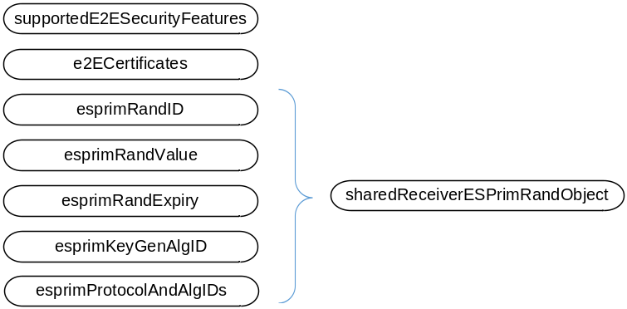
An esprim stands for End-to-End Security of Primitives. The esprim related information is very sentative in my mind.
esprimRandID is an identifier for the receiverESPrimRandObject, assigned by the CSE or AE generating the receiverESPrimRandObject
esprimRandValue is a 128-bit randomly-generated value.
esprimRandExpiry is a time when the receiverESPrimRandObject expires.
esprimKeyGenAlgIDs is a list of enumerated identifiers for algorithms supported for sessionESPrimKey generation by the CSE or AE generating the receiverESPrimRandObject
esprimProtocolAndAlgIDs is a list of enumerated identifiers for AEAD Algorithms supported by the CSE or AE generating the receiverESPrimRandObject
Are these parameters (esprimRandID, esprimRandValue, esprimRandExpiry, esprimKeyGenAlgIDs, esprimProtocolAndAlgIDs) sentative or not?

Second, how to use e2eSecInfoRef
Current TS-0001 has store e2eSecInfo under the existing resource as following figure.
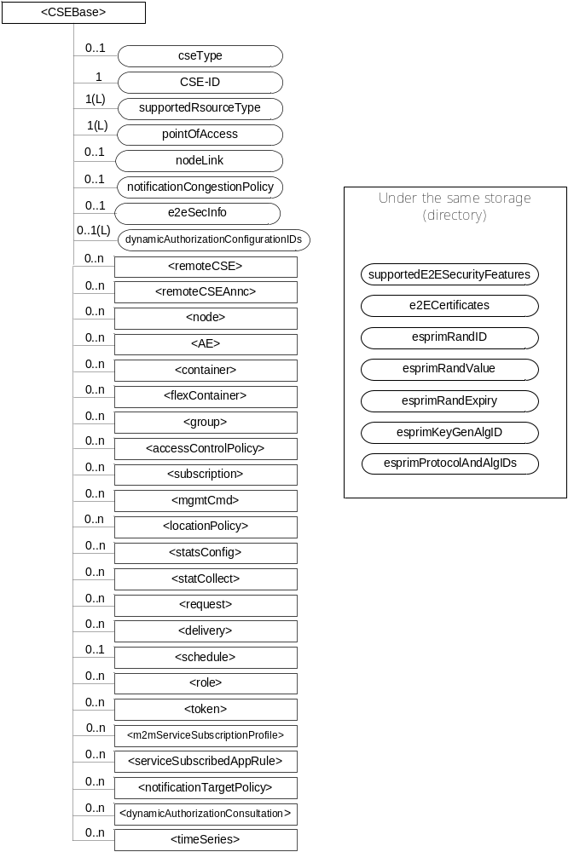
For example, an e2eSecInfoRef is used for an information to indicate e2eSecInfo
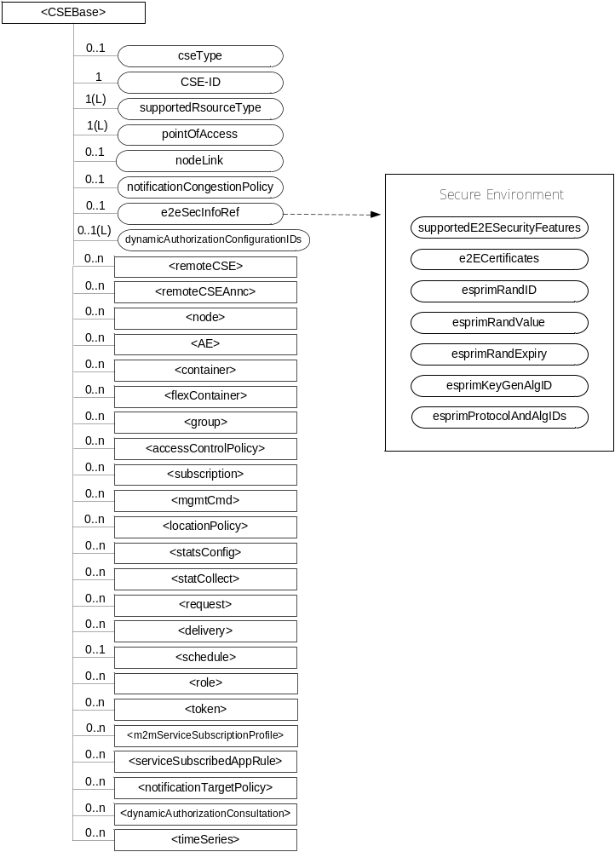

-----------------------Start of change 1-------------------------------------------

9.6.1.3.2 Common attributes
The following attributes are commonly used in multiple, but not all, resource types which are normal, not virtual or announced. Common attributes for announced resource types are independently defined in claused 9.6.26.3.
NOTE: The list of attributes in table 9.6.1.3.2-1 is not exhaustive.
Table 9.6.1.3.2-1: Common Attributes
Attribute Name | Description
accessControlPolicyIDs | The attribute contains a list of identifiers of an <accessControlPolicy> resource. The privileges defined in the <accessControlPolicy> resource that are referenced determine who is allowed to access the resource containing this attribute for a specific purpose (e.g. Retrieve, Update, Delete, etc.).  If a resource type does not have an accessControlPolicyIDs attribute definition, then the accessControlPolicyIDs for that resource is governed in a different way, for example, the accessControlPolicy associated with the parent may apply to a child resource that does not have an accessControlPolicyIDs attribute definition, or the privileges for access are fixed by the system. Refer to the corresponding resource type definitions and procedures to see how access control is handled in such cases.  If a resource type does have an accessControlPolicyIDs attribute definition, but the (optional) accessControlPolicyIDs attribute is not set, or it is set to a value that does not correspond to a valid, existing <accessControlPolicy> resource, or it refers to an <accessControlPolicy> resource that is not reachable (e.g. because it is located on a remote CSE that is offline or not reachable), then the system default access privileges shall apply.  All resources are accessible if and only if the privileges (i.e. shored as privileges or selfPrivileges attribute of <accessControlPolicy> resource) allow it, therefore all resources shall have an associated accessControlPolicyIDs attribute, either explicitly (setting the attribute in the resource itself) or implicitly (either by using the parent privileges or the system default policies). Which means that the system shall provide a default access privileges in case that the Originator does not provide a specific accessControlPolicyIDs during the creation of the resource.  To update this attribute, a Hosting CSE shall check whether an Originator has Update permission in any selfPrivileges of the <accessControlPolicy> resources which this attribute originally indicates.
stateTag | An incremental counter of modification on the resource. When a resource is created, this counter is set to 0, and it will be incremented on every modification of the resource (see notes 1 and 2).
announceTo | This attribute may be included in a CREATE or UPDATE Request in which case it contains a list of addresses/CSE-IDs where the resource is to be announced. For the case that CSE-IDs are provided, the announced-to CSE shall decide the location of the announced resources based on the rules described in clause 9.6.26.  For the original resource, this attribute shall only be present if it has been successfully announced to other CSEs. This attribute maintains the list of the resource addresses to the successfully announced resources. Updates on this attribute will trigger new resource announcement or de-announcement.  If announceTo attribute includes resource address(s), the present document does not provide any means for validating these address(s) for announcement purposes. It is the responsibility of the Hosting-CSE referenced by the resource address(s) to validate the access privileges of the originator of the Request that triggers the announcement.
announcedAttribute | This attributes shall only be present at the original resource if some Optional Announced (OA) type attributes have been announced to other CSEs. This attribute maintains the list of the announced Optional Attributes (OA type attributes) in the original resource. Updates to this attribute will trigger new attribute announcement if a new attribute is added or de-announcement if the existing attribute is removed.
labels | Tokens used to add meta-information to resources.  This attribute is optional.  The value of the labels attribute is a list of individual labels, each of them being:  - Either a standalone label-key, used as a simple "tag", that can be used for example for discovery purposes when looking for particular resources that one can "tag" using that label-key  - Or a composite element made of a label-key and a label-value, separated by a special character defined in [3]. A label-key itself can consist of several sub-elements, separated by a special character also defined in [3].  The list of allowed characters in a label (and in label-keys and label-values) and separator characters is defined in [3], clause 6.3.3.
e2eSecInfoRef | e2eSecInfoRef is a reference to end-to-end security information (e2eSecInfo) which is stored at secure environment (e.g. UICC). An AE or CSE may represent e2eSecInfoRef which indicates the end-to-end security capabilities supported by the AE or CSE. It may indicate supported end-to-end security frameworks. It may also contains a certificate or credential identifier used by the AE or CSE. It may include random values for use in end-to-end security protocols. The details of this attributes are specified at clause 8.4.3.1 in oneM2M TS-0003 [Error: Reference source not found].  This attribute is optional and if not present it means that the represented entity does not support oneM2M end-to-end security procedures.
dynamicAuthorizationConsultationIDs | This attribute contains a list of identifiers of <dynamicAuthorizationConsultation> resources. The information defined in a <dynamicAuthorizationConsultation> resource is used by a CSE for initiating consultation-based dynamic authorization requests.  Consultation-based dynamic authorization is only performed for a targeted resource if and only if it is linked to an enabled <dynamicAuthorizationConsultation> resource.  If the attribute is not set or has a value that does not correspond to a valid <dynamicAuthorizationConsultation> resource(s), or it refers to an <dynamicAuthorizationConsultation> resource(s) that is not reachable, then the dynamicAuthorizationConsultationIDs associated with the parent may apply to the child resource if present, or a system default <dynamicAuthorizationConsultation> may apply if present.
creator | The AE-ID or CSE-ID of the entity which created the resource containing this attribute.
NOTE 1: In order to enable detection of overflow, the counter needs to be capable of expressing sufficiently long numbers.
NOTE 2: This attribute has the scope to allow identifying changes in resources within a time interval that is lower than the one supported by the attribute lastModifiedTime (e.g. less than a second or millisecond). This attribute can also be used to avoid race conditions in case of competing modifications.

-----------------------End of change 1---------------------------------------------

-----------------------Start of change 2---------------------------------------------

9.6.3 Resource Type CSEBase
A <CSEBase> resource shall represent a CSE. The <CSEBase> resource shall be the root for all resources that are residing in the CSE.
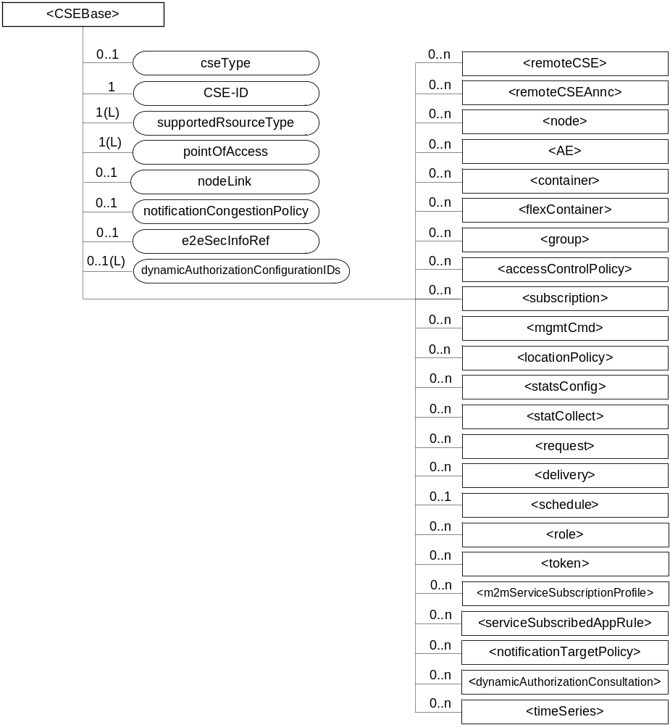
Figure 9.6.3-1: Structure of <CSEBase> resource
Figure 9.6.3-1 does not show the child announce resource types defined in table 9.6.3-2.
The <CSEBase> resource shall contain the child resources specified in table 9.6.3-1.
Table 9.6.3-1: Child resources of <CSEBase> resource
Child Resources of <CSEBase> | Child Resource Type | Multiplicity | Description
[variable] | <remoteCSE> | 0..n | See clause 9.6.4
[variable] | <remoteCSEAnnc> | 0..n | Announced variant of <remoteCSE>. Resource with CSE-specific information for a CSE that announced itself to another CSE with which it does not have a registration relationship.
[variable] | <node> | 0..n | See clause 9.6.18
[variable] | <AE> | 0..n | See clause 9.6.5
[variable] | <container> | 0..n | See clause 9.6.6
[variable] | <flexContainer> | 0..n | See clause 9.6.35
[variable] | <group> | 0..n | See clause 9.6.13
[variable] | <accessControlPolicy> | 0..n | See clause 9.6.2
[variable] | <subscription> | 0..n | See clause 9.6.8
[variable] | <mgmtCmd> | 0..n | See clause 9.6.16
[variable] | <locationPolicy> | 0..n | See clause 9.6.10
[variable] | <statsConfig> | 0..n | See clause 9.6.23
[variable] | <statsCollect> | 0..n | See clause 9.6.25
[variable] | <request> | 0..n | See clause 9.6.12
[variable] | <delivery> | 0..n | See clause 9.6.11
[variable] | <schedule> | 0..1 | This resource defines the reachability schedule information of the entity. The absence of this resource implies the entity is always reachable. See clause 9.6.9
[variable] | <role> | 0..n | See clause 9.6.38
[variable] | <token> | 0..n | See clause 9.6.39
[variable] | <m2mServiceSubscriptionProfile> | 0..n | See clause 9.6.19
[variable] | <serviceSubscribedAppRule> | 0..n | See clause 9.6.29
[variable] | <notificationTargetPolicy> | 0..n | See clause 9.6.32
[variable] | <dynamicAuthorizationConsultation> | 0..n | See clause 9.6.40
[variable] | <timeSeries> | 0..n | See clause 9.6.36

An instance of a <remoteCSEAnnc> resource shall be created as a child of a <CSEBase> resource when an Originator CSE of an announcement request (i.e. original resource Hosting CSE) and a targeted Hosting CSE of an announced resource (i.e. announced resource Hosting CSE) have no registration relationship (e.g. the Originator CSE has not created <remoteCSE> resource on the Hosting CSE), see clause 9.6.26.
The <CSEBase> resource shall contain the attributes specified in table 9.6.3-2.
Table 9.6.3-2: Attributes of <CSEBase> resource
Attributes of <CSEBase> | Multiplicity | RW/  RO/  WO | Description
resourceType | 1 | RO | See clause 9.6.1.3.
resourceID | 1 | RO | See clause 9.6.1.3.
resourceName | 1 | RO | See clause 9.6.1.3.
parentID | 1 | RO | See clause 9.6.1.3. Shall be NULL.
creationTime | 1 | RO | See clause 9.6.1.3.
lastModifiedTime | 1 | RO | See clause 9.6.1.3.
accessControlPolicyIDs | 0..1 (L) | RO | See clause 9.6.1.3.
labels | 0..1 (L) | RO | See clause 9.6.1.3.
dynamicAuthorizationConsultationIDs | 0..1 (L) | RO | See clause 9.6.1.3.
cseType | 0..1 | RO | Indicates the type of CSE represented by the created resource:  - Mandatory for an IN-CSE, hence multiplicity (1).  - Its presence is subject to SP configuration in case of an ASN-CSE or a MN-CSE.
CSE-ID | 1 | RO | The CSE identifier in SP-relative CSE-ID format (clause 7.2).
supportedResourceType | 1 (L) | RO | List of the resource types which are supported in the CSE. This attribute contains subset of resource types listed in clause 9.2.
pointOfAccess | 1 (L) | RO | Represents the list of physical addresses to be used by remote CSEs to connect to this CSE (e.g. IP address, FQDN). This attribute is exposed to its Registree.
nodeLink | 0..1 | RO | The resource identifier of a <node> resource that stores the node specific information of the node on which the CSE represented by this <CSEBase> resource resides.
notificationCongestionPolicy | 0..1 | RO | This attribute applies to CSEs generating subscription notifications. It specifies the rule which is applied when the storage of notifications for each subscriber (an AE or CSE) reaches the maximum storage limit for notifications for that subscriber. E.g. Delete stored notifications of lower notificationStoragePriority to make space for new notifications of higher notificationStoragePriority, or delete stored notifications of older creationTime to make space for new notifications when all notifications are of the same notificationStoragePriority.
e2eSecInfoRef | 0..1 | RO | See clause 9.6.1.3.

-----------------------End of change 2---------------------------------------------

-----------------------Start of change 3---------------------------------------------

9.6.4 Resource Type remoteCSE
A <remoteCSE> resource shall represent a Registree CSE that is registered to the Registrar CSE. <remoteCSE> resources shall be located directly under the <CSEBase> resource of Registrar CSE.
Similarly <remoteCSE> resource shall also represent a Registrar CSE. <remoteCSE> resource shall be located directly under the <CSEBase> resource of Registree CSE.
For example, when CSE1 (Registree CSE) registers with CSE2 (Registrar CSE), there will be two <remoteCSE> resources created: one in CSE1: <CSEBase1>/<remoteCSE2> and one in CSE2: <CSEBase2>/<remoteCSE1>.
Note that the creation of the two resources does not imply mutual registration. The <CSEBase1>/<remoteCSE2> does not mean CSE2 registered with CSE1 in the example above.
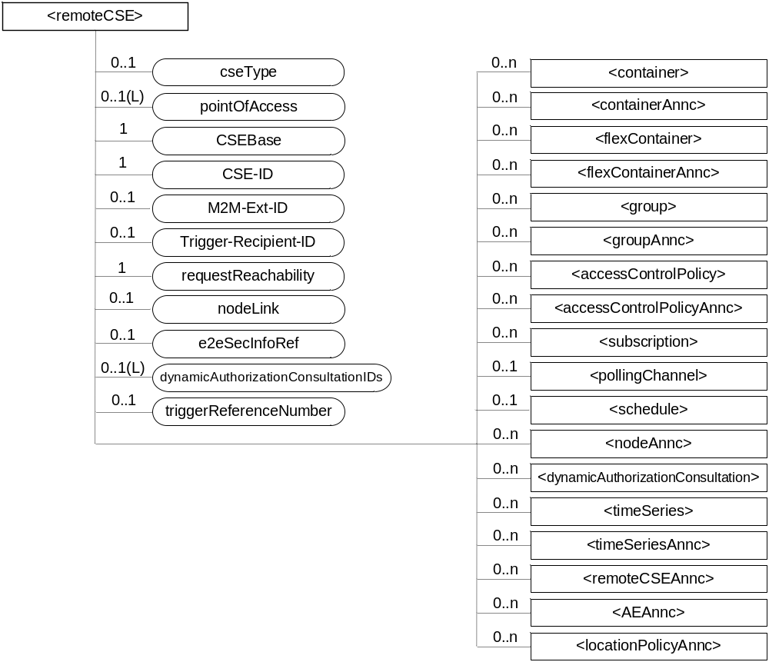
Figure 9.6.4-1: Structure of <remoteCSE> resource
The <remoteCSE> resource shall contain the child resources specified in table 9.6.4-1. The <remoteCSE> resource may contain <remoteCSEAnnc> child resources.
Table 9.6.4-1: Child resources of <remoteCSE> resource
Child Resources of <remoteCSE> | Child Resource Type | Multiplicity | Description | <remoteCSEAnnc> Child Resource Types
[variable] | <container> | 0..n | See clause 9.6.6 | <container>
[variable] | <containerAnnc> | 0..n | Announced variant of <container>. See clause 9.6.6 | <containerAnnc>
[variable] | <flexContainer> | 0..n | See clause 9.6.35 | <flexContainer>
[variable] | <flexContaineAnnc> | 0..n | Announced variant of <flexContainer>. See clause 9.6.35 | <flexContainerAnnc>
[variable] | <group> | 0..n | See clause 9.6.13 | <group>
[variable] | <groupAnnc> | 0..n | Announced variant of <group>. See clause 9.6.13 | <groupAnnc>
[variable] | <accessControlPolicy> | 0..n | See clause 9.6.2 | <accessControlPolicy>
[variable] | <accessControlPolicyAnnc> | 0..n | Announced variant of <accessControlPolicy>. See clause 9.6.2 | <accessControlPolicyAnnc>
[variable] | <subscription> | 0..n | See clause 9.6.8 | <subscription>
[variable] | <pollingChannel> | 0..1 | See clause 9.6.21. If requestReachability is FALSE, the CSE that created this <remoteCSE> resource should create a <pollingChannel> resource and perform long polling. The <pollingChannel> shall be utilized by the the parent resource. | None
[variable] | <schedule> | 0..1 | This resource defines the reachability schedule information of the node. See clause 9.6.9 for <schedule>. | <scheduleAnnc>
[variable] | <nodeAnnc> | 0..n | Announced variant of <node>. This announced resource is assoiated with a <node> resource that is hosted on a CSE which is represented by the parent <remoteCSE> or <remoteCSEAnnc> resource. See clause 9.6.18 for <node>. | <nodeAnnc>
[variable] | <dynamicAuthorizationConsultation> | 0..n | See clause 9.6.40
[variable] | <timeSeries> | 0..n | See clause 9.6.36 | <timeSeries>
[variable] | <timeSeriesAnnc> | 0..n | Announced variant of <timeSeries>. See clause 9.6.36 | <timeSeriesAnnc>
[variable] | <remoteCSEAnnc> | 0..n | Announced variant of <remoteCSE> defined in the present clause 9.6.4. | <remoteCSEAnnc>
[variable] | <AEAnnc> | 0..n | Announced variant of <AE>. See clause 9.6.5 | <AEAnnc>
[variable] | <locationPolicyAnnc> | 0..n | Announced variant of <locationPolicy>. See clause 9.6.10 | <locationPolicyAnnc>

The <remoteCSE> resource shall contain the attributes specified in table 9.6.4-2.
Table 9.6.4-2: Attributes of <remoteCSE> resource
Attributes of <remoteCSE> | Multiplicity | RW/  RO/  WO | Description | <remoteCSEAnnc> Attributes
resourceType | 1 | RO | See clause 9.6.1.3. | NA
resourceID | 1 | RO | See clause 9.6.1.3. | NA
resourceName | 1 | WO | See clause 9.6.1.3. | NA
parentID | 1 | RO | See clause 9.6.1.3. | NA
creationTime | 1 | RO | See clause 9.6.1.3. | NA
lastModifiedTime | 1 | RO | See clause 9.6.1.3. | NA
expirationTime | 1 | RW | See clause 9.6.1.3. | MA
accessControlPolicyIDs | 0..1 (L) | RW | See clause 9.6.1.3. | MA
labels | 0..1 (L) | RW | See clause 9.6.1.3. | MA
announceTo | 0..1 (L) | RW | See clause 9.6.1.3. | NA
announcedAttribute | 0..1 (L) | RW | See clause 9.6.1.3. | NA
dynamicAuthorizationConsultationIDs | 0..1 (L) | RW | See clause 9.6.1.3. | OA
cseType | 0..1 | WO | Indicates the type of CSE represented by the created resource.  - Mandatory for an IN-CSE, hence multiplicity (1).  - Its presence is subject to SP configuration in case of an ASN-CSE or a MN-CSE. | OA
pointOfAccess | 0..1 (L) | RW | For request-reachable remote CSE it represents the list of physical addresses to be used to connect to it (e.g. IP address, FQDN).  If this information is not provided and <pollingChannel> resource does exis, the CSE should use <pollingChannel> resource. Then the Hosting CSE can forward a request to the CSE without using the PoA. | OA
CSEBase | 1 | WO | The address of the <CSEBase> resource represented by this <remoteCSE> resource. | OA
CSE-ID | 1 | WO | The CSE identifier of the remote CSE represented by this <remoteCSE> resource in SP-relative CSE-ID format (clause 7.2). | OA
M2M-Ext-ID | 0..1 | RW | Supported when Registrar is IN-CSE.  See clause 7.1.8 where this attribute is described. This attribute is used only for the case of dynamic association of M2M-Ext-ID and CSE-ID. | NA
Trigger-Recipient-ID | 0..1 | RW | Supported when Registrar is IN-CSE. See clause 7.1.10 where this attribute is described. This attribute is used only for the case of dynamic association of M2M-Ext-ID and CSE-ID. | NA
requestReachability | 1 | RW | If the CSE that created this <remoteCSE> resource can receive a request from other AE/CSE(s), this attribute is set to "TRUE" otherwise "FALSE" (see note) | OA
nodeLink | 0..1 | RW | The resource identifier of a <node> resource that stores the node specific information of the node on which the CSE represented by this <remoteCSE> resource resides. | OA
e2eSecInfoRef | 0..1 | RW | See clause 9.6.1.3. | MA
triggerReferenceNumber | 0..1 | RW | This is to identify device trigger procedure request. This attribute is used only for device trigger and assigned by the IN-CSE. | NA
NOTE: Even if this attribute is set to "FALSE", it does not mean it AE/CSE is always unreachable by all entities. E.g. the requesting AE/CSE is behind the same NAT, so it can communicate within the same NAT.

-----------------------End of change 3---------------------------------------------

-----------------------Start of change 4---------------------------------------------

9.6.5 Resource Type AE
An <AE> resource shall represent information about an Application Entity registered to a CSE.
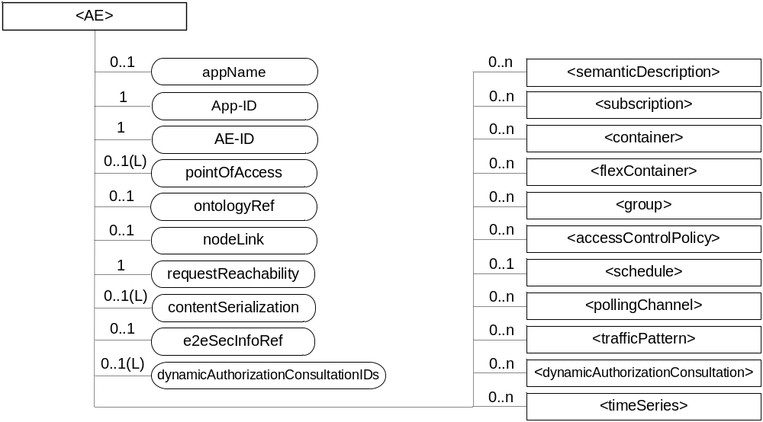
Figure 9.6.5-1: Structure of <AE> resource
The <AE> resource shall contain the child resources specified in table 9.6.5-1.
Table 9.6.5-1: Child resources of <AE> resource
Child Resources of <AE> | Child Resource Type | Multiplicity | Description | <AEAnnc> Child Resource Types
[variable] | <semanticDescriptor> | 0..n | See clause 9.6.30 | <semanticDescriptor>, <semanticDescriptorAnnc>
[variable] | <subscription> | 0..n | See clause 9.6.8 | <subscription>
[variable] | <container> | 0..n | See clause 9.6.6 | <container> <containerAnnc>
[variable] | <flexContainer> | 0..n | See clause 9.6.35 | <flexContainer>  <flexContainerAnnc>
[variable] | <group> | 0..n | See clause 9.6.13 | <group>  <groupAnnc>
[variable] | <accessControlPolicy> | 0..n | See clause 9.6.2 | <accessControlPolicy>  <accessControlPolicyAnnc>
[variable] | <schedule> | 0..1 | See clause 9.6.9 | <scheduleAnnc>
[variable] | <pollingChannel> | 0..1 | See clause 9.6.21  When the AE is request-unreachable, the AE should create this <pollingChannel> resource and perform long polling. The <pollingChannel> shall be utilized by the parent resource | None
trafficPattern | <trafficPattern> | 0..n | See clause 9.6.41 | <trafficPatternAnnc>
[variable] | <dynamicAuthorizationConsultation> | 0..n | See clause 9.6.40 | None
[variable] | <timeSeries> | 0..n | See clause 9.6.36 | <timeSeries>  <timeSeriesAnnc>

The <AE> resource shall contain the attributes specified in table 9.6.5-2.
Table 9.6.5-2: Attributes of <AE> resource
Attributes of  <AE> | Multiplicity | RW/  RO/  WO | Description | <AEAnnc> Attributes
resourceType | 1 | RO | See clause 9.6.1.3. | NA
resourceID | 1 | RO | See clause 9.6.1.3. Contains the AE-ID-Stem of the AE (see clause 7.2 on identifier formats and clause 10.1.1.2.2 for AE registration procedure). | NA
resourceName | 1 | WO | See clause 9.6.1.3. | NA
parentID | 1 | RO | See clause 9.6.1.3. | NA
expirationTime | 1 | RW | See clause 9.6.1.3. | MA
accessControlPolicyIDs | 0..1 (L) | RW | See clause 9.6.1.3. | MA
creationTime | 1 | RO | See clause 9.6.1.3. | NA
lastModifiedTime | 1 | RO | See clause 9.6.1.3. | NA
labels | 0..1 (L) | RW | See clause 9.6.1.3. | MA
announceTo | 0..1 (L) | RW | See clause 9.6.1.3. | NA
announcedAttribute | 0..1 (L) | RW | See clause 9.6.1.3. | NA
dynamicAuthorizationConsultationIDs | 0..1 (L) | RW | See clause 9.6.1.3. | OA
appName | 0..1 | RW | The name of the application, as declared by the application developer(e.g. "HeatingMonitoring").  Several sibling resources may share the appName. | OA
App-ID | 1 | WO | The identifier of the Application (see clause 7.1.3). | OA
AE-ID | 1 | RO | The identifier of the Application Entity (see clause 7.1.2). | OA
pointOfAccess | 0..1 (L) | RW | The list of addresses for communicating with the registered Application Entity over Mca reference point via the transport services provided by Underlying Network (e.g. IP address, FQDN, URI). This attribute shall be accessible only by the AE and the Hosting CSE.  If this information is not provided and the <pollingChannel> resource does exist, the AE should use <pollingChannel> resource. Then the Hosting CSE can forward a request to the AE without using the PoA. | OA
ontologyRef | 0..1 | RW | A URI of the ontology used to represent the information that is managed and understood by the AE. | OA
requestReachability | 1 | RW | If the AE that created this <AE> resource can receive a request, this attribute is set to "TRUE" otherwise "FALSE" | OA
nodeLink | 0..1 | RW | The resource identifier of a <node> resource that stores the node specific information of the node on which the AE represented by this <AE> resource resides. | OA
contentSerialization | 0..1 (L) | RW | The list of supported serializations of the Content primitive parameter for receiving a request from its registrar CSE. (e.g. XML, JSON). The list shall be ordered so that the most preferred format comes first. | OA
e2eSecInfoRef | 0..1 | RW | See clause 9.6.1.3. | MA

-----------------------End of change 4---------------------------------------------

CHECK LIST
- Does this change request include an informative introduction containing the problem(s) being solved, and a summary list of proposals.?
- Does this CR contain changes related to only one particular issue/problem?
- Have any mirror crs been posted?
- Does this change request make all the changes necessary to address the issue or problem? E.g. A change impacting 5 tables should not only include a proposal to change only 3 tables. Includes any changes to references, definitions, and acronyms in the same deliverable?
- Does this change request follow the drafting rules?
- Are all pictures editable?
- Have you checked the spelling and grammar?
- Have you used change bars for all modifications?
- Does the change include the current and surrounding clauses to clearly show where a change is located and to provide technical context of the proposed change? (Additions of complete sections need not show surrounding clauses as long as the proposed section number clearly shows where the new section is proposed to be located.)
- Are multiple changes in this CR clearly separated by horizontal lines with embedded text such as, start of change 1, end of change 1, start of new clause, end of new clause.?

