CHANGE REQUEST
Meeting:* | ARC#25
Source:* | InterDigital, AT&T
Date:* | 2016-10-17
Contact:* | Catalina Mladin, Catalina.Mladin@InterDigital.com  Michael Starsinic, Michael.Starsinic@InterDigital.com  James Hu, James.Hu@att.com
Reason for Change/s:* | Introduces descriptions for CIoT IP and non-IP data delivery
CR against: Release* | Release 3
CR against: WI* | Active <WI-0058>  MNT Maintenance / < Work Item number(optional)>  STE Small Technical Enhancements / < Work Item number (optional)>  Only ONE of the above shall be ticked
CR against: TS/TR* | TR-0024
Clauses/Sub Clauses* | 8.7
Type of change: * | Editorial change  Bug Fix or Correction  Change to existing feature or functionality  New feature or functionality  Only ONE of the above shall be ticked
Post Freeze checking:* | This CR contains only essential changes and corrections? YES NO  This CR may break backwards compatibility with the last approved version of the TS? YES NO  This CR is a mirror CR? YES if YES, please indicate the document number of the original CR: <Document Number) : NO
Template Version:27 May 2015 (Dot not modify)

oneM2M Notice
The document to which this cover statement is attached is submitted to oneM2M. Participation in, or attendance at, any activity of oneM2M, constitutes acceptance of and agreement to be bound by terms of the Working Procedures and the Partnership Agreement, including the Intellectual Property Rights (IPR) Principles Governing oneM2M Work found in Annex 1 of the Partnership Agreement.
GUIDELINES for Change Requests:
Provide an informative introduction containing the problem(s) being solved, and a summary list of proposals.
Each CR should contain changes related to only one particular issue/problem.
In case of a correction, and the change apply to previous releases, a separated “mirror CR” should be posted at the same time of this CR
Follow the principle of completeness, where all changes related to the issue or problem within a deliverable are simultaneously proposed to be made E.g. A change impacting 5 tables should not only include a proposal to change only 3 tables. Includes any changes to references, definitions, and acronyms in the same deliverable.
Follow the drafting rules.
All pictures must be editable.
Check spelling and grammar to the extent practicable.
Use Change bars for modifications.
The change should include the current and surrounding clauses to clearly show where a change is located and to provide technical context of the proposed change. Additions of complete sections need not show surrounding clauses as long as the proposed section number clearly shows where the new section is proposed to be located.
Multiple changes in a single CR shall be clearly separated by horizontal lines with embedded text such as, start of change 1, end of change 1, start of new clause, end of new clause.
When subsequent changes are made to content of a CR, then the accepted version should not show changes over changes. The accepted version of the CR should only show changes relative to the baseline approved text.

Introduction
The goal of this contribution is to lay a foundation in oneM2M so that work on Non-IP data delivery and 3GPP Interworking in general can proceed quickly.
This contribution describes the Control Plane Data Delivery features that 3GPP added in Rel-13. There are sub-sections that describe each of the 3 Control Plane Data Delivery methods; Non-IP via the SCEF, Non-IP via the P-GW, and IP via the P-GW. Each subsection highlights important points that should be considered when attempting to use the feature in a oneM2M system.
Although other standards bodies (i.e. OMA) may develop the API’s that are used to acces the NIDD feature. oneM2M still needs to develop a stage 3 binding of the Mca and Mcc reference points to non-IP. In order to delveop this bdining to NIDD, several key open issues need to be addressed. The notes included identify these issues, highlighting stage 2 issues (e.g. use of PoA) and stage 3 issues (e.g. support for NIDD data via oneM2M protocol). How the Mca and Mcc reference are bound to the Non-IP is left FFS.
Open Issues: The Notes that are listed in this CR are items that need to be addressed in TS-0026.

-----------------------Start of Change 1-------------------------------------------

8.7 Control Plane Data Delivery
3GPP Release 13 introduces the ability to send data to and from the UE in NAS messaging. 3GPP refers to this feature as “Control Plane (CP) CIoT Optimizations”. Since no data plane set up is required when sending data to the MME/SGSN via NAS messaging, using CP CIoT optimizations results in a reduced total number of control plane messages that are required to send a short data transaction.
Control Plane (CP) CIoT Optimizations provide the UE with 3 new options for sending data to and from a remote server (IN-CSE / SCS).
- IP Data, via the P-GW
- Non-IP Data, via the P-GW
- Non-IP Data, via the SCEF
The ability to send data over the control plane is a mandatory feature NB-IoT UE’s and an optional feature for WB-UE’s. Figure 8.7-1 shows the 3 new control plane data paths alongside the existing data plane path.
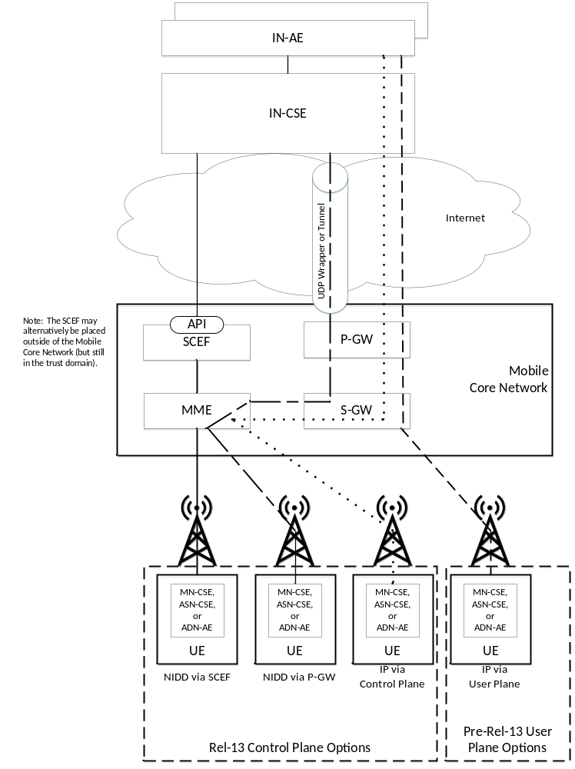
Figure 8.7-1 Small Data Delivery Options

When a PDN connection is established (e.g. in Attach or PDN Connectivity Request), the UE and Network determine which of the 4 paths shown in Figure 8.7-1 is used. In the Attach or PDN Connectivity Request, the UE indicates if the PDN type should be IP or non-IP and if the control plane should be used. The UE may also optionally indicate an APN name. If the UE does not provide an APN, the network will use the appropriate default APN from the UE’s subscription. Note that the UE may have two default APN’s in its subscription; a default IP APN and a default non-IP APN. When a non-IP APN is selected, the APN configuration will indicate if the PDN connection should be anchored at the SCEF or P-GW. Notice that the UE is not aware if its Non-IP PDN connection is anchored at the P-GW or the SCEF. However, the IN-CSE must know whether data is routed via the P-GW to the SCEF.

8.7.1 Non-IP Data Delivery (NIDD)
Non-IP data can be exchanged between the IN-CSE and the UE hosted MN-CSE, ADN-AE, or ASN-CSE. Non-IP data packets are opaque to the 3GPP Network; in other words, the 3GPP Network makes no assumptions of the contents or structure of the data packet. Non-IP data may be exchanged via the SCEF or the P-GW, depending on which node the UE’s PDN Connection is anchored to.
Note 1: The API’s that are used to access the NIDD feature may be developed by standards organizations other than oneM2M (i.e. OMA). However, oneM2M still needs to develop a stage 3 specification to show how the Mcc and Mca reference points are bound to Non-IP. This binding is FFS.

Each Non-IP PDN connection has maximum packet size which is set by the 3GPP network. The SCEF or P-GW will signal the maximum packet size to the UE when the PDN connection is established. 3GPP does not define how the SCS (IN-CSE) knows the maximum packet size. The IN-CSE may be provisioned to know the maximum packet size for each APN or it may be signalled by the SCEF. Note that the maximum packet size may be as small as 128 bytes.
Note 2 : If the IN-CSE and UE hosted MN-CSE, ADN-AE, or ASN-CSE desire to exchange packets that are larger than 128 bytes, then segmentation and re-assembly will need to be performed in the IN-CSE and the UE hosted MN-CSE, ADN-AE, or ASN-CSE. It is for FFS how packet segmentation and re-assembly will be accomplished.
Note 3: If the IN-CSE and UE hosted MN-CSE, ADN-AE, or ASN-CSE require some or all Non-IP data packets to be acknowledge, then it is for FFS how packets will be acknowledged.
Once a PDN connection is established, the UE hosted MN-CSE, ADN-AE, or ASN-CSE may use the PDN connection to send Non-IP data packets to the IN-CSE.
Note 4: It is FFS what PoA is used by the UE hosted MN-CSE, ADN-AE, or ASN-CSE to reach the IN-CSE. The UE hosted MN-CSE, ADN-AE, or ASN-CSE should associate an APN with the IN-CSE; thus it is recommended that the PoA includes an APN.
Dedicated bearers are not supported for Non-IP data PDN connections and there is no concept of Port ID. Thus, a Non-IP PDN connection can only be associated with one IN-CSE to UE hosted MN-CSE, ADN-AE, or ASN-CSE connection. If one UE hosted MN-CSE, ADN-AE, or ASN-CSE needs to use NIDD to connect to more than one IN-CSE, then the UE needs to be provisioned with an APN for each connection. Separate PDN connections must be used for each IN-CSE.
If more than one UE hosted MN-CSE, ADN-AE, or ASN-CSE uses NIDD to connect to the same IN-CSE, then each UE hosted MN-CSE, ADN-AE, or ASN-CSE needs to be associated with its own APN and to establish its own PDN connection.

8.7.1.1 Non-IP Data Delivery (NIDD) via the P-GW
At each PDN connectivity request with PDN Type Non-IP, if the network finds that the APN configuration does not include an “Invoke SCEF selection indicator”, then the P-GW option is used.
The P-GW decides at PDN connection establishment if Non-IP data should be sent via UDP or via a point-to-point tunneling technique between the P-GW and the AS. This information, as well as the tunnel parameters (i.e. IN-CSE IP address and port and source IP address and port) are pre-configured at the P-GW. The configuration is on a per-APN per-UE basis.
Once a PDN connection is established, the IN-CSE may use the PDN connection to send Non-IP data packets to the UE hosted MN-CSE, ADN-AE, or ASN-CSE. When Non-IP data is routed via the P-GW, the PoA that is associated with the UE hosted MN-CSE, ADN-AE, or ASN-CSE is an IP Address and Port number. The IP Address and Port number is used to route the Non-IP data packets to the 3GPP Network via the P-GW. The Non-IP packets may be tunneled or wrapped in a UDP packet. The P-GW will use the IP Address and Port Number to determine what UE and APN the packet is associated with.
Note 1: It is FFS how the IN-CSE learns the IP Address and Port Number that is used to reach the UE hosted MN-CSE, ADN-AE, or ASN-CSE. The IP Address and Port Number may be provisioned in the IN-CSE per SLA or the IN-CSE may wait for the UE hosted MN-CSE, ADN-AE, or ASN-CSE to initiate contact and learn the IP Address and port number when the first Non-IP packet is received (i.e. by looking at the source IP Address and port of the UDP wrapper or tunnel). The IP address used by IN-CSE to reach the UE hosted MN-CSE, ADN-AE or ASN-CSE needs to provide routing through the same PGW as the one indicated by the APN configuration in the UE.

8.7.1.1.1 Mobile Originated NIDD procedure via the P-GW
Figure 8.7.1.1.1-1 illustrates the procedure used by UE to send non-IP data to the IN-CSE via the P-GW.
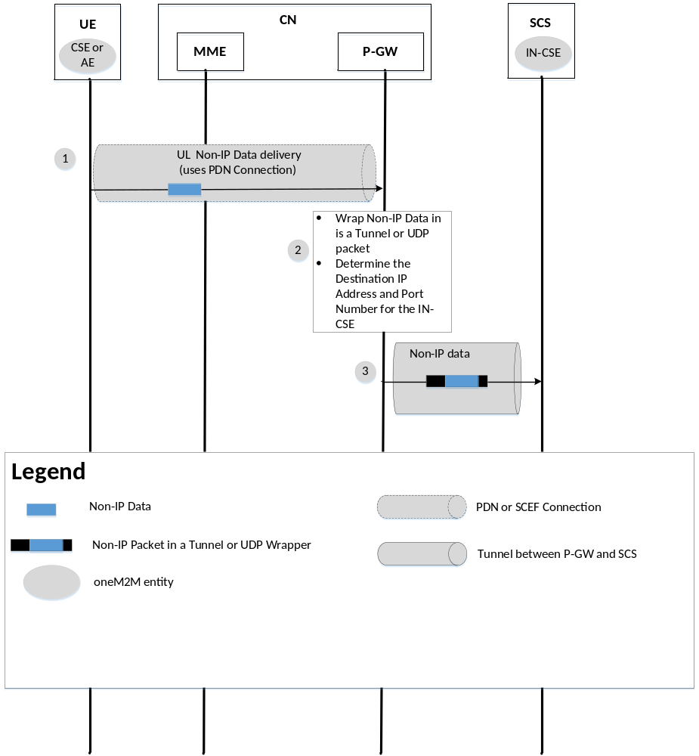

Figure 8.7.1.1.1-1 MO NIDD procedure via P-GW
- The UE sends a Non-IP data packet to the IN-CSE. The UE knows the target IN-CSE because it is associated with the APN and PDN Connection.
- The P-GW wraps the non-IP data in a UDP wrapper or tunnels it to the IN-CSE using the pre-configured destination and source IP address and UDP port number.
- The P-GW forwards the wrapped or tunnelled packet to the IN-CSE. The IN-CSE unwraps the received data and may note the source IP address and port number for further communications with the UE.

8.7.1.1.2 Mobile Terminated NIDD procedure via the P-GW
Figure 8.7.1.1.2-1 illustrates the procedure used by an IN-CSE to send non-IP data to a UE via the P-GW.

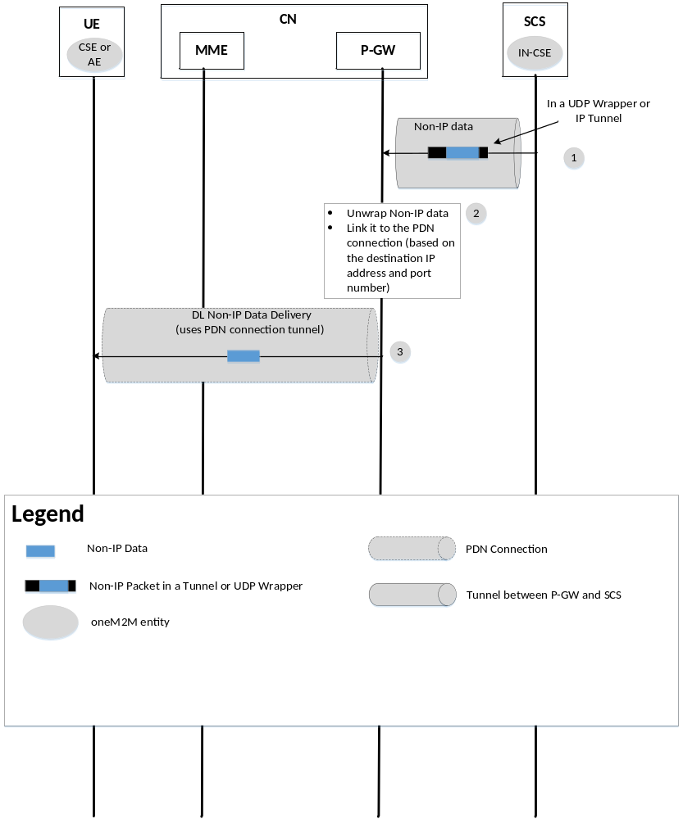
Figure 8.7.1.1.2-1 MT NIDD procedure via P-GW

- The IN-CSE sends a data packet (wrapped in UDP packet or tunnelled) to the PoA that is associated with the UE hosted MN-CSE, ADN-AE, or ASN-CSE (the PoA will be an IP address and port number).
- The P-GW extracts the Non-IP data packet and uses the destination IP Address and Port Number to identify the UE is that is being addressed and the PDN connection.
- The P-GW forwards the non-IP data to the UE. The UE identifies the source IN-CSE based on the APN that is associated with the PDN connection that used to receive the Non-IP data packet.
Note: MT flows for both IP and non IP flow for devices that uses PSM and eDRX need to be specified. It is FFS as how to handle unreachable situation within oneM2M system.

8.7.1.2 Non-IP Data Delivery (NIDD) via the SCEF
In TS 23.682, 3GPP defines an optional NIDD Configuration procedure that may be used by the IN-CSE to inform the SCEF that it expects Non-IP Data from a UE; the UE is identified with an External ID or MSISDN. The SCEF will send the UE identity and APN to the HSS to check that the SCEF is authorized to receive data from the UE / APN combination. Alternatively, the SCEF could be provisioned to know what UE / APN combinations will be anchored to it.
When the UE makes a PDN connectivity request with PDN Type Non-IP, if the APN configuration includes an “Invoke SCEF selection indicator” and an SCEF Identifier, then the SCEF routing option is used. A connection between the MME/SGSN and SCEF will be established when the PDN connection is established.
An API will be used by the SCEF and IN-CSE to exchange Non-IP data packets. When the IN-CSE sends a Non-IP packet to the SCEF it includes a UE identifier (e.g. External ID or MSISDN) and an APN. The combination UE/APN maps to a MN-CSE, ADN-AE, or ASN-CSE that is hosted on the UE.
Once a PDN connection is established, the IN-CSE may use the PDN connection to send Non-IP data packets to the UE hosted MN-CSE, ADN-AE, or ASN-CSE. When Non-IP data is routed via the SCEF, the PoA that is associated with the UE hosted MN-CSE, ADN-AE, or ASN-CSE is a UE Identity (e.g. External ID), APN, and SCEF ID combination. . The SCEF will use the UE Identity and APN to determine what MME the Non-IP packet should be sent to and what EPS Bearer ID (EBI) that is associated with the UE.
Note 1: It is FFS how the IN-CSE learns the APN and UE Identity that is used to reach the UE hosted MN-CSE, ADN-AE, or ASN-CSE. This information may be provisioned in the IN-CSE per SLA. If there is only one MTC application that is hosted on the UE using Non-IP data, then the IN-CSE does not need to be aware of the APN.

8.7.1.2.1 SCEF Configuration for NIDD
Figure 8.7.1.2.1-1 illustrates a procedure through which the IN-CSE may configure the SCEF for future NIDD. This procedure is optional as the parameters may be pre-provisioned at the SCEF. The purpose is to provide the SCEF with information needed for non-IP communication between a specific AS and a specific UE. 3GPP aspects of the procedure are described in [2]. It is assumed that this procedure occurs prior to the UE’s attachment to the network. If, at UE attachment, the SCEF has not been configured for NIDD with this procedure or by pre-provisioning, the SCEF may initiate the procedure or the SCEF may reject the PDN connection attempt.

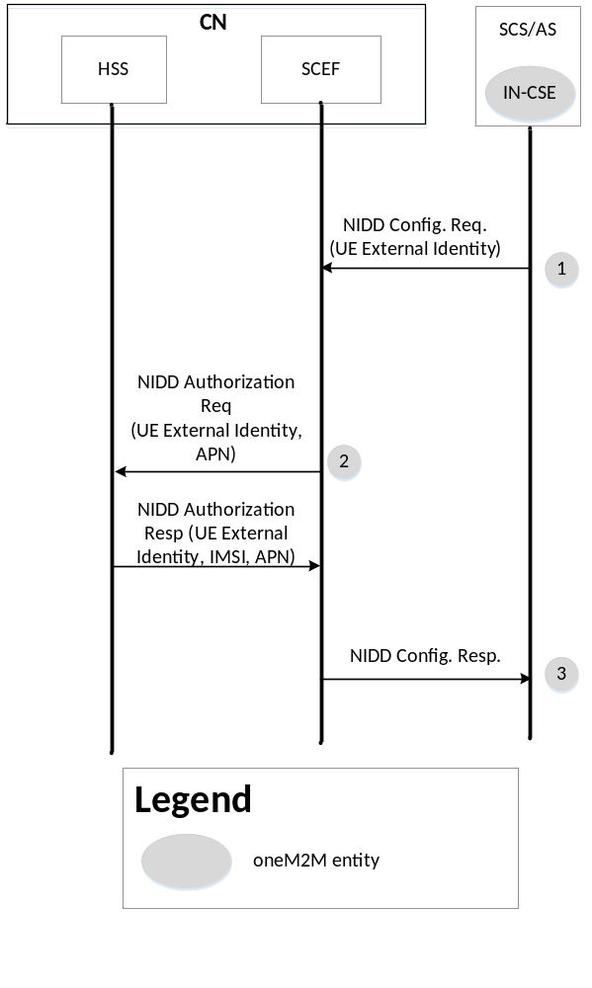
Figure 8.7.1.2.1-1 NIDD Configuration procedure at the SCEF

NOTE: Interactions within the 3GPP network are shown for informative purposes only, they are out of scope of oneM2M.
1. The IN-CSE sends an NIDD Configuration Request message to the SCEF. This step will be accomplished via an SCEF API call. The step is fully explained in TS 23.682, however the purpose of the procedure is to configure the SCEF to know that the IN-CSE is expecting Non-IP Data from the UE and for the SCEF to authorize it.
NOTE: The IN-CSE is expected to be provisioned to use the same SCEF as the one selected by the network during the UE's attachment to the network.
2. The SCEF stores the UE Identity (External Identifier or MSISDN) and IN-CSE Identifier. The SCEF also authorizes the NIDD configuration request (for the received UE Identifier and APN combination) and obtains the UE’s IMSI.
3. The SCEF sends an NIDD Configuration Response message to the IN-CSE to acknowledge acceptance of the NIDD Configuration Request. This step is in response to API call of step 1.
Later, when the UE establishes the PDN Connection with the same APN, the UE’s MME will contact the SCEF and perform a T6a establishment procedure. T6a refers to the reference point between the MME and SCEF. The procedure is used by the MME to provide the SCEF with an IMSI, EBI, and APN combination and it is used by the SCEF to provide the MME with the maximum Non-IP packet size. The IMSI, EBI, and APN will be needed by the SCEF when routing Non-IP Data between the IN-CSE and UE.

8.7.1.2.2 Mobile Terminated NIDD Procedure via the SCEF
Figure 8.7.1.2.2-1 illustrates the procedure used by an IN-CSE to send non-IP data to a UE via the SCEF.
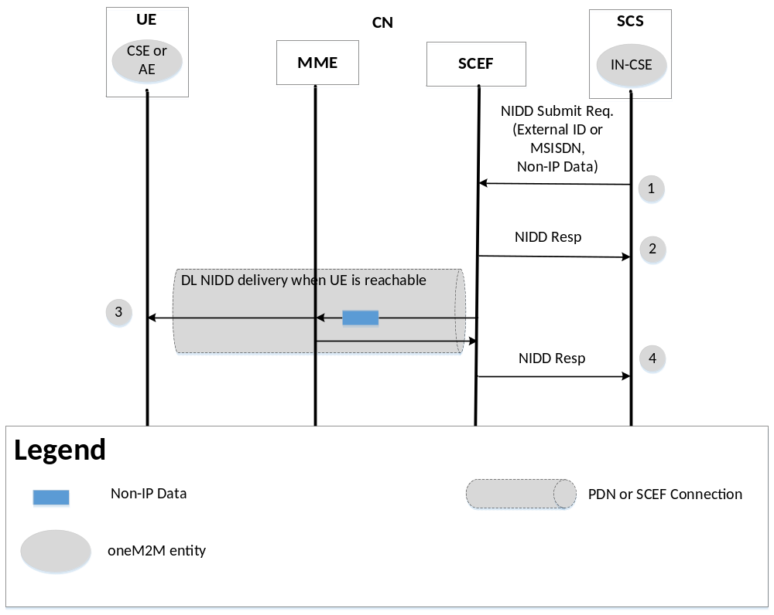
Figure 8.7.1.2.2-1 MT NIDD procedure via SCEF
- The IN-CSE initiates the MT NIDD procedure by sending a Non-IP data packet towards the SCEF. A UE Identity (e.g. External ID), APN, and SCEF ID combination is used as the UE’s PoA. This step will be accomplished via an SCEF API call.
- Optionally, if the UE is not reachable (i.e. in a deep sleep mode due to PSM or eDRX), the SCEF may respond to the IN-CSE that the UE is not reachable and indicate if the data is buffered or discarded. This step is in response to API call of step 1.
- The MME uses the PDN connection to deliver the Non-IP data to the UE.
- The SCEF indicates to the IN-CSE that the non-IP data packet was delivered. This step is in response to API call of step 1.

8.7.1.2.3 Mobile Originated NIDD Procedure via the SCEF
Figure 8.7.1.2.3-1 illustrates the procedure used by UE to send non-IP data to the IN-CSE via the SCEF.
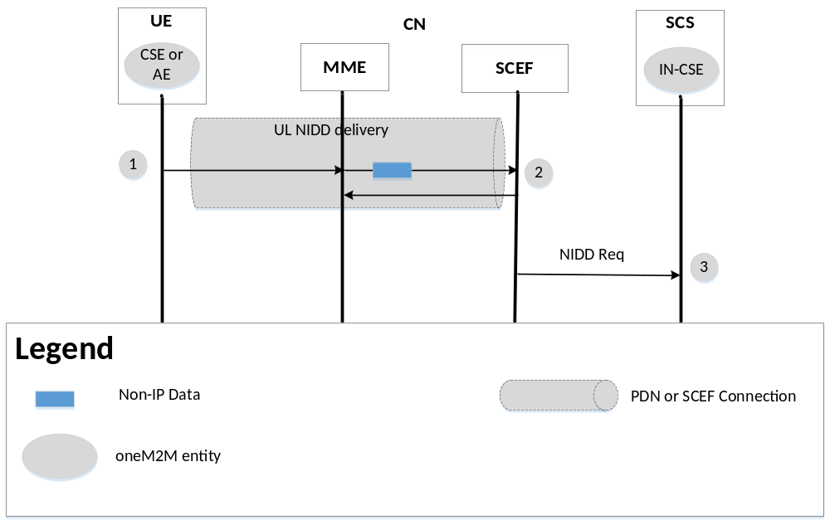
Figure 8.7.1.2.3-1 MO NIDD procedure via SCEF

- The UE Hosted MN-CSE, ADN-AE, or ASN-CSE initiates UL NIDD procedures by sending non-IP data using the PDN connection. The target IN-CSE is identified based on the APN that is associated with the PDN connection.
- The MME sends the Non-IP data packet, EBI, and IMSI to the SCEF. The SCEF uses the EBI and IMSI to determine the UE’s External Identifier, APN, and the associated IN-CSE.
- The SCEF sends the Non-IP Data, UE Identity (External ID or MSISDN), and APN to the IN-CSE.

8.7.2 IP Data Delivery via the Control Plane
When IP data is received at the IN-CSE, the IN-CSE is not aware of whether the UE sent the data to the eNodeB via the user or control plane. The UE Hosted MN-CSE, ADN-AE, or ASN-CSE is also largely unaware of whether its IP data is using the control plane or user plane path. However, some entity on the UE, such as the UE Hosted MN-CSE, ADN-AE, or ASN-CSE may need to indicate whether the PDN connection is better suited for the control or user plane.

-----------------------End of Change 1 ---------------------------------------------

CHECK LIST
- Does this change request include an informative introduction containing the problem(s) being solved, and a summary list of proposals?
- Does this CR contain changes related to only one particular issue/problem?
- Have any mirror crs been posted?
- Does this change request make all the changes necessary to address the issue or problem? E.g. A change impacting 5 tables should not only include a proposal to change only 3 tables. Includes any changes to references, definitions, and acronyms in the same deliverable?
- Does this change request follow the drafting rules?
- Are all pictures editable?
- Have you checked the spelling and grammar?
- Have you used change bars for all modifications?
- Does the change include the current and surrounding clauses to clearly show where a change is located and to provide technical context of the proposed change? (Additions of complete sections need not show surrounding clauses as long as the proposed section number clearly shows where the new section is proposed to be located.)
- Are multiple changes in this CR clearly separated by horizontal lines with embedded text such as, start of change 1, end of change 1, start of new clause, end of new clause?

