CHANGE REQUEST
Meeting:* | ARC#26
Source:* | InterDigital,
Date:* | 2016-12-05
Contact:* | Catalina Mladin, mladin.catalina@convidawireless.com,  Michael Starsinic, Starsinic.Michael@convidawireless.com
Reason for Change/s:* | 3GPP Triggering for ADNs
CR against: Release* | Release 3
CR against: WI* | Active <WI-0058>  MNT Maintenance / < Work Item number(optional)>  STE Small Technical Enhancements / < Work Item number (optional)>  Only ONE of the above shall be ticked
CR against: TS/TR* | TS-0001
Clauses/Sub Clauses* | 6.2.9.2, 7.1.7, 7.1.8, 7.1.10, 7.3, 8.3.3, 9.6.5, B.1, B.2, B.3, B.4, B.5, B.6, C.1, C.2, C.3, C.4, C.5
Type of change: * | Editorial change  Bug Fix or Correction  Change to existing feature or functionality  New feature or functionality  Only ONE of the above shall be ticked
Post Freeze checking:* | This CR contains only essential changes and corrections? YES NO  This CR may break backwards compatibility with the last approved version of the TS? YES NO  This CR is a mirror CR? YES if YES, please indicate the document number of the original CR: <Document Number) : NO
Template Version:27 May 2015 (Dot not modify)

oneM2M Notice
The document to which this cover statement is attached is submitted to oneM2M. Participation in, or attendance at, any activity of oneM2M, constitutes acceptance of and agreement to be bound by terms of the Working Procedures and the Partnership Agreement, including the Intellectual Property Rights (IPR) Principles Governing oneM2M Work found in Annex 1 of the Partnership Agreement.
GUIDELINES for Change Requests:
Provide an informative introduction containing the problem(s) being solved, and a summary list of proposals.
Each CR should contain changes related to only one particular issue/problem.
In case of a correction, and the change apply to previous releases, a separated “mirror CR” should be posted at the same time of this CR
Follow the principle of completeness, where all changes related to the issue or problem within a deliverable are simultaneously proposed to be made E.g. A change impacting 5 tables should not only include a proposal to change only 3 tables. Includes any changes to references, definitions, and acronyms in the same deliverable.
Follow the drafting rules.
All pictures must be editable.
Check spelling and grammar to the extent practicable.
Use Change bars for modifications.
The change should include the current and surrounding clauses to clearly show where a change is located and to provide technical context of the proposed change. Additions of complete sections need not show surrounding clauses as long as the proposed section number clearly shows where the new section is proposed to be located.
Multiple changes in a single CR shall be clearly separated by horizontal lines with embedded text such as, start of change 1, end of change 1, start of new clause, end of new clause.
When subsequent changes are made to content of a CR, then the accepted version should not show changes over changes. The accepted version of the CR should only show changes relative to the baseline approved text.

Introduction
Section 8.3.3.1 of TS-0001 defines triggering as:
Device Triggering is a means by which a node in the infrastructure domain (e.g. IN-CSE) sends information to a node in the field domain (e.g. ASN-CSE) to perform a specific task, e.g. to wake up the device, to establish communication from the field domain towards the infrastructure domain, or when IP address for the device is not available or reachable by the infrastructure domain.
Currently, TS-0001 only supports sending a trigger to a CSE. However, there are times when an ADN also needs to wake up and establish a connection and there are times when the IP address of the device hosting the AE is not available or reachable by the infrastructure domain; thus it should be permissible to send a trigger towards an ADN. For example, a location tracking application may be an ADN that sleeps for long periods of time. The infrastructure domain may wish to trigger the ADN in order to wake the ADN or in order to request that it establish communication with the IN-CSE.
This contribution updates TS-0001 so that triggering of ADNs is possible just as it is possible to trigger a CSE. Besides updating the general triggering text, the M2M-Ext-ID and Trigger-Recipient-ID attributes are added to the <AE> resource.
Text highlited in green has been agreed in ARC-2016-044R02-3GPP_Trigger_payload.
Note that Figure B.2.1-2 was not editable. To update it, the latest the latest figure from 23.682 was used as basis, so some of the graphics are different. The only technical content change is to introduce ADN as option for the UE.

-----------------------Start of change 1-------------------------------------------

6.2.9.2 Detailed Descriptions
Registration is the process of delivering AE or CSE information to another CSE in order to use M2M Services.
An AE on an ASN, an MN or an IN performs registration locally with the corresponding CSE in order to use M2M services offered by that CSE. An AE on an ADN performs registration with the CSE on an MN or an IN in order to use M2M services offered by that CSE. An IN-AE performs registration with the corresponding CSE on an IN in order to use M2M services offered by that IN CSE. An AE can have interactions with its Registrar CSE (when it is the target CSE) without the need to have the Registrar CSE register with other CSE.
The CSE on an ASN performs registration with the CSE in the MN in order to be able to use M2M Services offered by the CSE in the MN. As a result of successful ASN-CSE registration with the MN-CSE, the CSEs on the ASN and the MN establish a relationship allowing them to exchange information.
The CSE on an MN performs registration with the CSE of another MN in order to be able to use M2M Services offered by the CSE in the other MN. As a result of successful MN-CSE registration with the other MN-CSE, the CSEs on the MNs establish a relationship allowing them to exchange information.
The CSE on an ASN or on an MN perform registration with the CSE in the IN in order to be able to use M2M Services offered by the CSE in the IN. As a result of successful ASN/MN registration with the IN-CSE, the CSEs on ASN/MN and IN establish a relationship allowing them to exchange information.
Following a successful registration of an AE to a CSE, the AE is able to access, assuming access privilege is granted, the resources in all the CSEs that are potential targets of request from the Registrar CSE.
The capabilities supported by the REG CSF are as follows:
- ability for AEs to register to their associated CSE, as per table 6.4-1;
- ability for CSE to register to the other CSE, as per table 6.4-1;
- ability for an ASN-CSE/MN-CSE or ADN-AE to register association of its M2M-Ext-ID (if available) with its CSE-ID or AE-ID (see clause 7.1.8);
- ability for an ASN-CSE/MN-CSE or ADN-AE to register association of its Trigger-Recipient-ID (if available) with its CSE-ID or AE-ID (see clause 7.1.10). When Trigger-Recipient-ID is not present, it is assumed that the ADN-AE or CSE is not able to receive triggers.
NOTE: Such registrations are applicable to a single M2M Service Provider Domain.
Registration information for a Node includes:
- Identifier of the Node.
- Reachability schedules; which are elements of a Node's policy, and specify when messaging can occur between Nodes. Reachability schedules can be used in conjunction with other policy elements. When reachability schedules are not present in a Node then that Node is expected to be always reachable.
- Managing connection state of communication channel to the registred AE or CSE.

-----------------------End of change 1-------------------------------------------

-----------------------Start of change 2-------------------------------------------

7.1.7 M2M Request Identifier (M2M-Request-ID)
The M2M-Request-ID tracks a Request initiated by an AE over the Mca reference point, and by a CSE over the Mcc reference point, if applicable, end to end. It is also included in the Response to the Request over the Mca or Mcc reference points.
To enable an AE to track Requests and corresponding Responses over the Mca reference point, AEs shall include a distinct M2M Request Identifier per request over the Mca Reference point to the CSE for any initiated request.
The CSE shall make such M2M Request Identifier unique by prepending the AE-ID-Stem (see clause 7.2) and slash('/') in front of it (e.g. C190XX7T/001).
If the CSE creates an M2M Request Identifier, then the CSE shall maintain a binding between the M2M Request Identifier received from the AE and the M2M Request Identifier it created in its interactions towards other peer CSEs. The CSE shall include the M2M Request Identifier received from the AE in its Response to the AE. This binding shall be maintained by the CSE until the Request message sequence is completed. Note that the Request initiated by the CSE could be the result of an application Request, or a request initiated autonomously by the CSE to fulfil a service.
In case an IN-CSE needs to send a request to a receiving CSE or ADN-AE that is not reachable over any of the underlying networks, the IN-CSE initiates the procedure for "waking up" the Node hosting the receiving CSE or ADN-AE by using procedures such as device triggering over the Mcn reference point. For Device Triggering, the triggering reference number to co-relate device triggering response is independent of the M2M Request Identifier. An IN-CSE may use the same value of an M2M-Request-Identifier in an incoming request for the triggering reference number in its interaction with the underlying network.
A CSE receiving a Request from a peer CSE shall include the received M2M Request Identifier in all additional Requests unspanned (i.e. 1:1) it has to generate (including propagation of the incoming Request) and that are associated with the incoming Request, where applicable.
If a Receiver CSE receives a request from an Originator for which another request with the same Request Identifier is already pending, the request shall be rejected. Otherwise - even if the same Request Identifier was already used by the same Originaor sometime in the past, the request shall be treated as a new request.

-----------------------End of change 2-------------------------------------------

-----------------------Start of change 3-------------------------------------------

7.1.8 M2M External Identifier (M2M-Ext-ID)
The M2M-Ext-ID is used by an M2M Service Provider (M2M SP) when services targeted to a M2M Device are requested from the Underlying Network.
The M2M External Identifier allows the Underlying Network to identify the M2M Device (e.g. ADN, ASN, MN) . To that effect, the Underlying Network maps the M2M-Ext-ID to the Underlying Network specific Identifier it allocated to the target M2M Device. In addition, the M2M SP shall maintain the association between the CSE-ID or AE-ID, the M2M-Ext-ID and the identity of the Underlying Network.
Both pre-provisioned and dynamic association between the M2M-Ext-ID with the CSE-ID or ADN AE-ID are supported.
NOTE 1: For each CSE-ID or ADN AE-ID, there is only one M2M-Ext-ID for a specific UNetwork-ID. Hence an M2M SP interworking with multiple Underlying Networks has different M2M-Ext-IDs associated with the same CSE-ID or ADN AE-ID, one per Underlying Network and selects the appropriate M2M-Ext-ID for any service request it initiates towards an Underlying Network.
NOTE 2: The mapping by the Underlying Network of the M2M-Ext-ID to the M2M Device is Underlying Network specific.
NOTE 3: The Underlying Network provider and the M2M Service Provider collaborate for the assignment of an M2M-Ext-ID to each M2M Device. At the same time, the Underlying Network provider maintains association of the M2M-Ext-ID with the Underlying Network specific Identifier allocated to the M2M Device .
For pre-provisioned M2M-Ext-IDs, the M2M-Ext-ID along with the associated CSE-ID or ADN AE-ID shall be made available at the Infrastructure Node. The CSE or AE at M2M Device does not need to have knowledge of the M2M-Ext-ID assigned to it.
For dynamic M2M-Ext-IDs, the M2M-Ext-ID specific to the Underlying Network shall be made available at the M2M Device in the Field Domain. Such M2M-Ext-ID shall be conveyed to the IN-CSE during Registration.

-----------------------End of change 3-------------------------------------------

-----------------------Start of change 4 -------------------------------------------

7.1.10 Trigger Recipient Identifier (Trigger-Recipient-ID)
The Trigger-Recipient-ID is used when device triggering services are requested from the Underlying Network, to identify a M2M Device, to which the trigger is routed.
EXAMPLE: When 3GPP device triggering is used, the Trigger-Recipient-ID maps to the Application-Port-Identifier (3GPP TS 23.682 [Error: Reference source not found]).
NOTE 1: For pre-provisioned M2M-Ext-IDs, Trigger-Recipient-ID is provisioned at the Infrastructure Node along with the M2M-Ext-ID and the associated CSE-ID or ADN AE-ID.
NOTE 2: For dynamic M2M-Ext-IDs, Trigger-Recipient-ID specific to the Underlying Network is provisioned at each M2M Device in the Field Domain. Such Trigger-Recipient-ID is conveyed to the IN-CSE during Registration.

-----------------------End of change 4 ------------------------------------------

---------------------------------------------------------Start of change 5 ------------------------------------------------------------------------

7.3 M2M Identifiers lifecycle and characteristics
Table 7.3-1: M2M Identifiers lifecycle and characteristics
Identifier | Assigned by | Assigned to | Assigned during | Lifetime | Uniqueness | Used during | Remarks
M2M Service Provider Identifier | Out of scope | AE, CSE | Out of scope | Out of scope | Global | Provisioning
Application Entity Identifier | AE or Registrar CSE | AE | AE start-up | Application Entity Registration | Global | - Application Entity Registration  - Security Context Establishment  - All other operations initiated by the AE | Security requirements apply for Security Context Establishment
Application Identifier | Out of scope | Out of scope | Pre-provisioned | Out of scope | Specific to M2M service deployment | - Application Entity registration
CSE Identifier | M2M SP | CSE | Security Provisioning | Life of the CSE | Global | - Information flows (clause 10)  - Security Context Establishment | Security requirements apply for Security Context Establishment
M2M Node Identifier | Out of Scope | All M2M Nodes | Pre-provisioned | Life of the M2M Node | Global | - Device Management | Needs to be Read Only
M2M Subscription Identifier | M2M SP, Out of Scope | Application Entities, and one or more CSEs belonging to the same M2M subscriber | At service signup | Life of the M2M Service Subscription with the M2M Service Provider | Global | - Charging and Information Recorded  - Role based access control  - Authentication | Multiple CSEs can be allocated the same M2M Subscription Identifier
M2M Service Profile Identifier | M2M SP | Every M2M Node | At service signup | Life of M2M Service Subscriptions with the M2M Service Provider | Global for roaming cases otherwise local | Information Flows (clause 10) | The ID has to be pre-provisioned after signup, but may need to be updated during the subscription lifetime due to changes in the subscribed services
M2M-Request-ID | Mcc: CSE  Mca: Application Entity | A request initiated by an AE or CSE | Mcc: When a request is initiated by a CSE, or handling of a request received by a CSE.  Mca: When a request is initiated by an AE | Equal to the lifetime of the Request and its corresponding Response | Mcc: Global  Mca: Local or global | Requests and corresponding responses
External Identifier | Jointly between the Underlying Network provider and M2M SP. | M2M Node belonging to a CSE or ADN-AE that wants to utilize services of the Underlying Network. | Administrative Agreement. | Life of the CSE or ADN-AE. | Local or global, decided by the specific Underlying Network provider | Requests initiated by a CSE over the Mcn reference point, where applicable. | Pre-Provisioned Mode:  Made available at the Infrastructure Node.  Dynamic Mode:  Made available at M2M device. Conveyed to IN-CSE during CSE or AE Registration.
Underlying Network Identifier | M2M SP | Underlying Networks | Pre-provisioned | Life of the agreement by the M2M SP with the Underlying Network | Local to M2M SP domain | UL Network selection
Trigger Recipient Identifier | Execution Environment | ASN/MN-CSE or  ADN-AE | ASN/MN-CSE or ADN-AE start-up or wake-up | Life of the CSE or ADN-AE | Execution Environment-wide | Device Triggering procedures, where applicable | Pre-Provisioned Mode:  Made available at Infrastructure Node along with M2M-Ext-ID.  Dynamic Mode:  Made available at M2M device. Conveyed to IN-CSE during CSE or AE Registration along with M2M-Ext-ID.
M2M Service Identifier | M2M Service Provider, Out of Scope | A service defined by the M2M Service Provider which consists of a set of functions defined by the present document. | Out of Scope | Out of Scope | Local to the M2M Service Provider | For M2M Service Subscription
Role-ID | M2M Service Provider | Application Entities, and one or more CSEs belonging to the same M2M subscriber | Out of scope | Out of scope | Local to M2M SP domain | Access Control Policy
Token-ID | Token Issuer | Token | Token Assignment | Specified by Token | Global | Dynamic Authorization
Local-Token-ID | A Hosting CSE making access decisions with the corresponding token | Token | After Hosting CSE has been provided with Token | Specified by Token | Local to the Hosting CSE | Indirect Dynamic Authorization | See clause 11.5.3

------------------------------------------------------End of change 5 ----------------------------------------------------------------------------

-----------------------Start of change 6 ------------------------------------------

8.3.3 Device Triggering

8.3.3.1 Definition and scope
Device Triggering is a means by which a node in the infrastructure domain (e.g. IN-CSE) sends information to a node in the field domain (e.g. ASN-CSE or ADN-AE) to perform a specific task, e.g. to wake up the device, to establish communication from the field domain towards the infrastructure domain, or when IP address for the device is not available or reachable by the infrastructure domain.
Underlying Network functionality is used to perform device triggering for example, using alternate means of communication (e.g. SMS) with the Field Node.
NOTE: Device Triggering is applicable for the entities which are registered with IN-CSE.
Each Underlying Network type may provide different way of performing a device triggering, for example 3GPP and 3GPP2 have defined dedicated interfaces for requesting device triggering. The normative references for applicable interfaces are as follows: 3GPP TS 23.682 [Error: Reference source not found] and 3GPP2 X.S0068 [Error: Reference source not found]. Access specific mechanisms are covered in the annexes B and C.

8.3.3.2 General Procedure for Device Triggering

8.3.3.2.0 Overview
This clause covers different scenarios for device triggering.

8.3.3.2.1 Triggering procedure
This case describes the scenario where IN-CSE targets an ASN/MN-CSE or ADN-AE for the Device Triggering request.
Figure 8.3.3.2.1-1 shows the general procedure for Device Triggering and, if required, for establishment of connectivity between IN-CSE and the Field Node.

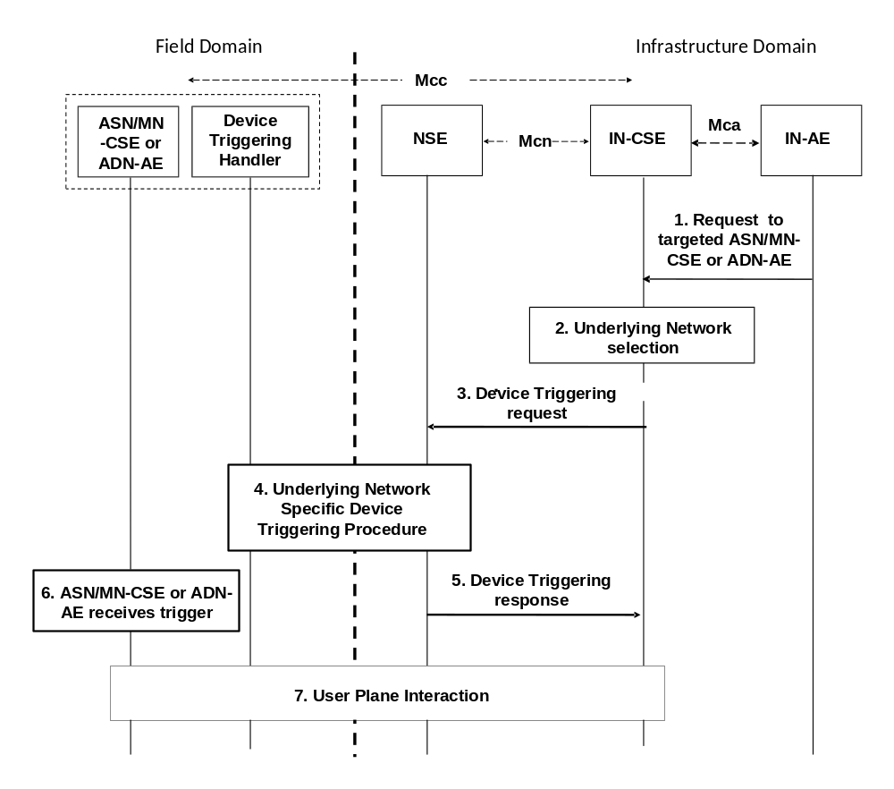
NOTE 1: The IN and M2M Device are assumed to be connected through the same Underlying Network.
NOTE 2: The Device Triggering Handler is a functional entity that receives the device triggering request, and it is dependent on the Underlying Network. The Device Triggering Handler is out of scope of the present document.

Figure 8.3.3.2.1-1: Device Triggering general procedure for CSE
Pre-condition
The ASN/MN-CSE or ADN-AE which is the target of the device triggering has to be registered with the IN-CSE, or the IN-CSE is provisioned to know the information necessary to send a trigger to the ASN/MN-CSE or ADN-AE.”.
For the ASN/MN-CSE, after registration the CSE-PoA contains either an IP address or none. For the ADN-AE, after registration the AE-PoA contains either an IP address or none.
Step-1 (Optional): Request to the targeted ASN/MN-CSE or ADN-AE
The IN-AE requests to perform one of the CRUD operations targeting the ASN/MN-CSE or ADN-AE, the request is sent via the Mca reference point to the IN-CSE.
Step-2: Underlying network selection
The IN-CSE selects the Underlying Network and the mechanism to deliver the triggering request to the Underlying Network according to the configuration for connected Underlying Networks.
For example for 3GPP access network IN-CSE can use Tsp, Tsms and GSMA OneAPI; and for 3GPP2 access networks IN-CSE can use Tsp and SMS. However the preferred mechanism is Tsp.
Step-3: Device Triggering request
IN-CSE issues the device triggering request to the selected Underlying Network.
NOTE 1: The Underlying Network dependent Device Triggering procedure for 3GPP and 3GPP2 systems are described in annexes B and Annex C respectively.
Some information provided to the selected Underlying Network for performing device triggering includes:
- M2M-Ext-ID associated with the target ASN/MN-CSE or ADN-AE of the triggering request (see clause 7.1.8).
- Trigger-Recipient-ID associated with the target ASN/MN-CSE or ADN-AE (see clause 7.1.10). For example when 3GPP Underlying Network is used this identifier could map to Application-Port-ID.
- IN-CSE ID which could be used by the Underlying Network to authorize the IN-CSE for device triggering.
- Optional Trigger Payload which includes a triggerPurpose field and a triggerInfo field. The triggerInfo field can take different values depending on the triggerPurpose.
  - The triggerPurpose field can take the following values
    - establishConnection – The ASN/MN-CSE or ADN-AE shall interpret this as a request to refresh its PoA
    - registrationRequest – The ASN/MN-CSE or ADN-AE shall interpet this as a request to register with a MN/IN-CSE.
    - executeCRUDN – The ASN/MN-CSE or ADN-AE shall interpet this as a request to execute a particular CRUDN operation.
  - Depending on the triggerPurpose field, the triggerInfo may contain a Resource ID, a URI, a resource representation, or be empty.
    - When the triggerPurpose field is set to “establishConnection”, triggerInfo is the resource address of the remoteCSE where the PoA needs to be updated. If triggerInfo is not provided, the ASN/MN-CSE or ADN-AE assumes that the PoA on its registrar CSE does not need to be updated.
    - When the triggerPurpose field is set to “registrationRequest”, triggerInfo is the URI of the <cseBase> that the ASN/MN-CSE or ADN-AE should register to.
    - When the triggerPurpose field is set to “executeCRUDN”, triggerInfo provides the type of CRUDN operation and the resource address of the resource that the operation should be performed on.
NOTE 2: The M2M-Ext-ID may be pre-provisioned at the IN-CSE along with the associated CSE-ID or AE-ID, or may be sent at registration (see clause 7.1.8).
NOTE 3: The above Trigger-Recipient-ID is sent at registration.
NOTE 4: It is left to Stage 3 to develop the bit encoding for the triggerPurpose and triggerInfo fields.
Step-4: Underlying Network Specific Device Triggering procedure
Device Triggering processing procedure is performed between the Underlying Network and the target Node
Step-5: Device Triggering response
The IN-CSE receives a response for the Device Triggering request via the Mcn reference point.
Step-6: ASN/MN-CSE Receives Device Trigger
Step-7 (Optional): Connection establishment
In case that it is required by the Device Triggering request, connectivity is established between the ASN/MN-CSE or the ADN-AE and the IN-CSE and the renewal of the corresponding CSE-PoA or AE-PoA might be needed.

8.3.3.2.2 Support for device trigger recall/replace procedure
Figure 8.3.3.2.2-1 shows a generic procedure for device triggering recall/replace between oneM2M and 3GPP network.

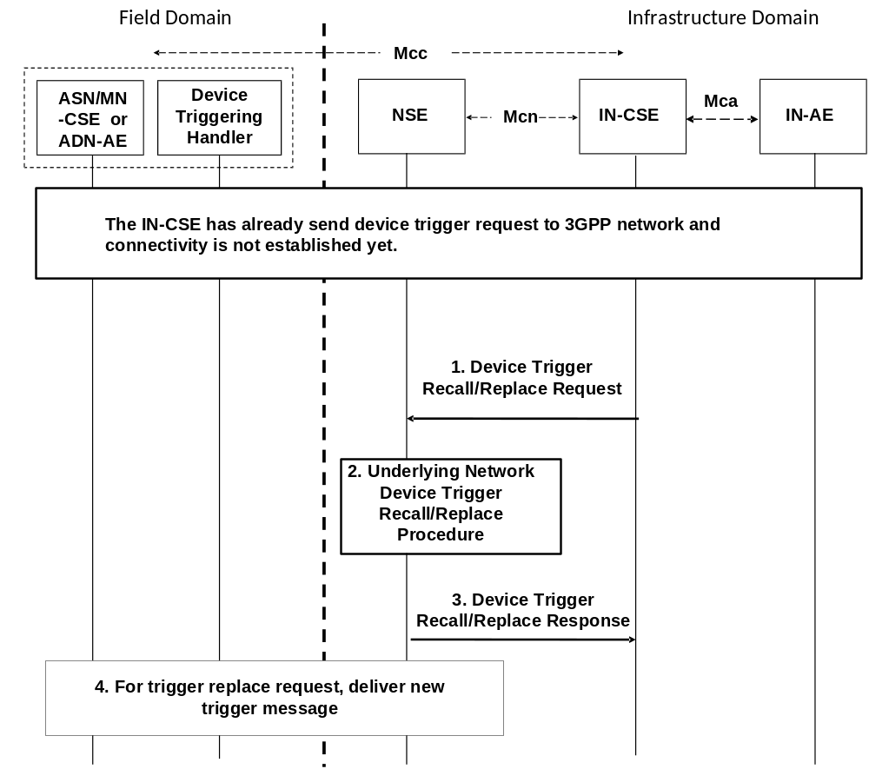
Figure 8.3.3.2.2-1: General device triggering recall/replace procedure
between oneM2M and 3GPP network
Pre-condition
The IN-CSE has already sent device trigger request to 3GPP network and connectivity is not established yet. IN-CSE has already stored the previous device trigger information, e.g. trigger reference number, etc..
Step-1: Device Trigger Recall/Replace request
IN-CSE issues the device trigger Recall/Replace request to 3GPP network.
In addition to same parameters in the original device trigger request, the following additional parameters for 3GPP device trigger recall/replace include:
- The old trigger reference number was assigned to the previously submitted trigger message that the IN-CSE wants to recall/replace.
- For trigger replace request, the new trigger reference number which is assigned by the IN-CSE to the newly submitted trigger message.
Step-2: 3GPP Network Device Trigger Recall/Replace procedure
Device Trigger Recall/Replace procedure is performed in 3GPP Network, which is specified in 3GPP TS 23.682 [Error: Reference source not found].
Step-3: 3GPP Device Trigger Recall/Replace response
The IN-CSE receives a response for the Device Trigger Recall/Replace request via the Mcn reference point.
If the IN-CSE receives a success response, the IN-CSE updates the device trigger information as following:
- For device trigger replace success response, the IN-CSE shall store the new trigger reference number replace the old trigger reference number.
- For device trigger recall success response, the IN-CSE shall clear the old trigger reference number.
Step-4: For trigger replace request, deliver new trigger message.
For trigger replace request, the new trigger message will be delivered to the target Node as specified in 3GPP TS 23.682 [Error: Reference source not found].

-----------------------End of Change 6 -------------------------------------------

-----------------------Start of Change 7 -------------------------------------------

9.6.5 Resource Type AE
An <AE> resource shall represent information about an Application Entity registered to a CSE.

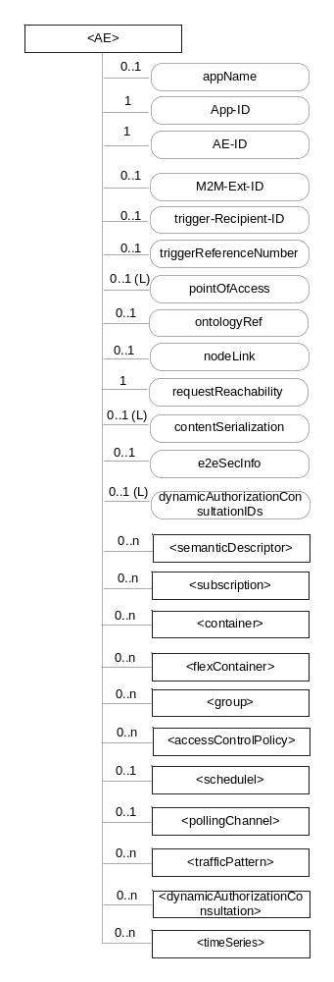
Figure 9.6.5-1: Structure of <AE> resource
The <AE> resource shall contain the child resources specified in table 9.6.5-1.
Table 9.6.5-1: Child resources of <AE> resource
Child Resources of <AE> | Child Resource Type | Multiplicity | Description | <AEAnnc> Child Resource Types
[variable] | <semanticDescriptor> | 0..n | See clause 9.6.30 | <semanticDescriptor>, <semanticDescriptorAnnc>
[variable] | <subscription> | 0..n | See clause 9.6.8 | <subscription>
[variable] | <container> | 0..n | See clause 9.6.6 | <container> <containerAnnc>
[variable] | <flexContainer> | 0..n | See clause 9.6.35 | <flexContainer>  <flexContainerAnnc>
[variable] | <group> | 0..n | See clause 9.6.13 | <group>  <groupAnnc>
[variable] | <accessControlPolicy> | 0..n | See clause 9.6.2 | <accessControlPolicy>  <accessControlPolicyAnnc>
[variable] | <schedule> | 0..1 | See clause 9.6.9 | <scheduleAnnc>
[variable] | <pollingChannel> | 0..1 | See clause 9.6.21  When the AE is request-unreachable, the AE should create this <pollingChannel> resource and perform long polling. The <pollingChannel> shall be utilized by the parent resource | None
trafficPattern | <trafficPattern> | 0..n | See clause 9.6.41 | <trafficPatternAnnc>
[variable] | <dynamicAuthorizationConsultation> | 0..n | See clause 9.6.40 | None
[variable] | <timeSeries> | 0..n | See clause 9.6.36 | <timeSeries>  <timeSeriesAnnc>

The <AE> resource shall contain the attributes specified in table 9.6.5-2.
Table 9.6.5-2: Attributes of <AE> resource
Attributes of  <AE> | Multiplicity | RW/  RO/  WO | Description | <AEAnnc> Attributes
resourceType | 1 | RO | See clause 9.6.1.3. | NA
resourceID | 1 | RO | See clause 9.6.1.3. Contains the AE-ID-Stem of the AE (see clause 7.2 on identifier formats and clause 10.1.1.2.2 for AE registration procedure). | NA
resourceName | 1 | WO | See clause 9.6.1.3. | NA
parentID | 1 | RO | See clause 9.6.1.3. | NA
expirationTime | 1 | RW | See clause 9.6.1.3. | MA
accessControlPolicyIDs | 0..1 (L) | RW | See clause 9.6.1.3. | MA
creationTime | 1 | RO | See clause 9.6.1.3. | NA
lastModifiedTime | 1 | RO | See clause 9.6.1.3. | NA
labels | 0..1 (L) | RW | See clause 9.6.1.3. | MA
announceTo | 0..1 (L) | RW | See clause 9.6.1.3. | NA
announcedAttribute | 0..1 (L) | RW | See clause 9.6.1.3. | NA
dynamicAuthorizationConsultationIDs | 0..1 (L) | RW | See clause 9.6.1.3. | OA
appName | 0..1 | RW | The name of the application, as declared by the application developer(e.g. "HeatingMonitoring").  Several sibling resources may share the appName. | OA
App-ID | 1 | WO | The identifier of the Application (see clause 7.1.3). | OA
AE-ID | 1 | RO | The identifier of the Application Entity (see clause 7.1.2). | OA
M2M-Ext-ID | 0..1 | RW | Supported when Registrar is IN-CSE.  See clause 7.1.8 where this attribute is described. This attribute is used only for the case of dynamic association of M2M-Ext-ID and AE-ID. | NA
trigger-Recipient-ID | 0..1 | RW | Supported when Registrar is IN-CSE. See clause 7.1.10 where this attribute is described. This attribute is used only for the case of dynamic association of M2M-Ext-ID and AE-ID. | NA
triggerReferenceNumber | 0..1 | RW | This is to identify device trigger procedure request. This attribute is used only for device trigger and assigned by the IN-CSE. | NA
pointOfAccess | 0..1 (L) | RW | The list of addresses for communicating with the registered Application Entity over Mca reference point via the transport services provided by Underlying Network (e.g. IP address, FQDN, URI). This attribute shall be accessible only by the AE and the Hosting CSE.  If this information is not provided and the <pollingChannel> resource does exist, the AE should use <pollingChannel> resource. Then the Hosting CSE can forward a request to the AE without using the PoA. | OA
ontologyRef | 0..1 | RW | A URI of the ontology used to represent the information that is managed and understood by the AE. | OA
requestReachability | 1 | RW | If the AE that created this <AE> resource can receive a request, this attribute is set to "TRUE" otherwise "FALSE" | OA
nodeLink | 0..1 | RW | The resource identifier of a <node> resource that stores the node specific information of the node on which the AE represented by this <AE> resource resides. | OA
contentSerialization | 0..1 (L) | RW | The list of supported serializations of the Content primitive parameter for receiving a request from its registrar CSE. (e.g. XML, JSON). The list shall be ordered so that the most preferred format comes first. | OA
e2eSecInfo | 0..1 | RW | See clause 9.6.1.3. | MA

-----------------------End of Change 7 -------------------------------------------

-----------------------Start of Change 8 -------------------------------------------

B.1 3GPP MTC Underlying Network Introduction
In order to provide end-to-end M2M services, interworking between oneM2M System and the 3GPP Underlying Network is required. This entails the following aspects:
- Connectivity establishment between the IN-CSE and the CSE or ADN-AE at the M2M/MTC device/Gateway in the 3GPP Underlying Network for the following two cases.
- ASN/MN-CSE or ADN-AE initiated connectivity establishment when the device/GW has lost connectivity with the Underlying Network and needs to send data to the AE.
- IN-CSE initiated triggering for cases when the ASN/MN-CSE or ADN-AE needs to be contacted by the IN-CSE.
- Mapping of oneM2M and 3GPP Identifiers to assist the specific entities on the two system in connectivity establishment.
This annex provides system level information on the above aspects specifically related to the interworking i.e. connectivity between the oneM2M System and the 3GPP Underlying Network.

-----------------------End of Change 8 -------------------------------------------

-----------------------Start of Change 9 -------------------------------------------

B.2 3GPP MTC Functionality

B.2.1 3GPP Release-11 MTC Functionality
Interworking with oneM2M Release-1 is based on 3GPP Release-11 specifications. The relevant 3GPP Release-11 specification references are as follows:
- 3GPP TS 23.682 [Error: Reference source not found]: Architecture Enhancements to facilitate Communication with Packet Data Networks and Applications;
- 3GPP TS 23.401 [Error: Reference source not found]: GPRS Enhancements for E-UTRAN Access;
- 3GPP TS 23.402 [Error: Reference source not found]: Architecture Enhancements for non-3GPP Accesses;
- 3GPP TS 23.060 [Error: Reference source not found]: General Packet Radio Service (GPRS) Service Description;
- 3GPP TS 22.368 [Error: Reference source not found]: Service requirements for Machine Type Communications (MTC); Stage 1.
In annex A of 3GPP TS 23.682 [Error: Reference source not found] the following MTC deployment scenarios are depicted on which the oneM2M entities are mapped.

Application

Server

Application

Server

Application

Server

Operator

Network

Operator Network

UE

UE

UE

SCS

SCS

Operator

Boundary

A

.

Direct Model

B

.

Indirect Model

(MTC Service Provider

Controlled)

C

.

Indirect Model

(Mobile Network Operator

Controlled)

Operator

Network

Control plane

User plane

IN
-
CSE

IN
-
CSE

AE

AE

ASN/MN-CSE or ADN-AE
ASN/MN-CSE or ADN-AE

Figure B.2.1-1: MTC deployment scenarios for Direct and Indirect model
The focus of this Annex is on deployment scenario B (Indirect Model), where the M2M (or MTC in 3GPP nomenclature) Services Capability Server (SCS) is outside the 3GPP operator domain. The indirect model, scenario C in figure B.2.1-1, where the M2M SCS is inside the 3GPP operator domain is also not ruled out.
Hybrid model which is a combination of above scenario B and C is also mentioned in 3GPP TS 23.682 [Error: Reference source not found] which may also be supported but is not shown here.
Taking 3GPP Release-11 MTC network as the Underlying Network, oneM2M IN-CSE is considered as equivalent to or part of the SCS, and oneM2M ASN/MN-CSE or ADN-AE is considered equivalent to a UE. The mapping of oneM2M entities to 3GPP entities is shown in figure B.2.1-2.

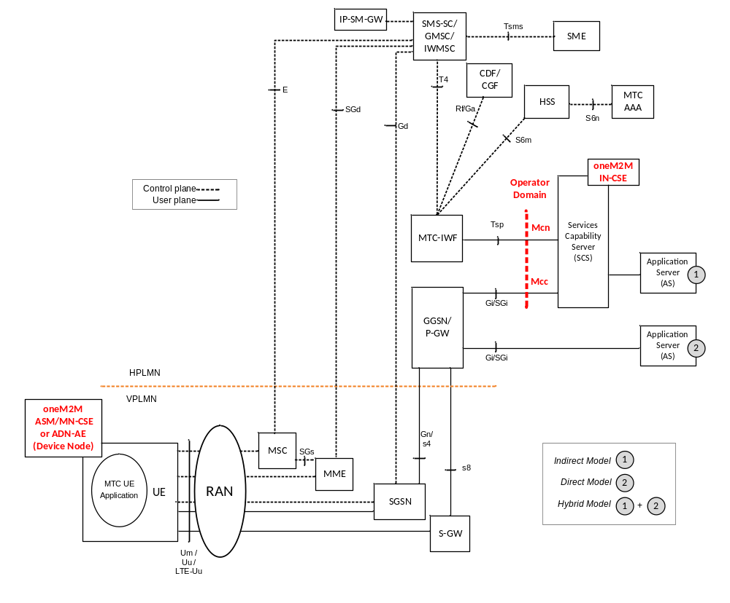
Figure B.2.1-2: Mapping of oneM2M entities to the 3GPP Architecture for
Machine-to-Machine Communications
The IN-CSE can be inside or outside the 3GPP operator domain and interacts with the 3GPP Underlying Network via MTC-IWF and/or GGSN/P-GW. This requires mapping of oneM2M reference points (Mcn, Mcc) to 3GPP reference points (Tsp, Gi/SGi), along with the mapping of the identifiers in the two systems.

-----------------------End of Change 9 -------------------------------------------

-----------------------Start of Change 10 -------------------------------------------

B.3 ASN/MN-CSE and ADN-AE initiated connectivity establishment

B.3.0 Overview
It is assumed that there is no connectivity previously established, i.e. no association between the ASN/MN-CSE or ADN-AE and the serving IN-CSE exists. When the ASN/MN-CSE or ADN-AE needs to send data to the serving IN-CSE it first discovers the serving IN-CSE, which is located in a packet data network, and establishes connection. Two methods can be used, as follows:
- Use of DHCP and DNS.
- Pre-configuration.

B.3.1 Use of DHCP and DNS
The ASN/MN-CSE or ADN-AE requests the DNS server address from the DHCP server followed by requesting the serving IN-CSE IP address from the DNS server.

B.3.2 Pre-configuration
The ASN/MN-CSE or ADN-AE is preconfigured with the fully qualified domain name (FQDN) of the serving IN-CSE or the IP address of the serving IN-CSE. If the FQDN is known, DNS resolution is used to obtain the IP address.

-----------------------End of Change 10 -------------------------------------------

-----------------------Start of Change 11 -------------------------------------------

B.4 Serving IN-CSE initiated connectivity establishment
It is assumed that there is no connectivity previously established between the ASN/MN-CSE or AND-AE and the serving IN-CSE. When the serving IN-CSE needs to contact the ASN/MN-CSE or ADN-AE to send data or request data, connectivity between them is established. This connectivity is triggered by the serving IN-CSE.

-----------------------End of Change 11 -------------------------------------------

-----------------------Start of Change 12 -------------------------------------------

B.5 Connectivity between oneM2M Service Layer and 3GPP Underlying Network
ASN/MN-CSE or ADN-AE communicates with the serving IN-CSE after completion of the Underlying Network bearer establishment and discovery of the serving IN-CSE. Data can then traverse the IP connection in the Underling Network over 3GPP Gi/SGi interface. In addition, the signalling connectivity is also realized. Figure B.5-1 depicts the connectivity between the ASN/MN-CSE or ADN-AE and the IN-CSE.

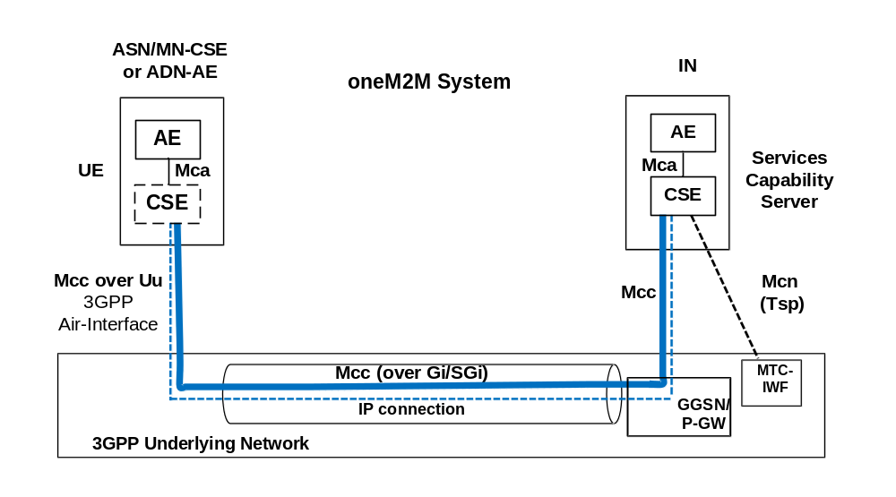
Figure B.5-1: Connectivity Establishment between ASN/MN-CSE or ADN-AE and IN-CSE

-----------------------End of Change 12 -------------------------------------------

-----------------------Start of Change 13 -------------------------------------------

B.6 Connectivity Establishment Procedures

B.6.1 General

B.6.1.0 Overview
When data is to be exchanged between the ASN/MN-CSE or ADN-AE and the IN-CSE, connectivity between them needs to be established. The need for this connectivity can arise for two reasons:
- ASN/MN-CSE or ADN-AE initiated: When the ASN/MN-CSE or ADN-AE needs to send/receive data to/from the IN-CSE; or
- IN-CSE initiated: When the IN-CSE needs to send/receive data to/from the ASN-CSE or ADN-AE (known as device triggering).
Connectivity establishment procedures in this clause are example illustrations and do not exclude other realizations.

B.6.1.1 ASN/MN-CSE or ADN-AE Initiated Connectivity Establishment Procedure

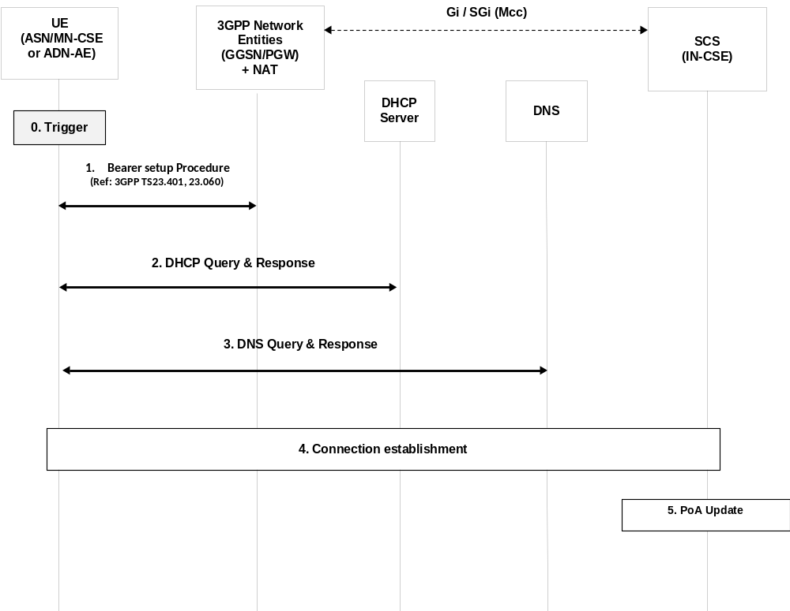

Figure B.6.1.1-1: ASN/MN-CSE initiated connectivity establishment
Step-0: Trigger
Subsequent procedures are triggered either when the ASN/MN-CSE or ADN-AE powers on or resulting from Device Triggering mentioned in clause B.6.1.2.
Step-1: Bearer Setup Procedure
Establish a 3GPP bearer(s) if not already available by using the procedures available in the 3GPP network.
Step-2: DHCP Query & Response
The ASN/MN-CSE or ADN-AE sends a query to a DHCP server to find a particular DNS server IP address. The DHCP server responds with the IP address of a corresponding DNS server. Additionally, it is also possible to include one or a list of domain names, i.e. FQDNs of target IN-CSEs.
Step-3: DNS Query & Response
The ASN/MN-CSE or ADN-AE performs a DNS query to retrieve the IN-CSE(s) IP addresses from which one is selected. If the response does not contain the IP addresses, an additional DNS query is needed to resolve a Fully Qualified Domain Name (FQDN) of the serving IN-CSE to an IP address.
Step-4: Connection Establishment
After reception of domain name and IP address of an IN-CSE, the ASN/MN-CSE or ADN-AE can initiate communication towards the IN-CSE via the IP connection. The IN-CSE at this time shall be informed which Trigger Recipient ID of the ASN/MN-CSE or ADN-AE to use for establishing communication.
Step-5: CSE-PoA Update
Once the M2M Service Connection (Mcc) is established, in the IN-CSE the CSE-PoA of the ASN-CSE/MN-CSE or the AE-PoA of the ADN-AE shall be updated with the new established IP address.
The IN-CSE holds the state information and needs to be informed when the connection is closed.

B.6.1.2 IN-CSE initiated connectivity establishment procedure over Tsp
Connection Establishment between IN-CSE and ASN/MN-CSE or ADN-AE
Whenever the IN-CSE requires to establish a connection towards another entity (e.g. ASN/MN-CSE or ADN-AE), Device Triggering procedure over the Tsp interface as described in 3GPP TS 23.682 [Error: Reference source not found] shall be used.

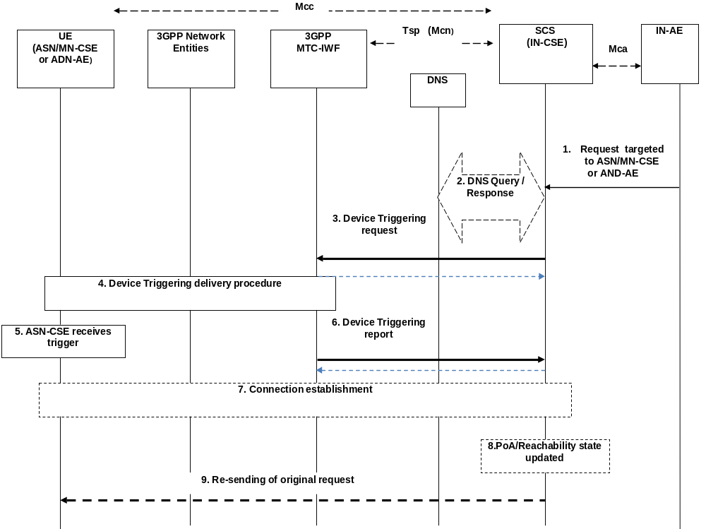
Figure B.6.1.2-1: IN-CSE initiated connectivity establishment
Pre-condition
The IN-CSE checks the state information of the target device. Some of this state information is the result of provisioning or a previous connection establishment or triggering requests, such as the case of power-off, dormant and/or connected state. The IN-CSE decides its next action, e.g. if it needs to start device triggering or to report to IN-AE about the inability to perform the request.
The CSE-PoA for the ASN/MN-CSE or AE-PoA of the ADN-AE either already contain an IP address which is not valid anymore or no IP address at all, or FQDN does not resolve to a valid IP address. This is a pre-requisite for performing the device triggering procedure.
Step 1 (Optional): Request targeted to ASN/MN-CSE or ADN-AE
The IN-AE requests to perform one of the CRUD operation on a resource residing on the ASN/MN-CSE or ADN-AE, the request is sent via the Mca reference point to the IN-CSE. The request from IN-AE includes the address of the target resource.
Step 2: DNS Query/Response
The IN-CSE determines the need to trigger the ASN/MN-CSE or ADN-AE.
If the IN-CSE has no contact details for a contact MTC-IWF, it may determine the IP address(es)/port(s) of the MTC-IWF by performing a DNS query using the M2M-Ext-ID (M2M External Identifier) assigned to the target ASN/MN-CSE or ADN-AE, or using a locally configured MTC-IWF identifier.
Step-3: Device Triggering Request
The IN-CSE buffers the original request information and sends the Device Trigger Request message that contains information as specified in 3GPP TS 23.682 [Error: Reference source not found]. Such information includes:
- M2M-Ext-ID or MSISDN;
- SCS-Identifier, (is set to the IN-CSE ID);
- Trigger reference number (used to correlate the request with the response);
- Validity period, (which indicates how long the request is valid);
- Priority (this field allows to set the priority on or off);
- Application Port ID, (is set to the ASN/MN-CSE or ADN-AE Trigger-Recipient-ID since it is the triggering application addressed in the device from 3GPP point of view);
- Trigger payload, (optional information can be set to the payload).
NOTE 1: In case that the Device Triggering request is for an M2M Service Connection setup request as in the present flow, it is assumed that when the target (i.e. ASN/MN-CSE or or ADN-AE) is woken up on receiving the trigger it initiates connection establishment with the IN-CSE with which it is registered. The information of the IN-CSE may be pre-stored in the target (i.e. ASN/MN-CSE or ADN-AE) or obtained from the payload.
Acknowledge
Once, 3GPP-MTC-IWF receives the Trigger Request, it asks the HSS to determine if the IN-CSE is authorized to perform the triggering to the target (i.e. ASN/MN-CSE or ADN-AE) and the HSS resolves the M2M-Ext-ID to IMSI (or MSISDN). Then the 3GPP MTC-IWF acknowledges to the IN-CSE with the confirmation of receiving Device Triggering Request.
Step-4: Device Triggering delivery procedure
The MTC-IWF initiates the T4 trigger delivery procedure according to the 3GPP TS 23.682 [Error: Reference source not found], based on the information received from HSS and local policy.
NOTE 2: 3GPP Network Entities (e.g. SMS-SC) can select appropriate device triggering mechanism (e.g. SMS based or SIP based via IP-SM-GW) according to the device capabilities.
Step 5: ASN/MN-CSE receives the trigger

As a result of the triggering procedure, the payload is delivered to the ASN/MN-CSE or ADN-AE trigger recipient.

NOTE 3: In case the Device Trigger contains the optional part of the trigger payload, it is assumed that such trigger payload e is forwarded to the application inside the ASN/MN-CSE or ADN-AE that is started as a result of device trigger.
Step 6: Device Triggering report
Request:
The MTC-IWF sends the Device Trigger Report message (containing the M2M-Ext-ID or MSISDN and trigger reference number) to the IN-CSE with a cause value indicating whether the trigger delivery succeeded or failed and the reason for the failure.
Acknowledge:
IN-CSE acknowledges to the MTC-IWF with the conformation of the received Device Triggering Report.
Step 7 (Optional): Connection establishment procedure
The ASN/MN-CSE or ADN-AE performs the Connection establishment procedure as described in clause B.6.1.1 and oneM2M TS-0003 [Error: Reference source not found] for Secure Connection establishment.
As a result of this procedure the initial request over the reference point Mcc can be executed.
Step 8 (Optional): CSE-PoA/Reachability state updated
Once the connection over Mcc is established, the PoA of the ASN/MN-CSE or ADN-AE shall be updated at the IN-CSE with the new established IP address and the IN-CSE holds the reachability state of the ASN/MN-CSE or ADN-AE.
Step 9 (Optional): Re-sending of original request
As a result of step 7, the communication is established and now the initial request with the information stored in the buffer of the IN-CSE at Step 3 can be re-issued over the reference point Mcc.

-----------------------End of Change 13 -------------------------------------------

-----------------------Start of Change 14 -------------------------------------------

C.1 General Concepts
Interworking between oneM2M System and 3GPP2 Underlying Networks is based on 3GPP2 X.P0068 [Error: Reference source not found].
In order to provide M2M services, interworking between oneM2M System and the 3GPP2 Underlying Network is required. M2M Applications (AEs) in the M2M UEs (M2M Nodes such as the ASNs, MNs, and ADNs) and the M2M Applications in the external network (Infrastructure Domain) use services provided by the 3GPP2 Underlying Network, and optionally the services provided by an M2M Server (IN-CSE). The 3GPP2 Underlying Network provides transport and communication services, including 3GPP2 bearer services, IMS and SMS.
3GPP2 Underlying Network supports several interworking models, such as the following:
- Direct Model - Direct Communication provided by the 3GPP2 Network Operator:
- The M2M Applications in the external network connect directly to the M2M Applications in the UEs used for M2M via the 3GPP2 Underlying Network without the use of any M2M Server.
- Indirect Model - M2M Service Provider controlled communication:
- Uses an M2M Server that is an entity outside the 3GPP2 Underlying Network operator domain for enabling communications between the Applications in the external network and at the UEs used for M2M. Tsp interface or SMS interface is an external interface that the third party M2M Server supports with the entities that are within the 3GPP2 Underlying Network domain.
- Indirect Model - 3GPP2 Operator controlled communication:
- Uses an M2M Server that is an entity inside the 3GPP2 Underlying Network operator domain for enabling communications between the Applications in the external network and at the UEs used for M2M. Tsp interface or SMS interface is an internal interface that the 3GPP2 Underlying Network operator controlled M2M Server supports with other entities within the 3GPP2 Underlying Network domain.
- Hybrid Model:
- Direct and Indirect models are used simultaneously in the hybrid model i.e. performing Control Plane signalling using the Indirect Model and connecting the M2M Applications in the external network and at the UEs used for M2M over User Plane using the Direct Model.

-----------------------End of Change 14 -------------------------------------------

-----------------------Start of Change 15 -------------------------------------------

C.2 M2M Communication Models
In the indirect and hybrid models, the deployment of an M2M Server (IN-CSE) may be inside or outside the 3GPP2 Underlying Network operator domain as illustrated in figures C.2-1 and C.2-2. When the M2M Server is part of the 3GPP2 Underlying Network operator domain (figures C.2-1(C) and C.2-2), the M2M Server is considered a 3GPP2 Underlying Network operator internal network function, is operator controlled, and may provide operator value-added services. In this case, security and privacy protection for communication between the M2M-IWF and the M2M Server (IN-CSE) is optional. When the M2M Server is deployed outside the 3GPP2 Underlying Network operator domain (figures C.2-1(B) and C.2-2), the M2M Server is M2M Service Provider controlled. In this case, security and privacy protection for communication between the M2M-IWF and the M2M Server (IN-CSE) is needed. In the direct model (figure C.2-1(A)), there is no external or internal M2M Server in the communication path.
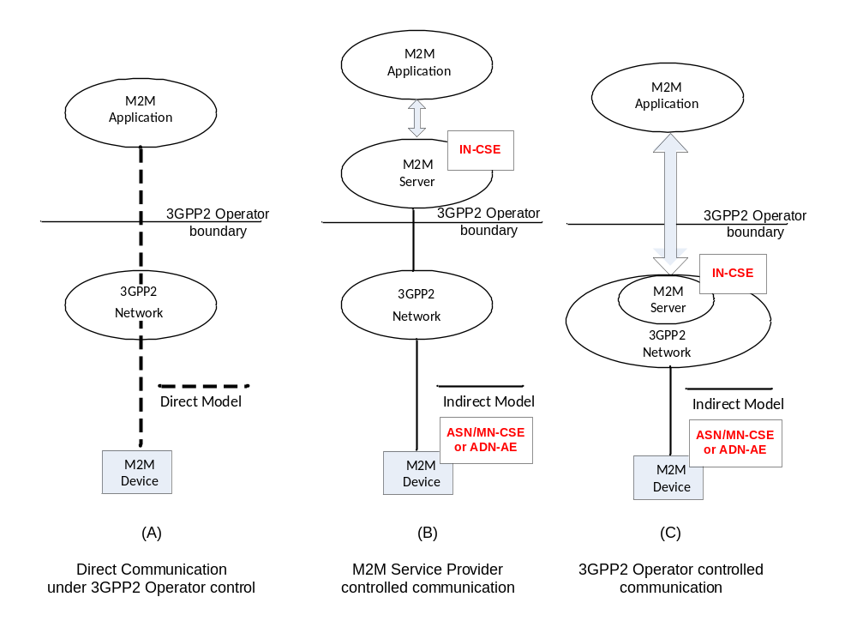
Figure C.2-1: M2M Communication Models
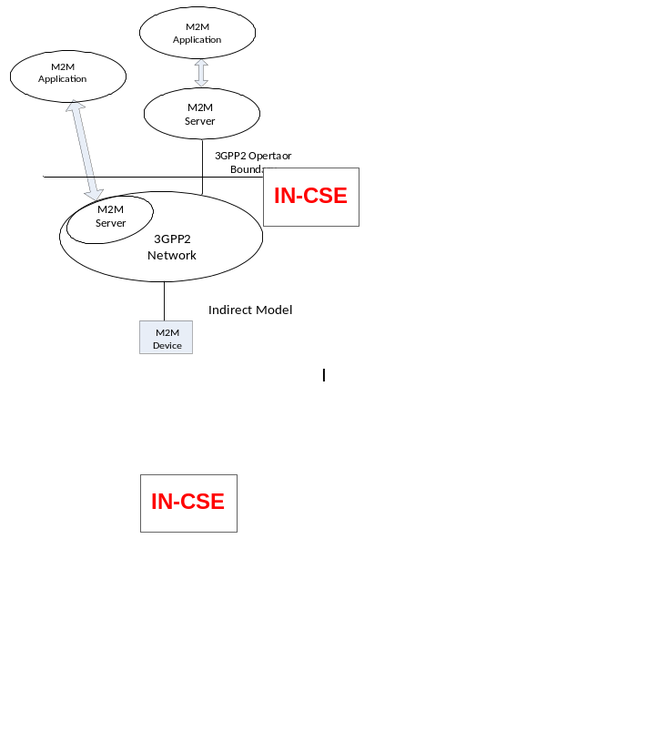
Figure C.2-2: Multiple M2M Applications Using Diverse Communication Models
A 3GPP2 network operator may deploy the hybrid model with a combination of no internal and external M2M Server (as in the Direct Model) and internal and/or external M2M Server (as in the Indirect Model). As shown in figure C.2-2, a UE (an M2M Node such as ASN/MN or ADN-AE) may be in communication with multiple M2M Servers which can be made up of a combination of 3GPP2 Underlying Network operator controlled and M2M Service Provider controlled M2M Servers. In that scenario, the M2M Service Provider controlled M2M Server, and the 3GPP2 Underlying Network operator controlled M2M Server may offer different capabilities to the M2M Applications.
Though not illustrated, it is also possible that in the Indirect Service Model with 3GPP2 network operator controlled M2M Server; the M2M Application may be inside the 3GPP2 network operator domain and under 3GPP network operator control.

-----------------------End of Change 15 -------------------------------------------

-----------------------Start of Change 16 -------------------------------------------

C.3 3GPP2 Architectural Reference Model for M2M
Figure C.3-1 shows the architecture for a UE used for M2M connecting to the 3GPP2 Underlying Network. The architecture supports various architectural models described in clause C.2.

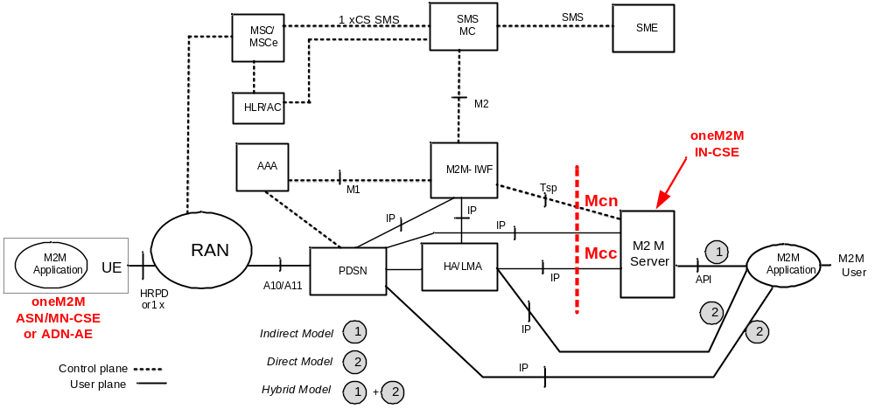
Figure C.3-1: Enhanced 3GPP2 Network Architecture for Supporting M2M
The M2M Server (IN-CSE) is the entity which connects to the 3GPP2 Underlying Network for providing communication with the UEs used for M2M. The M2M Server offers capabilities for use by one or multiple M2M Applications (AEs) hosted by the UE (ASN/MN or ADN-AE). The corresponding M2M Applications in the external network (Infrastructure Domain) are hosted by one or multiple M2M Application platform(s).
The M2M Server interfaces with the 3GPP2 Underlying Network entities located in the home domain of the UE used for M2M via the Tsp and IP interfaces. M2M Server encompasses the IN-CSE entity specified by oneM2M. M2M Server interfaces with the M2M-IWF via Tsp Interface for Control Plane communications. User plane interactions between the M2M Server and 3GPP2 Underlying Network entities such as the PDSN and/or HA/LMA is via native-IP. With this configuration, oneM2M reference points Mcn and Mcc map to 3GPP2 reference points Tsp and IP respectively.

-----------------------End of Change 16 -------------------------------------------

-----------------------Start of Change 17 -------------------------------------------

C.4 Communication between oneM2M Service Layer and 3GPP2 Underlying Network
Communication between the M2M Server (IN-CSE) and the entities in the 3GPP2 Underlying Network make use of the User Plane and the Control Plane communication paths, as needed for different 3GPP2 M2M communication models. User Plane communication path uses IP transport between the M2M Server (IN-CSE) and the ADN-AE or the CSE in the UE used for M2M (ASN/MN-CSE). The User Plane maps to oneM2M Mcc reference point. Control Plane communication path is over Tsp interface and maps to oneM2M Mcn reference point.

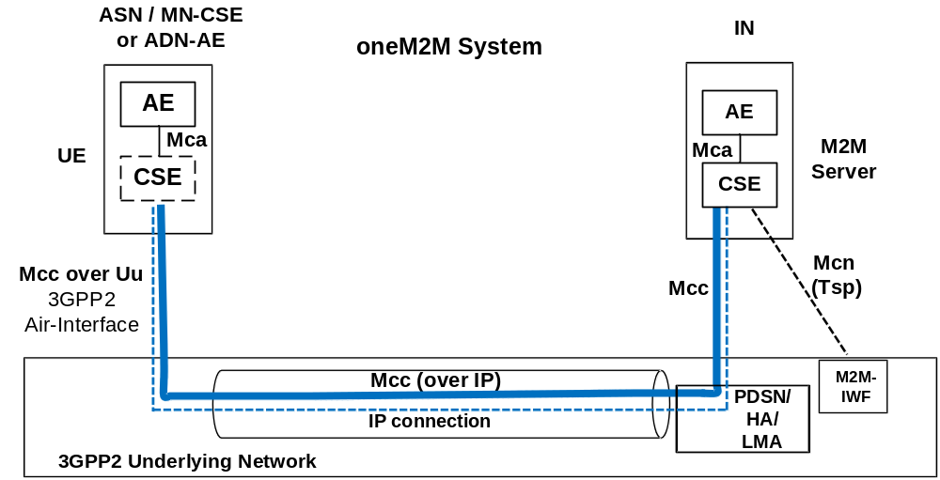
Figure C.4-1: User Plane and Control Plane Communication Paths

-----------------------End of Change 17 -------------------------------------------

-----------------------Start of Change 18 -------------------------------------------

C.5 Information Flows

C.5.0 Overview
3GPP2 X.S0068 [Error: Reference source not found] specifies several system optimizations that can be used for M2M applications. Such optimizations include the following:
- Interaction of M2M Server with M2M-IWF for device triggering.
- Device trigger using SMS.
- Device trigger using broadcast SMS.
- Device trigger using IP transport.

C.5.1 Tsp Interface Call Flow
Figure C.5.1-1 is the high level call flow illustrating device triggering using Tsp interface.

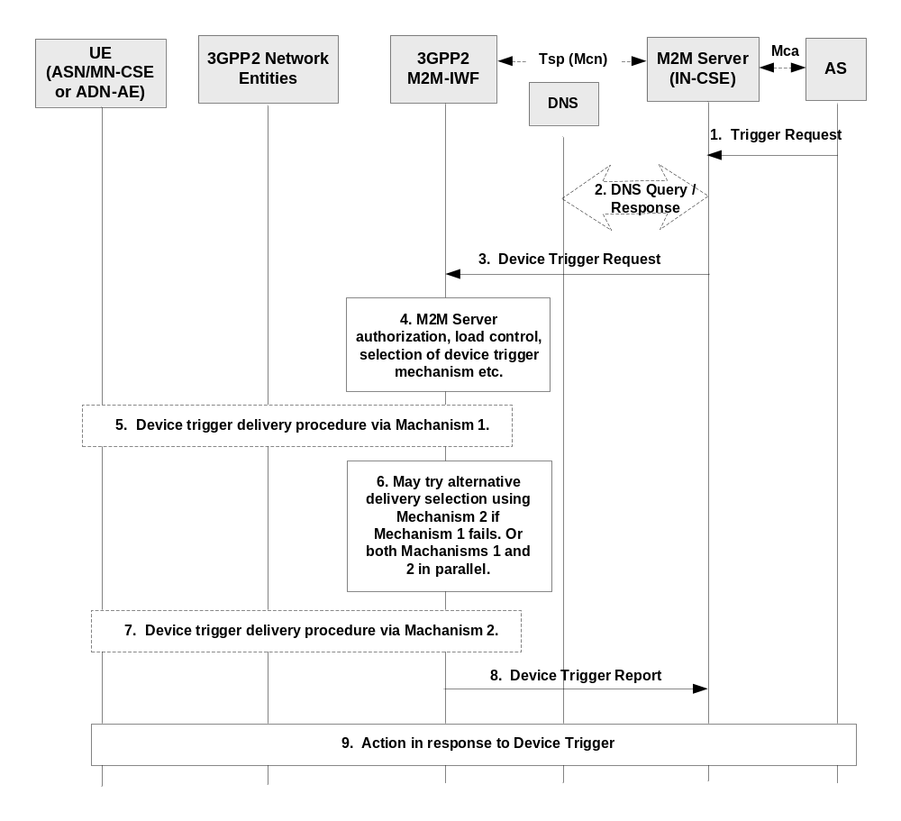Figure C.5.1-1: Tsp Interface Call Flow
- M2M Server (IN-CSE) receives a request from an M2M Application Server (AE in Infrastructure Domain) to deliver data to a UE used for M2M (ASN/MN-CSE or ADN-AE) located in the 3GPP2 Underlying Network. Knowing the CSE-ID or AE-ID of the destination M2M Node, IN-CSE deduces its 3GPP2 External Identifier.
- M2M Server (IN-CSE) may perform DNS query to obtain the IP address of the M2M-IWF for reaching the destination M2M Node.
- M2M Server sends Device Trigger Request message to the M2M-IWF that includes destination M2M Node External ID and other information.
- M2M-IWF checks that the M2M Server is authorized to send trigger requests and performs other tasks such as verifying that the M2M Server has not exceeded its quota or rate of trigger submission over Tsp. If such checks fail, the MTC-IWF sends a Device Trigger Confirm message with a cause value indicating the reason for the failure condition and the call flow stops at this step.
Otherwise, the MTC-IWF continues to interact with HAAA/HLR for obtaining 3GPP2 Internal ID for the M2M Node and other information for reaching the M2M Node in the 3GPP2 Underlying Network. M2M-IWF also determines the device trigger mechanisms (e.g. Mechanism 1, Mechanism 2 etc.) supported by the M2M Node. The flow continues with Step 5.
- M2M-IWF decides to deliver device trigger using e.g. Mechanism 1 and performs appropriate 3GPP2 Underlying Network specific procedures.
- M2M-IWF may try alternative device trigger delivery mechanism (e.g. Mechanism 2) if Mechanism 1 fails. Or both Mechanism 1 and 2 can be performed in parallel.
- M2M-IWF performs appropriate 3GPP2 Underlying Network specific procedures for delivering device trigger using Mechanism 2.
- M2M-IWF sends Device Trigger Report to the M2M Server upon receiving the acknowledgment from the M2M Node that it has received M2M device trigger.
- The M2M Node and the M2M Server/AS take actions in response to the device trigger as needed.

-----------------------End of Change 18 -------------------------------------------

CHECK LIST
- Does this change request include an informative introduction containing the problem(s) being solved, and a summary list of proposals?
- Does this CR contain changes related to only one particular issue/problem?
- Have any mirror crs been posted?
- Does this change request make all the changes necessary to address the issue or problem? E.g. A change impacting 5 tables should not only include a proposal to change only 3 tables. Includes any changes to references, definitions, and acronyms in the same deliverable?
- Does this change request follow the drafting rules?
- Are all pictures editable?
- Have you checked the spelling and grammar?
- Have you used change bars for all modifications?
- Does the change include the current and surrounding clauses to clearly show where a change is located and to provide technical context of the proposed change? (Additions of complete sections need not show surrounding clauses as long as the proposed section number clearly shows where the new section is proposed to be located.)
- Are multiple changes in this CR clearly separated by horizontal lines with embedded text such as, start of change 1, end of change 1, start of new clause, end of new clause?

