CHANGE REQUEST
Meeting:* | ARC 26.2
Source:* | Huawei
Date:* | 2016-11-25
Contact:* | Jessie, Huawei, lijing80@huawei.com  Echo,Huawei,echo.xubei@huawei.com
Reason for Change/s:* | <exact change/s to be provided below>
CR against: Release* | Release 3
CR against: WI* | Active < WI-0031>  MNT Maintenace / < Work Item number(optional)>  STE Small Technical Enhancements / < Work Item number (optional)>  Only ONE of the above shall be ticked
CR against: TS/TR* | TS-0001-V2.10.1
Clauses/Sub Clauses*
Type of change: * | Editorial change  Bug Fix or Correction  Change to existing feature or functionality  New feature or functionality  Only ONE of the above shall be ticked
Post Freeze checking:* | This CR contains only essential changes and corrections? YES NO  This CR may break backwards compatibility with the last approved version of the TS? YES NO  This CR is a mirror CR? YES if YES, please indicate the document number of the original CR: <Document Number) : NO
Template Version:27 May 2015 (Dot not modify)

oneM2M Notice
The document to which this cover statement is attached is submitted to oneM2M. Participation in, or attendance at, any activity of oneM2M, constitutes acceptance of and agreement to be bound by terms of the Working Procedures and the Partnership Agreement, including the Intellectual Property Rights (IPR) Principles Governing oneM2M Work found in Annex 1 of the Partnership Agreement.
GUIDELINES for Change Requests:
Provide an informative introduction containing the problem(s) being solved, and a summary list of proposals.
Each CR should contain changes related to only one particular issue/problem.
In case of a correction, and the change apply to previous releases, a separated “mirror CR” should be posted at the same time of this CR
Follow the principle of completeness, where all changes related to the issue or problem within a deliverable are simultaneously proposed to be made E.g. A change impacting 5 tables should not only include a proposal to change only 3 tables. Includes any changes to references, definitions, and acronyms in the same deliverable.
Follow the drafting rules.
All pictures must be editable.
Check spelling and grammar to the extent practicable.
Use Change bars for modifications.
The change should include the current and surrounding clauses to clearly show where a change is located and to provide technical context of the proposed change. Additions of complete sections need not show surrounding clauses as long as the proposed section number clearly shows where the new section is proposed to be located.
Multiple changes in a single CR shall be clearly separated by horizontal lines with embedded text such as, start of change 1, end of change 1, start of new clause, end of new clause.
When subsequent changes are made to content of a CR, then the accepted version should not show changes over changes. The accepted version of the CR should only show changes relative to the baseline approved text.
R04 Update history:
- Delete operation from change 6 to change 8.
- Delete the AE resource change.

Introduction
When an application wants to send a message to the members of a certain group, it may send the request to the <fanOutPoint> resource, then the request is fanned out to each of the members of the <group> resource indicated by the membersIDs attribute of the <group> resource. This is how the group message is transferred from the application to the group members defined by the current specification.
However, the existing method applied to M2M group message communication only saves the communication between the application and the group management server, but the group management server still needs to communicate with each group member separately. If the group management server or the network has limited capability or bandwidth, then the communication between the group management server and the group members will be a high cost and is not economical. The communication cost between the group server and the group members can be decreased by reusing the existing underlying network technologies, for example, 3GPP MBMS or IP multicast. But not all the M2M devices and networks support multicast, so it is necessary for oneM2M to extend the group related resources to manage and reuse the multicast capability of the underlying network, in order to make the group communication more efficient and economical.
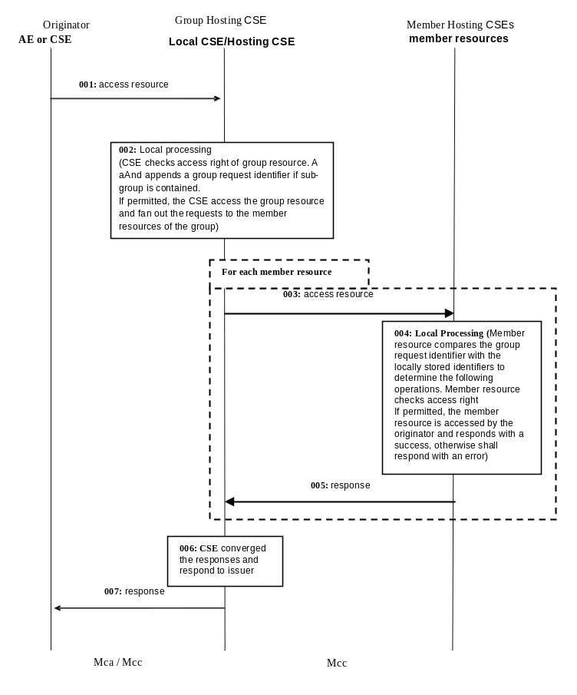

-----------------------Start of change 1-------------------------------------------

9.6.3 Resource Type CSEBase
A <CSEBase> resource shall represent a CSE. The <CSEBase> resource shall be the root for all resources that are residing in the CSE.

Figure 9.6.3-1: Structure of <CSEBase> resource
Figure 9.6.3-1 does not show the child announce resource types defined in table 9.6.3-2.
The <CSEBase> resource shall contain the child resources specified in table 9.6.3-1.
Table 9.6.3-1: Child resources of <CSEBase> resource
Child Resources of <CSEBase> | Child Resource Type | Multiplicity | Description
[variable] | <remoteCSE> | 0..n | See clause 9.6.4
[variable] | <remoteCSEAnnc> | 0..n | Announced variant of <remoteCSE>. Resource with CSE-specific information for a CSE that announced itself to another CSE with which it does not have a registration relationship.
[variable] | <node> | 0..n | See clause 9.6.18
[variable] | <AE> | 0..n | See clause 9.6.5
[variable] | <container> | 0..n | See clause 9.6.6
[variable] | <flexContainer> | 0..n | See clause 9.6.35
[variable] | <group> | 0..n | See clause 9.6.13
[variable] | <accessControlPolicy> | 0..n | See clause 9.6.2
[variable] | <subscription> | 0..n | See clause 9.6.8
[variable] | <mgmtCmd> | 0..n | See clause 9.6.16
[variable] | <locationPolicy> | 0..n | See clause 9.6.10
[variable] | <statsConfig> | 0..n | See clause 9.6.23
[variable] | <statsCollect> | 0..n | See clause 9.6.25
[variable] | <request> | 0..n | See clause 9.6.12
[variable] | <delivery> | 0..n | See clause 9.6.11
[variable] | <schedule> | 0..1 | This resource defines the reachability schedule information of the entity. The absence of this resource implies the entity is always reachable. See clause 9.6.9
[variable] | <role> | 0..n | See clause 9.6.38
[variable] | <token> | 0..n | See clause 9.6.39
[variable] | <m2mServiceSubscriptionProfile> | 0..n | See clause 9.6.19
[variable] | <serviceSubscribedAppRule> | 0..n | See clause 9.6.29
[variable] | <notificationTargetPolicy> | 0..n | See clause 9.6.32
[variable] | <dynamicAuthorizationConsultation> | 0..n | See clause 9.6.40
[variable] | <timeSeries> | 0..n | See clause 9.6.36
[variable] | <parantGroup> | 0..n | See clause 9.6.y

An instance of a <remoteCSEAnnc> resource shall be created as a child of a <CSEBase> resource when an Originator CSE of an announcement request (i.e. original resource Hosting CSE) and a targeted Hosting CSE of an announced resource (i.e. announced resource Hosting CSE) have no registration relationship (e.g. the Originator CSE has not created <remoteCSE> resource on the Hosting CSE), see clause 9.6.26.
The <CSEBase> resource shall contain the attributes specified in table 9.6.3-2.
Table 9.6.3-2: Attributes of <CSEBase> resource
Attributes of <CSEBase> | Multiplicity | RW/  RO/  WO | Description
resourceType | 1 | RO | See clause 9.6.1.3.
resourceID | 1 | RO | See clause 9.6.1.3.
resourceName | 1 | RO | See clause 9.6.1.3.
parentID | 1 | RO | See clause 9.6.1.3. Shall be NULL.
creationTime | 1 | RO | See clause 9.6.1.3.
lastModifiedTime | 1 | RO | See clause 9.6.1.3.
accessControlPolicyIDs | 0..1 (L) | RO | See clause 9.6.1.3.
labels | 0..1 (L) | RO | See clause 9.6.1.3.
dynamicAuthorizationConsultationIDs | 0..1 (L) | RO | See clause 9.6.1.3.
cseType | 0..1 | RO | Indicates the type of CSE represented by the created resource:  - Mandatory for an IN-CSE, hence multiplicity (1).  - Its presence is subject to SP configuration in case of an ASN-CSE or a MN-CSE.
CSE-ID | 1 | RO | The CSE identifier in SP-relative CSE-ID format (clause 7.2).
supportedResourceType | 1 (L) | RO | List of the resource types which are supported in the CSE. This attribute contains subset of resource types listed in clause 9.2.
pointOfAccess | 1 (L) | RO | Represents the list of physical addresses to be used by remote CSEs to connect to this CSE (e.g. IP address, FQDN). This attribute is exposed to its Registree.
nodeLink | 0..1 | RO | The resource identifier of a <node> resource that stores the node specific information of the node on which the CSE represented by this <CSEBase> resource resides.
notificationCongestionPolicy | 0..1 | RO | This attribute applies to CSEs generating subscription notifications. It specifies the rule which is applied when the storage of notifications for each subscriber (an AE or CSE) reaches the maximum storage limit for notifications for that subscriber. E.g. Delete stored notifications of lower notificationStoragePriority to make space for new notifications of higher notificationStoragePriority, or delete stored notifications of older creationTime to make space for new notifications when all notifications are of the same notificationStoragePriority.
e2eSecInfo | 0..1 | RO | See clause 9.6.1.3.
multicastCapability | 0..1(L) | RW | Indicates the oneM2M node multicast Capability, pre-defined values are:  - MBMS  - IP

-----------------------End of change 1-------------------------------------------

resource

resource

-----------------------Start of change 2-------------------------------------------

9.6.13 Resource Type group
The <group> resource represents a group of resources of the same or mixed types. The <group> resource can be used to do bulk manipulations on the resources represented by the memberIDs attribute. The <group> resource contains an attribute that represents the members of the group and the <fanOutPoint> virtual resource that enables generic operations to be applied to all the resources represented by those members. By grouping <semanticDescriptor> resources across which a semantic description is distributed, another virtual resource (<semanticFanOutPoint>) enables semantic discovery procedures to be applied across the full logical tree in the description.

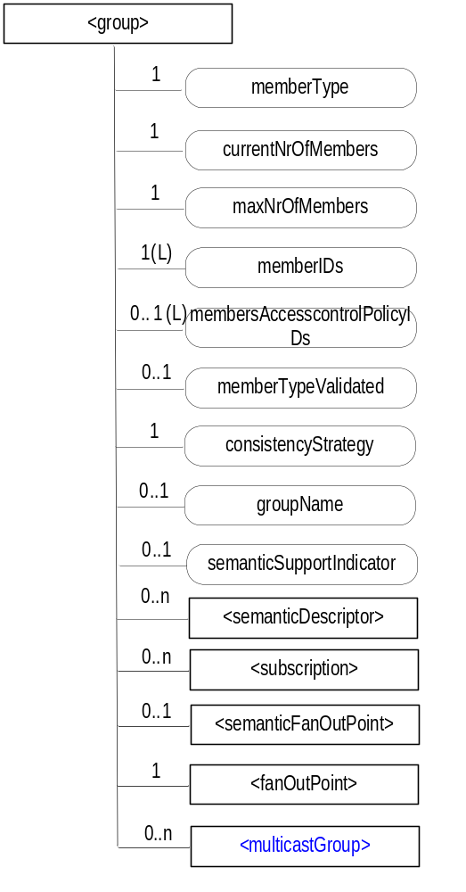
Figure 9.6.13-1: Structure of <group> resource
The <group> resource shall contain the child resources specified in table 9.6.13-1.
Table 9.6.13-1: Child resources of <group> resource
Child Resources of <group> | Child Resource Type | Multiplicity | Description | <groupAnnc> Child Resource Types
[variable] | <semanticDescriptor> | 0..n | See clause 9.6.30 | <semanticDescriptor>, <semanticDescriptorAnnc>
[variable] | <subscription> | 0..n | See clause 9.6.8 | <subscription>
fanOutPoint | <fanOutPoint> | 1 | See clause 9.6.14 | none
semanticFanOutPoint | <semanticFanOutPoint> | 0..1 | See clause 9.6.14a | none
multicastGroup | <multicastGroup> | 0..n | See clause 9.6.x | none

The <group> resource shall contain the attributes specified in table 9.6.13-2.
Table 9.6.13-2: Attributes of <group> resource
Attributes of  <group> | Multiplicity | RW/  RO/  WO | Description | <groupAnnc> Attributes
resourceType | 1 | RO | See clause 9.6.1.3. | NA
resourceID | 1 | RO | See clause 9.6.1.3. | NA
resourceName | 1 | WO | See clause 9.6.1.3. | NA
parentID | 1 | RO | See clause 9.6.1.3. | NA
expirationTime | 1 | RW | See clause 9.6.1.3. | MA
accessControlPolicyIDs | 0..1 (L) | RW | See clause 9.6.1.3. | MA
labels | 0..1 (L) | RW | See clause 9.6.1.3. | MA
creationTime | 1 | RO | See clause 9.6.1.3. | NA
lastModifiedTime | 1 | RO | See clause 9.6.1.3. | NA
announceTo | 0..1 (L) | RW | See clause 9.6.1.3. | NA
announcedAttribute | 0..1 (L) | RW | See clause 9.6.1.3. | NA
dynamicAuthorizationConsultationIDs | 0..1 (L) | RW | See clause 9.6.1.3. | OA
creator | 0..1 | RO | See clause 9.6.1.3. | NA
memberType | 1 | WO | It is the resource type of the member resources of the group, if all member resources (including the member resources in any sub-groups) are of the same type. Otherwise, it is of type 'mixed'. | OA
currentNrOfMembers | 1 | RO | Current number of members in a group. It shall not be larger than maxNrOfMembers. | OA
maxNrOfMembers | 1 | RW | Maximum number of members in the <group>. | OA
memberIDs | 1 (L) | RW | List of member resource IDs referred to in the remaining of the present document as memberID. Each ID (memberID) should refer to a member resource or a (sub-) <group> resource of the <group>. A <group> resource with an empty member list is allowed. | OA
membersAccessControlPolicyIDs | 0..1 (L) | RW | List of IDs of the <accessControlPolicy> resources defining who is allowed to access the <fanOutPoint> resource. | OA
memberTypeValidated | 0..1 | RO | Denotes if the resource types of all members resources of the group has been validated by the Hosting CSE. In the case that the memberType attribute of the <group> resource is not 'mixed', then this attribute shall be set.. | OA
consistencyStrategy | 1 | WO | This attribute determines how to deal with the <group> resource if the memberType validation fails. Its possible values are  - ABANDON_MEMBER  - ABANDON_GROUP  - SET_MIXED  Which means delete the inconsistent member if the attribute is ABANDON_MEMBER; delete the group if the attribute is ABANDON_GROUP; set the memberType to "mixed" if the attribute is SET_MIXED.  If it is not given by the Originator at the creation procedure, default is " ABANDON_MEMBER " | OA
groupName | 0..1 | RW | Human readable name of the <group>. | OA
semanticSupportIndicator | 0..1 | RO | Indicator of support for sematic discovery functionality via <semanticFanOutPoint>. | OA

-----------------------End of change 2---------------------------------------------

-----------------------Start of change 3-------------------------------------------

9.6.x Resource Type multicastGroup
The <multicastGroup> resource is used by the group management server, e.g. IN-CSE, to record the mapping relationship between the member resources, the multicast fanout URI, and the multicast address for multicast management in the group resource. One <group> resource may include multiple <multicastGroup> child resources.
The <multicastGroup> resource shall contain the attributes specified in table 9.6.x-1.
Table 9.6.x-1: Attributes of <multicastGroup> resource
Attributes of <multicastGroup> | Multiplicity | RW/  RO/  WO | Description | <multicastGroupAnnc> Attributes
resourceType | 1 | RO | See clause 9.6.1.3. | NA
resourceID | 1 | RO | See clause 9.6.1.3. | NA
resourceName | 1 | WO | See clause 9.6.1.3. | NA
parentID | 1 | RO | See clause 9.6.1.3. | NA
creationTime | 1 | RO | See clause 9.6.1.3. | NA
lastModifiedTime | 1 | RO | See clause 9.6.1.3. | NA
expirationTime | 1 | RW | See clause 9.6.1.3. | MA
accessControlPolicyIDs | 0..1 (L) | RW | See clause 9.6.1.3. | MA
labels | 0..1 (L) | RW | See clause 9.6.1.3. | MA
dynamicAuthorizationConsultationIDs | 0..1 (L) | RW | See clause 9.6.1.3. | OA
announceTo | 0..1(L) | RW | See clause 9.6.1.3. | NA
announcedAttribute | 0..1(L) | RW | See clause 9.6.1.3. | NA
multicastType | 1 | RW | Indicating the underlying networks multicast capability of the group members:  - 3GPP_MBMS_group,  - IP_mulicast_group.  Note: Within one multicast group, the multicastType should be the same. | NA
multicastAddress | 1 | RW | The multicast address allocated to the members in the memberlist.  If the multicastType is 3GPP MBMS group, the multicastAddress should be the address of 3GPP group service server; if the multicastType is IP multicast group, the multicastAddress should be the address of IP multicast server. | NA
addressType | 0..1 | RW | Optional information.it is used to describe that the address type in multicastAddress is IPv4 or IPv6, and other information. | NA
fanOutURI | 0..1 | RW | The destination URI of the member resource that the access request will be sent to by the group server. | NA
memberList | 0..1(L) | RW | memberList is optional information and used to describe the member resource list involved in the group mapping relationship, that is, the member devices having the member resources and the access paths of the member resources on the member devices. | NA

-----------------------End of change 3---------------------------------------------

-----------------------Start of change 4---------------------------------------------

9.6.y Resource Type parentGroup
The <parentGroup> resource is used by the M2M nodes to store the multicast group information, after the member resources of the M2M Devices/Gateways have joined the multicast group. <parentGroup> could be created as the child resource of either the <CSEBase> resource or the <AE> resource of the M2M nodes. And one M2M node may contain multiple <parentGroup> resources.
The <parentGroup> resource shall contain the attributes specified in table 9.6.y-1.
Table 9.6.y-1: Attributes of <parentGroup> resource
Attributes of < parentGroup > | Multiplicity | RW/  RO/  WO | Description | < parentGroupAnnc> Attributes
resourceType | 1 | RO | See clause 9.6.1.3. | NA
resourceID | 1 | RO | See clause 9.6.1.3. | NA
resourceName | 1 | WO | See clause 9.6.1.3. | NA
parentID | 1 | RO | See clause 9.6.1.3. | NA
creationTime | 1 | RO | See clause 9.6.1.3. | NA
lastModifiedTime | 1 | RO | See clause 9.6.1.3. | NA
expirationTime | 1 | RW | See clause 9.6.1.3. | MA
accessControlPolicyIDs | 0..1 (L) | RW | See clause 9.6.1.3. | MA
labels | 0..1 (L) | RW | See clause 9.6.1.3. | MA
dynamicAuthorizationConsultationIDs | 0..1 (L) | RW | See clause 9.6.1.3. | OA
announceTo | 0..1(L) | RW | See clause 9.6.1.3. | NA
announcedAttribute | 0..1(L) | RW | See clause 9.6.1.3. | NA
parentGroupID | 1 | RW | Indicating the group resourceID which the group member belong to. | NA
multicastAddress | 1 | RW | The multicast address of the multicast group that the local member resources in the memberList join. | NA
addressType | 1 | RW | It is used to describe that the address type in multicastAddress is IPv4 or IPv6, and other information. | NA
fanOutURI | 1 | RW | The fanOutURI corresponds to the multicast group that the local member resources in the memberList join. | NA
memberList | 0..1(L) | RW | A local member resource list corresponds to the fanOutURI. It may be a complete URI of local member resources or store only access paths of local member resources on the member device. | NA
responseURI | 1 | RW | Indicating the response address when the multicast member device receives any multicast request, the default value should be the URI of the group hosting CSE. | NA

-----------------------End of change 4---------------------------------------------

CREATE

UPDATE

DELETE

CREATE

RETRIEVE

UPDATE

DELETE

RETRIEVE

DELETE

DELETE

CHECK LIST
- Does this change request include an informative introduction containing the problem(s) being solved, and a summary list of proposals.?
- Does this CR contain changes related to only one particular issue/problem?
- Have any mirror crs been posted?
- Does this change request make all the changes necessary to address the issue or problem? E.g. A change impacting 5 tables should not only include a proposal to change only 3 tables. Includes any changes to references, definitions, and acronyms in the same deliverable?
- Does this change request follow the drafting rules?
- Are all pictures editable?
- Have you checked the spelling and grammar?
- Have you used change bars for all modifications?
- Does the change include the current and surrounding clauses to clearly show where a change is located and to provide technical context of the proposed change? (Additions of complete sections need not show surrounding clauses as long as the proposed section number clearly shows where the new section is proposed to be located.)
- Are multiple changes in this CR clearly separated by horizontal lines with embedded text such as, start of change 1, end of change 1, start of new clause, end of new clause.?

