CHANGE REQUEST
Meeting:* | ARC#27/MAS#27
Source:* | Huawei
Date:* | 2017-01-13
Contact:* | Yongjing Zhang, Huawei, zhangyongjing@huawei.com  Andreas Kraft, Deutsche Telekom AG, A.Kraft@telekom.de
Reason for Change/s:* | It’ll be beneficial to support the semantic annotation to <mgmtObj> resource, so that the management capabilities and properties of a device (AE/CSE) can also be described in semantic triples and then used as the knowledge base for the semantic discovery/query of the devices (and its related data/services).  This CR proposes to add <semanticDescriptor> as the child resource of <mgmtObj> resource to enable the semantic annotation/ discovery/ query against the management information of a device.
CR against: Release* | Release-3
CR against: WI* | Active <WI-00xx>  MNT maintenance / < Work Item number(optional)>  STE Small Technical Enhancements / < WI-0050>  Only ONE of the above shall be ticked
CR against: TS/TR* | TS-0001 V3.2.0
Clauses/Sub Clauses* | Clause 9.6.15, Annex D
Type of change: * | Editorial change  Bug Fix or Correction  Change to existing feature or functionality  New feature or functionality  Only ONE of the above shall be ticked
Post Freeze checking:* | This CR contains only essential changes and corrections? YES NO  This CR may break backwards compatibility with the last approved version of the TS? YES NO  This CR is a mirror CR? YES if YES, please indicate the document number of the original CR: <Document Number) : NO
Template Version:27 May 2015 (Dot not modify)

oneM2M Notice
The document to which this cover statement is attached is submitted to oneM2M. Participation in, or attendance at, any activity of oneM2M, constitutes acceptance of and agreement to be bound by terms of the Working Procedures and the Partnership Agreement, including the Intellectual Property Rights (IPR) Principles Governing oneM2M Work found in Annex 1 of the Partnership Agreement.
GUIDELINES for Change Requests:
Provide an informative introduction containing the problem(s) being solved, and a summary list of proposals.
Each CR should contain changes related to only one particular issue/problem.
In case of a correction, and the change apply to previous releases, a separated “mirror CR” should be posted at the same time of this CR
Follow the principle of completeness, where all changes related to the issue or problem within a deliverable are simultaneously proposed to be made E.g. A change impacting 5 tables should not only include a proposal to change only 3 tables. Includes any changes to references, definitions, and acronyms in the same deliverable.
Follow the drafting rules.
All pictures must be editable.
Check spelling and grammar to the extent practicable.
Use Change bars for modifications.
The change should include the current and surrounding clauses to clearly show where a change is located and to provide technical context of the proposed change. Additions of complete sections need not show surrounding clauses as long as the proposed section number clearly shows where the new section is proposed to be located.
Multiple changes in a single CR shall be clearly separated by horizontal lines with embedded text such as, start of change 1, end of change 1, start of new clause, end of new clause.
When subsequent changes are made to content of a CR, then the accepted version should not show changes over changes. The accepted version of the CR should only show changes relative to the baseline approved text.

Introduction
It’ll be beneficial to support the semantic annotation to <mgmtObj> resource, so that the management capabilities and properties of a device (AE/CSE) can also be described in semantic triples and then used as the knowledge base for the semantic discovery/query of the devices (and its related data/services).
For example, HAIM defined in TS-0023 now uses [deviceInfo] resource (the specialization of <mgmtObj>) as the device properties of all device models. It’s very useful that a device model instance can be discovered semantically based on the properties like ‘manufacturer’, ‘type’, ‘model’, ‘country’, etc. This can only be realized if [deviceInfo] resource support semantic annotation by having a <semanticDescriptor> as its child resource.
This CR proposes to add <semanticDescriptor> as the child resource of <mgmtObj> resource to enable the semantic annotation/ discovery/ query against the management information of a device.

-----------------------Start of change 1-------------------------------------------

9.6.15 Resource Type mgmtObj
The <mgmtObj> resource contains management data which represents individual M2M management functions. It represents a general structure to map to technology specific data model e.g. OMA DM [Error: Reference source not found], BBF TR-069 [Error: Reference source not found] and LWM2M [Error: Reference source not found]. Each instance of <mgmtObj> resource shall be mapped to single technology specific protocol.

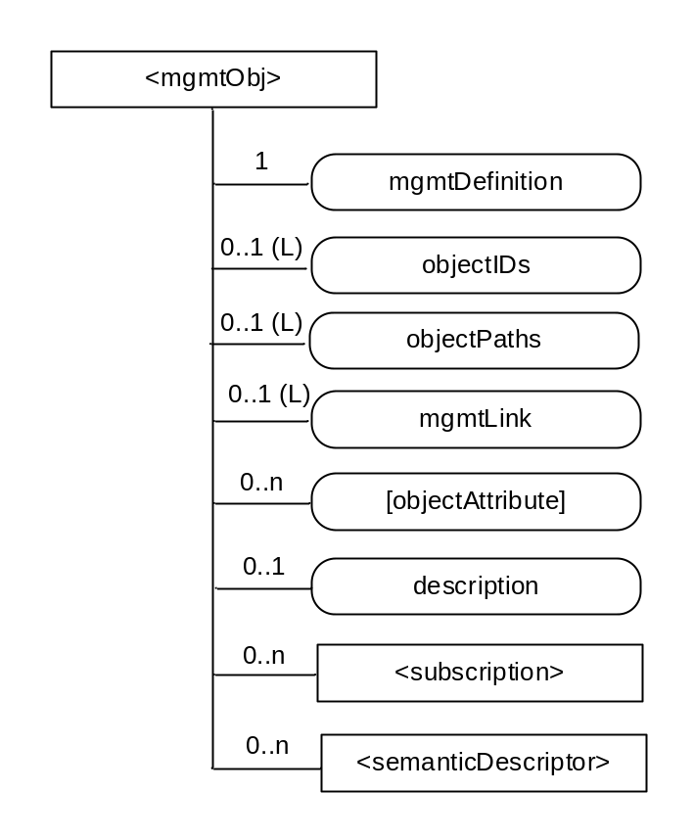

Figure 9.6.15-1: Structure of <mgmtObj> resource
The <mgmtObj> resource shall contain the child resource specified in table 9.6.15-1.
Table 9.6.15-1: Child resources of <mgmtObj> resource
Child Resources of <mgmtObj> | Child Resource Type | Multiplicity | Description | <mgmtObjAnnc> Child Resource Type
[variable] | <subscription> | 0..n | See clause 9.6.8 | <subscription>
[variable] | <semanticDescriptor> | 0..n | See clause 9.6.30 | <semanticDescriptor>, <semanticDescriptorAnnc>

The <mgmtObj> resource shall contain the attributes specified in table 9.6.15-2.
Table 9.6.15-2: Attributes of <mgmtObj> resource
Attributes of <mgmtObj> | Multiplicity | RW/  RO/  WO | Description | <mgmtObjAnnc> Attributes
resourceType | 1 | RO | See clause 9.6.1.3. | NA
resourceID | 1 | RO | See clause 9.6.1.3. | NA
resourceName | 1 | WO | See clause 9.6.1.3. | NA
parentID | 1 | RO | See clause 9.6.1.3. | NA
expirationTime | 1 | RW | See clause 9.6.1.3. | MA
accessControlPolicyIDs | 0..1 (L) | RW | See clause 9.6.1.3. | MA
creationTime | 1 | RO | See clause 9.6.1.3. | NA
lastModifiedTime | 1 | RO | See clause 9.6.1.3. | NA
labels | 0..1 (L) | RW | See clause 9.6.1.3. | MA
announceTo | 0..1 (L) | RW | See clause 9.6.1.3. | NA
announcedAttribute | 0..1 (L) | RW | See clause 9.6.1.3. | NA
dynamicAuthorizationConsultationIDs | 0..1 (L) | RW | See clause 9.6.1.3. | OA
mgmtDefinition | 1 | WO | Specifies the type of <mgmtObj> resource e.g. software, firmware, memory. The list of the value of the attribute can be seen in annex D. | MA
objectIDs | 0..1 (L) | RW | Contains the list URNs that uniquely identify the technology specific data model objects used for this <mgmtObj> resource as well as the managed function and version it represents. This attribute shall be provided during the creation of the <mgmtObj> resource and shall not be modifiable afterwards.  If the <mgmtObj> resource is mapped to multiple technology specific data model objects, this attribute shall list all URNs for each mapped technology specific data model objects. This is mandatory for the <mgmtObj>, for which the data model is not specified by oneM2M but mapped from technology specific data model. | OA
objectPaths | 0..1 (L) | RW | Contains the list of local paths of the technology specific data model objects on the managed entity which is represented by the <mgmtObj> resource in the Hosting CSE.  This attribute shall be provided during the creation of the <mgmtObj>, so that the Hosting CSE can correlate the created <mgmtObj> with the technology specific data model object on the managed entity for further management operations. It shall not be modifiable after creation.  The format of this attribute shall be a local technology specific data model object path in the form as specified by technology specific protocol. (e.g. "./anyPath/Fw1" in OMA DM [Error: Reference source not found], "Device.USBHosts.Host.3." in BBF TR-069 [Error: Reference source not found]).  The combination of the objectPaths and the objectIDs attribute, allows to address the technology specific data model. | OA
mgmtLink | 0..1 (L) | RW | This attribute contains reference to a list of other <mgmtObj> resources in case a hierarchy of <mgmtObj> is needed. | OA
[objectAttribute] | 0..n | RW | Each [objectAttribute] is mapped from a leaf node of a hierarchical structured technology specific data model object (including oneM2M data model and the technology specific data model objects) based on the mapping rules below the table. | OA
description | 0..1 | RW | Text format description of <mgmtObj>. | OA

When mapping objects from technology specific protocol to a corresponding <mgmtObj> resource, the following rules shall apply:
- The root objects of technology specific data model objects maps to the <mgmtObj> resource.
- For the child of the root of technology specific data model objects:
- Rule1: If the child technology specific data model object cannot have another child technology specific data model object, the technology specific data model object maps to the [objectAttribute] attribute of the <mgmtObj> resource with the same resource name.
- Rule2: If the child technology specific data model object can have another child technology specific data model object, the technology specific data model object maps to a new <mgmtObj> resource. The ID of the new <mgmtObj> resource is stored as an mgmtLink attribute of the <mgmtObj> resource which is mapped from the parent technology specific data model object.

-----------------------End of change 1---------------------------------------------

-----------------------Start of change 2-------------------------------------------

Annex D (normative):
<mgmtObj> Resource Instances Description

D.1 oneM2M Management Functions
This clause describes the management functions supported by oneM2M. These functions are fulfilled by defining specializations of <mgmtObj> resources. These specializations can be regarded as "sub-types" of the <mgmtObj> resource type with specific designing to support different management capabilities through operations defined by oneM2M. These specializations are service layer information models for the purpose of management. They can be used within the M2M service layer or they can be further mapped to existing management technologies such as OMA DM [Error: Reference source not found], OMA LWM2M [Error: Reference source not found] and BBF TR-069 [Error: Reference source not found] to enable the management of devices with OMA or BBF compliant management clients.
NOTE: The resources defined in this Annex D represent specializations of the <mgmtObj> resource as a result of introducing specializations of the [objectAttribute] attribute. The mgmtDefinition attribute carries the name of the resource type specialization. The names of instantiations of these resource specializations are not fixed.

D.2 Resource firmware
The [firmware] resource is used to share information regarding the firmware on the device. The [firmware] resource is a specialization of the <mgmtObj>resource.
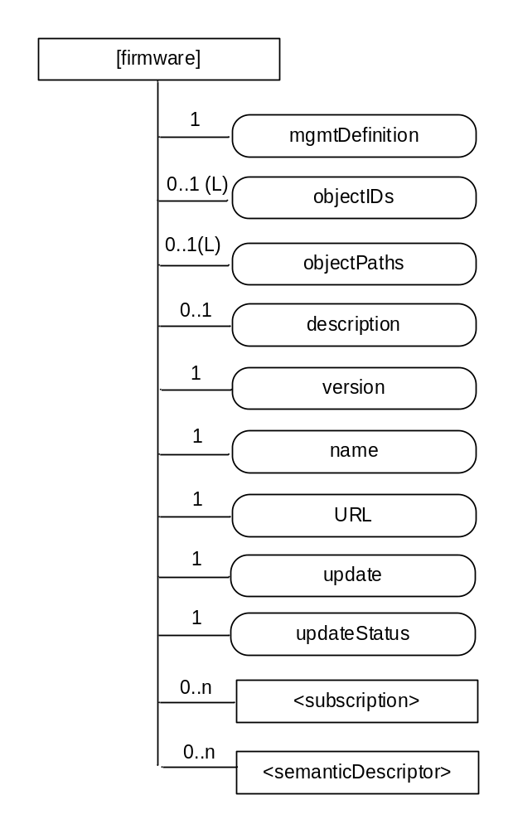
Figure D.2-1: Structure of [firmware] resource
The [firmware] resource shall contain the child resources specified in table D.2-1.
Table D.2-1: Child resources of [firmware] resource
Child Resources of [firmware] | Child Resource Type | Multiplicity | Description
[variable] | <subscription> | 0..n | See clause 9.6.8 where the type of this resource is described.
[variable] | <semanticDescriptor> | 0..n | See clause 9.6.30

The [firmware] resource shall contain the attributes specified in table D.2-2.
Table D.2-2: Attributes of [firmware] resource
Attributes of  [firmware] | Multiplicity | RW/  RO/  WO | Description
resourceType | 1 | RO | See clause 9.6.1.3.
resourceID | 1 | RO | See clause 9.6.1.3.
resourceName | 1 | WO | See clause 9.6.1.3.
parentID | 1 | RO | See clause 9.6.1.3.
expirationTime | 1 | RW | See clause 9.6.1.3.
accessControlPolicyIDs | 0..1 (L) | RW | See clause 9.6.1.3.
creationTime | 1 | RO | See clause 9.6.1.3.
lastModifiedTime | 1 | RO | See clause 9.6.1.3.
labels | 0..1(L) | RW | See clause 9.6.1.3.
mgmtDefinition | 1 | WO | See clause 9.6.15. Has fixed value "firmware" to indicate the resource is for firmware management.
objectIDs | 0..1 (L) | RW | See clause 9.6.15.
objectPaths | 0..1 (L) | RW | See clause 9.6.15.
description | 0..1 | RW | See clause 9.6.15.
version | 1 | RW | The version of the firmware. This attribute is a specialization of [objectAttribute] attribute.
name | 1 | RW | The name of the firmware to be used on the device. This attribute is a specialization of [objectAttribute] attribute.
URL | 1 | RW | The URL from which the firmware image can be downloaded. This attribute is a specialization of [objectAttribute] attribute.
update | 1 | RW | The action that downloads and installs a new firmware in a single operation. The action is triggered by assigning value "TRUE" to this attribute. This attribute is a specialization of [objectAttribute] attribute.
updateStatus | 1 | RO | Indicates the status of the update. This attribute is a specialization of [objectAttribute] attribute.

D.3 Resource software
The [software] resource is used to share information regarding the software on the device. The [software] resource is a specialization of the <mgmtObj>resource.
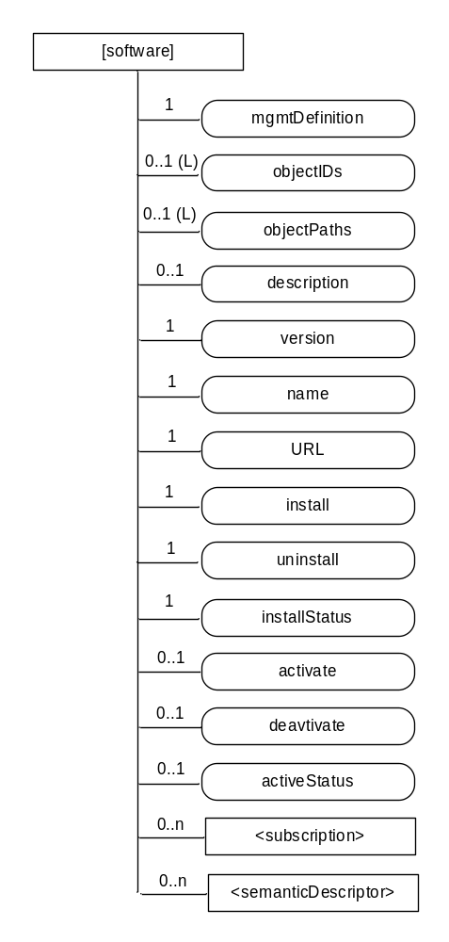
Figure D.3-1: Structure of [software] resource
The [software] resource shall contain the child resource specified in table D.3-1.
Table D.3-1: Child resources of [software] resource
Child Resources of [software] | Child Resource Type | Multiplicity | Description
[variable] | <subscription> | 0..n | See clause 9.6.8 where the type of this resource is described.
[variable] | <semanticDescriptor> | 0..n | See clause 9.6.30

The [software] resource shall contain the attributes specified in table D.3-2.
Table D.3-2: Attributes of [software] resource
Attributes of  [software] | Multiplicity | RW/  RO/  WO | Description
resourceType | 1 | RO | See clause 9.6.1.3.
resourceID | 1 | RO | See clause 9.6.1.3.
resourceName | 1 | WO | See clause 9.6.1.3.
parentID | 1 | RO | See clause 9.6.1.3.
expirationTime | 1 | RW | See clause 9.6.1.3.
accessControlPolicyIDs | 0..1 (L) | RW | See clause 9.6.1.3.
creationTime | 1 | RO | See clause 9.6.1.3.
lastModifiedTime | 1 | RO | See clause 9.6.1.3.
labels | 0..1(L) | RW | See clause 9.6.1.3.
mgmtDefinition | 1 | WO | See clause 9.6.15. Has fixed value "software" to indicate the resource is for software management.
objectIDs | 0..1 (L) | RW | See clause 9.6.15.
objectPaths | 0..1 (L) | RW | See clause 9.6.15.
description | 0..1 | RW | See clause 9.6.15.
version | 1 | RW | The version of the software. This attribute is a specialization of [objectAttribute] attribute.
name | 1 | RW | The name of the software to be used on the device. This attribute is a specialization of [objectAttribute] attribute.
URL | 1 | RW | The URL from which the software package can be downloaded. This attribute is a specialization of [objectAttribute] attribute.
install | 1 | RW | The action that downloads and installs new software in a single operation. The action is triggered by assigning value "TRUE" to this attribute. This attribute is a specialization of [objectAttribute] attribute.
uninstall | 1 | RW | The action that un-installs the software. The action is triggered by assigning value "TRUE" to this attribute. This attribute is a specialization of [objectAttribute] attribute.
installStatus | 1 | RO | Indicates the status of the install. This attribute is a specialization of [objectAttribute] attribute.
activate | 0..1 | RW | The action that activates software previously installed. The action is triggered by assigning value "TRUE" to this attribute. This attribute is a specialization of [objectAttribute] attribute.
deactivate | 0..1 | RW | The action that deactivates software. The action is triggered by assigning value "TRUE" to this attribute. This attribute is a specialization of [objectAttribute] attribute.
activeStatus | 0..1 | RW | The status of active or deactivate action. This attribute is a specialization of [objectAttribute] attribute.

The state machine for managing the software in oneM2M is shown in figure D.3-2.
Uninstalled
Execute: ./[software]/Install
Execute: ./[software]/Uninstall
Removed
Installed
Delete: ./[software]
Figure D.3-2: State machine for [software] management
Figure D.3-3 is the state machine after install starts from the deactivated state.

Figure D.3-3: State machine for [software] management after install

D.4 Resource memory
The [memory] resource is used to share information regarding the memory on the device. The [memory] resource is a specialization of the <mgmtObj>resource.
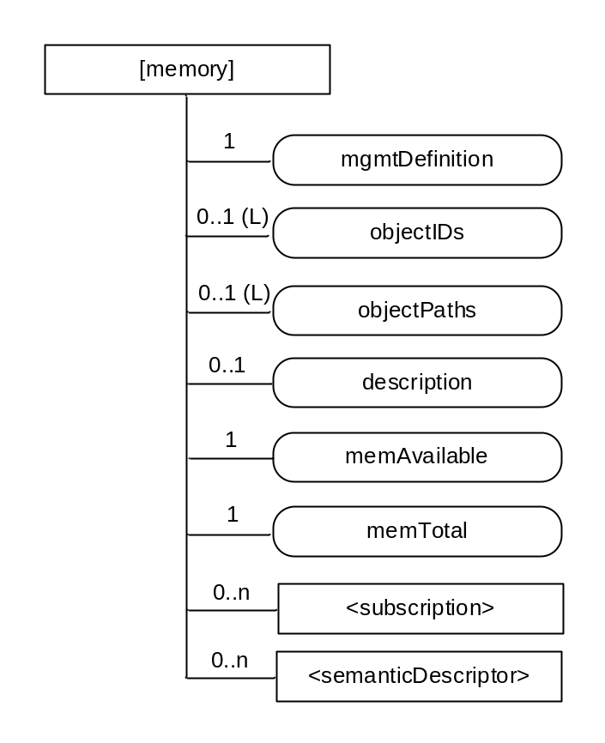
Figure D.4-1: Structure of [memory] resource
The [memory] resource shall contain the child resources specified in table D.4-1.
Table D.4-1: Child resources of [memory] resource
Child Resources of [memory] | Child Resource Type | Multiplicity | Description
[variable] | <subscription> | 0..n | See clause 9.6.8 where the type of this resource is described.
[variable] | <semanticDescriptor> | 0..n | See clause 9.6.30

The [memory] resource shall contain the attributes specified in table D.4-2.
Table D.4-2: Attributes of [memory] resource
Attributes of  [memory] | Multiplicity | RW/  RO/  WO | Description
resourceType | 1 | RO | See clause 9.6.1.3.
resourceID | 1 | RO | See clause 9.6.1.3.
resourceName | 1 | WO | See clause 9.6.1.3.
parentID | 1 | RO | See clause 9.6.1.3.
expirationTime | 1 | RW | See clause 9.6.1.3.
accessControlPolicyIDs | 0..1 (L) | RW | See clause 9.6.1.3.
creationTime | 1 | RO | See clause 9.6.1.3.
lastModifiedTime | 1 | RO | See clause 9.6.1.3.
labels | 0..1(L) | RW | See clause 9.6.1.3.
mgmtDefinition | 1 | WO | See clause 9.6.15. Has fixed value "memory" to indicate the resource is for memory management.
objectIDs | 0..1 (L) | RW | See clause 9.6.15.
objectPaths | 0..1 (L) | RW | See clause 9.6.15.
description | 0..1 | RW | See clause 9.6.15.
memAvailable | 1 | RW | The current available amount of memory. This attribute is a specialization of [objectAttribute] attribute.
memTotal | 1 | RW | The total amount of memory. This attribute is a specialization of [objectAttribute] attribute.

D.5 Resource areaNwkInfo
The [areaNwkInfo] resource is a specialization of the <mgmtObj>resource.
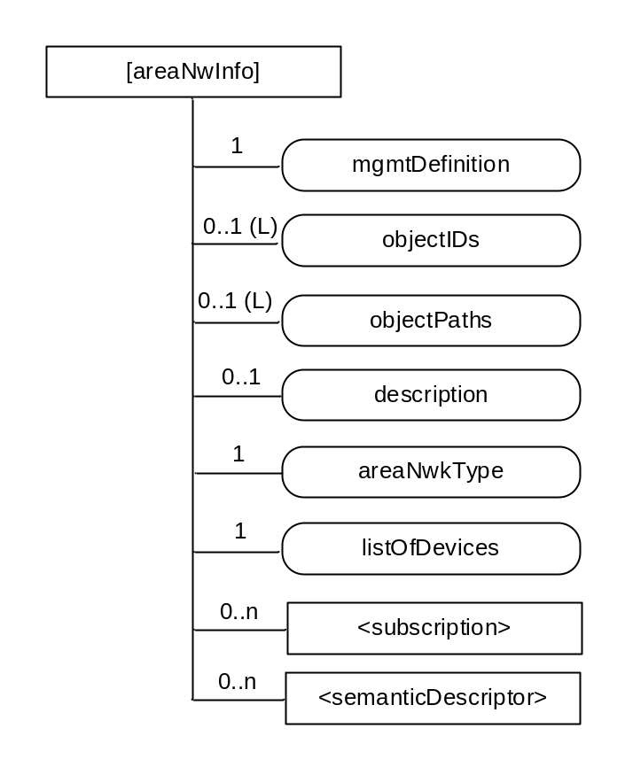
Figure D.5-1: Structure of [areaNwkInfo] resource
The [areaNwkInfo] resource shall contain the child resource specified in table D.5-1.
Table D.5-1: Child resources of [areaNwInfo] resource
Child Resources of [areaNwkInfo] | Child Resource Type | Multiplicity | Description
[variable] | <subscription> | 0..n | See clause 9.6.8 where the type of this resource is described.
[variable] | <semanticDescriptor> | 0..n | See clause 9.6.30

The [areaNwkInfo] resource shall contain the attributes specified in table D.5-2.
Table D.5-2: Attributes of [areaNwkInfo] resource
Attributes of [areaNwkInfo] | Multiplicity | RW/  RO/  WO | Description
resourceType | 1 | RO | See clause 9.6.1.3.
resourceID | 1 | RO | See clause 9.6.1.3.
resourceName | 1 | WO | See clause 9.6.1.3.
parentID | 1 | RO | See clause 9.6.1.3.
expirationTime | 1 | RW | See clause 9.6.1.3.
accessControlPolicyIDs | 0..1 (L) | RW | See clause 9.6.1.3.
creationTime | 1 | RO | See clause 9.6.1.3.
lastModifiedTime | 1 | RO | See clause 9.6.1.3.
labels | 0..1(L) | RW | See clause 9.6.1.3.
mgmtDefinition | 1 | WO | See clause 9.6.15. Has fixed value "areaNwkInfo" to indicate the resource is for area network information.
objectIDs | 0..1 (L) | RW | See clause 9.6.15.
objectPaths | 0..1 (L) | RW | See clause 9.6.15.
description | 0..1 | RW | See clause 9.6.15.
areaNwkType | 1 | RW | The areaNwkType is an implementation-chosen string that indicates the type of M2M Area Network. This attribute is a specialization of [objectAttribute] attribute.
listOfDevices | 1 | RW | Indicates the list of devices in the M2M Area Network. The attribute contains references to [areaNwkDeviceInfo] resource. From listOfDevices, the topology of the area network can be discovered and retrieved. This attribute is a specialization of [objectAttribute] attribute.

D.6 Resource areaNwkDeviceInfo
The [areaNwkDeviceInfo] resource is a specialization of the <mgmtObj>resource.
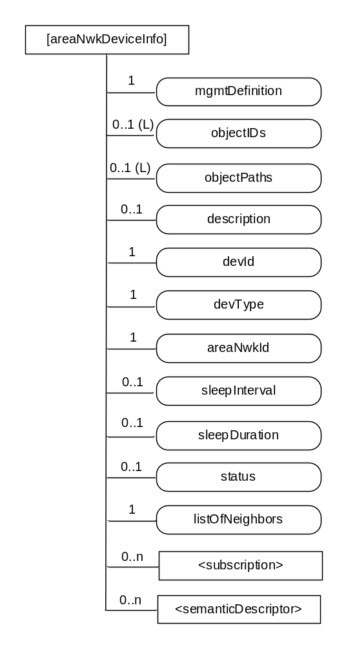
Figure D.6-1: Structure of [areaNwkDeviceInfo] resource
The [areaNwkDeviceInfo] resource shall contain the child resources specified in table D.6-1.
Table D.6-1: Child resources of [areaNwkDeviceInfo] resource
Child Resources of [areaNwkDeviceInfo] | Child Resource Type | Multiplicity | Description
[variable] | <subscription> | 0..n | See clause 9.6.8 where the type of this resource is described.
[variable] | <semanticDescriptor> | 0..n | See clause 9.6.30

The [areaNwkDeviceInfo] resource shall contain the attributes specified in table D.6-2.
Table D.6-2: Attributes of [areaNwkDeviceInfo] resource
Attributes of [areaNwkDeviceInfo] | Multiplicity | RW/  RO/  WO | Description
resourceType | 1 | RO | See clause 9.6.1.3.
resourceID | 1 | RO | See clause 9.6.1.3.
resourceName | 1 | WO | See clause 9.6.1.3.
parentID | 1 | RO | See clause 9.6.1.3.
expirationTime | 1 | RW | See clause 9.6.1.3.
accessControlPolicyIDs | 0..1 (L) | RW | See clause 9.6.1.3.
creationTime | 1 | RO | See clause 9.6.1.3.
lastModifiedTime | 1 | RO | See clause 9.6.1.3.
labels | 0..1(L) | RW | See clause 9.6.1.3.
mgmtDefinition | 1 | WO | See clause 9.6.15. Has fixed value "areaNwkDeviceInfo" to indicate the resource is for area network device information.
objectIDs | 0..1 (L) | RW | See clause 9.6.15.
objectPaths | 0..1 (L) | RW | See clause 9.6.15.
description | 0..1 | RW | See clause 9.6.15.
devId | 1 | RW | Indicates the id of the device. It could be the id of the hardware or nodeId. This attribute is a specialization of [objectAttribute] attribute.
devType | 1 | RW | Indicates the type of the device. The attribute also indicates the functions or services that are provided by the device. Examples include temperature sensor, actuator, Zigbee coordinator or Zigbee router. This attribute is a specialization of [objectAttribute] attribute.
areaNwkId | 1 | RW | The reference to an areaNwkInfo resource which this device associates with. This attribute is a specialization of [objectAttribute] attribute.
sleepInterval | 0..1 | RW | The interval between two sleeps. This attribute is a specialization of [objectAttribute] attribute.
sleepDuration | 0..1 | RW | The time duration of each sleep. This attribute is a specialization of [objectAttribute] attribute.
status | 0..1 | RW | The status of the device (sleeping or waked up).
listOfNeighbors | 1 | RW | Indicates the neighbour devices of the same area network. When modified, the connection relationship of the devices shall be modified accordingly. This attribute is a specialization of [objectAttribute] attribute.

D.7 Resource battery
The [battery] resource is used to share information regarding the battery. The [battery] resource is a specialization of the <mgmtObj> resource.
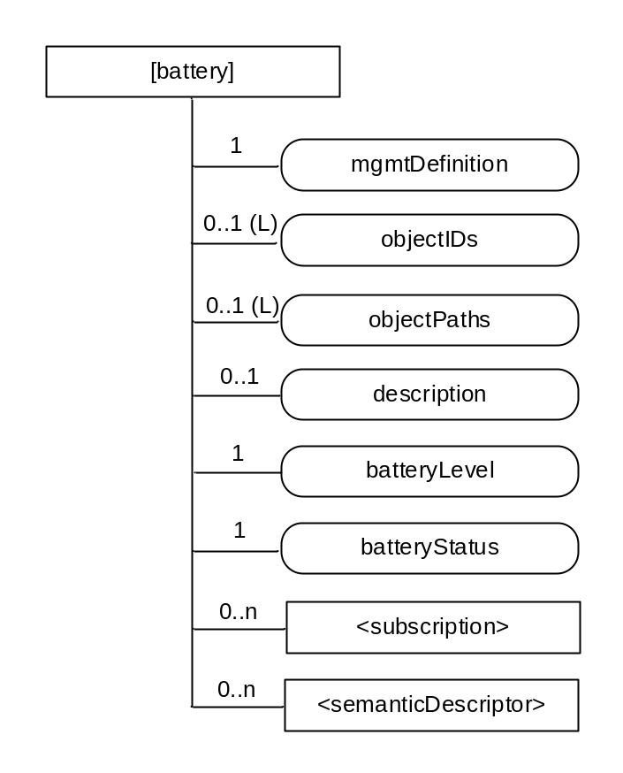
Figure D.7-1: Structure of [battery] resource
The [battery] resource shall contain the child resources specified in table D.7-1.
Table D.7-1: Child resources of [battery] resource
Child Resources of [battery] | Child Resource Type | Multiplicity | Description
[variable] | <subscription> | 0..n | See clause 9.6.8 where the type of this resource is described.
[variable] | <semanticDescriptor> | 0..n | See clause 9.6.30

The [battery] resource shall contain the attributes specified in table D.7-2.
Table D.7-2: Attributes of [battery] resource
Attributes of  [battery] | Multiplicity | RW/  RO/  WO | Description
resourceType | 1 | RO | See clause 9.6.1.3.
resourceID | 1 | RO | See clause 9.6.1.3.
resourceName | 1 | WO | See clause 9.6.1.3.
parentID | 1 | RO | See clause 9.6.1.3.
expirationTime | 1 | RW | See clause 9.6.1.3.
accessControlPolicyIDs | 0..1 (L) | RW | See clause 9.6.1.3.
creationTime | 1 | RO | See clause 9.6.1.3.
lastModifiedTime | 1 | RO | See clause 9.6.1.3.
labels | 0..1(L) | RW | See clause 9.6.1.3.
mgmtDefinition | 1 | WO | See clause 9.6.15. This attribute shall have the fixed value "battery".
objectIDs | 0..1 (L) | RW | See clause 9.6.15.
objectPaths | 0..1 (L) | RW | See clause 9.6.15.
description | 0..1 | RW | See clause 9.6.15.
batteryLevel | 1 | RO | The current battery level. This attribute is a specialization of [objectAttribute] attribute.
batteryStatus | 1 | RO | Indicates the status of the battery. This attribute is a specialization of [objectAttribute] attribute.

D.8 Resource deviceInfo
The [deviceInfo] resource is used to share information regarding the device. The [deviceInfo] resource is a specialization of the <mgmtObj> resource.
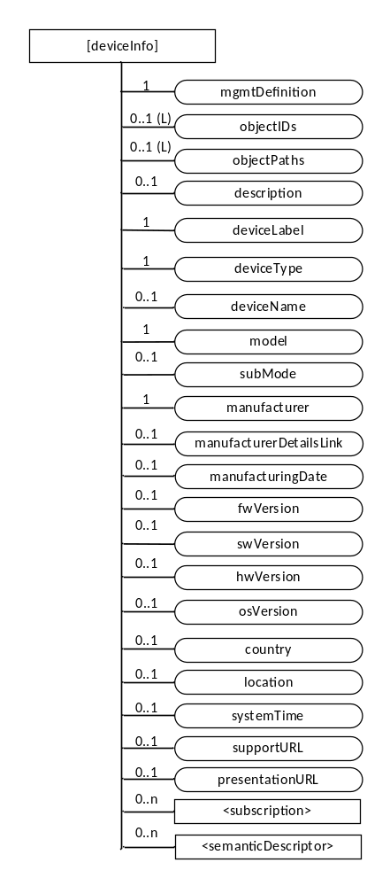
Figure D.8-1: Structure of [deviceInfo] resource
The [deviceInfo] resource shall contain the child resources specified in table D.8-1.
Table D.8-1: Child resources of [deviceInfo] resource
Child Resources of [deviceInfo] | Child Resource Type | Multiplicity | Description
[variable] | <subscription> | 0..n | See clause 9.6.8 where the type of this resource is described.
[variable] | <semanticDescriptor> | 0..n | See clause 9.6.30

The [deviceInfo] resource shall contain the attributes specified in table D.8-2.
Table D.8-2: Attributes of [deviceInfo] resource
Attributes of [deviceInfo] | Multiplicity | RW/  RO/  WO | Description
resourceType | 1 | RO | See clause 9.6.1.3.
resourceID | 1 | RO | See clause 9.6.1.3.
resourceName | 1 | WO | See clause 9.6.1.3.
parentID | 1 | RO | See clause 9.6.1.3.
expirationTime | 1 | RW | See clause 9.6.1.3.
accessControlPolicyIDs | 0..1 (L) | RW | See clause 9.6.1.3.
creationTime | 1 | RO | See clause 9.6.1.3.
lastModifiedTime | 1 | RO | See clause 9.6.1.3.
labels | 0..1(L) | RW | See clause 9.6.1.3.
mgmtDefinition | 1 | WO | See clause 9.6.15. This attribute shall have the fixed value "deviceInfo".
objectIDs | 0..1 (L) | RW | See clause 9.6.15.
objectPaths | 0..1 (L) | RW | See clause 9.6.15.
description | 0..1 | RW | See clause 9.6.15.
deviceLabel | 1 | RO | Unique device label assigned by the manufacturer. The uniqueness may be global or only valid within a certain domain (e.g. vendor-wise or for a certain deviceType). This attribute is a specialization of [objectAttribute] attribute. It’s typically used as e.g. device serial number.
manufacturer | 1 | RO | The name/identifier of the device manufacturer. This attribute is a specialization of [objectAttribute] attribute.
manufacturerDetailsLink | 0..1 | RO | URL to manufacturer's website. This attribute is a specialization of [objectAttribute] attribute.
manufacturingDate | 0..1 | RO | Manufacturing date of device. This attribute is a specialization of [objectAttribute] attribute.
model | 1 | RO | The name/identifier of the device mode assigned by the manufacturer. This attribute is a specialization of [objectAttribute] attribute.
subModel | 0..1 | RO | Device sub-model name. This attribute is a specialization of [objectAttribute] attribute.
deviceType | 1 | RO | The type (e.g. cell phone, photo frame, smart meter) or product class (e.g. X-series) of the device. This attribute is a specialization of [objectAttribute] attribute.
deviceName | 0..1 | RO | Device name. This attribute is a specialization of [objectAttribute] attribute.
fwVersion | 0..1 | RO | The firmware version of the device (see note).
swVersion | 0..1 | RO | The software version of the device. This attribute is a specialization of [objectAttribute] attribute.
hwVersion | 0..1 | RO | The hardware version of the device. This attribute is a specialization of [objectAttribute] attribute.
osVersion | 0..1 | RO | Version of the operating system (defined by manufacturer). This attribute is a specialization of [objectAttribute] attribute.
country | 0..1 | RO | Country code of the device. It could be manufacturing country, deployment country or procurement country. This attribute is a specialization of [objectAttribute] attribute.
location | 0..1 | RO | Location where the device is installed. It may be configured via the user interface provided by the ‘presentationURL' property or any other means. This attribute is a specialization of [objectAttribute] attribute.
systemTime | 0..1 | RO | Reference time for the device. This attribute is a specialization of [objectAttribute] attribute.
supportURL | 0..1 | RO | URL that points to product support information of the device. This attribute is a specialization of [objectAttribute] attribute.
presentationURL | 0..1 | RO | To quote UPnP: "the control point can retrieve a page from this URL, load the page into a web browser, and depending on the capabilities of the page, allow a user to control the device and/or view device status. The degree to which each of these can be accomplished depends on the specific capabilities of the presentation page and device". This attribute is a specialization of [objectAttribute] attribute.
NOTE: If the device only supports one kind of Software this is identical to swVersion. This attribute is a specialization of [objectAttribute] attribute.

D.9 Resource deviceCapability
The [deviceCapability] resource represents each device's capability. The [deviceCapability] resource is a specialization of the <mgmtObj> resource.
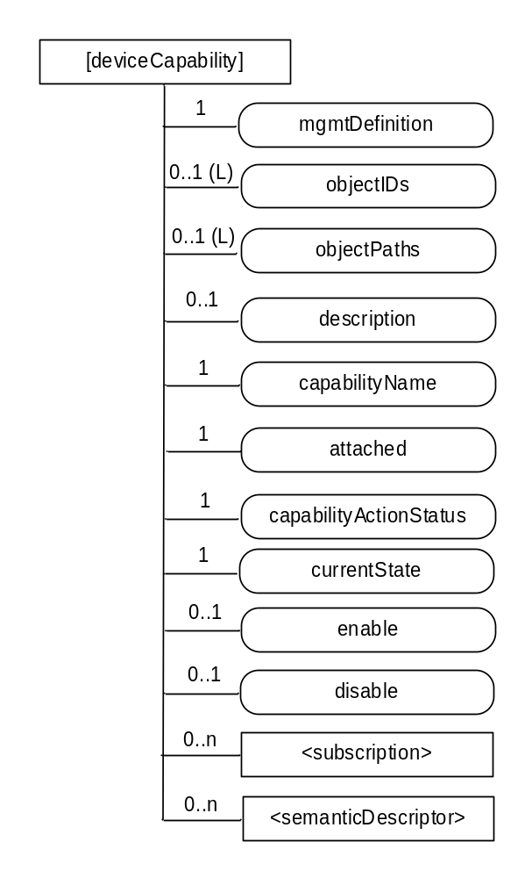
Figure D.9-1: Structure of [deviceCapability] resource
The [deviceCapability] resource shall contain the child resources specified in table D.9-1.
Table D.9-1: Child resources of [deviceCapability] resource
Child Resources of [deviceCapability] | Child Resource Type | Multiplicity | Description
[variable] | <subscription> | 0..n | See clause 9.6.8 where the type of this resource is described.
[variable] | <semanticDescriptor> | 0..n | See clause 9.6.30

The [deviceCapability] resource shall contain the attributes specified in table D.9-2.
Table D.9-2: Attributes of [deviceCapability] resource
Attributes of [deviceCapability] | Multiplicity | RW/  RO/  WO | Description
resourceType | 1 | RO | See clause 9.6.1.3.
resourceID | 1 | RO | See clause 9.6.1.3.
resourceName | 1 | WO | See clause 9.6.1.3.
parentID | 1 | RO | See clause 9.6.1.3.
expirationTime | 1 | RW | See clause 9.6.1.3.
accessControlPolicyIDs | 0..1 (L) | RW | See clause 9.6.1.3.
creationTime | 1 | RO | See clause 9.6.1.3.
lastModifiedTime | 1 | RO | See clause 9.6.1.3.
labels | 0..1(L) | RW | See clause 9.6.1.3.
mgmtDefinition | 1 | WO | See clause 9.6.15. This attribute shall have the fixed value "deviceCapability".
objectIDs | 0..1 (L) | RW | See clause 9.6.15.
objectPaths | 0..1 (L) | RW | See clause 9.6.15.
description | 0..1 | RW | See clause 9.6.15.
capabilityName | 1 | WO | The name of the capability. This attribute is a specialization of [objectAttribute] attribute.
attached | 1 | RO | Indicates whether the capability is attached to the device or not. This attribute is a specialization of [objectAttribute] attribute.
capabilityActionStatus | 1 | RO | Indicates the status of the Action (including a performed action and the corresponding final state). This attribute is a specialization of [objectAttribute] attribute.
currentState | 1 | RO | Indicates the current state of the capability (e.g. enabled or disabled). This attribute is a specialization of [objectAttribute] attribute.
enable | 0..1 | WO | The action that allows enabling the device capability. This attribute is a specialization of [objectAttribute] attribute.
disable | 0..1 | WO | The action that allows disabling the device capability. This attribute is a specialization of [objectAttribute] attribute.

D.10 Resource reboot
The [reboot] resource is used to reboot a device. The [reboot] resource is a specialization of the <mgmtObj> resource.
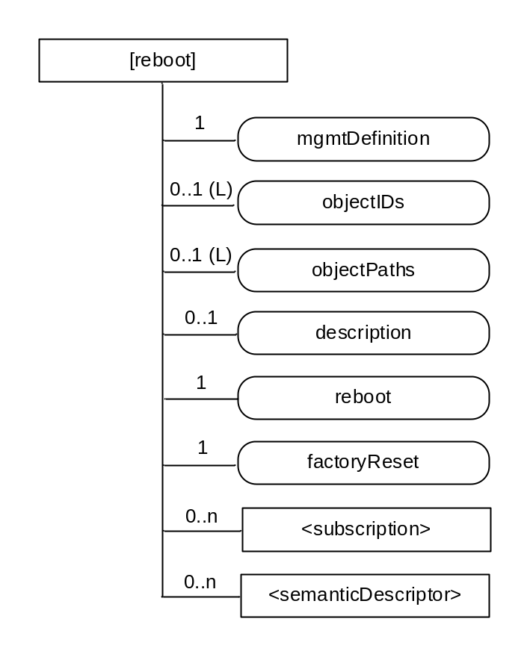
Figure D.10-1: Structure of [reboot] resource
The [reboot] resource shall contain the child resources specified in table D.10-1.
Table D.10-1: Child resources of [reboot] resource
Child Resources of [reboot] | Child Resource Type | Multiplicity | Description
[variable] | <subscription> | 0..n | See clause 9.6.8 where the type of this resource is described.
[variable] | <semanticDescriptor> | 0..n | See clause 9.6.30

The [reboot] resource shall contain the attributes specified in table D.10-2.
Table D.10-2: Attributes of [reboot] resource
Attributes of  [reboot] | Multiplicity | RW/  RO/  WO | Description
resourceType | 1 | RO | See clause 9.6.1.3.
resourceID | 1 | RO | See clause 9.6.1.3.
resourceName | 1 | WO | See clause 9.6.1.3.
parentID | 1 | RO | See clause 9.6.1.3.
expirationTime | 1 | RW | See clause 9.6.1.3.
accessControlPolicyIDs | 0..1 (L) | RW | See clause 9.6.1.3.
creationTime | 1 | RO | See clause 9.6.1.3.
lastModifiedTime | 1 | RO | See clause 9.6.1.3.
labels | 0..1(L) | RW | See clause 9.6.1.3.
mgmtDefinition | 1 | WO | See clause 9.6.15. This attribute shall have the fixed value "reboot".
objectIDs | 0..1 (L) | RW | See clause 9.6.15.
objectPaths | 0..1 (L) | RW | See clause 9.6.15.
description | 0..1 | RW | See clause 9.6.15.
reboot | 1 | RW | The action that allows rebooting the device. The action is triggered by assigning value "TRUE" to this attribute. This attribute is a specialization of [objectAttribute] attribute.
factoryReset | 1 | RW | The action that allows making the device returning to the factory settings. The action is triggered by assigning value "TRUE" to this attribute. This attribute is a specialization of [objectAttribute] attribute.

D.11 Resource eventLog
The [eventLog] resource is used to record the event log for a device. The [eventLog] resource is a specialization of the <mgmtObj> resource.
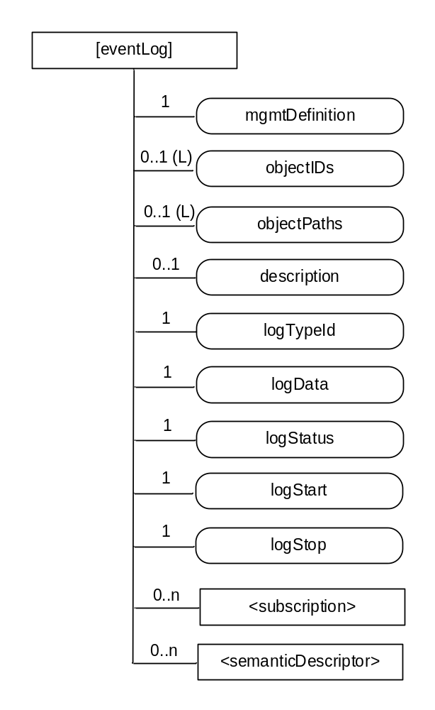
Figure D.11-1: Structure of [eventLog] resource
The [eventLog] resource shall contain the child resources specified in table D.11-1.
Table D.11-1: Child resources of [eventLog] resource
Child Resources of [eventLog] | Child Resource Type | Multiplicity | Description
[variable] | <subscription> | 0..n | See clause 9.6.8 where the type of this resource is described.
[variable] | <semanticDescriptor> | 0..n | See clause 9.6.30

The [eventLog] resource shall contain the attributes specified in table D.11-2.
Table D.11-2: Attributes of [eventLog] resource
Attributes of [eventLog] | Multiplicity | RW/  RO/  WO | Description
resourceType | 1 | RO | See clause 9.6.1.3.
resourceID | 1 | RO | See clause 9.6.1.3.
resourceName | 1 | WO | See clause 9.6.1.3.
parentID | 1 | RO | See clause 9.6.1.3.
expirationTime | 1 | RW | See clause 9.6.1.3.
accessControlPolicyIDs | 0..1 (L) | RW | See clause 9.6.1.3.
creationTime | 1 | RO | See clause 9.6.1.3.
lastModifiedTime | 1 | RO | See clause 9.6.1.3.
labels | 0..1(L) | RW | See clause 9.6.1.3.
mgmtDefinition | 1 | WO | See clause 9.6.15. This attribute shall have the fixed value "eventLog".
objectIDs | 0..1 (L) | RW | See clause 9.6.15.
objectPaths | 0..1 (L) | RW | See clause 9.6.15.
description | 0..1 | RW | See clause 9.6.15.
logTypeId | 1 | RW | Identifies the types of log to be recorded. E.g. security log, system log. This attribute is a specialization of [objectAttribute] attribute.
logData | 1 | R | Diagnostic data logged upon event of interests defined by this diagnostic function. This attribute is a specialization of [objectAttribute] attribute.
logStatus | 1 | RO | Indicates the status of thelogging process. E.g. Started, Stopped. This attribute is a specialization of [objectAttribute] attribute.
logStart | 1 | RW | The action that allows starting the log corresponding to the mentioned logTypeId. The action is triggered by assigning value "TRUE" to this attribute. This attribute is a specialization of [objectAttribute] attribute.
logStop | 1 | RW | The action that allows stopping the log corresponding to the mentioned logTypeId. The action is triggered by assigning value "TRUE" to this attribute. This attribute is a specialization of [objectAttribute] attribute.

D.12 Resource cmdhPolicy

D.12.0 Overview
A [cmdhPolicy] resource is defined as a specialization of the <mgmtObj> resource type as specified in clause 9.6.15. It includes a number of child resources which are referenced by means of mgmtLink attributes. Each of these linked child resources represents itself a specialization of the <mgmtObj> resource type. These child resources and their child resources are defined in clauses D.12.1 to D.12.8.
The [cmdhPolicy] resource represents a set of rules associated with a specific CSE that govern the behaviour of that CSE regarding rejecting, buffering and sending request or response messages via the Mcc reference point. The rules contained in a [cmdhPolicy] resource are sub-divided into rules represented by different child resources with different purposes as follows:
- Defaults: Defines which CMDH related parameters will be used by default when a request or response message issued by a registrar of the associated CSE or the associated CSE itself contains the Event Category parameter but not all other CMDH related parameters and which default Event Category parameter shall be used when none is given in the request or response.
- Limits: Defines the allowed limits for CMDH related parameters in request or response messages with a given Event Category value.
- Network usage: Defines the conditions when usage of specific Underlying Networks is allowed for request or response messages with a given Event Category value.
- Buffering: Defines limits of supported buffer size to be used for storing pending messages with a given Event Category value and their priorities when deletion cannot be avoided.
The relationships of [cmdhPolicy] resources with other resources and the position within the overall resource structure are depicted in figure D.12.0-1. One or several [cmdhPolicy] resources can be assigned as child resources under a parent of <node> resource type. The <node> resource carrying CMDH policies is linked by means of a nodeLink attribute from either the local <CSEBase> resource or an instance of a <remoteCSE> resource type. This nodeLink attribute as well as the reverse hostedCSELink attribute in the <node> resource define to which CSE the set of CMDH policies apply whenever this CSE receives requests or responses that need to be forwarded over Mcc reference point. Since only one particular set of CMDH rules can be active for a given CSE at any given point in time, an [activeCMDHPolicy] child resource under the parent <node> resource that represents the node which hosts the respective CSE is used to point to the active [cmdhPolicy] resource that shall be effective for that particular CSE.
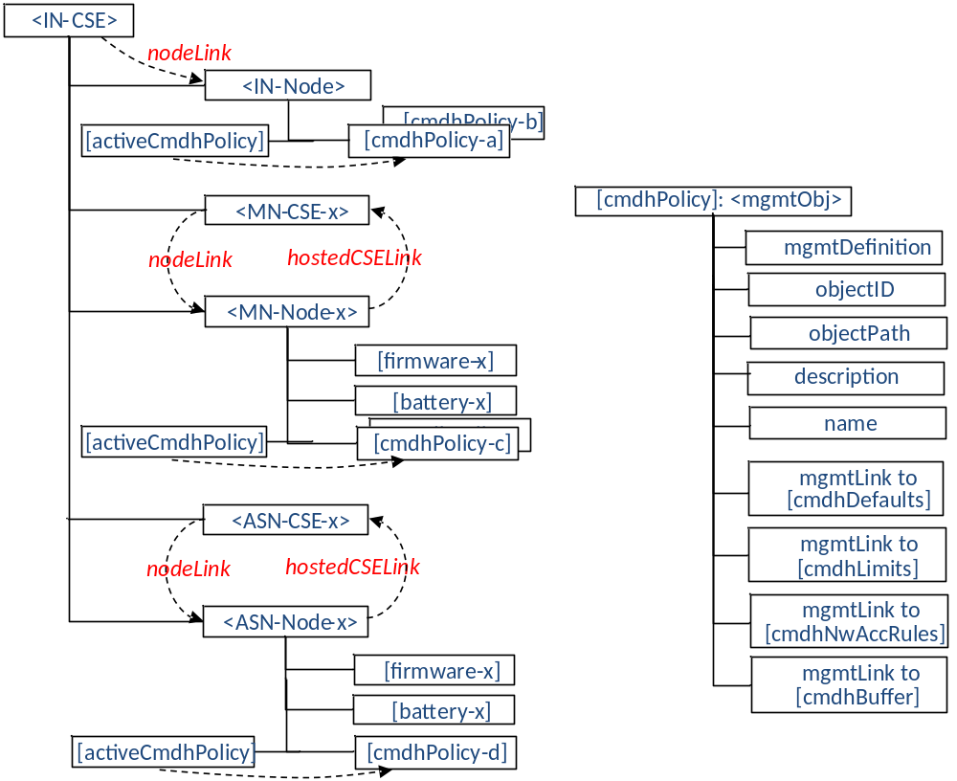
Figure D.12.0-1: Relationships between [cmdhPolicy] resource and other resources
When employing external management technology, the [cmdhPolicy] resources are assigned under instances of the <node> resources that represent the remotely managed field nodes in the IN-CSE performing device management for these nodes. In this scenario, the [cmdhPolicy] resources are transferred to the field node by means of the external device management technology applicable for that specific node.
When a field domain node is managed via the Mcc reference point, the [cmdhPolicy] resources are provisioned directly to instances of the <node> resources in the field domain CSE from an IN-CSE responsible for the device/entity management.
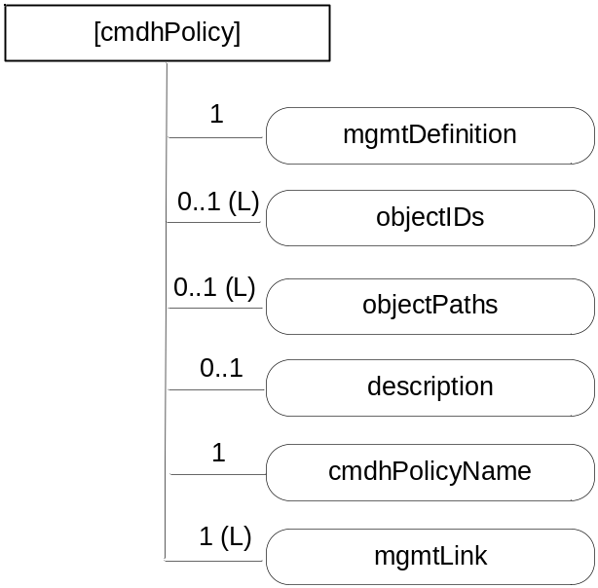
Figure D.12.0-2: Structure of [cmdhPolicy] resource
The [cmdhPolicy] resource shall contain attributes specified in table D.12.0-1.
Table D.12.0-1: Attributes of [cmdhPolicy] resource
Attributes of [cmdhPolicy] | Multiplicity | RW/  RO/  WO | Description
resourceType | 1 | RO | See clause 9.6.1.3.
resourceID | 1 | RO | See clause 9.6.1.3.
resourceName | 1 | WO | See clause 9.6.1.3.
parentID | 1 | RO | See clause 9.6.1.3.
expirationTime | 1 | RW | See clause 9.6.1.3.
accessControlPolicyIDs | 0..1 (L) | RW | See clause 9.6.1.3.
creationTime | 1 | RO | See clause 9.6.1.3.
lastModifiedTime | 1 | RO | See clause 9.6.1.3.
labels | 0..1(L) | RO | See clause 9.6.1.3.
mgmtDefinition | 1 | WO | See clause 9.6.15. Has fixed value "cmdhPolicy" to indicate the resource is for CMDH policy management.
objectIDs | 0..1 (L) | RW | See clause 9.6.15.
objectPaths | 0..1 (L) | RW | See clause 9.6.15.
description | 0..1 | RW | See clause 9.6.15.
cmdhPolicyName | 1 | RW | A name under which the CMDH policy will be referred. This attribute is a specialization of [objectAttribute] attribute.
mgmtLink | 1 (L) | RW | A list containing at least 4 links.  - 1 link to [cmdhDefaults] resource;  - At least 1 or more link(s) to [cmdhLimits] resource(s);  - At least 1 or more link(s) to [cmdhNetworkAccessRules] resource(s);  - At least 1 or more link(s) to [cmdhBuffer] resource(s).

D.12.1 Resource activeCmdhPolicy
A managed node can have one or more sets of [cmdhPolicy] resources assigned as children.
The [activeCmdhPolicy] resource is used to provide a link to the currently active set of CMDH policies. This identifies which set of CMDH policies is currently actively in use in the corresponding CSE. It allows the device management technology to activate a policy set independently of the download of a new set of CMDH policies in order to avoid potential race conditions. The [activeCmdhPolicy] and [cmdhPolicy] resources are children of the same <node> resource to which these policies apply.
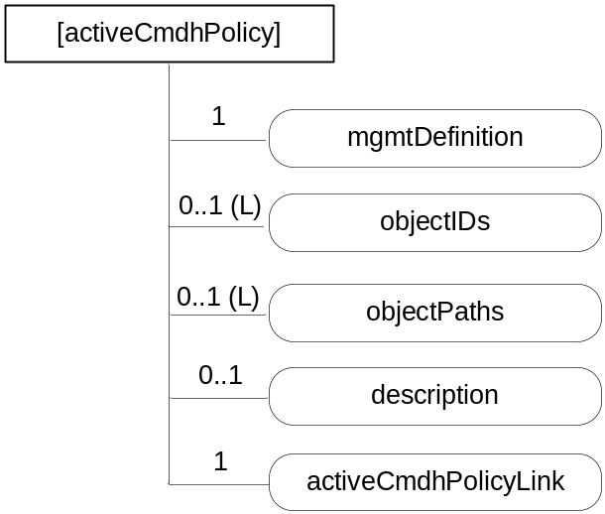
Figure D.12.1-1: Structure of [activeCmdhPolicy] resource
The [activeCmdhPolicy] resource shall contain attributes specified in table D.12.1-1.
Table D.12.1-1: Attributes of [activeCmdhPolicy] resource
Attributes of [activeCmdhPolicy] | Multiplicity | RW/  RO/  WO | Description
resourceType | 1 | RO | See clause 9.6.1.3.
resourceID | 1 | RO | See clause 9.6.1.3.
resourceName | 1 | WO | See clause 9.6.1.3.
parentID | 1 | RO | See clause 9.6.1.3.
expirationTime | 1 | RW | See clause 9.6.1.3.
accessControlPolicyIDs | 0..1 (L) | RW | See clause 9.6.1.3.
creationTime | 1 | RO | See clause 9.6.1.3.
lastModifiedTime | 1 | RO | See clause 9.6.1.3.
labels | 0..1(L) | RO | See clause 9.6.1.3
mgmtDefinition | 1 | WO | See clause 9.6.15. Has fixed value "activeCmdhPolicy".
objectIDs | 0..1 (L) | RW | See clause 9.6.15.
objectPaths | 0..1 (L) | RW | See clause 9.6.15.
description | 0..1 | RW | See clause 9.6.15.
activeCmdhPolicyLink | 1 | RW | The resource ID of the [cmdhPolicy] resource instance containing the CMDH policies that are currently active for the associated CSE, i.e. for the CSE which is hosted by the node that is represented by the parent <node> resource.

D.12.2 Resource cmdhDefaults
The [cmdhDefaults] resource is used to define default values that shall be used for CMDH-related parameters when requests issued by Originators (registered AEs or functions inside the CSE itself) do not contain a value for the parameters Event Category, Request Expiration Timestamp, Result Expiration Timestamp, Operation Execution Time, Result Persistence, and/or Delivery Aggregation.
Upon receiving a request, the CSE shall first look if the Event Category parameter is set. If not, the CSE shall use the [cmdhDefEcValue] resources (see below) to determine a value that should be used for Event Category.
Then, if any of the parameters Request Expiration Timestamp, Result Expiration Timestamp, Operation Execution Time, Result Persistence or Delivery Aggregation is not set, the CSE shall use the [cmdhEcDefParamValues] resources (see below) to populate the missing parameters (and only the missing ones).
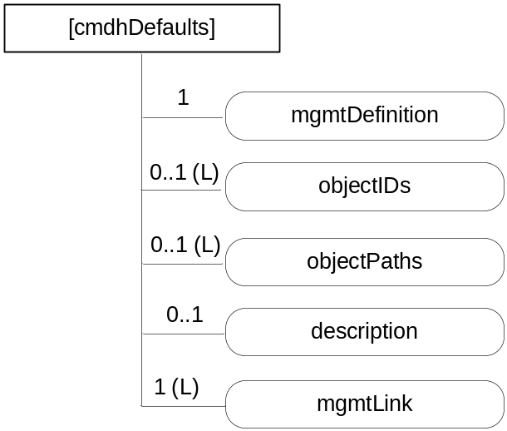
Figure D.12.2-1: Structure of [cmdhDefaults] resource
The [cmdhDefaults] resource shall contain attributes specified in table D.12-2-1.
Table D.12.2-1: Attributes of [cmdhDefaults] resource
Attributes of [cmdhDefaults] | Multiplicity | RW/  RO/  WO | Description
resourceType | 1 | RO | See clause 9.6.1.3.
resourceID | 1 | RO | See clause 9.6.1.3.
resourceName | 1 | WO | See clause 9.6.1.3.
parentID | 1 | RO | See clause 9.6.1.3.
expirationTime | 1 | RW | See clause 9.6.1.3.
accessControlPolicyIDs | 0..1 (L) | RW | See clause 9.6.1.3.
creationTime | 1 | RO | See clause 9.6.1.3.
lastModifiedTime | 1 | RO | See clause 9.6.1.3.
labels | 0..1(L) | RO | See clause 9.6.1.3
mgmtDefinition | 1 | WO | See clause 9.6.15. Has fixed value "cmdhDefaults".
objectIDs | 0..1 (L) | RW | See clause 9.6.15.
objectPaths | 0..1 (L) | RW | See clause 9.6.15.
description | 0..1 | RW | See clause 9.6.15.
mgmtLink | 1 (L) | RW | A list containing at least 2 links:  - One or more link(s) to [cmdhDefEcValue] resource(s); and  - One or more link(s) to [cmdhEcDefParamValues] resource(s).

D.12.3 Resource cmdhDefEcValue
The [cmdhDefEcValue] resource is used to define a value for the Event Category parameter of an incoming request when it is not defined.
Upon receiving a request, the CSE will go through all the [cmdhDefEcValue] resources (in the order of their order attribute), check the requestOrigin and any present requestContext and requestCharacteristics attributes to see if they match (see description of matching), and if they all do, assign the value stored in the defEcValue attribute to the Event Category parameter.
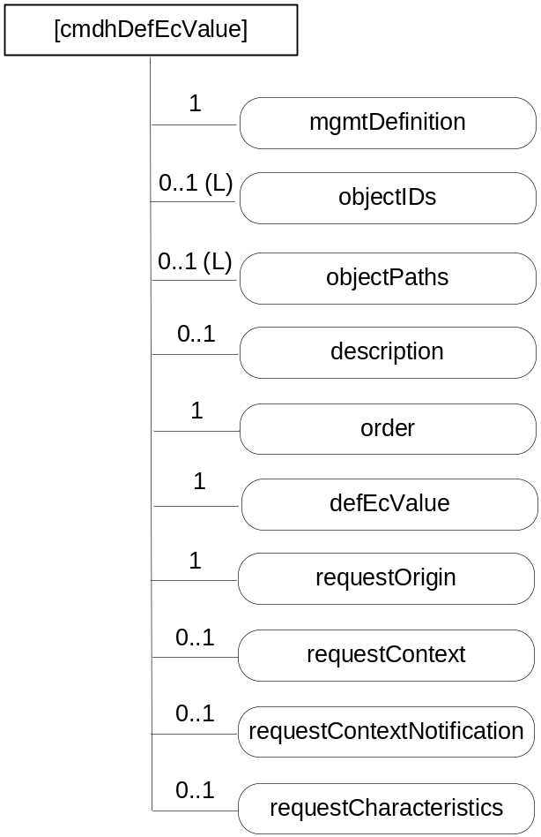
Figure D.12.3-1: Structure of [cmdhDefEcValue] resource
The [cmdhDefEcValue] resource shall contain attributes specified in table D.12.3-1.
Table D.12.3-1: Attributes of [cmdhDefEcValue] resource
Attributes of [cmdhDefEcValue] | Multiplicity | RW/  RO/  WO | Description
resourceType | 1 | RO | See clause 9.6.1.3.
resourceID | 1 | RO | See clause 9.6.1.3.
resourceName | 1 | WO | See clause 9.6.1.3.
parentID | 1 | RO | See clause 9.6.1.3.
expirationTime | 1 | RW | See clause 9.6.1.3.
accessControlPolicyIDs | 0..1 (L) | RW | See clause 9.6.1.3.
creationTime | 1 | RO | See clause 9.6.1.3.
lastModifiedTime | 1 | RO | See clause 9.6.1.3.
labels | 0..1(L) | RO | See clause 9.6.1.3.
mgmtDefinition | 1 | WO | See clause 9.6.15. Has fixed value "cmdhDefEcValue".
objectIDs | 0..1 (L) | RW | See clause 9.6.15.
objectPaths | 0..1 (L) | RW | See clause 9.6.15.
description | 0..1 | RW | See clause 9.6.15.
order | 1 | RW | The index indicating in which order the [cmdhDefEcValue] resource will be treated by the CSE to determine a value for the Event Category parameter. This attribute is a specialization of [objectAttribute] attribute.
defEcValue | 1 | RW | The actual value to use for the Event Category parameter if the conditions expressed in the requestOrigin, requestContext and requestCharacteristics attributes all match. If none of these attributes are defined, then the defEcValue shall be applied. This attribute is a specialization of [objectAttribute] attribute.
requestOrigin | 1 | RW | The requestOrigin attribute is a list of zero or more local AE-IDs, App-IDs, or the strings 'localAE' or 'thisCSE'.  When an AE-ID appears in the requestOrigin attribute, the default Event Category value defined inside the defEcValue attribute is applicable for the Event Category if the request was issued by that specific Application Entity.  When an App-ID appears in the requestOrigin attribute, the default Event Category value defined inside the defEcValue attribute is applicable for the Event Category if the request was issued by the AE with that App-ID unless covered by another [cmdhDefEcValue] resource with a requestOrigin attribute containing its specific AE-ID.  When the string 'localAE' appears in the requestOrigin attribute, the default Event Category value defined inside the defEcValue attribute is applicable for the Event Category for requests issued by all local AEs unless covered by another [cmdhDefEcValue] resource with a requestOrigin attribute containing the specific AE-ID or App-ID of the Originator of the request.  When the string 'thisCSE' appears in the requestOrigin attribute, the default Event Category value defined inside the defEcValue attribute is applicable for the Event Category for requests that are originating from within the registrar CSE.  The Hosting CSE shall contain at least one [cmdhDefEcValue] resource that contains 'localAE' in the requestOrigin attribute and has no requestContext and no requestCharacteristics attribute.  The Hosting CSE shall contain at least one [cmdhDefEcValue] resource that contains 'thisCSE' in the requestOrigin attribute and has no contextCondtion and no requestCharacteristics attribute.  This attribute is a specialization of [objectAttribute] attribute.
requestContext | 0..1 | RW | The requestContext attribute represents the Dynamic Context condition under which the default Event Category value defined inside the defEcValue attribute is applicable for the Event Category.  This may refer to conditions such as current battery status, or current network signal strength. This attribute is a specialization of [objectAttribute] attribute.
requestContextNotification | 0..1 | RW | True or false. If set to true, then this CSE will establish a subscription to the dynamic context information defined in the requestContext attribute as well as a subscription to this [cmdhDefEcValue] resource for all AEs corresponding to the AE-ID or an App-ID appearing in the requestOrigin attribute. Both, changes in the context information and changes to the [cmdhDefEcValue] resource will be notified to the respective AEs. The subscription(s) is/are established when the [cmdhDefEcValue] is provisioned or updated. This attribute is a specialization of [objectAttribute] attribute.
requestCharacteristics | 0..1 | RW | The requestCharacteristics attribute represents conditions pertaining to the request itself, such as the requested Response Type or other parameters of the request. This attribute is a specialization of [objectAttribute] attribute.

D.12.4 Resource cmdhEcDefParamValues
The [cmdhEcDefParamValues] resource is used to represent a specific set of default values for the CMDH related parameters Request Expiration Timestamp, Result Expiration Timestamp, Operation Execution Time, Result Persistence and Delivery Aggregation that are applicable for a given Event Category if these parameters are not specified in the request.
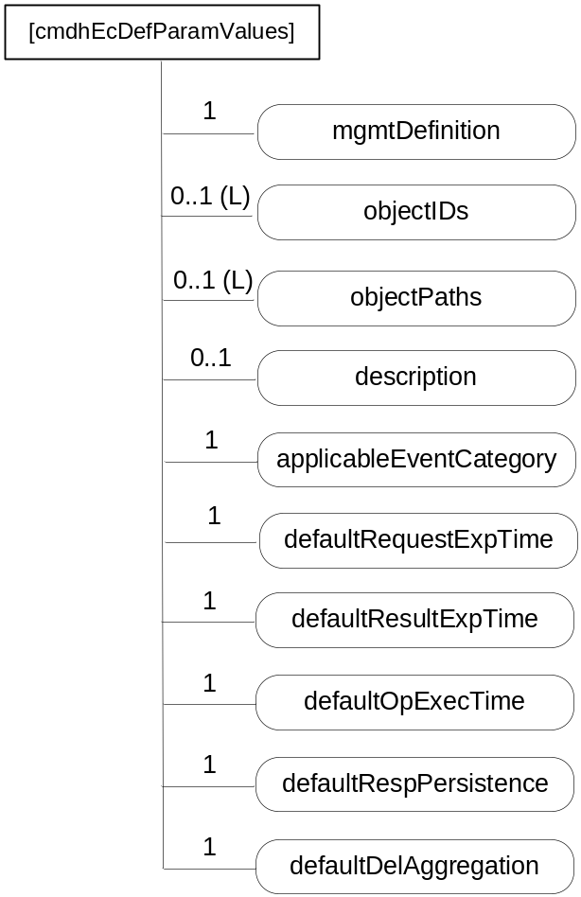
Figure D.12.4-1: Structure of [cmdhEcDefParamValues] resource
The [cmdhEcDefParamValues] resource shall contain attributes specified in table D.12.4-1.
Table D.12.4-1: Attributes of [cmdhEcDefParamValues] resource
Attributes of [cmdhEcDefParamValues] | Multiplicity | RW/  RO/  WO | Description
resourceType | 1 | RO | See clause 9.6.1.3.
resourceID | 1 | RO | See clause 9.6.1.3.
resourceName | 1 | WO | See clause 9.6.1.3.
parentID | 1 | RO | See clause 9.6.1.3.
expirationTime | 1 | RW | See clause 9.6.1.3.
accessControlPolicyIDs | 0..1 (L) | RW | See clause 9.6.1.3.
creationTime | 1 | RO | See clause 9.6.1.3.
lastModifiedTime | 1 | RO | See clause 9.6.1.3.
labels | 0..1(L) | RO | See clause 9.6.1.3.
mgmtDefinition | 1 | WO | See clause 9.6.15. Has fixed value "cmdhEcDefParamValues".
objectIDs | 0..1 (L) | RW | See clause 9.6.15.
objectPaths | 0..1 (L) | RW | See clause 9.6.15.
description | 0..1 | RW | See clause 9.6.15.
applicableEventCategory | 1 | RW | This attribute defines the event categories for which this set of default parameters defined in this [cmdhEcDefParamValues] resource are applicable. This attribute is a list of zero or more Event Category values, or the string 'default'.  When an Event Category value appears in the applicableEventCategory attribute, the set of default parameters defined in this [cmdhEcDefParamValues] resource are applicable for requests associated with that specific Event Category value.  When the string 'default' appears in the applicableEventCategory attribute, the set of default parameters defined in this [cmdhEcDefParamValues] resource are applicable for all requests whose associated Event Category value is not listed in the applicableEventCategory attribute of any other provisioned [cmdhEcDefParamValues] resource on the Hosting CSE.  A specific Event Category value shall appear at most once in any of the applicableEventCategory attributes of any of the provisioned [cmdhEcDefParamValues] resources on the Hosting CSE.  The string 'default' shall appear exactly once in any of the applicableEventCategory attributes of any of the provisioned [cmdhEcDefParamValues] resources on the Hosting CSE.  This attribute is a specialization of [objectAttribute] attribute.
defaultRequestExpTime | 1 | RW | Default value for the Request Expiration Timestamp parameter in a request when the Request Expiration Timestamp parameter of the request is not set. This attribute is a specialization of [objectAttribute] attribute.
defaultResultExpTime | 1 | RW | Default value for the Result Expiration Timestamp parameter in a request when the Result Expiration Timestamp parameter of the request is not set. This attribute is a specialization of [objectAttribute] attribute.
defaultOpExecTime | 1 | RW | Default value for the Operation Execution Time parameter in a request when the Operation Execution Time parameter of the request is not set. This attribute is a specialization of [objectAttribute] attribute.
defaultRespPersistence | 1 | RW | Default value for the Result Persistence parameter in a request when the Result Persistence parameter of the request is not set. This attribute is a specialization of [objectAttribute] attribute.
defaultDelAggregation | 1 | RW | Default value for the Delivery Aggregation parameter in a request when the Delivery Aggregation parameter of the request is not set. This attribute is a specialization of [objectAttribute] attribute.

D.12.5 Resource cmdhLimits
The [cmdhLimits] resource is used to define limits for CMDH related parameter values used in requests issued by Originators (registered AEs or functions inside the CSE itself). When an incoming request is processed that does not comply with the limits defined by the corresponding [cmdhLimits] resource, the request shall be rejected by the CSE.
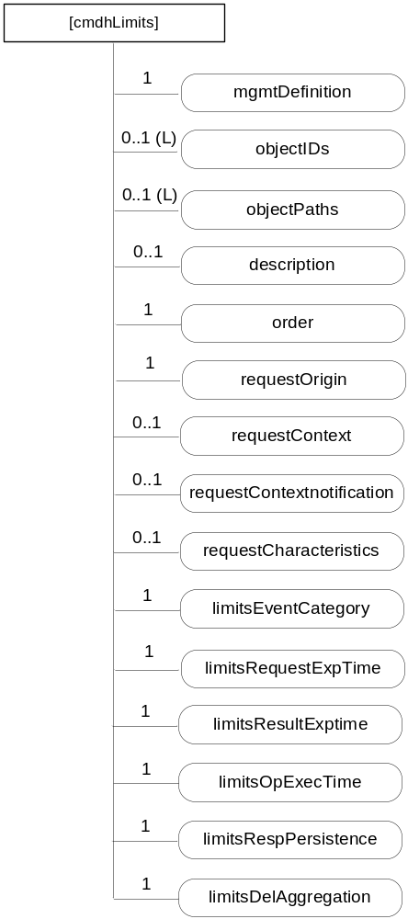
Figure D.12.5-1: Structure of [cmdhLimits] resource
The [cmdhLimits] resource shall contain attributes specified in table D.12.5-1.
Table D.12.5-1: Attributes of [cmdhLimits] resource
Attributes of [cmdhLimits] | Multiplicity | RW/  RO/  WO | Description
resourceType | 1 | RO | See clause 9.6.1.3.
resourceID | 1 | RO | See clause 9.6.1.3.
resourceName | 1 | WO | See clause 9.6.1.3.
parentID | 1 | RO | See clause 9.6.1.3.
expirationTime | 1 | RW | See clause 9.6.1.3.
accessControlPolicyIDs | 0..1 (L) | RW | See clause 9.6.1.3.
creationTime | 1 | RO | See clause 9.6.1.3.
lastModifiedTime | 1 | RO | See clause 9.6.1.3.
labels | 0..1(L) | RO | See clause 9.6.1.3.
mgmtDefinition | 1 | WO | See clause 9.6.15. Has fixed value "cmdhLimits".
objectIDs | 0..1 (L) | RW | See clause 9.6.15.
objectPaths | 0..1 (L) | RW | See clause 9.6.15.
description | 0..1 | RW | See clause 9.6.15.
order | 1 | RW | The index indicating in which order the [cmdhLimits] resource will be treated by the CSE to determine a value for the limit parameters. This attribute is a specialization of [objectAttribute] attribute.
requestOrigin | 1 | RW | The requestOrigin attribute is a list of zero or more local AE-IDs, App-IDs, or the strings 'localAE' or 'thisCSE'.  When an AE-ID appears in the requestOrigin attribute, the CMDH parameter limits defined inside [cmdhLimits] resources are applicable for requests issued by that specific Application Entity.  When an App-ID appears in the requestOrigin attribute, the CMDH parameter limits defined inside [cmdhLimits] resources are applicable for requests issued by the AE with that App-ID unless already covered by another [cmdhLimits] resource with a requestOrigin attribute containing its specific AE-ID.  When the string 'localAE' appears in the requestOrigin attribute, CMDH parameter limits defined inside [cmdhLimits] resources are applicable for all local AEs unless covered by another [cmdhLimits] resource with a requestOrigin attribute containing the specific AE-ID or App-ID of the Originator of the request.  When the string 'thisCSE' appears in the requestOrigin attribute, CMDH parameter limits defined inside [cmdhLimits] resources are applicable for all requests that are originating from within the Hosting CSE.  The Hosting CSE shall contain at least one [cmdhLimits] resource that contains 'localAE' in the requestOrigin attribute and has no contextCondition and no requestCharacteristics attribute.  The Hosting CSE shall contain at least one [cmdhLimits] resource that contains 'thisCSE' in the requestOrigin attribute and has no requestContext and no requestCharacteristics attribute.  This attribute is a specialization of [objectAttribute] attribute.
requestContext | 0..1 | RW | The requestContext attribute represents the Dynamic Context condition under which CMDH parameter limits defined inside the [cmdhLimits] resource is applicable.  This may refer to conditions such as current battery status, or current network signal strength. This attribute is a specialization of [objectAttribute] attribute.
requestContextNotification | 0..1 | RW | True or false. If set to true, then this CSE will establish a subscription to the dynamic context information defined in the requestContext attribute as well as a subscription to this [cmdhLimits] resource for all AEs corresponding to the AE-ID or an App-ID appearing in the requestOrigin attribute. Both, changes in the context information and changes to the [cmdhLimits] resource will be notified to the respective AEs. The subscription(s) is/are established when the [cmdhLimits] is provisioned or updated. This attribute is a specialization of [objectAttribute] attribute.
requestCharacteristics | 0..1 | RW | The requestCharacteristics attribute represents conditions pertaining to the request itself, such as the requested Response Type or other attributes of the request. This attribute is a specialization of [objectAttribute] attribute.
limitsEventCategory | 1 | RW | Allowed values for the Event Category parameter) in a request of any of the Originators indicated in the requestOrigin attribute. This attribute is a specialization of [objectAttribute] attribute.
limitsRequestExpTime | 1 | RW | Range of allowed values for the Request Expiration Timestamp parameter in a request of any of the Originators indicated in the requestOrigin attribute. This attribute is a specialization of [objectAttribute] attribute.
limitsResultExpTime | 1 | RW | Range of allowed values for the Result Expiration Timestampparameter in a request of any of the Originators indicated in the requestOrigin attribute. This attribute is a specialization of [objectAttribute] attribute.
limitsOpExecTime | 1 | RW | Range of allowed values for the Operation Execution Time parameter in a request of any of the Originators indicated in the requestOrigin attribute. This attribute is a specialization of [objectAttribute] attribute.
limitsRespPersistence | 1 | RW | Range of allowed values for the Result Persistence parameter in a request of any of the Originators indicated in the requestOrigin attribute. This attribute is a specialization of [objectAttribute] attribute.
limitsDelAggregation | 1 | RW | List of allowed values for the Delivery Aggregation parameter in a request of any of the Originators indicated in the requestOrigin attribute. This attribute is a specialization of [objectAttribute] attribute.

D.12.6 Resource cmdhNetworkAccessRules
The [cmdhNetworkAccessRules] resource is used to define the usage of Underlying Networks for forwarding information to other CSEs during processing of CMDH-related requests in a CSE. When an incoming request is processed by a CSE, it can only use Underlying Networks for forwarding any information to other CSEs in compliance with the rules defined by the corresponding [cmdhNetworkAccessRules] resource.
If a request cannot be successfully completed in compliance with the rules defined in the corresponding [cmdhNetworkAccessRules] resource, that request shall either be rejected in case it has not already been accepted by the CSE or it has to be purged. Error reporting on failed CMDH processing depends on error reporting parameters.
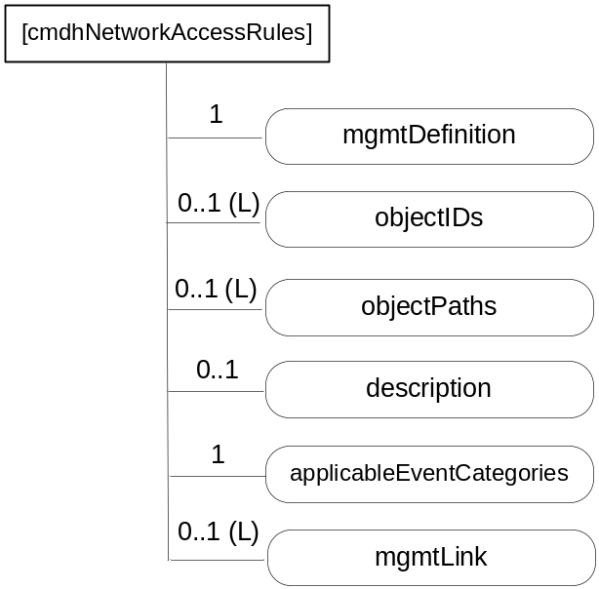
Figure D.12.6-1: Structure of [cmdhNetworkAccessRules] resource
If a [cmdhNetworkAccessRules] resource has no mgmtLink attribute to [cmdhNwAccessRules] resources (i.e. multiplicity of 0), requests that match with the applicableEventCategorie attribute (see description of attributes in table D.12.6-1) will not be allowed to use any Underlying Network for forwarding information, i.e. such requests need to be rejected.
The [cmdhNetworkAccessRules] resource shall contain attributes specified in table D.12.6-1.
Table D.12.6-1: Attributes of [cmdhNetworkAccessRules] resource
Attributes of [cmdhNetworkAccessRules] | Multiplicity | RW/  RO/  WO | Description
resourceType | 1 | RO | See clause 9.6.1.3.
resourceID | 1 | RO | See clause 9.6.1.3.
resourceName | 1 | WO | See clause 9.6.1.3.
parentID | 1 | RO | See clause 9.6.1.3.
expirationTime | 1 | RW | See clause 9.6.1.3.
accessControlPolicyIDs | 0..1 (L) | RW | See clause 9.6.1.3.
creationTime | 1 | RO | See clause 9.6.1.3.
lastModifiedTime | 1 | RO | See clause 9.6.1.3.
labels | 0..1(L) | RO | See clause 9.6.1.3.
mgmtDefinition | 1 | WO | See clause 9.6.15. Has fixed value "cmdhNetworkAccessRules".
objectIDs | 0..1 (L) | RW | See clause 9.6.15.
objectPaths | 0..1 (L) | RW | See clause 9.6.15.
description | 0..1 | RW | See clause 9.6.15.
applicableEventCategories | 1 | RW | This attribute defines for which requests the rules contained in [cmdhNwAccessRule] resources linked from this [cmdhNetworkAccessRules] resource shall be applied.  This attribute is a list of zero or more Event Category values, or the string 'default'.  When an Event Category value appears in the applicableEventCategories attribute, the network usage rules defined inside [cmdhNwAccessRule] child resources are applicable for requests associated with that specific Event Category value.  When the string 'default' appears in the applicableEventCategories attribute, the network usage rules defined inside [cmdhNwAccessRule] child resources are applicable for all requests whose associated Event Category value is not listed in the applicableEventCategories attribute of any other provisioned [cmdhNetworkAccessRules] resource on the Hosting CSE.  A specific Event Category value shall appear at most once in any of the applicableEventCategories attributes of any of the provisioned [cmdhNetworkAccessRules] resources on the Hosting CSE.  The string 'default' shall appear exactly once in any of the applicableEventCategories attributes of any of the provisioned [cmdhNetworkAccessRules] resources on the Hosting CSE.  This attribute is a specialization of [objectAttribute] attribute.
mgmtLink | 0..1 (L) | RW | List of link(s) to [cmdhNwAccessRule] resource(s)

D.12.7 Resource cmdhNwAccessRule
The [cmdhNwAccessRule] resource is used define limits in usage of specific Underlying Networks for forwarding information to other CSEs during processing of CMDH-related requests.
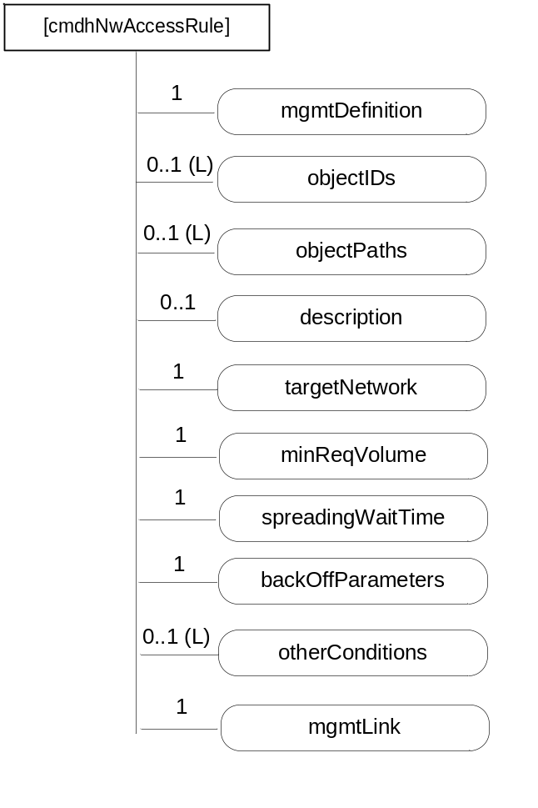
Figure D.12.7-1: Structure of [cmdhNwAccessRule] resource
Requests matching the applicableEventCategories attribute of the parent [cmdhNetworkAccessRules] resource of this [cmdhNwAccessRule] resource are processed for forwarding to other CSEs. The Underlying Networks allowed for those Requests are indicated by the targetNetwork attribute. The allowed schedule is indicated by the <schedule> resource pointed at by the mgmtLink attribute (see description of attributes in table D.12.7-1).
The [cmdhNwAccessRule] resource shall contain attributes specified in table D.12.7-1.
Table D.12.7-1: Attributes of [cmdhNwAccessRule] resource
Attributes of [cmdhNwAccessRule] | Multiplicity | RW/  RO/  WO | Description
resourceType | 1 | RO | See clause 9.6.1.3.
resourceID | 1 | RO | See clause 9.6.1.3.
resourceName | 1 | WO | See clause 9.6.1.3.
parentID | 1 | RO | See clause 9.6.1.3.
expirationTime | 1 | RW | See clause 9.6.1.3.
accessControlPolicyIDs | 0..1 (L) | RW | See clause 9.6.1.3.
creationTime | 1 | RO | See clause 9.6.1.3.
lastModifiedTime | 1 | RO | See clause 9.6.1.3.
labels | 0..1(L) | RO | See clause 9.6.1.3.
mgmtDefinition | 1 | WO | See clause 9.6.15. Has fixed value "cmdhNwAccessRules".
objectIDs | 0..1 (L) | RW | See clause 9.6.15.
objectPaths | 0..1 (L) | RW | See clause 9.6.15.
description | 0..1 | RW | See clause 9.6.15.
targetNetwork | 1 | RW | The targetNetwork attribute defines for which Underlying Networks the usage limits contained in this [cmdhNwAccessRule] resource shall be applied.  The targetNetwork attribute is a list of one or more strings identifying names of Underlying Networks or the string 'default'.  NOTE: A naming convention for Underlying Network names is not supported in this release of the specification.  When a name of an Underlying Network appears in the targetNetwork attribute, the usage limits contained in this [cmdhNwAccessRule] resource shall be applied for usage of that specific Underlying Network when processing requests matching with the parent [cmdhNetworkAccessRules] resource's applicableEventCategories attribute.  When the string 'default' appears in the targetNetwork attribute, the usage limits contained in this [cmdhNwAccessRule] resource shall be applied for usage of all Underlying Networks that are not listed with their specific name in the targetNetwork attribute of any other [cmdhNwAccessRule] child resource under the same parent [cmdhNetworkAccessRules] resource when processing requests matching with the parent [cmdhNetworkAccessRules] resource's targetNetwork.  Each Underlying Network name or the string 'default' shall appear at most once in any of the targetNetwork attributes of any of the provisioned [cmdhNwAccessRule] child resources under the same parent [cmdhNetworkAccessRules] resource.  This attribute is a specialization of [objectAttribute] attribute.
minReqVolume | 1 | RW | Minimum amount of data that needs to be aggregated before any of the Underlying Networks matching with the targetNetwork attribute of this [cmdhNwAccessRule] resource can be used for forwarding information to other CSEs.
spreadingWaitTime | 1 | RW | This parameter consists of a number SWT such that before accessing the underlying network (typically to forward an incoming request), the CSE will wait for an additional amount of time randomly chosen between 0 and SWT.  This attribute is a specialization of [objectAttribute] attribute.
backOffParameters | 1 | RW | Parameters that define how usage of any of the Underlying Networks matching with the targetNetwork attribute of this [cmdhNwAccessRule] resource shall be handled when attempts to use such networks have failed.  The backOffParameters attribute can either:  - Consist of the following values:  - An intial back-off time IBT that defines how long a CSE needs to wait before attempting to use a specific Underlying Network again after a first failed attempt  - An additional back-off time ABT increment that defines by how much the back-off time shall be increased after each additional consecutive failed attempt to use the same Underlying Network without success  - A maximum back-off time MBT that defines the maximum wait time before attempting to use an Underlying Network again after previous failures.  - An optional random back-off time RBT that will make the network access actually occur randomly in a time window starting at IBT+n.ABT and ending at IBT+n.ABT+RBT (if RBT is not present, then no randomization occurs and the access takes place at IBT+n.ABT)  In which case the back-off timers apply for any action attempted onto the network to fulfil the incoming request (registration to the network, opening of data session, etc.)  - Or consist of an array of several elements, each composed like this [NWA, IBT, ABT, MBT, (optional RBT)] where IBT, ABT, MBT and RBT are defined above, and where NWA is the name of a specific action that is actually attempted on the network. This specification defines the following network action names, that can be used when the CSE knows that it uses an underlying network where these actions are valid:  - "cellular-registration" for an IMSI CS-Registration onto 3GPP-compliant cellular networks  - "cellular-attach" for a GPRS Attach onto 3GPP-compliant cellular networks  - "cellular-pdpctxact" for a PDP Context Activation onto 3GPP-compliant cellular networks  - "cellular-sms" for SMS originating from this CSE onto 3GPP-compliant cellular networks  - "default" for all other actions not already declared in this backOffParameters attribute (this action will be used by the CSE when it does not know which kind of underlying network it uses)  In which case the back-off timers apply only for the specified actions.  This attribute is a specialization of [objectAttribute] attribute.
otherConditions | 0..1 (L) | RW | List of additional conditions that need to be fulfilled before any of the Underlying Networks matching with the targetNetwork attribute of this [cmdhNwAccessRule] resource can be used for forwarding information to other CSEs. This attribute is a specialization of [objectAttribute] attribute.
mgmtLink | 1 | RW | Link to an instance allowedSchedule of a <schedule> resource as defined in clause 9.6.9. This attribute is a specialization of [objectAttribute] attribute.

D.12.8 Resource cmdhBuffer
The [cmdhBuffer] resource is used to define limits in usage of buffers for temporarily storing information that needs to be forwarded to other CSEs during processing of CMDH-related requests in a CSE. When an incoming request is processed by a CSE, it can only use buffers for temporary storage in compliance with the rules defined by the corresponding [cmdhBuffer] resource.
If a request cannot be processed in compliance with the rules defined in the corresponding [cmdhBuffer] resource, that request shall either be rejected in case it has not already been accepted by the CSE or it has to be purged. Error reporting on failed CMDH processing depends on error reporting parameters.
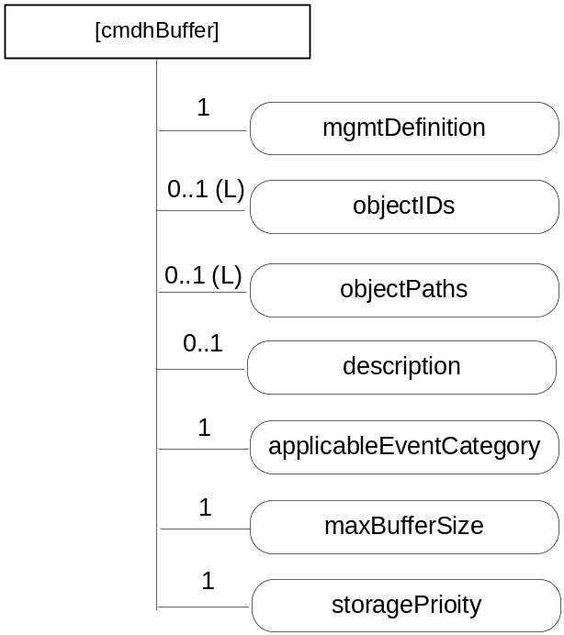
Figure D.12.8-1: Structure of [cmdhBuffer] resource
The [cmdhBuffer] resource shall contain attributes specified in table D.12.8-1.
Table D.12.8-1: Attributes of [cmdhBuffer] resource
Attributes of [cmdhBuffer] | Multiplicity | RW/  RO/  WO | Description
resourceType | 1 | RO | See clause 9.6.1.3.
resourceID | 1 | RO | See clause 9.6.1.3.
resourceName | 1 | WO | See clause 9.6.1.3.
parentID | 1 | RO | See clause 9.6.1.3.
expirationTime | 1 | RW | See clause 9.6.1.3.
accessControlPolicyIDs | 0..1 (L) | RW | See clause 9.6.1.3.
creationTime | 1 | RO | See clause 9.6.1.3.
lastModifiedTime | 1 | RO | See clause 9.6.1.3.
labels | 0..1(L) | RO | See clause 9.6.1.3.
mgmtDefinition | 1 | WO | See clause 9.6.15. Has fixed value "cmdhBuffer".
objectIDs | 0..1 (L) | RW | See clause 9.6.15.
objectPaths | 0..1 (L) | RW | See clause 9.6.15.
description | 0..1 | RW | See clause 9.6.15.
applicableEventCategory | 1 | RW | The applicableEventCategory attribute defines for which requests the limits contained in this [cmdhBuffer] resource shall be applied.  The applicableEventCategory attribute is a list of zero or more Event Category values, or the string 'default'.  When an Event Category value appears in the applicableEventCategory attribute, the buffer usage limits defined inside this [cmdhBuffer] resource are applicable for requests associated with that specific Event Category value.  When the string 'default' appears in the applicableEventCategory attribute, the buffer usage limits defined inside this [cmdhBuffer] resource are applicable for all requests whose associated Event Category valueis not listed in the applicableEventCategory attribute of any other provisioned [cmdhBuffer] resource on the Hosting CSE.  A specific Event Category value shall appear at most once in any of the applicableEventCategory attributes of any of the provisioned [cmdhBuffer] resources on the Hosting CSE.  The string 'default' shall appear exactly once in any of the applicableEventCategory attributes of any of the provisioned [cmdhBuffer] resources on the Hosting CSE.  This attribute is a specialization of [objectAttribute] attribute.
maxBufferSize | 1 | RW | Maximum amount of memory that can be used for buffering requests matching with the applicableEventCategory attribute of this [cmdhBuffer] resource. This attribute is a specialization of [objectAttribute] attribute.
storagePriority | 1 | RW | Storage priority for data that is stored for buffering requests matching with the attribute of this [cmdhBuffer] resource.  The storage priority defines the how to handle purging of buffered data when buffer memory is exhausted and buffered requests need to be purged. Buffered requests associated with a lower storage priority shall be purged before buffered requests with a higher storage priority. The range of storage priority is from 1 to 10. This attribute is a specialization of [objectAttribute] attribute.

-----------------------End of change 2---------------------------------------------

CHECK LIST
- Does this change request include an informative introduction containing the problem(s) being solved, and a summary list of proposals.?
- Does this CR contain changes related to only one particular issue/problem?
- Have any mirror crs been posted?
- Does this change request make all the changes necessary to address the issue or problem? E.g. A change impacting 5 tables should not only include a proposal to change only 3 tables. Includes any changes to references, definitions, and acronyms in the same deliverable?
- Does this change request follow the drafting rules?
- Are all pictures editable?
- Have you checked the spelling and grammar?
- Have you used change bars for all modifications?
- Does the change include the current and surrounding clauses to clearly show where a change is located and to provide technical context of the proposed change? (Additions of complete sections need not show surrounding clauses as long as the proposed section number clearly shows where the new section is proposed to be located.)
- Are multiple changes in this CR clearly separated by horizontal lines with embedded text such as, start of change 1, end of change 1, start of new clause, end of new clause.?

