CHANGE REQUEST
Meeting ID:* | ARC#29
Source:* | Catalina Mladin, Convida Wireless, Mladin.Catalina@convidawireless.com  Rocco DiGirolamo, Convida Wireless, DiGirolamo.Rocco@convidawireless.com
Date:* | 2017-05-14
Reason for Change/s:* | Solution for maintaining AE contact from TR-0026
CR against: Release* | Release 3
CR against: WI* | Active <WI-0046>  MNT maintenance / < Work Item number(optional)>  Is this a companion CR? Yes No  Companion CR number: (Note to Rapporteur - use latest agreed revision)Is this a mirror CR? Yes No  Mirror CR number: (Note to Rapporteur - use latest agreed revision)  STE Small Technical Enhancements / < Work Item number (optional)>  Only ONE of the above shall be ticked
CR against: TS/TR* | TS-0001 v 3.5.0
Clauses * | 9.6.5, 9.6.26.3, 10.2.2.2, 10.1.6, 10.1.2, 10.1.4, 10.1.5, 9.6.1.3.1, 10.2.6.1  New: 9.6.xx1. 9.6.xx2, 10.2.xx1
Type of change: * | Editorial change  Bug Fix or Correction  Change to existing feature or functionality  New feature or functionality  Only ONE of the above shall be ticked
Impacted other TS/TR(s) | <TS/TR number>, <Version Number>, and <Description on which aspect should be reflected in this TS/TR>
Post Freeze checking:* | This CR contains only essential changes and corrections? YES NO  This CR may break backwards compatibility with the last approved version of the TS? YES NO
Template Version: January 2017 (Do not modify)

oneM2M Notice
The document to which this cover statement is attached is submitted to oneM2M. Participation in, or attendance at, any activity of oneM2M, constitutes acceptance of and agreement to be bound by terms of the Working Procedures and the Partnership Agreement, including the Intellectual Property Rights (IPR) Principles Governing oneM2M Work found in Annex 1 of the Partnership Agreement.
GUIDELINES for Change Requests:
Provide an informative introduction containing the problem(s) being solved, and a summary list of proposals.
Each CR should contain changes related to only one particular issue/problem.
In case of a correction, and the change apply to previous releases, a separate “mirror CR” should be posted at the same time of this CR
Mirror CR: applies only when the text, including clause numbering are exactly the same.
Companion CR: applies when the change means the same but the baselines differ in some way (e.g. clause number).
Follow the principle of completeness, where all changes related to the issue or problem within a deliverable are simultaneously proposed to be made E.g. A change impacting 5 tables should not only include a proposal to change only 3 tables. Includes any changes to references, definitions, and acronyms in the same deliverable.
Follow the drafting rules.
All pictures must be editable.
Check spelling and grammar to the extent practicable.
Use Change bars for modifications.
The change should include the current and surrounding clauses to clearly show where a change is located and to provide technical context of the proposed change. Additions of complete clauses need not show surrounding clauses as long as the proposed clause number clearly shows where the new clause is proposed to be located.
Multiple changes in a single CR shall be clearly separated by horizontal lines with embedded text such as, start of change 1, end of change 1, start of new clause, end of new clause.
When subsequent changes are made to content of a CR, then the accepted version should not show changes over changes. The accepted version of the CR should only show changes relative to the baseline approved text.

Introduction
This contribution provides details for the TR-0026 solution for maintaining AE contact information. In order to implement the solution, the following changes are proposed:
- New handling during AE Registration procedure (clause 10.2.2.2). The AE registration now allows the following possibilities:
- Initial registration with no AE-ID-Stem
- Initial registration with AE-ID-Stem starting with ‘C’, but not provided by AE
- Initial registration with AE-ID-Stem starting with ‘S’, but not provided by AE
- Re-registration with AE-ID-Stem starting with ‘C’, to the same Registrar CSE
- Re-registration with AE-ID-Stem starting with ‘S’, to the same Registrar CSE
- (new) Re-registration with AE-ID-Stem starting with ‘C’, to a different Registrar CSE
- (new) Re-registration with AE-ID-Stem starting with ‘S’, to a different Registrar CSE
- New procedures at CSEs to manage a change in registration point (new clause 10.2.xx1).
- New resources at IN-CSE that allow notifying only impacted CSEs, when there is an AE that has changed its registration point (new clauses 9.6.xx1, 9.6.xx2).
- Additional cases to send notifications (to inform CSEs about a change in registration point) (clause10.1.6).
- Modified CREATE, UPDATE, DELETE procedures to signal any changes to resources that have references of an Application Entity Resource ID (clauses 10.1.2, 10.1.4, 10.1.5).
- Modified DISCOVERY procedure to deal with discovery of <AE> resources, for AEs that have changed registration point (clause 10.2.6.1).

R01 contains changes requested at ARC#29: a clarification in change 3 and the new change section 12 which updates the resource table in 9.6.1 with the new resource types

---------------------------start of change 1 ----------------------------------------------------

9.6.5 Resource Type AE
An <AE> resource shall represent information about an Application Entity registered to a CSE.
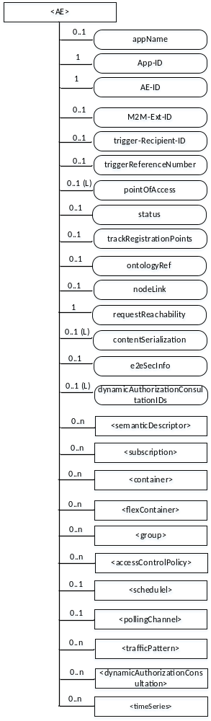
Figure 9.6.5-1: Structure of <AE> resource
The <AE> resource shall contain the child resources specified in table 9.6.5-1.
Table 9.6.5-1: Child resources of <AE> resource
Child Resources of <AE> | Child Resource Type | Multiplicity | Description | <AEAnnc> Child Resource Types
[variable] | <semanticDescriptor> | 0..n | See clause 9.6.30 | <semanticDescriptor>, <semanticDescriptorAnnc>
[variable] | <subscription> | 0..n | See clause 9.6.8 | <subscription>
[variable] | <container> | 0..n | See clause 9.6.6 | <container> <containerAnnc>
[variable] | <flexContainer> | 0..n | See clause 9.6.35 | <flexContainer>  <flexContainerAnnc>
[variable] | <group> | 0..n | See clause 9.6.13 | <group>  <groupAnnc>
[variable] | <accessControlPolicy> | 0..n | See clause 9.6.2 | <accessControlPolicy>  <accessControlPolicyAnnc>
[variable] | <schedule> | 0..1 | See clause 9.6.9 | <scheduleAnnc>
[variable] | <pollingChannel> | 0..1 | See clause 9.6.21  When the AE is request-unreachable, the AE should create this <pollingChannel> resource and perform long polling. The <pollingChannel> shall be utilized by the parent resource | None
trafficPattern | <trafficPattern> | 0..n | See clause 9.6.41 | <trafficPatternAnnc>
[variable] | <dynamicAuthorizationConsultation> | 0..n | See clause 9.6.40 | None
[variable] | <timeSeries> | 0..n | See clause 9.6.36 | <timeSeries>  <timeSeriesAnnc>

The <AE> resource shall contain the attributes specified in table 9.6.5-2.
Table 9.6.5-2: Attributes of <AE> resource
Attributes of  <AE> | Multiplicity | RW/  RO/  WO | Description | <AEAnnc> Attributes
resourceType | 1 | RO | See clause 9.6.1.3. | NA
resourceID | 1 | RO | See clause 9.6.1.3. Contains the AE-ID-Stem of the AE (see clause 7.2 on identifier formats and clause 10.2.2.2 for AE registration procedure). | NA
resourceName | 1 | WO | See clause 9.6.1.3. | NA
parentID | 1 | RO | See clause 9.6.1.3. | NA
expirationTime | 1 | RW | See clause 9.6.1.3. | MA
accessControlPolicyIDs | 0..1 (L) | RW | See clause 9.6.1.3. | MA
creationTime | 1 | RO | See clause 9.6.1.3. | NA
lastModifiedTime | 1 | RO | See clause 9.6.1.3. | NA
labels | 0..1 (L) | RW | See clause 9.6.1.3. | MA
announceTo | 0..1 (L) | RW | See clause 9.6.1.3. | NA
announcedAttribute | 0..1 (L) | RW | See clause 9.6.1.3. | NA
dynamicAuthorizationConsultationIDs | 0..1 (L) | RW | See clause 9.6.1.3. | OA
appName | 0..1 | RW | The name of the application, as declared by the application developer(e.g. "HeatingMonitoring").  Several sibling resources may share the appName. | OA
App-ID | 1 | WO | The identifier of the Application (see clause 7.1.3). | OA
AE-ID | 1 | RO | The identifier of the Application Entity (see clause 7.1.2). | OA
M2M-Ext-ID | 0..1 | RW | Supported when Registrar is IN-CSE.  See clause 7.1.8 where this attribute is described. This attribute is used only for the case of dynamic association of M2M-Ext-ID and AE-ID. | NA
trigger-Recipient-ID | 0..1 | RW | Supported when Registrar is IN-CSE. See clause 7.1.10 where this attribute is described. This attribute is used only for the case of dynamic association of M2M-Ext-ID and AE-ID. | NA
triggerReferenceNumber | 0..1 | RW | This is to identify device trigger procedure request. This attribute is used only for device trigger and assigned by the IN-CSE. | NA
pointOfAccess | 0..1 (L) | RW | The list of addresses for communicating with the registered Application Entity over Mca reference point via the transport services provided by Underlying Network (e.g. IP address, FQDN, URI). This attribute shall be accessible only by the AE and the Hosting CSE.  If this information is not provided and the <pollingChannel> resource does exist, the AE should use <pollingChannel> resource. Then the Hosting CSE can forward a request to the AE without using the PoA. | OA
status | 0..1 | RW | Denotes status of the AE registration. If ACTIVE, the <AE> resource and all its child resources may be discoverable. If INACTIVE, the <AE> resource and all its child resources shall not be discoverable.  Set to ACTIVE during a AE registration or re-registration. When an AE changes its registration point, the registration at the old registration point is set to INACTIVE . | OA
trackRegistrationPoints | 0..1 | RW | Denotes if the Application Entity requests that its Registration Points be tracked. If TRUE, AE requests to be tracked as it changes its Registration Points. If FALSE, the AE requests not to be tracked as it changes its Registration Points. | OA
ontologyRef | 0..1 | RW | A URI of the ontology used to represent the information that is managed and understood by the AE. | OA
requestReachability | 1 | RW | If the AE that created this <AE> resource can receive a request, this attribute is set to "TRUE" otherwise "FALSE" | OA
nodeLink | 0..1 | RW | The resource identifier of a <node> resource that stores the node specific information of the node on which the AE represented by this <AE> resource resides. | OA
contentSerialization | 0..1 (L) | RW | The list of supported serializations of the Content primitive parameter for receiving a request from its registrar CSE. (e.g. XML, JSON). The list shall be ordered so that the most preferred format comes first. | OA
e2eSecInfo | 0..1 | RW | See clause 9.6.1.3. | MA

---------------------------end of change 1 ----------------------------------------------------

---------------------------start of change 2 ----------------------------------------------------

9.6.26.3 Common Attributes for Announced Resources
Table 9.6.26.3-1 lists the common attributes for the announced resources.
Table 9.6.26.3-1: Commonly Used Attributes for Announced Resources
Attribute Name | Mandatory /Optional | Description
accessControlPolicyIDs | Conditionally Mandatory | The list of identifiers (either an ID or a URI) of an <accessControlPolicy> resource announced by the original resource See clause 9.6.1.3.2 for further information on this attribute.  If this attribute was not present in the original resource, the original resource shall include this attribute by providing the accessControlPolicyIDs from the original resource's parent resource or from the local policy according at the original resource.
stateTag | Conditionally Mandatory | An incremental counter of modification on the resource.  See clause 9.6.1.3.2 for information on this attribute.
labels | Conditionally Mandatory | Tokens used as keys for discovering resources as announced by the original resource. See clause 9.6.1.3 for further information on this attribute.  The attribute is conditionally mandatory, which means that the attribute shall exist in the announced resource if it is present in the original resource.
status | Optional | Only optional for announced <AE> resource. Denotes status of the announced AE registration. If ACTIVE, the announced <AE> resource and all its child resources may be discoverable. If INACTIVE, the announced <AE> registration and all its child resources shall not be discoverable.  The attribute is conditionally mandatory, which means that the attribute shall exist in the announced resource if it is present in the original resource.

---------------------------end of change 2 ----------------------------------------------------

---------------------------start of change 3 ---------------------------------------------------

9.6.xx1 Resource Type AEContactList
An <AEContactList> resource shall contain <AEContactListPerCSE> child resources, one for each CSE that has sent a NOTIFY request to the CSE about the creation, update, or deletion of a resource that references an Application Entity resource identifier. The <AEContactList> resource shall only be created as a child of <CSEBase> in the IN-CSE.

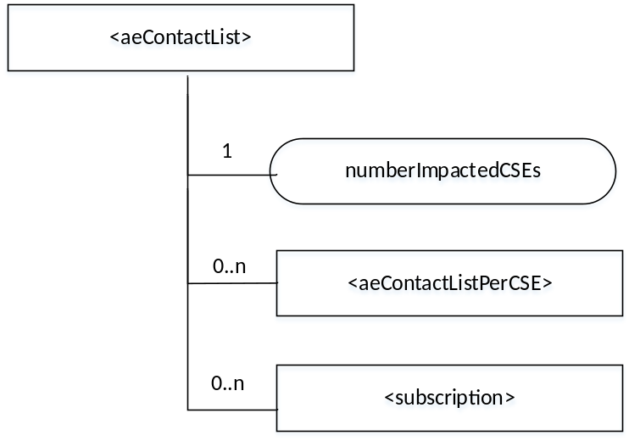
Figure 9.6.xx1-1: Structure of <AEContactList> resource
The <AEContactList> resource shall contain the child resources specified in table 9.6. xx1-2.
Table 9.6. xx1-2: Child resources of <AEContactList> resource
Child Resources of <AEContactList> | Child Resource Type | Multiplicity | Description
[variable] | <subscription> | 0..n | See clause 9.6.8
[variable] | <AEContactListPerCSE> | 0..n | See clause 9.6.xx2

The <AEContactList> resource shall contain the attributes specified in table 9.6.xx1-3.
Table 9.6.xx1-3: Attributes of <AEContactList> resource
Attributes of  < AEContactList > | Multiplicity | RW/  RO/  WO | Description
resourceType | 1 | RO | See clause 9.6.1.3.
resourceID | 1 | RO | See clause 9.6.1.3.
resourceName | 1 | RO | See clause 9.6.1.3.
parentID | 1 | RO | See clause 9.6.1.3.
expirationTime | 1 | RO | See clause 9.6.1.3.
accessControlPolicyIDs | 0..1 (L) | RO | See clause 9.6.1.3.
creationTime | 1 | RO | See clause 9.6.1.3.
lastModifiedTime | 1 | RO | See clause 9.6.1.3.
labels | 0..1 (L) | RO | See clause 9.6.1.3.
numberImpactedCSEs | 1 | RO | The number of Hosting CSEs that have reported that they have a reference to an Application Entity resource identifier

9.6.xx2 Resource Type AEContactListPerCSE
An <AEContactListPerCSE> resource shall represent information about a CSE that has resources that reference an Application Entity resource identifier (SP-relative-Resource-IDs of an AE). For example, these Application Entity resource identifiers may occur in announcement links, notification targets, group member IDs, or in the OriginatorID list of the accessControlOriginators parameter tied to an <accessControlPolicy> resource. The <AEContactListPerCSE> resource shall only be created in the IN-CSE.

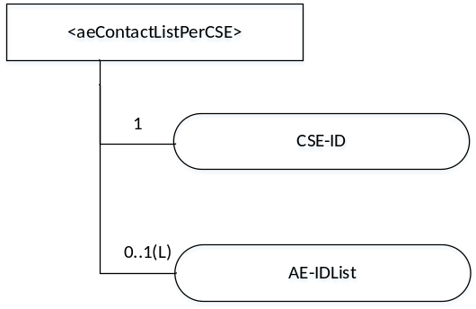
Figure 9.6.xx2-1: Structure of <AEContactListPerCSE> resource
The <AEContactListPerCSE> resource shall contain the attributes specified in table 9.6.xx2-1.
Table 9.6.xx2-1: Attributes of <AEContactListPerCSE> resource
Attributes of  <AContactListPerCSE> | Multiplicity | RW/  RO/  WO | Description
resourceType | 1 | RO | See clause 9.6.1.3.
resourceID | 1 | RO | See clause 9.6.1.3.
resourceName | 1 | RO | See clause 9.6.1.3.
parentID | 1 | RO | See clause 9.6.1.3.
expirationTime | 1 | RO | See clause 9.6.1.3.
accessControlPolicyIDs | 0..1 (L) | RO | See clause 9.6.1.3.
creationTime | 1 | RO | See clause 9.6.1.3.
lastModifiedTime | 1 | RO | See clause 9.6.1.3.
labels | 0..1 (L) | RO | See clause 9.6.1.3.
CSE-ID |  | RO | The identifier of the Hosting CSE which has a reference to an Application Entity resource identify (SP-relative-Resource-ID that points to an AE).  Hosting CSEs notify the IN-CSE when they have a reference to an <AE> resource through e.g. announcements, notification targets, group member IDs, <accessControlPolicy> resource OriginatorID lists.
AE-IDList | 0..1(L) | RO | List of Application Entity resource identifiers hosted on CSE with identifier CSE-ID

---------------------------end of change 3 ---------------------------------------------------

---------------------------start of change 4 ---------------------------------------------------

10.2.2.2 Create <AE>
This procedure shall be used for creating an <AE> resource. This operation is part of the registration procedure for AEs on the Registrar CSE (which is also the Hosting CSE), as described in clause 10.2.2.2.
Table 10.2.2.2-1: <AE> CREATE
<AE> CREATE
Associated Reference Point | Mca
Information in Request message | All parameters defined in table 8.1.2-3 apply with the specific details for:  From: Registree AE only  Content: The resource content shall provide the information as defined in clause 9.6.5
Processing at Originator before sending Request | According to clause 10.2.2.2
Processing at Receiver | According to clause 10.2.2.2
Information in Response message | All parameters defined in table 8.1.3-1
Processing at Originator after receiving Response | According to clause 10.2.2.2
Exceptions | According to clause 10.2.2.2

The procedure for AE registration follows the message flow description depicted in figure 10.2.2.2-1. It defines in which cases additional procedures need to be initiated by the Registrar CSE for creating or updating of <AEAnnc> resources hosted on the M2M SP's IN-CSE in case an AE-ID-Stem starting with an 'S' character shall be used, see table 7.2-1 for the definition of AE-ID-Stem.
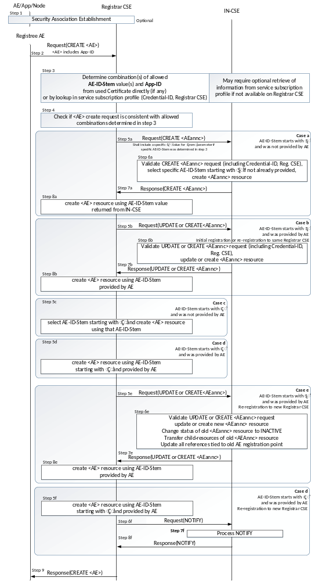
Figure 10.2.2.2-1: Procedure for Creating an <AE> Resource
Originator: The Originator shall be the Registree AE.
Receiver: The Receiver shall allow the creation of the <AE> resource according to the access control policy and information in the applicable m2m service subscription profile. To validate the m2m service subscription profile, the Receiver shall check the corresponding <serviceSubscribedNode> resource, by matching the CSE-ID in the m2m service subscription profile against the Receiver owned CSE-ID. Subsequently the Receiver shall check whether the Registree AE is included in the linked (i.e. ruleLinks attribute) <serviceSubscribedAppRules> resource(s).
Step 001: Optional: In case the Registree AE intends to use a Security Association to perform the registration, a Security Association Establishment procedure (see clause 11.2.2) shall get carried out first. In some cases (e.g. registration of AE internal to an MN or ASN), this may not be required depending on deployment choices of the M2M SP. Therefore, this step is optional. This optional Security Association can be established between the following entities:
- The Registree AE and the Registrar CSE - in which case the specific AE that is subsequently sending the request to get registered shall be authenticated.
- The Node on which the Registree AE is hosted and the Registrar CSE - in which case only the Node from which the registration request is received at the Registrar CSE shall be authenticated. In this case one or more AEs hosted on the authenticated node may communicate over either a single Security Association or over individual Security Associations.
NOTE: The Node authentication should be used only when the M2M Service Provider trusts the AE (on the Node) to provide the correct AE-ID and App-ID. The present document does not provide mechanisms by which the M2M Service Provider can obtain assurance about the trustworthiness of the AE when using Node authentication. For example, such a mechanism (by which the M2M Service Provider can obtain assurance about the trustworthiness of the AE) could be provided by executing the M2M Application on a secure environment.
The identifier of the security credentials used for establishing the Security Association in this step shall be termed 'Credential-ID' for the remainder of this procedure description. If no Security Association has been performed the Credential-ID shall be assumed to have the value 'None'.
Step 002: The Originator shall send the information defined in clause 10.1.2 for the registration CREATE procedure with the following specific information in the CREATE Request message:
From: AE-ID-Stem or Not Present:
- In case the Registree AE has already registered successfully before, then deregistered and intends to register again to the same Registrar CSEwith the same AE-ID-Stem value as before, the Registree AE shall include that AE-ID-Stem value into the From parameter.
- In case the Registree AE intends to initiate a fresh registration with a pre-provisioned AE-ID-Stem value, the Registree AE shall include that pre-provisioned AE-ID-Stem value into the From parameter.
- In case the Registree AE has not registered successfully before and intends to get an M2M-SP-assigned AE-ID-Stem starting with an 'S' character assigned to itself but it does not have any specific value to suggest, it shall set the From parameter to the character 'S'.
- In case the Registree AE has not registered successfully before and intends to get a Registrar CSE-assigned AE-ID-Stem starting with an 'C' character assigned to itself but it does not have any specific value to suggest, it shall set the From parameter to the character 'C'.
- In case the Registree AE intends to initiate a fresh registration and has no preference for the AE-ID-Stem value, the From parameter shall not be sent.
- In case the Registree AE has already registered successfully to a Registrar CSE, and now intends to register to a different Registrar CSE (i.e. Registree AE has changed its registration point), the Registree AE shall include its AE-ID-Stem value (from the prior registration) into the From parameter.
The CSE shall allow unknown AEs to attempt the ‘CREATE’ before they are granted this permission. See TS-0003[2] for further details about authentication for the AE.
Step 003: The Receiver shall determine whether the request to register the Registree AE meets any of the following conditions:
- In case the Security Association Establishment in Step 001 was performed using security credentials in form of a Certificate that included an App-ID and an AE-ID-Stem attribute, check if they match with the App-ID attribute in the Content parameter of the request and the AE-ID-Stem in the From parameter of the request.
- Check if the applicable service subscription profile lists a combination of (allowed AE-ID-Stem value and allowed App-ID value) for the Credential-ID and the Registrar CSE-ID (see clause 11.2.2) that match with the App-ID attribute in the Content parameter of the request and the AE-ID-Stem in the From parameter of the request. If the information needed to perform that checking is not available to the Registrar CSE locally, the Registrar CSE shall retrieve that information from the applicable service subscription profile(s) from the IN-CSE. If the From parameter was notset in the request and the allowed AE-ID-Stem includes a wild card ("*") in the applicable service subscription profile(s), the Registrar CSE shall assign the starting character ('S', 'C') in accordance with provisioned Service Provider policy. The applicable rules for this checking are contained in the <serviceSubscribedAppRule> resource(s) which are linked to by the ruleLinks attribute of the <m2mServiceSubscribedNode> resource(s) associated with the Registrar CSE. The <m2mServiceSubscribedNode> resource(s) associated with the Registrar CSE can be retrieved from the IN-CSE by applying the Filter Criteria parameter set to "CSE-ID={Registrar-CSE-ID}"where {Registrar-CSE-ID} needs to be substituted by the actual CSE-ID of the Registrar-CSE.
If none of the conditions are met, the registration is not allowed and the Receiver shall respond with an error.
Step 004: If the From parameter of the request provides a complete AE-ID-Stem value, i.e. case i, ii, or vi of Step 002 applied, the Registrar CSE shall check whether an <AE> resource with an Unstructured-CSE-relative-Resource-ID identical to the AE-ID-Stem value provided in the From parameter of the request does already exist on the Registrar CSE. If so, there is still an active registration using the same AE-ID-Stem on the Registrar CSE and the Registrar CSE shall respond with an error. If not, the Registrar CSE shall perform action (3) in Step 002 of clause 10.1.2.
If the From parameter of the request provides a complete AE-ID-Stem and starts with ‘S’, i.e. case i, ii or vi of Step 002 applied and ‘S’ is the first character of the provided AE-ID-Stem, and if the Registrar CSE determines that this is an initial registration or a re-registration to the same Registrar CSE, the procedure continues with case b) of the present step 004 below.
If the From parameter of the request provides a complete AE-ID-Stem and starts with ‘S’, i.e. case i, ii or vi of Step 002 applied and ‘S’ is the first character of the provided AE-ID-Stem, and if the Registrar CSE determines that this is a re-registration due to a change in registration point, and if the Registree AE requests not to be tracked as it changes its registration point (trackRegistrationPoints= TRUE), the procedure continues as an initial registration, with case b) of the present step 004 below.
If the From parameter of the request provides a complete AE-ID-Stem and starts with ‘S’, i.e. case i, ii or vi of Step 002 applied and ‘S’ is the first character of the provided AE-ID-Stem, and if the Registrar CSE determines that this is a re-registration due to a change in registration point, and if the Registree AE requests to be tracked as it changes its registration point (trackRegistrationPoints = FALSE), the procedure continues as a re-registration to a new Registrar CSE, with case e) of the present step 004 below.
If From parameter of the request provides a complete AE-ID-Stem and starts with ‘C’, i.e. case i, ii or vi of Step 002 applied and ‘C’ is the first character of the provided AE-ID-Stem, and if the Registrar CSE determines that this is an initial registration or a re-registration to the same Registrar CSE, the procedure continues with case d) of the present step 004 below.
If From parameter of the request provides a complete AE-ID-Stem and starts with ‘C’, i.e. case i, ii or vi of Step 002 applied and ‘C’ is the first character of the provided AE-ID-Stem, and if the Registrar CSE determines that this is a re-registration due to a change in registration point, and if the Registree AE requests not to be tracked as it changes its registration point (trackRegistrationPoints = TRUE), the procedure continues as an initial registration, with case d) of the present step 004 below.
If From parameter of the request provides a complete AE-ID-Stem and starts with ‘C’, i.e. case i or ii or vi of Step 002 applied and ‘C’ is the first character of the provided AE-ID-Stem, and if the Registrar CSE determines that this is a re-registration due to a change in registration point, and if the Registree AE requests to be tracked as it changes its registration point (trackRegistrationPoints = FALSE), the procedure continues as a re-registration to a new Registrar CSE, with case f) of the present step 004 below.

If the From parameter of the request is equal to the value ‘S’, i.e. case iii of Step 002 applied, the procedure continues with case a) of the present step 004 below.
If the From parameter of the request is equal to the value ‘C’, i.e. case iv of Step 002 applied, the procedure continues with case c) of the present step 004 below.
If the From parameter of the request is not sent, the Registrar CSE shall perform action (3) in Step 002 of clause 10.1.2 to assign the resourceID with starting character ('S', 'C') in accordance with provisioned Service Provider policy and shall set the corresponding value in AE-ID-Stem. If the assigned value in AE-ID-Stem attribute starts with ‘S’, the procedure continues with case b) else the procedure continues with case d)
Case a) AE-ID-Stem starts with 'S' and AE does not include an AE-ID-Stem (initial registration):
Condition: In Step 003 it was determined that the AE-ID-Stem value to be used for the Registree AE starts with an 'S' character but no specific AE-ID-Stem was provided with the CREATE request of the Registree AE. This case applies when the Registree AE is supposed to use an M2M-SP-assigned AE-ID and wants to perform the initial registration:
- Step 005a: The Receiver shall send a CREATE request for an <AEAnnc> resource to the IN-CSE in order to create an <AEAnnc> resource on the IN-CSE that is associated with the Registree AE. The following information shall be sent with that CREATE request:
- In case no specific AE-ID-Stem value to be used for the Registree AE was determined during Step 003, the value 'S' shall be used in what follows for the AE-ID-Stem. Otherwise use the value determined in step 003.
- The From parameter of the CREATE request for the <AEAnnc> resource shall be set to the SP-relative-CSE-ID or Absolute-CSE-ID followed by ‘/S’.
- The link attribute of the <AEAnnc> resource to be created shall be set to the SP-Relative-Resource-ID format of a - not yet existent - <AE> resource hosted on the Registrar CSE constructed with a Unstructured-CSE-relative-Resource-ID that is equal to the AE-ID-Stem value used for the Registree AE.
- The App-ID attribute of the <AEAnnc> resource to be created shall be present and set to the App-ID attribute value of the Registree AE.
- The concatenation of the string 'Credential-ID:' and the actual Credential-ID of the Security Association used by the Registree AE - if any - shall be placed into the labels attribute of the <AE Annc> resource. If no noSecurity Association was used by the Registree AE, a value of 'None' shall be used for Credential-ID.
- Step 006a: Upon reception of the CREATE <AEAnnc> request, the IN-CSE shall validate the request and verify whether the provided values of the App-ID attribute and the AE-ID-Stem in the From parameter is allowed for the combination of Credential-ID included in the labels attribute and the CSE-ID of the Registrar CSE included in the link attribute, according to the applicable service subscription profile. If that verification is successful and no specific AE-ID-Stem is provided, i.e. if the From parameter contains only the character 'S', the IN-CSE shall select an AE-ID-Stem in line with the applicable service subscription profile.
- Step 007a: When the validation and verification in Step 006a completed successfully, the IN-CSE shall create <AEAnnc> resource with an Unstructured-CSE-relative-Resource-ID equal to the value of the AE-ID-Stem, replace the AE-ID-Stem for the trailing ‘S’ character in the Unstructured-CSE-relative-Resource-ID present in the link attribute if the AE-ID-Stem was selected by the IN-CSE, and send a successful response to the Registrar CSE.
- Step 008a: Upon reception of a successful response from the IN-CSE, the Registrar CSE shall use the Unstructured-CSE-relative-Resource-ID that was used for the <AEAnnc> resource on the IN-CSE also as the assigned Unstructured-CSE-relative-Resource-ID for the <AE> resource to be created on the Registrar CSE and continue with action (4) of Step 002 of the non-registration related CREATE procedure in clause 10.1.2.
Case b) AE-ID-Stem starts with 'S' and AE includes an AE-ID-Stem (initial registration or re-registration to the same Registrar CSE):
Condition: In Step 003 it was determined that the AE-ID-Stem value to be used for the Registree AE starts with an 'S' character and a specific AE-ID-Stem was provided with the CREATE request of the Registree AE. This case applies when the Registree AE is supposed to use an M2M-SP-assigned AE-ID and wants to perform initial registration or re-registration using its already assigned AE-ID-Stem:
- Step 005b: The receiver shall determine if an <AEAnnc> resource already exists on the IN-CSE that is associated with the Registree AE. The Receiver shall send an UPDATE request for an <AEAnnc> resource to the IN-CSE in order to update the already existing <AEAnnc> resource on the IN-CSE that is associated with the Registree AE in case of re-registration or the Receiver shall send a CREATE request for an <AEAnnc> resource to the IN-CSE in order to create an <AEAnnc> resource on the IN-CSE that is associated with the Registree AE in case of initial registration. The following information shall be sent with that UPDATE or CREATE request:
- The To parameter shall contain the SP-relative-Resource-ID format of the Resource ID for the <AEAnnc> resource which shall be constructed from the CSE-ID of the IN-CSE and the AE-ID-Stem that the Registree AE provided.
- From parameter of the CREATE or UPDATE request for the <AEAnnc> resource shall be set to the SP-relative-CSE-ID or Absolute-CSE-ID followed by ‘/’ and the AE-ID-Stem value.
- The link attribute of the <AEAnnc> resource shall be set (in case of initial registration) or updated (in case of re-registration) to the SP-Relative-Resource-ID format of a - not yet existent - <AE> resource hosted on the Registrar CSE constructed with an Unstructured-CSE-relative-Resource-ID that is equal to the AE-ID-Stem value used for the Registree AE.
- The labels attribute of the <AEAnnc> resource shall be set (in case of initial registration) or updated (in case of re-registration) to the concatenation of the string 'Credential-ID:' and the Credential-ID of the Security Association used by the Registree AE, replacing the existing entry starting with 'Credential-ID:' if present. If no Security Association was used by the Registree AE, a value of 'None' shall be used for Credential-ID.
- Step 006b: Upon reception of the CREATE or UPDATE <AEAnnc> request, the IN-CSE shall validate the request and verify whether the values suggested to be set or to be updated for the Credential-ID included in the labels attribute - if any - and the CSE-ID of the Registrar CSE included in the From parameter still match with any of the allowed combinations of App-ID attribute and the AE-ID-Stem in the link attributeaccording to the applicable service subscription profile.
- Step 007b: When the validation and verification in Step 006b completed successfully, the IN-CSE shall create <AEAnnc> resource with an Unstructured-CSE-relative-Resource-ID equal to the value of the provided AE-ID-Stem or update the <AEAnnc> resource in line with the parameters provided in step 005b.
- Step 008b: Upon reception of a successful response from the IN-CSE, the Registrar CSE shall use the Unstructured-CSE-relative-Resource-ID equal to the AE-ID-Stem provided by the Registree AE for the <AE> resource to be created on the Registrar CSE and continue with action (4) of Step 002 of the non-registration related CREATE procedure in clause 10.1.2.
Case c) AE-ID-Stem starts with 'C' and AE does not include an AE-ID-Stem (initial registration):
Condition: In Step 003 it was determined that the AE-ID-Stem value to be used for the Registree AE starts with an 'C' character but no specific AE-ID-Stem was provided with the CREATE request of the Registree AE. This case applies when the Registree AE is not supposed to use an M2M-SP-assigned AE-ID and wants to perform the initial registration:
Step 005c: The Registrar CSE shall select an AE-ID-Stem starting with a 'C' character and use it for the Unstructured-CSE-relative-Resource-ID for the <AE> resource to be created on the Registrar CSE and continue with action (4) of Step 002 of the non-registration related CREATE procedure in clause 10.1.2.
Case d) AE-ID-Stem starts with 'C' and AE includes an AE-ID-Stem (initial registration or re-registration registration to the same Registrar CSE):
Condition: In Step 003 it was determined that the AE-ID-Stem value to be used for the Registree AE starts with an 'C' character and a specific AE-ID-Stem was provided with the CREATE request of the Registree AE. This case applies when the Registree AE is not supposed to use an M2M-SP-assigned AE-ID and wants to perform initial registration or re-registration using its already assigned AE-ID-Stem:
- Step 005d: The Registrar CSE shall use the Unstructured-CSE-relative-Resource-ID equal to the AE-ID-Stem in the From parameter for the <AE> resource to be created on the Registrar CSE and continue with action (4) of Step 002 of the non-registration related CREATE procedure in clause 10.1.2.
Case e) AE-ID-Stem starts with 'S' and AE includes an AE-ID-Stem (re-registration to a new Registrar CSE)
Condition: In Step 003 it was determined that the AE-ID-Stem value to be used for the Registree AE starts with an 'S' character and a specific AE-ID-Stem was provided with the CREATE request of the Registree AE. This case applies when the Registree AE is supposed to use an M2M-SP-assigned AE-ID and wants to perform a re-registration to a new Registrar CSE, using its already assigned AE-ID-Stem from a registration to a prior Registrar CSE:
- Step 005e: The receiver shall determine if an <AEAnnc> resource already exists on the IN-CSE that is associated with the Registree AE. If so, the Receiver shall send an UPDATE request for an <AEAnnc> resource to the IN-CSE in order to update the already existing <AEAnnc> resource on the IN-CSE that is associated with the Registree AE in case of re-registration. Otherwise, if there is no already existing <AEAnnc> resource associated with the Registree AE, the Receiver shall send a CREATE request for an <AEAnnc> resource to the IN-CSE in order to create an <AEAnnc> resource on the IN-CSE that is associated with the Registree AE. The following information shall be sent with that UPDATE or CREATE request:
- The To parameter shall contain the SP-relative-Resource-ID format of the Resource ID for the <AEAnnc> resource which shall be constructed from the CSE-ID of the IN-CSE and the AE-ID-Stem that the Registree AE provided.
- From parameter of the CREATE or UPDATE request for the <AEAnnc> resource shall be set to the SP-relative-CSE-ID or Absolute-CSE-ID followed by ‘/’ and the AE-ID-Stem value.
- The link attribute of the <AEAnnc> resource shall be set or updated, to the SP-Relative-Resource-ID format of a - not yet existent - <AE> resource hosted on the Registrar CSE constructed with an Unstructured-CSE-relative-Resource-ID that is equal to the AE-ID-Stem value used for the Registree AE.
- The labels attribute of the <AEAnnc> resource shall be set or updated to the concatenation of the string 'Credential-ID:' and the Credential-ID of the Security Association used by the Registree AE, replacing the existing entry starting with 'Credential-ID:' if present. If no Security Association was used by the Registree AE, a value of 'None' shall be used for Credential-ID.
- Step 006e: Upon reception of the CREATE or UPDATE <AEAnnc> request, the IN-CSE shall validate the request and verify whether the values suggested to be set or to be updated for the Credential-ID included in the labels attribute - if any - and the CSE-ID of the Registrar CSE included in the From parameter still match with any of the allowed combinations of App-ID attribute and the AE-ID-Stem in the link attribute according to the applicable service subscription profile.
- Step 007e: When the validation and verification in Step 006e completed successfully, the IN-CSE shall create <AEAnnc> resource with an Unstructured-CSE-relative-Resource-ID equal to the value of the provided AE-ID-Stem or update the <AEAnnc> resource in line with the parameters provided in step 005e. The IN-CSE shall change the status of the old <AEAnnc> resource (tied to the old registration point) to INACTIVE, and shall transfer all child-resources under the old <AEAnnc> resource to the newly created or updated <AEAnnc> resource. The IN-CSE shall update all references to the SP-Relative-Resource-ID references (e.g. in Announce links, Notification targets, group Member ID, <accessControlPolicy> resource OriginatorID lists) tied to the prior AE registration point, so that these refer to the new AE registration point. The IN-CSE shall manage the change in AE registration point, as described in clause 10.2.xx1.1.
- Step 008e: Upon reception of a successful response from the IN-CSE, the Registrar CSE shall use the Unstructured-CSE-relative-Resource-ID equal to the AE-ID-Stem provided by the Registree AE for the <AE> resource to be created on the Registrar CSE and continue with action (4) of Step 002 of the non-registration related CREATE procedure in clause 10.1.2.
Case f) AE-ID-Stem starts with 'C' and AE includes an AE-ID-Stem (re-registration to a new Registrar CSE):
Condition: In Step 003 it was determined that the AE-ID-Stem value to be used for the Registree AE starts with an 'C' character and a specific AE-ID-Stem was provided with the CREATE request of the Registree AE. This case applies when the Registree AE is not supposed to use an M2M-SP-assigned AE-ID and wants to perform a re-registration to a new Registrar CSE and it wants to have its registration points tracked:
- Step 005f: The Registrar CSE shall use the Unstructured-CSE-relative-Resource-ID equal to the AE-ID-Stem in the From parameter for the <AE> resource to be created on the Registrar CSE,
- Step 006f: The Registrar CSE shall send a NOTIFY request to the IN-CSE. The Content parameter shall contain the SP-relative-Resource-ID at the prior registration point and the SP-relative-Resource-ID at the new registration point.
- Step 007f: Upon reception of the NOTIFY request, the IN-CSE shall manage the change in AE registration point, as described in clause 10.2.xx1.1.
- Step 008f: Upon reception of a successful response from the IN-CSE, the receiver shall then continue with action (4) of Step 002 of the non-registration related CREATE procedure in clause 10.1.2.

---------------------------end of change 4 -----------------------------------------------------

---------------------------start of change 5 ----------------------------------------------------

10.2.xx1 Procedure for Managing Change in AE Registration Point
10.2.xx1.1 Procedure at IN-CSE
The IN-CSE may determine that an AE has changed registration point either by:
- Observing the creation on an <AEAnnc> resource with an AE-ID-Stem that it had previously assigned for a different Registrar CSE (Case e of Section 10.2.2.2).
- Receiving a NOTIFY request from a Registrar CSE whose content includes the SP-relative-Resource-ID before and after the change in registration point (Case f of Section 10.2.2.2).
In both cases, the IN-CSE shall send a NOTIFY request to the CSEs, so that these may update the references to the <AE> resources for the AE that has changed its registration point. If the IN-CSE maintains an <AEContactList> resource, the IN-CSE shall determine which CSEs are effected, and shall send the NOTIFY request only to these. If the IN-CSE does not maintain an <AEContactList> resource, the IN-CSE shall send the NOTIFY request to all CSEs. The Content parameter of the NOTIFY request shall contain the SP-relative-Resource-ID at the prior registration point and at the new registration point.
10.2.xx1.2 Procedure at any CSE
Upon receiving a NOTIFY request regarding a change in AE registration point,
- if the receiving CSE hosts references to the SP-Relative-Resource-ID (e.g. in Announce links, Notification targets, group Member IDs, <accessControlPolicy> resource OriginatorID lists) tied to the prior AE registration point, the receiving CSE shall update these to refer to the new AE registration point.
- if the receiving CSE hosts the registration of the prior AE registration point, the receiving CSE shall update the status of this registration to “INACTIVE”.

---------------------------end of change 5 ------------------------------------------------------

---------------------------start of change 6 -----------------------------------------------------

10.1.6 NOTIFY (N)
The NOTIFY operation shall be used for notifying information. All the specific notification procedures defined in this present document are listed in clause 10.1.6 (Notification procedures).
Originator: The Originator requests to notify an entity by using NOTIFY method. See clause 8.1.2 for the information to be included in a Request message.
Receiver: The Receiver responds to the Originator with the operation results as specified in clause 8.1.3.
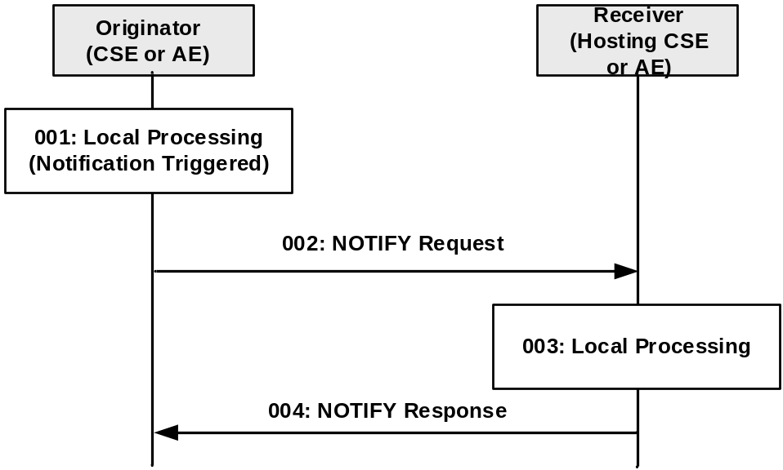
Figure 10.1.6-1: Procedure for NOTIFYing Information
Step 001: A notification to be sent to the Receiver is triggered in the Originator.
Step 002: The Originator shall send mandatory parameters and may send optional parameters in Request message for NOTIFY operation as specified in clause 8.1.2.
Step 003: Local Processing.
Step 004: The Receiver shall respond with mandatory parameters and may send optional parameters in Response message for NOTIFY operation as specified in clause 8.1.3.
General Exceptions:
- See oneM2M TS-0003 [Error: Reference source not found].
In the present specification, notification procedures are defined in the following procedures:
- <subscription> resource handling (clause 10.2.10)
  - to notify Receiver(s) of modifications of a resource for an associated <subscription> resource
  - to notify aggregated notifications from <subscription> member resources of <group> resource
  - to request Receiver(s) to perform resource subscription verification
  - to notify deletion of the <subscription> resource
  - to seek authorization from the subscription creator during a notification target deletion
- Asynchronous non-blocking request handling (clause 8.2.2.3)
  - to send the result of the request
- <pollingChannelURI> resource handling (clause 10.2.5.19)
  - to send the response corresponding to a request delivered via service layer long polling
- IPE on-demand discovery handling (clause 10.2.6)
  - to notify Receiver(s)(i.e., IPE) for on-demand discovery request.
- End-to-end security handling (clause 11.4)
  - to send the request/response that cannot be readable by Transit CSEs
- Dynamic authorization consultation handling (clause 11.5)
  - to seek authorization to access a resource from Dynamic Authorization Server
- Change in AE Registration Point (clause 10.2.xx1)
- to notify Receivers that an AE has changed registration point
- Change in a resource with reference to an Application Entity Resource ID (clause 10.1.2 (CREATE), 10.1.4 (UPDATE), 10.1.5 (DELETE), 9.6.1.3.1 (expiration timer expiry)
- to notify IN-CSE that the Originator has a new/updated reference to an Application Entity Resource identifier

----------------------end of change 6 ----------------------------------------------------------

-----------------------start of change 7 ------------------------------------------------------

10.1.2 CREATE (C)
Originator requests to create a resource by using the CREATE method. See clause 8.1.2 for the parameters to be included in the Request message.
Hosting CSE If the request is allowed by the given privileges, the Receiver shall create the resource.
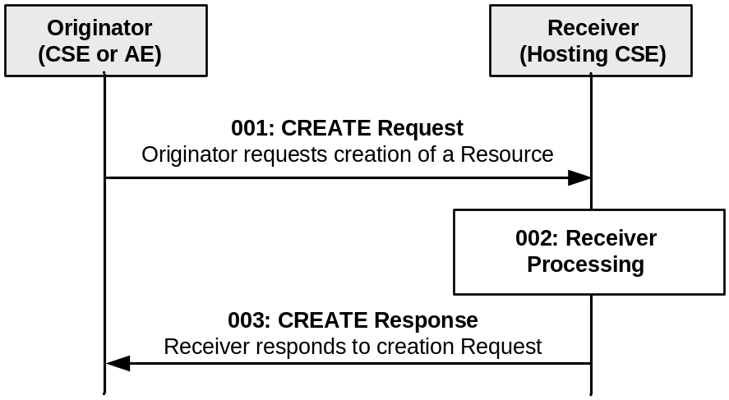
Figure 10.1.2-1: Procedure for CREATEing a Resource
Step 001: The Originator shall send mandatory parameters and may send optional parameters in Request message for CREATE operation as specified in clause 8.1.2.
Step 002: The Receiver shall:
- Check if the Originator has the appropriate privileges for performing the request. Privileges of the targeted resource are linked by the accessControlPolicyIDs attribute. Different handlings for a target resource which does not have the accessControlPolicyIDs attribute by the resource type definition(e.g. schedule resource type) or a target resource which has the definition but the attribute has no value and so on are defined in the Table 9.6.1.3.2-1 (common attributes description).
- Verify that the name for the created resource as suggested by the resourceName attribute in Content parameter, if provided by the Originator in the CREATE Request message, does not already exist among child resources of the target resource. If no child within the targeted resource exists with the same resourceName as suggested by the Originator, use that name for the resource to be created. If a child uses the resourceName already, the Receiver shall reject the request and return an error to the Originator. If the name was not suggested by the Originator, assign a name generated by the Receiver to the resource to be created.
NOTE: The name of a resource in general is not the same as its Resource ID. While a name of a resource only needs to be unique among the children of the same parent resource, the Resource ID needs to be unique in context of the Hosting CSE. When the name of the resource to be created is assigned by the Receiver, it may choose to use a name that is identical to the Unstructured-CSE-relative-Resource ID.
- Assign a Resource-ID (see resourceID attribute in common attribute table 9.6.1.3.2-1) to the resource to be created.
- Assign values for mandatory RO mode attributes of the resource and override values provided for other mandatory attributes, where needed, and where allowed by the resource type definition and if not provided by the Originator itself.
- the Receiver shall assign a value to the following common attributes specified in clause 9.6.1.3:
a) parentID;
b) creationTime;
c) expirationTime: if not provided by the Originator, the Receiver shall assign the maximum value possible (within the restriction of the Receiver policies). If the value provided by the Originator cannot be supported, due to either policy or subscription restrictions, the Receiver will assign a new value;
d) lastModifiedTime: which is equals to the creationTime;
e) Any other RO (Read Only) attributes within the restriction of the Receiver policies.
- The Receiver shall check whether a creator attribute is included in the Content parameter of the request. If included, the creator attribute shall not have a value in the Content parameter of the request. If the creator attribute is included in the request and the creator attribute is supported for the type of resource being created, then the Receiver shall to include the creator attribute in the resource to be created. The Receiver shall assign a value equal to the value carried in the From request parameter. In the event that the originator provides a value for the creator attribute within the request, this request shall be deemed invalid.
On the other hand if the creator attribute is not included in the Content parameter of the request, then the Receiver shall not include the creator attribute in the resource to be created.
- On successful validation of the Create Request, the Receiver shall create the requested resource.
- The Receiver shall check if the created child resource leads to changes in its parent resource's attribute(s), if so the parent resource's attribute(s) shall be updated.
- The Receiver shall check if the created child resource references an Application Entity Resource ID, if so the Hosting CSE shall send a NOTIFY request to the IN-CSE, requesting to add the entry to the <AEContactList> resource.
Step 003: The Receiver shall respond with mandatory parameters and may send optional parameters in Response message for CREATE operation as specified in clause 8.1.3.
General Exceptions:
- The Originator does not have the privileges to create a resource on the Receiver. The Receiver responds with an error.
- The resource with the specified name (if provided) already exists at the Receiver. The Receiver responds with an error.
- The provided information in Content is not accepted by the Receiver (e.g. missing mandatory parameter). The Receiver responds with an error.

---------------------------end of change 7 -----------------------------------------------------

---------------------------start of change 8 ----------------------------------------------------

10.1.4 UPDATE (U)
The UPDATE operation shall be used for updating the information stored for any of the attributes at a target resource. Especially important is the expirationTime, since a failure in refreshing this attribute may result in the deletion of the resource. The Originator CSE or AE can request to update, create or delete specific attribute(s) at the target resource by including the name of such attribute(s) and its values in the Content parameter of the request message.
Originator requests update any of the attributes at the target resource by using UPDATE Request message. The Originator shall send new (proposed) values for the attribute(s) that need to be updated. The UPDATE operation allows to modify or create previously non-existing attributes of the resource type (defined in clause 9.6) that are indicated as "RW" (Read Write) for the specific resource type definition.
The Originator requests to delete attributes at the target resource by using UPDATE Request message. The Originator shall send the name of the attributes to be deleted (defined in clause 9.6) for the specific resource type with their value set to NULL, in the Request message.
See clause 8.1.2 for the information to be included in the Request message.
Receiver The Receiver verifies the existence of the addressed resource, the validity of the attributes provided and the privileges to modify them, the Receiver shall update the attributes provided and shall return a Response message to the Originator with the operation results as specified in clause 8.1.3.
If the attributes provided do not exist, after verifying the existence of the addressed resource, the Receiver validates the attributes provided and the privileges to create them. On successful validation, the Receiver shall create the attributes provided with their associated values and shall return a Response message to the Originator with the operation results as specified in clause 8.1.3.
If the attributes provided have their value set to NULL, after verifying the existence of the addressed resource, the Receiver validates the attributes provided and the privileges to delete them. On successful validation, the Receiver shall delete such attributes and shall return a Response message to the Originator with the operation results as specified in clause 8.1.3.
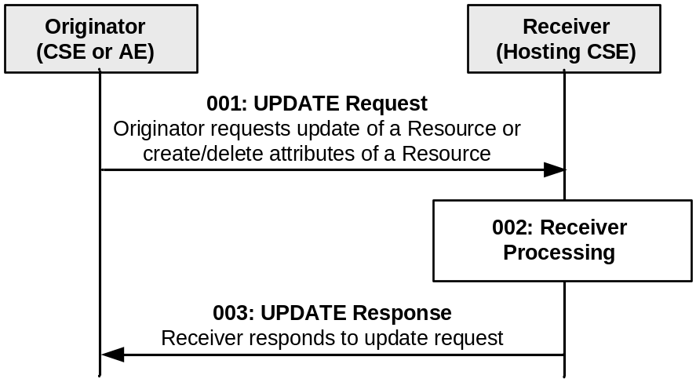
Figure 10.1.4-1: Procedure for UPDATing a Resource
Step 001: The Originator shall send mandatory parameters and may send optional parameters in Request message for UPDATE operation as specified in clause 8.1.2.
Step 002: The Receiver shall verify the existence (including Filter Criteria checking, if it is given) of the requested resource and if the Originator has the appropriate privilege to update the resource. This privilege checking follows the rules defined in the Table 9.6.1.3.2-1 (common attributes description). On successful validation, the Receiver shall update the resource as requested. If the attributes provided do not exist, the Receiver shall validate if the Originator has appropriate privileges to create the attributes at the target resource. On successful validation, the Receiver shall create the attributes with their associated values at the resource as requested. If the attributes provided have their value set to NULL, the Receiver shall validate if the Originator has appropriate privileges to delete the attributes at the target resource. On successful validation, the Receiver shall delete such attributes. The Receiver shall check if the updated target resource is a child of a parent resource having a stateTag attribute and increment the stateTag if present. The Receiver shall check if the update causes a change to a reference to an Application Entity Resource ID. If so the Hosting CSE shall send a NOTIFY request to the IN-CSE, requesting to update the entry to the <AEContactList> resource.
Step 003: The Receiver shall respond with mandatory parameters and may send optional parameters in Response message for UPDATE operation as specified in clause 8.1.3.
General Exceptions:
- The targeted resource in To parameter does not exist. The Receiver responds with an error.
- The Originator does not have the privilege to modify the resource, create attributes or delete attributes on the Receiver. The Receiver responds with error.
- The provided information in the Content is not accepted by the Receiver. The Receiver responds with error.

--------------------end of change 8 ------------------------------------------------------------

--------------------start of change 9 --------------------------------------------------------

10.1.5 DELETE (D)
The DELETE operation shall be used by an Originator CSE or AE to delete a resource at a Receiver CSE. For such operation, the DELETE procedure shall consist of the deletion of all related information of the target resource.
Originator requests deletion of a resource by using a DELETE Request message. See clause 8.1.2 for the information to be included in the Request message.
Receiver The Receiver verifies the existence of the requested resource, and the privileges for deleting the resource.
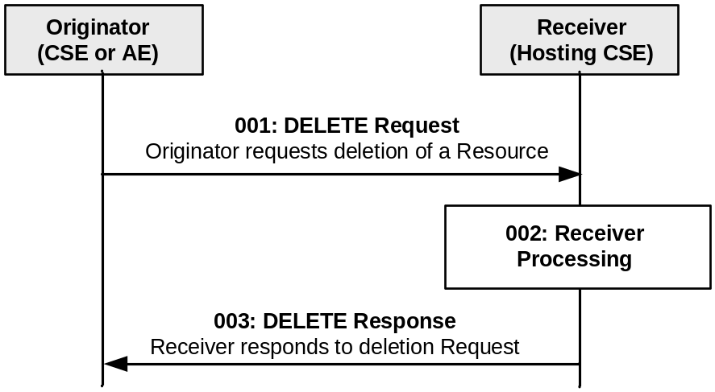
Figure 10.1.5-1: Procedure for DELETING a Resource
Step 001: The Originator shall mandatory parameters and may send optional parameters in Request message for DELETE operation as specified in clause 8.1.2.
Step 002: The Receiver shall verify the existence (including Filter Criteria checking, if it is given) of the requested resource and if the Originator has the appropriate privilege to delete the resource. This privilege checking follows the rules defined in the Table 9.6.1.3.2-1 (common attributes description). On successful validation, the Receiver shall check for child resources and delete all child resources and the associated references in parent resources and it shall remove the resource itself. The Receiver shall check if the deleted child resource leads to changes in its parent resource's attribute(s), if so the parent resource's attribute(s) shall be updated. If the deleted resource had a reference to an Application Entity Resource ID, the Hosting CSE shall send a NOTIFY request to the IN-CSE, requesting to delete the entry from the <AEContactList> resource.
Step 003: The Receiver shall respond with mandatory parameters and may send optional parameters in Response message for DELETE operation as specified in clause 8.1.3.
General Exceptions:
- The targeted resource in To information does not exist. The Receiver responds with an error.
- The Originator does not have the privileges to delete the resource on the Receiver. The Receiver responds with an error.

--------------------end of change 9 -----------------------------------------------------------

--------------------start of change 10 ----------------------------------------------------------

9.6.1.3.1 Universal attributes
The following attributes are universal to all resource types which are normal, not virtual or announced. Universal attributes for announced resource types are independently defined in claused 9.6.26.2..
Table 9.6.1.3.1-1: Universal Attributes
Attribute Name | Description
resourceType | Resource Type. This Read Only (assigned at creation time. and then cannot be changed) attribute identifies the type of the resource as specified in clause 9.6. Each resource shall have a resourceType attribute.
resourceID | This attribute is an identifier for the resource that is used for 'non-hierarchical addressing method', i.e. this attribute shall contain the 'Unstructured-CSE-relative-Resource-ID' format of a resource ID as defined in table 7.2-1.  This attribute shall be provided by the Hosting CSE when it accepts a resource creation procedure. The Hosting CSE shall assign a resourceID which is unique in that CSE.
resourceName | This attribute is the name for the resource that is used for 'hierarchical addressing method' to represent the parent-child relationships of resources. See clause 7.2 for more details.  This attribute may be provided by the resource creator. The Hosting CSE shall use a provided resourceName as long as it does not already exist among child resources of the targeted parent resource. If the resourceName already exists, the Hosting CSE shall reject the request and return an error to the Originator. The Hosting CSE shall assign a resourceName if one is not provided by the resource creator.
parentID | This attribute is the resourceID of the parent of this resource. The value of this attribute shall be NULL for the <CSEBase> resource type.
creationTime | Time/date of creation of the resource.  This attribute is mandatory for all resources and the value is assigned by the system at the time when the resource is locally created. Such an attribute cannot be changed.
lastModifiedTime | Last modification time/date of the resource.  The lastModifiedTime value is set by the Hosting CSE when the resource is created,and the lastModifiedTime value is updated when the resource is updated.
expirationTime | Time/date after which the resource will be deleted by the Hosting CSE. This attribute can be provided by the Originator, and in such a case it will be regarded as a hint to the Hosting CSE on the lifetime of the resource. The Hosting CSE can however decide on the real expirationTime. If the Hosting CSE decides to change the expirationTime attribute value, this is communicated back to the Originator.  The lifetime of the resource can be extended by providing a new value for this attribute in an UPDATE operation. Or by deleting the attribute value, e.g. by updating the attribute with NULL when doing a full UPDATE, in which case the Hosting CSE can decide on a new value.  This attribute is mandatory when specified. If the Originator does not provide a value in the CREATE operation the system shall assign an appropriate value depending on its local policies and/or M2M service subscription agreements.  A resource is known as 'obsolete' when the resource contains the attribute "expirationTime" and the lifetime of this resource has reached the value of this attribute. If the ‘obselete’ resource had a reference to an Application Entity Resource ID, the Hosting CSE shall send a NOTIFY request to the IN-CSE, requesting to delete the entry from the <AEContactList> resource.

------------------end of change 10 ----------------------------------------------------------

------------------start of change 11 ----------------------------------------------------------

10.2.6.1 Discovery without Result Content parameter
Editor's Note: this is normal discovery procedure that returns a list of resource addresses
The resource discovery procedures allow discovering of resources residing on a CSE. The use of the Filter Criteria parameter allows limiting the scope of the results.
Resource discovery shall be accomplished using the RETRIEVE method by an Originator which shall also include the root of where the discovery begins: e.g. <CSEBase>. The unfiltered result of the resource discovery procedure includes all the child resources under the root of where the discovery begins, which the Originator has a Discover access right on. The unfiltered results do not include any resources whose status is marked as “INACTIVE”, as well as any child resources of these “INACTIVE” resources. For the allowed Result Content parameter options for Discovery related RETRIEVE see section 8.1.2.
Filter criteria conditions may be provided as parameters to the RETRIEVE method. The filter criteria conditions describe the rules for resource discovery, e.g. resource types, creation time and matching string. The filter criteria can also contain the parameters for specifying the maximum number of discovered resources included in the response, the maximum limit on the number of levels in the resource tree (starting from the target resource) that the Hosting CSE shall perform the discovery request upon and an offset for specifying the number of discovered resources the Hosting CSE shall skip over and not include within the response. Table 8.1.2-2 describes the Filter Criteria parameter.
A match shall happen when a resource matches the configured filter criteria conditions and the Originator has a Discover access right on the resource. A successful response contains a list for the matched resources addressable in any of the forms expressed in clause 9.3.1 if matches are found. If no matches are found, a successful response returns no matched resources. If Discovery Result Type parameter is specified in a discovery request, the Hosting CSE shall choose the addressing form specified by the Discovery Result Type parameter.
The discovery results may be modified by the Hosting CSE to restrict the scope of discoverable resources according to the Originator's access control policy or M2M service subscription.
The Hosting CSE may also implement a configured upper limit on the size of the answer. In such a case when the Originator and the Hosting CSE have different upper limits, the smaller of the two shall apply.
This procedure shall be used for the discovery of resources under <CSEBase> that match the provided Filter Criteria parameter. The discovery result shall be returned to the Originator using a successful Response message.
Table 10.2.6.1-1: Discovery procedure via Retrieve Operation
<resource> RETRIEVE
Associated Reference Point | Mca, Mcc and Mcc'.
Information in Request message | All parameters defined in table 8.1.2-3 apply with the specific details for:  For the allowed Result Content parameter options for Discovery related RETRIEVE see clause 8.1.2.  To: Address of the root of where the discovery begins.  Filter Criteria: Filter criteria for searching and expected returned result. The filterUsage parameter shall be set in this case.  Discovery Result Type: optional, format of discovery results returned (see clause 8.1.2 for options applicable to Discovery, and how results shall be displayed).
Processing at Originator before sending Request | According to clause 10.1.3 with the following:  - Setup the RETRIEVE operation in the Request.  - Include the conditions in the filter criterion to limit the scope of the discovery results.  - Specify the desired format of returned discovery results.
Processing at Receiver | According to clause 10.1.3 with the following specific processing:  - Checks the validity of the Request (e.g. format of Filter Criteria).  - Checks if the request is in accordance with the M2M service subscription.  - May change the filter criteria according to local policies.  - Searches matched resources from the addressed resource hierarchy.Any resources whose status is marked as “INACTIVE” are not searched, as well as any child resources of these “INACTIVE” resources.  - Limits the discovery result according to DISCOVER privileges of the discovered resources.  - Limits the discovery result according to the upper limit on the size of the answer.  The Hosting CSE shall read the values of all attributes belonging to the addressed resource structure and the references of all sub-resources and it shall build a representation of these. The Hosting CSE shall use the appropriate addressing (see clause 9.3.1) form for each element included in the list in accordance with the incoming request. If Filter Criteria is provided in the request, the Hosting CSE uses it identifying the resources whose attributes match the Filter Criteria. The Hosting CSE shall respond to the Originator with the appropriate list of discovered resources in the Hosting CSE.  If the Filter Criteria includes filterUsage element set to "IPEOnDemandDiscovery", the target is the <AE> resource and the Hosting CSE has no match from the discovery of existing resources, then the Hosting CSE shall send a NOTIFY request containing the Filter Criteria to the AE(i.e. pointOfAccess of the <AE> resource) and the Originator ID of this discovery request. When the CSE gets the successful NOTIFY response with the resource address(es) which are created under the <AE> resource, then the CSE shall check the DISCOVER privilege and return the address(es) to the Originator. When the CSE gets the unsuccessful NOTIFY response, then the CSE shall send the Response Status Code in the NOTIFY response to the Originator.  The Hosting CSE may modify the Filter Criteria including upper limit provided by the Originator or the discovery results based on the local policies.  If the size of the result list is bigger than the upper limit or the scope of discoverable resources, according to the Originator's access control policy or service subscription has been modified by the Hosting CSE, the full list is not returned. Instead, an incomplete list is returned and an indication is added in the response for warning the requestor.
Information in Response message | All parameters defined in table 8.1.3-1 apply with the specific details for:  - Contains the address list of discovered resources expressed in any of the methods depicted in clause 9.3.1. The address list may be empty if no result matching the filter criterion is discovered.  - Contains an incomplete list warning if the full list is not returned.
Processing at Originator after receiving Response | According to clause 10.1.3.
Exceptions | According to clause 10.1.3, with the following:  - The requesting M2M AE or CSE is not registered.  - The request contains invalid parameters.  - The on-demand discovery was rejected by the requested M2M Application.

------------------end of change 11 ----------------------------------------------------------

------------------------- start of change 12 ----------------------------------------------------

9.6.1 Overview

9.6.1.1 Resource Type Summary
Table 9.6.1.1-1 introduces the normal and virtual resource types and their related child or parent resource types. Details of each resource type follow in the remainder of this clause.
Table 9.6.1.1-1 lists each specified ordinary – i.e. not announced – resource type. An addition of suffix "Annc" to the respective resource type identifier indicates the associated announced resource type. Resource types that can occur as child resources of announced resources are summarized in Table 9.6.26.1-1 "Announced Resource Types".
Among the resource types listed in Table 9.6.1.1-1, the following are termed "Content Sharing Resources" in oneM2M Specifications for the purpose of referring to any of those resource types:
- container;
- contentInstance;
- flexContainer;
- timeSeries;
- timeSeriesInstance.

Table 9.6.1.1-1: Resource Types
Resource Type | Short Description | Child Resource Types | Parent Resource Types | Clause
accessControlPolicy | Stores a representation of privileges. It is associated with resources that shall be accessible to entities external to the Hosting CSE. It controls "who" is allowed to do "what" and the context in which it can be used for accessing resources | subscription | AE, AEAnnc, remoteCSE, remoteCSEAnnc, CSEBase | 9.6.2
AE | Stores information about the AE. It is created as a result of successful registration of an AE with the Registrar CSE | subscription, container,  flexContainer,  group, accessControlPolicy,  schedule, pollingChannelsemanticDescriptor,  timeSeries | CSEBase | 9.6.5
container | Shares data instances among entities. Used as a mediator that buffers data exchanged between AEs and/or CSEs. The exchange of data between AEs (e.g. an AE on a Node in a field domain and the peer-AE on the infrastructure domain) is abstracted from the need to set up direct connections and allows for scenarios where both entities in the exchange do not have the same reachability schedule | container,  flexContainer, contentInstance, subscription, latest, oldest，semanticDescriptor | AE, AEAnnc, container, containerAnnc, remoteCSE, remoteCSEAnnc,  CSEBase,  flexContainer, flexContainerAnnc | 9.6.6
contentInstance | Represents a data instance in the <container> resource | semanticDescriptor | Container, containerAnnc | 9.6.7
flexContainer | A template which allows to define specialized (customizable) versions of containers with a flexible and lightweight structure | container,  flexContainer, subscription, semanticDescriptor | AE, AEAnnc, container, containerAnnc,  flexContainer, flexContainerAnnc, remoteCSE, remoteCSEAnnc,  CSEBase | 9.6.35
CSEBase | The structural root for all the resources that are residing on a CSE. Stores information about the CSE itself | remoteCSE, remoteCSEAnnc, node, AE, container, group, accessControlPolicy, subscription, mgmtCmd, locationPolicy, statsConfig, statsCollect, request, delivery,  schedule,  notificationTargetPolicy,  flexContainer,  timeSeries, AEContactList | None specified | 9.6.3
delivery | Forwards requests from CSE to CSE | subscription | CSEBase | 9.6.11
eventConfig | Defines events that trigger statistics collection | subscription | statsConfig | 9.6.24
execInstance | Contains all execution instances of the same Management Command | subscription | mgmtCmd | 9.6.17
fanOutPoint (V) | Virtual resource containing target for group request  It is used for addressing bulk operations to all the resources that belong to a group | None specified | group | 9.6.14
group | Stores information about resources of the same type that need to be addressed as a Group. Operations addressed to a Group resource shall be executed in a bulk mode for all members belonging to the Group | fanOutPoint,  subscription,  semanticFanOutPoint, semanticDescriptor | AE, AEAnnc, remoteCSE, remoteCSEAnnc, CSEBase | 9.6.13
latest (V) | Virtual resource that points to most recently created <contentInstance> child resource within a <container> resource | None specified | container | 9.6.27
locationPolicy | Includes information to obtain and manage geographical location. It is only referenced within a container, the contentInstances of the container provide location information | subscription | CSEBase | 9.6.10
mgmtCmd | Management Command resource represents a method to execute management procedures required by existing management protocols | execInstance,  subscription | CSEBase | 9.6.16
mgmtObj | Management Object resource represents management functions that provides an abstraction to be mapped to external management technology. It represents the node and the software installed in the node (see note) | subscription, mgmtObj, schedule | node, mgmtObj, mgmtObjAnnc | 9.6.15  Annex D
m2mServiceSubscriptionProfile | Data pertaining to the M2M Service Subscription | serviceSubscribedNode,  subscription | CSEBase | 9.6.19
node | Represents specific Node information | mgmtObj,  subscription, semanticDescriptor | CSEBase | 9.6.18
notificationTargetMgmtPolicyRef | Represents a list of notification targets and the deletion policy | subscription | subscription | 9.6.31
notificationTargetPolicy | Represents a notification target deletion policy with pre-defined action and deletion rules | subscription, policyDeletionRules | CSEBase | 9.6.32
notificationTargetSelfReference (V) | Virtual resource used to remove the Notification Target | None specified | subscription | 9.6.34
oldest (V) | Virtual resource that points to first created <contentInstance> child resource within a <container> resource | None specified | container | 9.6.28
pollingChannel | Represent a channel that can be used for a request-unreachable entity | pollingChannelURI | remoteCSE, AE | 9.6.21
pollingChannelURI (V) | Virtual resource used to perform service layer long polling of a resource Hosting CSE by a request-unreachable entity | None specified | pollingChannel | 9.6.22
policyDeletionRules | Represents a set of rules which is associated with notification target removal policy | subscription | notificationTargetPolicy | 9.6.33
remoteCSE | Represents a remote CSE for which there has been a registration procedure with the registrar CSE identified by the CSEBase resource | container, containerAnnc,  flexContainer, flexContainerAnnc,  group, groupAnnc, accessControlPolicy, accessControlPolicyAnnc, subscription, pollingChannel, schedule,  timeSeries,  timeSeriesAnnc,  remoteCSEAnnc,  nodeAnnc,  AEAnnc,  locationPolicyAnnc | CSEBase | 9.6.4
request | Expresses/access context of an issued Request | subscription | CSEBase | 9.6.12
schedule | Contains scheduling information for delivery of messages | subscription | subscription, CSEBase, remoteCSE,  AE | 9.6.9
serviceSubscribedNode | Node information | subscription | m2mServiceSubscriptionProfile | 9.6.20
statsCollect | Defines triggers for the IN-CSE to collect statistics for applications | subscription | CSEBase (in IN-CSE) | 9.6.25
statsConfig | Stores configuration of statistics for applications | eventConfig,  subscription | CSEBase (in IN-CSE) | 9.6.23
subscription | Subscription resource represents the subscription information related to a resource. Such a resource shall be a child resource for the subscribe-to resource | schedule, notificationTargetSelfReference, notificationTargetMgmtPolicyRef | accessControlPolicy,accessControlPolicyAnnc, AE, AEAnnc, container, containerAnnc, CSEBase, delivery, eventConfig, execInstance, group, groupAnnc, locationPolicy, locationPolicyAnnc, mgmtCmd, mgmtObj, mgmtObjAnnc, m2mServiceSubscriptionProfile, node, nodeAnnc, serviceSubscribedNode, remoteCSE, remoteCSEAnnc, request, schedule, scheduleAnnc,  semanticDescriptor, semanticDescriptorAnnc, statsCollect, statsConfig,  flexContainer, flexContainerAnnc,  timeSeries, timeSeriesAnnc | 9.6.8
serviceSubscribedAppRule | Represents a rule that defines allowed App-ID and AE-ID combinations that are acceptable for registering an AE on a Registrar CSE | subscription | CSEBase | 9.6.29
semanticDescriptor | Stores semantic description pertaining to a resource and potentially sub-resources. | subscription | AE, container, contentInstance，group, node, flexContainer, timeSeries | 9.6.30
semanticFanOutPoint | Virtual resource used as target for semantic discovery aimed at a logical graph distributed over multiple semanticDescriptor resources, which belong to the corresponding group parent resource | None specified | group | 9.6.14a
trafficPattern | Represents the communication pattern and the mobility pattern of a Field Domain Node. | schedule,  subscription | Node, AE | 9.6.41
dynamicAuthorizationConsultation | Represents consultation information used by a CSE when performing consultation-based dynamic authorization | None Specified | AE, AEAnnc, remoteCSE, remoteCSEAnnc, CSEBase | 9.6.40
timeSeries | Stores and Shares Time Series Data instances among entities. | timeSeriesInstance, subscription, semanticDescriptor | AE, AEAnnc, remoteCSE, remoteCESAnnc, CSEBase | 9.6.36
timeSeriesInstance | Represents a Time Series Data instance in the <timeSeries> resource | None specified | timeSeries, timeSeriesAnnc | 9.6.37
authorizationDecision | Represents an access control decision point | subscription | CSEBase | 9.6.42
authorizationPolicy | Represents an access control policy retrieval point | subscription | CSEBase | 9.6.43
authorizationInformation | Represents an access control information point | role  token  subscription | CSEBase | 9.6.44
AEContactList | Contains information about a CSE that has resources that referencing an AE-ID | AEContactListPerCSE, subscription | CSEBase | 9.6.xx1
AEContactListPerCSE | Contains information about a CSE that has resources that referencing an AE resource identifier for tracking purposes | None specified | AEContactList | 9.6.xx2
NOTE: See clause 9.6.12 for a summary of specializations of <mgmtObj>.

------------------end of change 12 ----------------------------------------------------------

CHECK LIST
- Does this Change Request include an informative introduction containing the problem(s) being solved, and a summary list of proposals.?
- Does this CR contain changes related to only one particular issue/problem?
- Have any mirror CRs been posted?
- Does this Change Request make all the changes necessary to address the issue or problem? E.g. A change impacting 5 tables should not include a proposal to change only 3 tables?Does this Change Request follow the drafting rules?
- Are all pictures editable?
- Have you checked the spelling and grammar?
- Have you used change bars for all modifications?
- Does the change include the current and surrounding clauses to clearly show where a change is located and to provide technical context of the proposed change? (Additions of complete clauses need not show surrounding clauses as long as the proposed clause number clearly shows where the new clause is proposed to be located.)
- Are multiple changes in this CR clearly separated by horizontal lines with embedded text such as, start of change 1, end of change 1, start of new clause, end of new clause.?

