

oneM2M
Technical Specification
Document Number | TS-0026-V-0.2.0
Document Name: | 3GPP Interworking
Date: | 2017-04-27
Abstract: | This document specifis interworking between oneM2M service layer and 3GPP Rel-13 & Rel-14 features, so that some 3GPP Rel13 & Rel14 features can be exposed to oneM2M service layer for the benefit of IoT applications, and vice-versa
Template Version: 08 September 2015 (Dot not modify)

This Specification is provided for future development work within oneM2M only. The Partners accept no liability for any use of this Specification.
The present document has not been subject to any approval process by the oneM2M Partners Type 1. Published oneM2M specifications and reports for implementation should be obtained via the oneM2M Partners' Publications Offices.

About oneM2M
The purpose and goal of oneM2M is to develop technical specifications which address the need for a common M2M Service Layer that can be readily embedded within various hardware and software, and relied upon to connect the myriad of devices in the field with M2M application servers worldwide.
More information about oneM2M may be found at: http//www.oneM2M.org
Copyright Notification
© 2015, oneM2M Partners Type 1 (ARIB, ATIS, CCSA, ETSI, TIA, TSTDI, TTA, TTC).
All rights reserved.
The copyright extends to reproduction in all media.

Notice of Disclaimer & Limitation of Liability
The information provided in this document is directed solely to professionals who have the appropriate degree of experience to understand and interpret its contents in accordance with generally accepted engineering or other professional standards and applicable regulations. No recommendation as to products or vendors is made or should be implied.
NO REPRESENTATION OR WARRANTY IS MADE THAT THE INFORMATION IS TECHNICALLY ACCURATE OR SUFFICIENT OR CONFORMS TO ANY STATUTE, GOVERNMENTAL RULE OR REGULATION, AND FURTHER, NO REPRESENTATION OR WARRANTY IS MADE OF MERCHANTABILITY OR FITNESS FOR ANY PARTICULAR PURPOSE OR AGAINST INFRINGEMENT OF INTELLECTUAL PROPERTY RIGHTS. NO oneM2M PARTNER TYPE 1 SHALL BE LIABLE, BEYOND THE AMOUNT OF ANY SUM RECEIVED IN PAYMENT BY THAT PARTNER FOR THIS DOCUMENT, WITH RESPECT TO ANY CLAIM, AND IN NO EVENT SHALL oneM2M BE LIABLE FOR LOST PROFITS OR OTHER INCIDENTAL OR CONSEQUENTIAL DAMAGES. oneM2M EXPRESSLY ADVISES ANY AND ALL USE OF OR RELIANCE UPON THIS INFORMATION PROVIDED IN THIS DOCUMENT IS AT THE RISK OF THE USER.

Contents
Contents 3
1 Scope 4
2 References 4
2.1 Normative references 4
2.2 Informative references 4
3 Definitions, symbols and abbreviations 4
3.1 Definitions 4
3.2 Symbols 5
3.3 Abbreviations 5
3.4 Acronyms 5
4 Conventions 5
5 oneM2M Architecture for 3GPP cellular IoT interworking with oneM2M 6
6.1 Overview 8
6.2 ASN/MN-CSE Pre-configuration 9
6.3 ASN/MN-CSE or ADN-AE Initiated Connectivity Establishment Procedure 10
6.4 IN-CSE initiated connectivity establishment procedure 11
7 Interworking with CIoT network features exposed to service layer 11
7.1 Cellular IoT IP and non-IP data delivery 11
7.2 UE context information storage 11
7.3 High latency communications 11
7.4 Monitoring events 11
7.5 SMS Based Device triggering 11
7.6 Configuration of Traffic Patterns 14
7.7 Group message delivery 16
7.8 Informing about Potential Network Issues 16
7.9 Setting up an AS session with required QoS procedure 16
7.10 Resource management of background data transfer 16
7.11 Change the chargeable party at session set-up or during the session procedure 16
8 Cellular IoT device management 16
8.1 sub-function of device management (e.g. Device Configuration) 16
Annex <A> (Informative): Informative introduction of 3GPP Cellular IoT network 16
A.1 Main concepts of 3GPP cellular IoT network 16
A.2 The 3GPP architecture for service capabilities exposure 17
Annex <X> 18
X.1 First clause of the annex (style H1) 18
X.1.1 First subdivided clause of the annex (style H2) 18
History 18

1 Scope
The present document specifies interworking between oneM2M service layer and 3GPP network, so that relevant 3GPP features defined by Cellular IoT i.e.Rel13 & Rel14 and by previous Releases (including Rel11 & Rel12) can be used by oneM2M service layer for the benefit of IoT applications

2 References
The following text block applies.
References are either specific (identified by date of publication and/or edition number or version number) or non-specific. For specific references,only the cited version applies. For non-specific references, the latest version of the referenced document (including any amendments) applies.

2.1 Normative references
The following referenced documents are necessary for the application of the present document.
[1] oneM2M TS-0001 Reference Architecture (v3)
[2] 3GPP 23.682 Architecture enhancements to facilitate communications with packet data networks and applications; (Release 14)
[3] OMA-TS-REST-NetAPI-CommunicationPatterns-V1-0: '"RESTful Network API for Communication Patterns'", Version 1.0, Open Mobile Alliance.

2.2 Informative references
The following referenced documents are not necessary for the application of the present document but they assist the user with regard to a particular subject area.

[i.1] oneM2M Drafting Rules (http://member.onem2m.org/Static_pages/Others/Rules_Pages/oneM2M-Drafting-Rules-V1_0.doc)

3 Definitions, symbols and abbreviations
Delete from the above heading the word(s) which is/are not applicable.

3.1 Definitions

Clause numbering depends on applicability.
- A definition shall not take the form of, or contain, a requirement.
- The form of a definition shall be such that it can replace the term in context. Additional information shall be given only in the form of examples or notes (see below).
- The terms and definitions shall be presented in alphabetical order.
For the purposes of the present document, the [following] terms and definitions [given in ... and the following] apply:
Definition format
<defined term>: <definition>
If a definition is taken from an external source, use the format below where [N] identifies the external document which must be listed in Section 2 References.
<defined term>[N]: <definition>
example 1: text used to clarify abstract rules by applying them literally
NOTE: This may contain additional information.

3.2 Symbols
Clause numbering depends on applicability.
For the purposes of the present document, the [following] symbols [given in ... and the following] apply:
Symbol format
<symbol> <Explanation>
<2nd symbol> <2nd Explanation>
<3rd symbol> <3rd Explanation>

3.3 Abbreviations
Abbreviations should be ordered alphabetically.
Clause numbering depends on applicability.
For the purposes of the present document, the [following] abbreviations [given in ... and the following] apply:
Abbreviation format
<ABREVIATION1> <Explanation>
<ABREVIATION2> <Explanation>
<ABREVIATION3> <Explanation>

3.4 Acronyms
Acronyms should be ordered alphabetically.
Clause numbering depends on applicability.
For the purposes of the present document, the [following] abbreviations [given in ... and the following] apply:
Acronym format
<ACRONYM1> <Explanation>
<ACRONYM2> <Explanation>
<ACRONYM3> <Explanation>

4 Conventions
The key words “Shall”, ”Shall not”, “May”, ”Need not”, “Should”, ”Should not” in this document are to be interpreted as described in the oneM2M Drafting Rules [i.1]

5 oneM2M Architecture for 3GPP cellular IoT interworking with oneM2M

5.1 Introduction
This document introduces a baseline architecture for supporting 3GPP interworking and 3GPP CIoT features such as IP and non-IP data Control Plane Data Delivery. It describes how the oneM2M system may leverage the IoT related features and services that 3GPP added in releases 10 through 13. Features and services may be accessed by an ADN-AE, MN-CSE, or an ASN-CSE that is hosted on a UE, an IN-CSE that is able to access services that are exposed by a mobile network operator.
Figure 5.1-1 shows, at a high level, how 3GPP interfaces with external entities. A more detailed picture can be found in 3GPP TS 23.682 [2].
The Service Capability Server (SCS) is a 3GPP term that refers to an entity which connects to the 3GPP network to communicate with UEs used for MTC and the MTC-IWF and/or SCEF. The SCS offers services to MTC Applications that are hosted on the UE or in an Application Server (AS).
In addition to connecting to the 3GPP though the SGi (IP based data plane) interface, the SCS connects to the 3GPP network via the MTC Interworking Function (MTC-IWF) and/or the Service Capability Exposure Function (SCEF). Both the MTC-IWF and SCEF are described 3GPP TS 23.682 [2].
The MTC-IWF offers a single service to the SCS: device triggering via SMS. This service is accessed via the Tsp Reference point which is a Diameter based interface.
The SCEF offers multiple services to the SCS. These services are accessed via an API exposed by the SCEF. The API is not defined by 3GPP. The API maybe defined by other standardization bodies or it may be customized by the SCEF operator. OMA has standardized APIs that may be used to access some of the exposed services, e.g. Communication Patterns [3].
The SCEF and MTC-IWF may be co-located. In this type of deployment, the Tsp interface would not be exposed to the SCS; SMS device triggering functionality would be exposed to the SCS by the SCEF via API. The SCEF API and the Tsp interface are also described in 3GPP TS 23.682 [2].
MTC Applications on the UE interact with the 3GPP network via 3 different interfaces. MTC Applications may use the 3GPP network to send IP packets to and from the SCS and/or other MTC Applications. SMS device triggers may be received by MTC Applications that are hosted in the UE. Also, NAS messaging may be used to send and receive non-IP data, send and receive IP data, configure power savings mode, configure extended idle mode DRX, configure low priority indicators, etc.
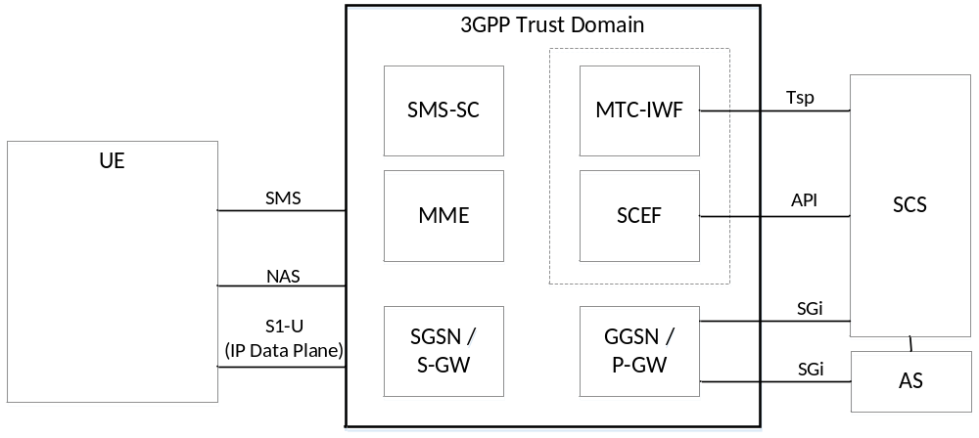
Figure 5.1-1: 3GPP IoT Related Interfaces

5.2 Functional mapping between 3GPP and oneM2M
Figure 5.2-1 is an updated version of Figure 5.1-1. This figure has been updated to show, at a high level, how oneM2M functional entities may access the features and services that are exposed by 3GPP. The oneM2M entities are shaded in grey.
The “MTC Applications” that are hosted on the UE correspond to oneM2M entities which may be ADN, ASN or MN, or the UE may host a noDN. The SCS may be an IN-CSE, and the “MTC-Applications” or ASs that are hosted in an external network may be an IN-AE.
The “3GPP Domain” box in Figures 5.1-1 and Figure 5.2-1 captures the functional entities that MUST be part of the 3GPP domain (the network). Although Figure 5.2-1 show that the IN-CSE and IN-AE are outside of the 3GPP Domain, it should be noted that the IN-CSE may be part of the operator domain.
This figure also shows the oneM2M reference points Mcn and Mca. The Mcc reference point is not shown explicitly as it would have rendered the picture less legible, but as is defined in [1], clause 5, the Mcc reference point is per definition between the two CSEs on respectively the left-hand side and the right-hand side of the figure. It is transported over any available data path between the two CSEs.

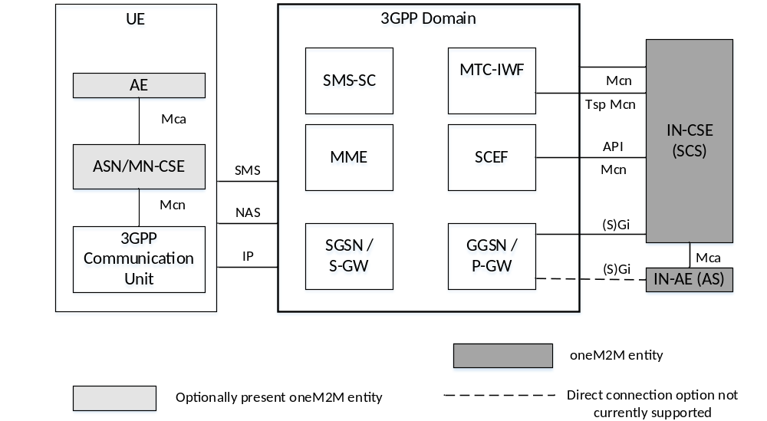
Figure 5.2-1: oneM2M Interfaces to the 3GPP Network
Several implementation options for the placement of the oneM2M (IN) CSE relative to the SCEF and the 3GPP network are envisioned. In all implementations, the SCEF always resides within 3GPP domain.
In some options the IN-CSE and the SCEF are deployed by a mobile network provider and are both part of the operator domain. In other options the SCEF is part of the 3GPP domain and the IN-CSE is not part of the operator domain.
In all options, services within the IN-CSE may access the network services that are exposed by the SCEF via the API.

5.3 Cellular IoT Features and Services
The SCEF exposes the following services to the IN-CSE. This document describes how the IN-CSE may access each service.
  - Configuring Communication Patterns, see clause 6.6.
  - Configuring Session QoS, see clause 6.9.
  - Configuring Session Sponsorship, see clause 6.11.
  - Background Data Transfer, see clause 6.10.
  - Monitoring, see clause 6.4.
  - High Latency Communication – Extended S-GW and SCEF Buffering, see clause 6.3.
  - High Latency Communication – Configuring PSM and eDRX, see clause 6.3.
  - Mobile Core Network Issue Reports, see clause 6.8.
  - SMS Based Device Triggering, see clause 6.5.
  - Group Messaging (via MBMS), see clause 6.7.
  - Non-IP Data Delivery, see clause 6.1.1.
A UE hosted ADN-AE, MN-CSE, or ASN-CSE may access the following features that may be exposed by the 3GPP modem. This document describes how the UE hosted ADN-AE, MN-CSE, or ASN-CSE may access each service.
- SMS Based Device Triggering, see clause 6.5.
- Group Messaging (via MBMS), see clause 6.7.
- Non-IP Data Delivery, see clause 6.1.1.
- Configuring Low Access Priority Connections, see clause TBD.
- High Latency Communication – Configuring PSM and eDRX, see clause 6.3.
- User Plane CIoT Optimizations (Suspend / Resume), see clause TBD.

Editor’s Note: A full list of 3GPP Release 13 & Release 14 service capabilities exposure functions will be shown and in order to scope down the work in R3, a subset of functions that are considered to be the highest priority and are aimed to be specified in this TS in R3 will also be given in this subclause.

6 Connectivity Establishment

6.1 Overview
ASN/MN-CSE and the serving IN-CSE communicate after completion of the Underlying Network bearer establishment and discovery of the serving IN-CSE. Data can then traverse between CSEs over the IP connection in the Underling Network over 3GPP Gi/SGi interface. In addition, the signalling connectivity between the two CSEs is also realized. Figure 6.11 depicts the connectivity between the ASN/MN-CSE and the IN-CSE.
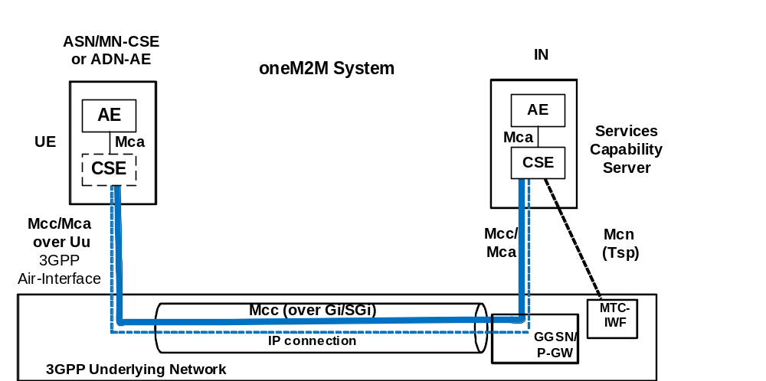
Figure 6.1-1: Connectivity Establishment between ASN/MN-CSE or ADN-AE and IN-CSE

For ASN/MN initiated connectivity establishment, it is assumed that there is no connectivity previously established, i.e. no association between the ASN/MN-CSE or ADN-AE and the serving IN-CSE exists. When the ASN/MN-CSE or ADN-AE needs to send data to the serving IN-CSE it first discovers the serving IN-CSE, which is located in a packet data network, and establishes connection. Two methods can be used, as follows:
- Use of DHCP and DNS.
- Pre-configuration.
For serving IN-CSE initiated connectivity establishment, it is assumed that there is no connectivity previously established between the ASN/MN-CSE and the serving IN-CSE. When the serving IN-CSE needs to contact the ASN/MN-CSE to send data or request data, connectivity between them is established. This connectivity is triggered by the serving IN-CSE.
NOTE: How the serving IN-CSE triggers a non-CSE capable M2M device (e.g. ADN) within the 3GPP Underlying Network is not specified in this release of the document.
The ASN/MN-CSE or ADN-AE requests the DNS server address from the DHCP server followed by requesting the serving IN-CSE IP address from the DNS server.

6.2 ASN/MN-CSE Pre-configuration
The ASN/MN-CSE or ADN-AE is preconfigured with the fully qualified domain name (FQDN) of the serving IN-CSE or the IP address of the serving IN-CSE. If the FQDN is known, DNS resolution is used to obtain the IP address.

6.3 ASN/MN-CSE or ADN-AE Initiated Connectivity Establishment Procedure
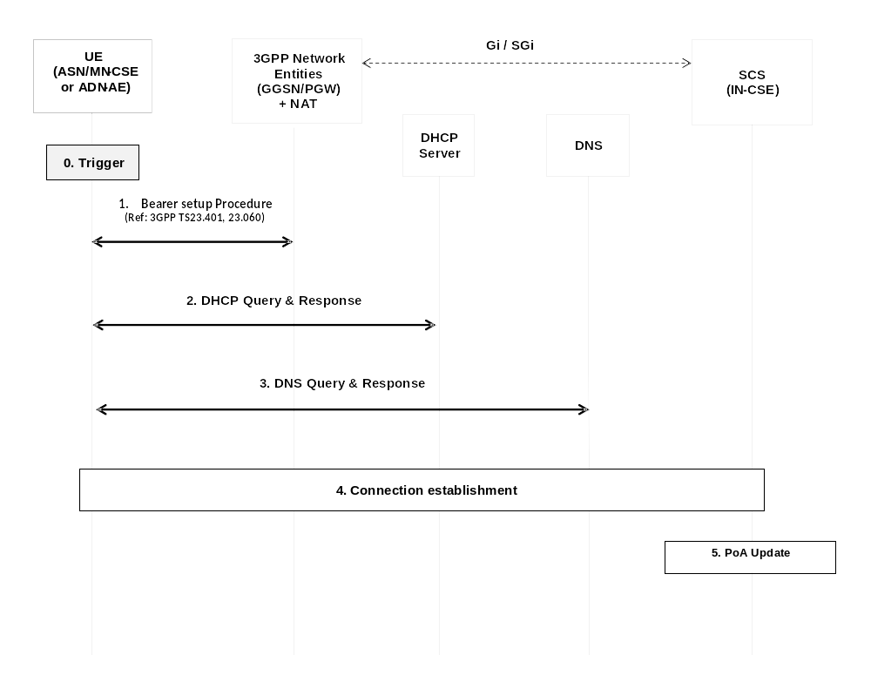
Figure 6.3-1: ASN/MN-CSE or ADN-AE initiated connectivity establishment
Step-0: Trigger
Subsequent procedures are triggered either when the ASN/MN-CSE or ADN-AE powers on or resulting from Device Triggering
Step-1: Bearer Setup Procedure
Establish a 3GPP bearer(s) if not already available by using the procedures available in the 3GPP network.
Step-2: DHCP Query & Response
The ASN/MN-CSE or ADN-AE sends a query to a DHCP server to find a particular DNS server IP address. The DHCP server responds with the IP address of a corresponding DNS server. Additionally, it is also possible to include one or a list of domain names, i.e. FQDNs of target IN-CSEs.
Step-3: DNS Query & Response
The ASN/MN-CSE or ADN-AE performs a DNS query to retrieve the IN-CSE(s) IP addresses from which one is selected. If the response does not contain the IP addresses, an additional DNS query is needed to resolve a Fully Qualified Domain Name (FQDN) of the serving IN-CSE to an IP address.
Step-4: Connection Establishment
After reception of domain name and IP address of an IN-CSE, the ASN/MN-CSE or ADN-AE can initiate communication towards the IN-CSE via the IP connection. The IN-CSE at this time shall be informed which Trigger Recipient ID of the ASN/MN-CSE or ADN-AE or the AE-PoA of the ADN-AE to use for establishing communication.
Step-5: CSE-PoA Update
Once the M2M Service Connection (Mcc) is established, in the IN-CSE the CSE-PoA of the ASN-CSE/MN-CSE or the AE-PoA of the ADN-AE shall be updated with the new established IP address.
The IN-CSE holds the state information and needs to be informed when the connection is closed.

6.4 IN-CSE initiated connectivity establishment procedure

See clause 7.5 SMS Based Device Triggering.
Editor’s note: NIDD section should be added

7 Interworking with CIoT network features exposed to service layer
Editor’s Note: the signalling flows and resources specified in the following clauses should focus on the Mca and Mcn interfaces: CIoT features synergy with oneM2M service layer. At the time when this skeleton is drafted, the subclauses of clause 6 intend to capture all the 3GPP service capabilities exposure function categories. Once the subset of functions is fixed in subclause 5.3, some 3GPP service capabilities exposure functions may be removed in this TS.

7.1 Cellular IoT IP and non-IP data delivery

7.2 UE context information storage

7.3 High latency communications

7.4 Monitoring events

7.5 SMS Based Device triggering
Connection Establishment between IN-CSE and ASN/MN-CSE or ADN-AE
Whenever the IN-CSE requires to establish a connection towards another entity (e.g. ASN/MN-CSE or ADN-AE, ADN-AE), Device Triggering procedure over the Tsp interface as described in 3GPP TS 23.682 [Error: Reference source not found] shall be used.
This procedure assumes the ASN/MN-CSE or ADN-AE is directly connected to 3GPP access network.

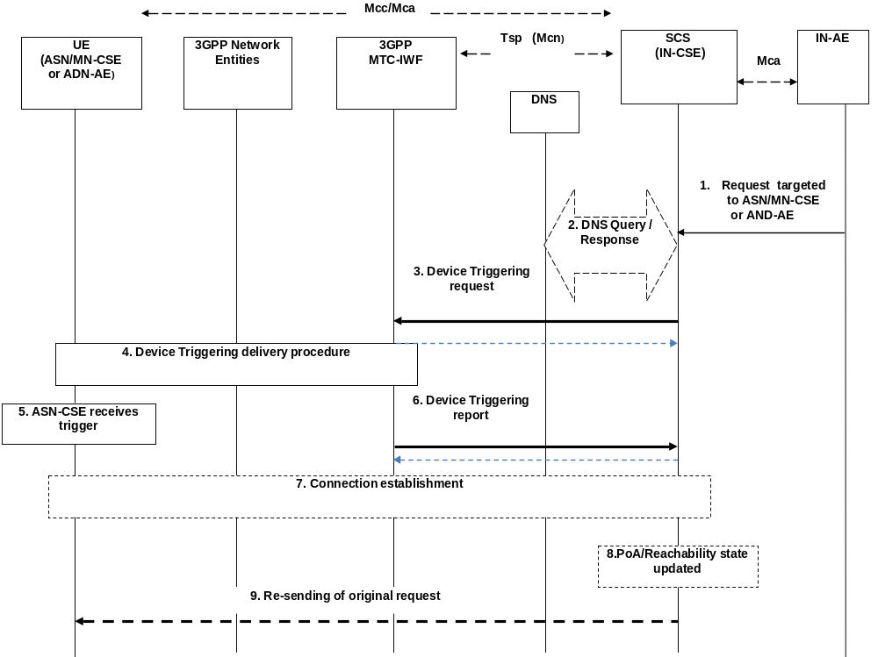

Figure 7.5.1-1: IN-CSE initiated connectivity establishment
Pre-condition
The IN-CSE checks the state information of the target device. Some of this state information is the result of provisioning or a previous connection establishment or triggering requests, such as the case of power-off, dormant and/or connected state. The IN-CSE decides its next action, e.g. if it needs to start device triggering or to report to IN-AE about the inability to perform the request.
The CSE-PoA for the ASN/MN-CSE or AE-PoA of the ADN-AE either already contains an IP address which is not valid anymore or no IP address at all, or FQDN does not resolve to a valid IP address. This is a pre-requisite for performing the device triggering procedure.
Step 1 (Optional): Request targeted to ASN/MN-CSE or ADN-AE
The IN-AE requests to perform one of the CRUD operation on a resource residing on the ASN/MN-CSE or ADN-AE, the request is sent via the Mca reference point to the IN-CSE. The request from IN-AE includes the address of the target resource.
Step 2: DNS Query/Response
The IN-CSE determines the need to trigger the ASN/MN-CSE or ADN-AE.
If the IN-CSE has no contact details for a contact MTC-IWF, it may determine the IP address(es)/port(s) of the MTC-IWF by performing a DNS query using the M2M-Ext-ID (M2M External Identifier) assigned to the target ASN/MN-CSE or ADN-AE, or using a locally configured MTC-IWF identifier.
Step-3: Device Triggering Request
The IN-CSE buffers the original request information and sends the Device Trigger Request message that contains information as specified in 3GPP TS 23.682 [i.14Error: Reference source not found]. Such information includes:
- M2M-Ext-ID or MSISDN;
- SCS-Identifier, (is set to the IN-CSE ID);
- Trigger reference number (used to correlate the request with the response);
- Validity period, (which indicates how long the request is valid);
- Priority (this field allows to set the priority on or off);
- Application Port ID, (is set to the ASN/MN-CSE or ADN-AE Trigger-Recipient-ID since it is the triggering application addressed in the device from 3GPP point of view);
- Trigger payload, (optional information can be set to the payload).
NOTE 1: In case that the Device Triggering request is for an M2M Service Connection setup request as in the present flow, it is assumed that when the target (i.e. ASN/MN-CSE or or ADN-AE) is woken up on receiving the trigger it initiates connection establishment with the IN-CSE with which it is registered. The information of the IN-CSE may be pre-stored in the target (i.e. ASN/MN-CSE or ADN-AE) or obtained from the payload.
Acknowledge
Once, 3GPP-MTC-IWF receives the Trigger Request, it asks the HSS to determine if the IN-CSE is authorized to perform the triggering to the target (i.e. ASN/MN-CSE or ADN-AE) and the HSS resolves the M2M-Ext-ID to IMSI (or MSISDN). Then the 3GPP MTC-IWF acknowledges to the IN-CSE with the confirmation of receiving Device Triggering Request.
Step-4: Device Triggering delivery procedure
The MTC-IWF initiates the T4 trigger delivery procedure according to the 3GPP TS 23.682 [i.14Error: Reference source not found], based on the information received from HSS and local policy.
NOTE 2: 3GPP Network Entities (e.g. SMS-SC) can select appropriate device triggering mechanism (e.g. SMS based or SIP based via IP-SM-GW) according to the device capabilities.
Step 5: ASN/MN-CSE receives the trigger
As a result of the triggering procedure, the payload is delivered to the ASN/MN-CSE or ADN-AE trigger recipient.
NOTE 3: In case the Device Trigger contains the optional part of the trigger payload, it is assumed that such trigger payload is forwarded to the application inside the ASN/MN-CSE or ADN-AE that is started as a result of device trigger.
Step 6: Device Triggering report
Request:
The MTC-IWF sends the Device Trigger Report message (containing the M2M-Ext-ID or MSISDN and trigger reference number) to the IN-CSE with a cause value indicating whether the trigger delivery succeeded or failed and the reason for the failure.
Acknowledge:
IN-CSE acknowledges to the MTC-IWF with the conformation of the received Device Triggering Report.
Step 7 (Optional): Connection establishment procedure
The ASN/MN-CSE or ADN-AE performs the Connection establishment procedure as described in clause 6.4 and oneM2M TS-0003 [2] for Secure Connection establishment.
As a result of this procedure the initial request over the reference point Mcc can be executed.
Step 8 (Optional): CSE-PoA/Reachability state updated
Once the connection over Mcc is established, the PoA of the ASN/MN-CSE or ADN-AE shall be updated at the IN-CSE with the new established IP address and the IN-CSE holds the reachability state of the ASN/MN-CSE or ADN-AE.
Step 9 (Optional): Re-sending of original request
As a result of step 7, the communication is established and now the initial request with the information stored in the buffer of the IN-CSE at Step 3 can be re-issued over the reference point Mcc.

7.6 Configuration of Traffic Patterns
oneM2M uses the 3GPP MTC feature for Configuration of Device Communication Patterns to configure Node Traffic Patterns in the Underlying Network (see TS-0001 section 8.3.5 Configuration of Node Traffic Patterns).
To that purpose the IN-CSE translates the oneM2M Node Traffic Pattern (TP) into a 3GPP Device Communication Pattern. The generic oneM2M procedure for configuration of Node traffic Patterns is shown in Figure 7.6-1

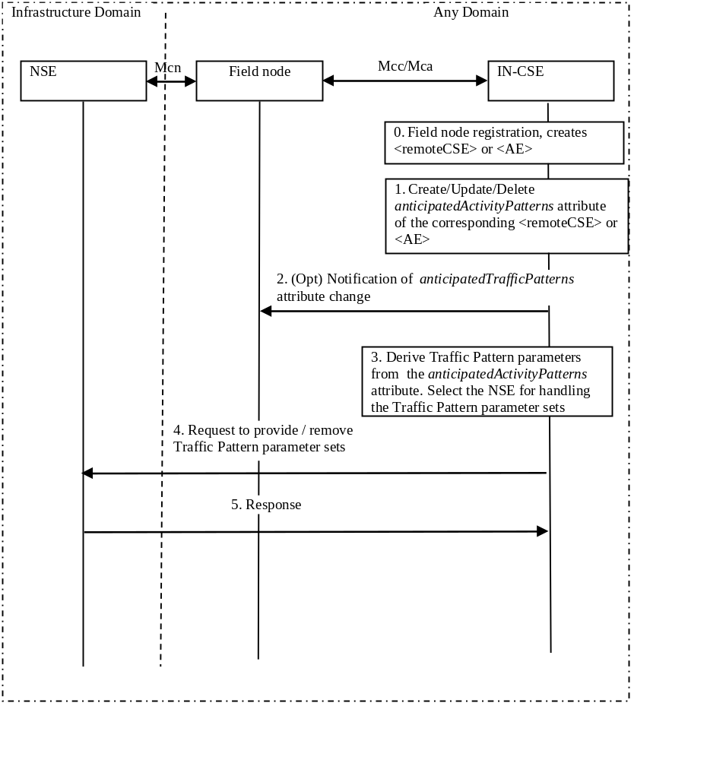
Figure 7.6.1-1: General procedure for oneM2M configuration of Traffic Patterns

The 3GPP Underling Network signalling sequence for provisioning of CP parameters is described in 3GPP TS 23.682 [Error: Reference source not found]. Figure 7.6-2 provides the signalling sequence derived from the 3GPP specification.
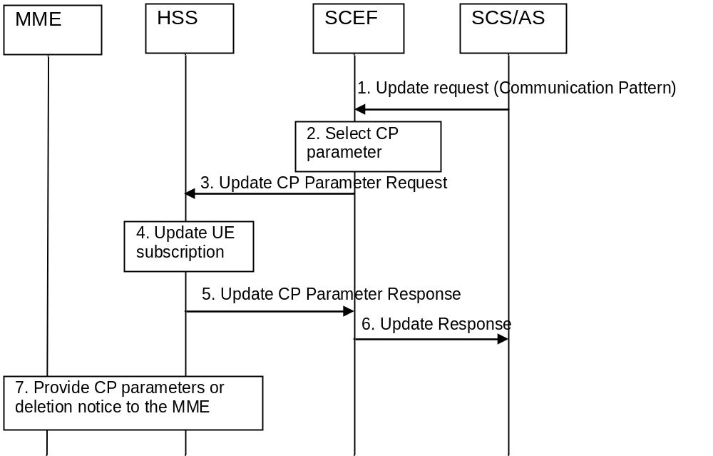
Figure 7.6-1: Signalling sequence for provisioning of CP Parameters
3GPP TS 23.682 [i.14] defines the request message of step 1 as below:
Editor’s note: the following text should be updated for R14
- The SCS/AS sends an Update Request (External Identifier or MSISDN, SCS/AS Identifier, SCS/AS Reference ID(s), CP parameter set(s), validity time(s), SCS/AS Reference ID(s) for Deletion) message to the SCEF.
NOTE 1: The SCS/AS uses this procedure to add, change or delete some or all of the CP parameter sets of the UE, e.g. if the AS is aware that the UE has started or stopped moving for a significant time period, especially if the AS is instructing the UE to do so, then the SCS/AS provides the corresponding CP parameter set(s) and its validity time to the SCEF. The interface between SCEF and SCS/AS is outside the scope of 3GPP and the messages in the Figure are exemplary.
3GPP TS 23.682 [Error: Reference source not found] defines the request message of step 3 as below:
- The SCEF sends Update CP Parameter Request (External Identifier or MSISDN, SCEF Reference ID(s), SCEF Address, CP parameter set(s), validity time(s), SCEF Reference ID(s) for Deletion) messages to the HSS for delivering the selected CP parameter set(s) per UE. There may be multiple CP parameter sets included in this message where each CP parameter set for addition or modification has been determined to be non-overlapping with other CP parameter sets either included in the message or already provisioned for a given UE. The SCEF derives the SCEF Reference (IDs) for CP parameter sets to be sent to the HSS based on the SCS/AS Reference ID(s) from the SCS/AS.
NOTE 2: A request for deletion of a CP parameter set from the SCS/AS may result in a request for modification of the non-overlapping CP parameter set by the SCEF.
EXAMPLE 1: In the case that the selected server NSE is a 3GPP HSS, the protocol of the S6t reference point defined by 3GPP is used for the request. The S6t uses one of Diameter Application protocols defined by 3GPP. The request on the S6t reference point for the configuration of the CP parameter sets (a CIR command) must include a User-Identifier AVP (either an External Identifeir or a MSISDN of the UE), may include one or more AESE-Communication-Pattern AVP. An AESE-Communication-Pattern AVP must include a SCEF-ID AVP (represent the ID of the IN-CSE or M2M-SP-ID), may include a SCEF-Reference-ID AVP (assigned by the IN-CSE or M2M-SP to identify the configuration of CP parameter sets uniquely) , may include one or more Communication-Pattern-Set AVP. A Communication-Pattern-Set AVP may include AVPs for Periodic-Communication-Indicator, Communication-Duration-Time, Periodic-Time, one or more Scheduled-Communication-Time, Stationary-Indication, and Validity-Time. Refer to the 3GPP TS 29.336 [Error: Reference source not found] for the detailed protocol description.
3GPP TS 23.682 [Error: Reference source not found] defines the response message of step 5 as below:
- The HSS sends Update CP Parameter Response (SCEF Reference ID, Cause) message to the SCEF. The cause value indicates successful subscription update or the reason of failed subscription update.
- The actual parameters for the request and response messages in above steps 3 and 5 are defined by 3GPP TS 29.336 [Error: Reference source not found], clauses 7 and 8 for S6t reference point.
EXAMPLE 2: In the case that the selected server NSE is a 3GPP HSS, the protocol of the S6t reference point defined by 3GPP is used for the response. The response on the S6t reference point for the configuration of the CP parameter sets (a CIA command) must include either Result-Code AVP or Experimental-Result AVP, may include a User-Identifier AVP if successful case, may include one or more AESE-Communication-Pattern-Config-Status AVP. An AESE-Communication-Pattern-Config-Status AVP must include the SCEF-Reference-ID AVP (same value in the request), may include the SCEF-ID (same value in the request) and an AESE-Error-Report AVP. Refer to the 3GPP TS29.336 for the detailed protocol description.
3GPP TS 23.682 [Error: Reference source not found] defines the response message of step 6 as below:
The SCEF sends the Update Response (SCS/AS Reference ID, Cause) message to inform the SCS/AS whether the provision of the CP parameter set(s) was successful.

7.7 Group message delivery

7.8 Informing about Potential Network Issues

7.9 Setting up an AS session with required QoS procedure

7.10 Resource management of background data transfer

7.11 Change the chargeable party at session set-up or during the session procedure

8 Cellular IoT device management

8.1 sub-function of device management (e.g. Device Configuration)

Annex <A> (Informative): Informative introduction of 3GPP Cellular IoT network

A.1 Main concepts of 3GPP cellular IoT network
Editor’s Note: Introduction of basic concepts of 3GPP cellular IoT network including Radio Access Network technologies (NB-IoT, LTE-M, EC-GSM) and the core network. For oneM2M, the focus is the interface to the 3GPP core network.

A.2 The 3GPP architecture for service capabilities exposure

Annex <X>

X.1 First clause of the annex (style H1)
<Text>

X.1.1 First subdivided clause of the annex (style H2)
<Text>

History
This clause shall be the last one in the document and list the main phases (all additional information will be removed at the publication stage).
Publication history
V1.1.1 | <dd-Mmm-yyyy> | <Milestone>

Draft history (to be removed on publication)
V0.0.1 | 19-10-2016 | ARC-2016-0394R04-New_TS_on_3GPP-interworking_Draft_Baseline
V0.1.1 | 16-11-2016 | Includes agreed contribution at TP#25 meeting:  WI-0058 Cellular IoT IWK V0.1.0 : Update the document name.  ARC-2016-0471R01-TS-0026_Scope-section：Add new scope content.  ARC-2016-0439R03-TS-0026_sec5:Add new section 5.
V0.2.0 | 2017-04-27 | Includes agreed contribution at TP#28 meeting:  ARC-2017-0091R03-3GPP_TS_0001_to_TS_0026

