CHANGE REQUEST
Meeting ID:* | ARC #31
Source:* | Dale Seed, Convida Wireless, Seed.Dale@ConvidaWireless.com  Bob Flynn, Convida Wireless, Flynn.Bob@ConvidaWireless.com
Date:* | 2017-09-10
 | See Introduction
Reason for Change/s:* | Rel-3
CR against: Release* | Active  MNT maintenance / < Work Item number(optional)>  Is this a companion CR? Yes No  Companion CR number: (Note to Rapporteur - use latest agreed revision)Is this a mirror CR? Yes No  Mirror CR number: (Note to Rapporteur - use latest agreed revision)  STE Small Technical Enhancements / < Work Item number (optional)>  Only ONE of the above shall be ticked
CR against: WI* | WI-0050 – Rel-3 Small Technical Enhancements
CR against: TS/TR* | TS-0001 Version 3.7.0
Clauses * | Editorial change  Bug Fix or Correction  Change to existing feature or functionality  New feature or functionality  Only ONE of the above shall be ticked
Type of change: * | TS-0001 Version 3.7.0 – Sections - Various
Impacted other TS/TR(s) | This CR contains only essential changes and corrections? YES NO  This CR may break backwards compatibility with the last approved version of the TS? YES NO
Post Freeze checking:* | This CR contains only essential changes and corrections? YES NO  This CR may break backwards compatibility with the last approved version of the TS? YES NO

oneM2M Notice
The document to which this cover statement is attached is submitted to oneM2M. Participation in, or attendance at, any activity of oneM2M, constitutes acceptance of and agreement to be bound by terms of the Working Procedures and the Partnership Agreement, including the Intellectual Property Rights (IPR) Principles Governing oneM2M Work found in Annex 1 of the Partnership Agreement.
GUIDELINES for Change Requests:
Provide an informative introduction containing the problem(s) being solved, and a summary list of proposals.
Each CR should contain changes related to only one particular issue/problem.
In case of a correction, and the change apply to previous releases, a separate “mirror CR” should be posted at the same time of this CR
Mirror CR: applies only when the text, including clause numbering are exactly the same.
Companion CR: applies when the change means the same but the baselines differ in some way (e.g. clause number).
Follow the principle of completeness, where all changes related to the issue or problem within a deliverable are simultaneously proposed to be made E.g. A change impacting 5 tables should not only include a proposal to change only 3 tables. Includes any changes to references, definitions, and acronyms in the same deliverable.
Follow the drafting rules.
All pictures must be editable.
Check spelling and grammar to the extent practicable.
Use Change bars for modifications.
The change should include the current and surrounding clauses to clearly show where a change is located and to provide technical context of the proposed change. Additions of complete clauses need not show surrounding clauses as long as the proposed clause number clearly shows where the new clause is proposed to be located.
Multiple changes in a single CR shall be clearly separated by horizontal lines with embedded text such as, start of change 1, end of change 1, start of new clause, end of new clause.
When subsequent changes are made to content of a CR, then the accepted version should not show changes over changes. The accepted version of the CR should only show changes relative to the baseline approved text.

Introduction
Release version handling allows oneM2M entities to publish the release version of the oneM2M specification they are compliant with. It also allows oneM2M entities to detect the release version of other oneM2M entities that they communicate with.
During the PRO30.X conference calls, consensus was reached on adding the following functionality to support release version handling in oneM2M.
- The addition of a new supportedReleaseVersions attribute to the <AE> and <remoteCSE> and <CSEBase> resources
- The addition of a new Release Version Indicator request message parameter
- The addition of a new Release Version Indicator response message parameter
- Release version handling procedures.

This contribution proposes corresponding changes to TS-0001 for the above functionality.

-----------------------Start of change 1-------------------------------------------

8.1.2 Request
Requests over the Mca and Mcc reference points, from an Originator to a Receiver, shall contain mandatory and may contain optional parameters. Certain parameters may be mandatory or optional depending upon the Requested operation. In this clause, the mandatory parameters are detailed first, followed by those that are operation dependent, and then by those that are optional:
- To: Address of the target resource or target attribute for the operation. The To parameter shall conform to clause 9.3.1.
NOTE 1: To parameter can be known either by pre-provisioning (clause 11.2) or by discovery (clause 10.2.6 for discovery). Discovery of <CSEBase> resource is not supported in this release of the document. It is assumed knowledge of <CSEBase> resource is by pre-provisioning only.
NOTE 2: The term target resource refers to the resource which is addressed for the specific operation. For example the To parameter of a Create operation for a resource <example> would be "/m2m.provider.com/exampleBase". The To parameter for the Retrieve operation of the same resource <example> is "/m2m.provider.com/exampleBase/example".
NOTE 3: For Retrieve operation (clause 10.1.3), the To parameter can be the URI of an attribute to be retrieved.
- From: Identifier representing the Originator.
The From parameter is used by the Receiver to check the Originator identity for access privilege verification.
- Operation: operation to be executed: Create (C), Retrieve (R), Update (U), Delete (D), Notify (N).
The Operation parameter shall indicate the operation to be executed at the Receiver:
- Create (C): To is the address of the target resource where the new resource (parent resource).
- Retrieve (R): an existing To addressable resource is read and provided back to the Originator.
- Update (U): the content of an existing To addressable resource is replaced with the new content as in Content parameter. If some attributes in the Content parameter do not exist at the target resource, such attributes are created with the assigned values. If some attributes in the Content parameter are set to NULL, such attributes are deleted from the addressed resource.
- Delete (D): an existing To addressable resource and all its sub-resources are deleted from the Resource storage.
- Notify (N): information to be sent to the Receiver, processing on the Receiver is not indicated by the Originator.
- Request Identifier: request Identifier (see clause 7.1.7).
Example usage of request identifier includes enabling the correlation between a Request and one of the many received Responses.
Operation dependent Parameters:
- Content: resource content to be transferred.
The Content parameter shall be present in Request for the following operations:
- Create (C): Content is the content of the new resource with the resource type ResourceType.
- Update (U): Content is the content to be replaced in an existing resource. For attributes to be updated at the resource, Content includes the names of such attributes with their new values. For attributes to be created at the resource, Content includes names of such attributes with their associated values. For attributes to be deleted at the resource, Content includes the names of such attributes with their value set to NULL.
- Notify (N): Content is the notification information.
The Content parameter may be present in Request for the following operations:
- Retrieve (R): Content is the list of attribute names from the resource that needs to be retrieved. The values associated with the attribute names shall be returned.
- Resource Type: type of resource.
The ResourceType parameter shall be present in Request for the following operations:
- Create (C): Resource Type is the type of the resource to be created.
Optional Parameters:
- Role IDs: optional, required when role based access control is applied. A list of Role-IDs that are allowed by the service subscription shall be provided otherwise the request is considered not valid.
The Role IDs parameter shall be used by the Receiver to check the Access Control privileges of the Originator.
- Originating Timestamp: optional originating timestamp of when the message was built.
Example usage of the originating timestamp includes: to measure and enable operation (e.g. message logging, correlation, message prioritization/scheduling, accept performance requests, charging, etc.) and to measure performance (distribution and processing latency, closed loop latency, SLAs, analytics, etc.)
- Request Expiration Timestamp: optional request message expiration timestamp. The Receiver CSE should handle the request before the time expires. If a Receiver CSE receives a request with Request Expiration Timestamp with the value indicating a time in the past, then the request shall be rejected.
Example usage of the request expiration timestamp is to indicate when request messages (including delay-tolerant) should expire and to inform message scheduling/prioritization. When a request with set expiration timestamp demands an operation on a Hosting CSE different than the current Receiver CSE, then the current CSE shall keep trying to deliver the Request to the Hosting CSE until the request expiration timestamp time, in line with provisioned policies.
- Result Expiration Timestamp: optional result message expiration timestamp. The Receiver CSE should return the result of the request before the time expires.
Example usage of the result expiration timestamp: An Originator indicates when result messages (including delay-tolerant) should expire and informs message scheduling/prioritization. It can be used to set the maximum allowed total request/result message sequence round trip deadline.
- Response Type: optional response message type: Indicates what type of response shall be sent to the issued request and when the response shall be sent to the Originator:
- nonBlockingRequestSynch: In case the request is accepted by the Receiver CSE, the Receiver CSE responds, after acceptance, with an Acknowledgement confirming that the Receiver CSE will further process the request. The Receiver CSE includes in the response to an accepted request a reference that can be used to access the status of the request and the result of the requested operation at a later time. Processing of Non-Blocking Requests is defined in clause 8.2.2 and in particular for the synchronous case in clause 8.2.2.2.
- nonBlockingRequestAsynch {optional list of notification targets}: In case the request is accepted by the Receiver CSE, the Receiver CSE shall respond, after acceptance, with an Acknowledgement confirming that the Receiver CSE will further process the request. The result of the requested operation needs to be sent as notification(s) to the notification target(s) provided optionally within this parameter as a list of entities or to the Originator when no notification target list is provided. When an empty notification target list is provided by the Originator, no notification with the result of the requested operation shall be sent at all. Processing of Non-Blocking Requests is defined in clause 8.2.2 and in particular for the asynchronous case in clause 8.2.2.3.
- blockingRequest: In case the request is accepted by the Receiver CSE, the Receiver CSE responds with the result of the requested operation after completion of the requested operation. Processing of Blocking Requests is defined in clause 8.2.1. This is the default behaviour when the Response Type parameter is not given the request.
- flexBlocking {optional list of notification targets}: When Response Type in the request received by the Receiver CSE is set to flexBlocking, it means that the Originator of the request has the capability to accept the following types of responses: nonBlockingRequestSynch, nonBlockingRequestAsynch and blockingRequest.
The Receiver CSE shall make the decision to respond using blocking or non-blocking based on its own local context (memory, processing capability, etc.) if not defined in the resource handling procedure.
If the Receiver CSE choose to respond using non-blocking mode, based on the presence of notification targets in the request:
- If the notification targets are provided in the request and the Recerver CSE is responding, the Receiver CSE shall notify the result using nonBlockingRequestAsynch.
- If notification targets are not provided, the Receiver CSE shall respond with the address of <request> resource using nonBlockingRequestSynch.
Example usage of the response type set to nonBlockingRequestSynch: An Originator that is optimized to minimize communication time and energy consumption wants to express a Request to the receiver CSE and get an acknowledgement on whether the Request got accepted. After that the Originator may switch into a less power consuming mode and retrieve a Result of the requested Operation at a later time.
Further example usage of response type set to nonBlockingRequestSynch: When the result content is extremely large, or when the result consists of multiple content parts from a target group which are to be aggregated asynchronously over time.
- Result Content: optional result content: Indicates what are the expected components of the result of the requested operation. The Originator of a request may not need to get back a result of an operation at all. This shall be indicated in the Result Content parameter. Settings of Result Content depends on the requested operation specified in Operation. Possible values of Result Content are:
- attributes: A representation of the targeted resource including all its attributes shall be returned as content, without the address(es) of the child resource(s) or their descendants. For example, if the request is to retrieve a <container> resource, the address(es) of the <contentInstance> child-resource(s) is not provided. This setting shall be only valid for Create, Retrieve, Update, or Delete operation. If the Originator does not set Result Content parameter in a Create, Retrieve or Update request message, this setting shall be the default value when the Receiver processes the request message.
- modified-attributes: This setting shall be only valid for a Create or Update operation. A representation of the targeted resource including only the assigned or modified attributes relative to what was provided by the Originator of the request shall be returned as content, without the address(es) of the child resource(s) or their descendants.
- hierarchical-address: Representation of the address of the created resource. This setting shall only be valid for a Create operation. The address shall be in hierarchical address scheme.
- hierarchical-address+attributes: Representation of the addresss in hierarchical address scheme and the attributes of the created resource. This setting shall only be valid for a Create operation.
- attributes+child-resources: Representation of the requested resource, along with a nested representation of all of its child resource(s) , and their descendants, in line with any provided filter criteria as given in the Filter Criteria parameter shall be returned as content. If there is no filter criteria parameter in the request message then all children/descendants are returned along with their attributes. For example, if the request is to retrieve a <container> resource that only has <contentInstance> children, the attributes of that <container> resource and a representation of all of its <contentInstance> child-resource(s) , including their attributes, are provided.
The originator may request to limit the maximum number of allowed nesting levels. The orginator may also include an offset that indicates the starting point of the direct child resource. The offset shall start at 1. The hosting CSE shall return all direct child resources and their descendants, or up to the maximum nesting level specififed in a request subject to maximum size limit that may be imposed by the hosting CSE. The offset, maximum number/size and maximum level shall be specified in Filter Criteria as offset, limit, and level condition, respectively, by the Originator.
The hosting CSE shall list parent resources before their children. This means that the originator of the request will not receive a discovered resource without having received its parents. The hosting CSE shall also ensure that proper nesting representation of all the children is incorporated in its listing for parents and children.
Nested processing is applicable at every level in the resource tree. If a direct child resource and all its descendants cannot be included in the returned content due to size limitations imposed by the hosting CSE then the direct child resource shall not be included in the response.
An indication shall be included in the response signalling if the returned content is partial. If the indication is for partial content, the response shall include an offset for the direct child resource where processing can restart for the remaining direct child resources
This shall be only valid for a Retrieve/Delete operation.
- child-resources: A nested representation of the resource's child resource(s) their descendants and their attributes shall be returned as content. The resources that are returned are subject to any filter criteria that are given in the Filter Criteria parameter (if there are no filter criteria then all children and their descendants are returned). The attributes of the parent resource are not returned, but all the attributes of the children are returned. For example, if the request is to retrieve a <container> resource that only has <contentInstance> children, only a representation of all of its <contentInstance> child-resource(s) is provided.
The offset, maximum number/size and maximum level shall be specified in Filter Criteria as offset, limit, and level condition, respectively, by the Originator. Processing of direct child resources, size limitations, maximum nesting level, and offset for the starting of direct child resource processing of the attributes+child-resources option shall apply to this option as well.
This shall be only valid for a Retrieve/Delete operation.
- attributes+child-resource-references : Representation of the requested resource, along with the address(es) of the child resource(s), and their descendants shall be returned as content. For example, if the request is to retrieve a <container> resource, the <container> resource and the address(es) of the <contentInstance> child-resource(s) are provided.
The offset, maximum number/size and maximum level shall be specified in Filter Criteria as offset, limit, and level condition, respectively, by the Originator. Processing of child resources, size limitations, maximum nesting level, and offset for the starting of child resource processing of the attributes+child-resources option shall apply to this option as well.
This shall be only valid for a Retrieve/Delete operation.
- child-resource-references: Address(es) of the child resources and their descendants, without any representation of the actual requested resource shall be returned as content. For example, if the request is to retrieve a <container> resource, only the address(es) of the <contentInstance> child-resource(s) is provided.
The offset, maximum number/size and maximum level shall be specified in Filter Criteria as offset, limit, and level condition, respectively, by the Originator. Processing of child resources, size limitations, maximum nesting level, and offset for the starting of child resource processing of the attributes+child-resources option shall apply to this option as well.
This shall be only valid for a Retrieve/Delete operation.
This option can be used within the context of resource discovery mechanisms (see clause 10.2.6).
- nothing: Nothing shall be returned as operational result content. If the Originator does not set the Result Content parameter in a Delete request message, this setting shall be the default value when the Receiver processes the request message. This setting shall be valid for a Create,Update,Delete, orNotify operation.
EXAMPLE: If the request is to delete a resource, this setting indicates that the response shall not include any content.
- original-resource: Representation of the original resource pointed by the link attribute in the announced resource shall be returned as content, without the address(es) of the child resource(s). This shall be only valid for a Retrieve operation where the To parameter targets the announced resource.
- semantic-content: Representation of semantic information that is the result of a semantic query as indicated by the setting of the Semantic Query Indicator parameter.
Note that for any of the above options, Discovery access control is applied against discovery related procedures, while Retrieve access control procedures is applied against non-discovery related Retrieve operations.
Note that the fitter criteria usage governs the purpose of a Retrieve operation.
Table 8.1.2-1: Summary of Result Content Values
Value | Create | Retrieve | Update | Delete | Notify
attributes | default | default | default | valid | n/a
modified-attributes | valid | n/a | valid | n/a | n/a
hierarchical-address | valid | n/a | n/a | n/a | n/a
hierarchical-address+attributes | valid | n/a | n/a | n/a | n/a
attributes+child-resources | n/a | valid | n/a | valid | n/a
child-resources | n/a | valid | n/a | valid | n/a
attributes+child-resource-references | n/a | valid | n/a | valid | n/a
child-resource-references | n/a | valid | n/a | valid | n/a
nothing | valid | n/a | valid | default | valid
original-resource | n/a | valid | n/a | n/a | n/a
semantic-content | n/a | valid | n/a | n/a | n/a

- Result Persistence: optional result persistence: indicates the time for which the response may persist to. The parameter is used in case of non-blocking request where the result attribute of the <request> resource should be kept at the CSE, for example, with the purpose of sharing, tracking and analytics.
In the case the response of a request is required to be kept in the CSE, for example the procedures of <request> resource, <delivery> resource and <group> resource, the Result Persistence indicates the time duration for which the CSE keeps the response available after receiving it.
Example usage of result persistence includes requesting sufficient persistence for analytics to process the response content aggregated asynchronously over time. If a result expiration time is specified then the result persistence lasts beyond the result expiration time.
- Operation Execution Time: optional operation execution time: indicates the time when the specified operation Operation is to be executed by the target CSE. A target CSE shall execute the specified operation of a Request having its operational execution time indicator set, starting at the operational execution time. If the execution time has already passed or if the indicator is not set, then the specified operation shall be immediately executed, unless the request expiration time, if set, has been reached.
Example usage of operational execution time includes asynchronous distribution of flows, which are to be executed synchronously at the operational execution time.
NOTE 6: Time-based flows could not supported depending upon time services available at CSEs.
- Event Category: optional event category: Indicates the event category that should be used to handle this request. Event categories are impacting how Requests to access remotely hosted resources are processed in the CMDH CSF. Selection and scheduling of connections via CMDH are driven by policies that can differentiate event categories.
Example usage of "event category" set to specific value X: When the request is demanding an operation to be executed on a Hosting CSE that is different from the current Receiver CSE, the request may be stored in the current Receiver CSE that is currently processing the request on the way to the Hosting CSE until it is allowed by provisioned policies for that event category X to use a communication link to reach the next CSE on a path to the Hosting CSE or until the request expiration timestamp is expired.
The following values for Event Category shall have a specified pre-defined meaning:
- Event Category = immediate: Requests of this category shall be sent as soon as possible and shall not be subject to any further CMDH processing, i.e. the request will not be subject to storing in CMDH buffers when communication over an underlying network is possible. In particular, CMDH processing will respect values for Request Expiration Timestamp, Result Expiration Timestamp given in the original request and not fill in any default values if they are missing.
- Event Category = bestEffort: Requests of this category can be stored in CMDH buffers at the discretion of the CSE that is processing the request for an arbitrary time and shall be forwarded via Mcc on a best effort basis. The CSE does not assume any responsibility to meet any time limits for delivering the information to the next CSE. Also the maximum amount of buffered requests for this category is at the discretion of the processing CSE.
- Event Category = latest:
- If this category is used in a request asking for a CRUD operation on a resource, the following shall apply:
CRUD requests using this category shall undergo normal CMDH processing as outlined further below in the present document and in oneM2M TS-0004 [Error: Reference source not found] with a maximum buffer size of one pending request for a specific pair of From and To parameters that appear in the request. If a new request message is received by the CSE with a pair of parameters From and To that has already been buffered for a pending request, the newer request will replace the buffered older request.
- If this category is used in a notification request triggered by a subscription, the following shall apply:
Notification requests triggered by a subscription using this category shall undergo normal CMDH processing as outlined further below in the present document and in oneM2M TS-0004 [Error: Reference source not found] with a maximum buffer size of one pending notification request per subscription reference that appears in a notification request. If a new notification request is received by the CSE with a subscription reference that has already been buffered for a pending notification request, the newer request will replace the buffered older request.
- If no further CMDH policies are provisioned for this event category, the forwarding process shall follow the 'bestEffort' rules defined above.
The M2M Service Provider shall be able to provision CMDH policies describing details for the usage of the specific Underlying Network(s) and the applicable rules as defined in the [cmdhPolicy] resource type for other Event Category values not listed above.
- Delivery Aggregation: optional delivery aggregation on/off: Use CRUD operations of <delivery> resources to express forwarding of one or more original requests to the same target CSE(s). When this parameter is not given in the request, the default behaviour is determined per the provisioned CMDH policy if available. If there is no such CMDH policy, then the default value is "aggregation off".
NOTE 7: Since Delivery Aggregation is optional, there could be a default value to be used when not present in the Request. This parameter could not be exposed to AEs via Mca.
Example usage of delivery aggregation set on: The CSE processing a request shall use aggregation of requests to the same target CSE by requesting CREATE of a <delivery> resource on the next CSE on the path to the target CSE.
- Group Request Identifier: optional group request identifier: Identifier optionally added to the group request that is to be fanned out to each member of the group in order to detect loops and avoid duplicated handling of operation in case of loops of group and common members between groups that have parent-child relationship.
- Group Request Target Members: optional group request target members: Indicates subset of members of a group for which fanout is to be executed. Example usage of Group Request Target Members: if fanout operation failed for some of the members then the Originator may use this parameter to execute fanout for failed members of a previous fanout operation.
- Filter Criteria: optional filter criteria: conditions for filtered retrieve operation are described in table 8.1.2-2. This is used for resource discovery (clause 10.2.6) and general retrieve, update, delete requests (clauses 10.1.3, 10.1.4 and 10.1.5).
Example usage of retrieve requests with filter criteria using modifiedSince condition tag: if a target resource is modified since 12:00 then the Hosting CSE will send a resource representation.
- Discovery Result Type: Optional Discovery result format. This parameter applies to discovery related requests (see filterUsage in table 8.1.2-2 and clause 10.2.6) to indicate the preference of the Originator for the format of returned information in the result of the operation. This parameter shall take on one of the following values reflecting the options in clause 9.3.1:
- Hierarchical addressing method.
- Non-hierarchical addressing method.
For example if Discovery Result Type is set to Non-hierarchical addressing method, then the request Originator indicates that the discovered resources should be in the form of Non-hierarchical address.
The absence of the parameter implies that the result shall be in the form of a Hierarchical address.
- Token Request Indicator: Optional parameter used to indicate that the Originator supports the Token Request procedure, and the Originator may attempt the Token Request procedure if the Receiver provides a Token Request Information parameter in the response.
- Tokens: Optional parameter used to transport ESData-protected Tokens applicable to the request for use in Indirect Dynamic Authorization.
- Token IDs: Optional parameter used to transport Token-IDs applicable to the request for use in Indirect Dynamic Authorization.
- Local Token IDs: Optional parameter used to transport Local-Token-IDs applicable to the request for use in Indirect Dynamic Authorization.
- Authorization Signature Indicator: Optional parameter used to indicate the capability for creating AuthorRelMapRecord when Originator is an AE. If the Hosting CSE does not support this parameter, the Hosting CSE should ignore it. The details of the AuthorRelMapRecord are described in clause 7.3.2.2 of oneM2M TS-0003 [Error: Reference source not found].
- Authorization Signature: Optional parameter used to transport the signatures for Token(s) or TokenID(s) generated using the certificate of the AE or a MIC generated using a symmetric key shared between the AE and DAS server.
- Authorization Relationship Indicator: Optional parameter used to indicate that the relationship between the AE and the Token(s) are maintained in the DAS server.
- Semantic Query Indicator: Optional parameter used to indicate whether a RETRIEVE request is a semantic query or a semantic resource discovery. If the request contains this parameter with the value set to “TRUE”, the request shall be processed as a semantic query based on the SPARQL query statement included in the “semanticsFilter” condition tag; other Filter Criteria and the following parameters shall be ignored: Discovery Result Type, Delivery Aggregation.The parameter Result Content shall be set to semantic-content to indicate that the response message contains the result of a semantic query request. If it is not set or set to “FALSE” the request shall be processed as a semantic resource discovery.
- Release Version Indicator: Optional parameter used to indicate the oneM2M release version that this request message conforms to. The release version indicated shall apply to all oneM2M defined request parameters and certain types of content carried in the Content request parameter. Within the Content request parameter, the release version indicated shall apply to all oneM2M defined elements (e.g. notifications) and resource types with the exception of <flexContainer> and <mgmtObj> specializations which have their own version implicitly defined by their respective containerDefinition and mgmtSchema attributes. In addition, the release version indicated does not apply to resource types or specializations defined external to oneM2M.
Table 8.1.2-2: Filter Criteria conditions
Condition tag | Multiplicity | Matching condition
createdBefore | 0..1 | The creationTime attribute of the resource is chronologically before the specified value.
createdAfter | 0..1 | The creationTime attribute of the resource is chronologically after the specified value.
modifiedSince | 0..1 | The lastModifiedTime attribute of the resource is chronologically after the specified value.
unmodifiedSince | 0..1 | The lastModifiedTime attribute of the resource is chronologically before the specified value.
stateTagSmaller | 0..1 | The stateTag attribute of the resource is smaller than the specified value.
stateTagBigger | 0..1 | The stateTag attribute of the resource is bigger than the specified value.
expireBefore | 0..1 | The expirationTime attribute of the resource is chronologically before the specified value.
expireAfter | 0..1 | The expirationTime attribute of the resource is chronologically after the specified value.
labels | 0..1 | The labels attributes of the resource matches the specified value.
labelsQuery | 0..1 | The value is an expression for the filtering of labels attribute of resource when it is of key-value pair format. The expression is about the relationship between label-key and label-value which may include equal to or not equal to, within or not within a specified set etc. For example, label-key equals to label value, or label-key within {label-value1, label-value2}. Details is defined in [3]
resourceType | 0..n | The resourceType attribute of the resource is the same as the specified value. It also allows differentiating between normal and announced resources.
sizeAbove | 0..1 | The contentSize attribute of the <contentInstance> resource is equal to or greater than the specified value.
sizeBelow | 0..1 | The contentSize attribute of the <contentInstance> resource is smaller than the specified value.
contentType | 0..n | The contentInfo attribute of the <contentInstance> resource matches the specified value.
limit | 0..1 | The maximum number of resources to be returned in the response. This may be modified by the Hosting CSE. When it is modified, then the new value shall be smaller than the suggested value by the Originator.
attribute | 0..n | This is an attribute of resource types (clause 9.6). Therefore, a real tag name is variable and depends on its usage and the value of the attribute can have wild card *. E.g. creator of container resource type can be used as a filter criteria tag as "creator=Sam" , "creator=Sam*" , "creator=*Sam" .
filterUsage | 0..1 | Indicates how the filter criteria is used. If provided, possible values are 'discovery' and 'IPEOnDemandDiscovery'.  If this parameter is not provided, the Retrieve operation is a generic retrieve operation and the content of the child resources fitting the filter criteria is returned.  If filterUsage is'discovery', the Retrieve operation is for resource discovery (clause 10.2.6), i.e.only the addresses of the child resources are returned.  If filterUsage is 'IPEOnDemandDiscovery', the other filter conditions are sent to the IPE as well as the discovery Originator ID. When the IPE successfully generates new resources matching with the conditions, then the resource address(es) shall be returned. This value shall only be valid for the Retrieve request targeting an <AE> resource that represents the IPE.
semanticsFilter | 0..n | Both semantic resource discovery and semantic query use semanticsFilter to specify a query statement that shall be specified in the SPARQL query language [Error: Reference source not found]. When a CSE receives a RETRIEVE request including a semanticsFilter, and the Semantic Query Indicator parameter is also present in the request, the request shall be processed as a semantic query; otherwise, the request shall be processed as a semantic resource discovery.  In the case of semantic resource discovery targeting a specific resource, if the semantic description contained in the <semanticDescriptor> of a child resource matches the semanticFilter, the URI of this child resource will be included in the semantic resource discovery result.  In the case of semantic query, given a received semantic query request and its query scope, the SPARQL query statement shall be executed over aggregated semantic information collected from the semantic resource(s) in the query scope and the produced output will be the result of this semantic query.  Examples for matching semantic filters in SPARQL to semantic descriptions can be found in [Error: Reference source not found].
filterOperation | 0..1 | Indicates the logical operation (AND/OR) to be used for different condition tags. The default value is logical AND.
contentFilterSyntax | 0..1 | Indicates the Identifier for syntax to be applied for content-based discovery.
contentFilterQuery | 0..1 | The query string shall be specified when contentFilterSyntax parameter is present.
level | 0..1 | The maximum level of resource tree that the Hosting CSE shall perform the operation starting from the target resource (i.e. To parameter). This shall only be appiled for Retrieve operation. The level of the target resource itself is zero and the level of the direct children of the target is one.
offset | 0..1 | The number of direct child and descendant resources that a Hosting CSE shall skip over and not include within a Retrieve response when processing a Retrieve request to a targeted resource.

The rules when multiple conditions are used together shall be as follows:
- Different condition tags shall use the "AND/OR" logical operation based on the filterOperation specified;
e.g. createdBefore = "time1" AND unmodifiedSince = "time2" if filterOperation = "AND" or "NULL", or createdBefore = "time1" OR unmodifiedSince = "time2" if filterOperation = "OR".
- Same condition tags shall use the "OR" logical operation, i.e. filterOperation doesn't apply to same conditions.
No mixed AND/OR filter operation will be supported.
Once the Request is delivered, the Receiver shall analyze the Request to determine the target resource.
If the target resource is addressing another M2M Node, the Receiver shall route the request appropriately.
If the target resource is addressing the Receiver, it shall:
- Check the existence of To addressed resource.
- Identify the resource type by Resource Type.
- Check the privileges for From Originator to perform the requested operation.
- Perform the requested operation (using Content content when provided) according to the provided request parameters as described above.
- Depending on the request result content, respond to the Originator with indication of successful or unsuccessful operation results. In some specific cases (e.g. limitation in the binding protocol or based on application indications), the Response could be avoided.
Table 8.1.2-3 summarizes the parameters specified in this clause for the Request message, showing any differences as applied to C, R, U, D or N operations. "M" indicates mandatory, "O" indicates optional, "N/A" indicates "not applicable".
Table 8.1.2-3: Summary of Request Message Parameters
Request message parameter |  | Operation
 |  | Create | Retrieve | Update | Delete | Notify
Mandatory | Operation - operation to be executed | M | M | M | M | M
Mandatory | To - the address of the target resource on the target CSE | M | M | M | M | M
Mandatory | From - the identifier of the message Originator | O  See note | M | M | M | M
Mandatory | Request Identifier - uniquely identifies a Request message | M | M | M | M | M
Operation dependent | Content - to be transferred | M | O | M | N/A | M
Operation dependent | Resource Type - of resource to be created | M | N/A | N/A | N/A | N/A
Optional | Originating Timestamp - when the message was built | O | O | O | O | O
Optional | Request Expiration Timestamp - when the request message expires | O | O | O | O | O
Optional | Result Expiration Timestamp - when the result message expires | O | O | O | O | O
Optional | Operational Execution Time - the time when the specified operation is to be executed by the target CSE | O | O | O | O | O
Optional | Response Type - type of response that shall be sent to the Originator | O | O | O | O | O
Optional | Result Persistence - the duration for which the reference containing the responses is to persist | O | O | O | O | N/A
Optional | Result Content - the expected components of the result | O | O | O | O | N/A
Optional | Event Category - indicates how and when the system should deliver the message | O | O | O | O | O
Optional | Delivery Aggregation - aggregation of requests to the same target CSE is to be used | O | O | O | O | O
Optional | Group Request Identifier - Identifier added to the group request that is to be fanned out to each member of the group | O | O | O | O | O
Optional | Group Request Target Members-indicates subset of members of a group | O | O | O | O | N/A
Optional | Filter Criteria - conditions for filtered retrieve operation | N/A | O | O | O | N/A
Optional | Discovery Result Type - format of information returned for Discovery operation | N/A | O | N/A | N/A | N/A
Optional | Token Request Indicator - indicating that the Originator may attempt Token Request procedure (for Dynamic Authorization) if initiated by the Receiver | O | O | O | O | O
Optional | Tokens - for use in dynamic authorization | O | O | O | O | O
Optional | Token IDs - for use in dynamic authorization | O | O | O | O | O
Optional | Role IDs - for use in role based access control | O | O | O | O | O
Optional | Local Token IDs - for use in dynamic authorization | O | O | O | O | O
Optional | Authorization Signature Indicator – for use in Authorization Relationship Mapping | O | O | O | O | N/A
Optional | Authorization Signature – for use in Authorization Relationship Mapping | O | O | O | O | N/A
Optional | Authorization Relationship Indicator - for use in Authorization Relationship Mapping | O | O | O | O | N/A
Optional | Semantic Query Indicator – for use in semantic queries | N/A | O | N/A | N/A | N/A
 | Release Version Indicator – the oneM2M release version that this request message conforms to. | O | O | O | O | O
NOTE: From parameter is optional in case of an AE CREATE request and mandatory for all other requests.

-----------------------End of change 1---------------------------------------------

-----------------------Start of change 2---------------------------------------------

8.1.3 Response
The Response received by the Originator of a Request accessing resources over the Mca and Mcc reference points shall contain mandatory and may contain optional parameters. Certain parameters may be mandatory or optional depending upon the Requested operation (CRUDN) or the mandatory response code. In this clause, the mandatory parameters are detailed first, followed by those that are conditional, and then by those that are optional:
Mandatory Parameters:
- Response Status Code: response status code: This parameter indicates that a result of the requested operation is successful, unsuccessful, acknowledgement or status of processing such as authorization timeout, etc.:
- A successful code indicates to the Originator that the Requested operation has been executed successfully by the Hosting CSE.
- An unsuccessful code indicates to the Originator that the Requested operation has not been executed successfully by the Hosting CSE.
- An acknowledgement indicates to the Originator that the Request has been received and accepted by the attached CSE, i.e. by the CSE that received the Request from the issuing Originator directly, but the Request operation has not been executed yet. The success or failure of the execution of the Requested operation is to be conveyed later.
Details of successful, unsuccessful and acknowledge codes are provided in clause 6.6 of oneM2M TS-0004 [Error: Reference source not found].
- Request Identifier: Request Identifier. The Request Identifier in the Response shall match the Request Identifier in the corresponding Request.
Conditional Parameters:
- Content: resource content:
- If Response Status Code is successful then:
The Content response parameter may be present in a Create/Update/Delete Response and the information in this Content response parameter depends on the value of the Result Content request parameter of the corresponding Request. If the value of the Result Content request parameter is “nothing” or if the Result Content request parameter is not present in a Delete Request, the Content response parameter shall not be present. Otherwise, the Content response parameter shall be present. in the following cases:
- The Content parameter shall be present in a Retrieve Response and the information in this Content parameter depends on the Result Content value of the corresponding Retreive Request. If Response Status Code is unsuccessful then the Content parameter may be present in a Response to provide more error information.
- If Response Status Code is acknowledgment then the Content parameter:
- Shall contain the address of a <request> resource if the response was an acknowledgement of a non-blocking request and the <request> resource type is supported by the Receiver CSE.
- Is not present otherwise.
- Content Status: This parameter shall be present in the response to a Retrieve operation when the returned content is partial. More specifically, this parameter takes the value of partial depending on the Content parameter.
- If Response Code is successful then and the Content parameter is present due to the following case:
- Retrieve (R): Content is the retrieved resource content or aggregated contents of discovered resources and the retrieved content is partial
Then Content Status parameter shall be present in the response for a Retrieve (R) operation
- Content Offset: This parameter includes the point where a Hosting CSE left off with processing a Retrieve operation that resulted in a response with partial content (i.e. due to reaching the limit on the number of resources allowed in a response). This parameter shall be expressed as a number which can be used in a subsequent Retrieve request. The parameter shall be used by the Hosting CSE to skip over the specified number of direct child and descendant resources of a targeted resource and retrieve the remaining direct child and descendant resources. Its value depends on the information included in the Content Status parameter
- If Content Status parameter is complete then this parameter shall not be included
- If Content Status parameter is partial then this shall include the offset where processing can restart for the remaining descendant resources in the resource tree.
Then Content Offset parameter shall be present in the response for a Retrieve (R) operation.
Optional parameters:
- To: ID of the Originator or the Transit CSE.
- From: ID of the Receiver.
The To and From parameters can be used in the response for specific protocol bindings (e.g. MQTT):
- Originating Timestamp: originating timestamp of when the message was built.
- Result Expiration Timestamp: result expiration timestamp. The Receiver shall echo the result expiration timestamp if set in the Request message, or may set the result expiration timestamp itself.
Example usage of the Receiver setting the result expiration timestamp is when the value of the delivery time is dependent upon some changing Receiver context e.g. Result message deadline for aircraft position based upon velocity.
- Event Category: event category: Indicates the event category that should be used to handle this response. The definition of event category is the same as in the case of requests in clause 8.1.2.
Example usage of "event category" set to specific value X: When the response is targeted to an entity that is different from the Transit CSE currently processing the response message and is not an AE registered with the Transit CSE that is currently processing the response message, the response may be stored in the Transit CSE that is currently processing the response on the way to the destination of the response message until it is allowed by provisioned policies for that event category X to use a communication link to reach the next CSE on a path to the destination of the response message or until the result expiration timestamp is expired.
- Token Request Information: Optional parameter which may be used for requesting Tokens from Dynamic Authorization Systems.
- Authorization Signature Request Information: Optional parameter used to request the Authorization Signature(s) of the Token(s) from an AE which is the holder of the Token(s)
- Release Version Indicator: Optional parameter used to indicate the oneM2M release version that this response message is compliant with. The release version indicated shall apply to all oneM2M defined response parameters and certain types of content carried in the Content response parameter. Within the Content response parameter, the release version indicated shall apply to all oneM2M defined elements (e.g. notifications) and resource types with the exception of <flexContainer> and <mgmtObj> specializations which have their own version implicitly defined by their respective containerDefinition and mgmtSchema attributes. The release version indicated does not apply to resource types or specializations defined external to oneM2M.

- Table 8.1.3-1 summarizes the parameters specified in this clause for the Response messages, showing any differences as applied to successful C, R, U, D or N operations, and unsuccessful operations. "M" indicates mandatory, "O" indicates optional, "N/A" indicates "not applicable".
Table 8.1.3-1: Summary of Response Message Parameters
Response message parameter/success or not | Ack |  |  | successful Operation |  |  |  |  |  |  |  |  |  | unsuccessful Operation
Response message parameter/success or not |  |  |  | Create |  | Retrieve |  | Update | Delete |  |  | Notify |  | Create / Retrieve / Update / Delete |  | Notify
Response Status Code - successful, unsuccessful, ack |  | M | M |  | M |  | M |  |  | M | M |  | M |  | M
Request Identifier - uniquely identifies a Request message |  | M | M |  | M |  | M |  |  | M | M |  | M |  | M
Content - to be transferred |  | O  (address of <request> resource if response is ACK of a non-blocking request) | O  (The address and/or the content of the created resource) |  | M  (the retrieved resource content or aggregated contents or an address list) |  | O  (The content replaced in an existing resource. The content of the new attributes created. The name of the attributes deleted.) |  |  | O  (The content actually deleted) | O (see note, end-to-end security protocol message) |  | O  (Additional error info) |  | O (see note, additional error info secured using ESPrim)
To - the identifier of the Originator or the Transit CSE that sent the corresponding non-blocking request |  | O | O |  | O |  | O |  |  | O | O |  | O |  | O
From - the identifier of the Receiver |  | O | O |  | O |  | O |  |  | O | O |  | O |  | O
Originating Timestamp - when the message was built |  | O | O |  | O |  | O |  |  | O | O |  | O |  | O
Result Expiration Timestamp - when the message expires |  | O | O |  | O |  | O |  |  | O | O (see note) |  | O |  | O (see note)
Event Category - what event category shall be used for the response message |  | O | O |  | O |  | O |  |  | O | O |  | O |  | O
Content Status |  | N/A | N/A |  | O |  | N/A |  |  | N/A | N/A |  | N/A |  | N/A
Content Offset |  | N/A | N/A |  | O |  | N/A |  |  | N/A | N/A |  | N/A |  | N/A
Token Request Information |  | N/A | N/A |  | N/A |  | N/A |  |  | N/A | N/A |  | O |  | O
Authorization Signature Request Information |  | N/A | N/A |  | N/A |  | N/A |  |  | N/A | N/A |  | O |  | N/A
Release Version Indicator - the oneM2M release version that this response message conforms to |  | O | O |  | O |  | O |  |  | O | O |  | O |  | O
NOTE: This parameter is present if the response contains an end-to-end security protocol message. Otherwise this parameter is not applicable.

-----------------------End of change 2---------------------------------------------

-----------------------Start of change 3---------------------------------------------

9.6.3 Resource Type CSEBase
A <CSEBase> resource shall represent a CSE. The <CSEBase> resource shall be the root for all resources that are residing in the CSE.

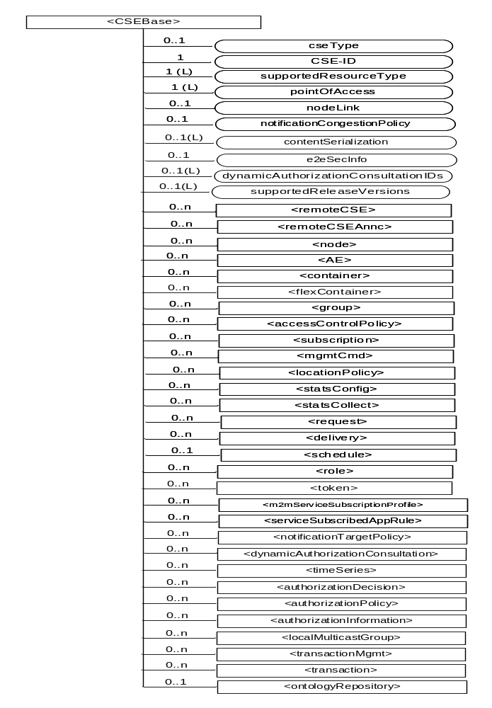
Figure 9.6.3-1: Structure of <CSEBase> resource
Figure 9.6.3-1 does not show the child announce resource types defined in table 9.6.3-2.
The <CSEBase> resource shall contain the child resources specified in table 9.6.3-1.
Table 9.6.3-1: Child resources of <CSEBase> resource
Child Resources of <CSEBase> | Child Resource Type | Multiplicity | Description
[variable] | <remoteCSE> | 0..n | See clause 9.6.4
[variable] | <remoteCSEAnnc> | 0..n | Announced variant of <remoteCSE>. Resource with CSE-specific information for a CSE that announced itself to another CSE with which it does not have a registration relationship.
[variable] | <node> | 0..n | See clause 9.6.18
[variable] | <AE> | 0..n | See clause 9.6.5
[variable] | <container> | 0..n | See clause 9.6.6
[variable] | <flexContainer> | 0..n | See clause 9.6.35
[variable] | <group> | 0..n | See clause 9.6.13
[variable] | <accessControlPolicy> | 0..n | See clause 9.6.2
[variable] | <subscription> | 0..n | See clause 9.6.8
[variable] | <mgmtCmd> | 0..n | See clause 9.6.16
[variable] | <locationPolicy> | 0..n | See clause 9.6.10
[variable] | <statsConfig> | 0..n | See clause 9.6.23
[variable] | <statsCollect> | 0..n | See clause 9.6.25
[variable] | <request> | 0..n | See clause 9.6.12
[variable] | <delivery> | 0..n | See clause 9.6.11
[variable] | <schedule> | 0..1 | This resource defines the reachability schedule information of the entity. The absence of this resource implies the entity is always reachable. See clause 9.6.9
[variable] | <role> | 0..n | See clause 9.6.38
[variable] | <token> | 0..n | See clause 9.6.39
[variable] | <m2mServiceSubscriptionProfile> | 0..n | See clause 9.6.19
[variable] | <serviceSubscribedAppRule> | 0..n | See clause 9.6.29
[variable] | <notificationTargetPolicy> | 0..n | See clause 9.6.32
[variable] | <dynamicAuthorizationConsultation> | 0..n | See clause 9.6.40
[variable] | <timeSeries> | 0..n | See clause 9.6.36
[variable] | <authorizationDecision> | 0..n | See clause 9.6.41
[variable] | <authorizationPolicy> | 0..n | See clause 9.6.42
[variable] | <authorizationInformation> | 0..n | See clause 9.6.43
[variable] | <localMulticastGroup> | 0..n | See clause 9.6.44
[variable] | <transactionMgmt> | 0..n | See clause 9.6.47
[variable] | <transaction> | 0..n | See clause 9.6.48
[variable] | <ontologyRepository> | 0..1 | See clause 9.6.50

An instance of a <remoteCSEAnnc> resource shall be created as a child of a <CSEBase> resource when an Originator CSE of an announcement request (i.e. original resource Hosting CSE) and a targeted Hosting CSE of an announced resource (i.e. announced resource Hosting CSE) have no registration relationship (e.g. the Originator CSE has not created <remoteCSE> resource on the Hosting CSE), see clause 9.6.26.
The <CSEBase> resource shall contain the attributes specified in table 9.6.3-2.
Table 9.6.3-2: Attributes of <CSEBase> resource
Attributes of <CSEBase> | Multiplicity | RW/  RO/  WO | Description
resourceType | 1 | RO | See clause 9.6.1.3.
resourceID | 1 | RO | See clause 9.6.1.3.
resourceName | 1 | RO | See clause 9.6.1.3.
parentID | 1 | RO | See clause 9.6.1.3. Shall be NULL.
creationTime | 1 | RO | See clause 9.6.1.3.
lastModifiedTime | 1 | RO | See clause 9.6.1.3.
accessControlPolicyIDs | 0..1 (L) | RO | See clause 9.6.1.3.
labels | 0..1 (L) | RO | See clause 9.6.1.3.
dynamicAuthorizationConsultationIDs | 0..1 (L) | RO | See clause 9.6.1.3.
cseType | 0..1 | RO | Indicates the type of CSE represented by the created resource:  - Mandatory for an IN-CSE, hence multiplicity (1).  - Its presence is subject to SP configuration in case of an ASN-CSE or a MN-CSE.
CSE-ID | 1 | RO | The CSE identifier in SP-relative CSE-ID format (clause 7.2).
supportedResourceType | 1 (L) | RO | List of the resource types which are supported in the CSE. This attribute contains subset of resource types listed in clause 9.2.
pointOfAccess | 1 (L) | RO | Represents the list of physical addresses to be used by remote CSEs to connect to this CSE (e.g. IP address, FQDN). This attribute is exposed to its Registree.
nodeLink | 0..1 | RO | The resource identifier of a <node> resource that stores the node specific information of the node on which the CSE represented by this <CSEBase> resource resides.
notificationCongestionPolicy | 0..1 | RO | This attribute applies to CSEs generating subscription notifications. It specifies the rule which is applied when the storage of notifications for each subscriber (an AE or CSE) reaches the maximum storage limit for notifications for that subscriber. E.g. Delete stored notifications of lower notificationStoragePriority to make space for new notifications of higher notificationStoragePriority, or delete stored notifications of older creationTime to make space for new notifications when all notifications are of the same notificationStoragePriority.
contentSerialization | 0..1 (L) | RO | The list of supported serializations of the Content primitive parameter for receiving a request from its registrants. (e.g. XML, JSON). The list shall be ordered so that the most preferred format comes first.
e2eSecInfo | 0..1 | RO | See clause 9.6.1.3.
supportedReleaseVersions | 0..1 (L) | RO | List of oneM2M release versions which are supported by the CSE. The CSE shall allow Registree AEs and CSEs to register (i.e. create <AE> and <remoteCSE> resources) if the Registree’s supported release version(s) matches one of the supported release versions in this list. Otherwise, the registration shall not be permitted.  Starting with Release 3, this attribute is mandatory for a CSE. For CSEs compliant to older releases, this attribute is optional. For CSEs that do not include this attribute, the default release version shall be Release 2.

9.6.4 Resource Type remoteCSE
A <remoteCSE> resource shall represent a Registree CSE that is registered to the Registrar CSE. <remoteCSE> resources shall be located directly under the <CSEBase> resource of Registrar CSE.
Similarly <remoteCSE> resource shall also represent a Registrar CSE. <remoteCSE> resource shall be located directly under the <CSEBase> resource of Registree CSE.
For example, when CSE1 (Registree CSE) registers with CSE2 (Registrar CSE), there will be two <remoteCSE> resources created: one in CSE1: <CSEBase1>/<remoteCSE2> and one in CSE2: <CSEBase2>/<remoteCSE1>.
Note that the creation of the two resources does not imply mutual registration. The <CSEBase1>/<remoteCSE2> does not mean CSE2 registered with CSE1 in the example above.

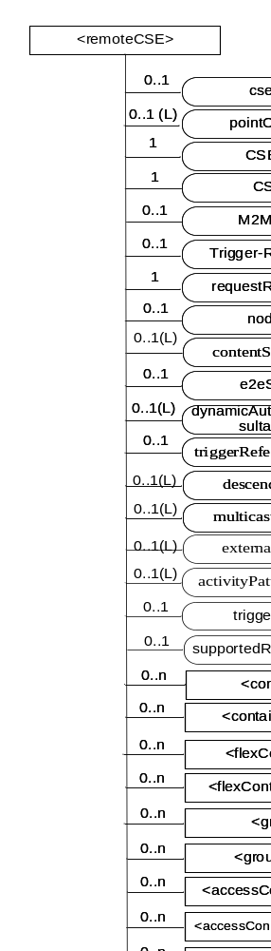
Figure 9.6.4-1: Structure of <remoteCSE> resource
The <remoteCSE> resource shall contain the child resources specified in table 9.6.4-1. The <remoteCSE> resource may contain <remoteCSEAnnc> child resources.
Table 9.6.4-1: Child resources of <remoteCSE> resource
Child Resources of <remoteCSE> | Child Resource Type | Multiplicity | Description | <remoteCSEAnnc> Child Resource Types
[variable] | <container> | 0..n | See clause 9.6.6 | <container>
[variable] | <containerAnnc> | 0..n | Announced variant of <container>. See clause 9.6.6 | <containerAnnc>
[variable] | <flexContainer> | 0..n | See clause 9.6.35 | <flexContainer>
[variable] | <flexContaineAnnc> | 0..n | Announced variant of <flexContainer>. See clause 9.6.35 | <flexContainerAnnc>
[variable] | <group> | 0..n | See clause 9.6.13 | <group>
[variable] | <groupAnnc> | 0..n | Announced variant of <group>. See clause 9.6.13 | <groupAnnc>
[variable] | <accessControlPolicy> | 0..n | See clause 9.6.2 | <accessControlPolicy>
[variable] | <accessControlPolicyAnnc> | 0..n | Announced variant of <accessControlPolicy>. See clause 9.6.2 | <accessControlPolicyAnnc>
[variable] | <subscription> | 0..n | See clause 9.6.8 | <subscription>
[variable] | <pollingChannel> | 0..1 | See clause 9.6.21. If requestReachability is FALSE, the CSE that created this <remoteCSE> resource should create a <pollingChannel> resource and perform long polling. The <pollingChannel> shall be utilized by the the parent resource. | None
[variable] | <nodeAnnc> | 0..n | Announced variant of <node>. This announced resource is assoiated with a <node> resource that is hosted on a CSE which is represented by the parent <remoteCSE> or <remoteCSEAnnc> resource. See clause 9.6.18 for <node>. | <nodeAnnc>
[variable] | <dynamicAuthorizationConsultation> | 0..n | See clause 9.6.40
[variable] | <timeSeries> | 0..n | See clause 9.6.36 | <timeSeries>
[variable] | <timeSeriesAnnc> | 0..n | Announced variant of <timeSeries>. See clause 9.6.36 | <timeSeriesAnnc>
[variable] | <remoteCSEAnnc> | 0..n | Announced variant of <remoteCSE> defined in the present clause 9.6.4. | <remoteCSEAnnc>
[variable] | <AEAnnc> | 0..n | Announced variant of <AE>. See clause 9.6.5 | <AEAnnc>
[variable] | <locationPolicyAnnc> | 0..n | Announced variant of <locationPolicy>. See clause 9.6.10 | <locationPolicyAnnc>
[variable] | <transactionMgmt> | 0..n | See clause 9.6.47 | <transactionMgmt>
[variable] | <transaction> | 0..n | See clause 9.6.48 | <transaction>
[variable] | <ontologyRepositoryAnnc> | 0..1 | Announced variant of <ontologyRepository>. See clause 9.6.50 | <ontologyRepositoryAnnc>
[variable] | <multimediaSession> | 0..n | See Clause 9.6.x. This resources holds information describing the established multimedia session | None

The <remoteCSE> resource shall contain the attributes specified in table 9.6.4-2.
Table 9.6.4-2: Attributes of <remoteCSE> resource
Attributes of <remoteCSE> | Multiplicity | RW/  RO/  WO | Description | <remoteCSEAnnc> Attributes
resourceType | 1 | RO | See clause 9.6.1.3. | NA
resourceID | 1 | RO | See clause 9.6.1.3. | NA
resourceName | 1 | WO | See clause 9.6.1.3. | NA
parentID | 1 | RO | See clause 9.6.1.3. | NA
creationTime | 1 | RO | See clause 9.6.1.3. | NA
lastModifiedTime | 1 | RO | See clause 9.6.1.3. | NA
expirationTime | 1 | RW | See clause 9.6.1.3. | MA
accessControlPolicyIDs | 0..1 (L) | RW | See clause 9.6.1.3. | MA
labels | 0..1 (L) | RW | See clause 9.6.1.3. | MA
announceTo | 0..1 (L) | RW | See clause 9.6.1.3. | NA
announcedAttribute | 0..1 (L) | RW | See clause 9.6.1.3. | NA
dynamicAuthorizationConsultationIDs | 0..1 (L) | RW | See clause 9.6.1.3. | OA
cseType | 0..1 | WO | Indicates the type of CSE represented by the created resource.  - Mandatory for an IN-CSE, hence multiplicity (1).  - Its presence is subject to SP configuration in case of an ASN-CSE or a MN-CSE. | OA
pointOfAccess | 0..1 (L) | RW | For request-reachable remote CSE it represents the list of physical addresses to be used to connect to it (e.g. IP address, FQDN).  If this information is not provided and <pollingChannel> resource does exis, the CSE should use <pollingChannel> resource. Then the Hosting CSE can forward a request to the CSE without using the PoA. | OA
CSEBase | 1 | WO | The address of the <CSEBase> resource represented by this <remoteCSE> resource. | OA
CSE-ID | 1 | WO | The CSE identifier of the remote CSE represented by this <remoteCSE> resource in SP-relative CSE-ID format (clause 7.2). | OA
M2M-Ext-ID | 0..1 | RW | Supported when Registrar is IN-CSE.  See clause 7.1.8 where this attribute is described. This attribute is used only for the case of dynamic association of M2M-Ext-ID and CSE-ID. | NA
Trigger-Recipient-ID | 0..1 | RW | Supported when Registrar is IN-CSE. See clause 7.1.10 where this attribute is described. This attribute is used only for the case of dynamic association of M2M-Ext-ID and CSE-ID. | NA
requestReachability | 1 | RW | This attribute is an indication of static capability of the CSE that created this <remoteCSE> resource. If the CSE can receive requests originated at or forwarded by its registar CSE, this attribute is set to "TRUE" otherwise "FALSE" (see note). | OA
nodeLink | 0..1 | RW | The resource identifier of a <node> resource that stores the node specific information of the node on which the CSE represented by this <remoteCSE> resource resides. | OA
contentSerialization | 0..1 (L) | RW | The list of supported serializations of the Content primitive parameter for receiving a request (e.g. XML, JSON). The list shall be ordered so that the most preferred format comes first. | OA
e2eSecInfo | 0..1 | RW | See clause 9.6.1.3. | MA
triggerReferenceNumber | 0..1 | RW | This is to identify device trigger procedure request. This attribute is used only for device trigger and assigned by the IN-CSE. | NA
descendantCSEs | 0..1(L) | RW | This attribute contains a list of identifiers of descendent CSEs of the Registree CSE represented by this <remoteCSE> resource. A descendant CSE is a CSE that either registers to the CSE represented by this <remoteCSE>, or registers to another CSE which is a descendant CSE of this <remoteCSE>. The Registree CSE represented by this <remoteCSE> shall configure this attribute with a list of descendent CSEs upon creation of the <remoteCSE> resource. The Registree CSE shall update this attribute whenever a new descendent CSE either registers or de-registers. The Registree CSE shall detect when a descendent CSE registers or de-registers by monitoring its <remoteCSE> resources and the descendentCSEs attribute(s) of these <remoteCSE> resources.  For a <remoteCSE> resource representing a Registrar CSE this attribute shall not be set. | OA
multicastCapability | 0..1(L) | RW | Indicates the oneM2M node multicast Capability, pre-defined values are:  - MBMS  IP | OA
externalGroupID | 0..1(L) | RW | Supported when Registrar CSE is IN-CSE. It is the External-Group-ID as specified in 3GPP TS23.682 [i.14] clause 4.6.3. It is the globally unique ID exposed by the underlying network that is mapped to an internally used identifier for a specific group related services. | OA
triggerEnable | 0..1 | RW | When set to “TRUE”, trigger requests may be sent to the CSE represented by this <remoteCSE> resource. When set to “FALSE” trigger requests shall not be sent to this CSE. | OA
activityPatternElements | 0..1(L) | RW | This attribute describes the anticipated availability of the CSE for communications. See further description below and table 9.6.4-3. | OA
supportedReleaseVersions | 0..1(L) | WO | The oneM2M release versions supported by the CSE represented by this <remoteCSE> resource.  Starting with Release 3, this attribute is mandatory for a CSE. For CSEs compliant to older releases, this attribute is optional. For CSEs that do not include this attribute, the default release version shall be Release 2. | MA
NOTE: Even if this attribute is set to "FALSE", it is not meant that the CSE is always unreachable by its registrees. E.g. if the CSE and its registrees are behind the same NAT, then the CSE can receive requests from its registrees. See also pollingChannel description in clause 9.6.21.

The set of activity patterns represented in the activityPatternElements attribute describes the anticipated availability of the CSE for communications. The set provides the anticipated activity timing pattern, and may provide additional information about the anticipated mobility status and expected data size to be exchanged. Each activityPatternElements item is comprised of triples (scheduleElement, stationaryIndication, dataSizeIndicator) with parameters shown and described in table 9.6.4-3.
Table 9.6.4-3: Parameters in activityPatternElements triple
Name | Description
scheduleElement | See clause 9.6.9. This parameter shall be composed from seven fields of second, minute, hour, day of month, month, day of week and year. This is a mandatory parameter in the triple. This parameter indicates the times when the entity is available to send and receive primitives.
stationaryIndication | It indicates the field node as 'Stationary (Stopping)' or 'Mobile (Moving)' for the traffic pattern. The default value is NULL, denoting that no stationaryIndication is provided
dataSizeIndicator | It indicates the expected data size for the traffic pattern. The default value is NULL, denoting that no dataSizeIndicator is provided.

9.6.5 Resource Type AE
An <AE> resource shall represent information about an Application Entity registered to a CSE.
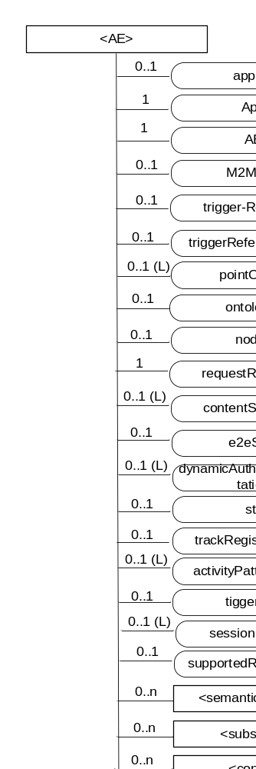
Figure 9.6.5-1: Structure of <AE> resource
The <AE> resource shall contain the child resources specified in table 9.6.5-1.
Table 9.6.5-1: Child resources of <AE> resource
Child Resources of <AE> | Child Resource Type | Multiplicity | Description | <AEAnnc> Child Resource Types
[variable] | <semanticDescriptor> | 0..n | See clause 9.6.30 | <semanticDescriptor>, <semanticDescriptorAnnc>
[variable] | <subscription> | 0..n | See clause 9.6.8 | <subscription>
[variable] | <container> | 0..n | See clause 9.6.6 | <container> <containerAnnc>
[variable] | <flexContainer> | 0..n | See clause 9.6.35 | <flexContainer>  <flexContainerAnnc>
[variable] | <group> | 0..n | See clause 9.6.13 | <group>  <groupAnnc>
[variable] | <accessControlPolicy> | 0..n | See clause 9.6.2 | <accessControlPolicy>  <accessControlPolicyAnnc>
[variable] | <pollingChannel> | 0..1 | See clause 9.6.21  When the AE is request-unreachable, the AE should create this <pollingChannel> resource and perform long polling. The <pollingChannel> shall be utilized by the parent resource | None
[variable] | <dynamicAuthorizationConsultation> | 0..n | See clause 9.6.40 | None
[variable] | <timeSeries> | 0..n | See clause 9.6.36 | <timeSeries>  <timeSeriesAnnc>
[variable] | <transactionMgmt> | 0..n | See clause 9.6.47 | <transactionMgmt>
[variable] | <transaction> | 0..n | See clause 9.6.48 | <transaction>
[variable] | <triggerRequest> | 0..n | See clause 9.6.49 | None
[variable] | <multimediaSession> | 0..n | See Clause 9.6.57. This resources holds information describing the established multimedia session | None

The <AE> resource shall contain the attributes specified in table 9.6.5-2.
Table 9.6.5-2: Attributes of <AE> resource
Attributes of  <AE> | Multiplicity | RW/  RO/  WO | Description | <AEAnnc> Attributes
resourceType | 1 | RO | See clause 9.6.1.3. | NA
resourceID | 1 | RO | See clause 9.6.1.3. Contains the AE-ID-Stem of the AE (see clause 7.2 on identifier formats and clause 10.2.2.2 for AE registration procedure). | NA
resourceName | 1 | WO | See clause 9.6.1.3. | NA
parentID | 1 | RO | See clause 9.6.1.3. | NA
expirationTime | 1 | RW | See clause 9.6.1.3. | MA
accessControlPolicyIDs | 0..1 (L) | RW | See clause 9.6.1.3. | MA
creationTime | 1 | RO | See clause 9.6.1.3. | NA
lastModifiedTime | 1 | RO | See clause 9.6.1.3. | NA
labels | 0..1 (L) | RW | See clause 9.6.1.3. | MA
announceTo | 0..1 (L) | RW | See clause 9.6.1.3. | NA
announcedAttribute | 0..1 (L) | RW | See clause 9.6.1.3. | NA
dynamicAuthorizationConsultationIDs | 0..1 (L) | RW | See clause 9.6.1.3. | OA
appName | 0..1 | RW | The name of the application, as declared by the application developer(e.g. "HeatingMonitoring").  Several sibling resources may share the appName. | OA
App-ID | 1 | WO | The identifier of the Application (see clause 7.1.3). | OA
AE-ID | 1 | RO | The identifier of the Application Entity (see clause 7.1.2). | OA
M2M-Ext-ID | 0..1 | RW | Supported when Registrar is IN-CSE.  See clause 7.1.8 where this attribute is described. This attribute is used only for the case of dynamic association of M2M-Ext-ID and AE-ID. | NA
trigger-Recipient-ID | 0..1 | RW | Supported when Registrar is IN-CSE. See clause 7.1.10 where this attribute is described. This attribute is used only for the case of dynamic association of M2M-Ext-ID and AE-ID. | NA
triggerReferenceNumber | 0..1 | RW | This is to identify device trigger procedure request. This attribute is used only for device trigger and assigned by the IN-CSE. | NA
pointOfAccess | 0..1 (L) | RW | The list of addresses for communicating with the registered Application Entity over Mca reference point via the transport services provided by Underlying Network (e.g. IP address, FQDN, URI). This attribute shall be accessible only by the AE and the Hosting CSE.  If this information is not provided and the <pollingChannel> resource does exist, the AE should use <pollingChannel> resource. Then the Hosting CSE can forward a request to the AE without using the PoA. | OA
status | 0..1 | RW | Denotes status of the AE registration. If ACTIVE, the <AE> resource and all its child resources may be discoverable. If INACTIVE, the <AE> resource and all its child resources shall not be discoverable.  Set to ACTIVE during a AE registration or re-registration. When an AE changes its registration point, the registration at the old registration point is set to INACTIVE . | OA
trackRegistrationPoints | 0..1 | RW | Denotes if the Application Entity requests that its Registration Points be tracked. If TRUE, AE requests to be tracked as it changes its Registration Points. If FALSE, the AE requests not to be tracked as it changes its Registration Points. | OA
ontologyRef | 0..1 | RW | A URI of the ontology used to represent the information that is managed and understood by the AE. | OA
requestReachability | 1 | RW | This attribute is an indication of static capability of the AE that created this <AE> resource. If the AE can receive requests s originated at or forwarded by its registar CSE, this attribute is set to "TRUE" otherwise "FALSE". | OA
nodeLink | 0..1 | RW | The resource identifier of a <node> resource that stores the node specific information of the node on which the AE represented by this <AE> resource resides. | OA
contentSerialization | 0..1 (L) | RW | The list of supported serializations of the Content primitive parameter for receiving a request from its registrar CSE. (e.g. XML, JSON). The list shall be ordered so that the most preferred format comes first. | OA
e2eSecInfo | 0..1 | RW | See clause 9.6.1.3. | MA
activityPatternElements | 0..1(L) | RW | This attribute describes the anticipated availability of the AE for communications. See further description below and table 9.6.4-3 | OA
triggerEnable | 0..1 | RW | When set to “TRUE”, trigger requests may be sent to the AE represented by this <AE> resource. When set to “FALSE” trigger requests shall not be sent to this AE. | OA
sessionCapabilities | 0..1 (L) | RW | The list of supported session media types (e.g. audio, video, image) and supported session protocols (e.g. RTP, RTP/AVP) as defined by session parameters as defined by the IETF IANA Session Descriptor Protocol (SDP) Parameter Registry. | OA
supportedReleaseVersions | 0..1(L) | WO | The oneM2M release versions supportedby the Registree AE represented by this <AE> resource.  Starting with Release 3, this attribute is mandatory for an AE. For AEs compliant to older releases, this attribute is optional. For AEs that do not include this attribute, the default release version shall be Release 2. | MA

The set of activity patterns represented in the activityPatternElements attribute describes the anticipated availability of the AE for communications. The set provides the anticipated activity timing pattern and might provide additional information about the anticipated mobility status and expected data size to be exchanged . Each activityPatternElements item is comprised of triples (scheduleElement, stationaryIndication, datasizeIndicator) with parameters shown and described in table 9.6.4-3.

-----------------------End of change 3---------------------------------------------

-----------------------Start of change 4---------------------------------------------

10.2.2.7 Create <remoteCSE>
This procedure shall be used for creating a <remoteCSE> resource. It is part of the registration procedure for remote CSEs on the Registrar CSE (which is also the Hosting CSE), as described in clause 10.2.2.7.
Table 10.2.2.7-1: <remoteCSE> CREATE
<remoteCSE> CREATE
Associated Reference Point | Mcc and Mcc'
Information in Request message | All parameters defined in table 8.1.2-3 apply with the specific details for:  From: Originator CSE-ID  Content: The resource content shall provide the information as defined in clause 9.6.4
Processing at Originator before sending Request | According to clause 10.2.2.7
Processing at Receiver | According to clause 10.2.2.7 with the following specific processing:  If the Receiver CSE has registered to another CSE, the Receiver CSE shall send an update request to its Registrar CSE to add the CSE-IDs of the Originator CSE and the Originator CSE’s descendants into the descendantCSEs attribute of the Receiver CSE’s <remoteCSE> hosted by the Registrar CSE.  If the IN-CSE is the receiver and if the M2M SP policies do allow access to the CSEs across multiple domains, then the IN shall create the appropriate entry in the M2M SP's DNS for successfully registered CSE
Information in Response message | All parameters defined in table 8.1.3-1 apply with the specific details for:  Content: Address of the created <remoteCSE> resource, according to clause 10.2.2.7
Processing at Originator after receiving Response | According to clause 10.1.1.2.1. the Originator upon receipt of successful CREATE response message, shall create <remoteCSE> resource locally and thereafter, it may issue a Retrieve request to its Registrar CSE’s <CSEBase> resource to update the optional attributes of locally created <remoteCSE> resource.
Exceptions | According to clause 10.2.2.7

The procedure for CSE Registration follows the procedure described in clause 10.1.2, but with some deviations. Below is the detailed description on how to perform the CSE Registration and which part of the procedure deviates from the one described in clause 10.1.2.
The Registration procedure requires the creation of two resources. A <remoteCSE> resource representing the Originator CSE is created under the <CSEBase> of the Receiver CSE and a <remoteCSE> resource representing the Receiving CSE is created under the <CSEBase> resource of the Originator CSE. The creation of <remoteCSE> resource representing the Receiving CSE is achieved by remotely retrieving the <CSEBase> resource of the Receiving CSE.
The Registration procedure is always initiated by a CSE in the field domain except in the inter-domain case described in clause 6.5.
Originator: The Originator shall be the registering CSE.
Receiver: The Receiver shall create the <remoteCSE> resource.
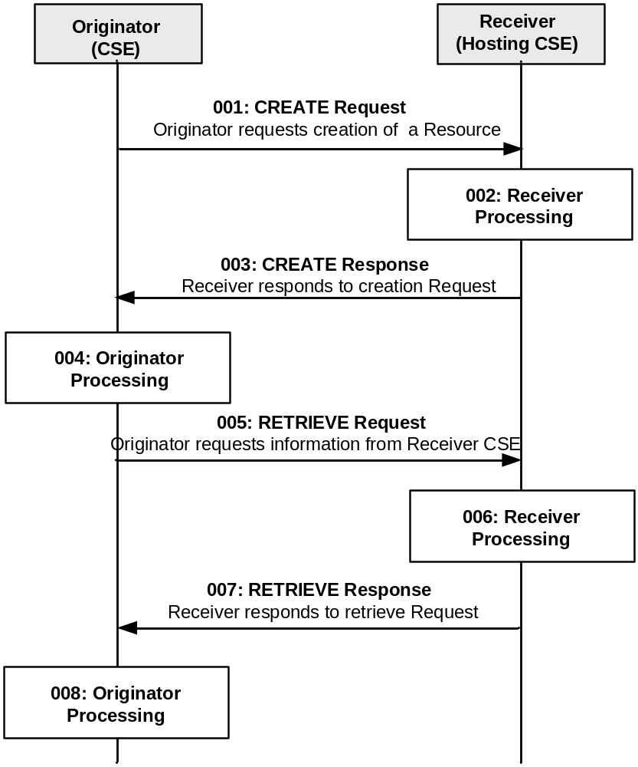
Figure 10.2.2.7-1: Procedure for CREATEing a <remoteCSE> Resource
All the parameters of the request and steps that are not indicated do not deviate from clause 10.1.2.
Step 001: The Originator shall send mandatory parameters and may send optional parameters in Request message for CREATE operation as specified in clause 8.1.2. The Orignator may configure the supportedReleaseVersions attribute with its supported release version(s) in the CREATE request.
Step 002: The Receiver shall:
- The Registrar CSE shall allow unknown remote CSE to attempt to ‘CREATE’ when it was authenticated by credential provided by the entity. See TS-0003[2] further detail about authentication for the CSE. The Registrar CSE shall only allow a remote CSE to ‘CREATE’ when the supported release versions of the remote CSE matches one of the supported release versions of the Registrar CSE. If a match is not found, the registration shall not be allowed and the Registrar CSE shall respond with an error. To make this determination, the Registrar CSE shall compare the supportedReleaseVersions attribute, if present, in the Content parameter of the CREATE request against the supportedReleaseVersions attribute, if present, of the Registrar CSE’s <CSEBase> resource. If the supportedReleaseVersions is not present in the CREATE request, the Registrar CSE shall assume the default release version of the remote CSE is Release 2. If the supportedReleaseVersions is not configured in the Registrar CSE’s <CSEBase> resource, the default release version of the Registrar CSE shall be Release 2.
- Perform sub-steps: 2)-8), from step 002 from clause 10.1.2 are applicable.
NOTE: Optionally, if the M2M Service Provider supports inter-domain communication, the Receiver could perform this step if the attribute CSEBase (part of the Content parameter of the request) contains the public domain of the CSE. The Receiver could construct the domain as described in clause 6.4 and 6.5. The Receiver could add an AAA or AAAA record in DNS with the public domain name of the Originator CSE and the IP address of the IN-CSE associated with the Originator.
Step 003: See clause 10.1.2.
Step 004: The Originator, upon receipt of the successful CREATE response message, shall create a <remoteCSE> resource locally under its <CSEBase> resource. This resource is representing the Receiver CSE. The Originator shall provide the appropriate values to all mandatory parameters as described in clause 9.6.4.
Step 005: The Originator may issue a RETRIEVE Request towards the Receiver (same To as for the CREATE request message) to obtain the <CSEBase> resource of the Receiver. The RETRIEVE procedure is described in clause 10.1.3.
See clauses 8.1.2 for the information to be included in the Request message.
Step 006: The Receiver verifies that the Originator has the appropriate privileges to access the information.
Step 007: The Receiver sends a RETRIEVE response message, according to the procedure described in clause 10.1.3.
See clauses 8.1.3 and 8.1.4 for the information to be included in the Response message.
Step 008: The Originator shall create a <remoteCSE> resource for the Receiver under the <CSEBase> resource of the Originator with the information obtained in step 007.
General Exceptions:
All exceptions from clause 10.1.2 are applicable; in addition the following exception may occur:
- The Originator does not have the privileges to retrieve the attributes of the Receiver CSE. The Receiver responds with an error.

-----------------------End of change 4---------------------------------------------

-----------------------Start of change 5---------------------------------------------

10.2.2.2 Create <AE>
This procedure shall be used for creating an <AE> resource. This operation is part of the registration procedure for AEs on the Registrar CSE (which is also the Hosting CSE), as described in clause 10.2.2.2.
Table 10.2.2.2-1: <AE> CREATE
<AE> CREATE
Associated Reference Point | Mca
Information in Request message | All parameters defined in table 8.1.2-3 apply with the specific details for:  From: Registree AE only  Content: The resource content shall provide the information as defined in clause 9.6.5
Processing at Originator before sending Request | According to clause 10.2.2.2
Processing at Receiver | According to clause 10.2.2.2
Information in Response message | All parameters defined in table 8.1.3-1
Processing at Originator after receiving Response | According to clause 10.2.2.2
Exceptions | According to clause 10.2.2.2

The procedure for AE registration follows the message flow description depicted in figure 10.2.2.2-1. It defines in which cases additional procedures need to be initiated by the Registrar CSE for creating or updating of <AEAnnc> resources hosted on the M2M SP's IN-CSE in case an AE-ID-Stem starting with an 'S' character shall be used, see table 7.2-1 for the definition of AE-ID-Stem.
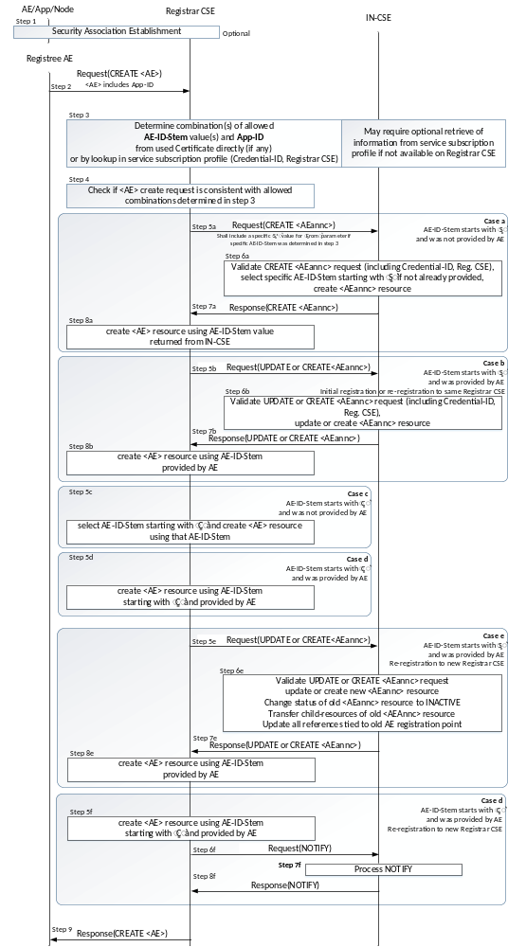
Figure 10.2.2.2-1: Procedure for Creating an <AE> Resource
Originator: The Originator shall be the Registree AE.
Receiver: The Receiver shall allow the creation of the <AE> resource according to the access control policy and information in the applicable m2m service subscription profile. To validate the m2m service subscription profile, the Receiver shall check the corresponding <serviceSubscribedNode> resource, by matching the CSE-ID in the m2m service subscription profile against the Receiver owned CSE-ID. Subsequently the Receiver shall check whether the Registree AE is included in the linked (i.e. ruleLinks attribute) <serviceSubscribedAppRules> resource(s).
Step 001: Optional: In case the Registree AE intends to use a Security Association to perform the registration, a Security Association Establishment procedure (see clause 11.2.2) shall get carried out first. In some cases (e.g. registration of AE internal to an MN or ASN), this may not be required depending on deployment choices of the M2M SP. Therefore, this step is optional. This optional Security Association can be established between the following entities:
- The Registree AE and the Registrar CSE - in which case the specific AE that is subsequently sending the request to get registered shall be authenticated.
- The Node on which the Registree AE is hosted and the Registrar CSE - in which case only the Node from which the registration request is received at the Registrar CSE shall be authenticated. In this case one or more AEs hosted on the authenticated node may communicate over either a single Security Association or over individual Security Associations.
NOTE: The Node authentication should be used only when the M2M Service Provider trusts the AE (on the Node) to provide the correct AE-ID and App-ID. The present document does not provide mechanisms by which the M2M Service Provider can obtain assurance about the trustworthiness of the AE when using Node authentication. For example, such a mechanism (by which the M2M Service Provider can obtain assurance about the trustworthiness of the AE) could be provided by executing the M2M Application on a secure environment.
The identifier of the security credentials used for establishing the Security Association in this step shall be termed 'Credential-ID' for the remainder of this procedure description. If no Security Association has been performed the Credential-ID shall be assumed to have the value 'None'.
Step 002: The Originator shall send the information defined in clause 10.1.2 for the registration CREATE procedure with the following specific information in the CREATE Request message:
From: AE-ID-Stem or Not Present:
- In case the Registree AE has already registered successfully before, then deregistered and intends to register again to the same Registrar CSE with the same AE-ID-Stem value as before, the Registree AE shall include that AE-ID-Stem value into the From parameter.
- In case the Registree AE intends to initiate a fresh registration with a pre-provisioned AE-ID-Stem value, the Registree AE shall include that pre-provisioned AE-ID-Stem value into the From parameter.
- In case the Registree AE has not registered successfully before and intends to get an M2M-SP-assigned AE-ID-Stem starting with an 'S' character assigned to itself but it does not have any specific value to suggest, it shall set the From parameter to the character 'S'.
- In case the Registree AE has not registered successfully before and intends to get a Registrar CSE-assigned AE-ID-Stem starting with an 'C' character assigned to itself but it does not have any specific value to suggest, it shall set the From parameter to the character 'C'.
- In case the Registree AE intends to initiate a fresh registration and has no preference for the AE-ID-Stem value, the From parameter shall not be sent.
- In case the Registree AE has already registered successfully to a Registrar CSE, and now intends to register to a different Registrar CSE (i.e. Registree AE has changed its registration point), the Registree AE shall include its AE-ID-Stem value (from the prior registration) into the From parameter.
The Orignator may configure the supportedReleaseVersions attribute with its supported release versions in the CREATE request.
The CSE shall allow unknown AEs to attempt the ‘CREATE’ before they are granted this permission. See TS-0003[2] for further details about authentication for the AE.
Step 003: The Receiver (i.e. Registrar CSE) shall determine whether the request to register the Registree AE meets any of the following conditions:
- In case the Security Association Establishment in Step 001 was performed using security credentials in form of a Certificate that included an App-ID and an AE-ID-Stem attribute, check if they match with the App-ID attribute in the Content parameter of the request and the AE-ID-Stem in the From parameter of the request.
- Check if the applicable service subscription profile lists a combination of (allowed AE-ID-Stem value and allowed App-ID value) for the Credential-ID and the Registrar CSE-ID (see clause 11.2.2) that match with the App-ID attribute in the Content parameter of the request and the AE-ID-Stem in the From parameter of the request. If the information needed to perform that checking is not available to the Registrar CSE locally, the Registrar CSE shall retrieve that information from the applicable service subscription profile(s) from the IN-CSE. If the From parameter was not set in the request and the allowed AE-ID-Stem includes a wild card ("*") in the applicable service subscription profile(s), the Registrar CSE shall assign the starting character ('S', 'C') in accordance with provisioned Service Provider policy. The applicable rules for this checking are contained in the <serviceSubscribedAppRule> resource(s) which are linked to by the ruleLinks attribute of the <m2mServiceSubscribedNode> resource(s) associated with the Registrar CSE. The <m2mServiceSubscribedNode> resource(s) associated with the Registrar CSE can be retrieved from the IN-CSE by applying the Filter Criteria parameter set to "CSE-ID={Registrar-CSE-ID}"where {Registrar-CSE-ID} needs to be substituted by the actual CSE-ID of the Registrar-CSE.
If none of the conditions are met, the registration is not allowed and the Registrar CSE shall respond with an error.
The Registrar CSE shall also check the release versions of the Registree AE and only allow an AE to register when the supported release versions of the AE match at least one of the supported release versions of the Registrar CSE. If a match is not found, the registration shall not be allowed and the Registrar CSE shall respond with an error. To make this determination, the Registrar CSE shall compare the supportedReleaseVersions attribute, if present, in the Content parameter of the CREATE request against the supportedReleaseVersions attribute, if present, in the Registrar CSE’s <CSEBase> resource. If the supportedReleaseVersions is not present in the CREATE request, the Registrar CSE shall assume the default release version of the AE is Release 2. If the supportedReleaseVersions is not configured the Registrar CSE’s <CSEBase> resource, the Registrar CSE’s default release version shall be Release 2.
Step 004: If the From parameter of the request provides a complete AE-ID-Stem value, i.e. case i, ii, or vi of Step 002 applied, the Registrar CSE shall check whether an <AE> resource with an Unstructured-CSE-relative-Resource-ID identical to the AE-ID-Stem value provided in the From parameter of the request does already exist on the Registrar CSE. If so, there is still an active registration using the same AE-ID-Stem on the Registrar CSE and the Registrar CSE shall respond with an error. If not, the Registrar CSE shall perform action (3) in Step 002 of clause 10.1.2.
If the From parameter of the request provides a complete AE-ID-Stem and starts with ‘S’, i.e. case i, ii, or vi of Step 002 applied and ‘S’ is the first character of the provided AE-ID-Stem, and if the Registrar CSE determines that this is an initial registration or a re-registration to the same Registrar CSE, the procedure continues with case b) of the present step 004 below.
If the From parameter of the request provides a complete AE-ID-Stem and starts with ‘S’, i.e. case i, ii or vi of Step 002 applied and ‘S’ is the first character of the provided AE-ID-Stem, and if the Registrar CSE determines that this is a re-registration due to a change in registration point, and if the Registree AE requests not to be tracked as it changes its registration point (trackRegistrationPoints= TRUE), the procedure continues as an initial registration, with case b) of the present step 004 below.
If the From parameter of the request provides a complete AE-ID-Stem and starts with ‘S’, i.e. case i, ii or vi of Step 002 applied and ‘S’ is the first character of the provided AE-ID-Stem, and if the Registrar CSE determines that this is a re-registration due to a change in registration point, and if the Registree AE requests to be tracked as it changes its registration point (trackRegistrationPoints = FALSE), the procedure continues as a re-registration to a new Registrar CSE, with case e) of the present step 004 below.
If From parameter of the request provides a complete AE-ID-Stem and starts with ‘C’, i.e. case i, ii, or vi of Step 002 applied and ‘C’ is the first character of the provided AE-ID-Stem, and if the Registrar CSE determines that this is an initial registration or a re-registration to the same Registrar CSE, the procedure continues with case d) of the present step 004 below.
If From parameter of the request provides a complete AE-ID-Stem and starts with ‘C’, i.e. case i, ii or vi of Step 002 applied and ‘C’ is the first character of the provided AE-ID-Stem, and if the Registrar CSE determines that this is a re-registration due to a change in registration point, and if the Registree AE requests not to be tracked as it changes its registration point (trackRegistrationPoints = TRUE), the procedure continues as an initial registration, with case d) of the present step 004 below.
If From parameter of the request provides a complete AE-ID-Stem and starts with ‘C’, i.e. case i or ii or vi of Step 002 applied and ‘C’ is the first character of the provided AE-ID-Stem, and if the Registrar CSE determines that this is a re-registration due to a change in registration point, and if the Registree AE requests to be tracked as it changes its registration point (trackRegistrationPoints = FALSE), the procedure continues as a re-registration to a new Registrar CSE, with case f) of the present step 004 below.
If the From parameter of the request is equal to the value ‘S’, i.e. case iii of Step 002 applied, the procedure continues with case a) of the present step 004 below.
If the From parameter of the request is equal to the value ‘C’, i.e. case iv of Step 002 applied, the procedure continues with case c) of the present step 004 below.
If the From parameter of the request is not sent, the Registrar CSE shall perform action (3) in Step 002 of clause 10.1.2 to assign the resourceID with starting character ('S', 'C') in accordance with provisioned Service Provider policy and shall set the corresponding value in AE-ID-Stem. If the assigned value in AE-ID-Stem attribute starts with ‘S’, the procedure continues with case b) else the procedure continues with case d).
Case a) AE-ID-Stem starts with 'S' and AE does not include an AE-ID-Stem (initial registration):
Condition: In Step 003 it was determined that the AE-ID-Stem value to be used for the Registree AE starts with an 'S' character but no specific AE-ID-Stem was provided with the CREATE request of the Registree AE. This case applies when the Registree AE is supposed to use an M2M-SP-assigned AE-ID and wants to perform the initial registration:
- Step 005a: The Receiver shall send a CREATE request for an <AEAnnc> resource to the IN-CSE in order to create an <AEAnnc> resource on the IN-CSE that is associated with the Registree AE. The following information shall be sent with that CREATE request:
- In case no specific AE-ID-Stem value to be used for the Registree AE was determined during Step 003, the value 'S' shall be used in what follows for the AE-ID-Stem. Otherwise use the value determined in step 003.
- The From parameter of the CREATE request for the <AEAnnc> resource shall be set to the SP-relative-CSE-ID or Absolute-CSE-ID followed by ‘/S’.
- The link attribute of the <AEAnnc> resource to be created shall be set to the SP-Relative-Resource-ID format of a - not yet existent - <AE> resource hosted on the Registrar CSE constructed with a Unstructured-CSE-relative-Resource-ID that is equal to the AE-ID-Stem value used for the Registree AE.
- The App-ID attribute of the <AEAnnc> resource to be created shall be present and set to the App-ID attribute value of the Registree AE.
- The concatenation of the string 'Credential-ID:' and the actual Credential-ID of the Security Association used by the Registree AE - if any - shall be placed into the labels attribute of the <AE Annc> resource. If no noSecurity Association was used by the Registree AE, a value of 'None' shall be used for Credential-ID.
- Step 006a: Upon reception of the CREATE <AEAnnc> request, the IN-CSE shall validate the request and verify whether the provided values of the App-ID attribute and the AE-ID-Stem in the From parameter is allowed for the combination of Credential-ID included in the labels attribute and the CSE-ID of the Registrar CSE included in the link attribute, according to the applicable service subscription profile. If that verification is successful and no specific AE-ID-Stem is provided, i.e. if the From parameter contains only the character 'S', the IN-CSE shall select an AE-ID-Stem in line with the applicable service subscription profile.
- Step 007a: When the validation and verification in Step 006a completed successfully, the IN-CSE shall create <AEAnnc> resource with an Unstructured-CSE-relative-Resource-ID equal to the value of the AE-ID-Stem, replace the AE-ID-Stem for the trailing ‘S’ character in the Unstructured-CSE-relative-Resource-ID present in the link attribute if the AE-ID-Stem was selected by the IN-CSE, and send a successful response to the Registrar CSE.
- Step 008a: Upon reception of a successful response from the IN-CSE, the Registrar CSE shall use the Unstructured-CSE-relative-Resource-ID that was used for the <AEAnnc> resource on the IN-CSE also as the assigned Unstructured-CSE-relative-Resource-ID for the <AE> resource to be created on the Registrar CSE and continue with action (4) of Step 002 of the non-registration related CREATE procedure in clause 10.1.2.
Case b) AE-ID-Stem starts with 'S' and AE includes an AE-ID-Stem (initial registration or re-registration to the same Registrar CSE):
Condition: In Step 003 it was determined that the AE-ID-Stem value to be used for the Registree AE starts with an 'S' character and a specific AE-ID-Stem was provided with the CREATE request of the Registree AE. This case applies when the Registree AE is supposed to use an M2M-SP-assigned AE-ID and wants to perform initial registration or re-registration using its already assigned AE-ID-Stem:
- Step 005b: The receiver shall determine if an <AEAnnc> resource already exists on the IN-CSE that is associated with the Registree AE. The Receiver shall send an UPDATE request for an <AEAnnc> resource to the IN-CSE in order to update the already existing <AEAnnc> resource on the IN-CSE that is associated with the Registree AE in case of re-registration or the Receiver shall send a CREATE request for an <AEAnnc> resource to the IN-CSE in order to create an <AEAnnc> resource on the IN-CSE that is associated with the Registree AE in case of initial registration. The following information shall be sent with that UPDATE or CREATE request:
- The To parameter shall contain the SP-relative-Resource-ID format of the Resource ID for the <AEAnnc> resource which shall be constructed from the CSE-ID of the IN-CSE and the AE-ID-Stem that the Registree AE provided.
- From parameter of the CREATE or UPDATE request for the <AEAnnc> resource shall be set to the SP-relative-CSE-ID or Absolute-CSE-ID followed by ‘/’ and the AE-ID-Stem value.
- The link attribute of the <AEAnnc> resource shall be set (in case of initial registration) or updated (in case of re-registration) to the SP-Relative-Resource-ID format of a - not yet existent - <AE> resource hosted on the Registrar CSE constructed with an Unstructured-CSE-relative-Resource-ID that is equal to the AE-ID-Stem value used for the Registree AE.
- The labels attribute of the <AEAnnc> resource shall be set (in case of initial registration) or updated (in case of re-registration) to the concatenation of the string 'Credential-ID:' and the Credential-ID of the Security Association used by the Registree AE, replacing the existing entry starting with 'Credential-ID:' if present. If no Security Association was used by the Registree AE, a value of 'None' shall be used for Credential-ID.
- Step 006b: Upon reception of the CREATE or UPDATE <AEAnnc> request, the IN-CSE shall validate the request and verify whether the values suggested to be set or to be updated for the Credential-ID included in the labels attribute - if any - and the CSE-ID of the Registrar CSE included in the From parameter still match with any of the allowed combinations of App-ID attribute and the AE-ID-Stem in the link attributeaccording to the applicable service subscription profile.
- Step 007b: When the validation and verification in Step 006b completed successfully, the IN-CSE shall create <AEAnnc> resource with an Unstructured-CSE-relative-Resource-ID equal to the value of the provided AE-ID-Stem or update the <AEAnnc> resource in line with the parameters provided in step 005b.
- Step 008b: Upon reception of a successful response from the IN-CSE, the Registrar CSE shall use the Unstructured-CSE-relative-Resource-ID equal to the AE-ID-Stem provided by the Registree AE for the <AE> resource to be created on the Registrar CSE and continue with action (4) of Step 002 of the non-registration related CREATE procedure in clause 10.1.2.
Case c) AE-ID-Stem starts with 'C' and AE does not include an AE-ID-Stem (initial registration):
Condition: In Step 003 it was determined that the AE-ID-Stem value to be used for the Registree AE starts with an 'C' character but no specific AE-ID-Stem was provided with the CREATE request of the Registree AE. This case applies when the Registree AE is not supposed to use an M2M-SP-assigned AE-ID and wants to perform the initial registration:
Step 005c: The Registrar CSE shall select an AE-ID-Stem starting with a 'C' character and use it for the Unstructured-CSE-relative-Resource-ID for the <AE> resource to be created on the Registrar CSE and continue with action (4) of Step 002 of the non-registration related CREATE procedure in clause 10.1.2.
Case d) AE-ID-Stem starts with 'C' and AE includes an AE-ID-Stem (initial registration or re-registration registration to the same Registrar CSE):
Condition: In Step 003 it was determined that the AE-ID-Stem value to be used for the Registree AE starts with an 'C' character and a specific AE-ID-Stem was provided with the CREATE request of the Registree AE. This case applies when the Registree AE is not supposed to use an M2M-SP-assigned AE-ID and wants to perform initial registration or re-registration using its already assigned AE-ID-Stem:
- Step 005d: The Registrar CSE shall use the Unstructured-CSE-relative-Resource-ID equal to the AE-ID-Stem in the From parameter for the <AE> resource to be created on the Registrar CSE and continue with action (4) of Step 002 of the non-registration related CREATE procedure in clause 10.1.2.
Case e) AE-ID-Stem starts with 'S' and AE includes an AE-ID-Stem (re-registration to a new Registrar CSE)
Condition: In Step 003 it was determined that the AE-ID-Stem value to be used for the Registree AE starts with an 'S' character and a specific AE-ID-Stem was provided with the CREATE request of the Registree AE. This case applies when the Registree AE is supposed to use an M2M-SP-assigned AE-ID and wants to perform a re-registration to a new Registrar CSE, using its already assigned AE-ID-Stem from a registration to a prior Registrar CSE:
- Step 005e: The receiver shall determine if an <AEAnnc> resource already exists on the IN-CSE that is associated with the Registree AE. If so, the Receiver shall send an UPDATE request for an <AEAnnc> resource to the IN-CSE in order to update the already existing <AEAnnc> resource on the IN-CSE that is associated with the Registree AE in case of re-registration. Otherwise, if there is no already existing <AEAnnc> resource associated with the Registree AE, the Receiver shall send a CREATE request for an <AEAnnc> resource to the IN-CSE in order to create an <AEAnnc> resource on the IN-CSE that is associated with the Registree AE. The following information shall be sent with that UPDATE or CREATE request:
- The To parameter shall contain the SP-relative-Resource-ID format of the Resource ID for the <AEAnnc> resource which shall be constructed from the CSE-ID of the IN-CSE and the AE-ID-Stem that the Registree AE provided.
- From parameter of the CREATE or UPDATE request for the <AEAnnc> resource shall be set to the SP-relative-CSE-ID or Absolute-CSE-ID followed by ‘/’ and the AE-ID-Stem value.
- The link attribute of the <AEAnnc> resource shall be set or updated, to the SP-Relative-Resource-ID format of a - not yet existent - <AE> resource hosted on the Registrar CSE constructed with an Unstructured-CSE-relative-Resource-ID that is equal to the AE-ID-Stem value used for the Registree AE.
- The labels attribute of the <AEAnnc> resource shall be set or updated to the concatenation of the string 'Credential-ID:' and the Credential-ID of the Security Association used by the Registree AE, replacing the existing entry starting with 'Credential-ID:' if present. If no Security Association was used by the Registree AE, a value of 'None' shall be used for Credential-ID.
- Step 006e: Upon reception of the CREATE or UPDATE <AEAnnc> request, the IN-CSE shall validate the request and verify whether the values suggested to be set or to be updated for the Credential-ID included in the labels attribute - if any - and the CSE-ID of the Registrar CSE included in the From parameter still match with any of the allowed combinations of App-ID attribute and the AE-ID-Stem in the link attribute according to the applicable service subscription profile.
- Step 007e: When the validation and verification in Step 006e completed successfully, the IN-CSE shall create <AEAnnc> resource with an Unstructured-CSE-relative-Resource-ID equal to the value of the provided AE-ID-Stem or update the <AEAnnc> resource in line with the parameters provided in step 005e. The IN-CSE shall change the status of the old <AEAnnc> resource (tied to the old registration point) to INACTIVE, and shall transfer all child-resources under the old <AEAnnc> resource to the newly created or updated <AEAnnc> resource. The IN-CSE shall update all references to the SP-Relative-Resource-ID references (e.g. in Announce links, Notification targets, group Member ID, <accessControlPolicy> resource OriginatorID lists) tied to the prior AE registration point, so that these refer to the new AE registration point. The IN-CSE shall manage the change in AE registration point, as described in clause 10.2.xx1.1.
- Step 008e: Upon reception of a successful response from the IN-CSE, the Registrar CSE shall use the Unstructured-CSE-relative-Resource-ID equal to the AE-ID-Stem provided by the Registree AE for the <AE> resource to be created on the Registrar CSE and continue with action (4) of Step 002 of the non-registration related CREATE procedure in clause 10.1.2.
Case f) AE-ID-Stem starts with 'C' and AE includes an AE-ID-Stem (re-registration to a new Registrar CSE):
Condition: In Step 003 it was determined that the AE-ID-Stem value to be used for the Registree AE starts with an 'C' character and a specific AE-ID-Stem was provided with the CREATE request of the Registree AE. This case applies when the Registree AE is not supposed to use an M2M-SP-assigned AE-ID and wants to perform a re-registration to a new Registrar CSE and it wants to have its registration points tracked:
- Step 005f: The Registrar CSE shall use the Unstructured-CSE-relative-Resource-ID equal to the AE-ID-Stem in the From parameter for the <AE> resource to be created on the Registrar CSE,
- Step 006f: The Registrar CSE shall send a NOTIFY request to the IN-CSE. The Content parameter shall contain the SP-relative-Resource-ID at the prior registration point and the SP-relative-Resource-ID at the new registration point.
- Step 007f: Upon reception of the NOTIFY request, the IN-CSE shall manage the change in AE registration point, as described in clause 10.2.xx1.1.
- Step 008f: Upon reception of a successful response from the IN-CSE, the receiver shall then continue with action (4) of Step 002 of the non-registration related CREATE procedure in clause 10.1.2.

-----------------------End of change 5---------------------------------------------

-----------------------Start of change 6---------------------------------------------

10.2.XX Release Version Handling

10.2.XX.1 Introduction
Some oneM2M deployments may consist of multiple oneM2M entities (AEs and CSEs) that conform to different release versions of the oneM2M standard. This clause provides a set of rules regarding release version handling to ensure interoperability between oneM2M entities in these types of deployments.

10.2.XX.2 Release Version Handling Rules
- As defined in clauses 10.2.2.2 and 10.2.2.7, a Registrar CSE shall allow a Registree AE or CSE to register only if the Registree AE or CSE have at least one supported release version in common with the Registrar CSE.
- If an Originator is compliant to a single release version, then it should not include a Release Version Indicator parameter in requests that it initiates.
- If an Originator is compliant to a multiple release versions, then it shall include a Release Version Indicator parameter in requests that it initiates.
- If an AE or Hosting CSE is compliant to only Release 2 and it receives a request, then it shall process the request as a Release 2 compliant request. If the request includes a Release Version Indicator parameter, the AE or Hosting CSE should ignore the parameter and attempt to process the request. If processing of the request fails, the AE or Hosting CSE shall generate an error.
- If a Receiving CSE is compliant to only Release 2 and it receives a request or response that requires forwarding, then the Hosting CSE shall forward the request or response. If the received request or response includes a Release Version Indicator parameter, then it should be included in the forwarded request or response. Otherwise it should not.
- If a Receiving CSE or AE is compliant to only Release 2 and it receives a response for a request that it originated, then it shall process the response as a Release 2 compliant response. If the response includes a Release Version Indicator parameter, then the Receiving CSE or AE should ignore the parameter and attempt to process the response. If processing of the response fails due to release version incompatibility, then the Receiving CSE or AE may drop the response.
- If an AE or Hosting CSE is compliant to Release 3 or higher and it receives a request, then it shall process the request as follows:
  - The AE or Hosting CSE shall determine the release version of the received request by checking if the request includes a Release Version Indicator parameter.
Case 1 - The Release Version Indicator parameter is not present. If an AE received the request, then it shall use its supported release version. If the AE supports multiple release versions, then the AE shall use the highest supported release version. If a Hosting CSE received the request, then it shall check if the request originated from one of its Registrees or its Registrar by checking the From request parameter.
Case 1.1 - The request originated from one of its Registrees or its Registrar. The Hosting CSE shall check whether the supportedReleaseVersions attribute is present in the Registree’s or Registrar’s <AE> or <remoteCSE> resource.

Case 2.1.1 - The supportedReleaseVersions attribute is present. The Hosting CSE shall use the release version specified. If there are multiple release versions specified, then the Hosting CSE shall use the highest supported release version.

Case 2.1.2 - The supportedReleaseVersions attribute is not present, the Hosting CSE shall use its supported release version. If the Hosting CSE supports multiple release versions, then it shall use the highest supported release version.

Case 2.2 - The request did not originate from one of its Registrees or its Registrar. The Hosting CSE shall use a default Release 2 version.

Case 2 - The Release Version Indicator parameter is present. The AE or Hosting CSE shall use the release version specified if supported. If not supported, then AE or Hosting CSE shall use its own supported release version(s).
  - The AE or Hosting CSE shall process the request and return a success or failure response. If the request includes a Release Version Indicator parameter, then the AE or Hosting CSE shall include a Release Version Indicator parameter in the response. The value of this parameter shall be set to the release version that the AE or Hosting CSE used to process the request.
- If a Receiving CSE is compliant to Release 3 or higher and it receives a request that it requires forwarding, then it shall process the request as follows:
  - The Receiving CSE shall determine the release version of the received request by checking if the request includes a Release Version Indicator parameter.
Case 1 – The received request includes a Release Version Indicator parameter. The Receiving CSE shall use this release version.
Case 2 – The received request does not include a Release Version Indicator parameter. The Receiving CSE shall check if the request originated from one of its Registrees or its Registrar by checking the From request parameter.
Case 2.1 - The request originated from one of its Registrees or its Registrar. The Receiving CSE shall check whether the supportedReleaseVersions attribute is present in the Registree’s or Registrar’s <AE> or <remoteCSE> resource.

Case 2.1.1 - The supportedReleaseVersions attribute is present. The Receiving CSE shall use the release version specified. If there are multiple release versions specified, then the Receiving CSE shall use the highest supported release version.

Case 2.1.2 - The supportedReleaseVersions attribute is not present, the Receiving CSE shall use a default Release 2 version.

Case 2.2 - The request did not originate from one of its Registrees or its Registrar. The Receiving CSE shall use a default Release 2 version.

  - The Receiving CSE shall determine whether the next hop is the Target. The Receiving shall check whether the entity specified in the To request parameter is one of its Registrees or its Registrar.
Case 1 – The next hop is the Target. The Receiving CSE shall check whether the supportedReleaseVersions attribute is present in the corresponding <AE> or <remoteCSE> resource of the Target.
Case 1.1 - The supportedReleaseVersions attribute is present. The Receiving CSE shall use the release version specified. The Receiving CSE shall check whether the release version of the request is present in the supportedReleaseVersions.

Case 1.1.1 – The release version is present and is the only release version specified. The Receiving CSE shall not include a Release Version Indicator parameter in the forwarded request to the Target.

Case 1.1.2 – The release version is not present or it is present but there are other supported release versions as well. The Receiving CSE shall include a Release Version Indicator parameter in the forwarded request and configured with the release version of the request.

Case 1.2 – The supportedReleaseVersions attribute is not present, the Receiving CSE shall assume the Target supports the default release Release 2 version. The Receiving CSE shall not include a Release Version Indicator parameter in the forwarded request.

Case 2 – The next hop is not the Target. The Receiving CSE shall include a Release Version Indicator parameter in the forwarded request configured with the release version of the request.
  - The Receiving CSE shall forward the request to the next hop
- If a Receiving CSE or AE is compliant to Release 3 or higher and it receives a response for a request that it originated, then it shall process the response as follows:
  - The Receiving CSE or AE shall determine the release version of the received request by checking if the response includes a Release Version Indicator parameter.
Case 1 - The response does not include a Release Version Indicator parameter. The Receiving CSE or AE shall assume the response complies with its own release version. If the Receiving CSE or AE supports multiple release versions, then it shall use its highest supported release version.
Case 2 - If the response includes a Release Version Indicator parameter and the Receiving CSE or AE supports the release version, then this release version shall be used.
Case 3 - If the response includes a Release Version Indicator parameter and the Receiving CSE or AE does not support the release version, then it should attempt to process the response based on one or more of its supported release versions.
  - The Receiving CSE shall process the response.
- If a Receiving CSE is compliant to Release 3 or higher and it receives a response that it must forward, then it shall process the response as follows:
  - The Receiving CSE shall determine the release version of the received response by checking if the request includes a Release Version Indicator parameter.
Case 1 – The received response includes a Release Version Indicator parameter. The Receiving CSE shall use this release version.
Case 2 – The received response does not include a Release Version Indicator parameter. The Receiving CSE shall check if the response originated from one of its Registrees or its Registrar.
Case 2.1 - The response originated from one of its Registrees or its Registrar. The Receiving CSE shall check whether the supportedReleaseVersions attribute is present in the Registree’s or Registrar’s <AE> or <remoteCSE> resource.

Case 2.1.1 - The supportedReleaseVersions attribute is present. The Receiving CSE shall use the release version specified. If there are multiple release versions specified, then the Receiving CSE shall use the highest supported release version.

Case 2.1.2 - The supportedReleaseVersions attribute is not present, the Receiving CSE shall use a default Release 2 version.

Case 2.2 - The response did not originate from one of its Registrees or its Registrar. The Receiving CSE shall use a default Release 2 version.
.
  - The Receiving CSE shall determine if the next hop is the Originator of the request for this response.
Case 1 – The next hop is the Originator. The Receiving CSE shall check whether the supportedReleaseVersions attribute is present in the corresponding <AE> or <remoteCSE> resource of the Originator.
Case 1.1 - The supportedReleaseVersions attribute is present. The Receiving CSE shall check if the release version of the response is present in the supportedReleaseVersions.

Case 1.1.1 – The release version is present and is the only release version specified. The Receiving CSE shall not include a Release Version Indicator parameter in the forwarded response.

Case 1.1.2 – The release version is not present or it is present but there are other supported release versions as well. The Receiving CSE shall include a Release Version Indicator parameter in the forwarded response configured with the release version of the response.

Case 1.2 – The supportedReleaseVersions attribute is not present. The Receiving CSE shall assume the Originator supports the default Release 2 version. The Receiving CSE shall not include a Release Version Indicator parameter in the forwarded response.

Case 2 – The next hop is not the Originator. The Receiving CSE shall include a Release Version Indicator parameter in the forwarded response configured with the release version of the response.
  - The Receiving CSE shall forward the response to the next hop

-----------------------End of change 6---------------------------------------------

-----------------------Start of change 7---------------------------------------------

-----------------------End of change 7---------------------------------------------

Annex L (informative):
Release Version Examples

L.1 Release Version Incompatability Examples
In this Annex, examples are provided to show cases where release version incompatabilies exist between a Registrar CSE and a Registree. A release version incompatability exists when a Registrar CSE and Registree do not have at least one supported release version in common. Per Rule 1 defined in clause 10.2.X.2, the Registrar CSE shall not allow a Registree to register in the case.

L.1.1 Registrar only supports a lower release than Registree
In this example, the Registrar ASN/MN-CSE only supports release 2 and the Registree ADN/ASN/MN-AE only supports release 3. Hence the ADN/ASN/MN-AE cannot register to the ASN/MN-CSE due to incompatible release versions.
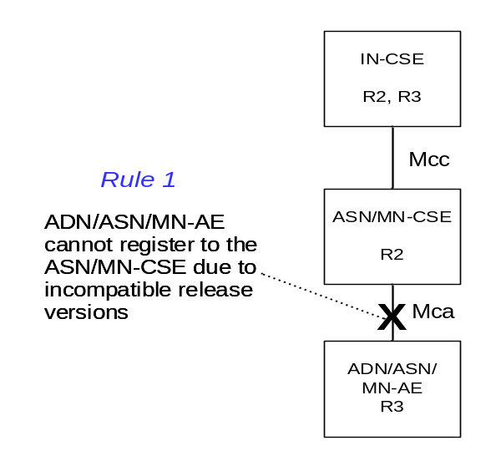
Figure L.1-1

L.1.2 Registrar only supports a lower release than Registree
In this example, the Registrar IN-CSE only supports release 3 and the Registree ASN/MN-CSE only supports release 2. Hence ASN/MN-CSE cannot register to the IN-CSE.

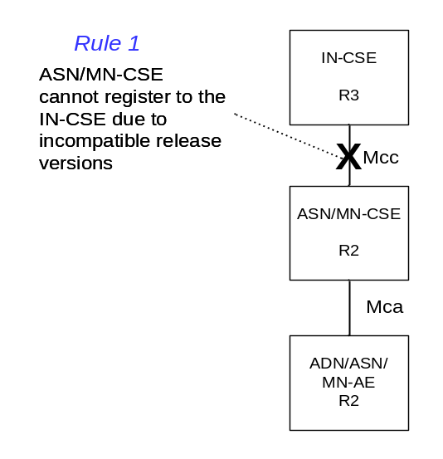
Figure L.1-2

L.2 Valid Release Version Examples
In this Annex, a set of release version examples are provided to show valid scenarios in which Registrar CSEs support at least one release version that is the same as each of their Registrees. These examples also show when the Release Version Indicator parameter is used in requests and responses per the Release Version Handling Rules defined in clause 10.2.X.2.

L.2.1 Example 1
In this 0-hop example, both entities only support Release 2. Per Rules 2 and 4 defined in clause 10.2.X.2, the Release Version Indicator parameter is not required in the request or response.
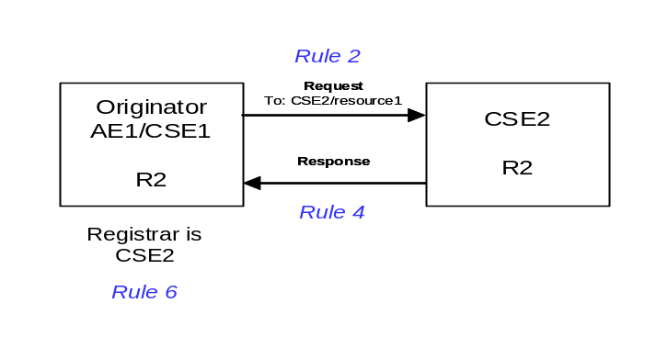
Figure L.2-1

L.2.2 Example 2
In this 0-hop example, the Originator does not include a Release Version Indicator parameter in its request and the Hosting CSE does not include a Release Version Indicator parameter in the response per Rules 2, 6 and 7 defined in clause 10.2.X.2 9.
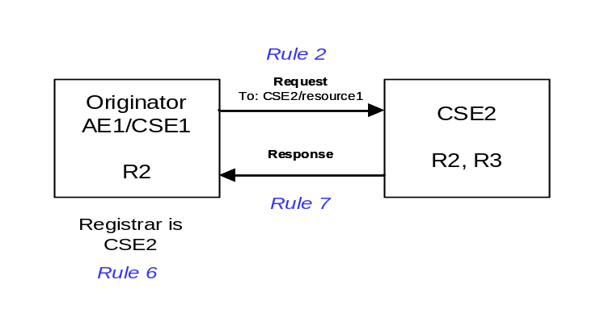
Figure L.2-2

L.2.3 Example 3
In this 0-hop example, the Originator includes a Release Version Indicator parameter in its request and the Hosting CSE includes a Release Version Indicator parameter in the response per Rules 3, 7 and 9 defined in clause 10.2.X.2.
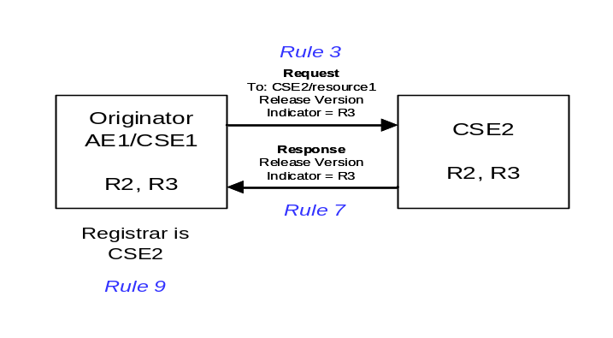
Figure L.2-3

L.2.4 Example 4
In this multi-hop example, all the entities are release 2 compliant and do not support the Release Version Indicator parameter. Hence the Release Version Indicator parameter is not included in any of the requests or responses per Rules 2, 4, 5 and 6 defined in clause 10.2.X.2.
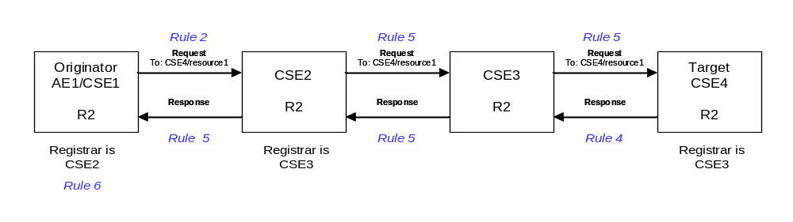
Figure L.2-4

L.2.5 Example 5
In this multi-hop example, all entities with the exception of CSE3 are release 2 compliant and do not support the Release Version Indicator parameter that was not introduced until release 3. CSE3 supports both release 2 and 3. Per Rules 2, 4, 5, 6 and 8 defined in clause 10.2.X.2, the Release Version Indicator parameter is not present in any of the requests or responses.
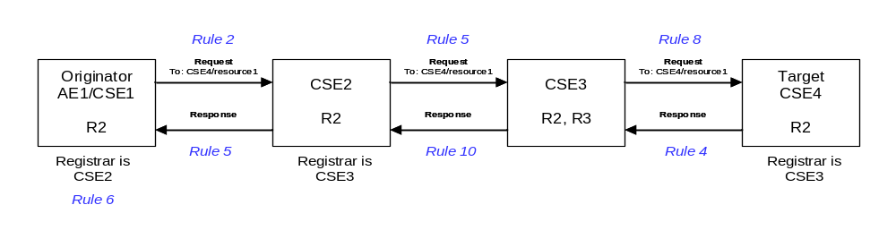
Figure L.2-5

L.2.6 Example 6
In this multi-hop example, all the entities are release 3 compliant. Per Rules 2, 7, 8, 9 and 10 defined in clause 10.2.X.2, a Release Version Indicator parameter is only required in the request that CSE2 forwards to CSE3 and the response that CSE3 forwards to CSE2.
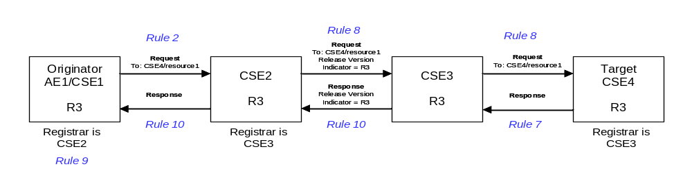
Figure L.2-6

L.2.7 Example 7
In this multi-hop example, a Release Version Indicator parameter is only required in the request that CSE2 forwards to CSE3 per the Rules 2, 4, 6, 8, and 10 defined in clause 10.2.X.2.
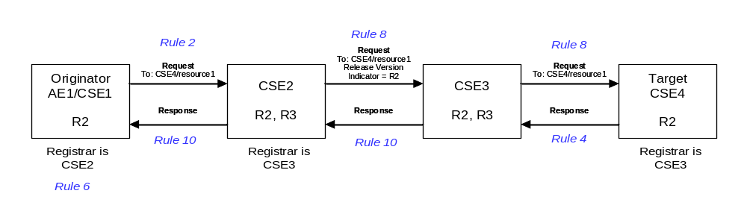
Figure L.2-7

L.2.8 Example 8
In this multi-hop example, a Release Version Indicator parameter is required in the request that CSE2 forwards to CSE3, the request CSE3 forwards to CSE4, the response CSE4 sends to CSE3 and the response CSE3 forwards to CSE2 per the Rules 2, 6, 7, 8 and 10 defined in clause 10.2.X.2.
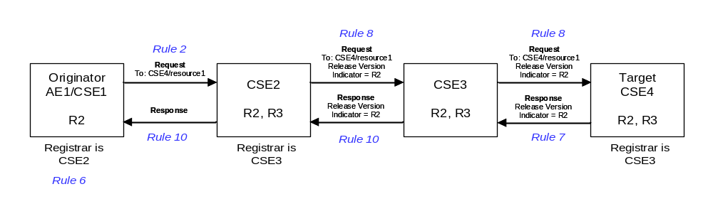
Figure L.2-8

L.2.9 Example 9
In this multi-hop example, a Release Version Indicator parameter is required in the request that CSE2 forwards to CSE3, the request CSE3 forwards to CSE4, the response CSE4 sends to CSE3 and the response CSE3 forwards to CSE2 per the Rules 2, 6, 7, 8 and 10 defined in clause 10.2.X.2.
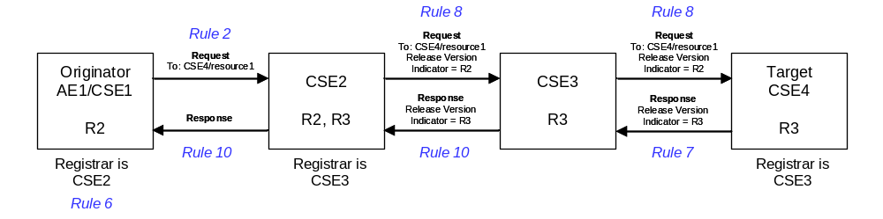
Figure L.2-9

L.2.10 Example 10
In this multi-hop example, a Release Version Indicator parameter is only required in the request that CSE2 forwards to CSE3 per the Rules 2, 4, 8, 9 and 10 defined in clause 10.2.X.2.
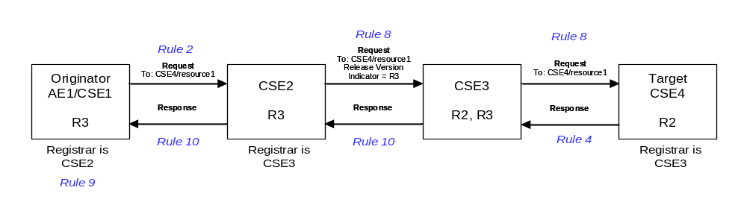
Figure L.2-10

CHECK LIST
- Does this Change Request include an informative introduction containing the problem(s) being solved, and a summary list of proposals.?
- Does this CR contain changes related to only one particular issue/problem?
- Have any mirror CRs been posted?
- Does this Change Request make all the changes necessary to address the issue or problem? E.g. A change impacting 5 tables should not include a proposal to change only 3 tables?Does this Change Request follow the drafting rules?
- Are all pictures editable?
- Have you checked the spelling and grammar?
- Have you used change bars for all modifications?
- Does the change include the current and surrounding clauses to clearly show where a change is located and to provide technical context of the proposed change? (Additions of complete clauses need not show surrounding clauses as long as the proposed clause number clearly shows where the new clause is proposed to be located.)
- Are multiple changes in this CR clearly separated by horizontal lines with embedded text such as, start of change 1, end of change 1, start of new clause, end of new clause.?

