CHANGE REQUEST
Meeting ID:* | ARC #31.2
Source:* | Dale Seed, Convida Wireless, Seed.Dale@ConvidaWireless.com  Bob Flynn, Convida Wireless, Flynn.Bob@ConvidaWireless.com
Date:* | 2017-10-18
 | See Introduction
Reason for Change/s:* | Rel-2
CR against: Release* | Active  MNT maintenance / < Work Item number(optional)>  Is this a companion CR? Yes No  Companion CR number: (Note to Rapporteur - use latest agreed revision)  Is this a mirror CR? Yes No  Mirror CR number: ARC-2017-0424  STE Small Technical Enhancements / < Work Item number (optional)>  Only ONE of the above shall be ticked
CR against: WI* | Rel2 - Maintenance
CR against: TS/TR* | TS-0001 Version 2.16.0
Clauses *
Type of change: * | Editorial change  Bug Fix or Correction  Change to existing feature or functionality  New feature or functionality  Only ONE of the above shall be ticked
Impacted other TS/TR(s) | This CR contains only essential changes and corrections? YES NO  This CR may break backwards compatibility with the last approved version of the TS? YES NO
Post Freeze checking:* | This CR contains only essential changes and corrections? YES NO  This CR may break backwards compatibility with the last approved version of the TS? YES NO

oneM2M Notice
The document to which this cover statement is attached is submitted to oneM2M. Participation in, or attendance at, any activity of oneM2M, constitutes acceptance of and agreement to be bound by terms of the Working Procedures and the Partnership Agreement, including the Intellectual Property Rights (IPR) Principles Governing oneM2M Work found in Annex 1 of the Partnership Agreement.
GUIDELINES for Change Requests:
Provide an informative introduction containing the problem(s) being solved, and a summary list of proposals.
Each CR should contain changes related to only one particular issue/problem.
In case of a correction, and the change apply to previous releases, a separate “mirror CR” should be posted at the same time of this CR
Mirror CR: applies only when the text, including clause numbering are exactly the same.
Companion CR: applies when the change means the same but the baselines differ in some way (e.g. clause number).
Follow the principle of completeness, where all changes related to the issue or problem within a deliverable are simultaneously proposed to be made E.g. A change impacting 5 tables should not only include a proposal to change only 3 tables. Includes any changes to references, definitions, and acronyms in the same deliverable.
Follow the drafting rules.
All pictures must be editable.
Check spelling and grammar to the extent practicable.
Use Change bars for modifications.
The change should include the current and surrounding clauses to clearly show where a change is located and to provide technical context of the proposed change. Additions of complete clauses need not show surrounding clauses as long as the proposed clause number clearly shows where the new clause is proposed to be located.
Multiple changes in a single CR shall be clearly separated by horizontal lines with embedded text such as, start of change 1, end of change 1, start of new clause, end of new clause.
When subsequent changes are made to content of a CR, then the accepted version should not show changes over changes. The accepted version of the CR should only show changes relative to the baseline approved text.

Introduction
Correcting a typo in the default Release Version which was intended to be 1 instead 2.

-----------------------Start of change 1-------------------------------------------

9.6.3 Resource Type CSEBase
A <CSEBase> resource shall represent a CSE. The <CSEBase> resource shall be the root for all resources that are residing in the CSE.
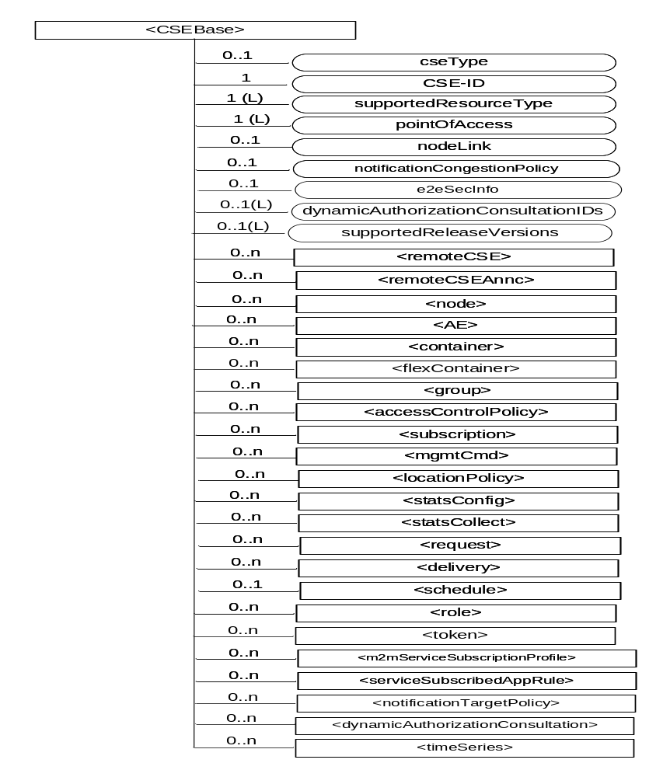

Figure 9.6.3-1: Structure of <CSEBase> resource
Figure 9.6.3-1 does not show the child announce resource types defined in table 9.6.3-2.
The <CSEBase> resource shall contain the child resources specified in table 9.6.3-1.

Table 9.6.3-1: Child resources of <CSEBase> resource
Child Resources of <CSEBase> | Child Resource Type | Multiplicity | Description
[variable] | <remoteCSE> | 0..n | See clause 9.6.4
[variable] | <remoteCSEAnnc> | 0..n | Announced variant of <remoteCSE>. Resource with CSE-specific information for a CSE that announced itself to another CSE with which it does not have a registration relationship.
[variable] | <node> | 0..n | See clause 9.6.18
[variable] | <AE> | 0..n | See clause 9.6.5
[variable] | <container> | 0..n | See clause 9.6.6
[variable] | <flexContainer> | 0..n | See clause 9.6.35
[variable] | <group> | 0..n | See clause 9.6.13
[variable] | <accessControlPolicy> | 0..n | See clause 9.6.2
[variable] | <subscription> | 0..n | See clause 9.6.8
[variable] | <mgmtCmd> | 0..n | See clause 9.6.16
[variable] | <locationPolicy> | 0..n | See clause 9.6.10
[variable] | <statsConfig> | 0..n | See clause 9.6.23
[variable] | <statsCollect> | 0..n | See clause 9.6.25
[variable] | <request> | 0..n | See clause 9.6.12
[variable] | <delivery> | 0..n | See clause 9.6.11
[variable] | <schedule> | 0..1 | This resource defines the reachability schedule information of the entity. The absence of this resource implies the entity is always reachable. See clause 9.6.9
[variable] | <role> | 0..n | See clause 9.6.38
[variable] | <token> | 0..n | See clause 9.6.39
[variable] | <m2mServiceSubscriptionProfile> | 0..n | See clause 9.6.19
[variable] | <serviceSubscribedAppRule> | 0..n | See clause 9.6.29
[variable] | <notificationTargetPolicy> | 0..n | See clause 9.6.32
[variable] | <dynamicAuthorizationConsultation> | 0..n | See clause 9.6.40
[variable] | <timeSeries> | 0..n | See clause 9.6.36

An instance of a <remoteCSEAnnc> resource shall be created as a child of a <CSEBase> resource when an Originator CSE of an announcement request (i.e. original resource Hosting CSE) and a targeted Hosting CSE of an announced resource (i.e. announced resource Hosting CSE) have no registration relationship (e.g. the Originator CSE has not created <remoteCSE> resource on the Hosting CSE), see clause 9.6.26.
The <CSEBase> resource shall contain the attributes specified in table 9.6.3-2.

Table 9.6.3-2: Attributes of <CSEBase> resource
Attributes of <CSEBase> | Multiplicity | RW/  RO/  WO | Description
resourceType | 1 | RO | See clause 9.6.1.3.
resourceID | 1 | RO | See clause 9.6.1.3.
resourceName | 1 | RO | See clause 9.6.1.3.
parentID | 1 | RO | See clause 9.6.1.3. Shall be NULL.
creationTime | 1 | RO | See clause 9.6.1.3.
lastModifiedTime | 1 | RO | See clause 9.6.1.3.
accessControlPolicyIDs | 0..1 (L) | RO | See clause 9.6.1.3.
labels | 0..1 (L) | RO | See clause 9.6.1.3.
dynamicAuthorizationConsultationIDs | 0..1 (L) | RO | See clause 9.6.1.3.
cseType | 0..1 | RO | Indicates the type of CSE represented by the created resource:  - Mandatory for an IN-CSE, hence multiplicity (1).  - Its presence is subject to SP configuration in case of an ASN-CSE or a MN-CSE.
CSE-ID | 1 | RO | The CSE identifier in SP-relative CSE-ID format (clause 7.2).
supportedResourceType | 1 (L) | RO | List of the resource types which are supported in the CSE. This attribute contains subset of resource types listed in clause 9.2.
pointOfAccess | 1 (L) | RO | Represents the list of physical addresses to be used by remote CSEs to connect to this CSE (e.g. IP address, FQDN). This attribute is exposed to its Registree.
nodeLink | 0..1 | RO | The resource identifier of a <node> resource that stores the node specific information of the node on which the CSE represented by this <CSEBase> resource resides.
notificationCongestionPolicy | 0..1 | RO | This attribute applies to CSEs generating subscription notifications. It specifies the rule which is applied when the storage of notifications for each subscriber (an AE or CSE) reaches the maximum storage limit for notifications for that subscriber. E.g. Delete stored notifications of lower notificationStoragePriority to make space for new notifications of higher notificationStoragePriority, or delete stored notifications of older creationTime to make space for new notifications when all notifications are of the same notificationStoragePriority.
e2eSecInfo | 0..1 | RO | See clause 9.6.1.3.
supportedReleaseVersions | 0..1 (L) | RO | List of oneM2M release versions which are supported by the CSE.  Starting with Release 2, this attribute is mandatory for a CSE. For CSEs compliant to older releases, this attribute is optional. For CSEs that do not include this attribute, the default release version shall be Release 1.

9.6.4 Resource Type remoteCSE
A <remoteCSE> resource shall represent a Registree CSE that is registered to the Registrar CSE. <remoteCSE> resources shall be located directly under the <CSEBase> resource of Registrar CSE.
Similarly <remoteCSE> resource shall also represent a Registrar CSE. <remoteCSE> resource shall be located directly under the <CSEBase> resource of Registree CSE.
For example, when CSE1 (Registree CSE) registers with CSE2 (Registrar CSE), there will be two <remoteCSE> resources created: one in CSE1: <CSEBase1>/<remoteCSE2> and one in CSE2: <CSEBase2>/<remoteCSE1>.
Note that the creation of the two resources does not imply mutual registration. The <CSEBase1>/<remoteCSE2> does not mean CSE2 registered with CSE1 in the example above.
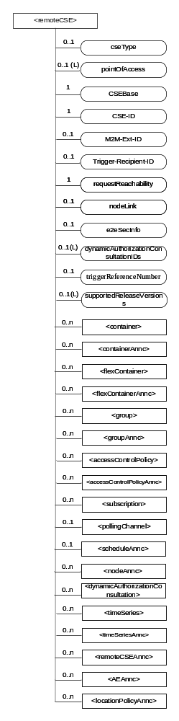

Figure 9.6.4-1: Structure of <remoteCSE> resource
The <remoteCSE> resource shall contain the child resources specified in table 9.6.4-1. The <remoteCSE> resource may contain <remoteCSEAnnc> child resources.

Table 9.6.4-1: Child resources of <remoteCSE> resource
Child Resources of <remoteCSE> | Child Resource Type | Multiplicity | Description | <remoteCSEAnnc> Child Resource Types
[variable] | <container> | 0..n | See clause 9.6.6 | <container>
[variable] | <containerAnnc> | 0..n | Announced variant of <container>. See clause 9.6.6 | <containerAnnc>
[variable] | <flexContainer> | 0..n | See clause 9.6.35 | <flexContainer>
[variable] | <flexContaineAnnc> | 0..n | Announced variant of <flexContainer>. See clause 9.6.35 | <flexContainerAnnc>
[variable] | <group> | 0..n | See clause 9.6.13 | <group>
[variable] | <groupAnnc> | 0..n | Announced variant of <group>. See clause 9.6.13 | <groupAnnc>
[variable] | <accessControlPolicy> | 0..n | See clause 9.6.2 | <accessControlPolicy>
[variable] | <accessControlPolicyAnnc> | 0..n | Announced variant of <accessControlPolicy>. See clause 9.6.2 | <accessControlPolicyAnnc>
[variable] | <subscription> | 0..n | See clause 9.6.8 | <subscription>
[variable] | <pollingChannel> | 0..1 | See clause 9.6.21. If requestReachability is FALSE, the CSE that created this <remoteCSE> resource should create a <pollingChannel> resource and perform long polling. The <pollingChannel> shall be utilized by the parent resource. | None
[variable] | <scheduleAnnc> | 0..1 | Announced variant of <schedule> which defines the reachability schedule information of the node. See clause 9.6.9 for <schedule>. | <scheduleAnnc>
[variable] | <nodeAnnc> | 0..n | Announced variant of <node>. This announced resource is associated with a <node> resource that is hosted on a CSE which is represented by the parent <remoteCSE> or <remoteCSEAnnc> resource. See clause 9.6.18 for <node>. | <nodeAnnc>
[variable] | <dynamicAuthorizationConsultation> | 0..n | See clause 9.6.40
[variable] | <timeSeries> | 0..n | See clause 9.6.36 | <timeSeries>
[variable] | <timeSeriesAnnc> | 0..n | Announced variant of <timeSeries>. See clause 9.6.36 | <timeSeriesAnnc>
[variable] | <remoteCSEAnnc> | 0..n | Announced variant of <remoteCSE> defined in the present clause 9.6.4. | <remoteCSEAnnc>
[variable] | <AEAnnc> | 0..n | Announced variant of <AE>. See clause 9.6.5 | <AEAnnc>
[variable] | <locationPolicyAnnc> | 0..n | Announced variant of <locationPolicy>. See clause 9.6.10 | <locationPolicyAnnc>

The <remoteCSE> resource shall contain the attributes specified in table 9.6.4-2.

Table 9.6.4-2: Attributes of <remoteCSE> resource
Attributes of <remoteCSE> | Multiplicity | RW/  RO/  WO | Description | <remoteCSEAnnc> Attributes
resourceType | 1 | RO | See clause 9.6.1.3. | NA
resourceID | 1 | RO | See clause 9.6.1.3. | NA
resourceName | 1 | WO | See clause 9.6.1.3. | NA
parentID | 1 | RO | See clause 9.6.1.3. | NA
creationTime | 1 | RO | See clause 9.6.1.3. | NA
lastModifiedTime | 1 | RO | See clause 9.6.1.3. | NA
expirationTime | 1 | RW | See clause 9.6.1.3. | MA
accessControlPolicyIDs | 0..1 (L) | RW | See clause 9.6.1.3. | MA
labels | 0..1 (L) | RW | See clause 9.6.1.3. | MA
announceTo | 0..1 (L) | RW | See clause 9.6.1.3. | NA
announcedAttribute | 0..1 (L) | RW | See clause 9.6.1.3. | NA
dynamicAuthorizationConsultationIDs | 0..1 (L) | RW | See clause 9.6.1.3. | OA
cseType | 0..1 | WO | Indicates the type of CSE represented by the created resource.  - Mandatory for an IN-CSE, hence multiplicity (1).  - Its presence is subject to SP configuration in case of an ASN-CSE or a MN-CSE. | OA
pointOfAccess | 0..1 (L) | RW | For request-reachable remote CSE it represents the list of physical addresses to be used to connect to it (e.g. IP address, FQDN).  If this information is not provided and <pollingChannel> resource does exist, the CSE should use <pollingChannel> resource. Then the Hosting CSE can forward a request to the CSE without using the PoA. | OA
CSEBase | 1 | WO | The address of the <CSEBase> resource represented by this <remoteCSE> resource. | OA
CSE-ID | 1 | WO | The CSE identifier of the remote CSE represented by this <remoteCSE> resource in SP-relative CSE-ID format (clause 7.2). | OA
M2M-Ext-ID | 0..1 | RW | Supported when Registrar is IN-CSE.  See clause 7.1.8 where this attribute is described. This attribute is used only for the case of dynamic association of M2M-Ext-ID and CSE-ID. | NA
Trigger-Recipient-ID | 0..1 | RW | Supported when Registrar is IN-CSE. See clause 7.1.10 where this attribute is described. This attribute is used only for the case of dynamic association of M2M-Ext-ID and CSE-ID. | NA
requestReachability | 1 | RW | If the CSE that created this <remoteCSE> resource can receive a request from other AE/CSE(s), this attribute is set to "TRUE" otherwise "FALSE" (see note) | OA
nodeLink | 0..1 | RW | The resource identifier of a <node> resource that stores the node specific information of the node on which the CSE represented by this <remoteCSE> resource resides. | OA
e2eSecInfo | 0..1 | RW | See clause 9.6.1.3. | MA
triggerReferenceNumber | 0..1 | RW | This is to identify device trigger procedure request. This attribute is used only for device trigger and assigned by the IN-CSE. | NA
supportedReleaseVersions | 0..1(L) | WO | The oneM2M release versions supported by the CSE represented by this <remoteCSE> resource.  Starting with Release 2, this attribute is mandatory for a CSE. For CSEs compliant to older releases, this attribute is optional. For CSEs that do not include this attribute, the default release version shall be Release 1. | MA
NOTE: Even if this attribute is set to "FALSE", it does not mean it AE/CSE is always unreachable by all entities. E.g. the requesting AE/CSE is behind the same NAT, so it can communicate within the same NAT.

9.6.5 Resource Type AE
An <AE> resource shall represent information about an Application Entity registered to a CSE.
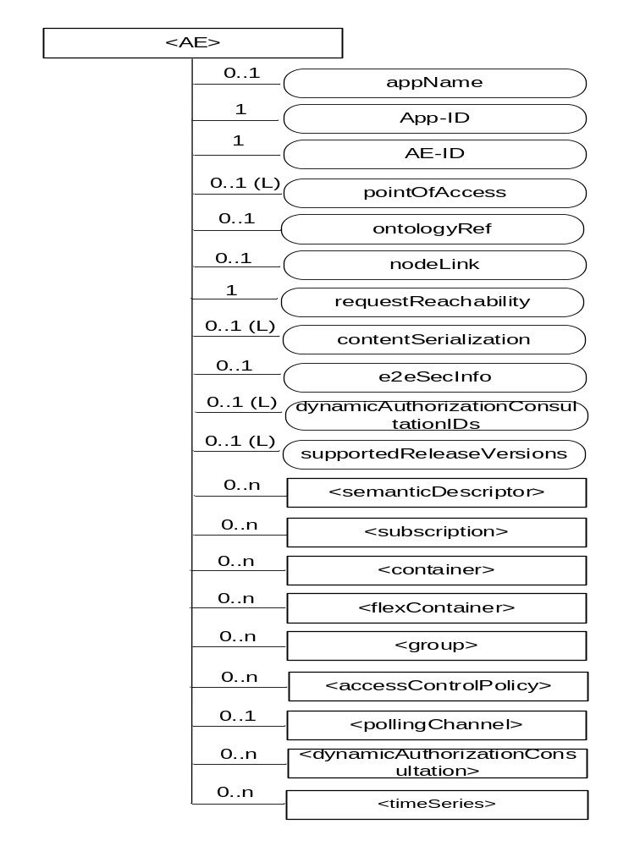

Figure 9.6.5-1: Structure of <AE> resource
The <AE> resource shall contain the child resources specified in table 9.6.5-1.

Table 9.6.5-1: Child resources of <AE> resource
Child Resources of <AE> | Child Resource Type | Multiplicity | Description | <AEAnnc> Child Resource Types
[variable] | <semanticDescriptor> | 0..n | See clause 9.6.30 | <semanticDescriptor>, <semanticDescriptorAnnc>
[variable] | <subscription> | 0..n | See clause 9.6.8 | <subscription>
[variable] | <container> | 0..n | See clause 9.6.6 | <container> <containerAnnc>
[variable] | <flexContainer> | 0..n | See clause 9.6.35 | <flexContainer>  <flexContainerAnnc>
[variable] | <group> | 0..n | See clause 9.6.13 | <group>  <groupAnnc>
[variable] | <accessControlPolicy> | 0..n | See clause 9.6.2 | <accessControlPolicy>  <accessControlPolicyAnnc>
[variable] | <schedule> | 0..1 | See clause 9.6.9 | <scheduleAnnc>
[variable] | <pollingChannel> | 0..1 | See clause 9.6.21  When the AE is request-unreachable, the AE should create this <pollingChannel> resource and perform long polling. The <pollingChannel> shall be utilized by the parent resource | None
trafficPattern | <trafficPattern> | 0..n | See clause 9.6.41 | <trafficPatternAnnc>
[variable] | <dynamicAuthorizationConsultation> | 0..n | See clause 9.6.40 | None
[variable] | <timeSeries> | 0..n | See clause 9.6.36 | <timeSeries>  <timeSeriesAnnc>

The <AE> resource shall contain the attributes specified in table 9.6.5-2.

Table 9.6.5-2: Attributes of <AE> resource
Attributes of  <AE> | Multiplicity | RW/  RO/  WO | Description | <AEAnnc> Attributes
resourceType | 1 | RO | See clause 9.6.1.3. | NA
resourceID | 1 | RO | See clause 9.6.1.3. Contains the AE-ID-Stem of the AE (see clause 7.2 on identifier formats and clause 10.1.1.2.2 for AE registration procedure). | NA
resourceName | 1 | WO | See clause 9.6.1.3. | NA
parentID | 1 | RO | See clause 9.6.1.3. | NA
expirationTime | 1 | RW | See clause 9.6.1.3. | MA
accessControlPolicyIDs | 0..1 (L) | RW | See clause 9.6.1.3. | MA
creationTime | 1 | RO | See clause 9.6.1.3. | NA
lastModifiedTime | 1 | RO | See clause 9.6.1.3. | NA
labels | 0..1 (L) | RW | See clause 9.6.1.3. | MA
announceTo | 0..1 (L) | RW | See clause 9.6.1.3. | NA
announcedAttribute | 0..1 (L) | RW | See clause 9.6.1.3. | NA
dynamicAuthorizationConsultationIDs | 0..1 (L) | RW | See clause 9.6.1.3. | OA
appName | 0..1 | RW | The name of the application, as declared by the application developer(e.g. "HeatingMonitoring").  Several sibling resources may share the appName. | OA
App-ID | 1 | WO | The identifier of the Application (see clause 7.1.3). | OA
AE-ID | 1 | RO | The identifier of the Application Entity (see clause 7.1.2). | OA
pointOfAccess | 0..1 (L) | RW | The list of addresses for communicating with the registered Application Entity over Mca reference point via the transport services provided by Underlying Network (e.g. IP address, FQDN, URI). This attribute shall be accessible only by the AE and the Hosting CSE.  If this information is not provided and the <pollingChannel> resource does exist, the AE should use <pollingChannel> resource. Then the Hosting CSE can forward a request to the AE without using the PoA. | OA
ontologyRef | 0..1 | RW | A URI of the ontology used to represent the information that is managed and understood by the AE. | OA
requestReachability | 1 | RW | If the AE that created this <AE> resource can receive a request, this attribute is set to "TRUE" otherwise "FALSE" | OA
nodeLink | 0..1 | RW | The resource identifier of a <node> resource that stores the node specific information of the node on which the AE represented by this <AE> resource resides. | OA
contentSerialization | 0..1 (L) | RW | The list of supported serializations of the Content primitive parameter for receiving a request from its registrar CSE. (e.g. XML, JSON). The list shall be ordered so that the most preferred format comes first. | OA
e2eSecInfo | 0..1 | RW | See clause 9.6.1.3. | MA
supportedReleaseVersions | 0..1(L) | WO | The oneM2M release versions supportedby the Registree AE represented by this <AE> resource.  Starting with Release 2, this attribute is mandatory for an AE. For AEs compliant to older releases, this attribute is optional. For AEs that do not include this attribute, the default release version shall be Release 1. | MA

-----------------------End of change 1---------------------------------------------

CHECK LIST
- Does this Change Request include an informative introduction containing the problem(s) being solved, and a summary list of proposals.?
- Does this CR contain changes related to only one particular issue/problem?
- Have any mirror CRs been posted?
- Does this Change Request make all the changes necessary to address the issue or problem? E.g. A change impacting 5 tables should not include a proposal to change only 3 tables?Does this Change Request follow the drafting rules?
- Are all pictures editable?
- Have you checked the spelling and grammar?
- Have you used change bars for all modifications?
- Does the change include the current and surrounding clauses to clearly show where a change is located and to provide technical context of the proposed change? (Additions of complete clauses need not show surrounding clauses as long as the proposed clause number clearly shows where the new clause is proposed to be located.)
- Are multiple changes in this CR clearly separated by horizontal lines with embedded text such as, start of change 1, end of change 1, start of new clause, end of new clause.?

