CHANGE REQUEST
Meeting ID:* | ARC 32
Source:* | Albert Zhao, BOE, zhaojunjie111@boe.com.cn  Max Zhang, BOE, zhangqiancto@boe.com.cn
Date:* | 2017-10-30
Reason for Change/s:* | Resource table and figure are inconsistent
CR against: Release* | Release 3
CR against: WI* | Active <Work Item number>  MNT maintenance / < Work Item number(optional)>  Is this a companion CR? Yes No  Companion CR number: (Note to Rapporteur - use latest agreed revision)Is this a mirror CR? Yes No  Mirror CR number: (Note to Rapporteur - use latest agreed revision)  STE Small Technical Enhancements / < Work Item number (optional)>  Only ONE of the above shall be ticked
CR against: TS/TR* | TS-0001 V3.8.0
Clauses * | 9.6.4, 9.6.8, 9.6.10, 9.6.20, 9.6.29, 9.6.31, 9.6.33, 9.6.35, 9.6.39, 9.6.46, 9.6.53, 9.6.54, 9.6.56, 9.6.57, 9.6.58, 9.6.60
Type of change: * | Editorial change  Bug Fix or Correction  Change to existing feature or functionality  New feature or functionality  Only ONE of the above shall be ticked
Impacted other TS/TR(s) | <TS/TR number>, <Version Number>, and <Description on which aspect should be reflected in this TS/TR>
Post Freeze checking:* | This CR contains only essential changes and corrections? YES NO  This CR may break backwards compatibility with the last approved version of the TS? YES NO
Template Version: January 2017 (Do not modify)

oneM2M Notice
The document to which this cover statement is attached is submitted to oneM2M. Participation in, or attendance at, any activity of oneM2M, constitutes acceptance of and agreement to be bound by terms of the Working Procedures and the Partnership Agreement, including the Intellectual Property Rights (IPR) Principles Governing oneM2M Work found in Annex 1 of the Partnership Agreement.
GUIDELINES for Change Requests:
Provide an informative introduction containing the problem(s) being solved, and a summary list of proposals.
Each CR should contain changes related to only one particular issue/problem.
In case of a correction, and the change apply to previous releases, a separate “mirror CR” should be posted at the same time of this CR
Mirror CR: applies only when the text, including clause numbering are exactly the same.
Companion CR: applies when the change means the same but the baselines differ in some way (e.g. clause number).
Follow the principle of completeness, where all changes related to the issue or problem within a deliverable are simultaneously proposed to be made E.g. A change impacting 5 tables should not only include a proposal to change only 3 tables. Includes any changes to references, definitions, and acronyms in the same deliverable.
Follow the drafting rules.
All pictures must be editable.
Check spelling and grammar to the extent practicable.
Use Change bars for modifications.
The change should include the current and surrounding clauses to clearly show where a change is located and to provide technical context of the proposed change. Additions of complete clauses need not show surrounding clauses as long as the proposed clause number clearly shows where the new clause is proposed to be located.
Multiple changes in a single CR shall be clearly separated by horizontal lines with embedded text such as, start of change 1, end of change 1, start of new clause, end of new clause.
When subsequent changes are made to content of a CR, then the accepted version should not show changes over changes. The accepted version of the CR should only show changes relative to the baseline approved text.

Introduction
After reviewing the resource type defination, there are several inconsistences between the resource type figure and resource type talbe, the detail as follows:
 |  | Resource Type Figure | Resource Type Table | suggestion
1 | 9.6.4 Resource Type remoteCSE | has a <scheduleAnnc> sub-resource with multiplicity 0..1 | has no <scheduleAnnc> sub-resource  consistent with TS-0004 | change figure
2 | 9.6.8 Resource Type subscription | <notificationTargetMgmtPolicyRef> with multiplicity 0..1  <notificationTargetSelfReference> with multiplicity 0..1 | <notificationTargetMgmtPolicyRef> with multiplicity 0..n  consistent with TS-0004  <notificationTargetSelfReference> with multiplicity 1  consistent with TS-0004 | change figure
3 | 9.6.10 Resource Type locationPolicy | M2M-Ext-ID | authID  consistent with TS-0004 | change figure
4 | 9.6.20 Resource Type serviceSubscribedNode | niddRequired with multiplicity 0..1(L) | niddRequired with multiplicity 0..1 | change figure
5 | 9.6.29 Resource Type serviceSubscribedAppRule | allowedAppIDs attribute  allowedRoleIDs attribute | allowedApp-IDs attribute  consistent with TS-0004  allowedRole-IDs attribute  consistent with TS-0004 | change figure
6 | 9.6.31 Resource Type notificationTargetMgmtPolicyRef | notificationTargetURI with multiplicity 1  notificationlPolicyID with multiplicity 1 | notificationTargetURI with multiplicity 1(L)  consistent with TS-0004  notificationlPolicyID with multiplicity 0..1  consistent with TS-0004 | change figure
7 | 9.6.33 Resource Type policyDeletionRules | deletionRules with multiplicity 1(L) | deletionRules with multiplicity 0..1(L)  consistent with TS-0004 | change figure
8 | 9.6.35 Resource Type flexContainer | no timeseries | timeSeries with multiplicity 0..n  not update in TS-0004 | change figure
9 | 9.6.39 Resource Type token | notBefore with multiplicity 0..1  consistent with TS-0004 | notBefore with multiplicity 1 | change table
10 | 9.6.46 Resource Type AEContactListPerCSE | CSE-ID with multiplicity 1 | CSE-ID with multiplicity NULL | change table
11 | 9.6.53 Resource Type semanticMashupJobProfile | memberFilter with multiplicity 1(L) | memberFilter with multiplicity 1  consistent with TS-0004 | change figure
12 | 9.6.54 Resource Type semanticMashupInstance | smjpInputParameter with multiplicity 0..1  resultGenType with multiplicity 1  consistent with TS-0004 | smjpInputParameter with multiplicity 1  consistent with TS-0004  resultGenType with multiplicity 1(L) | change figure  change table
13 | 9.6.57 Resource Type multimediaSession | offeredSessionDescriptions with multiplicity 1(L)  not defined in TS-0004 | offeredSessionDescriptions with multiplicity 1 | change table
14 | 9.6.58 Resource Type crossResourceSubscription | regularResourcesAsTarget with multiplicity 0..1(L)  subscriptionResourcesAsTarget with multiplicity 0..1(L)  consistent with TS-0001 crossResourceSubscription resource defination | regularResourcesAsTarget with multiplicity 0..1  subscriptionResourcesAsTarget with multiplicity 0..1 | change table
15 | 9.6.60 Resource Type backgroundDataTransfer | transferSelectionGuidance with multiplicity 0..1 | transferSelectionGuidance with multiplicity 0..1(L) | change figure

-----------------------Start of change 1-------------------------------------------

9.6.4 Resource Type remoteCSE
A <remoteCSE> resource shall represent a Registree CSE that is registered to the Registrar CSE. <remoteCSE> resources shall be located directly under the <CSEBase> resource of Registrar CSE.
Similarly <remoteCSE> resource shall also represent a Registrar CSE. <remoteCSE> resource shall be located directly under the <CSEBase> resource of Registree CSE.
For example, when CSE1 (Registree CSE) registers with CSE2 (Registrar CSE), there will be two <remoteCSE> resources created: one in CSE1: <CSEBase1>/<remoteCSE2> and one in CSE2: <CSEBase2>/<remoteCSE1>.
Note that the creation of the two resources does not imply mutual registration. The <CSEBase1>/<remoteCSE2> does not mean CSE2 registered with CSE1 in the example above.
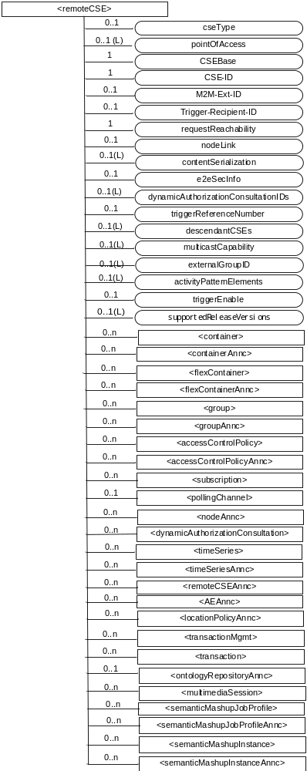
Figure 9.6.4-1: Structure of <remoteCSE> resource
The <remoteCSE> resource shall contain the child resources specified in table 9.6.4-1. The <remoteCSE> resource may contain <remoteCSEAnnc> child resources.
Table 9.6.4-1: Child resources of <remoteCSE> resource
Child Resources of <remoteCSE> | Child Resource Type | Multiplicity | Description | <remoteCSEAnnc> Child Resource Types
[variable] | <container> | 0..n | See clause 9.6.6 | <container>
[variable] | <containerAnnc> | 0..n | Announced variant of <container>. See clause 9.6.6 | <containerAnnc>
[variable] | <flexContainer> | 0..n | See clause 9.6.35 | <flexContainer>
[variable] | <flexContaineAnnc> | 0..n | Announced variant of <flexContainer>. See clause 9.6.35 | <flexContainerAnnc>
[variable] | <group> | 0..n | See clause 9.6.13 | <group>
[variable] | <groupAnnc> | 0..n | Announced variant of <group>. See clause 9.6.13 | <groupAnnc>
[variable] | <accessControlPolicy> | 0..n | See clause 9.6.2 | <accessControlPolicy>
[variable] | <accessControlPolicyAnnc> | 0..n | Announced variant of <accessControlPolicy>. See clause 9.6.2 | <accessControlPolicyAnnc>
[variable] | <subscription> | 0..n | See clause 9.6.8 | <subscription>
[variable] | <pollingChannel> | 0..1 | See clause 9.6.21. If requestReachability is FALSE, the CSE that created this <remoteCSE> resource should create a <pollingChannel> resource and perform long polling. The <pollingChannel> shall be utilized by the the parent resource. | None
[variable] | <nodeAnnc> | 0..n | Announced variant of <node>. This announced resource is assoiated with a <node> resource that is hosted on a CSE which is represented by the parent <remoteCSE> or <remoteCSEAnnc> resource. See clause 9.6.18 for <node>. | <nodeAnnc>
[variable] | <dynamicAuthorizationConsultation> | 0..n | See clause 9.6.40
[variable] | <timeSeries> | 0..n | See clause 9.6.36 | <timeSeries>
[variable] | <timeSeriesAnnc> | 0..n | Announced variant of <timeSeries>. See clause 9.6.36 | <timeSeriesAnnc>
[variable] | <remoteCSEAnnc> | 0..n | Announced variant of <remoteCSE> defined in the present clause 9.6.4. | <remoteCSEAnnc>
[variable] | <AEAnnc> | 0..n | Announced variant of <AE>. See clause 9.6.5 | <AEAnnc>
[variable] | <locationPolicyAnnc> | 0..n | Announced variant of <locationPolicy>. See clause 9.6.10 | <locationPolicyAnnc>
[variable] | <transactionMgmt> | 0..n | See clause 9.6.47 | <transactionMgmt>
[variable] | <transaction> | 0..n | See clause 9.6.48 | <transaction>
[variable] | <ontologyRepositoryAnnc> | 0..1 | Announced variant of <ontologyRepository>. See clause 9.6.50 | <ontologyRepositoryAnnc>
[variable] | <multimediaSession> | 0..n | See Clause 9.6.x. This resources holds information describing the established multimedia session | None
[variable] | <semanticMashupJobProfile> | 0..n | See clause 9.6.53 | <semanticMashupJobProfile>
[variable] | <semanticMashupJobProfileAnnc> | 0..n | Announced variant of <semanticMashupJobProfile>. See clause 9.6.53 | <semanticMashupJobProfileAnnc>
[variable] | <semanticMashupInstance> | 0..n | See clause 9.6.54 | <semanticMashupInstance>
[variable] | <semanticMashupInstanceAnnc> | 0..n | Announced variant of <semanticMashupInstance >. See clause 9.6.54. | <semanticMashupInstanceAnnc>

-----------------------End of change 1---------------------------------------------

-----------------------Start of change 2-------------------------------------------

9.6.8 Resource Type subscription
The <subscription> resource contains subscription information for its subscribed-to resource.
A subscription to a resource allows an entity in the oneM2M architecture to be notified about changes of the subscribed-to resource. The <subscription> resource shall represent a subscription to a subscribed-to resource. In order to establish a subscription, a <subscription> resource shall be created as a child resource of the subscribed-to resource. The <subscription> child resource contains information about the exact scope of the subscription and targets to be notified. For example, a <container> resource having a <subscription> resource as a child resource (see clause 9.6.6) shall result in notification(s) of target(s) configured in the <subscription> child resource when changes to the parent <container> resource matching with notification event criteria described by the child <subscription> resource occur. A <subscription> resource shall be deleted when the parent subscribed-to resource is deleted.
In general, an Originator shall be able to create a resource of <subscription> resource type when the Originator has RETRIEVE privilege to the subscribed-to resource. The Originator which creates a <subscription> resource becomes the resource subscriber. The Originator shall only be able to create a resource of <subscription> resource type with event notification criteria conditions set to establish notification event type of “Update to attributes of the subscribed-to resource with blocking of the triggering UPDATE operation” – see the details of eventNotificationCriteria conditions below – when the Originator has UPDATE privilege to the subscribe-to resource.
Each <subscription> may include notification policies that specify which, when, and how notifications are sent. These notification policies may work in conjunction with CMDH policies.
When a <subscription> resource is deleted, a Notify request shall be sent to the target indicated by the attribute subscriberURI if it is provided by the Subscriber.
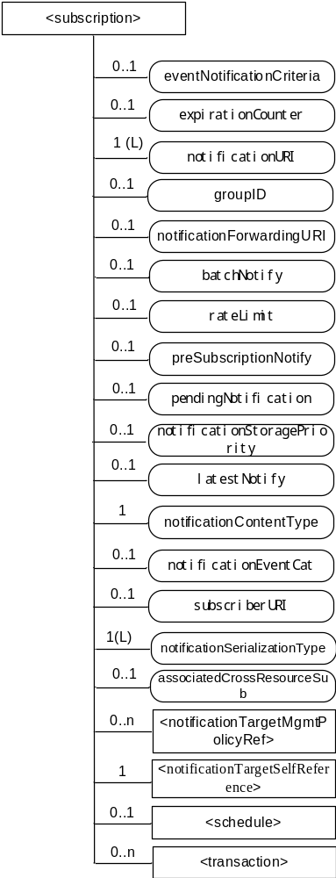
The <subscription> resource shall contain the child resources specified in table 9.6.8-1.
Table 9.6.8-1: Child resources of <subscription> resource
Child Resources of <subscription> | Child Resource Type | Multiplicity | Description
notificationSchedule | <schedule> | 0..1 | In the context of the <subscription> resource, the notificationSchedule specifies when notifications may be sent by the Hosting CSE to the notificationURI(s). See clause 9.6.9.
[variable] | <notificationTargetMgmtPolicyRef> | 0..n | See 9.6.31 for this type of resource.
nstr | <notificationTargetSelfReference> | 1 | See 9.6.34 for this type of resource.
[variable] | <transaction> | 0..n | See clause 9.6.48

-----------------------End of change 2---------------------------------------------

-----------------------Start of change 3-------------------------------------------

9.6.10 Resource Type locationPolicy
The <locationPolicy> resource represents the method for obtaining and managing geographical location information of an M2M Node.
The actual location or event result (in case Geo-fence-Based method) information shall be stored in a <contentInstance> resource which is a child resource of the <container> resource. The <container> resource includes the locationID attribute which holds the ID of this <locationPolicy> resource. A CSE can obtain location information based on the attributes defined under <locationPolicy> resource, and store the location information in the target <container> resource.
Based on the locationSource attribute, the method for obtaining location information of an M2M Node can be differentiated. The methods for obtaining location information shall be as follows:
- Network-based method: where the CSE on behalf of the AE obtains the target M2M Node's location information from an Underlying Network.
- Device-based method: where the ASN is equipped with any location capable modules or technologies (e.g. GPS) and is able to position itself.
- Sharing-based method: where the ADN has no GPS nor an Underlying Network connectivity. Its location information can be retrieved from either the associated ASN or a MN.
NOTE: Geographical location information could include more than longitude and latitude.
Figure 9.6.10-0 shows the graphical information regarding the event types for the Geo-fence feature defined as the geofenceEventCriteria attribute. The time diffence between t₁ and t₂ described in the figure below is defined by locationUpdatePeriod attribute.
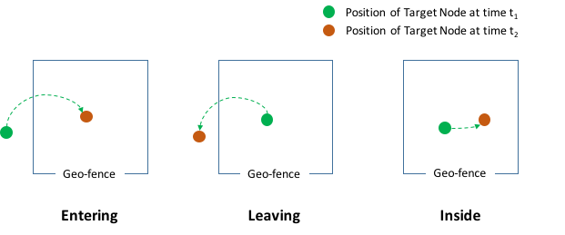
Figure 9.6.10-0: The Event Types for the Geo-fence
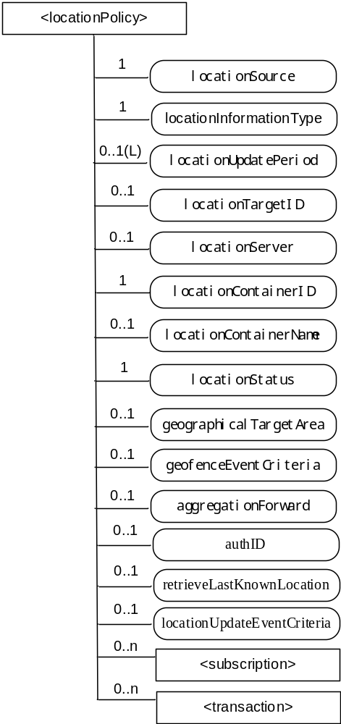
Figure 9.6.10-1: Structure of <locationPolicy> resource
The <locationPolicy> resource shall contain the child resources specified in table 9.6.10-1.
Table 9.6.10-1: Child resources of <locationPolicy> resource
Child Resources of <locationPolicy> | Child Resource Type | Multiplicity | Description | <locationPolicyAnnc> Child Resource Types
[variable] | <subscription> | 0..n | See clause 9.6.8 | None
[variable] | <transaction> | 0..n | See clause 9.6.48 | <transaction>

The <locationPolicy> resource shall contain the attributes specified in table 9.6.10-2.
Table 9.6.10-2: Attributes of <locationPolicy> resource
Attributes of <locationPolicy> | Multiplicity | RW/  RO/  WO | Description | <locationPolicyAnnc> Attributes
resourceType | 1 | RO | See clause 9.6.1.3. | NA
resourceID | 1 | RO | See clause 9.6.1.3. | NA
resourceName | 1 | WO | See clause 9.6.1.3. | NA
parentID | 1 | RO | See clause 9.6.1.3. | NA
expirationTime | 1 | RW | See clause 9.6.1.3. | MA
accessControlPolicyIDs | 0..1 (L) | RW | See clause 9.6.1.3. | MA
creationTime | 1 | RO | See clause 9.6.1.3. | NA
lastModifiedTime | 1 | RO | See clause 9.6.1.3. | NA
labels | 0..1 (L) | RW | See clause 9.6.1.3. | MA
announceTo | 0..1 (L) | RW | See clause 9.6.1.3. | NA
announcedAttribute | 0..1 (L) | RW | See clause 9.6.1.3. | NA
dynamicAuthorizationConsultationIDs | 0..1 (L) | RW | See clause 9.6.1.3. | OA
locationSource | 1 | RW | Indicates the source of location information:  - Network Based;  - Device Based;  - Sharing Based. | OA
locationInformationType | 1 | RW | Indicate the types of location information:  - Position fix (e.g. longitude and latitude);  - Geo-fence event (e.g. entering and leaving). | OA
locationUpdatePeriod | 0..1(L) | RW | Indicates the period for updating location information. If the value is marked '0' or not defined and locationUpdateEventCriteria is absent, location information is updated only when a retrieval request to the <latest> child resource of the <container> indicated by locationContainerID is detected. If the attribute has more than one value and the hosting CSE of the resource is the target device, the value could be selected within the listed values depending on device's local context information(e,q, velocity, status of battery, range of the location etc). Zero('0') shall not be stored with non zero value(s).  When the value is read, the first value in the list is the current active update period. | OA
locationTargetID | 0..1 | RW | The identifier to be used for retrieving the location information of a remote Node and this attribute is only used for the case that location information is provided by a location server. For example, when the remote Node is a 3GPP UE, locationTargetID could be M2M-Ext-ID or MSISDN. | OA
locationServer | 0..1 | RW | Indicates the identity of the location or Geo-fence server. This attribute is only used in that case location information is provided by a location server or Geo-fence server. | OA
locationContainerID | 1 | RO | ID of the <container> resource where the actual location information or event result of a M2M Node is stored. | OA
locationContainerName | 0..1 | WO | A name of the <container> resource where the actual location information of a M2M Node is stored. If it is not assigned, the Hosting CSE automatically assigns a name of the resource (see note). | OA
locationStatus | 1 | RO | Contains the information on the current status of the location request (e.g. location server fault). | OA
geographicalTargetArea | 0..1 | RW | Indicates area information where the Geo-fence feature is applied. | OA
geofenceEventCriteria | 0..1 | RW | Indicate the event type of Geo-fence feature:  - Entering;  - Leaving;  - Inside;  - Outside. | OA
aggregationForward | 0..1 | RW | Indicate how Geo-fence relevant information (e.g. measurement or position fix) from the target node is forwarded to Geo-fence server:  - True/False;  - Number of Events;  - Time-based Accmulation. | OA
authID | 0..1 | RW | Indicates the identity of the application which retrieves the location information of a remote node. This attribute is only used by the Location Server in the Underlying Network to verify whether the application is authorized to request the location information.  See clause 7.1.8 where this attribute is described. | OA
retrieveLastKnownLocation | 0..1 | RW | Indicates if the Hosting CSE shall retrieve the last known location when the Hosting CSE fails to retrieve the latest location.  This attribute shall only be applicable when the locationSource is Network Based.  The supported values are:  - True: Shall retrieve the last known location.  - False: Shall not retrieve the last known location. | OA
locationUpdateEventCriteria | 0..1 | RW | Indicates the type of event that shall result in a location update. This attribute shall only be applicable when locationUpdatePeriod is zero or not defined and locationSource is Network Based.  The supported values are:  - LocationChange | OA
NOTE: The created <container> resource related to this policy shall be stored only in the Hosting CSE.

-----------------------End of change 3---------------------------------------------

-----------------------Start of change 4---------------------------------------------

9.6.20 Resource Type serviceSubscribedNode
The <serviceSubscribedNode> resource represents M2M Node information that is needed as part of the M2M Service Subscription resource and is only stored on IN-CSE. It contain M2M-Node-ID and optionally CSE-ID running on that Node.
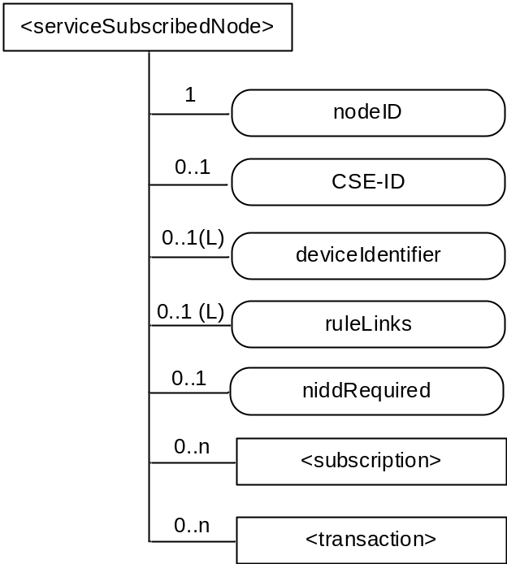
Figure 9.6.20-1: Structure of <serviceSubscribedNode> resource
The <serviceSubscribedNode> resource shall contain the child resource specified in table 9.6.20-1.
Table 9.6.20-1: Child resources of <serviceSubscribedNode> resource
Child Resources of <serviceSubscribedNode> | Child Resource Type | Multiplicity | Description
[variable] | <subscription> | 0..n | See clause 9.6.8
[variable] | <transaction> | 0..n | See clause 9.6.48

The <serviceSubscribedNode> resource shall contain the attributes specified in table 9.6.20-2.
Table 9.6.20-2: Attributes of <serviceSubscribedNode> resource
Attributes of <serviceSubscribedNode> | Multiplicity | RW/  RO/  WO | Description
resourceType | 1 | RO | See clause 9.6.1.3.
resourceID | 1 | RO | See clause 9.6.1.3.
resourceName | 1 | WO | See clause 9.6.1.3.
parentID | 1 | RO | See clause 9.6.1.3.
expirationTime | 1 | RW | See clause 9.6.1.3.
accessControlPolicyIDs | 0..1 (L) | RW | See clause 9.6.1.3. If no accessControlPolicyIDs value is configured, the accessControlPolicyIDs of the parent resource shall be applied for privilege checking.
creationTime | 1 | RO | See clause 9.6.1.3.
labels | 0..1 (L) | RW | See clause 9.6.1.3
lastModifiedTime | 1 | RO | See clause 9.6.1.3.
dynamicAuthorizationConsultationIDs | 0..1 (L) | RW | See clause 9.6.1.3.
nodeID | 1 | WO | M2M-Node-ID of the node that is represented by this instance.
CSE-ID | 0..1 | WO | CSE-ID pertaining to this node (for nodes that have a CSE).
deviceIdentifier | 0..1 (L) | WO | A list of device identifiers that uniquely identify a device. The format of a device identifier is one of the following:  - Case 1: Identify a device using the format <OUI> "-" <ProductClass> "-" <SerialNumber> as defined in section 3.4.4 of BBF TR-069 [Error: Reference source not found]. The format of the URN is urn:dev:ops:<OUI> "-" <ProductClass> "-" <SerialNumber>.  - Case 2: Identify a device using the format <OUI> "-"<SerialNumber> as defined in section 3.4.4 of BBF TR-069 [Error: Reference source not found]. The format of the URN is urn:dev:os:<OUI> "-"<SerialNumber>.  - Case 3: Identify a device using an International Mobile Equipment Identifiers of 3GPP TS 23 003 [Error: Reference source not found]. This URN specifies a valid, 15 digit IMEI. The format of the URN is urn:imei:###############.  - Case 4: Identify a device using an Electronic Serial Number. The ESN specifies a valid, 8 digit ESN. The format of the URN is urn:esn:########.  - Case 5: Identify a device using a Mobile Equipment Identifier. This URN specifies a valid, 14 digit MEID. The format of the URN is urn:meid:##############.  - Case 6: Identify a device using an Object IDentifier (OID). This URN specifies a valid OID - see Annex H for one possible naming convention. The format of the URN is urn:oid:<OID>.  - Case 7: Identify a device using a Universally Unique IDentifier (UUID). The UUID specifies a valid, hex digit character string as defined in RFC4122 [i.26]. The format of the URN is  urn:uuid:########-####-####-############.
ruleLinks | 0..1 ((L) | RW | This attribute contains a list of links towards <serviceSubscribedAppRule> resources pertaining to this <serviceSubscribedNode>. See clause 9.6.29 for an explanation of the <serviceSubscribedAppRule> resource. This attribute shall exist only when the CSE-ID attribute is present. When the list is empty, it means no applications are allowed to register on the CSE which is indicated by the CSE-ID attribute.
niddRequired | 0..1 | RW | Controls whether the IN-CSE configures the underlying network to enable Non-IP Data Delivery for this node.  Valid values are "TRUE" or "FALSE". If not configured, then IN-CSE default policy shall apply. See [15].

-----------------------End of change 4---------------------------------------------

-----------------------Start of change 5---------------------------------------------

9.6.29 Resource Type serviceSubscribedAppRule
The <serviceSubscribedAppRule> resource represents a rule that defines allowed Role-ID, App-ID and AE-ID combinations that are acceptable for registering an AE on a Registrar CSE and is only stored on IN-CSE. The rule in a <serviceSubscribedAppRule> resource shall apply for CSEs for which the associated <serviceSubscribeNode> resource is linked with the <serviceSubscribedAppRule> via the ruleLinks attribute of the <serviceSubscribedNode> resource. The rule contained in a <serviceSubscribedAppRule> resource defines a mapping between:
- one or more Credential-ID(s); and
- combinations of one or more Role-ID(s), one or more App-ID(s) and one or more AE-ID(s) which are allowed to be used for registering AE(s) that issued a registration request via a Security Association established with the credentials associated with the Credential-ID(s) listed in (a).
When applications shall be allowed in situations where no Security Association has been established prior to issuing the registration request, the Credential-ID 'None' shall be used in the rule.
The parent resource of a <serviceSubscribedAppRule> resource is the <CSEBase> resource of the IN-CSE hosting the <serviceSubscribedNode> resource(s) that point to the <serviceSubscribedAppRule> resource.
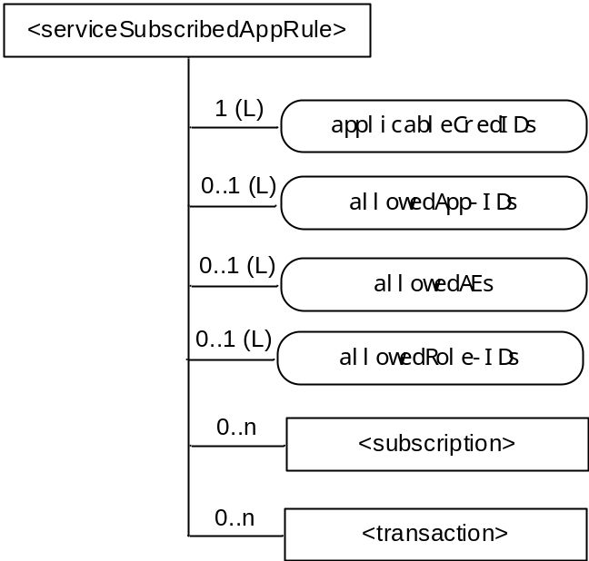
Figure 9.6.29-1: Structure of <serviceSubscribedAppRule> resource
The <serviceSubscribedAppRule> resource shall contain the child resource specified in table 9.6.29-1.
Table 9.6.29-1: Child resources of <serviceSubscribedAppRule> resource
Child Resources of <serviceSubscribedAppRule> | Child Resource Type | Multiplicity | Description
[variable] | <subscription> | 0..n | See clause 9.6.8 where the type of this resource is described.
[variable] | <transaction> | 0..n | See clause 9.6.48

The <serviceSubscribedAppRule> resource shall contain the attributes specified in table 9.6.29-2.
Table 9.6.29-2: Attributes of <serviceSubscribedAppRule> resource
Attributes of <serviceSubscribedAppRule> | Multiplicity | RW/  RO/  WO | Description
resourceType | 1 | RO | See clause 9.6.1.3.
resourceID | 1 | RO | See clause 9.6.1.3.
resourceName | 1 | WO | See clause 9.6.1.3.
parentID | 1 | RO | See clause 9.6.1.3.
expirationTime | 1 | RW | See clause 9.6.1.3.
accessControlPolicyIDs | 0..1 (L) | RW | See clause 9.6.1.3. If no accessControlPolicyIDs value is configured, the accessControlPolicyIDs of the parent resource shall be applied for privilege checking.
creationTime | 1 | RO | See clause 9.6.1.3.
labels | 0..1 (L) | RW | See clause 9.6.1.3
lastModifiedTime | 1 | RO | See clause 9.6.1.3.
dynamicAuthorizationConsultationIDs | 0..1 (L) | RW | See clause 9.6.1.3.
applicableCredIDs | 1 (L) | RW | List of credential IDs for which this rule is applicable, i.e. for registration requests coming into a CSE via a Security Association Endpoint (SEA) [Error: Reference source not found], that was authenticated using credentials that match with any of these credential-IDs, the current rule applies. This can contain a '*' for any credential ID or 'None' for not authenticated case. Also Wildcards within an element of this list are possible (e.g. 'C123*X' for any Credential ID that starts with 'C123' and ends with 'X') to define sets or ranges of Credential-IDs.
allowedApp-IDs | 0..1 (L) | RW | List of App-IDs that shall be considered to be allowed for AE registration requests received via Security Association Endpoint (SEA) [Error: Reference source not found] associated with credentialID stored in the attribute applicableCredID. This can contain '*' for any App-ID. Also Wildcards within an element of this list are possible (e.g. 'C123*X' for any App-ID that starts with 'C123' and ends with 'X') to define sets or ranges of App-IDs.
allowedAEs | 0..1 (L) | RW | List of allowed AE-ID-Stems to be used for the registering AEs. This can contain zero or more specific AE-ID-Stem values, 'S*' for any SP-Assigned AE-ID-Stem, 'C*' for any CSE-assigned AE-ID-Stem, or '*' for any AE-ID-Stem. Also Wildcards within an element of this list are possible (e.g. 'C123*X' for any AE-ID that starts with 'C123' and ends with 'X') to define sets or ranges of AE-ID-Stems.
allowedRole-IDs | 0..1(L) | RW | List of Role-IDs that shall be considered to be allowed in Request operations.

-----------------------End of change 5---------------------------------------------

-----------------------Start of change 6---------------------------------------------

9.6.31 Resource Type notificationTargetMgmtPolicyRef
The <notificationTargetMgmtPolicyRef> resource is a child resource of a <subscription> resource and lists a reference to the policy to be followed by the hosting CSE for every Target Notification of a subscription. The policy is applied by the hosting CSE when it receives a request to stop receiving a notification from a Target Notification. If no policy is defined for the Target Notification, then the hosting CSE shall apply the default policy. The default policy is either created by the subscription originator or the hosting CSE shall have a system created default one to apply. The system created default policy shall be configurable by the M2M Service Provider.
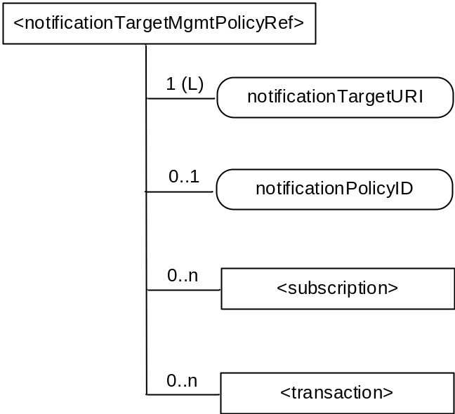
Figure 9.6.31-1: Structure of <notificationTargetMgmtPolicyRef> resource
Table 9.6.31-1: Child resources of <notificationTargetMgmtPolicyRef> resource
Child Resources of <notificationTargetMgmtPolicyRef> | Child Resource Type | Multiplicity | Description
[variable] | <subscription> | 0..n | See clause 9.6.8
[variable] | <transaction> | 0..n | See clause 9.6.48

Table 9.6.31-2: Attributes of <notificationTargetMgmtPolicyRef> resource
Attributes of <notificationTargetMgmtPolicyRef> | Multiplicity | RW/  RO/  WO | Description
resourceType | 1 | RO | See clause 9.6.1.3.
resourceID | 1 | RO | See clause 9.6.1.3.
resourceName | 1 | WO | See clause 9.6.1.3.
parentID | 1 | RO | See clause 9.6.1.3.
expirationTime | 1 | RW | See clause 9.6.1.3.
accessControlPolicyIDs | 0..1 (L) | RW | See clause 9.6.1.3. If no accessControlPolicyIDs value is configured, the accessControlPolicyIDs of the parent resource shall be applied for privilege checking.
creationTime | 1 | RO | See clause 9.6.1.3.
labels | 0..1 (L) | RW | See clause 9.6.1.3.
lastModifiedTime | 1 | RO | See clause 9.6.1.3.
dynamicAuthorizationConsultationIDs | 0..1 (L) | RW | See clause 9.6.1.3.
notificationTargetURI | 1 (L) | RW | address(es) of the resource subscriber receiving a notification.The notificationTarget URI shall be listed in the notificationURI attribute of the parent <subscription> resource, otherwise the default Notification Target policy shall apply.
notificationlPolicyID | 0..1 | RW | A link to the <notificationTargetPolicy> resource applicable to the notificationTargetURI. If none is specified than the default policy shall apply to the targetNotificationURI. See clause 9.6.32 for an explanation of the <notificationTargetPolicy> resource.

-----------------------End of change 6---------------------------------------------

-----------------------Start of change 7---------------------------------------------

9.6.33 Resource Type policyDeletionRules
The <policyDeletionRules> resource lists the rules to be applied by the hosting CSE during policy execution. Each <policyDeletionRules> can define any number of rules with an AND or OR relationship to be applied between them. The attribute deletionRulesRelation define the relationship between rules. It can have an AND or OR value.
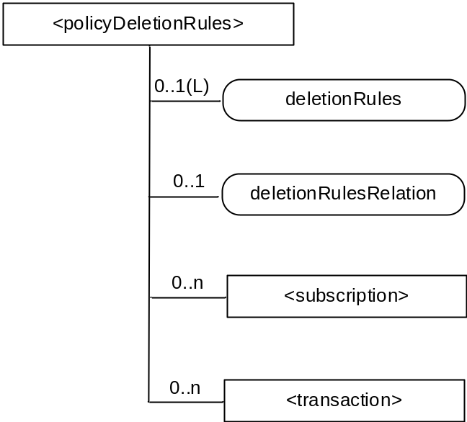
Figure 9.6.33-1: Structure of <policyDeletionRules> resource
Table 9.6.33-1: Child resources of <policyDeletionRules> resource
Child Resources of <policyDeletionRules> | Child Resource Type | Multiplicity | Description
[variable] | <subscription> | 0..n | See clause 9.6.8
[variable] | <transaction> | 0..n | See clause 9.6.48

Table 9.6.33-2: Attributes of <policyDeletionRules> resource
Attributes of <policyDeletionRules> | Multiplicity | RW/  RO/  WO | Description
resourceType | 1 | RO | See clause 9.6.1.3.
resourceID | 1 | RO | See clause 9.6.1.3.
resourceName | 1 | WO | See clause 9.6.1.3.
parentID | 1 | RO | See clause 9.6.1.3.
expirationTime | 1 | RW | See clause 9.6.1.3.
accessControlPolicyIDs | 0..1 (L) | RW | See clause 9.6.1.3. If no accessControlPolicyIDs value is configured, the accessControlPolicyIDs of the parent resource shall be applied for privilege checking.
creationTime | 1 | RO | See clause 9.6.1.3.
labels | 0..1 (L) | RW | See clause 9.6.1.3.
lastModifiedTime | 1 | RO | See clause 9.6.1.3.
dynamicAuthorizationConsultationIDs | 0..1 (L) | RW | See clause 9.6.1.3.
deletionRules | 0..1(L) | RW | Lists the applicable rules. The rules include at minimum ; time of the day, geaographical location of the Target Notification. Where the rule applies.
deletionRulesRelation | 0..1 | RW | Defines the relation to be applied between the deletionRules. This shall be either AND or OR.

-----------------------End of change 7---------------------------------------------

-----------------------Start of change 8---------------------------------------------

9.6.35 Resource Type flexContainer
The <flexContainer> resource type is a customizable container for data instances. It is a template for the definition of flexible specializations of data containers. Like a <container> resource, specializations of this <flexContainer> resource type are used to share information with other entities and potentially to track the data. While the <container> resources includes data to be made accessible to oneM2M entities inside <contentInstance> children, a specialization of the <flexContainer> resource includes associated content directly inside the <flexContainer> by means of one or more [customAttribute] attribute(s). The attribute name and attribute data type of [customAttribute] attributes are defined explicitly for each specialization of <flexContainer>, i.e. the specific set of attribute name and type are defined in a corresponding XSD-file.
Example usage of <flexContainer>: As a specialization of <flexContainer> that includes two [customAttribute] attributes, named "temperature"(xs:float type) and "humidity"(xs:positiveInteger type) can be specified in some TS. The actual data types of [customAttribute] will be described both in the specification document or XSD file which are referred by the value of containerDefinition attribute.
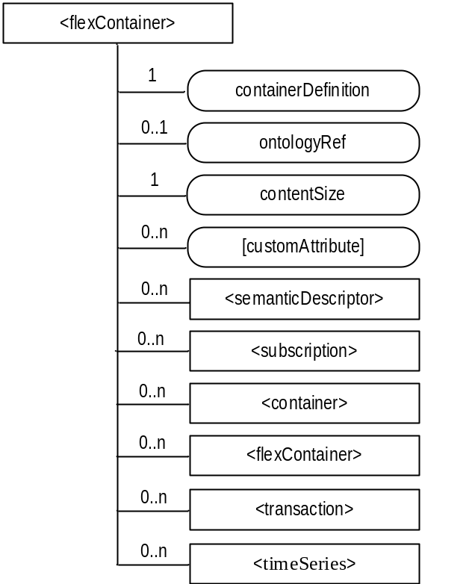
Figure 9.6.35-1: Structure of <flexContainer> resource
The <flexContainer> resource shall contain the child resource specified in table 9.6.35-1.
Table 9.6.35-1: Child resources of <flexContainer> resource
Child Resources of <flexContainer> | Child Resource Type | Multiplicity | Description | <flexContainerAnnc> Child Resource Type
[variable] | <semanticDescriptor> | 0..n | See clause 9.6.30 | <semanticDescriptor>, <semanticDescriptorAnnc>
[variable] | <subscription> | 0..n | See clause 9.6.8 | <subscription>
[variable] | <container> | 0..n | See clause 9.6.6 | <container>  <containerAnnc>
[variable] | <flexContainer> | 0..n | <flexContainer> resource can include any of its specializations as child resource | <flexContainer>  <flexContainerAnnc>
[variable] | <timeSeries> | 0..n | See clause 9.6.36 | <timeSeries>,  <timeSeriesAnnc>
[variable] | <transaction> | 0..n | See clause 9.6.48 | <transaction>

The <flexContainer> resource shall contain the attributes specified in table 9.6.35-2.
Table 9.6.35-2: Attributes of <flexContainer> resource
Attributes of  <flexContainer> | Multiplicity | RW/  RO/  WO | Description | <flexContainerAnnc> Attributes
resourceType | 1 | RO | See clause 9.6.1.3. | NA
resourceID | 1 | RO | See clause 9.6.1.3. | NA
resourceName | 1 | WO | See clause 9.6.1.3. | NA
parentID | 1 | RO | See clause 9.6.1.3. | NA
expirationTime | 0..1 (note) | RW | See clause 9.6.1.3. | MA
accessControlPolicyIDs | 0..1 (L) | RW | See clause 9.6.1.3. | MA
labels | 0..1 (L) | RW | See clause 9.6.1.3. | MA
creationTime | 0..1  (note) | RO | See clause 9.6.1.3. | NA
lastModifiedTime | 0..1  (note) | RO | See clause 9.6.1.3. | NA
stateTag | 1 | RO | See clause 9.6.1.3.  This stateTag attribute value shall be incremented when a <container> or [flexContainer] child resource is created or deleted. This works same as the stateTag attribute update on a <container> resource at a <contentInstance> resource creation or deletion. | OA
announceTo | 0..1 (L) | RW | See clause 9.6.1.3. | NA
announcedAttribute | 0..1 (L) | RW | See clause 9.6.1.3. | NA
dynamicAuthorizationConsultationIDs | 0..1 (L) | RW | See clause 9.6.1.3. | OA
creator | 0..1 | RO | See clause 9.6.1.3. | NA
containerDefinition | 1 | WO | This contains an identifier reference (URI) to the <flexContainer> schema definition which shall be used by the CSE to validate the syntax of the <flexContainer> resource.  This URI may refer to one of the oneM2M <flexContainer> defintions specified in the following documents:  - Generic Interworking [Error: Reference source not found]]  - AllJoyn Interworking [7];  - Home Domain Information Model [8]  A list of oneM2M <flexContainer> defintions is also provided in clause 9.6.1.2.2 [3].  Other URI for other <flexContainer> definitions may be specified. | MA
ontologyRef | 0..1 | RW | A reference (URI) of the ontology used to represent the information that is stored in the present <flexContainer> resource. | OA
contentSize | 1 | RO | Sum of the size in bytes of all of the custom attributes. | OA
[customAttribute] | 0..n | RW | Specialization-specific attribute(s). Name and data type defined in each specialization of <flexContainer> resource. | OA
NOTE: When an instance of <flexContainer> is a child of a <flexContainer> resource, these attributes can be optional. Their presence is determined by the respective definition referred to by the containerDefinition attribute.

-----------------------End of change 8---------------------------------------------

-----------------------Start of change 9---------------------------------------------

9.6.39 Resource Type token
The <token> resource is used for storing a token that is issued to an AE or CSE. Details of the token may also be stored here in plaintext.
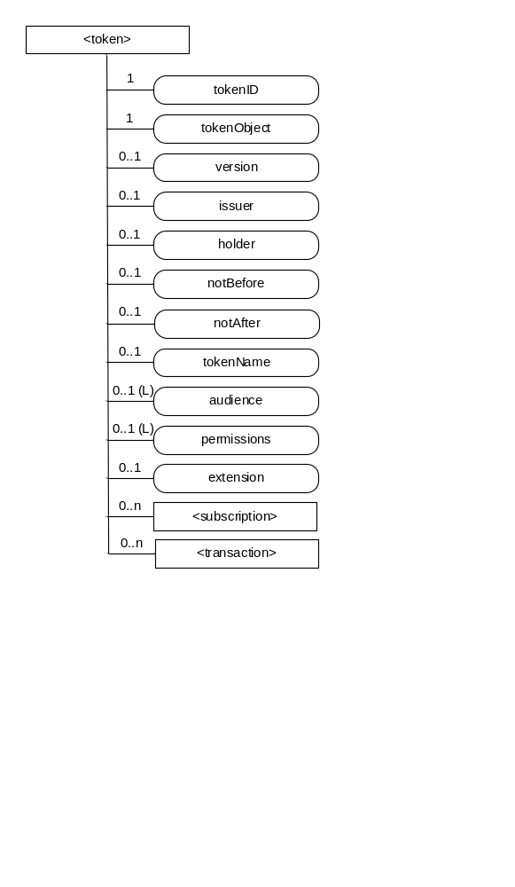
Figure 9.6.39-1: Structure of <token> resource
The <token> resource shall contain the child resources specified in table 9.6.39-1.
Table 9.6.39-1: Child resources of <token> resource
Child Resources of <token> | Child Resource Type | Multiplicity | Description
[variable] | <subscription> | 0..n | See clause 9.6.8
[variable] | <transcaction> | 0..n | See clause 9.6.48

The <token> resource shall contain the attributes specified in table 9.6.39-2.
Table 9.6.39-2: Attributes of <token> resource
Attributes of <token> | Multiplicity | RW/  RO/  WO | Description
resourceType | 1 | RO | See clause 9.6.1.3.
resourceID | 1 | RO | See clause 9.6.1.3.
resourceName | 1 | WO | See clause 9.6.1.3.
parentID | 1 | RO | See clause 9.6.1.3.
expirationTime | 1 | RW | See clause 9.6.1.3.
accessControlPolicyIDs | 0..1 (L) | RW | See clause 9.6.1.3.
creationTime | 1 | RO | See clause 9.6.1.3.
labels | 0..1 (L) | RW | See clause 9.6.1.3.
lastModifiedTime | 1 | RO | See clause 9.6.1.3.
dynamicAuthorizationConsultationIDs | 0..1 (L) | RW | See clause 9.6.1.3.
tokenID | 1 | WO | The identifier of the token.
tokenObject | 1 | WO | Used to store the token. See clause TS-0003 [2] for further details of a token.
version | 0..1 | WO | Version of the token.
issuer | 0..1 | WO | The identifier of the entity that is responsible for issuing the token to the AE or CSE.
audience | 0..1 (L) | WO | List of identifiers of the CSEs expected to accept the token.
holder | 0..1 | WO | The identifier of the AE or CSE to which the token is issued.
notBefore | 0..1 | WO | Start time of the token can be used for access control.
notAfter | 0..1 | WO | End time of the token can be used for access control.
tokenName | 0..1 | WO | Human readable name of the <token>..
permissions | 0..1 (L) | WO | List of token permissions associated with the token. The structure of token permission is specified in the table 9.6.39-3.
extension | 0..1 | WO | Extension information held by the token, e.g. application-specific information.

The structure of token permission is specified in the table 9.6.39-3.
Table 9.6.39-3: Structure of token permission
Element | Multiplicity | Description | Note
resourceIDs | 0..1 | The resources to which this permission applies. If the privileges element is present, then this element shall be present.
privileges | 0..1 | A set of access control rules applicable to the identified resources (for the identified holder) | At least one of these must be present.
roleIDs | 0..1 | A set of role IDs applicable to the identified resources (for the identified holder) | At least one of these must be present.

-----------------------End of change 9---------------------------------------------

-----------------------Start of change 10---------------------------------------------

9.6.46 Resource Type AEContactListPerCSE
An <AEContactListPerCSE> resource shall represent information about a CSE that has resources that reference an Application Entity resource identifier (SP-relative-Resource-IDs of an AE). For example, these Application Entity resource identifiers may occur in announcement links, notification targets, group member IDs, or in the OriginatorID list of the accessControlOriginators parameter tied to an <accessControlPolicy> resource. The <AEContactListPerCSE> resource shall only be created in the IN-CSE.

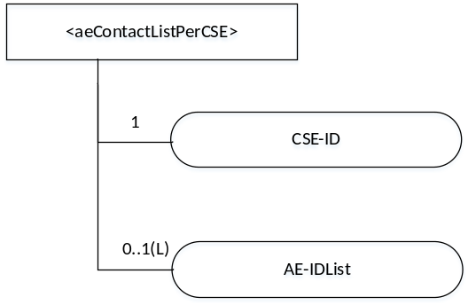
Figure 9.6.46-1: Structure of <AEContactListPerCSE> resource
The <AEContactListPerCSE> resource shall contain the attributes specified in table 9.6.46-1.
Table 9.6.46-1: Attributes of <AEContactListPerCSE> resource
Attributes of  <AContactListPerCSE> | Multiplicity | RW/  RO/  WO | Description
resourceType | 1 | RO | See clause 9.6.1.3.
resourceID | 1 | RO | See clause 9.6.1.3.
resourceName | 1 | RO | See clause 9.6.1.3.
parentID | 1 | RO | See clause 9.6.1.3.
expirationTime | 1 | RO | See clause 9.6.1.3.
accessControlPolicyIDs | 0..1 (L) | RO | See clause 9.6.1.3.
creationTime | 1 | RO | See clause 9.6.1.3.
lastModifiedTime | 1 | RO | See clause 9.6.1.3.
labels | 0..1 (L) | RO | See clause 9.6.1.3.
CSE-ID | 1 | RO | The identifier of the Hosting CSE which has a reference to an Application Entity resource identify (SP-relative-Resource-ID that points to an AE).  Hosting CSEs notify the IN-CSE when they have a reference to an <AE> resource through e.g. announcements, notification targets, group member IDs, <accessControlPolicy> resource OriginatorID lists.
AE-IDList | 0..1(L) | RO | List of Application Entity resource identifiers hosted on CSE with identifier CSE-ID

-----------------------End of change 10---------------------------------------------

-----------------------Start of change 11---------------------------------------------

9.6.53 Resource Type semanticMashupJobProfile
The <semanticMashupJobProfile> resource represents a Semantic Mashup Job Profile (SMJP). A SMJP describes the profile and necessary information required for a specific mashup service such as input parameters, member resources, mashup function, and output parameters. Based on the profile describled in the SMJP, Originators (e.g. AEs) can create corresponding semantic mashup instances where semantic mashup results will be generated and stored. The structure of a <semanticMashupJobProfile> resource is also illustrated in Figure 9.6.53-1.

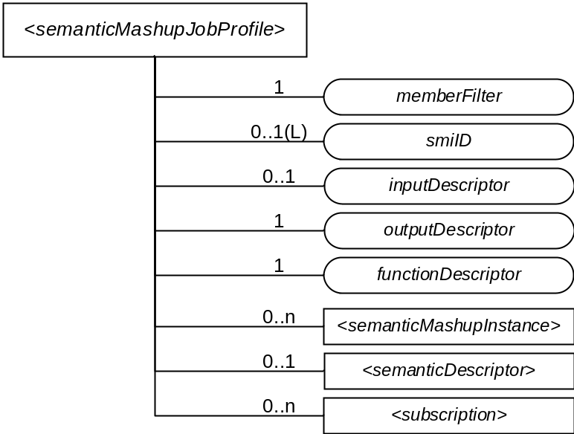
Figure 9.6.53-1: Structure of <semanticMashupJobProfile> Resource

The <semanticMashupJobProfile> resource shall contain the child resources specified in Table 9.6.53-1.
Table 9.6.53-1: Child resources of <semanticMashupJobProfile> resource
Child Resources of <semanticMashupJobProfile> | Child Resource Type | Multiplicity | Description | <semanticMashupJobProfileAnnc> Child Resource Types
<variable> | <semanticMashupInstance> | 0..n | Represents semantic mashup instances which have been created based on this <semanticMashupJobProfile> resource. This child resource is optional as related<semanticMashupJobProfile> and <semanticMashupInstance> may be stored separately within the resource tree or on different CSEs.  See clause 9.6.54. | <semanticMashupInstance>, <semanticMashupInstanceAnnc>
<variable> | <semanticDescriptor> | 0..1 | Describes general semantic information about this <semanticMashupJobProfile> resource.  See clause 9.6.30. | <semanticDescriptor>, <semanticDescriptorAnnc>
<variable> | <subscription> | 0..n | Represents subscriptions on this resource.  See clause 9.6.8. | <subscription>

The <semanticMashupJobProfile> resource shall contain the attributes specified in Table 9.6.53-2.
Table 9.6.53-2: Attributes of <semanticMashupJobProfile> resource
Attributes of  <semanticMashupJobProfile> | Multiplicity | RW/  RO/  WO | Description | <semanticMashupJobProfileAnnc> Attributes
resourceType | 1 | RO | See clause 9.6.1.3. | NA
resourceID | 1 | RO | See clause 9.6.1.3. | NA
resourceName | 1 | WO | See clause 9.6.1.3. | NA
parentID | 1 | RO | See clause 9.6.1.3. | NA
expirationTime | 1 | RW | See clause 9.6.1.3. | MA
accessControlPolicyIDs | 0..1 (L) | RW | See clause 9.6.1.3. | MA
labels | 0..1 (L) | RW | See clause 9.6.1.3. | MA
creationTime | 1 | RO | See clause 9.6.1.3. | NA
lastModifiedTime | 1 | RO | See clause 9.6.1.3. | NA
stateTag | 1 | RO | See clause 9.6.1.3. | OA
announceTo | 0..1 (L) | RW | See clause 9.6.1.3. | NA
announcedAttribute | 0..1 (L) | RW | See clause 9.6.1.3. | NA
dynamicAuthorizationConsultationIDs | 0..1 (L) | RW | See clause 9.6.1.3. | OA
creator | 0..1 | RO | See clause 9.6.1.3. | NA
memberFilter | 1 | RW | Semantically describes the types of member resources which are involved in this semantic mashup job profile <semanticMashupJobProfile>. When a <semanticMashupInstance> is created based on this <semanticMashupJobProfile>, the member resources of the <semanticMashupInstance> shall be discovered and selected based on this memberFilter attribute. The value of this attribute is a SPARQL query. | OA
smiID | 0..1(L) | RO | List of resource identifiers of related semantic mashup instance resources which have been created based on this <semanticMashupJobProfile>. | OA
inputDescriptor | 0..1 | RW | Semantically (i.e. using semantic triples) describes the types of input parameters, which are required in order to use this <semanticMashupJobProfile> to create <semanticMashupInstance>. Some semantic mashup job profiles may not need input parameters and as such this attribute is optional. | OA
outputDescriptor | 1 | RW | Semantically (e.g. in semantic triples) describes the types of output parameters generated as semantic mashup results if using this <semanticMashupJobProfile>. | OA
functionDescriptor | 1 | RW | Semantically (e.g. in semantic triples) describes the mashup function of this <semanticMashupJobProfile>. The mashup function specifies how semantic mashup results should be generated based on input parameters (defined by the inputDescriptor attribute) and original member resources (defined by the memberFilter attribute). | OA

-----------------------End of change 11---------------------------------------------

-----------------------Start of change 12---------------------------------------------

9.6.54 Resource Type semanticMashupInstance
<semanticMashupInstance> models and represents a Semantic Mashup Instance (SMI) resource. A CSE/AE as a Mashup Requestor can request to create <semanticMashupInstance> resources at another oneM2M CSE which implements the semantic mashup function. Each created <semanticMashupInstance> resource corresponds to a semantic mashup job profile (i.e. a <semanticMashupJobProfile> resource); in other words, how the <semanticMashupInstance> resource should execute the mashup operation to calculate the mashup result is specified in the corresponding <semanticMashupJobProfile> resource. Note that the <semanticMashupInstance> and its corresponding <semanticMashupJobProfile> resources may be placed at the same CSE or at different CSEs, and the smjpID attribute of the <semanticMashupInstance> allows locating the corresponding <semanticMashupJobProfile> resource. If the <semanticMashupInstance> resource has a <semanticMashupResult> as its child resource, the Mashup Requestor may use it to retrieve the mashup result.
The structure of <semanticMashupInstance> resource is also illustrated in Figure 9.6.54-1.
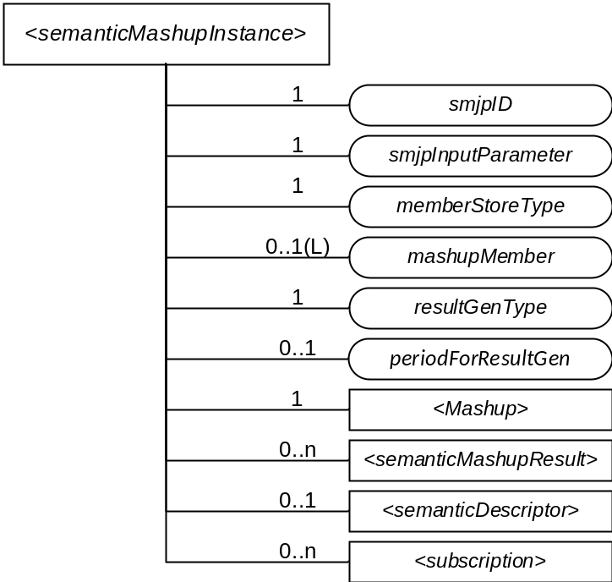
Figure 9.6.54-1: Structure of <semanticMashupInstance> Resource

<semanticMashupInstance> resource shall contain the child resources specified in Table 9.6.54-1.
Table 9.6.54-1: Child resources of <semanticMashupInstance> resource
Child Resources of <semanticMashupInstance> | Child Resource Type | Multiplicity | Description | <semanticMashupInstanceAnnc> Child Resource Types
<variable> | <semanticMashupResult> | 0..n | Contains mashup result. A <semanticMashupInstance> resource may have multiple <semanticMashupResult> child resources, with each mashup result instance resulting from different input parameters and/or member resource values. The hosting CSE generates <semanticMashupResult> each time when it executes the mashup operation and calculate a new semantic mashup result. | <semanticMashupResult>, <semanticMashupResultAnnc>
<variable> | <semanticDescriptor> | 0..1 | Describes general semantic information about this <semanticMashupInstance> resource. | <semanticDescriptor>, <semanticDescriptorAnnc>
<variable> | <subscription> | 0..n | Stands for any subscription on this <semanticMashupInstance>. | <subscription>
msp | <mashup> | 1 | This is a standard oneM2M virtual resource. When a Mashup Requestor sends a RETRIEVE operation on this virtual resource, it triggers a re-calculation and re-generation of the mashup result. | None

<semanticMashupInstance> resource shall contain the attributes specified in Table 9.6.54-2.

Table 9.6.54-2: Attribute of <semanticMashupInstance> resource
Attributes of  <semanticMashupInstance> | Multiplicity | RW/  RO/  WO | Description | <semanticMashupInstanceAnnc> Attributes
resourceType | 1 | RO | See clause 9.6.1.3. | NA
resourceID | 1 | RO | See clause 9.6.1.3. | NA
resourceName | 1 | WO | See clause 9.6.1.3. | NA
parentID | 1 | RO | See clause 9.6.1.3. | NA
expirationTime | 1 | RW | See clause 9.6.1.3. | MA
accessControlPolicyIDs | 0..1 (L) | RW | See clause 9.6.1.3. | MA
labels | 0..1 (L) | RW | See clause 9.6.1.3. | MA
creationTime | 1 | RO | See clause 9.6.1.3. | NA
lastModifiedTime | 1 | RO | See clause 9.6.1.3. | NA
stateTag | 1 | RO | See clause 9.6.1.3. | OA
announceTo | 0..1 (L) | RW | See clause 9.6.1.3. | NA
announcedAttribute | 0..1 (L) | RW | See clause 9.6.1.3. | NA
dynamicAuthorizationConsultationIDs | 0..1 (L) | RW | See clause 9.6.1.3. | OA
creator | 0..1 | RO | See clause 9.6.1.3. | NA
smjpID | 1 | RW | Denotes the identifier (e.g. URI) of the semantic mashup job profile resource <semanticMashupJobProfile> which this <semanticMashupInstance> is based on. | OA
smjpInputParameter | 1 | RW | Contains the value of all input parameters which are required to calculate the mashup result. Note that the types of these input parameters are specified by the inputDescriptor attribute of the corresponding <semanticMashupJobProfile> which is denoted by the smjpID attribute of this <semanticMashupInstance> resource. This attribute is not needed if the corresponding <semanticMashupJobProfile> does not have inputDescriptor attribute. | OA
memberStoreType | 1 | RW | Indicates the way which member resources should be stored under this <semanticMashupInstance>. For example,  - If memberStoreType=“URI Only”, the mashupMember attribute contains the URI of each member resource;  - If memberStoreType=“URI and Value”, the mashupMember attribute contains both the URI and the value of each member resource. | OA
mashupMember | 0:1(L) | RW | Stores the URI and/or value of each mashup member resource, which is dependent on the value of memberStoreType attribute. | OA
resultGenType | 1(L) | RW | Describes how the mashup result should be generated using this <semanticMashupInstance>. Example values for this attribute could be one of the following or a combination of them.  - If resultGenType=“When SMI Is Created”, the semantic mashup result is generated when this <semanticMashupInstance> is created by running semantic functions specified by the corresponding <semanticMashupJobProfile>.  - If resultGenType=“When Mashup Requestor Requests”, the mashup result is to be calculated and generated when requested or triggered by a Mashup Requestor which sends a RETRIEVE operation on the virtual child resource mashup.  - If resultGenType=“Periodically”, the CSE which hosts <semanticMashupInstance> calculates and generates the semantic mashup result periodically based on the periodForResultGen attribute.  - If resultGenType=“When A Mashup Member Is Updated”, the CSE which hosts <semanticMashupInstance> calculates and generates the semantic mashup result whenever there is any update on the mashupMember attribute of <semanticMashupInstance>. | OA
periodForResultGen | 0:1 | RW | Is the time period for re-calculating and generating the semantic mashup result. When it is the time to re-calculate the semantic mashup result, the CSE hosting this <semanticMashupInstance> needs to retrieve the latest content value of each member resource if it is not obtained yet. This attribute is needed when resultGenType=“Periodically”. | OA

-----------------------End of change 12---------------------------------------------

-----------------------Start of change 13---------------------------------------------

9.6.57 Resource Type multimediaSession
An <multimediaSession> resource shall represent information about a multimedia session involving two AEs facilitated by CSE(s).

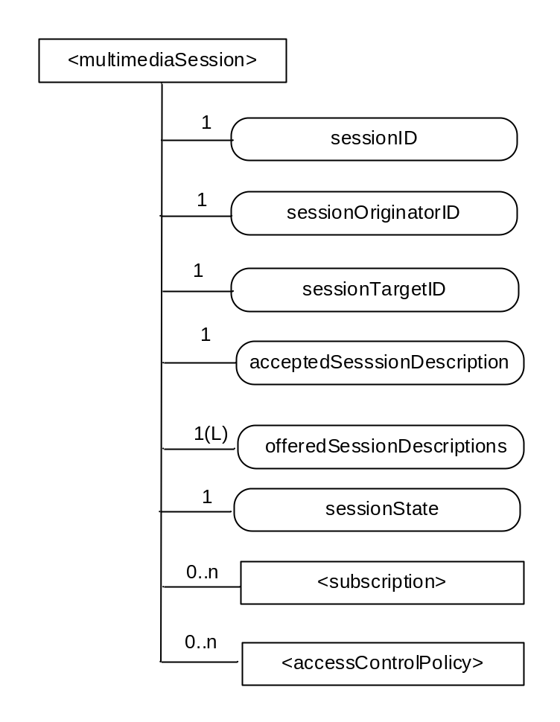
Figure 9.6.57-1: Structure of <multimediaSession> resource
The <multimediaSession> resource shall contain the child resources specified in table 9.6.57-1.
Table 9.6.57-1: Child resources of <multimediaSession> resource
Child Resources of < multimediaSession > | Child Resource Type |  | Multiplicity | Description | < multimediaSession Annc> Child Resource Types
[variable] | <subscription> | 0..n |  | See clause 9.6.8 | <subscription>
[variable] | <accessControlPolicy> | 0..n |  | See clause 9.6.2 | <accessControlPolicy>  <accessControlPolicyAnnc>

The <multimediaSession> resource shall contain the attributes specified in table 9.6.57-2.
Table 9.6.57-2: Attributes of <multimediaSession> resource
Attributes of  <multimediaSession> | Multiplicity | RW/  RO/  WO | Description | <multimediaSessionAnnc> Attributes
resourceType | 1 | RO | See clause 9.6.1.3. | NA
resourceID | 1 | RO | See clause 9.6.1.3. | MA
resourceName | 1 | WO | See clause 9.6.1.3. | MA
parentID | 1 | RO | See clause 9.6.1.3. | NA
expirationTime | 1 | RW | See clause 9.6.1.3. | MA
accessControlPolicyIDs | 0..1 (L) | RW | See clause 9.6.1.3. | MA
creationTime | 1 | RW | See clause 9.6.1.3. | NA
lastModifiedTime | 1 | RO | See clause 9.6.1.3. | NA
labels | 0..1 (L) | RO | See clause 9.6.1.3 where this common attribute is described. | MA
sessionID | 1 | RO | The sessionID shall be the same as the resourceID | NA
sessionOriginatorID | 1 | WO | The AE-ID of the multimedia session originator | NA
sessionTargetID | 1 | RW | The identifier of the <AE> resource of the multimedia session target | NA
acceptedSessionDescription | 1 | RW | Session description, including charateristics of the session t. The sessionDescription attribute is compliant to [i.31]. This is the the final accepted and agreed upon session description based on the received response from the target of the multimedia session. | NA
offeredSessionDescriptions | 1(L) | RW | A list of session descriptions offered by the originator of the session to the target. The attribute contains a list of session descriptors that are compliant to to [i.31]. | NA
sessionState | 1 | RW | The current state of the multimedia session. The supported values are ONLINE and OFFLINE. When the session is in the OFFLINE state, the corresponding AE session endpoints shall not initiate the flow of media between one another. When in the ONLINE state, the AEs are free to initiate the flow of media. | NA

-----------------------End of change 13---------------------------------------------

-----------------------Start of change 14---------------------------------------------

9.6.58 Resource Type crossResourceSubscription
The <crossResourceSubscription> resource represents a cross-resource subscription over a set of target resources which could be existing <subscription> and/or other subscribable oneM2M resources. The Hosting CSE shall generate a cross-resource notifications only when expected changes occur on a designated number of target resources concurrently within a time window. The <crossResourceSubscription> resource shall specify the involved target resources in order to generate cross-resource notification.

The structure of a <crossResourceSubscription> resource is also illustrated in Figure 9.6.58-1.

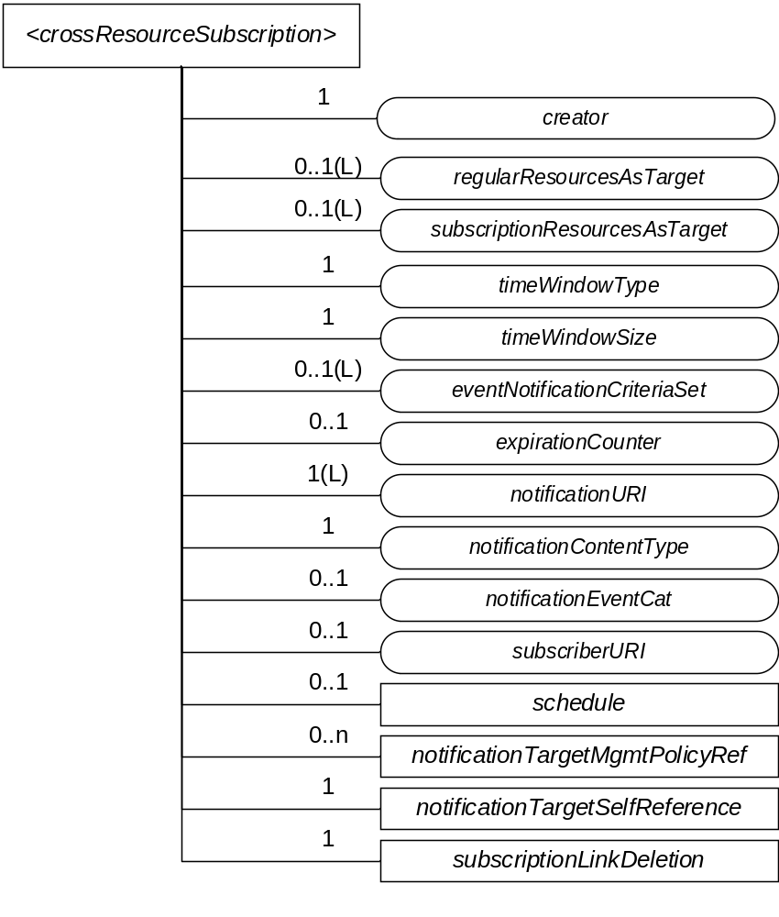
Figure 9.6.58-1: Structure of <crossResourceSubscription> Resource

The <crossResourceSubscription> resource shall contain the child resources specified in Table 9.6.58-1.
Table 9.6.58-1: Child resources of <crossResourceSubscription> resource

Child Resources of <crossResourceSubscription> | Child Resource Type | Multiplicity | Description
notificationSchedule | <schedule> | 0..1 | See clause 9.6.9.
[variable] | <notificationTargetMgmtPolicyRef> | 0..n | See clause 9.6.31.
nstr | <notificationTargetSelfReference> | 1 | See clause 9.6.34.
sld | <subscriptionLinkDeletion> | 1 | A virtual resource which shall be used by a <subscription> Hosting CSE, if the <subscription> is included in the subscriptionResourcesAsTarget list of this <crossResourceSubscription> resource, to delete the <subscription> resource from the list.

The <crossResourceSubscription> resource shall contain the attributes specified in Table 9.6.58-2.
Table 9.6.58-2: Attributes of <crossResourceSubscription> resource
Attributes of  <crossResourceSubscription> | Multiplicity | RW/  RO/  WO | Description
resourceType | 1 | RO | See clause 9.6.1.3.
resourceID | 1 | RO | See clause 9.6.1.3.
resourceName | 1 | WO | See clause 9.6.1.3.
parentID | 1 | RO | See clause 9.6.1.3.
expirationTime | 1 | RW | See clause 9.6.1.3.
accessControlPolicyIDs | 0..1 (L) | RW | See clause 9.6.1.3.
labels | 0..1 (L) | RW | See clause 9.6.1.3.
creationTime | 1 | RO | See clause 9.6.1.3.
lastModifiedTime | 1 | RO | See clause 9.6.1.3.
stateTag | 1 | RO | See clause 9.6.1.3.
announceTo | 0..1 (L) | RW | See clause 9.6.1.3.
announcedAttribute | 0..1 (L) | RW | See clause 9.6.1.3.
dynamicAuthorizationConsultationIDs | 0..1 (L) | RW | See clause 9.6.1.3.
creator | 1 | RO | See clause 9.6.1.3.
expirationCounter | 0..1 | RW | See clause 9.6.8.
notificationURI | 1 (L) | RW | See clause 9.6.8.
notificationContentType | 1 | RW | See clause 9.6.8.
notificationEventCat | 0..1 | RW | See clause 9.6.8.
subscriberURI | 0..1 | WO | See clause 9.6.8.
regularResourcesAsTarget | 0..1(L) | RW | This attribute indicates a list of regular resources (i.e. normal resources rather than <subscription> resources), which shall be used as the target resource for this cross-resource subscription. Here, the regular resource is referred to as any subscribable oneM2M resources.
subscriptionResourcesAsTarget | 0..1(L) | RW | This attribute indicates a list of existing <subscription> resources, which shall be used as the target resource for this cross-resource subscription.
timeWindowType | 1 | RW | This attribute indicates the type of time window mechanisms (e.g. timeWindowType=1 stands for periodic time window without any overlapping and timeWindowType=2 represents sliding time window where current time window will be slided to become next time window when a cross-resource notification is generated for instance) which will be used to determine the generation of a cross-resource notification.
timeWindowSize | 1 | RW | This attribute indicates the size or time duration (e.g. in seconds) of the time window, based on which cross-resource notifications shall be generated. Note that the maximum window size (e.g. 60 seconds) may be enforced by the Hosting CSE for a subscriber; if the timeWindowSize indicated or requested by a subscriber is larger than the maximum window size, the Hosting CSE may reject the subscriber’s request for cross-resource subscription.
eventNotificationCriteriaSet | 0..1(L) | RW | This attribute lists eventNotificationCriteria for each regular target resource as indicated in regularResourcesAsTarget attribute and involved in a cross-resource subscription. If there is only one eventNotificationCriteria contained in this attribute, it shall be applied to all target resources as indicated by regularResourcesAsTarget attribute. If only subscriptionResourcesAsTarget attribute appears (i.e. no regularResourcesAsTarget attribute), eventNotificationCriteriaSet shall not be needed.  See clause 9.6.8 for the description of eventNotificationCriteria.

-----------------------End of change 14---------------------------------------------

-----------------------Start of change 15---------------------------------------------

9.6.60 Resource Type backgroundDataTransfer
The <backgroundDataTransfer> resource is used to request that the IN-CSE negotiates a background data transfer for a set of field nodes, with the Underlying Network. The resource attributes provide the characteristics of the background data transfer, optional guidance for transfer policy selection and the field nodes involved with the data transfer.

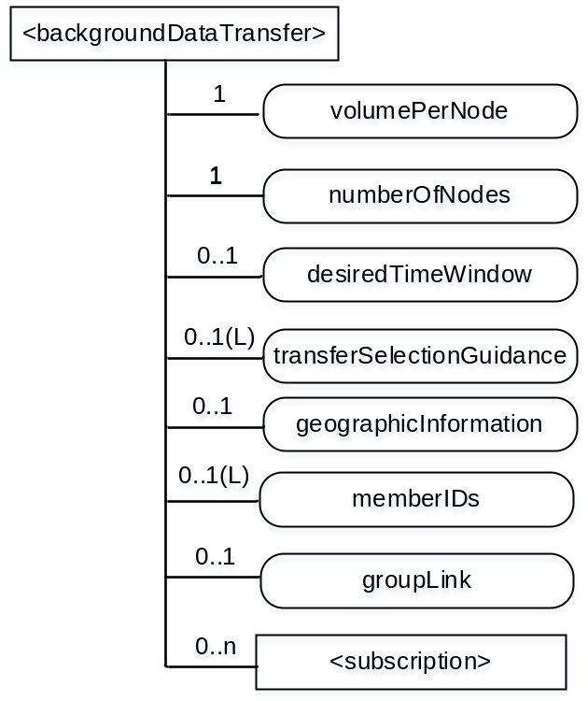

Figure 9.6.60-1: Structure of <backgroundDataTransfer> resource
The <backgroundDataTransfer> resource contains the child resources specified in table 9.6.60-1.
Table 9.6.60-1: Child resources of <backgroundDataTransfer> resource
Child Resources of <backgroundDataTransfer> | Child Resource Type | Multiplicity | Description | <backgroundDataTransfer> Child Resource Types
[variable] | <subscription> | 0..n | See clause 9.6.8. | <subscription>

The <backgroundDataTransfer> resource contains the attributes specified in table 9.6.60-2.
Table 9.6.60-2: Attributes of <backgroundDataTransfer> resource
Attributes of < backgroundDataTransfer > | Multiplicity | RW/  RO/  WO | Description
resourceType | 1 | RO | See clause 9.6.1.3
resourceID | 1 | RO | See clause 9.6.1.3
resourceName | 1 | WO | See clause 9.6.1.3
parentID | 1 | RO | See clause 9.6.1.3
creationTime | 1 | RO | See clause 9.6.1.3
lastModifiedTime | 1 | RO | See clause 9.6.1.3
expirationTime | 1 | RW | See clause 9.6.1.3
accessControlPolicyIDs | 0..1 (L) | RW | See clause 9.6.1.3
labels | 0..1 (L) | RW | See clause 9.6.1.3.
announceTo | 0..1(L) | RW | See clause 9.6.1.3
volumePerNode | 1 | WO | Expected data volume for the background data transfer.
numberOfNodes | 1 | WO | Desired number of nodes for the background data transfer.
desiredTimeWindow | 0..1 | WO | Desired time window for the background data transfer.
transferSelectionGuidance | 0..1(L) | WO | List that includes guidance to IN-CSE in selecting from multiple transfer policies provided by underlying network. Possible values include:” lowest cost”, “highest throughput given maximum cost of X”, etc.  If not included, the IN-CSE may independently choose from among multiple transfer policies.
geographicInformation | 0..1 | WO | Provides geographic information for the policy request
groupLink | 0..1 | RW | This attribute shall be used if the background data transfer is requested for sending a request to a group of field domain nodes. It is assumed that a <group> resource, with a memberIDs list includeing all field domain nodes that need to be reached, has already been created. This attribute contains the resource identifier of the <group> resource of field domain nodes for which the background data transfer applies.  The backgroundDataTransfer resource may have either a groupLink attribute or a list of memberIDs. If the memberIDs attribute contains a valid list of member resource IDs, the groupLink attribute shall be ignored.
memberIDs | 0..1 (L) | RW | List of member resource IDs for which the transfer policy applies. The valid resource types are <remoteCSE> and <AE>.  The backgroundDataTransfer resource may have either a groupLink attribute or a list of memberIDs. If the memberIDs attribute contains a valid list of member resource IDs, the groupLink attribute shall be ignored.

-----------------------End of change 15---------------------------------------------

CHECK LIST
- Does this Change Request include an informative introduction containing the problem(s) being solved, and a summary list of proposals.?
- Does this CR contain changes related to only one particular issue/problem?
- Have any mirror CRs been posted?
- Does this Change Request make all the changes necessary to address the issue or problem? E.g. A change impacting 5 tables should not include a proposal to change only 3 tables?Does this Change Request follow the drafting rules?
- Are all pictures editable?
- Have you checked the spelling and grammar?
- Have you used change bars for all modifications?
- Does the change include the current and surrounding clauses to clearly show where a change is located and to provide technical context of the proposed change? (Additions of complete clauses need not show surrounding clauses as long as the proposed clause number clearly shows where the new clause is proposed to be located.)
- Are multiple changes in this CR clearly separated by horizontal lines with embedded text such as, start of change 1, end of change 1, start of new clause, end of new clause.?

