CHANGE REQUEST
Meeting ID:* | ARC 32
Source:* | Albert Zhao, BOE, zhaojunjie111@boe.com.cn  Max Zhang, BOE, zhangqiancto@boe.com.cn
Date:* | 2017-10-30
Reason for Change/s:* | Resource table and figure are inconsistent
CR against: Release* | Release 3
CR against: WI* | Active <Work Item number>  MNT maintenance / < Work Item number(optional)>  Is this a companion CR? Yes No  Companion CR number: (Note to Rapporteur - use latest agreed revision)Is this a mirror CR? Yes No  Mirror CR number: (Note to Rapporteur - use latest agreed revision)  STE Small Technical Enhancements / < Work Item number (optional)>  Only ONE of the above shall be ticked
CR against: TS/TR* | TS-0001 V3.8.0
Clauses * | 9.6.39, 9.6.57, 9.6.58
Type of change: * | Editorial change  Bug Fix or Correction  Change to existing feature or functionality  New feature or functionality  Only ONE of the above shall be ticked
Impacted other TS/TR(s) | <TS/TR number>, <Version Number>, and <Description on which aspect should be reflected in this TS/TR>
Post Freeze checking:* | This CR contains only essential changes and corrections? YES NO  This CR may break backwards compatibility with the last approved version of the TS? YES NO
Template Version: January 2017 (Do not modify)

oneM2M Notice
The document to which this cover statement is attached is submitted to oneM2M. Participation in, or attendance at, any activity of oneM2M, constitutes acceptance of and agreement to be bound by terms of the Working Procedures and the Partnership Agreement, including the Intellectual Property Rights (IPR) Principles Governing oneM2M Work found in Annex 1 of the Partnership Agreement.
GUIDELINES for Change Requests:
Provide an informative introduction containing the problem(s) being solved, and a summary list of proposals.
Each CR should contain changes related to only one particular issue/problem.
In case of a correction, and the change apply to previous releases, a separate “mirror CR” should be posted at the same time of this CR
Mirror CR: applies only when the text, including clause numbering are exactly the same.
Companion CR: applies when the change means the same but the baselines differ in some way (e.g. clause number).
Follow the principle of completeness, where all changes related to the issue or problem within a deliverable are simultaneously proposed to be made E.g. A change impacting 5 tables should not only include a proposal to change only 3 tables. Includes any changes to references, definitions, and acronyms in the same deliverable.
Follow the drafting rules.
All pictures must be editable.
Check spelling and grammar to the extent practicable.
Use Change bars for modifications.
The change should include the current and surrounding clauses to clearly show where a change is located and to provide technical context of the proposed change. Additions of complete clauses need not show surrounding clauses as long as the proposed clause number clearly shows where the new clause is proposed to be located.
Multiple changes in a single CR shall be clearly separated by horizontal lines with embedded text such as, start of change 1, end of change 1, start of new clause, end of new clause.
When subsequent changes are made to content of a CR, then the accepted version should not show changes over changes. The accepted version of the CR should only show changes relative to the baseline approved text.

Introduction
After reviewing the resource type defination, there are several inconsistences between the resource type figure and resource type talbe, the detail as follows:
 |  | Resource Type Figure | Resource Type Table | suggestion
1 | 9.6.4 Resource Type remoteCSE | has a <scheduleAnnc> sub-resource with multiplicity 0..1 | has no <scheduleAnnc> sub-resource  consistent with TS-0004 | change figure
2 | 9.6.8 Resource Type subscription | <notificationTargetMgmtPolicyRef> with multiplicity 0..1  <notificationTargetSelfReference> with multiplicity 0..1 | <notificationTargetMgmtPolicyRef> with multiplicity 0..n  consistent with TS-0004  <notificationTargetSelfReference> with multiplicity 1  consistent with TS-0004 | change figure
3 | 9.6.10 Resource Type locationPolicy | M2M-Ext-ID | authID  consistent with TS-0004 | change figure
4 | 9.6.20 Resource Type serviceSubscribedNode | niddRequired with multiplicity 0..1(L) | niddRequired with multiplicity 0..1 | change figure
5 | 9.6.29 Resource Type serviceSubscribedAppRule | allowedAppIDs attribute  allowedRoleIDs attribute | allowedApp-IDs attribute  consistent with TS-0004  allowedRole-IDs attribute  consistent with TS-0004 | change figure
6 | 9.6.31 Resource Type notificationTargetMgmtPolicyRef | notificationTargetURI with multiplicity 1  notificationlPolicyID with multiplicity 1 | notificationTargetURI with multiplicity 1(L)  consistent with TS-0004  notificationlPolicyID with multiplicity 0..1  consistent with TS-0004 | change figure
7 | 9.6.33 Resource Type policyDeletionRules | deletionRules with multiplicity 1(L) | deletionRules with multiplicity 0..1(L)  consistent with TS-0004 | change figure
8 | 9.6.35 Resource Type flexContainer | no timeseries | timeSeries with multiplicity 0..n  not update in TS-0004 | change figure
9 | 9.6.39 Resource Type token | notBefore with multiplicity 0..1  consistent with TS-0004 | notBefore with multiplicity 1 | change table
10 | 9.6.46 Resource Type AEContactListPerCSE | CSE-ID with multiplicity 1 | CSE-ID with multiplicity NULL | change table
11 | 9.6.53 Resource Type semanticMashupJobProfile | memberFilter with multiplicity 1(L) | memberFilter with multiplicity 1  consistent with TS-0004 | change figure
12 | 9.6.54 Resource Type semanticMashupInstance | smjpInputParameter with multiplicity 0..1  resultGenType with multiplicity 1  consistent with TS-0004 | smjpInputParameter with multiplicity 1  consistent with TS-0004  resultGenType with multiplicity 1(L) | change figure  change table
13 | 9.6.57 Resource Type multimediaSession | offeredSessionDescriptions with multiplicity 1(L)  not defined in TS-0004 | offeredSessionDescriptions with multiplicity 1 | change table
14 | 9.6.58 Resource Type crossResourceSubscription | regularResourcesAsTarget with multiplicity 0..1(L)  subscriptionResourcesAsTarget with multiplicity 0..1(L)  consistent with TS-0001 crossResourceSubscription resource defination | regularResourcesAsTarget with multiplicity 0..1  subscriptionResourcesAsTarget with multiplicity 0..1 | change table
15 | 9.6.60 Resource Type backgroundDataTransfer | transferSelectionGuidance with multiplicity 0..1 | transferSelectionGuidance with multiplicity 0..1(L) | change figure

R01: refter to the above talbe, we only resolve the table issues, since we agree to delete the figure in TS-0001 Rlease 3.
 |  | Resource Type Figure | Resource Type Table | suggestion
9 | 9.6.39 Resource Type token | notBefore with multiplicity 0..1  consistent with TS-0004 | notBefore with multiplicity 1 | change table
10 | 9.6.46 Resource Type AEContactListPerCSE | CSE-ID with multiplicity 1 | CSE-ID with multiplicity NULL | change table  ARC-2017-0434R01-TS-0001_corrections_AEContact_related
12 | 9.6.54 Resource Type semanticMashupInstance | resultGenType with multiplicity 1 | resultGenType with multiplicity 1(L) | No change table  NOTE: TS-0001 Table 9.6.56-2 states “Describes how the mashup result should be generated using this <semanticMashupInstance>. Example values for this attribute could be one of the following or a combination of them.”
 | 6 ResuactListPerCSE |  | NULL
 | 54 RouicMashupInstanc | with multiplicconsistent with TS-0004
13 | 9.6.57 Resource Type multimediaSession | offeredSessionDescriptions with multiplicity 1(L)  not defined in TS-0004 | offeredSessionDescriptions with multiplicity 1 | change table  ARC-2017-0465-modification_on_multimediaSession
14 | 9.6.58 Resource Type crossResourceSubscription | regularResourcesAsTarget with multiplicity 0..1(L)  subscriptionResourcesAsTarget with multiplicity 0..1(L)  consistent with TS-0001 crossResourceSubscription resource defination | regularResourcesAsTarget with multiplicity 0..1  subscriptionResourcesAsTarget with multiplicity 0..1 | change table

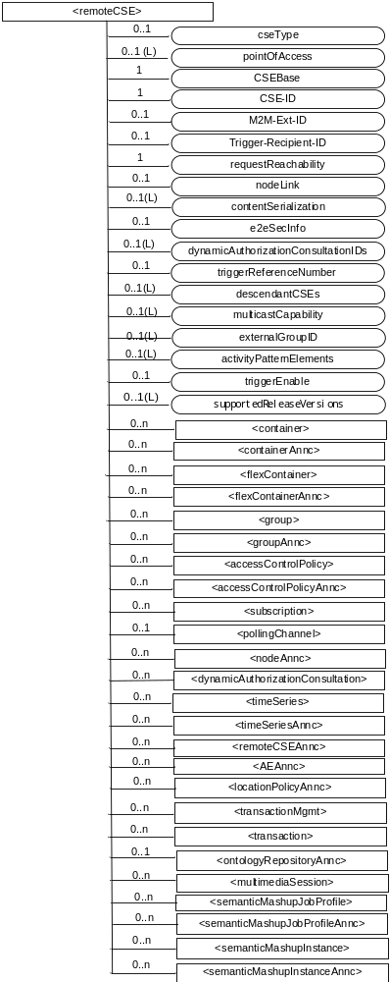

resource

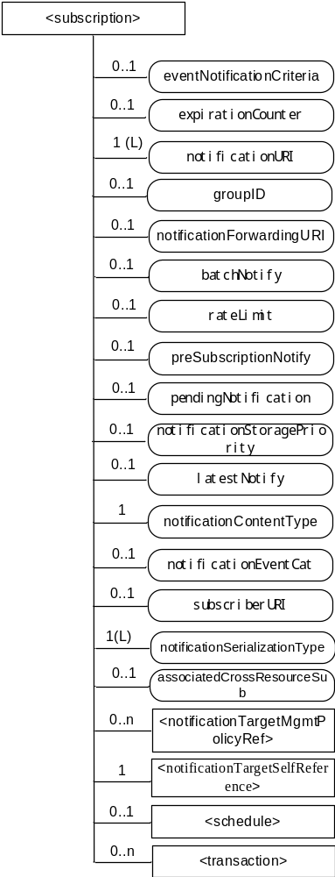

resource

resource

resource

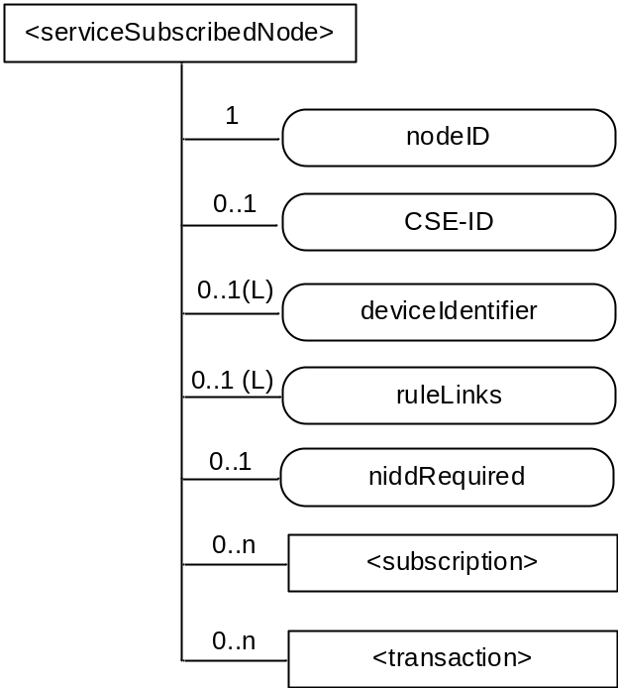

resource

resource
- Error: Reference source not found
- Error: Reference source not found
- Error: Reference source not found

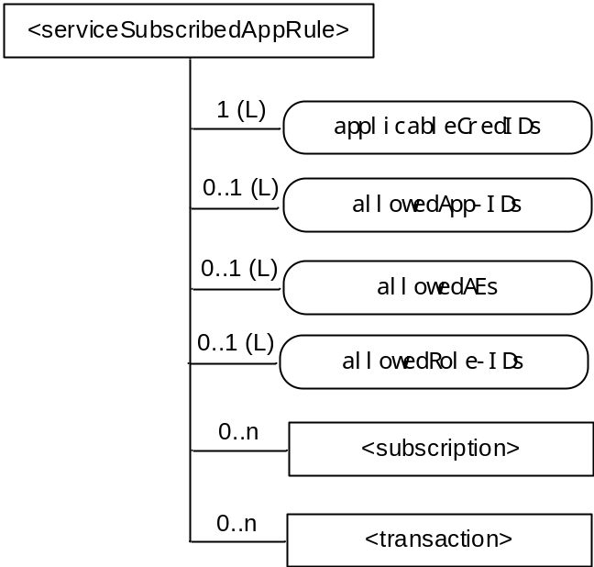

resource

resource
Error: Reference source not found
Error: Reference source not found

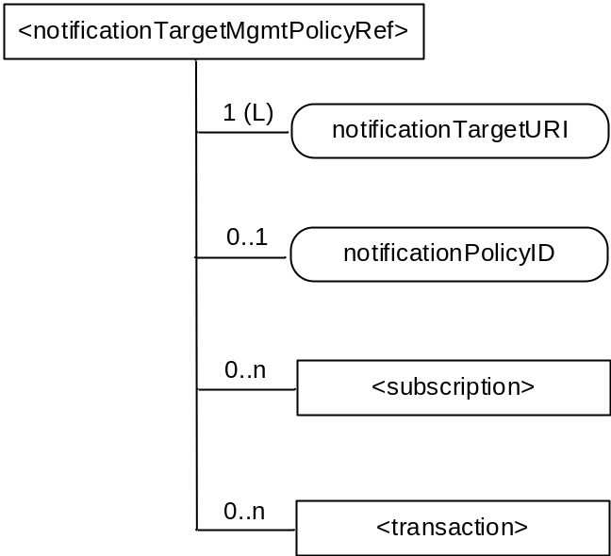

resource

resource

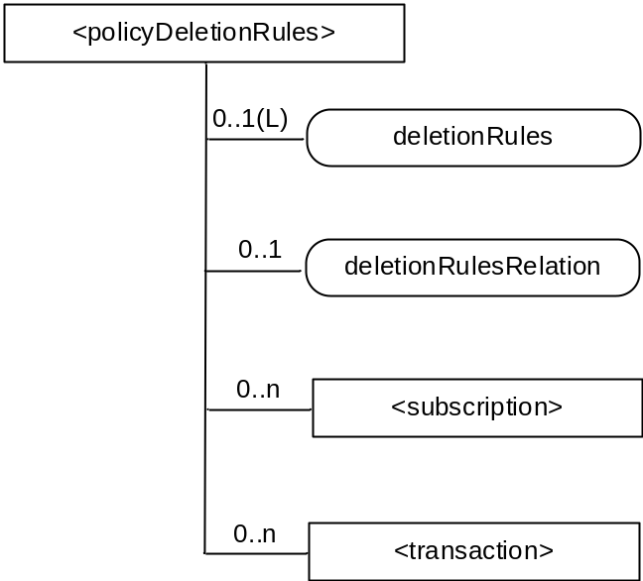

resource

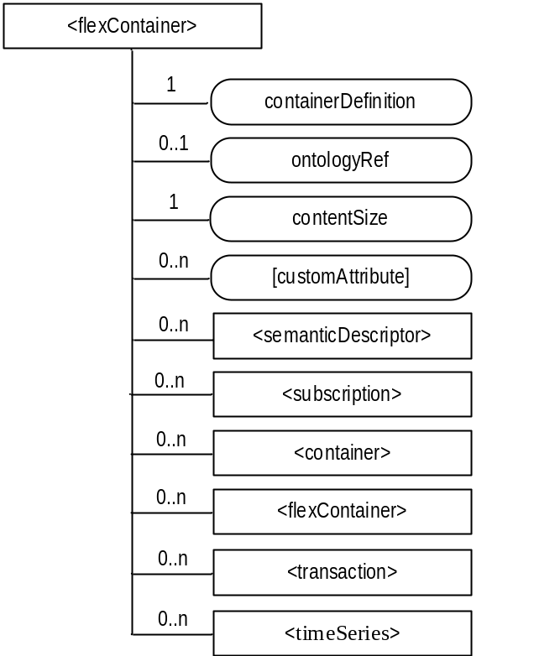

> resource

> resource
- Error: Reference source not found

-----------------------Start of change 9---------------------------------------------

9.6.39 Resource Type token
The <token> resource is used for storing a token that is issued to an AE or CSE. Details of the token may also be stored here in plaintext.
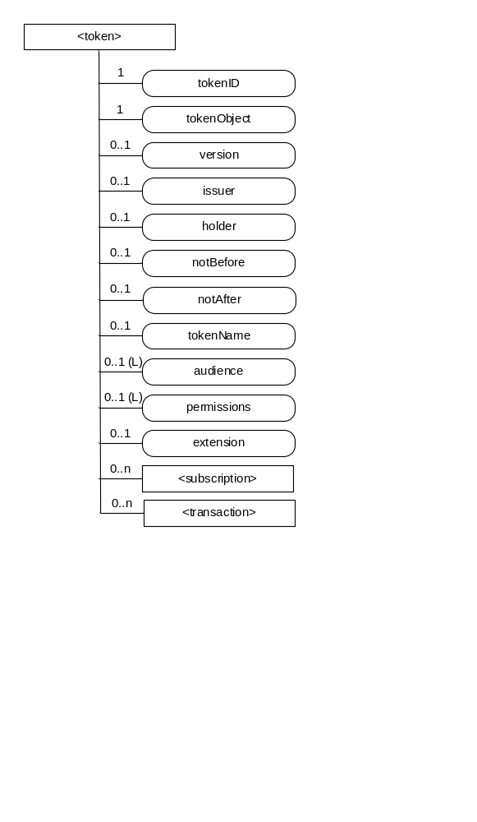
Figure 9.6.39-1: Structure of <token> resource
The <token> resource shall contain the child resources specified in table 9.6.39-1.
Table 9.6.39-1: Child resources of <token> resource
Child Resources of <token> | Child Resource Type | Multiplicity | Description
[variable] | <subscription> | 0..n | See clause 9.6.8
[variable] | <transcaction> | 0..n | See clause 9.6.48

The <token> resource shall contain the attributes specified in table 9.6.39-2.
Table 9.6.39-2: Attributes of <token> resource
Attributes of <token> | Multiplicity | RW/  RO/  WO | Description
resourceType | 1 | RO | See clause 9.6.1.3.
resourceID | 1 | RO | See clause 9.6.1.3.
resourceName | 1 | WO | See clause 9.6.1.3.
parentID | 1 | RO | See clause 9.6.1.3.
expirationTime | 1 | RW | See clause 9.6.1.3.
accessControlPolicyIDs | 0..1 (L) | RW | See clause 9.6.1.3.
creationTime | 1 | RO | See clause 9.6.1.3.
labels | 0..1 (L) | RW | See clause 9.6.1.3.
lastModifiedTime | 1 | RO | See clause 9.6.1.3.
dynamicAuthorizationConsultationIDs | 0..1 (L) | RW | See clause 9.6.1.3.
tokenID | 1 | WO | The identifier of the token.
tokenObject | 1 | WO | Used to store the token. See clause TS-0003 [2] for further details of a token.
version | 0..1 | WO | Version of the token.
issuer | 0..1 | WO | The identifier of the entity that is responsible for issuing the token to the AE or CSE.
audience | 0..1 (L) | WO | List of identifiers of the CSEs expected to accept the token.
holder | 0..1 | WO | The identifier of the AE or CSE to which the token is issued.
notBefore | 0..1 | WO | Start time of the token can be used for access control.
notAfter | 0..1 | WO | End time of the token can be used for access control.
tokenName | 0..1 | WO | Human readable name of the <token>..
permissions | 0..1 (L) | WO | List of token permissions associated with the token. The structure of token permission is specified in the table 9.6.39-3.
extension | 0..1 | WO | Extension information held by the token, e.g. application-specific information.

The structure of token permission is specified in the table 9.6.39-3.
Table 9.6.39-3: Structure of token permission
Element | Multiplicity | Description | Note
resourceIDs | 0..1 | The resources to which this permission applies. If the privileges element is present, then this element shall be present.
privileges | 0..1 | A set of access control rules applicable to the identified resources (for the identified holder) | At least one of these must be present.
roleIDs | 0..1 | A set of role IDs applicable to the identified resources (for the identified holder) | At least one of these must be present.

-----------------------End of change 9---------------------------------------------

resource

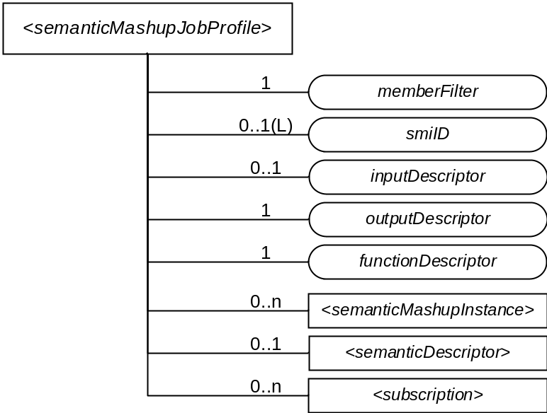

> resource

> resource

> resource

e> resource

> resource

> resource

-----------------------Start of change 14---------------------------------------------

9.6.58 Resource Type crossResourceSubscription
The <crossResourceSubscription> resource represents a cross-resource subscription over a set of target resources which could be existing <subscription> and/or other subscribable oneM2M resources. The Hosting CSE shall generate a cross-resource notifications only when expected changes occur on a designated number of target resources concurrently within a time window. The <crossResourceSubscription> resource shall specify the involved target resources in order to generate cross-resource notification.

The structure of a <crossResourceSubscription> resource is also illustrated in Figure 9.6.58-1.

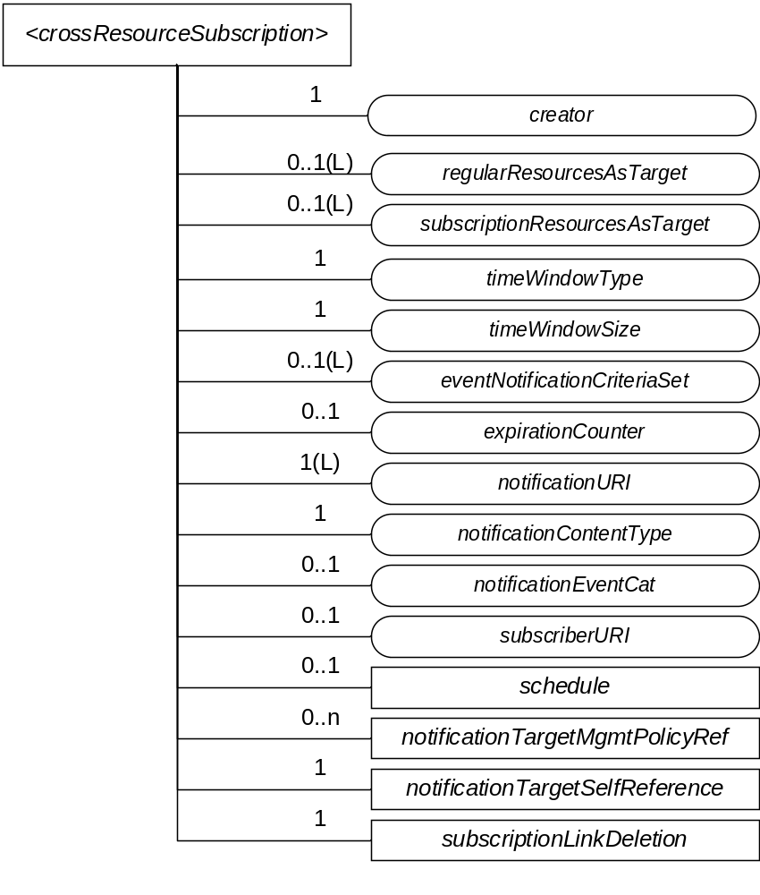
Figure 9.6.58-1: Structure of <crossResourceSubscription> Resource

The <crossResourceSubscription> resource shall contain the child resources specified in Table 9.6.58-1.
Table 9.6.58-1: Child resources of <crossResourceSubscription> resource

Child Resources of <crossResourceSubscription> | Child Resource Type | Multiplicity | Description
notificationSchedule | <schedule> | 0..1 | See clause 9.6.9.
[variable] | <notificationTargetMgmtPolicyRef> | 0..n | See clause 9.6.31.
nstr | <notificationTargetSelfReference> | 1 | See clause 9.6.34.
sld | <subscriptionLinkDeletion> | 1 | A virtual resource which shall be used by a <subscription> Hosting CSE, if the <subscription> is included in the subscriptionResourcesAsTarget list of this <crossResourceSubscription> resource, to delete the <subscription> resource from the list.

The <crossResourceSubscription> resource shall contain the attributes specified in Table 9.6.58-2.
Table 9.6.58-2: Attributes of <crossResourceSubscription> resource
Attributes of  <crossResourceSubscription> | Multiplicity | RW/  RO/  WO | Description
resourceType | 1 | RO | See clause 9.6.1.3.
resourceID | 1 | RO | See clause 9.6.1.3.
resourceName | 1 | WO | See clause 9.6.1.3.
parentID | 1 | RO | See clause 9.6.1.3.
expirationTime | 1 | RW | See clause 9.6.1.3.
accessControlPolicyIDs | 0..1 (L) | RW | See clause 9.6.1.3.
labels | 0..1 (L) | RW | See clause 9.6.1.3.
creationTime | 1 | RO | See clause 9.6.1.3.
lastModifiedTime | 1 | RO | See clause 9.6.1.3.
stateTag | 1 | RO | See clause 9.6.1.3.
announceTo | 0..1 (L) | RW | See clause 9.6.1.3.
announcedAttribute | 0..1 (L) | RW | See clause 9.6.1.3.
dynamicAuthorizationConsultationIDs | 0..1 (L) | RW | See clause 9.6.1.3.
creator | 1 | RO | See clause 9.6.1.3.
expirationCounter | 0..1 | RW | See clause 9.6.8.
notificationURI | 1 (L) | RW | See clause 9.6.8.
notificationContentType | 1 | RW | See clause 9.6.8.
notificationEventCat | 0..1 | RW | See clause 9.6.8.
subscriberURI | 0..1 | WO | See clause 9.6.8.
regularResourcesAsTarget | 0..1(L) | RW | This attribute indicates a list of regular resources (i.e. normal resources rather than <subscription> resources), which shall be used as the target resource for this cross-resource subscription. Here, the regular resource is referred to as any subscribable oneM2M resources.
subscriptionResourcesAsTarget | 0..1(L) | RW | This attribute indicates a list of existing <subscription> resources, which shall be used as the target resource for this cross-resource subscription.
timeWindowType | 1 | RW | This attribute indicates the type of time window mechanisms (e.g. timeWindowType=1 stands for periodic time window without any overlapping and timeWindowType=2 represents sliding time window where current time window will be slided to become next time window when a cross-resource notification is generated for instance) which will be used to determine the generation of a cross-resource notification.
timeWindowSize | 1 | RW | This attribute indicates the size or time duration (e.g. in seconds) of the time window, based on which cross-resource notifications shall be generated. Note that the maximum window size (e.g. 60 seconds) may be enforced by the Hosting CSE for a subscriber; if the timeWindowSize indicated or requested by a subscriber is larger than the maximum window size, the Hosting CSE may reject the subscriber’s request for cross-resource subscription.
eventNotificationCriteriaSet | 0..1(L) | RW | This attribute lists eventNotificationCriteria for each regular target resource as indicated in regularResourcesAsTarget attribute and involved in a cross-resource subscription. If there is only one eventNotificationCriteria contained in this attribute, it shall be applied to all target resources as indicated by regularResourcesAsTarget attribute. If only subscriptionResourcesAsTarget attribute appears (i.e. no regularResourcesAsTarget attribute), eventNotificationCriteriaSet shall not be needed.  See clause 9.6.8 for the description of eventNotificationCriteria.

-----------------------End of change 14---------------------------------------------

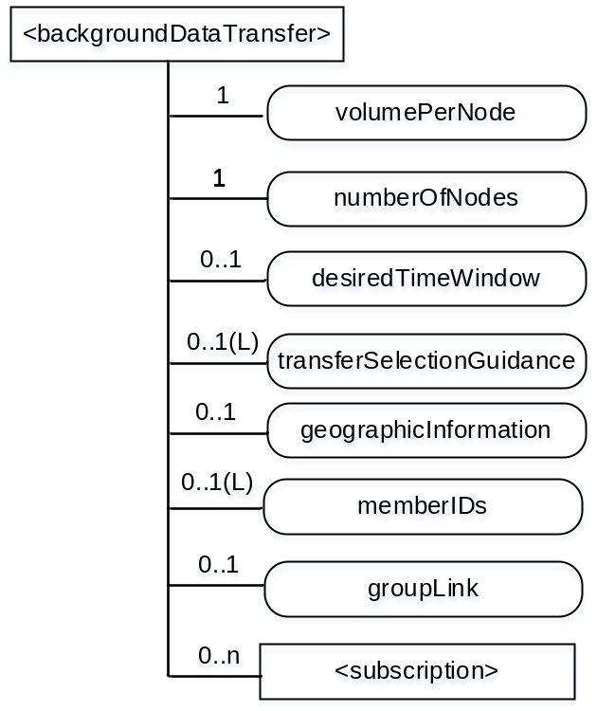

resource

resource

CHECK LIST
- Does this Change Request include an informative introduction containing the problem(s) being solved, and a summary list of proposals.?
- Does this CR contain changes related to only one particular issue/problem?
- Have any mirror CRs been posted?
- Does this Change Request make all the changes necessary to address the issue or problem? E.g. A change impacting 5 tables should not include a proposal to change only 3 tables?Does this Change Request follow the drafting rules?
- Are all pictures editable?
- Have you checked the spelling and grammar?
- Have you used change bars for all modifications?
- Does the change include the current and surrounding clauses to clearly show where a change is located and to provide technical context of the proposed change? (Additions of complete clauses need not show surrounding clauses as long as the proposed clause number clearly shows where the new clause is proposed to be located.)
- Are multiple changes in this CR clearly separated by horizontal lines with embedded text such as, start of change 1, end of change 1, start of new clause, end of new clause.?

